Date
Name
Department
Revalidation
Date or N/A
Pay Progression Date or N/A
Manager
Name

Step 1 Prepare
Employee Checklist |  | Manager Checklist
Self-Assessment tool (optional) | ☐ | Familiarised with the process | ☐
Completed questions below | ☐ | Prepared your thought/comments | ☐
Gathered feedback (optional) | ☐ | Agreed date/time for discussion | ☐
Familiarised with the process | ☐
Send the completed form to your manager | ☐

Step 2 During the Discussion
Please think about how what you do contributes to the aims of Cardiff and Vale UHB.
Our Mission: Caring for People, Keeping People Well
Our Vision: A person’s chance of leading a healthy life is the same wherever they live and whoever they are.

This is your opportunity to share with your manager your thoughts about the difference you are making now in your role, what you do best, what’s holding you back, where you want to be and how you’ve used your values and behaviours to meet your objectives over the last 12 months.

About You
Question | Employee Responses | Manager Responses
What motivates you and makes you feel valued at work?

What do you find most interesting about your job?

What ambitions do you have for the future or are you happy with what you are doing?

Is there anything else you would like your manager to know about you?

You in your Role
Question | Employee Responses | Manager Responses
What have been your main accomplishments/achievements in the past year? What have you done well?

How do your performance and behaviours align with the organisation’s values?

What gets in the way of you doing a good job?

Your Support and Development
Question | Employee Responses | Manager Responses
What would help you achieve your objectives in your role?

How do you feel about your development so far? Do you wish to develop further?

What support do you need to do your job well?

Developing Healthy Relationships at Work
Question | Employee Responses | Manager Responses
How would you describe your relationship with your colleagues and manager?

What suggestion do you have for maintaining or improving team relationships?

Your health & wellbeing is important, is there anything you would like to discuss or ask regarding this?

Question | Employee Responses | Manager Responses
Any other comments?

For more prompt questions, please refer to the VBA guide page 14
N.B – Optional – you can use to the self-assessment tool and the feedback you have collected from others during the discussion.
Career Conversation Framework
This framework is designed to enable a conversation about your role in the UHB. Think of it as a map you can use to plot your position and direction. The discussion is not just about what you do (better results) but how you do it (better ways of working). See ‘Values Based Appraisal Guide’ for the complete framework and the descriptions of the boxes. Tick the area that best represents where you feel you currently sit. Your position can, and will, change over time.
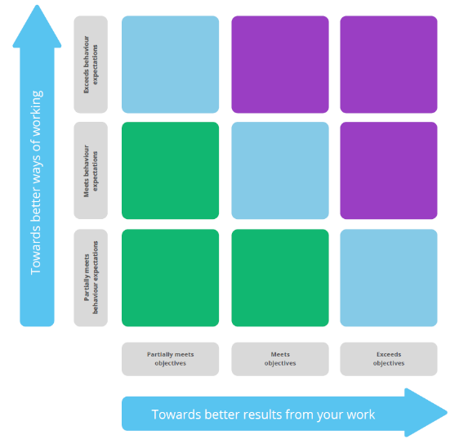
Confirm the area that you and your manager have AGREED best represents where you currently sit.
Tick the area that best represents where you feel you currently sit. Your position can, and will, change over time.

There are no right or wrong places to be – the most important thing is the quality of the conversation, in helping you understand and maximise your potential.

Step 3 Recording the Outcomes
Your manager will record on ESR where you are right now based on your ratings for behaviours and performance and the outcome of your discussions. This information will be used to direct you towards appropriate support, development opportunities and succession planning – please see guide on how to record the appraisal on ESR overleaf.

QUICK GUIDE – HOW TO ENTER A VBA ONTO ESR – EMPLOYEE AND MANAGER PROCESS
By employee | By employee continued…. | By manager
- From the dashboard, click “My Appraisals and Reviews”  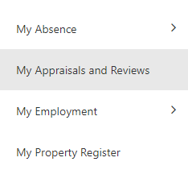  (in the left-hand menu)  - From the right-hand side, ensure the drop down says “Create Standard Appraisal” and click the blue “Go” button.  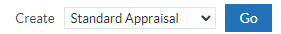  - Set the details as below: | 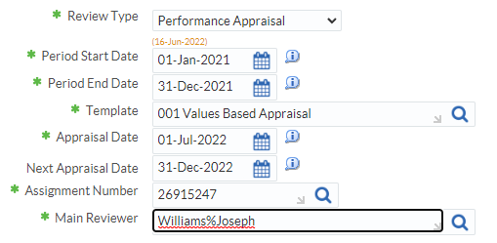  Click “Add Details” at the top-right side of the window.    - Click “Share with Main Appraiser” at the top-right of the window.  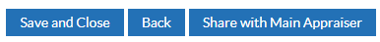  - Enter a message for your manager, then click “Submit” at the top-right.  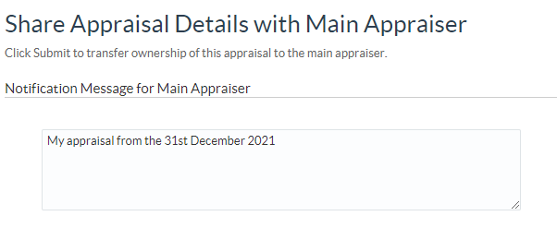  Manager/ Appraiser will have to log in and sign off – they will do this by;  - From the manager or supervisor dashboard, click ‘My Team Career Information’  - Find the appropriate staff member from the list – scroll to the right, then click the icon ‘Appraise’  - Then ‘Update Appraisal’ to enter in further information – see points 5 & 6 in the ‘By manager’ section  OR  - ‘Complete Appraisal’ to sign off just dates. | - From the manager or supervisor dashboard, click ‘My Team Career Information’, ‘Appraisals and Reviews’  - From the right-hand side, ensure the drop down says “Create Standard Appraisal” and click the blue “Go” button.  - ‘People in Hierarchy’, click the ‘Action’ icon against the appropriate staff member.  - Follow steps 3 – enter dates & 4 - ‘Add Details’  - Click on ‘Complete Questionnaire’  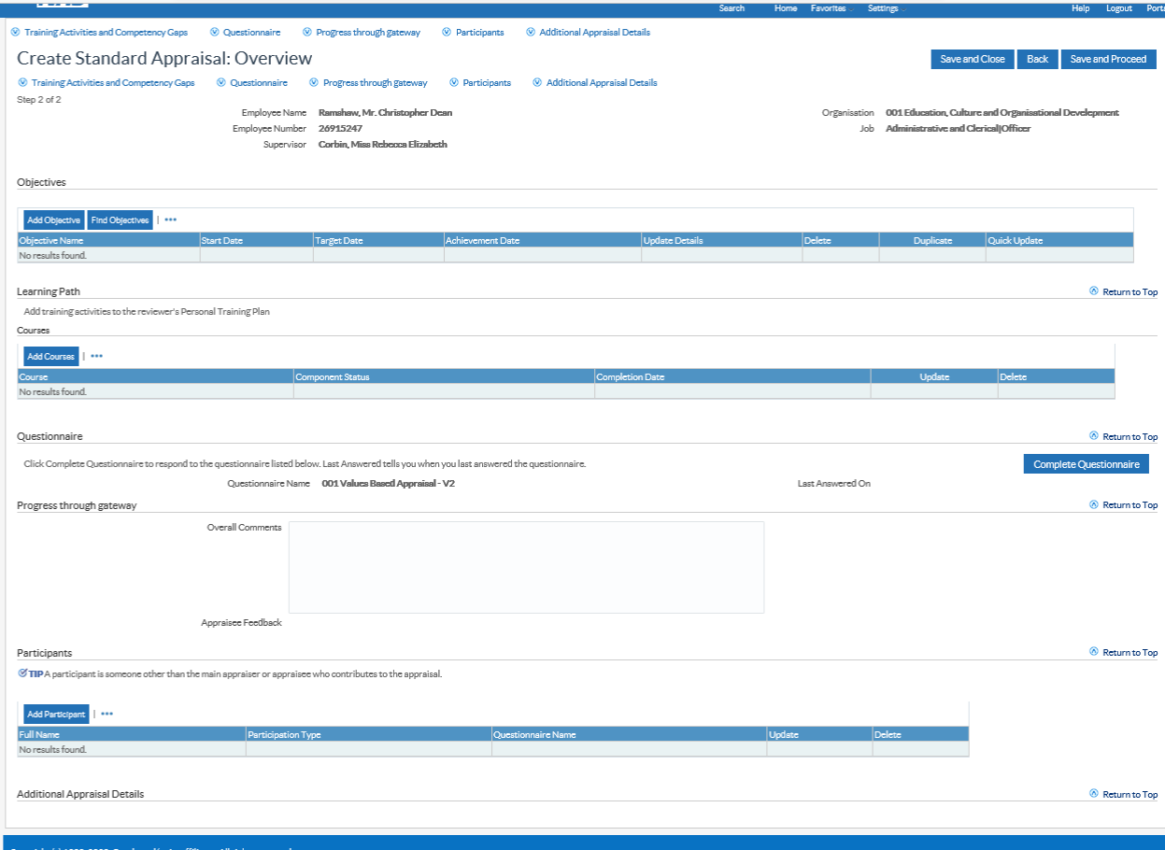  - This will open a new form – enter in details against the agreed placement on the Career Conversation Framework and the Personal Development Action Plan  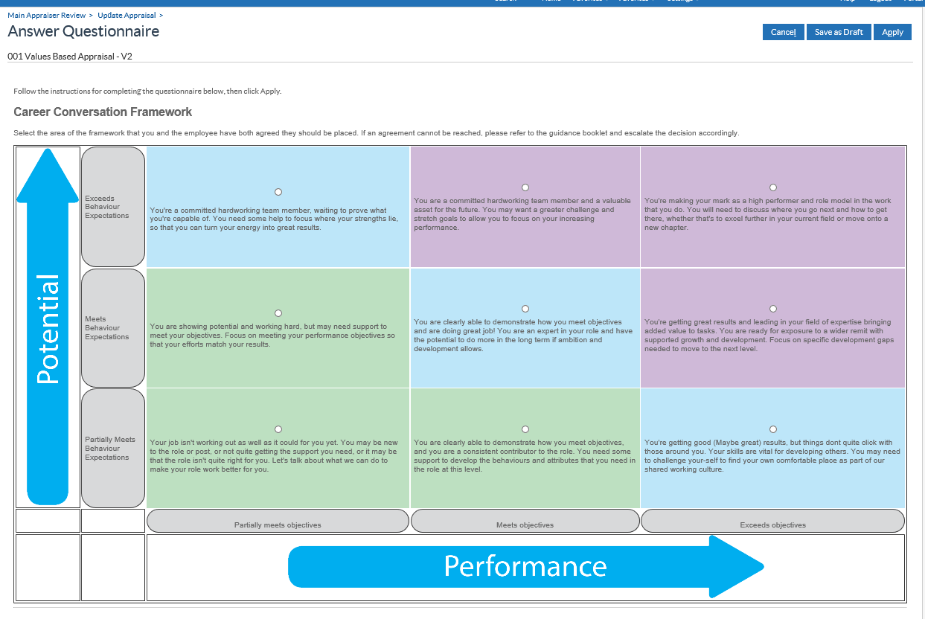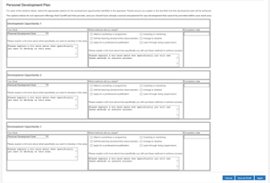  - Then complete the VBA, by clicking ‘save and proceed’, then click ‘complete appraisal’, then click ‘Continue’, then ‘Submit’
  Review Type | Select “Performance Appraisal”
  Period Start Date | Enter the start date from the period you are reviewing (previous year)
  Period End Date: | Enter the end date of the period you are reviewing
  Template | Enter “001 Values Based Appraisal”
  Appraisal Date | Enter or select the date of the appraisal
  Next Appraisal Date | Enter or select a date one year after the date of the appraisal or the proposed next VBA date
  Main Appraiser | Search for your line manager/ appraiser. To find them, search by surname then first name, separated by a “%” sign. For example, to find “Joseph Williams” you would enter “Williams%Joseph”. Click on the magnifying glass, then select them from the list.
For further detailed information, please follow the processes/ watch the recorded teams sessions via the VBA Toolkit

