Cardiff Intestinal Failure and Rehabilitation Centre

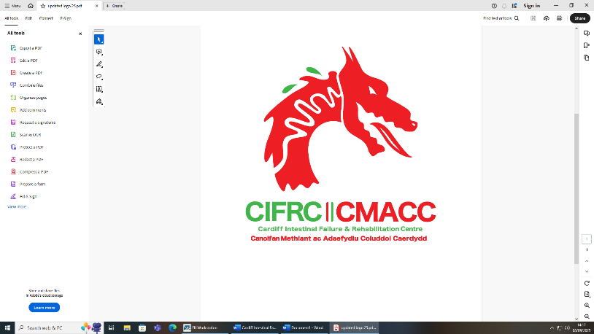

Home Parenteral Support
Information for patients, relatives and carers

What is Home Parenteral Support?
Parenteral Support (PS) can be a liquid nutrition or fluids given through a type of feeding line called a catheter which goes directly into the bloodstream (intravenous/IV). It is possible for patients to have this at home and is referred to as Home Parenteral Support (HPS). You or a family member can be taught how to do this at home.
Why do people need Home Parenteral Support?
We usually obtain all the nourishment we need from eating and drinking. However, this is not possible for some people, and there are many reasons this may occur. The most common causes are the gut, or bowel is too short or doesn’t absorb or function in the usual way and this is known as Intestinal Failure. HPS is the treatment for Intestinal Failure and depending on the underlying condition this may be temporary, or it may be required permanently, although the amount you need may change over time.
How do nutrients get into the bloodstream?
The feed or infusion (PS) is given through a feeding line known as a catheter and goes directly into the bloodstream and therefore bypasses the gut. The line or catheter will be placed in the radiology department before you go home. You will either have a Broviac (tunnelled line) or a PICC line (peripherally inserted central catheter). The team can provide more detailed information on the type of line and procedure, and it is important that you read the information that applies to your line. Sometimes, if only fluids are required you may be able to receive your fluids via a Subcutaneous line which sits just under the skin.
Broviac (tunnelled line)
The feeding line or catheter enters a large vein near the shoulder and then goes down inside the vein until the tip rests near your heart. The other end is brought out through the skin on your chest. From the heart, large blood vessels take the nutrients to all parts of the body.
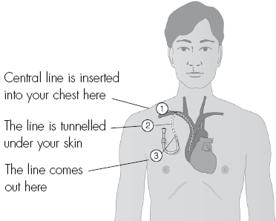

This feeding line is placed under x-ray guidance and if well cared for can last for many years. A strict aseptic non-touch technique (ANTT) must be used at all times whenever handling the line by yourself or others to prevent contamination by germs or organisms which can cause infection.
PICC Line (peripherally inserted central catheter):
This type of line enters a vein in your upper arm and the tip rests near your heart. From the heart, large blood vessels take the nutrients to all parts of the body.
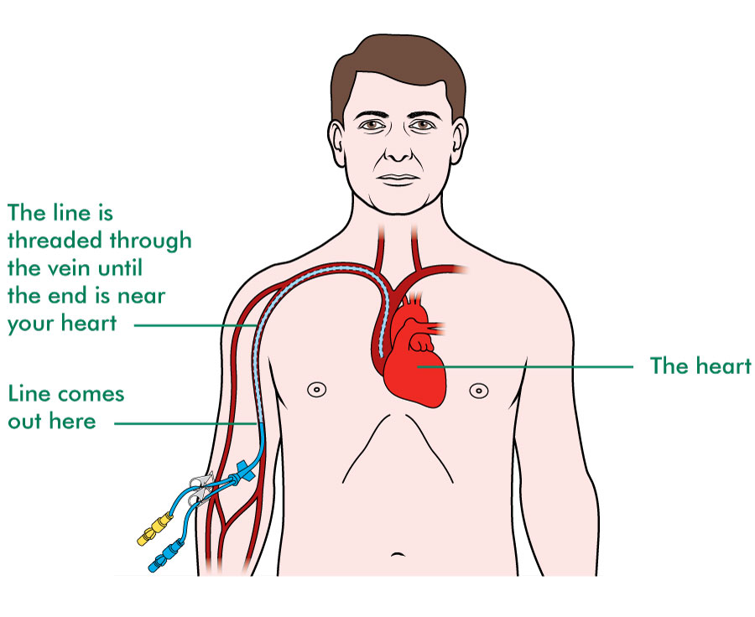
A PICC line can be inserted using X-ray guidance or sometimes at the bedside by a specially trained health care professional. If cared for well, this line can stay in place for 1-2 years. A strict aseptic non-touch technique (ANTT) must be used at all times whenever handling the line by yourself or others to prevent contamination by germs or organisms which can cause infection.

HPS-practicalities
We aim to get you as independent as possible with your HPS. Where possible, the nurses will train you whilst in hospital. If you are unable to do the procedures yourself, a relative may be able to be trained to undertake them for you. This can provide flexibility in when you have your feeds or infusion, and this will be discussed with you. Most patients prefer to have the feed overnight, having the daytime free of any infusions-
You will require an infusion pump, and a portable drip stand which you can hang your feed on and a backpack in which you can carry both your feed and pump. This is useful if you are going to feed during the day and want to go out and about, or if you will be moving a lot when connected, e.g. up and down stairs. You will be trained how to use the infusion pump.
All the equipment needed to administer the feed including gloves, dressing packs and giving sets will be provided for you, as well as a tray or trolley that will be used as a working surface for your procedures. Containers will also be provided to dispose of items safely, such as any sharp items or clinical waste.
The Cardiff IF&R team work closely with three home care companies to provide the treatment when you are at home. Before you go home a nurse from the company will contact you to undertake an assessment and arrange to visit your home prior to discharge. The company will provide all the equipment and feeds when you go home and provide a 24-hour helpline in case you have any problems out of hours. The hospital based Parenteral Support Nurses are available for queries 8-6pm 7 days a week (please see useful telephone number sheet).
There is no reason why you cannot undertake ‘normal’ activities of daily living whilst having HPS. The only restriction to your activity is how you feel generally, and some patients are able to return to work. With careful organisation and planning, it is possible to arrange holidays both at home and abroad. If there is an activity you’d like to be involved in and are unsure of please ask the team.
Storage and administration of feeds
Depending on the type of feed or infusion you need, you may require a fridge in which to store them safely and one will be provided for you. The feeds should be placed evenly on the shelves and the temperature of the fridge checked daily. You will receive a delivery of feeds and equipment every 1-2 weeks. You will also be provided with an additional bag often referred to as a ‘buffer’ bag and some additional fluids. This is in case your usual delivery is delayed due to manufacturing problems or weather conditions, meaning you will always have a spare feed in case of emergency.
The feed should be removed from the fridge 1-2 hours before you need it to let it warm to room temperature. The expiry date should be checked and the bag visually inspected for any sedimentation or ice. The feed should be covered to protect it from light once it has been removed from the fridge.
What are the complications of HPS?
There are some side-effects or complications that can occur as a result of the feed, feeding line or your underlying condition and these will be discussed with you. The Broviac (tunnelled) line can remain in place for several years without complications if well cared for. You will be trained how to do this, or it could be done for you by a relative or nurse.
Complications that can occur including why they happen and how they can be prevented are discussed in the next section. It is important that you contact the Nutrition Support Team as soon as possible if they occur.
Line occlusion or blockage
A blockage or occlusion of the line usually occurs as a result of build-up of residue in a line and can be caused by inadequate flushing of the line or something else. To help prevent blockages, the line is flushed with saline after each infusion and with alcohol once a week. If you notice some resistance or a sudden blockage or ballooning when flushing your line, you must not use force or try to unblock the line yourself as this may cause the line to rupture. It may be possible to unblock the line with specialist treatment and you should contact the team without delay.
Line break or tear
A break, tear or hole usually happens through wear and tear causing weakness in the line. To prevent wear on any part of the line that may weaken it and cause it to split, the clamp should be regularly moved along the thicker section of the line. You may notice a hole in your line or feed may leak from the line. It is important that you secure the line to minimize the risk of infection. You should apply a blue clamp between the break/tear and the exit site of the line on your chest and cover the end of the line and around the break/tear. It is often possible to repair the line and if this is not possible the line will need to be replaced, and you should contact the team without delay.
Line Infection
There are several types of line infection, and you should contact the team if you experience any symptoms.
Tunnel or exit site infection
This may start as an irritation or redness of the skin at the exit site of the line, with leakage of serous fluid or pus. If not treated immediately, the infection may travel under the skin and become very red, swollen and painful. The line often has to be removed, and you may need a potential treatment and hospital admission period of 10-14 days.
Line and bloodstream infection
This is the result of micro-organisms getting into your line. Micro-organisms can be found in the environment and water as well as on the skin. Sometimes if not careful these micro-organisms can find a way into your line and cause infection. Whilst developing an infection may be a result of poor line care and procedures, there are other factors that could contribute to it such as an infection elsewhere in your body that has gone into your line.
To minimise the risk of infection whilst you are caring for your line, we ask you follow this advice: turn off fans, close windows and ensure nobody is doing anything around you that could potentially blow or lift up dust containing micro-organisms, such as hoovering or making a bed. Keep pets out of the room and ensure hands are thoroughly dry to prevent water particles dripping onto your sterile field.
If you have a temperature, experience shivering when feeding (rigors) or have redness or leakage (exudate) from your exit site, you potentially have a line infection. You will need to be admitted to hospital for treatment with intravenous antibiotics, and depending on the micro-organism and your clinical condition the line may need to be removed or salvaged. It is likely that you will be an inpatient for 10-18 days depending on which treatment is appropriate. It is essential that you contact the NST as soon as possible at the first possible signs of infection (see page 12 for contact details).
If you are admitted with a line infection, a nutrition nurse will re-assess your procedures or those of your relative if not independent.

PS Procedures
It is vital to undertake your procedures as taught by your Nutrition Nurse to stay infection free. You should have a refresher session every 6-12 months.
Training videos are available @
https://www.youtube.com/watch?v=yPttxdTnQUU (Connecting your TPN)
Or
https://youtu.be/8nWE56mvUIM (Disconnecting your TPN from your Broviac Line)

Alternatively, you can scan the QR codes below -



Key Infection Control and Prevention Measures
Handwashing
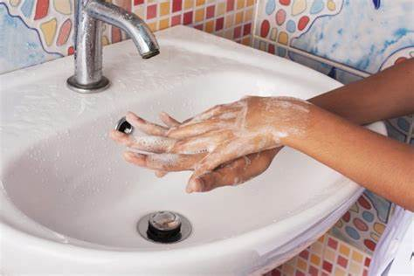

Correct use of Clinell wipes and alcohol gel (see patient videos/training sheets) 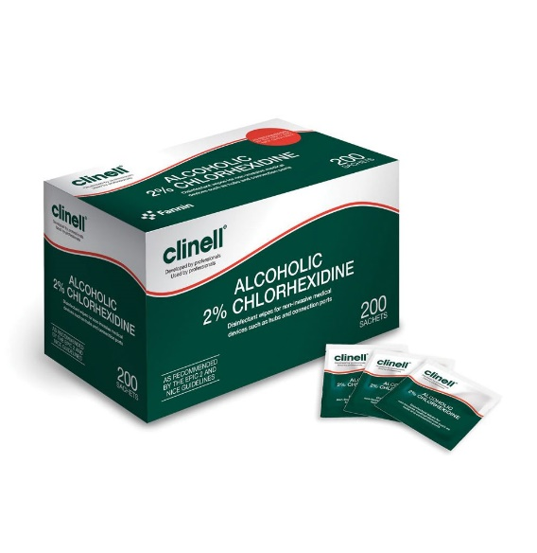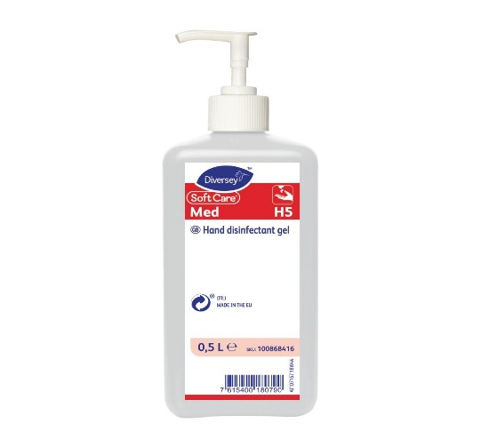

Correct flushing with saline and alcohol
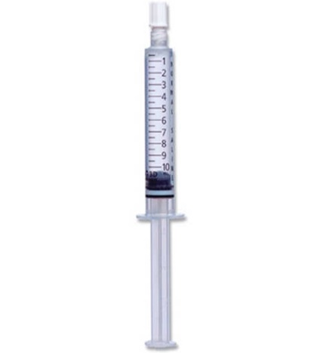

Needle Free Device Curos Port/Swabcap
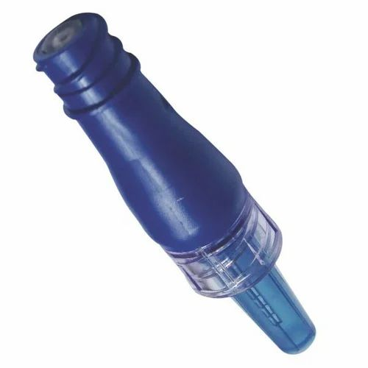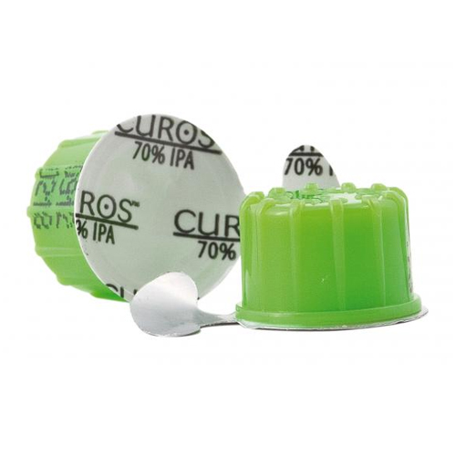

Chloraprep (or chlorhexidine if allergic) 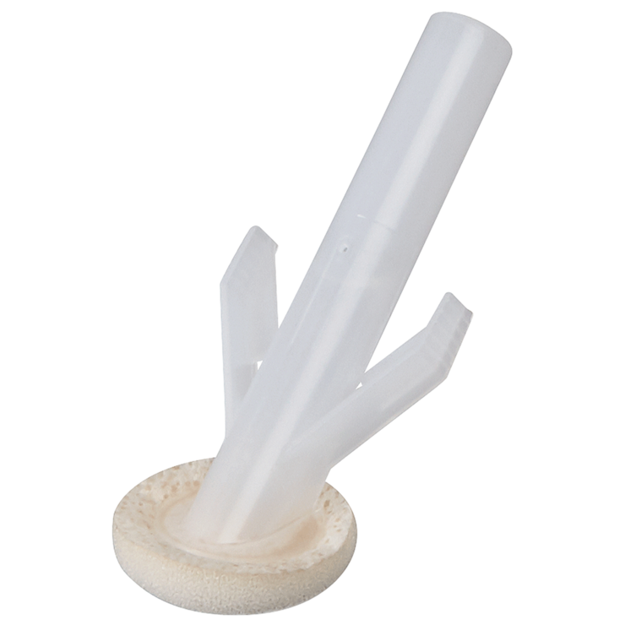
Dressings
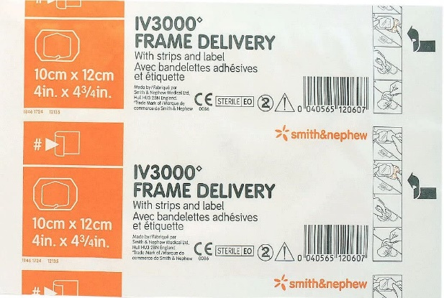

Biochemical complications
Your blood tests or biochemistry will be monitored regularly, and your feeds will be adjusted as necessary depending on the results, your clinical condition and fluid balance. The frequency will be less frequent when you are at home. You must inform the NST if you are not receiving all of your prescribed feeds as this may affect your treatment. Swelling of the ankles or legs may mean you are having too much fluid whilst being thirsty and passing little or concentrated urine may indicate that you are dehydrated. If you feel unwell or dizzy after your feed, this could be a result of it being infused too quickly or stopped too abruptly. It is important that you report any side-effects you experience related to your infusions to the team.
The feeds sometimes are unable to provide all the nutrients you need, and you may require additional infusions such as iron or injections of vitamin D and B12. You may also be prescribed oral vitamin and mineral supplements.
Long term HPS may mean you are at higher risk of osteoporosis or brittle bones. A bone scan (Dexa) will be done every 2-3 years to monitor this. Treatment may include oral supplementation or intravenous therapy.
Having long term HPS can sometimes also affect the liver, especially if you have an underlying pre-existing liver condition, short bowel and/or high calorie requirements within your feed. This is why we routinely monitor your liver blood tests every time you see us in clinic. If there are any concerns, we may ask for additional scans to be done.
Monitoring your condition
After discharge home you will be seen in the specialist clinic (suite 5) after 4-6 weeks to check on your progress, and thereafter you will be seen 3- 6 monthly if stable and more often if needed. Bloods will be taken from your line by a specialist nurse, and you will be seen by several of the team members and sometimes students. If you are experiencing problems and want to bring the appointment forward, you can contact the team to arrange. When attending the clinic, you should bring a list of current medication, and a note of any questions you want to ask.
Additional Information and Support
Electricity
You should contact your electricity provider and register as an emergency or priority user. This means in the event of a power cut you will be given priority for emergency power supply. In the event of power loss, phone National Grid on 0800 032 8301. Check the temperature of the fridge and keep it closed-the feeds will remain stable for up to 6 hours. If the power is off for more than 6 hours, contact the Homecare company and the NST. Do not use the feeds, new ones will be supplied.
Water
Register for emergency water in case of flooding or loss of water supply. Call Welsh Water on 0800 0520130 who will advise you what to do in case of an emergency. Bottled water may be required for handwashing.
Waste Removal
You will be provided with a “sharps” bin. This is used to dispose of clinical waste such as the empty feed bags and needles and syringes. This will be collected by the Homecare Company. All other waste such as gauze and wipes can be put in your local authority waste-contact them if you have any concerns.
Financial Support
You may be entitled to additional benefits depending on your circumstances. Contact the Dept for Work and Pensions or Citizen’s Advice Bureau or PINNT.
PINNT (www.PINNT.com)
Patients on Intravenous and Nasogastric Nutrition Therapy (PINNT) is a free to join support group for people receiving artificial nutrition and provides information and support to members through newsletters and local and national meetings.
Travel Information
The Homecare Companies and the Cardiff IF&R team are able to support you to go on holiday both abroad and in the UK with some planning. You will need a fit to fly and equipment letter and changes to your prescription may be necessary and this should be discussed with the team and your homecare company before booking your holiday.
Advice for HPN Patients Regarding Swimming
Swimming increases the risk of both line infection and damage. The manufacturers state that the line should not be submerged in water and therefore we cannot recommend swimming. However, we appreciate that this may prove restrictive for you and would advise that if you choose to swim that you follow these guidelines.

- Wait for a minimum of 3 weeks after insertion of a new line
- Swim in chlorinated pools or clean sea waters
- Do not swim if you have an exit site infection
- Do not swim in obviously dirty or muddy water or polluted beaches
- Do not use hot tubs

Care of the line while swimming
To reduce the risk of infection and potential damage to the line we suggest that you cover the line with a large waterproof dressing. The dressing has to be large enough to completely cover the line and hub as shown below. Suitable dressings can be obtained from Boots® or any large chemist.

- Coil the line over the exit site dressing.
- Cover the coiled line with a waterproof dressing

Protecting the line with a waterproof dressing during swimming

Aftercare
After you have swam, we would recommend that you change your dressing and clean the exit site. Overuse of chloroprep during dressing changes can cause skin irritation which can develop into an exit or tunnel infection. If changing the dressing more frequently than once a week then saline should be used. After swimming, the next time you access your line you should apply a new needle free device in case water entered the curos port/swab cap. If you plan to swim or do any water related sports on a regular basis, we would recommend you purchasing a dry suit which will prevent any water coming into contact with the line or surrounding skin. A short- sleeved version can be obtained from Hammonds Dry Suits www.hammond.drysuits.co.uk. Please avoid using hot tubs as the heat, chemicals and water may increase the risk of infection.
Cardiff Intestinal Failure and Rehabilitation Team
University Hospital of Wales

Consultant Dr Kate Edwards
Dr Sarmad Tayyab

Secretary Linda Bradley 029 21845112
(do not call if of clinical concern)

Dietitians Amelia Jukes 029 21846393 (answer machine)
Steven Evans

Nutrition Pharmacists Alex Speakman
Sean Dodington
Su Harwood 029 21848109 (Tues/Fri)

Nutrition Nurses Sarah Arnold 029 21846393 (answer machine)
Sara Marini
Katherine Gallagher
Alexandra Thomas
Samantha Hughes
Rency Bino

Clinical Psychologist Dr Nicola Taylor 029 21846393

Ward A7 Reception 029 21843296/029 21843289
North 029 21843844
South 029 21843845

Stoma Care Deb Keoghane 029 21843350 (answer machine)

Home care company 24 hr helpline for issues regarding your pump, fridge or feed deliveries.

Calea 24 hr helpline 0800 121 8300

Lloyds – 0800 035 5678

B-Braun – 0800 840 5503

How to Contact us
Calls may be made to any of the above phone numbers. However, if you are unable to obtain an answer or want to leave a message, please phone the main office number 02921846393 and your call will be returned as soon as possible. The answer machine is checked regularly within the hours 0800 – 1700 hr, Monday to Friday and less regularly at the weekend.

If you are unwell within core working hours (Mon-Fri 8am-5pm)
Phone and discuss with a member of the NST at the earliest opportunity. We may arrange to bring forward a clinic appointment, review you on the ward, or for you to attend Medical or Surgical Assessment Unit.

UHW Nutrition Nurse Support (Mon-Sunday 8am-5pm)
Nutrition nurse support is available 7-days a week, with an on-call service on Bank holidays. If you are unwell or have any urgent concerns please phone the main number 029 21846393 and leave a message. The answerphone messages are checked regularly within the hours 0800 – 1700 hrs (Monday to Friday) or 0800- 1300 hrs (Saturday/ Sunday). Calls after these times may not be routinely picked up until the next day. If urgent (or a Bank holiday), please follow up an answerphone message with a call to Ward A7. The weekend service is currently only supported by the specialist nurses and routine queries may be followed up in core working hours and calls may take longer to be returned.

If you are unwell outside of these hours:
If it cannot wait until the next working day, you should call the out of hours GP for advice or attend the hospital emergency department. Ideally, if transport is available, patients on HPS should be referred to or present to the emergency department at UHW, Cardiff. If you are admitted to your local hospital for whatever reason, you should notify the Cardiff team as soon as possible. If the admission is related to your HPN such as infection or biochemistry, ensure the medical team contact the Cardiff team as soon as possible and we will arrange transfer to UHW.

If you are to be admitted for planned treatment:
Please let the team know if you have any planned treatment, especially if it requires a hospital admission. If you require additional support following surgery for example, this can be arranged in advance.

Patient Feedback
We are always looking for ways to improve patient experience and the service we provide. Please could you complete the attached feedback form before discharge and hand to your TPN Nurse.
Patient Feedback Form
1.Have you found this information helpful? If so, how?

2.Is there anything you think is missing from the information provided?

3. Do you have any ideas that would help improve the service of the Nutrition Support Team in Cardiff?

4.If you/carer have received training for administering feeds whilst in hospital, how have you found this process?

5. Could we have done anything differently that would have improved the training process?

