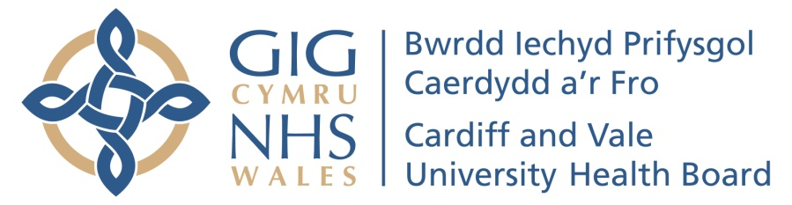

2 MINUTES OF YOUR TIME – MATERNITY CARE SURVEY

To help us understand how well we care for you, and to help us improve, we would be grateful if you could complete this short survey. Taking part is voluntary, and your answers will be treated in confidence.
If you would like a response to any concerns, please provide your contact details on the other side of this sheet
Hospital………………………………………… Ward………………………………………………. Date……………………

For each of the statements below, please place a cross (X) in the appropriate column | Never | Sometimes | Usually | Always | N/A
Do you feel that people were polite to you?
Do you feel that you were listened to?
Were you given all of the information you needed?
Were you given enough privacy?

Were you given support with communication needs?

Were you able to speak Welsh to staff if you needed to?
Did you see the staff clean their hands before they cared for you?
Did you feel that everything you needed for your care was available to you?
If you asked for assistance,
- Did you get it?
- Did you get it when you needed it?
Were you involved as much as you wanted to be in decisions about your care?
Were things explained to you in a way that you could understand?
Did you feel you understood what was happening in your care?
How clean was the environment?  (Please circle or delete as appropriate) | Not clean at all | Not very clean | Fairly clean | Very clean | Not applicable
Please score your answer according to the scale | Strongly Disagree | Disagree | Neither | Agree | Strongly Agree
Our aim is to prepare you and your partner to begin parenting feeling confident and well supported to care for your baby. Did we manage to do this? | 1 | 2 | 3 | 4 | 5
It is important to us that you are treated with kindness and respect. Did we manage to do this? | 1 | 2 | 3 | 4 | 5
Was there anything particularly good about your experience that you would like to tell us about?

Was there anything that we could change to improve your experience?

- I would like to be contacted about the care I received during my hospital stay.

I would prefer to be contacted by
- Home telephone…………………………………………….
- Mobile …………………………………………………………..
- Email……………………………………………………………..
- Other…………………………………………………………….

- I would be happy to be contacted about taking part in a future survey about the maternity services I received.
NAME
ADDRESS

DATA PROTECTION STATEMENT
Your personal details and any information about your care or the care of your baby will not be used without your permission. By filling out this survey, your data protection rights are not affected. We will only use the information in this survey anonymously. Unless you request it, your name will not be shared with the staff who have provided your care

Please return this survey either by email to Suzanne Hardacre, Head of Midwifery at Suzanne.Hardacre@wales.nhs.uk, or by post to Patient Feedback Survey, Directorate Offices, Women’s Unit, University Hospital of Wales, Heath Park, Cardiff Cf14 4XW.


Lots of families tell us they would like to give something back to the maternity unit.
If this is something you would like to do, Cardiff & Vale Health Charity (RCN 1056544) holds a specific fund (number 9114) for our department. There are several ways to donate, you can either:
- Text ‘BABY12 £5’ or ‘BABY12 £10’ to 70070
- Phone 029 2174 1802 to pay by card to Cardiff and Vale Health Charity Number 9114
- Post a cheque made payable to ‘Cardiff & Vale Health Charity’ (including reference
number 9114)
Whilst there is no obligation to donate, we are very grateful for any donations received, all donations go back into improving the environment of care for women using our services. Examples of which can be found on our Maternity Services Facebook Page or ask your midwife about how your generosity has made a difference to mums and babies in Cardiff and Vale.

