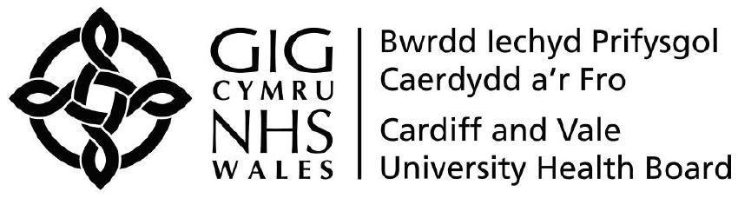 | Reference Number: UHB (if a brand-new procedure, the Corporate Governance Team will fill this bit in)  Version Number:  Next Review Date: ??  Previous Trust/LHB Reference  Number: (If there is one)
Title of Procedure

Introduction and Aim

It is the procedure of Cardiff and Vale UHB to…

Objectives

The Objectives of the procedure are to: -

Scope

This procedure applies to all of our staff in all locations including those with Honorary Contracts.

Equality Impact Assessment | An Equality and Health Impact Assessment (EHIA) has been completed and this found there to be no impact/impact on....  or  An Equality Impact Assessment has not been completed. This is because...
Documents to read alongside this Procedure | Any relevant policies listed here.  They will be hyperlinked if appropriate
Approved by | Committee or Board or Executive
Accountable Executive or Clinical Board Director

Author(s)

Disclaimer
If the review date of this document has passed please ensure that the version you are using is the most up to date either by contacting the document author or the Governance Directorate.

Summary of reviews/amendments
Version Number | Date of Review Approved | Date Published | Summary of Amendments
1 |  |  | Content previously included within Management of Policies, Procedures and Other Written Control Documents Policy. It has been updated to include any changes in arrangements and the new style of written control documents.

CONTENTS

1. INTRODUCTION
2. PROCEDURE STATEMENT
3. SCOPE
4. TRAINING
5. IMPLEMENTATION
6. RESPONSIBILITIES
7.REVIEW
8.REFERENCES

APPENDIX A
APPENDIX B
APPENDIX C

