ADULT INTRAOSSEOUS CANNULATION PROTOCOL USING THE EZ-IO DEVICE FOR EMERGENCY INTRAVASCULAR ACCESS.

Reference No: | Issued by Policy Manager | Version No: | 3 | Previous Trust / LHB Ref No:

Classification of document: Corporate

Area for Circulation: UHB Wide

Author/Reviewee: Resuscitation Service

Executive Lead: Aled Roberts,
Chair UHB RADAR
Recognition of Acute Deterioration and Resuscitation.

Group Consulted Via/ Group: RADAR

Approved by: RADAR

Date of Approval: June 2021

Date of Review: June 2024

Date Published: Date becomes live

Disclaimer
When using this document please ensure that the version you are using is the most up to date either by checking on the UHB database for any new versions. If the review date has passed please contact the author.

OUT OF DATE POLICY DOCUMENTS MUST NOT BE RELIED ON

Contents

Section |  | Page
1 | Introduction | 3
2 | Purpose | 3
3 | Scope | 3
4 | Definitions | 4
5 | Roles and Responsibilities | 4
6 | Protocol | 5
6.1 | Principals for Practice | 5
6.2 | Indications | 6
6.3 | Contra Indications | 6
6.4 | Complications | 6
6.5 | Equipment | 6-7
6.6 | Insertion Procedure | 8-11
6.7 | Ongoing Use | 11
6.8 | Removal Procedure | 11
7 | Training Implications | 12
8 | Monitoring Arrangements | 13
9 | Links to Other UHB Policies | 13
10 | Associated Documentation | 13
11 | References | 14
Appendices
1 | Insertion Sites | 15
2 | Local Anaesthesia | 16
3 | Intraosseous Care Pathway | 17
4 | Intraosseous Cannulation Assessment | 18

ADULT INTRAOSSEOUS CANNULATION PROTOCOL USING THE EZ-IO DEVICE FOR EMERGENCY INTRAVSACULAR ACCESS

1. Introduction

1.1 This protocol describes a standardised approach to emergency intraosseous (IO) cannulation for in-patients across Cardiff and Vale University Health Board. It will harmonise the education and clinical delivery of IO access. IO access has been included in Resuscitation Council UK (2021) adult Advanced Life Support (ALS) guidelines for cases in which intravenous access is difficult or unavailable.

Intraosseous cannulation is the insertion of a needle into a bone to allow the delivery of intravenous (medication) therapy in emergency situations. If intravenous access has failed, is inadequate, unlikely to be achieved or would significantly delay time critical treatment. In the peri-arrest situation the intraosseous route should also be considered. The Resuscitation Council (UK) Guidelines 2015 recommend the intraosseous route if no other access has been established in the first two minutes of cardiac arrest.

This protocol was developed from procedure and protocol guidance provided by Teleflex, the manufacturers of EZ-IO, combined with input from the Resuscitation Service, Cardiff and Vale University Health Board.

2. Purpose

2.1 To ensure that the UHB maintains standards for insertion of EZ-IO access which includes maintenance and removal.

2.3 To ensure that the Practitioner is able to competently undertake the insertion of EZIO in order to meet patient needs. The practitioner must relate theory to practice using knowledge and skill.

3. Scope

3.1 This protocol applies to all clinical staff who insert EZ-IO devices and/or who care for and maintain intraosseous cannulas for adult patients in Cardiff and Vale University Health Board. The procedure includes the responsibilities of staff involved in EZ-IO insertion, on-going care and maintenance of intraosseous cannulas and the standards that should be adopted for each step in the process.

4. Definitions

4.1 Intravenous (IV) – situated within, occurring within, or administered by entering a vein.

4.2 Intraosseous (IO) – situated within, occurring within, or administered by entering a bone.

4.3 A Practitioner – One who is legally accountable or responsible for their practice. E.g. Healthcare professionals including Doctors, Nurses, Operating Department Practitioners, Radiographers, Midwives.

5. Roles and responsibilities

5.1 The Chief Executive with support from the Resuscitation Service will ensure that this intraosseous protocol is in place, that staff are aware of its existence, and is accessible to those who need it, and that this protocol is subject to appropriate audit and monitoring arrangements.

5.1.1 The RADAR Committee maintain the overall responsibility for governance concerning the EZ-IO device.

5.2 The Clinical Board Management Teams will ensure that the Clinical Board, for which they are responsible, complies with this protocol.

5.3 Managers will:

5.3.1 ensure that all staff who insert EZ-IO needles receives training and complete competence assessment in intraosseous cannulation (insertion).

5.3.2 maintain a record of all staff who have received training.

5.3.3 ensure that any staff who administer intraosseous therapy have adequate cover for hepatitis B. If staff do not have cover, they must be referred to Occupational Health.

5.3.4 ensure that the required notices that comply with UHB Sharps Injury Procedure are displayed in their areas to inform employees on procedures to be followed after accidental/incident involving exposure to body fluids.

5.4 Individual staff who undertake intraosseous insertion, use intraosseous cannula or remove intraosseous cannula must:

5.4.1 understand the UHB protocol on EZ-IO Insertion. All staff have a responsibility for ensuring that the principles outlined within this document are universally applied.

5.4.2 receive training before practicing and attend refresher training as required.

5.4.3 take responsibility for arranging further practise to maintain and increase competency within the work place.

5.4.4 practice in accordance with their own professional duties.

5.4.5 practice universal precautions.

5.4.3 practice an aseptic non-touch technique.

5.4.4 follow the UHB sharps injury procedure.

    - delegate to a more experienced practitioner if they are not competent to insert, use or remove intraosseous cannula.

6. Protocol

6.1 Principles for practice
Medications or Fluids via the Intraosseous route should only be administered by Healthcare Professional who have successfully achieved competence in administration of Intravenous products.

6.1.1 All staff that undertake intraosseous cannulation must:

• Have knowledge of local policies and procedures, specifically; Universal
Precautions, Health and Safety issues and Infection Control issues.

• Understand their legal and professional responsibilities.

• Have knowledge of the anatomy and physiology of the various intraosseous cannulation sites.

• If unsure of their competency in the procedure, hand over the responsibility to a more expert practitioner. The Practitioner must ensure that the person delegated to perform the task is competent to do so.

• Only attempt intraosseous insertion twice and if unsuccessful ask for a more experienced practitioner to make further attempts.

.

6.2 Indications

6.2.1 EZ-IO devices should be considered where there is no or inadequate IV access and an immediate need for fluids and/or medication to treat or prevent cardiac arrest, peri-arrest or emergency situations.

6.2.2 Other situations where there is no or inadequate IV access and IV access is difficult or has failed and there is an immediate or urgent need for fluids and/or medication.

6.3 Contra indications

6.3.1 The following are contra indications:

• If a patient with capacity refuses consent.
• If the practitioner is put at risk (e.g. lack of patient compliance).
• Existing proximal fracture of the tibia, femur or humeral head.
• Previous orthopaedic surgery near the insertion site (caution titanium pates)
• Previous IO insertion or failed access within 48 hours in the target bone.
• Local Infection at the insertion site.
• Inability to identify or locate taught anatomical landmarks on the patient.
• The stylet and catheter are made from tungsten steel and are therefore not MRI compatible so must not go into an MRI scanner

6.4 Complications

6.4.1 The following are potential complications and the patient should be observed for:

• Extravasation
• Compartment syndrome
• Fracture of the target bone
• Infection
• Pain on insertion
• Skin necrosis
• Embolism

6.5 Equipment required

6.5.1 An EZ-IO power driver and suitably sized EZ-IO needle based on patient size and weight. NB the weight range on EZ-IO needle sets is a guide only and not an absolute indication that the needle is appropriate for a particular weight. The most important check of correct needle length is that once the needle is inserted through skin and soft tissue and makes contact with the target bone, there must be at least one black mark on the needle still visible.

6.5.2 Needles are:

• Pink, 15mm, 3-39kg (typically used in infants and very small children)
• Blue, 25mm, 40kg or over (typically used in children and adults)
• Yellow, 45mm, 40kg or over (main needle of choice in all adults and for humeral insertion)

The recommendations for EZ IO are the use of 45mm needle for proximal humerus insertions.

5 mm mark or

“black line”
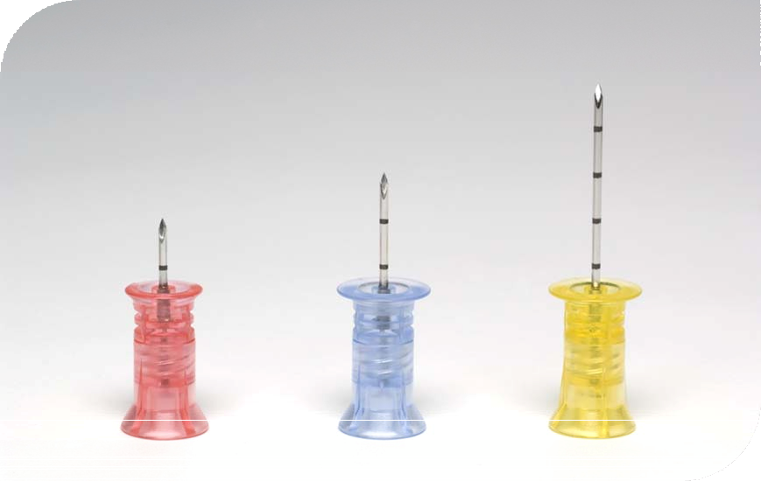

15 mm/15g 25 mm/15g 45 mm/15g

6.5.3 Equipment required:

• EZ-Connect (extension set with needle free connector)
• Pre filled syringe 0.9% saline flush
• Two empty 10ml syringe (if attempting sample collection)
• Consider preservative free 2% Lidocaine for patients responding to pain
• Non-sterile non-latex gloves
• 2% chlorhexidine in 70% Isoprolol wipe. Eg. Clinelle skin wipe
• (optional)
• EZ IO stabiliser dressing
• Cannulation tray
• Sharps bin or the “needle vice” from the EZ-IO needle set packet

6.6 EZ-IO Procedure (Preparation)
• Wear personal protective equipment
• Obtain suitable assistance as required

6.6.1 Make a positive identification of patient and check name, address, date of birth and identification number.
6.6.2 Ascertain the need for IO cannulation and if possible obtain consent as per the UHB consent policy
- Choose appropriate sterile needle set (appendix C) and assemble equipment including appropriate receptacle for sharps
- Draw up 10mls normal saline 0.9% solution into syringe
- Connect syringe to the EZ-Connect lumen and prime with normal saline solution (NACL 0.9%) - leave syringe attached to EZ-Connect
EZ-IO Procedure (Assessment)
- Locate target site on selected limb and assess viability for needle insertion
- EZ-IO 25mm needle: (commonly for 40 kg and over)
  - Proximal Tibia – Insertion site is approximately 2 cm below the patella and approximately 2 cm (depending on patient anatomy) medial to the tibial tuberosity
  - Distal Tibia - Insertion site is located approximately 3 cm proximal to the most prominent aspect of the medial malleolus. Place one finger directly over the medial malleolus; move approximately 2 cm (depending on patient anatomy) proximal and palpate the anterior and posterior borders of the tibia to assure that your insertion site is on the flat centre aspect of the bone
  - Proximal Humerus – Insertion site is located directly on the most prominent aspect of the greater tubercle. Slide thumb up the anterior shaft of the humerus until you feel the greater tubercle, this is the surgical neck. Approximately 1 cm (depending on patient anatomy) above the surgical neck is the insertion site. Ensure that the patient’s hand is resting on the abdomen and that the elbow is adducted (close to the body). Alternatively, if the patient is in cardiac arrest and chest compressions are ongoing to place patient’s hand, palm facing down under the buttocks.
  - Note that EZ-IO 45mm needle (yellow) is recommended for the proximal humerus in patients with excessive tissue over the insertion site or when a black line is not visible after penetration into the tissue
- EZ-IO 15mm needle (pink): (commonly for 3-39 kg, consider tissue density over the landmark desired)
  - Proximal Tibia -The insertion site is located approximately 2cm medial to the tibial tuberosity along the flat aspect of the tibia. Carefully feel for the “give” or “pop” indicating penetration into the medullary space.
  - Distal Tibia - Place one finger directly over the medial malleolus; move approximately 2 cm (depending on patient anatomy) proximal and palpate the anterior and posterior borders of the tibia to assure that your insertion site is on the flat centre aspect of the bone

  - Proximal Humerus - The insertion is located directly on the most prominent aspect of the greater tubercle. Slide thumb up the anterior shaft of the humerus until you feel the greater tubercle, this is the surgical neck. Approximately 1 cm (depending on patient anatomy) above the surgical neck is the insertion site. Ensure that the patient’s hand is resting on the abdomen and that the elbow is adducted and positioned at the level of the spine. The proximal humerus may be difficult or impossible to palpate in children less than 5 years of age as the greater tubercle has not yet developed. In these cases the insertion will most likely be a shaft insertion

EZ-IO Procedure (Insertion)
- Cleanse site using cleaning agent currently being used for IV cannulation
- Stabilise the limb of the selected target site
- Insert EZ-IO needle into the selected site. IMPORTANT: Keep hand and fingers away from Needle set
- Position the driver at the insertion site with the needle set at a 90-degree angle to the bone surface. Gently pierce the skin with the Needle Set until the needle set tip touches the bone
- Check to ensure that at least one black line is visible and the needle is touching the bone. If no black line is visible, patient may have excessive soft tissue over selected insertion site and needle set may not reach the medullary space. Consider an alternative site for insertion or a longer needle
- Penetrate the bone cortex by squeezing driver’s trigger and applying gentle, consistent, steady, downward pressure (allow the driver to do the work)
- Release the driver’s trigger and stop the insertion process when:
1. On adult patients you will stop by releasing the trigger when the hub is almost flush with the skin or when you feel a decrease in resistance.
2. On paediatric patients when you feel a decrease in resistance, indicating the needle has entered the medullary space - release the trigger
- Remove EZ-IO Power Driver from Needle Set while stabilizing the catheter hub

- Remove stylet from catheter by turning counter-clockwise and immediately dispose of stylet in an appropriate sharps container

- Attach EZIO dressing supplied in packaging

- Connect primed EZ-Connect to exposed Luer-lock hub on EZ-IO needle

- Confirm placement by aspirating bone marrow into EZ-Connect

- Syringe bolus: flush the catheter with remaining NACL 0.9%

- Assess for post-insertion complications

- Disconnect 10 ml syringe from EZ-Connect extension set and provide therapy

- Attach pink band after completing the date, time and signature of insertion next to patient’s identification band.

- Any failed attempts to EZIO insertion will also require a pink ID band being placed on patient, stating date, time and signature of failed attempt.

EZIO Pain Management

When inserting EZIO needle into a conscious patient pain management it is recommended to ensure the patient experiences as little pain as possible during the procedure.
Adult

- Observe recommended cautions/contraindications to using 2% preservative and adrenaline free lidocaine (IV lidocaine)
- Confirm lidocaine dose as per UHB medicines administration policy
- Prime extension set with lidocaine. Note that the priming volume of the EZ-connect is approximately 1.0ml
- Slowly infuse lidocaine 40mg IO over 120 seconds
- Allow lidocaine to dwell in IO space for 60 seconds
- Flush with 5 to 10mls of Normal Saline 0.9%
- Slowly administer an additional 20mg of lidocaine IO over 60 seconds
- Repeat PRN
- Consider systemic pain control for patients not responding to lidocaine
- The use of any lidocaine or other medication is the responsibility of the treating physician and qualified prescriber working within their scope of practice within the UHB

Paediatric

- Observe recommended cautions/contraindications to using 2% preservative and adrenaline free lidocaine (IV lidocaine)
- Confirm lidocaine dose as per UHB medicines administration policy. Usually initial dose is 0.5 mg/kg not to exceed 40mg
- Prime extension set with lidocaine. Note that the priming volume of the EZ-connect is approximately 1.0ml. For smaller doses of lidocaine, consider administering by carefully attaching syringe directly to catheter hub (prime extension set with Normal Saline 0.9%)
- Slowly infuse lidocaine over 120 seconds.
- Allow lidocaine to dwell in IO space for 60 seconds
- Flush with 2 to 5mls on Normal Saline 0.9%
- Slowly administer subsequent lidocaine (half the initial dose) IO over 60 seconds.
- Repeat PRN
- Consider systemic pain control for patients not responding to lidocaine.
- The use of any lidocaine or other medication is the responsibility of the treating physician and qualified prescriber working within their scope of practice within the UHB

  - EZ-IO Procedure (Aftercare)
- Begin infusion utilising a pressure delivery system as required

- Secure the needle using an appropriate dressing

- Continue to monitor extremity for complications on a regular basis, especially pre and post infusion

- Apply pink EZ-IO wristband next to current patient ID wristband

- Document time, date, rationale and any supporting information for EZ-IO insertion in medical notes

- Ensure multi-disciplinary staff are fully informed of the procedure

  - EZIO Procedure (Removal)
- Remove the extension set from the needle hub

- Attach a 10 ml sterile syringe (with standard Luer-lock) to act as a handle and to cap the open IO port

- Grasp syringe and continuously rotate clockwise while gently pulling the catheter out (maintain a 90-degree angle to the bone). DO NOT ROCK OR BEND DURING REMOVAL

- Dispose of IO needle into an appropriate receptacle for sharps

- Apply pressure to site as needed; apply adhesive dressing as indicated

- The catheter should not remain in place for greater than 72 hours

- Document time and date of removal in medical and nursing notes

- Pink EZIO band must remain on patient for 48hours post-removal to avoid another IO needle being inserted in the same site

7. Training implications

7.1 Intraosseous cannulation, use and removal require training prior to practice.

7.2 Teleflex in conjunction with the Resuscitation Service will provide training on the insertion, use and removal of intraosseous cannula.

7.3 Training will be targeted at registered healthcare staff that may need to use intraosseous cannula in their clinical duties.

7.4 Non medical staff that have been trained in intraosseous cannulation outside of UHB should be assessed locally either by an appropriately experienced practitioner or by the Resuscitation Service (see appendix 4 for assessment form) and this will be recorded.

7.5 Refresher training is not mandatory but practitioners must be satisfied that they are meeting their professional requirements and seek training if there is any doubt about their competency. The Resuscitation Service recommends annual refresher training.

7.6 Use of intraosseous cannula is similar to use of an intravenous cannula and staff that use intraosseous cannula must also undertake an intravenous course.

7.7 Key points for staff
When the trigger is pressed, the LED will show either:
SOLID GREEN = IO injector has sufficient battery power
FLASHING RED = IO injector has less than 10% battery power
REPLACE IO INJECTOR
Whenever possible carry a backup device
Life expectancy and approx. number of insertions will depend on multiple factors – actual usage, bone density, insertion time, storage conditions and frequency of driver testing
Ensure resuscitation equipment checklist includes how to check the device and where to record that the indicator light shows the battery is working i.e Green LED

8. Monitoring Arrangements

Measurable Policy Objective | Monitoring / Audit Method | Frequency | Responsibility for performing monitoring | Where is monitoring reported and which groups / Groups will be responsible for progressing and reviewing action plans
Duration of insertion must be under 72 hours | IO Care Pathway inserted into patients notes | Each insertion

9. Links to other UHB policies

All Resuscitation Service and UHB policies are available on CAVweb.

10. Associated Documentation

See appendix 3 for IO Care Pathway

11. References:-
Davidoff J, Fowler R, Gordon D, et al. (2005) Clinical evaluation of a novel intraosseous device for adults: prospective, 250-patient, multi-centre trial. JEMS; 30(10):s20-
23.

DOH (2007), Saving Lives: High Impact Intervention 2 (NB whilst this document is aimed at IV access the principals apply to IO)

Fowler R, Gallagher JV, Isaacs SM, et al. (2007) The role of intraosseous vascular access in the out-of-hospital environment (resource document to NAEMSP position statement). Prehospital Emergency Care; 11(1):63-6.

Fowler RL, Pierce A, Nazeer S et al. 1,128 case series: Powered intraosseous insertion provides safe and effective vascular access for emergency patients. Manuscript in preparation for submission to Annals of Emergency Medicine

Frascone RJ, Jensen JP, Kaye K, Salzman JG. (2007) Consecutive field trials using two different intraosseous devices. Prehospital Emergency Care; 11:164-71.

Gillum L, Kovar J. (2005) Powered intraosseous access in the prehospital setting: MCHD EMS puts the EZ-IO to the test. JEMS; 30:s24-6.

Hixson R, Intraosseous Vascular Access and Lidocaine, http://www.pawz.net/index_htm_files/IO%20Lidocaine.pdf, May 2011

Miller L, Kramer GC, Bolleter S. (2005) Rescue access made easy. JEMS; 30(10):s8-18.

NMC 2015, The Code

NPSA guidelines 2007. Administration of injectable medicines.

Ong MEH, Chan YH, Oh JJ, Ngo AS-Y. (2009) An observational, prospective study comparing tibial and humeral intraosseous access using the EZ-IO. American Journal of Emergency Medicine; 27:8-15.

Paxton JH, Knuth TE, Klausner HA. (2008) Humeral head intraosseous insertion: The preferred emergency venous access. Annals of Emergency Medicine; 52(4):S58.

Philbeck TE, Miller LJ, Montez D. Pain Management during Intraosseous Infusion through the Proximal Humerus. Manuscript in preparation for submission to Annals of Emergency Medicine.

Resuscitation Guidelines 2021, Resuscitation Council (UK)

RCN 2010. Standards for Infusion Therapy (NB there is general guidance on IO that is very useful. However, this protocol (TCPnnn) takes precedence and it should be noted that the RCN guidance on insertion sites DOES NOT APPLY TO EZ-IO).

Wayne MA. (2007) Intraosseous vascular access: devices, sites and rationale for IO use.
JEMS; 32:s23-5.
: www.teleflex.com
Appendix 1 - Insertion sites

• Adult Proximal Tibia – Insertion site is approximately 2 cm below the patella and approximately 2 cm (depending on patient anatomy) medial to the tibial tuberosity.
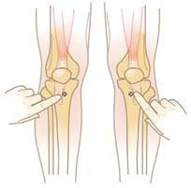

• Adult Distal Tibia - Insertion site is located approximately 3 cm proximal to the most prominent aspect of the medial malleolus. Place one finger directly over the medial malleolus; move approximately 2 cm (depending on patient anatomy) proximal and palpate the anterior and posterior borders of the tibia to assure that your insertion site is on the flat centre aspect of the bone.
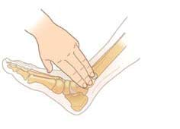

• Adult Proximal Humerus – Insertion site is located directly on the most prominent aspect of the greater tubercle. Ensure that the patient’s hand is resting on the abdomen and that the elbow is adducted (close to the body). Slide thumb up the anterior shaft of the humerus until you feel the greater tubercle, this is the surgical neck. Approximately 1 cm (depending on patient anatomy) above the surgical neck is the insertion site.
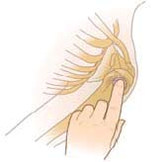

Appendix 2 – Local Anaesthesia

IO is most commonly used in cardiac arrest and peri-arrest and anaesthesia is not normally required. However, in the unusual situation where the IO route is used and the patient is conscious and sensitive to pain, the clinician may consider analgesia after insertion and prior to medication/fluid administration.

IO Infusion Pain Management Using 2% Lidocaine (preservative-free and epinephrine-free) Review lidocaine manufacturer’s IFU prior to administration and observe recommended cautions/contraindications. With the stabilizer in place, carefully attach syringe directly to IO catheter luer-lock hub, without extension set in place.
1. Slowly infuse initial dose of lidocaine over 120 seconds and allow to dwell for 60 seconds • Adult: initial dose 40 mg • Infant/Child: initial dose 0.5mg/kg (NOT to exceed 40 mg)
2. Flush IO catheter with normal saline • Adult flush: 5-10 mL 3. Slowly infuse lidocaine (half of initial dose) over 60 seconds
3. Attach extension set primed with normal saline and flush Repeat PRN. Consider systemic pain control for patients not responding to IO lidocaine.

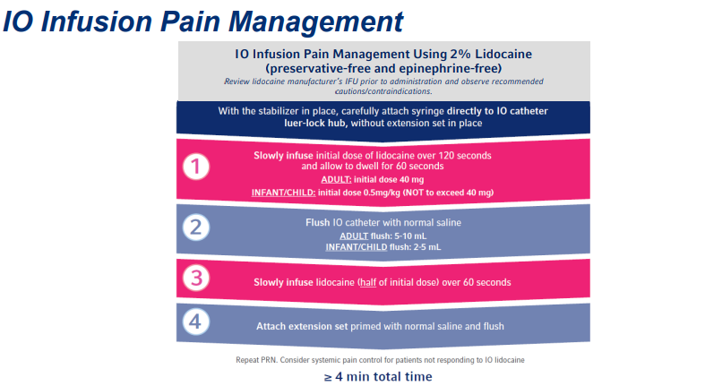

Observe for extravasation and hypersensitivity reaction with every IO Lidocaine injection. If these occur immediately stop administration and treat as appropriate.

If extravasation occurs remove IO and place another IO needle in a different bone. Consult UHB policy on extravasation.

See summary of product characteristics (SPC) for other known side effects of
Lidocaine.

This strength of preservative and adrenaline free Lidocaine can be found in the Emergency Department, Theatres, Intensive Care, Cardiac areas and several other wards in either prefilled syringes or ampoules.
Appendix 3 – Intraosseous Care Pathway

IO Care Pathway
Date of insertion: _ _ / _ _ / _ _ _ _

Time of insertion: Affix patient
Insertion site: sticker here

Inserted by (print):

Handover to Ward / Unit: 48Hrs after insertion: 72Hrs after insertion:

IO Secured IO Secured IO Secured
IO Flushing (8 hourly) IO Flushing (8 hourly) IO Flushing (8 hourly) Site looks healthy Site looks healthy Site looks healthy

Signature of Nurse: Signature of Nurse: Signature of Nurse:

Comments: Comments: Comments:

Removed Today Removed Today Removed Today
Date/time: Date/time: Date/time:

IO must be removed when IV access is obtained
OR within 72 hours.
Flush with 10mls Saline To Remove IO Needle |  | Avoid rocking!
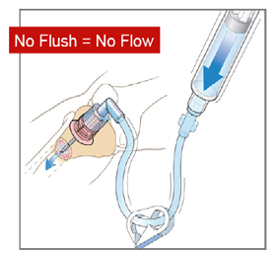
Alter pressure if patient experiences pain Only undertake this procedure once trained |  | Avoid rocking  the needle

Appendix 4 – Assessment of Intraosseous Cannulation

Name | Grade or  band | Area of work (ward/department)

Date assessed: / /

Competent to practice: Yes / No

Comments (if not competent to practice you must explain why):

Signature of assessor:

Name and grade of assessor:

Please return completed assessment form to: Resuscitation Service, Upper ground Floor,
Jubilee Courtyard, UH

