Reference Number: UHB 054  Version Number: 3 | Next Review Date: 11 May 2025 Trust/LHB Reference  Number: T129
Counter Fraud Bribery and Corruption Procedure

Introduction and Aim
To ensure the Health Board delivers its aims, objectives, responsibilities and legal requirements transparently and consistently, we will be committed to reducing the level of fraud and/or corruption within the NHS to an absolute minimum and keeping it at that level, thereby this will free up public money that can be put to providing better patient care. As one of the basic principles of Public Sector organisations is the proper use of public funds, the Health Board must ensure that its employees act with absolute integrity and honesty as expected and detailed under the various Codes of Conduct.

Objectives
The objective is to ensure that all assets and public funds entrusted to the Health Board are protected against Fraud and/or Loss. The Counter Fraud and Corruption Procedure describes the mechanisms and process that the Health Board will implement and then use to investigate allegations of fraud and fraud related offences, and to develop an Anti-Fraud Culture in accordance with the NHS Counter Fraud Authority’s / Cabinet Office required standards.

Scope
This policy relates to all forms of fraud and corruption and is intended to provide direction and help to members of staff who may identify suspected fraud.

It is intended to provide a framework for responding to suspicions of fraud, advice and information on various aspects of fraud and implications of an investigation.

This policy applies to all CAVUHB staff, including secondees, those engaged via the bank, volunteers, those with honorary contracts, Independent Members, those working in bodies hosted by CAVUHB and other parties who may have a business relationship with CAVUHB e.g. consultants, vendors or contractors.

Equality Impact Assessment | An Equality and Health Impact Assessment (EHIA) has been completed and this found there to be no impact. This procedure relies on the generic EHIA for admin type policies.
Documents to read alongside this Procedure | This procedure should be read in conjunction with the UHB Counter Fraud and Corruption Policy, the All Wales Raising Concerns Policy and the All Wales Disciplinary Policy.
Approved by | Audit Committee
Accountable Executive or Clinical Board Director | Executive Director of Finance
Author(s) | Gareth Lavington – Head Counter Fraud

Disclaimer
If the review date of this document has passed please ensure that the version you are using is the most up to date either by contacting the document author or the Governance Directorate.

Summary of reviews/amendments
Version Number | Date of Review Approved | Date Published | Summary of Amendments
1 | 24/05/2011 | 24/05/2011 | None
2 | 03/12/2019 | 05/12/2019 | Updated
3 | 11/05/2023 | 16/05/2023 | Procedure amended and updated to reflect changes to NHS CFA requirements and to maintain accuracy.

Table of Contents
1. Introduction 4
2. What is Fraud? 5
3. Public Service Values 6
4. CAVUHB Policy Statement 7
5. Roles and Responsibilities 7
6. The Response Plan 11
7. The Law and its Remedies 20
8. References 22
9. Further Information 23
Appendix 1: NHS Fraud and Corruption: Dos and Don’ts 24

Introduction

  - One of the basic principles of public sector organisations is the proper use of public funds. It is therefore important that all those who work in the public sector are aware of the risk of and means of enforcing the rules against fraud and other illegal acts involving dishonesty or damage to property. For simplicity all such offences are hereafter referred to as “fraud”, except where the context indicates otherwise. This document sets out the Cardiff and Vale University Health Board policy and response plan for detected or suspected fraud.

  - It is essential that all staff are aware of, and are able to access up-to-date, accurate Cardiff and Vale University Health Board (CAVUHB) policies to ensure they are aware of current approved practices to help reduce risk.

  - CAVUHB already has procedures in place that reduces the likelihood of fraud occurring. These include Standing Orders, Standing Financial Instructions, documented procedures and a system of internal control and a system of risk assessment. In addition, CAVUHB tries to ensure that a risk (and fraud) awareness culture exists throughout the organisation.

  - This document is intended to provide direction and help to those officers and directors who find they have to deal with suspected cases of theft, fraud or corruption. It gives a framework for response, advice, and information on various aspects and implications of an investigation.

  - The three crucial public service values which must underpin the work of the health service: accountability, probity, and openness. CAVUHB is absolutely committed to maintaining an honest, open, and well-intentioned atmosphere within the organisation. It is therefore committed to the reduction of any fraud occurring within CAVUHB, and to the rigorous investigation of any such cases that do occur.

  - CAVUHB wishes to encourage anyone having reasonable concern that a fraud has or may be occurring to contact the Counter Fraud service. It is CAVUHB policy that no employee will suffer in any way as a result of reporting reasonably their concerns.

  - The flowcharts in section 6.2 describe CAVUHB response when a referral is made to the Counter Fraud service. The flowcharts are intended to provide procedures that allow for evidence gathering and collation in a manner that will facilitate informed initial decisions, while ensuring that evidence gathered will be admissible in any future criminal or civil actions.

  - CAVUHB has a Service Level Agreement with Cardiff & Vale University Health Board for the provision of the Local Counter Fraud service. The Counter Fraud Manager will report directly to the Director of Finance and will produce an agreed work plan to follow, to fulfil the requirements of the role.

What is Fraud?

  - Fraud:

The Fraud Act 2006 was introduced on the 15th of January 2007 and
is focused upon the dishonest behaviour of a suspect and the
intent to make a gain or cause a loss. It includes the following
offences that could be committed against the NHS:
  - Fraud by false representation (s.2) – dishonestly
misrepresenting something using any means, e.g. by words or
actions.
  - Fraud by failing to disclose information (s.3) – not saying
something where there is a legal duty to do so.
  - Fraud by abuse of a position of trust (s.4) – abusing a position
where there is an expectation to safeguard the financial
interests of another person or organisation.

Areas where fraud may occur include but are not limited to:

- Travel and expense claims
- Petty cash vouchers
- Items of Service claims from independent contractors
- Time sheets
- Fraudulent use of authorised leave
- Overpayment of salary/wages
- Fraudulent use of CAVUHB resources
- Working whilst on the sick
- Handling of cash
- Misappropriation of equipment

This is covered in more detail at section 7.

  - Bribery and Corruption:

“The offering, giving, soliciting of an inducement or reward that may influence the actions taken by a body, its members or officers.”

Source: The Code of Audit Practice – Audit Commission

Corruption does not always result in a loss. The corrupt person does not have to benefit directly from their deeds, they may unreasonably use their position to give some advantage to another.

It is a common law offence of corruption to bribe the holder of a
public office and it is similarly an offence for the office holder to
accept a bribe.

Corruption prosecutions tend to be most commonly brought using
specific pieces of legislation dealing with corruption, i.e. under the
The Bribery Act 2010.

  - Bribery Act 2010

The Bribery Act 2010 received Royal Assent on 8th April 2010 and came into force on 1st July 2011. The Bribery Act 2010 will abolish all existing UK Anti-Bribery Laws and replace them with a suite of new offences markedly different to what has gone before. The Bribery Act 2010 makes it a criminal offence to “give, promise or offer a bribe and to request, agree to receive or accept a bribe either at home or abroad”. It will increase the maximum penalty for bribery to 10 years imprisonment, with an unlimited fine. In addition, the Act introduces a ‘corporate offence’ of failing to prevent bribery by the organisation not having adequate preventative procedures in place. An organisation may avoid conviction if it can show that it had such procedures and protocols in place to prevent bribery. The ‘corporate offence’ is not a standalone offence, but always follows from a bribery and/or corruption offence committed by an individual associated with the company or organisation in question.

Public Service Values

Source: WHC (2006) 090 ‘The Codes of Conduct and Accountability for NHS Boards and the Code of Conduct for NHS Managers Directions 2006’.

  - The codes reinforce the seven principles of public life (The Nolan Principles) and focuses on the three crucial public service values which must underpin the work of the health service: accountability, probity, and openness.
- Accountability: Everything done by those who work in the NHS in Wales must be able to stand the test of scrutiny by the Welsh Government, public judgments on propriety and professional codes of conduct.
- Probity: There should be an absolute standard of honesty in dealing with the assets of the NHS in Wales: integrity should be the hallmark of all personal conduct in decisions affecting patients, staff and suppliers, and in the use of information acquired in the course of the NHS in Wales’s duties.
- Openness: There should be sufficient transparency about the NHS in Wales’s activities to promote confidence between the NHS body and its staff patients and the public.

CAVUHB Policy Statement

  - CAVUHB is absolutely committed to maintaining an honest, open, and well- intentioned atmosphere within the organisation. It is also committed to the elimination of any fraud within CAVUHB, and to the rigorous investigation of any such cases.

  - CAVUHB wishes to encourage anyone having reasonable suspicions of fraud to report them. Therefore, it is also CAVUHB policy, which will be rigorously enforced, that no employee will suffer in any way as a result of reporting reasonably held suspicions.

  - All members of staff can therefore be confident that they will not suffer in any way as a result of reporting reasonably held suspicions of fraud. For these purposes “reasonably held suspicions” shall mean any suspicions other than those which are raised maliciously and found to be groundless.

Roles and Responsibilities

  - Executive Director of Finance

The Director of Finance, in conjunction with the Chief Executive, monitors and ensures compliance with the Counter Fraud Directions for the organisation.

The Director of Finance will, depending on the outcome of investigations and/or the potential significance of suspicions that have been raised, inform appropriate senior management accordingly.

The Director of Finance and Local Counter Fraud Specialist (LCFS) will be responsible for informing third parties such as external audit or the police at the earliest opportunity, as circumstances dictate.

The Director of Finance will inform and consult the Chief Executive in cases where the loss may be above the agreed limit or where the incident may lead to adverse publicity.

If an investigation is deemed to be appropriate, the Director of Finance will delegate to the LCFS, who has responsibility for leading the investigation, whilst retaining overall responsibility himself/herself.

The Director of Finance or the LCFS will consult with the Executive Director of People and Services or delegated representative, if a member of staff is to be interviewed or disciplined.

The Director of Finance or LCFS will not conduct a disciplinary investigation, but the employee may be the subject of a separate investigation as part of a disciplinary process.

  - Local Counter Fraud Specialist

Local Counter Fraud Specialists (LCFS) are located in each NHS organisation. The Lead LCFS is appointed by the Executive Director of Finance and will be responsible for investigating cases of fraud up to a value of £15,000. All investigations involving more than £15,000 and/or Corruption must be referred to the NHS Counter Fraud Service (Wales) Regional Team. Only individuals who are accredited as Counter Fraud Specialists will be responsible for investigating cases of fraud. The LCFS will be responsible for notifying all cases of fraud to NHS CFS (Wales) in the appropriate manner and via the CLUE Case Management System. The LCFS shall:
- Report to Executive Director of Finance.
- Provide a written report at least annually to CAVUHB on counter fraud work within the organisation.
- Be entitled to attend Audit Committee meetings and have a right of access to all Audit Committee members and the Chairman and Chief Officer of CAVUHB.
- Undertake, as agreed with CAVUHB Executive Director of Finance, proactive work to detect cases of fraud and corruption, particularly where systems weaknesses have been identified. This work shall be carried out so as to complement the detection of potential fraud and/or corruption by auditors in the course of routine audits.
- Proactively seek and report to CFS (Wales) opportunities where details of counter fraud work (involving action on prevention, detection, investigation, sanctions or redress) can be used within presentation or publicity in order to deter fraud and corruption.
- Investigate cases of suspected fraud in accordance with the division of work specified in the Directions as amended and replaced from time to time. Refer to CFS (Wales) all cases appropriate to them.
- Inform CFS (Wales) of all cases of suspected fraud investigated by CAVUHB.
- Investigate, report and effect remedy in relation to identified system weaknesses within the organisation that can allow the opportunity for fraud to occur.

  - NHS Counter Fraud Service (Wales)

The NHS Counter Fraud Service (CFS) (Wales) will investigate all cases that do not fall within the responsibility of the Local Counter Fraud Specialist.

NHS CFS (Wales) will be responsible for the investigation of cases above £15,000, all corruption cases, and any case at the request of the LCFS, where the CFS (Wales) specialist knowledge and resources could assist with the investigation.

Counter Fraud Service Wales will act as the point of contact for the LCFS in relation to liaison with the Crown Prosecution Service.

  - NHS Counter Fraud Authority

On the 1st November 2017, an independent special health authority was implemented in England entitled the NHS Counter Fraud Authority (NHSCFA). This was achieved under amendment from the UK Government Secretary of State for Health.

As a result of this, the previous arrangements which Welsh Ministers entered into with the predecessor organisation of the NHSCFA i.e. NHSBSA/NHS Protect, which was pursuant to section 83 of the Government of Wales Act 2006, which deals with the discharge of certain counter fraud functions in relation to the health service in Wales were reviewed and remained effective with the NHSCFA.

NHSCFA has responsibility for all policy, operational and training matters relating to the prevention, detection and investigation of fraud, bribery and corruption in the NHS.

NHSCFA also provides advice, guidance and risk measurement to NHS Bodies in Wales on all aspects of fraud, bribery and corruption. All instance where fraud is suspected are properly investigated, until their conclusion, by staff who are fully trained and accredited and who are duly nominated by NHSCFA.

  - CAVUHB Management

Managers must be vigilant and ensure that procedures to guard against fraud, bribery and corruption are followed.

They should be alert to the possibility that unusual events or transactions could be symptoms of fraud, bribery and corruption. If they have any doubts, they must seek advice from the nominated LCFS.

Managers must instil and encourage an anti-fraud, and anti-bribery and corruption culture within their team and ensure that information on procedures is made available to all employees. The LCFS will proactively assist the encouragement of an anti-fraud culture by undertaking work that will raise fraud awareness.

All instances of actual or suspected fraud, bribery or corruption which come to the attention of a manager must be reported immediately to the lead LCFS. If formal investigation is undertaken by the LCFS/CFS managers have a duty to produce any documents or evidence that is required by the investigation team in a timely manner.

Line managers at all levels have a responsibility to ensure that an adequate system of internal control exists within their areas of responsibility and that controls operate effectively.

The responsibility for the prevention and detection of fraud and corruption therefore primarily rests with managers but requires the co-operation of all employees.

The Response Plan

  - Introduction

The flowcharts in section 6.2 describe CAVUHB intended response to reported suspicion of fraud. The flowcharts are intended to provide procedures that allow for evidence gathering and collation in a manner that will facilitate informed initial decisions, while ensuring that evidence gathered will be admissible in any future criminal or civil actions. Each situation is different; therefore, the guidance in the flowcharts will need to be considered carefully in relation to the actual circumstances of each case before action is taken.

Further details on the processes in the flowchart are provided in section 6.3 (Commentary on Flowchart Items).

  - Flowcharts

Chart 1

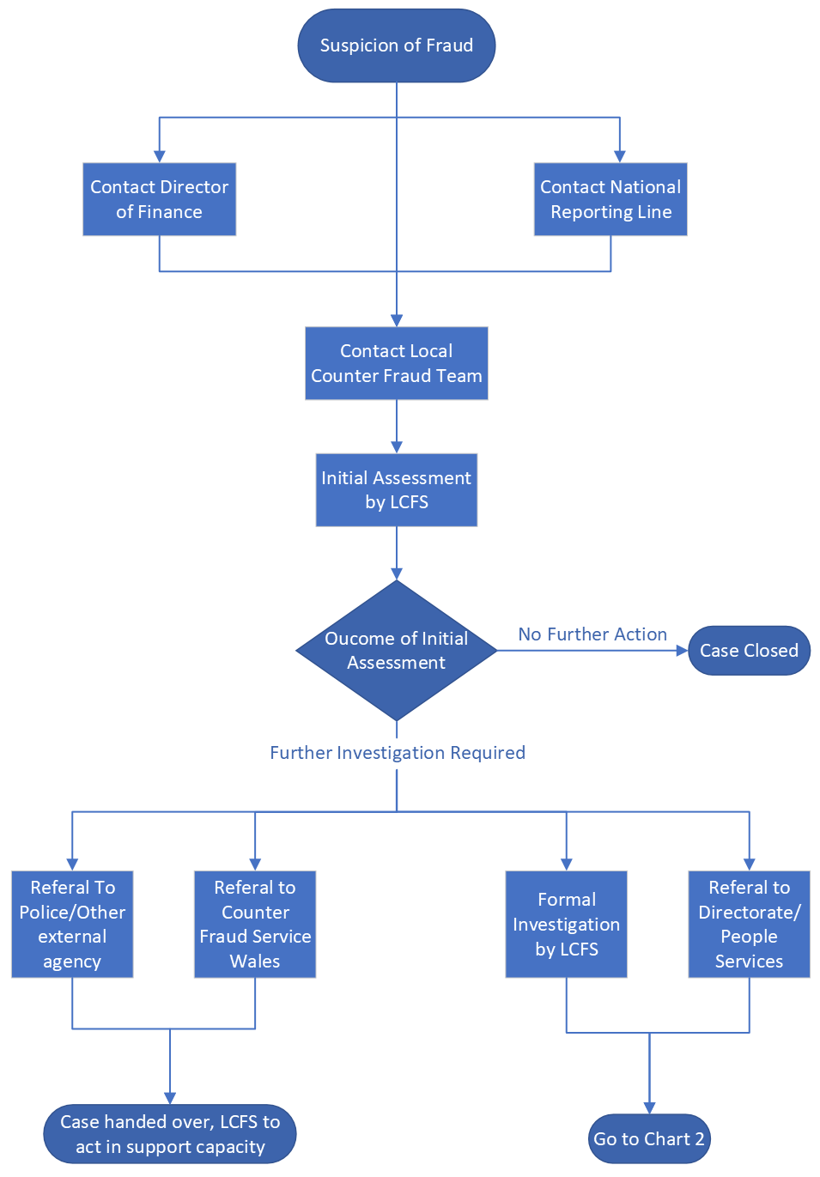

Chart 2 – Local Counter Fraud Investigation
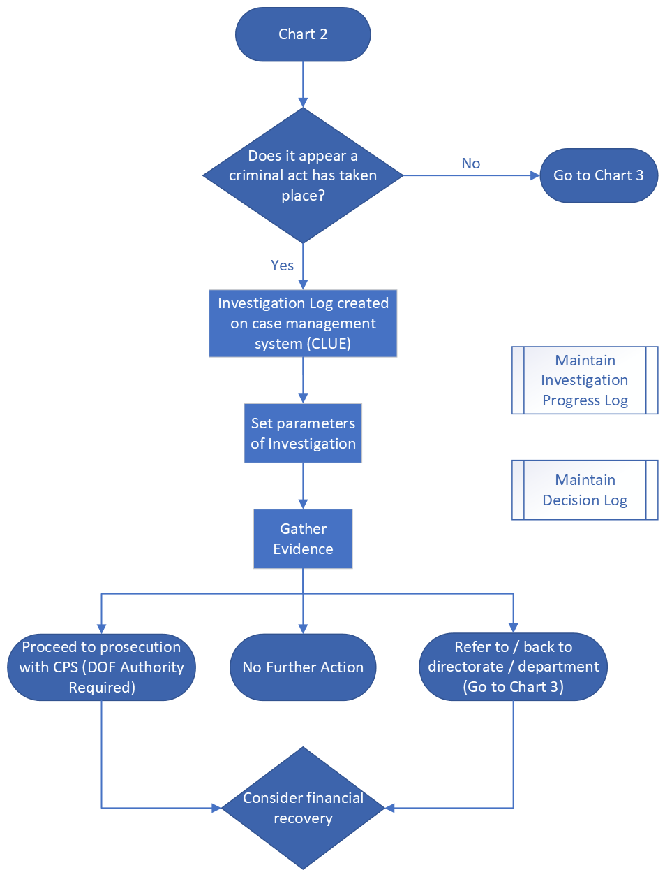

Chart 3 – Disciplinary Process

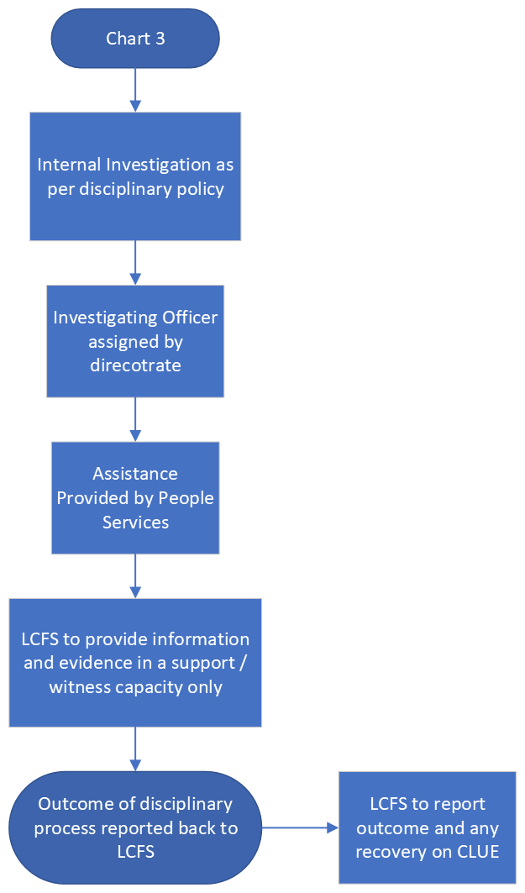

  - Commentary on Flowchart Items

Further explanation of many items is also given elsewhere in this document.

Chart 1 – Suspicion of Fraud

    - The Local Counter Fraud Specialist (LCFS)

The Lead LCFS will be authorised to treat inquiries confidentially and anonymously if so requested by the individual making the referral.

The LCFS will receive appropriate skill-based training leading to professional accreditation and will be able to respond tactfully and appropriately to concerns raised by staff.

LCFS services are currently provided as part of a Service Level Agreement with Cardiff & Vale University Health Board.

    - Suspicion of Fraud or Any Irregularities/Anomalies

If any CAVUHB employee has any concerns that a fraud has or is taking place, then he/she should discuss any suspicions in the first instance with the Nominated Lead LCFS on 02921 836265.

However, an employee may choose instead to contact the “NHS Fraud & Corruption Reporting Line” on 0800 028 4060.

This contact can be made anonymously.

Time may be of the utmost importance to prevent further loss to CAVUHB.

    - Upon receipt of a referral LCFS will carry out an initial assessment to understand and identify whether there are reasonable grounds to suspect whether criminal offences have been committed. If not, the case will be concluded with no further action taken. Should there be issues of managerial concern evident then LCFS will liaise with appropriate departmental management and People Services department.

LCFS will consider and decide whether the case needs to be referred on to other agencies e.g. Police and Counter Fraud Service Wales. If this is appropriate then LCFS will make the appropriate arrangements. In some instances, a joint investigation may take place.

CHART 2 – Local Counter Fraud Investigation

    - Progress of investigation

All investigations carried out by the Counter Fraud Department, will be led by an accredited LCFS and will be overseen by the Head of Counter Fraud. All investigations into fraud will be compliant with the Criminal Procedures and Investigations Act 1990 and the Police and Criminal Evidence Act 1984.

The Local Counter Fraud Specialist in charge of the investigation (OIC) will keep a log of events to record the progress of the investigation. This will commence immediately following referral. If a criminal offence is suspected then the referral will be promoted to formal investigation and recorded upon the NHS CFA case management system (CLUE).

    - Does it appear a Criminal Act Has Taken Place?

In some cases, this question may be asked more than once during an investigation. The answer to the question obviously determines if there is to be a criminal investigation. In practice it may not be obvious if a criminal act has taken place. If a criminal act is believed to have occurred, the matter will be dealt with by the LCFS/CFS (Wales) as appropriate. If other criminal offences are involved e.g. theft, criminal damage, consideration should be given to reporting the matter, after consultation with the LCFS, to the police

    - Evidence

For the purposes of criminal proceedings, the admissibility of evidence is governed by the Police and Criminal Evidence Act (PACE). For non-criminal (i.e. civil or disciplinary) proceedings, PACE does not apply, but should nevertheless be regarded as best practice.

It is imperative that the collection of evidence must be coordinated if several parties are involved in an investigation, e.g. LCFS and internal audit, police and solicitors. The LCFS will take the lead on this. Evidence gathering requires skill and experience and professional guidance should be sought where necessary. There is a considerable amount of case law concerning the admissibility of evidence and incorrect procedure can lead to a prosecution collapsing.

    - Witnesses

If a witness to the event is identified, then they will need to give a written statement. The LCFS will take a chronological record using the witness’s own words. (The witness should be prepared to sign the document as a true record) and advised that the statement may be used as evidence should the matter proceed to court. All witness statements will be completed in accordance with Section 9 Criminal Justice Act 1967 and on the witness statement document provided for this purpose. All witnesses will be provided with ongoing guidance and support throughout the process.

    - Physical Evidence

Upon taking control of any physical evidence, it is very important that a record is made of the time, date, and place it is taken from and by whom, continuity is essential. If evidence consists of several items, for example many documents, each one should be tagged with a reference number corresponding to the written record. It is the responsibility of the LCFS to manage the retrieval, documentation and storage of physical evidence collected during the course of an investigation.

Documentary evidence should be properly recorded, it will need to be numbered and include accurate descriptions of when and where it was obtained and who it was obtained by and from. In criminal actions evidence on or obtained from electronic media needs a document confirming its accuracy.

    - Interviews

Any interviews carried out with a suspect during the course of a fraud investigation will be carried out only by an accredited LCFS, and will be compliant with the relevant codes and sections of the Police and Criminal Evidence Act 1984.

The subject of the investigation will be written to and advised of the reason for the interview and that he/she is entitled to have a person present at the interview who can act in a legal capacity (i.e. solicitor), but they are not entitled to have a friend, work colleague and/or union representative present at the interview.

The person being interviewed is also to be informed that whilst their attendance at the interview is voluntary, should they not attend, then the matter may be referred to the police which could then result in their subsequent arrest.

Prior to the start of an interview, the interviewee will be assessed with regard to their wellbeing and a decision will be made whether or not it is appropriate to continue with it. If it is not appropriate, then an alternative date in the future will be sought.

The interview under caution will be tape recorded and once the interview has concluded the interviewee and their legal representative will be provided with a notice informing them of their entitlement to a copy of the recording made. All recordings must be made on a recording device authorised for the purpose.

    - Investigate Internally

If, after discussion with the LCFS, it appears a criminal act has not taken place, or that the act/s are of a minor nature and it would not be proportionate nor in the public interest to proceed criminally, the next step should be an internal review to determine the facts. The review may recommend various courses of action; instigate an investigation under CAVUHB Disciplinary Policy and Procedure; establish what can be done to recover a loss and what may need to be done to improve internal control to prevent the event happening again. Internal disciplinary investigations are the responsibility of the Directorate/Departmental management in conjunction with the People Services team.

    - Recovering a Loss

The seeking of financial redress or recovery of losses should always be considered in cases of fraud, bribery or corruption that are investigated by either the LCFS or NHS Counter Fraud Service (Wales) where a loss is identified. As a general rule, recovery of the loss caused by the perpetrator should always be sought. The decisions must be taken in the light of the particular circumstances of each case. Redress allows resources that are lost to fraud, bribery and corruption to be returned to the NHS for use as intended, for provision of high-quality patient care and services.

Where recovering a loss is likely to require a civil action, in the absence of established procedures for this recovery, e.g overpayments policy and debt collection agencies, it will be necessary to seek legal advice. Where external legal advisors are required, due to the possible high cost implications, the investigation manager must ensure that the Director of Finance is consulted. The decision of whether to proceed with any civil action will rest with the Director of Finance.

    - Court Action, Adverse Publicity and/or Police Involvement

Where the investigation reaches a stage where the case is likely to end up in a criminal prosecution via the criminal justice system, then the LCFS must liaise with the Finance Director. Should the investigation or prosecution be likely to lead to adverse publicity then LCFS should also liaise with CAVUHB Communications/Press relations Department. Where a fraud is suspected and the need to use the police to carry out an arrest and/or search, then lead LCFS will make the appropriate arrangements and liaise with the relevant organisation directly. The Director of Finance will be appraised accordingly.

No member of staff should contact members of the press without the authority of the Director of Finance and or the Communications/Press Relations team.

    - Risk Management

At the conclusion/during the course of an investigation it may become clear that system or process weaknesses or failings have provided the opportunity for fraud or loss to occur. In these circumstances LCFS will conduct a risk assessment into the target area and report accordingly upon any weaknesses identified. The CLUE case management system will be used for this purpose. Any weaknesses and recommendation for remedial action will be reported to the relevant directorate or department. Any risks identified during the course of an investigation will be recorded on the local risk register by departmental management in conjunction with the LCFS. This may give rise to future proactive work such as Local Proactive Exercises that will be conducted by the LCFS to test that remedial actions have been undertaken. Where fraud risk assessment/fraud proofing work is required, departmental management must assist in providing all necessary information requested by the LCFS or Internal Audit in relation to the processes or systems under review.

CHART 3 – Disciplinary Process

    - Disciplinary Procedure

CAVUHB Disciplinary Policy and Procedure has to be followed in any disciplinary action taken by CAVUHB towards an employee (including dismissal). This may involve the investigation manager recommending a disciplinary hearing to consider the facts, the results of the investigation (a formal report) and take appropriate action against the employee.

In the event of a disciplinary investigation taking place where a suspicion of fraud exists, then the appointed investigating officer must liaise with the LCFS to agree a way forward. A decision will be made whether the investigations can run concurrently or whether the internal investigation will need to be put on hold until the completion of the criminal investigation or part of it.

In some cases where a fraud is suspected it may be deemed by the Lead LCFS that the matter is of a minor nature, or that it would not pass the relevant evidential or public interest threshold tests, and therefore a formal criminal investigation will not progress. In these instances’ the LCFS will keep departmental management and People Services appraised that no further action will be taken. A disciplinary investigation can still take place in these circumstances. If a disciplinary investigation only ensues following the report of a fraud or fraud related offence, the internal investigating officer and People Services representative will ensure that the LCFS is kept appraised of the process and any resulting action that takes place. The LCFS will act in support of any disciplinary only investigation in the position of a witness only. Any evidence gathered by the LCFS will be shared with management if it assists with the case.

As per national requirements LCFS will report any outcome on the CLUE case management system.

The Law and its Remedies

  - Introduction

Section 6 of the NHS Counter Fraud Manual provides in-depth details of how sanctions can be applied where fraud and corruption is proven and how redress can be sought.

To summarise, local action can be taken to recover money by using the administrative procedures of the organisation or civil law. In cases of serious fraud, bribery and corruption, it is recommended that parallel sanctions are applied. For example: disciplinary action relating to the status of the employee in the NHS; use of civil law to recover lost funds; and use of criminal law to apply an appropriate criminal penalty upon the individual(s) and/or a possible referral of information and evidence to external bodies – for example, professional bodies – if appropriate. This is known as the triple track approach.

Actions which may be taken when considering seeking redress include:

• no further action
• criminal investigation
• civil recovery
• disciplinary action
• confiscation order under the Proceeds of Crime Act 2002 (POCA)
• recovery sought from ongoing salary payments

In some cases (taking into consideration all the facts of a case), it may be that CAVUHB under guidance from the LCFS and with the approval of the Director of Finance, decides that no further recovery action is taken.

Criminal investigations are primarily used for dealing with any criminal activity. The main purpose is to determine if activity was undertaken with criminal intent. Following such an investigation, it may be necessary to bring this activity to the attention of the criminal courts (Magistrates’ Court and Crown Court). Depending on the extent of the loss and the proceedings in the case, it may be suitable for the recovery of losses to be considered under POCA.

  - Proceeds of Crime Act

The NHS Counter Fraud Service (Wales) can also apply to the courts to make a restraining order or confiscation order under the Proceeds of Crime Act 2002 (POCA). This means that a person’s money is taken away from them if it is believed that the person benefited from the crime. It could also include restraining assets during the course of the investigation.

  - Fraud Act 2006

The Fraud Act came into force on 15th January 2007.
The following offences have been repealed:

  - Theft Act 1968
  - Obtain property by deception (section 15)
  - Obtain money transfer by deception (section 15A)
  - Obtain pecuniary advantage (section 16)
  - Procure execution of valuable security (section 20)

  - Theft Act 1978
- Obtain service by deception (section1)
- Evade liability (section 2)

The new Act simplifies the original deception offences. There is no need to prove that any person was deceived. The Act now outlines three ways to commit fraud:
- Fraud by False Representation (section 2)
- Fraud by Failing to Disclose Information (section 3)
- Fraud by Abuse of a Position (section 4)

Many original ‘deception’ offences will now be covered by section 2 of the Fraud Act 2006 (false representation) which has three main ingredients:
- Dishonesty
- A false representation (no limitations on how this takes place)
- Intention to commit gain or cause loss

Section 3 covers the offence of fraud by failing to disclose information where there is a legal duty to do so.

Section 4 covers the offence of fraud by abuse of position where the defendant is in a privileged position expected to safeguard (not act against) the financial interests of another person.

Section 6 covers the offence of possession of articles for use in fraud. This extends to possession or control of any article, anywhere and includes electronic data.

Section 7 covers the offence of making or supplying articles for use in fraud. It is designed to capture those who supply personal financial details for use in frauds to be carried out by others; or those who manufacture software programmes for generating credit card numbers.

Section 11 of the Fraud Act – Obtain Services Dishonestly replaces ‘obtain services by deception.’ This offence requires the actual obtaining of a service and must include a dishonest act or false representation.

The test for dishonesty that is currently relied upon rests in case law and the cases of Ivy v Genting Casino 2017 and Barton and Booth v R 2020.

  - Corruption

The definition (in the context of the Prevention of Corruption Acts) is the offering, giving, soliciting, or acceptance of an inducement or reward, which may influence the action of any person.

References

This policy should be read in conjunction with:
- Standing Orders
- Standing Financial Instructions
- Disciplinary Policy and Procedure
- Standards of Business Conduct
- I.T Security Policy
- Public Relations and Communications Strategy
- Procedure for NHS Staff to raise concerns
- Respect and Resolution Policy
- CAVUHB policies relating to:
  - Gifts
  - Hospitality
  - Conflicts of Interest
  - Procurement
  - Capital/PFI Contracts

Further Information

Further information and a copy of the fraud policy and response plan may be obtained from the LCFS or CAVUHB intranet.

NHS Fraud and Corruption: Dos and Don’ts
A desktop guide for CAVUHB

FRAUD is the deliberate or reckless intent to permanently deprive an employer of money or goods through false representation, failing to disclose information or abuse of position.

CORRUPTION is the deliberate use of bribery or payment of benefit-in-kind to influence an individual to use their position in an unreasonable way to help gain advantage for another.

DO  - Note your concerns  Record details such as your concerns, names, dates, times, details of conversations and possible witnesses. Time, date and sign your notes.  - Retain evidence  Retain any evidence that may be destroyed, or make a note and advise your LCFS.  - Report your suspicion  Confidentiality and anonymity will be respected – delays may lead to further financial loss. | DO NOT  - Confront the suspect or convey concerns to anyone other than those authorised, as listed below  Never attempt to question a suspect yourself; this could alert a fraudster or accuse an innocent person.  - Try to investigate, or contact the police directly  Never attempt to gather evidence yourself unless it is about to be destroyed; gathering evidence must take into account legal procedures in order for it to be useful. Your LCFS can conduct an investigation in accordance with legislation.  - Be afraid of raising your concerns  The Public Interest Disclosure Act 1998 protects employees who have reasonable concerns. You will not suffer discrimination or victimisation by following the correct procedures.

If you suspect that fraud against the NHS has taken place, you must report it immediately, by:
- directly contacting the Local Counter Fraud Specialist, or
- telephoning the free phone NHS Fraud and Corruption Reporting Line, or
- contacting the Director of Finance.

Do you have concerns about a fraud taking place in the NHS?

If so, any information can be passed to the NHS Fraud and Corruption Reporting Line:
0800 028 40 60

All calls will be treated in confidence and investigated by professionally trained staff

Your nominated Local Counter Fraud Specialist are:

Gareth Lavington - Head of Counter Fraud – Gareth.Lavington2@wales.nhs.uk– 02921836265

Henry Bales – Local Counter Fraud Specialist – Henry.Bales@nhs.wales.uk 02921836264

Nicola Tillings – Local Counter Fraud Specialist -Nicola.Tillings@wales.nhs.uk
02921836262

If you would like further information about the NHS Counter Fraud Service, please visit www.nhscfa.co.uk or Counter Fraud - Home (sharepoint.com)

