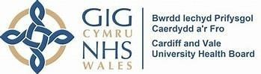

Cardiff and the Vale University Health Board (Cardiff and Vale UHB) Eye Health Needs (EHNA) Assessment March 2025 v3

Our Population
Cardiff and Vale UHB cover the two unitary authorities of Cardiff and the Vale of Glamorgan. Combined, Cardiff and Vale have a population of 518,269 (population estimates by Local Authority and age), of which 383,536 live in Cardiff and 134,733 in the Vale of Glamorgan. This number has increased since the most recent totals in the Regional Partnership Board’s Population Needs Assessment (2022-27) and populations are expected to continue to increase in the next decade. The current Local Authority local development plans for Cardiff and the Vale of Glamorgan which will shape how the population grows up until 2036, provides opportunities to deliver in the region of 24,000 additional homes in Cardiff and 9,460 homes in the Vale or Glamorgan for an estimate of c.77,000 residents.

Cardiff has a relatively young population, mainly due to the student population in the city. The proportion of older people is slightly higher than the Wales average in the Vale; the number of older people and the proportion of people who are older is increasing across both areas.

Every year, people migrate into and out of both Cardiff and the Vale. In 2021-22 the net effect of this was around 500 people moving into each local authority areas from elsewhere in the UK; there was also a significant increase in the number of international migrants moving into the area, with a net effect of over 10,000 people moving into Cardiff and over 500 into the Vale from overseas. Combined, this made up over half the number of international migrations into Wales as a whole.

Table 1: Age breakdown of the population of Cardiff and Vale.
Area | 0–15year-old | % | 16-64-yearold | % | 65+ year old | % | All ages
Cardiff | 67,230 | 18% | 261,449 | 68% | 54,857 | 14% | 383,536
Vale | 24,819 | 18% | 79,811 | 60% | 30,103 | 22% | 134,733
Cardiff and Vale | 92,049 | 18% | 341,260 | 66% | 84,960 | 16% | 518,269
Source: Stats Wales
Available at: Population estimates by local authority and age
Published on: July 2024 (most recent release)

Table 2: Sex of population of Cardiff and Vale.
Area | Males | % | Females |  | % | All persons
Cardiff | 188,596 | 49% | 194,940 | 51% |  | 383,536
Vale | 65,072 | 48% | 69,661 | 52% |  | 134,733
Cardiff and Vale | 253,668 | 49% | 264,601 | 51% |  | 518,269
Source: Stats Wales
Available at: Population estimates by local authority and age
Published on: July 2024

Table 3: Patients registered with a GP Practice per cluster in Cardiff and Vale (includes cross border patients who are resident in other Health Board areas).
Cluster | Number | %
Cardiff East | 59,033 | 10.9%
Cardiff South East | 66,179 | 12.3%
City and South Cardiff | 42,537 | 7.9%
Cardiff North | 106,181 | 19.7%
Cardiff South West | 74,968 | 13.9%
Cardiff West | 53,833 | 10.0%
Central Vale | 67,081 | 12.4%
Eastern Vale | 36,825 | 6.8%
Western Vale | 31,906 | 5.9%
CAV Unidentified Cluster | 620 | 0.1%
CAV TOTAL | 539,163 | 100.0%
Source: Stats Wales patients registered at a GP Practice 2024
Available at: Patients Registered at a GP Practice Published on: July 2024 *Note: Discrepancy in population data due to different data sources used.

Welsh Index Multiple Deprivation (WIMD)
Deprivation is the lack of access to opportunities and resources, which might be expected in society. This can be in terms of material goods or the ability of an individual to participate in the normal social life of the community. The Welsh Index of Multiple Deprivation is the official measure of relative deprivation for small areas in Wales. It identifies areas with the highest concentrations of several different types of deprivation.

Cardiff and the Vale of Glamorgan have areas of established inequalities; in Cardiff 39 Lower Super Output Areas (LSOAs) are included in the top 10% most deprived in Wales, whilst 3 LSOAs in the Vale of Glamorgan are ranked in the top 10% most deprived area in Wales. In Cardiff, around one-fifth of residents live in the most deprived 10% LSOAs and approximately 50% of Cardiff’s population live in the 50% least deprived LSOAs while for the Vale of Glamorgan, 65% live in the 50% least deprived areas.

Table 4: Number (%) of patients living in the most deprived 20% of WIMD, 2019, by cluster.
Cluster | Number of patients living in most deprived 20% of WIMD | % of patients living in most deprived 20% of WIMD
Cardiff East | 26915 | 45.65
Cardiff South East | 26421 | 38.94
City and South Cardiff | 21220 | 50.11
Cardiff North | 3432 | 3.22
Cardiff South West | 34107 | 45.54
Cardiff West | 7177 | 13.38
Central Vale | 16736 | 25
Eastern Vale | 56 | 0.15
Western Vale | 1 | 0
CAV TOTAL | 136065 | 24.66
Source: Stats Wales deprivation at GP cluster level 2022
Available at: Deprivation at GP cluster level Date of publication: April 2024 Ethnicity:

People from different ethnic communities are at greater risk of some of the leading causes of sight loss. The proportion of people from minority ethnic groups is higher than the average for Wales, 12.10% of the population are from minority ethnic groups, compared to 4.30% across Wales.

Table 5: Total population by ethnicity.
Ethnicity | Population |  | Percentage
White |  | 414,952 |  | 88%
Mixed ethnicity |  | 11,726 |  | 3%
Asian / Asian British |  | 25,230 |  | 5%
Black / Black British |  | 8,690 |  | 2%
Other ethnic groups |  | 11,828 |  | 3%
Note: Percentages may not sum to 100 due to rounding.
Source: RNIB Sight Loss Data Tool Version 5.2
Date created: March 2023

Prevalence of Health Conditions

Prevalence is a measure of the frequency of a disease or health condition in a population at a particular point in time (and is different to incidence, which is a measure of the number of newly diagnosed cases within a particular time period). An integral part of the General Medical Services (GP) contract is the collection of prevalence data to allow practices to case find those patients that require specific management and for Health Boards to inform wider planning of health services. Prevalence data are collected in the form of practice "registers" and counts patients with one specific disease or condition. There may also be other criteria for inclusion on a register, such as age or date of diagnosis. Patients may be on more than one register.

The table below describes Cardiff and Vale and cluster level figures for each of the 17 registers, and where this compares with the national average. Targeted monitoring of activity provided by optometry services will include a focus on those areas in Cardiff and the Vale showing as an outlier, and have an impact on eye health, to ensure appropriate implementation of WGOS that meets population needs.

Table 6: Prevalence Data - Chronic Disease Prevalence in Cardiff and Vale Population.
 |  | Chronic Disease Prevalence in CAV  Population | CAV UHB (%) | Wales (%)
 |  | Asthma | 6.51% | 7.16%
 |  | Atrial fibrillation | 1.93% | 2.56%
 |  | Cancer | 2.91% | 3.55%
 |  | Chronic obstructive pulmonary disease | 1.70% | 2.28%
 | Secondary prevention of coronary heart disease |  | 2.58% | 3.43%
 | Dementia |  | 0.65% | 0.74%
 | Diabetes mellitus (patients aged 17+) |  | 6.85% | 8.17%
 | Epilepsy (patients aged 18+) |  | 0.81% | 0.95%
 | Heart failure |  | 1.10% | 1.28%
 | Hypertension |  | 12.81% | 15.95%
 | Learning disability |  | 0.44% | 0.50%
 | Mental health |  | 0.96% | 1.05%
 | Obesity (patients aged 16+) |  | 9.04% | 11.24%
 | Osteoporosis (patients aged 50+) |  | 0.23% | 0.23%
 | Palliative care |  | 0.28% | 0.30%
 | Rheumatoid Arthritis (patients aged 16+) |  | 0.57% | 0.76%
 | Stroke and transient ischemic attack |  | 1.73% | 2.18%
Source – Digital Health and Care Wales, Primary Care Information Portal 2023/2024

Table 7: Chronic Disease Prevalence in Cardiff and Vale Cluster Population.
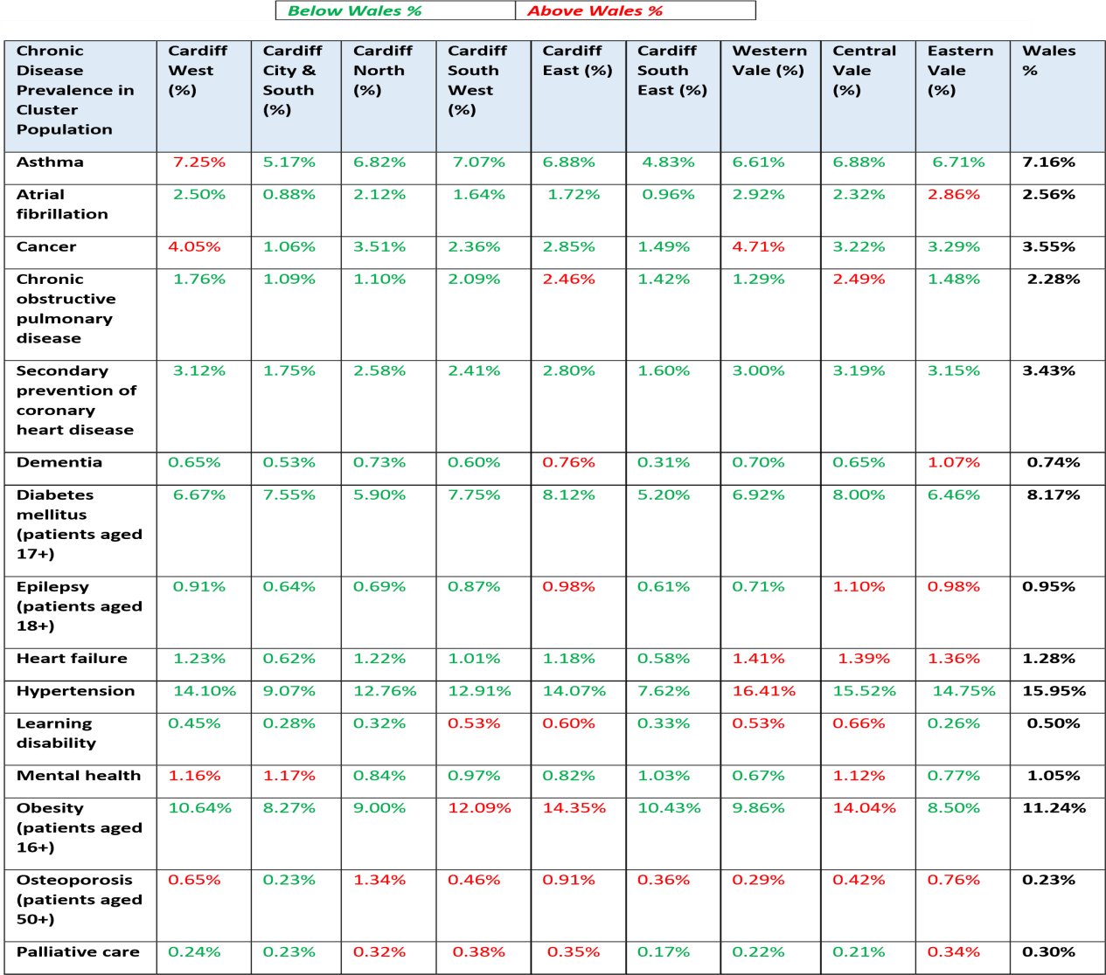

Chronic  Disease  Prevalence in  Cluster  Population | Cardiff  West  (%) | Cardiff  City &  South  (%) | Cardiff  North  (%) | Cardiff  South  West  (%) | Cardiff  East (%) | Cardiff  South  East (%) | Western  Vale (%) | Central  Vale  (%) | Eastern  Vale  (%) | Wales %
Rheumatoid  Arthritis  (Patients aged  16+) | 0.77% | 0.77% | 0.67% | 0.58% | 0.86% | 0.43% | 0.73% | 0.81% | 0.66% | 0.76%
Stroke and transient ischaemic attack | 2.18% | 1.07% | 1.78% | 1.60% | 1.65% | 1.04% | 2.70% | 1.99% | 2.09% | 2.18%
Source – Digital Health and Care Wales, Primary Care Information Portal 2023/2024

Stroke
Around 60% of people who experience strokes will also experience some form of visual impairment immediately after their stroke. There are national guidelines recommending specialist vision assessment for stroke survivors who have a suspected visual problem.
It is estimated that 2,100 people have a long-standing health condition after experiencing a stroke.
This equates to approximately 9,300 patients in Cardiff and Vale who may experience some form of visual impairment as a result of their stroke.
Dementia
Prevalence estimates suggest that over 1 million people in the UK have some form of dementia. Prevalence of sight loss is higher among people with dementia, especially those living in care homes. In Cardiff and the Vale, it is estimated that 6,880 people are living with dementia. Within this group it is estimated that 2,460 people have dementia and vision impairment.
Learning disabilities
People with learning disabilities are 10 times more likely to experience sight loss than the general population. In the CAV UHB it is estimated that 580 adults have a learning disability and partial sight. A further 170 adults have a learning disability and blindness.
Hearing impairment
In the CAV UHB it is estimated that 45,800 people have a moderate or severe hearing impairment, and 1,000 people have a profound hearing impairment.
Dual sensory loss
An estimated 2,760 people are living with some degree of dual sensory loss in the CAV UHB. Of these people, it is estimated that 1,080 are living with severe dual sensory loss.
Falls
Falls are more common, and are more likely to have serious outcomes, amongst older people. In some cases, falls can lead to serious medical problems and a range of adverse outcomes for health and wellbeing.

Diabetes
Diabetes can cause several health complications affecting the eyes. Diabetic retinopathy, cataract, and glaucoma are all conditions linked to diabetes. There may be an increased risk of other eye conditions with a diabetes diagnoses including those that affect the cornea, eye muscle problems or retinal vessel occlusion (a blocked retinal blood vessel). In Cardiff and Vale 6.85% of the population has Diabetes (37,000 people).

Hypertension
Hypertension can raise the risk of developing glaucoma and macular degeneration, both of which can impair vision. Managing blood pressure through a healthy lifestyle and regular medication is crucial to prevent these complications. Regular eye exams are also important for early detection and treatment. Prevalence data highlights that 12.81% (69,000) of the population are living with Hypertension.

Sight Loss in Cardiff and Vale
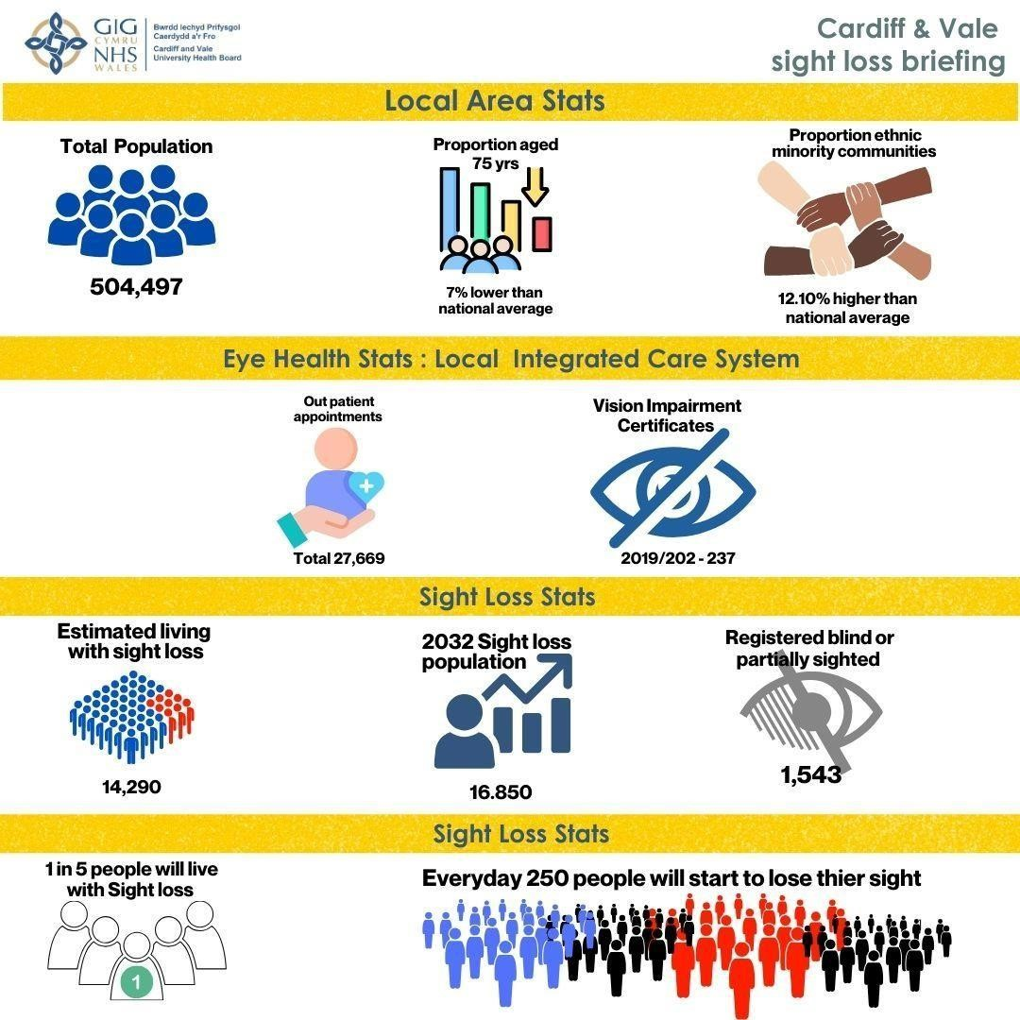

Source
:

RNIB Sight Loss Data Tool Version

5.2

Date created:

March 2023

People living with sight loss in Cardiff and Vale

Of the estimated 14,290 people living with sight loss, this includes around:
- 9,210 people living with mild sight loss.
- 3,190 people living with moderate sight loss.
- 1,880 people living with severe sight loss.

The estimated prevalence of sight loss in Cardiff and Vale UHB is 2.90% which is lower the average for Wales (3.8%). This estimate is based on age and gender. A range of other factors could potentially impact on the prevalence of sight loss in the local area including higher proportions of people from ethnic minority communities, the number of people in low-income households and access to healthcare services.
Future projections
By 2032 there are expected to be 16,850 people in the CAV UHB living with sight loss, an estimated increase of 18% over the next decade.

Table 8: Estimated prevalence of sight loss over time, by severity.
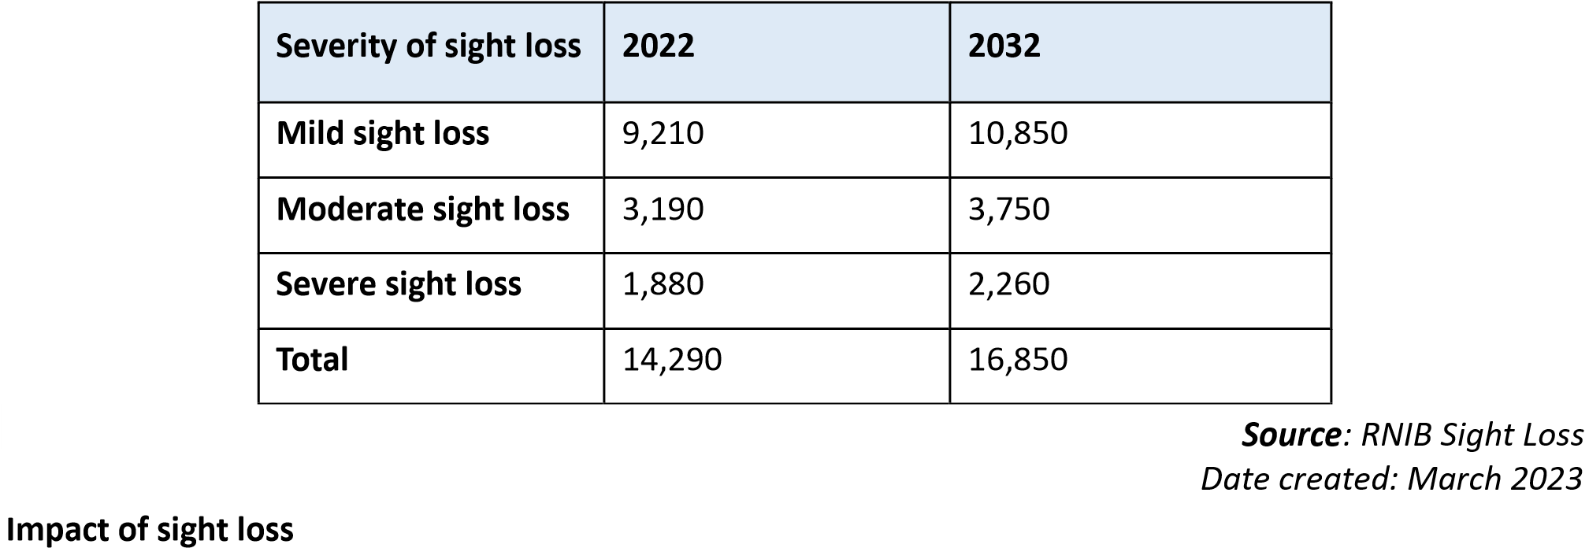

According to the RNIB (2023) many visually impaired children are educated in inclusive (mainstream) education, but many children are being deprived of specialist support due to variation in service provision, and learning materials and exams are not consistently made available in alternative formats. This results in lower educational attainment compared to children without a special educational need. Around half of children with a vision impairment will have additional disabilities and additional special educational needs.
People with sight loss have a lower employment rate compared to the UK average. The majority of blind and partially sighted say that they feel that their sight loss has stopped them reaching their full potential at work.
Many blind and partially sighted people have reduced opportunities to do the things they would like to take part in. This includes general leisure pursuits, and things like sports and fitness, civic and cultural engagement, and access to volunteering opportunities.
Many blind and partially sighted people are also living with other health problems or disabilities. Sight loss is linked to age, and as we get older, people are more likely to be living with many health conditions at the same time.
In Cardiff and Vale UHB, it is estimated that:
- 1,780 people with sight loss aged over 65 experience a fall per year.
- Of these falls, 840 are directly attributable to sight loss.
- 140 people aged over 65 with sight loss experience a severe fall per year (here, a severe fall is defined as a fall that results in hospital admission through A&E).
- Of these severe falls, 70 are directly attributable to sight loss.

Other population characteristics in Cardiff and Vale - Homeless People, Prisoners, and Travellers

Cardiff and Vale UHB host the Cardiff and Vale Inclusion Service to address the needs of patients who do not or may have difficulty in accessing traditional models of healthcare. The concept of inclusion health typically encompasses people experiencing homelessness, vulnerable migrants, sex workers, Gypsies, and Travellers and those in contact with the criminal justice service. These marginalised populations share common overlapping risk factors for poor health that include poverty, adverse life experiences, discrimination, violence, and complex trauma. These risk factors, accompanied with multiple barriers and negative experiences when attempting to access health and care services, result in significantly poorer health outcomes, putting those affected beyond the extreme end of the gradient of health inequalities.

The impact of this extreme structural exclusion impacts on the ways in which health inclusion groups try to access care, often presenting reactively to urgent and emergency care services with complex presentations involving multiple, chronic conditions that are poorly controlled. This creates significant costs for public services, in addition to the human costs for individuals and their families. Yet inequitable access to healthcare and poor health outcomes are not inevitable or unalterable and can be prevented, or mitigated, by health and social care services working in partnership to provide tailored care that addresses the patient's total health, care, and social needs. Health, and its partners, have both a fundamental role and moral obligation to develop and invest in inclusion health interventions.
The Impact of Limited Access on Eye Care

For these groups, the lack of access to eye care services can have severe consequences. Vision problems can go undetected and untreated, leading to a decline in overall quality of life, increased dependency on others, and, in some cases, complete loss of sight. Additionally, poor vision can impact their ability to engage in daily activities, maintain employment, or, in the case of prisoners, successfully reintegrate into society upon release.

Table 9: A table describing the population totals and trends for health excluded populations in Cardiff and the Vale of Glamorgan.
Population | Total for CAV UHB | Future Trend
People experiencing homelessness | 2,265 households on statutory assessment (for all of 2020/21); currently 1,600 estimated to be experiencing core homelessness | Stable, predicted to gradually decline
People engaged in sex work | 100-1,000 estimated (note the wide range reflects  methodology and the difficulty of estimating this group) | Unknown, estimated to be stable
Vulnerable migrants | 1,300-1,500 asylum seekers currently; 40-50 resettled refugees per year; unknown number of undocumented  migrants | Increase for asylum seekers and refugees (reflecting Ukraine conflict); unknown for undocumented migrants
People recently released from prison | Currently 1,967 released under licensed supervision in Cardiff | Stable
& Vale from the National
Probation service
Gypsy and Traveler communities | 524 on 2011 census, 227 caravans on latest count | Stable, gradual increase in Cardiff
Total | 5,500-6,700 | Overall stable
Source: Cardiff and Vale Health Inclusion Service, Health Inclusion Report Version 1.4 October 2022

Homeless People

Homeless individuals often struggle with accessing healthcare due to various socio-economic and logistical barriers. Without a fixed address, they may be unable to register with a general practitioner (GP) or access an optometry practice, which limits their access to free General Ophthalmic Services (GOS) sight tests. Additionally, financial constraints and competing priorities, such as finding shelter and food, often mean that eye care is not seen as an immediate need.

Furthermore, many homeless individuals suffer from chronic health conditions, including diabetes, substance use disorders, and mental health issues, all of which can impact eye health. Without regular screening, conditions like diabetic retinopathy, glaucoma, and cataracts may go undiagnosed and untreated, leading to irreversible vision loss.

Adult Prisoners in HMP Cardiff

Prisoners also face challenges in accessing timely and appropriate eye care. Although healthcare services, including optometry, are available in many prisons, there can be long waiting times and limited resources. Prisoners may have difficulty getting appointments due to institutional bureaucracy, staff shortages, or a lack of prioritisation of eye health within prison healthcare systems.

Moreover, prisoners often experience higher rates of underlying health conditions, including diabetes and hypertension, both of which can have serious consequences for vision if not managed properly. Regular eye tests and screening for sight-threatening conditions may not be as easily accessible in prison settings, putting inmates at increased risk of undiagnosed and untreated eye diseases.

Traveller Community

The Traveller community, which includes Gypsies, Roma, and other nomadic groups, often faces additional obstacles in accessing sight care services due to their mobility and difficulty in registering with healthcare providers. Many Travellers move frequently, which disrupts the continuity of care and makes it challenging to schedule and attend regular eye tests. Additionally, there may be a lack of awareness or trust in mainstream healthcare services, as well as cultural and language barriers that further hinder access.

For individuals within the Traveller community who have chronic conditions like diabetes, regular screening for diabetic retinopathy may be inconsistent or unavailable due to their transient lifestyle. This lack of continuous monitoring increases the risk of undetected eye conditions leading to significant visual impairment.

Vision Rehabilitation in Cardiff and Vale of Glamorgan
Vision rehabilitation is a critical service for individuals experiencing sight loss, mandated under the Social Services and Wellbeing (Wales) Act 2014. When someone is certified as visually impaired, they are entitled to a specialist sensory assessment to determine their needs for support, separate from general care assessments. The recent revision of the CVI(W) emphasises this entitlement, reinforcing the essential role of a Vision Rehabilitation Specialist (VRS) in supporting individuals with sight loss.
VRSs play a key role in helping individuals navigate the challenges of daily life. They assess the risks associated with vision impairment and provide tailored solutions, including training, equipment, and environmental modifications. These interventions help individuals retain their independence and confidence, reducing the need for long-term social care, minimising hospital admissions, and improving overall quality of life.
Despite the importance of vision rehabilitation, the Wales Council of the Blind (2024) highlights a shortage of VRSs in Cardiff and the Vale of Glamorgan. Cardiff requires 5.1 full-time equivalent (FTE) VRSs but currently has only 1 FTE VRS. A trainee VRS, funded by Sight Cymru, is in training to help address this gap. Similarly, Vale of Glamorgan needs 1.9 FTE VRSs but currently has just 1 FTE VRS, with plans to recruit a trainee by September 2025.
In Cardiff, the VRS service is integrated with Sight Life, a third-sector organisation that provides initial advice, promotes independence, and refers individuals to social services for further assessments. The VRS is contracted through Sight Cymru, which manages professional support, while the Council oversees workload allocation and monitoring. In the Vale of Glamorgan, Sight Cymru provides the sole VRS, working in partnership with the local authority.
Financial analysis from the Office of Public Management (2017) demonstrates the cost-effectiveness of vision rehabilitation. Each referral saves an estimated £4,487 by reducing reliance on social care and healthcare services. Additionally, falls among older people cost NHS Wales £2.3 billion annually, with half of these incidents linked to sight loss. Early rehabilitation interventions that focus on safe movement at home and outdoors can significantly reduce these falls, cutting healthcare costs (College of Optometrists, 2020).
Third-sector organisations play a vital role in supporting individuals while they wait for treatment. Eye Care Liaison Officers (ECLOs), embedded within clinics, facilitate referrals to rehabilitation services. Additionally, low-vision optometrists identify patients who may need support and direct them to the appropriate services. More information on third-sector support in the Cardiff and Vale University Health Board area is available at Wales Council of the Blind.

Current Service Provision

Cardiff and Vale Homeless Service Ty Ephraim, Cardiff.

An Optometrist currently volunteers at one Cardiff Council Homeless site and provides bi-monthly sessions to residents as well as walk ins. There are ongoing discussions between Cardiff and Vale UHB and Welsh Government to launch a homeless service in Cardiff and Vale. This new homeless service would align to WGOS in the same way that other static and mobile optometry providers do.

HMP Cardiff Optometry Service

HMP Cardiff is a remand centre (Category B) covering the courts of south-east Wales with space for up to 800 men. In December 2024, following a successful procurement exercise, a contract was awarded to the existing prison Optometry service provider for a period of two years. The provider, ‘The Prison Opticians Company’ provides 2 sessions per calendar month at HMP Cardiff and operates for 48 weeks per year and sees on average 10 patients per week.

Wales General Ophthalmic Services Provision in Cardiff and Vale
The introduction of Wales General Ophthalmic Services (WGOS) on 20 October 2023, saw the unification of the service architecture, governance, and evaluation across Wales to provide care closer to home and ensure that people only attend secondary care when required. WGOS is a tiered Service comprising of the following:

WGOS 1: | Sight test and patient management plan.
WGOS 2: | Made up of three bands:  - Band 1 – Acute eye care and accept referrals from another healthcare professional.  - Band 2 - Further examination to inform or prevent a referral.  - Band 3 - Follow up to Band 1 and Post Cataract Assessment.
WGOS 3: | Replaces the existing Low Vision Service, assessing those with low vision and providing low vision aids where appropriate, as well as holistically supporting the patient and providing rehabilitative support. This Service also allows Optometrists, listed to provide. WGOS 1,2 and 3; to provide Certification of Vision Impairment in Primary Care for patients whose leading cause of vision loss is Dry Age-Related Macular Degeneration
WGOS 4: | Service where patients who would previously have been referred to/or managed in the Hospital Eye Service (HES) instead remain in primary care for further enhanced assessment as part of an agreed referral refinement or monitoring pathway.
WGOS 5: | Provision of eye care services in primary care that require an independent prescriber Optometrist/OMP to manage, treat and monitor patients to prevent onward referral.  Optical vouchers: provision of optical appliances.

Cardiff and Vale UHB WGOS 1-5 Provision Levels January 2025

Static Optometry Practices: 59 (including Cardiff University site) Mobile Providers: 11 providers offering domiciliary services.

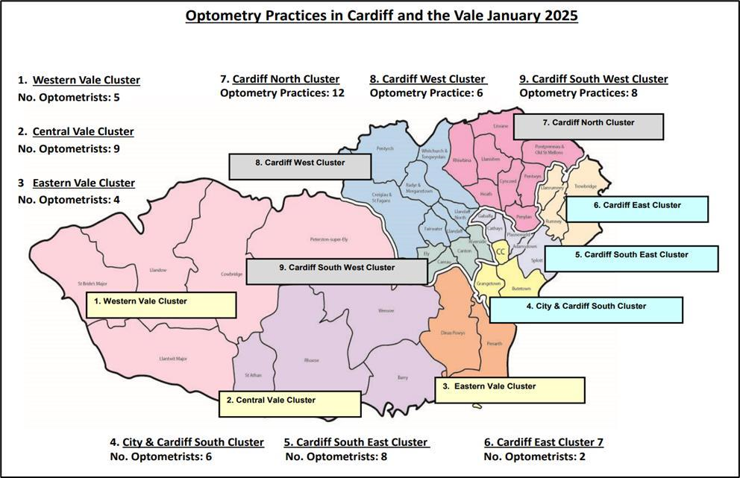

WGOS Services within primary care are currently provided by the following:

Table 10: Moble Providers in Cardiff and Vale.

Cluster Base | Practice Name | Lead Practitioner | Tel No
NA | The Outside Clinic | Nick Wingate /  Matthew Burford  Co7a4150@wales.nhs.uk  nick.wingate@wales.nhs.uk  matthew.burford@wales.nhs.uk | 01793 648688
Central Vale | Specsavers  Home Visits | Jason Scaife  Djvp.catvog.uk@specsavers.com | 01446 508128
Central Vale | Jones & Jones | Adrian Jones  Co7a4476@wales.nhs.uk | 01446 400015
Western Vale | Home Eye Care Wales | Lisa Evans  Lisa.Evans43@wales.nhs.uk | 07756 420965
Eastern Vale | Home Optika | Hector Marcus  homeoptika@gmail.com /  Hector.marcos@wales.nhs.uk | 07743 847807
City & south | Darlington Opticians | Philip Darlington  Philip.Darlington@wales.nhs.uk | 07882 200983
City & south | Optical Healthcare Ltd | Paul McGinley  Opticall@hotmail.co.uk | NA
Cardiff West | JR Lane Opticians | Jason Lane  jrlaneopticains@yahoo.co.uk | 02920 568885
Cardiff North | Home Vision Visits | Umayr Ali  Homevisionvisits@outlook.com | 02922 520453
Cardiff East | @Home Healthcare | Matthew Barefoot  info@home-hub.co.uk | 07592 195453

Table 11: Static Providers in Cardiff and Vale.
Cluster | Static Practices  (including Cardiff University) | Address |  | Postcode
Cardiff East | Julian Davies Opticians, St  Mellons | 14 Crickhowell Road | St Mellons | CF3 0EF
Cardiff East | Stamford Optical | 10 Countisbury Avenue | Llanrumney | CF3 5RN
Cardiff  North | Beresford Opticians | 37 Wellfield Road | Roath | CF24 3PA
Cardiff  North | Julian Davies Opticians,  Llanedeyrn | Unit 3, Lewis Court,  Maelfa | Llanedeyrn | CF23 9PL
Cardiff  North | Kingman Optometrists | 3a Beulah Road | Rhiwbina | CF14 6LT
Cardiff  North | Medi-Optics Opticians, Llanishen | 3 Thornhill Road | Llanishen | CF14 6PD
Cardiff  North | Medi-Optics Opticians, Roath | 12 Maryport Road | Roath Park | CF23 5JX
Cardiff  North | Parish Opticians | 101 Caerphilly Road | Birchgrove | CF14 4AE
Cardiff  North | Pearce & Blackmore, Llanishen | Church School House,  2Heol Hir | Llanishen | CF14 5AE
Cardiff  North | Pearce & Blackmore, Pentwyn | St Davids Medical  Centre, Pentwyn Drive | Pentwyn | CF23 7SD
Cardiff  North | Robert E Lloyd Ltd. | 310 Heathwood Road | Birchgrove | CF14 4HT
Cardiff  North | Specsavers, Llanishen | Unit 1B Ty Glas Retail  Park | Llanishen | CF14 5DU
Cardiff  North | Stewart Greenberg Opticians | 59 Wellfield Road | Roath | CF24 3PA
Cardiff  South East | Cardiff University Eye Clinic,  School of Optometry | Maindy Road | Cathays | CF24 4LU
Cardiff  South East | Chalmers Opticians | 36 Albany Road | Roath | CF24 3RQ
Cardiff  South East | City Eyecare | Cardiff Royal Infirmary,  Newport Road | Roath | CF24 0SZ
Cardiff  South East | Direct Eyecare Opticians | 12 Clifton Street | Splott | CF24 1PX
Cardiff  South East | Eye 2 Eye Opticians | 82 Crwys Road | Cathays | CF24 4NP
Cardiff  South East | RN Roberts Optometrists | 280-282 North Road | Gabalfa | CF14 3BN
Cardiff  South East | Specsavers, Albany Rd | 59 Albany Road | Roath | CF24 3LL
Cardiff  South East | Vision Express, Tesco Western  Avenue | Excelsior Drive | Gabalfa | CF14 3AT
Cardiff  South West | A&C Opticians | 182 Cowbridge Road  East | Ely | CF11 9NE
Cardiff  South West | Canton Optical Ltd. | 232 Cowbridge Rd East | Canton | CF5 1GY
Cardiff  South West | Costco Optical | Capital Retail Park | Leckwith | CF11 8AZ
Cardiff  South West | iCare Opticians | 253 Cowbridge Road  West | Ely | CF5 5TD
Cardiff  South West | Marks & Spencer Opticians,  Culverhouse Cross | Copthorne Way,  CulverHouse Cross | Ely | CF5 6YX
Cardiff  South West | Perfect Vision | 100 Cowbridge Road  East | Canton | CF11 9DX
Cardiff  South West | Specsavers, Leckwith | Pod 2, Unit 2, Capitol  Shopping Park | Leckwith | CF11 8AZ
Cardiff  South West | Vision Express, Culverhouse Cross | Culverhouse Cross | Ely | CF5 6XQ
Cardiff  West | Asda Vision Centre | Longwood Drive | Coryton | CF14 7EW
Cardiff  West | Fairwater Green Opticians | 3 Chesnut Road | Fairwater | CF5 3HR
Cardiff  West | J R Lane Ltd. | 96b Station Road | Llandaff  North | CF14 2FG
Cardiff  West | Julian Davies Opticians,  Whitchurch | 32 Merthyr Road | Whitchurch | CF14 1DD
Cardiff  West | Julian Davies Opticians, Llandaff | 52 High Street | Llandaff | CF5 2DZ
Cardiff  West | Radyr Eyecare Ltd. | 14 Station Road | Radyr | CF15 8AA
City &  South | Boots Opticians | 36 Queen Street | Cardiff | CF10 2RG
City &  South | Darlington Opticians | 144 Clare Road | Grangetown | CF11 6RW
City &  South | Direct Eyecare Opticians | 42a Corporation Road | Grangetown | CF11 7AU
City &  South | John Lewis Opticians | John Lewis Stores | Cardiff | CF10 1EG
City &  South | Specsavers, Queen Street | 90-92 Queen Street | Cardiff | CF10 2GR
City &  South | Vision Express, St Davids | 22 Cathedral Walk, St  Davids Centre | Cardiff | CF10 2DS
Central Vale | Annette Dobbs Eyecare | 40 Tynewydd Road | Barry | CF62 8AZ
Central Vale | Arbuthnot Opticians, Barry | 6 Broad Street | Barry | CF62 7XP
Central Vale | Asda Opticians Barry | Fford Y Mileniwm | Barry | CF62 5AT
Central Vale | Barry Eye Centre | 87 Holton Road | Barry | CF63 4HG
Central Vale | Jones & Jones Optometrists | 70 High Street | Barry | CF62 7DZ
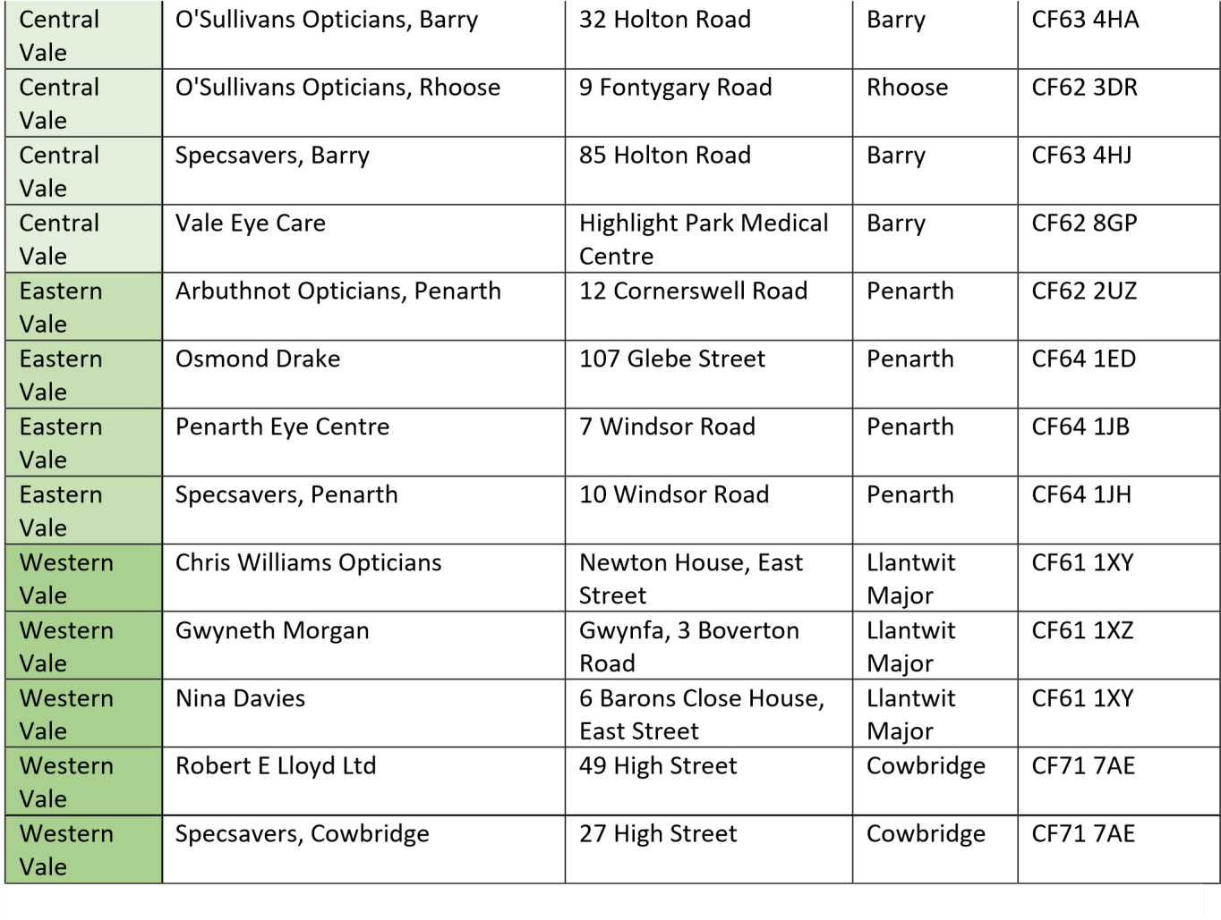
Table 12: WGOS 3 Low Vision Service Wales providers across Cardiff and the Vale.
Cluster | Practice | Address |  | Postcode
Cardiff East | Julian Davies Opticians, St Mellons | 14 Crickhowell Road | St Mellons | CF3 0EF
Cardiff East | Stamford Optical | 10 Countisbury  Avenue | Llanrumney | CF3 5SJ
Cardiff  North | Julian Davies Opticians,  Llanedeyrn | Unit 3, Lewis Court,  Maelfa, Llanedeyrn | Llanedeyrn | CF23 9PL
Cardiff  North | Kingman Opticians | 3A Beulah Road,  Rhiwbina | Rhiwbina | CF14 6LT
Cardiff  North | Parish Opticians | 101 Caerphilly Road,  Birchgrove | Birchgrove | CF14 4AE
Cardiff  North | Pearce & Blackmore, Llanishen | Church School House,  2 Heol Hir | Llanishen | CF14 5AE
Cardiff  North | Pearce & Blackmore, Pentwyn | St David Medical  Centre | Pentwyn | CF23 7SD
Cardiff  North | Specsavers, Llanishen | Unit 1B Ty Glas Retail  Park | Llanishen | CF14 5DU
Cardiff  South East | Cardiff University Eye Clinic,  School of Optometry | Maindy Road | Cathays | CF24 4HQ
Cardiff  South East | Chalmers Opticians | 34-36 Albany Road | Cardiff | CF24 3RQ
Cardiff  South East | RN Roberts Optometrists | 282 North Road | Gabalfa | CF14 3BN
Cardiff  South East | Specsavers, Albany Road | 59 Albany Road | Roath | CF24 3LL
Cardiff  South West | Canton Optical Ltd | 232 Cowbridge Road  East | Canton | CF5 1GY
Cardiff  South West | iCare Opticians | 253 Cowbridge Road  West | Ely | CF5 5TD
Cardiff  South West | Perfect Vision | 100 Cowbridge Road  East | Canton | CF11 9DX
Cardiff  West | Fairwater Green Opticians | 3 Chesnut Road | Fairwater | CF5 3HR
Cardiff  West | Julian Davies Opticians,  Whitchurch | 32 Merthyr Road | Whitchurch | CF14 1DH
Cardiff  West | Julian Davies Opticians, Llandaff | 52 High Street | Llandaff | CF5 2DZ
Cardiff  West | Radyr Eyecare Ltd | 14 Station Road | Radyr | CF15 8AA
City &  South | Specsavers, Queen Street | 90-92 Queen Street | Cardiff | CF10 2GR
Central Vale | Annette Dobbs Eyecare | 40 Tynewydd Road | Barry | CF62 8AZ
Central Vale | Arbuthnot Opticians, Barry | 6 Broad Street | Barry | CF62 7XP
Central Vale | Jones & Jones Optometrists | 70 High Street | Barry | CF62 7DZ
Central Vale | O'Sullivan's Opticians, Barry | 32 Holton Road | Barry | CF63 4HD
Central Vale | O'Sullivan's Opticians, Rhoose | 9 Fontygary Road | Rhoose | CF62 3DR
Eastern  Vale | Arbuthnot Opticians, Penarth | 12 Cornerswell Road | Penarth | CF64 2UZ
Eastern  Vale | Osmond Drake Opticians | 107 Glebe Street | Penarth | CF64 1ED
Eastern  Vale | Specsavers, Penarth | 10 Windsor Road | Penarth | CF64 1JH
Western  Vale | Gwyneth Morgan | Gwynfa, 3 Boverton  Road | Llantwit  Major | CF61 1XZ
Western  Vale | Nina Davies | 6 Barons Close House,  East Street | Llantwit  Major | CF61 1XY
Western  Vale | Specsavers, Cowbridge | 27 High Street | Cowbridge | CF71 7AE

Table 13: WGOS 4 Glaucoma Filtering and Glaucoma Monitoring providers across Cardiff and the Vale.
Cluster | Practice Name | WGOS 4 GF/GM  Provider(s) | Address |  | Post Code
Cardiff North | Kingman Opticians | Emily Kingman | 3a Beulah Road | Rhiwbina | CF14 6LT
Cardiff North | Medi-Optics Opticians | Dr David Woolf | 12 Maryport Road | Roath | CF23 5JX
Cardiff North | Robert E Lloyd | David Lloyd | 310 Heathwood Road | Birchgrove | CF14 4HT
Cardiff  South East | Cardiff University  Eye Clinic | Gavin Howells  Geraint Jones  Angela Whitaker  Grant Robinson | Maindy Road | Cathays | CF24 4LU
Cardiff  South East | Direct Eyecare | Pervaze Jan | 42a Corporation Road | Canton | CF11 7AU
City & South | Direct Eyecare | Pervaze Jan | 12 Clifton Street, | Cardiff | CF24 1PX
Central Vale | Jones & Jones | Dr Adrian Jones | 70 High Street, | Barry | CF64 2WF
Western  Vale | Chris Williams Optometrist | Chris Williams | Newton House, East  Street | Llantwit Major | CF61 1XY
Western  Vale | Nina Davies | Nina Davies | 6 Barons Close House,  East Street | Llantwit Major | CF61 1XY
Western  Vale | Robert E Lloyd | David Lloyd | 49 High Street | Cowbridge | CF71 7AE
Western  Vale | Specsavers, Cowbridge | Adam Thomas | 27 High Street | Cowbridge | CF71 7AE

Table 14: WGOS 5 IPOS Urgent providers across Cardiff and Vale.
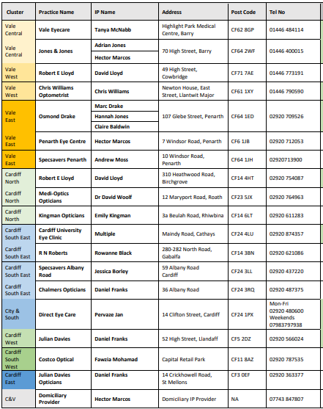

Table 15: Implementation of the New Optometry Contract - WGOS Progress.
WGOS | Timescale | Progress  (*in accordance with current WGOS pathways; these are likely to increase in scope)
WGOS 1,2 & 3 | 20th October 2023 | Implemented
WGOS 4  Glaucoma Filtering  Glaucoma Monitoring  Medical Retina Filtering  Medical Retina Monitoring | 7th October 2024  4th November 2024  February 2025 (phased)  Spring 2025 (phased) | Implemented  Implemented  Lauch February 2025  Lauch TBC once Regional Coordinator recruited
WGOS 5  Urgent Independent  Prescribing Service (IPOS) | 20th January 2024 | Implemented

Table 16: Number of WGOS activity claims 2024 -2025 (to date).
Activity | WGOS1 | WGOS2 | WGOS3 | WGOS4 | WGOS5 | Total
Apr-24 | 10,971 | 4,542 | 69 | 249 | 488 | 16,319
May-24 | 11,082 | 4,531 | 66 | 262 | 506 | 16,447
Jun-24 | 11,168 | 5,004 | 55 | 195 | 602 | 17,024
Jul-24 | 11,372 | 5,030 | 121 | 231 | 542 | 17,296
Aug-24 | 10,575 | 4,880 | 107 | 164 | 572 | 16,298
Sep-24 | 10,438 | 4,422 | 75 | 156 | 454 | 15,545
Oct-24 | 10,345 | 4,328 | 63 | 229 | 461 | 15,426
Nov-24 | 11,800 | 5,327 | 53 | 172 | 519 | 17,871
Dec-24 | 11,681 | 5,087 | 117 | 134 | 595 | 17,614
Jan-25 | 8,232 | 3,714 | 61 | 48 | 412 | 12,467
Total | 107,664 | 46,865 | 787 | 1,840 | 5,151 | 162,307
Source -NWSSP monthly activity claimed reports 2024/2025.

Accelerated Cluster Development/Optometry Collaboratives

Primary care clusters where primary care services are coordinated on a geographical locality basis, bring together the collaborative leads from each contractor profession (Optometry, Pharmacy, GMS, and Dentistry) and from other sectors such as Allied Health Professionals and Third Sector operators within a cluster area. Clusters are allocated budgets which they can use to improve service provision to local populations through a variety of means. Clusters also have a key role in supporting local health needs assessments, allocating appropriate resources, and forecasting the potential future demand on primary care.

All optometry contractors must attend at least four meetings of the relevant optometry collaborative in each financial year and vote in the election of the optometric lead of the relevant optometry collaborative. For the purposes of complying with contractual requirements, each contractor may appoint an individual who is an optometrist, an ophthalmic medical practitioner, or a dispensing optician to act on the contractor’s behalf. This requirement is mandatory and is set out to all contractors in 2023 No. 1053 (W. 179) The National Health Service (Ophthalmic Services) (Wales) Regulations 2023.

The Primary Care Collaborative Optometric Lead will play a critical role in shaping the engagement and providing leadership and representation for optometric practices within the Primary Care Cluster. The lead will work closely with optometric practices in the Primary Care Cluster, identifying areas of concern and escalating issues (if required) through the appropriate channels, discussing service change and communicating with practices around the delivery of optometry services, which are aligned to national priorities and specifically those of the Primary Care Cluster. The Collaborative Lead will be representing the professional collaborative and therefore will share their views at the Primary Care Cluster as well as sharing the views from the Primary Care Cluster back with the professional Collaborative.

At present, CAV UHB have 7 of the 9 collaborative lead roles filled, there are currently vacancies in both Central Vale Cluster and Cardiff East Cluster. The attendance at these meetings is improving, with the Health Board taking a non-punitive approach to facilitate attendance. However, due to continued non-compliance in certain clusters an All-Wales Breach Process has been prepared and agreed by the All-Wales Eye Care Wales Committee (ECWC, Jan 2025) in readiness for application from April 2025 as well maintaining regular reminders and contact with the non-engaging contractors.

Table 17: Collaborative Meeting Attendance 2024/2025.
Cluster | Q1 Attendance  (practice engagement) | Q2 Attendance  (practice engagement) | Q3 Attendance  (practice engagement)
Central Vale | 78% | 100% | 100%
Western Vale | 100% | 100% | 100%
Eastern Vale | 100% | 100% | 100%
City & South | 67% | 83% | 83%
Cardiff east | 100% | 0% | 50%
Cardiff South East | 50% | 87.5% | 100%
Cardiff North | 75% | 92% | 67%
Cardiff west | 83% | 83% | 67%
Cardiff South West | 75% | 75% | 12%

Demand and unmet need for WGOS.
Access to data is limited currently, therefore this section will evolve in future versions of the EHNA as additional WGOS pathways are implemented to track demand and prevalence.
Table 18: Provision of WGOS providers per cluster as of January 2025.
Optometry Practices per cluster providing WGOS | WGOS 1 | WGOS 2 | WGOS 3 | WGOS 4 | WGOS 5
Central Vale | 8 | 8 | 5 | 2 | 2
Western Vale | 5 | 5 | 3 | 4 | 2
Eastern Vale | 4 | 4 | 3 | NA | 3
City & South | 6 | 6 | 1 | 1 | 1
Cardiff East | 2 | 2 | 2 | 1 | NA
Cardiff South East | 8 | 8 | 4 | 2 | 4
Cardiff North | 11 | 11 | 6 | 3 | 3
Cardiff West | 6 | 6 | 5 | NA | 1
Cardiff South West | 8 | 8 | 3 | NA | 2
Mobile/Domiciliary providers | 11 | 11 | 3 | NA | 1
Practice (static and mobile)  Total | 70 | 70 | 35 | 13 | 16

Next steps
- WGOS4 Glaucoma Filtering Secondary Care Long-Wait patients.
Collaboration between Primary Care and Secondary Care to address long-wait patients (over 104 weeks) on the Glaucoma Filtering Secondary Care waiting list. As part of this effort to reduce the list, an urgent waiting list initiative will see eligible patients seen in Primary Care by WGOS4 Glaucoma Filtering providers from February and will continue until May 2025.
- Implementation of WGOS4 Medical Retina
25 providers (across 28 sites) in CAV will be providing WGOS4 Medical Retina services (filtering, monitoring, and Hydroxychloroquine (HCQ) monitoring) by the end of February 2025. Access to data is limited currently, therefore this section will evolve in future iterations of the EHNA as additional WGOS pathways are implemented to track demand and prevalence.
Currently, as part of the Transition Plan 2024, Cardiff University provide Medical Retina services ((filtering, monitoring, and Hydroxychloroquine monitoring) to Secondary Care patients. This service will cease once WGOS4 Medical Retina in Primary Care is implemented, and Cardiff University will become a Primary Care provider in line with all other contractors.
• Recruitment of a WGOS Regional Coordinator (over Cardiff and Vale, Aneurin Bevan, and Cwm Taf Morgannwg UHB)
Commencing in April 2025, as part of Transformation funding, the Welsh Government has stipulated that Health Boards appoint a Regional Coordinator for South East Wales. This role will be instrumental in streamlining patient pathways, ensuring the efficient and timely transfer of patients from secondary to primary care. As this role evolves, data will be made available on the transfer of patients from secondary to primary care to receive services under WGOS pathways closer to home.

Workforce data

Access to data is limited currently, therefore this section will evolve in future versions as more data is readily available. Currently, there is no dedicated workforce planning tool available for Optometry. However, Health Education and Improvement Wales (HEIW) has plans to develop such a tool in the future to support Health Board’s with workforce planning and service delivery.

As further WGOS pathways evolve and are implemented in Primary Care, Cardiff and Vale UHB, in collaboration with HEIW will provide opportunities for providers to complete advanced qualifications to support WGOS delivery in Cardiff and Vale. National workforce tools will be developed by NWSSP to enable the Health Board to collate and monitor this data to aid service planning.

Table 19 & 20: Summary of workforce with advanced qualifications.
 | Medical Retina  Filtering (MRF) | Medical Retina  Monitoring  (MRM) | HCQ  Monitoring | Glaucoma  Filtering (GF) |  | Glaucoma Monitoring (GM)
Professional  Certificate  Glaucoma | N | N | N | X |  | Y
Higher Certificate  Glaucoma | N | N | N | Y |  | Y
Diploma Glaucoma | N | N | N | Y |  | Y
Professional  Certificate Medical Retina | Y | Y | Y | N |  | N
Higher Certificate Medical Retina | Y | Y | Y | N |  | N
N | Not Relevant to the service
Y | Qualification enables participation in the service
X | Qualification does not enable participating in the service

Cardiff and Vale  UHB | Medical Retina Filtering (MRF) | Medical Retina  Monitoring  (MRM) | HCQ Monitoring | Glaucoma  Filtering (GF) | Glaucoma  Monitoring  (GM) | Independent Prescribing
Number of individuals on the Performers list who hold the qualification | 69 | 69 | 69 | 16 | 68 | 16
Source: NWSSP

Welsh language
Access to data is limited currently, therefore this section will evolve as more data is readily available to monitor contractual compliance.
The Welsh Language provisions in the National Health Service (Ophthalmic Services) (Wales) Regulations 2023 require contractors providing primary ophthalmic services to:
- Notify the Local Health Board if they offer services in Welsh.
- Provide Welsh versions of documents or forms supplied by the Local Health Board for public use.
- Ensure bilingual signage, with text in both English and Welsh.
- Use the Local Health Board’s translation service for signage if needed.
- Encourage Welsh-speaking staff to wear a badge indicating their ability to speak Welsh.
- Promote Welsh language awareness by encouraging staff to attend training on the language, its history, and its role in Welsh culture.
- Record language preferences of patients to facilitate service delivery in their chosen language.

*NOTE The providers listed within this document was accurate at the time the report was written.

