Patients Name……………………………………..

Date……………………………………………………

Dietitian………………………………………………

NET Nurse………………………………………………

Telephone…………………………………………...
A Guide to Taking Pancreatic Enzyme Supplements

Department of Nutrition and Dietetics

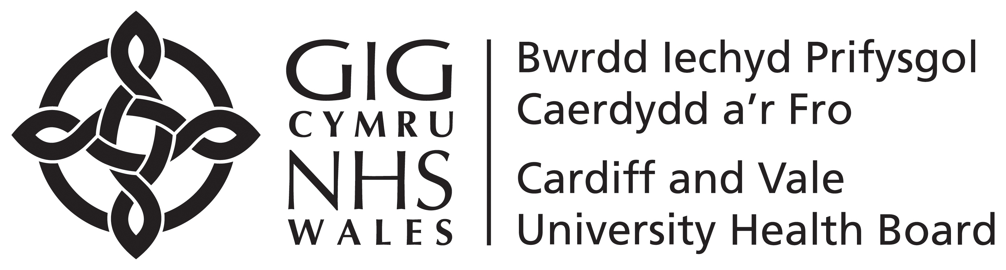
Pancreatic Enzyme Supplements

Why do I need to take Pancreatic Enzymes?
The pancreas is an organ in the body which produces digestive enzymes. These enzymes are chemicals which help break down fats, protein and starchy carbohydrates in the diet. People with NETs can struggle to produce these enzymes properly due to surgery, the NET or the treatment they are on. Without these enzymes your body cannot absorb all of the nutrients from food.
The pancreatic enzyme supplement (e.g. Creon, Pancrease, Pancrex V, Nutrizym) that you have been prescribed will act like the enzymes produced from the body and break down food for you.
If you do not take them, or do not take enough it is likely you will experience the following symptoms:
- Tiredness, lack of energy
- Weight loss
- Abdominal pain
- Diarrhoea (yellow/pale/oily/floats/difficult to flush/offensive)
- Wind and bloating

How many enzymes should be taken?
A good guideline is to start with 1 capsule with a snack or milky drink and 2 with meals. It may be that more is needed to be taken if you have a particularly large meal or a meal very high in fat.

If you still experience symptoms after following the guidance you should contact your dietitian or the NET team.

Can I take too many enzymes?
Taking too many enzymes is unlikely to do you any long-term harm. You may notice a slight stinging sensation when you open your bowels or nausea, if this occurs you should discuss it with your healthcare professional.

- Take at the start of your meal.
- If you are having several courses in a meal you may need to increase your dose and spread the capsules throughout the meal, don’t just take them at the beginning.
- If you feel you are slow to eat consider taking half the enzyme dose at the beginning and the remaining enzymes halfway through your meal.
- The capsules should be swallowed whole, never crushed or chewed or you may develop painful mouth ulcers.
- If you have trouble swallowing the capsules whole then they can be opened up and all the granules swallowed down with an acidic drink e.g. orange, pineapple or grapefruit juice or a spoonful of jam/yoghurt.
- Avoid taking your enzymes with a very hot drink as this may stop the enzymes from working.
- Enzymes should be taken to help you absorb nutrition from most food and drinks. They do not need to be taken with squash, lemonade, glucose drinks, fruit, boiled sweets or jellied sweets. These contain very little protein, starchy carbohydrates or fat.

All pancreatic enzyme supplements are produced using enzymes derived from pork. Unfortunately, there are no pork-free alternatives currently available. Due to the risks of not taking these enzymes and there not being a suitable alternative, organisations representing Muslim and Jewish communities have stated that these are acceptable to take. If you have further concerns, you may wish to discuss this and potential risks with your NET team, family, friends or religious leader.

Contact Details:
Specialist Nurse……………………………………………..
Dietitian……………………………………………………….

When and how should enzymes be taken?

