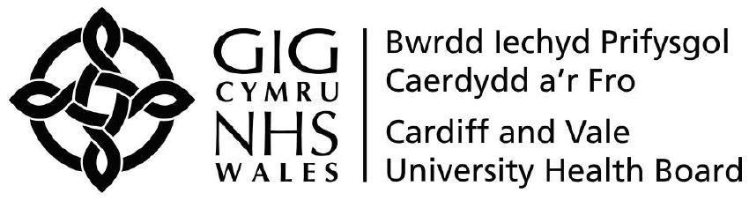
Retire and Return Contract Proforma
(returning to current post (no change in role))

Employee Details
Name of employee (in Full):
Employee number:
Employee Address:

Email address:

Details of Position
Job Title:
Band:
Department:
Directorate:
Start date in current position:
Start date in UHB:
Start date in NHS:
Current Hours of Work:
Accountable to (Managers Title)
Reporting to (Manager’s Title)
Professionally Responsible to
Date of Retirement:
Details of Return to Work
Date of Return to Work (there must be a minimum break of 14 days between retirement and returning to work):
Hours of work on Return (after one calendar month and one day):
Permanent / Temporary:
If Temporary please state duration of contract:
Does the post require a DBS check? |  | Yes / No (please delete a appropriate)
Does the postholder have a current a DBS check? |  | Yes / No
If Yes please provide disclosure number and date check was carried out |  | Number: ________________  Date: ___________________
Manager Signature:
Manager Name (in Full):
Job title:
Date:

When completed in full and signed please send to the HR Advisory Team for contract to be issued.

