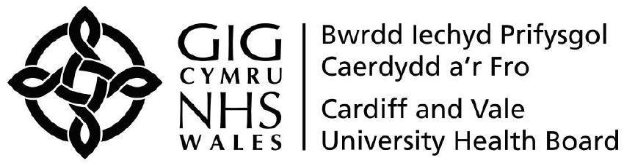

RESERVE FORCES LEAVE APPLICATION FORM

Name: |  |  |  |  | Employee Number:
Address:
Job Title: |  |  |  |  | Ward / Department / Directorate / Division
Details of Leave:

Please note that you should give as much notice as possible to allow appropriate planning for absences. Permission will be granted where the notice exceeds one month and should normally be granted in other circumstances. Permission once given will not be rescinded except in exceptional circumstances.

Duration: |  |  |  | Dates (to-from):
Indicate reason and provide details for request (e.g. annual training etc):

Please provide details of any training already taken within the last 12 months:

Print Name: |  |  | Signed: |  |  |  |  |  | Date:
To be completed by Manager:

Please note that paid leave of up to 10 days per year will be made available to Reservists to attend annual camp or equivalent continuous training. Any additional leave should be taken as Unpaid leave or Annual leave.

*Approved / Not Approved (*delete as appropriate) |  |  |  |  | *Paid / Unpaid / Annual (*delete as appropriate)
If not approved please provide reason:
Print Name: |  |  |  |  | Job Title:
Signed: |  |  |  |  | Date:

Return completed and signed form to HR Advisory Team, Lakeside Buildings, UHW
c.c. Personal File

