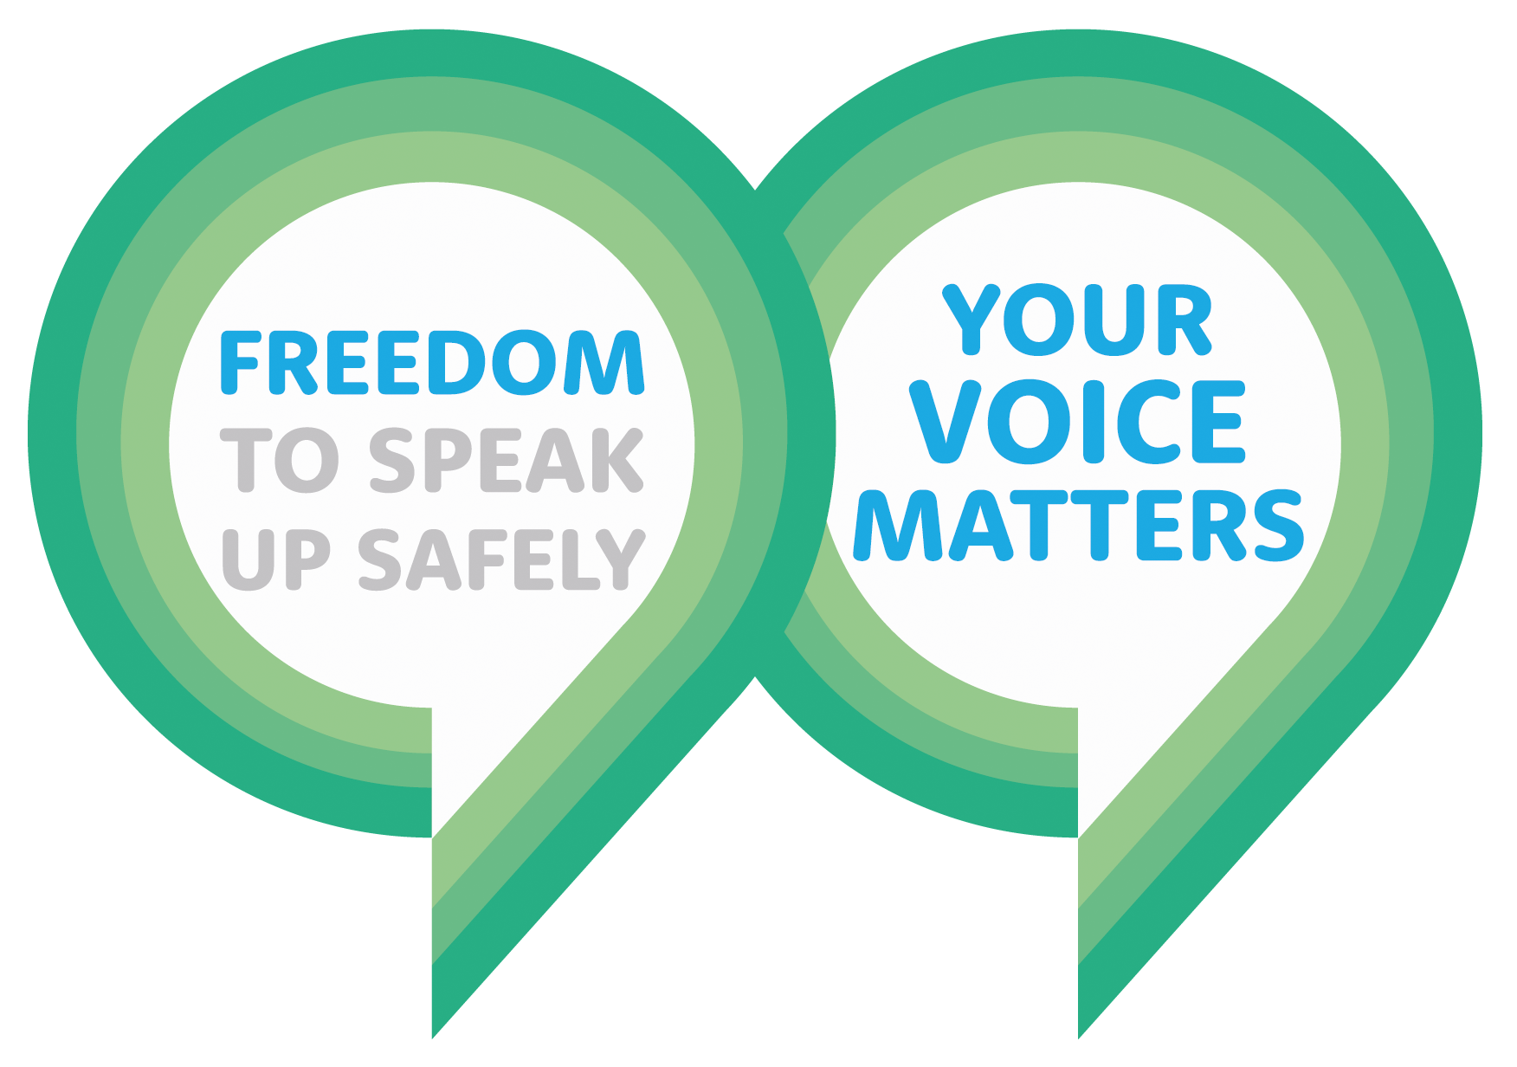

Cardiff and Vale University Health Board Raising a Concern Form

Section A: Your details
Please note that you are able to raise your concern anonymously if you wish. However, if you raise your concern anonymously it will be more difficult for us to investigate the matter and we will be unable to update you.
We encourage you to provide us with as much information as you can in order to try and resolve the concern as effectively as possible. If there are parts of the form you do not feel comfortable completing, please leave these blank.

Please describe your position at CAV UHB:
Employee

Ex-employee

Volunteer

Trade Union Representative on behalf of an employee

Other (please specify) ………………………………………..
Name:
Job Title:
Department:
Email:
Phone Number:

Please state your preferred way to be contacted ………………………………………………

Section B: Details about the concern
What is your concern about?
Behaviour and/or communication
Someone’s health and/or safety
Damage has been caused to the enviornment
A criminal offence has been comitted
A legal obligation has been breached
There has been a deliberate attempt to cover up any of the above
Other (please specify) ………………………………………………………………………………………………………………………………………………………………………………………………………………………………………………………………………………………………………………………………………………………………………………………………………………………………………………………………………….

Date of incident or how long it has been happening:

Have you already raised your concern informally with line management? If not, what is the reason for this? If so, how was this handled?

What department and clinical board is the concern related to?

Please explain your concern, providing as much detail as possible:

Are there others who witnessed the concern/ behaviour or who have had similar experiences?

What would you like to happen as a result of raising your concern?

Please provide any additional information or comments:

Please state whether you are happy for us to contact your department and other witnesses you have provided.

YES

NO

Please email this form to F2SUCAV@wales.nhs.uk

Alternatively, return it to:
Freedom to Speak Up Team
Risk and Regulation
Cardiff & Vale University Health Board
2nd Floor, Woodland House
Maes Y Coed Road
Cardiff CF14 4HH

