
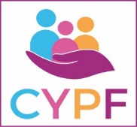

Children, Young People & Family Health Services
Welcome to the Children, Young People & Family Health Services who promote and support a healthy start in life for children, young people and their families as they grow and develop. Our aim is to ensure that all children and young people are able to reach their full potential and be physically and emotionally healthy.

Our team of highly skilled professionals work alongside parents, children and young people to support their needs from birth to 18. We also work closely in partnership with other organisations to provide support to families and to safeguard the health and wellbeing of children and young people in Cardiff and the Vale of Glamorgan.

We provide high quality and integrated care services to children with disabilities and complex needs, those with developmental difficulties, behavioural difficulties and emotional wellbeing and mental health concerns, as well as children and young people in special circumstances such as those in care.

Our promise to you
Our Children and Young People’s Health Charter sets out how we work with children, young people and families, how we provide our range of services, and how we ensure those who use the care we provide will be actively involved.
- Download a copy of the Charter here -

Response to COVID-19
Click here to access all information about COVID-19 from Cardiff and Vale UHB.
The City Recovery Strategy for Cardiff is now available in a child friendly version and in eight languages. Click here to access these resources.

Contact Us
Children, Young People & Family Health Services
Woodland House
Maes Y Coed Road
Cardiff
CF14 2HH

Tel: 029 2183 6574

2. Link: http://www.cardiffandvaleuhb.wales.nhs.uk/community-child-health-team

3. Link to Services list page: http://www.cardiffandvaleuhb.wales.nhs.uk/community-child-health-services
The Children, Young People & Family Health Services provides a wide range of services in Health Board premises and across the community, including in schools. These services include:
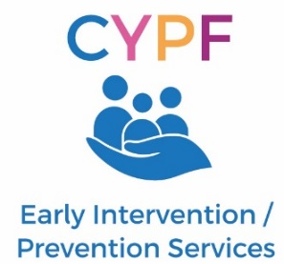 | 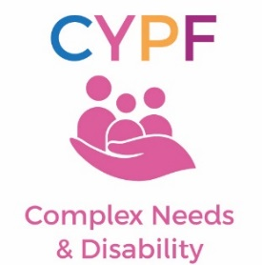 | 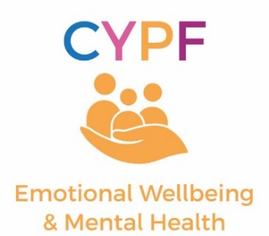
Integrated Children’s Community Nursing Service
Children and Young People’s Continuing Care
Safeguarding
Looked After Children
School Nursing
Early Years Psychology
Specialist Health Visiting
Primary Mental Health
CAMHS
Specialist Nurse Led Services
Enfys
Resilience Project
Emotional Wellbeing Service
Flying Start - Cardiff
Continence
Flying Start - Vale
Occupational Therapy
Speech & Language Therapy
Physiotherapy
Community Family Psychology

Community Paediatrics

Health Visiting

