Quality and Safety Governance
Draft Internal Audit Report (Advisory)
2025/26
Cardiff and Vale University Health Board


Advisory

Contents  Executive Summary 1  Findings & Suggested Actions 4  Appendix A 12  Appendix B 13  Appendix C 14 | Review Reference |  | CVU-2526-24
 | Fieldwork |  | July - October 2025
 | Executive Sign Off |  | XX 2025
 | Audit Committee |  | February 2026
 | Executive Lead |  | Suzanne Rankin, Chief Executive
 | Audit Team |  | Ian Virgill, Head of Internal Audit  Lucy Jugessur, Deputy Head of Internal Audit

Executive Summary
Purpose
Our advisory audit of the Health Board’s Quality & Safety Governance Arrangements has been completed as an addition to the 2025/26 internal audit plan for Cardiff and Vale University Health Board (the ‘Health Board’), following a request from the Health Board’s Chair and Chief Executive.
Prior to this audit, a comprehensive internal review of theatre services was undertaken at the University Hospital of Wales (UHW) Theatres after evidence surfaced of a number of issues. That review commenced on the 24 October 2024, focusing on the following key themes:
• Values and behaviours;
• Leadership and management capability;
• UHW theatres leadership structure and roles and responsibilities;
• Team dynamics;
• Communication and engagement;
• Fairness and equity; and
• Staff turnover.
The review’s findings were presented to the Chief Operating Officer on the 7 May 2025, outlining 66 recommendations under the above themes, with patient and staff safety and experience and theatre efficiency themes also being incorporated into the review. There were six recommendations that required immediate action.
The review highlighted a number of concerning themes, including leadership failures, inconsistent adherence to policies and procedures, and poor culture. In addition, it also revealed that governance and oversight of theatres within the Surgical Clinical Board and the broader organisation had been insufficient.
Following a Service of Concern meeting with the Health Board on 12 May 2025, Health Inspectorate Wales (HIW) also requested that the Health Board demonstrate how it has considered the overall governance processes in place.
Following the review and the request from HIW, a number of actions were agreed to be undertaken, including commissioning Audit and Assurance to undertake a review of the Health Board’s quality and safety governance in order to evaluate the effectiveness of the current arrangements.
The Audit has primarily focussed on the Medicine and Surgery Clinical Boards, while also reviewing the wider corporate quality and safety governance arrangements within the Health Board.
Overview
The Health Board’s corporate policies and procedures were reviewed, and discussions were held with key individuals in order to establish and evaluate the centralised quality and safety governance processes that are in place. Observations in relation to Clinical Board, directorate and speciality level quality and safety governance arrangements have been derived from our enquiries within the Medicine and Surgery Clinical Boards along with the examination of minutes, terms of reference and other documentation relating to the various quality and safety groups operating within them.
The breadth of scope of quality and safety governance arrangements in a Health Board setting necessitates a multi-faceted and stratified approach involving a wide range of stakeholders. This review has focused on the core governance arrangements, and as such, some supporting processes may be in place that have not been captured.
Overall, we found that established Quality & Safety governance arrangements are in place within the Health Board. Reporting arrangements have frequently been documented, although some inconsistencies were identified in the regularity of reporting, and the reporting processes in some areas had not been clearly defined.
Although quality and safety groups are operating appropriately and relevant staff are engaging with governance processes, a paucity of central guidance has contributed to some inconsistencies in the management and administration of groups at speciality and directorate levels. Quality and safety leads have been nominated across many specialities and directorates and at the Clinical Board level, but the roles and responsibilities of leads have not been clearly defined in all cases. There is no central register of quality and safety groups or leads, and it is not clear if there has been sufficient oversight to ensure the groups operate consistently and are mutually supportive.
Feedback from relevant staff members indicated that a good level of awareness exists with regard to quality and safety reporting processes, but there is a lack of clarity around the means by which issues are escalated once they have been reported.
The conclusions of this review would indicate that, notwithstanding some shortcomings in administrative matters, there are generally sufficient resources and expertise being dedicated to the quality and safety governance processes within the Health Board, which are often well established and operate effectively. However, significant benefits are likely to be derived from the production and dissemination of more detailed guidance, and the implementation of some centralised processes to ensure a greater degree of consistency in the management of groups.
As this is an advisory review no assurance rating is provided. The following opportunities have been identified that the Health Board may wish to take forward in order to strengthen processes:
- Inclusion of target dates in relation to escalation framework actions.
- Production of a comprehensive structure chart to illustrate the quality and safety governance arrangements within the Health Board.
- Establishing a register of quality and safety groups and compiling a list of quality and safety leads.
- Production of guidance for Clinical Boards and Directorates.
- Ensuring the regularity of reports to the Quality Committee.
- Co-ordination of meeting frequency and scheduling between the tiers of the governance hierarchy.
- Provision of support to Clinical Boards in ensuring all relevant areas are encompassed by the quality and safety governance arrangements.
- Production of Terms of Reference, and implementation of contingency measures to mitigate the impact of shortcomings in administrative support resources.
- Production of supporting guidance for staff.
Full details of matters arising are detailed within the Findings & Suggested Action Plan.
Advisory Scope Summary
Objectives |  | Related Actions
1 | Establish and evaluate the current Quality & Safety Governance arrangements operating within the Health Board | 1
2 | Are the current arrangements clearly documented within relevant policies / procedures and are they readily available / known across the organisation | 2, 3, 4
3 | Do the arrangements allow for a clear and timely route of reporting, escalation and assurance from ward and service areas up to the Board | 5, 6
4 | Are the processes within the Clinical Boards operating in accordance with the stated policies / procedures | 7, 8
5 | Do key management and clinical staff within the Clinical Boards have a good knowledge and understanding of the processes and what they should do if they become aware of an issue | 9

Management Actions | Themes | Risk Types
9 |  | Quality or Safety Issues

Findings & Suggested Actions
Objective 1: Establish and evaluate the current Quality & Safety Governance arrangements operating within the Health Board
Quality and Safety Governance arrangements are in place. The Health Board's Quality Committee reports to the Board itself, and Clinical Board QSE Groups report to the Quality Committee. Further to this, groups within Clinical Boards at the directorate or individual specialty level report to the Clinical Board QSE Groups.
The scope of the arrangements is intended to cover all areas of the Health Board, including those areas managed by individual Clinical Boards.
There are additional groups which report to the Quality Committee, these include the Clinical Effectiveness Group, which addresses national audits and NICE guidelines, the Clinical Safety Group, which acts as a hub for approximately twenty five Clinical Advisory Groups, and the Quality Excellence Learning Programme, which is concerned with linking quality programmes within the Health Board, learning from events, and identifying emerging themes.
The hierarchy of the Health Board's Quality and Safety Governance arrangements is outlined in the Health Board's Quality, Safety and Experience Framework 2021-26, which confirms that meetings should take place at Clinical Board and Directorate levels.
Arrangements within the Medicine and Surgery Clinical Boards were documented, and it was confirmed that Clinical Board QSE meetings take place, and that individual directorates, or specialties within them also conduct meetings.
The Quality and Safety Governance arrangements within the Health Board are consistent with the Welsh Government's Quality and Safety Framework and are broadly in line with the arrangements in place within other Health Boards in Wales.
The Welsh Government, in July 2025, extended the Health Board’s escalation status to level 4 for the whole organisation, where this had previously applied only to finance, strategy and planning. Twenty-three of the matters directly highlighted by WG as part of this process were identified by the Assistant Director of Quality Safety as having direct relevance to the Health Board's quality and safety processes. Nineteen of these were categorised within the 'Quality' escalation domain, and a further four were within the 'Clinical services' domain. These have been documented, and responses have been recorded, along with supporting evidence in relation to sixteen of the 'Quality' matters, and one of the four within the 'Clinical services' domain. The points listed are formatted as observations or questions, but they have been taken forward as actions. Designated Leads for each point are listed, but target dates are not specified.

Key Findings |  | Risk & Impact | Suggested Management Action
1 | Escalation Framework Target Dates  Whilst the points contained within the escalation framework were found to have largely been addressed, and suitable supporting evidence had been collated, target dates had not been recorded against the listed issues. | Areas of poor performance are not identified and addressed.  A lack of clear, consistent direction, accountability and leadership with governance arrangements not properly discharged. | Suggested Action: Target dates will be listed for any actions contained within the escalation framework action plan which remain outstanding.
1 |  |  | Expected Evidence of Implementation:
1 |  |  | Officer:  Target Implementation Date:
1 | Theme: Performance Monitoring | Control Operation | Officer:  Target Implementation Date:

Objective 2: Are the current arrangements clearly documented within relevant policies / procedures and are they readily available / known across the organisation
The Health Board published a Quality, Safety and Experience Framework (2021-26) in September 2021. The Framework describes the interlinked key elements that must always be working together to ensure continuous improvement in quality, and one of the eight key priority areas covers Quality Governance arrangements. The Framework includes an overview of the Health Board's quality and safety committee and group structure, but this is out of date and does not provide any specific detail on the Clinical Board or Directorate arrangements. The Framework has not been revised since it’s introduction and is not available on the Health Board’s website or intranet. We were unable to identify any other document that sets out the current Quality and Safety Governance arrangements.
Although, as confirmed as part of Objective 1, the scope of the arrangements is intended to include all areas of the Health Board, local arrangements are managed by individual Clinical Boards and directorates, and as such there is no centralised means by which it can be ensured that all areas are subject to appropriate oversight.
Enquiries were made with Clinical Boards, directorates and specialities to determine if information, instructions or guidance in relation to the administration of Quality and Safety governance arrangements had been provided. It was generally reported that the arrangements that are in place have been maintained in accordance with previous practices.
Guidance for Clinical Boards or directorates with respect to the maintenance of quality and safety, or quality, safety and experience groups has not been produced. Some quality leads have been appointed at various levels within Clinical Boards and directorates, but this is not consistent across the Health Board.

Key Findings |  | Risk & Impact | Suggested Management Action
2 | Quality and Safety Governance Structure Chart  The structure chart of the Health Board's quality and safety arrangements included in the Quality, Safety and Experience Framework is out of date and contains insufficient detail in relation to Clinical Board, directorate and speciality level QSE groups.  The Framework and associated structure chart are not currently available to relevant management and staff within the Health Board. | A lack of clear, consistent direction, accountability and leadership with governance arrangements not properly discharged. | Suggested Action: The structure chart included in the Quality, Safety and Experience Framework will be updated to include more detail in relation to Clinical Board, directorate and service level QSE groups.  The updated structure chart will then be made available to relevant staff across the Health Board.
2 |  |  | Expected Evidence of Implementation:
2 |  |  | Officer:  Target Implementation Date:
2 | Theme: Quality, Safety & Patient Experience | Control Design | Officer:  Target Implementation Date:
3 | Register of Quality and Safety Groups and Leads  There is no single register of quality and safety groups that are in operation throughout the Health Board, and as such it is not possible to readily confirm that quality and safety governance arrangements encompass all areas of the Health Board's operations.  A list of quality and safety leads has not been maintained and as such, it is unclear how it is ensured that relevant information in relation to quality and safety governance processes can be promptly disseminated to relevant individuals. | A lack of clear, consistent direction, accountability and leadership with governance arrangements not properly discharged. | Suggested Action: A register of all scheduled Quality and Safety or Quality, Safety and Experience meetings will be maintained.  A list of all quality and safety leads will also be developed and maintained.
3 |  |  | Expected Evidence of Implementation:
3 |  |  | Officer:  Target Implementation Date:
3 | Theme: Information, Data Quality & Data Accuracy | Control Design | Officer:  Target Implementation Date:
4 | Quality and Safety Governance Guidance  Limited guidance is available to Clinical Boards and directorates with respect to quality and safety governance arrangements. | A lack of clear, consistent direction, accountability and leadership with governance arrangements not properly discharged. | Suggested Action: Guidance for staff in relation to the Health Board's quality and safety governance processes will be produced and disseminated.
4 |  |  | Expected Evidence of Implementation:
4 |  |  | Officer:  Target Implementation Date:
4 | Theme: Policies & Procedures | Control Design | Officer:  Target Implementation Date:

Objective 3: Do the arrangements allow for a clear and timely route of reporting, escalation and assurance from ward and service areas up to the Board
Although quality and safety governance arrangements are in operation at all levels, the reporting mechanisms linking each of these groups are not consistent. Some groups have well established reporting and escalation processes, whereas others do not have clear processes in place and are reliant on ad-hoc reports in order to escalate issues or distribute information.
We reviewed reports from the Medicine and Surgery Clinical Board Quality and Safety groups to the Health Board's Quality Committee. During the 12-month period examined (2024/25), the Medicine Clinical Board had submitted six sets of Quality and Safety Group minutes whilst Surgery Clinical Board had submitted none. Annual Assurance Reports were provided to the Quality Committee from both the Medicine (February 2025) and Surgery (April 2025) Clinical Boards.
Other reports to the Committee which are programmed to take place as part of the Health Board's Quality and Safety arrangements were identified as either not taking place or taking place with insufficient frequency.
In the Medicine Clinical Board, seven department / specialty level groups were identified within the Integrated Medicine Directorate, three of which could be confirmed to provide copies of their minutes directly to the Medicine Clinical Board's QSE Committee. Reporting and escalation pathways were not clear in relation to the remaining four groups. Directorate level Integrated Medicine meetings take place, but the minutes examined did not show that any of the departments / specialties within the directorate were providing reports to this group.
A further four department / specialty groups were identified within the Specialist Medicine Directorate, two of which had provided minutes to the Medicine Clinical Board's QSE Committee, and two for which the reporting pathway remains unclear. It was reported that there is no directorate level QSE group in Specialist Medicine.
The three directorates we evaluated from the Surgery Clinical Board were all found to maintain directorate level groups which provide standard exception reports to the Surgery Clinical Board's QSE Committee.
A diagram illustrating the identified reporting flows within the Medicine and Surgery Clinical Boards is included at Appendix A. The diagram represents the meetings and reporting lines which have been identified as part of this review, it is not exhaustive and does not include details of groups outside of the Medicine and Surgery Clinical Boards. Groups are highlighted as having no documented reporting or escalation channels where this could not be confirmed from minutes or other supporting documentation, alternative reporting arrangements may be in place.
It should be considered that the absence of formal reporting processes or documented evidence of issues being escalated via some channels does not imply that reports and escalations do not take place. Throughout our enquiries it was reported that individuals were aware of means by which issues may be escalated outside of the quality and safety groups, and this is supported to some degree by broader feedback.
The monthly Clinical Board reviews and Senior Leadership Team meetings, whilst not part of the formal Quality and Safety governance structure, are additional established pathways for escalating quality and safety related issues from the Clinical Boards to the Executives, Quality Committee and Board. Review of the papers for the Medicine and Surgery reviews held between October 24 and September 25 confirmed that quality is an agenda item with the areas covered including, Quality Improvement & Efficiency Plans, patient safety incidents, concerns and Infection Prevention & Control. However, the meetings did not occur monthly, with only 5 reviews having been held in the 12-month period. We were also able to confirm that ad-hoc reports on quality and safety related areas, including Speaking Up Safely, Theatres Updates and Quality Management System Project updates were presented to meetings of the Senior Leadership Team during the same period.
However, even effective ad-hoc reporting processes cannot be said to provide sufficient assurance that issues will be escalated appropriately.
Although quality and safety meetings take place at regular intervals across all levels of the Health Board in accordance with established schedules, there is some variation in the frequency of meetings, and it is not clear if the timings of meetings have been considered to ensure issues can be escalated promptly.

Key Findings |  | Risk & Impact | Suggested Management Action
5 | Reports to the Quality Committee  The majority of Clinical Board Quality and Safety Committees regularly provide copies of their minutes to the Health Board's Quality Committee, but minutes from the Surgery Clinical Board do not appear to have been provided.  Whilst reports from the Clinical Effectiveness Committee are recorded as having been submitted to the Health Board's Quality Committee, this has occurred less frequently than the Committee's terms of reference specify.  Reports from the Clinical Safety Group do not appear to have been submitted to the Quality Committee. It could not be confirmed that the Clinical Advisory Groups are reporting regularly to the Clinical Safety Group. | Objectives may not be delivered if quality and safety governance arrangements are not effectively identifying and escalating concerns and if arrangements are not properly discharged.  Areas of poor performance are not identified and addressed. | Suggested Action: Regularly programmed reports to the Quality Committee will be confirmed on the committee’s future work plan, and where reports do not take place in accordance with their programmed frequency, investigations will take place. The reasons for any delayed or cancelled reports will be clearly documented and reported to the Quality Committee.
5 |  |  | Expected Evidence of Implementation:
5 |  |  | Officer:  Target Implementation Date:
5 | Theme: Reporting | Control Operation | Officer:  Target Implementation Date:
6 | Meeting Frequency and Scheduling  The various Quality and Safety groups evaluated during this review were found to operate on a variety of schedules, with many of the speciality / directorate level groups following the Health Board's Clinical Audit Schedule. Decisions in relation to the scheduling of quality and safety meetings appear to be co-ordinated at Clinical Board level, and the process by which factors such as the frequency of meetings are determined is not clear and has not been documented. | Objectives may not be delivered if quality and safety governance arrangements are not effectively identifying and escalating concerns and if arrangements are not properly discharged. | Suggested Action: The scheduling of quality and safety meetings will be co-ordinated centrally in consultation with Clinical Boards to ensure that there is consensus on the expected frequency of meetings, and to ensure that escalation pathways are able to function efficiently, with minimal delays.
6 |  |  | Expected Evidence of Implementation:
6 |  |  | Officer:  Target Implementation Date:
6 | Theme: Planning, Delivery & Deadline Management | Control Design | Officer:  Target Implementation Date:

Objective 4: Are the processes within the Clinical Boards operating in accordance with the stated policies / procedures
Enquiries were made within the Medicine and Surgery Clinical Boards in order to confirm that Quality and Safety Governance arrangements are in place in accordance with the specifications of the Health Board’s QSE Framework, and that they were operating in compliance with any Terms of Reference or other agreed scope of activity.
Discussions with the Clinical Board triumvirates indicated that the quality and safety governance arrangements operating within each Clinical Board consisted of meetings which take place at a Clinical Board level, supported by further meetings which take place at the Directorate level. As highlighted under objective 3 above, it was subsequently found that some meetings are also held within individual departments / specialties. The relationships between the meetings at different tiers has not been documented, and regularised reporting arrangements do not appear to have been established in all cases. There is no clear mechanism to ensure that all areas under the responsibility of each Clinical Board are within the scope of QSE meetings.
Clinical Board QSE meetings for the Medicine and Surgery Clinical Boards are well attended and take place at regular intervals in accordance with established schedules.
Meetings of the directorate and specialty level QSE groups within the Medicine and Surgery Clinical Boards are also well attended and take place at regular intervals in accordance with established schedules, although Terms of Reference documents had not been produced for all of these groups. A small number of instances were identified whereby minutes of meetings had not been produced as sufficient administrative resources were not available.

Key Findings |  | Risk & Impact | Suggested Management Action
7 | Scope of Governance Arrangements  A hierarchical system is in place with respect to the Health Board's quality and safety governance arrangements, and responsibilities in relation to the establishment and maintenance of quality and safety groups have been largely delegated to individual Clinical Boards. There is no guidance to support Clinical Boards in ensuring that the scope of the quality and safety arrangements that they administer encompasses all of the areas for which they are responsible. | Objectives may not be delivered if quality and safety governance arrangements are not effectively identifying and escalating concerns and if arrangements are not properly discharged. | Suggested Action: Guidance will be provided to Clinical Boards to support them in ensuring that their areas of responsibility are encompassed by the Health Board's quality and safety governance arrangements.
7 |  |  | Expected Evidence of Implementation:
7 |  |  | Officer:  Target Implementation Date:
7 | Theme: Information, Data Quality & Data Accuracy | Control Design | Officer:  Target Implementation Date:
8 | Documentation and Record-Keeping  Terms of Reference documents have not been produced in relation to all quality and safety groups.  Several directorates, departments and specialties reported that they have experienced difficulties in identifying appropriate administrative resources to support the documentation of quality and safety meetings that have occurred. | Areas of poor performance are not identified and addressed. | Suggested Action: It will be ensured that all quality and safety groups produce a terms of reference document in accordance with an established template.  Support will be offered to directorates and departments to identify effective processes such as the use of Co-pilot, to ensure that all quality and safety meetings are consistently documented.
8 |  | Areas of poor performance are not identified and addressed. | Expected Evidence of Implementation:
8 |  | Areas of poor performance are not identified and addressed. | Officer:  Target Implementation Date:
8 | Theme: Resourcing | Control Operation | Officer:  Target Implementation Date:

Objective 5: Do key management and clinical staff within the Clinical Boards have a good knowledge and understanding of the processes and what they should do if they become aware of an issue.
As previously identified, guidance documents to provide information to staff in relation to the Health Board's quality and safety processes have not been produced and / or made available.
As part of this review, a short questionnaire was issued to a sample of staff in order to evaluate their awareness of Quality and Safety Governance processes within the Medicine and Surgery Clinical Boards. We issued a total of 118 questionnaires and received 36 responses back.
In summary, the responses indicate that there is a satisfactory level of general awareness of quality and safety processes amongst staff, but there is a lack of procedural guidance or training, and limited confidence that reported issues will be dealt with promptly.
The main themes highlighted through the responses were as follows:
- Over half (56%) of respondents indicated that their role involved direct participation in Quality and Safety Groups, or similar sub-groups and listed various quality and safety, health and safety, performance, and audit meetings as examples.
• Almost half (47%) of respondents indicated that there had been cause for them to report a quality or safety concern in their current role, and of these, 94% confirmed that they reported the concern.
• 94% of respondents indicated that they are provided with sufficient opportunities to report quality or safety concerns, and supportive management was cited as contributing to this. There was however, less clarity with respect to the processes by which any concerns may be escalated after they have initially been reported, with little detail provided by members of staff in this area.
• There were also some concerns in relation to the promptness by which escalations take place, with one third of respondents indicating that they did not have confidence that issues raised will be escalated appropriately and within reasonable timescales, comments submitted by these respondents indicated that issues were not always resolved promptly.
• Half of respondents indicated that they were aware of policies, procedures or guidance documents relating to Quality and Safety. Given that the survey sample consisted of individuals who would be expected to have some involvement with or responsibility for the administration of some aspects of the Health Board's quality and safety processes, this is a lower proportion than may be expected and possibly is reflective of the absence of central guidance.
A copy of the questionnaire is included at Appendix B.

Key Findings |  | Risk & Impact | Suggested Management Action
9 | Supporting Guidance for Staff  Whilst responses to the questionnaire issued to staff indicated that a good level of knowledge exists with respect to the processes by which quality and safety concerns may be reported within the Health Board, there was less confidence and clarity surrounding the means by which issues may be addressed or escalated once they had been reported. There does not appear to be any specific guidance to provide staff with information in respect of escalation processes. | Objectives may not be delivered if quality and safety governance arrangements are not effectively identifying and escalating concerns and if arrangements are not properly discharged.  Areas of poor performance are not identified and addressed. | Suggested Action: Guidance will be provided to staff with respect to the Health Board's quality and safety governance arrangements, with particular emphasis placed on the escalation of issues after they are reported.
9 |  |  | Expected Evidence of Implementation:
9 |  |  | Officer:  Target Implementation Date:
9 | Theme: Communication & Engagement | Control Design | Officer:  Target Implementation Date:

Appendix A

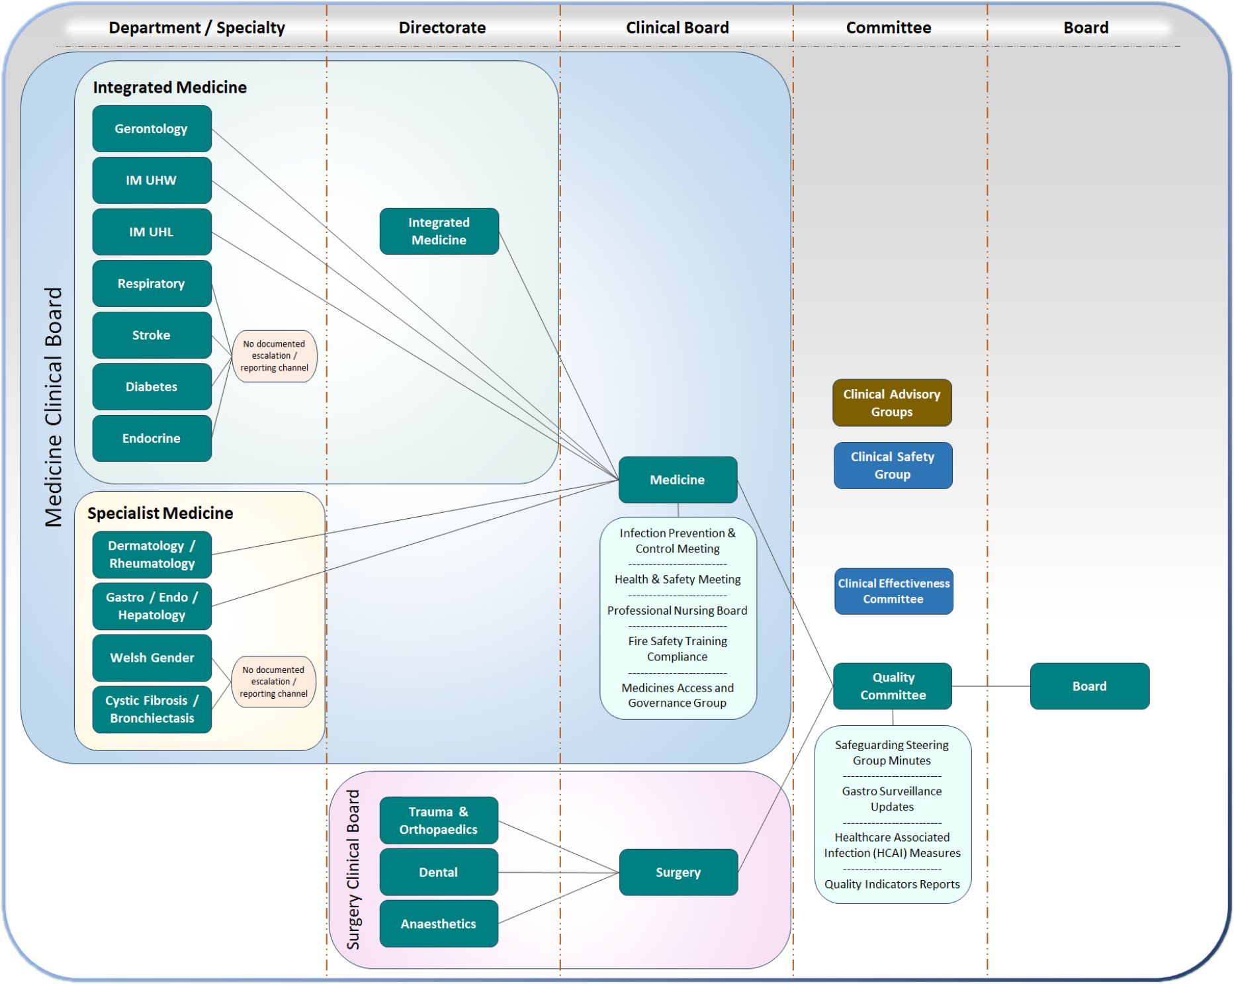

Appendix B - Questionnaire

Introduction
The purpose of this short survey is to collect information from across the Health Board in order to establish the level of staff awareness in relation to quality and safety governance processes. Completed questionnaires will be evaluated only by the NWSSP Audit and Assurance Service and individuals’ details will not be shared with the Health Board.
Groups & Meetings  Does your role involve direct participation in any Quality and Safety Groups, or similar sub-groups such as those relating to Health and Safety or Infection Prevention and Control? (Yes/No)  Please provide an outline of any such groups that you are aware of that operate within your department.  Please provide details of any other regular meetings or ad-hoc exercises relating to quality or safety that have taken place within your department.  -------------------------------------------------------------------  Cause to Report  Have you had cause to report any quality or safety concern(s) in your current role? (Yes/No)  Please provide some brief details of the concern(s) below.  Did you report the concern? (Yes/No)  Please provide further details of the report.  -------------------------------------------------------------------  Reporting Process Awareness  How would you report any quality or safety concerns you may have?  Who would you report any Quality or Safety concerns to? (Please list relevant roles, include all that apply in cases where concerns may be reported to more than one individual). | Opportunities to Report & Escalate  Are you provided with sufficient opportunities to report quality or safety concerns? (Yes/No)  Please provide additional details.  What is your understanding of the process(es) by which any issues you raise may be escalated after you have reported them?  Do you have confidence that issues you raise will be escalated appropriately and within reasonable timescales?  Please provide additional details.  -------------------------------------------------------------------  Policies, Procedures, Training  Are you aware of any policies, procedures or guidance documents relating to Quality and Safety that have been issued within your department or across the Health Board as a whole? (Yes/No)  Please specify.  Have you received any training which included information in relation to the Health Board's Quality and Safety processes or those operating within your department? (Yes/No)  Please provide additional details.  -------------------------------------------------------------------  End of Questionnaire

Appendix C
Assurance Opinion Disclaimer
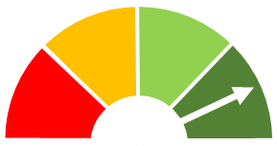 | Substantial | Few matters require attention and are compliance or advisory in nature.  Low impact on residual risk exposure. |  | This audit report has been prepared for internal use only. Audit and Assurance Services reports are prepared, in accordance with the agreed audit brief, and the Audit Charter as approved by the Audit Committee.  Audit reports are prepared by the staff of the NHS Wales Audit and Assurance Services and addressed to Independent Members or officers including those designated as Accountable Officer. They are prepared for the sole use of Cardiff and Vale University Health Board and no responsibility is taken by the Audit and Assurance Services Internal Auditors to any director or officer in their individual capacity, or to any third party.  The report is based on the review work undertaken and is not necessarily a complete statement of all weaknesses that exist or potential improvements. Whilst every care has been taken to ensure that the information provided in this report is as accurate as possible, no complete guarantee or warranty can be given with regard to the advice and information contained.  Our work does not provide absolute assurance that material errors, loss or fraud do not exist. Responsibility for a sound system of internal controls and the prevention and detection of fraud and other irregularities rests with management of Cardiff and Vale University Health Board. Work performed by internal audit should not be relied upon to identify all strengths and weaknesses in internal controls, or all circumstances of fraud or irregularity. Effective and timely implementation of recommendations is important for the development and maintenance of a reliable internal control system.
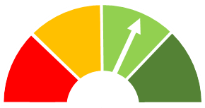 | Reasonable | Some matters require management attention in control design or compliance.  Low to moderate impact on residual risk exposure until resolved.
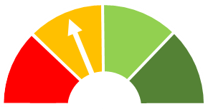 | Limited | More significant matters require management attention.  Moderate impact on residual risk exposure until resolved.
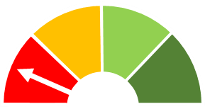 | Unsatisfactory | Action is required to address the whole control framework in this area.  High impact on residual risk exposure until resolved.
 | Advisory | Given to reviews and support provided to management which form part of the internal audit plan, to which the assurance definitions are not appropriate.  These reviews are still relevant to the evidence base upon which the overall opinion is formed.
Public Sector Internal Audit Standards
Audit work undertaken by NHS Wales Audit and Assurance Services conforms with the International Standards for the Professional Practice of Internal Auditing and associated Public Sector Internal Audit Standards as validated through the external quality assessment undertaken by the Chartered Institute of Public Finance & Accountancy in April 2023.

Website: Audit & Assurance Services - NHS Wales Shared Services Partnership

