Cardiff and Vale University Health Board Business Case
For revenue investment proposals greater than £75,000
All business cases must be submitted in line with the timescales outlined in Annex d

Title | Case to fulfil gaps in Obstetric and Neonatal Service Provision against the Ockenden Recommendations
Clinical /Service Board or Department | Children & Women

Expected funding source (highlight/delete as appropriate) | UHB Core Funding  There is potential for future WG allocation that may partially offset the investment. The proposal also aims to realise longer-term financial savings in material areas such as clinical negligence expenditure.
Where a business case is in regards to external funding sources this template must be used unless the source of funding requires their own template to be used.
Approval and scrutiny route

Has this case been signed off by the Clinical Board / Corporate Departments senior team? | Yes, Children and Women Core Board Meeting 09/01/2023
Has this case been signed off by the Clinical Board / Corporate Departments finance and workforce business partners? | Workforce sign-off: No Business Partner allocated to Children and Women at present  Finance sign-off: Yes - Assistant Director of Finance
Clinical Boards: Has the COOs office signed off this document?  Corporate Departments: Has the relevant Executive sponsor signed of this document? | Yes – 16/02/2022  Yes – Executive Nurse Director

Contents
1. Introduction and Background 1
2. Strategic Context – Alignment to UHB strategic direction 3
3. Summary current service provision and case for change 3
4. Case of change - The evidence (Phase 1) 6
5. Option Appraisal 8
6.1 Benefits 8
Benefits Tracker 14
Benefit 14
Metric 14
Baseline 14
Target 14
Timeline / Ambition 14
Still Birth Reduction 14
Number of Still Births / 1,000 births 14
4.5 - 4.75 in C&V UHB 14
2.3 in line with NHSE Ambition 14
By 2030, with steady improvement 14
Minimise unplanned NCCU admissions and SCBU occupancy 14
% unplanned NCCU admissions 14
4.4% unplanned term admissions 14
4% term admissions, exceeding UK performance 14
By March 2025 14
C-Section Rates to meet standard, national norm for Robson 1 14
% Emergency C-Section Rate of overall Births 14
22% currently 14
15% per national standard 14
By March 2025 14
Length of Stay 14
Hours 14
MLU: 20 hours (Up to 30) 14
6 hours on MLU 14
March 2026 14
Reduction in NRIs, Concerns and other issues resulting in Clinical Negligence claims 14
Clinical Negligence expenditure (O&G) 14
Circa £12m per annum recognised in annual accounts 14
10-15% initial reduction 14
Likely a 3-5 year time horizon, given current caseload 14
6.2 Risk 15
6.3 Total Cost - Resource Implications and Affordability 16

Introduction and Background

The recommendations of the Ockenden Review into maternity services in England were published at the end of March 2022. The review is based on tens of thousands of families’ experiences and outcomes and is mature in that it recognises not just maternity services, but their symbiotic relationship with Perinatal Care. The Ockenden Review and its recommendations is very much in the public domain and attracted significant coverage from the media.

This paper introduces the principles and learning from the review as well as a detailed assessment of the current position and the resource requirements required to comply with each of the recommendations within Cardiff and Vale University Health Board. Becoming compliant with the Ockenden recommendations also brings opportunity benefits such as full compliance with the Cwm Taf review recommendations, achieving BAPM (British Association of Perinatal Medicine) compliance in the Neo-Natal Unit, and addresses the issues raised in the recent HIW inspection.

It is of note when considering the report that in the past financial year alone there have been three obstetric cases from Cardiff and Vale that have been settled via Welsh Risk Pool, the quantum of each of the cases ranges from 21 to 35 million pounds. The Phase 1 investment requested in the paper is £2.7m recurrently.

A dashboard is currently under construction that allows monitoring of maternity red flags, and will enable in time benchmarking with centres across the UK, and will provide the data to evidence the quality and safety benefits that will be seen as a consequence of investment in the Ockenden recommendations, such as reduction in transfer rates to Intensive Care, full review of all unexpected admissions to Neonatal Intensive Care, learning from NRIs to be implemented and measured within six months etc.
The background to and summary of the Ockenden report is best understood in the quote from Donna Ockenden below:

“This final report of the Independent Maternity Review of maternity services at the Shrewsbury and Telford Hospital NHS Trust is about an NHS maternity service that failed. It failed to investigate, failed to learn and failed to improve, and therefore often failed to safeguard mothers and their babies at one of the most important times in their lives.”

The report details 89 recommendations that should be enacted to improve maternity services across the UK.

An immediate self-assessment of the Cardiff and Vale service was undertaken against the Ockenden requirements, concluding that 45 of the requirements were already met, 27 partially met, and 17 not met at all.

The gap analysis describing all of the unmet recommendations in Cardiff and Vale is seen in Appendix 1.

The recommendations that the UHB currently fails to meet can be grouped into 3 broad categories:

1) patient safety, quality, and experience
2) staff training
3) workforce

The most salient issues to be addressed under each category are summarised below, and further detail is found in Appendix 1 gap analysis of current service against recommendations.

Patient safety quality and experience recommendations: Funding adequate clinical and administrative time to investigate and learn from events

Staff Training: Dedicated job planned time for Consultants and Midwives for human factors training and simulation with the Multi-Disciplinary Team (MDT), including colleagues from Neonatology and Anaesthetics. Computerised Tomography training (CTG) Labour ward co-ordination training

Workforce:
- Labour Lead (inductions)
- Fetal Surveillance Lead
- Bereavement Psychologist across maternity and neonates
- Neonatal nurses and Allied Health Professionals for transitional care babies (currently cared for by midwives), this comes with an associated opportunity benefit of improving flow through the neo-natal unit and into the Childrens Hospital, likely to benefit capacity within the neo-natal unit
- Lactation lead nurse
- Consultant sessions to enable reviews on the Early Pregnancy Assessment Unit (EPAU), Obstetric Assessment Unit (OAU) and all admissions within 12 hours, and ultimately delivering 12 hours per day of Consultant Cover in Labour ward

In England 180 million pounds of funding was released to enable compliance with all of the Ockenden Recommendations.

Welsh Government have invested £1 million in the Mat Neo Safety Program across Wales, which is currently in its Discovery phase for circa 12 months, next steps of which are yet to be communicated. The operational view is that it is unlikely any further investment will be made available by Welsh Government to support implementation of the recommendations.

Strategic Context – Alignment to UHB strategic direction

Outcome and Priority | How does this proposal support any of these outcomes
Outcome 1: Home first | Full investment enables sustainable delivery of community and home birth services alongside the Midwifery Led Unit (MLU) and consultant-led care.
Outcome 2: Outcomes that matter to people | Maternal Choice is a fundamental tenet of obstetric care that, at present, we are unable to fully deliver. Full investment enables maternal choice for delivery, including homebirth, alongside key clinical support through the care of both mother and baby.
Outcome 3: Empower the person | This case is an investment in our staff, both in expanding the team as well as training, developing and retaining them. This is turn will support improved outcomes and experience for our women and their families (see benefits tracker 6.6.1)
Outcome 4: Waste, harm and variation | The proposal enables timely investigation of RCAs and learning from events and ensuing system benefits. It ensures the right care at the right time, avoiding harm and poor patient experience delivered by appropriately trained staff.

Summary current service provision and case for change

The case for change is predicated entirely on closing the current gaps in our service provision against the Ockenden recommendations identified as set out in Appendix 1.

Current Service Provision

The annual birth rate within Cardiff and Vale is 5400 with over 70% of women requiring Obstetric Led Care. The remaining 30% receive midwifery led care.

Welsh Government in the Maternity Vision for Wales 2019 set the ambitious target of 45% of women starting their labour outside of an obstetric unit either in a midwifery led unit or home. Since the publication of the Ockenden report, and other national reports the focus has shifted from place of birth and intervention rates to clinical outcomes and experience. This was further impacted upon by the publication of the NICE clinical guideline for Induction of labour (2021). Nationally there has been a significant rise in the number of women having their labour induced or opting for an elective caesarean section. These increased rates of medicalised birth, place new and challenging demands on both the obstetric and midwifery workforce.

Maternity services comprise 3 main areas: Antenatal Care, Intrapartum Care and Postnatal Care. These are all supported by a Clinical Governance service which also responds to patients’ concerns and complaints.

Antenatal care:

Antenatal can be divided into scheduled and unscheduled care. Scheduled care comprises Consultant-led outpatient antenatal clinics (ANC) and inpatient antenatal care (pooled), whilst unscheduled care is provided by the Obstetric Assessment Unit (OAU) which acts as an emergency assessment unit for both Midwifery-led and Consultant-led women.

Ante natal clinics include general and specialist clinics including Endocrine, Maternal Medicine, Cardiac disorders, Haematology, Rainbow Clinic (for patients experiencing still births or intra uterine deaths), Perinatal Mental Health and Fetal Medicine. Approximately 70% of women are referred for consultant review at the start of pregnancy. Currently a consultant delivers at best 42 weekly sessions annually and at present there is no funded establishment that enables cross covering a clinic when the Consultant is on leave.

Inpatient antenatal care is currently not provided equitably on all days of the week with some days not having a consultant ward round. On these days, Inpatient care is pooled with the duty Labour Ward Consultant reviewing all antenatal and postnatal inpatients, which results in complex patients either having delayed management plans or not being reviewed. Currently there is no funded establishment with which to provide cross cover.

Unscheduled Antenatal Care is provided by the Obstetric Assessment Unit (OAU) which is a 24-hour service. This is the “front door” for obstetrics. The busiest time for this unit is in the afternoon and early evening since it takes referrals from both hospital and community clinics as well as self-referrals from women directly. This unit is currently managed by midwives and junior doctors with escalation to the Labour Ward Consultant as deemed necessary. This is not ideal and can result in the loss of the helicopter view to the unit which is paramount to patient safety.

Patients with problems in early pregnancy are assessed in the Early Pregnancy Assessment Unit (EPAU) on C1 ward. Prior to the pandemic patients with ectopic pregnancies, and bleeding were directed to the Emergency Unit (EU). This service was moved in its entirety from EU to C1 during the COVID 19 pandemic without any staff uplift or reconfiguration of the area to accommodate the increase in acuity of women presenting. The current arrangement puts patients in early pregnancy at significant risk of maternal morbidity and mortality. Investment in this business case enables Consultant presence in EPAU 8-5 Monday to Friday, increasing supervision of midwifery and junior medical staff and improving patient safety.

Intrapartum Care:

Intrapartum care can also be divided into scheduled and unscheduled care.

Unscheduled intrapartum care is provided on the Consultant-led labour Ward and is the busiest and most complex area of intrapartum care provided by the multidisciplinary team. Currently we provide 68 hours of consultant presence on the Labour Ward. Ockenden recommends that 84 hours of on-site Consultant Cover is provided. Full investment into this case enables 84 hours per week of Consultant cover as required as soon as the posts are appointed to and there are 16 wte on the rota, (at present there are 12 wte on the rota). There is no possibility of increasing this cover with existing resource.

Scheduled care comprises of the induction of labour service (IOL) and the elective caesarean section service.

The scheduled IOL service has expanded considerably in recent years in response to the introduction of numerous national clinical guidelines around the management of high-risk pregnancy. The induction of labour rate in Cardiff and Vale has increased from 24% to its current 36% in keeping with rates seen in other UK tertiary centres (9 inductions per day)

The elective caesarean section rate in Cardiff and Vale has increased in line with NICE guidance in recent years from 21% to 33% over the past six years. The current service utilises one full day list undertaking 4-5 cases every weekday.

The elective caesarean list often incurs delays due to peaks of acuity. A dedicated consultant for elective surgery is needed to deliver direct patient care, support training, and provide support for post-operative complications as required together with a dedicated surgical assistant at level ST2 and above. There are currently insufficient total consultant sessions to allow consistent cover of the elective stream which means that caesarean sections are frequently delayed or cancelled.

Postnatal Care:

Postnatal care comprises of

1 - care of women and their babies on the post-natal wards
2 - support to bereaved families and those who have had complex or traumatic deliveries

Routine inpatient care is provided by midwives and junior doctors with consultant input only to women on a need basis as part of a joint Antenatal/Postnatal ward round as described above. Funding of this business case would enable a full Consultant led ward round on the postnatal ward Monday to Friday inclusive of prospective cover.

A requirement of Ockenden is that the service is expanded to enable a dedicated support / debrief to women whose intrapartum care was complex and to identify women who require a more in-depth postnatal debrief. Funding of this business case would enable a support clinic to be delivered fortnightly.

Case of change - The evidence (Phase 1)

The evidence for the case for change may be viewed in appendix 1, which details the service gap analysis against the Ockenden Recommendations. The gap analysis has been presented at SLB and shared with Welsh Government. The posts and training requirements outlined below correlate directly with compliance with gap analysis against the recommendations.

Investment required By Ockenden Recommendation | Evidence for Change – the deliverables of each Ockenden recommendation are described below
2 WTE band 8a patient safety Specialists  Ockenden Recommendation 1.1 | The Ockenden report requires all trusts and Health Boards to have a safety team dedicated to maternity and neonatal services. At present the Directorate has no funded patient safety specialists within its establishment.  These roles will sit within the core Directorate Management Team and ensure that all adverse incidents are investigated in a timely manner and that prompt action is taken such that practice changes are implemented within an appropriate time frame.  The Ockenden report requires that appropriate staff training is available, including CTG, emergencies (PROMPT), NLS (Neonatal Life Support), that this must be an effective department wide multi-disciplinary teaching program. This must include clinical governance, skills and drills for obstetric emergencies, CTG interpretation, human factor training, NLS and psychological safety; incorporating learning from audits. Ensure that staff have timely access to the training that is required for them to carry out their roles. Investment is required to develop a training programme that is fit for purpose encompassing all the requirements set out by Ockenden.
1 Consultant Session Neonatal governance  Ockenden Recommendation 1.2 | Same rationale as above
1 Neonatal consultant | Action already taken. To ensure sufficient job planning and arrangements for Weekends, On Call, Onsite 12hrs 7 days/wk and Transitional Care Unit cover
Obstetric consultant sessions  (Plans to recruit 4 consultants to cover the job plans incl. Governance)  Ockenden Recommendation 1.38/3.6/3.7 | Additional sessions are required to ensure:  Enables 84 hours per week of on-site Consultant Cover for Labour Ward as well as  - Post-natal ward round provision  - Obstetric Assessment Unit cover  - Onsite after-hours senior cover  - Antenatal clinic demand and complex pathways  - Establish External Cephalic Version (ECV) Clinic  - Ensure sufficient SPA, Admin and Trainee Supervision  - Prospective cover 52 weeks for Labour Ward, ward rounds and Obstetric Assessment Unit  - Debrief clinics to support women whose intrapartum care was complex.  - Dedicated hours are required for consultants to fulfil their governance requirements and support ongoing investigations. Allocation of protected time within job plans will reduce the number of outstanding investigations and ensure the clinical board is compliant with the Nationally Reported Incident (NRI) reporting timeframe. Due to the risk involved these three sessions have already been allocated as additional sessions within Consultant Job Plans on a non-recurrent basis.
Training Costs  Ockenden Recommendation 1.10 | The Ockenden report requires that appropriate staff training is available, including CTG, emergencies (PROMPT), Neonatal Life Support (NLS), that this must be an effective department wide multi-disciplinary teaching program. This must include clinical governance, skills and drills for obstetric emergencies, interpretation, human factor training, and psychological safety; incorporating learning from audits. Ensure that staff have timely access to the training that is required for them to carry out their roles. Investment is required to develop a training programme that is fit for purpose encompassing all the requirements set out by Ockenden. Currently staff are required to attend CTG and PROMPT training annually. There is no national standard for NLS however it is our local standard that registered staff attend the full days training 3 yearly with an annual update, to achieve this investment funded training places is required.
Uplift from band 7 to 8a fetal surveillance  Ockenden Recommendation 1.11 | This role requires a clinical expert. Elevating the role to an 8a recognises the complexities of fetal surveillance and will enable high quality teaching both classrooms based and within the clinical areas. This role will be realised by a measurable reduction in the cases of Hypoxic Ischaemic Encephalopathy and a reduction in caesareans section rates for suspected hypoxia.
0.6 wte band 7 MW and 1.4 wte band 7 neonatal services  Ockenden Recommendation 1.36 | Bereavement care must be available daily to ensure compassionate, individualised, high quality bereavement care is consistently offered to all families experiencing perinatal loss. Additional resource is required to provide a 7-day service within both midwifery and neonatal services.
Education and development  Ockenden Recommendation 3.2 | The Health Board must ensure midwives responsible for coordinating labour ward attend a fully funded and nationally recognised labour ward coordinator education module, which supports advanced decision-making, learning through training in human factors, situational awareness and psychological safety, to tackle behaviours in the workforce.
Other training provision (HDU)  Ockenden Recommendation 3.4 | All Health Boards must develop a core team of senior midwives who are trained in the provision of high dependency maternity care. The core team should be large enough to ensure there is at least one HDU trained midwife on each shift, 24/7. This is to ensure appropriate care is given to high-risk women, improving recognition of deteriorating patient leading to increased patient safety. Reducing harm and variation of care. This also reduces reliance upon General Adult ICU capacity.
1 wte 8b psychologist  Ockenden Recommendation 2.5 | Emotional and specialist support for families is an essential part of maternity and neonatal services and should be delivered by psychological practitioners who have specialist expertise in maternity care. The current service model is unable to offer this support to bereaved or those that experience trauma during pregnancy or birth.
Additional band 6 Nursing for Transitional Care Unit 6.6 wte  Ockenden Recommendation 5.9 | To enable British Association of Perinatal Medicine (BAPM) standards compliance as per Ockenden investment is required to appropriately staff Transitional Care Unit with neonatal nurses and nursery nurses.
1 wte band 7 infant feeding lead  Ockenden Recommendation 5.9 | Ockenden recommends full compliance with BAPM standards of which this post is a requirement
Birth-rate + 11 wte midwives Ockenden Recommendation 3.11 | Mandated by Welsh Government  Supporting paper and calculations attached as Appendix 2.
Director of midwifery | In keeping with the approach taken across the UK appointment to a Director of Midwifery has been included in the case to support the implementation of the Ockenden recommendations and ongoing development of the patient safety, quality and experience agenda.

Option Appraisal

Option 1:

Do Nothing. There is a significant reputational risk if an external investigation into Obstetric and Neonatal provision at Cardiff and Vale highlights that the recommendations made on the basis of learning from the Cwm Taf review locally and the Ockenden review nationally have not been implemented in full.

Financially, there is a risk to not progressing actions in response to the recommendations. These include legal risks over any complications arising from lack of cover, appropriate staffing levels and lead governance, safety and patient-support roles. In addition, the current challenges are resulting in Bank & Agency, including enhanced overtime, usage.

Option 2:

This business case sets out the resource requirements for the first of a two-phase response to recommendations from the Ockenden Review and following a recent Health Inspectorate Wales (HIW) inspection. It is predicated on a gap analysis against the recommendations and is cross-referenced with narratives regarding compliance with these. The case has been prepared further to discussion and agreement in principle through Senior Leadership Board. It is clear that there is only one option to satisfy both the Ockenden review and HIW and that is to implement the Ockenden review in full, via a pragmatic phased approach based upon operational deliverability.

6.1 Benefits

There are a number of specific targets and ambitions associated with the recommended Option 2, which bring system-wide benefits. These are set out below.

6.1 (a) Still Births

The Cardiff & Vale UHB uncorrected Still Birth Rate for 2021 was 4.75 / 1,000 births (Annual Report 2021), and is currently circa 4.5.

The NHS England Business Plan aims to deliver inprovements in maternity care, stating,

“We will continue to implement changes to make maternity care safer and more personalised, supporting the ambition to reduce the number of stillbirths, neonatal and maternal deaths and brain injuries. We will continue to support the development of the maternity workforce.”

Previous guidance called Saving Babies’ Lives Care Bundle is part of a drive to halve the rate of still births in England from a previous level of 4.7 per thousand to 2.3 per thousand by 2030, potentially avoiding the tragedy of still birth for more than 1,500 families in England every year.

This business case aims to deliver the same ambition for the Cardiff and Vale UHB catchment population, impacting over 100 families in Wales a year.

Benefit Tracker:
Reduce Still Birth Rate per thousand from 4.75 to 2.3 by 2030 in line with NHSE – in addition this would rank us through the Vermont-Oxford International Network to be best in UK.

6.1 (b) Unplanned Admissions to Neonatal Critical Care and Occupancy

In 2016, NHS Improvement identified that over 20% of admissions of full-term babies to neonatal units could be avoided and documented that by providing services and staffing models that keep mother and baby together, harm caused by separation could be reduced.

The four main areas identified for unplanned term admissions are:

1. Respiratory
2. Hypoglycaemia
3. Jaundice
4. Hypoxic Ischaemic Encephalopathy

Term admissions are associated with, for example:

1. Negative impact on maternal infant attachment
2. Negative impact on breastfeeding rates
3. Impact on maternal perinatal mental health
4. Proxy for preventable harm

Information taken from the 2021 NICU Annual Report and previous 2020 mortality review has highlighted the level of ‘Unplanned Term admissions’, with principle reasons remaining Respiratory/Hypoglycaemia/Jaundice. Circa 55% of admissions to NICU were for Term babies, with 243 admission with this primary reason. See below Pie Chart. In 2021, 243 babies were admitted unexpectedly to NICU rising from 206 in 2017. It is likely this is caused by a rsing rate of instrumental delivery, which is assocaited with increased incidence of respiratory disease. The National standard for unplanned term admissions to NICU is 5%, we are currently at 4.4%, but aim to exceed UK standards and reduce this further to 4% through improvements in the timing and mode of deliveries and improved management of temperature and fluid management in babies.

Occupancy levels for SCBU in particuar over the recent years have continued to exceed both the WHSSC 90% target and also the recommended 80% standard. A reduction in unplanned admissions alongside improvements in quality and TCU resources would support an improvement in this. Reduction in occupancy is likely to also have a consequential benefit of reducing Health Care Acquired Infections.

Benefit Tracker:
Ambition to reduce unplanned admissions from 4.4 to 4%, exceeding best in UK performance (National Standard 5%))
SBCU occupany level to achieve (Short Term) 90% and (Medium Term) 80%
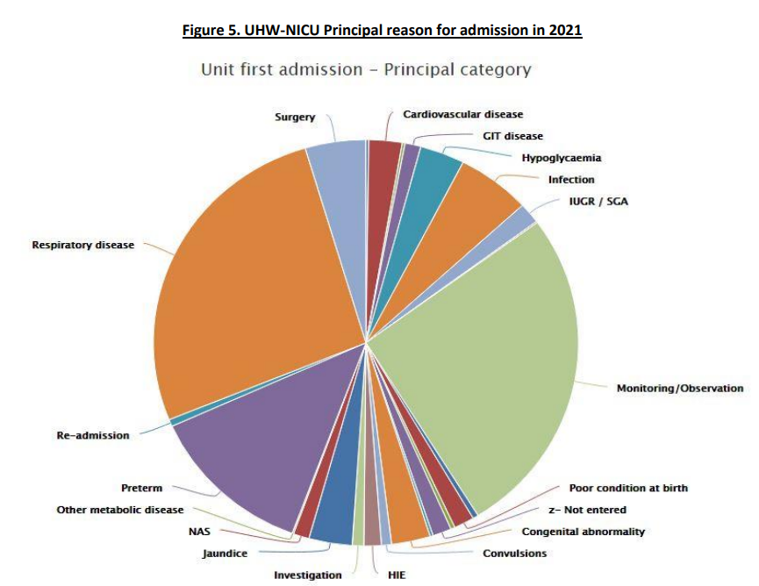

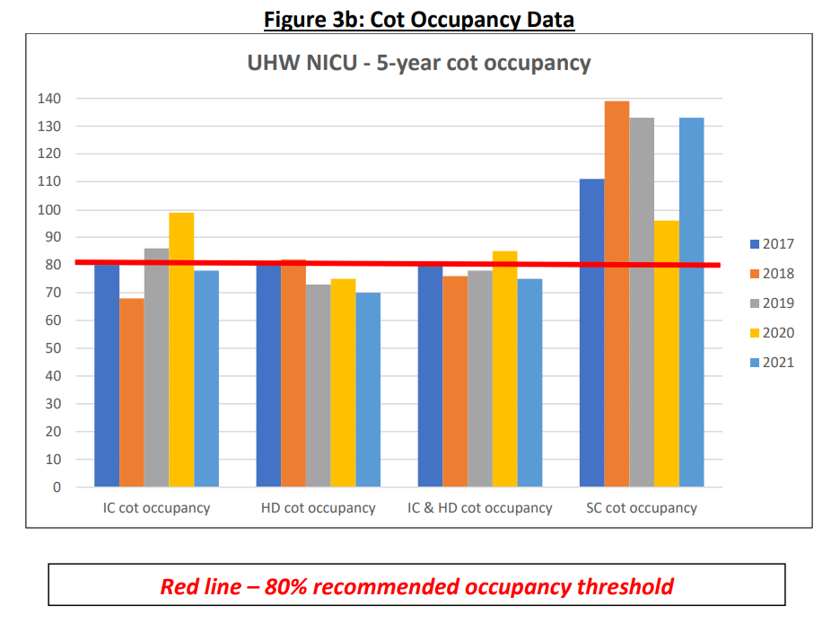
WHSSC 90% SCBU Target

(staffed cots)

6.1 (c) Elective C-Section Rates

The recommended options, including the additional medical cover, will enable the service to return to the national norm for Robson 1 caesarean sections.
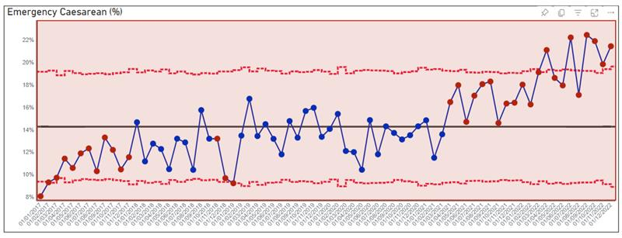

Currently, Cardiff & Vale UHB caesarean section rates stand at:

- Emergency: 22% of all births [National Standard is 15%]
- Elective: 16% of all surgical births [National Standard is 10%]

This will support improved patient experience, length of stay associated with caesarean section and also potentially change the pathway for future pregnancies / deliveries for the same mothers.

In addition to the above, the External cephalic version (ECV) clinic will support in a reduced section rate for breach presentations.

The reduction in caesarean sections will realise a capacity gain in theatres, with the potential for variable theatre consumables savings. If 50% of the theatres costs (circa £700 per case) were saved, delivering national standard could release circa £175k per annum.

Benefit Tracker:
Deliver to national standard caesarean section rates

6.1 (d) MLU and C-Section Lenth of Stay

Linked with the above benefits, the additional resources will ensure all patients can be reviewed within a maximum of 14 hours of admission. With improved patient flow, preventative and early support and post natal care, a reduced length of stay is expected within MLU as well caesarean section pathways.

Whilst this is not necessarily cash-releasing in the short term, due to fixed staffing ratios, BR+ etc., it will ensure an improvement in quality and mother/baby support and experience.

Benefit Tracker:
Reduce MLU LOS to 6 hours from current 20 hours (up to 30 hours)
Reduce C-Sec LOS to 48 hours from current 50-60 hours

6.1 (e) NRIs, concerns and other issues resulting in clinical negligence claims

UHB has recognised circa £12m per annum in the accounts 2018-2021 relating to O&G clinical negligence settlements. In addition, the current live caseload expected to settle stands at circa £64m, with several cases exceeding £10m liability.

This business case aims to address a number of contributing factors including training and learning, medical cover, quality and governance, patient support and experience etc.

The service expect to realise a reduction in NRIs and concerns, and ultimately longer term financial savings from preventable issues resulting in clinical negligence claims.

It is recognised that the legal timeframes surrounding existing cases, as well as the timeline for implentation, will result in an estimated 3 to 5 year time horizon to realise resultant savings, but an initial target of 10-15% reduction, £1.2m to £1.8m is assumed.

The long-term ambition would be that this case is ultimately self-funding from the avoidance of clinical negligence claims.

Benefit Tracker:
Reduction in O&G Clinical Negligence Claims expenditure by 10%-15% over the next 3-5 years.

Benefits Tracker

Benefit | Metric | Baseline | Target | Timeline / Ambition
Still Birth Reduction | Number of Still Births / 1,000 births | 4.5 - 4.75 in C&V UHB | 2.3 in line with NHSE Ambition | By 2030, with steady improvement
Minimise unplanned NCCU admissions and SCBU occupancy | % unplanned NCCU admissions  % SCBU occupancy of staffed beds | 4.4% unplanned term admissions  Regularly well exceeding 100% | 4% term admissions, exceeding UK performance  90% WHSSC target  80% Ideal Standard | By March 2025  By March 2025  By March 2026
C-Section Rates to meet standard, national norm for Robson 1 | % Emergency C-Section Rate of overall Births  % Elective C-Section Rate of Surgical Births | 22% currently  16% currently | 15% per national standard  10% per national standard | By March 2025  By March 2025
Length of Stay | Hours | MLU: 20 hours (Up to 30)  C-Section: 50-60 hours | 6 hours on MLU  48 Hours to discharge | March 2026  By March 2025
Reduction in NRIs, Concerns and other issues resulting in Clinical Negligence claims | Clinical Negligence expenditure (O&G) | Circa £12m per annum recognised in annual accounts  Circa £64m of live certain / probable settlements | 10-15% initial reduction | Likely a 3-5 year time horizon, given current caseload  Ambition of 15% by March 2028

6.2 Risk

Risk Title | Descriptor | Probability (1-5) | Impact (1-5) | Total risk score (PxI) | Mitigating Action | Owner
Midwifery uplift to BirthRate+ | Inability to recurit to midwifery vacancies | 5 | 5 | 25 | Over recruit the unregistered workforce and consider 15/85 midwifey split to support services
Uplift of Consltant sessions | Inability to recruit to the additional posts to fulfil the level of on site cover that Ockenden requires | 5 | 4 | 20 | Expedient recruitment, several suitable candidates have informally expressed interest, amd if we delay in acting this opportunity may be lost
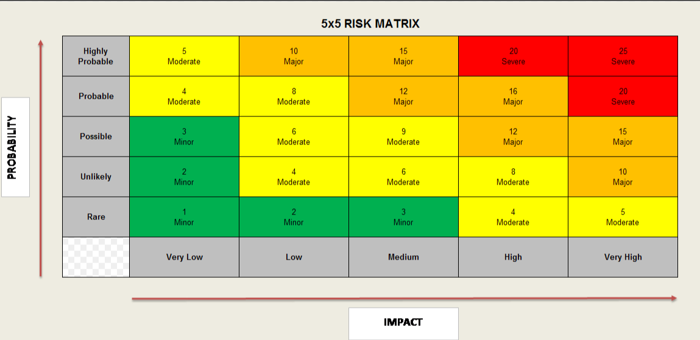

Key: 5x5 risk matrix

6.3 Total Cost - Resource Implications and Affordability

In England 180 million pounds of funding was released to enable compliance with all of the Ockenden Recommendations.

Welsh Government have invested £1 million in the Mat Neo Safety Program across Wales, which is currently in its Discovery phase for circa 12 months – the next steps of which are yet to be communicated. The operational view is that it is unlikely any further investment will be made available by Welsh Government to support implementation of the recommendations.

A phased approach to implementation has been described, given the timeline associated with recruitment to posts, and also in acknowledgement that there is no funding source identified to support this investment. There is a high degree of operational confidence in the deliverability of the phased recruitment schedule described in the table. The table below describes the financial impact of meeting the Phase 1 proposals.

The investment reflects a £2.7m recurrent requirement, with £0.084m in 2022/23 and £1.441m in 2023/24.

Additional obstetric sessions to support Ockenden recommendations and full 84 hour / week additional cover:

Whilst there is a financial risk to implementing the recommendations without an associated funding stream, the risks of not responding to the recommendations are significant. Given that the Ockenden Report’s focus is on services that have “failed to listen and failed to learn”, receiving and not acting upon the recommendations is indefensible, clinically, experientially, politically and reputationally

Appendix 1 - Gaps in Service Provision against Ockenden Recommendations

Ockenden Recommendation Ref | Ockenden Recommendation | Current Situation - i.e. gap against recommendation
1.1 | Patient safety specialist should be in post at each health board. | Nominated patient safety facilitator for the clinical board, having a regular presence at local governance forums and meetings. This is a role shared between clinical boards, and not a dedicated post for the women and Childrens clinical board
1.2 | Any clinician with the responsibility for clinical governance must have sufficient time within their job plan to deliver their duties. They should also receive training in human factors, causal analysis and family engagement. Have appropriate clinical risk and governance processes and training in place, including a consultant lead. A governance framework from ward to board must be evident ensuring joint ownership form maternity and neonates. | Obstetrics:  No current protected time given within Obstetric job plans for governance activities.  Midwifery:  There is currently no senior midwife lead for governance within the clinical board or directorate, no protected time is given to midwives undertaking investigations.  Neonatal:  Recommendations from the Deep Dive exercise and report into neonatal care at Cwm Taf identified a need for protected time for nursing and medical staff to lead on governance and patient safety. Currently there is no dedicated time for neonatal team staff to undertake these vital roles.
1.4 | Processes are in place for data collection and accuracy checking, clinical validation and monitoring of clinical practice and outcomes. Clinical change where required must be embedded across health boards with regional clinical oversight in a timely way. Health boards must be able to provide evidence of this through structured reporting mechanisms. | No senior governance lead for midwifery or protected Obstetric sessions for completion of SI and RCA investigation’s impacting on the length of time for completion. Non-compliant with the timeframe of six month. Currently changes in practice that result from serious investigations are not consistently audited to ensure effectiveness and sustainability. Patient Safety and Quality are working with Maternity and across the Health Board to ensure that patient safety priorities, risks and safety related service improvements feature in their clinical audit plans. Children & Women’s Clinical Board will pilot the implementation of AMaT, a quality assurance management system to monitor clinical audit, which will improve Quality Assurance and Clinical Effectiveness. No senior governance lead for midwifery or protected Obstetric sessions for completion of SI and RCA investigation’s impacting on the length of time for completion.
1.10. | Ensure appropriate staff training is available, including CTG, emergencies, NLS and  Develop an effective department wide multi-disciplinary teaching program. This must include clinical governance, skills and drills for obstetric emergencies, CTG interpretation, human factor training, NLS and psychological safety; incorporating learning from audits. Ensure that staff have timely access to the training that is required for them to carry out their roles. Compliance should be monitored. | Time allocated for Prompt/ community prompt and CTG training for midwifery and obstetrics. Dedicated time for monthly clinical governance session for all staff, elective work suspended for governance sessions to improve attendance. In Neonatology members of the MDT do not attend any joint sessions and no allocated time within job plans to facilitate this. Need for neonatal simulation training.
1.11 | Health Boards should appoint a dedicated Lead Midwife and Lead Obstetrician for fetal surveillance who will run regular fetal surveillance meetings, cascade training and lead on the review of cases of adverse outcome involving poor FHR interpretation and practice. | 1 WTE Fetal surveillance Midwife in place to support 300+ midwives.
1.18 | External clinical specialist opinion from outside the Health Board, must be mandated for cases of intrapartum fetal death, maternal death, neonatal brain injury and neonatal death. This should include the use of the PMRT where applicable. | Investigations are undertaken internally. The PMRT tool used by an MDT including members from outside of our clinical board. Investigations are conducted within the clinical board and have been recognised for their quality from external peers.
1.24 | Regional integration of maternal mental health services should be considered | Local perinatal mental health team including a perinatal mental health specialists’ midwife
1.28 | Complex pregnancy pathways must be in place for, Preconception advice and management of women with pre-existing conditions and Multifetal pregnancies | Preconceptual appointments available within specialist maternal medicine clinics, these are on an adhoc basis there is currently no formally recognised pre conceptional. Pathways for complex pregnancies are already in place for the above-mentioned conditions excluding chronic hypertension. There is currently no service provision for chronic hypertension.
1.32 | Pathways must be in place for induction of labour, that includes the management of delays | pathway now in place and 0.24 Induction of Labour lead in place
1.36 | Bereavement care must be available on a daily basis to ensure compassionate, individualised, high quality bereavement care is consistently offered to all families experiencing perinatal loss. This should be included as part of regular training updates. | 1 bereavement MW in place only able to cover 5 days
1.38 | Postnatal care must include systems in place to ensure a consultant review of all readmissions within 14 hours of readmission, including daily review of unwell postnatal women regardless of clinical setting. | Once daily consultant postnatal ward round (Monday – Friday)
2.2 | Service users (ideally through the MVP / MSLC) must be involved in the complaints process, ensuring responses are caring and transparent | No current lay involvement in the complaints process for maternity or neonatal services.
2.5 | All Health Boards will have pathways in place to provide timely emotional and specialist psychological support | Business case approved for funded psychological sessions for survivors of FGM. There is limited psychological support for women via clear pathway referrals to the perinatal mental health team. No current psychological support for women and their families following a stillbirth. No current psychological support for women with mild to moderate symptoms. Women can self-refer to the birth afterthoughts service Psychological support with a specialist psychology available for women with complex needs via the perinatal mental health team.
3.2 | Midwives responsible for coordinating labour ward must attend a funded and nationally recognised labour ward coordinator education module. This must be a specialist post with an accompanying Job Description | There is currently no training available or offered to newly appointed band 7 delivery suite coordinators. They have a supernumerary period of up to 4 weeks. Following this they have responsibility for the safe coordination of the maternity unit.
3.4 | Health Boards must train a core team of midwives to deliver high dependency maternity care, sufficient in numbers to ensure one midwife is available each shift | An established team of senior Band 6 delivery suite midwifery work as a core team supporting the delivery suite band 7 midwives. Current service provision has no formally HDU trained midwives.
3.6 | Ensure the Medical Director has effective oversight and management of the consultant body by: making sure they are available and responsive to the needs of the service, urgently reviewing and agreeing job plans to ensure the service needs are met, clarifying what is to be covered as part of SPA activity (audit, governance, teaching, guidelines, data assurance, train more consultant obstetricians as appraisers), ensuring the most unwell women are seen initially by a consultant and all women are seen by a consultant within 12 hour NCEPOD recommendation4 (national standard). | The HB has last year published Job Planning guidelines and we are in the process of ratifying JP’s. Not all JP’s are yet agreed. At present we have 12hr onsite cover for Mondays – Fridays. Weekend onsite consultant cover is 8:00 – 12:00.
3.7 | Ensure obstetric consultant cover is achieved in all clinical areas when required by: • reviewing the clinical timetables to ensure that 12-hour cover per day on Labour ward is achieved, • undertake a series of visits to units where extended consultant Labour ward presence has been implemented. Ensure the consultant on-call for the labour ward has ownership of all patients in the maternity unit for the period of call. This must involve the antenatal ward round being performed by the consultant. | The HB has last year published Job Planning guidelines and we are in the process of ratifying JP’s. Not all JP’s are yet agreed. At present we have 12hr onsite cover for Mondays – Fridays. Weekend onsite consultant cover is 8:00 – 12:00.
3.11 | Review their workforce plans to ensure appropriate actions are being taken to address the impact of staff working excessive hours, and any shortfall across staff groups. | Continuous review of midwifery establishment to ensure BirthRate+ compliance. Second year of student streamlining completed. Agreement in place that vacancies will not be held for newly qualified midwives. During periods of high vacancy rates centralisation of services is considered to ensure continued safe services.
3.16 | Investment in neonatal nursing staff, part matron part improvement. Nurse in charge to be supernumerary, ANNP should be expanded to ensure career progression. Nurse consultant roles to be explored. AHP in line with national recommendations including an expansion of pharmacy services. Lack of lead nurse for NICU. We have a lack of AHP’s in line with national recommendations: Physiotherapy and psychology. | Part time psychology funded by charitable funds limited until 2023. Lead nurse allocated with responsibilities for additional wards and services. No funded improvement roles. Physiotherapy cover (limited).
5.4 | Staffing uplift to be representative of the previous 3 years data on sickness, maternity leave, mandatory training and annual leave | Current maternity services uplift is in line with the safe staffing act. 26.9%
5.9 | Neonatal units must be staffed according to BAPM guidelines. Nursing workforce: • The minimum nurse to baby ratio should be 1:1 for babies receiving intensive care and 1:2 for high dependency care (these should be QIS nurses) and 1:4 for special care. • Bed occupancy should be no more than 70%. • BAPM recommends a dedicated neonatal lead for TC and a ratio of 1:4 nursing care for neonates on TCU. Medical workforce: • NICUs with more than 2500 intensive care days per annum should double tier 2 cover at night by adding a second experienced junior doctor ST4‐8 or appropriately trained specialty doctor or ANNP. • Consultant cover should be on site for 12 hours 7 days a week. • Each neonatal patient on the transitional care unit should have daily input equivalent to that provided in the nursery/SCBU area with an NICU | Demand for neonatal care outstrips the available cot provision and available staffing. Additional high levels of maternity leave reducing available workforce (up to 14 wte in the last 12 months). Due to volume of newly qualified staff within the workforce training is challenging. The current period of time means it takes approximately 2 years to become fully QIS trained. Lack of lead nurse and staffing ratios not consistent with 1:4 ratio. Only have 1 tier 2 doctor working on a night shift. Consultant weekend cover not within current job plans. Consultant covers both TCU and NICU – need additional consultant to ensure senior input is consistent and equitable on TCU.

Appendix 2 November 2022 Birthrate + Report for Cardiff and Vale

