Cardiff and Vale University Health Board Business Case
For revenue investment proposals greater than £75,000
All business cases must be submitted in line with the timescales outlined in Annex d

Title | Phased Critical Care Expansion:  24/7 P@RT
Clinical /Service Board or Department | Specialist Services Clinical Board/Adult Critical Care Unit

Expected funding source (highlight/delete as appropriate) | UHB core funding
Where a business case is in regards to external funding sources this template must be used unless the source of funding requires their own template to be used.
Approval and scrutiny route

Has this case been signed off by the Clinical Board / Corporate Departments senior team? | Clinical Board approved 15/02/23
Has this case been signed off by the Clinical Board / Corporate Departments finance and workforce business partners? | Yes
Clinical Boards: Has the COOs office signed off this document?  Corporate Departments: Has the relevant Executive sponsor signed of this document? | Yes  Yes (COO)

Contents
1. Introduction and Background 0
2. Strategic Context – Alignment to UHB strategic direction 2
3. Summary current service provision and case for change 3
4. Case of change 5
5. Option Appraisal 5
7.1 Benefits 6
7.1.1 Benefits tracker 0
Risk 0
7.3 Total Cost - Resource Implications and Affordability 1
6. Useful Links and References 2

Introduction and Background

Ward patients may acutely deteriorate either as a consequence of their admitting illness or as a result of complications acquired during their hospital stay. These patients are at risk of unanticipated admission into the ICU, cardiac arrest or death. Much of the U.K., including Wales, has adopted National Early Warning Scores (NEWS) as a mechanism to identify and respond to deteriorating patients. The success of NEWS relies upon the timely arrival of an appropriately trained team at the bedside of patients with elevated scores.

In 2019 the Royal College of Anaesthesia (RCoA) review team identified CAVUHB did not have an adequate system to manage deteriorating patients across its two acute hospital sites and recommended immediate action to correct them. In 2019 the Welsh Government Task and Finish Group recommended that every Health Board across Wales establish a 24/7 critical care outreach team.

In November 2019, a UHB, multidisciplinary group including all relevant stakeholders was tasked to address all of the recommendations relating to the provision of outreach services made in the RCoA report. The remit of this group was to consider how existing UHB services could be reconfigured and enhanced to produce a model of outreach care that would be consistent with national guidance (Welsh Government Task and finish group on critical care July 2019), satisfy the concerns expressed in the RCoA report and be fiscally responsible.

In October 2020 the P@RT team was launched as a daytime only service, with the anticipation that it would grow into a 24/7 service within 12-24 months. Since the inception of the service, P@RT practitioners have undertaken > 10,000 ward reviews across the UHW and UHL sites. This equates to approximately 25-30 ward reviews per day. The response times to the sickest ward patients (NEWS =/> 9) is 100% compliant with the national target of review within 10 minutes. Additionally, P@RT practitioners attend all cardiac arrest calls between 07.00-19.30 hours. 75% of these events are related to patients who are seriously ill but not in cardiac arrest. Practitioners provide an essential role in ensuring that a robust, clinical management plan is in put in place for these patients, including completion of treatment escalation plans, enhanced clinical management or transfer to intensive care.

Overnight management of deteriorating patients is managed by the hospital at night team and site practitioners. The current inequity between night time and daytime service means that timely, efficient and patient centred care, and staff education is compromised. Moreover, the current service provision does not adhere to the national guidance issued by Welsh Government in July 2019, nor comply with a key recommendation made in an external review of intensive care services in Cardiff and Vale UHB by the RCoA in April 2019. It is imperative that the P@RT service is expanded to a 24/7 provision to ensure the organisation is able to support deteriorating patients overnight across both UHW and UHL; at a time where senior clinical support staffing levels are at their lowest.

The purpose of this business case is to present the development of a 24/7 P@RT service.

Current Performance

Below is an infographic summarising the workload during the first year of the P@RT service.
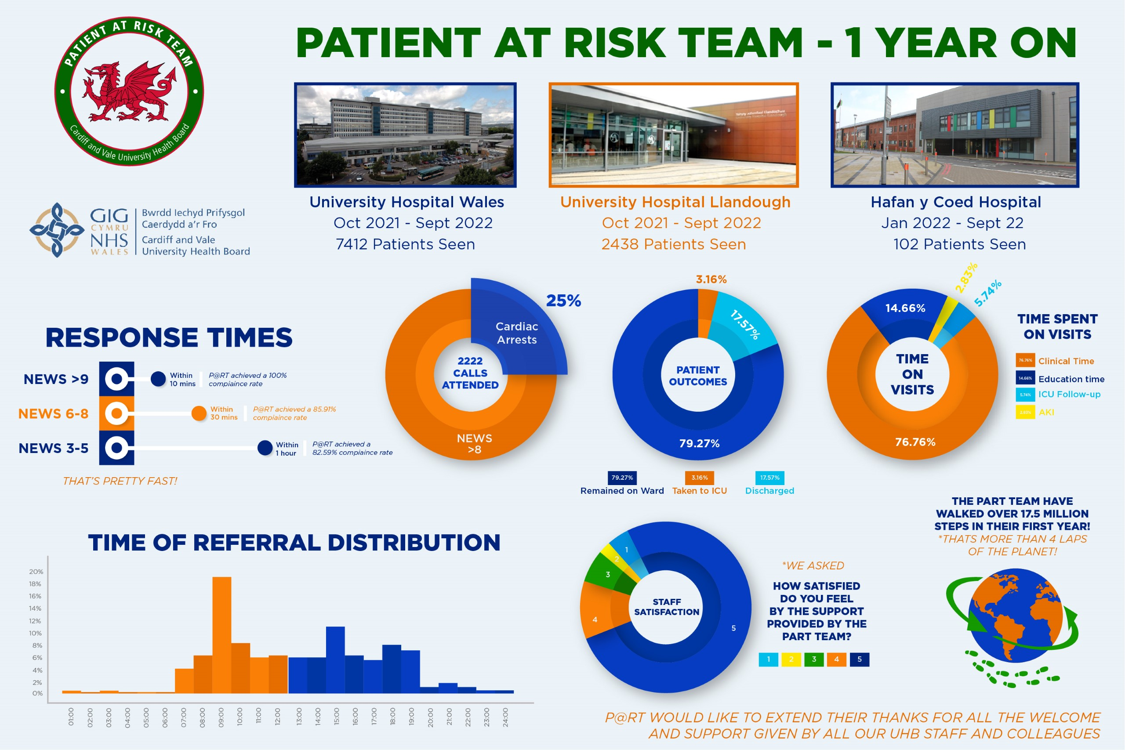

Timeframe for This Case

The urgent need to uplift the P@RT to a 24/7 service h is well recognised formally and informally by the Critical Care Network and CAVUHB Executive Team.

A consilience of evidence to support this case and the risks of not investing will be presented below.

Strategic Context – Alignment to UHB strategic direction

Outcome and Priority | How does this proposal support any of these outcomes
Outcome 1: Home first | - Due to the nature of critically ill patients' condition, this case does not have impact on this outcome.
Outcome 2: Outcomes that matter to people | - P@RT team to deliver equitable access 24/7 – improve experience for patients.  - Continue to manage patients on the ward with optimal management plans.  - Staff survey data shows that P@RT is highly evaluated, 95% of ward staff gave a satisfaction score of 5/5 with the service.  - Improving survival  - Improving functional outcomes
Outcome 3: Empower the person | - Critical illness is an extremely vulnerable situation for patients and families. Its time critical nature means immediate access to ICU, if appropriate, is essential.  - P@RT to support patients to make decisions about individual escalation plans.
Outcome 4: Waste, harm and variation | - Early intervention by P@RT will support reduction in patient harm.  - 24/7 P@RT reduces variation in services between day and night service provision.  - Delivery of on-ward teaching in order to upskill teams to deliver consistent care to the deteriorating patient.

Critical Care Directorate Strategic Plan

This business case specifically refers to the development of a 24/7 P@RT service. However, the wider context is this is a part of a six stage “Cardiff Critical Care Redevelopment Project – creating a sustainable service”.

- Intensive Care Unit Capacity – closing the gap
- Critical Care Infrastructure plan
- Cardiff 24/7 Patient at Risk Team
- ECMO - a fundamental part of tertiary Critical Care
- Enhance Care Level 1 area development plan for CAV (whole system)
- Evolving our Long-Term Ventilation service.

This strategy also aligns with Welsh Government Critical Care Strategy via the Wales Critical Care Network – (reference 13)

Summary current service provision and case for change

Patient at Risk Team Activity and Benefits (Oct 2021-September 2022)

The patient at risk team have undertaken more than 10,000 ward reviews since its inception. Prior to the P@RT team management of the deteriorating patient was delivered in a less structured way. P@RT offers support to ward teams by delivering hands on care to deteriorating patients when needed, providing bedside education, and in conjunction with the local clinical team will develop robust, clinical management plan is in put in place for these patients, including completion of treatment escalation plans, enhanced clinical management or transfer to intensive care. This coproduction approach builds the skills and confidence of ward staff to deal with complexity; and has been particularly impactful in mitigating the risks associated with reduced intensive care capacity.

The P@RT team support patient flow in and out of ICU. All ICU discharges are followed up by the P@RT team, which provides an additional tier of safety to these patients who are at higher risk of deterioration. Additionally, P@RT practitioners have a key role in supporting patients awaiting admission into intensive care by providing enhanced monitoring and timely, specialised treatments that may be outside of the usual scope of practice of ward staff.

It is important to note that the vast majority (>90%) of P@RT referrals do not require ICU admission rather an enhanced level of clinical supervision and acute, specialised treatment facilitated by the P@RT.

In UHL the P@RT team has facilitated the continuation of specialised psychiatric care by the supervision and provision of treatment for nosocomial, medical complications in both Hafan-Y-Coed and the MHSOP wards. Prior to P@RT patients would have to be transferred to the emergency stream to safely meet their needs.

Patient at risk team activity
- 7,412 ward reviews in UHW.
- 2,438 ward reviews in UHL.
- 255 ward reviews on MHSOP wards in UHL.
- 103 ward reviews in Hafan-Y-Coed.
- > 80% compliance with review time targets
  - NEWS > 9: 100% compliance with target of bedside review within 10 minutes of call.
  - NEWS 6-8: 86% compliance with target of bedside review within 30 minutes of call.
  - NEWS 3-5: 83% compliance with target of bedside review within 1 hour of call.
- 250 transfers into the ICU from general wards
- Attend all 2222 calls during daytime hours, over 70% of these calls are patients with a NEWS of =/>9.
- Follow up of all ICU discharges approximately 30 per month.
- Follow up of high-risk discharges from the PACU.
- Review of other high-risk groups including NIV, NELA and CAR-T patients*
- Membership of RADAR committee.

*NIV: Non-Invasive Ventilation, NELA: National Emergency Laparotomy Audit, CAR-T: Chimeric antigen receptor T-cell therapy.

Workforce

Table three: Summary of current P@RT workforce and required investment uplift.
Workforce | Current WTE Budget | 24/7 Investment WTE
Registered Nursing
Nurse Manager Band 8A | 1.00
Registered Nurse Band 7 | 13.34 | 14.08
Admin & Clerical | 0.5 | 0.3
Total Number | 14.84 | 15.10

Case of change

Patient at Risk Team Unmet need

At night deteriorating patients are managed across the acute sites by the hospital at night team with support from site practitioners. The 24/7 P@RT team would enhance the safety and experience of care given overnight to our patients. Due to workforce constraints the current overnight clinical service is limited and focuses on support to sicker patients. This is evidenced by the P@RT referral data which suggests that there is a significant, unmet need for the timely management of the sickest ward patients overnight. There is typically a spike in referrals to P@RT in the mornings (09.00). This is likely to reflect a reduction in the number of experienced clinicians on site overnight.

The P@RT team support any patient with a NEWS score >3 with the aim of intervening early to prevent deterioration. Furthermore, the P@RT practitioners have a number of prescribers and PDGs in place; they are able to order diagnostic tests. Using these advanced skills and interventions, the P@RT team would reduce the workload for the junior doctors overnight both by retaining a cohort of patients under the care of the P@RT team, or by working up patients prior to a medical review.

Option Appraisal

- Do nothing – Continue with P@RT delivering a daytime only service.

  - A lack of action is not considered acceptable, both operationally and politically.
  - Failure to realise reduction in mortality
  - Increased pressure on an overstretched Critical Care services
  - Increased operational risk to the current service.
  - Fail to comply with national guidance issued by Welsh Government in July 2019.

- Invest in a 24/7 P@RT service:
- Comply with national guidance issues by Welsh Government in July 2019, and a key recommendation made in an external review of intensive care services in Cardiff and Vale UHB by the Royal College of Anaesthetists in April 2019.
- Highly evaluated, 95% of ward staff gave a satisfaction score of 5/5.
- Investment will address the current inequity between night-time and daytime service which will result in timely, efficient and patient centred care and staff education which is currently compromised by night.
- Support night-time ward nursing staff and Junior Doctors

The Preferred option

Based on the above options, the preferred and recommended way forward is Option 2. This would address current inequity of service and achieve compliance with national guidance.

Benefits

Quantifiable benefits | Non-quantifiable benefits
- Expansion of P@RT 24/7 will provide equity of service day and night  - Improving timeliness and quality of clinical care  - Reduce significant unmet need for the sickest patients on the wards overnight  - More appropriate patient flow overnight  - Improving functional outcomes by formulating optimal patient management plans  - Improved education and training opportunties  - Workkforce resilience due to reduced staffing numbers and poor skill mix by night. P@RT would support the nursing teams and junior doctors  - Investment would enable us to comply with national guidance issued by Welsh Government in July 2019, and of a key recommendation made in an external review of intensive care services in Cardiff and Vale UHB by the Royal College of Anaesthetists in April 2019 | - Reduced known unmet need. Improved culture across the system from reduced strain because of critical care strain.  - Other unmeasured efficiencies across the system e.g Emergency department secondary strain from critical care.

7.1.1 Benefits tracker

Benefit title | Benefit descriptor including | Expected realisation date | Measure(s) to be used | Baseline position at 01/04/2023 | Projected position at  01/07/2023 | Actual position at 01/07/2023 | Projected position at 01/01/2024 | Actual position  at 01/01/2024 | Projected position at 31/03/2024 | Actual position  at 31/03/2024
Increased used of digital technologies. | Half of future FU appointments can be undertaken virtually | By Q4 24/25 | % of FU appointments taking place virtually | 10% | 20% by Q2 22-23 | To be populated at Q2 22-23 | 35% by Q1 23-24 | To be populated at Q1 23-24 | 50% by Q4 24/25 | To be populated at Q4 24/25
P@RT – continuity of care 24/7 for patients requiring P@RT support | Patients on P@RT caseload no longer handed onto H@N or general ward nursing teams at night. P@RT team will continue to support ward teams with care 24/7. Improved experience for patients and nursing teams. Reduction in workload for junior doctors. | By Q2 23/24 | P@RT audit data | Zero | Recruitment underway | To be populated | Recruitment complete | Completed | Completed | Completed
P@RT – identification and escalation of high-risk patients that would benefit from earlier admission to ICU | Earlier review and escalation of high-risk patient groups including NIV, NELA and CAR-T patients that would benefit from earlier admission to ICU. These high-risk groups when admitted sicker have a higher mortality rate. | By Q4 23/24 | Audit of NELA and ICNARC data | Zero | Early identification and escalation to ICU/reduced mortality rate | To be populated | Early identification and escalation to ICU/reduced mortality rate | To be populated | Early identification and escalation to ICU/ reduced mortality rate | To be populated
P@RT – Specialised care delivered in the most appropriate setting | Currently patients requiring specialised care overnight are moved from general wards to areas with higher supervision. P@RT will be able to deliver specialised care, negating moves, improving patient experience and delivering care in the most appropriate location. | By Q2 23/24 | P@RT audit data  72% patients are treated on the ward in daytime hours | Zero | Aim for daytime % | To be populated | 70% by Q3 | To be populated | 70% by Q4 | To be populated
P@RT – out of hours discharge support from ICU | Currently patients are discharged from ICU late in the evening. P@RT will support the wards with these transfers. | By Q2 23/24 | P@RT audit data | Zero | Recruitment underway | To be populated | Recruitment complete | Completed | Completed | Completed
Workforce Resilience – General Wards | Improved workforce resilience and enhanced support for general ward nurses and junior doctors out of hours. | By Q3  23/24 | P@RT evaluation  Staff Surveys – main current scores of 5/5 | Day time cover only | Recruitment underway | To be populated | Completed | Completed | Completed | Completed
National Standards | Comply with national guidance issued by Welsh Government in July 2019, and of a key recommendation made in an external review of intensive care services in Cardiff and Vale UHB by the Royal College of Anaesthetists in April 2019 | By Q3  23/24 | Compliance rates | Day time cover only | Working towards compliance | To be populated | 100% by Q3 | To be populated | 100% by Q4 | To be populated
National Standards | Comply with national response times to the sickest ward patients (NEWS =/> 9) target of review within 10 minutes. | By Q3  23/24 | Compliance rates | Day time cover only  Currently 100% Compliant | Aim for daytime compliance – 100% | To be populated | 100% by Q3 | To be populated | 100% by Q4 | To be populated

Risk

Risk Title | Descriptor | Probability (1-5) | Impact (1-5) | Total risk score (PxI) | Mitigating Action | Owner
Workforce destablisation | Investment into P@RT has the risk to destablish the workforce across EU/Critical Care and Site services as recruitment is likely to attract staff from these departments.  Given the propsed WTE uplift there maybe delays with recruitment and impact on training to get the practitioners up skilled. | 4 | 3 | 12 | Continuous recruitment campaign. Negotiation around starts dates - dependent upon areas impacted. | Jane Morris/Claire Main

Key: 5x5 risk matrix

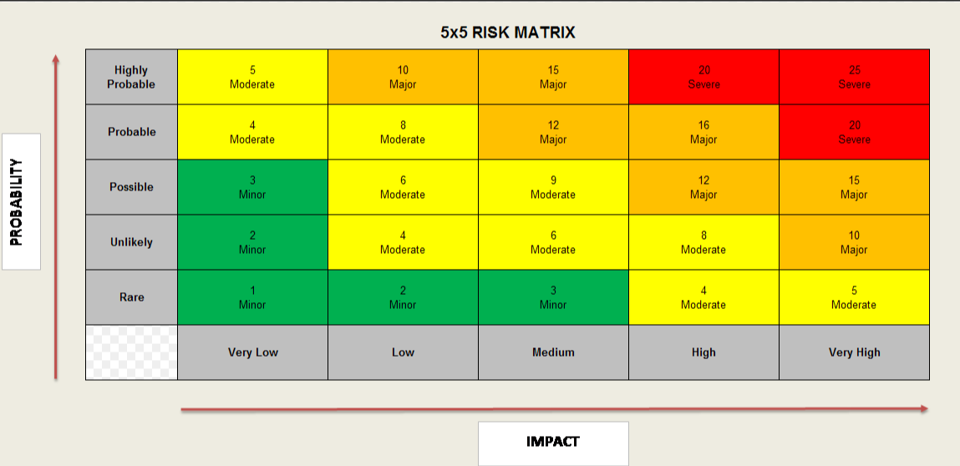

7.3 Total Cost - Resource Implications and Affordability

The case is costed and presented is:

- Uplift beyond baseline to P@RT to deliver a full 24/7 service - £1.024m

The total initial phased expansion therefore requires £1.024m recurrently, with an anticipated part-year-effect of £433k in 2023/24.

Useful Links and References

Capacity and Demand:
1. Our World in Data - ICU Capacity & OECD - ICU Capacity
2. WG 2014 CC Unmet needs study
3. WG - Care of Critically ill - Quality Statement
4. Cardiff Critical Care Strategy 2021-22 (on request)
5. FICM External Review 2019 and 2022 progress update (on request)
6. Getting It Right First Time - Adult Critical Care 2021
7. GPICS – UK Critical Care Standards
8. BTS/ICS Res Support Unit Guidance 2021
9. Enhanced Care Units https://www.ficm.ac.uk/sites/ficm/files/documents/2021-10/enhanced_care_guidance_final_-_may_2020-.pdf

Welsh Government strategic documents:
11. A Healthier Wales: the long-term plan for health and care in Wales.
12. WHC 2016(041) Revised guidelines for transfer of the critically ill adult
13. Delivery Plan for Critically ill
14. Task and Finish Group on Critical Care: Final Report July 2019
17. Health in Wales Critical Care
18. National Clinical Framework 8.0 (gov.wales)
19. Quality and Safety Framework
20. Health and Care Standards

National Institute for Clinical Excellence:
21. 2007 NICE Clinical Guideline 50: Acutely ill Patients in Hospital
22. 2009 NICE Clinical Guideline 83: Rehabilitation after Critical Illness
23. 2017 NICE Quality Standard Rehabilitation after Critical Illness in Adults

Other Referenced Documents:
24. ICNARC Data
25. A novel approach to an evolving cohort of critical care patients
26. Association of Anaesthethiests

