Cardiff and Vale University Health Board Business Case
For revenue investment proposals greater than £75,000
All business cases must be submitted in line with the timescales outlined in Annex d

Title | Phased Critical Care Expansion:  Initial 3-Bed Expansion
Clinical /Service Board or Department | Specialist Services Clinical Board/Adult Critical Care Unit

Expected funding source (highlight/delete as appropriate) | UHB core funding
Where a business case is in regards to external funding sources this template must be used unless the source of funding requires their own template to be used.
Approval and scrutiny route

Has this case been signed off by the Clinical Board / Corporate Departments senior team? | Clinical Board sign off 15/02/23
Has this case been signed off by the Clinical Board / Corporate Departments finance and workforce business partners? | Yes
Clinical Boards: Has the COOs office signed off this document?  Corporate Departments: Has the relevant Executive sponsor signed of this document? | Yes  COO

Contents
1. Introduction and Background 1
2. Strategic Context – Alignment to UHB strategic direction 3
3. Summary current service provision and case for change 5
4. Case of change 6
5. Option Appraisal 9
6. The Preferred option 9
7.1 Benefits 9
7.1.1 Benefits tracker 0
Risk 0
7.3 Total Cost - Resource Implications and Affordability 3
7. Useful Links and References 5

Introduction and Background

Critical care encompasses the care provided for all the sickest, and therefore highest risk, patients in the healthcare system. The quality of this care and the outcomes for these patients is determined by access to the right care at the right time. Conceptually, 5 measurable components determine the quality of this care.

A critically ill patient care shared mental model:

- Early recognition of acute illness.
- Early time critical resuscitation and organ support.
- Early time critical diagnosis.
- Early time critical treatment/intervention/therapy.
- Early time critical rehabilitation and recovery – psychological, physical.

Why does understanding this shared mental model matter to this case?

These components represent the most important measurable metrics of quality care for our highest risk patients. Critical Care capacity (across all areas of the critical care directorate), including ICU capacity, directly impacts access to this care.

The demands on critical care continue to increase. The Intensive Care National Audit and Research Centre (ICNARC) predicts that future demand will rise by 4% per year. In Wales, the critical care bed capacity per capita is one of the lowest in Europe.

The adult Critical Care service in Cardiff includes care of:

- Patients inside the adult Intensive Care Unit (ICU) at UHW.
- High risk elective surgical patients inside the Post Anaesthetics Care Unit (PACU) at UHW.
- Patients requiring prolonged invasive ventilation beyond their acute illness via the Long-Term Ventilation Service (LTiV) at UHW.
- Any acutely unwell in-patients outside of these areas by the Patient at Risk Team (P@RT) at both UHW and UHL.

This case focuses on the plans for a phased expansion of adult intensive care capacity, with an initial 3-bed expansion within the current footprint. There are plans in development to expand the physical footprint of the ICU which are being managed via the Acute Master Site Plan structure. There are also plans to deliver an expanded LTiV service to the population of South and Mid Wales. This initiative is being progressed with support from the Critical Care Network and WHSSC. Alongside ICU development, there is a need to look at level 1 capacity across the UHB, particularly within the Medicine Clinical Board, to support delivery of enhanced care outside of the ICU footprint. The wider infrastructure, development of P@RT 24/7, LTiV and level 1 provision developments have been excluded from this case.

Intensive Care Unit

The service reconfigured at the beginning of the pandemic and currently has 45 physical bed spaces, of which only 31 ICU beds are funded. Evidence generated in 2014 by Welsh Government indicated the unit needs to safely expand to a footprint of 50 level 3 beds, with a workforce to staff these beds in order to be able to safely admit patients 95% of the time.

Cardiff Critical Care has continued to meet increasing demand for services and is committed to providing care that meets the needs of our patients. The service frequently runs significantly above recommended capacity of 75%, with additional unfunded beds opened flexibly to meet demand. Although the service aims to meet increased demand, this is achieved through a combination of compromises in nursing ratios, a heavy reliance on agency nursing, and use of non-critical care capacity to support discharges. Combined, this impacts on patients’ continuity of care and experience.

There are ongoing effects on the safety and quality of care. For example:

- Patients managed inappropriately; at times, critically unwell patients may be cared for in resus, theatres recovery or in ward areas
- Routinely operating over capacity, which in turn affects staff wellbeing
- Delayed transfers of care; patients who should be nursed in ward areas are exposed to critical care for prolonged periods,
- Delays in admission to critical care due to insufficient capacity which is associated with excess mortality
- ICNARC Standardised Mortality Ratio has exceeded 3SD
- Absolute mortality has reached 40% as the unit only has capacity to admit the sickest patients

The purpose of this business case is to present the evidence for an urgent phased increase in the provision of secondary care capacity within the ICU at UHW. This improved capacity aims to close a large existing and anticipated future growing unmet need for access to intensive care at UHW.

Commissioning Arrangements and Performance

Adult ICU has mixed commissioning arrangements across WHSSC, LHBs, cross-border flows and locally in C&V. External funding is recovered through varying bedday contacts based on actual activity.

WHSSC has uplifted funding in specialised services ICU provision through successive ICP planning rounds, including full-cost uplifts and Major Trauma, as well as funding the establishment of the LTV Unit.

Aside from directed WG Task & Finish Group monies, LHBs have not uplifted ICU baselines or rates for a number of years, and so contracts operate on historic marginal prices. There is scope to corporately consider the reimbursement level across Aneurin Bevan, Cwm Taf Morgannwg and Hywel Dda as part of wider LTA rebasing discussions.

However, the locally commissioned capacity for secondary care C&V residents is recognised as a key challenge, whilst trying to sustain expanded regional and specialised services.

The table below summarises the existing bed day baselines. Cardiff and Vale resident activity would equate to a 10-11 bed provision at 100% occupancy, or alternatively allocating out actual utilisation at occupancy standards would only equate to a 12-13 bed capacity. This is not sufficient to meet demand.

Timeframe for This Case

The urgent need for change has already been presented and is well recognised formally and informally by Welsh Government, Chief Medical Officer, Critical Care Network and CAVUHB Executive Team.

A consilience of evidence to support this case and the risks of not investing will be presented below.

Strategic Context – Alignment to UHB strategic direction

Outcome and Priority | How does this proposal support any of these outcomes
Outcome 1: Home first | - Due to the nature of critically ill patients' condition, this case does not have impact on this outcome.
Outcome 2: Outcomes that matter to people | - Time critical access to the ICU means timely access to resuscitation, organ support, diagnostics, treatment and rehabilitation. This affects all outcomes.  - ICNARC data compared to similar units  - We only have capacity for Sicker patients  - ICNARC severity of illness score higher  - Ratio of Level 2: Level 3 patients’ outlier  - Mortality high as capacity only able to admit sicker patients  - Absolute 40% (usually 20%)  - Early and late mortality affected  - See Kaplan Meier curve for UHW (Reference 24)  - Length of stay – for those patients who survive critical illness, local data shows that their length of stay is reduced overall by early access to intensive care. (Reference 25)  - Improving survival – early recognition, time critical diagnosis, organ support etc.  - Improving functional outcomes.  - Improving timely clinical care.  - Patient experience – Critical Illness, for both patients and families, is a major traumatic life event with psychological, physical, social, and financial impact. Appropriate access or not to that care directly affects the experience for all those involved as well as the secondary consequences after the event.
Outcome 3: Empower the person | - Critical illness is an extremely vulnerable situation for patients and families. Its time critical nature means immediate access to ICU, if appropriate, is essential.
Outcome 4: Waste, harm and variation | - Delayed access for acutely unwell patients to the correct care (see Introduction - Critically Ill Shared Mental Model) is inefficient and causes serious patient harm.  - These acutely unwell patients come from every adult clinical specialty and therefore affects every acutely unwell patient from every adult specialty.  - Reduction in unmet need.  - Equity of care for patients that cannot be admitted into critical care due to lack of capacity

Critical Care Directorate Strategic Plan

This business case specifically refers to increasing secondary care capacity of the adult ICU to safe levels. ICU tertiary commissioned capacity is commissioned by WHSSC and will be addressed separately. However, the wider context is this is a part of a six stage “Cardiff Critical Care Redevelopment Project – creating a sustainable service”.

- Intensive Care Unit Capacity – closing the gap
- Critical Care Infrastructure plan
- Cardiff 24/7 Patient at Risk Team
- ECMO - a fundamental part of tertiary Critical Care
- Enhance Care Level 1 area development plan for CAV (whole system)
- Evolving our Long-Term Ventilation service.

This strategy also aligns with Welsh Government Critical Care Strategy via the Wales Critical Care Network – (reference 13)

Summary current service provision and case for change

The ICU is funded for 31 beds and admits approximately 1,300 patients per year. Capacity at UHW often runs at >100% the majority of the time which results in the service operating in a permanent state of escalation and is one of the most strained units in Wales. This constant strain is having a negative impact on the health and wellbeing of the staff within the directorate but also effects services across the health board.

As demand for ICU continues to outstrip capacity it was acknowledged by the Executive team that investment is required to address the secondary care provision capacity gap and work towards staffing the unit in line with National GPICS standards.

This paper evidences the need for investment in additional capacity over the next few years that allows expansion using a phased approach in line with current modelling that suggests the ICU should have closer to 50 beds.

A pragmatic approach to this means that we are seeking investment in 2023/24 of an additional 3 beds which will allow us to recruit and train in year. This prudent approach protects the ‘dilution effect’ on the workforce thus allowing us to retain current skill-mix and expertise. We will continue with this incremental growth approach until we reach the required number of beds to maintain a safe service and eradicate the permanent escalation status we find ourselves in.

Safe Staffing Standards

GPICS standards are professionally agreed National UK standards published for critical care multi-disciplinary staffing. These are covered in the General Provision of Intensive Care Services (GPICS). GPICS sets a standard (reference 6) against which Cardiff critical care services can be audited. The service currently falls short against these standards when measured against current level 3 bed numbers in several areas. These standards have been referenced when developing the workforce requirement to support the growth of the service by three level three beds. However, the workforce investment set out in this case falls short of compliance against GPICS standards. It is recognised that a balance must be struck between a workforce that is affordable financially versus the broader patient safety and staff wellbeing costs of a stretched workforce.

The Designed for Life Quality Standard for ICU, Wales (2006) state:
- Staffing levels must be at least 7.0 WTE per level 3 bed
- at least 70% having specialist qualification in critical care nursing

Intensive Care Unit Workforce

Table One: Summary of current Adult ICU workforce and required investment uplift by 3 beds.
Workforce | Current WTE Budget | Phase 1 Investment WTE
Registered Nursing
Nurse Consultant Band 8C | 0.60
Nurse Manager Band 8A | 2.50 | 1.00
Nurse Manager Band 8B | 1.00
Registered Nurse Band 5 | 137.45 | 12.30
Registered Nurse Band 6 | 83.00 | 8.20
Registered Nurse Band 7 | 11.75
Registered Nurse Band 7 - ACCPs | 4.00
Registered Nurse Band 8A - ACCPs | 4.00
Unqualified Nursing/HCSW | 18.80
Scientific Practitioner – Technicians | 4.76 | 1.00
Scientific Practitioner – Physiologist | 1.00
Management and Admin & Clerical Staff | 12.39 | 1.00
Psychology | 0.2 | 0.25
AHP – not directly employed by the directorate |  | 1.00
Medical Consultant | 26.14 | 2.50
Medical Junior | 26.00
Total Workforce | 333.59 | 27.25

Case of change

ICU Demand

The main ICU at UHW admits approximately 1,300 patients per year. It is well recognised internally that the ICU in Cardiff is not able to admit all the patients we should to the ICU.

The Intensive Care National Audit and Research centre (ICNARC) is the comparable dataset collected by all UK Intensive Care Units (214). This data is very robust and has:

- Has observed a 4% increase per year in demand for critical care beds. This is a doubling time of beds required of approx. 15 years. That was published in 2011.

- Shows that the ICU admit sicker patients because the clinicians often have to triage the sickest patients for access. Consequently, the longer-term outcome of our patients is worse (Kaplan Myer curve).

The ratio of Level 2 (less sick) to Level 3 (sicker) patients is vastly different to comparable units. In most units the minority of patients are Level 3. Currently, approximately 75% of admissions to the unit are Level 3. Consequently, most Level 2 patients are not able to access ICU. This means we only have capacity for the sickest patients referred. For other patients who would benefit from an earlier admission to ICU, and perhaps prevent deterioration, it is not possible. This is not the case compared to similar comparable intensive care units.

This constraint also manifests in our mortality data. Absolute mortality in intensive care is usually around 20%. In our unit this has been as high as 40% at times. The risk adjust mortality is not outlier status. The Kaplan Myer curve for longer term mortality is also compatible with a sicker patient profile on admission than for comparable units.

Unmet Need

In 2014 WG commissioned an audit into unmet need. At the time the ICU at UHW had 27 funded beds. Based on the data collected, by 2024, the beds required in UHW would be over double that figure.

written-statement-provision-of-critical-care-services-in-wales-annex.pdf (gov.wales)

Currently, our known unmet need shows we cannot admit every patient we want to because of capacity constraints. We prospectively collect data of every referral to the ICU at UHW. Every referral is reviewed by a consultant intensivist. Of the referrals suitable for admission to the ICU, 10-15% of these patients are not admitted because of lack of capacity.

Patient Example – Patients undergoing an emergency laparotomy are audited through the National Emergency Laparotomy Audit (NELA). These patients are risk assessed pre and post operatively and those patients with a predicted mortality >5% are recommended for admission the Critical Care postoperatively. Out of 214 ICUs in UK, CAV is the one of the highest volume centers for Emergency Laparotomies. However, we have one of the lowest admission rates for high- risk post op patients (30% vs national average 80%). With a predicted mortality of >10% in this patient cohort, access is worse in CAV than elective patients to PACU (1-2% predicted mortality) or elective cardiac surgery (<5% predicted mortality). For this group this is Inequitable care internally and compared to other similar centres.

Unknown Unmet Need Exists

This is difficult to attribute the direct effects of the limited access to intensive care but it is an important consideration. Realistic possible effect will be a change in referral practice due to changing lowered expectations of admission. It should be considered what effect this would then have on patient outcomes.

The ICU has 31 funded beds. How does CAVUHB ICU capacity compare in the UK and Europe?

The unit of ICU capacity is beds per 100,000 population being served. OECD data captures this data.

Europe | Average in Europe Is 11 (Germany 22).
UK | England has 7 beds per 100,000.  Wales (5 per 100,000) has the second lowest critical care beds per 100,000 people in Europe.

Optimising Existing Capacity

- Delayed Transfers of Care - Minimising delayed transfers of care (DToCs) has appropriately been seen as an important way to optimise prudent use of ICU capacity. We have focused a working group on this for the last 18 months with a resultant reduction in DToCs to some of their lowest ever levels.

- Appropriate admissions – all referrals are reviewed 24/7 by consultant intensivist prior to admission.

Workforce Capacity

Historically ICU has struggled to recruit to its establishment. This impacted upon service delivery, both in terms of open beds and the ability to adequately train and retain staff. Since July 2020 ICU has made significant progress with nursing recruitment and is fully established. This is a great achievement.

The service has a nursing workforce strategy which outlines its commitment to investing in the workforce, with education and training opportunities, pastoral care etc. to ensure that the gains made in recruitment can be maintained with a highly skilled and supported workforce. With support from HEIW the service is offering a Post Graduate Certificate of Education in Critical Care. Since starting this programme 1 year ago we now have over 50 nurses enrolled on this course.

Whist we have made significant improvements within our nursing workforce, investment in other staff groups such as AHPs and pharmacy has not kept pace, meaning a larger gap in care relative to other areas. This case does not address this issue. Further phases of investment will be required to close this gap and expand the workforce to deliver AHP support closer aligned with GIPICS standards.

The critical care directorate are non-compliant with Medicines legislation on safe storage and the following GPICS standards:

- There must be sufficient patient-facing pharmacy technical staff to provide supporting roles.
- The Consultant in Intensive Care Medicine-led ward round must occur twice a day and must have daily input from pharmacy to assist decision making.
- Follow-Up clinics should include a review, rationalisation & optimisation of a Patient’s current medication with input from pharmacy as required

Benchmarking/Modelling

- As previously described, ICNARC Has observed a 4% increase per year in demand for critical care beds. This is a doubling time of beds required of approx. 15 years. That was published in 2011. At the time this was published UHW ICU capacity was 27. This again suggest 45-50 level 3 beds would be expected for current demand.
- WG commissioned audit and modelling from 2014 (reference 2) predicted a need for ICU capacity to double by 2024.
- Locally commissioned modelling exercise completed by NHS Modelling Collaborative (to be published imminently) supports the ICNARC and WG bed capacity requirements.

Option Appraisal

- Do nothing - Capacity being delivered in 2022 is consistently above commissioned capacity (peak of 47 patients in 2022). This is despite optimisation of current capacity and does not include a 10-15% known unmet need.

A lack of action is not considered acceptable, both operationally and politically. A clear strategic direction has been discussed with WG, and continued capacity gaps whilst running at escalation will not ensure the best access and care for patients, or wellbeing for staff.

- Increase secondary care provision by commissioning 3 beds (Phase 1):
  - This balances an acceptance of need to expand with pragmatic commissioning against an achievable recruitment of workforce.
  - This option is based on what could realistically be achieved from a recruitment perspective in 12 months followed by a review of this progress to determine the next phase in 2024.
.
- Single expansion to 50 level 3 beds – Whilst addressing the absolute capacity recommendations for the catchment population at standard, the risks and pressures created by a large expansion of beds would make this option undeliverable and will delay a timely expansion. A realistic, managed recruitment strategy is equally as important to ensure successful delivery.

The Preferred option

Based on the above options, the preferred and recommended way forward is Option 2. This would increase capacity within the main ICU, reduce the gap against GPICS standards and reduce premium rate costs of delivering services in constant escalation/surge.

Benefits
Quantifiable benefits | Non-quantifiable benefits
Impact on value for money  - Reduced length of stay for survivors  - Pharmacy – less waste  - Access to care that matters for acutely ill patients;  - Increased rehabiliation and recovery capaability. Supporting psychologocal and physical wellbeing (right-sizing of AHP)  Clinical Skills and Sustainability  - Improved staff retenetion  - Better staff satisfaction with consequent more stable workforce  - Improved training opportunties  - Safe environment that supports the delivery of care  - Less time spent in escalation/surge capacity  Health gain  - Improving timely clinical care and patient experience  - Improving survival  Equity  - More appropriate patient flow | - Reduced Unknown unmet need. Improved culture across the system from reduced strain because of critical care strain  - Other unmeasured efficiencies across the system e.g Emergency department secondary strain from critical care  - Reduction in patient/families concerns

7.1.1 Benefits tracker

Benefit title | Benefit descriptor including | Expected realisation date | Measure(s) to be used | Baseline position at 01/04/2023 | Projected position at  01/07/2023 | Actual position at 01/07/2023 | Projected position at 01/01/2024 | Actual position  at 01/01/2024 | Projected position at 31/03/2024 | Actual position  at 31/03/2024
Increased used of digital technologies. | Half of future FU appointments can be undertaken virtually | By Q4 24/25 | % of FU appointments taking place virtually | 10% | 20% by Q2 22-23 | To be populated at Q2 22-23 | 35% by Q1 23-24 | To be populated at Q1 23-24 | 50% by Q4 24/25 | To be populated at Q4 24/25
Improved access to Critical Care | Additional bed capacity will go some way to improve access to critical care for the 15% of referrals that are deemed to require critical care but not currently admitted. | Q4 23/24 | Open beds and reduce episodes of operating in escalation/surge | 31 Level 3 beds | 32 Level 3 beds | To be populated | 33 Level 3 beds | To be populated | 34 Level 3 beds | To be populated
Improved admission rates for high-risk post op emergency laparotomies | Additional bed capacity should start to improve admission rates for high- risk post op emergency laparotomy patients. Currently we admit around 30% vs national average 80% with a predicted mortality of >10% (predicted mortality >5% are recommended for admission the Critical Care postoperatively). | Q4 23/24 | Audit of NELA and ICNARC data | Approximately 50% are not admitted due to lack of capacity – vs the national average with a higher mortality rate | Increase in admissions and potential reduction in mortality rate | To be populated | Increase in admissions and potential reduction in mortality rate | To be populated | Increase in admissions and potential reduction in mortality rate | To be populated
Improved access to Critical Care – capacity to admit patients that would benefit from an earlier admission to ICU | Additional bed capacity will go some way to improve access and enable us to admit patients who would benefit from an earlier admission to ICU, and perhaps prevent deterioration. | Q4 23/24 | Audit of ICNARC and overall hospital RAMI data. | Only have capacity for the sickest patients referred  Higher Absolute mortality (risk adjusted mortality is not an outlier) | 3% appropriate increase in admissions  (addressing the lack of capacity to admit patients earlier) | To be populated | 6% appropriate increase in admissions (addressing the lack of capacity to admit patients earlier) | To be populated | 9% appropriate increase in admissions (addressing the lack of capacity to admit patients earlier) | To be populated
Improved quality and reduction in patient harm | Additional bed capacity will support:  - Early recognition of acute illness.  - Early time critical resuscitation and organ support.  - Early time critical diagnosis.  - Early time critical treatment/intervention/therapy.  - Early time critical rehabilitation and recovery – psychological, physical. | Q4 23/24 | Commissioned additional capacity operational and a reduction in unmet need | 10-15% not admitted due to lack of capacity | 3% appropriate increase in admissions (addressing unmet need) | To be populated | 6% appropriate increase in admissions (addressing unmet need) | To be populated | 9% appropriate increase in admissions (addressing unmet need) | To be populated
Pharmacy support to ward rounds | Pharmacy investment will start to close the gap in pharmacy support to the service. Pharmacy to support ward rounds. Increasing MDT support at the bedside to enable quicker decision making and delivery of treatment to patients. | Q2 23/24 | Audit ward rounds | Zero attendance at ward rounds | Recruitment complete | To be populated | Ward round support | To be populated | Ward round support | To be populated
Increasing AHP support | Additional AHP support to the ICU patients will enhance the rehabilitation and recovery capability for the patients on the unit. Supporting psychologocal and physical wellbeing. | Q2 23/24 | Audit of ICNARC data | Do not meet GPICS standards.  Not all patients have adequate rehabilitation | Recruitment underway | To be populated | Complete | Complete | Complete | Complete
Workforce Resilience - Nursing | Substantive nursing workforce required to open additional beds. Improved employee satisfaction and continuity of care for patients. | Q4  23/24 | Staff feedback – employment satisfaction.  Track temporary expenditure | Reliance on enhanced temporary spend - £1m forecast RN agency spend 22/23 * (see below) | Recruitment complete – I bed  Reduction in temporary spend | To be populated | Recruitment complete – 2 beds  Reduction in temporary spend of 25% | To be populated | Recruitment complete – 3 beds  Reduction in temporary spend of 50% | To be populated
Workforce Resilience - Medical | Substantive medical workforce required to open additional beds. Improved employee satisfaction and continuity of care for patients. Potential for the reduction in premium medical expenditure. | Q4  23/24 | Staff feedback – employment satisfaction.  Track temporary expenditure | Reliance on additional sessions and locum cover – current CCU locum spend circa £250k 22/23 ** | Reduction in premium rate and locum cover - subject to demand | To be populated | Recruitment into substantive posts.  Further reduction in premium costs – 25% target | To be populated | Overall reduction in premium rate/locum cover expenditure – 50% target | To be populated
* It’s important to note that overall nursing is materially underspent despite the level of Agency spend, due to significant vacancies earlier in the year. As such, a saving would improve that element of the run rate, but not present a budgetary reduction plan.
** Reductions are subject to CCU demand and surge capacity requirements, where additional sessions and shifts may be required, as well as site plans that impact the COVID configurations.

Risk
Risk Title | Descriptor | Probability (1-5) | Impact (1-5) | Total risk score (PxI) | Mitigating Action | Owner
Affordibility | There is significant revenue requirements for an initial 3 bed expansion, timely release of funding is required to ensure sufficient workforce can be recruited within the timeframe. | 5 | 4 | 20 | Continue to seek investment. | Anne-Marie Morgan/Tom Holmes
Delayed Nurse Recruitment | Given the proposed WTE required there maybe delays with the nursing recuritment. | 3 | 3 | 9 | Continuous recruitment campaign  Senior nursing oversight of the recruitment process.  Continue with student streaming and overseas recruitment. | Jo Clements
Delayed Admin & Clerical Recruitment | We are currently experiencing significant delays in the recruitment of admin and clerical roles. Therefore, we risk further delays in this area. | 3 | 4 | 12 | Working in partnership with LED in the development of apprenticeship roles within the directorate. Undertake a workforce review. | Kevin Nicholls
Workforce shortfall against GPICS standards | Investment in additional ICU capacity does not address the workforce shortfall against GPICS standards | 4 | 2 | 8 | Continue to seek investment to rightsize the workforce to meet GPICS standards | Anne-Marie Morgan
Gap in capacity | The investment into an additional 3 beds still leaves a gap in ICU capacity versus what is required. | 5 | 4 | 20 | Continue to optimise capacity - drive improvements around DToC’s and continue to review all referrals prior to admission | Tom Holmes
Delayed AHP Recruitment | Given the proposed WTE required there maybe delays with the AHP recuritment. | 3 | 3 | 9 | Continuous recruitment campaign. | AHP Leads – Paul Twose & Helen Thomas

Key: 5x5 risk matrix

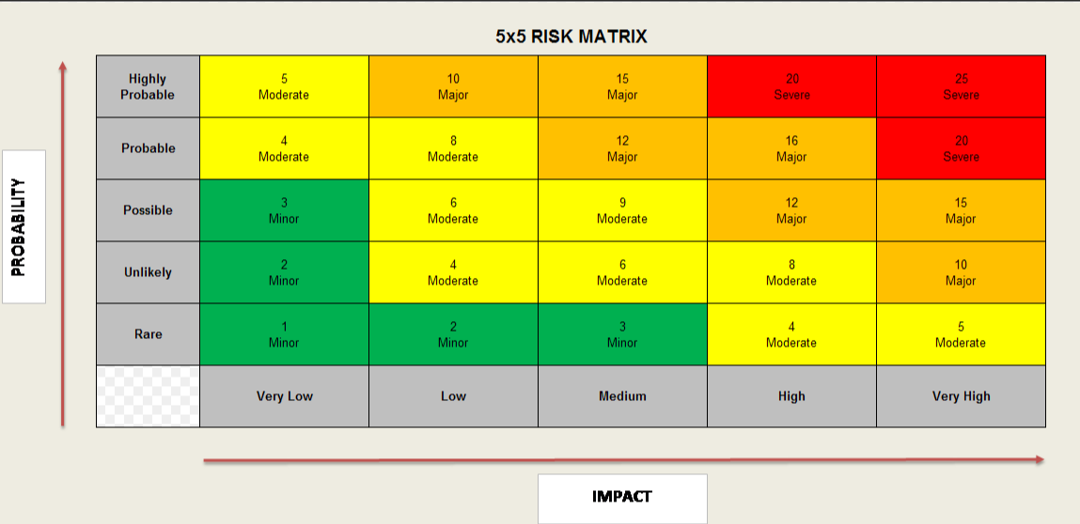

7.3 Total Cost - Resource Implications and Affordability

The revenue consequences of the 3-bed stepped expansion proposal are set out below and total £2.176m recurrently, an effective bed day rate of £1,987. The part-year-effect is projected to be £1.151m in 2023/24.

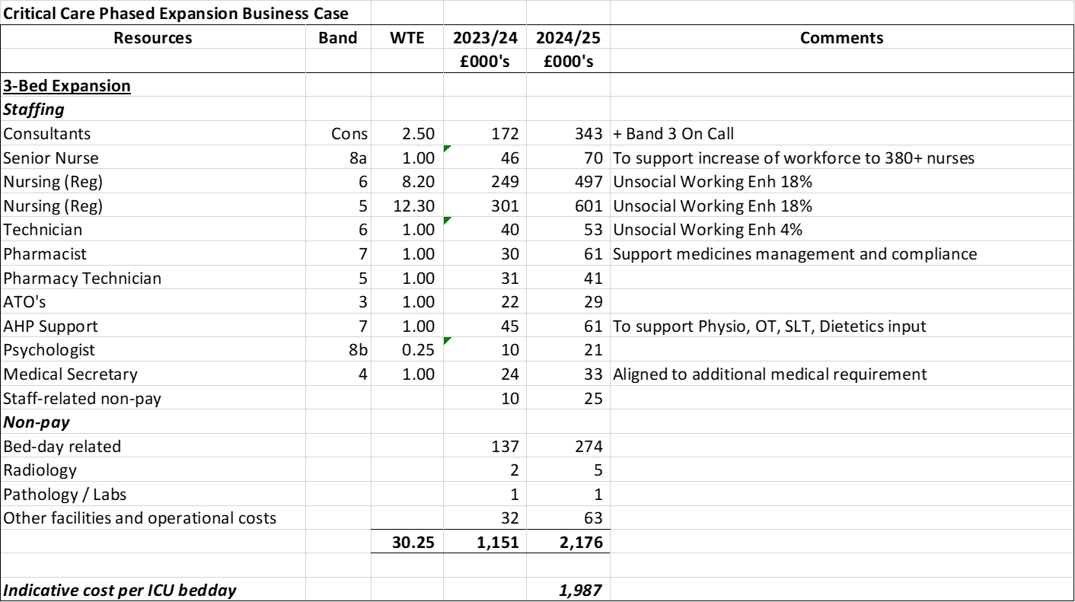

Useful Links and References

Capacity and Demand:
1. Our World in Data - ICU Capacity & OECD - ICU Capacity
2. WG 2014 CC Unmet needs study
3. WG - Care of Critically ill - Quality Statement
4. Cardiff Critical Care Strategy 2021-22 (on request)
5. FICM External Review 2019 and 2022 progress update (on request)
6. Getting It Right First Time - Adult Critical Care 2021
7. GPICS – UK Critical Care Standards
8. BTS/ICS Res Support Unit Guidance 2021
9. Enhanced Care Units https://www.ficm.ac.uk/sites/ficm/files/documents/2021-10/enhanced_care_guidance_final_-_may_2020-.pdf

Welsh Government strategic documents:
11. A Healthier Wales: the long-term plan for health and care in Wales.
12. WHC 2016(041) Revised guidelines for transfer of the critically ill adult
13. Delivery Plan for Critically ill
14. Task and Finish Group on Critical Care: Final Report July 2019
17. Health in Wales Critical Care
18. National Clinical Framework 8.0 (gov.wales)
19. Quality and Safety Framework
20. Health and Care Standards

National Institute for Clinical Excellence:
21. 2007 NICE Clinical Guideline 50: Acutely ill Patients in Hospital
22. 2009 NICE Clinical Guideline 83: Rehabilitation after Critical Illness
23. 2017 NICE Quality Standard Rehabilitation after Critical Illness in Adults

Other Referenced Documents:
24. ICNARC Data
25. A novel approach to an evolving cohort of critical care patients

