Report Title: |  |  |  | Finance Report for the Period Ended 30th September 2022 |  |  |  |  |  |  |  |  |  |  | Agenda Item no. |  |  | 2.1
Meeting: |  |  |  | Finance Committee |  |  |  |  |  | Public |  |  |  | x | Meeting Date: |  |  | 19th October 2022
 |  |  |  |  |  |  |  |  |  | Private
Status  (please tick one only): |  |  |  | Assurance |  |  |  | X |  | Approval |  |  |  |  | Information
Lead Executive: |  |  |  | Executive Director of Finance
Report Author (Title): |  |  |  | Interim Deputy Director of Finance (Operational)
Main Report
Background and current situation:
Summary

At month 6 the UHB is reporting an overspend of £12.807m against it’s submitted draft plan. This is comprised of £4.257m of operational overspend and the planned deficit of £8.550m (six twelfths of the annual planned deficit of £17.1m set out in 2022/23 financial plan).

The UHB assumes that Covid and exceptional costs incurred to date, of £31.846m, will be funded by Welsh Government and further costs will continue to be funded to the end of the financial year.

Table 1: Month 6 Financial Position 2022/23
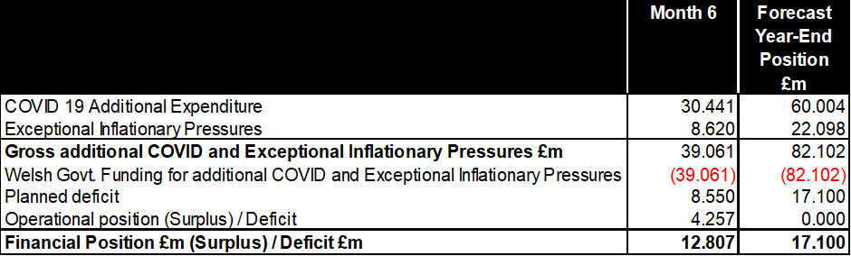

Financial Plan

The Health Board submitted an initial draft financial plan to Welsh Government at the end of March 2022. A revised re-submission of the Plan was sent to Welsh Government on 30 June 2022. The plan is structured in three parts, in line with Welsh Government discussions, as follows:

• Core Financial Plan including recovery
• Exceptional inflationary cost increases
• Ongoing COVID response costs (Local and Welsh Government Covid Programmes)

The UHB’s core financial plan incorporated:

• Brought forward underlying deficit of £29.7m
• Allocations and inflationary uplifts of £29.8m
• Capped cost pressures and investments of £36.9
• A £16m (2%) Savings programme
This resulted in an initial 2022-23 planning deficit of £20.8m. The plan was subject to further development during quarter 1 of 2022/23 when further Financial Recovery Plans totaling £3.7m in 2022/23 were identified, resulting in a revised planning deficit of £17.1m per Table 2.

Table 2: 2022/23 Draft Financial Plan - Resubmitted 30 June 2022

Core Financial Plan – Month 6 Cumulative Position

The UHB is overspent by £12.807m against its core financial plan. £8.550m of this was planned as part of the underlying financial deficit. £4.257m is unplanned as an overspend in delegated and central positions. The rate of unplanned overspend increased in month, deteriorating by £1.730m from the cumulative Month 5 unplanned overspend of £2.527m. Table 3 provides a summary of the Month 6 position.

Table 3: Finance - Key Performance Indicator Dashboard at September 2022

A number of cost pressures have emerged or increased in the year to date that were not foreseen in the original financial plan. Table 4 summarises the year to date position across the Clinical Boards and delegated areas of the UHB.

Financial Performance of Clinical Boards

Budgets were set to ensure that there is sufficient resource available to deliver the UHB’s plan. Financial performance for month 6 by Clinical Board is shown in Table 4.

Table 4: Financial Performance for the period ended 30th September 2022

The operational deficit of £8.907m against delegated budgets is offset by a £4.650m underspend against central budgets leaving a total operational overspend of £4.257m before the addition of the cumulative £8.550m planned deficit to leave a total overspend of £12.807m

The largest operational overspends are in the Medicine Clinical Board (£2.834m deficit) where the main pressure areas are nursing and medical staffing, in Mental Health (£2.003m deficit) where there are nursing and continuing healthcare placement pressures and Capital Estates & Facilities (£1.699m deficit) where there are pressures against security costs, patient catering in EU and commercial income.

Table 5 provides details of some of the cost pressures impacting operational positions. These pressures are incorporated within the financial tables included within the body of the report and within the appendices. The cost pressures have the effect of removing budgetary surpluses that the UHB has partially relied on to achieve break even positions in previous financial years.

Table 5 Key Cost pressures and risks within delegated positions as at Month 6
 | Impact in Month | Year to date impact | Full Year Forecast Impact
Key Cost pressures incorporated in position at Month 6 | £000s | £000s | £000s | Future outlook and potential mitigations
Unfunded Medical Staffing inc. Agency & Premium costs | 259 | 3,081 | 5,769 | Strategies to improve permanent Recruitment and Retention will improve agency dependency
Nursing Staff Agency & Premium costs | 722 | 2,350 | 4,950
International Nurse Recruitment | 22 | 361 | 815 | Non recurrent based on unforeseen excess costs 2021-22 initiative
WHSSC LTA performance | 30 | 545 | 1,100 | WHSSC performance should recover towards the end of the year and will improve on return to pre Covid footprint
Patient Catering to EU and food price rises | 106 | 399 | 797 | Will benefit from throughput initiatives
Prescribing | 378 | 1,336 | 4,975 | Currently assessing the impact of days supplied and bank holidays
Mental Health CHC Placements | 239 | 1,277 | 2,958 | Nurse Director led initiative to improve CHC placement pressures
General Dental Services Ers pension costs | -47 | 250 | 500 | Seek to manage this within the totality of contractor services
Security at Rookwood & Whitchurch | 79 | 621 | 1,242 | In the system until the disposal of estate
Footfall impact on Aroma Sales/Concourse Leases | 112 | 672 | 1,344 | Anticipated that footfall will improve as UHB moves away from Covid footprint

The UHB continues to face a significant challenge as it improves elective throughput from an operational footprint that is still dealing with Covid patients and primed for a further upswing in cases. This is coupled with difficulties in discharging patients to appropriate support packages in the community whilst experiencing increased emergency demand. This in turn has restricted the UHB’s ability to deliver a full elective output when contractual obligations to recover to pre pandemic activity levels has re-introduced financial performance arrangements for under delivery of patient activity. In particular, WHSSC commissioned specialties operate to sensitive contract parameters that include high marginal rates for under and over performance.

The current UHB forecast assumes that the UHB will successfully identify and deliver the required cost and income improvement to meet the revised Financial Plan deficit of £17.1m.

The continued deterioration of the UHB position in Month 6 and the ongoing nature of the cost pressures highlighted in Table 5 places the UHB ambition to return to a position within the 2022-23 planned deficit at significant risk. A central focus of Executive Performance Reviews with Clinical Boards has been on the remedial actions and additional savings that are needed to mitigate and address these cost pressures.

This trajectory does not include a number of potential cost issues that could add pressure to efforts to recover the trajectory. These include Winter Pressures planning for additional bed capacity and Emergency Unit service mitigations whilst Covid restricts the ability to efficiently discharge patients. The UHB also still has to deliver additional savings of £1.9m against its plans in the second half of 2022-23.

Exceptional Costs

In line with guidance from Welsh Government, the UHB’s plan anticipated Welsh Government funding for the three National Inflationary Pressure exceptional costs:

- Increased energy costs of £20.9m for 2022-23. The current forecast informed by information provided by Shared Services is £15.837m for the year, which is £5.063m less than the estimate in the plan and reflects a decrease of £21.188m in the annual forecast between August and September.

The UHB receives market intelligence on prices from Shared Services on a monthly basis, which in turn is based on market forecasting provided by British Gas. The Shared Services Forecasting model is based on the latest spot price and consequently provides for a high level of volatility between forecasts. In September the spot price reduced at the same time the government announced the Energy Billing Relief Scheme (EBRS). This has had a significant impact on the forecast costs requiring Welsh government support.

The energy forecast will remain a live piece of work involving the UHB Capital and Estates Team and Shared Services market intelligence, in light of the volatility of market intelligence.

2) Employers NI costs of £6.9m. The forecast of the employers cost of NI levy had previously decreased by £1.0m from the planning estimate of £6.9m to £5.9m. Following the recent announcement of the discontinuation of the levy from November 6th 2022 the forecast has been revised down to £3.361m and will continue to be reviewed in October and November.

3) The impact of paying Real Living Wage (RLW) for staff working within social care and Third Sector remains at the original estimated level of a £2.9m increase in annual costs. This position assumes that the cost impact of 2022/23 real living wage for staff directly employed on the UHB’s payroll will be supported separately through the 2022/23 pay settlement.

A summary of forecast exceptional costs is outlined in Table 5 below:

Table 6 – Exceptional Cost forecast for 2022-23

Welsh Government funding to support these costs is assumed but has not yet been confirmed.

COVID 19 Expenditure and Funding

At month 6, the UHB projects expenditure (and matched income) of £60.004m relating to Covid costs. £9.274m has already been received as funding in allocations with an additional £32.469m for Local Response and £18.261m for National Programmes anticipated. The forecast costs, and associated income assumption, will adjust throughout the year as Covid prevalence fluctuates, combined with developments in Welsh Government vaccination and infection control policy. The current outlook is summarised in Table 7 below which demonstrates that forecast 2022/23 costs have increased by £1.081m between Month 5 and Month 6. The increase is primarily a result of the 2022/23 pay award with forecast provider pay costs being £39.445m at month 6 compared to £38.534m at Month 5.

Table 7: Summary of Forecast COVID 19 Net Expenditure
Welsh Government funding to support these costs is assumed but has not yet been confirmed.

Summary Financial Table

The following table analyses the £12.807m overspend at Month 6, between Income, Pay and Non Pay. The table details the costs as Covid, Exceptional and Operational categories with funding assumed to match Covid and Exceptional cost categories.

Table 8: Summary Financial Position for the period ended 30th September 2022
Further detail in respect of the Income, Pay and Non pay budgetary positions is provided at Appendix 1.

Key Financial Assumptions and Risks

Following on from Tables 6 & 7 the overall UHB position assumes:
- Local COVID response allocations from Welsh Government of £35.553m (annual) to support the ongoing additional COVID costs and to fund achieving the Cleaning Standards.

- Funding for national COVID programmes on an actual cost basis, currently forecast at £20.889m to cover:

- Testing costs
- Tracing costs (allocated from separate fund)
- Mass vaccination programme
- Extended Flu Vaccination
- PPE

- Funding for exceptional cost pressures of £22.098m, which are deemed to be outside of the UHB’s direct control. The forecast cost of exceptional cost pressures will be subject to review as the year progresses driven by the unpredictability of some cost areas, such as energy.

Table 9 summarises the Finance Department’s Risk Register. The key risk which feeds the UHB Corporate Risk Register is the failure of the UHB to deliver a breakeven position by 2022-23 year end with a current planned deficit of £17.1m.

Table 9: Risk Register at September 2022

 | Risks | Rating | Comment
Key Corporate Risk | Approved Three year Financial plan (IMTP) | 20 | A revised financial plan was submitted into Welsh Government on 30 June 2022. The plan projected a £17.1m deficit by the end of 2022-23. Welsh Government has now moved into Enhanced Monitoring based on financial concerns.
Key Corporate Risk | Revenue Funding Limit. | 20 | The UHB has submitted a £17.1m deficit plan and therefore will breach breakeven duty in 2022-23. There is a high risk that this will not be recovered in years two and three of the rolling performance measure.
Key Corporate Risk | Capital Funding - Three Year Rolling Breakeven Duty | 10 | The current 2022-23 UHB Capital Plan is structured to remain within the Capital Resource limit
Financial Performance | Operational delegated positions deteriorate in year resulting from cost and service pressures and excess inflation. | 20 | Table 5 refers to new in year cost pressures arising from demand and staffing pressures whilst still maintaining a Covid ready environment.
Financial Performance | Failure to deliver 2022-23 Savings Programme | 16
Financial Performance | Failure to deliver 2022-23 Savings Programme | 16 | Most savings have been identified to address the 2022-23 programme but the lack of recurrent savings within this will bring pressure on the underlying carry forward deficit of the UHB. In addition, the UHB has to identify £3.7m of new savings to deliver the revised £17.1m deficit plan.
Financial Performance | Failure to deliver 2022-23 Savings Programme | 16 | At month 6, the gap against the total revised target was £1.9m
Financial Performance | Failure to exit current Covid Response costs once Welsh Government funding ceases. Cost will transfer to the UHB underlying deficit. | 16 | The timing of full Covid exit is uncertain alongside any associated Welch Government funding. On full exit there are likely to be care model and building support costs that will maintain e.g. Lakeside Wing support costs.
Financial Performance | 2022-23 One Year LTA framework in NHS Wales | 16 | Failure to recover delivery of activity to contracted organisations (WHSSC , Welsh LHBs to a level of 90% of 2019-20 levels and beyond. Initial activity figured for 2022-23 indicate that the UHB will struggle to deliver 90% across the Board whilst the WHSSC contracts are more sensitive to any activity deficits below 100%.
Funding Assumptions | Welsh Government has notified LHBs that assumed funding for Exceptional Costs remains at risk | 16 | Circa £22m risk to assumed funding within the UHB Financial Plan
Funding Assumptions | Welsh Government has notified LHBs that assumed funding for Covid Response remains at risk | 16 | Circa £35m risk to assumed funding within the UHB

Savings Programme

At month 6, the UHB is forecasting £17.457m of savings to deliver against the revised £19.400m savings target leaving a further £1.943m schemes to identify. This represents a marginal increase in identified schemes of £0.012m in month. Delegated budget holders are being pressed to close the remaining gap through the established internal review process. The UHB expects to finalise the balance of savings plans required to deliver the revised planning deficit of £17.1m.

Overall progress in the identification of savings schemes is outlined in table 10 below:

Table 10: Savings Schemes
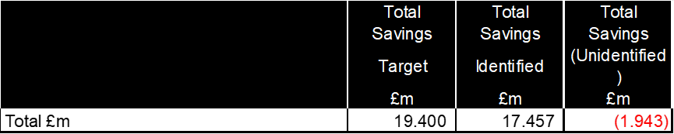

The UHB expects to finalise the balance of savings plans required to deliver the revised planning deficit of £17.1m. Further analysis of the September position is shown in Appendix 2.

Underlying Financial Position

A key challenge to the UHB is the elimination of the underlying deficit. The UHB’s accumulated underlying deficit brought forward into 2022/23 was £29.7m. An illustration of the year on year movement in the underlying deficit is shown at Appendix 3.

Delivery of the UHB’s draft financial plan will ensure that the underlying position does not deteriorate in 2022/23 and reduces to £20.0m as outlined in Table 11.

Table 11: Summary of Underlying Financial Position

Balance Sheet

The balance sheet at month 6 is detailed in Appendix 4. The opening balances at the beginning of April 2022 reflect the closing balances in the 2021/22 Annual Accounts approved by the UHB’s Board.

The increase in the carrying value of property, plant & equipment since the start of the year is due to the impact of annual indexation plus the recognition of Right of use Assets (£12m), which is a result of the implementation of International Financial Reporting Standard (IFRS) 16 Leases.

Overall trade debtors have increased by £44.8m since the start of the year. This relates to amounts due from the Welsh Risk Pool in respect of clinical negligence cases, NHS receivables and prepayments.

Trade and other payables have fallen by around £57m since the start of the year. This mainly relates to a significant decrease in the levels of Accounts Payable Control, NHS and capital accruals. The fall in Trade and other payables has in part been abated by the recognition of £12m of Lease payables as a result of the implementation IFRS 16 Leases.

Cash Flow Forecast

The closing cash balance at the end of September, was £4.669m.

The UHB Is currently predicting a cash shortfall in 2022/23 in line with the forecast deficit as shown at Appendix 4. The UHB has highlighted the forecast cash deficit within the monthly monitoring return provided to Welsh Government and expects to discuss its working capital requirements as the year progresses.

In addition, the UHB has identified an estimated working cash balance requirement of £2.774m
to Welsh Government. This is comprised of a £1.334m of payment in respect of the Annual Leave Buy Back Scheme and a further £1.440m in respect of 2021/22 Welsh Government funding confirmed in March 2022, which was not backed by cash because of the proximity of the end of the financial year.

Public Sector Payment Compliance

The UHB’s public sector payment compliance performance remains below the target of 95%. Performance for the 6 months to the end of September was 93.9%. Whilst this remains below the target, it is an improvement of 1.3% in month.

The below target performance is due to the high number of invoices which were on hold and subsequently cleared following work by the Procurement department with those placing orders to clear the backlog of holds. However, this has contributed to the performance remaining below target, as holds exceeding the 30 days have been resolved and paid.

Performance is expected to improve in the coming months as newer holds will be cleared, and then paid, within the 30 days target. Work is ongoing with departments within the UHB, including training, to address the level of orders not receipted, and the high number of workforce and nursing holds, which should improve the UHB’s position.

Capital Resource Limit (CRL)

Progress against the CRL for the period to the end of September 2022 is summarised in Table 12 and detailed in Appendix 4.

Table 12: Progress against Capital Resource Limit @ September 2022
 | £m
Planned Capital Expenditure at month 6 | 16.945
Actual net expenditure against CRL at month | 12.074
Variance against planned Capital Expenditure at month 6 | (4.871)

Of the UHB’s approved Capital Resource Limit, 27% has been expended to date. VAT recovery for a number of schemes has been reflected in M6 reducing the overall year to date expenditure.

Whilst all schemes are currently classified as low risk, two schemes are being closely monitored:

- Maelfa which is forecasting a potential slippage of £0.5m
- Genomics forecasting a potential £0.2m overspend

All other schemes are currently in line with annual forecast.

The UHB had an approved capital resource limit of £45.404m in line with the latest CRL received from Welsh Government 15th September 2022 comprising of £10.263m discretionary funding and £35.141m towards specific projects (including Maelfa Primary Care Pipeline, the National Imaging Programme, Developing Genomics Partnership Wales, UHL Electrical infrastructure, Endoscopy Unit UHL & Refit - Phase 2)

Executive Director Opinion and Key Issues to bring to the attention of the Board/Committee:
The draft Financial Plan sets out the UHB financial strategy in three parts:

- Core Financial Plan including recovery
- National inflationary pressures which are out of the direct control of individual Health Boards
- Ongoing COVID response costs and Welsh Government Covid Programmes

The planning deficit included in the UHBs Final Financial Plan for 2022/23 reduced from £20.8m to £17.1m financial plan following the inclusion of further recurrent Financial Recovery Plans totaling £3.7m.

Delivery of the core financial plan initially included an 2% (£16.0m) savings requirement, which included a recurrent savings target of £12.0m . A further recurrent savings target of £3.4m was added to the initial target and included within the final financial plan submitted to Welsh Government at the end of Quarter 1. Further progress needs to be made in respect of the £3.312m shortfall against the final recurrent savings target of £15.4m.

The UHB also needs to manage its operational position and mitigate any emerging pressures as its Covid response costs are collapsed. The rate of operational overspend was £1.731m in month 6 which is an increase on the trend in the first 5 months of the year. The reported operational overspend which is £4.257m for the 6 months to the end of September remains cause for concern and has prompted enhanced monitoring through the monthly Executive Performance Reviews of Clinical Boards.

The UHB position is heavily predicated on the assumption of Welsh Government continuing to provide income support for local Covid response, exceptional costs and central Covid programmes. The total of these is currently forecast at £82.102m in 2022-23 which is a decrease of £22.646m on the forecast at month 5 mainly due to energy price volatility and the impact of the Energy Billing Relief Scheme (EBRS).

These assumptions will be tested out in ongoing discussions with Welsh Government regarding the UHB’s Financial Plan.

Recommendation:
At Month 6 the Committee are requested to:

- NOTE the reported overspend of £12.807m due to £4.257m of operational pressures and a planning deficit of £8.550m.
- NOTE the financial impact of COVID 19 which is assessed at £30.441m.
- NOTE the additional Welsh Government COVID 19 funding of £30.441m assumed within the position.
- NOTE the financial impact of Exceptional Inflationary Pressures which is assessed at £8.620m.
- NOTE the additional Exceptional Inflationary Pressures funding of £8.620m assumed within the position.
- NOTE the forecast deficit of £17.1m, which is consistent with the Final Financial plan and is a reduction of £3.7m from the £20.8m included within the initial Draft Financial Plan .
- NOTE the 2021/22 brought forward Underlying Deficit of £29.7m and the planned forecast carry forward of £20.0m to 2023/24.

Link to Strategic Objectives of Shaping our Future Wellbeing:
Please tick as relevant
- Reduce health inequalities |  |  |  |  |  |  |  |  |  |  | - Have a planned care system where demand and capacity are in balance
- Deliver outcomes that matter to people |  |  |  |  |  |  |  |  |  |  | - Be a great place to work and learn
- All take responsibility for improving our health and wellbeing |  |  |  |  |  |  |  |  |  |  | - Work better together with partners to deliver care and support across care sectors, making best use of our people and technology
- Offer services that deliver the population health our citizens are entitled to expect |  |  |  |  |  |  |  |  |  |  | - Reduce harm, waste and variation sustainably making best use of the resources available to us |  |  |  |  |  |  |  | x
- Have an unplanned (emergency) care system that provides the right care, in the right place, first time |  |  |  |  |  |  |  |  |  |  | - Excel at teaching, research, innovation and improvement and provide an environment where innovation thrives
Five Ways of Working (Sustainable Development Principles) considered
Please tick as relevant
 | Prevention |  | Long term |  |  | x | Integration |  |  |  |  |  | Collaboration |  |  |  | Involvement
Impact Assessment:
Please state yes or no for each category. If yes please provide further details.
Risk: Yes
No

Safety: Yes/No
No

Financial: Yes
As detailed in the report.

Workforce: Yes/No
No

Legal: Yes/No
No

Reputational: Yes/No
Yes, if forecast financial position is not delivered.

Socio Economic: Yes/No
No

Equality and Health: Yes/No
No

Decarbonisation: Yes/No
No

Approval/Scrutiny Route:
Finance Committee |  |  |  |  | Date: 19th October 2022

Appendix 1

ANALYSIS OF INCOME, PAY AND NON PAY BUDGETS BY CATEGORIES

Income

The year to date and in month financial position for income is shown in Table 13:

Table 13: Income Variance @ September 2022

The income position at month 6 is an underspend of £0.187m. This position includes consideration of additional Welsh Government income of £0.507m in recognition of income losses caused by COVID 19 disruption. The position excludes anticipated income relating to exceptional costs and Covid 19 response costs. Part of the in year financial pressure, already noted in Table 4, relates to the shortfall on accommodation and catering income previously supported by Welsh Government funding but now, no longer falling within the defined Covid response costs. This pressure is £0.429m in month 6.

Pay

The year to date and in month financial position for pay is shown in Table 14.

Table 14: Analysis of pay expenditure by staff group @ September 2022

The pay position at month 6 is an operational underspend of £3.670m. The in month pay position underspend was £0.629m which is broadly in line with the trend for first 5 months of the year.

Performance against operational pay varies across the UHB with the largest overspend being reported by the Medicine Clinical Board where there is an operational overspend of £1.938m, as a result of nursing and medical staffing pressures.

Non Pay

The year to date and in month financial position for non pay is shown in Table 15.

Table 15: Non-Pay Variance @ September 2022
There is an operational overspend of £16.664m on non-pay budgets which incorporates the 2022/23 year to date planning deficit of £8.550m.

The additional gross COVID 19 expenditure of £9.051m (local response and national programmes) is matched by £9.051m of anticipated COVID 19 funding and the additional exceptional energy costs of £4.368m and continuing healthcare costs of £1.450m arising from national pressures are matched by assumed funding of £5.818m.

Pressures are reported against Premises and Fixed Plant by all Clinical Boards, with the majority of overspends being reported against Capital Estates & Facilities, Executive and Central Budgets as identified by Table 16 below:

Table 16: Cumulative overspend Premises and Fixed Plant @ Month 6

Appendix 2

2022/23 SAVING SCHEMES

2022-23 In-Year Effect

2022-23 Full Year Effect

Appendix 3

Year on Year Movement in Cardiff & Vale UHB Underlying Deficit

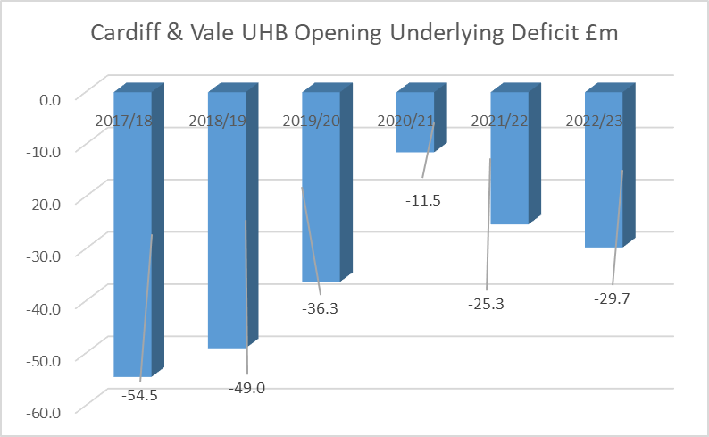

Appendix 4

BALANCE SHEET AT THE END OF SEPTEMBER 2022

Appendix 5

CASHFLOW FORECAST AT THE END OF SEPTEMBER 2022

Appendix 6

PROGRESS AGAINST CRL AS AT 30th SEPTEMBER 2022

