Aneurin Bevan, Cardiff and Vale and Cwm Taf Morgannwg
University Health Boards
Business Case

Title | Regional Cataracts Expansion Business Case
 |  | Date Last Updated | 05/04/2023
Accountable Executive | Chris Dawson Morris, Director of Planning (AB) | Lead /Project Manager  Clinical Lead | Hannah Brayford, Programme Manager  Dr Rhianon Reynolds, Dr Siene Ng, Dr Anjana Haridas
Clinical Service |  | Planned Care, Ophthalmology

Executive Summary
This Business Case seeks to provide a 14 month solution for additional regional capacity for cataract outpatient and inpatient stages to enact a collaborative regional approach to recovery and to maximise the use of our assets across the region.
This additional capacity will provide a service for health board patients from Aneurin Bevan, Cwm Taf Morgannwg and Cardiff and Vale University Health Boards.
Aims
The aims of the regional solution outlined in this business case are
- to enact a collaborative regional approach to recovery
- to provide additional regional capacity for cataract outpatient and inpatient stages
- to demonstrate optimal utilisation of our assets and resources across the region
- to address current waiting list backlogs
- to reduce clinical risk on an equitable basis across the region

The Regional Ophthalmology Programme Board have also agreed a set of regional working principles on which the approach to expanding cataract capacity will be based.
- Treating the longest waiters first, regardless of their ‘home’ health board
- Using the outsourcing, insourcing, evenings and weekends capacity for less complex patients
- Adopting best practice guidance in all sites
- Adopting shared waiting list (PTL) management arrangements
Each health board is at a different starting point for their waiting list and this is reflected in the trajectories and projections. It is anticipated that as a result of this business case the following trajectories will be met:
- Aneurin Bevan: no patients waiting over 104 weeks for an outpatient appointment by the end of the funding period
- Cwm Taf Morgannwg: no patients waiting over 104 weeks for an outpatient appointment by the end of the funding period
- Cardiff and Vale: no patients waiting over 78 weeks for an outpatient appointment by the end of the funding period

Staged Delivery
The Regional Ophthalmology Programme Board have agreed the following staged approach to delivering sustainable cataracts solutions in the region, whilst balancing the need to activate capacity quickly and reduce the rate that the backlog is growing. This business case represents the first stage.
- Stage 1 – A Business Case for maximising our existing assets and increasing capacity with a focus on recovery activity and reducing waiting lists to run for 14 months.
- Stage 2 – Developing sustainable staffing and clinical models for the region. For cataracts and VR in University Hospital Wales (UHW), Cardiff, and cataracts and VR referral pathways across the region. To include new staffing models, new clinical models and costings, this model will be operational on the conclusion of stage 1.

Demand and Capacity
The region is presented with a sizable challenge for backlog, demand and capacity. Demand continues to outstrip capacity and is forecast to grow year on year.
- The total number of patients waiting for assessment and treatment for cataracts is forecast to reach over 19,000 by the end of March 2023.
- Demand across the region has returned to pre-pandemic levels and is forecast to be 9,960 per year for 23/24
- The projected combined core capacity across the region for 23/24 with no further intervention is 5,940 treatments and assessments per year, broken down as follows
  - Aneurin Bevan UHB – 2,400
  - Cardiff and Vale UHB – 1,440
  - Cwm Taf Morgannwg UHB – 2,100

Eliminating the waiting list backlog in 23/24 would require a capacity of 28,960 in one year, almost five times the projected combined core capacity. With no further intervention the projected waiting list of 19,000 in March 2023 would therefore be over 23,000 by March 2024.

Delivery Assumptions
Shared PTL
To support a regional approach, the three health boards have agreed to pool their patient treatment lists (PTL) and adopt shared waiting list management arrangements for the allocation of the additional regional capacity. This will be supported by a regional booking team who will also manage the shared patient waiting list ensuring that the patients who have been waiting the longest are treated first, regardless of their ‘home’ health board.
North and South Hubs
The geography of the region lends itself to distributing the capacity is across a North and South Hub model. This model that will keep service delivery closer to home and reduce patient travel as far as possible.
Insourcing and Outsourcing
The capacity across the region can be rapidly increased by utilising the local opportunities for insourcing and outsourcing. These arrangements make the best use of our assets across the region for short-term flexible arrangements that protect our core capacity.
Patient Second Offer and Travel
Patients will be offered the opportunity to travel to receive their assessment and treatment as part of the additional capacity arrangements where thy may be able to be treated sooner. At a maximum travel would be 40 miles and 55 minutes by private car under normal traffic conditions and most of the patient travel will be shorter. Patients unable or unwilling to travel will keep their place on the waiting list and receive treatment from their home health board. A recent survey of 140 patients across the region shows that 71% of patients would be willing to travel.
Allocation by Health Board
The table below shows the numbers of patients waiting and how this is split proportionally across the region. Data relates to August 2022 and includes the total number of patients waiting in each health board.
Patient Waits | Total |  |  | Over 52 weeks
AB | 7041 | 39% |  | 2175 | 36%
CAV | 4066 | 22% |  | 891 | 15%
CTM | 7103 | 39% |  | 2939 | 49%
 | 18210 |  |  | 6005
As a proportion of the patients waiting, 39% are from AB. 39% from CTM and 22% from CAV. When this is viewed as patients waiting at the end of the lists the proportions change and it is from this pool of patients that the additional capacity would be targeted.
Of this group of longer waiters 49% are from CTM, 36% from AB and 15% from CAV and this indicates how the additional capacity will be used.

Options
To achieve the stated aims of the business case, the options need to:
- Be mobilised quickly
- Be deliverable with the resources available
- Protect the viability of the core capacity
- Keep patient travel to a minimum

The options are:
- Option 1: Do nothing
  - Core capacity 5,940 only

- Option 2: Maximising the use of NHH and POWH
  - North Hub: in NHH (1,610, weekdays NHS staff recruitment)
  - North Hub: in NHH (1,500 Weekend Insourcing)
  - South Hub: in POWH (3,558, for 1 NHS session and Evenings and Weekend Insourcing)
  - Outsourcing (2,000)
  - Total additional 8,668 (plus 5,940 core is 14,608 total)
  - One theatre in NHH and twin theatres in POWH

- Option 3a: Vanguard and NHH
  - North Hub: in NHH (1,500 Weekend Insourcing)
  - South Hub: 12.5 sessions of Vanguard Unit (2,770 weekdays NHS staff)
  - South Hub: in UHW (1,500 Weekend Insourcing)
  - Outsourcing (2,000)
  - Total additional 7700 (plus 6,120 core is 13,820 total)
  - One theatre in NHH and twin theatres in Vanguard

- Option 3b: Vanguard and Maximising NHH
  - North Hub: in NHH (1,610, weekdays NHS staff recruitment)
  - North Hub: in NHH (1,500 Weekend Insourcing)
  - South Hub: 12.5 sessions of Vanguard Unit (2,770 weekdays NHS staff)
  - South Hub: in UHW (1,500 Weekend Insourcing)
  - Outsourcing (2,000)
  - Total additional 9,310 (plus 7,140 core is 16,450 total)
  - One theatre in NHH and twin theatres in Vanguard

- Option 4: Weekend Insourcing and Outsourcing only
  - North Hub: in NHH (1,500 Weekend Insourcing)
  - South Hub: in POWH (1,500 Weekend Insourcing)
  - Outsourcing (2,000)
  - Total additional 5000 (plus 5,940 core is 10,940 total)
  - One theatre in NHH and twin theatres in POWH

- Option 5: Outsourcing activity to external provider (s)
  - Outsourcing (5,000)
  - Total additional 5000 (plus 5,940 core is 10,940 total)

Options Summary
 | Option 1 Do Nothing | Option 2 POWH and NHH | Option 3a Vanguard and NHH | Option 3b Vanguard and Max NHH ** | Option 4 Weekends | Option 5 Outsourcing
North Hub: NHH Weekdays NHS Staff |  | 1610 |  | 1610
North Hub: NHH Weekends Insourcing |  | 1500 | 1500 | 1500 | 1500
South Hub: Vanguard Weekdays NHS Staff |  |  | 2700 | 2700
South Hub: Vanguard Weekends Insourcing |  |  | 1500 | 1500
South Hub: POWH Evenings insourcing (+1 NHS session) |  | 2058
South Hub: POWH Weekends Insourcing |  | 1500 |  |  | 1500
Outsourcing |  | 2000 | 2000 | 2000 | 2000 | 5000
Total Additional | 0 | 8668 | 7700 | 9310 | 5000 | 5000
Plus Core | 5940 | 5940 | 6120 | 7140 | 5940 | 5940
Total | 5940 | 14608 | 13,820 | 16450 | 10940 | 10940
*Yellow – Provision on AB site, Blue – provision on CAV site, Green – provision on CTM site
**Option 3b is for 14 months

High level Financials
 | Option 1 Do Nothing | Option 2 POWH and NHH | Option 3a Vanguard and NHH | Option 3b Vanguard and Max NHH* | Option 4 Weekends | Option 5 Outsourcing
Core Capacity | 5,940 | 5,940 | 6,120 | 7,140* | 5,940 | 5,940
Additional Regional Capacity | 0 | 8668 | 7,700 | 9,310 | 5,000 | 5,000
Total Capacity | 5,940 | 14,608 | 13,820 | 16,450 | 10,940 | 10,940
Total Revenue Costs | £0 | £12.4m | £10.5m | £12.9m** | £7.5m | £7m
Total Capital Costs | £0 | £0 | £2.4m | £2.4m | £0 | £0
Total Costs (Capital + Revenue) | £0 | £12.4m | £12.9m | £15.3m | £7.5m | £7m
Cost per patient | n/a | £1,436 | £1,672 | £1,640 | £1,504 | £1,410
*Option 3b is for 14 months
**Costing for this option include 5% increase on all pay costs

Waiting List Changes
The table below shows the impact of each of the options on the total size of the waiting list. The start position for each option is 19,000 patients waiting.
 | Option 1 Do Nothing | Option 2 POWH and NHH | Option 3a Vanguard and NHH | Option 3b Vanguard and Max NHH* | Option 4 Weekends | Option 5 Outsourcing
Waiting list project end | 23,046 | 14,352 | 15,186 | 14,168 | 18,483 | 18,483
Waiting list change from 19,000 baseline | +4,046 | -4,648 | -3,814 | -4,832 | -517 | -517

Options Appraisal
The six options have been through an options appraisal process. An exercise was undertaken with each health board individually to score and assess each option against the business case aims and the principles of regional working in section 2.1 below and appendix two.
Weighting for the scoring was allocated as follows:
- Quality and Safety: 35%
- Effective use of resources: 10%
- Strategic Fit: 10%
- Sustainability: 15%
- Access: 10%
- Deliverability: 20%

Results of the appraisal process are shown below. All three health boards have selected the same option as the highest scoring option against the criteria. Results are shown below. Scores are out of 5, with the regional total out of 15.

 | Option 1 Do Nothing | Option 2 POWH and NHH | Option 3a Vanguard and NHH | Option 3b Vanguard and Max NHH | Option 4 Weekends | Option 5 Outsourcing
Cardiff and Vale | 1.65 | 3.10 | 4.00 | 4.25 | 1.85 | 1.65
Cwm Taf Morgannwg | 1.60 | 4.30 | 3.70 | 4.35 | 2.30 | 2.00
Aneurin Bevan | 1.80 | 3.35 | 3.30 | 3.55 | 2.15 | 2.15
Regional Total | 5.05 | 10.75 | 11.00 | 12.15 | 6.30 | 5.80

Preferred Option
The preferred option in this business case is Option 3b Vanguard and Max NHH

- South Hub Weekdays: Retaining the weekday 20 sessions in vanguard and using 7.5 sessions for CAV core capacity (1620 patients per year, funded by CAV) and 12.5 sessions for regional capacity (2700 patients per year, regionally funded, provided by NHS staff)
- South Hub Weekends: 1,500 outpatient assessment and inpatient procedures carried out by an insourcing company in Vanguard (UHW)
- North Hub Weekdays: 1610 outpatient assessment and inpatient procedures carried out in weekdays in NHH using NHS staffing
- North Hub Weekends: 1,500 outpatient assessment and inpatient procedures carried out by an insourcing company in NHH
- An additional 2,000 outsourced outpatient and inpatient procedures
- One theatre in NHH and twin theatres in Vanguard
- Total core 7,140 for 14 months (6,120 annual)
- Plus 9,310 additional
- Total capacity 16,450 per year
- Waiting list reduction 4,832 (from 19,000 to 14,168)
- Total costs: £15.3m
- Cost per patient: £1,640

Preferred Option Financials

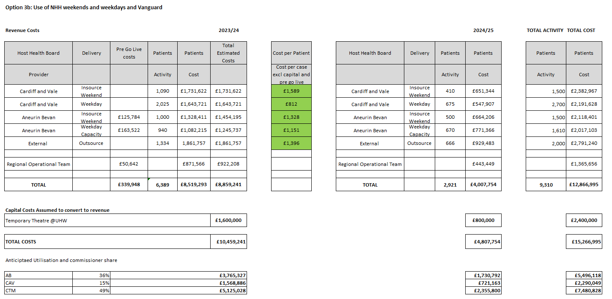

Financial Assumptions
Key Assumptions
- Activity and cost is assumed to be utilised as per the ‘long waiters’ commissioner split in the business case. An indicative commissioner share of cost and activity is in the attached
- Some costs are now fully expected in 2023/24 where these are required as ‘pre go live’. These relate to revenue equipment costs in AB.
- Vanguard and procurement costs are estimated based on current agreements and are therefore subject to possible variation
- The ‘regional operational team’ meets workforce expectations for the structure and requirements
- There is risk of recurrent recruitment costs if staff are permanently employed for a time limited project however there is an expectation of future service development
- Delivery plans and costings are estimated on the case mix complexity as outlined in the business case

Contents
1. Executive Summary 1
2. Introduction and Background 12
3. The Case for Change 17
4. Current Service Provision 21
5. Cataracts and the opportunities for collaboration across the region 30
6. Benefits, Risks and Governance 37
7. Options 41
8. Option 1 - Do Nothing 46
9. Option 2 – Maximising the use of NHH and POWH 48
10. Option 3a –Vanguard and NHH 54
11. Option 3b –Vanguard and maximising NHH 60
12. Option 4 – Weekend Insourcing and Outsourcing Only 69
13. Option 5 – Outsourcing 74
14. Preferred Option 78
15. Summary 81
16. Interdependencies 82
17. Implementation Plans 82
18. Approvals 83
Appendix One: Financials 84
Appendix Two: Options Appraisal details 88
Appendix Three: Option 1 Details 90
Appendix Four: Option 2 Details 93
Appendix Five: Option 3a Details 106
Appendix Six: Option 3b Details 119
Appendix Seven: Option 4 Details 131
Appendix Eight: Option 5 Details 141
Appendix Nine: Split of Preferred Option By Health Board 148
Appendix Ten: Full Patient Travel Survey 149

Introduction and Background

2.1 Regional Working
The Regional Portfolio is made up of three main programmes, Orthopaedics, Diagnostics and Ophthalmology. The three University Health Boards in South Eat Wales, Aneurin Bevan, Cardiff and Vale and Cwm Taf Morgannwg have agreed to work together regionally and adopt for following regional working principles
- To reduce unwarranted variation and inequality in health outcomes, access to services and experience at a regional population level.
- To improve resilience.
- To make effective use of capacity and capability in whichever organisation it sits.
- To create critical mass for effective high quality care delivery when and where it makes sense to do so accepting that my not reside in every organisation.
- Take all opportunities to use the evidence base and best practice to improve quality, efficiency, productivity, and use of finite resources.
- To enable clinical leaders, and others, to work together, lead together and learn together.
- Distributed leadership (The SRO maybe from organisation A, clinical lead from org B and delivery of service in B and C.)
- Approach collaboration with benign intent, honesty, transparency, and integrity in order to build trusting and effective relationships.
- To agree approaches to engagement and communications together.
- To avoid leaving anyone behind and learn from the past and progress in an open, honest and humble way.

2.2 Regional Ophthalmology Programme and Clinical Summit
The Regional Ophthalmology Programme has been running for 4 years in South East Wales with a pause for the pandemic and restarted with a renewed focus in summer 2021. The Programme aligns strongly with national priorities and is designed around delivering solutions on a regional basis where this would provide the best care to patients. The three Health Boards in the region are committed to working together, sharing resources and solutions across Ophthalmology, where working together would add value for patients and the workforce. The Programme includes active clinical and management representation from Cwm Taf Morgannwg, Cardiff and Vale and Aneurin Bevan University Health Boards.
A Clinical Summit was held in December 2021 where clinical staff were engaged in discussing and agreeing key issues and priorities for Ophthamology services in South East Wales. It was agreed that a new regional strategy should be developed to inform the future direction of the programme, including agreement regarding the ophthalmic specialties that would benefit from a collaborative regional approach

2.3 Regional Ophthalmology Strategy
A Regional Ophthalmology Strategy has been developed with clinical staff to set out the high level direction for the Regional Programme. The principles set out in the strategy are:
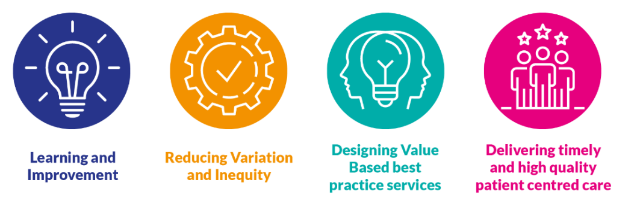
The Strategy has a number of delivery themes that reflect the issues and priorities identified in the Clinical Summit and now inform the future direction for the service on a regional footprint, these are set out below
- Regional Model: Adoption of a regional model would bring together ophthalmic services under the umbrella described as a Regional Centre of Excellence network model. This will provide additional regional cataracts capacity and will use the network model approach to bring experts together to provide the best care for patients and sector-leading teaching and education expertise.
- Sustainable Services: There are many services that cannot be sustained on a health-board only level and need to be brought together on a regional footprint. These include Vitreo-Retinal (VR) services, Corneal Cross linking and out of hours and emergency cover as requiring the most urgent attention.
- Workforce: There is a significant skills shortage across the Ophthalmic disciplines and the strategy will also work to address the training and development of key staff to deliver a regional sustainable workforce with strong succession planning, teaching, training and development.
- Research, Innovation and Development: Key to attracting workforce and achieving the other aspects of the strategy over the longer term is a Regional Clinical Research Facility allowing delivery of high quality clinical research trials which will increase income and quality of care for patients whilst building links with industry partners with strong consultant support.

Regionalising Services to ensure their sustainability and offer the best services to patients aligns with A Healthier Wales, The National Clinical Framework and Royal College of Ophthalmologists Clinical Guidance and best practice. ​The long term goal is a South East Wales regional centre of eye care excellence which can co-ordinate and provide the services identified above at a tertiary level. This will enable the region to care for all complex eye care procedures, for specialist clinicians to share and enhance their skills and to reduce the need for patients to travel outside Wales for certain specialist treatment.

2.4 Programme Plans and Phased approach
The diagram below represents the timeframes for the implementation of the strategy through a programme approach. Regional working starts first with the cataracts solution, closely followed by Vitreo Retinal hub and out of hours arrangements. The plans for the Regional Centre of Excellence will be developed through the 3 stage business case process alongside workforce developments and a research and innovation facility.

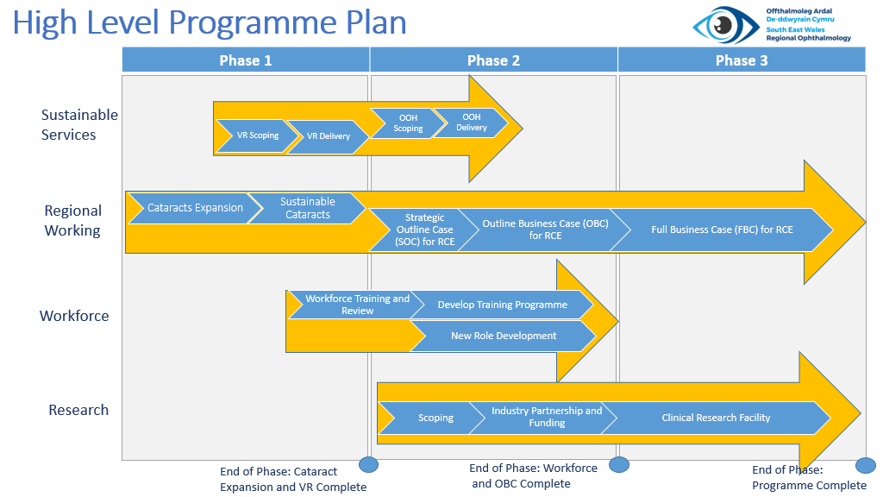

2.5 Cataracts Sustainability Staged Approach
The Regional Ophthalmology Programme Board have agreed the following staged approach to delivering sustainable cataracts solutions in the region, whilst balancing the need to activate capacity quickly and reduce the rate that the backlog is growing. This business case represents the first stage.
- Stage 1 – A Business Case for maximising our existing assets and increasing capacity with a focus on recovery activity and reducing waiting lists to run for 12 months.
- Stage 2 – Developing sustainable staffing and clinical models for the region. For cataracts and VR in University Hospital Wales (UHW), Cardiff, and cataracts and VR referral pathways across the region. To include new staffing models, new clinical models and costings, this model will be operational on the conclusion of stage 1.

The Case for Change

3.1 National Drivers for Change
Throughout the United Kingdom ophthalmic services are under considerable pressure. The Way Forward document produced by the Royal College of Ophthalmologists in 2017 indicate
- Cataract surgery alone represents 6% of all surgery carried out in the UK, with an expected growth within 10 years of 25%.
- 35% of patients over the age of 65 have visually significant cataract.
- 10% of all out-patient appointments within the UK (9 million appointments) are for eye clinics, and the demand on our services is expected to increase by 40% over the next 20 years.
- Overall, the economic burden of sight loss in the country was estimated to be £28 billion.
- In 2019 UK wide there was a shortfall of 230 consultants, and 67% of eye units were using locums to fill 127 vacant posts.
- 85% of units depended on waiting list initiatives in out-of-hours sessions to try and meet their demand.
- 22 patients a month were losing vision from hospital-initiated system delays.

All of these statistics pre-date the Covid pandemic, during which things have grown considerably worse (External Review of Eye Care Services in Wales, 2021).

3.2 Planned Care
The Welsh Government April 2022 document “Our programme for transforming and modernising planned care and reducing waiting lists in Wales” states 5 planned care goals
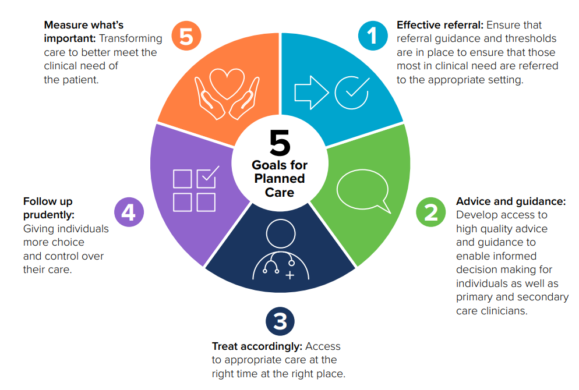
And 7 Planned Care priorities to support and influence recovery planning and investment decisions:
- Transformation of outpatients.
- Prioritisation of diagnostic services.
- Focus on early diagnosis and treatment of suspected cancer patients.
- Implementing a fair and equitable approach to patient prioritisation to minimise health inequalities.
- Eliminating long waiters at all stages of the pathway.
- Build sustainable planned care capacity across the care pathway.
- The provision of appropriate information and support to people.

This business case, and the long term proposals that it supports in stage 2 align closely with the Planned Care priorities, in particular the patient prioritisation and the long waiters.

3.3 Getting It Right First Time (GIRFT)
The Ophthalmology GIRFT Programme National Specialty Report 2019 also considers the challenging context for Ophthalmic services in the UK with demand for services across primary and secondary care increasing by over 10% in a 5 year period to 2019 and further increases expected. The report notes that workforce has not grown in line with demand and that Ophthalmology departments are cramped with little room for expansion. This review makes some cataract specific recommendations including making optimum use of theatre time
This business case and the longer-term approach planned for cataract provision across the region addresses the points raised in the report.

3.4 Royal College of Ophthalmologists, External Review of Eye Care Services in Wales
An External Review of Eye Care Services in Wales published in 2021 makes ten recommendations for Wales including Data Management, a reduction in patients transferred to England for treatment and more frequent sharing of best practice. Recommendation 8 is about Cataract Service Redesign and increased use of high-volume surgery. This will reduce waiting times and also - but as the report notes - encourage improvements in the end to end process where surgery is just one part.
This business case aims to address this recommendation for South East Wales and provide an increased number of high volume lists. The longer term approach identified in section 2.5 above will then address other areas for improvements.

3.5 Patient Harm
Cataracts can lead to progressive visual loss and if left untreated can lead to almost total vision loss with the sufferer only being able to perceive light and dark. Prior to Covid-19, vision loss of this nature was an unusual occurrence however, in the current climate this is alarmingly becoming more common.
A significant proportion of patients waiting for this surgery have been rendered severely sight impaired because of the delay to the treatment albeit in a reversible manner. Furthermore, the surgical complexity and time taken to perform cataract surgery increases in such cases. This reduces the number of cases that can be completed on a list, but also increases the risk of a serious complication that could lead to a second or third surgery being needed at a specialist centre.
The disability that cataracts cause has a significant impact on the sufferer. Driving is impossible leading to loss of independence. The ability to work or carry out activities of daily living may also be impaired. Poor mental health in people with vision impairment is an all too familiar problem. Furthermore, it has been identified that falls and the resulting injury and morbidity are significantly increased in this vulnerable population, thereby significantly adding to the trauma load and the hospitalisation that inevitably accompanies it.
Evidence suggests sight impairment in older people is associated with increases in the incidence of falls and hip fractures. Compared to the general older population, this group is 1.7 times more likely to fall, 1.9 times more likely to have multiple falls and 1.3–1.9 times more likely to experience hip fractures. Often the patients may be a carer for their family, and their preventable visual impairment begins to make this impossible, further increasing the burden on social care.

3.6 Service issues and gaps
There are some significant service issues and gaps that further evidence the need for increased capacity of cataracts procedures across the region. These include:
- Demand across the region being greater than the cataract capacity across the region - with no additional capacity the total number of patients waiting by March 2024 will be over 23,000
- Shortage of trained ophthalmology staff at all levels. All health boards have vacancies they cannot fill
- Burn out amongst staff
- Due to long waits, case mix can be more challenging
- Currently limited ability to share resources across the region for cataract surgery
- Patients waiting longer and are at greater risk of coming to additional harm

Current Service Provision
This section sets out the current activity and capacity assumptions for cataract surgery across AB, CAV, and CTM UHB’s.

4.1 Current Situation Background
During the covid-19 pandemic, the ability to operate on cataracts patients was reduced significantly. This has resulted in a considerable backlog of patients waiting to be seen for both assessments and surgery. Cataract surgery is the most frequently performed surgery within the NHS. Quality of life gains following successful surgery are amongst the highest of any procedure in Ophthalmology. With an ageing population the demand for the service across the region has steadily grown and demand outstrips the resources available to delivery capacity at current levels.
Current demand for cataract surgery is high. Across the region there are over 830 new cataract referrals every month and the current capacity across the region is struggling to cope with this level of demand. Across the region approximately 735 surgical procedures are undertaken per month. This will reduce to 495 per month From April 2023 if there is no further regional investment.

4.2 Current Waiting Lists
Waiting times are high for patients and are increasing across the region as capacity is consistently not able to meet the current demand. The total number of patients waiting across the region as at October 2022 is 19,236 and of these 6,163 (32%) have been waiting longer that 52 weeks
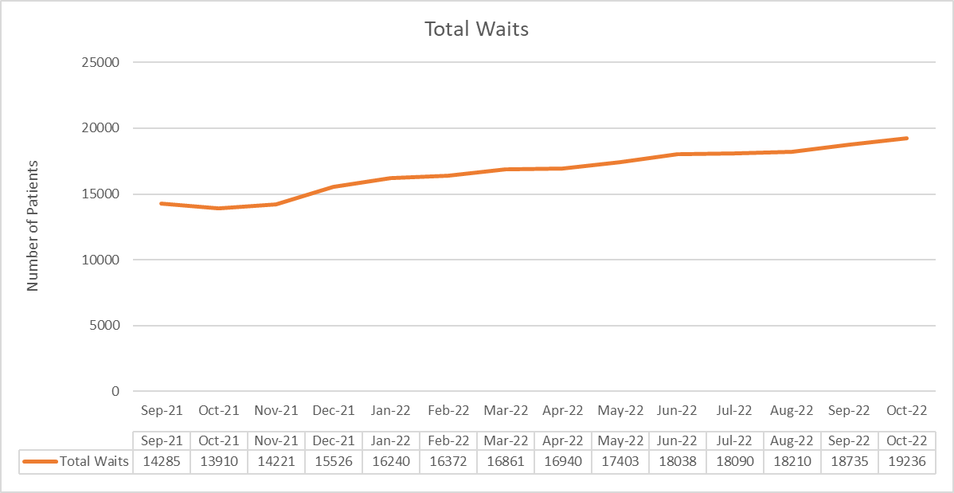
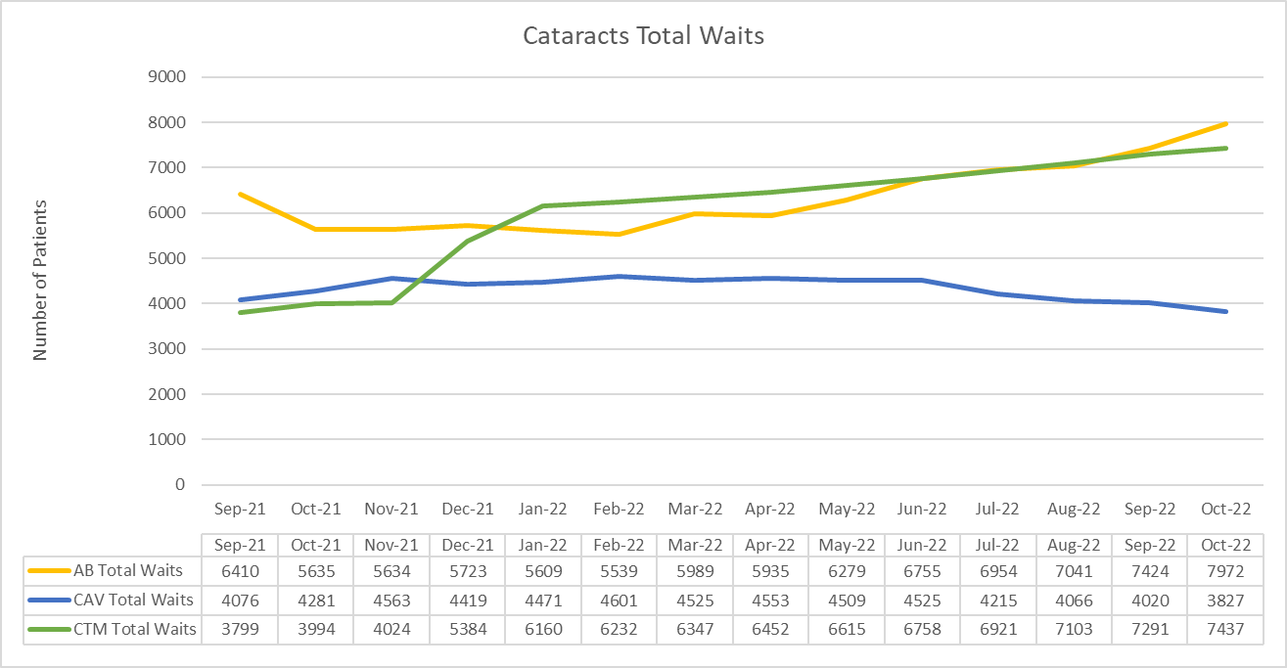

4.3 Pre-pandemic Referral Levels and Demand
The referrals for cataracts are expected to return to pre pandemic levels once the referrals delayed through covid are received into the system. For planning purposes projections suggest that 830 referrals is the monthly level across the region. This results in approximately 10,000 referrals across the region per year.

Pre pandemic referral levels for cataracts are shown below:
Year | CTM | AB | CAV | Total | Average per Month
2018/19 | 3705 | 3571 | 2205 | 9481 | 790
2019/20 | 4438 | 3594 | 2094 | 10126 | 844

4.4 Current Referral Levels / Demand
The rate of new referrals in the region is further extending the waiting times for patients, as more patients are added to the list per month than are treated. New referrals have been steadily climbing since September 2021, reaching a peak of over 1,100 in March 2022. From arch 22 onwards referral levels stop climbing and provide a better basis for planning future demand. Between March 2022 and November 2022 inclusive, average demand across the region is Since For the last 5 months the referrals have been returning to pre covid levels or an average of 850 per month across the region.
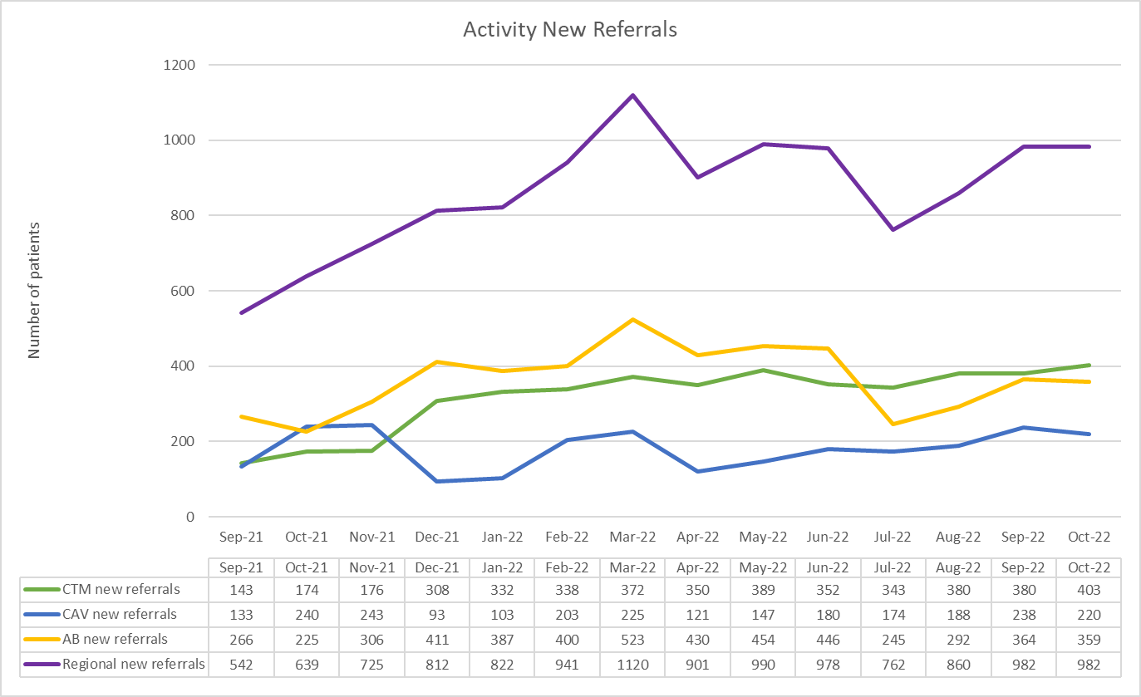

For the purposes of this business case the demand is forecast for 2023/24 as shown below:
Health Board | Monthly | Annual
AB | 340 | 4080
CAV | 150 | 1800
CTM | 340 | 4080
Regional Total | 830 | 9,960

Current referral rates are now slightly higher than pre pandemic levels, indicating that there is still some latent demand coming through the system, however most of the demand that presented by mid-2022 is in line with pre pandemic referral levels for the service.

4.5 Patient Pathway and Case mix
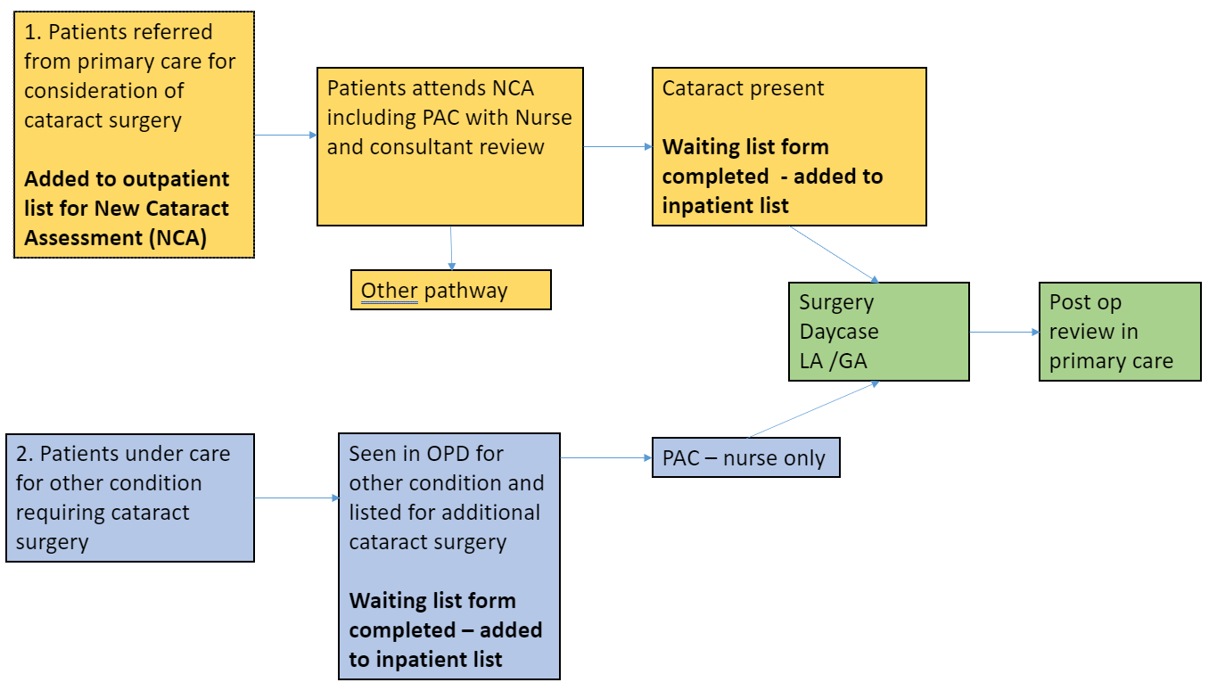
The diagram above demonstrates the patient pathway and the outpatient and inpatient sections of the pathway. Many of the patients are waiting to start this pathway at the outpatient stage and 19% are waiting for the inpatient stage.
The case mix of the patients at the end of the waiting list has been clinically assessed as:
- 50% complex patients
- 30% non-complex (high flow)
- 20% no further action on cataracts pathway

It is anticipated that the increased capacity that this business case will provide will reduce the percentage of complex patients as backlogs are addressed. The case mix will then move towards a greater proportion of non-complex patients. This will in turn will release core capacity within Health Boards to provide optimal care for the remaining complex cases.

4.6 Current Activity Inpatient and Outpatient
Activity across the region has been increasing, as operational teams and clinical staff work hard to restore sessions and undertake additional sessions to build back capacity post-COVID. The addition of the Vanguard mobile twin theatre theatre unit in Cardiff has also had a big impact towards increasing the activity the teams are able to provide. The Vanguard Unit opened in January 2022 and reached full capacity by March 2022. In September 2021 the regional inpatient activity including outsourcing was 438 procedures per month and in May 2022 including outsourcing, increasing capacity and opening the Vanguard theatres the activity was 749 procedures per month, an increase of 71% capacity in 8 months and demonstrating the work of the operational teams to increase capacity. Outpatient activity to prepare patients for surgery is also a critical step in the pathway. Outpatient activity was 1,038 in September, increasing to 1,564 in May 2022.
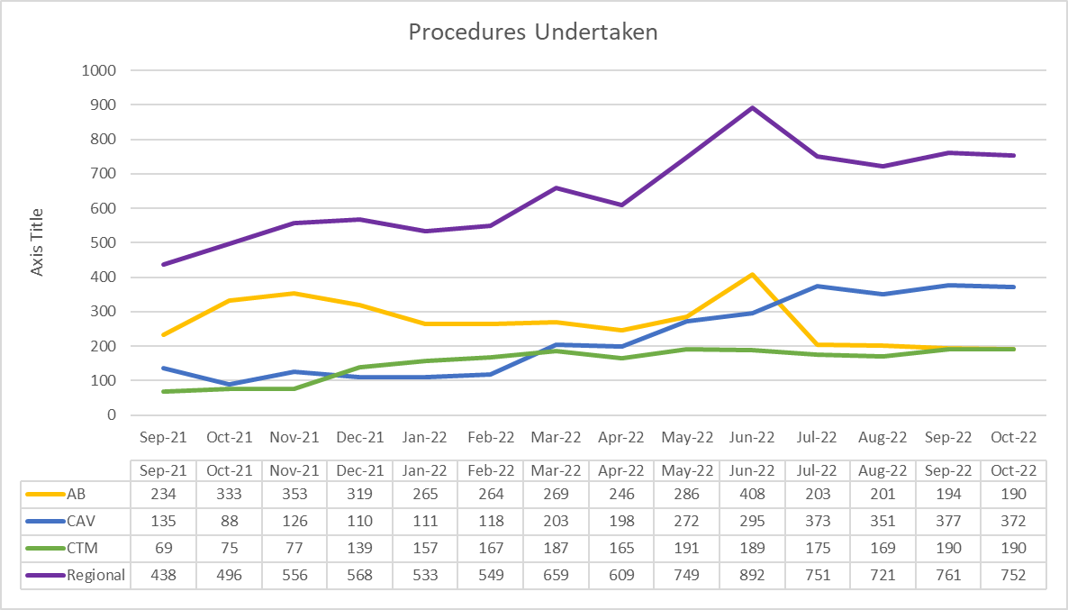

The gap between demand and capacity is growing, as shown in the chart below.
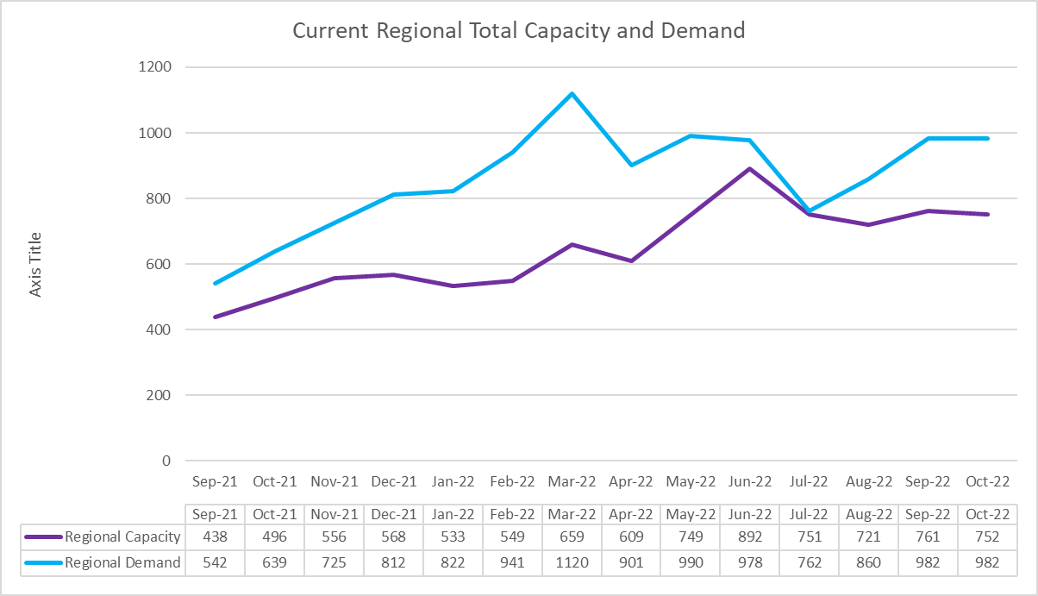

4.7 Workforce

Workforce
The current session planning and job planning arrangements include some sessions that are assigned as cataract only lists and some theatres sessions that run mixed lists where cataracts procedures are on the same surgical list as other ophthalmic procedures. Running mixed lists does enable the service to use any available theatre time to undertake cataract surgery but makes identifying the exact workforce assigned to cataract surgery more difficult.
As an illustration, the workforce typically required to undertake cataract surgery, and the outpatient pre-operative assessment is shown below.
Outpatient Pre-Operative assessment
During 1 session the workforce can see approximately 7 patients on a list, however the numbers may reduce if the patients are more complex. Workforce for 1 session includes a Consultant, 2 pre-assessment Nurses, 2 Health Care Support Workers and a Receptionist. There is also workforce required for booking and for notes retrieval and typing after the session.
Theatre Session
During 1 theatre session there will be up to 6 patients booked on a theatre list, depending upon case complexity. Workforce for 1 session includes a Consultant, Anaesthetist, 2 Scrub Nurses, 1 ODP, 2 Health Care Support Workers and 2 Nurses for the recovery area and a Receptionist. There is also workforce required for booking and for notes retrieval and typing after the session.
Workforce Gaps
The vacancy levels across the region for Ophthalmology services have been identified as shown below. This information helps to demonstrate that in the short term the capacity can only be increased by an insourcing and outsourcing model.
CTMU
- 0.7 WTE Corneal consultant
- 1 WTE Specialty Doctor
- 1 WTE Band 6 nurse
- 1 WTE band 5 qualified nurse

ABUHB
- 1x Band 3 Scheduler & 1 x Band 3 Outpatient booking Clerk- Both Full time posts
- 5.8 WTE Band 5 Nurses
- 3.4 WTE Band 6 Nurse Practitioners,
- 4.7 WTE Band 2 HCSW
- 1 WTE Consultant

CVUHB
- 1 x trainee vacancy
- 2.5 x Band 3 admin vacancies
- 1 x Band 2 nursing vacancy
- 2 x Band 5 Directorate Support Managers

4.8 Service Improvements
All service provision is being reviewed on a continuous basis to identify where small changes can be made to improve the way the service is delivered. These changes will ensure optimal utilisation of existing core capacity in Health Boards, while this business case sets out the further additional capacity required to support cataracts recovery. Actions include:
CTMUHB
- All vacancies within theatres are in the process of being filled, which will ensure all available space can be adequately staffed.
- A Health Board theatre utilisation group has been formed to look at how we can maximise the theatre space we have in both areas, as well as looking at late starts and early finishes.
- IPC regulations are due to change, allowing the department to fill lists at short notice, which will help with utilisation when patients cancel at short notice.
- Eye bay nurse staffing is also being looked at with support from the main nursing hub being sought so that ophthalmic nurses can be utilised elsewhere, such as pre-assessment clinics.
- The concept of a ‘golden list’ has been developed, involving optimal circumstances of efficiency, flow and patient attendance. This will be rolled out to as many clinicians as possible
ABUHB
- Start and finish times of Theatre sessions are being monitored with reasons being audited for improvements to be identified.
- A patient “Stand by list” is being generated to utilise any very short notice cancellations.
- All patient biometry is being uploaded to Clinical Workstation for Consultants to review patients sooner to prevent delays to treatment and to reduce day of admission cancellations.
CVUHB
- Maximising utilisation by ensuring templates are booked to agreed capacity and backfilled as necessary when cancellations occur.
- Theatre utilisation – both booking and in-session – is monitored with the scheduling team on a weekly basis.
- HVLC lists are run where appropriate cases are identified, with performance and utilisation monitored with the scheduling team on a weekly basis

Cataracts and the opportunities for collaboration across the region

5.1 North and South Hubs and Patient Travel
The large geographical area of South East Wales, the road network and the position of the hospitals lends itself to a North / South split that can reduce patient travel across the region by providing hubs in the North and South of the region. These hub have the potential to provide additional capacity. 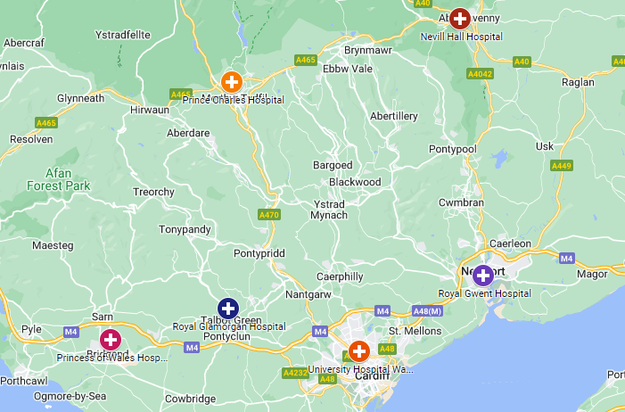
Geographical options for Cataracts in the North are Prince Charles Hospital (PCH) and Nevill Hall Hospital (NHH). There is no opportunity for expanding provision in PCH due to existing theatre usage and NHH is the remaining North option where 1 theatre is available. In Nevill Hall Hospital in Abergavenny as there is potential theatre space available to the region. The population in the North of the region is approximately 500,000 people and includes North Cwm Taf Morgannwg and North Aneurin Bevan.
In the South the Hub is proposed to be either University Hospital of Wales or Princess of Wales Hospital depending on the option taken forward both site use a twin theatre model. The population of the South of the region is approximately 1,000,000 people and includes South Cwm Taf Morgannwg, Cardiff and Vale and South Aneurin Bevan.

Travel Times By Car (From the centre of the town to the hospital site)
North Hub | South Hub | South Hub
To Abergavenny NHH | To Cardiff Vanguard | To Bridgend POWH
From Cwmbran = 30 minutes / 15 miles | From Newport = 30 minutes / 13 miles | From Pontypridd = 35 minutes / 25 miles
From Merthyr = 30 minutes / 18 miles | From Blackwood = 40 minutes / 23 miles | Treorchy = 35 minutes / 15 miles
From Blackwood = 35 minutes / 20 miles | From Bridgend = 45 minutes / 20 miles | From Newport = 40 minutes / 30 miles
From Aberdare = 45 minutes / 25 miles | From Aberdare = 50 minutes / 23 miles | From Cardiff = 40 minutes / 25 miles
From Newport = 40 minutes / 30 miles | From Treorchy = 55 minutes / 22 miles | From Aberdare = 55 minutes / 40 miles

Through the use of the North and south model no patient would travel further than 40 miles or for longer than 55 minutes by private car in normal traffic conditions.
The North and South hub model enables the additional regional capacity for cataract outpatient and inpatient stages to enact a collaborative regional approach to recovery and to maximise the use of our assets across the region.
Patient Second Offer and Travel
Patients will be offered the opportunity to travel to receive their assessment and treatment as part of the additional capacity arrangements where thy may be able to be treated sooner. At a maximum travel would be 40 miles and 55 minutes by private car under normal traffic conditions and most of the patient travel will be shorter. Patients unable or unwilling to travel will keep their place on the waiting list and receive treatment from their home health board.
Patient travel Survey
A patients travel questionnaire was undertaken in Princess of Wales Hospital on 5th January, Royal Gwent Hospital on 11th January, and University of Wales Hospital on 12th January 2023. A total of 140 patients attending appointments on those day were asked questions about their travel to hospital and their willingness to travel to another hospital for treatment. All respondents were anonymous. An extract of the survey is shown below. Full results are in appendix ten

Would you be prepared to travel further if you could have been treated sooner?

Would you be prepared to travel further to the treated sooner? | Princess of Wales Hospital | Royal Gwent Hospital | University Hospital of Wales | Grand Total
Yes | 25 (71%) | 27 (77%) | 47 (67%) | 99 (71%)
No | 10 (29%) | 8 (23%) | 23 (33%) | 41 (29%)
Grand Total | 35 | 35 | 70 | 140

Where would you travel to?
- From Princess of Wales Hospital in Bridgend, of the 25 patients willing to travel 25 would go to Cardiff and 19 to Swansea
- From Royal Gwent Hospital in Newport, of the 27 patients willing to travel 19 would be willing to travel to Cardiff and 25 to Abergavenny
- From University Hospital of Wales in Cardiff, of the 47 patients willing to travel 38 would be willing to travel to Bridgend and 41 to Newport

Where would you travel to? | From Princess of Wales Hospital | From Royal Gwent Hospital | From University Hospital of Wales
Bridgend / POWH |  | 7 | 38
Cardiff / UHW | 25 | 19
Newport / RGH | 11 |  | 41
Abergavenny / NHH | 5 | 25 | 30
Bristol | 5 | 6 | 10
Swansea | 19 | 3 | 10
Further in the UK | 5 | 3 | 4
Grand Total | 70 | 63 | 133
*patients could provide multiple answers to this question

Regional Working Principles
The Regional Ophthalmology Programme Board have endorsed the following regional working principles
- Treating the longest waiters first, regardless of their ‘home’ health board
- Using the outsourcing, insourcing, evenings and weekends capacity for less complex patients
- Adopting best practice guidance in all centres
- Adopting shared waiting list management arrangements

The three Health Boards have committed to working as a region and understand that this does not necessarily mean sharing the provision requested in this business case equally, but equitably across the region and allocating this provision to the patients of greatest need regardless of their ‘home’ health board.
The chart below shows the waits for outpatient and inpatient appointments across the region and the variation across Health Boards. Both AB are approaching 8,000 total patients waiting and CTM 7,500. CAV have under 4,000 patients waiting with trajectories moving towards reducing this figure each month.

5.3 Insourcing and Outsourcing
The capacity across the region can be rapidly increased by utilising the local opportunities for insourcing and outsourcing. These arrangements make the best use of our assets across the region for short-term flexible arrangements that protect our core capacity.

5.4 Shared Patient Treatment List (PTL)
As an agreed principle of this regional model, the three health boards have agreed to work together to share waiting list management (see section 5.4) and ensure that capacity is distributed across the region to the patients who have been waiting the longest and require this treatment.
The three health boards will share their patient treatment lists through a regional team and those patients at the end of the list that are suitable for this type of treatment will be assessed and treated as part of this regional capacity.
The table below shows the numbers of patients waiting and how this is split proportionally across the region. Data relates to August 2022 and includes the total number of patients waiting in each health board.
Patient Waits | Total |  |  | Over 52 weeks
AB | 7041 | 39% |  | 2175 | 36%
CAV | 4066 | 22% |  | 891 | 15%
CTM | 7103 | 39% |  | 2939 | 49%
 | 18210 |  |  | 6005

As a proportion of the patients waiting, 39% are from AB. 39% from CTM and 22% from CAV. When this is viewed as patients waiting at the end of the lists the proportions change and it is from this pool of patients that the additional capacity would be targeted.
Of this group of longer waiters 49% are from CTM, 36% from AB and 15% from CAV and this indicates how the additional capacity will be used.

5.5 Regional Waiting List Management
Also see section 5.3 (shared PTL)

5.5.1 Shared waiting list management arrangements
All health Boards have agreed to share waiting lists and treat the longest waiters from across the region first.
The waiting lists could be shared via a SharePoint which is supported from an information governance perspective as access is only via NADEX numbers so access can be limited and monitored. To ensure that longest waiters are treated first, the three spreadsheets could be merged.
In terms of how patients are removed from waiting lists once treated, this would be managed in the same way that patients are treated in Spire/Nuffield. The NHH/UHW centres would be added as options for removal on a drop down list a feature which is on the CTM and C&V waiting lists.
The regional team will hold the shared list and the patients waiting the longest will be treated first, any issues will be managed by the regional team and demonstrated with the data.
SLA type arrangements will be in place for sharing data and resolving issues

5.5.2 Regional Booking and Scheduling
There will be a joint Regional Booking and Scheduling Team across the region to book all the additional capacity patients into outpatient appointments and schedule them for surgery. This team will be hosted by a Health Board but work for the region to support this additional service for the patients. Bringing this team together offers resilience in the service and flexibility to book into the North and South hubs via access to all the systems operated by each of the Health Boards.
The manager of this team will also oversee the data integrity for the joint waiting list arrangements with the three regional Ophthalmology Directorate Managers.

5.6 IT and Data Systems
North Hub
Patients booked and scheduled for assessment and treatment in the North Hub will be assigned an AB patient number and recorded on the AB systems as AB patients. Records will be shared with other health boards via Welsh Clinical Portal (WCP). CTM and CAV patients treated in the North hub will be recorded as ‘outsourced’ on the CTM and CAV systems (see below)
South Hub
Patients booked for outpatient appointments in the South Hub will attend POWH for their appointment and, if required, UHW for surgery. Upon funding approval the specific details for sharing information across the two health boards for patients will be developed and delivered as part of the implementation plan
Outsourcing
There are established practices to follow for recording outsourced patients already as outsourcing is a continuing practice in health boards within the region. Patients are listed as outsourced on the home system and information is shared between the outsourcing provider and the home health board via Welsh Clinical Portal (WCP)
Uploading on to the Welsh Clinical Portal upload records between the Health Boards
IT and data systems will require more full scoping when funding is agreed.

5.7 Additionality
The service model represents additional capacity established in the region when compared to the core base capacity that was provided before the pandemic. In Cardiff and Vale, there were 7.5 cataract sessions per week and the Vanguard Unit has increased this to 20 sessions per week. Through this business case 62.5% (12.5 out of 20 sessions) of the Vanguard Unit would be available for regional use, returning the Cardiff and Vale capacity to pre pandemic levels.
In Aneurin Bevan the way services are delivered has been reconfigured but the total capacity for cataract surgery remains unchanged from pre pandemic levels, demonstrating that this business case represents additional capacity across the region.

Benefits, Risks and Governance

6.1 High Level Benefits
The high-level benefits associated with undertaking the additional capacity are demonstrated below. Through the do-nothing option, these benefits will be foregone.
Patient Benefits
- Reduced waiting times for patients
- Improved quality of life (measured through PROMS/PREMS)
Wider Regional and Health Board Benefits
- Increased Capacity across the region
- Reduced waiting list size
- Making the best use of regional resources

Health gain
- Reducing sight loss
- Reducing complications and other relating to sight loss e.g.falls
- Improving outcomes for patients
- Improving timely clinical care and patient experience
Equity
- Equity of service provision and access across the region
- Capacity for the longest waiters

6.2 High Level Risks
The high level risks associate with undertaking the additional capacity are demonstrated below.
High-level Risks to Delivery
Delivery of the business case is dependent on the following risks being managed and mitigated:

Risk | Assessment | Mitigation
Reliability of providers to deliver services: that the service provider cannot fulfil the staffing required to meet the sessions they are contracted for | Prob: 1  Impact: 3  Score: 3 (low) | Contract management and open communication with the provider to manage any changes in the volumes and arrange times to increase capacity in future weeks/months
Availability of additional support service and equipment, trays, HSDU: That the additional capacity on weekends compromises the core capacity and there is not enough equipment to service the whole capacity required | Prob: 2  Impact: 3  Score: 6 (Medium) | Early modelling of requirements and ordering of supplies with longer lead in times. Detailed planning of these resources and close monitoring of all usage and risk areas
Booking and scheduling staff appointments: That there is not enough booking and scheduling time to manage the additional patients and that the additional capacity is not fully utilised | Prob: 1  Impact: 4  Score: 4 (Low) | Planning for resource required and bringing them together into a regional team to enable cross cover and resilience to the service.
Ensuring equity of provision across the region: That the regional provision does not go to the patients waiting longest and HB’s benefit disproportionately | Prob: 1  Impact: 4  Score: 4 (Low) | Regular and robust waiting lists management processes and pooled lists that adjust and review on a monthly basis to manage the lists as a whole
Reduction in core capacity: That core capacity is reduced or compromised because the regional solution is in place | Prob: 3  Impact: 3  Score: 9 (Medium) | Regular monitoring and early corrective actions towards additional capacity and core capacity alongside waiting list reductions in size and waiting times
IT systems and record keeping: that IT systems can’t share information across HB boundaries and that patient records get lost through manual processes | Prob: 3  Impact: 4  Score: 12 (High) | Bring additional IT support into the programme to provide expertise and enable accurate record keeping and sharing through system and maintenance of information governance
Contracting impacting on core capacity: That staff take on contracting shifts and are then not able to provide the core capacity required to maintain Health Board levels of activity | Prob: 3  Impact: 3  Score: 9 (Medium) | Working with the provider to limit impacts on HB staff and planning schedules in advance and communicating this widely. Monitoring sickness levels
Clinical Risk: That staff do not have the appropriate qualifications and experience | Prob: 2  Impact: 5  Score: 10 (Medium) | Clinical Governance processes and working with provider to ensure every member of staff is suitable qualified and experienced.
Clinical Risk: That unsuitable patients are referred for insourcing and outsourcing and are routed back into core capacity making the patient journey longer | Prob: 1  Impact: 4  Score: 4 (Low) | Clear and clinically agreed criteria for referring patients for insourcing and outsourcing treatment routes
Clinical Risk: That patient cancellation rates are high and the insourcing and outsourcing efficiency is compromised | Prob: 1  Impact: 3  Score: 3 (Low) | Communication with patients prior to referral and follow ups of cancelling patients for feedback/reasons
Low Risk 1-5, medium 6-10, High 12-20

6.3 Contracting arrangements
Local Health Boards will utilise the expertise of the All Wales Procurement team to undertake a tender process on behalf of all three Health Boards. Depending on their technical advice the intention would be to undertake one procurement exercise for both insourcing and outsourcing recognising that these will be awarded to separate providers. In addition, given the scale of the volumes required, the awards may include a multitude of providers to enable flexibility of patients and to promote patient choice.
The procurement timetable will need to include a full 30 days tender advertisement given the volumes and financial value involved. The procurement process will be undertaken by the All Wales team, with the detailed specification around clinical requirements, patient pathways, governance and processes etc led by a small working group comprised of all three Health Boards and involving expertise from all relevant disciplines. This will confirm the contractual arrangements around the awarding and management of the contracts. Tenders will then be evaluated by a team drawn from all Health Boards and awarded to the successful providers.
Contracts are awarded on a cost per case basis with the expectation that the full number of procedures will be delivered by the Provider. The award of any new contracts would be underpinned by an activity plan, with clear timescales for delivery, and any appropriate scaling back of insourced activity in line with the implementation plan for the sustainable regional solution.

6.4 Clinical Governance
The Clinical Governance arrangements will be mainly managed through the contracting arrangements. The contracting will include all the clinical staffing required to undertake outpatient assessments and inpatient procedures.
Specific areas of attention for clinical governance are:
Surgeon Competence
Insourced and Outsourcing contracts need to ensure that surgeons are of an appropriate competence and quality and have comparable complication rates to consultant surgeons on the National Ophthalmic Database. Processes for checking and ageing the competence of surgeons will be in place as part of the contracting and implementation of the business case.
Follow Ups and Complications
As part of core Health Board delivery of this type of surgery, any complications are the responsibility of the operating surgeon and follow up arrangements of this nature will be included in the insourcing contracting details. If follow ups cannot be rectified by the operating surgeon (or insourcing company) then they will be invoiced for the follow up treatments required.

Clinical Processes
Insourcing staff will be expected to follow the clinical processes of the site on which they are working including incident reporting. There may be occasions where clinical policies vary across sites and the implementation of the business case will aim to address areas of significant variation by aligning guidance across sites as far as practicable, although in the short term this will not be possible in every case.

6.5 Waiting List Modelling
The Regional Ophthalmology Programme have been working with the Delivery Unit to develop a mathematical model to inform the planning of the additional cataracts capacity. Data to feed into the model has been sourced from health boards and operational colleagues have been refining and testing the model with the Delivery unit and have finalised the model for this purpose. The model ensures that there is balance between the outpatient and inpatient capacity based on the following assumptions.
- There is a waiting list of 19,000 patients (forecast position end of March 2023)
- 80% of patients referred as suitable for surgery
- 18% of patients are not suitable for surgery
- 2% of patients DNA
- Patients are reviewed by primary care post-surgery within 3 weeks
- None of the outpatient appointments undertaken on patients expire
- 20% of patients require surgery on a second eye
- One outpatient appointment will cover both eyes
- Second eye surgery is undertaken at least 10 weeks after first eye surgery

In section 4.5 the case mix discusses that 20% of the patients who move through the outpatient stage will not require surgery. However, 20% of the patients who require surgery require it for both eyes and so the demand for surgery/inpatient stage is then in line with the demand for the outpatient stage.

Options
The business case considers six options to achieve the following key aims:-
- to enact a collaborative regional approach to recovery
- to provide additional regional capacity for cataract outpatient and inpatient stages
- to demonstrate optimal utilisation of our assets across the region
- to address current waiting list backlogs
- to reduce clinical risk on an equitable basis across the region

To achieve the stated aims of the business case, the options need to:
- Be mobilised quickly
- Be deliverable with the resources available
- Protect the viability of the core capacity
- Keep patient travel to a minimum
- Deliver value for money

The options are:
- Option 1: Do nothing
  - Core capacity 5,940 only

- Option 2: Maximising the use of NHH and POWH
  - North Hub: in NHH (1,610, weekdays NHS staff recruitment)
  - North Hub: in NHH (1,500 Weekend Insourcing)
  - South Hub: in POWH (3,558, for 1 NHS session and Evenings and Weekend Insourcing)
  - Outsourcing (2,000)
  - Total additional 8,668 (plus 5,940 core is 14,608 total)
  - One theatre in NHH and twin theatres in POWH

- Option 3a: Vanguard and NHH
  - North Hub: in NHH (1,500 Weekend Insourcing)
  - South Hub: 12.5 sessions of Vanguard Unit (2,770 weekdays NHS staff)
  - South Hub: in UHW (1,500 Weekend Insourcing)
  - Outsourcing (2,000)
  - Total additional 7700 (plus 6,120 core is 13,820 total)
  - One theatre in NHH and twin theatres in Vanguard

- Option 3b: Vanguard and Maximising NHH
  - North Hub: in NHH (1,610, weekdays NHS staff recruitment)
  - North Hub: in NHH (1,500 Weekend Insourcing)
  - South Hub: 12.5 sessions of Vanguard Unit (2,770 weekdays NHS staff)
  - South Hub: in UHW (1,500 Weekend Insourcing)
  - Outsourcing (2,000)
  - Total additional 9,310 (plus 7,140 core is 16,450 total)
  - One theatre in NHH and twin theatres in Vanguard

- Option 4: Weekend Insourcing and Outsourcing only
  - North Hub: in NHH (1,500 Weekend Insourcing)
  - South Hub: in POWH (1,500 Weekend Insourcing)
  - Outsourcing (2,000)
  - Total additional 5000 (plus 5,940 core is 10,940 total)
  - One theatre in NHH and twin theatres in POWH

- Option 5: Outsourcing activity to external provider (s)
  - Outsourcing (5,000)
  - Total additional 5000 (plus 5,940 core is 10,940 total)

Theatres Available
- University Hospital of Wales: The Vanguard Unit is a twin theatre set up based in the car park in UHW. This will be used for the weekday and the weekend sessions.
- Princess of Wales Hospital: In Bridgend Eye theatres there is a twin theatre set up. This would be used for the weekend and evening sessions. The 1 NHS session in POWH would be run as a single theatre set up.
- Nevill Hall Hospital: One theatre is available in the main theatres block in NHH. The weekday sessions and the weekend sessions will be run from this theatre.

Options Summary
 | Option 1 Do Nothing | Option 2 POWH and NHH | Option 3a Vanguard and NHH | Option 3b Vanguard and Max NHH ** | Option 4 Weekends | Option 5 Outsourcing
North Hub: NHH Weekdays NHS Staff |  | 1610 |  | 1610
North Hub: NHH Weekends Insourcing |  | 1500 | 1500 | 1500 | 1500
South Hub: Vanguard Weekdays NHS Staff |  |  | 2700 | 2700
South Hub: Vanguard Weekends Insourcing |  |  | 1500 | 1500
South Hub: POWH Evenings insourcing (+1 NHS session) |  | 2058
South Hub: POWH Weekends Insourcing |  | 1500 |  |  | 1500
Outsourcing |  | 2000 | 2000 | 2000 | 2000 | 5000
Total Additional | 0 | 8668 | 7700 | 9310 | 5000 | 5000
Plus Core | 5940 | 5940 | 6120 | 7140 | 5940 | 5940
Total | 5940 | 14608 | 13,820 | 16450 | 10940 | 10940
*Yellow – Provision on AB site, Blue – provision on CAV site, Green – provision on CTM site
**Option 3b is for 14 months
High level Financials
 | Option 1 Do Nothing | Option 2 POWH and NHH | Option 3a Vanguard and NHH | Option 3b Vanguard and Max NHH* | Option 4 Weekends | Option 5 Outsourcing
Core Capacity | 5,940 | 5,940 | 6,120 | 7,140* | 5,940 | 5,940
Additional Regional Capacity | 0 | 8668 | 7,700 | 9,310 | 5,000 | 5,000
Total Capacity | 5,940 | 14,608 | 13,820 | 16,450 | 10,940 | 10,940
Total Revenue Costs | £0 | £12.4m | £10.5m | £12.9m** | £7.5m | £7m
Total Capital Costs | £0 | £0 | £2.4m | £2.4m | £0 | £0
Total Costs (Capital + Revenue) | £0 | £12.4m | £12.9m | £15.3m | £7.5m | £7m
Cost per patient | n/a | £1,436 | £1,672 | £1,640 | £1,504 | £1,410
*Option 3b is for 14 months
**Costing for this option include 5% increase on all pay costs

Waiting List Changes
The table below shows the impact of each of the options on the total size of the waiting list. The start position for each option is 19,000 patients waiting.
 | Option 1 Do Nothing | Option 2 POWH and NHH | Option 3a Vanguard and NHH | Option 3b Vanguard and Max NHH* | Option 4 Weekends | Option 5 Outsourcing
Waiting list project end | 23,046 | 14,352 | 15,186 | 14,168 | 18,483 | 18,483
Waiting list change from 19,000 baseline | +4,046 | -4,648 | -3,814 | -4,832 | -517 | -517

Options Appraisal
The six options have been through an options appraisal process. An exercise was undertaken with each health board individually to score and assess each option against the business case aims and the principles of regional working in section 2.1 below and appendix two.
Weighting for the scoring was allocated as follows:
- Quality and Safety: 35%
- Effective use of resources: 10%
- Strategic Fit: 10%
- Sustainability: 15%
- Access: 10%
- Deliverability: 20%

Results of the appraisal process are shown below. All three health boards have selected the same option as the highest scoring option against the criteria. Results are shown below. Scores are out of 5, with the regional total out of 15.

 | Option 1 Do Nothing | Option 2 POWH and NHH | Option 3a Vanguard and NHH | Option 3b Vanguard and Max NHH | Option 4 Weekends | Option 5 Outsourcing
Cardiff and Vale | 1.65 | 3.10 | 4.00 | 4.25 | 1.85 | 1.65
Cwm Taf Morgannwg | 1.60 | 4.30 | 3.70 | 4.35 | 2.30 | 2.00
Aneurin Bevan | 1.80 | 3.35 | 3.30 | 3.55 | 2.15 | 2.15
Regional Total | 5.05 | 10.75 | 11.00 | 12.15 | 6.30 | 5.80

Preferred Option
The preferred option in this business case is Option 3b Vanguard and Max NHH

- South Hub Weekdays: Retaining the weekday 20 sessions in vanguard and using 7.5 sessions for CAV core capacity (1620 patients per year, funded by CAV) and 12.5 sessions for regional capacity (2700 patients per year, regionally funded, provided by NHS staff)
- South Hub Weekends: 1,500 outpatient assessment and inpatient procedures carried out by an insourcing company in Vanguard (UHW)
- North Hub Weekdays: 1610 outpatient assessment and inpatient procedures carried out in weekdays in NHH using NHS staffing
- North Hub Weekends: 1,500 outpatient assessment and inpatient procedures carried out by an insourcing company in NHH
- An additional 2,000 outsourced outpatient and inpatient procedures
- One theatre in NHH and twin theatres in Vanguard
- Total core 7,140 for 14 months (6,120 annual)
- Plus 9,310 additional
- Total capacity 16,450 per year
- Waiting list reduction 4,832 (from 19,000 to 14,168)
- Total costs: £15.3m
- Cost per patient: £1,640

8. Option 1 - Do Nothing
This option involves providing no further funding and resources to cataract surgery across the region at this stage. Each health board will continue with only their planned core capacity and there will be no sharing of patient treatment lists (PTL’s). The Vanguard rental will end on 30th June 2023 following the short term regional extension arrangement.

8.1.1 Core capacity
The annual core capacity of each Health Board is shown below
 | Core: AB In House | Core: CTM In House | Core: CTM Outsourced | Core: CAV In house | Regional Total Core | Regional Demand | Difference
Annual capacity | 2400 | 1920 | 180 | 1440 | 5940 | 9,960 | -4,020

8.1.2 Option Assumptions
This option is based on the following assumptions
- Use of Vanguard ends by 30th June 2023
- Capacity in CTM and AB for 23/24 remains at 2022 activity levels
- CAV have 7.5 sessions in main theatres to undertake core cataracts activity, reverting to pre-Vanguard capacity.

8.2 Option 1 – Option Appraisal

8.2.1 Option 1 Benefits
The high level benefits identified above (section 6.1) are foregone in this option. The benefits identified for this option are listed below
- No changes to the way that services are currently run
- No management capacity required to organise additional services
- No direct costs

8.2.2 Option 1 Risks
The specific risks associated with option 1 are:
- Demand continues to outstrip supply (high risk as business case is mitigation action)
- Backlogs will continue to grow (high risk as business case is mitigation action)
- Planned Care target will be missed (high risk as business case is mitigation action)
- Increased proportions of higher complexity patients as waiting times are increased (medium risk as business case is mitigation action)
- Loss of experienced and well trained staff at the Vanguard Unit (medium risk as business case is mitigation action)
- Reduction in training capacity across the region (medium risk as business case is mitigation action)
- Increases the backlog by 4,046 patients (high risk as business case is mitigation action)

8.2.3 Option 1 Patient Considerations
Through this option all patients will continue to be treated by their home health board. They will be treated within their own health board boundary but are likely to have to wait more than 1 year for assessment and treatment. As patient waits lengthen, the risk increases of patients coming to harm while waiting.

8.2.4 Option 1 costs
There are no direct costs associated with this option
Indirect costs include:
- Increased reliance on WLI’s / agency staff
- Increased patient complaints
- Multiple patient referrals as primary care escalate patients due to deterioration
- Additional waiting list validation required
- Increased costs of complications as patient complexity increases

8.2.5 Option 1 Activity Modelling
This scenario is based on the following assumptions for year 1:
- 5,940 cataracts procedures per year (114 per week, 495 per month)
- 5,940 outpatients per year (114 per week, 495 per month)
- 9,960 referrals per year (192 per week, 830 per month)

After 52 weeks of the total capacity of 5,940 per year the waiting list is increased from 19,000 across the region to 23,046

Option 2 – Maximising the use of NHH and POWH
Option 2 is an NHS recruitment, insourcing and outsourcing option involving a two-hub model of NHH in the North and POWH in the South. At both sites the weekday and weekend capacity is utilised, along with outsourcing in the following volumes over a 12 month period:
- North Hub Weekdays: 1610 outpatient assessment and inpatient procedures carried out in weekdays in NHH using NHS staffing
- North Hub Weekends: 1,500 outpatient assessment and inpatient procedures carried out by an insourcing company in NHH
- South Hub: 3,558 (2,058 weekdays plus 1,500 weekends) outpatient assessment and inpatient procedures carried out by an insourcing company in POWH
- An additional 2,000 outsourced outpatient and inpatient procedures
- Total core 5,940
- Plus 8,668 additional
- Total capacity 14,608 per year
- Waiting list reduction 3,814 (from 19,000 to 15,186)
- Total costs: £12.4m
- Cost per patient: £1,436

9.1. Option 2 - Clinical and Service Model
The Clinical Model includes an outpatient stage and inpatient stage.
At the outpatient stage the clinical teams review the patients, determine their suitability for surgery and conduct pre-operative assessments. Through the proposed model this will be carried out during a single patient visit.
At the inpatient stage patient receive their cataract surgery. Following surgery patients are discharged to Primary Care. Primary Care advisors have confirmed that no additional resource is required in primary care at present for the additional capacity as it will be adequately dispersed amongst optometric practices across the region.

9.1.1 Clinical Service Model North Hub (NHH)
The North hub would primarily provide outpatient and inpatient provision to patients primarily in North CTM and North AB from Nevill Hall Hospital (NHH) in Abergavenny as the regional geography suits. There is 1 theatre available in NHH that will be used for 7 sessions in the week by NHS staff and both days on the weekend by an insourcing team.
Delivery Plan for NHH Sessions
Delivery Plan Outpatients
 |  | Month 1 | Month 2 | Month 3 | Month 4 | Months 5-11 | Month 12 |  | Total
 | Patients per list | 6 | 7 | 8 | 8 | 8 | 8
 | Sessions per week | 5 | 5 | 5 | 5 | 5 | 5
 | weeks | 4 | 4 | 4 | 4 | 25 | 1 |  | 42
 | total patients | 120 | 140 | 160 | 160 | 1000 | 40 |  | 1620
Delivery Plan Inpatients
 |  | Month 1 | Month 2 | Month 3 | Month 4 | Months 5-11 | Month 12 |  | Total
 | Patients per list | 4 | 5 | 6 | 6 | 6 | 6
 | Sessions per week | 4 | 5 | 5 | 7 | 7 | 5
 | weeks | 1 | 4 | 4 | 4 | 28 | 1 |  | 42
 | total patients | 16 | 100 | 120 | 168 | 1176 | 30 |  | 1610

Delivery Plan for Insourcing Sessions in NHH
 | Outpatients | Inpatients
Patients per list | 8 | 7.5
Sessions per week | 4 | 4
Patients per week | 32 | 30
weeks per year | 47 | 50
total patients | 1504 | 1500

9.1.2 Clinical Service Model South Hub (POWH)
Through Option 2 the South Hub would provide outpatient and inpatient provision for patients in the south of the region. The outpatient and inpatient provision will be delivered from Princess of Wales Hospital site on weekdays and weekends via an insourcing company with one weekday session per week provided by NHS staff.
Delivery Plan
weekdays
Outpatients
Session Type | method | patients per list | Sessions | patients per week | Weeks | Total Patients
1 day session | Insourcing | 8 | 1 | 8 | 38 | 304
Evenings | Insourcing | 8 | 6 | 48 | 38 | 1824
Total |  |  |  | 56 |  | 2128
Inpatients
Session Type | method | patients per list | Sessions | patients per week | Weeks | Total Patients
1 day session | NHS Staff | 7 | 1 | 7 | 42 | 294
Evenings | Insourcing | 7 | 6 | 42 | 42 | 1764
Total |  |  |  | 49 |  | 2058
weekends
Outpatients
Session Type | method | patients per list | Sessions | patients per week | Weeks | Total Patients
Saturday | Insourcing | 8 | 4 | 32 | 32 | 1024
Sunday | Insourcing | 8 | 2 | 16 | 31 | 496
Total |  |  |  | 48 |  | 1520
Inpatients
Session Type | method | patients per list | Sessions | patients per week | Weeks | Total Patients
Saturday | Insourcing | 7 | 4 | 28 | 36 | 1008
Sunday | Insourcing | 7 | 2 | 14 | 36 | 504
Total |  |  |  | 42 |  | 1512

9.1.3 Outsourcing Arrangements
Option 2 Outsourcing @ 2,000 cases per year

9.1.4 Booking and scheduling For Option 2 (Maximising the use of NHH and POWH):
In one year the team will need to book 6,700 outpatient appointments across both the North and South Hubs and schedule 6,700 inpatient procedures and facilitate 2,000 outsourced patients. Totalling 15,400 patient bookings per year. A Regional booking and scheduling team are required for these patient volumes, along with a POWH Eye Unit Manager and NHH Eye Unit Manager to ensure capacity levels are maximised.

9.1.5 Option 2 Assumptions
- Shared PTL across the region
- Share of regional capacity based on percentage split of over 52 week waiters
- 52 weeks waiters numbers under monthly review and capacity adjusted accordingly
- Regional booking team may not all be based in one place
- IT solutions will need to be worked through
- Insourcing and Outsourcing contracting will be done at a National level
- That insourcing and outsourcing capacity will be available in the market through contracting arrangements
- Insourcing numbers on a list to be determined by the insourcing company with annual numbers included in the contracting arrangement
- Effective clinical governance arrangements
- NHH Workforce can be fully recruited
- Patients receive pre-assessment and surgery through the same element of provision (e.g. weekend pre-assessment and weekend surgery)
- Patient eligibility criteria are to be developed and agreed
- 80% conversion rate from outpatients to surgery
- 20% of patients require a second eye
- Patients requiring second eye have one pre assessment to cover both eyes

9.2 Option 2 – Option Appraisal

9.2.1 Additional Regional Capacity
Capacity | Core Annual | Additional Capacity % | Additional Regional | Total | Average Demand | Difference
AB | 2400 | 36% | 3121 | 5521 | 4080 | 1441
CAV | 1440 | 15% | 1300 | 2740 | 1800 | 940
CTM | 2100 | 49% | 4247 | 6347 | 4080 | 2267
Regional Total | 5940 |  | 8668 | 14608 | 9960 | 4648

9.2.2 Regional Capacity by expected patients treated
Reviewing the end of the list 49% of the long waiters are from CTM, 36% from AB and 15% from CAV. Projections of the use of the regional capacity are based on these percentages, however as the waiting list progresses, the percentages will change over time
AB Patients
 | Core: AB In House | AB 36% | AB Total from this business case
Capacity | 2400 | 3121 | 5521

CTM Patients
 | Core: CTM In House | Core: CTM Outsourced | CTM 49% | CTM Total from this business case
Capacity | 1920 | 180 | 4247 | 6347

CAV Patients
 | Core: CAV In house | CAV 15% | CAV Total from this business case
Capacity | 1440 | 1300 | 2740

Regional Total
 | AB Total | CAV Total | CTM Total | Regional Total
Capacity | 5521 | 2740 | 6347 | 14608

9.2.3 Option 2 Benefits
In addition to the high level benefits identified above, the additional benefits of this option include
- Recruiting additional NHS workforce for NHH
- Provides a solid base to develop the sustainable regional solution
- Fully utilised the POWH Eye Unit 7 days per week
- Enables a greater reduction in the backlog
- No additional capital required
- Reduces the backlog by 4,648 patients waiting

9.2.4 Option 2 Risks
The specific risks associated with option 2 are:
- High volumes of surgery through POWH Eye Unit may put a strain on equipment readiness levels (low risk following mitigation actions)
- Clinical risks and patient harm risks associated with outsourcing and insourcing capacity (low risk following mitigation actions)

9.2.5 Option 2 Patient Considerations
Through this option there would be additional capacity for patients across the region for cataract assessment and surgery and patient waiting time will start to reduce. This option includes a North and South Hub where patients who meet the criteria for this additional capacity would be directed to their closest hub for assessment and treatment. Patients unable or unwilling to travel will be treated within their own health board as part of the core capacity. Waiting times may vary between core and additional capacity provision.
This option also includes outsourcing where the costing includes patient travel as this may be outside of the boundary of the region (dependent on the contracting). The core capacity, insourcing, and NHS sessions do not include patient travel contributions.

9.2.6 Option 2 costs
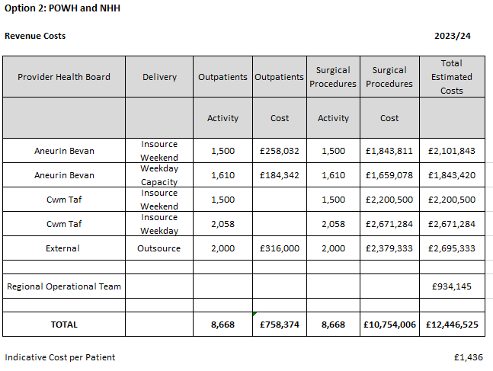

9.2.7 Option 2 Activity Modelling
This scenario is based on the following assumptions for year 1:
- 9,960 referrals per year (192 per week, 830 per month)
- 14,608 cataracts procedures per year (281 per week, 1217 per month)
- 14,608 outpatients per year (282 per week, 1224 per month)

After 52 weeks of the total capacity of 14,608 per year the waiting list is reduced from 19,000 across the region to 14,352

Further details on Option 2 can be found in Appendix Four

Option 3a –Vanguard and NHH
Option 3a is an insourcing and outsourcing option involving a two-hub model of NHH in the North and the Vanguard Unit in the South with the following volumes over a 12 month period:
- South Hub: Retaining the weekday 20 sessions in vanguard and using 7.5 sessions for CAV core capacity (1620 patients per year, funded by CAV) and 12.5 sessions for regional capacity (2700 patients per year, regionally funded, provided by NHS staff)
- South Hub: 1,500 outpatient assessment and inpatient procedures carried out by an insourcing company in Vanguard (UHW)
- North Hub: 1,500 outpatient assessment and inpatient procedures carried out by an insourcing company in NHH
- An additional 2,000 outsourced outpatient and inpatient procedures
- Total core 6,120
- Plus 7,700 additional
- Total capacity 13,820 per year
- Waiting list reduction 3,814 (from 19,000 to 15,186)
- Total costs 23/24: £12.9m
- Cost per patient: £1,672

10.1 Option 3a - Clinical and Service Model
The Clinical Model includes an outpatient stage and inpatient stage.
At the outpatient stage the clinical teams review the patients, determine their suitability for surgery and conduct pre-operative assessments. Through the proposed model this will be carried out during a single patient visit.
At the inpatient stage patient receive their cataract surgery. Following surgery patients are discharged to Primary Care. Primary Care advisors have confirmed that no additional resource is required in primary care at present for the additional capacity as it will be adequately dispersed amongst optometric practices across the region.

10.1.1 Maximising the Use of the Vanguard Unit in UHW
The Vanguard Unit in UHW is a mobile twin theatre alongside modular units for consulting, patient waiting and recovery. It is currently contracted for use for cataract surgery by CAV on a 5 day per week basis Monday to Friday with this arrangement running until 8th January 2023. As a short-term solution and to maximise the options available for this business case, the unit will be extended until 31st March 2023 and the capacity during this extension period will be divided between the three health boards in the region.
If extended, then the new contract for the Vanguard Unit will be for 7 days per week to maximise the use of the unit for the regional extension of the cataracts service. The Vanguard Unit requires capital funding.
The benefits of retaining the Vanguard Unit include the stability of staff and retaining this well trained and experienced staffing group, the ability to treat more complex patients than the insourcing and outsourcing will enable, increasing the training opportunities available across the region and providing a solid foundation for the second sustainable phase of the cataracts expansion to be based.

10.1.2 Clinical Service Model North Hub
The North hub would primarily provide outpatient and inpatient provision to patients in North CTM and North AB from Nevill Hall Hospital (NHH) in Abergavenny as the regional geography suits. There is 1 theatre available in NHH that will be used on both days on the weekend by an insourcing team.
Delivery Plan for Insourcing Sessions in NHH
 | Outpatients | Inpatients
Patients per list | 8 | 7.5
Sessions per week | 4 | 4
Patients per week | 32 | 30
weeks per year | 47 | 50
total patients | 1504 | 1500

10.1.3 Clinical Service Model South Hub
Through this option The South Hub would provide outpatient and inpatient provision for patients in the south of the region. The Vanguard Unit would be used 7 days per week.
On weekdays the twin theatre unit will be staff by NHS staff in a continuation of current practice. These 20 sessions will be split, 7.5 for CAV and 12.5 for regional patients. On the weekends the provision in the vanguard unit will be staffed via an insourcing company.
Weekdays
Outpatients
Time | Delivery | patients Per list | Sessions | patients per week | Weeks | Total Patients
Weekdays | NHS Staff | 8 | 7.5 | 60 | 46 | 2760
Inpatients
Time | Delivery | patients Per list | Sessions | patients per week | Weeks | Total Patients (less CNA's)
Weekdays | NHS Staff | 5 | 12.5 | 62.5 | 48 | 2700
Weekends
Outpatients
Time | Delivery | patients Per list | Sessions | patients per week | Weeks | Total Patients
Weekends | Insourcing | 8 | 6 | 48 | 32 | 1536
Inpatients
Time | Delivery | patients Per list | Sessions | patients per week | Weeks | Total Patients
Weekends | Insourcing | 7 | 6 | 42 | 36 | 1500

10.1.4 Outsourcing Arrangements
Outsourcing @ 2,000 cases per year

10.1.5 Booking and scheduling For Option 3a (Vanguard Capacity and North Hub NHH Weekends):
In one year the team will need to book 5,900 outpatient appointments across both the North and South Hubs and schedule 5,900 inpatient procedures and facilitate 2,000 outsourced patients. Totalling 13,800 patient bookings per year. A Regional booking and scheduling tam are required for these patient volumes, along with a Vanguard Unit Manager and NHH Eye Unit Manager to ensure capacity levels are maximised.

10.1.6 Option 3a Assumptions
- Shared PTL across the region
- Share of regional capacity based on percentage split of over 52 week waiters
- 52 weeks waiters numbers under monthly review and capacity adjusted accordingly
- Regional booking team may not all be based in one place
- IT solutions will need to be worked through
- Insourcing and Outsourcing contracting will be done at a National level
- That insourcing and outsourcing capacity will be available in the market through contracting arrangements
- Insourcing numbers on a list to be determined by the insourcing company with annual numbers included in the contracting arrangement
- Effective clinical governance arrangements
- Vanguard workforce can continue into 23/24
- NHH Workforce can be fully recruited
- Patients receive pre-assessment and surgery through the same element of provision (e.g. weekend pre-assessment and weekend surgery)
- Patient eligibility criteria are to be developed and agreed
- 80% conversion rate from outpatients to surgery
- 20% of patients require a second eye
- Patients requiring second eye have one pre assessment to cover both eyes

10.2 Option 3a – Option Appraisal

Additional Regional Capacity
Capacity | Core Annual | Additional Capacity % | Additional Capacity | Total | Average Demand | Difference
AB | 2400 | 36% | 2772 | 5172 | 4080 | 1092
CAV | 1620 | 15% | 1155 | 2775 | 1800 | 975
CTM | 2100 | 49% | 3773 | 5873 | 4080 | 1793
Regional Total | 6120 |  | 7700 | 13820 | 9960 | 3860

10.2.2 Regional Capacity by expected patients treated
Reviewing the end of the list 49% of the long waiters are from CTM, 36% from AB and 15% from CAV. Projections of the use of the regional capacity are based on these percentages, however as the waiting list progresses, the percentages will change over time
AB Patients
 | Core: AB In House | AB 36% | AB Total from this business case
Capacity | 2400 | 2772 | 5172

CTM Patients
 | Core: CTM In House | Core: CTM Outsourced | CTM 49% | CTM Total from this business case
Capacity | 1920 | 180 | 3773 | 5873

CAV Patients
 | Core: CAV In house | CAV 15% | CAV Total from this business case
Capacity | 1620 | 1155 | 2775

Regional Total
 | AB Total | CAV Total | CTM Total | Regional Total
Capacity | 5172 | 2775 | 5873 | 13820

10.2.3 Option 3a Benefits
In addition to the high level benefits identified above, the additional benefits of this option include
- Retaining a well trained and experienced staff within the Vanguard unit
- Ability to treat more complex patients are part of the regional capacity
- Continuity and stability of employment for Vanguard staff
- Increased opportunities for staff training learning and development
- Provides a solid base to develop the sustainable regional solution
- Fully utilised the Vanguard unit 7 days per week
- Enables a greater reduction in the backlog
- Stabilises the short term regional arrangement (Jan-March 2023)
- Reduces the backlog by 3,814 patients waiting

10.2.4 Option 3a Risks
The specific risks associated with option 3a are:
- High volumes of surgery through Vanguard Unit may put a strain on equipment readiness levels (low risk following mitigation actions)
- Clinical risks and patient harm risks associated with outsourcing and insourcing capacity (low risk following mitigation actions)

10.2.5 Option 3a Patient Considerations
Through this option there would be additional capacity for patients across the region for cataract assessment and surgery and patient waiting time will start to reduce. This option includes a North and South Hub where patients who meet the criteria for this additional capacity would be directed to their closest hub for assessment and treatment. Patients unable or unwilling to travel will be treated within their own health board as part of the core capacity. Waiting times may vary between core and additional capacity provision.
This option also includes outsourcing where the costing includes patient travel as this may be outside of the boundary of the region (dependent on the contracting). The core capacity, insourcing, and NHS sessions do not include patient travel contributions.

10.2.6 Option 3a Costs
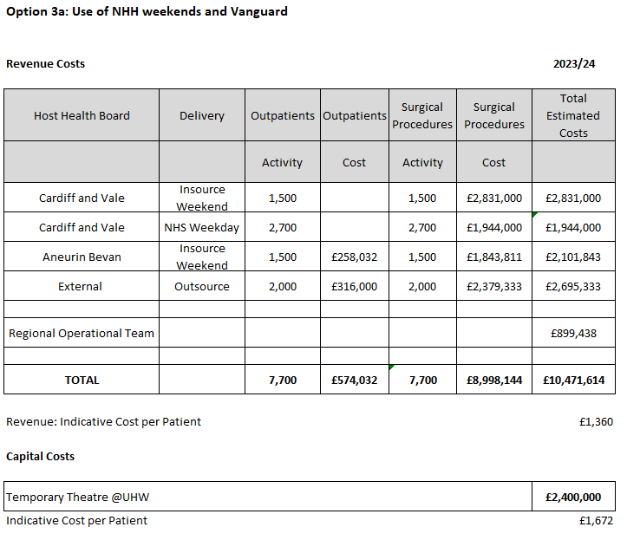

10.2.7 Option 3a Activity Modelling
This scenario is based on the following assumptions for year 1:
- 9,960 referrals per year (192 per week, 830 per month)
- 13,820 cataracts procedures per year (266 per week, 1152 per month)
- 13,820 outpatients per year (266 per week, 1152 per month)

After 52 weeks of the total capacity of 13,820 per year the waiting list is reduced from 19,000 across the region to 15,186
Further details on Option 3a can be found in Appendix Five

Option 3b –Vanguard and maximising NHH
This is the preferred option
As the preferred option this option has been developed in more detail than the other options.
Realistic assumptions have been made about the feasibility of delivery and the model has been designed to be distributed over 14 months split across 23/24 and 24/25.
Option 3b
As option 3a but with the addition of 7 weekday NHS sessions in NHH
Option 3b is an insourcing and outsourcing option involving a two-hub model of NHH in the North and the Vanguard Unit in the South with the following volumes over a 14 month period:

- South Hub Weekdays: Retaining the weekday 20 sessions in vanguard and using 7.5 sessions for CAV core capacity (1620 patients per year, funded by CAV) and 12.5 sessions for regional capacity (2700 patients per year, regionally funded, provided by NHS staff)
- South Hub Weekends: 1,500 outpatient assessment and inpatient procedures carried out by an insourcing company in Vanguard (UHW)
- North Hub Weekdays: 1610 outpatient assessment and inpatient procedures carried out in weekdays in NHH using NHS staffing
- North Hub Weekends: 1,500 outpatient assessment and inpatient procedures carried out by an insourcing company in NHH
- An additional 2,000 outsourced outpatient and inpatient procedures
- One theatre in NHH and twin theatres in Vanguard
- Total core 7,140 for 14 months (6,120 annual)
- Plus 9,310 additional
- Total capacity 16,450 per year
- Waiting list reduction 4,832 (from 19,000 to 14,168)
- Total costs: £15.3m
- Cost per patient: £1,640

11.1 Clinical and Service Model
The Clinical Model includes an outpatient stage and inpatient stage.
At the outpatient stage the clinical teams review the patients, determine their suitability for surgery and conduct pre-operative assessments. Through the proposed model this will be carried out during a single patient visit.
At the inpatient stage patient receive their cataract surgery. Following surgery patients are discharged to Primary Care. Primary Care advisors have confirmed that no additional resource is required in primary care at present for the additional capacity as it will be adequately dispersed amongst optometric practices across the region.

11.1.1 Maximising the Use of the Vanguard Unit in UHW
The Vanguard Unit in UHW is a mobile twin theatre alongside modular units for consulting, patient waiting and recovery. It is currently contracted for use for cataract surgery by CAV on a 5 day per week basis Monday to Friday with this arrangement running until 8th January 2023. As a short-term solution and to maximise the options available for this business case, the unit will be extended until 30th June 2023 and the capacity during this extension period will be divided between the three health boards in the region.
If extended, then the new contract for the Vanguard Unit will be for 7 days per week to maximise the use of the unit for the regional extension of the cataracts service. The Vanguard Unit requires capital funding.
The benefits of retaining the Vanguard Unit include the stability of staff and retaining this well trained and experienced staffing group, the ability to treat more complex patients than the insourcing and outsourcing will enable, increasing the training opportunities available across the region and providing a solid foundation for the second sustainable phase of the cataracts expansion to be based.

11.1.2 Clinical Service Model North Hub
The North hub would primarily provide outpatient and inpatient provision to patients primarily in North CTM and North AB from Nevill Hall Hospital (NHH) in Abergavenny as the regional geography suits using an additional theatre in NHH on weekdays, staffed by NHS staff and on both days on the weekend by an insourcing team
Delivery Plan for NHH Sessions Weekdays NHS Staff
Delivery Plan Outpatients
Delivery from months 3-14 of the plan
 |  | Month 3 | Month 4 | Month 5 | Month 6 | Months 7-13 | Month 14 |  | Total
 | Patients per list | 6 | 7 | 8 | 8 | 8 | 8
 | Sessions per week | 5 | 5 | 5 | 5 | 5 | 5
 | weeks | 4 | 4 | 4 | 4 | 25 | 1 |  | 42
 | total patients | 120 | 140 | 160 | 160 | 1000 | 40 |  | 1620
Delivery Plan Inpatients
Delivery from months 3-14 of the plan
 |  | Month 3 | Month 4 | Month 5 | Month 6 | Months 7-13 | Month 14 |  | Total
 | Patients per list | 4 | 5 | 6 | 6 | 6 | 6
 | Sessions per week | 4 | 5 | 5 | 7 | 7 | 5
 | weeks | 1 | 4 | 4 | 4 | 28 | 1 |  | 42
 | total patients | 16 | 100 | 120 | 168 | 1176 | 30 |  | 1610

Delivery Plan for Insourcing Sessions in NHH Weekends
 | Outpatients | Inpatients
Patients per list | 8 | 7.5
Sessions per week | 4 | 4
Patients per week | 32 | 30
weeks per year | 47 | 50
total patients | 1504 | 1500

11.1.3 Clinical Service Model South Hub
Through this option The South Hub would provide outpatient and inpatient provision for patients in the south of the region. The Vanguard Unit would be used 7 days per week.
On weekdays the twin theatre unit will be staff by NHS staff in a continuation of current practice. These 20 sessions will be split, 7.5 for CAV and 12.5 for regional patients. On the weekends the provision in the vanguard unit will be staffed via an insourcing company.
Weekdays
Outpatients
Time | Delivery | patients Per list | Sessions | patients per week | Weeks | Total Patients
Weekdays | NHS Staff | 8 | 7.5 | 60 | 46 | 2760
Inpatients
Time | Delivery | patients Per list | Sessions | patients per week | Weeks | Total Patients (less CNA's)
Weekdays | NHS Staff | 5 | 12.5 | 62.5 | 48 | 2700
Weekends
Outpatients
Time | Delivery | patients Per list | Sessions | patients per week | Weeks | Total Patients
Weekends | Insourcing | 8 | 6 | 48 | 32 | 1536
Inpatients
Time | Delivery | patients Per list | Sessions | patients per week | Weeks | Total Patients
Weekends | Insourcing | 7 | 6 | 42 | 36 | 1500

11.1.4 Outsourcing Arrangements
Outsourcing @ 2,000 cases per year

11.1.5 Booking and scheduling For Option 3a (Vanguard Capacity and North Hub NHH Weekends):
In one year the team will need to book 7,310 outpatient appointments across both the North and South Hubs and schedule 7,310 inpatient procedures and facilitate 2,000 outsourced patients. Totalling 16,620 patient bookings per year. A Regional booking and scheduling team are required for these patient volumes, along with a Vanguard Unit Manager and NHH Eye Unit Manager to ensure capacity levels are maximised.

11.1.6 Delivery Plan
The delivery will run for 14 months and individual streams of activity will start and finish as follows:
- Month 1 to month 12
  - Vanguard Weekdays
- Month 2 to month 12
  - Vanguard Insourcing
- Month 2 to month 13
  - NHH Insourcing
  - Outsourcing
- Month 3 to month 14
  - NHH Weekdays

11.1.7 Option 3b Assumptions
- NHH Workforce can be fully recruited
- Shared PTL across the region
- Share of regional capacity based on percentage split of over 52 week waiters
- 52 weeks waiters numbers under monthly review
- Regional booking team may not all be based in one place
- IT solutions will need to be worked through
- Insourcing and Outsourcing contracting will be done at a National level
- That insourcing and outsourcing capacity will be available in the market through contracting arrangements
- Insourcing numbers on a list to be determined by the insourcing company with annual numbers included in the contracting arrangement
- Effective clinical governance arrangements
- Vanguard workforce can continue into 23/24
- CTM continue with their current levels of outsourcing (15 per month)
- NHH Workforce can be fully recruited
- Patients receive pre-assessment and surgery through the same element of provision (e.g. weekend pre-assessment and weekend surgery)
- Patient eligibility criteria are to be developed and agreed
- 80% conversion rate from outpatients to surgery
- 20% of patients require a second eye
- Patients requiring second eye have one pre assessment to cover both eyes

11.2 Option 3b – Option Appraisal

11.2.1 Additional Regional Capacity

Capacity | Core 14 months | Additional Capacity % | Additional Regional | Total | 14 months demand | Difference
AB | 2800 | 36% | 3352 | 6152 | 4760 | 1392
CAV | 1890 | 15% | 1397 | 3287 | 2100 | 1187
CTM | 2440 | 49% | 4562 | 7002 | 4760 | 2242
Regional Total | 7140 |  | 9310 | 16450 | 11620 | 4830

11.2.2 Regional Capacity by expected patients treated
Reviewing the end of the list 49% of the long waiters are from CTM, 36% from AB and 15% from CAV. Projections of the use of the regional capacity are based on these percentages.
Delivery is split over 2 financial years as follows:
- 9 months of 23/24 from 1st July 2023 to 31st March 2024
- 5 months of 24/25 from 1st April 2024 to 31st August 2024
AB Patients
 | Core: AB In House | AB 39% | AB Total from this business case
1st July 2023 to 31st March 2024 | 1800 | 2313 | 4113
1st April 2024 to 31st August 2024 | 1000 | 1039 | 2039
Total Allocation | 2800 | 3352 | 6152

CAV Patients
 | Core: CAV In house | CAV 15% | CAV Total from this business case
1st July 2023 to 31st March 2024 | 1215 | 964 | 2179
1st April 2024 to 31st August 2024 | 675 | 433 | 1108
Total Allocation | 1890 | 1397 | 3287

CTM Patients
 | Core: CTM In House | Core: CTM Outsourced | CTM 49% | CTM Total from this business case
1st July 2023 to 31st March 2024 | 1440 | 135 | 3148 | 4723
1st April 2024 to 31st August 2024 | 800 | 75 | 1414 | 2289
Total Allocation | 2240 | 210 | 4562 | 7012

Regional Total
 | AB Total | CAV Total | CTM Total | Regional Total
1st July 2023 to 31st March 2024 | 4113 | 2179 | 4723 | 11014
1st April 2024 to 31st August 2024 | 2039 | 1108 | 2289 | 5436
Total Allocation | 6152 | 3287 | 7012 | 16450

11.2.3 Option 3b Benefits
In addition to the high level benefits identified above, the additional benefits of this option include
- Retaining a well trained and experienced staff within the Vanguard unit
- Ability to treat more complex patients are part of the regional capacity
- Continuity and stability of employment for Vanguard staff
- Increased opportunities for staff training learning and development
- Provides a solid base to develop the sustainable regional solution
- Fully utilised the Vanguard unit 7 days per week
- Greater proportion of cataracts surgery undertaken by NHS staff
- Enables a greater reduction in the backlog
- Stabilises the short term regional arrangement (Jan-March 2023)
- Reduces the backlog by 4,832 patients waiting

11.2.4 Option 3b Risks
The specific risks associated with this option are:
- High volumes of surgery through Vanguard Unit may put a strain on equipment readiness levels (low risk following mitigation actions)
- Clinical risks and patient harm risks associated with outsourcing and insourcing capacity (low risk following mitigation actions)

11.2.5 Option 3b Patient Considerations
Through this option there would be additional capacity for patients across the region for cataract assessment and surgery and patient waiting time will start to reduce. This option includes a North and South Hub where patients who meet the criteria for this additional capacity would be directed to their closest hub for assessment and treatment. Patients unable or unwilling to travel will be treated within their own health board as part of the core capacity. Waiting times may vary between core and additional capacity provision.
This option also includes outsourcing where the costing includes patient travel as this may be outside of the boundary of the region (dependent on the contracting). The core capacity, insourcing, and NHS sessions do not include patient travel contributions.

11.2.6 Option 3b Costs

Financial Assumptions
Key Assumptions
- Activity and cost is assumed to be utilised as per the ‘long waiters’ commissioner split in the business case. An indicative commissioner share of cost and activity is in the attached
- Some costs are now fully expected in 2023/24 where these are required as ‘pre go live’. These relate to revenue equipment costs in AB.
- Vanguard and procurement costs are estimated based on current agreements and are therefore subject to possible variation
- The ‘regional operational team’ meets workforce expectations for the structure and requirements
- There is risk of recurrent recruitment costs if staff are permanently employed for a time limited project however there is an expectation of future service development
- Delivery plans and costings are estimated on the case mix complexity as outlined in the business case

11.2.7 Option 3b Activity Modelling
This scenario is based on the following assumptions:
- 9,960 referrals per year (192 per week, 830 per month)
- 15,430 cataracts procedures per year (297 per week, 1286 per month)
- 15,430 outpatients per year (297 per week, 1286 per month)

Over 14 months this would be:
- 11,620 referrals per year
- 16,450 cataracts procedures per year
- 16,450 outpatients per year

After 14 months the total capacity of 16,450 per year the waiting list is reduced from 19,000 across the region to 14,168
Further details on Option 3b can be found in Appendix Six

Option 4 – Weekend Insourcing and Outsourcing Only
The Insourcing and outsourcing option involves a two hub model of NHH in the North and the use of POWH in the south for outpatients and Inpatients, along with outsourcing in the following volumes over a 12 month period:
- North Hub: 1,500 outpatient assessment and inpatient procedures carried out by an insourcing company in NHH
- South Hub: 1,500 outpatient assessment and inpatient procedures carried out by an insourcing company in POWH
- An additional 2,000 outsourced outpatient and inpatient procedures
- Total core 5,940
- Plus 5,000 additional
- Total capacity 10,940 per year
- Waiting list reduction 517 (from 19,000 to 18,483)
- Total costs 23/24: £7.5m
- Cost per patient: £1,504

12.1 Option 4 – Clinical and Service Model
The Clinical Model includes an outpatient stage and inpatient stage.
At the outpatient stage the clinical teams review the patients, determine their suitability for surgery and conduct pre-operative assessments. Through the proposed model this will be carried out during a single patient visit.
At the inpatient stage patient receive their cataract surgery. Following surgery patients are discharged to Primary Care. Primary Care advisors have confirmed that no additional resource is required in primary care at present for the additional capacity as it will be adequately dispersed amongst optometric practices across the region.

12.1.1 Clinical Service Model North Hub
The North hub would primarily provide outpatient and inpatient provision to patients in North CTM and North AB from Nevill Hall Hospital (NHH) in Abergavenny as the regional geography suits. There is 1 theatre available in NHH that will be used on both days on the weekend by an insourcing team.
Delivery Plan for Insourcing Sessions in NHH
 | Outpatients | Inpatients
Patients per list | 8 | 7.5
Sessions per week | 4 | 4
Patients per week | 32 | 30
weeks per year | 47 | 50
total patients | 1504 | 1500

12.1.2 South Hub
Through this Option the South Hub would provide outpatient and inpatient provision for patients in the south of the region. The outpatient and inpatient provision will be delivered from Princess of Wales Hospital in Bridgend on weekends via an insourcing company
weekends
Outpatients
Session Type | method | patients per list | Sessions | patients per week | Weeks | Total Patients
Saturday | Insourcing | 8 | 4 | 32 | 32 | 1024
Sunday | Insourcing | 8 | 2 | 16 | 31 | 496
Total |  |  |  | 48 |  | 1520
Inpatients
Session Type | method | patients per list | Sessions | patients per week | Weeks | Total Patients
Saturday | Insourcing | 7 | 4 | 28 | 36 | 1000
Sunday | Insourcing | 7 | 2 | 14 | 36 | 500
Total |  |  |  | 42 |  | 1500

12.1.3 Outsourcing Arrangements
This Option will deliver an additional 2,000 cases per year. Outsourcing arrangements and costs include patient travel.

12.1.4 Booking and scheduling for Option 4 (Weekend Insourcing and Outsourcing)
In one year the team will need to book 3,000 outpatient appointments across both the North and South Hubs and schedule 3,000 inpatient procedures in addition to facilitating 2,000 outsourced patients totalling 8,000 patient contacts per year. A Regional booking and scheduling tam are required for these patient volumes.

12.1.5 Option 4 Assumptions
- Shared PTL across the region
- Share of regional capacity based on percentage split of over 52 week waiters
- 52 weeks waiters numbers under monthly review and capacity adjusted accordingly
- Regional booking team may not all be based in one place
- IT solutions will need to be worked through
- Insourcing and Outsourcing contracting will be done at a National level
- That insourcing and outsourcing capacity will be available in the market through contracting arrangements
- Insourcing numbers on a list to be determined by the insourcing company with annual numbers included in the contracting arrangement
- Effective clinical governance arrangements
- Patients receive pre-assessment and surgery through the same element of provision (e.g. weekend pre-assessment and weekend surgery)
- Patient eligibility criteria are to be developed and agreed
- 80% conversion rate from outpatients to surgery
- 20% of patients require a second eye
- Patients requiring second eye have one pre assessment to cover both eyes

12.2 Option 4 – Option Appraisal

12.2.1 Additional Regional Capacity
Capacity | Core Annual | Additional Capacity % | Additional Capacity | Total | Average Demand | Difference
AB | 2400 | 36% | 1800 | 4200 | 4080 | 120
CAV | 1440 | 15% | 750 | 2190 | 1800 | 390
CTM | 2100 | 49% | 2450 | 4550 | 4080 | 470
Regional Total | 5940 |  | 5000 | 10940 | 9960 | 980

12.2.2 Regional Capacity by expected patients treated
Reviewing the end of the list, 49% of the long waiters are from CTM, 36% from AB and 15% from CAV. Projections of the use of the regional capacity are based on these percentages, however as the waiting list progresses, the percentages will change over time
AB Patients
 | Core: AB In House | AB 36% | AB Total
Capacity | 2400 | 1800 | 4200

CTM Patients
 | Core: CTM In House | Core: CTM Outsourced | CTM 49% | CTM Total
Capacity | 1920 | 180 | 2450 | 4550

CAV Patients
 | Core: CAV In House | CAV 15% | CAV Total
Capacity | 1440 | 750 | 2190

Regional Total
 | AB Total | CAV Total | CTM Total | Regional Total
Capacity | 4200 | 2190 | 4550 | 10940

12.2.4 Option 4 Benefits
In addition to the high level benefits identified above, the additional benefits of this option include
- Outpatient assessments and inpatients treatments are performed on the same site
- Reduces the backlog by 517 patients waiting

12.2.5 Option 4 Risks
The specific risks associated with this option are:
- Loss of experienced and well trained staff at the Vanguard Unit (low risk following mitigation actions)
- Reduction in training capacity across the region (medium risk following mitigation actions)
- Reduced capacity to treat more complex patients (medium risk following mitigation actions)

12.2.6 Option 4 Patient Considerations
Through this option there would be additional capacity for patients across the region for cataract assessment and surgery and patient waiting time will remain at current levels. This option includes a North and South Hub where patients who meet the criteria for this additional capacity would be directed to their closest hub for assessment and treatment. Patients unable or unwilling to travel will be treated within their own health board as part of the core capacity. Waiting times may vary between core and additional capacity provision.
This option also includes outsourcing where the costing includes patient travel as this may be outside of the boundary of the region (dependent on the contracting). The core capacity, insourcing, and NHS sessions do not include patient travel contributions.

12.2.7 Option 4 Costs
Option 4 costs are shown here
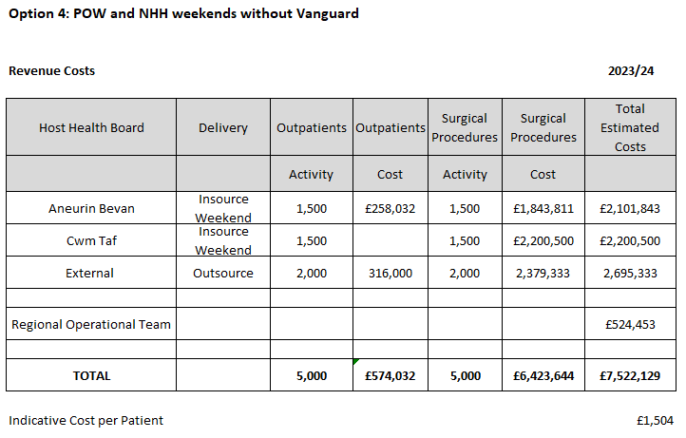
Costing assumptions-
- Cost assumptions are based on locally provided figures
- Insource cost estimates are based on Framework expectation of PbR plus 10% but will depend on casemix and provider
- Outsourcing estimates are based on PbR with an element for transport but dependent on casemix and provider

12.2.8 Option 4 Activity Modelling
This scenario is based on the following assumptions for year 1:
- 9,960 referrals per year (192 per week, 830 per month)
- 10,940 cataracts procedures per year (202 per week, 874 per month)
- 10,940 outpatients per year (202 per week, 874 per month)

After 52 weeks of the total capacity of 10,940 per year the waiting list is reduced from 19,000 across the region to 18,483

Further details on Option 4 can be found in Appendix Seven

Option 5 – Outsourcing
The option involves outsourcing the whole additional capacity. By using outsourcing only, the demands on the regional booking and scheduling team also reduce. It is unlikely that one supplier would be able to fulfil the whole 5,000 procedures per year and so it would be split across different providers with the following volumes over a 12 month period:
- An additional 5,000 outsourced outpatient and inpatient procedures
- Total core 5,940
- Plus 5,000 additional
- Total capacity 10,940 per year
- Waiting list reduction 517 (from 19,000 to 18,483)
- Total costs 23/24: £7m
- Cost per patient: £1,410

13.1 Option 5 – Clinical and Service Model

13.1.1 Outsourcing Arrangements
Outsourcing can relieve some of the management and back office administrative time associated with working through the backlog as the booking and scheduling, record keeping, outpatient and inpatient activity are all supplied as part of the contract. In this way the outsourcing opportunities also represent value for money and free up valuable resources for allocation towards the management of the core capacity and the insourcing arrangements. Through this option 5,000 cases are outsourced. Outsourcing arrangements and costs include patient travel.
Patients are reviewed by a non-clinical administrator for their suitability for outsourcing and then referred on to the outsourcing company for assessment and treatment. Communication with the patient about booking and scheduling and locations are conducted by the outsourcing company. Follow ups post-surgery are conducted in primary care. Hospital patient records are updated.

13.1.2 Booking and scheduling For Option 5 (Outsourcing)
In one year the team would need to facilitate 5,000 outsourced patients and ensure records are kept up to date and that these patients are suitable for the outsourcing route.

13.1.3 Option 5 Assumptions
- Shared PTL across the region
- Share of regional capacity based on percentage split of over 52 week waiters
- 52 weeks waiters numbers under monthly review and capacity adjusted accordingly
- Regional booking team may not all be based in one place
- IT solutions will need to be worked through
- Outsourcing contracting will be done at a National level
- Outsourcing may be through a number of providers
- That outsourcing capacity will be available in the market through contracting arrangements
- Outsourcing company(ies) to carry out enough outpatient assessments to treat 5,000 patients
- Effective clinical governance arrangements

13.2 Option 5 – Option Appraisal

13.2.1 Additional Regional Capacity
Capacity | Core Annual | Additional Capacity % | Additional Capacity (outsourced) | Total | Average Demand | Difference
AB | 2400 | 36% | 1800 | 4200 | 4080 | 120
CAV | 1440 | 15% | 750 | 2190 | 1800 | 390
CTM | 2100 | 49% | 2450 | 4550 | 4080 | 470
Regional Total | 5940 |  | 5000 | 10940 | 9960 | 980

13.2.3 Regional Capacity by expected patients treated
Reviewing the end of the list 49% of the long waiters are from CTM, 36% from AB and 15% from CAV. Projections of the use of the regional capacity are based on these percentages, however as the waiting list progresses, the percentages will change over time
AB Patients
 | Core: AB In House | AB 36% | AB Total
Capacity | 2400 | 1800 | 4200

CTM Patients
 | Core: CTM In House | Core: CTM Outsourced | CTM 49% | CTM Total
Capacity | 1920 | 180 | 2450 | 4550

CAV Patients
 | Core: CAV In House | CAV 15% | CAV Total
Capacity | 1440 | 750 | 2190

Regional Total
 | AB Total | CAV Total | CTM Total | Regional Total
Capacity | 4200 | 2190 | 4550 | 10940

13.2.4 Option 5 Benefits
In addition to the high level benefits identified above, the additional benefits of this option include
- Outpatient assessments and inpatients treatments are performed on the same site
- Additional capacity delivered at reduced costs from insourcing
- Reduces the backlog by 517 patients waiting

13.2.5 Option 5 Risks
The specific risks associated with option 2 are:
- Loss of experienced and well trained staff at the Vanguard Unit (medium risk following mitigation actions)
- Reduction in training capacity across the region (medium risk following mitigation actions)
- Reduced capacity to treat more complex patients (medium risk following mitigation actions)
- Increased number of patients required to travel further for treatment

13.2.6 Option 4 Patient Considerations
Through this option there would be additional capacity for patients across the region for cataract assessment and surgery and patient waiting time will remain at current levels.
This option is for outsourcing activity where patients who meet the criteria for this additional capacity would be directed to outsourcing for assessment and treatment. Patients unable or unwilling to travel will be treated within their own health board as part of the core capacity. Waiting times may vary between core and outsourcing capacity provision. This option also includes patient travel as this may be outside of the boundary of the region (dependent on the contracting). The core capacity does not include patient travel contributions.

13.2.7 Option 5 Costs
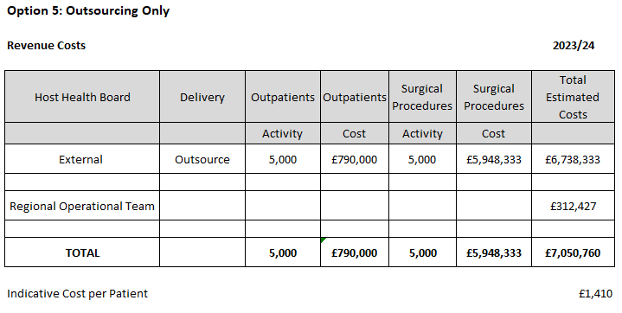

13.2.8 Option 5 Activity Modelling
The assumptions used in this option are the same as in option 4, as the capacity stays the same but the mode of delivery changes.
After 52 weeks of the total capacity of 10,940 per year the waiting list is reduced from 19,000 across the region to 18,483
Further details on Option 5 can be found in Appendix Eight

Preferred Option

14.1 Preferred Option
The preferred option in this business case is Option 3b Vanguard and Max NHH

- South Hub Weekdays: Retaining the weekday 20 sessions in vanguard and using 7.5 sessions for CAV core capacity (1620 patients per year, funded by CAV) and 12.5 sessions for regional capacity (2700 patients per year, regionally funded, provided by NHS staff)
- South Hub Weekends: 1,500 outpatient assessment and inpatient procedures carried out by an insourcing company in Vanguard (UHW)
- North Hub Weekdays: 1610 outpatient assessment and inpatient procedures carried out in weekdays in NHH using NHS staffing
- North Hub Weekends: 1,500 outpatient assessment and inpatient procedures carried out by an insourcing company in NHH
- An additional 2,000 outsourced outpatient and inpatient procedures
- One theatre in NHH and twin theatres in Vanguard
- Total core 7,140 for 14 months (6,120 annual)
- Plus 9,310 additional
- Total capacity 16,450 per year
- Waiting list reduction 4,832 (from 19,000 to 14,168)
- Total costs: £15.3m
- Cost per patient: £1,640

14.2 Options Appraisal
The six options have been through an options appraisal process. An exercise was undertaken with each health board individually to score and assess each option against the business case aims and the principles of regional working in section 2.1 below and appendix two.
Weighting for the scoring was allocated as follows:
- Quality and Safety: 35%
- Effective use of resources: 10%
- Strategic Fit: 10%
- Sustainability: 15%
- Access: 10%
- Deliverability: 20%

Results of the appraisal process are shown below. All three health boards have selected the same option as the highest scoring option against the criteria. Results are shown below. Scores are out of 5, with the regional total out of 15.

 | Option 1 Do Nothing | Option 2 POWH and NHH | Option 3a Vanguard and NHH | Option 3b Vanguard and Max NHH | Option 4 Weekends | Option 5 Outsourcing
Cardiff and Vale | 1.65 | 3.10 | 4.00 | 4.25 | 1.85 | 1.65
Cwm Taf Morgannwg | 1.60 | 4.30 | 3.70 | 4.35 | 2.30 | 2.00
Aneurin Bevan | 1.80 | 3.35 | 3.30 | 3.55 | 2.15 | 2.15
Regional Total | 5.05 | 10.75 | 11.00 | 12.15 | 6.30 | 5.80

14.3 Option Costs

Financial Assumptions
Key Assumptions
- Activity and cost is assumed to be utilised as per the ‘long waiters’ commissioner split in the business case. An indicative commissioner share of cost and activity is in the attached
- Some costs are now fully expected in 2023/24 where these are required as ‘pre go live’. These relate to revenue equipment costs in AB.
- Vanguard and procurement costs are estimated based on current agreements and are therefore subject to possible variation
- The ‘regional operational team’ meets workforce expectations for the structure and requirements
- There is risk of recurrent recruitment costs if staff are permanently employed for a time limited project however there is an expectation of future service development
- Delivery plans and costings are estimated on the case mix complexity as outlined in the business case

Summary
The business case demonstrates a clear need for additional capacity for cataracts assessment and surgery in the South East Wales Region. By working together the three health boards can provide this capacity for patients and deliver the benefits described in the case.
This business case has strong strategic links with the National Planned Care goals, the Ophthalmology GIRFT Programme report and the Royal College of Ophthalmologists External Review of Eye Care Services in Wales and contributes towards the delivery of reducing waiting times for patients.
The additional capacity addresses the significant backlog in this area and provides the headroom necessary to plan and implement longer term sustainable solution and to demonstrate the successes of regional working. This business case enables the region to maximise the existing capacity available on our hospital sites and more provide timely care to patients regardless of where they live within the region.
The table below summarises the options

High level Financials
 | Option 1 Do Nothing | Option 2 POWH and NHH | Option 3a Vanguard and NHH | Option 3b Vanguard and Max NHH* | Option 4 Weekends | Option 5 Outsourcing
Core Capacity | 5,940 | 5,940 | 6,120 | 7,140* | 5,940 | 5,940
Additional Regional Capacity | 0 | 8668 | 7,700 | 9,310 | 5,000 | 5,000
Total Capacity | 5,940 | 14,608 | 13,820 | 16,450 | 10,940 | 10,940
Total Revenue Costs | £0 | £12.4m | £10.5m | £12.9m** | £7.5m | £7m
Total Capital Costs | £0 | £0 | £2.4m | £2.4m | £0 | £0
Total Costs (Capital + Revenue) | £0 | £12.4m | £12.9m | £15.3m | £7.5m | £7m
Cost per patient | n/a | £1,436 | £1,672 | £1,640 | £1,504 | £1,410
*Option 3b is for 14 months
**Costing for this option include 5% increase on all pay costs

Interdependencies
The interdependencies identified through this work are:
- Stabilising and protecting core capacity in CAV
- Stabilising and protecting core capacity in CTM
- Stabilising and protecting core capacity in AB
- Commissioners –appropriate commissioning frameworks to be developed
- Capital funding required for Vanguard.

Implementation Plans
The implementation plan for the business case is shown below.
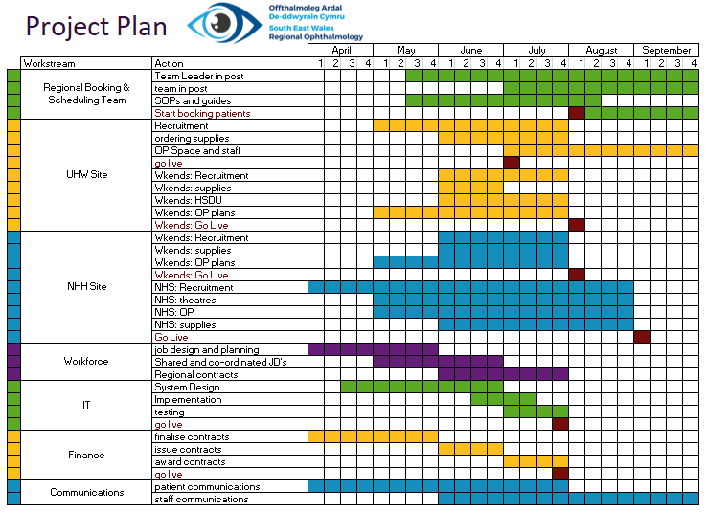

Implementation
The Implementation of this business case is a priority across Health Boards and the outline plan above is for the implementation phase. This will be an intensive phase of activity across the health boards and will require an additional project manager to work full time on this work as part of the programme. There will likely be a soft launch of the additional capacity and time will be required to embed the new models and make improvements to processes. As part of the wider Regional Programme proposals for a regional Vitreo-Retinal hub service need to be planned and implemented early in the calendar year to support the complications arising from the cataract service and so additional project support and a dedicated clinical lead is required for the programme.

Approvals

Milestone | Date | Decision
Completion by the working group | Wednesday 16th November | Agreement to go forward to Ophthalmology Programme Board
Ophthalmology Programme Board | 12th December | Approved to go forward to next stage
Regional Portfolio Delivery Board | 6th April 2023 | Approved to go forward to next stage
Regional Portfolio Oversight Board | 13th April 2023 | Approved to go forward to next stage
Management Execs AB | 13th April 2023
Investment Group CAV | 18th April 2023
Management Execs (SLB) CAV | 4th May 2023
Management Execs CTM
Board Meeting AB
Board Meeting CAV | 25th May 2023
Board Meeting CTM
Welsh Gov Submission

Appendix One: Financials

Option 3b - Preferred Option
Financial Assumptions
Key Assumptions
- Activity and cost is assumed to be utilised as per the ‘long waiters’ commissioner split in the business case. An indicative commissioner share of cost and activity is in the attached
- Some costs are now fully expected in 2023/24 where these are required as ‘pre go live’. These relate to revenue equipment costs in AB.
- Vanguard and procurement costs are estimated based on current agreements and are therefore subject to possible variation
- The ‘regional operational team’ meets workforce expectations for the structure and requirements
- There is risk of recurrent recruitment costs if staff are permanently employed for a time limited project however there is an expectation of future service development
- Delivery plans and costings are estimated on the case mix complexity as outlined in the business case

Option 1 – Do nothing
Do nothing – no additional costs

Option 2 – Maximising NHH and POWH

Option 3a Costs vanguard and NHH Weekends

Option 4 - Weekend Insourcing and Outsourcing Only

Option 5 - Outsourcing

Appendix Two: Options Appraisal details
The following six options were considered as part of the options appraisal.
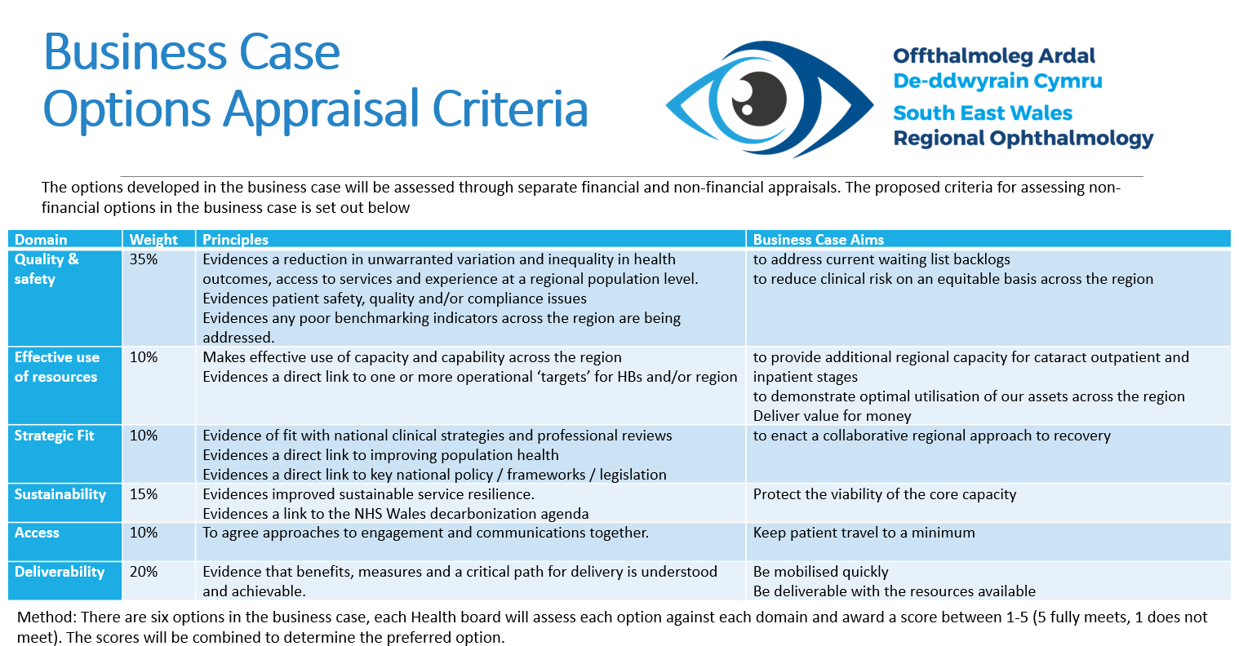
Results of the Options appraisal are shown below
 | Option 1 Do Nothing | Option 2 POWH and NHH | Option 3a Vanguard and NHH | Option 3b Vanguard and Max NHH | Option 4 Weekends | Option 5 Outsourcing
Cardiff and Vale | 1.65 | 3.10 | 4.00 | 4.25 | 1.85 | 1.65
Cwm Taf Morgannwg | 1.60 | 4.30 | 3.70 | 4.35 | 2.30 | 2.00
Aneurin Bevan | 1.80 | 3.35 | 3.30 | 3.55 | 2.15 | 2.15
Total | 5.05 | 10.75 | 11.00 | 12.15 | 6.30 | 5.80

Appendix Three: Option 1 Details
This option involves providing no further funding and resources to cataract surgery across the region at this stage. Each health board will continue with only their planned core capacity and there will be no sharing of patient treatment lists (PTL’s). The Vanguard rental will end on 31st March 2023 following the two month short term regional arrangement.

8.1.1 Core capacity
The annual core capacity of each Health Board is shown below
 | Core: AB In House | Core: CTM In House | Core: CTM Outsourced | Core: CAV In house | Regional Total Core | Regional Demand | Difference
2023/24 | 2400 | 1920 | 180 | 1440 | 5940 | 9,960 | -4,020

8.1.2 Option Assumptions
This option is based on the following assumptions
- Use of Vanguard ends by March 31st 2023
- Capacity in CTM and AB for 23/24 remains at 2022 activity levels
- CAV have 7.5 sessions in main theatres to undertake core cataracts activity, reverting to pre-Vanguard capacity.

8.2 Option 1 – Option Appraisal

8.2.1 Option 1 Benefits
The high level benefits identified above (section 6.1) are foregone in this option. The benefits identified for this option are listed below
- No changes to the way that services are currently run
- No management capacity required to organise additional services
- No direct costs

8.2.2 Option 1 Risks
The specific risks associated with option 1 are:
- Demand continues to outstrip supply (high risk as business case is mitigation action)
- Backlogs will continue to grow (high risk as business case is mitigation action)
- Planned Care target will be missed (high risk as business case is mitigation action)
- Increased proportions of higher complexity patients as waiting times are increased (medium risk as business case is mitigation action)
- Loss of experienced and well trained staff at the Vanguard Unit (medium risk as business case is mitigation action)
- Reduction in training capacity across the region (medium risk as business case is mitigation action)
- Increases the backlog by 4,046 patients (high risk as business case is mitigation action)

8.2.3 Option 1 Patient Considerations
Through this option all patients will continue to be treated by their home health board. They will be treated within their own health board boundary but are likely to have to wait more than 1 year for assessment and treatment. As patient waits lengthen, the risk increases of patients coming to harm while waiting.

8.2.4 Option 1 costs
There are no direct costs associated with this option
Indirect costs include:
- Increased reliance on WLI’s / agency staff
- Increased patient complaints
- Multiple patient referrals as primary care escalate patients due to deterioration
- Additional waiting list validation required
- Increased costs of complications as patient complexity increases

8.2.5 Option 1 Activity Modelling
This scenario is based on the following assumptions for year 1:
- 5,940 cataracts procedures per year (114 per week, 495 per month)
- 5,940 outpatients per year (114 per week, 495 per month)
- 9,960 referrals per year (192 per week, 830 per month)

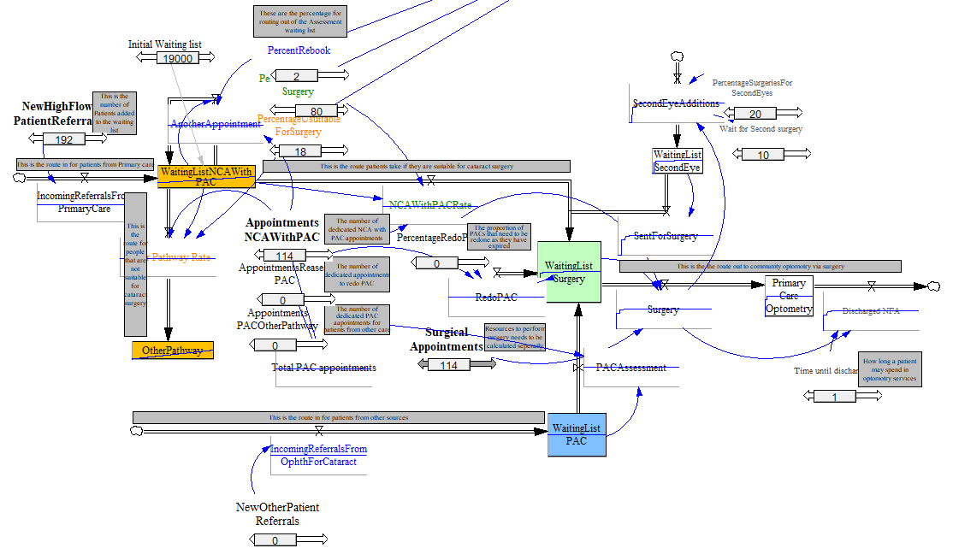
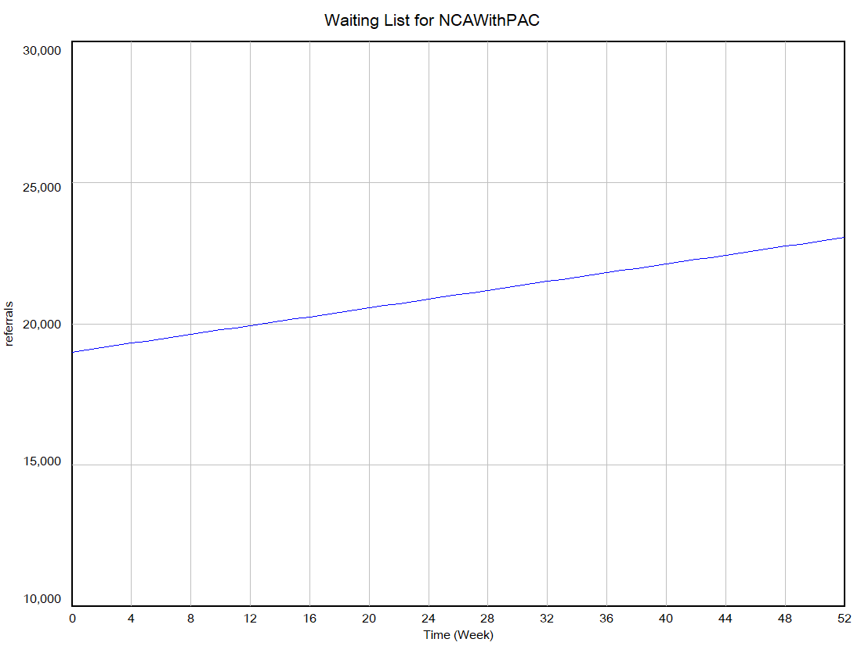
After 52 weeks of the total capacity of 5,940 per year the waiting list is increased from 19,000 across the region to 23,046

Appendix Four: Option 2 Details
Option 2 is an NHS recruitment, insourcing and outsourcing option involving a two-hub model of NHH in the North and POWH in the South. At both sites the weekday and weekend capacity is utilised, along with outsourcing in the following volumes over a 12 month period:
- North Hub Weekdays: 1610 outpatient assessment and inpatient procedures carried out in weekdays in NHH using NHS staffing
- North Hub Weekends: 1,500 outpatient assessment and inpatient procedures carried out by an insourcing company in NHH
- South Hub: 3,558 (2,058 weekdays plus 1,500 weekends) outpatient assessment and inpatient procedures carried out by an insourcing company in POWH
- An additional 2,000 outsourced outpatient and inpatient procedures
- Total core 5,940
- Plus 8,668 additional
- Total capacity 14,608 per year
- Waiting list reduction 3,814 (from 19,000 to 15,186)
- Total costs 23/24: £12.4m
- Cost per patient: £1,436

9.1. Option 2 - Clinical and Service Model
The Clinical Model includes an outpatient stage and inpatient stage.
At the outpatient stage the clinical teams review the patients, determine their suitability for surgery and conduct pre-operative assessments. Through the proposed model this will be carried out during a single patient visit.
At the inpatient stage patient receive their cataract surgery. Following surgery patients are discharged to Primary Care. Primary Care advisors have confirmed that no additional resource is required in primary care at present for the additional capacity as it will be adequately dispersed amongst optometric practices across the region.

9.1.1 Clinical Service Model North Hub (NHH)
The North hub would primarily provide outpatient and inpatient provision to patients primarily in North CTM and North AB from Nevill Hall Hospital (NHH) in Abergavenny as the regional geography suits.

Weekdays: Outpatients Stage (NHS Staff)
Patients will be booked into the additional capacity for outpatients in NHH via the regional booking and scheduling team (see section 5.4)
In order to undertake 135 outpatient appointments per month (38 per week, 1,620 per year) the sessions will be a ‘one stop shop’ model, held on weekdays in the OP dept in NHH. 4 consulting rooms will be required plus a waiting area. This weekday activity will be staffed through recruitment of NHS staff for all of the clinical and not clinical staff required.

Weekends: Outpatient Stage (Insourcing Staff)
Patients will be booked into the additional capacity for outpatients in NHH via the regional booking and scheduling team (see section 5.4)
In order to undertake 125 outpatient appointments per month (30 per week, 1,500 per year) the sessions will be a ‘one stop shop’ model, held on a Saturday in the OP dept in NHH. 4 consulting rooms will be required plus a waiting area. This will be staffed thought an insourcing company
Assuming that the required clinical staff including Consultants, PAC nurse and biometry staff will be provided by the Insourcing provider, the following additional staff will also be required to run weekly Saturday OP clinics for 1 year:
- 0.5 WTE Receptionist Band 2 £15,780
- 0.5 WTE Health Records Clinical Notes Band 2 £15,780
- 0.5 WTE Governance Nurse band 6 £29,372
Other non staff requirements for the OP sessions are
- Cleaning (Saturday) £7500
Lenses will be also ordered at this point if the patient is suitable for surgery. Costs of lenses will be included in the Inpatient section.

Outpatients Clinical Model
These patients are taken from new or stage 1 waiting list. During the one-stop session, patients are:
- Ophthalmic history/general medical history/medication/family history/allergies
- Vision
- Anterior segment examination
- Biometry +/- corneal topography
- Pupil dilatation
- Posterior segment examination by ophthalmologist
- Choose intraocular lens/refractive plan
- Cataract care pathway checklist completed
- Consented for surgery

Weekdays; Inpatient Stage (NHS Staff)
Patients attending the weekday regional capacity for cataract surgery in the North Hub will be booked through the regional booking team (see section 6.4). They will also have had their OP assessment through the North hub weekday arrangements in NHH with NHS staff.
In order to undertake 38 procedures per week (135 per month, 1,610 per year) the procedures will be undertaken in Main Theatres at NHH on weekdays, Mondays and Wednesday to Friday.
As this is additional volume and there is a strong requirement to protect the core capacity additional trays and handpieces will need to be purchased to support this additional capacity.

Weekends: Inpatient Stage (Insourcing Staff)

Patients attending the weekend regional capacity for cataract surgery in the North Hub will be booked through the regional booking team (see section 6.4). They will also have had their OP assessment through the North hub weekend arrangements in NHH with insourcing staff.
In order to undertake 30 procedures per week (125 per month, 1,500 per year) the procedures will be undertaken in Main Theatres at NHH on Saturdays and Sundays.
As this is additional volume and there is a strong requirement to protect the core capacity additional trays and handpieces will need to be purchased to support this additional capacity.
Assuming that all of the clinical staff required for the surgery and recovery are provided by the insourcing company (Consultants, Nurses, HCSW’s) then the following additional staff are required to support the service model:
- 0.6 WTE Receptionist Band 2 £18,936
- 0.6 WTE Health Records Clinical Notes Band 2 £18,936
- 0.6 WTE Governance Nurse band 6 £35,246

Non-Staff Requirements
Other non-staff requirements for the Inpatient sessions are:
Weekends
Cleaning / Waste / Facilities - £47,883
HSDU costs (Including transport) - £30,000
Purchase of additional surgical trays and equipment - £38,284
Stellaris Handpieces- £87,500
Pharmacy costs, Lens and consumables - £224,310
Additional lens costs £7,716

9.1.2 Clinical Service Model South Hub (POWH)
Through Option 2 the South Hub would provide outpatient and inpatient provision for patients in the south of the region. The outpatient and inpatient provision will be delivered from Princess of Wales Hospital site on weekdays and weekends via an insourcing company with one weekday session per week provided by NHS staff.

Weekdays: Outpatient Stage
During Weekdays the outpatient stage will be undertaken through insourcing with all clinical staff provided by the insourcing company. Outpatient assessments will be carried out during evenings on the POWH site. Two pre assessment rooms are available.

Weekends: Outpatient Stage
The POWH site has two pre-assessment rooms which can be used concurrently during weekends during 2023/24. Each room would house one pre-assessment nurse each, and both could be serviced with one doctor in clinic. All the clinical staff would be provided through the insourcing company. In one session using two PAC nurses concurrently, 10 patients could be assessed.

Staff Recruitment
In addition the staffing costs for running outpatient clinics evenings and weekends would be:
Weekends
- 0.5 WTE B2 Receptionist
- 0.5 WTE B3 Booking
- 0.5 WTE B6 Governance Nurse

Non- staffing costs
- Cleaning for evenings and weekends

Outpatient Clinical Model
Patients are taken from new or stage 1 waiting list. During the one-stop session, patients are:
- Ophthalmic history/general medical history/medication/family history/allergies
- Vision
- Anterior segment examination
- Biometry +/- corneal topography
- Pupil dilatation
- Posterior segment examination by ophthalmologist
- Choose intraocular lens/refractive plan
- Cataract care pathway checklist completed
- Consented for surgery

Weekdays: Inpatient Stage (Insourcing, plus 1 NHS staffed session)
Patients accessing the additional capacity for weekday insourcing in the South Hub will be booked through the regional booking team (see section 5.4). They will also have had their OP assessment through the South hub weekday arrangements in POWH.
POWH has a twin theatre set up and the flow enables a maximum of 7 patients on a list for high flow low complexity patients. Running the twin theatres enables 14 patients to be seen in a morning. Weekday capacity in POWH will be achieved through 1 weekday ‘in hours’ session to be staffed by NHS staff and 3 evenings per week to be staffing through insourcing.
By running the two theatres on three evenings per week on weekdays, 42 patients can be seen in the evenings (total 6 sessions) plus the additional day session with 7 patients on a list totalling 49 patients per week on evenings and the 1 day session.
As this is additional volume and there is a strong requirement to protect the core capacity additional trays and handpieces will need to be purchased to support this additional capacity

Weekends: Inpatient Stage (Insourcing)
Patients accessing the additional capacity for weekend insourcing in the South Hub will be booked through the regional booking team (see section 5.4). They will also have had their OP assessment through the South hub weekend arrangements in POWH.
POWH has a twin theatre set up and the flow enables a maximum of 7 patients on a list for high flow low complexity patients. Running the twin theatres enables 14 patients to be seen in a morning. By running the two theatres on Saturdays all day and Sunday mornings, 42 patients can be seen in a weekend (total 6 sessions). This model can run for 36 weeks to treat the 1,500 patients through the insourcing.
As this is additional volume and there is a strong requirement to protect the core capacity additional trays and handpieces will need to be purchased to support this additional capacity

Staff Recruitment
Assuming that all of the clinical staff required for the surgery and recovery are provided by the insourcing company (Consultants, Nurses, HCSW’s) then the following additional staff are required to support the service model:
Weekends
- 0.6 WTE Receptionist Band 2 £18,936
- 0.6 WTE Health Records Clinical Notes Band 2 £18,936
- 0.6WTE Governance Nurse band 6 £35,246

Non Staff Requirements
Other non-staff requirements for the Inpatient sessions are:
Weekends
- Cleaning / Waste / Facilities - £47,883
- HSDU costs (Including transport) - £30,000
- Purchase of 45 additional surgical trays and handpieces - £239,682
- Pharmacy costs, Lens and consumables - £225,000 - This is based on a consumable pack costing £150 per patient (1500 patients )Alcon managed contract

9.1.3 Outsourcing Arrangements
In addition to the insourcing arrangements the capacity across the region can be further increased by utilising the local opportunities for outsourcing. Outsourcing can relieve some of the management and back office administrative time associated with working through the backlog as the booking and scheduling, record keeping, outpatient and inpatient activity are all supplied as part of the contract. In this way the outsourcing opportunities also represent value for money and free up valuable resources for allocation towards the management of the core capacity and the insourcing arrangements. Outsourcing arrangements and costs include patient travel.
- Option 2 Outsourcing @ 2,000 cases per year

9.1.4 Booking and scheduling For Option 2 (Maximising the use of NHH and POWH):
In one year the team will need to book 6,700 outpatient appointments across both the North and South Hubs and schedule 6,700 inpatient procedures and facilitate 2,000 outsourced patients. Totalling 15,400 patient bookings per year
A team of 16 booking and scheduling staff on Band 3 are required to support the regional arrangements along with a band 7 team leader and 3 waiting list managers band 5. A POWH Eye Unit Manager and NHH Eye Unit Manager is also required to manage the unit on evenings and weekends as much of the activity is happening outside of usually office hours and to ensure capacity levels are maximised.
Staff Required:
- 8 WTE Patient Schedulers Band 3
- 8 WTE Booking Clerks Band 3
- 3 WTE Waiting list managers Band 5
- 1 WTE Team Leader Band 7
- 1 WTE POWH Eye Unit Manager Band 7
- 1 WTE NHH Unit Manager Band 7
Non Staff Costs
- Facilities costs for 22 members of staff, IT costs and office space have been estimated at £90,000

9.1.5 Option 2 Assumptions

- Shared PTL across the region
- Share of regional capacity based on percentage split of over 52 week waiters
- 52 weeks waiters numbers under monthly review and capacity adjusted accordingly
- Regional booking team may not all be based in one place
- IT solutions will need to be worked through
- Insourcing and Outsourcing contracting will be done at a National level
- That insourcing and outsourcing capacity will be available in the market through contracting arrangements
- Insourcing numbers on a list to be determined by the insourcing company with annual numbers included in the contracting arrangement
- Effective clinical governance arrangements
- NHH Workforce can be fully recruited
- Patients receive pre-assessment and surgery through the same element of provision (e.g. weekend pre-assessment and weekend surgery)
- Patient eligibility criteria are to be developed and agreed
- 80% conversion rate from outpatients to surgery
- 20% of patients require a second eye
- Patients requiring second eye have one pre assessment to cover both eyes

9.2 Option 2 – Option Appraisal

9.2.1 Additional Regional Capacity
Capacity | Core Annual | Additional Capacity % | Additional Regional | Total | Average Demand | Difference
AB | 2400 | 36% | 3121 | 5521 | 4080 | 1441
CAV | 1440 | 15% | 1300 | 2740 | 1800 | 940
CTM | 2100 | 49% | 4247 | 6347 | 4080 | 2267
Regional Total | 5940 |  | 8668 | 14608 | 9960 | 4648

9.2.2 Regional Capacity Plan
The chart below shows how the regional capacity will be delivered during 2023 and 2024. The business case will run for 12 months with a ‘tail’ of 6 months to enable the sustainable capacity (second business case) to build up.
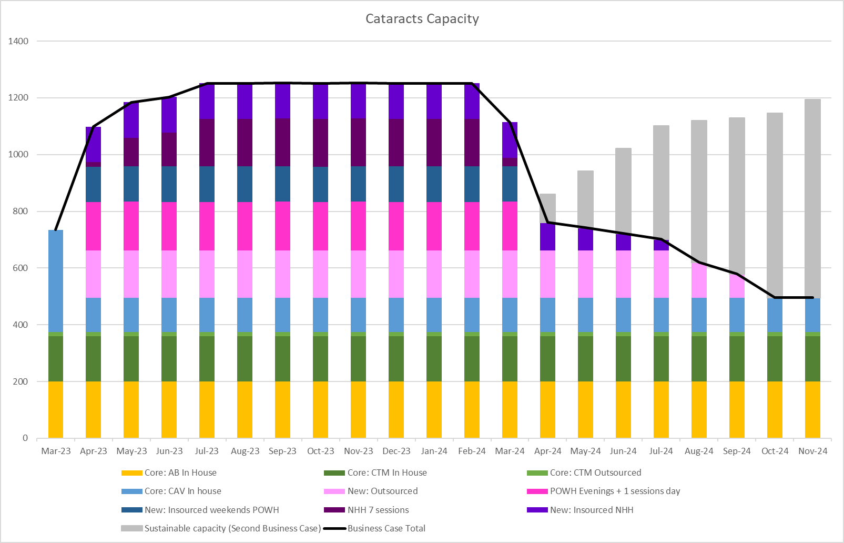

 | Core: AB In House | Core: CTM In House | Core: CTM Outsourced | Core: CAV In house | New: Outsourced | New: POWH | New: NHH | Business Case Total
2023/24 | 2400 | 1920 | 180 | 1440 | 2000 | 3558 | 3110 | 14608
2024/25 | 1200 | 960 | 90 | 720 | 875 | 0 | 280 | 4125

9.2.3 Regional Delivery by Site
This chart indicates the volumes that will be delivered on each site, for outpatients and for day case/inpatients
For Outpatients
 | Core: AB In House | Core: CTM In House | Core: CTM Outsourced | Core: CAV In house | New: Outsourced | New: POWH | New: NHH | Business Case Total
23/24 | 2400 | 1920 | 180 | 1440 | 2000 | 3628 | 3120 | 14688
24/25 | 1200 | 960 | 90 | 720 | 875 | 0 | 280 | 4125

For Inpatients
 | Core: AB In House | Core: CTM In House | Core: CTM Outsourced | Core: CAV In house | New: Outsourced | New: POWH | New: NHH | Business Case Total
23/24 | 2400 | 1920 | 180 | 1440 | 2000 | 3558 | 3110 | 14608
24/25 | 1200 | 960 | 90 | 720 | 875 | 0 | 280 | 4125

9.2.4 Regional Capacity by expected patients treated
Reviewing the end of the list 49% of the long waiters are from CTM, 36% from AB and 15% from CAV. Projections of the use of the regional capacity are based on these percentages, however as the waiting list progresses, the percentages will change over time
AB Patients
 | Core: AB In House | AB 36% | AB Total from this business case
2023/24 | 2400 | 3121 | 5521
2024/25 | 1200 | 416 | 1616

CTM Patients
 | Core: CTM In House | Core: CTM Outsourced | CTM 49% | CTM Total from this business case
2023/24 | 1920 | 180 | 4247 | 6347
2024/25 | 960 | 90 | 566 | 1616

CAV Patients (estimated)
 | Core: CAV In house | CAV 15% | CAV Total from this business case
2023/24 | 1440 | 1300 | 2740
2024/25 | 720 | 173 | 893

Regional Total
 | AB Total | CAV Total | CTM Total | Regional Total
2023/24 | 5521 | 2740 | 6347 | 14608
2024/25 | 1616 | 893 | 1616 | 4125

9.2.5 Option 2 Benefits
In addition to the high level benefits identified above, the additional benefits of this option include
- Recruiting additional NHS workforce for NHH
- Provides a solid base to develop the sustainable regional solution
- Fully utilised the POWH Eye Unit 7 days per week
- Enables a greater reduction in the backlog
- No additional capital required
- Reduces the backlog by 4,648 patients waiting

9.2.6 Option 2 Risks
The specific risks associated with option 2 are:
- High volumes of surgery through POWH Eye Unit may put a strain on equipment readiness levels (low risk following mitigation actions)
- Clinical risks and patient harm risks associated with outsourcing and insourcing capacity (low risk following mitigation actions)

9.2.7 Option 2 Patient Considerations
Through this option there would be additional capacity for patients across the region for cataract assessment and surgery and patient waiting time will start to reduce. This option includes a North and South Hub where patients who meet the criteria for this additional capacity would be directed to their closest hub for assessment and treatment. Patients unable or unwilling to travel will be treated within their own health board as part of the core capacity. Waiting times may vary between core and additional capacity provision.
This option also includes outsourcing where the costing includes patient travel as this may be outside of the boundary of the region (dependent on the contracting). The core capacity, insourcing, and NHS sessions do not include patient travel contributions.

9.2.9 Option 2 Activity Modelling
This scenario is based on the following assumptions for year 1:
- 9,960 referrals per year (192 per week, 830 per month)
- 14,608 cataracts procedures per year (281 per week, 1217 per month)
- 14,608 outpatients per year (282 per week, 1224 per month)

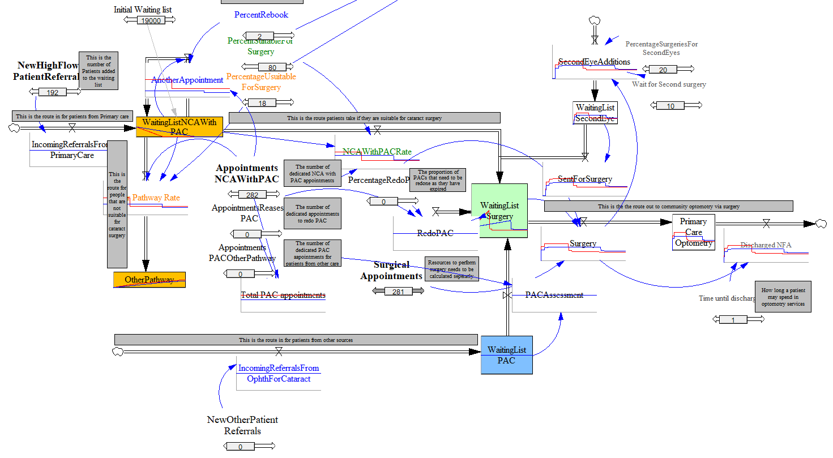

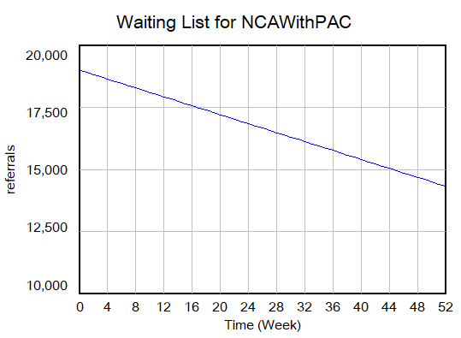

After 52 weeks of the total capacity of 14,608 per year the waiting list is reduced from 19,000 across the region to 14,352

Appendix Five: Option 3a Details
Option 3a –Vanguard and NHH
Option 3a is an insourcing and outsourcing option involving a two-hub model of NHH in the North and a combination of POWH for outpatients and Vanguard for Inpatients in the South, along with outsourcing in the following volumes over a 12 month period:
- South Hub: Retaining the weekday 20 sessions in vanguard and using 7.5 sessions for CAV core capacity (1620 patients per year, funded by CAV) and 12.5 sessions for regional capacity (2700 patients per year, regionally funded, provided by NHS staff)
- South Hub: 1,500 outpatient assessment and inpatient procedures carried out by an insourcing company in Vanguard (UHW)
- North Hub: 1,500 outpatient assessment and inpatient procedures carried out by an insourcing company in NHH
- An additional 2,000 outsourced outpatient and inpatient procedures
- Total core 6,120
- Plus 7,700 additional
- Total capacity 13,820 per year
- Waiting list reduction 3,814 (from 19,000 to 15,186)
- Total costs 23/24:
- Cost per patient:

10.1 Option 3a - Clinical and Service Model
The Clinical Model includes an outpatient stage and inpatient stage.
At the outpatient stage the clinical teams review the patients, determine their suitability for surgery and conduct pre-operative assessments. Through the proposed model this will be carried out during a single patient visit.
At the inpatient stage patient receive their cataract surgery. Following surgery patients are discharged to Primary Care. Primary Care advisors have confirmed that no additional resource is required in primary care at present for the additional capacity as it will be adequately dispersed amongst optometric practices across the region.

10.1.1 Maximising the Use of the Vanguard Unit in UHW
The Vanguard Unit in UHW is a mobile twin theatre alongside modular units for consulting, patient waiting and recovery. It is currently contracted for use for cataract surgery by CAV on a 5 day per week basis Monday to Friday with this arrangement running until 8th January 2023. As a short-term solution and to maximise the options available for this business case, the unit will be extended until 31st March 2023 and the capacity during this extension period will be divided between the three health boards in the region.
If extended, then the new contract for the Vanguard Unit will be for 7 days per week to maximise the use of the unit for the regional extension of the cataracts service. The Vanguard Unit requires capital funding.
The benefits of retaining the Vanguard Unit include the stability of staff and retaining this well trained and experienced staffing group, the ability to treat more complex patients than the insourcing and outsourcing will enable, increasing the training opportunities available across the region and providing a solid foundation for the second sustainable phase of the cataracts expansion to be based.

10.1.2 Clinical Service Model North Hub
The North hub would primarily provide outpatient and inpatient provision to patients in North CTM and North AB from Nevill Hall Hospital (NHH) in Abergavenny.

Outpatient Stage
Patients will be booked into the additional capacity for outpatients in NHH via the regional booking and scheduling team (see section 5.4)
In order to undertake 125 outpatient appointments per month (30 per week, 1,500 per year) the sessions will be a ‘one stop shop’ model, held on a Saturday in the OP dept in NHH. 4 consulting rooms will be required plus a waiting area.
Assuming that the required clinical staff including Consultants, PAC nurse and biometry staff will be provided by the Insourcing provider, the following additional staff will also be required to run weekly Saturday OP clinics for 1 year:
- 0.5 WTE Receptionist Band 2 £15,780
- 0.5 WTE Health Records Clinical Notes Band 2 £15,780
- 0.5 WTE Governance Nurse band 6 £29,372
Other non staff requirements for the OP sessions are
- Cleaning (Saturday) £7500
Lenses will be also ordered at this point if the patient is suitable for surgery. Costs of lenses will be included in the Inpatient section.
Clinical Model
These patients are taken from new or stage 1 waiting list. During the one-stop session, patients are:
- Ophthalmic history/general medical history/medication/family history/allergies
- Vision
- Anterior segment examination
- Biometry +/- corneal topography
- Pupil dilatation
- Posterior segment examination by ophthalmologist
- Choose intraocular lens/refractive plan
- Cataract care pathway checklist completed
- Consented for surgery

Inpatient Stage
Patients accessing the additional capacity for insourcing in the North Hub will be booked through the regional booking team (see section 6.4). They will also have had their OP assessment through the North hub arrangements in NHH.
In order to undertake 30 procedures per week (125 per month, 1,500 per year) the procedures will be undertaken in Main Theatres at NHH every Saturday and Sunday.
As this is additional volume and there is a strong requirement to protect the core capacity additional trays and handpieces will need to be purchased to support this additional capacity
Assuming that all of the clinical staff required for the surgery and recovery are provided by the insourcing company (Consultants, Nurses, HCSW’s) then the following additional staff are required to support the service model:
- 0.6 WTE Receptionist Band 2 £18,936
- 0.6 WTE Health Records Clinical Notes Band 2 £18,936
- 0.6 WTE Governance Nurse band 6 £35,246

Other non-staff requirements for the Inpatient sessions are:
- Cleaning / Waste / Facilities - £47,883
- HSDU costs (Including transport) - £30,000
- Purchase of additional surgical trays and equipment - £38,284
- Stellaris Handpieces- £87,500
- Pharmacy costs, Lens and consumables - £224,310
- Additional lens costs £7,716.

10.1.3 Clinical Service Model South Hub Weekends (Option 1 UHW)
Through Option 1 The South Hub would provide outpatient and inpatient provision for patients in the south of the region. The outpatient and inpatient provision will be delivered from University Hospital of Wales on weekends via an insourcing company

Outpatients Stage (Weekend Insourcing in UHW)
The UHW site has two pre-assessment rooms which can be used concurrently during weekends during 2023/24. Each room would house one pre-assessment nurse each, and both could be serviced with one doctor in clinic. All the clinical staff would be provided through the insourcing company. In one session using two PAC nurses concurrently, 10 patients could be assessed.
In addition the staffing costs for running outpatient clinics evenings and weekends would be:
- 0.5 WTE B2 Receptionist
- 0.5 WTE B3 Booking
- 0.5 WTE B6 Governance Nurse
Non- staffing costs are
- Cleaning

Clinical Model
These patients are taken from new or stage 1 waiting list. During the one-stop session, patients are:
- Ophthalmic history/general medical history/medication/family history/allergies
- Vision
- Anterior segment examination
- Biometry +/- corneal topography
- Pupil dilatation
- Posterior segment examination by ophthalmologist
- Choose intraocular lens/refractive plan
- Cataract care pathway checklist completed
- Consented for surgery

Inpatient Stage (Weekend Insourcing in Vanguard Unit UHW)
Patients accessing the additional capacity for insourcing in the South Hub will be booked through the regional booking team (see section 5.4). They will also have had their Outpatient assessment through the South hub insourcing arrangements in UHW.
In the Vanguard theatres the flow enables a maximum of 7 patients on a list for high flow low complexity patients. Running the twin theatres enables 14 patients to be seen in a morning. By running the two theatres for AM and PM on Saturdays and AM on Sundays 42 patients can be seen in a weekend (total 6 sessions). This model can run for 36 weeks to treat the 1,500 patients through the insourcing.
As this is additional volume and there is a strong requirement to protect the core capacity additional trays and handpieces will need to be purchased to support this additional capacity
Assuming that all of the clinical staff required for the surgery and recovery are provided by the insourcing company (Consultants, Nurses, HCSW’s) then the following additional staff are required to support the service model:
- 0.33WTE Receptionist Band 2 £TBC
- 0.33WTE Health Records Clinical Notes Band 2 £TBC
- 0.33WTE Governance Nurse band 6 £TBC
- 1 wte Manager 8b (included in section 8.1.5)

Other non-staff requirements for the Inpatient sessions are:
- Cleaning / Waste / Facilities
- HSDU costs - £TBC
- Purchase of 45 additional surgical trays and handpieces - £239,682
- Pharmacy costs, Lens and consumables - £225,000 - This is based on a consumable pack costing £150 per patient (1500 patients )Alcon managed contract

10.1.4 Additional Vanguard Capacity for the Region
This option includes the additional Vanguard capacity for the region. The Vanguard Unit surgical capacity and the associated outpatient capacity required to run the service would continue to operate as it has since January 2022, retaining the same staff, maintaining the same list size, training opportunities and job plans as are currently in place and operational Monday to Friday for 20 sessions per week across the twin theatre arrangement. Through this option this existing service model would be retained until March 2024.
7.5 sessions out of 20 per week (37.5%) of the capacity would be for Cardiff and Vale core capacity funded by Cardiff and Vale and the other 12.5 sesions ourt of 20 (62.5%) would be available to the regional patients and funded by this regional business case.
As it is currently set up, the Vanguard Unit treats more complex patients that the outsourcing and insourcing capacity can. The unit will continue to treat the same complexity of patient and clinical criteria will need to be developed to determine the referral criteria for the regional proportion of the Unit.
Under this model, patients treated in the Vanguard unit will have their outpatient assessment on the UHW site on a weekday and this will continue to run as it currently is with the Cardiff and Vale staff and estates.

10.1.5 Outsourcing Arrangements
In addition to the insourcing arrangements the capacity across the region can be further increased by utilising the local opportunities for outsourcing. Outsourcing can relieve some of the management and back office administrative time associated with working through the backlog as the booking and scheduling, record keeping, outpatient and inpatient activity are all supplied as part of the contract. In this way the outsourcing opportunities also represent value for money and free up valuable resources for allocation towards the management of the core capacity and the insourcing arrangements. Outsourcing arrangements and costs include patient travel.
- Outsourcing @ 2,000 cases per year

10.1.6 Booking and scheduling For Option 3a (Vanguard Capacity and North Hub NHH Weekends):
In one year the team will need to book 5,900 outpatient appointments across both the North and South Hubs and schedule 5,900 inpatient procedures and facilitate 2,000 outsourced patients.
A team of 14 booking and scheduling staff on Band 3 are required to support the regional arrangements along with a band 7 team leader and 3 waiting list managers band 5. A Vanguard Unit Manager and NHH Eye Unit Manager are also required to manage the unit and to ensure capacity levels are maximised.
Staff Required:
- 7 WTE Patient Schedulers Band 3
- 7 WTE Booking Clerks Band 3
- 3 WTE Waiting list managers Band 5
- 1 WTE Team Leader Band 7
- 1 WTE Vanguard Unit Manager Band 8b
- 1 WTE NHH Eye Unit Manager Band 7
Non Staff Costs
- Facilities costs for 20 members of staff, IT costs and office space have been estimated at £90,000

10.1.7 Option 3a Assumptions
- Shared PTL across the region
- Share of regional capacity based on percentage split of over 52 week waiters
- 52 weeks waiters numbers under monthly review and capacity adjusted accordingly
- Regional booking team may not all be based in one place
- IT solutions will need to be worked through
- Insourcing and Outsourcing contracting will be done at a National level
- That insourcing and outsourcing capacity will be available in the market through contracting arrangements
- Insourcing numbers on a list to be determined by the insourcing company with annual numbers included in the contracting arrangement
- Effective clinical governance arrangements
- Vanguard workforce can continue into 23/24
- NHH Workforce can be fully recruited
- Patients receive pre-assessment and surgery through the same element of provision (e.g. weekend pre-assessment and weekend surgery)
- Patient eligibility criteria are to be developed and agreed
- 80% conversion rate from outpatients to surgery
- 20% of patients require a second eye
- Patients requiring second eye have one pre assessment to cover both eyes

10.2 Option 3a – Option Appraisal

10.2.1 Additional Regional Capacity
Capacity | Core Annual | Additional Capacity % | Additional Vanguard | Additional Capacity | Total | Average Demand | Difference
AB | 2400 | 36% | 1037 | 1800 | 5237 | 4080 | 1157
CAV | 1440 | 15% | 432 | 750 | 2622 | 1800 | 822
CTM | 2100 | 49% | 1411 | 2450 | 5961 | 4080 | 1881
Regional Total | 5940 |  | 2880 | 5000 | 13820 | 9960 | 3860

10.2.2 Regional Capacity Plan
The chart below shows how the regional capacity will be delivered during 2023 and 2024. The business case will run for 12 months with a ‘tail’ of 6 months to enable the sustainable capacity (second business case) to build up.
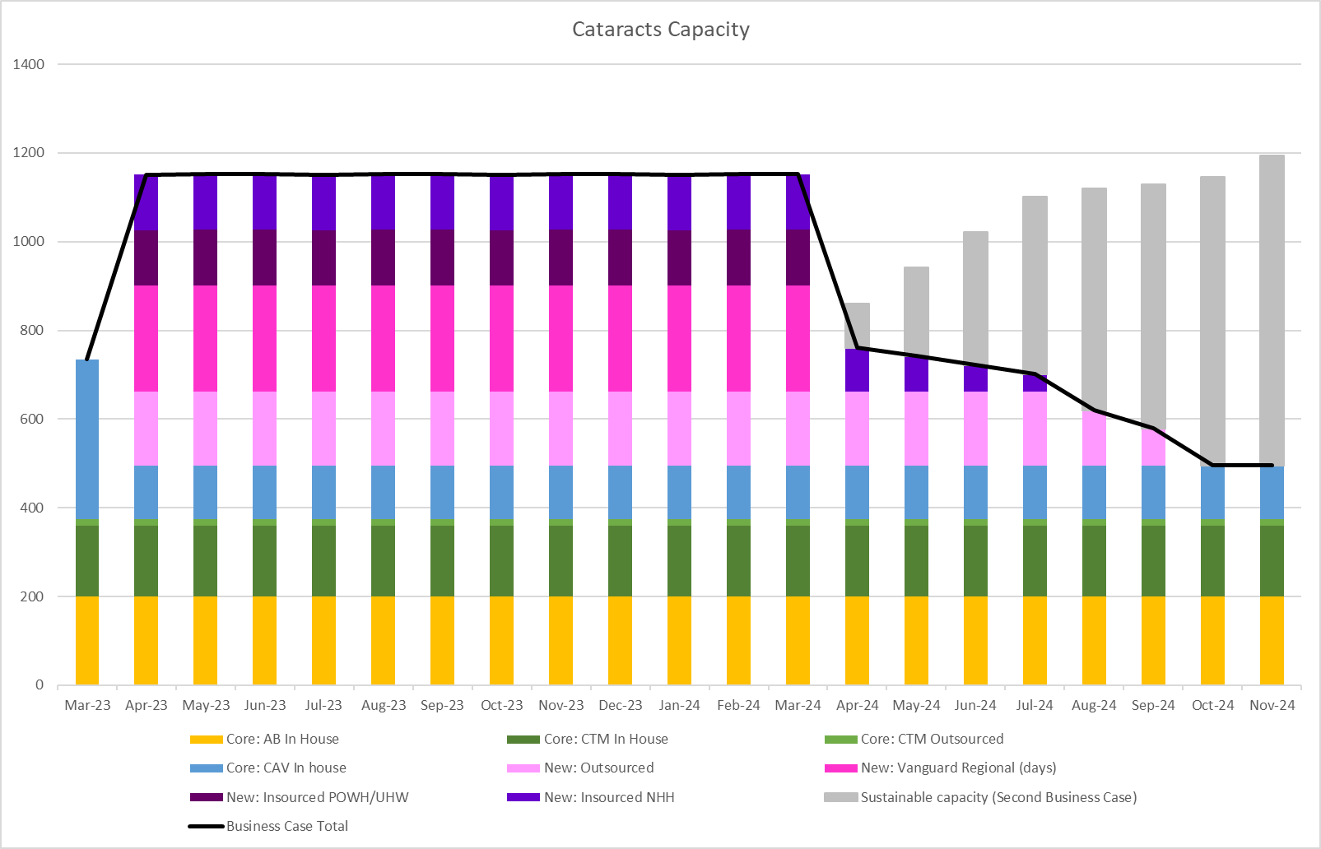

 | Core: AB In House | Core: CTM In House | Core: CTM Outsourced | Core: CAV In house | New: Outsourced | New: Vanguard Regional (days) | New: Insourced POWH/UHW | New: Insourced NHH | Business Case Total
2023/24 | 2400 | 1920 | 180 | 1440 | 2000 | 2880 | 1500 | 1500 | 13820
2024/25 | 1200 | 960 | 90 | 720 | 875 | 0 | 0 | 280 | 4125

10.2.3 Regional Delivery by Site
This chart indicates the volumes that will be delivered on each site, for outpatients and for day case/inpatients
For Outpatients
 | Core: AB In House | Core: CTM In House | Core: CTM Outsourced | Core: CAV In house | New: Outsourced | New: Vanguard Regional (days) | New: Insourced POWH | New: Insourced NHH | Business Case Total
23/24 | 2400 | 1920 | 180 | 1440 | 2000 | 2880 | 1500 | 1500 | 13820
24/25 | 1200 | 960 | 90 | 720 | 875 | 0 | 0 | 280 | 4125

For Inpatients
 | Core: AB In House | Core: CTM In House | Core: CTM Outsourced | Core: CAV In house | New: Outsourced | New: Vanguard Regional (days)CAV Surgery | New: Insourced UHW | New: Insourced NHH | Business Case Total
23/24 | 2400 | 1920 | 180 | 1440 | 2000 | 2880 | 1500 | 1500 | 13820
24/25 | 1200 | 960 | 90 | 720 | 875 | 0 | 0 | 280 | 4125

10.2.4 Regional Capacity by expected patients treated
Reviewing the end of the list 49% of the long waiters are from CTM, 36% from AB and 15% from CAV. Projections of the use of the regional capacity are based on these percentages, however as the waiting list progresses, the percentages will change over time
AB Patients
 | Core: AB In House | AB 36% | AB Total from this business case
2023/24 | 2400 | 2837 | 5237
2024/25 | 1200 | 416 | 1616

CTM Patients
 | Core: CTM In House | Core: CTM Outsourced | CTM 49% | CTM Total from this business case
2023/24 | 1920 | 180 | 3861 | 5961
2024/25 | 960 | 90 | 566 | 1616

CAV Patients (estimated)
 | Core: CAV In house | CAV 15% | CAV Total from this business case
2023/24 | 1440 | 1182 | 2622
2024/25 | 720 | 173 | 893

Regional Total
 | AB Total | CAV Total | CTM Total | Regional Total
2023/24 | 5237 | 2622 | 5961 | 13820
2024/25 | 1616 | 893 | 1616 | 4125

10.2.5 Option 3a Benefits
In addition to the high level benefits identified above, the additional benefits of this option include
- Retaining a well trained and experienced staff within the Vanguard unit
- Ability to treat more complex patients are part of the regional capacity
- Continuity and stability of employment for Vanguard staff
- Increased opportunities for staff training learning and development
- Provides a solid base to develop the sustainable regional solution
- Fully utilised the Vanguard unit 7 days per week
- Enables a greater reduction in the backlog
- Stabilises the short term regional arrangement (Jan-March 2023)
- Reduces the backlog by 3,814 patients waiting

10.2.6 Option 3a Risks
The specific risks associated with option 1 are:
- High volumes of surgery through Vanguard Unit may put a strain on equipment readiness levels (low risk following mitigation actions)
- Clinical risks and patient harm risks associated with outsourcing and insourcing capacity (low risk following mitigation actions)

10.2.7 Option 3a Patient Considerations
Through this option there would be additional capacity for patients across the region for cataract assessment and surgery and patient waiting time will start to reduce. This option includes a North and South Hub where patients who meet the criteria for this additional capacity would be directed to their closest hub for assessment and treatment. Patients unable or unwilling to travel will be treated within their own health board as part of the core capacity. Waiting times may vary between core and additional capacity provision.
This option also includes outsourcing where the costing includes patient travel as this may be outside of the boundary of the region (dependent on the contracting). The core capacity, insourcing, and NHS sessions do not include patient travel contributions.

10.2.9 Option 3a Activity Modelling
This scenario is based on the following assumptions for year 1:
- 9,960 referrals per year (192 per week, 830 per month)
- 13,820 cataracts procedures per year (266 per week, 1152 per month)
- 13,820 outpatients per year (266 per week, 1152 per month)

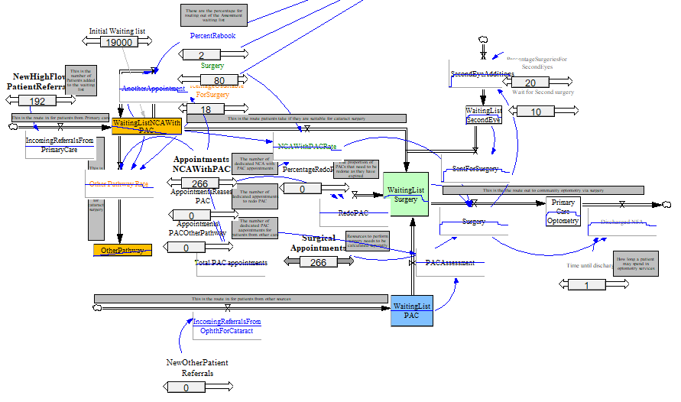

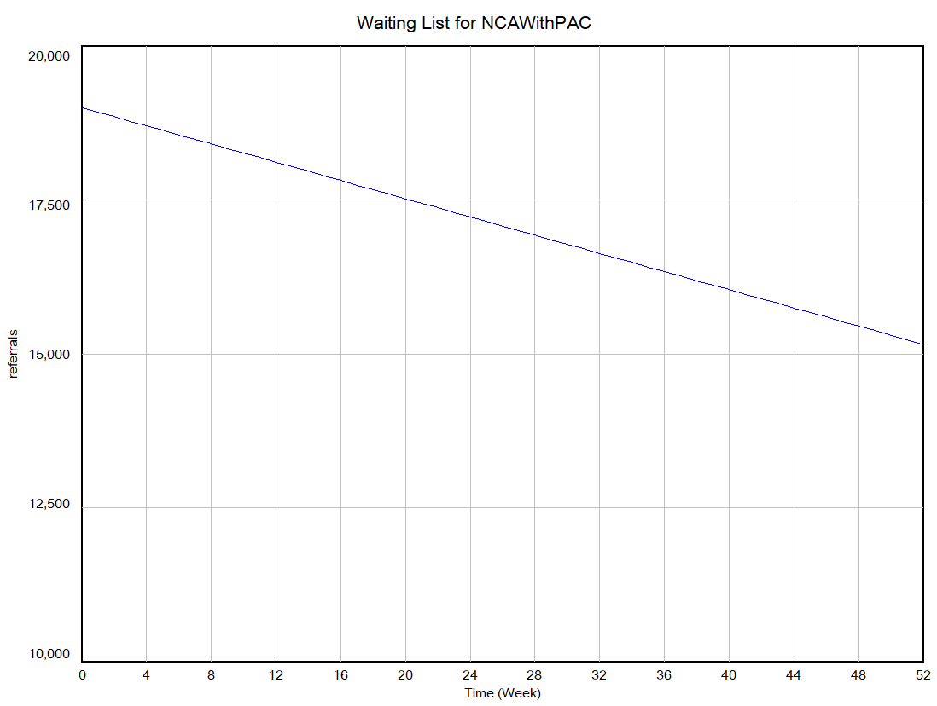
After 52 weeks of the total capacity of 13,820 per year the waiting list is reduced from 19,000 across the region to 15,186

Appendix Six: Option 3b Details
Option 3b –Vanguard and maximising NHH
This is the preferred option
As the preferred option this option has been developed in more detail than the other options.
Realistic assumptions have been made about the feasibility of delivery and the model has been designed to be distributed over 14 months split across 23/24 and 24/25.
Option 3b
As option 3a but with the addition of 7 weekday NHS sessions in NHH
Option 3b is an insourcing and outsourcing option involving a two-hub model of NHH in the North and the Vanguard Unit in the South with the following volumes over a 14 month period:

- South Hub Weekdays: Retaining the weekday 20 sessions in vanguard and using 7.5 sessions for CAV core capacity (1620 patients per year, funded by CAV) and 12.5 sessions for regional capacity (2700 patients per year, regionally funded, provided by NHS staff)
- South Hub Weekends: 1,500 outpatient assessment and inpatient procedures carried out by an insourcing company in Vanguard (UHW)
- North Hub Weekdays: 1610 outpatient assessment and inpatient procedures carried out in weekdays in NHH using NHS staffing
- North Hub Weekends: 1,500 outpatient assessment and inpatient procedures carried out by an insourcing company in NHH
- An additional 2,000 outsourced outpatient and inpatient procedures
- One theatre in NHH and twin theatres in Vanguard
- Total core 7,140 for 14 months (6,120 annual)
- Plus 9,310 additional
- Total capacity 16,450 per year
- Waiting list reduction 4,832 (from 19,000 to 14,168)
- Total costs: £15.3m
- Cost per patient: £1,640

11.1 Clinical and Service Model

11.1.1 Clinical Service Model North Hub (NHH) Additional for Option 3b
The North hub would primarily provide outpatient and inpatient provision to patients primarily in North CTM and North AB from Nevill Hall Hospital (NHH) in Abergavenny as the regional geography suits.

Weekdays: Outpatients Stage (NHS Staff)
Patients will be booked into the additional capacity for outpatients in NHH via the regional booking and scheduling team (see section 5.4)
In order to undertake 135 outpatient appointments per month (38 per week, 1,620 per year) the sessions will be a ‘one stop shop’ model, held on weekdays in the OP dept in NHH. 4 consulting rooms will be required plus a waiting area. This weekday activity will be staffed through recruitment of NHS staff for all of the clinical and not clinical staff required.

Outpatients Clinical Model
These patients are taken from new or stage 1 waiting list. During the one-stop session, patients are:
- Ophthalmic history/general medical history/medication/family history/allergies
- Vision
- Anterior segment examination
- Biometry +/- corneal topography
- Pupil dilatation
- Posterior segment examination by ophthalmologist
- Choose intraocular lens/refractive plan
- Cataract care pathway checklist completed
- Consented for surgery

Weekdays; Inpatient Stage (NHS Staff)
Patients attending the weekday regional capacity for cataract surgery in the North Hub will be booked through the regional booking team (see section 6.4). They will also have had their OP assessment through the North hub weekday arrangements in NHH with NHS staff.
In order to undertake 38 procedures per week (135 per month, 1,610 per year) the procedures will be undertaken in Main Theatres at NHH on weekdays, Mondays and Wednesday to Friday.
As this is additional volume and there is a strong requirement to protect the core capacity additional trays and handpieces will need to be purchased to support this additional

Non-Staff Requirements
Other non-staff requirements for the Inpatient sessions are:
Weekends
Cleaning / Waste / Facilities - £47,883
HSDU costs (Including transport) - £30,000
Purchase of additional surgical trays and equipment - £38,284
Stellaris Handpieces- £87,500
Pharmacy costs, Lens and consumables - £224,310
Additional lens costs £7,716

11.1.2 Booking and scheduling For Option 3b (Vanguard and Maximising NHH):
In one year the team will need to book 7,500 outpatient appointments across both the North and South Hubs and schedule 7,500 inpatient procedures and facilitate 2,000 outsourced patients. Totalling 17,000 patient bookings per year
A team of 18 booking and scheduling staff on Band 3 are required to support the regional arrangements along with a band 7 team leader and 3 waiting list managers band 5. A Vanguard Unit Manager and NHH Eye Unit Manager are also required to manage the unit and to ensure capacity levels are maximised.
Staff Required:
- 9 WTE Patient Schedulers Band 3
- 9 WTE Booking Clerks Band 3
- 3 WTE Waiting list managers Band 5
- 1 WTE Team Leader Band 7
- 1 WTE Vanguard Unit Manager Band 8b
- 1 WTE Eye Unit Manager NHH band 7
Non Staff Costs
- Facilities costs for 24 members of staff, IT costs and office space have been estimated at £100,000

11.1.3 Option 3b Assumptions
- NHH Workforce can be fully recruited
- Shared PTL across the region
- Share of regional capacity based on percentage split of over 52 week waiters
- 52 weeks waiters numbers under monthly review
- Regional booking team may not all be based in one place
- IT solutions will need to be worked through
- Insourcing and Outsourcing contracting will be done at a National level
- That insourcing and outsourcing capacity will be available in the market through contracting arrangements
- Insourcing numbers on a list to be determined by the insourcing company with annual numbers included in the contracting arrangement
- Effective clinical governance arrangements
- Vanguard workforce can continue into 23/24
- CTM continue with their current levels of outsourcing (15 per month)
- NHH Workforce can be fully recruited
- Patients receive pre-assessment and surgery through the same element of provision (e.g. weekend pre-assessment and weekend surgery)
- Patient eligibility criteria are to be developed and agreed
- 80% conversion rate from outpatients to surgery
- 20% of patients require a second eye
- Patients requiring second eye have one pre assessment to cover both eyes
- NHH Workforce can be fully recruited

11.2 Option 3b – Option Appraisal

11.2.1 Additional Regional Capacity

Capacity | Core 14 months | Additional Capacity % | Additional Regional | Total | 14 months demand | Difference
AB | 2800 | 36% | 3352 | 6152 | 4760 | 1392
CAV | 1890 | 15% | 1397 | 3287 | 2100 | 1187
CTM | 2440 | 49% | 4562 | 7002 | 4760 | 2242
Regional Total | 7140 |  | 9310 | 16450 | 11620 | 4830

11.2.2 Regional Capacity Plan
The chart below shows how the regional capacity will be delivered during 2023 and 2024. The business case will run for 12 months with a ‘tail’ of 6 months to enable the sustainable capacity (second business case) to build up.

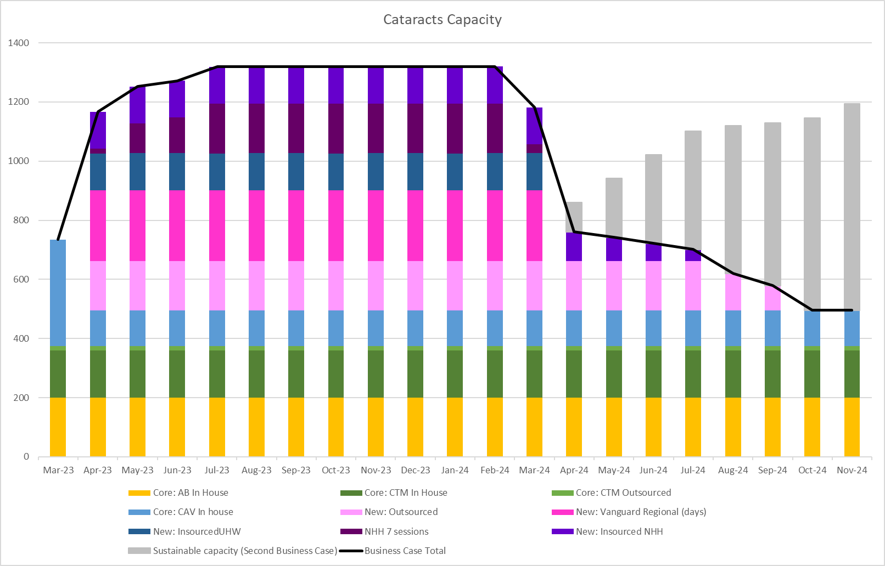

11.2.3 Regional Capacity by expected patients treated
Reviewing the end of the list 49% of the long waiters are from CTM, 36% from AB and 15% from CAV. Projections of the use of the regional capacity are based on these percentages.
Delivery is split over 2 financial years as follows:
- 9 months of 23/24 from 1st July 2023 to 31st March 2024
- 5 months of 24/25 from 1st April 2024 to 31st August 2024
AB Patients
 | Core: AB In House | AB 39% | AB Total from this business case
1st July 2023 to 31st March 2024 | 1800 | 2313 | 4113
1st April 2024 to 31st August 2024 | 1000 | 1039 | 2039
Total Allocation | 2800 | 3352 | 6152

CAV Patients
 | Core: CAV In house | CAV 15% | CAV Total from this business case
1st July 2023 to 31st March 2024 | 1215 | 964 | 2179
1st April 2024 to 31st August 2024 | 675 | 433 | 1108
Total Allocation | 1890 | 1397 | 3287

CTM Patients
 | Core: CTM In House | Core: CTM Outsourced | CTM 49% | CTM Total from this business case
1st July 2023 to 31st March 2024 | 1440 | 135 | 3148 | 4723
1st April 2024 to 31st August 2024 | 800 | 75 | 1414 | 2289
Total Allocation | 2240 | 210 | 4562 | 7012

Regional Total
 | AB Total | CAV Total | CTM Total | Regional Total
1st July 2023 to 31st March 2024 | 4113 | 2179 | 4723 | 11014
1st April 2024 to 31st August 2024 | 2039 | 1108 | 2289 | 5436
Total Allocation | 6152 | 3287 | 7012 | 16450

11.2.4 Option 3b Benefits
In addition to the high level benefits identified above, the additional benefits of this option include
- Retaining a well trained and experienced staff within the Vanguard unit
- Ability to treat more complex patients are part of the regional capacity
- Continuity and stability of employment for Vanguard staff
- Increased opportunities for staff training learning and development
- Provides a solid base to develop the sustainable regional solution
- Fully utilised the Vanguard unit 7 days per week
- Greater proportion of cataracts surgery undertaken by NHS staff
- Enables a greater reduction in the backlog
- Stabilises the short term regional arrangement (Jan-March 2023)
- Reduces the backlog by 4,832 patients waiting

11.2.5 Option 3b Risks
The specific risks associated with this option are:
- High volumes of surgery through Vanguard Unit may put a strain on equipment readiness levels (low risk following mitigation actions)
- Clinical risks and patient harm risks associated with outsourcing and insourcing capacity (low risk following mitigation actions)

11.2.6 Option 3b Patient Considerations
Through this option there would be additional capacity for patients across the region for cataract assessment and surgery and patient waiting time will start to reduce. This option includes a North and South Hub where patients who meet the criteria for this additional capacity would be directed to their closest hub for assessment and treatment. Patients unable or unwilling to travel will be treated within their own health board as part of the core capacity. Waiting times may vary between core and additional capacity provision.
This option also includes outsourcing where the costing includes patient travel as this may be outside of the boundary of the region (dependent on the contracting). The core capacity, insourcing, and NHS sessions do not include patient travel contributions.

11.2.8 Option 3b Activity Modelling
This scenario is based on the following assumptions:
- 9,960 referrals per year (192 per week, 830 per month)
- 15,430 cataracts procedures per year (297 per week, 1286 per month)
- 15,430 outpatients per year (297 per week, 1286 per month)

Over 14 months this would be:
- 11,620 referrals per year
- 16,450 cataracts procedures per year
- 16,450 outpatients per year

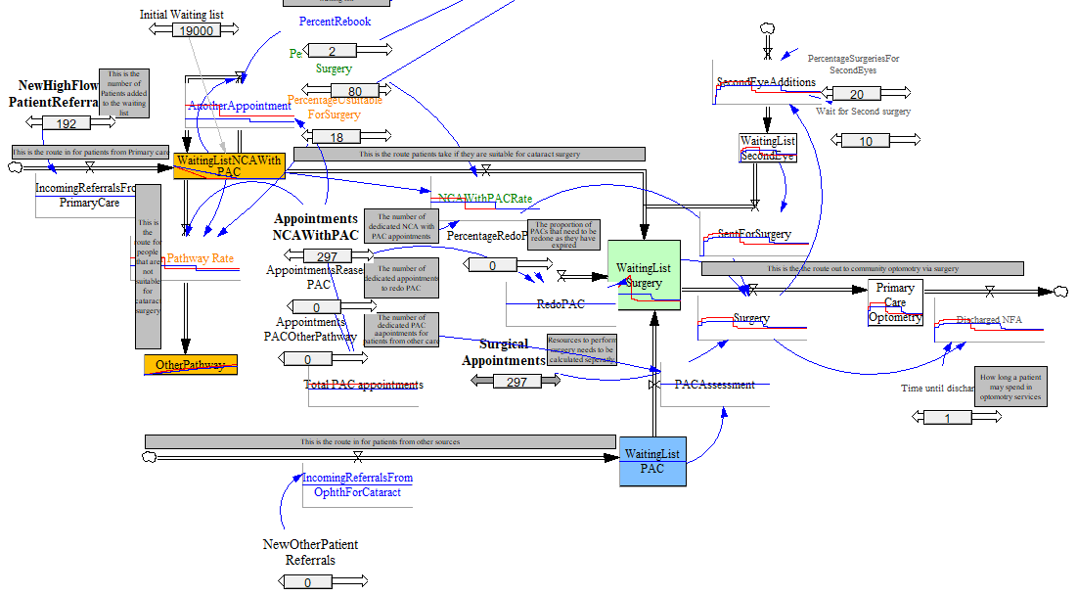

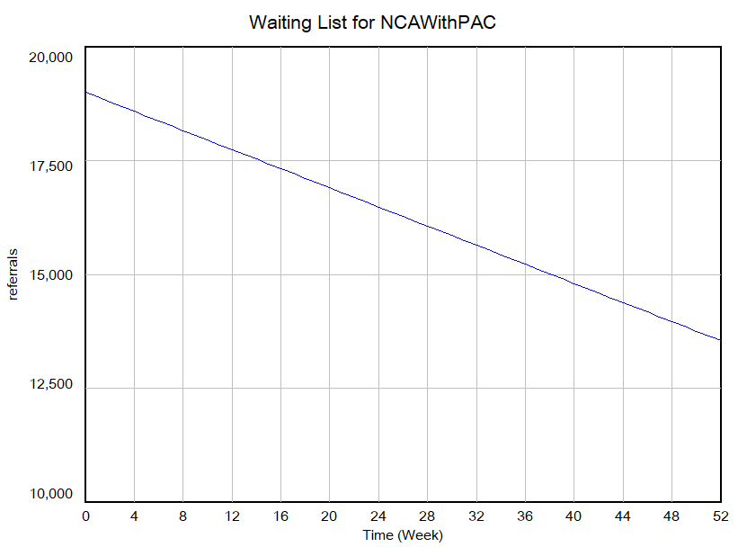
This scenario is based on the following assumptions:
- 9,960 referrals per year (192 per week, 830 per month)
- 15,430 cataracts procedures per year (297 per week, 1286 per month)
- 15,430 outpatients per year (297 per week, 1286 per month)

Over 14 months this would be:
- 11,620 referrals per year
- 16,450 cataracts procedures per year
- 16,450 outpatients per year

After 14 months the total capacity of 16,450 per year the waiting list is reduced from 19,000 across the region to 14,168

Appendix Seven: Option 4 Details
Option 4 – Weekend Insourcing and Outsourcing Only
The Insourcing and outsourcing option involves a two hub model of NHH in the North and the use of POWH in the south for outpatients and Inpatients, along with outsourcing in the following volumes over a 12 month period:
- North Hub: 1,500 outpatient assessment and inpatient procedures carried out by an insourcing company in NHH
- South Hub: 1,500 outpatient assessment and inpatient procedures carried out by an insourcing company in POWH
- An additional 2,000 outsourced outpatient and inpatient procedures
- Total core 5,940
- Plus 5,000 additional
- Total capacity 10,940 per year
- Waiting list reduction 517 (from 19,000 to 18,483)
- Total costs 23/24: £7,193,028
- Cost per patient: £1,439

12.1 Option 4 – Clinical and Service Model
The Clinical Model includes an outpatient stage and inpatient stage.
At the outpatient stage the clinical teams review the patients, determine their suitability for surgery and conduct pre-operative assessments. Through the proposed model this will be carried out during a single patient visit.
At the inpatient stage patient receive their cataract surgery. Following surgery patients are discharged to Primary Care. Primary Care advisors have confirmed that no additional resource is required in primary care at present for the additional capacity as it will be adequately dispersed amongst optometric practices across the region.

12.1.1 North Hub
The North hub would primarily provide outpatient and inpatient provision to patients in North CTM and North AB from Nevill Hall Hospital (NHH) in Abergavenny.

Outpatient Stage
Patients will be booked into the additional capacity for outpatients in NHH via the regional booking and scheduling team (see section 5.4)
In order to undertake 125 outpatient appointments per month (30 per week, 1,500 per year) the sessions will be a ‘one stop shop’ model, held on a Saturday in the OP dept in NHH. 4 consulting rooms will be required plus a waiting area.
Assuming that the required clinical staff including Consultants, PAC nurse and biometry staff will be provided by the Insourcing provider, the following additional staff will also be required to run weekly Saturday OP clinics for 1 year:
- 0.5 WTE Receptionist Band 2 £15,780
- 0.5 WTE Health Records Clinical Notes Band 2 £15,780
- 0.5 WTE Governance Nurse band 6 £29,372
Other non staff requirements for the OP sessions are
- Cleaning (Saturday) £7500
Lenses will be also ordered at this point if the patient is suitable for surgery. Costs of lenses will be included in the Inpatient section.
Patients are taken from new or stage 1 waiting list. During the one-stop session, patients are:
- Ophthalmic history/general medical history/medication/family history/allergies
- Vision
- Anterior segment examination
- Biometry +/- corneal topography
- Pupil dilatation
- Posterior segment examination by ophthalmologist
- Choose intraocular lens/refractive plan
- Cataract care pathway checklist completed
- Consented for surgery

Inpatient Stage
Patients accessing the additional capacity for insourcing in the North Hub will be booked through the regional booking team (see section 6.4). They will also have had their OP assessment through the North hub arrangements in NHH.
In order to undertake 30 procedures per week (125 per month, 1,500 per year) the procedures will be undertaken in Main Theatres at NHH every Saturday and Sunday.
As this is additional volume and there is a strong requirement to protect the core capacity additional trays and handpieces will need to be purchased to support this additional capacity
Assuming that all of the clinical staff required for the surgery and recovery are provided by the insourcing company (Consultants, Nurses, HCSW’s) then the following additional staff are required to support the service model:
- 0.6 WTE Receptionist Band 2 £18,936
- 0.6 WTE Health Records Clinical Notes Band 2 £18,936
- 0.6 WTE Governance Nurse band 6 £35,246

Other non-staff requirements for the Inpatient sessions are:
- Cleaning / Waste / Facilities - £47,883
- HSDU costs (Including transport) - £30,000
- Purchase of additional surgical trays and equipment - £38,284
- Stellaris Handpieces- £87,500
- Pharmacy costs, Lens and consumables - £224,310
- Additional lens costs £7,716.

12.1.2 South Hub
Through Option 2 The South Hub would provide outpatient and inpatient provision for patients in the south of the region. The outpatient and inpatient provision will be delivered from Princess of Wales Hospital in Bridgend on weekends via an insourcing company

Outpatients Stage (Weekend Insourcing in POWH)
The POWH site has two pre-assessment rooms which can be used concurrently during weekends during 2023/24. Each room would house one pre-assessment nurse each, and both could be serviced with one doctor in clinic. All the clinical staff would be provided through the insourcing company. In one session using two PAC nurses concurrently, 10 patients could be assessed.
In addition the staffing costs for running outpatient clinics evenings and weekends would be:
- 0.5 WTE B2 Receptionist
- 0.5 WTE B3 Booking
- 0.5 WTE B6 Governance Nurse
Non- staffing costs are
- Cleaning

Patients are taken from new or stage 1 waiting list. During the one-stop session, patients are:
- Ophthalmic history/general medical history/medication/family history/allergies
- Vision
- Anterior segment examination
- Biometry +/- corneal topography
- Pupil dilatation
- Posterior segment examination by ophthalmologist
- Choose intraocular lens/refractive plan
- Cataract care pathway checklist completed
- Consented for surgery

Inpatient Stage (Weekend insourcing at POWH)
Patients accessing the additional capacity for insourcing in the South Hub will be booked through the regional booking team (see section 5.4). They will also have had their OP assessment through the South hub arrangements in POWH.
POWH has a twin theatre set up and the flow enables a maximum of 7 patients on a list for high flow low complexity patients. Running the twin theatres enables 14 patients to be seen in a morning. By running the two theatres on Saturdays all day and Sunday mornings, 42 patients can be seen in a weekend (total 6 sessions). This model can run for 36 weeks to treat the 1,500 patients through the insourcing.
As this is additional volume and there is a strong requirement to protect the core capacity additional trays and handpieces will need to be purchased to support this additional capacity
Assuming that all of the clinical staff required for the surgery and recovery are provided by the insourcing company (Consultants, Nurses, HCSW’s) then the following additional staff are required to support the service model:
- 0.6 WTE Receptionist Band 2 £18,936
- 0.6 WTE Health Records Clinical Notes Band 2 £18,936
- 0.6WTE Governance Nurse band 6 £35,246
Other non-staff requirements for the Inpatient sessions are:
- Cleaning / Waste / Facilities - £47,883
- HSDU costs (Including transport) - £30,000
- Purchase of 45 additional surgical trays and handpieces - £239,682
- Pharmacy costs, Lens and consumables - £225,000 - This is based on a consumable pack costing £150 per patient (1500 patients )Alcon managed contract

12.1.3 Outsourcing Arrangements
In addition to the insourcing arrangements the capacity across the region can be further increased by utilising the local opportunities for outsourcing. Outsourcing can relieve some of the management and back office administrative time associated with working through the backlog as the booking and scheduling, record keeping, outpatient and inpatient activity are all supplied as part of the contract. In this way the outsourcing opportunities also represent value for money and free up valuable resources for allocation towards the management of the core capacity and the insourcing arrangements. Option 4 will deliver an additional 2,000 cases per year. Outsourcing arrangements and costs include patient travel.

12.1.4 Booking and scheduling for Option 4 (Weekend Insourcing and Outsourcing)
In one year the team will need to book 3,000 outpatient appointments across both the North and South Hubs and schedule 3,000 inpatient procedures in addition to facilitating 2,000 outsourced patients. There is also a requirement to confirm which patients are suitable for the additional capacity and which need to be treated as part of core capacity as they are more complex cases.
A team of 8 booking and scheduling staff on Band 3 are required to support the regional arrangements along with a band 7 team leader and 3 waiting list managers band 5.
Staff Required:
- 4 WTE Patient Schedulers Band 3
- 4 WTE Booking Clerks Band 3
- 3 WTE Waiting list managers Band 5
- 1 WTE Team Leader Band 7
Non Staff Costs
- Facilities costs for 14 members of staff, IT costs and office space have been estimated at £30,000

12.2 Option 4 – Option Appraisal

12.2.1 Additional Regional Capacity

Capacity | Core Annual | Additional Capacity % | Additional Capacity | Total | Average Demand | Difference
AB | 2400 | 36% | 1800 | 4200 | 4080 | 120
CAV | 1440 | 15% | 750 | 2190 | 1800 | 390
CTM | 2100 | 49% | 2450 | 4550 | 4080 | 470
Regional Total | 5940 |  | 5000 | 10940 | 9960 | 980

12.2.2 Regional Capacity Plan
The chart below shows how the regional capacity will be delivered during 2023 and 2024. The business case will run for 12 months with a ‘tail’ of 6 months to enable the sustainable capacity (second business case) to build up.
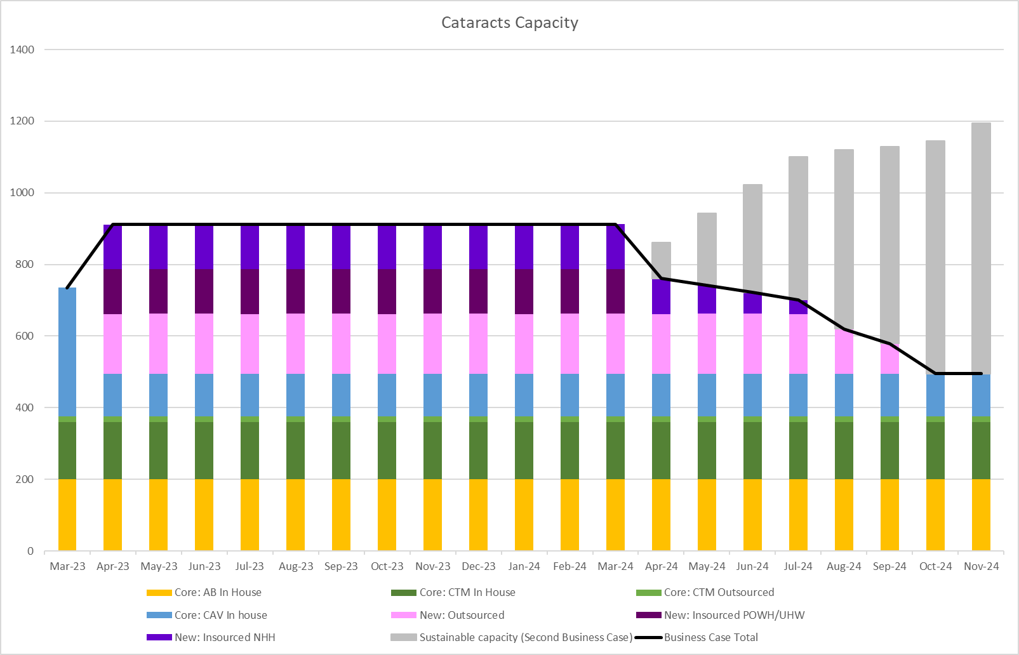

 | Core: AB In House | Core: CTM In House | Core: CTM Outsourced | Core: CAV In house | New: Outsourced | New: Insourced POWH | New: Insourced NHH | Business Case Total
2023/24 | 2400 | 1920 | 180 | 1440 | 2000 | 1500 | 1500 | 10940
2024/25 | 1200 | 960 | 90 | 720 | 875 | 0 | 280 | 4125

12.2.3 Regional Capacity by expected patients treated
Reviewing the end of the list, 49% of the long waiters are from CTM, 36% from AB and 15% from CAV. Projections of the use of the regional capacity are based on these percentages, however as the waiting list progresses, the percentages will change over time
AB Patients
 | Core: AB In House | AB 36% | AB Total
2023/24 | 2400 | 1800 | 4200
2024/25 | 1200 | 416 | 1616

CTM Patients
 | Core: CTM In House | Core: CTM Outsourced | CTM 49% | CTM Total
2023/24 | 1920 | 180 | 2450 | 4550
2024/25 | 960 | 90 | 566 | 1616

CAV Patients
 | Core: CAV In House | CAV 15% | CAV Total
2023/24 | 1440 | 750 | 2190
2024/25 | 720 | 173 | 893

Regional Total
 | AB Total | CAV Total | CTM Total | Regional Total
2023/24 | 4200 | 2190 | 4550 | 10940
2024/25 | 1616 | 893 | 1616 | 4125

12.2.4 Option 4 Benefits
In addition to the high level benefits identified above, the additional benefits of this option include
- Outpatient assessments and inpatients treatments are performed on the same site
- Reduces the backlog by 517 patients waiting

If the Vanguard theatres are not taken forward after March 2023 there will be additional staff from UHW that could be utilised at one of the other hub areas.

12.2.5 Option 4 Risks
The specific risks associated with this option are:
- Loss of experienced and well trained staff at the Vanguard Unit (low risk following mitigation actions)
- Reduction in training capacity across the region (medium risk following mitigation actions)
- Reduced capacity to treat more complex patients (medium risk following mitigation actions)

12.2.6 Option 4 Patient Considerations
Through this option there would be additional capacity for patients across the region for cataract assessment and surgery and patient waiting time will remain at current levels. This option includes a North and South Hub where patients who meet the criteria for this additional capacity would be directed to their closest hub for assessment and treatment. Patients unable or unwilling to travel will be treated within their own health board as part of the core capacity. Waiting times may vary between core and additional capacity provision.
This option also includes outsourcing where the costing includes patient travel as this may be outside of the boundary of the region (dependent on the contracting). The core capacity, insourcing, and NHS sessions do not include patient travel contributions.

12.2.7 Option 4 Costs
Option 4 costs are shown here
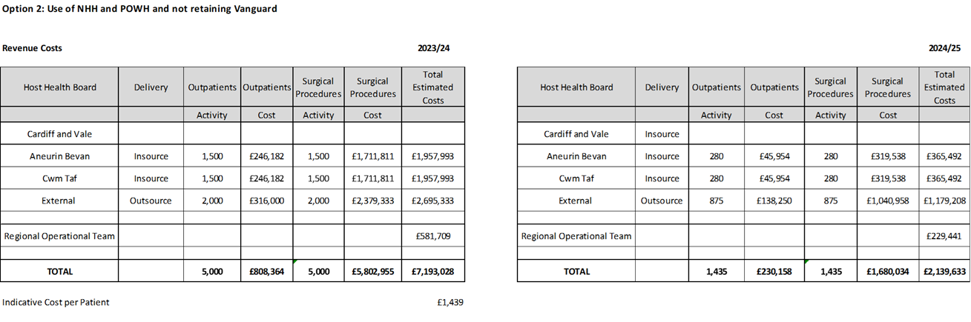

Assumptions-
- Cost assumptions are based on locally provided figures
- Insource cost estimates are based on Framework expectation of PbR plus 10% but will depend on casemix and provider
- Outsourcing estimates are based on PbR with an element for transport but dependent on casemix and provider

12.2.8 Option 4 Activity Modelling
This scenario is based on the following assumptions for year 1:
- 9,960 referrals per year (192 per week, 830 per month)
- 10,940 cataracts procedures per year (202 per week, 874 per month)
- 10,940 outpatients per year (202 per week, 874 per month)

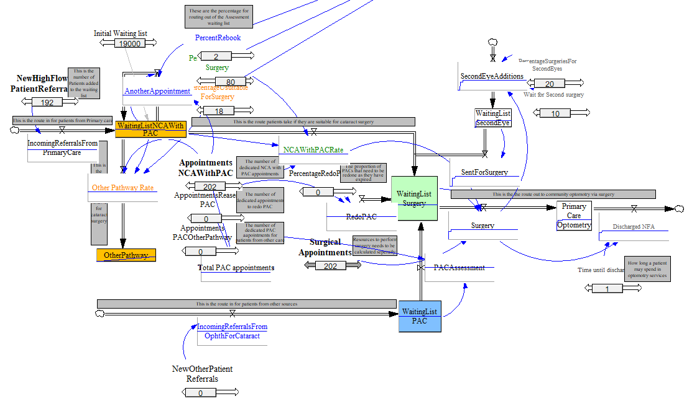
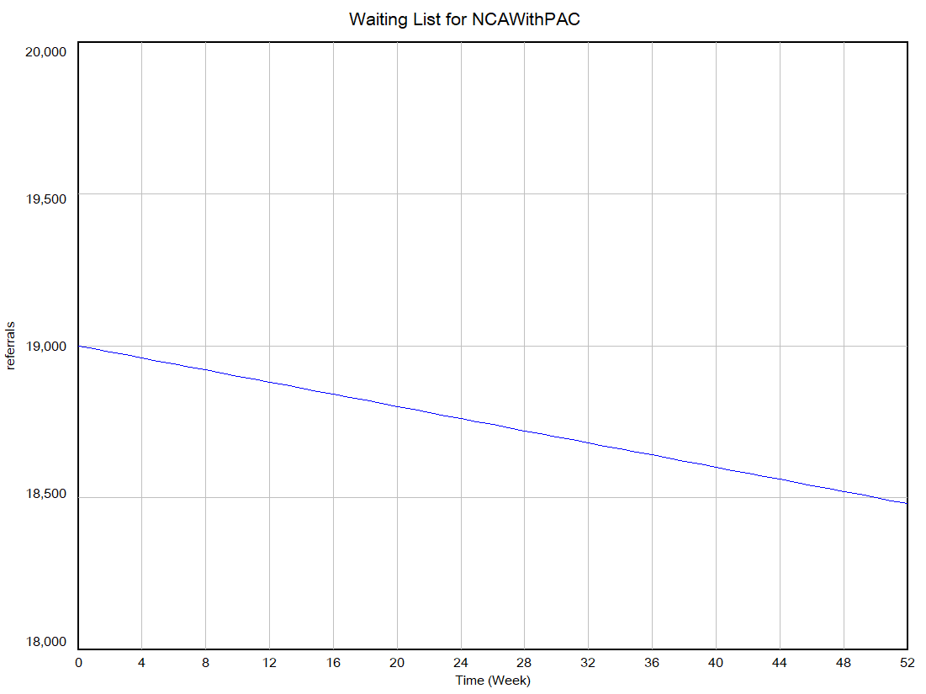
After 52 weeks of the total capacity of 10,940 per year the waiting list is reduced from 19,000 across the region to 18,483

Appendix Eight: Option 5 Details
Option 5 – Outsourcing
The option involves outsourcing the whole additional capacity and not insourcing or using the Vanguard Unit for capacity. By using outsourcing only, the demands on the regional booking and scheduling team also reduce. It is likely that one supplier would not be able to fulfil the whole 5,000 procedures per year and so it would be split across different providers with the following volumes over a 12 month period:
- An additional 5,000 outsourced outpatient and inpatient procedures
- Total core 5,940
- Plus 5,000 additional
- Total capacity 10,940 per year
- Waiting list reduction 517 (from 19,000 to 18,483)
- Total costs 23/24: £6,978,436
- Cost per patient: £1,396

13.1 Option 5 – Clinical and Service Model

13.1.1 Outsourcing Arrangements
Outsourcing can relieve some of the management and back office administrative time associated with working through the backlog as the booking and scheduling, record keeping, outpatient and inpatient activity are all supplied as part of the contract. In this way the outsourcing opportunities also represent value for money and free up valuable resources for allocation towards the management of the core capacity and the insourcing arrangements. Through this option 5,000 cases are outsourced. Outsourcing arrangements and costs include patient travel.

Patients are reviewed by a non-clinical administrator for their suitability for outsourcing and then referred on to the outsourcing company for assessment and treatment. Communication with the patient about booking and scheduling and locations are conducted by the outsourcing company. Follow ups post-surgery are conducted in primary care. Hospital patient records are updated.

13.1.2 Booking and scheduling For Option 5 (Outsourcing)
In one year the team would need to facilitate 5,000 outsourced patients and ensure records are kept up to date and that these patients are suitable for the outsourcing route.
A team of 4 patient liaison, 1 waiting list manager and a team leader are required to support the outsourcing
Staff Required:
- 4 WTE Patient Liaison Band 3
- 1 WTE Waiting List Manager Band 5
- 1 WTE Team Leader Band 7
Non Staff Costs
- Facilities costs for 6 members of staff, IT costs and office space have been estimated at £15,000

13.2 Option 5 – Option Appraisal

13.2.1 Additional Regional Capacity
Capacity | Core Annual | Additional Capacity % | Additional Capacity (outsourced) | Total | Average Demand | Difference
AB | 2400 | 36% | 1800 | 4200 | 4080 | 120
CAV | 1440 | 15% | 750 | 2190 | 1800 | 390
CTM | 2100 | 49% | 2450 | 4550 | 4080 | 470
Regional Total | 5940 |  | 5000 | 10940 | 9960 | 980

13.2.2 Regional Capacity Plan
The chart below shows how the regional capacity will be delivered during 2023 and 2024. The business case will run for 12 months with a ‘tail’ of 6 months to enable the sustainable capacity (second business case) to build up.
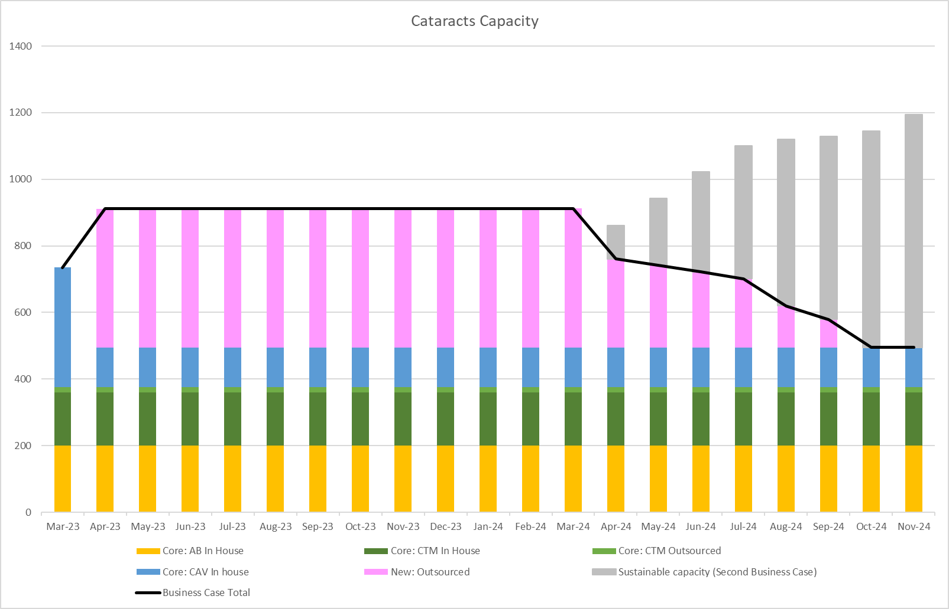

 | Core: AB In House | Core: CTM In House | Core: CTM Outsourced | Core: CAV In house | New: Outsourced | New: Insourced POWH | New: Insourced NHH | Business Case Total
2023/24 | 2400 | 1920 | 180 | 1440 | 5000 | 0 | 0 | 10940
2024/25 | 1200 | 960 | 90 | 720 | 1155 | 0 | 0 | 4125

13.2.3 Regional Capacity by expected patients treated
Reviewing the end of the list 49% of the long waiters are from CTM, 36% from AB and 15% from CAV. Projections of the use of the regional capacity are based on these percentages, however as the waiting list progresses, the percentages will change over time
AB Patients
 | Core: AB In House | AB 36% | AB Total
2023/24 | 2400 | 1800 | 4200
2024/25 | 1200 | 416 | 1616

CTM Patients
 | Core: CTM In House | Core: CTM Outsourced | CTM 49% | CTM Total
2023/24 | 1920 | 180 | 2450 | 4550
2024/25 | 960 | 90 | 566 | 1616

CAV Patients
 | Core: CAV In House | CAV 15% | CAV Total
2023/24 | 1440 | 750 | 2190
2024/25 | 720 | 173 | 893

Regional Total
 | AB Total | CAV Total | CTM Total | Regional Total
2023/24 | 4200 | 2190 | 4550 | 10940
2024/25 | 1616 | 893 | 1616 | 4125

13.2.4 Option 5 Benefits
In addition to the high level benefits identified above, the additional benefits of this option include
- Outpatient assessments and inpatients treatments are performed on the same site
- Additional capacity delivered at reduced costs from insourcing
- Reduces the backlog by 517 patients waiting

13.2.5 Option 5 Risks
The specific risks associated with option 2 are:
- Loss of experienced and well trained staff at the Vanguard Unit (medium risk following mitigation actions)
- Reduction in training capacity across the region (medium risk following mitigation actions)
- Reduced capacity to treat more complex patients (medium risk following mitigation actions)
- Increased number of patients required to travel further for treatment

13.2.6 Option 4 Patient Considerations
Through this option there would be additional capacity for patients across the region for cataract assessment and surgery and patient waiting time will remain at current levels.
This option is for outsourcing activity where patients who meet the criteria for this additional capacity would be directed to outsourcing for assessment and treatment. Patients unable or unwilling to travel will be treated within their own health board as part of the core capacity. Waiting times may vary between core and outsourcing capacity provision. This option also includes patient travel as this may be outside of the boundary of the region (dependent on the contracting). The core capacity does not include patient travel contributions.

13.2.7 Option 5 Costs
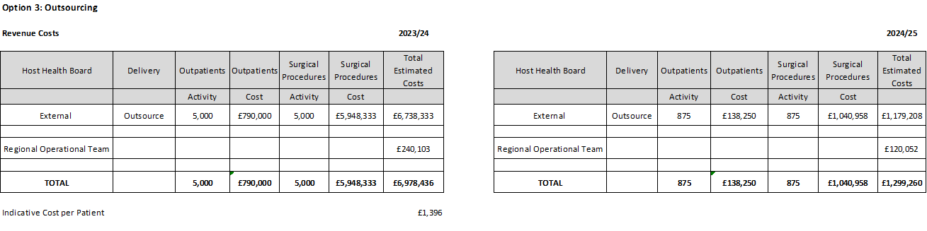

13.2.8 Option 5 Activity Modelling
The assumptions used in this option are the same as in option 4, as the capacity stays the same but the mode of delivery changes.
After 52 weeks of the total capacity of 10,940 per year the waiting list is reduced from 19,000 across the region to 18,483

Appendix Nine: Split of Preferred Option By Health Board
Delivery is split over 2 financial years as follows:
- 9 months of 23/24 from 1st July 2023 to 31st March 2024
- 5 months of 24/25 from 1st April 2024 to 31st August 2024
AB Patients
 | Core: AB In House | AB 36% | AB Total from this business case
1st July 2023 to 31st March 2024 | 1800 | 2313 | 4113
1st April 2024 to 31st August 2024 | 1000 | 1039 | 2039
Total Allocation | 2800 | 3352 | 6152

CAV Patients
 | Core: CAV In house | CAV 15% | CAV Total from this business case
1st July 2023 to 31st March 2024 | 1215 | 964 | 2179
1st April 2024 to 31st August 2024 | 675 | 433 | 1108
Total Allocation | 1890 | 1397 | 3287

CTM Patients
 | Core: CTM In House | Core: CTM Outsourced | CTM 49% | CTM Total from this business case
1st July 2023 to 31st March 2024 | 1440 | 135 | 3148 | 4723
1st April 2024 to 31st August 2024 | 800 | 75 | 1414 | 2289
Total Allocation | 2240 | 210 | 4562 | 7012

Regional Total
 | AB Total | CAV Total | CTM Total | Regional Total
1st July 2023 to 31st March 2024 | 4113 | 2179 | 4723 | 11014
1st April 2024 to 31st August 2024 | 2039 | 1108 | 2289 | 5436
Total Allocation | 6152 | 3287 | 7012 | 16450

Appendix Ten: Full Patient Travel Survey

Patient Travel Survey
January 2023

A patients travel questionnaire was undertaken in Princess of Wales Hospital on 5th January, Royal Gwent Hospital on 11th January, and University of Wales Hospital on 12th January. 140 patients attending appointments on those day were asked questions about their travel to hospital and their willingness to travel to another hospital for treatment. All respondents were anonymous. This report show the total responses from each location and will form part of the supporting information for the Regional Cataracts business case.
Question 1. Which Hospital are you attending today?
Princess of Wales | 35 patients | 25%
Royal Gwent | 35 patients | 25%
University Hospital of Wales | 70 patients | 50%
Total | 140 patients | 100%

Question 2. How did you travel here today?

How did you travel here today? | Princess of Wales Hospital | Royal Gwent Hospital | University Hospital of Wales | Grand Total
Bus | 6 | 1 | 10 | 17
Car | 28 | 29 | 47 | 104
Community / Hospital Transport |  |  | 3 | 3
Park and ride |  |  | 1 | 1
Taxi |  | 4 | 8 | 12
Walk | 1 | 1 | 1 | 3
Grand Total | 35 | 35 | 70 | 140

Question 3. How many miles Have you travelled today?

How many miles have you travelled today? | Princess of Wales Hospital | Royal Gwent Hospital | University Hospital of Wales | Grand Total
5 miles or less | 17 | 7 | 20 | 44
6 to 10 miles | 16 | 15 | 28 | 59
11 to 20 miles | 2 | 13 | 17 | 32
over 20 miles |  |  | 5 | 5
Grand Total | 35 | 35 | 70 | 140

Question 4. How long did your journey take you?

How long did your journey take you? | Princess of Wales Hospital | Royal Gwent Hospital | University Hospital of Wales | Grand Total
less than 15 minutes | 16 | 6 | 20 | 42
16 to 30 minutes | 16 | 18 | 18 | 52
31 to 60 minutes | 3 | 10 | 17 | 30
Over 1 hour |  | 1 | 15 | 16
Grand Total | 35 | 35 | 70 | 140

*on the day of the survey in UHW there was sever weather, flooding and an accident on the A470 resulting in journeys that were longer than the patients were expecting.
Question 5 asked patients where they travelled from

Question 6. Did a Relative or friend accompany you?

Did a relative or friend accompany you? | Princess of Wales Hospital | Royal Gwent Hospital | University Hospital of Wales | Grand Total
On own | 5 | 3 | 19 | 27
Relative / Friend | 30 | 32 | 50 | 112
Transport |  |  | 1 | 1
Grand Total | 35 | 35 | 70 | 140

Question 7. How easy has it been for you to arrange transport today?

How easy was it for you to arrange transport for today? | Princess of Wales Hospital | Royal Gwent Hospital | University Hospital of Wales | Grand Total
Extremely easy | 24 | 23 | 35 | 82
Somewhat easy | 6 | 9 | 20 | 35
Neutral | 4 | 1 | 8 | 13
Somewhat difficult | 1 | 2 | 7 | 10
Extremely difficult |  |  |  | 0
Grand Total | 35 | 35 | 70 | 140

Question 8. Would you be prepared to travel further if you could have been treated sooner?

Would you be prepared to travel further to the treated sooner? | Princess of Wales Hospital | Royal Gwent Hospital | University Hospital of Wales | Grand Total
Yes | 25 (71%) | 27 (77%) | 47 (67%) | 99 (71%)
No | 10 (29%) | 8 (23%) | 23 (33%) | 41 (29%)
Grand Total | 35 | 35 | 70 | 140

Question 9. Where would you travel to?
- From Princess of Wales Hospital in Bridgend, of the 25 patients willing to travel 25 would go to Cardiff and 19 to Swansea
- From Royal Gwent Hospital in Newport, of the 27 patients willing to travel 19 would be willing to travel to Cardiff and 25 to Abergavenny
- From University Hospital of Wales in Cardiff, of the 47 patients willing to travel 38 would be willing to travel to Bridgend and 41 to Newport

Where would you travel to? | From Princess of Wales Hospital | From Royal Gwent Hospital | From University Hospital of Wales
Bridgend / POWH |  | 7 | 38
Cardiff / UHW | 25 | 19
Newport / RGH | 11 |  | 41
Abergavenny / NHH | 5 | 25 | 30
Bristol | 5 | 6 | 10
Swansea | 19 | 3 | 10
Further in the UK | 5 | 3 | 4
Grand Total | 70 | 63 | 133
*patients could provide multiple answers to this question

The Way Forward | The Royal College of Ophthalmologists (rcophth.ac.uk)
External Review of Eye Care Services in Wales (rcophth.ac.uk)
Ophthalmology (gettingitrightfirsttime.co.uk)
External Review of Eye Care Services in Wales (rcophth.ac.uk)
Insourcing and Outsourcing will take the less complex patients
Vanguard offers the opportunity for more training lists that are shorter in size
Insourcing and Outsourcing will take the less complex patients
Vanguard offers the opportunity for more training lists that are shorter in size
Insourcing and Outsourcing will take the less complex patients
Vanguard offers the opportunity for more training lists that are shorter in size
Insourcing and Outsourcing will take the less complex patients
Vanguard offers the opportunity for more training lists that are shorter in size

