/

Annual Report of the Finance & Performance Committee
2025-26

- INTRODUCTION

In accordance with best practice and good governance, the Finance & Performance Committee produces an Annual Report to the Board setting out how the Committee has met its Terms of Reference during the financial year.
- MEMBERSHIP
In addition to the Chair of the Committee, the Committee membership is a minimum of two other Independent Members. The meetings are also attended by the Executive Director of Finance (Executive Lead for the Committee), Chief Executive, Chief Operating Officer, Executive Director of Nursing, Director of Corporate Governance, Deputy Director of Finance and Assistant Director of Finance. Other Executive Directors are required to attend on an ad hoc basis.

- MEETINGS AND ATTENDANCE
The Committee met 11 times during the period from 1st April 2025 to 31st March 2026. This is in line with its Terms of Reference. The Finance & Performance Committee achieved an attendance rate of 74.34% (80% is considered to be an acceptable attendance rate) during the period 1st April 2025 to 31st March 2026 as set out below:
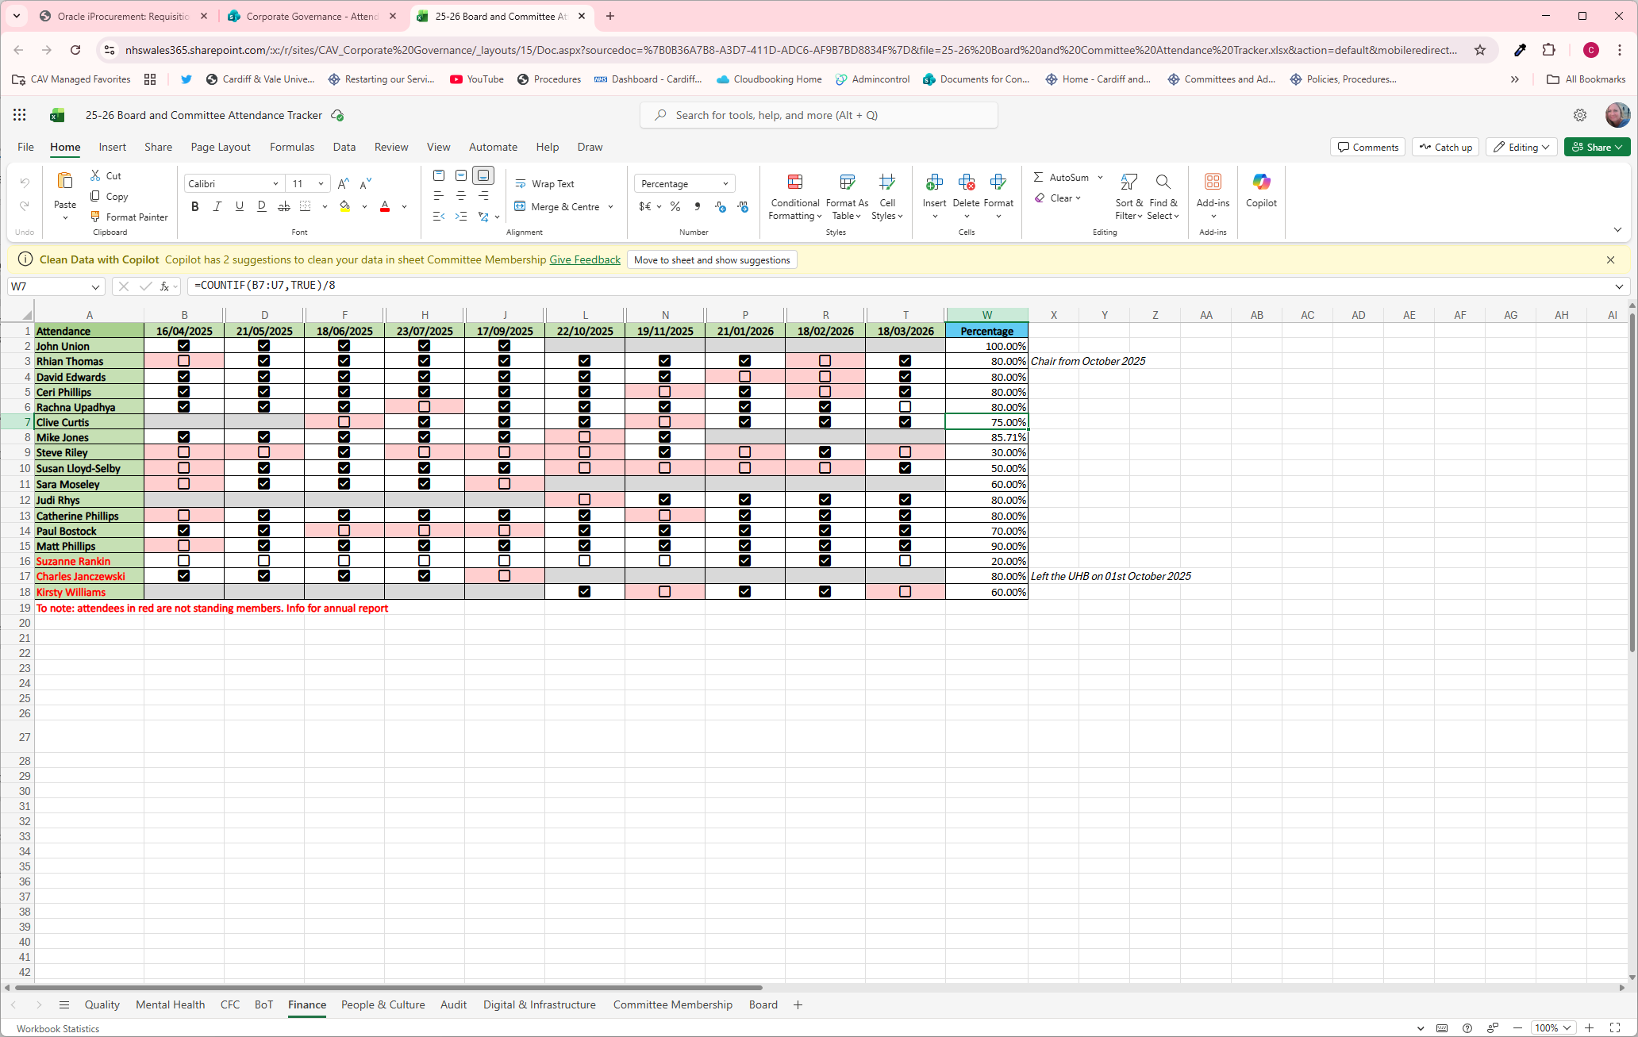

- WORK UNDERTAKEN
During the financial year 2025/26, the following standing items were considered and reviewed at each Finance Committee:
- Finance Report Update (including tracker)
- Operational Performance Update
- Board Assurance Framework (bi-monthly)
An extract from the Monthly Finance Monitoring Returns submitted to Welsh Government was also noted at each Committee Meeting.

The following items were considered periodically at the Finance committee during the financial year 2025/26:
- Planned Performance Dashboard
- RPB Quarterly Update
- Rapid Planning Event Report
- Annual Plan Reporting Framework
- Enabling Actions & Ministerial Advisory Group (MAG) Update
- Rapid Planning Event December 2024: Findings Report
- RPB Update
- Accountable Officer Letter
- Annual Plan / Quarterly IMTP
- Targeted Intervention

The following business cases were approved by the committee during 2025/26:
- Community Diagnostic Hub
- LHP OBC & South East Wales Regional Orthopaedic Plan
- Park View Wellbeing Hub
- Llantrisant Health Park – FBC Community Diagnostics Hub & OBC Orthopaedic
- UHW Ward Block Roof Replacement

- REPORTING RESPONSIBILITIES
The Committee has reported to each Board meeting by presenting a summary report of the key discussion items at the Finance Committee. The report is presented by the Chair of the Finance Committee. In addition, the finance dashboard which is reviewed at Committee meetings is included within the Performance Report which is submitted to each Board meeting.

- OPINION
The Committee is of the opinion that the Finance Committee Report 2025/26 is consistent with its role as set out within the Terms of Reference and that there are no matters that the Committee is aware of at this time that have not been disclosed appropriately.

Rhian Thomas
Committee Chair

