Annual Report of the
Audit & Assurance
Committee
2025/26

1. INTRODUCTION
In accordance with best practice and principles of good governance, the Audit & Assurance Committee produces an Annual Report to the Board setting out how the Committee has discharged its responsibilities and met its Terms of Reference during the financial year 2025/26. The report provides an overview of the work undertaken, key areas of focus, and the assurance provided to the Board and the Accountable Officer.

2. MEETINGS OF THE COMMITTEE
The Audit & Assurance Committee met five times during the 2025/26 financial year, including one special meeting convened to review and endorse the Annual Report and Accounts. Meetings were held in public with additional private sessions where required to consider confidential matters:
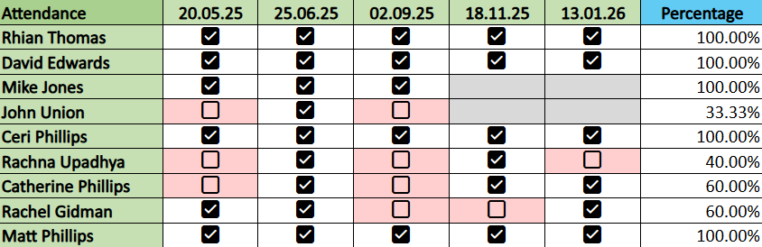

3. TERMS OF REFERENCE
The Committee operated in accordance with its Terms of Reference, which define its role in providing independent assurance to the Board on the effectiveness of governance, risk management, and internal control arrangements. The Committee’s remit includes oversight of internal and external audit, counter fraud arrangements, financial reporting, regulatory compliance, and procurement governance.

4. WORK UNDERTAKEN DURING THE YEAR
During 2025/26 the Committee undertook a substantial programme of work aligned to its Terms of Reference. This section summarises the key areas of business considered throughout the year.

4.1 Internal Audit
Internal Audit progress and output reports were presented at each scheduled Committee meeting, providing assurance on the delivery of the Internal Audit Plan and the effectiveness of internal controls across the organisation.
The Committee considered a wide range of internal audit reviews covering clinical governance, financial management, digital and information governance, workforce, estates, procurement, risk management, and strategic planning. Assurance ratings ranged from substantial to limited, with advisory reviews also undertaken in complex or evolving areas.
Where audits resulted in limited assurance, responsible Executives attended meetings to provide additional context, agree actions, and outline improvement plans. The Committee maintained particular oversight of audits relating to cyber security, procurement compliance, quality and safety governance, workforce planning, and major programmes.

4.2 Head of Internal Audit Opinion
The Committee reviewed and endorsed the Head of Internal Audit Opinion and Annual Report, which provided an overall assessment of the adequacy and effectiveness of the organisation’s governance, risk management, and internal control framework. The opinion informed the Annual Governance Statement within the Health Board’s Annual Report.

4.3 External Audit – Audit Wales
At each meeting the Committee received comprehensive updates from Audit Wales on financial audit, performance audit, and national studies relevant to the Health Board. These updates included progress on the audit of the annual accounts, charitable funds audit, structured assessment work, and thematic reviews such as planned care and eye care services.
The Committee reviewed significant Audit Wales reports, including those relating to planned care recovery, eye care services, structured assessment findings, and the Annual Audit Summary. Management responses were scrutinised, and assurance sought on how recommendations would be implemented and tracked.

4.4 Financial Reporting and Annual Accounts
The Committee played a key role in the scrutiny and oversight of the Health Board’s Annual Report and Accounts. It reviewed the draft Annual Report, Accountability Report, Performance Report, and Financial Statements prior to submission to Audit Wales.
Following external audit, the Committee considered the ISA 260 Report, Letter of Representation, and management responses to audit enquiries. It recommended approval of the Annual Report and Accounts to the Board and endorsed them for submission to Welsh Government and the Senedd.

4.5 Risk Management and Assurance Framework
The Committee monitored the development and implementation of the organisation’s risk management framework, including the transition to the Audit Management and Tracking (AMAT) system. It reviewed the Risk Management Policy, received updates on the Board Assurance Framework, and sought assurance on the identification, escalation, and management of risks across the organisation.

4.6 Procurement and Financial Governance
Procurement Compliance Reports were received at each meeting, providing transparency on non-compliant activity, Single Tender Actions, exemptions, and Chairs’ Actions. The Committee scrutinised trends and required enhanced narrative and data to understand underlying causes and mitigations.
Deep dives into procurement and non-pay spend were undertaken to explore controls, value for money, and emerging risks. The Committee noted improvements in compliance over the year and requested continued focus on education, early engagement, and assurance on delegated authority arrangements.

4.7 Counter Fraud
The Committee received regular Counter Fraud Progress Updates and reviewed the Counter Fraud Annual Report and Counter Fraud Plan. Assurance was taken that counter fraud arrangements met national standards and that investigative, preventative, and awareness-raising activity was effective.

4.8 Recommendation and Action Tracking
Throughout the year the Committee maintained oversight of internal audit, external audit, and regulatory recommendations through the use of centralised tracking via the AMAT system. Updates demonstrated improving completion rates, reduced numbers of long-outstanding actions, and strengthening executive ownership.

4.9 Committee Approvals
During the course of the 2025–26 financial year, the Audit & Assurance Committee approved the following key items:
- Internal Audit Plan 2025/26, including the Internal Audit Mandate, Charter, resource requirements, and key performance indicators
- Adjustments to the Internal Audit Plan during the year to reflect emerging risks, delivery challenges, and Committee priorities
- Head of Internal Audit Opinion and Annual Report 2024/25, confirming the level of assurance that could be taken over governance, risk management, and internal control
- Annual Report and Accounts 2024/25, including:
- ISA 260 Report (Communication with Those Charged with Governance)
- Letter of Representation
- Responses to Audit Enquiries for onward recommendation to the Board
- Audit & Assurance Committee Annual Report 2024/25 for submission to the Board
- Risk Management Policy, reflecting the transition to the Audit Management and Tracking (AMAT) system and revised organisational risk arrangements.
- Counter Fraud Annual Report 2024/25, confirming compliance with national counter fraud standards and effectiveness of arrangements.
- Counter Fraud Plan 2025-26
- Losses and Special Payments recommended by the Losses and Special Payments Panel for the relevant reporting period
- Procurement Compliance Reports, including approval/agreement of reported activity, mitigations, and improvements to reporting and controls during the year

4.10 Private Session Business
In line with standard practice, the Committee held private sessions to consider confidential matters, including counter fraud investigations, people and culture assurance, and sensitive audit findings. These sessions provided additional assurance and enabled open discussion where appropriate.

5. REPORTING TO THE BOARD
Following each meeting, the Committee reported key issues, assurances, and matters of significance to the Board through summary reports and formal minutes. Urgent or emerging issues were escalated as required to ensure appropriate awareness and action.

6. CONCLUSION AND OPINION
The Audit & Assurance Committee is satisfied that during 2025/26 it discharged its responsibilities in accordance with its Terms of Reference and provided the Board with effective independent assurance on governance, risk management, and internal control arrangements. The Committee is not aware of any matters that should be brought to the Board’s attention that have not been appropriately disclosed during the year.

David Edwards
Committee Chair

