Cardiology Review: Improvement Plan

Version History:
Date: | 20th May 2026
Author: | Cardiology Project Team
Project Exec / SRO: | Paul Bostock
Version No: | 1.3
Status: | Issued

Cardiology Executive Summary
The Cardiology Review Project has been established to address longstanding challenges in the delivery of consistently high-quality care within the Cardiology service. Central to the identified problem is unwarranted variability in care quality alongside a working environment that has not consistently enabled staff to feel supported, valued, and professionally safe. These factors have contributed to service instability and risk to sustainability. In response, the programme has set an ambitious but necessary aim: by September 2028, to establish a psychologically safe, cohesive, and empowered Cardiology team culture, enabling the consistent delivery of high-quality, patient centred care across all Cardiology services.
Significant progress has already been made in laying the foundations for sustainable improvement. Early programme activity has focused on team engagement and cultural reset, including structured engagement sessions, regular leadership walkabouts, and ongoing meetings with departmental leads. A clear improvement methodology has been agreed, supported by the development of a driver diagram, defined workstreams, and strengthened governance and reporting arrangements. Office 365 tools have been embedded to improve programme visibility, communication, and prioritisation.
Alongside this foundational work, a number of tangible service and quality improvements have been progressed:
- Education and workforce assurance: Enhanced monitoring by the GMC relating to the trainee programme for resident doctors has been successfully stepped down, reflecting improved oversight, support, and educational environment.
- Quality Management System (QMS): Further work is progressing to align Cardiology services into the Health Board’s QMS programme,
- Appointment of professional and clinical leads: strengthening accountability for quality, safety, and standards.
- Clinical and operational resilience: Successful recruitment of a locum Electrophysiologist and two locum Interventional Cardiologists has significantly strengthened clinical capacity, supporting safer patient care and improved ability to meet commissioned service requirements.
- Workforce and operating model development: Job planning is progressing with an agreed programme of work, and a review of roles, responsibilities, and the future operating model for the Directorate Management Team (DMT) is underway to enable clearer accountability and more effective leadership.
Collectively, these improvements demonstrate early momentum and a clear shift towards stronger governance, safer systems, and a more supportive and professionally accountable working environment.

Removal of GMC/HEIW enhanced monitoring
In May 2024, Health Education and Improvement Wales (HEIW) undertook a review of the cardiology training environment within Cardiff and Vale University Health Board following adverse trainee feedback relating to training opportunities, culture, and behaviours. As a result, the department was placed under enhanced monitoring in July 2024, with a defined set of requirements and recommendations forming the Cardiology Action Plan.
A follow-up visit in January 2025 confirmed continued progress, with the HEIW panel noting meaningful improvements in team structure, consultant leadership, and departmental culture. The panel recognised that changes led by the consultant body, supported by senior registrars, had strengthened team cohesion and created a more supportive learning environment. Reflecting this progress, the department’s GMC risk rating improved from 12 (high) to 8 (moderate).
Despite this progress, ongoing concerns remained regarding training opportunities in electrophysiology and devices, access to cardiac CT and outpatient clinics, departmental induction, and the educational needs of lower grade trainees. Enhanced monitoring therefore remained in place throughout 2025.
Building on the feedback from the January 2025 visit, additional improvement work was undertaken. Further 6-monthly HEIW reviews were undertaken and in February 2026 enhanced monitoring status was lifted. This represents a significant achievement for the department and provides clear evidence of sustained improvement in leadership, governance, culture, and educational delivery. The decision reflects strong assurance that actions have been embedded, the training environment stabilised, and a positive, supportive culture established. It also demonstrates the department’s ongoing commitment to continuous improvement, responsiveness to external scrutiny, and the delivery of high-quality training and patient care.
Key Actions Delivered:
- Strengthened trainee feedback mechanisms
- Reinforced a safe and transparent speaking up culture
- Established regular trainee forums
- Improved departmental induction
- Enhanced consultant leadership and team structure
- Improved access to training opportunities
- Strengthened departmental culture -Improved cohesion between consultants, registrars, and resident doctors.

Physiology Update:
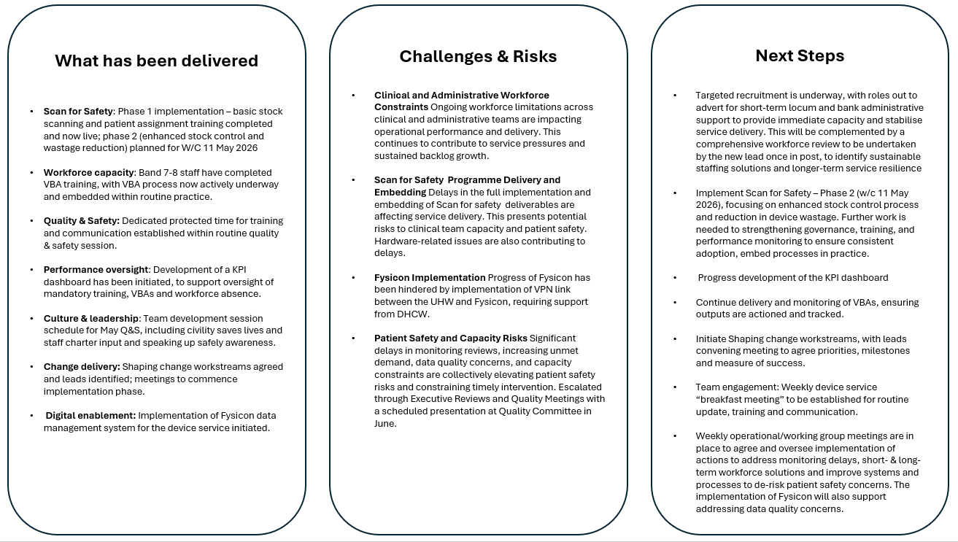
Cardiology Dashboard
A high-level comparison of February 2025 and February 2026 identified measurable improvements across several key workforce performance indicators. This reflects strong engagement and demonstrable progress in addressing several agreed recommendations. To sustain momentum and support ongoing oversight, a dashboard is being developed to provide real-time data. This will be routinely reviewed and monitored through the Directorate Management Team (DMT) forum.
.
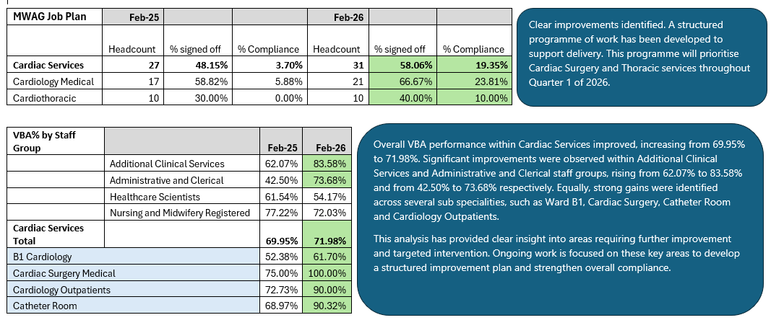
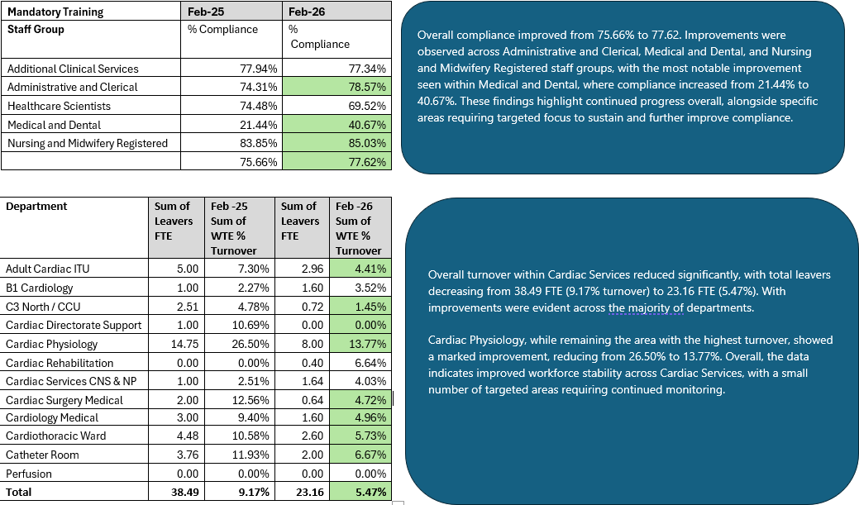

Recommendations Summary
The directorate has moved from recovery to stabilisation, now operating with improved governance, clearer leadership, stronger safety culture, and more consistent workforce processes. The next phase focuses on:
• Embedding cultural change (engagement charter, behavioural frameworks).
• Completing demand and capacity modelling to inform sustainable service design.
• Implementing a formal Quality Management System.
• Advancing service redesign in outpatients, Cath labs, and subspecialist areas.
With these foundations in place, the directorate is positioned to achieve the long‑term aim of a psychologically safe, cohesive, high‑performing cardiology service.
Summary Table:
Status | No. Recommendations
In Progress | 32
Completed | 30
Not Started | 6
De-Scoped | 3

Recommendation Updates
Rec. | Recommendation | Description | Aim | Deliverable Outcomes | Expected Completion Date | Updates | Status
1 | Act on concerns about individuals not aligning with organisational values via appropriate policies. | Throughout the review, the team have identified a small number of individuals who have worked outside the values and behaviours of the organisation. Whilst these individuals will not be individually referred to within the report, an addendum report has been supplied, that outlines the concerning themes and recommendations for action under the appropriate Policies & Procedures. These need to be acted upon. | To address and act upon behavioural concerns identified during the organisational review, ensuring alignment with the organisation’s values and behaviours through appropriate policy-driven actions. | Key behavioural concerns have been identified.  Organisational values and policies are reinforced.  Step are taken to improve accountability. | Thursday, December 31, 2026 | Ongoing process. | In Progress
2.1 | Introduce hot and structured debriefs (e.g. MedTRIM) after challenging clinical events. | The Cardiology Directorate should implement hot debriefs as well as structured debriefs, such as MedTRIM to support improved management, communication, learning and support for teams and individuals following challenging clinical situations. | Strengthen team communication, enhance learning from challenging clinical events, and improve emotional and professional support for staff. | Improved consistency and quality of post-event learning and reflection.  Enhanced team communication and shared understanding following critical incidents.  Better emotional wellbeing and support for staff involved in challenging situations. | Tuesday, September 29, 2026 | A lead has been identified, with a start date expected within the next 2 - 3 months. A Focus Group will be established once the lead is in post. In the meantime, insight and learning from other areas on structured debrief processes is being gathered, with the aim for the Focus Group to review and tailor an approach for Cardiology. A full implementation plan, will also be developed as part of this focus group. | In Progress
2.2 | Provide Civility Saves Lives training across all cardiology staff groups. | The directorate should implement specific training on Civility Saves Lives across all professional groups within in cardiology. | Promote a consistently respectful, supportive, and high-performing team culture within the Cardiology Directorate. | Improved understanding of the impact of behaviours on team performance and patient safety.  Increased confidence among staff to address incivility constructively. Strengthened culture of respect, collaboration, and psychological safety.  Reduction in incidents linked to poor communication or unprofessional behaviours. | Sunday, June 28, 2026 | A Task and Finish Group, chaired by people and Culture has been established; with representatives from all disciplines and Trade Union. The aim of the group is to develop a detailed roll out plan, tailoring the approach to each staff group.  Planned sessions to date: -  18th May 2026  GMC session on Professionalism, including Civility Saves Lives to be held for cardiology consultant team.  7th May 2026  GMC session on Professionalism, including Civility Saves Lives held for cardiac surgery team including surgeons, anaesthetists, scrub team, ODP, perfusion team & trainees. | In Progress
2.3 | Launch simulation training covering technical and non-technical skills, with anaesthetics collaboration. | The directorate should introduce a programme of simulation training with a focus both technical and non-technical skills including human factors and crew-resource management. This should be done in collaboration with the department of anaesthetics. Consideration should be given to external facilitation. | Enhanced clinical performance, teamwork, and patient safety. | Improved technical competence and confidence in managing complex clinical scenarios. Strengthened non-technical skills, including human factors awareness and crew-resource management. | Tuesday, September 29, 2026 | Early planning is underway. Lead and key stakeholders have been confirmed, and a focus group is now being formed to shape the implementation plan. | Not Started
2.4 | Reinforce mandatory WHO checklist use in Cath labs and audit compliance. | The review team recommends that the mandatory use of a WHO checklist is reinforced as standard practice for the Cath labs moving forward and that compliance is audited and monitored. |  |  | Thursday, December 31, 2026 | This recommendation is aligned to the work that is taking place with the WHO collaborative. | In Progress
3 | Conduct demand and capacity review for secondary and tertiary cardiology work. | A specific demand and capacity piece of work considering secondary and tertiary work should be undertaken. So that clarity of expectation can be established regarding work expected of all cardiologists. | Clear and equitable expectations for all cardiologists by completing a comprehensive demand-and-capacity review of secondary and tertiary work. | A clear understanding of the demand placed on cardiology services and the capacity required to meet it.  Transparent expectations for cardiologists regarding their secondary and tertiary workload.  Evidence-based workforce and service planning to support sustainable, equitable distribution of work. | Monday, September 28, 2026 | Update to job-plans underway for all consultants in service, to accurately assess workforce DCC capacity.  Specific pieces of demand/capacity work ongoing within cardiology, including  - Implanted Devices  - GP referral triage  - eAdvice  - PCI & TAVI activity levels  - Interventional cardiology workforce.  . | In Progress
4 | Promote Speaking Up Safely within cardiology. | The review team recommends raising awareness and promoting the use of Speaking Up Safely within Cardiology | To increase awareness and encourage routine use of the Speaking Up Safely process across the Cardiology Directorate. | Improved staff confidence in raising concerns promptly and appropriately. Greater visibility and uptake of the Speaking Up Safely pathway. Enhanced culture of openness, psychological safety, and early problem-identification. | Sunday, June 28, 2026 | Trade unions are holding Speaking up safely sessions. Sessions are planned in May with the GMC and NMC which is part of the formal response. Speaking up safely awareness and promotion will also be discussed and progressed as part of the Civility saves lives Task & Finish Group. | In Progress
5 | Establish a weekly senior clinical meeting to review cardiology business and concerns. | There should be a multidisciplinary senior Clinical meeting supported by the management team which reviews on a weekly basis the business in Cardiology alongside any specific concerns. This meeting should be compulsory and recognised within everybody’s working week as a time commitment | Consistent senior clinical oversight and effective management of Cardiology services. | reliable weekly forum is in place for senior clinicians and management to review service activity, issues, and concerns. Improved communication, coordination, and decision-making across the multidisciplinary team. | Tuesday, May 27, 2025 | The weekly meetings are now taking place as planned: the Friday Consultant Meeting and the Monday DMT meeting. Both are attended by MDT representatives from all professional groups | Completed (Done)
6 | Provide training for handling challenging conversations. | It is recommended that training for managing challenging conversations is put in place for the cardiology team. | Effective capability and confidence in handling challenging conversations. | Increased staff confidence and skill in handling difficult or sensitive conversations. Improved team communication, reducing escalation and unnecessary conflict. Enhanced psychological safety and a more supportive working environment. More consistent, professional approaches to addressing concerns or performance issues. | Sunday, June 28, 2026 | Sessions planned in May 2026 with the GMC and NMC, which is part of the formal response and include training in how to manage difficult conversations. | In Progress
7 | Collaborate with People and Culture team to ensure consistent policy implementation. | It is also recommended that the Cardiology Directorate engage the People and Culture team to review implementation of policies to ensure consistency. | Strengthen the implementation of HR and organisational policies within the Cardiology Directorate, ensuring consistent and fair application. | Greater consistency in how policies are understood, applied, and monitored across Cardiology. Improved confidence among staff and managers in using People and Culture processes. Enhanced fairness, transparency, and trust in decision-making. | Thursday, May 28, 2026 | Training dates are being confirmed, and all staff requiring training will be booked onto the appropriate sessions. The DMT will oversee ongoing review and communication of these dates. A monthly dialogue between Leaders and the People & Culture team is recommended for reinstatement, and a date is needed to establish a recurring monthly drop-in session. | In Progress
8 | Co-produce a unified cardiology vision across all subspecialties and professions. | The review team recommends that there is a co-produced Cardiology vision developed considering all parts and professions of Cardiology in order to draw together the individual subspecialist requirements. | A unified Cardiology vision that reflects the needs, priorities, and aspirations of all subspecialties and professional groups across the Directorate. | A shared, clearly articulated vision that aligns all areas of Cardiology around common goals. | Friday, October 30, 2026 | This is a long-term piece of work and needs to be scoped out and timescales agreed. Link to the charter development. | Not Started
9 | Hold regular senior physiology team meetings with clinical governance focus. | The review team recommends that there is a regular senior team meeting in physiology that encompasses appropriate clinical governance. This should be compulsory for all of the senior team. | Strengthen clinical governance and leadership within Physiology. | A consistent forum is in place for senior physiology staff to review clinical governance, service issues, and priorities. Improved communication, shared decision-making. | Tuesday, September 23, 2025 | March 2026: This has been completed. | Completed (Done)
10 | Undertake organisational development work on team dynamics and behaviour. | The review team recommends that there is a specific piece of work on organisational development of team dynamics and behaviour. | Strengthened team dynamics, behaviours, and collaborative working across the Cardiology Directorate. | Improved interpersonal behaviours and more effective multidisciplinary team working.  Enhanced psychological safety, communication, and trust within and between teams.  A more cohesive, supportive, and high-performing culture across Cardiology. | Sunday, June 28, 2026 | This will be covered in the outputs from recommendation 4 Civility Saves lives. | In Progress
10.1 | Develop an engagement charter with cardiology teams. | Consideration should be given to the development of an engagement charter, co-produced with teams within cardiology. | An Engagement Charter that sets out shared expectations, behaviours, and principles for positive engagement and collaborative working. | A clear, shared framework for how teams engage, communicate, and work together.  Stronger sense of collective ownership and mutual accountability.  More consistent, inclusive, and transparent engagement across the Directorate. |  | This is a long-term piece of work and needs to be scoped out and timescales agreed - Pre cursor to this work is recommendation: 2.2, 4, 6, 10. | Not Started
11.1 | Review and clarify attendance expectations for all cardiology meetings. | The cardiology directorate should review the current programme of regular directorate and clinical meetings and specify expected attendance across staff groups. This needs to include Quality and Safety, Mortality and Morbidity meetings in addition to other directorate meetings and should be benchmarked against other directorates within the Clinical Board and organisation. | Ensure effective governance and consistent engagement across the Cardiology Directorate. | A clear, structured meeting programmes.  Defined attendance expectations for each staff group to support consistent participation. Improved governance, communication, and decision-making across the directorate. | Thursday, February 12, 2026 | Feb 2026: This work has been completed, and the following meetings are now in place:  Quality & Safety Meeting  Mortality & Morbidity Meeting  Interventional MDT Meeting.  In addition, there is a Faculty of Educational Governance (FEG) structure in place. A FEG has been established for Cardiology, Cardiothoracic Surgery, and the Cardiac Surgery MDT Working Group.  The Quality & Safety, Mortality & Morbidity, and Interventional MDT meetings have been operating since February 2025, and the FEG and associated working groups were established in Q1 2026. | Completed (Done)
11.2 | Create standardised meeting etiquette for all professional groups. | There need to be a standardised etiquette for meetings that is shared and understood amongst all professional groups. | Adherence to a standardised etiquette for meetings that is shared and understood amongst all professional groups. |  | Tuesday, May 26, 2026 | SOP developed and circulated with DMT for comments and formal approval. It was formally signed off at the DMT meeting on the 20th of April and subsequently disseminated across the directorate, including publication on the relevant SharePoint pages. | Completed (Done)
12 | Conduct monthly walkarounds by directorate and board management to improve visibility. | It is recommended that there are structured regular (at least monthly) walk arounds by the directorate and clinical board management team to increase visibility and communication. | It is recommended that there are structured regular (at least monthly) walk arounds by the directorate and clinical board management team to increase visibility and communication. | Visibility, accessibility, and communication across Cardiology through structured, regular walkarounds involving the Directorate and Clinical Board management team. | Monday, December 8, 2025 | Feb 2026: A weekly walkaround takes place every Tuesday at 2:30pm. The venue rotates to ensure coverage of the full Directorate footprint. Clinical Board members also participate in walkarounds, either alongside the team or independently. In addition, there have been two visits from the Medical Director’s Office involving senior teams. DMT walkarounds continue to be supported. | Completed (Done)
13.1 | Reinforce WHO checklist use in Cath labs and monitor compliance (duplicate recommendation). | The review team recommends that the mandatory use of a WHO checklist is reinforced as standard practice for the Cath labs moving forward and that compliance is audited and monitored. |  |  |  | This is duplicate of recommendation 2.4. | De-Scoped
13.2 | Standardise COW model delivery to ensure consistent patient and staff experience. | Agree on standardised delivery of COW model based on daily timetable of duties, to ensure consistency of experience for patients, residents, and nursing team. Differential engagement cannot be allowed to continue. | Consistent, reliable, and high-quality experience for patients, residents, and the nursing team by agreeing and implementing a standardised Consultant of the Week model. | A single, standardised Consultant of the Week model is agreed and adopted across the directorate. Consistent consultant engagement and visibility throughout the week. Reduced variation in how duties are delivered, improving continuity of care and team coordination.  Improved experience for patients and clearer expectations for residents and nursing staff. | Sunday, September 28, 2025 | Feb 2026: The COW model is implemented. A clearly defined SOP has been developed and is consistently reviewed, current version 2.0. | Completed (Done)
13.3 | Hold 6-monthly reviews of COW effectiveness with stakeholder feedback. | There should be as a minimum a 6-monthly review with feedback from all stakeholders on the effectiveness of COW. | Effectiveness of COW model is reviewed every 6 months and feedback acted on. | Effective COW model.  Consistent reviews and improvement. | Thursday, October 30, 2025 | Model continues to be updated. Checklist incorporated to daily Board Round to ensure consistency in delivery of Consultant of the Week. | Completed (Done)
13.4 | Assess COW model benefits for cardiology and wider system. | The directorate team should analyse the benefits of the COW model to Cardiology and the wider system. | The impact and value of the Consultant of the Week (COW) model is clearly understood within the wider system. | Clear evidence on how the COW model affects patient flow, safety, staff experience, and system efficiency.  Informed decision-making on the future use or adaptation of the COW model in Cardiology. | Wednesday, January 28, 2026 | The Directorate is supporting the implementation of Ward Standards, as part of Urgent and Emergency Care programme. Plan to implement Standards Bundle on B1 Ward. | Completed (Done)
14 | Make waiting list management engagement mandatory for all consultants. | The review team recommends that engagement in waiting list management is compulsory for all consultants. | Consistent, fair, and effective management of waiting lists. | All consultants actively participate in waiting list management as part of their core duties. Improved equity, timeliness, and oversight of patient scheduling and access to care. Enhanced team coordination and more sustainable management of demand and capacity. | Wednesday, September 23, 2026 | The consultant team has commenced active triage of GP referrals, supported by planned sessions, and condition specific pathway development is in progress. Operational data is being generated to inform waiting list management. While progress is evident, further work is required to secure sustained and measurable improvement. | In Progress
15 | Require evidence of mandatory training completion during appraisal/job planning. | The directorate should require evidence of completion or mandatory training by all employees as part of the appraisal or job-planning process. | Increased and sustained compliance with mandatory training across all staff groups. | Improved assurance of workforce competence, safety, and regulatory alignment. Greater accountability through consistent inclusion of training compliance in appraisal and job-planning discussions. Reduced organisational risk linked to missed or overdue mandatory training. | Friday, March 20, 2026 | March 2026: Mandatory training is incorporated into the job planning process, and all required training must be completed before the job plan review takes place. Monitoring systems are already in place, and therefore this recommendation is agreed as complete. | Completed (Done)
16 | Include equity as a standing agenda item in directorate meetings. | It is recommended that the directorate include an agenda item through their directorate meetings that covers equity for Staff. Variation should be limited where possible, and equity pursued in all aspects. | Equity is consistently considered, monitored, and embedded across all aspects of the Cardiology Directorate. | Increased visibility and prioritisation of equity issues affecting staff.  Strengthened culture of inclusivity and consistency across all Cardiology teams. | Monday, February 2, 2026 | Feb 2026: This has been completed and all groups are included. | Completed (Done)
17 | Implement leadership and management training across the directorate. | Leadership should be the responsibility of a team. A programme of management and leadership training including organisational architecture, should be implemented for the whole directorate. | To embed a shared, team-based approach to leadership across the Cardiology Directorate. | Stronger collective leadership, reducing reliance on individuals and improving resilience. Consistent leadership capability across professional groups and subspecialties. Improved understanding of organisational structures, roles, and governance pathways. |  | Further work is underway to expand the clinical leadership structure within cardiology, including defining new consultant leadership roles and appointing an interim Clinical Director. This builds on the 24 March 2026 progress, where leadership development initiatives were being implemented, supported by a suggested TNA and broader opportunities across the team. With the recommendation now closed, ongoing leadership development and monitoring will transition into normal VBA and business as usual activity. | Completed (Done)
18 | Redesign cardiology leadership model with clear roles and responsibilities. | The leadership model should be redesigned for Cardiology. As part of this Physiology should have a single lead individual with the appropriate clinical background and managerial capability. Within the medical group a leadership team should be formalised with a single clinical director. There are a number of options to fulfil this team approach with either subspecialty leads or leads for functions within the department. Any extra SPA should only be allocated to job plans once the sessions highlighted above are prioritised. | A resilient team-based structure that supports effective decision-making and service delivery. | A strengthened, clearly defined leadership structure for Cardiology.  A single, clinically, and managerially competent lead for Physiology to support cohesive direction and professional oversight. A formalised medical leadership team with a designated Clinical Director and agreed leadership roles. Improved clarity of responsibilities across subspecialty or functional leadership areas. |  | March 2026: The leadership model has been defined. There is an educational lead, Clinical Audit lead, Morbidity and Mortality lead in place which are evolving roles. Physiology Clinical lead appointed. | Completed (Done)
19.1 | Review demand and capacity assumptions with Cardiff University for future planning. | The directorate and clinical board need to review the demand and capacity work with Cardiff university to ensure that the assumptions are correct going forward. They currently assume no change in practice. This should inform a rightsizing piece of work for Cardiology. |  |  |  | This recommendation will be covered in recommendation 3. Demand and Capacity review. | De-Scoped
19.2 | Improve outpatient pathways and primary care interface in line with best practice. | Within Outpatients the adoption of pathways and the role of interface with primary care needs consideration linking to best practice in Wales and the UK. | Improved outpatient effectiveness and patient flow by reviewing and adopting best-practice pathways and strengthening the interface with primary care, ensuring alignment with leading models in Wales and the UK. | Outpatient pathways are clearer, more consistent, and aligned with national best practice.  Stronger and more efficient communication and collaboration with primary care.  Reduced unnecessary referrals and improved appropriateness of patients seen in secondary care. Improved patient experience through more streamlined and predictable pathways.  Better use of outpatient capacity, supporting timelier access and service sustainability. | Wednesday, December 30, 2026 | This is in progress since September 2025, scope includes: development of a discreet patient pathways for conditions and enhanced triage for management of GP referrals. | In Progress
19.3 | Review pacing lab infrastructure ahead of move to theatre 6. | The current infrastructure of the pacing lab has been reported to be suboptimal and should be reviewed in line with its planned move to theatre 6. | Pacing lab meets clinical, safety, and operational requirements. | Clear identification of current infrastructure limitations and required improvements. A defined plan aligning pacing lab facilities with the capabilities of Theatre 6. A smooth and well-coordinated transition that minimises disruption to pacing procedures. | Tuesday, July 28, 2026 | This is partially completed: The pacing lab has moved to the short stay surgical unit. | In Progress
19.4 | Develop expansion plan based on demand and capacity data, including 7-day working. | Demand and capacity information should be acted upon and a coherent plan developed for expansion. This should include options for 7 day working and/or expansion. Within this links should be made to the wider availability of imaging equipment in the health board. | Demand and capacity information to develop a coherent, future-focused expansion plan for the service. | Clear understanding of current and future demand on the service. An evidence-based plan outlining expansion options, including 7-day working. Improved alignment with imaging availability across the health board. Enhanced capacity and patient flow through more efficient use of resources. | Thursday, December 31, 2026 | 2 NHS locum interventional consultants appointed to increase commissioned PCI activity; team exploring option for bank holiday lists and Saturday lists. | In Progress
20 | Review and improve cardiology stock management and procurement processes. | The review Team recommends that there is an entire review of the stock management and procurement process (including scan for safety) in cardiology so that the process is made safe and efficient. | Stock management and procurement within Cardiology is safe, efficient, and well-controlled. | Clear identification of weaknesses and risks within current stock management and procurement processes. A streamlined, standardised, and safer stock management system, supported by Scan for Safety principles. Reduced waste, improved traceability, and more efficient use of resources. Improved availability of essential equipment, supporting smoother clinical workflows and patient car. | Tuesday, September 29, 2026 | First draft of improvement plan in relation to stock management and prohibited use of expired devices completed. Scan for safety - basic scanning of stock and assign to patient training completed, this process is now underway. Phase two planned for w/c 11/05/2026 stock management and wastage. | In Progress
21 | Review on-call arrangements across all professions for safety and consistency. | The cardiology directorate should conduct a review of on-call arrangements across all professions to ensure consistency, sustainability, and safe practice across all specialties. | On-call arrangements across all professional groups within Cardiology are consistent, sustainable, and safe practice across all sub-specialties. | Clear understanding of current on-call models.  More consistent and equitable on-call arrangements. | Friday, October 30, 2026 | Complete a review of the current on-call arrangements and present findings. Work is underway and will require consistent evaluation. This will transition into business-as-usual activity. Project team need to identify at which point that the recommendation can be closed. | In Progress
22.1 | Conduct job planning for consultant workforce to reflect all work types. | Cardiology Directorate to conduct job-planning exercise for the cardiology consultant workforce, to reflect clinical & non-clinical work. | All job plan reviewed and updated to reflect clinical and non-clinical work. | Transparent, consistent job plans that reflect the full scope of consultant activity, including clinical commitments, leadership roles, teaching, training, and SPA time. Improved alignment between consultant capacity and service requirements, supporting safe and sustainable delivery. Greater clarity on expectations, responsibilities, and protected time for non-clinical work. Enhanced ability to plan, monitor, and optimise consultant workforce resource. | Wednesday, September 30, 2026 | Job planning is currently underway, with a primary focus on cardiac and thoracic surgery. All job plans are scheduled over the next three months. Next steps: - Completion of job planning for Cardiac and thoracic teams and agree next priority area. | In Progress
22.2 | Facilitate job planning meetings to align consultant work with departmental needs. | Job-planning meetings to be facilitated by Clinical Director and General Manager for cardiology to ensure that the needs of the department match the work being asked of consultants. | Job plans are aligned to departmental needs by facilitating structured job-planning meetings. | Clearer expectations and shared understanding between consultants and management regarding clinical and non-clinical commitments. Strengthened collaboration and transparency in the job-planning process. | Tuesday, September 30, 2025 | March 2026: This is completed - Job planning meetings are jointly delivered by the Clinical Director and General Manager. 14/04 - in line with 22.1. | Completed (Done)
22.3 | Ensure all job plans are current and signed off in Allocate system. | All job plans should be up to date and signed on Allocate system so that consultant work can be delivered efficiently and in a way that supports good service delivery. | Consultant job plans are current, accurate, and formally signed off within the Allocate system. | All consultant job plans up to date and approved on Allocate, providing a single, accurate source of workforce information. Improved efficiency and coordination of consultant activity through clearer, validated job-plan data. Enhanced ability to match consultant capacity to service needs, improving operational performance.  Greater transparency and assurance around consultant commitments and resource utilisation. | Wednesday, September 30, 2026 | In progress. 14/04/ - In line with 22.1. | In Progress
22.4 | Define SPA activity clearly and align non-core SPA with directorate goals. | Ensure SPA activity is well-defined within individual job plans and non-Core SPA activity is aligned with the objectives and goals of the directorate. Priority SPA should be assigned first as detailed above. | SPA activity is clearly defined within individual job plans, with non-core SPA time. | Clear distinction between core and non-core SPA activities in all job plans.  Directorate objectives are supported through aligned non-core SPA activities.  Improved transparency and consistency in SPA allocation across the workforce. | Wednesday, September 30, 2026 | In progress. 14/04- In line with 22.1. | In Progress
22.5 | Standardise core SPA allocation to 1.5 sessions for full-time consultants. | Standardise Core SPA allocation to 1.5 sessions for all full-time consultants. | Create consistency, equity, and clarity across consultant job plans by standardising Core SPA allocation to 1.5 sessions for all full-time consultants. | Consistent application of Core SPA time across all full-time consultant roles.  Improved transparency and fairness in job planning. | Monday, September 29, 2025 | Feb 2026: All fulltime consultants have 1.5 session allocated for Core SPA as per the Welsh Consultant Contract. This has been defined within Allocate job planning records as job plans are updated. | Completed (Done)
22.6 | Use SMART objectives in Allocate to define non-core SPA responsibilities. | Use the Personal Outcomes section of Allocate job plan to define responsibilities and output for Non-Core SPA, using SMART objectives. | Personal Outcomes section in Allocate is used and responsibilities are clearly defined. | Non-Core SPA responsibilities are transparent and consistently documented.  SMART objectives provide measurable outputs and clearer expectations.  Improved alignment of SPA activity with directorate and organisational priorities.  Enhanced ability to monitor progress and evidence achievement of Non-Core SPA work. | Wednesday, September 30, 2026 | This is in progress. As we job plan with Consultants - the Personal Objectives section is being updated. 14/04 - In line with 22.1. | In Progress
22.7 | Share DCC tariffs and job plan details on SharePoint for transparency. | Sharing of DCC tariffs and details within job plans on directorate SharePoint or Intranet page should be considered to demonstrate transparency, fairness, and equity. | Transparency, fairness, and equity in job planning by sharing DCC tariffs and related job plan details on the Directorate SharePoint or intranet. | Staff have clear visibility of DCC tariffs and how they are applied in job plans.  Increased trust and confidence in job-planning processes through openness and consistency. | Wednesday, August 26, 2026 | This is linked to the job planning recommendations in Foundations for change phase. | Not Started
22.8 | Update job plans to reflect correct on-call banding. | All job-plans updated on Allocate to reflect correct on-call banding | To ensure accuracy, consistency and compliance in job planning by updating all job plans on Allocate to reflect the correct on-call banding. | All consultant job plans display correct and up-to-date on-call banding.  Improved accuracy in workforce data, job planning, and rota management.  Reduced discrepancies in pay, workload expectations, and contractual compliance.  Enhanced transparency for consultants, managers, and workforce teams. | Monday, June 29, 2026 | This is in progress. | In Progress
22.9 | Conduct diary exercise to ensure on-call allowances match service demands. | Conduct diary exercise for interventional and non-interventional cardiologist groups to ensure on-call sessional allowance accurately reflects service demands. The intensity of the on call should be reflected in the job plan to ensure adequate rest. | On-call sessional allowances accurately reflect the true intensity and demands of the service. | Accurate representation of on-call workload for both interventional and non-interventional teams. Fair and evidence-based sessional allowances aligned to actual service intensity. Greater transparency and equity in on-call arrangements across consultant groups. |  | This recommendation is aligned to the Cath Lab transformation programme. | Not Started
23 | Ensure VBA completion at all levels as a supervisory priority. | The Management team should ensure completion of VBAs at all levels to ensure equity and this needs to be a key objective of everyone in a supervisory role. | Fairness, consistency, and accountability across the directorate by achieving full completion of VBAs at all levels. | Increased equity and standardisation in staff appraisal and development.  Clear accountability for supervisors in completing and maintaining VBAs.  Improved oversight of performance, development needs, and workforce planning | Wednesday, May 27, 2026 | VBA training has been successfully completed for Band 7 and Band 8 staff, with the next phase focusing on rollout to Band 6 colleagues. VBA performance data continues to be reviewed monthly at DMT meetings, ensuring ongoing oversight and accountability. A workforce performance dashboard is currently in development to provide real-time visibility and enhance monitoring within DMT forums. Comparative analysis against the previous year demonstrates overall improvement, while also identifying hotspot areas requiring targeted intervention and further support. Ongoing engagement with these hotspot areas is in place to drive continuous improvement. | In Progress
24 | Allocate staff to lead physiologists for fair VBA supervision. | The allocation of staff to each lead physiologist for the purpose of VBA supervision should be addressed so that it is consistent and ensures fairness and equity of workload. | Equitable and consistent performance management by achieving full completion of VBAs at all levels. | VBA completion becomes standard practice across the directorate. Greater consistency and fairness in staff appraisal and development. Clear accountability for supervisors in meeting appraisal expectation. | Monday, March 30, 2026 | VBA training for Band 8a staff has been provided. Meeting has been arranged with the Band 7 staff to discuss their training/support needs. A timetable will be produced by end of March, and the weekly monitoring is in place. | In Progress
25 | Embed escalation tracking and clarify accountability for action plans. | The review team recommends that a process is embedded with the directorate and clinical board to track escalations and decisions. Aligned to this there needs to be greater clarity on accountability for the completion of action plans from inspections. It is best done within the performance review process and the outcome of this needs to be visible to all of the teams within Cardiology and to the executive team. This work should be aligned to the development of the quality management system (recommendation 36). | Clear and accountable process for tracking escalations and decisions across the Directorate and Clinical Board. | Escalations and decisions are consistently tracked and visible to Cardiology teams and the executive. Clear accountability for completing inspection-related action plans. Improved governance through integration with the performance review process. Stronger alignment with the quality management system to support sustained improvement. | Monday, September 29, 2025 | Update 18th Feb 2026: Operational escalations and decisions are managed through the DMT, with actions tracked via meeting minutes and action log. Inspections from HEIW and queries from the JCC are overseen collaboratively by the clinical teams and the DMT, with regular written reports provided to both partner organisations. These processes have strengthened governance within the DMT and improved links with the clinical teams. | Completed (Done)
26 | Hold monthly Quality & Safety meetings with full attendance and minutes. | Directorate Quality and Safety meetings must be held at least monthly, to be chaired by the directorate Q&S lead, be fully minuted and should require attendance by all clinical and management staff; all non-emergency work should be cancelled to facilitate attendance. | Consistent, high-quality governance by holding monthly Directorate Quality & Safety meetings that are fully minuted, chaired by the Q&S lead, and attended by all clinical and management staff. | Regular, well-governed Q&S meetings take place with full attendance and clear documentation. Improved oversight, transparency, and shared accountability for quality and safety across the directorate. | Wednesday, May 28, 2025 | Feb 2026: The Q&S lead was appointed in 2025, and meetings have been set with a clear agenda. | Completed (Done)
27 | Include thematic analysis of concerns and incidents in Q&S meetings. | Thematic analysis of patient concerns, clinical incidents and nationally reportable incidents should be a standing agenda item at directorate Q&S meetings. | Strengthened governance and learning by making thematic analysis of patient concerns, clinical incidents, and nationally reportable incidents. | Regular thematic analysis informs decision-making and improvement actions. Earlier identification of trends, risks, and recurring issues. Enhanced transparency, shared learning, and accountability across the directorate. | Thursday, January 29, 2026 | Feb 2026: A rolling agenda programme has been established for DMT meetings, and Quality & Safety issues can be raised at any meeting. In addition, one DMT meeting each month is dedicated specifically to a Quality & Safety agenda. | Completed (Done)
28 | Improve clinical incident reporting across the directorate. | A programme of improving clinical incident reporting should be implemented by the directorate. | Strengthen patient safety and learning by implementing a directorate-wide programme that improves the quality and frequency of clinical incident reporting. | Increased and more consistent reporting of clinical incidents across all services.  Improved understanding of themes, risks, and learning opportunities.  Enhanced safety culture through proactive identification and management of issues. | Sunday, January 31, 2027 | March 2026: Datix reporting has increased, with more staff now able to access and lead on Datix processes. Our partnership with Patient Safety has strengthened, and managers are being well supported to use Datix effectively. | Completed (Done)
29 | Foster a just culture to support transparency and care improvement. | A supportive, just culture should be fostered to encourage transparency and a commitment to improving care. | A supportive, just culture that encourages openness, learning, and shared responsibility, enabling staff to feel safe to speak up and committed to improving care. | Update 24th March 2026: | Sunday, March 29, 2026 | March 2026: Trainees are increasingly speaking up, with appropriate actions taken in response to issues raised. Senior teams Walk-abouts take place every Tuesday, and Safe to Speak Up awareness has increased significantly. There has also been an increase in executive walkabouts and incident reporting. Trade Union drop-ins have expanded, and key messages are now incorporated into staff induction. There is a consistent flow of engagement through the SharePoint site. Weekly cardiology trainee feedback surveys are in place, and stakeholder groups are being actively used as part of senior appointment and interview processes. | Completed (Done)
30 | Update cardiology risk register to reflect current service risks. | Update Directorate’s risk register to reflect current risks across all components of the cardiology and cardiac Physiology service. | Effective governance and oversight by updating the Directorate risk register so it accurately reflects current risks across all areas of the Cardiology and Cardiac Physiology service. | A comprehensive and up-to-date risk register covering all components of the service. Improved visibility of emerging and ongoing risks to support informed decision-making. Strengthened assurance and accountability through accurate monitoring and mitigation of key risks. | Thursday, November 27, 2025 | Feb 2026: The risk register has been updated, and all risk will be transferred to AMaT where risks will be managed electronically. | Completed (Done)
31 | Make risk register a standard item in Q&S meetings. | Include risk register as a standard agenda item on every quality and safety meeting for cardiology directorates. | Strengthen governance and ensure consistent oversight by making the Directorate risk register a standing agenda item at every Cardiology Quality & Safety meeting. | Regular review of risks enhances awareness, accountability, and timely mitigation. Improved visibility of emerging and ongoing risks across the directorate. Stronger, more reliable Quality & Safety governance through consistent monitoring. | Friday, January 30, 2026 | March 2026: Dave Hanna will speak to Richard Wheeler regarding adding this to the Q&S agenda. High scoring risks are on the meeting agenda. All trained using AMaT. It is an agenda item on the DMT meeting. Based on recognition that this is the best place for it. | Completed (Done)
32.1 | Review NRIs from 2019–2024 and address outstanding actions. | Directorate team to review all NRIs between 2019 and 2024 and identify any actions which have not been implemented. | Learning, assurance, and improved safety by reviewing all NRIs from 2019–2024 and identifying any actions that remain outstanding. |  | Sunday, March 29, 2026 | March 2026: This is part of the Q&S function. Also, agenda item in DMT, Monthly meetings with Patient Safety to ensure compliance. Further training for DMT delivered. NRI's fed through Monthly Q&S. | Completed (Done)
32.2 | Provide evidence of implementing Learning Review recommendations. | Directorate to provide evidence of implementation of recommendations of Learning Reviews. | Strengthened governance and assurance by implementing all recommendations arising from Learning Reviews. | Documented evidence confirming that Learning Review recommendations have been acted on and embedded in practice. Improved organisational learning and accountability.  Greater assurance that identified risks have been addressed and patient safety has been enhanced. | Tuesday, June 29, 2027 | March 2026: This is in progress and part of the scope for the QMS prototyping. | In Progress
33 | Adopt EU Whiteboard or similar for acute cardiology referrals. | Adoption of EU Whiteboard, or similar, for all acute referrals from emergency unit to cardiology. | Improve visibility, safety, and coordination of acute referrals from the Emergency Unit to Cardiology. | All acute cardiology referrals are logged, visible, and tracked in real time. Improved communication and handover between Emergency Unit and Cardiology teams. Reduced missed or delayed referrals and enhanced patient flow. | Wednesday, April 29, 2026 | The infrastructure is in place; software has been installed on ward pc's - Cardiology formally went live on 1st April. Baseline data has been captured to support the measurement of improvement. Work is ongoing with IT development team to establish a separate reporting stream for cardiology and thoracic, which are currently combined within the dataset. Usage and demand will continue to be monitored are reviewed. | Completed (Done)
34 | Review workload of on-call cardiology registrars. | Directorate to conduct review of workload of on-call cardiology registrars (highlighted as an ongoing issue during Review). | Safe, sustainable, and equitable workload for on-call cardiology registrars. | Clear understanding of registrar on-call workload, pressures, and risk areas. Evidence-based actions identified to improve rota sustainability and wellbeing. | Wednesday, December 30, 2026 | To support the development of this recommendation, Cardiology went live on the 1st of April with consistent use of E-whiteboard system. Baseline performance and usage data have been reviewed and will be tracked to measure implementation success. Work is ongoing with the IT Development Team to create separate streams for cardiology and thoracic services, to provide accurate data streaming. Next Steps - Continue to monitor system usage and data collection. A minimum of 3-4 months data is required to support further development of this recommendation. | In Progress
35.1 | Appoint Q&S lead to review audit programmes and ensure compliance. | A review of local and national audit programmes should be conducted by a newly appointed lead for Quality and Safety within the Cardiology Directorate and a plan implemented for ensuring compliance which includes job planned time and evidence of consistent contribution. | Strengthened governance, assurance, and compliance by reviewing all local and national audit programmes. | Comprehensive understanding of current audit activity, gaps, and compliance levels.  Clear expectations for audit participation supported by job-planned time. Consistent and evidenced contribution to audit across the directorate.  Improved alignment of audit activity with quality, safety, and service priorities. | Thursday, December 31, 2026 | This is in progress; part of Q&S programme and QMS prototype programme; Devices workstream examining mechanisms for automating dataflow to NICOR dataset for Device. | In Progress
35.2 | Make audit a fixed agenda item in Q&S meetings. | Local and National audit should be a fixed agenda item on the regular directorate Quality and Safety meetings. | Local and National audits are a fixed agenda on the Directorate Quality and Safety meetings. | Regular, structured review of audit activity and findings.  Improved assurance that audit actions are tracked, completed, and inform quality improvement. Enhanced visibility of audit priorities and compliance across the directorate. | Friday, May 29, 2026 | Audit presentation within the Q&S is now in place. Additional work is required to formally agree the national and local audits in place and to establish how these are embedded within the directorate Q&S forum, to ensure a consistent and robust approach. | In Progress
35.3 | Use local audit to target areas needing improvement. | The local audit programme should be used to target areas of practice or outcomes which are believed to require improvement or have been a contributing factor to poor patient outcomes or reported incidents. | Local audit programme is used proactively to identify and address areas of practice or outcomes that require improvement. | Audit activity is targeted at priority areas where improvements are needed. Clear identification of practice issues contributing to adverse outcomes or incidents. Evidence-based actions are developed to address gaps and strengthen patient care.  Improved quality, safety, and consistency of clinical practice across the directorate. | Tuesday, June 30, 2026 | This is in progress and part of the scope for the QMS prototyping. | In Progress
36 | Develop a quality management system to sustain improvements. | Considering the extent of work required to improve the quality and safety processes and the recommendations within this review there is an opportunity to embed a quality management system to sustain the changes required. This should be developed in line with how responses to regulatory inspections are managed within other parts of the organisation. | Established and sustainable quality management system that supports ongoing improvements in quality and safety and aligns with organisational approaches to regulatory oversight. | A structured and sustainable quality management system is in place to support continuous improvement. Improvements identified in the review are embedded and maintained over time. | Monday, May 31, 2027 | This is in progress and part of the scope for the QMS prototyping. | In Progress
37 | Assign named clinical supervisors to resident doctors. | Each resident doctor working in the cardiology department to have a named clinical supervisor who is a consultant cardiologist and who will conduct formal clinical supervision meetings during the period of the resident doctor’s rotation in Cardiology. | Resident doctors in Cardiology receive consistent, high-quality supervision by assigning each a named consultant cardiologist. | Every resident doctor has a clearly identified clinical supervisor.  Regular, documented supervision meetings take place, supporting development, performance, and patient safety. | Thursday, December 4, 2025 | Feb 2026: This has been completed. | Completed (Done)
38 | Include Speaking Up Safely in resident doctor induction. | Resident doctor induction to include session of Speaking Up Safely, including how to use this service. | Increased awareness and encouraged routine use of the Speaking Up Safely process across the Cardiology Directorate. | Improved staff confidence in raising concerns promptly and appropriately.  Greater visibility and uptake of the Speaking Up Safely pathway.  Enhanced culture of openness, psychological safety, and early problem-identification. | Monday, June 29, 2026 | This is in progress. | In Progress
39 | Continue weekly SHO feedback, collated by non-clinical staff. | Continue weekly SHO feedback questionnaire but results to be collated by non-clinical team members e.g. directorate managers. | Strengthened learning and improve supervision by continuing the weekly SHO feedback questionnaire. | Consistent collection and objective collation of SHO feedback.  Improved oversight of trainee experience and identification of issues or themes. More reliable data to inform service improvements and support clinical teams. | Monday, March 30, 2026 | March 2026: Work has begun, and the feedback questionnaire is already in place. The platform is being moved to Microsoft Forms and will be managed by the DMT team, removing the risk of bias associated with the process being led by the consultant team. This has restarted on 20th March 2026. | Completed (Done)
40 | Share planned cardiology investments with HEIW. | Health Board to share details of any planned investments in the cardiology service with HEIW e.g. 4th Catheter Laboratory, further consultant recruitment. | Support strategic workforce and service planning by ensuring the Health Board shares details of any planned investments in the cardiology service. | HEIW has clear visibility of planned service developments and investment priorities. Improved alignment between workforce planning, training capacity, and future service needs. Stronger collaboration between the Health Board and HEIW, supporting sustainable service growth. | Monday, September 29, 2025 | March 2026: This is now complete. Six-monthly meetings with HEIW are underway, and pre-meeting reports are being submitted in advance, providing updates on service improvements and progress against recommendations. | Completed (Done)
41 | Ensure equal access to learning in pacing, intervention, and electrophysiology. | Ensure there is unimpeded access to learning opportunities in pacing, interventional cardiology, and electrophysiology for resident doctors, irrespective of which operator is leading the procedure. | Resident doctors have full and equitable access to learning opportunities in pacing, interventional cardiology, and electrophysiology, regardless of which operator is leading the procedure. | Resident doctors can attend and learn from procedures without restriction or variability.  Improved, consistent training exposure across all key cardiology subspecialties.  A fair and supportive learning environment that maximises educational opportunities for all residents. | Monday, September 29, 2025 | Feb 2026: This has now been completed. | Completed (Done)
42 | Formalise mitigations if training is limited by service capacity. | Ensure mitigations are formalised and in place if service capacity is limiting training opportunities e.g. in ablation | Ensure training opportunities are maintained despite service capacity constraints |  | Monday, March 1, 2027 | March 2026: There is currently no electrophysiology trainees allocated to UHW, in view of limited training opportunities however we are appointing a 3rd ep consultant which will improve training opportunities. Date for new consultant 22 March 2026. | Completed (Done)
43 | Update and maintain online Cardiology Handbook. | Update Cardiology Handbook online and ensure regular updates | Staff have access to accurate, up-to-date online Cardiology Handbook | The Cardiology Handbook is current, accurate, and reflects best practice.  Staff have reliable access to essential clinical and operational information.  A regular update schedule is in place, ensuring information remains relevant over time. | Monday, December 7, 2026 | All SOPs and guidelines are currently going through a process of review, audit, and updating as part of the Q&S and QMS work. | In Progress
44 | Migrate content of Cardiology Handbook for Cardiology onto a SharePoint page and EOLAS app to enable ease of access for residents. | Migrate content of Cardiology Handbook for Cardiology onto a SharePoint page and EOLAS app to enable ease of access for residents. | The Cardiology Directorate must complete a comprehensive review of on-call arrangements across all professional groups to ensure that practice is consistent, sustainable, and safe for all specialties. | Cardiology Handbook content fully migrated to SharePoint and EOLAS. Staff awareness and access enabled across both platforms. Process in place for ongoing updates and content governance. |  | In progress, migration of the Cardiology Handbook to SharePoint underway. | In Progress
45 | Formalise cover for registrar bleep during out-of-hours sickness. | Formalise arrangement for covering Cardiology registrar bleep if there is sickness during the out of hours period | Safe and consistent out-of-hours cardiology cover for registrar bleep cover during sickness absence. | Clear, reliable processes are in place for covering the cardiology registrar bleep during out-of-hours sickness.  Reduced risk to patient care through uninterrupted clinical cover. Improved clarity and confidence for staff regarding escalation and rota arrangement. | Tuesday, April 28, 2026 | March 2026: This is in progress - discussions are taking place. | Completed (Done)
46 | Ensure fair outpatient workload between consultants and residents. | Ensure equity of workload between consultants and residents in outpatient clinics. | Fair and balanced distribution of outpatient clinic workload between consultants and residents. | Workload is shared equitably, improving efficiency and team cohesion.  Residents receive appropriate training opportunities without being overburdened. Consultants have clearer, more balanced clinic responsibilities aligned to service needs | Thursday, October 30, 2025 | Feb 2026: Completed SOP has been produced. | Completed (Done)
47 | Share Wednesday teaching topics in advance and align with junior needs. | Ensure topics & programme for weekly Wednesday teaching sessions provided by ward registrars are circulated in advance and align with learning needs of junior residents. | Weekly Wednesday teaching sessions are well-planned and aligned with junior residents’ learning needs by circulating topics and the programme in advance. | Teaching topics and schedules are shared ahead of time, improving preparation for all attendees. Sessions consistently reflect the educational needs of junior residents. Enhanced quality, relevance, and engagement in weekly teaching. | Monday, June 29, 2026 | Multiple education opportunities available for trainees in the week; these include regular scheduled teaching such as echo and Friday academic meeting which has its agenda circulated in advance. Weds teaching sessions depend on composition of clinical teams on the ward, area of expertise and patient caseload, this will remain the team will retain flexibility around teaching topics each week. | In Progress
48 | Consider moving junior doctor start time to 08:00 to match consultants. | Consider moving SHO/junior doctor start times to 0800hrs in line with consultants and other inpatient specialties (would enable attendance at some 0800hrs teaching sessions where service constraints permit and facilitate finish at 1600hrs). |  |  |  | Feb 2026: This is de-scoped because the current SHO rota is designed to align with the cardiology service model, including the 09:00 board round each morning. | De-Scoped
49 | Maintain and circulate weekly calendar of training opportunities. | Directorate team to maintain calendar detailing training opportunities including theatre lists, multi-disciplinary team meetings, educational meetings, academic meeting, trainee forums and circulate to resident team on a weekly basis. | Awareness and uptake of training opportunities is increased by maintaining a weekly calendar of theatre lists, MDT meetings, educational sessions, academic meetings, and trainee forums, and circulating it to the resident team. | Residents receive timely, clear information on all available training opportunities each week. Improved attendance and engagement in educational and clinical training activities.  More equitable access to learning opportunities across the resident team.  Better planning and integration of training within clinical commitments. | Saturday, September 5, 2026 |  | Not Started

Appendix 1: Project Framework and Governance
To support effective delivery of the Cardiology Improvement Programme, a pillar‑based governance and delivery framework has been adopted. This approach provides a clear, structured method for organising a complex programme of work and ensures that delivery remains aligned to strategic priorities while supporting strong oversight and assurance.
The Cardiology Review recommendations have been divided into three pillars to enable clear delivery and logical sequencing of the work. This approach provides structure, clarity, and strong governance, ensuring recommendations are aligned, manageable and delivered in a coordinated way.

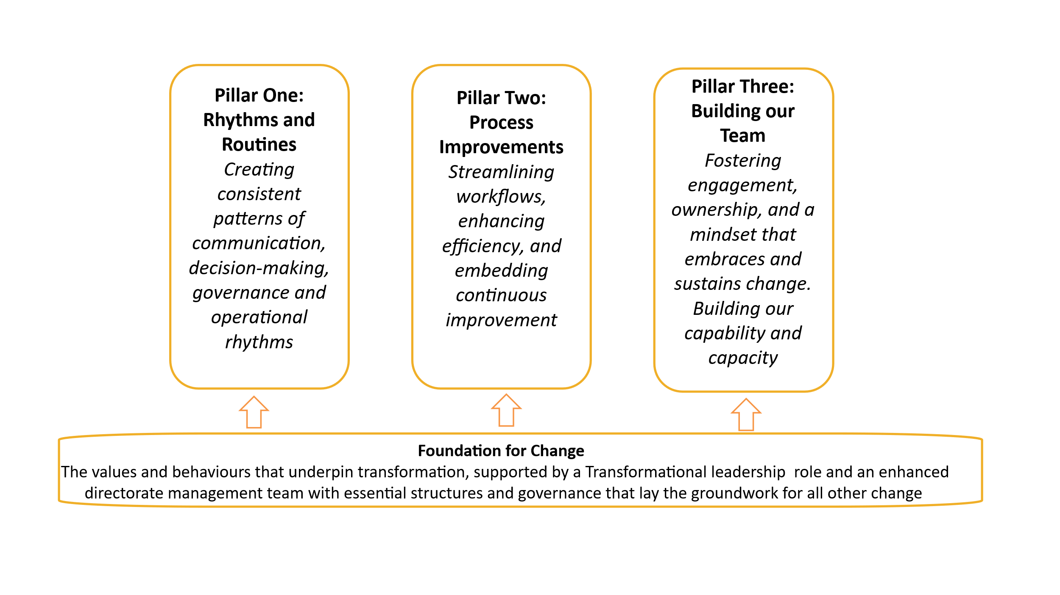

Governance Framework:
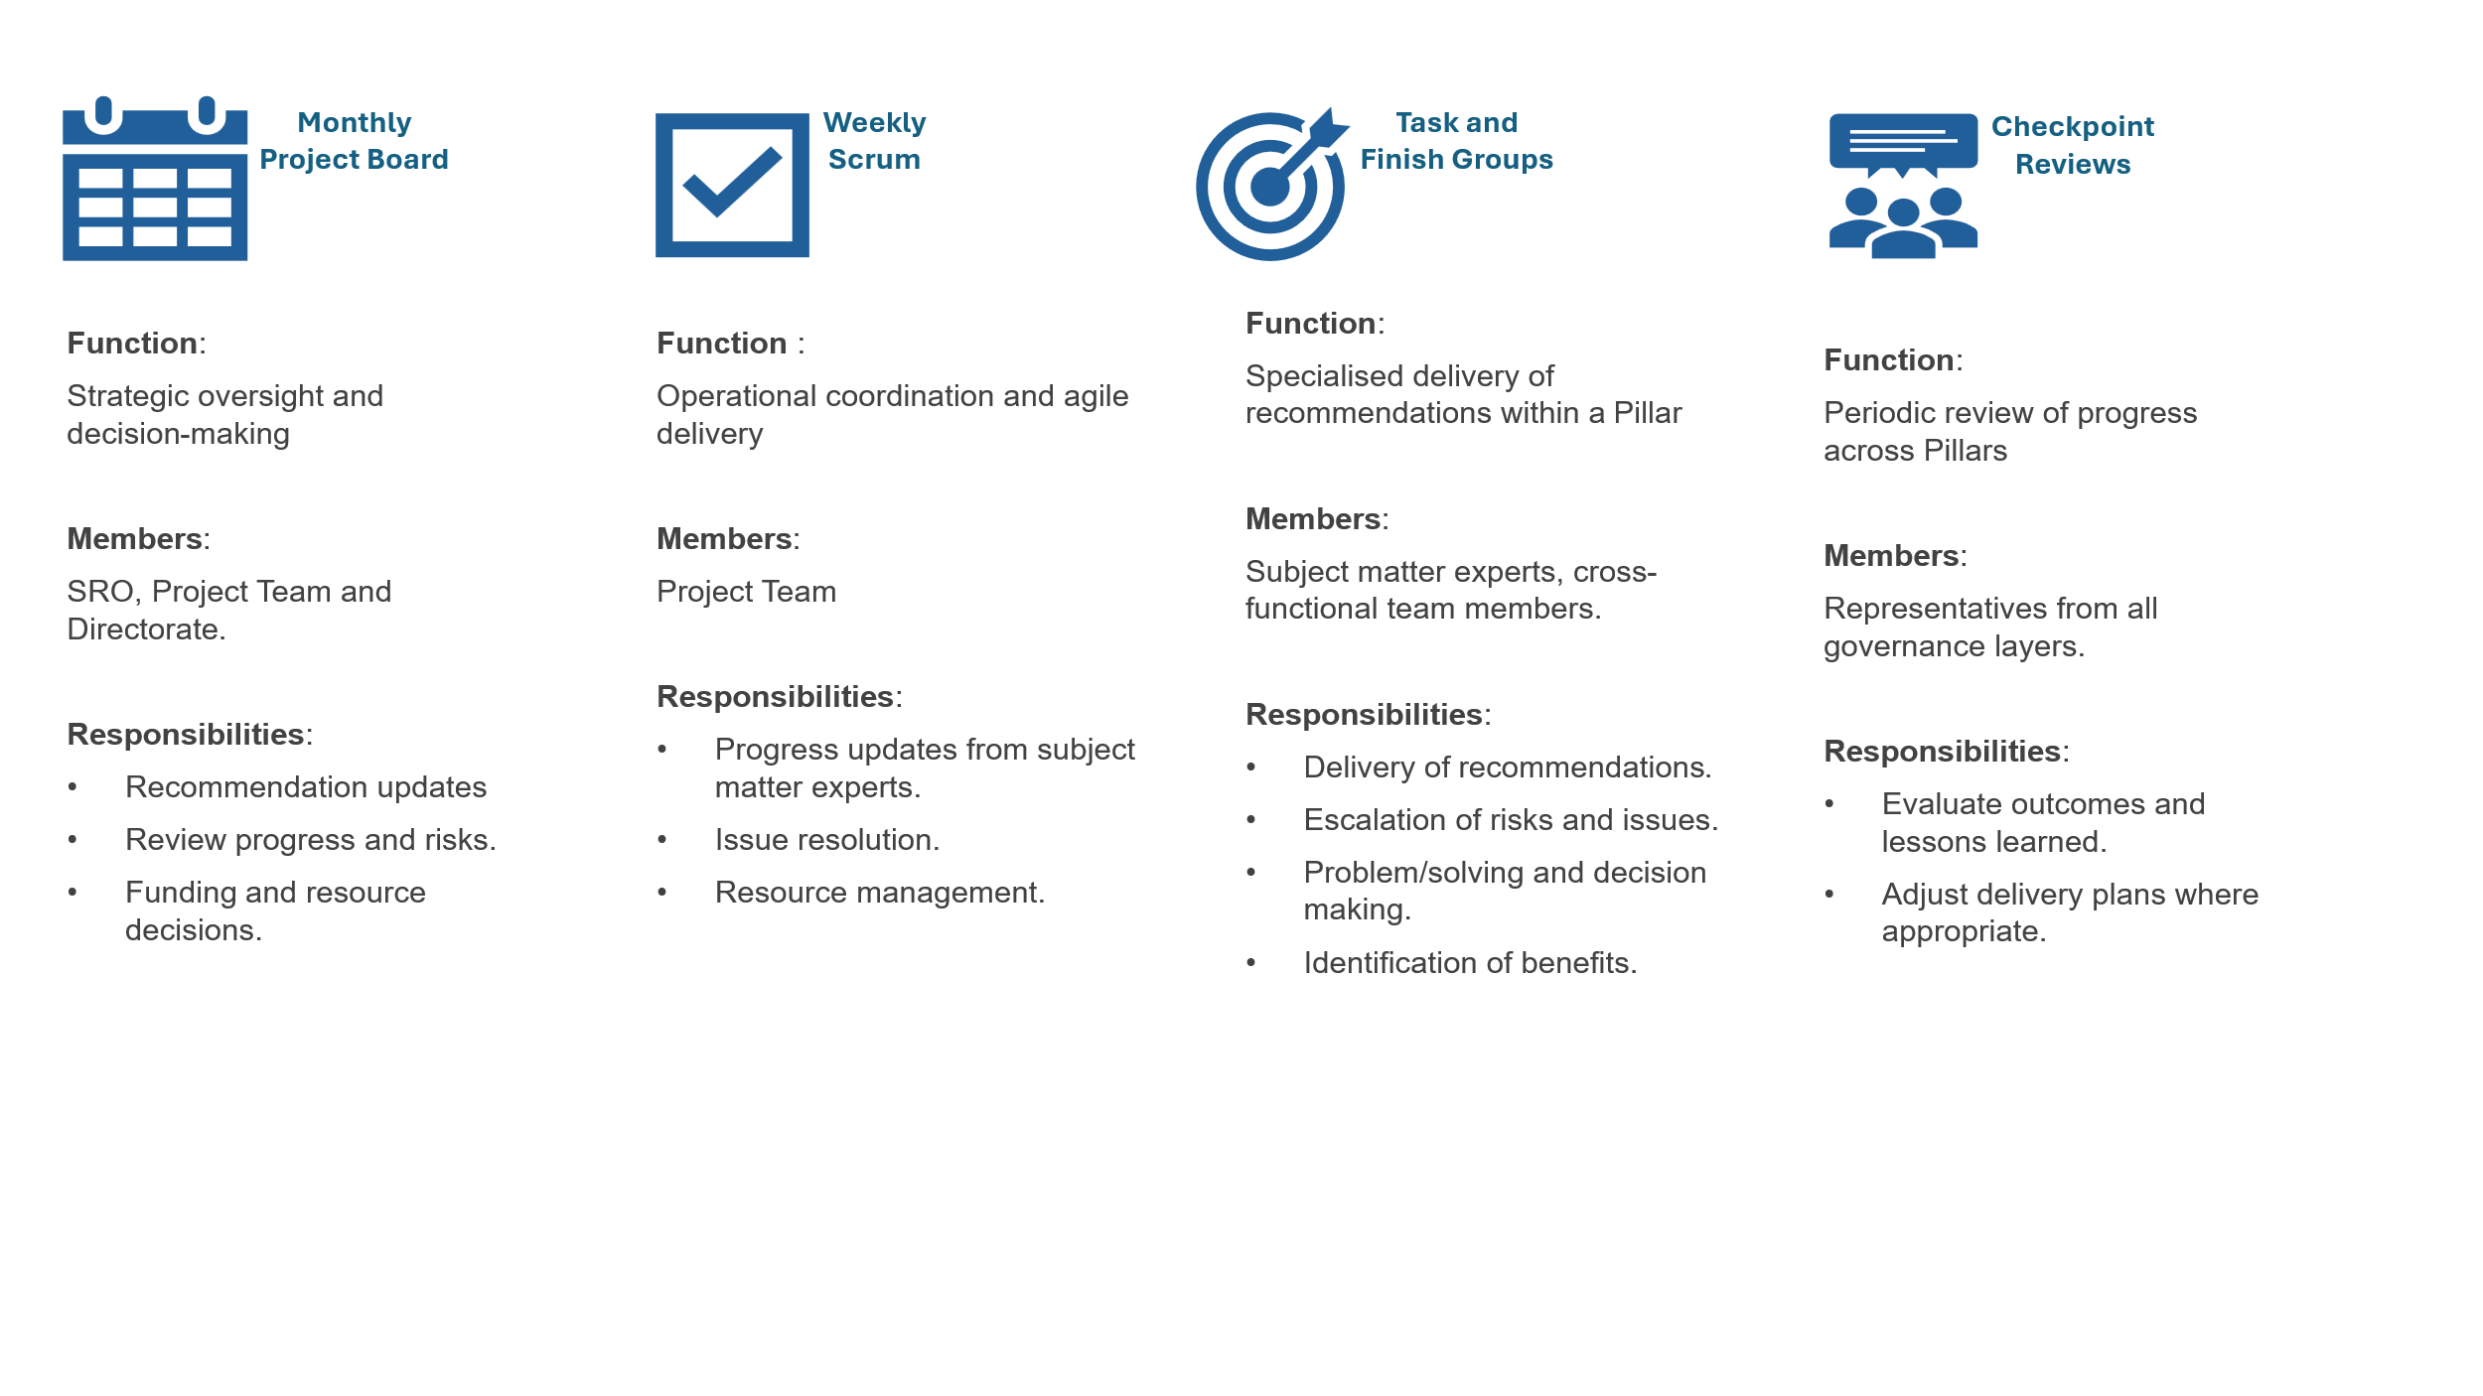

Appendix 2: Risks and Issue Summary
Open Risks
ID | Description | Cause/Impact | Current Rating | Mitigation
01 | There is a risk that the wider transformational work could draw focus, capacity, and leadership attention away from the delivery of the recommendations. Both areas are important and interconnected, but the scale and visibility of the transformational work may unintentionally reduce the time and resources available to progress the recommendations at the required pace. | Overlapping priorities, shared resources, and concurrent delivery timelines across workstreams. Slower delivery of recommendations.  Increased pressure on operational teams managing competing demands | 12 | Agree and communicate a clear prioritisation approach across both work areas. Map interdependencies to understand where sequencing or re-balancing is required. Strengthen governance oversight to monitor capacity and avoid priority conflicts. Ensure regular communication to maintain shared understanding of expectations Additional capacity has been secured through two days per week support from a Programme Manager, providing increased oversight, coordination, and delivery support across both work areas.
02 | There is a risk that limited capacity within the Directorate may delay the delivery of key project activities. Reduced availability of staff and competing operational priorities could slow progress across several workstreams, affecting the project’s ability to meet planned timelines. | Limited capacity within the Directorate. Delays may necessitate re-prioritisation of activities, extension of the project schedule, or additional support to maintain momentum. This could also impact stakeholder confidence and place increased pressure on existing team members. | 12 | Weekly scrum meetings to review progress and barriers.  Review sequencing of the work.  Escalation of resource gaps to the SRO and Project board where applicable. Map interdependencies to understand where sequencing or re-balancing is required.  Strengthen governance oversight to monitor capacity and avoid priority conflicts.  Ensure regular communication to maintain shared understanding of expectations  Additional capacity has been secured through two days per week support from a Programme Manager and also support from Shaping Change team.
03 | There is a risk that limited capacity within People & Culture and ECOD reduces the teams’ ability to support this project effectively due to competing demands from other programmes and projects. | Delays to decision-making, reviews, and approvals. Delays to decision-making, reviews, and approvals Reduced availability for project support activities  Slippage to planned milestones and delivery timelines Increased risk to quality due to compressed timescales or reduced input Potential misalignment between project outcomes and organisational needs | 12 | Weekly scrums are in place with People & Culture and ECOD representatives to review workload, priorities, and emerging capacity pressures.  Established governance forums are used to agree priorities, manage dependencies, and resolve conflicts across programmes and projects.

Open Issues
ID | Description | Cause/Impact | Rating | Actions
01 | Current project activity would benefit from stronger coordination across workstreams. There is a need for improved clarity around planning, ownership, and communication to ensure that activities are aligned, and key dependencies are fully understood | Without enhanced coordination, there is a risk of misaligned work, duplicated effort, unclear responsibilities, and delays in project delivery. | 9 | Additional capacity has been secured through two days per week support from a Programme Manager and also support from Shaping Change team

