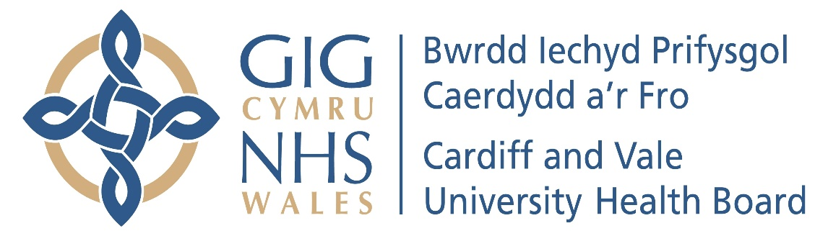

Annual Report of the
People & Culture Committee
2024/25

- Introduction
In accordance with best practice and good governance, the People & Culture Committee (the Committee) produces an Annual Report to the Board setting out how the Committee has met its Terms of Reference during the financial year.
- Membership
The Committee membership comprises of the Chair (who must be an Independent Member of the Board) plus a minimum of two other Independent Members of the Board. In addition to the Membership, the meetings are also attended by the Chief Executive, Executive Director of Strategic Planning, Chief Operating Officer, Executive Director of Workforce and Development, Executive Nurse Director or nominated deputy, Executive Director of Finance or nominated deputy, Executive Director of Public Health or nominated deputy, & Director of Corporate Governance. Other Executive Directors are required to attend on an ad hoc basis. The Committee may also co-opt additional independent ‘external’ members from outside the organisation to provide specialist skills, knowledge and expertise

- Meetings & Attendance
The Committee met six times during the period 1 April 2024 to 31 March 2025. This is in line with its Terms of Reference.
At least two members must be present to ensure the quorum of the Committee, one of whom should be the Committee Chair or Vice Chair.
The People & Culture Committee achieved an attendance rate of 93.32% (80% is considered to be an acceptable attendance rate) during the period 1st April 2024 to 31st March 2025 as set out below:
- Terms of Reference and Workplan
The Terms of Reference and Work Plan were reviewed and approved by the Board in March 2025.
- Work Undertaken
During the financial year 2024/25, the Committee reviewed the key items at its meetings as set out in this Report.

In addition to the routine business of the Committee, which is set out below, the Committee also had more detailed reviews for each of the following Clinical Boards:

- Specialist Services
- People & Culture Team
- Surgical Clinical Board
- Mental Health Clinical Board
- Primary Care & Intermediate Care (PCIC) Clinical Board

These detailed reviews included presentations from key staff and enabled the Committee Members to gain an in depth understanding of the work undertaken in these areas.

Public People & Culture Committee Key matters which were reviewed and discussed by the Committee included the following: -
Staff Story
A different staff story was shared at each of the People & Culture Committee meetings which focused on areas such as:
- Staff Retention
- Widening Access (returning to practise)
- International Nurses
- Staff Survey
- Staff Sickness
- Developing a Sustainable Workforce
High Level Staff Survey Results 2024
- Participation Rate increased to 26.8% of the organization.
- Engagement Score decreased, reflecting current organizational challenges
- Slight increase when asked if staff would recommend the UHB to a relative / friend to 60.6% from 58% last year, but still below the 75.1% in 2020
- Sharing dashboard access with clinical boards for local analysis.
- Analysing narrative responses (over 1000 lines) for deeper insights.
- Focus group events planned over the next six months to gather more feedback.

Key Workforce Performance Indicators
The following points regarding Key Workforce Performance Indicators were highlighted during 2024/25:
- The workforce grew since 2019, but the growth ceased in Jan / Feb 2024 (CAV workforce has since reduced by 100 WTE). This focus led to reduced spending on agency spend staff, especially in previously high-cost areas.
- Data from August showed a reduction in staff turnover reduced to 10.03%
- The VBA percentage remained at 79-80%.
- Retention Rates: There was a significant improvement in retention rates over the last four months, with the current rate being the lowest since June 2020. Specific improvements were noted in nursing and midwifery, estates and ancillary, and healthcare support workers
- Sickness Absence: Although there was a decrease, sickness absence remained higher than desired. The People Services team, was aligned with clinical boards to support managers and colleagues with sickness absence
- Disciplinary Investigations: There was a rise in formal disciplinary investigations, attributed to cases taking longer to resolve. Efforts were made to close cases quickly, with an expectation of reduced numbers in the coming months
- Variable Pay and Agency Use: There was a significant month-on-month reduction in variable pay and agency use, achieved through filling long-standing vacancies on a permanent basis, particularly in medical & dental workforce and registered nursing
- Staff turnover continued to reduce which indicated positive retention efforts
- CAV UHB use significantly less agency staff compared to other HB’s in NHS Wales.
- Sickness absence remained at 6%
- The increase in sickness absence was due to the winter months and would expect to see a reduction from February onwards
Health and Safety Update
The Health & Safety sub-committee ceased during 2024/25 and now report into the People & Culture committee. During 2024/25 the following Health & Safety points were highlighted to the People & Culture committee:
- The Tunnels at UHW were cleared of all items following focused work
- A planned 5-year program was being out in place to replace the drainage in UHW
- An incident was highlighted which involved a staff member cutting their finger on plastic teeth while using cling film, resulting in over three weeks of lost time.
- 52 RIDDOR entries in the financial year and estimated for 70 for 2024/25
- The current year shows a reduction in red incidents (those reportable to the Health and Safety Executive) compared to the previous financial year.
- The H&S team moved from Denbigh House (UHW) to Woodlands House
- 6 custodial sentences with one relating to sexually inappropriate behaviour
- Hate Crime at HYC – An incident of racially aggravated public order at the emergency unit resulted in an 18-week imprisonment.
- Racially aggravated public order offence at A&E, UHW – sentences to 18 weeks imprisonment
- Restorative justice is being used more frequently, empowering victims and ensuring perpetrators understand the impact of their actions.
- The lone worker device refresh program has been completed ahead of time, avoiding financial penalties.
- Manual Handling advisor continued to support all staff including community
- The bariatric patient pathway is being improved in collaboration with the Director of Nursing within the Medicine Clinical Board.
- A meeting with Cardiff Bus was scheduled to discuss the findings from the recent incident.
- A Health and Safety Executive safety alert regarding laboratory staff exposure to biological agents has been issued, with clinical boards asked to provide reassurance on their processes.
- Six fire incidents have occurred year-to-date, with measures in place to address cooking-related incidents and unwanted fire signals.
Board Assurance Framework
The committee rotates the focus on the Board Assurance Framework between recruitment, culture & wellbeing.

Other matters of business discussed during the year, included: -
- Job planning Process
- Staff Retention (including exit interviews)
- Long Term Sickness (LTS) Update
- Speaking Up Safely (Work in Confidence System)
- Sexual Safety Update
- Digital Communications & Analytics
- Notices from the Welsh Language Commissioner
- Primary Care Workforce Plan
- Executive Director of Public Health Update
- Staff Survey Results 2023
- People & Culture Plan Priorities
- Workforce Control & Assurances
- Workforce Growth
- Annual Equality Report
- Gender Pay Gap Report
- Notices from the Welsh Language Commissioner

Policies discussed / approved by the Committee

The following policies were approved at the People & Culture Committee meetings during 2024/25:
- Fire Safety Personal Emergency Evacuation Plan (PEEP) Policy
- No Smoking and Smoke Free Environment Policy
- People Policies Report

All the items discussed were reported to the Board via the formally agreed minutes and Chairs Reports.

Private People & Culture Committee

May, July, September, November 2024 & January, March 2025
The following topics were discussed during the Private People & Culture Committee meetings during 2024/25:
- Cultural Hotspots – Theatres
- Cultural Hotspots – Cardiology
- Patient Safety Visits
- Employment Cases
- Cardiff Bus Incident – Llandough Hospital (UHL)
- Fire Prosecution
- Clinical Service Review – HSDU
- Cultural Leadership Programme
- Pharmacy Estates Issue
- Oxygen Incident UHW
- NWSSP Audit
- Professional Regulation Overview

- Reporting Responsibilities

- Opinion
The Committee is of the opinion that the draft People & Culture Committee Annual Report 2024/25 is consistent with its role as set out within the Terms of Reference and that there are no matters that the Committee is aware of at this time that have not been disclosed appropriately.

Sara Moseley
Committee Chair

