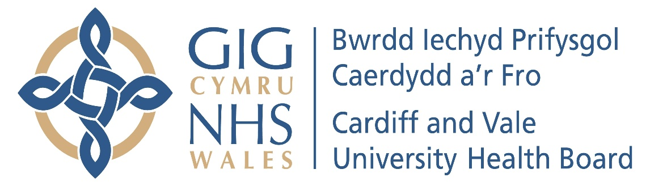

Annual Report of the Charitable Funds Committee
2024/25

- INTRODUCTION

In accordance with best practice and good governance, the Charitable Funds Committee (“the Committee”) produces an Annual Report to the Board setting out how the Committee has met its Terms of Reference during the financial year.

- MEETINGS & ATTENDANCE

The Committee met five times during the period 1 April 2024 to 31 March 2025. This is in line with its Terms of Reference. The table below demonstrates the attendance of the Committee Members through 2024/25:

The Charitable Funds Committee achieved an attendance rate of 77% (80% is considered to be an acceptable attendance rate) during the period 1st April 2024 to 31st March 2025.

- TERMS OF REFERENCE

Previously, there had been standalone terms of reference for each committee, available to access through the website. This allowed a degree of variation between some of the standard powers and responsibilities of the committees. A shared General Terms of Reference which applied to every Committee was reviewed and approved by the Board on the 28th November 2024.

- WORK UNDERTAKEN

The purpose of the Charitable Funds Committee is to provide advice to the Charity Trustee, with regards to the discharge of its duties and responsibilities for the Charitable Funds.

During the financial year 2024/25, the Charitable Funds Committee (“the Committee”) reviewed the following key items at its meetings:

- Health Charity Financial Position & Investment Update

At each meeting, the Committee was advised of its responsibility for overseeing the financial management and stewardship of the Charitable Funds. The Charitable Funds Financial Position Report provided information on the year to date’s financial performance of the Cardiff and Vale Health Charity (“the Charity) and assessed the forecast financial position of the Charity against commitments already made and investments.

At every meeting the latest income position of the Charity was provided to the Committee.

- Over £25K bids for approval

At each meeting a number of bids, where the value of each individual bid was over £25,000, were presented to the Committee for discussion and/or approval. Each bid discussed by the Committee during the year is listed below.

- Cardiology Services Legacy Funds Expenditure - £29,700 – 9644 Hughes Legacy Cardiology - for an ongoing clinical study examining the role of bi-ventricular pacing in patients with heart failure with preserved ejection fraction
- Cardiology Research Fund 9161 – RSA-PACE Clinical Study - £36,422.82
- Mental Health Services for Older People – Payne Legacy 9737 – Transformation and Development Lead - £67,719

- Reporting Feedback on Successful CFC bids

At each meeting, the Committee was advised of feedback from the bids that had previously been approved by the Committee. However, due to the closure of new bids, the only bid reported through 2024/25 was the below:

- Wales Transplant Games – five-year funding - flexible funding between £25k and £40k (estimated £8k per year)

- Health Charity Fundraising Report

A Fundraising Report was provided to the Committee on a quarterly basis. The reports covered the progress and activities of the Health Charity Appeals for the period 1st April 2024 – 31st March 2025. The report outlined various appeals, staff lottery updates, fundraising activities and any significant donations received by the Charity.

- Staff Benefits Group Report

Cardiff and Vale University Health Board Staff Benefits Group was established in 2017, to explore and co-ordinate discounts and benefits offered by external organisations for Health Board employees. The Staff Benefits Group would ensure and agree ‘best deals’ for staff and in governance terms would report their work to the Committee and the Local Partnership Forum.

At each meeting, the Committee was informed of staff benefits discussed and agreed by the Staff Benefits Group between April 2024 – March 2025.

Staff benefits are displayed on a dedicated link on the Health Board’s website intranet page.

- Staff Lottery Bids Panel Report

The Board of Trustees has delegated responsibility for the Staff Lottery Bids Panel to consider and approve Charitable Funds bids up to a maximum of £10,000.

The Small Bids process, which also allows bids up to a value of £250 to be fast tracked for approval, was formally agreed by the Committee at their meeting on the 19th September 2017.

The Lottery funds provide support to patients, staff and visitors and is extremely efficient in terms of its turnaround of fast-track bids for funding, which benefits services across the Health Board.

- Other matters of business discussed during the year, included: -

- Staff Lottery Bids Panel Terms of Reference
- Health Charity Events Planner 2024/25
- New Customer Relationship Manager (CRM) Provider & Operating License Update
- Signatory for Rathbones
- Chairs Action – External Consultant Proposal
- CAVUHB Charity Accounts 2023-24 – AW 2024 Audit Plan
- Children & Women’s Clinical Board transfer request from capital in perpetuity to endowment funds
- Investment Portfolio Update – presented by Rathbones
- Our Health Meadow Change of Status
- Charitable Funds Investment Management Services Contract Extension
- Food Sense Wales fund
- Responsible Gaming Policy
- Terms of Reference

- REPORTING RESPONSIBILITIES

The Committee has reported to the Board after each of its Committee meetings by presenting a summary report of the key discussion items at the Committee. The report is presented by the Chair of the Charitable Funds Committee.

- OPINION

The Committee is of the opinion that the draft Charitable Funds Committee Report 2024/25 is consistent with its role as set out within the Terms of Reference and that there are no matters that the Committee is aware of at this time that have not been disclosed appropriately.

John Union

Committee Chair

