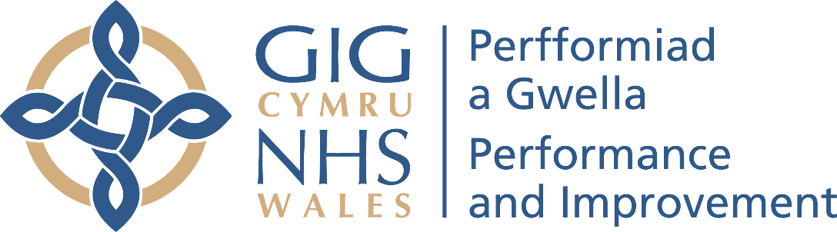

Terms of Reference (TORs)
Cardiff and Vale University Health Board Intervention
Assessment Phase

Author: Adele Gittoes – Interim Director of Intensive Support, Recovery and Turnaround
Em Wilkinson-Brice – Independent Advisor
Dr Pamela Johnston – Independent Advisor
Owner: Adele Gittoes
Date: 8th March 2026 | Version: 1
Publication/ Distribution:
- Draft considered by Welsh Government colleagues
- Draft considered by CAV UHB escalation lead executive
- Final version issued to UHB, WG and NHS P&I
Purpose and Summary of Document:
This document should be read in conjunction with the final CAV UHB Escalation Level 4 document issued to the Health Board on 5th March 2026. (attached for ease of reference).
This document states:
“Welsh Government, with the support of NHS P&I and in alignment with the leadership of the health board will arrange an independent review against the areas of escalation concern and its proposed actions to understand and advise all parties on:
• The underlying causes of the areas of escalation and challenge with a specific focus on governance, organisational culture and leadership
• A view on the validity and likely efficacy of the established improvement plans
• An outline of the approach to a phase 2 intervention programme.
It should be notice that this assessment will not be a diagnostic or deep dive of certain areas within the escalation domains but rather seek to identify the root causes driving concerns with a specific focus on leadership, culture and governance.
The role of NHS P&I and the independent advisors is to undertake this assessment, this complements Welsh Government oversight arrangements and the health board’s statutory responsibilities and supports effective de-escalation when sustained improvement is evidenced.
The NHS P&I Intensive Support, Recovery and Turnaround leads are:
- Adele Gittoes, Interim Director of Intensive Support, Recovery and Turnaround
- Em Wilkinson-Brice, Independent Advisor
- Dr Pamela Johnston, Independent Advisor

1 Context
NHS bodies under the NHS Wales Oversight and Escalation Framework intervention 4 and 5 require clear governance, targeted support, transparent assurance, and decisive action to address risks to performance and outcomes.
Following an assessment against the NHS Wales oversight and escalation framework in June 2025, Cardiff and Vale University Health Board escalation level is level 4.
In March 2026, Welsh Government issued the Health Board with a final, agreed Level 4 Escalation Framework setting out the intervention and support that would be provided via NHS Performance & Assurance. This document set out a two-phase approach, including Stage 1: Evaluative /Assessment.
This approach is aligned with recognised features of successful system improvement programs, namely an initial understanding of current state (not a written diagnostic as these are already in place), this will include views on current plans, delivery governance, assurance mechanisms, culture and leadership.
The assessment will determine whether four key conditions for success which affect an organisation’s overall performance are in place, namely:
- Assurance: Does the organisation ‘do’ what they are supposed to do?
- Maturity: Does the organisation undertake these activities in a way that creates the right culture/with the right behaviors.
- Approach: Does the Provider have the required capacity and capability to deliver sustainable improvement?
- Adaptability: Is the organisation able to adapt to change with a culture of improvement throughout the organization?
The outcome of this Phase 1 assessment will inform you of the requirements for Phase 2.

2 Approach
The assessment will be undertaken by two independent and suitably skilled individuals with senior operational and executive experience and senior medical leadership background to support understanding of the underlying clinical cultural dynamics within the organisation.
The Independent Advisers will be supported by the Director of ISRT from NHS P&I and support teams including administration, program management, quality and patient safety and medical staff.

The IAs will utilise three key methods to gather evidence as follows:

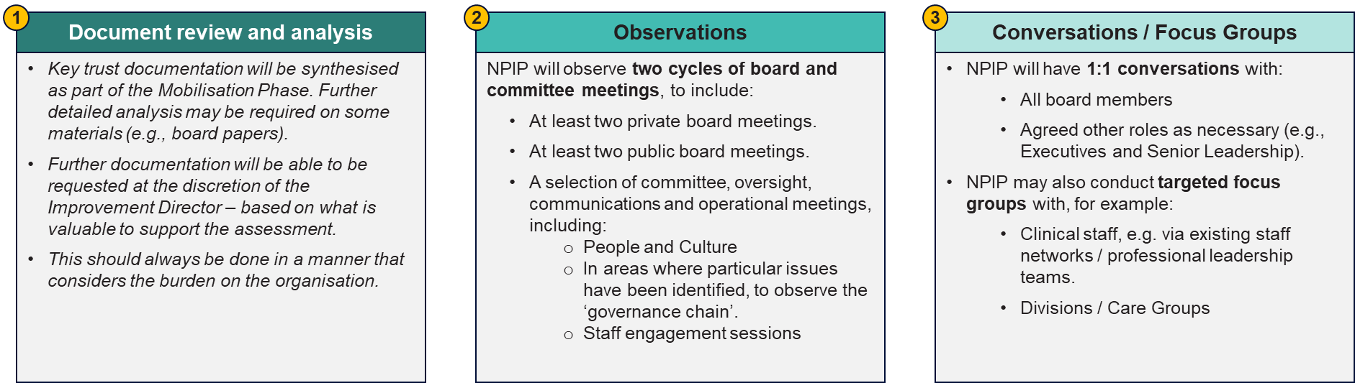
The Assessment Phase is planned to commence the week of 23rd March 2026, with meetings with the Chair and Chief Executive and the wider Executive Team scheduled for that week. NHS P&I will provide the IAs with a mobilisation report, as part of the mobilisation phase providing the portfolio of the organisation and relevant documents to inform the document review.
The assessment phase is anticipated to take 8-12 weeks with a mixture of onsite and virtual assessments.
The assessment will include the following core activities:
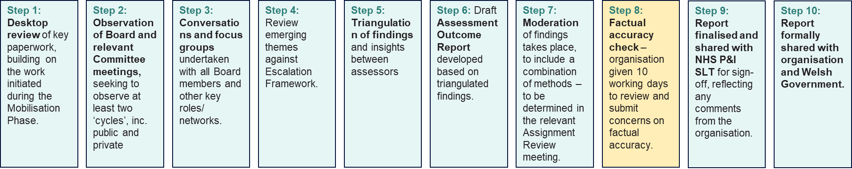

NHS P&I team will continuously identify and record key themes.

There will be weekly feedback to the Chair & CEO to ‘test’ out observations alongside support offers that can be mobilised/supported to be procured, to add value during the assessment.
_________________________

3. Reporting Lines and Relationships
• Direct reporting: Chair and Chief Executive of Organisation.
• Operational interface: Works alongside the Executive Team; does not assume line management of operational services.
• Welsh Government interface: Transparent, regular joint meetings with Welsh Government officials – Director General (HSCEY)/Chief Executive NHS Wales, Deputy CEO NHS Wales and Director of Operations NHS Wales – to provide assurance and agree any escalations (see Section 9).
• Support from NHSP&I: Access to specialist operational expertise and program management resource aligned to the plan through the Managing Director of NHS P&I

4. Authority and Decision Rights
• The Intensive Support and Recovery team has authority to advise, challenge, convene, and escalate within these ToR.
• The role does not carry executive decision rights over CAVUHB operational services; accountability for delivery remains with CAVUHB executives and clinical leaders.

5. Governance, Meetings and Assurance
Start up
• Initial meetings with the Chair and Chief Executive in week one (27 March 2026).
• The introduction to the wider health board will be coordinated and agreed between the Improvement Advisor and the Chief Executive to set expectations and promote joint ownership.
Oversight rhythm
• Weekly (preferred) touchpoint meetings between the Independent Advisors Chair, Chief Executive and relevant executives.
- Monthly attendance at UHB Executive Teams by Director of ISRT and IAs to provide updates.
• An Escalation Board chaired by the NHS Wales Chief Executive and a small number of the health board and Welsh Government Executive Team members.
- Monthly NHSP&I operational performance and delivery meetings to support operational improvements across a range of areas.
• The Chair will brief the Cabinet Secretary for Health and Social Care on progress during routine meetings.

6. Escalation
From CAVUHB to NHS P&I Managing Director
• Step 1: Concerns (delivery risks, safety, finance, or governance barriers) are raised with the Director of ISRT and/or Improvement Advisor at once.

• Step 2: If unresolved or urgent, the Improvement Advisor escalates jointly with the Chair/Chief Executive to Welsh Government officials at the next assurance touchpoint or sooner if required.
From the Director of ISRT/Improvement Advisor to NHS P&I Managing Director

• Step 1: Raise concern with the Chief Executive (and Chair if appropriate) and agree immediate local actions.

• Step 2: If risk persists or action is not timely, escalate to Welsh Government officials with a clear statement of issue, impact, and proposed remedy.

From the NHS P&I Managing Director to Welsh Government

• Step 1: Discuss directly with Chief Executive and Chair of UHB.

• Step 2: If risk persists or action is not timely, escalate to Welsh Government officials with a clear statement of issue, impact, and proposed remedy.

7. Ways of Working

- Information and access: The Improvement Advisor will have timely access to data, meetings, and decision makers necessary to fulfil this ToR, observing information governance requirements at all times.

• Culture and behaviour: Promote openness, candour, and constructive challenge; encourage cross system working (e.g., discharge, community, diagnostics) to resolve constraints.

• Communications: A brief communications note, agreed by the Improvement Advisor and Chief Executive, will set out the role, approach and expected ways of working to internal leaders and key partners.

8. Duration and Review

• Initial period: 8-12 weeks from 23rd March 2026, with a formal review every 4 weeks to consider continuation, modification, or exit based on progress and residual risk.

• Any extension will be jointly agreed by the Chair, Chief Executive and Welsh Government officials.

9. Risks and Mitigations

• Risk: Insufficient pace of action or slippage in delivery.
Mitigation: Weekly oversight, explicit “owner by when”, rapid escalation routes, single plan with milestone tracking.

• Risk: Over layering of governance and admin burden.
Mitigation: Use existing performance management reports and boards; concise highlight packs only.

10. Exit Criteria ISRT

The assessment phase forms part of a wider approach to Intensive Support, Recovery and Turnaround as set out below.

As part of this approach there are two relevant exit points:

- When the NHS P&I ISRT cease their support within the Health Board. This will be determined as part of the Phase 2 (CAV UHB Level 4 escalation framework) or phase 4 of the approach above – “Support”. The level of support required from NHS P&I ISRT during the support phase will be determined with clear exit points agreed.

These exit points may or may not be directly aligned to the de-escalation of the organisation.

Once ISRT support ceases, then as part of Phase 5 of the approach ‘Transition’ a review of what support is required from other functions within NHS P&I such as Performance and Delivery and Transformation and Improvement.

- When the organisation De-escalates – As per the Level 4 Escalation Framework
be determined by the Welsh Government, working in partnership with other key stakeholders and taking into consideration progress/achievement of the agreed de-escalation criteria set out in the Level 4 Escalation Framework and recommendations from NHS P&I and as part of its Intensive Support.

11. Approval and Review
These Terms of Reference are approved by the CAVUHB Chair and Chief Executive, NHS P&I (including Independent Advisors) and Welsh Government. They will be reviewed every 4 weeks or sooner if material changes to scope or oversight arrangements occur.

