

Theatres Together Improvement Plan

Version History:
Date: | 16 January 2026
Author: | Theatres Together Project Team
Project Exec / SRO: | Paul Bostock
Version No: | 1.3
Status: | Issued
Approvals | Theatres Together Triumvirate

Foreword
The Theatres Together project is being delivered through a structured tranche-based methodology, endorsed by both the project board and leadership team. This approach divides the work into five distinct tranches— Embedding Culture, Foundation, High Impact, Progression, and Transition—each designed to enable focused delivery, iterative improvement, and sustainable change.
Currently, the Embedding Culture, Foundation, and High Impact, tranches are being run in parallel to accelerate early gains and embed cultural change from the outset. The Progression and Transition tranches have been prioritised for recommendations that are less urgent, have lower immediate impact, or are dependent on higher-priority actions. This sequencing ensures that dependencies are managed effectively, and that change is delivered in a logical and sustainable manner.
All 66 actions within the project have been systematically assessed, risk-rated and prioritised using a weighted scoring methodology, underpinned by five strategic drivers: staff engagement, patient safety, creating a place to feel proud, theatre efficiency, and effective leadership. Each recommendation was assigned to a tranche based on its overall score and any critical interdependencies. This structured approach ensures that strategic focus, risk mitigation and investment are directed toward areas where they will deliver the greatest impact and value.
Theatres Together is governed through a robust structure, including a dedicated Theatres Triumvirate, with additional support from the Shaping Change, People and Culture and ECOD teams. Strategic oversight is provided via fortnightly project board meetings, while weekly scrum meetings drive operational progress. Task and finish groups have been established to deliver specific recommendations, ensuring focused and accountable delivery.
Each tranche concludes with a formal review to confirm delivery; capture lessons learned and ensure readiness for the next phase. While recommendations are initially allocated based on priority and dependencies, some recommendations may move between tranches as the project evolves. The Embedding Culture tranche runs continuously throughout the project, ensuring that values, behaviours, and leadership practices are integrated and sustained across all phases of change.

Theatres Together Project Update:
Foundation Tranche:
The Foundation Tranche contains eight recommendations. Five recommendations have been fully completed, the remaining three recommendations are: 8h Standard Operating Procedures and schedules for the theatre deep cleaning rota, 8a Audit adherence to policies and procedures for consent and ‘WHO Checklist’ and 8i Family room requires refurbishment. These recommendations have been fulfilled but further enhancement have been identified so they have been progressed to a point where they are more appropriately overseen within the High Impact tranche (8h and 8i) and Embedding Culture tranche (8a). These tranches are specifically designed to support high‑impact delivery, longer‑term cultural embedding, and sustained behavioural change.
The Project Board formally agreed to close the Foundation Tranche on 9 January 2026.
Embedding Culture Tranche
Work within the Embedding Culture Tranche is progressing well, with clear activity underway across leadership, culture, education, and theatre efficiency. ECOD and People & Culture are jointly leading the leadership and cultural development elements, ensuring alignment with organisational priorities. A task‑and‑finish group is in place for theatre efficiency, focusing on start‑of‑day processes, list planning, roster alignment, and reducing overruns. Reviews of theatre utilisation, staffing models, and handover processes are underway to support more consistent and efficient list delivery. On the cultural and leadership side, work is progressing on leadership development, collective leadership approaches, and strengthening psychological safety, including the introduction of ‘stay’ conversations and ongoing competency‑based training. The Education Team’s structure, purpose, and workload are being reviewed to ensure it can better support staff development and maintain required skills across the service. Overall, the tranche is moving forward with a clear focus on long‑term cultural change, leadership capability, and operational consistency, with appropriate governance in place to monitor progress.

High Impact
The High Impact Tranche has continued to make strong progress, with 13 recommendations now fully completed. Current work includes ensuring consistent availability of scrubs, reviewing the workload and supervisory capacity of clinical leaders, and strengthening clarity and accountability through defined roles and responsibilities. Digital access is being improved through verification of UHB email accounts, while a comprehensive review of rostering practices is examining how shift patterns contribute to late starts, early finishes, and overruns. The team is also exploring wider implementation of Tendable to support compliance monitoring and reviewing access to computers and printers across the theatre suite to improve day‑to‑day efficiency. Together, these activities demonstrate sustained momentum and a clear pathway to completing the tranche

Progression Tranche
The Progression Tranche includes 12 recommendations, several of which are already underway. A number of these actions also align with work currently progressing within the Embedding Culture Tranche. The work in this tranche includes a comprehensive review of leadership and management structures, clarity of roles and responsibilities, and the development of a robust competency framework for clinical leaders. It also includes work on supervisory models, induction and training pathways for ODPs, access to advanced practice training, and the configuration of the anaesthetic practitioner workforce to support major trauma and resuscitation. Operational elements—such as weekend theatre management cover, protection of study days, and a full equipment stocktake with strengthened medical device governance—add further depth to the tranche. While work on several of these areas is already underway, the formal launch of the tranche provides a clear framework for coordinated delivery across these interdependent and high‑complexity themes

Transition Tranche
Transition Tranche, due to formally commence in April 2026, that focus on cultural improvement, workforce redesign, and operational modernisation. Several elements are already underway due to their scale and interdependencies. The tranche will concentrate on addressing culture and leadership within Cardiac Theatres, undertaking a radical restructure of practitioner roles to create a flexible, multi‑skilled workforce, and evaluating how teams across scrub, anaesthetics, recovery, and the wider Cardiothoracic Service can be configured to support a resilient service model. It will also review the roles of Band 2 and 3 Theatre Assistants, assess ODP training and induction to support dual‑role proficiency, and benchmark Band 6 roles against comparable organisations. Further work will focus on standardising surgical equipment and stock management, reviewing IT systems across the theatre pathway to reduce duplication, strengthening training pathways—including exploring a postgraduate perioperative module—and considering reinstatement of the dual porter/HCSW role. Collectively, these recommendations represent significant structural and cultural change, requiring coordinated delivery across multiple professional groups.

WHO Checklist
The WHO collaborative formed in May 2025 bringing a collaborative approach of multi-disciplinary professionals to embed the principles of the WHO checklist.
In partnership with the perioperative team, anaesthetists and surgeons the WHO have developed a set of principles that must be adhered to, that supports a standardised WHO checklist process. The required systems and processes have been developed to ensure the adherence with the WHO checklist and to provide the correct resources to support adherence. Expectations have been verbalised across the staff groups and shared consistently ensuring engagement. 2 audits have been completed in conjunction with the patient safety team. The most recent audit information is demonstrated below:
Compliance with the WHO Surgical Safety Checklist is now monitored routinely as part of the Theatres Together programme, supporting assurance around safe surgery and consistent application of perioperative safety controls. The latest audit (October 2025) reviewed 85 Patient Records across four theatre suites. To support audit processes stickers were implemented into the WHO checklist pathway and are to be placed and signed at the ‘Sign In’ stage, ‘Time Out’ stage and the ‘Sign Out’ stage. The audit completed retrospectively away from the theatre environment was completed to provide a clear snapshot of current performance, reliability, and opportunities for further improvement. It important to note, that auditing sticker compliance and signatures (3 in total) does not always demonstrate lack of compliance.
Audit Findings and Compliance
During the audit most recently completed October 2025 across all 4 theatre suites, out of 85 patient notes audited, there were only 2 examples of incidents where there was no evidence of WHO being completed in the notes. On these occasions following further reviews, 1 was misfiled and the second was a local anaesthetic case that required a local Safety Standards for Invasive Procedures. The audit demonstrates strong compliance with the WHO checklist, however further learning and themes raised. These results and findings have been shared and discussed via the WHO Collaborate group, Senior Leadership Team and Surgery Clinical board Quality and Safety Group

Qualitative Themes and Learning
Stickers are consistently being used, but dual/team signatures are inconsistent, especially at sign out.
Time out is consistently documented, usually led by scrub practitioners.
Main gaps are surgeon and anaesthetist signatures at sign out, often due to workflow pressures (e.g., surgeons leaving to write notes).
Team feedback
Audit reflects real practice; similar findings in previous audit and has become an audit of sticker usage rather than practice.
Surgeons and anaesthetists are present but may not sign
Responsibility for chasing signatures often falls to anaesthetic practitioner or scrub staff.

These findings align with the wider programme learning that improvement must focus not only on individual compliance, but also on the reliability of the system, including consistent prompts, documentation, team expectations, and shared accountability.
Alignment with Theatres Together Improvement Work
The audit findings directly support the ongoing work under recommendation 8a, which aims to standardise application of the WHO checklist across all theatres and strengthen assurance through audit, training, and systems improvement. This includes the establishment of a multi-professional WHO Checklist Collaborative, co-production of standardised principles, and development of visual management solutions such as a WHO Checklist Whiteboard to support consistent team engagement and confirmation.
Next Steps
The next phase of improvement will focus on sustaining high compliance with Sign In and Time Out while strengthening reliability of Sign Out through:
- One signature required per sticker to represent completion of stages. Agreed at WHO collaborative 6th November 2025.
- Targeted reinforcement of expectations and principles for consistent checklist completion
- Addressing documentation variation through standardised white boards in each theatre. Continued audit cycles and an external audit will be undertaken in Feb 2026 to give further assurance.
- Ongoing engagement with staff groups to ensure practical implementation and to support psychological safety and speaking up if checklist steps are missed

Completed Recommendation Summary:
Tranche | Recommendation | Date completed
Foundation | 1h Explore security options to make the female changing area a more secure place to leave belongings. | October 2025
Foundation | 5g Provide colleagues with the necessary information pertinent to their role for maintaining safety for both staff/patients. | October 2025
Foundation | 8j Charitable bid to the Staff Lottery Fund to refurbish the staff room | October 2025
Foundation | 8b Review the management of paediatric cases in Mains Upper. | September 2025
Foundation | 8e Create standard operating procedures for the setup and standardisation of anaesthetic rooms throughout the department, where feasible. | December 2025
Embedding Culture | 1a Some individuals' values and behaviours need to be managed via UHB policies and procedures. | September 2025
Embedding Culture | 2f Improved visibility of the Directorate and Clinical Board Management team within the department. | October 2025
Embedding Culture | 1f Adherence to values and behaviours of the UHB and consequences for those that do not. | September 2025
Embedding Culture | 2g Ensure the effective utilisation of audit sessions. | October 2025
Embedding Culture | 9g Clinical leaders to be involved in scheduling of lists to aid roster management. Explore how the publishing of rosters could align to the 6,4,2 process. | September 2025
High impact | 1b Share the HSCW code of conduct to support individuals to be aware of the code. | September 2025
High impact | 1c To Share with colleagues how to raise concerns internally, share 'Speaking Up Safely'. | September 2025
High impact | 1e Consider support from a psychologist on a substantive basis to support colleagues through trauma informed approach. Further roll out of MEDTRIM.
High impact | 1g Celebrate success - feedback to the team when they receive positive feedback. | September 2025
High impact | 2h Sickness panels supported by People and Culture colleagues, to be conducted to ensure consistent approach, with regular attendance by clinical leads or deputies. | September 2025
High impact | 2i A senior advisor from people services should be allocated to theatres to provide consistent advice for the leadership team | September 2025
High impact | 5a Implement regular team meetings for all staff to improve communication and engagement. | October 2025
High impact | 5b Consider reinstating the General Manager /Lead Nurse drop-in sessions on a regular basis. | October 2025
High impact | 5c Regular meetings with General Manager, Lead Nurse and Theatre Manager with set agenda. | October 2025
High impact | 5d Regular meetings with General Manager, Lead Nurse, Theatre Manager and the Clinical Leaders. | Oct 2025
High impact | 5f Verify who has UHB email accounts and ensure that all individuals have access. Consider alternative methods of mass communication, such as Theatres SharePoint Site, Viva Engage or Teams channels, instead of relying solely on WhatsApp | December 2025
High impact | 6a Conduct a comprehensive review of rostering practices, including an analysis of shift times and their correlation with late finishes, late starts, and early finishes. Specifically, assess the feasibility of implementing 12-hour shifts within the Recovery Team. | December 2025
High impact | 6b Promote a culture that supports colleagues in managing their work-life balance. Review all current work-life balance requests in accordance with the needs of the service to ensure appropriate coverage on all shifts. | Sept 2025
High impact | 8e Create standard operating procedures for the setup and standardisation of anaesthetic rooms throughout the department, where feasible | December 2025
High impact | 8f Consider wider use and implementation of ‘Tendable’ to monitor compliance against standards and procedures including use of PPE. This would give more oversight to the Directorate and Clinical Board. IPC colleagues, Clinical Board Director of Nursing, Directorate Lead Nurse and Decontamination Lead to support ad hoc patient safety walk arounds and audits against standards. | December 2025
Progression Tranche | 6e Review how the anaesthetic practitioner workforce supports the resus team and major trauma calls and what skill set is required to support. | September 2025
Progression Tranche | 7c Protect study days and audit sessions. | September 2025
Transition Tranche | 6d Review the roles of the Band 2 and Band 3 Theatre Assistants, clearly distinguishing between them. Identify opportunities for Band 2 development within the department. | November 2025

Theatres Together Timeline
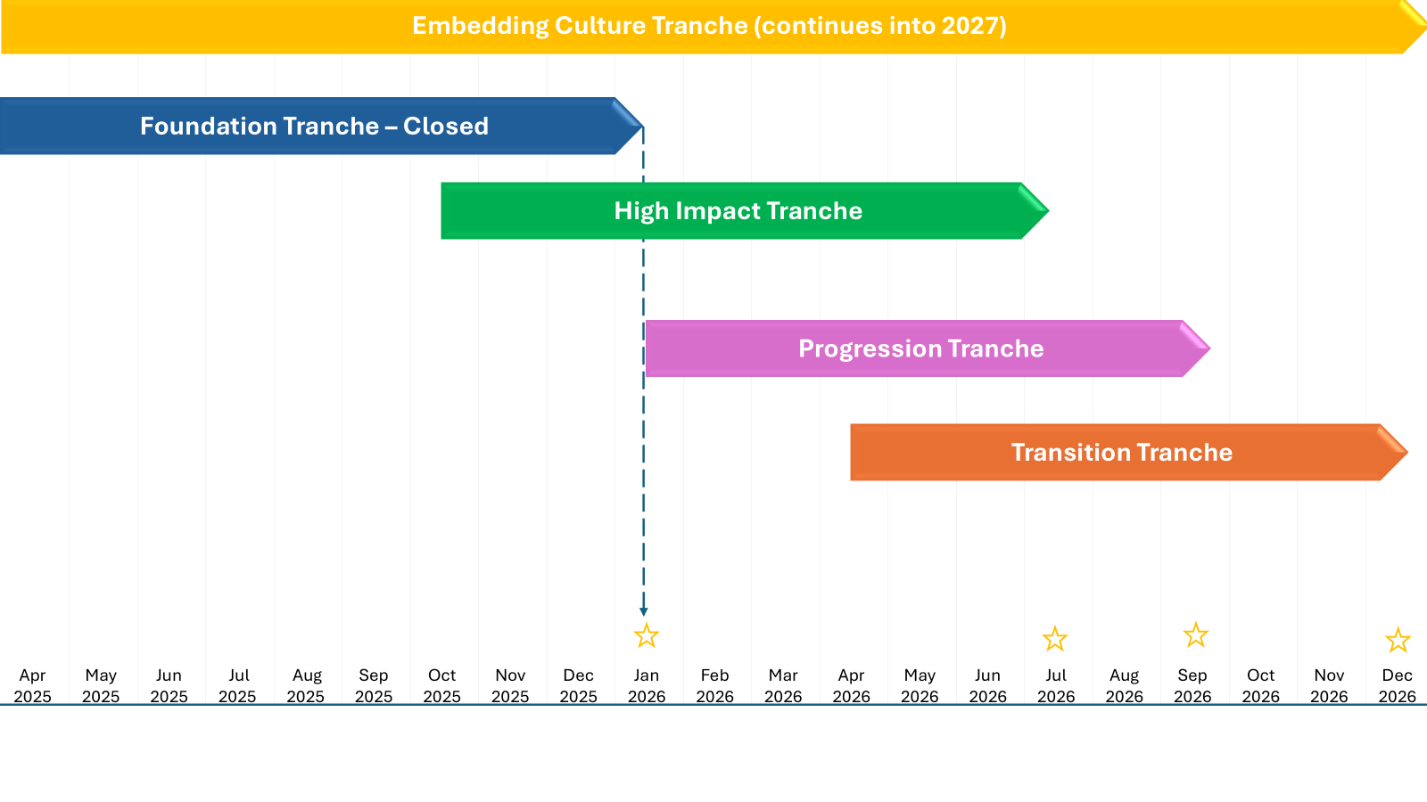
Theatres Together Governance Framework
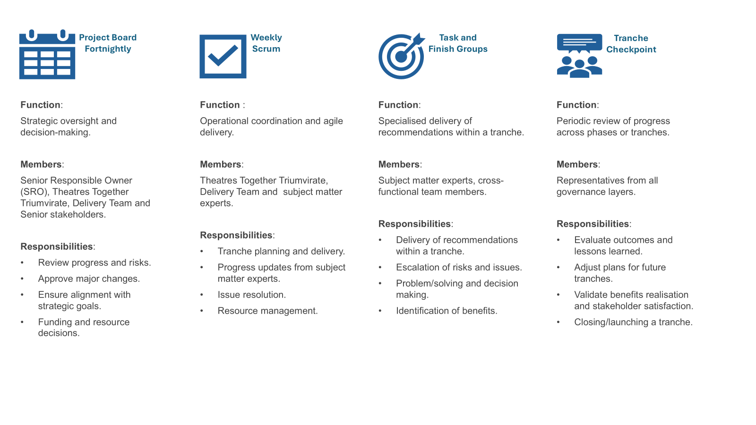

Staff Feedback
Staff feedback remains central to the delivery and assurance of the Theatres Together programme. The programme has prioritised co-production and continuous engagement to ensure improvement actions are informed by staff experience, responsive to emerging concerns, and aligned to the programme’s strategic drivers of staff engagement, patient safety, theatre efficiency, and effective leadership.
How Staff Feedback Has Been Captured
A structured and blended approach has been implemented to capture both qualitative insight and real-time indicators of staff experience. A variation of face-to-face sessions, and digital feedback has been collected and collated since launch of theatres together, examples include:
1) “What matters most to you at work?” co-production survey (May / Jun 2025)
A short survey was introduced to understand what staff value most in their working environment, how they would like these priorities to be addressed, and what barriers currently exist. This provides rich qualitative insight and directly informs improvement priorities and communications planning.
2) Daily pulse-check feedback (“How was your day?”) (Nov / Dec 2025)
A short, anonymous pulse-check tool has been implemented to capture immediate feedback on how staff are experiencing their working day, including what positively or negatively impacted their shift. This supports early identification of pressures and provides a mechanism for staff voice to be heard in real time.
3) Communications, belonging and recognition survey (Oct 2025)
A targeted survey has also been used to understand staff views on workload support, psychological/emotional safety, speaking up, recognition, and satisfaction with communications. It additionally gathered staff preferences for future communication channels and engagement methods, supporting a more inclusive and consistent communications approach across the theatre workforce.
Key Themes Emerging from Feedback
Across the range of staff feedback sources, several themes consistently emerged:
1) Teamwork, kindness and supportive colleagues remain a clear strength
Daily pulse feedback demonstrates that staff frequently describe their day as enjoyable and rewarding when teamwork is strong and colleagues feel supportive. Recent feedback highlights comments such as “Great teamwork” and “Positive staff and work environment,” showing that staff experience is strongly influenced by team culture and day-to-day relationships. This reinforces that the service has strong foundations of peer support, compassion, and resilience, even under pressure.
Feedback also reflected the positive impact of small gestures and professional respect, including examples such as a colleague being brought mince pies and coffee by a surgeon, demonstrating how recognition and kindness contribute to morale and a sense of value.
2) Patient-centred care and professionalism remain evident and valued
Feedback reflects pride in patient care, with examples highlighting positive patient experience and gratitude. Comments included reflections such as patients describing how kind everyone was and expressing thanks, reinforcing the compassion and professionalism experienced throughout the patient journey. This is a valuable indicator that despite operational pressures, staff continue to deliver high standards of patient-centred care.
3) Leadership engagement and communication are important to staff experience
Staff feedback continues to highlight the value of communication and meaningful interaction with senior leaders. Daily feedback included constructive reflections such as “Good to meet with lead nurse and discuss changes,” demonstrating that engagement opportunities are noticed and valued by staff, and that communication contributes positively even during challenging operational periods.
4) Pressures remain present, particularly staffing and interdepartmental demand
While much feedback is positive, staff also continue to highlight pressures, including staffing constraints and wider interdepartmental demands. These insights are important for understanding the conditions in which change is being delivered and reinforce the need for continued focus on workforce planning, rostering, and operational efficiency workstreams.
5) Core priorities identified through co-production remain consistent
The “What matters most” survey responses reinforce that staff priorities centre around:
- being respected and valued
- supportive teamworking and positive culture
- fair and consistent management/leadership
- staffing levels, workload management, and breaks
- access to training and development
These themes align directly to the programme’s Embedding Culture and workforce recommendations.
How Theatres Together Is Using Feedback
Staff feedback is actively being used to shape delivery and strengthen assurance, including:
- targeting cultural and leadership development interventions
- improving communication routes and ensuring messages reach all staff groups
- reinforcing recognition, celebration and wellbeing initiatives
- strengthening workforce planning and operational improvements
- supporting psychological safety and speaking up
Ongoing Monitoring and Next Steps
Theatres Together will continue to gather staff feedback through pulse-check tools, structured surveys, and engagement activity, ensuring staff voice remains central to improvement. A planned session in February 2026 will also be the focus of a more in-depth survey seeking staff interpretation of the already delivered improvements and seek their valuable opinion and insight into the current priorities helping shape the next stages of work. The programme will maintain a strong focus on “closing the loop” by sharing progress and outcomes with staff, ensuring feedback leads to visible change and supports sustained cultural improvement.

Theatres Together Dashboard
Summary
The Theatres Together programme has delivered an internal Power BI dashboard, which will become central to planning, tracking, and evidencing the impact of our work. This dashboard will not only support the delivery of recommendations but provides a view of programme benefits, extending beyond the original objectives. The current version being shared with Board in this update is provided to give assurance on the approach, more in-depth narrative on trends and actions being undertaken will be shared in future updates.
1. Developing the Dashboard: From Recommendations to Benefits
At the Board’s request, the dashboard has evolved to offer a broader perspective, enabling the tracking of benefits across key domains:
- Programme Progression
- Workforce Metrics
- Quality Metrics
- Theatre Efficiency Metrics
- Staff Engagement Metrics

This expansion will ensure that the Board can monitor not only the implementation of recommendations but also tangible improvements in workforce wellbeing, patient safety, operational efficiency, and staff engagement.
2. Data-Driven Insights: Integrating Key Metrics
Significant work has been undertaken to identify, source, and integrate relevant metrics. The dashboard will incorporate:
- Workforce metrics (from ESR)
- Quality metrics (from Beacon, CHKS and Datix)
- Theatre Efficiency metrics (in development, leveraging the new Aqua theatre system)

3. Visualising Progress and Impact
The charts below are taken directly from the Theatres together dashboard
3.1 Theatres Together Programme Progression
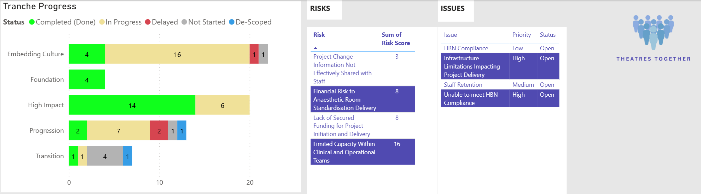
The dashboard visually tracks the status of key workstreams, highlighting completed, in-progress, and delayed actions, as well as identified risks and issues. This transparency enables proactive management and timely intervention, ensuring the programme remains on track to deliver its objectives.

3.2 Workforce Metrics
Important Caveat
These workforce metrics currently reflect data for the entire Theatres, Anaesthetic, SSU, and Sterilisation Services. As such, some of the positive trends—such as reductions in turnover, the developing trend in sickness reduction, and increased compliance with statutory and mandatory training—may not be solely attributable to change in the theatre’s workforce. These patterns will require further verification and refinement to ensure they accurately represent the impact of the Theatres Together programme specifically.
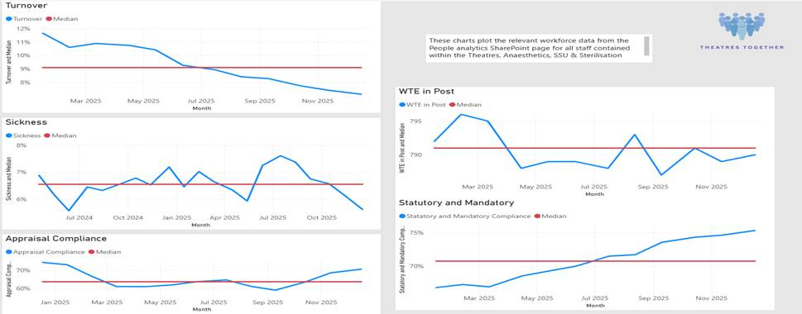The workforce section provides critical insights into turnover, sickness rates, appraisal compliance, and statutory/mandatory training. Early trends indicate reductions in turnover and sickness, and improvements in compliance, reflecting the positive impact of programme interventions.

3.3 Quality Metrics
We have identified an initial set of potential quality metrics that will help to demonstrate the impact of changes on the quality of care provided, they include those displayed below plus other suggestions such as post-surgical mortality. It will also include WHO Checklist compliance once established.
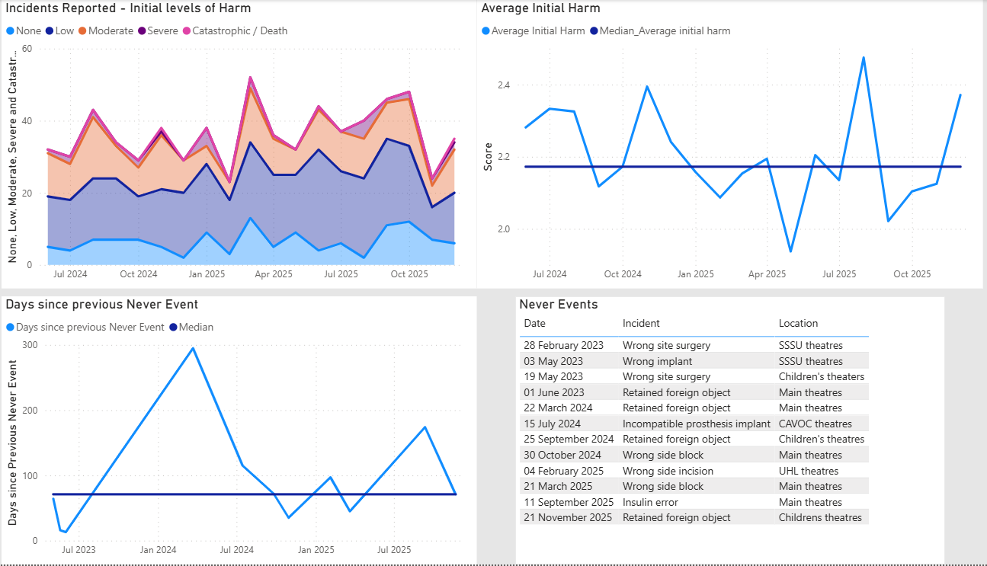
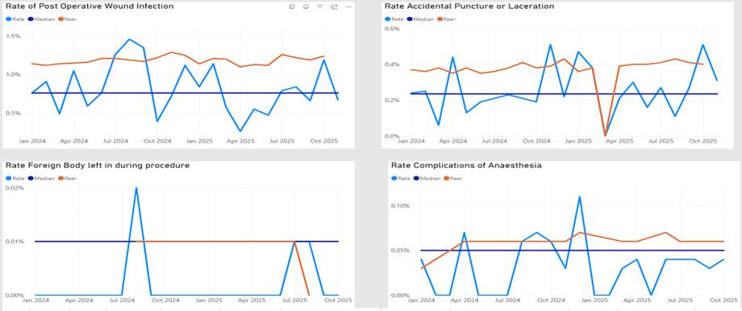
Quality metrics now include incident reporting, harm levels, and specific clinical outcomes such as post-operative infection and anaesthesia complications. This level of detail supports a culture of safety and learning, underpinning our commitment to high-quality patient care.
Never Events
Never Event data is being continually monitored and situations actively managed within standardised processes. The theatres together project is working closely with the WHO collaborative to improve processes relating to the 5 steps to surgical safety. Although this data set is small, it appears that the interventions made are having a positive impact on the never event frequency. The reported insulin error in September 2025 identified a wider insulin administration concern which has been managed with an internal quality improvement approach while also engaging with National safety organisations (SALG) to attempt to scope the breadth of the issue.

4. Continuous Improvement and Board Engagement
The current suite of metrics is the result of collaborative effort and will be continuously refined based on feedback and evolving needs. The dashboard’s flexibility ensures it remains a dynamic tool for governance, assurance, and strategic oversight.
Conclusion
The Theatres Together dashboard represents a significant step forward in our ability to evidence, monitor, and drive improvement across the programme. It will provide the Board with the actionable intelligence needed to assure delivery, maximise benefits, and support a culture of excellence.

Embedding Culture Tranche
Rec. | Recommendation | Aim | Owner | Expected Completion. End of | Deliverable Outcome | Key Actions | Updates | Status
1a | Some individuals' values and behaviours need to be managed via UHB policies and procedures. | Everyone who needs to be part of a process is. | People & Culture Team |  | Fair, equitable and appropriate adherence to UHB polices and procedures. Staff compliance with the UHB Values and Behaviours. | Identified and actioned appropriate UHB policy and processes within a timely manner. | All necessary processes are now complete | Completed (Done)
1d | Cultural action plan and programme of delivery to be developed by the Clinical Board with support from People and Culture including the Education, Culture and Organisational Development Team to improve the culture, trust and psychological safety within the department. | Theatres is a place where people feel safe to work in an open trusted environment. | Theatres delivery group and People and Culture | April 2026 | Improved culture, trust and psychological safety within the department. | Psychological safety survey  Share blended training materials  Attend and deliver sessions during audit days | Draft questionnaire has been developed, need to work through process of dissemination - expected date 30/09  Currently collating and analysing all training material. Need to agree how this will be shared with staff. Expected completion Oct 30  Audit Day dates are in the diaries, draft sessions development, to be agreed. (Monthly) | In Progress
1f | Adherence to values and behaviours of the UHB and consequences for those that do not. Support for the team to feel safe and confident to challenge when values and behaviours are not in line with what is expected. | Adherence to the UHB values and behaviours | Perioperative Directorate. People and Culture | December 2026 | Values and behaviours discussed regularly and more formally as part of the VBA process. | Ensuring leader have received VBA training.  Review VBA compliance  V&B awareness sessions  VBA reviewer ratio analysis  Continue to promote speaking up safely | VBA compliance report to be produced by end Sept.  VBA compliance is increasing. | In Progress
2c | Offer a comprehensive leadership and management development program, along with a support package for the current leadership team in Mains Theatre Upper, to strengthen their ability to implement cultural and behavioural changes throughout the department. This will encompass leadership training focused on compassion. | Leaders have skills and confidence to create a safe, developmental, positive culture. | Theatres delivery group and People and Culture | June 2026 | Leaders received leadership training and support to deliver a measurable change.  Process in place to identify on an ongoing basis leadership development programme. | Identify and enrol 8 individuals to attend the course. 8 individuals to undertake OD course funded by HEIW.  Theatre Managers to attend Clinical leadership programme.  Identify individuals to attend existing internal management courses e.g. essential management. | Individuals have been confirmed, and course will commence September 2025  The course is being tailored for the cohort. This will commence Dec 2025 and will be a rolling programme.  This will be part of the conversation about developing the training needs analysis action references 3c & 8m  Competency Booklet created  Managers on the Optimising Ops course | In Progress
2f | Improved visibility of the Directorate and Clinical Board Management team within the department including attendance at audit sessions. | Directorate and Clinical Board Management teams are visible and accessible. | Perioperative Directorate and Clinical Board. | April 2026 | Visibility, confidence in leadership. Ability to speak up and creating a culture of bi-directional communication. | Clinical Board to conduct a variety of sessions to be more visible in the department e.g. walkarounds, audit sessions meet and greets.  Develop a 6 Month proposal of sessions split across the SMT. as below | Focus groups held in May and June which were well received.  All sessions planned and scheduled | Completed (Done)
2g | Ensure the effective utilisation of audit sessions by having meaningful activities planned for all team members who are scheduled to work. Attendance should be mandated. | Accessible, regular attendance at audit sessions for all theatre staff. | Theatres education and Perioperative Directorate team | December 2025 | Improved staff engagement, access to education and learning opportunities. Increase staff attendance and improve internal communication | Development of all day sessions  Effective rostering to ensure access to all staff. (emergency theatre staff)  Clear agenda for sessions  Clear feedback opportunities  Attendance is logged | First all-day session is planned for 21st October.  First session delivered | Completed (Done)
2j | Explore collective leadership training. There is evidence to suggest that traditional hierarchical leadership model is clearly failing in healthcare. It is becoming increasingly evident that the interdependencies in healthcare require more collective leadership. To have a more inclusive approach to leadership, one that is typified by shared responsibility and accountability and a focus on collective impact rather than individual achievement. https://www.ucd.ie/collectiveleadership/ https://www.ucd.ie/collectiveleadership/resourcehub/toolkit/ |  |  |  |  | Get in contact with training for Human factors simulations in ABUHB  Link with 203 Field Hospital Captain Huw Williams re leadership events (contact via Kelly McGufie) | This recommendation will be fulfilled by the deliverables outlined in recommendation 2c.  Connected to the Workforce Structure work | In Progress
3b | Review of the workload of the clinical leaders to assess the feasibility of making them supervisory in line with their ward-based colleagues. Share with the team what is expected of the Clinical Leaders in their non-clinical time. | To have effective clinical leaders working in line with a standardised approach. | Theatres Together Delivery Team | October 2025 | Explore the feasibility of a supervisory clinical leaders' team with clear guidance developed to ensure responsibilities articulated. | A review of staffing establishment will be undertaken to identify resource requirements to support clinical leaders in a fully supervisory role.  Develop guidance for clinical leaders to support a standardised approach to their supervisory duties  A. Gap analysis of all clinical leaders’ non-clinical time | Held Workshop with all clinical leaders. Roles and responsibilities reviewed, discussed and answers collated to be included as part or wider workforce review.  Equity regarding nonclinical time will be reviewed as part of the workforce structure. | In Progress
3c | Clearly define roles and responsibilities and ensure accountability for fulfilling them across the workforce. Consider developing a training needs analysis to support the development of all staff. | Have an active and visible workforce plan and structure. | Theatres Together Delivery Team and People and Culture. | April 2026 | Develop a workforce structure with clear lines of reporting and responsibility. | A review of Perioperative workforce structures, roles and responsibilities will be undertaken to clearly define with line management and reporting/escalation arrangements.  A large-scale review of all education for all non-medical staff within the Perioperative Directorate will be undertaken to inform an educational strategy and a training needs analysis. That will expand access to leadership, clinical, and Level 7 education programmes and resources delivered internally to the UHB as well as national programmes of education (8m (part 1)). | A review of the current work force structure has been undertaken.  Reporting lines of responsibilities have been defined.  A review of job descriptions is underway to incorporate roles//responsibilities and competency requirements.  The education structure and delivery plan is being consulted and will link heavily within the entire workforce structure review. | In Progress
3d | Ensure the competency framework for clinical leaders is current and accurately reflects the requirements of the role, providing a clear pathway for their development. | This is linked to 2d and 2e. |  | April 2026 |  |  | Will flow from the deliverables of the workforce plan. | Not Started
3e | Review the Education Team structure and workload. Work with HEIW and HEI to develop and commission Level 7 post graduate qualification for Perioperative Care Module to support the development of a multi-skilled theatre practitioner workforce. Benchmark with other units, such as University College London Hospital. | Have an effective education programme that meets the needs of the perioperative team. | People and Culture, ECOD and Theatre Together Delivery Team. | April 2026 | Evidence based programme that meets the need of the perioperative team. | Undertake a Training needs analysis of all perioperative staff.  Training and educating the Education team so they can deliver the training requirements. Develop the education programme. | Training needs analysis session planned for 1 October. This recommendation is linked to 3c and 8m  Workshop planned for education team in January 2026 to review workload, deliverables and resources. | In Progress
4b | Review the role of the Education Team and develop clear purpose, roles and responsibilities to be communicated across the Directorate. | Have an effective education programme that meets the needs of the perioperative team. | People and Culture, ECOD and Theatre Together Delivery Team | April 2026 | Appropriately resourced education team to deliver education programme. | Accessible comms around the role of education team Developing a role profile for the education team | This is dependent on the education programme actions.3e | In Progress
6c | Review process for how ODP’s can access Advance Practice Training in line with Nurses, AHPs and Health Scientists to support development and training. | Ensure ODPs have equitable access to support with their development and training. | Theatres Together Delivery Team and People and Culture. | April 2026 | Clear process for ODP access to training. | Explore and communicate funding availability and process for application of funding for ODP.  Highlight ODPs who require training. | One ODP who had been nominated over the last year has received funding and training. | In Progress
7a | lore use of ‘stay’ conversations to help with retention and encourage the completion of exit questionnaires/ interviews | Implementation of stay conversations and exit questionnaires to improve retention. | Perioperative Directorate. | April 2026 | Staff leaving theatres complete exit questionnaire. | All questionnaires are currently under review.  Ensure managers are encouraging staff to complete exit surveys. | Need to understand how it fits  Under review by ECOD  under UHB review | Delayed
8a | Audit adherence to policies and procedures for consent and ‘WHO Checklist’, ensure standardised application across all theatres and provide update training as required. | Routine effective use by all staff of 5 steps of surgical safety in all procedure areas. | Surgical Clinical Board and Lead Nurse | March 2026 | In partnership with the perioperative team and surgeons develop a set of principles that must be adhered to, that support a standardised WHO checklist process.  Deliver the required systems and processes to ensure 100% adherence with the WHO checklist and to provide the correct resources to support adherence.  Deliver systems to ensure completion of consent prior to transfer to theatre.  Deliver strengthened digital record of theatre activity. | Establish a multi- professional WHO Checklist collaborative to design a programme of improvements to support compliance with the WHO checklist.  The WHO Collaborative reviewed the outcomes from patient safety incidents associated with non-adherence with the WHO checklist and co -produced a set of principles that standardised the checklist process and adherence with the checklist.  Engagement events have taken place to embed the WHO checklist principles.  Co-production of the design principles for a WHO Checklist Whiteboard is complete, and the draft design is to be presented at WHO collaborative.  Define processes and expectations for completion of consent  Concentric E Consent Platform to be piloted in Ophthalmology and Cardiology.  Replacement of Theatreman. | Communication from the Clinical Executive Team was sent to all Perioperative workforce and all surgeons on 13 May 2025 mandating the principles:  In partnership with the Perioperative team, anaesthetists and surgeons the WHO collaborative has developed a set of principles that must be adhered to, that support a standardised WHO checklist process.  We have developed the required systems and processes to ensure adherence with the WHO checklist and to provide the correct resources to support adherence.  We have verbalised the expectations as widely as possible across the Health Board across as many staff groups as possible  Scoped possibility of Perioperative white board to visualise the WHO checklist  Carried out baseline audit of compliance with required systems and processes  Co-production of the design principles for a WHO Checklist Whiteboard is complete, and the draft design is to be presented at WHO collaborative.  Communications have been shared to remind all staff of the requirement to ensure pre-operative checks are completed prior to the patient leaving the ward, including checking the presence of a consent form.  -Theatre assistants have been informed that patients must not leave the ward without a signed consent form.  -In the event that a consent form has not been completed they must escalate to the theatre manager.  Introduction of Aqua theatre system on 12th January 2026 | In Progress
8g | Regular training should be carried out to ensure that all staff maintain skills and competencies. This needs to include night staff. | Staff receive training that is relevant to their role. | Perioperative Directorate. People and Culture | April 2026 | Establishing a baseline for staff skills and competencies for the role. | Undertake an analysis of staff who require additional training.  Review and refreshing existing training plans. | This will be part of the conversation about developing the training needs analysis action references 3c & 8m | In Progress
8k | The cultural and leadership work will help to strengthen the team to feel safe and empowered to speak up and challenge where policies and procedures are not followed. |  |  |  |  |  | This will be addressed in delivery of recommendation 1f  We have witnessed an increase in staff speaking up and having confidence to raise concerns, reflected in workshops, datix submission and during face-to-face meeting sessions. | In Progress
9a | Review the start time of the theatre day and how staff are allocated. Ensure that all team members are responsible for patients arriving in the department on time. Consider using the recovery area in the morning for patients to wait before surgery. Consider if Theatre Assistants, Healthcare Support Workers and Recovery Practitioners can assist in collecting patients from the wards. | All patients scheduled for theatre arrive on time and ready for surgery, reducing late starts more than 15 minutes to less than 20% (aligned with GIRFT standards). | Task and finish group and perioperative directorate team. | March 2026 | Reduction in late starts.  Clarity and consistency across the workforce.  Clarity on rhythm throughout session including team brief and de-brief. | Identify stakeholders.  Set up task and finish group with appropriate governance and clear deliverables.  Gather data including theatre observations. | Task and Finish Group has been established and held its initial meeting.  Observational work within theatres is underway, with early findings highlighting areas of inefficiency.  Surveys for Theatres staff and Surgical Specialties undertaken and analyses underway  Implementation on New Theatre management system.  Start time agreed, with caveat to cardiac. The review of shift patterns in recovery is underway to identify staff to support with patient transfer. | In Progress
9c | Identify consistent overruns and inefficiencies and review rosters to plan shifts for late finishes. | Reduce end of list delays and overruns by implementing improved staffing procedures. | Task and finish group and People and Culture. | December 2025 | Reduction in avoidable overruns.  Develop process to support staffing of unplanned overruns. | Identify consistent overruns.  Identify avoidable overruns and plan for  Establish the number of sessions per speciality.  Establishing a consistent process for unplanned overruns. | Task and Finish Group has been established and held its initial meeting.  Observational work within theatres is underway, with early findings highlighting areas of inefficiency.  Surveys for Theatres staff and Surgical Specialties undertaken and analysis underway  a standardisation of the process for over runs has been established.  Strengthened 642 process allows for improved rostering of staff and minimise avoidable overruns.  Task and finish group supporting utilisation and efficiency. | In Progress
9d | Conduct a review of theatre utilisation and compare it to pre-COVID levels. Identify the reasons for any differences, determine the expected downtime between cases, and establish a reasonable number of cases to include on a list in line with best practice standards for cases per session and GIRFT (Getting it Right First Time). Share this analysis with the team to ensure that expectations are clearly defined. | Aligning session utilisation with GIRFT standards and reducing avoidable downtime compared to pre-COVID benchmarks. | Task and finish group and speciality managers. | December 2025 | Completed review with recommendations. | Establish baseline data and undertake initial analysis. | Have pulled initial data to compare with pre covid levels, there is indication that late starts have increased but there is further analysis that needs to be undertaken. Task and finish group will be taking forward the review and outlining recommendations.  Informing the wider theatre utilisation programme and the use of AQUA | In Progress
9f | Review the draft procedure for effective staffing resources and implement to help support the handover of patients to recovery practitioners to minimise delays at the end of lists. | Patients move from theatre to recovery without delay. | Task and finish group and Perioperative Directorate. | December 2025 | Review to understand requirement of recovery for theatre complex.  Have appropriate physical infrastructure and staffing resources to deliver requirements. | Establish baseline data.  Undertake theatre observations. | Task and finish group have been set up and have had the first meeting. | In Progress
9g | Clinical leaders to be involved in scheduling of lists to aid roster management. Explore how the publishing of rosters could align to the 6,4,2 process. | To have a robust scheduling system that enables properly resourced sessions. | Task and finish group and Perioperative Directorate. | December 2025 | Clinical leaders attend 6-4-2 scheduling sessions for planned work.  Adopting rostering principles - 6 weeks in advance. | Ensure clinical leaders attend all 6-4-2 meetings for planned Procedures.  Providing education to clinical leaders for adopting rostering principles. | Clinical leaders in both UHW and UHL attend weekly 6-4-2 meetings.  Improvement in rostering via Health roster introduction which has supported publishing of rosters.  642 is managed by the Theatre managers | Completed (Done)

Foundation Tranche
Rec. | Recommendation | Aim | Owner | Expected Completion. End of | Deliverable Outcome | Key Actions | Updates | Status
1h | Explore security options to make the female changing area a more secure place to leave belongings. | To make Main Upper Theatres a safe and secure area for staff and patients. | Theatres Together Delivery Team. | October 2025 | Provide secure changing rooms with lockable storage for all staff.  Development of a UHB Theatres Visitors Policy.  Secure theatres | Additional TSDI for the female and male changing room, and the scrub room.  Undertake an audit of the locker rooms to confirm that every person has been offered access to a locker and ensure access for all staff.  Update the existing policy.  Sign off policy following UHB governance processes.  Implement Policy.  Reinstate/repair existing TDSI access to the main department.  Temporary TDSI passes will be provided to visitors following completion of TDSI installation.  Cleanse current access list. | Additional TDSI equipment has been ordered – October 25.  Audit Complete, all Theatres staff have access to a locker.  The Procedure for the Management of Visitors within the Operating Environment exists and a UHB Theatres visitors policy has been developed.  Policy is being presented at the Perioperative Directorate Quality and Safety Meeting.  The policy will be shared with Corporate Governance to take through the UHB ratification process.  Complete.  TDSI Installation – October 25.  September 25. | Completed (Done)
5g | Provide colleagues with the necessary clinical information about patients that is pertinent to their role for maintaining safety of both staff and patients. | All staff involved in with the transportation of the patient to and from theatre get the pertinent information at appropriate points to ensure safety of patients and staff. | Surgical Clinical Board and Lead Nurse. | December 2025 | Develop a systems approach to ensure the communication of pertinent information to relevant staff. | Include pertinent information about patients, including infection control information.  Co-produce the system with all relevant stakeholders. | Initiating co-production with portering service to define roles, responsibilities and channels of communication.  Process for checks to be added to the collection sheet | Completed (Done)
8b | Examine the management of paediatric cases operated on in Mains Upper and determine whether the current arrangement of recovery in the adult recovery area aligns with the Royal College of Anaesthetists' Guidelines (Chapter 10: Guidelines for Provision of Paediatric Anaesthesia Services 2025). Assess the measures taken to safely manage children. Investigate what is required to fully utilise Children's Hospital for Wales to ensure that paediatric cases are operated on and recovered within Children’s Hospital for Wales. | Compliance with RCA recommendation where possible. | Theatres Anaesthetic Leads. | October 2025 | Standardised provision of Paediatric Anaesthesia services in line with Royal College of Paediatric Anaesthesia Guidelines. | Undertake a Gap analysis of paediatric care against the Royal College of Anaesthetists Guidelines Chapter 10 Guideline of the Provision of paediatric Anaesthesia Services 2025.  Agree model for the delivery of paediatric surgery in main theatres that includes required education and skills and staffing requirements. | A review of the paediatric recovery bays undertaken in partnership with Children’s Hospital of Wales to ensure that these areas meet the needs of paediatric patients and their families.  All required equipment has been identified, and funding support is being sought from Noah’s Ark Charity. | Completed (Done)
8j | Charitable bid to the Staff Lottery Fund to refurbish the staff room, including new furniture, fridges and a dishwasher. | Provide a comfortable space for staff to rest in main uppers. | Theatres Together Delivery Team. | September 2025 | Refurbishment of the Perioperative Staff Room | Design of the Staff room co-produced with Perioperative workforce.  Bid to Charitable Funds Committee for staff room refurbishment agreed on 10 June 2025.  Identification of an interim staff room during the refurbishment period alternative staff room.  Refurbishment work is planned for September 2025. | Refurbishment work will start on Monday 8th September and is expected to take 2 -3 weeks.  Works completed, staff feedback positive, Wall decorated with artwork from staff competition. Cleaning and maintenance schedules being maintained by theatre staff. | Completed (Done)

High Impact Tranche
Rec. | Recommendation | Aim | Owner | Expected Completion. End of | Deliverable Outcome | Key Actions | Updates | Status
1b | Share the HCSW code of conduct to support individuals to be aware of the code. | All HCSW are aware of the code of conduct | Theatres Together Delivery Team and People and Culture. | December 2025 | Ensure that the HCSW Code of Conduct is used to support professional conversations. | Re-distribute code of conduct to HCSW staff  A review of the Values Based Appraisal process will ensure that the code of conduct is integral to the appraisals of Health Care Support Workers. | Code shared with all staff and accessible on share point | Completed (Done)
1c | To share with colleagues how to raise concerns internally, share ‘Speaking Up Safely’. Consider support from HCPC and NMC on culture, the code and when to report to the regulator. | All staff feel able to speak up safely and raise concerns through appropriate channels | Surgical Clinical Board Lead Nurse | October 2025 | Promote the use of ‘Speaking up Safely’ to staff.  Consider support from HCPC and NMC on culture, the code and when to report to the regulator. | Promote Speaking up Safely  Contact the regulatory bodies to access advice on reporting to a regulator and consider how this information is shared. | Speaking up safely highlighted to all staff via communication from the Chief Executive following the publication of the theatre review.  Forms part of ongoing engagement and conversations with staff. No support required from HCPC and NMC after consideration | Completed (Done)
1e | Consider support from a psychologist on a substantive basis to support colleagues through trauma informed approach in a similar way to that of critical care and major trauma. Further roll out of TRIM | Staff have appropriate access to psychological support. | Theatres Together Delivery Team. |  |  | Review recommendation with Clinical directorate | Focus on MEDTRIM roll out and its impact before further understanding resources already available to staff via canopi and employee wellbeing services.  Further exploration of how other areas access Psychologist support with roles that are dual patient and staff support. Likely to identify that there is no requirement for the department other than some additional support for MEDTRIM team | Completed (Done)
1g | Celebrate success - feedback to the team when they receive positive feedback. | All staff feel recognised for their achievements. | Theatres Together Delivery Team and Leadership Team | October 2025 | Implement a range of initiatives to celebrate success and provide feedback. | Share positive feedback with the team promptly and visibly. Use team meetings or internal channels to celebrate success. Recognise individual and collective contributions. Encourage a culture of appreciation and alignment with values | A range of initiatives have been implemented across all four Perioperative areas to promote staff engagement, recognition, and wellbeing. These include  Shout-out boards have been introduced to showcase staff feedback and Greatix submissions. Student feedback is regularly shared via notice boards and social media platforms such as Facebook.  Positive feedback/ team successes are communicated through WhatsApp groups.  Greatix process has been widely promoted to encourage staff participation.  Newsletters are used to highlight good practice and achievements, and wellbeing events, including celebrations for Nurses, ODPs, and HCSW as well as events including bake sales, quizzes etc.  Surgery Star Awards is an opportunity to recognise individuals and teams for their efforts.  Staff are encouraged to engage with updates and discussions via Viva Engage.  Star of the month process has been positively received within Anaesthetic Practitioners and discussions are underway to expand this to teams of the month.  Communications about the re-runs of the Saving Lives in Cardiff TV programme has been broadened to reflect the contribution of the wider perioperative team as well as the surgeons.  Collaborate with the communications team to agree further opportunities to celebrate success aligned to maternity communication.  These are now ongoing and embedded across the directorate | Completed (Done)
1i | Investigate measures to ensure sufficient availability of scrubs for staff who require them, preventing access by colleagues not assigned to the theatre environment. | Ensure appropriate access to scrubs for all theatre staff and reduce unnecessary financial waste. | Theatres Together Delivery Team. | December 2025 | Appropriate staff will all have the scrubs they need | TDSI access for theatre staff  Develop clear process and guidance for scrubs  Investigate feasibility of scrub machine | Putting TDSI on door in October.  Access to Scrubs has now been improved with changes already implemented  There is now further work to look at optimising the processes around financial waste | In Progress
2h | Sickness panels supported by People and Culture colleagues, to be conducted to ensure consistent approach, with regular attendance by clinical leads or deputies. | There is a consistent and effective approach to managing sickness | Theatres Together Delivery Team and People and Culture. | October 2025 | Strengthen sickness management with support from people and Culture | People Services to meet with Theatre Managers on a weekly basis to review the previous weeks sickness cases to support with management of cases.  Sickness absence training/support to Clinical Leaders.  Sickness management forms part of the monthly Executive Reviews. | Regular sickness panels have been established with Theatre Managers, Lead Nurse, DON and Senior People and Culture Business Partner. | Completed (Done)
2i | A senior advisor from people services should be allocated to theatres to provide consistent advice for the leadership team. | A senior advisor is available until the point all are comfortable in ability to manage situations with usual resources. | Theatres Together Delivery Team and People and Culture. | September 2025 | Appoint senior advisor from Peoples Services to support theatres. | . | A senior advisor has been appointed to support theatres. A plan is in place to continue this support when the current advisor moves to a new role in September 2025 | Completed (Done)
5a | Implement regular team meetings for all staff to improve communication and engagement | Have clear and effective flow of information across all staff and set expectations of meeting structures and outcomes. | Theatres Together Delivery Team. | October 2025 | Develop a department meeting structure to ensure engagement with all staff. | Set Clear expectations for engagement and meeting with teams  Establish Regular Band 7 Forums  Clinical Leaders need supporting to meet regularly with their respective teams.  Forums for all staff groups to be planned.  Protect Q&S Sessions and changed to all day sessions with rotas arranged to ensure staff have opportunities to attend.  Establish a Directorate Management Team (DMT) to provide a structured weekly forum for departments to share staffing updates, operational issues, and key information, promoting consistent communication across the Directorate. | Clear expectations for engagement and meeting with teams have been set by the Theatres Management Team.  Regular band 7 forums have been established.  Clinical Leaders are supported to meet regularly with their respective teams.  Forums for all staff groups are currently being planned.  -  Q&S Sessions are protected and have been changed to all day sessions with rotas arranged to ensure staff have opportunities to attend.  A Directorate Management Team (DMT) has been established to provide a structured weekly forum for departments to share staffing updates, operational issues, and key information, promoting consistent communication across the Directorate. | Completed (Done)
5b | Consider reinstating the General Manager /Lead Nurse drop-in sessions on a regular basis | Have clear and effective flow of information across all staff and set expectations of meeting structures and outcomes. | Theatres Together Delivery Team. | October 2025 | General Manager / Lead Nurse drop-in sessions will be reinstated from September on a monthly basis. | Meetings to be scheduled until Q1 2026.  Dates and time of meeting will be shared via all communication channels. | -Regular band 7 forums have been established.  All dates are in Calendars | Completed (Done)
5c | Regular meetings with General Manager, Lead Nurse and Theatre Manager with set agenda | Have clear and effective flow of information across all staff and set expectations of meeting structures and outcomes. | Theatres Together Delivery Team. | October 2025 | Regular two to one meetings between the General Manager Lead Nurse and Theatre Manager have been re-established. | As above.  Agenda to be agreed and terms of reference. | -Clinical Leaders are supported to meet regularly with their respective teams.  These are now scheduled on a regular basis | Completed (Done)
5d | Regular meetings with General Manager, Lead Nurse, Theatre Manager and the Clinical Leaders | Have clear and effective flow of information across all staff and set expectations of meeting structures and outcomes. | Theatres Together Delivery Team. | October 2025 | A programme of meetings between the General Manager, Lead Nurse and Theatre Manager and the Clinical Leads is being developed. | As above.  Agenda to be agreed and terms of reference. | -Forums for all staff groups are currently being planned.  These are now scheduled on a regular basis | Completed (Done)
5e | Consider implementing the use of team briefs across the entire suite to enhance teamwork. This approach could be beneficial in celebrating successes, addressing concerns such as the impact of staff sickness in specific areas, and checking in with staff, particularly following challenging cases. | Have clear and effective flow of information across all staff and set expectations of meeting structures and outcomes. | Theatres Together Delivery Team and People and Culture. | October 2025 | Implementation of team briefs | Undertake an exercise to map out pathways for support for theatres.  MedTrim response was implemented in June 2025.  Twenty-three members of staff have undertaken MedTrim training with further training planned.  MedTrim response is supported with a protocol to standardise the implementation of de brief.  Roll out has been supported by awareness raising session. | -Q&S Sessions are protected and have been changed to all day sessions with rotas arranged to ensure staff have opportunities to attend.  This recommendation has multiple elements that require further exploration. Several of the elements are in place such as: Each theatre list begins with a team brief; formal debrief processes exist via MEDTRIM; Q&S sessions are protected, and Away day is planned for the 13th Feb | In Progress
5f | Verify who has UHB email accounts and ensure that all individuals have access. Consider alternative methods of mass communication, such as Theatres SharePoint Site, Viva Engage or Teams channels, instead of relying solely on WhatsApp. | All staff have access to an email account. | Theatres Together Delivery Team. | September 2025 | Provision of emails accounts to all staff. | Identify numbers of people who have signed up to viva engage.  Communications will be sent to all staff without email addresses with their login details.  Communication will include promoting the benefit to staff of accessing their email account, including improved communication within the department and the potential additional benefits to the individual staff members, such as access to NHS discount schemes | An audit has identified that 25% of theatre staff did not have an activated email account.  A department meeting structure has been developed (action 5a) to ensure engagement with all staff.  Education team working on padlet page.  All staff now have access and new starters are added. | Completed (Done)
6a | Conduct a comprehensive review of rostering practices, including an analysis of shift times and their correlation with late finishes, late starts, and early finishes. Specifically, assess the feasibility of implementing 12-hour shifts within the Recovery Team. | Staffing levels match theatre delivery requirement. | Theatres Together Delivery Team. | September 2025 | Undertake a review of rostering practices to identify areas for improvement.  Scope the feasibility of implementing 12-hour shifts. | Undertake systematic review of current health rostering, to include:  *Sign-off dates.  *Requesting process.  *Annual leave.  Health rostering learning sessions to be conducted in collaboration with the Health Rostering Team and the Corporate Nursing Team to support improvements in workforce planning.  Review existing roster templates, with a focus on aligning list start and finish times with staff working hours.  Plan a trial of 12-hour shift patterns to explore potential benefits for service delivery and staff wellbeing.  * Review the numbers against the establishment spreadsheet to see how this would work.  * Once completed the outcome of the pilot will be presented at the Nursing productivity Group.  * Communicate principle that 80% of AL is to be booked by December 2025 for 2026/27 as per UHB rostering policy. | Health rostering learning sessions have been conducted in collaboration with the Health Rostering Team and the Corporate Nursing Team to support improvements in workforce planning.  Existing roster templates are currently under review, with a focus on aligning list start and finish times with staff working hours.  A draft of the 4-week roster has been prepared, providing a clearer view of how the arrangement would function in practice.  All relevant staff retrained, Sign of dates improved  642 improvements have helped with rostering. And proper use is being monitored | Completed (Done)
6b | Promote a culture that supports colleagues in managing their work-life balance. Review all current work-life balance requests in accordance with the needs of the service to ensure appropriate coverage on all shifts. | Embedding an equitable work-life balance application process. | Perioperative Directorate Team. |  | There is equity across theatres in the application process. | Promote flexible working awareness and training to staff and managers.  Share policy and procedure with staff including relevant documentation and appeal processes. | This recommendation will also link to 2d/2e that looks at clinical leaders' competencies/capabilities to ensure these HR processes are also included. This would be picked up with ongoing collaboration with people of OD.  Process in place and now followed  Promoted in Clinical board newsletter | Completed (Done)
8e | Create standard operating procedures for the setup and standardisation of anaesthetic rooms throughout the department, where feasible. | Improve patient safety by decreasing variation in processes for ODP in main uppers. | Theatres Anaesthetic Leads. | December 2025 | Standardisation of the anaesthetic room layout and design.  Implement anaesthetic emergency toolboxes. | Design and co-produce a standardised anaesthetic room with Perioperative workforce.  Co-produce with anaesthetics to identify equipment and implement toolboxes. | Standardised contents list for drug cupboards has been produced with Anaesthetists and Anaesthetic Practitioners. -Standardised list of consumables and non-consumables  Theatre ownership plan has been developed ensuring rotation of staff provides exposure and experience within different specialties  A review of required equipment has been undertaken.  Equipment quotation requests have been submitted for storage trollies to replace cupboards.  Costings developed for environmental improvements and submitted to UHB Senior Leadership Team Meeting.  Agreed at Senior Leadership team and to progress for discussion at Capital Management Group.  Anaesthetic emergency toolboxes are in Theatre 1, Theatre 10, and Recovery, containing emergency drugs and guidelines for anaesthetic emergencies.  Recommendation is complete including the original SOP complete. Further work to optimise is underway in alignment with Refurbishment plans and financial support | In Progress
8f | Consider wider use and implementation of ‘Tendable’ to monitor compliance against standards and procedures including use of PPE. This would give more oversight to the Directorate and Clinical Board. IPC colleagues, Clinical Board Director of Nursing, Directorate Lead Nurse and Decontamination Lead to support ad hoc patient safety walk arounds and audits against standards. | All clinical leaders and deputies have access to tendable and there is an audit schedule set up. | Theatres Lead Nurse | September 2025 | A programme of Infection prevention and control quality assurance will be developed with clear reporting and exception reporting arrangements. | Perioperative directorate will develop a timetable of IP&C audits to be undertaken by Clinical Leaders.  These audits will be presented at the Perioperative quality and safety and reported by exception at the Surgery Clinical Board Quality and Safety Forums and the UHB IP&C meetings. | Audits are completed as per policy with comparable compliance rates.  Some work to ensure action items identified by audits and connecting with risk management | Completed (Done)
8h | Standard Operating Procedures and schedules for the theatre deep cleaning rota, including weekend protocols that are standardised across all theatre suites | Ensure all theatres are cleaned following UHB procedure and standard for theatre | Theatres Together Delivery Team. | October 2025 | Implement Standardised cleaning processes that meet the standards set out in the Perioperative Theatres Cleaning Procedure and national standards.  Align cleaning policy with updated CNO All Wales Cleaning policy when this is published. | Cost established for cleaning schedule, initial deep clean and one-off HPV clean - submitted to Senior Leadership Team.  Further discussion to explore the resourcing of standardised cleaning of theatres across the UHB.  Review of the operational arrangements for cleaning main theatres to align with other theatre areas within the UHB.  Develop a cleaning schedule checklist for each for individual theatre and communal areas.  Undertake a gap analysis of cleaning procedures against CNO All Wales Cleaning policy when published. | Theatres Cleaning procedure has been reissued to all staff.  Workshop to be run to identify current approaches and variation across theatre areas. September 25.  Task and finish group established.  Not yet published.  Visual scoping exercise and staff training to be implemented  The Local policy will be changed. Also working through the financial implications | In Progress
8m (part 1) | Review training on offer for new starters is the course transferable and does it cater for all learners. Explore working with HEI’s and HEIW on commissioning a post graduate level 7 perioperative care module. | New starters are supported and mentored to be competent and confident in their roles. | Theatres Together Delivery Team and People and Culture | April 2026 | Develop a Perioperative Education strategy that supports succession planning.  Development of a new starters’ education programme for all professional groups. | Meet with the University College London to explore their Theatre Workforce Strategy.  A large-scale review of all education for all non-medical staff within the Perioperative Directorate will be undertaken to inform an educational strategy and a training needs analysis. That will expand access to leadership, clinical, and Level 7 education programmes and resources delivered internally to the UHB as well as national programmes of education.  Review new starter education  Identify a funding source for resuscitation training for ODP. | Review of new starter education programme has been undertaken, and education and competency booklets have been further developed to support this approach.  Work has been undertaken with HEIW to agree funded places for leadership and organisational development, cardiothoracic study days and Facilitated teaching and learning education. | In Progress
9h | Review provision and access to computer and printers across the suite to support efficient working | Staff are given dedicated resource and time to support efficient working. | Theatres Together Delivery Team. | April 2026 | Staff have access to computers in theatre suites. | Provide cost for additional equipment and instillation. | Move to high impact tranche. This aligns with giving staff email for access as well as opportunities to do training and access to comms.  Awaiting additional computers that have been ordered | In Progress

Progression Tranche
Rec. | Recommendation | Aim | Owner | Expected Completion. End of | Deliverable Outcome | Key Actions | Updates | Status
1j | Focused programme of work to address the culture in Cardiac Theatres and develop leadership capacity and capability required to tackle poor behaviours. | Improve culture in cardiac theatres. | Theatres Together Delivery Team and Specialist Services. | August 2026 | Work collaboratively with specialist services to ensure appropriate leadership and capability. | Meet with specialist team. | Work underway in Specialist Services to address issues identified as part of a separate Cardiology Review. | In Progress
2b | Conduct a comprehensive review of the Directorate and departmental leadership and management structure, including the Clinical Lead workforce and the Education Team, to ensure clarity in roles and responsibilities within the management team. Benchmark with equivalent sized services. | Conduct a comprehensive review of the structure to ensure there is clarity of roles throughout | Theatres Together Delivery Team and People and Culture | April 2026 | Completed review, clarification of roles and responsibilities. |  | Meeting on 12th September with People and Culture and Theatre Delivery team to agree deliverables.  Another meeting held that identified a potential structure that needs to be benchmarked | In Progress
2d | Review expectations and competencies for the clinical leaders, set clear expectations of the role and support them to manage. Identify areas where there may be capability issues and implement targeted programs to address these gaps. | Clearly defined clinical leadership roles and address capability gaps through targeted development programmes | Theatres Together Delivery Team and People and Culture | April 2026 | Delivering a band 7 competency for clinical leaders throughout theatre suite. |  | Will be part of the deliverables of the workforce plan.  Connected to the structures work | In Progress
2e | Define the expectations for Clinical Leads regarding the allocation of time between clinical and non-clinical duties. Investigate how supervisory status could be structured and the appropriate use of this time, such as participating in ‘intentional rounding’, providing team support, teaching, management of clinical incidents including DATIX, ensuring breaks are taken, and performing audits using the ‘Tendable’ platform. | Define appropriate allocation of time between clinical and non-clinical duties. | Theatres Together Delivery Team and People and Culture | April 2026 | Undertake a skills analysis for current Clinical Leaders. |  | Dependent on the outcome of 2d. When there is clarity on the roles, responsibilities and expectations of clinical leader (2d) this will feed into ability to understand appropriate allocation and expectation during non-clinical duty. | In Progress
3a | Appoint substantively to provide stability in team. | Appoint substantively to meet full establishment. | Perioperative Directorate Team. | April 2026 | Review current position and where appropriate make appointments substantively. | Identify vacancies and fixed term contracts.  Advertise as per CVSP. | Theatre Manager substantively appointed  Completion dependant of structure agreed | In Progress
4a | Support the Clinical Leaders work collaboratively to ensure the safe operation of the department, under the supervision of Mains Theatre Upper Theatre Manager. |  |  | April 2026 |  |  | Connected with the structure work identified in several other recommendations | In Progress
4d | Review how the theatre manager/ coordinator role is covered at weekends and whether this should be a role that is supervisory. | To have safe and appropriate leadership cover over weekends. | Theatres Together Delivery Team and People and Culture. | April 2026 | Identify appropriate staffing levels including supervisory time at weekends. |  | Meeting on Friday 12th September with People and Culture to identify any financial implications associated with this and explore feasibility.  Will work alongside the workforce structure plans underway | In Progress
6e | Review how the anaesthetic practitioner workforce supports the resus team and major trauma calls and what skill set is required to support. | Clarity on role of anaesthetic practitioner’s support resus team and major trauma calls. | Theatres Together Delivery Team. | April 2026 | Review rostering principles of MERIT. | Workshop to look at roles / responsibilities / team working | Anaesthetic Practitioners no longer attend High NEWS scores since the implementation of NEWS 2  Expansion of Anaesthetic team imminent with implementation of Thrombectemy Plan | Completed (Done)
7b | Assess the training and induction processes for Operating Department Practitioners (ODP). Identify how training can be effectively utilised to ensure proficiency in multiple roles, such as scrub and anaesthetic positions. Conduct benchmarking against other centres to gain insights into the practical application of dual roles. | To understand the feasibility and benefit of having dual roles. | Theatres Together Delivery Team and ECOD. | April 2026 | An assessment on feasibility of dual role. | Assess current induction process and identify potential areas for improvement. | This will not be delivered within the timescale of Theatres together.  This will become an action for delivery as part of business as usual | De-Scoped
7c | Protect study days and audit sessions. | Staff have study days and attend audit sessions. | Perioperative Directorate Team. | April 2026 | Study days to be given to staff for education pertinent to their roles and time to attend audit sessions. | Share guidance on CPD hours with staff and study leave guidelines. | Staff are allocated study leave for essential education. Further study leave is applied as per UHB policy and guidelines. | Completed (Done)
8c | Conduct an equipment stock take and set up a replacement program with support from Clinical Enginering. Strengthen and develop the role of the Medical Devices Safety Officer within the Directorate. | Strengthen the relationship between theatres and clinical engineering. | Theatres Together Delivery Team. | April 2026 | Conduct a stock take.  Set up replacement program.  Develop role of medical devices safety officer. | Set up a task and finish group to define deliverables of this recommendation including stakeholders from theatres, clinical engineering, IP&C and other relevant teams. | The task and finish group will be set up towards January 2026.  Delayed due to not having sufficient resource to undertake | Delayed
8i | The family room requires refurbishment. Explore options for charitable funding to improve the environment for relatives waiting. This space could also be used for staff to pray or take some quiet time when not in use. | Refurbishment of family room (John Davies room). | Theatres Together Delivery Team. | October 2025 | Refurbishment of family room. | Develop refurbishment plan for family room.  In conjunction with Capital, Estates and Facilities. | Awaiting confirmation work timescales.  Not currently an Estates priority | Delayed
9e | Explore how all theatres can work collaboratively to support efficiency including how Children Hospital for Wales is staffed on weekends and bank holidays. | Understand if there is benefit of staff movement across theatre suites | Task and finish group and Perioperative Directorate. | October 2025 | Recommendation for next steps if needed | Review activity and staffing model in children’s hospital on weekends. . | It is dependent on various other work, e.g. 6.4.2. and workforce planning | Not Started

Transition Tranche
Rec. | Recommendation | Aim | Owner | Expected Completion. End of | Deliverable Outcome | Key Actions | Updates | Status
2a | Radical restructure of the practitioner role across the department and the wider Directorate to provide flexibility across the suite and have a multi-skilled workforce to provide a sustainable and resilient service. Similar to the work undertaken by University College London Hospital. | To have a flexible workforce appropriate to meet the needs of the services | Theatres Together Delivery Team. | August 2026 | A workforce plan that meets the needs of the future | To understand current workforce.  To visit UCLH to understand the scope of their workforce plan. | Will form part of the workforce plan considerations. | Not Started
4c | Evaluate the balance between flexibility across the suite and the advantages of having a discreet team. Consider a comprehensive re-evaluation of the roles and functions of scrub, anaesthetics, and recovery teams. Additionally, explore the potential for leveraging the skills from across Cardiothoracic Service to support cardiac theatres. |  |  | August 2026 |  |  | This recommendation links significantly with 2a. Completion of 4c will support with achieving deliverable outcomes in 2a. | Not Started
6d | Review the roles of the Band 2 and Band 3 Theatre Assistants, clearly distinguishing between them. Identify opportunities for Band 2 development within the department. |  |  | August 2026 |  |  | This is part of an all-Wales changed and actions will be picked up as part of this.  Now have Band 2 and Band 3 job descriptions. All staff apart from Recovery Healthcare support workers are band 3 | Completed (Done)
7d | Compare the roles and responsibilities and number of band 6 roles in other organisations of similar size and complexity and share the findings with the team. | To understand workforce in other comparable size centres. | Theatres Together Delivery Team. | August 2026 | Robust benchmarking data. | Arrange visit. | Initial conversations between centres have taken place.  Job Descriptions being Reviewed and benchmarked | In Progress
8d | Clinical Directors of each Surgical Specialty to collaborate with Theatres to standardise surgical equipment and devices where feasible and safe. With assistance from procurement, establish minimum and maximum stock levels to ensure essential items are always available, use ‘Scan for Safety’ to manage stock efficiently and maintain traceability of consumables. | Appropriate equipment is available when needed. | Theatres Together Delivery Team. | August 2026 | To standardise and reduce variation in surgical equipment and devices. | Set up task and finish group to look at procurement and stock management. | Will aim to have first meeting in February 2026 | Not Started
8l | Review the IT systems in use across the theatre pathway and assess if they are fit for purpose, explore what it would take to get one system used by all to avoid duplication. |  |  | August 2026 |  | To visit UCLH to understand the scope of their workforce plan. | waiting on Aqua, Roster Pro, Clinical Workstation, ePMA | Not Started
9b | Review reinstating the dual role of porter / HCSW. | To have a flexible workforce appropriate to meet the needs of the services | Theatres Together Delivery Team and People and Culture. | August 2026 | Create SBAR/recommendation document as output of review. | Include this at a later stage of workforce review. | Will form part of the workforce planning considerations  Cannot be done with new HEIW review of band 2/3 roles | De-Scoped

Appendix 1 – Theatres together Risks and Issue Management
Risks and issues are recorded by the project team in O365. The full risk log includes a complete audit trail, capturing the date raised, owner, and risk rating. The issue log records the date raised, owner, actions, and current status. Both risks and issues are reviewed monthly at the Theatres Together Project Board meeting.
Risk Log
Title | Description | Cause/Impact | Previous Rating | Current Rating | Mitigation | Update
Limited Capacity Within Clinical and Operational Team | There is a risk that limited capacity across under-established clinical and operational teams may constrain the project's ability to deliver key activities effectively. Resource gaps and competing priorities could impact the pace and quality of implementation. | This could lead to delays in implementation, reduced effectiveness of planned interventions, and potential challenges in achieving project outcomes within the expected timeframe. It may also place additional pressure on existing staff, affecting engagement and sustainability | 16  Significant | 16  Significant | Capacity assessments will be conducted early across clinical and operational teams to identify resource gaps. This will inform prioritisation and enable targeted resource allocation to support delivery. | Tranche Review in January - this will be reviewed during this session.
Financial Risk to Anaesthetic Room Standardisation Delivery | There is a risk that adequate funding may not be secured to complete all necessary works required to standardise the anaesthetic rooms in line with the proposed recommendation. | There is no allocated funding for this project. Failure to secure sufficient funding could delay or compromise the delivery of the standardisation works, potentially affecting the quality and consistency of anaesthetic services across the site. | 16  Significant | 8  Moderate | A feasibility report has been developed by the Estates team and reviewed by the Theatres Together project group. The findings and recommendations will be submitted to Welsh Government for consideration and potential funding support. The Shaping Change team are reviewing the standardisation work completed to date and save standardisation without any costs. | Two theatres are scheduled for refurbishment in February 2026, and planning for this work is already underway.  The risk scores have been amended following review 1 December 25
Lack of Secured Funding for Project Initiation and Delivery | The project currently lacks allocated funding, which presents a significant risk to its timely initiation and successful delivery. Without confirmed financial resources, critical activities—including procurement, staffing, and implementation—may be delayed, scaled back, or halted entirely. | There is no allocated funding for this project. The project is dependent on external funding sources, as there is no available budget within the Clinical Board. This financial constraint may result in the non-delivery of some recommendations, thereby compromising the overall scope and intended outcomes of the project. | 16  Significant | 8  Moderate | Costs have been identified for each recommendation to enable accurate financial planning. In addition, a framework is being developed to calculate the total funding requirement for the programme. Once complete, funding proposals will be prepared and submitted to the Project Board for review and decision-making, ensuring financial risks are managed proactively., | Meeting planned on the 15 December to review the recommendations that have a potential cost and then to develop a plan to cost out those recommendations.
Project Change Information Not Effectively Shared with Staff | There is a risk that changes related to the project are not being communicated effectively or in a timely manner to staff. This may lead to confusion, misalignment, reduced engagement, and increased resistance to change due to a lack of awareness or understanding of project developments | This is caused by the complexities of communicating with a large group of staff using multiple platforms. This may lead to confusion or misinformation, which can undermine trust in project leadership. This lack of clarity may result in delays to implementation due to teams being unprepared or unaware of key developments, and could increase resistance to change. | 8  Moderate | 3  Low | A clear communication plan is developed with defined channels and responsibilities, using various formats like email, meetings, and posters to reach all staff. Feedback should be monitored and messages kept concise, consistent, and accessible. | Periop newsletter has been issued to staff which give a comprehensive update on the Theatres together project. Agreed to review original approach and look at bite size comms. Also looking at reviewing the SharePoint site.

Open Issues
Title | Description | Cause/Impact | Rating | Actions
Unable to meet HBN Compliance | The existing anaesthetic room does not meet the spatial requirements set out in the Health Planning Note (HBN) standards. Due to the physical constraints of the current building layout, it is not possible to expand or reconfigure the room to achieve compliance within the scope of the project. | As a result, the project will not be able to fully meet HBN standards, which may affect clinical functionality, staff workflow, and patient safety. This non-compliance could also impact regulatory assurance, limit future service development, and reduce the overall effectiveness and credibility of the project outcomes | High | A feasibility report has been developed by the Estates team and reviewed by the Theatres Together project group. The findings and recommendations will be submitted to Welsh Government for consideration and potential funding support.
Infrastructure Limitations Impacting Project Delivery | The age and condition of the existing building infrastructure may limit the ability to implement optimal actions or improvements. Ongoing maintenance issues and structural constraints could restrict the feasibility of certain upgrades or redesigns, potentially compromising the overall effectiveness of project outcomes. | Inability to implement the desired changes may result in reduced functionality, lower operational efficiency, and increased long-term maintenance costs. It could also negatively affect staff satisfaction and limit the project's ability to meet modern standards or compliance requirements. | High
Staff Retention | Due to ongoing engagement challenges and low staff morale, retention levels within the team are significantly low, with several staff members choosing to leave. This high turnover is creating instability within the workforce, reducing continuity, and weakening the foundation needed to support the delivery of project objectives. | The loss of experienced staff may lead to delays in project delivery, reduced capacity to implement key actions, and difficulty embedding sustainable change. It also undermines efforts to foster a positive workplace culture, which is essential for long-term transformation and staff engagement. | Medium | This will be reviewed in the planning session in January
HBN Compliance – Standardisation | HBN compliance requirements are impacting the standardisation of anaesthetic rooms. This is causing insufficient funding and resource allocation for the standardisation initiative | Delay or failure to achieve standardisation goals. Increased training and operational inefficiencies caused by non-standard environments.  Potential safety risks and reduced quality of care due to variability in room setups.  Long-term cost implications from maintaining non-standardised infrastructure. | Low | Shaping change team are reviewing standardisation work to see what improvements can be made that are not linked to HBN compliance.

