Report Title: |  |  | Phase 3 Planned Care Recovery |  |  |  |  |  |  |  |  |  |  | Agenda Item no. |  |  |  |  | 2
Meeting: |  |  | Special Board |  |  |  |  | Public |  |  |  |  |  | x |  |  | Meeting Date: |  | 16.07.25
 |  |  |  |  |  |  |  | Private
Status: |  |  | Assurance |  |  |  |  | Approval |  |  |  |  |  | x |  |  | Information
Lead Executive: |  |  | Chief Operating Officer
Report Author: |  |  | Managing Director Planned Care
Background and current situation:
Background

Welsh Government have committed to reducing the number of patients waiting for a new outpatient appointment across Wales by 200,000 by the end of March 2026. It is important to note that this ambition is based on volume only, rather than achieving a particular length of wait, notwithstanding, the Ministerial Priority remains that no patient waits over 104 weeks in total remains.

The plan to deliver 200,000 additional outpatients consists of two parts that run in parallel and are funded by additional non-recurrent funding from Welsh Government.

Part 1 is a Welsh Government procured, Health Board held insourcing contract. The specialties and volumes selected by Welsh Government to be part of the insourcing are based on the largest top 10 specialties by volume across Wales.

The total volumes, split by Health Board are in the table 1 below. The volume set for Cardiff and Vale is 26549.

Table 1 – Part 1 - total outpatient volumes by Speciality and Health Board
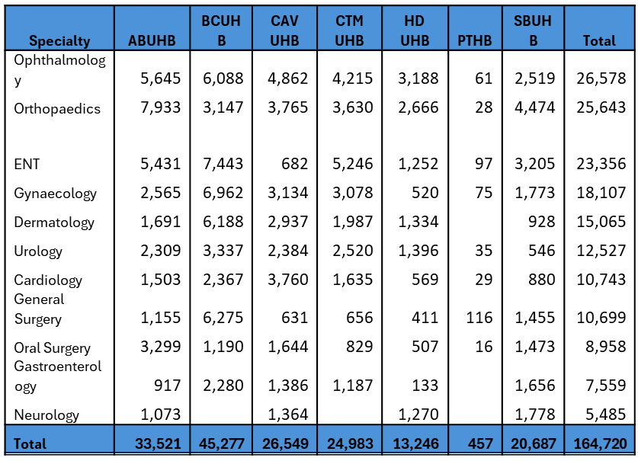

Part 2 is a broader Health Board led approach which aims to deliver an additional 50,000 new outpatient appointments. Whilst again funded by WG, Health Boards have discretion within this cohort to choose the specialties and the delivery model. The volumes allocated to each Health Board for this part of the plan were also derived by Welsh Government proportional to the overall volumes on each Health Boards waiting list, as seen below in table 2.

Table 2 – Part 2 outpatient volumes by Health Board

Therefore, across the two parts of the plan, Cardiff and Vale are required to deliver an additional 35,888 outpatient appointments between July and March 2026. It is estimated that this equates to 2,260 additional clinics– 30 per weekend, every weekend from July 25 – March 26.

Delivery Plan

On award of the insourcing tender for Part 1, Cardiff and Vale will be required to let the contract and deliver the insourcing through our estate. There is sufficient physical space to deliver the clinics, and an allocation of £193,000 has been received by the Health Board to support the administration of the clinics, a workforce plan for which is currently being developed.

The clinics will be restricted to running on Saturday and Sundays, and the offer to deliver the clinics will be from the insourcing company to our own staff in the first instance.

Delivery of these clinics assumes full delivery of Health Board core capacity, and those partaking are aware these clinics are additional, rather than a switch out of core job planned sessions.

Utilising our own staff is in line with previous custom and practice and mirrors the approach being taken across Wales. The patient pathway included in the insourcing tender is described below

- Provider clinician will see patient and either:
  - Discharge
  - Refer to diagnostics
- Additionality for diagnostics being worked up in a parallel WG programme but will be funded
- Referring clinician will be responsible for actioning outcome of diagnostic – i.e. this work won’t fall back to CAV core clinicians

In terms of part two of the Plan, (detail of which may be seen in appendix 1), a mixed economy of insourcing and waiting list initiatives is proposed.

Diagnostics

Ministerial advice regarding the allocation for patients requiring a diagnostic post as a consequence of the additional outpatient slots above core is expected imminently.

Current situation

Part 1

The tender evaluation of the insourcing procurement was held by Welsh Government on the 10th of June, however in accordance with procurement rules a standstill period is required. The contract has now been awarded to a company called HBS, and Board are asked to give approval to the contract being held and delivered within Cardiff and Vale University Health Board. Details of the award are seen in below.

Procurement Update

The complete procurement report is attached as Appendix 2 for Board Members. Please note that the Procurement Report will not be shared in the public domain and will be treated as Commercial in Confidence. The most salient part including contract value and Mandatory Questions that Providers must pass, including indemnity is outlined below:
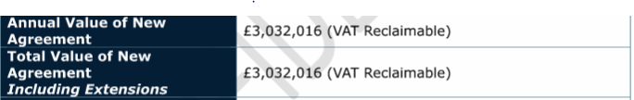

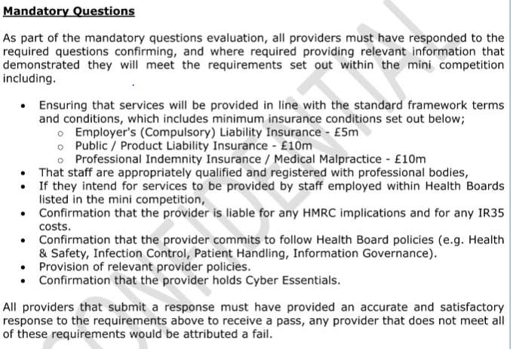

Part 2

For the Health Board delivered component of the activity, plans were required to be submitted to Welsh Government on the 7th of June, for an assessment of deliverability, and confirmation of funding. This deadline was met and we have received confirmation that we secured the full £2.3 million pounds requested.

The plan, (specialty breakdown and method of delivery) to deliver the Cardiff and Vale allocation of 9337 appointments is seen in appendix 1.

The Health’s Board plan, in part, intends to make further use of the nationally commissioned insourcing contract.

This plan identifies the costs associated with first appointment only, including a 10% uplift for medicines and facilities costs. There is national recognition, that this will result in an increased demand on diagnostic services and subsequent conversion to treatments.

The actual impact on diagnostic services is being assessed and the Health Board will notify Welsh Government colleagues overseeing this in terms of cases and cost.

Executive Director Opinion and Key Issues to bring to the attention of the Board:
The key principles underpinning the initiative, roles and responsibilities of Welsh Government, the Insourcing provider and the Health Board are detailed below

Key principles
- Core activity to be delivered and UHB IMTP plans fully delivered (100% additionality)
- Treat in turn – 1st OP booking also maximises impact on 104 weeks
- By nature, majority will be routine backlog
- Reasonable offer rules apply
- Alternative pathways still stand – i.e. straight to test
- Maximum numbers per specialty as per letter issued
- Will only be funded for patients via IS arrangement
- Numbers per clinic to be agreed between provider and NHSE – target to be booked per clinic – book 100% + capacity

WG/NHSE responsibility
- Secure funding for plan
- Confirm policy position and “core principles” to inform implementation
- Oversee National procurement and activity allocation
- Oversee delivery of provider and UHBs and report delivery to WG – agreed reporting mechanism
- Support UHBs to escalate issues/concerns and obtain timely decisions
- Validate allocation to UHBs based on actual activity

Provider Responsibility
- Secure funding for plan
- Confirm policy position and “core principles” to inform implementation
- Oversee National procurement and activity allocation
- Oversee delivery of provider and UHBs and report delivery to WG – agreed reporting mechanism
- Support UHBs to escalate issues/concerns and obtain timely decisions
- Validate allocation to UHBs based on actual activity

Health Board Responsibility
- Contract award (Part 1) - approval by Boards latest end of June 2025
- Internal governance arrangements to oversee delivery and contract management
- Point of contact for NHSE and provider
- Provision of estate and facilities every weekend until end of March 2026 and week evenings where possible
- Induction of provider staff
- Booking of patients (in line with core principles)
- £193k made available per UHB for 2025/26 to support admin – receptionist, booking, data
- Day to day management of contract and relationships with the provider

Risks
- Provider capacity – pre-procurement survey undertaken by Welsh Government suggests capacity available may be sufficient, will be confirmed via evaluation exercise after the 3rd of July
- Timeline to mobilisation – particularly in light of the delay in procuring the contract -
- UHB plans WLIs etc v Insourcing – clinical capacity and facilities, and potentially differential pay rates depending on agreements within the national tender
- Clinical engagement – conversion and duplicating 1st OP appt
- Conversion to treatment. Current plan deals with OP and diagnostics: current WG thinking is the only impact to treatment outwith what Health Boards have submitted in their Annual Plans is the requirement to substitute 104 patients for urgent patients identified through the additional outpatient activity. WG plan to address this via Phase 6 of their Planned Care Plan.

- Financial - An assessment has been made of the costs associated with running the phase 1 clinics that are out with the insourcing contract and will sit with C and V for salary for cleaning, linen and consumables of 3.3k for every week that the clinics run. In addition, an assessment of the Medicines costs associated with these appointments is a further £175, 000, as described below
Specialty | Planned Pts | New Rx | New £
Ophthalmology | 4862 | 174 | £4,797.28
Orthopaedics | 3765 | 4 | £25.24
ENT | 682 | 39 | £666.56
Gynaecology | 3134 | 132 | £3,227.03
Dermatology | 2937 | 179 | £12,217.16
Urology | 2384 | 12 | £538.82
Cardiology | 3760 | 72 | £3,235.35
General Surgery | 631 | 4 | £147.44
Oral Surgery | 1644 | 0 | £0.00
Gastroenterology | 1386 | 46 | £5,219.85
Neurology | 1364 | 157 | £145,280.04
Total | 26549 | 819 | £175,354.77

NB -– new Rx means estimated number of new prescriptions for the planned patients so we would estimate an increase in 819 prescriptions (split between primary and secondary care pharmacies) with an estimated cost of £175.3k (which also includes primary care dispensing fees for the proportion dispensed in primary care).

The rows in yellow are estimates as no current outpatient attendance data for those areas is available so are estimated on the ratio of appointments and prescriptions.

Appendices:
- Appendix 1 – Plan Part Two Specialty Selection, Mode of delivery and Cost
- Appendix 2 - The complete procurement report (Commercial in Confidence)

Recommendation:
The Board are requested to:

- Approve the Welsh Government Insourcing contract with HBS to be let and delivered via Cardiff and Vale University Health Board
- To approve the Part 2 internal Cardiff and Vale Delivery Plan

Link to Strategic Objectives of Shaping our Future Wellbeing:
https://shapingourfuturewellbeing.com/
  1.  Click the objective above to view more detail. |  |  |  |  |  |  |  |  |  |  |  |   2.  Click the objective above to view more detail.
  3.  Click the objective above to view more detail. |  |  |  |  |  |  |  |  |  |  |  |   4.  Click the objective above to view more detail.
Five Ways of Working (Sustainable Development Principles) considered
Prevention |  |  | Long term |  |  | Integration |  |  |  |  | Collaboration |  |  |  |  |  |  | Involvement
Quality Impact Assessment Completed?
Yes – (please provide completed QIA document) |  |  |  | No – (Please provide reasoning, e.g. not required)
Impact Assessment:
Risk: Yes/No (delete as appropriate)
Safety: Yes/No
Financial: Yes/No
Workforce: Yes/No
Legal: Yes/No
Reputational: Yes/No
Socio Economic: Yes/No - Useful Guidance on the application of the Socio-Economic Duty can be found at the following link: The Socio-economic Duty: guidance | GOV.WALES

Equality and Health: Yes/No
Decarbonisation: Yes/No
Welsh Language: Yes/No
Approval/Scrutiny Route (please note anywhere else this paper has been before):
Committee/Group/Exec |  |  |  |  | Date:

Specialty | RAG | Scheme |  |  | Patients | Cost
Ophthalmology | Green | Outsource |  |  | 423 | £ 253,800
Ophthalmology | Green | Insource |  |  | 380 | £ 75,783
Ophthalmology | Amber | Locum |  |  | 654 | £ 75,500
Ophthalmology | Amber | WLI |  |  | 164 | £ 18,923
Ophthalmology | Green | WGOS |  |  | 1,162 | £ 127,820
Orthopaedics | Amber | Insource |  |  | 605 | £ 322,217
Orthopaedics | Amber | Outsource |  |  | 529
Gynaecology | Amber | WLI |  |  | 449 | £ 126,420
Gynaecology | Amber | Outsource |  |  | 273
General Surgery | Green | WLI |  |  | 500 | £ 35,139
Breast | Green | WLI |  |  | 280 | £ 35,000
Oral Surgery | Amber | WLI |  |  | 149 | £ 45,000
AVM | Green | WLI |  |  | 139 | £ 40,500
Neuro | Green | WLI |  |  | 378 | £ 113,000
Allergy | Green | Insource |  |  | 1,350 | £ 527,850
Cardiology | Amber | Insource |  |  | 1,000 | £ 148,120
PARKINSONS | Green | WLI |  |  | 70 | £ 14,674
MEMORY | Green | WLI |  |  | 147 | £ 47,933
COPD (THORACIC) | Green | WLI |  |  | 96 | £ 15,652
ILD (THORACIC) | Amber | Locum |  |  | 207 | £ 18,632
GEN RESP (THORACIC) | Amber | Locum |  |  | 384 | £ 37,263
 |  |  |  |  | 9,339 | £ 2,079,226
Validation
Infrastructure Support
 |  |  |  |  |  | £ -
 |  |  |  |  |  | £ 2,183,226
Appendix 1 – Plan Part Two Specialty Selection, Mode of delivery and Cost

