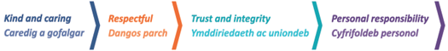
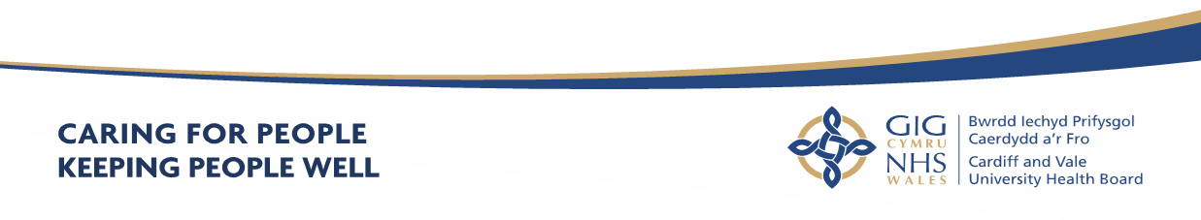

Cardiff and Value UHB
Annual Report
2023 – 2024

Accessibility

If you require additional copies of this document, it can be downloaded in both English and Welsh versions from our website. Alternatively, if you require the document in an alternative format, we can provide a summary of this document in different languages, larger print or Braille. Please contact us using the details below:

Corporate Governance Department
Cardiff and Vale University Health Board
Corporate Headquarters
Woodland House
Maes-y-Coed Road
Heath
Cardiff CF14 4HH

A full PDF version is available on our website.

Contact Us

 | Corporate Governance  Cardiff and Vale University Health Board  Woodland House  Maes-y-Coed Road  Cardiff  CF14 4HH
 | 029 2074 7747
 | news@wales.nhs.uk/ Corporate.Meetingcav@wales.nhs.uk
 | www.cardiffandvaleuhb.wales.nhs.uk/
 | @CV_UHB
 | https://www.facebook.com/cardiffandvaleuhb
 | https://www.instagram.com/cv_uhb

Contents | Page
1.Welcome from Chair and Chief Executive | 9
2.Cardiff and Vale Health Board Profile  2.1 About Us  2.2 Our Mission and Vision  2.3 Our Board  2.4 Our Structure  2.5 The Population We Serve  2.5.1 Demographics  2.5.2 Health in Our Area  2.5.3 Inequalities in Health and Health Outcomes  2.5.4 Human Rights  2.5.5 Citizen Voice Body (Llais)  2.6 Principles of Remedy  2.7 Our Strategy  2.8 Research and Development  2.9 Innovation and Partnerships | 12  12  13  13  17  17  17  18  19  19  20  20  21  23  24
Part 1 – Performance Report
3. Key Service Changes delivered in 2023-2024  3.1 Introduction  3.2 Statement from the Chief Executive  3.3 Integrated Medium-Term Plan (IMTP)  3.4 Performance Appraisal and Assessment  3.5 Financial Performance Trends  3.6 Delivery and Performance Analysis  3.6.1 Operational Performance Analysis  3.7 Quality Performance Analysis  3.8 Patient Experience  3.9 Patient Feedback  3.10 Well-being of Future Generations (Wales) Act Wellbeing Statement and Annual Reporting  3.11 Governance Arrangements relating to the WFG Act  3.12 Progress Against our Well-being Objectives  3.13 Case Studies for ‘Long-Term’ and ‘Prevention’  3.14 Welsh Language Regulations 2018  3.15 Sustainability Report | 27  27  27  29  31  35  36  36  42  45  45  47  48  54  55  56  59
4. Quality Governance Arrangements  4.1 Digital & Transformation Quality Work | 66  66
5. Delivering in Partnership  5.1 Cardiff and Vale Regional Partnership Board  5.2 Regional Healthcare Services  5.3 Specialised and Tertiary Services | 69  69  70  70
6. Our People | 71
6.1 Workforce Management | 71
6.2 Attract and Recruit | 71
6.3 Retaining our People | 74
6.4 Workforce Wellbeing | 74
6.5 Equity, Diversity and Inclusion | 76
6.6 The People and Culture Plan | 77
7. Conclusion and Forward Look | 78
Part 2 – Accountability Report
8. Scope of the Accountability Report
8.1 Corporate Governance Report | 80
8.2 The Composition of the Board | 80
8.3 Statement of the Chief Executive’s responsibilities as Accountable Officer of Cardiff & Vale University Health Board | 81
8.4 Statement of Directors’ Responsibilities in Respect of the Accounts | 81
8.6 Declaration of Interests | 82
Annual Governance Statement
9.1 Scope of Responsibility | 84
9.2 Escalation and Intervention Arrangements | 84
9.3 Model Standing Orders and Scheme of Reservation and Delegation | 85
9.4 The Board and its Committees | 86
9.5 Audit and Assurance Committee | 87
9.6 Composition of the Board | 88
9.7 Committees | 89
9.8 Advisory Groups & Joint Committees | 93
9.9 Public Appointments | 95
9.10 Public Interest Declaration | 95
9.11 Board and Committee Membership & Attendance 2023-2024 | 95
10. Risk | 95
10.1 Audit Assurance on Risk Management | 99
10.2 Management of Risk | 99
11. Mandatory Disclosures
11.1 Revised Health and Care Standards | 100
11.2 Emergency Preparedness | 100
11.3 Ministerial Directions and Welsh Health Circulars (WHCs) | 101
11.4 Regulatory and Inspection Reports | 101
11.5 Data Security and Information Governance | 102
11.6 NHS Pension Scheme | 103
11.7 UK Corporate Governance Code | 103
11.8 Review of Effectiveness | 103
11.9 Board and Committee Effectiveness | 105
12. Internal Audit
12.1 The Head of Internal Audit Opinion (DRAFT) | 106
12.2 Limited Assurance | 108
13. External Audit – Audit Wales
13.1 The Annual Audit Report for 2023 | 108
13.2 Cardiff and Vale University Health Board – Structured Assessment | 109
14. Modern Slavery Act 2015 – Transparency in Supply Chains | 110
15. Conclusion | 111
Appendices  Appendix 1 - Board and Committee Membership and Attendance 2023-2024  Appendix 2 – Dates of Board and Committee meetings held during 2023-2024  Appendix 3 – Ministerial Directions and Welsh Health Circulars | 113  119  121
16. Part 2b Remuneration and Staff Report
16.1 Staff Numbers | 128
16.2 Staff Composition | 128
16.3 Sickness Absence Data | 133
16.4 Staff Policies | 133
16.5 Salary and Pension Entitlements of Senior Managers 2023-2024 | 136
16.6 Consultancy Expenditure | 142
16.7 Tax Assurance for Off-payroll Appointees | 142
17. Part 2c Senedd Cymru/Welsh Parliament Accountability & Audit Report
17.1 Regularity of Expenditure  17.1.2 Long Term Expenditure Plans 2018-2024 | 145  145
17.3 Fees and Charges | 151
17.4 Managing Public Money | 151
17.5 Material remote contingent liabilities | 151
17.6 The Certificate of the Auditor General for Wales to the Senedd | 152
Part 3 Audited Financial Statement (Annual Accounts)
18. Financial Statements | 154


- Welcome from our Chair and Chief Executive

Thank you for taking the time to read the Health Board’s Annual Report for 2023-2024. The Annual Report provides us with the opportunity to share the progress made by the Health Board team with the support of a wide range of stakeholders and the community we serve, towards the achievement of our Annual Plan and the Shaping our Future Wellbeing Strategy. But also, to reflect upon some of the challenges impacting our team and those relying on us to support and care for them, often when they are at their most vulnerable.
In September 2023, following a period of co-production and consultation with our colleagues and stakeholders, our refreshed strategy, Shaping our Future Wellbeing, was approved by the Board. This strategy provides us with a high-level description of what we want to achieve by 2035, and the strategic objectives on which we will focus to get us there. Each of the strategic objectives include key milestones that we aim to deliver on over the next five and ten years. The strategy aims to bolster our unwavering commitment to rectifying disparities in access and outcomes. It encompasses the implementation of robust care models, a focus on quality, adoption of innovative healthcare technologies, digitisation efforts, modern infrastructure, and adherence to best practice. These multifaceted endeavours are essential to realising our ambitions and effectively serving the needs of the communities we serve.
Our vision is that a person’s chance of leading a healthy life should be the same wherever they live and whoever they are. We recognise the negative impacts of the cost-of-living crisis and the legacy of Covid-19, and as a Health Board, continue to progress towards the long-held ambition of addressing long-standing inequalities in outcomes between those living in the most and least deprived of our areas, and with ethnic minority communities and other marginalised groups. Our colleagues have also been affected by these external factors but continue to work tirelessly to meet the ever-increasing health and care needs of the citizens of Cardiff and the Vale of Glamorgan with great dedication, expertise and compassion and we wish to record here our thanks and pride in their unceasing commitment. We also recognise that as a result of the levels of demand, combined with our infrastructure and staffing challenges, individuals sometimes find access to our services and their experience within them difficult. We would like to thank the people of Cardiff and the Vale of Glamorgan for their continued support and feedback as we seek to continuously learn and improve the quality of access, care, treatment and experience for everyone. We have challenging times ahead, but we are confident that by tackling these challenges together, we can support people to live healthier lives and reduce the unfair differences in the prevalence of illness and health outcomes we see in our communities today.
NHS Wales has experienced periods of industrial action across 2023/24. As a Health Board we recognise colleagues right to take industrial action and our commitment throughout is to ensure the continued safe delivery of care our patients. We would like to record our thanks and gratitude to our teams that have delivered and supported one another remarkably well during these challenging periods and have ensured the safe continuation of our services. Through effective partnership working and collaboration we have sustained a safe response to these periods, and we acknowledge the hard work and commitment that this has required from colleagues.
As a Health Board we continue to place a particular focus on improving access to planned care and reducing waiting times for patients. Positive progress is being made and throughout this year we have met or exceeded requirements and sustained an improvement trajectory for our planned care services. Additionally, work to reduce our waiting lists has also made good progress, including for those waiting for cancer treatment.
The Health Board continues to place a consistent and persistent focus on all aspects of urgent and emergency care. Our teams are showing sustained improvement in these areas, and we have maintained our commitment to our objectives under the Six Goals programme throughout 2023/24. Our Medical Same Day Emergency Care (MSDEC) has achieved a significant milestone, surpassing the national set ambition for the percentage of the medical intake seen. Our stroke performance has seen a significant improvement and within this year we were awarded the highest rating (A) by the Sentinel Stroke National Audit Programme (SSNAP). Additionally, our Urgent Primary Care Centres (UPCC) have successfully covered 86% of the Health Board’s geographical area with UPCC appointments and it is our intention to ensure this level of coverage and utilisation is maintained. Furthermore, throughout 2023/24 we have made significant and sustained improvement in ambulance handover times which has resulted in greater patient safety and enabled a faster community response to people in need of emergency care.
2023/24 has seen the launch of a new multi-agency and multi-professional integrated urgent response service, Safe @ Home. This service forms part of our long-term solution to address the current gap in our range of intermediate care services and its goal is to provide an immediate and safe alternative to ambulance conveyance, EU (Emergency Unit) attendance and admission to hospital when it is safe and appropriate to do so. This partnership initiative presents a new opportunity to improve our offering of healthcare and support to our patients in the community.
The Health Board also launched a tool for classroom based physical activity in school children aged 4-6 years old, QuickChange. This tool was created through the collaborative working of our Local Public Health Team and our Podiatry Team and aims to encourage strength, balance and mindfulness. The tool reflects our commitment to embedding the sustainability principles set out in the Wellbeing of Future Generations Act and we are proud to be facilitating this opportunity to improve the wellbeing of generations to come.
The Covid-19 pandemic has significantly highlighted the importance of mental health support, particularly for young people. The Hangout was opened by the Health Board in September 2023 in partnership with mental health charity Platform. The Hangout provides an opportunity to redefine how children and young people access mental health and wellbeing support when they need it in a non-clinical setting. The Hangout also acts as an activity hub for young people. 2023 also saw the opening of the new Paediatric Trauma Unit in the Children's Hospital for Wales with the goal of improving the way we deliver patient care and providing a better working environment for our teams.
Within this year we have also seen the roll out of the Buvidal Drug Pilot through our Buvidal Psychological Support Service (BPSS). The Buvidal drug is used to treat opioid dependence in patients who are receiving medical, social and psychological support. This pilot has produced positive findings and has demonstrated that BPSS is an effective model that enables many patients to transform their lives and relieve their dependence on opioids.
In August 2023 the Health Board became a Member of the Florence Nightingale Foundation (FNF) Academy, a global initiative that helps develop, support and retain nurses and midwives. Our Health Board endorses the core principles of the Florence Nightingale Foundation in its pursuit of excellence in healthcare and our collaboration will empower nurses and midwives to reach new heights and deliver even better patient care.
December 2023 saw the official opening of the Canolfan Iechyd Genomig Cymru by the Minister for Health and Social Services. Funded by Welsh Government, the state-of-the-art facility co-locates some of Wales’ leading experts in the field of genomics: Genomics Partnership Wales, the All-Wales Medical Genomics Service (AWMGS), Pathogen Genomics Unit and Public Health Genomics Programme, and Wales Gene Park. This collaborative environment will be home to world-class clinical and research laboratories, purpose-built clinical spaces, and will drive innovation forward. This will support Wales in becoming a leading nation in this area of health care, whilst ultimately improving the lives of the patients who use these services and bringing huge benefits to the Welsh population.
Successes like this would not have been possible without flexible and innovative colleagues who have supported and created these changes, and many more. They have provided better outcomes for people and a significant decrease in the time it takes to be assessed, treated or admitted.
These are just a few examples of so many where colleagues, partners, patients and people have worked collaboratively, often in challenging circumstances, with great enthusiasm professionalism and creativity to deliver, improve and adapt services. We are continually inspired and impressed, and we thank you all for your continued support over the past year. We look forward to strengthening our work in partnership and to listen, understand and learn so that we can continue to improve and make a positive difference those who work with and depend upon us.



- Cardiff and the Vale Health Board Profile

2.1 About Us

Cardiff and the Vale University Health Board is one of the largest NHS organisations in Europe. Established in 2009, it provides a range of health and wellbeing services to its population. We spend around £1.86 billion every year on providing our communities with the full range of health and wellbeing services including:
- Primary and community-based services: GP practices, Dentists, Pharmacy and Optometry and a host of community led therapy services via community health teams. We also provide step-down, step-up community hospital care from St Davids and Barry Hospitals.
- Acute services through our two main University Hospitals and Children’s Hospital: providing a broad range of medical and surgical treatments and interventions.
- Public Health: we support the communities of Cardiff and the Vale with a range of public health and preventative health advice and guidance.
- Tertiary centre: we also serve a wider population across Wales and often the UK with specialist treatment and complex services such as neurosurgery and cardiac services.
The diagram below illustrates the various services we provide.
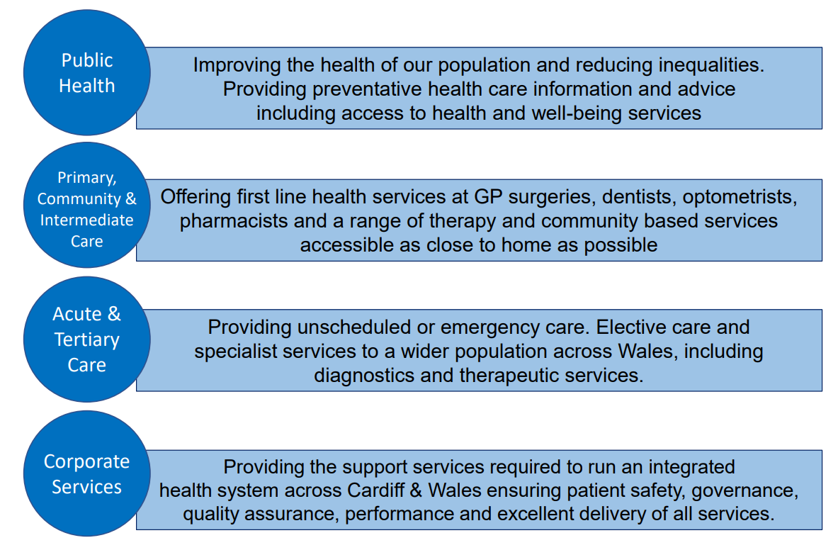
2.2 Our Mission and Vision

Our Vision, for the people we serve, is through working together, we will help improve lives so that by 2035 people are healthier and unfair differences in health outcomes are reduced. The care we provide for people who need our services and those delivering services will be outstanding, with outcomes and experience for all that compare with the highest performing peer organisations.
Everyone should have the best possible opportunity to live a healthy and fulfilling life - where the unfair differences in health outcomes, which impact on life expectancy, are reduced. We will achieve this by working with local communities and the Public Services Board partners to tackle the issues that cause preventable illness and premature death.
To achieve our vision, we have developed our strategic objectives – the Health Board’s wellbeing objectives - which reflect our commitment to embedding the sustainability principles set out in the Wellbeing of Future Generations Act in the way that we work together to deliver them.
We also aspire to provide outstanding healthcare, where the outcomes reflect that we are a highly research- active University Health Board and are comparable with high-performing peers. We will measure our performance against health care organisations that are like us in terms of the size and complexity of the Health Board’s services, teaching and research, at UK and international level.
2.3 Our Board

Our Board consists of 20 members, including Chair, Vice Chair and Chief Executive. The Health Board has 11 Independent Members, all of whom are appointed by the Minister for Health and Social Services, and three Associate Members.

The Board provides leadership and direction to the organisation and is responsible for governance, scrutiny and public accountability, ensuring that its work is open and transparent by holding its meetings in public.

In addition to their responsibilities and accountabilities set out in their terms and conditions of appointment, Board members also fulfil a number of Champion roles where they act as ambassadors for these matters.

The Board is supported by a number of Committees, each chaired by an Independent Member.

Our Committee meetings have continued to be held virtually during the year. Members of the public have been able to view recordings of our virtual Committee meetings since February 2022 via our website. The Committees, which meet in public, provide their minutes to each Board meeting to contribute to its assessment of assurance and to provide scrutiny against the delivery of objectives.

From May 2022 we resumed holding our Board meetings in public, with members of the public being able to observe public meetings of the Board in person since 26 May 2022.

Copies of the papers and minutes are available from the Director of Corporate Governance and are also on the Health Board’s website (see link: https://cavuhb.nhs.wales/about-us/governance-and-assurance/board-meetings/). The website also contains a summary of each Committee’s responsibilities and Terms of Reference. All actions required by the Board and Committees are included in an Action Log and at each meeting progress is monitored. These Action Logs are also published on the Health Board’s website.

All Committees annually review their Terms of Reference and Work Plans to support the Board’s business, in addition to producing an Annual Report to demonstrate compliance with their respective Terms of Reference. Committees also work together on behalf of the Board to ensure that work is planned cohesively and focusses on matters of greatest risk that would prevent us from meeting our mission and objectives. To ensure consistency and links between Committees, the Health Board has a Governance Co-ordinating Group, chaired by the Chair of the Health Board.







2.4 Our Structure

We have a workforce of around 17,862 staff who consistently deliver high quality services to all of our patients. Our organisation is structured and designed into seven Clinical Boards which were created in June 2013 and have been successful in providing strong leadership in clinical areas and have resulted in the acceleration of operational decision-making, greatly enhancing the outcomes for patients in their care. The Clinical Boards are held to account via the Executive Directors.
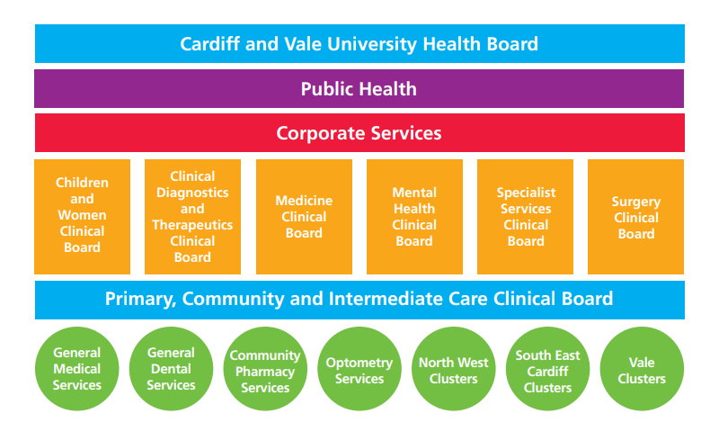

Our corporate and planning services are an integral part of the overall structure and smooth running of the Health Board. These include:

- Strategy, Planning and Commissioning
- Finance including Capital, Estates and Facilities
- Workforce and Organisational Development
- Digital Health Intelligence
- Communications, Arts, Health Charity and Engagement
- Corporate Governance
- Research & Development and Innovation & Improvement

Scrutiny of the Corporate Services directorates is through a combination of governance, Executive Director and senior management accountability and progress is mapped against key projects within their areas of expertise.

2.5 The Population We Serve

2.5.1 Demographics
Nearly 500,000 people live in Cardiff and the Vale of Glamorgan.
Cardiff has a relatively young population, mainly due to the student population in the city. The proportion of older people is slightly higher than the Wales average in the Vale; the number of older people and the proportion of people who are older is increasing across both areas.
Previous trends in population growth in our area have slowed, with a projected increase of 3-4% over the next 10 years, or around 15-20,000 more residents.
Every year, people migrate into and out of both Cardiff and the Vale. In 2021-22 the net effect of this was around 500 people moving into each of our local authority areas from elsewhere in the UK; there was also a significant increase in the number of international migrants moving into our area, with a net effect of over 10,000 people moving into Cardiff and over 500 into the Vale from overseas. Combined, this made up over half the number of international migrations into Wales as a whole. Migration includes the reception of Ukrainian refugees, the Afghan Citizens Resettlement Scheme (ACRS) and other asylum seeker populations.
Cardiff is more ethnically diverse than most of the rest of Wales, with just over a quarter of people identifying as not White British in the 2021 Census. The corresponding figure for the Vale of Glamorgan was 8%. In Cardiff this includes sizeable populations reporting Black African, Indian, Pakistani, Bangladeshi, Arab and Chinese ethnicity; along with non-British white ethnicities.
Both Cardiff and the Vale contain some of the most affluent areas of Wales, alongside some of the most deprived. In Cardiff, there are pockets of deprivation throughout the city, but many are located in the ‘southern arc’, including Ely, Caerau, Grangetown, Riverside, Llanrumney and St Mellons; in the Vale again there are scattered pockets of deprivation throughout, with a higher concentration in the central Vale, in and around Barry.23.1% of adults in Cardiff and 30% of adults in the Vale can speak Welsh.

2.5.2 Health in Our Area
We can get a picture of the health of our residents through assessments such as the Well-being assessments (for Cardiff and the Vale) and the Population needs assessment for the region, along with individual health needs assessments and routine and bespoke surveillance data.
Particular issues in our area which impact on people’s health are:
Wider determinants
- Air quality
- Adverse weather events (heatwaves, flooding) due to climate change
- Access to healthy and affordable food
- Access to affordable high-quality housing
- Access to nature and green spaces, and biodiversity loss
- High quality public transport, and walking and cycling networks
- Social isolation and loneliness

Health behaviours
- Tobacco and vape (e-cigarette) use
- Immunisation uptake
- Being physically active regularly
- Achieving and maintaining a healthy weight
- Alcohol consumption
Healthcare
- Timely access to primary and secondary care
Over three-quarters of adults (76%) in our area reported being in good or very good health, the highest in Wales. Nearly a third (31%) of people said they were limited by one or more long-term illness, though again this was the lowest rate in Wales. Life expectancy for men in our area is nearly 79 years, and for women is 83, both above the Wales average.
The number of people living with long term conditions is increasing, along with the number living with more than one illness. The number of new cases of type 2 diabetes in particular is forecast to increase significantly in the coming decade, with diet, smoking and overweight known risk factors.
It is estimated that over a fifth of deaths in England and Wales are avoidable, due to preventable or treatable conditions.
2.5.3 Inequalities in Health and Health Outcomes
Within Cardiff and Vale there is a stark difference in life expectancy between people living in our least and most deprived areas, some of the worst in Wales. If you live in one of our least deprived areas you can expect to live 8.3 years longer as a woman or 9.3 years longer as a man, than someone in our most deprived areas. Despite a concerted effort to reduce this gap over the past decade, the gap has actually increased.
This gap is even wider when looking at the years of life which are healthy – healthy life expectancy – for which people in our most deprived areas can expect to have between 14 and 18 fewer years of healthy life than someone living in our most affluent areas.
Along with poorer health outcomes, the majority of the factors determining health described above are also worse in more deprived areas.
Reducing inequalities and prioritising prevention run throughout our revised long-term strategy, Shaping our future Well-being. Operational delivery of our population health priorities is described in our local public health plan which is updated annually.

2.5.4 Human Rights

The Health Board has an Equality, Diversity and Human Rights Policy which sets out the organisational commitment to promoting equality, diversity and human rights in relation to employment. It also ensures staff recruitment is conducted in an equal manner.

2.5.5 Citizen Voice Body (Llias)

Throughout this year we have worked closely with the new Citizen Voice Body (Llias), the national independent body set up by Welsh Government to give the people of Wales a stronger voice in their health and social care services.

We work together with Llias to discuss the delivery and development of the services we provide, and we welcomed reports from them and are grateful for their advice, challenge and support.

For more information, please contact:

Llais Cardiff
Parc Ty Glas, Llanishen
Cardiff
CF14 5DU
Telephone: 02920 750112
Email: enquiries@llaiscymru.org

2.6 Principles of Remedy

The Health Board has fully embraced the regulations which guide the handling and response to concerns (complaints and incidents) launched by Welsh Government in April 2011. In addition, the Health Board’s approach to dealing with concerns very much reflects the ‘Principles of Remedy’ published by the Public Services Ombudsman for Wales.

- Getting it right

- We acknowledge when we identify things that could have been improved.
- We consider all relevant factors when deciding the appropriate remedy, ensuring fairness for the complainant and, where appropriate, for others who have suffered injustice or hardship as a result of the same maladministration or poor service.
- We apologise and explain the maladministration or poor service.
- We try to understand and manage people’s expectations and needs.
- We always try to deal with people professionally and sensitively.

- Being customer focused

- We acknowledge and accept responsibility for failure if and when it occurs.
- We explain clearly why the failure happened and express sincere regret for any resulting injustice or hardship.

- Being open and accountable

- We try to be open and transparent
- We strive to treating people without bias, unlawful discrimination or prejudice.

- Acting fairly and proportionately

- We consider all forms of remedy (such as an apology, an explanation, remedial action, or financial compensation).

- Putting things right

- We are focussed upon using information on the outcome and themes from concerns to improve services.

- Seeking continuous improvement

- We seek to offer a proportionate, reasonable investigation and response that aims to identify the opportunities for service improvement.

2.7 Our Strategy

In September 2023 our refreshed strategy, Shaping our Future Wellbeing, was approved by the Board, a copy of which can be accessed via the following link: Home - Shaping our Future Wellbeing

This strategy provides us with a high-level description of what we want to achieve by 2035 and the strategic objectives on which we will focus to get us there, Each of the strategic objectives have key milestones that we will aim to deliver over the next five and ten years to deliver the Health Board’s strategy. This strategy builds on Shaping Our Future Wellbeing 2015 - 2025, developed in 2013 and still reflects many of its underlying principles
We have challenging times ahead, but we are confident that by tackling these challenges together, we can support people to live healthier lives and reduce the unfair differences in the prevalence of illness and health outcomes we see in our communities today. We aspire to deliver outstanding care and treatment for people when they need it, where they need it; care that compares well with the best in the world, but to do so, we need to transform how we deliver services over the next decade and beyond.
We are a values-driven organisation and our goals will only be realised if our values are at the heart of everything we do. Created by colleagues, patients and their families and carers, our values are:
- We are kind and caring
- We are respectful
- We have trust and integrity
- We take personal responsibility

Within the refreshed Strategy, we have set four strategic objectives, the achievement of which will enable us to realise our vision for better health and outstanding care. These are:
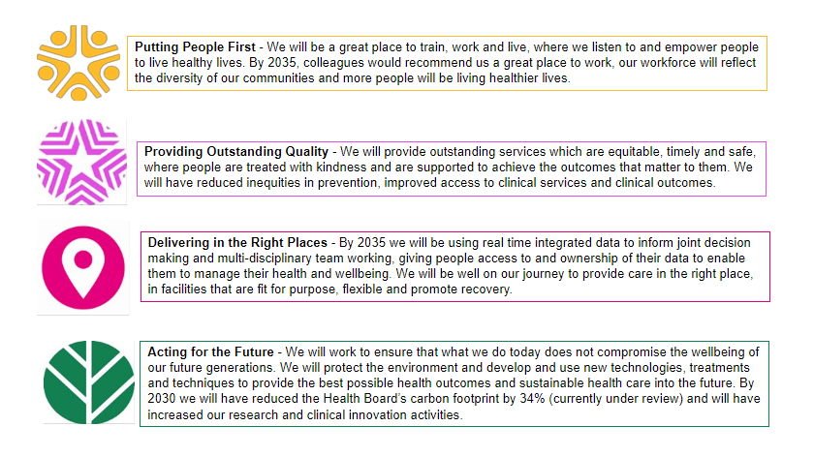To deliver our strategy we will work in a way that is participatory. This means enabling and empowering people to be involved in shaping our plans and taking an active role in their care and health as equal partners. Co-production will be at the heart of how we improve our services and we will act on regular and timely feedback from those who use and deliver our services. We will actively seek the participation of our partners in the planning and delivery of services – this includes everyone who works in the Health Board, NHS partners, local authority and third sector partners, and university partners. We will participate effectively in the formal partnerships of which we are members – the Cardiff and Vale of Glamorgan Public Services Boards (PSBs) and the Cardiff and Vale of Glamorgan Regional Partnership Board (RPB), our regional service planning and delivery partnerships (South East Wales health boards and, for tertiary and specialist services, our partnership with Swansea Bay UHB), Cardiff University Partnership, and collaborative commissioning partnerships such as Welsh Health Specialist Services Commissioner (WHSSC).
Prevention will be at the centre of our pathways of care; preventing illness in the first place, intervening early and addressing preventable deterioration when a health condition is diagnosed. We will work in a way that anticipates people’s needs, using integrated real-time data to plan and deliver personalised health care and treatment plans for all the family, and using intelligence to accurately predict changing demand to help us plan and manage our services into the future.
2.8 Research and Development

The Health Board is proud of its long-standing University status designation and its history of delivering pioneering, high-quality clinical research and development (R&D). This upholds one of the core principles of the ongoing NHS and Health Board strategy, namely, to embrace R&D and innovation to generate new knowledge and drive change and transformation within healthcare.

Embracing research across the organisation not only allows patients better access to study participation but also the potential for novel therapeutics that can alter disease trajectory. The downstream benefits of trials include change in practice, education, clinical experience, financial gain, staff recruitment, retention and reputational growth.

Given the size of the budget, R&D punches well above its weight. Recruiting and retaining staff remains a challenge, as is the case across the whole NHS and healthcare system. Our performance far exceeds other University Health Boards in Wales and accounts for approximately 40% of all recruitment in Wales.

169 ‘hosted’ studies were approved to open this year, however we believe we can achieve more. There is a need to expand the delivery team to be able to support the number of trials our investigators want to deliver. We plan to continue to explore opportunities to develop a larger, sustainable delivery workforce that can meet demand.

In part, this will be powered by developing our own investigators leveraging grant income. This year Cardiff and Vale researchers have continued to achieve success in securing large National Institute of Health Research (NIHR) Grants. These include the The ELIPSE Study - a randomized controlled trial comparing the clinical and cost-effectiveness of lymph node removal in patients undergoing curative surgery
for localized high-risk prostate cancer. The project has secured £2 million via the NIHR Health Technology Assessment grant and being led by Krishna Narahari. The study will open across to recruitment across the UK in 2024-25.

Nine investigator led research projects were developed and set up this year by Cardiff and Vale staff. It is hoped the success of our own investigators will continue to grow with the support of the Joint Research Office and collaboration with our academic partners at Cardiff University.

Another important collaboration which continues to mature is the Cardiff Cancer Research Hub which is a collaborative between CAV, Velindre Cancer Centre (led by Mererid Evans) and Cardiff University (led by Awen Gallimore). This will not only provide a wider access to medium and high-risk early phase trials and advanced cell therapies but also the opportunity to develop bench to bedside therapies, reverse translation and novel diagnostics.

The publication of the Lord O’Shaughnessy review ‘Commercial clinical trials in the UK’ has led to a shift in emphasis in both NIHR and HCRW and is an attempt to address the fall in commercial trial activity in the UK. Both Moderna and BioNTech are looking to invest in the UK, focusing particularly on vaccine trials. HCRW have entered into a collaboration with BioNTech to facilitate the delivery of their vaccine trials pipelines. Cardiff and Vale in collaboration with Velindre are building up the infrastructure to support delivery of these studies. This is a great opportunity, not only for patients, but also has downstream benefits for preventative healthcare and the burden on the NHS in Wales. CV UHB are leading on the development of a vaccine program in Wales with a vaccine centre based in the Clinical Research Facility led by Andrew Freedman

Building reputational resilience as a leading research active organisation is vital for attracting and retaining talented healthcare professionals. An indicator of this is publishing in international high impact journals to this end our researchers have published in the three leading global journals in healthcare, the New England Journal of Medicine, Journal of the American Medical Association and Lancet over the last year.

There are many additional opportunities around developing expertise in the delivery of unscheduled care trials, advanced therapies and using some of the excellent infrastructure that exists in Cardiff such as Cedar Health Technology Research Centre, High Consequence Infectious Diseases unit (HCID), the Wales Research and Diagnostic PET Imaging Centre (PETIC) and Cardiff University Brain Research Imaging Centre (CUBRIC).

2.9 Innovation and Partnerships
The identification, implementation and wide deployment of innovative solutions to improve health outcomes is not something that a single Health Board or NHS organisation can achieve individually. Collaboration and partnership is crucial, be that with colleagues within the organisation, who can help identify and prioritise the need, or with external organisations be they within the NHS, commercial, 3rd and not-for-profit sectors, and Government and arm’s length bodies. We have continued to work closely with our extended peer group across Wales to identify opportunities to help simplify and accelerate the development, adoption and implementation of novel solutions across all areas of the Health Board, in both clinical and non-clinical areas. Having contributed to the Government’s strategy published in 2023, Wales Innovates: Creating a Stronger, Fairer, Greener Wales, we have actively engaged in the development and operationalisation of the next stage implementation plan. In particular, at a national level, good progress has been made on identifying areas to adopt common aims and a harmonised approach; for example, in the creation of a central programme directory, a potential approached to intellectual property management, policy frameworks, funding opportunities and adoption. We also created a ‘bitesize’ introduction to innovation training package, that has been well received by colleagues, with the intention to ‘stimulate the creative juices’ and help everyone understand better where the innovation opportunities may be in their area and how the innovation team could support the exploration of those and help turn them into reality. Rewardingly, this initiative was the catalyst to a wider national initiative to develop a range of additional, accredited modules, at various levels for Wales.
Locally, we have also continued to ongoing activities, such as the Cardiff Capital Region funded, ‘Endoscopy Challenge’ with a view to addressing waiting lists by the development of enabling technological solutions and approaches; the Small Business Research Initiative Wales project to develop a system that can process exhaled Entonox (pain-relieving gas) to reduce unnecessary exposure; and colleagues who have been working on innovative pathway changes in conjunction with the Bevan Commission. Looking to the future, we are continually exploring new ways of partnership working and held our first ‘showcase’ event. Working with the Life Science Hub Wales we brought together, in the University Hospital Llandough, a number of companies a range of products all of which have application in the area of dementia along with clinical and non-clinical colleagues to explore how these may be applied within our organisation. Similarly, in another ‘first’ we are exploring a multi-way partnership with several large Pharma companies to see how we can improve lipid management and control in patients with heart failure. Currently in the planning phase we aim to ‘go live’ in 2024.
Recognising the move to work more closely with colleagues and organisations in social care and the shift to integrated care models, our Regional Innovation Coordination Hub team have continued to work closely with our Regional Partnership board. Here we have identified and helped support awareness and adoption of best practice, for example in social prescribing, through direct contact with teams, convening and facilitating workshops, as well as through ‘storytelling’ through written and film media. The team also directly supported other initiatives, in addition to social prescribing, in the area of end of life care, by helping individuals spend that time in an appropriate setting, and in the development of a digital care record approach to enable correct identification of individuals across health and social care record systems. These important projects will also continue to be supported this year.

Part 1
Performance Report

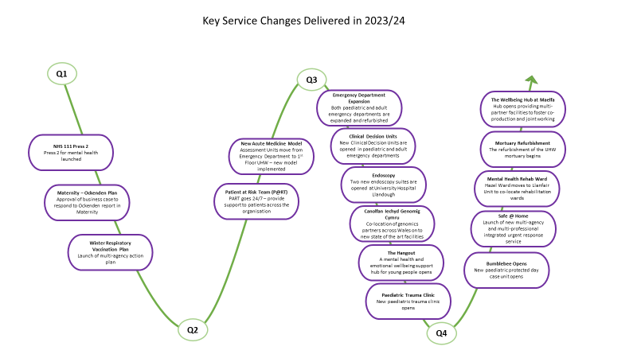

3. Performance Overview
3.1 Introduction
The Health Board submitted its final Annual Plan set in a three-year context in March 2023. Delivery of the plan over the last 12 months has continued to be challenging and we have continued to worked hard, in conjunction with our partners, to recover and improve the delivery of healthcare services. Additionally, the Health Board successfully published our refreshed strategy ‘Shaping our Future Wellbeing to 2035’ in July 2023. This strategy demonstrates our shared vision and purpose, reaffirms our organisational values, and creates the strategic framework for delivery in short, medium, and long-term contexts. Our emphasis has continued to be on ensuring that quality and value underpin our approach with a commitment to preserving or improving patient safety, quality, access to services and staff wellbeing. This Performance Overview section provides a summary of some of the key organisational achievements, challenges and risks over the past year.
3.2 Statement from the Chief Executive
Our organisational performance over the 2023-24 period was characterised by gradual and steady recovery as our teams balanced the lasting impacts of the Covid-19 pandemic with the prerogative of recovery and redesigning our services for the future. The Health Board’s approach to performance was underpinned by the Ministerial Priorities and the “accountability conditions” issued later in 2022/23. A note on our approach and delivery against each of these priorities is provided below, with the detail provided throughout the Performance Overview and wider content of the Annual Report.
A Healthier Wales - as the overarching policy context
A Healthier Wales sets out a long-term vision that everyone in Wales should live longer, healthier and happier lives. It proposes a whole-system approach to health and social care which is equitable, and where services are designed around individuals and groups based on their unique needs and what matters to them, as well as quality and safety outcomes. The delivery of this ethos has continued to be integral to both our planning and delivery of services and has underpinned the creation of our strategy ‘Shaping our Future Wellbeing to 2035’.
Population health
Our commitment to improving population health has been shaped around our plan ‘Shaping our Future Population Health’. Published in February 2022, this plan has helped us to set out a system approach to identify and address current and future population health issues, improve health, prevent ill health, and reduce inequalities in health outcomes among residents and communities in our area.
NHS recovery
Our progress with recovering and redesigning services has been significant while we continue to address the challenges resulting from the Covid-19 response in conjunction with our workforce challenges. We have seen sustained commitment to achieving our objectives under the Six Goals for Urgent and Emergency Care programme as well as to our objectives for Planned and Elective Care. Delivery of services has been in line with our Annual Plan commitments in most areas. Further detail on our achievements and areas that require continued improvement, is provided within the Performance Appraisal section below.
Mental Health and emotional wellbeing
Mental Health and Emotional Wellbeing services have seen a significant increase in referrals over the past year and we are proud that despite this we have delivered core targets for assessment and treatment. Our focus continues to be on improvements in services, such as Neurodevelopment where we have a need to reduce waiting times and continue to strengthen our cohesion with education services.
Supporting the health and care workforce
The health and wellbeing of our people continues to be of the utmost importance. The impact of the pandemic has had wide ranging and deep implications for our teams. Over the last year we have remained committed to supporting and enhancing the wellbeing of our people. Our ambition continues to be to make the Health Board a great place to work and we continue to make progress on embedding the ambitions set out within Our People and Culture Plan launched in 2022.
NHS Finance and managing within resources
The Annual Report sets out how the Health Board has managed its financial resources during the financial year 2023/2024.
Working alongside Social Care
The challenges facing our Health and Social Care system can only be addressed through close, open and supportive partnership working. Over the last year the Health Board has embedded this approach throughout our partner organisations at operational, strategic and Executive level. The development of a Regional Incident Management Team to address pressing shared issues, underscores the importance the Health Board has placed on close working with Local Authority partners, with senior teams meeting twice a month to work on initiatives including joint workforce planning and the commissioning of additional social care capacity over Winter.
3.3 Integrated Medium-Term Plan (IMTP)
Within Wales and across the UK, we are operating within the most challenging circumstances that the NHS has faced since its inception. This is primarily a result of the legacy of Covid and Brexit, the volatile economic environment, the impact of the cost-of-living crisis on our staff and our residents, and the increased demand upon our services

In 2023/2024, against the backdrop of unprecedented and uncertain circumstances, our organisation submitted an annual plan within a three-year context. We were unable to deliver the level of recurrent savings that we set out in our 2022/2023 plan or mitigate escalating cost pressures.

Delivery of the 2023/24 financial plan has been challenging and the delivery of the 2024/25 Annual Plan will see a continuation of our drive to deliver a robust financial sustainability programme and spend more money on prevention as per our strategy in what continues to be a very difficult operational and financial environment.

The Annual Plan was informed by our Commissioning Intentions (as summarised in the diagrams below). The Commissioning Intentions for 2024-2027 were informed by the Primary Care Cluster and Pan-Cluster Plans in conjunction with the Cardiff and Vale of Glamorgan population needs assessments and the Wellbeing assessments of the two local authority areas to ensure we are delivering outcomes that matter to our population. These highlight the specific health needs of our population and are supported by the needs profiles for our three localities. The Commissioning Intentions form the bridge between our 10-year strategy and IMTP by continuing to outline our strategic objectives but also look towards the future priorities for our organisation. Our commissioning intentions were agreed by the Board in July 2023 and were been updated alongside our strategy refresh.

Diagrams showing a summary of our Commissioning Intentions
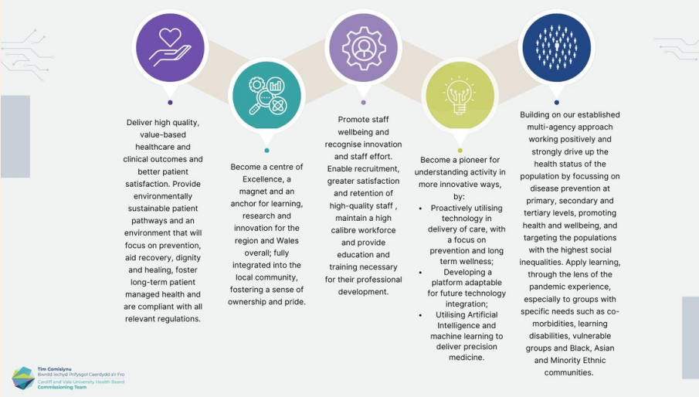

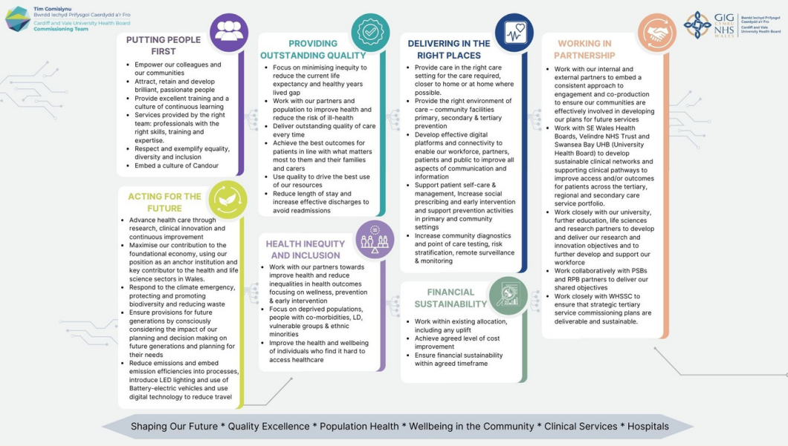
Similarly, our Annual Plan responds to the commissioning requirements of our neighbouring health boards and the Welsh Health Specialised Services Committee (WHSSC) for the specialist and tertiary services we provide for their populations and patients.

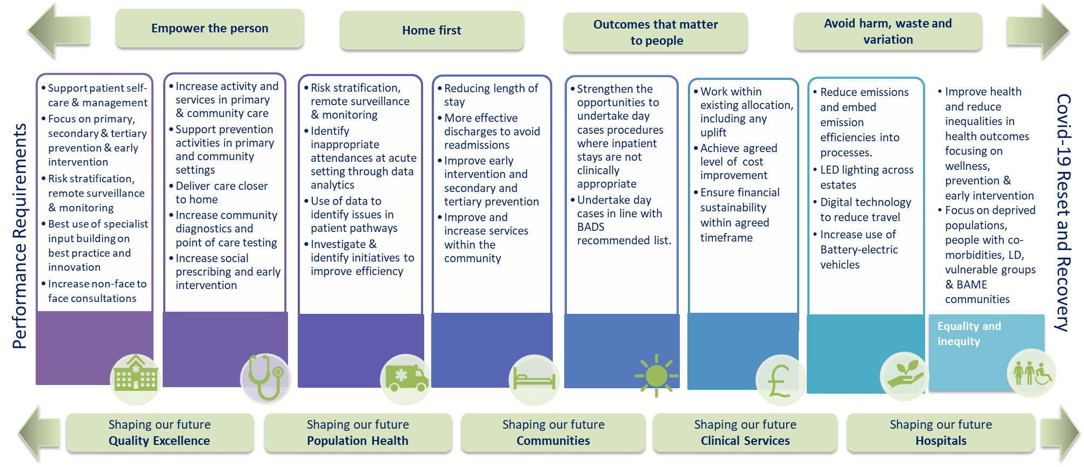
In response to the Health Board’s Annual Plan, the Welsh Government has issued a number of Accountability Conditions (set out below) which are required to be met and which require the following “Five Ways of Working” sustainable development principles of the Well-being of Future Generations Act to be central to the Health Board’s approach.

“Five Ways of Working”

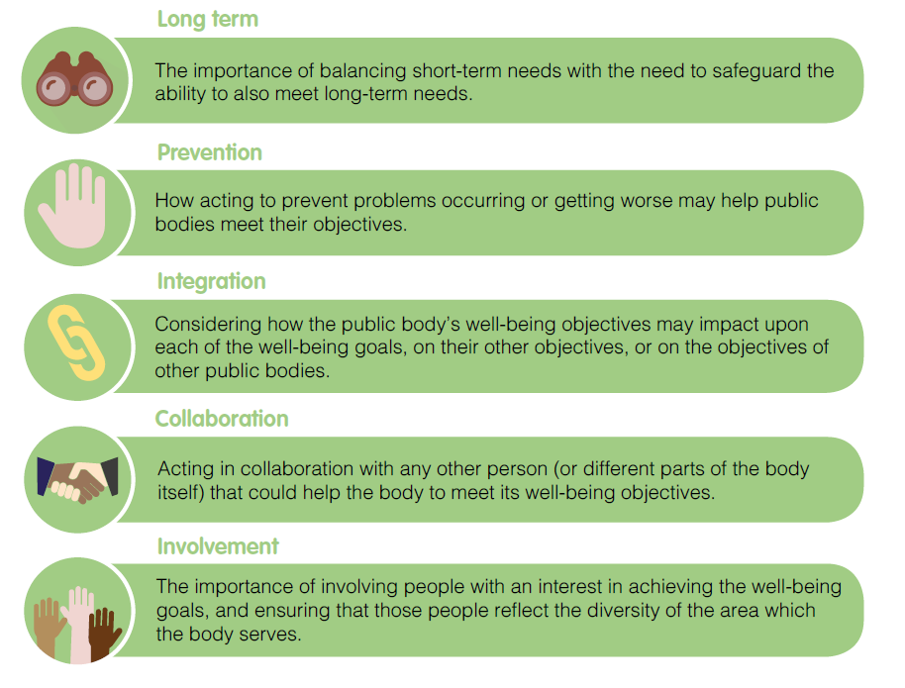

3.4 Performance Appraisal and Assessment
The Health Board’s overall performance was characterised by a number of improvements in access and quality within urgent and emergency, specialist and mental health pathways alongside continued challenges in planned care services. The delivery of improvements, despite the impact of sustained and significant periods of industrial action, give cause for reassurance that the organisation is progressing towards its objectives albeit at a slower rate than originally planned. Challenges across Health and Social care, particularly in relation to workforce pressures and a reduction in social care capacity, have proved extremely difficult to overcome. In order to mitigate these as well as possible, the Health Board has sought to keep our focus on quality and candour at all times.
To assess our performance, we have reviewed our delivery ambitions that were outlined in our annual plan. Figure 1 provides a high-level picture of achievement against some of the key performance ambitions we set ourselves this year. Where the ambition has not be achieved further explanation of the performance can be found in the Delivery and Performance Analysis section.
The remaining measures require further work, particularly in relation to planned care performance and feature as revised priorities in our 2024/25 annual plan.

3.5 Financial Performance Trends

The health board has a statutory obligation to remain within its resources on a three year rolling measure.
After several years on deficit the health board managed to meet this requirement at the end of 2021-22.
The target was not met in 2022-23 as Covid pandemic funding decreased at a time when the health board coped with inflationary pressures and system pressures in part incurred as a legacy of the Covid pandemic period.
The target was again not met in 2023-24 as a result of the significant pressures the health board faced in year as it continued to deliver services from an operational footprint still predominantly designed to address Covid demands and infection control.

Performance against the 3 year financial break even duty
 | Year end position surplus / (deficit) £'m | Rolling 3 year break even duty surplus / (deficit) £'m | Pass or fail financial duty
2014/15 | (21.364) | n/a | n/a
2015/16 | 0.068 | n/a | n/a
2016/17 | (29.243) | (50.539) | Fail
2017/18 | (26.853) | (56.028) | Fail
2018/19 | (9.872) | (65.968) | Fail
2019/20 | 0.058 | (36.667) | Fail
2020/21 | 0.090 | (9.724) | Fail
2021/22 | 0.232 | 0.380 | Pass
2022/23 | (26.789) | (26.467) | Fail
2022/23 | (16.404) | (42.961) | Fail

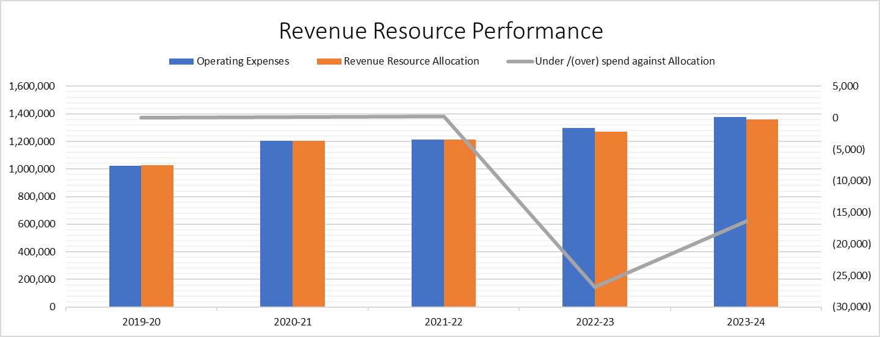

Capital Resource Limit
The health board continues to manage within its annual Capital Resource allocation through the proactive management of the health board Capital Management Group which oversees capital bids and progress on major capital projects to appropriately flex expenditure plans and utilise each year’s capital allocation effectively.

Public Sector Payment Performance
The UHB met its public sector performance target in 2023-24 and continued to improve its NHS payment compliance within this overall level of performance.

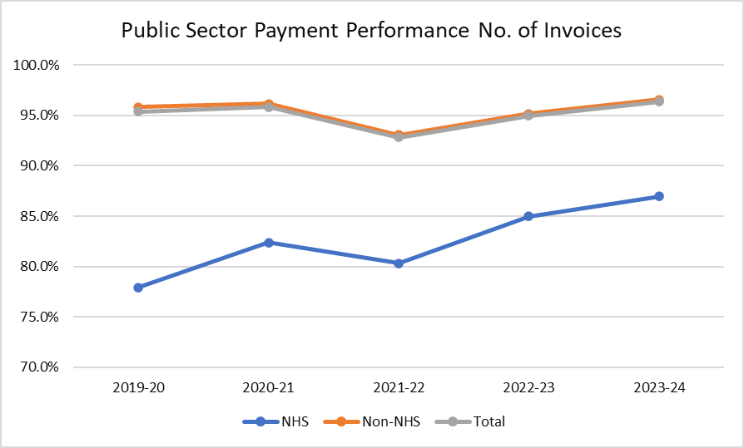

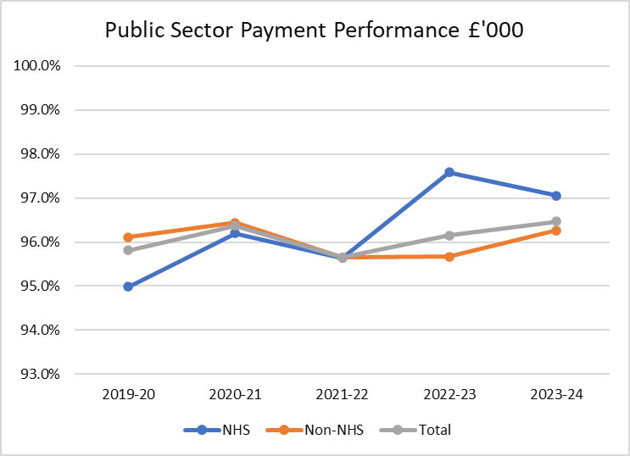

Figure 1 – Snapshot performance against some key ambitions
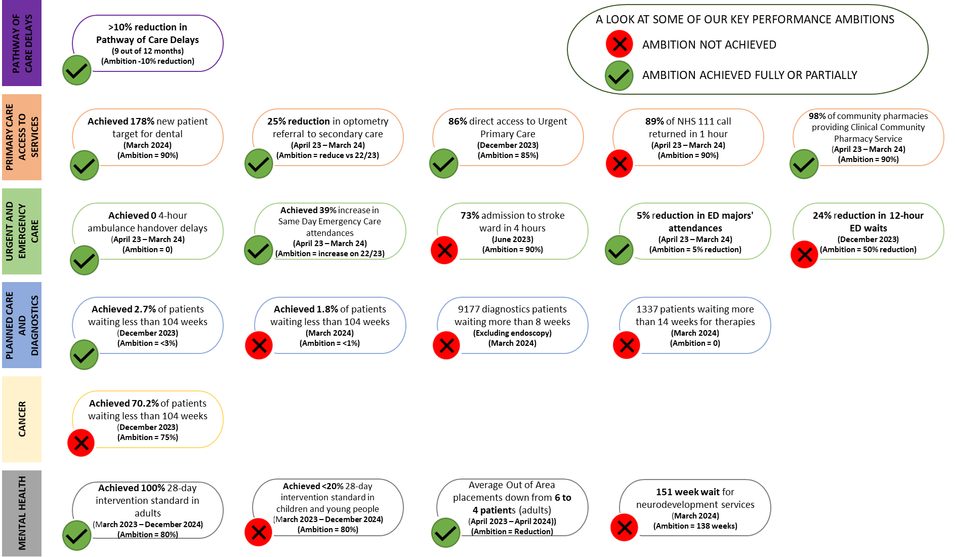

3.6 Delivery and Performance Analysis

3.6.1 Operational Performance Analysis

Urgent and Emergency Care

Our focus on Urgent and Emergency Care has led to some significant improvements in key services over the last year. We have continued to utilise our 6 Goals for Urgent and Emergency Care Delivery Board to implement clinically led and outcomes focused changes. Our approach to this work spans primary, community, acute and tertiary services. Primary and community care teams continue to be the foundation of our urgent and emergency care system. During 2023/24 the Health Board provided over 225,000 district nursing visits which have helped to support our patients receive care in their usual place of residence. Our community teams have increased the access options available to our patients. This has included the launch of our Safe @ Home pilot scheme, this is a new multi-agency and multi-professional integrated urgent response service which aim is to provide an immediate and safe alternative to ambulance conveyance, EU attendance and admission to hospital when it is safe and appropriate to do so. The team is comprised of GPS, WAST practitioners, Nurses, Therapists and Support workers

We have continued to support primary care with the expansion of Urgent Primary Care Centres (UPCC), these centres have provided valuable additional capacity to help improve access for patients and to relieve pressure on General Medical Services (GMS) practices. There are now over 1100 UPCC appointments available per week in Cardiff and the Vale, with 86% of GP practices having direct access. Access to primary and community care has also continued to evolve through the introduction of NHS 111 and the continued delivery of our CAV 24/7 service. Call volumes to CAV OOH service have increased with an average of over 15,100 per month.

As a Health System we have faced similar pressures to other parts of Wales with a particular challenge in discharging patients and ensuring that there is availability of Social Care workforce and community support for patients no longer requiring acute hospital care. Working with partners across Health and Social Care has continued to be of the highest organisational importance. Partnership working is embedded throughout the Health Board and includes daily operational meetings with Local Authority and Integrated Discharge Services. At the end of the year we had 221 patients who had delayed transfers out of hospital.

2023/24 was a year in which the Health Board delivered on its commitment to begin transformation of the care we deliver within our Emergency Department. A reorganisation programme has reconfigured the department, providing additional capacity in triage, minors, paediatrics and provided space for the introduction of Clinical Decision Units for both adults and children. Whilst there is still much improvement to be made, these changes will provide the basis for our continued commitment to transform the patient experience within our urgent and emergency care system.

The Health Board has continued to be a positive outlier in Wales in relation to ambulance handover performance. We remain the only Health Board to have no patients waiting longer than 4 hours on an ambulance and our average lost minutes per arrival reduced from 30 minutes in 2022/23 to 22 minutes in 2023/24. These improvements have been delivered by a system wide response but with significant clinical leadership from teams. Despite this improvement, we are focused on reducing these waits further as well as improving patient experience by reducing the time it takes to be assessed and treated or admitted in our emergency department. This is particularly important as we know the number of patients waiting for over 12 hours before admission or discharge is still far above our expected standard.

Avoiding unnecessary hospital admissions has been a focus over the last year and progress has been achieved through the continued delivery of our 7-day Same Day Emergency Care (SDEC) Units and virtual wards.

Our performance in some of the key emergency pathways, such as stroke and hip fractures, has been a real success of 2023/24. Figures 2 and 3 show the improvements in the % of stroke who are admitted to the stroke ward within 4 hours and the % of patients who receive a CT scan within 1 hour.

Figure 2 – Stroke Ward admission within 4 hours

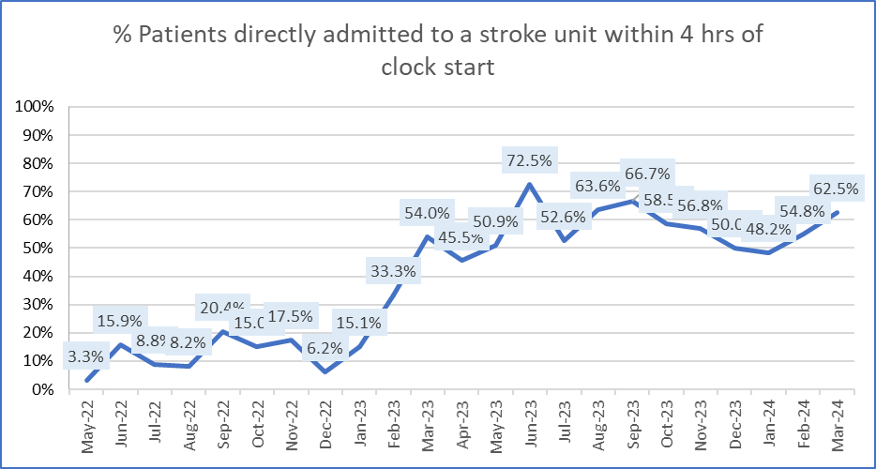

Figure 3 – Stroke patients CT scanned within 1 hour

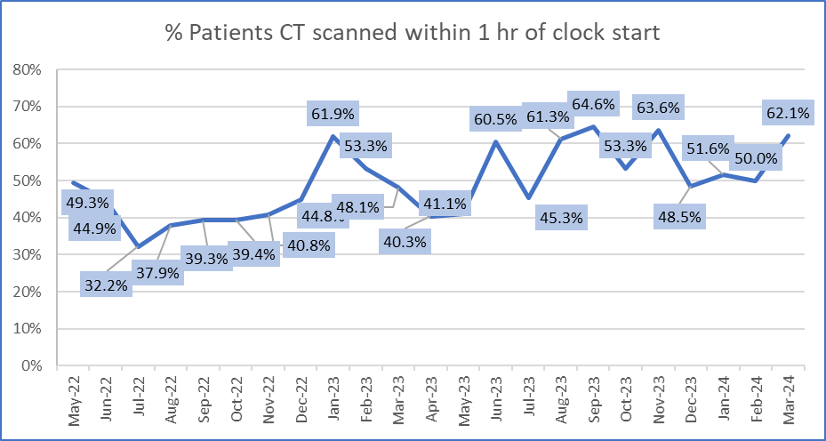

Figure 4 shows the improvement that has been made in ensuring that patients with a hip fracture are admitted to the ward within 4 hours. The graph shows how our performance improvement each month means we are far exceeded the average from the top performing hospitals across the UK in this measure.

Figure 4 – Hip patients admission to ward within 4 hours

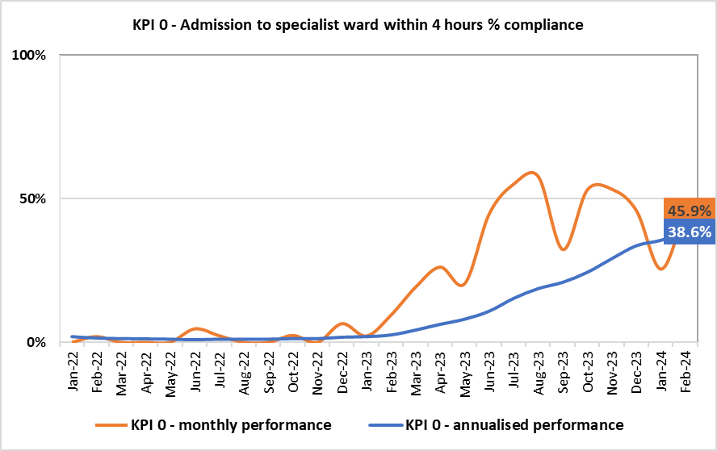

Cancer

Performance within Cancer Services has been gradually improving when compared to previous years. Referrals have increased by 8% this year when compared the previous year. Whilst we have not met our ambition to have 75% of patients treated within 62 days, we did deliver our highest ever performance of 70.2% of patients during December 2023. Since January 2024 we have seen a reduction in the number of patients waiting over 62 and 104 days for treatment, in addition to a reduction in the overall waiting list size. Our approach to delivering these improvements has been aligned to the national cancer pathways. The Cancer team have broken our performance reporting down by pathway stage which has driven improvements in time to first outpatient appointment and time to diagnostics, in additional to the progress made in reducing the backlog of patients over 62 and 104 days.

Planned Care and Diagnostics
We have worked hard to reduce our waiting lists across planned care. Improvements have been made in spite of the challenging operational pressures across the Health Service and the unprecedented breadth of industrial action. Our delivery of service change has been led through our planned care programme and this includes close regional working across South East Wales in specialities such as Ophthalmology, Orthopaedics and Endoscopy. The total number of patients waiting for treatment on a Referral to Treatment (RTT) waiting list has increased to 147,620 in March 2024. On the key ministerial priorities was the reduction in the number of patients waiting over 2 years for treatment. The Health Board was able to meet the standard of having less than 3% of the waiting list waiting over 2 years in December. We made further progress over winter, reducing this to less than 2% in March. This meant we had 2681 patients waiting on RTT waiting lists greater than two years and allow we were pleased to reduced the number of specialities reporting these long waits from 14 to 7 over the year, we know patients are still waiting too long and we continue to make this a priority for the coming year.

Despite our reductions in extremely long waiting patients (over 2 years), the number of patients waiting over 52 weeks for treatment has increased to 31,124. This is due to a combination of increased demand, operational pressures, industrial action and a focus on the extremely long waiting patients.

Within our outpatient clinics we have been concerned at the high number of patients who are awaiting a follow up appointment. We know that there is potential clinical risk within this cohort of patients and have been working hard to improve the position. Each follow up has a target date, in April 2024 over 54,000 patients had waited over twice as long as their target date. This number has reduced to 28,000 in March 2024. Whilst still far too high, there is a concerted effort to reduce all follow up delays during 2024/25.

Further detail on the improvements made to reduce waiting times can be found in figures 5, 6, and 7 below.

Figure 5 – number of patients waiting longer than 52 weeks for a new outpatient appointment

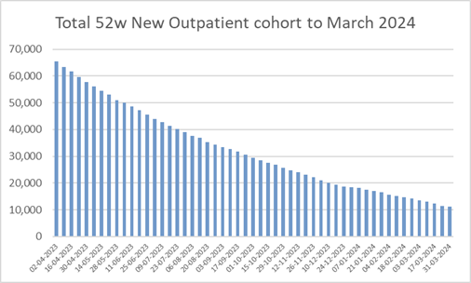
Figure 6 – number of patients with a total wait longer than two years
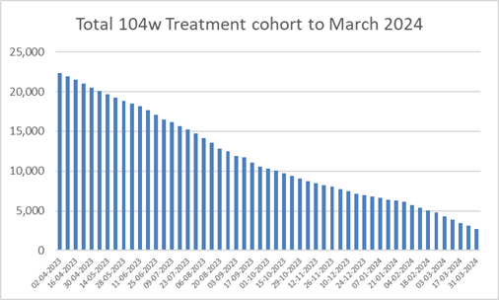
Figure 7 – number of patients with a total wait longer than three years
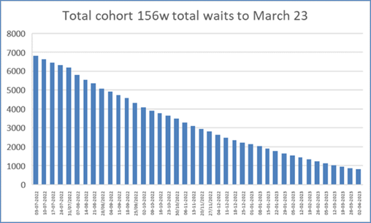

We have continued our focus on Children’s services, paying particular attention to the disproportionate impact long waiting times can have on a child's development and opportunity to live a healthy life. The number of children on an RTT waiting list has reduced from 11,442 in March 2023 to 10,697 in March 2024.

Diagnostics are a fundamental part of the planned care pathway and our overall performance in the last year has been below the standards we have aspired to. Figure 8 shows the total number of patients waiting over 8 weeks for a diagnostics test has increased significantly, peaking at over 14,000. This has not been a universal picture with improvements in 8-week waits for Echos, Holter tapes, Angiograms and CT scans. The main drivers for the increases in diagnostic waits have been MRI and non-obstetric Ultrasound with the latter accounting for nearly half our total reported 8-week breaches. In addition to these, Endoscopy capacity has been focused on Cancer, Urgent and long waiting surveillance patients and the impact of this has been a deterioration in the number of 8-week waits for colonoscopy, flexi sigmoidoscopy and gastroscopy.

Figure 8 – Diagnostic Waits

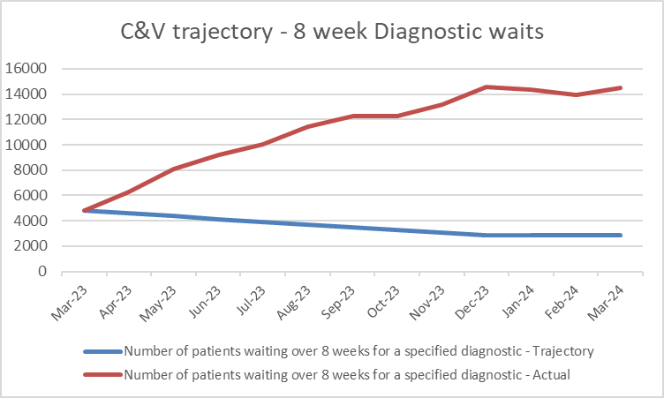
Figure 9 shows the reduction in the number of patients waiting longer than 14 weeks for therapies which has increased from 952 in March 2023 to 1337 in March 2024

Figure 9 - >14-week therapy waits
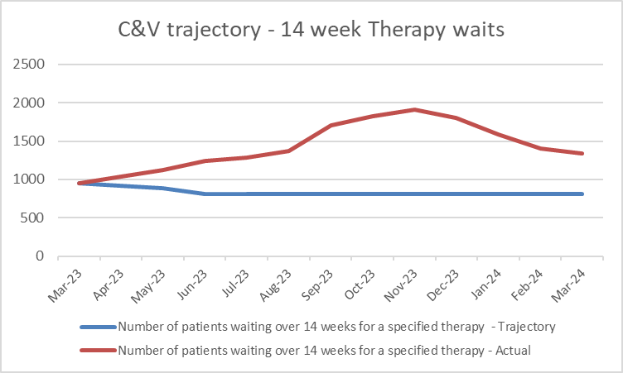

Mental Health

Demand for Adult and Children’s Mental Health Services has continued to be high, for example referrals in to adult services again increasing by over 10% on the previous year and being over 40% up on 2020 levels.

Within Children’s Emotional Wellbeing and Mental Health we have largely met the 28-day assessment standard but consistently fallen below the 28-day intervention standard. Our challenges are a combination of workforce pressures and increased demands and our teams have set out an improvement trajectory to reduce these waits during 2024/25.

Figure 10 – Children’s Emotional Wellbeing and Mental Health Performance
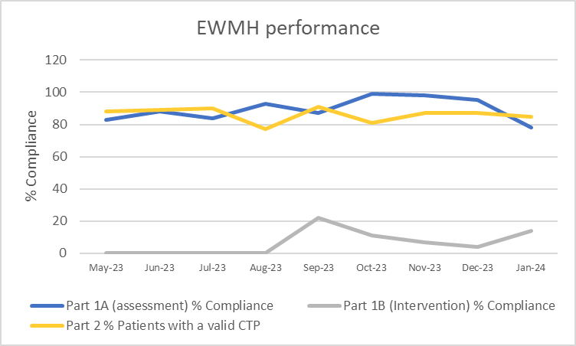

Neurodevelopmental services provide multidisciplinary assessment, intervention, information and advice for children and young people who may have a neurodevelopmental disorder, and their families. Since the start of the pandemic the referrals to these services have increased significantly and this had led to patients waiting a long time for assessment. Our teams have implemented a number of improvements in 2023 which has helped to reduce the overall number of patients waiting and we have plans to reduce the long waits in 2023/24 but these are still significant.

Within adult services, we have consistently delivered on both the 28-day assessment and intervention standards. This delivery has not been without some challenges as the increases in demand have caused fluctuations in performance.

Figure 11– 28-day assessment standard in adults

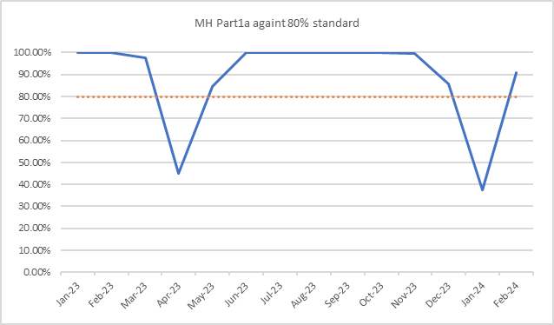

Figure 12 – 28-day intervention standard in adults

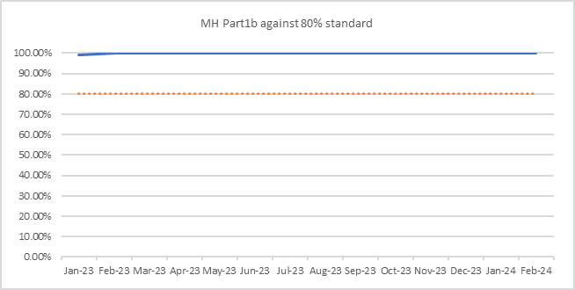

Adult and Paediatric Eating Disorder services have seen a reduction in the size of their waiting lists and the number weeks wait for their longest waiting patients. Psychological Therapy services have seen a decrease in the number of patients on their waiting lists and a decrease increase in the proportion of patients waiting less than 26 weeks for an appointment.

The end of 2023 saw the Health Board extend the use NHS 111 by launching our Mental Health line which provides specialist support and onward direction for patients who would benefit from accessing primary or secondary mental health services. During 2023/24 the volume of calls has increased with over 200 calls per week being received in March 2024.

Primary and Community Planned Care

Primary and Community Services have remained under significant pressure during 2023/24 and this has been characterised by an increase in the number of GP practices reporting high escalation levels. Despite these pressures, the Health Board has continue to prioritise the delivery of services in the community as part of our drive to deliver care closer to home for patients. Some key performance measures include:

- 98% of all eligible community pharmacies providing Clinical Community Pharmacy Services
- 32% increase in the number of pharmacy independent provided consultations
- 98% of GP practices achieving the core access standards (in hours)
- 139% achievement of the standard of new patient appointments in Dental
- A decrease in referrals from optometry to secondary care of 25%

3.7 Quality Performance Analysis

Quality is at the heart of all that we do – our services must be safe for our patients and provide good patient experience and outcomes. We recognise the importance in ensuring we have a key emphasis on quality in the services that we deliver and we are creating a culture that is committed to learning and continuous organisational development through measurement of evidence-based practice to deliver demonstrable improvements in patient care.

Clinical Audit

Cardiff and Vale UHB is committed to delivering effective clinical audit in all the clinical services it provides. The Health Board sees clinical audit as essential to continually evolve, develop and maintain high quality patient-centred services. The organisation has adopted a policy on the governance and practice of clinical audit, which applies to all staff. Achieving the objectives set out in this strategy will ensure that the UHB policy is implemented and effective, resulting in sustained improvements to the quality of care provided to patient

In 2022 the UHB published a three-year clinical audit strategy. The aim of this strategy is to use clinical audit as a process to ensure clinical quality at all levels of the organisation over the next three years. The UHB clinical audit forward plan incorporates all mandated national clinical audit as well as Tier 2 clinical audits undertaken to support assurance and inform quality improvement relating to quality and Patient Safety. The Clinical Audit forward plan is a rolling programme that evolves and changes throughout the year. The 2023 -24 clinical audit plans for each Clinical Board were presented to the UHB Audit committee in October 2023 and National clinical Audit results are presented to the Quality Safety and Experience Committee biannually via the UHB Clinical Effectiveness Committee.

Quality Improvement Initiatives

Continuous quality improvement is a fundamental component of the Duty of Quality implementation in the health board. Quality improvement initiatives encompass a wide range of activities, including clinical audit programs, staff training and development, patient feedback mechanisms, and service redesign projects aimed at optimizing patient outcomes and experiences.

The Quality, Safety, and Experience Committee receives regular Quality Indicators reports, aligning with the Duty of Quality Act and Safe Care. These reports cover incident reporting, mortality, maternity outcomes, infection control, ambulance handover times, patient experience, stroke pathway compliance, values-based healthcare, health inequalities, and person-centred concerns and feedback statistics.

The diagram below demonstrates the Quality, Safety and Experience Committee and Group Structure.

It is worth highlighting that work remains ongoing as we implement the Organisational Learning Committee which has not yet been finalised, the committee will provide a senior level overview of identified learning ensuring it is robust and sustainable as well as providing senior level support to Health Board wide learning. The Organisational Learning Committee will capture learning from patient and staff feedback. Compliments, incidents, complaints, redress cases, Ombudsman cases, claims, inquests, local and national audits, HIW reports and tendable data. The Organisational Learning Committee will work with the Innovation and Improvement team, universities, and other interested parties.

Further information in relation to our quality improvement initatives is set out in your Duty of Quality report for 2023-2024.

Quality Improvement Examples for 2023-2024

Suicide & Self Harm 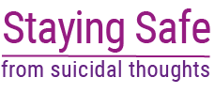

- The Suicide Mitigation and Awareness Training continues to be rolled out beyond mental health in-patient services and into Mental Health community services. Discussions are under way regarding the potential for offering training outside of the mental health Clinical Board and what the governance of that would be.
- Mental Health Clinical Board has set up a Suicide Training Implementation Group to oversee and support the rollout process. This group now includes representation from Lived Experience.
- The Mental Health Clinical Board Director of Nursing has been tasked with setting up a Suicide and Self Harm sub-group to the Clinical Safety Group.

Falls Prevention

Community
- Promotion of Community Falls Prevention Pathway to partners in primary care, local authorities and third sector. continues
- Falls Prevention messages and services promoted on our social media and staff communication channels
- Elderfit - case study published on UHB website
- Falls Prevention Week – Falls prevention ‘crime scene’ exercise as per images below
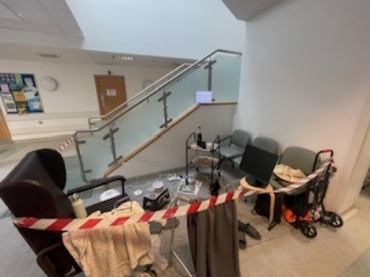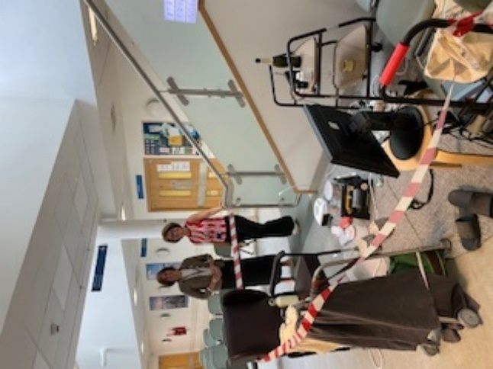

- ‘Ageing Well’ community programme in development with health board Co-production Forum that includes partners from health, social care local authorities and third sector organisations.​
- ‘Compassionate Conversation’ card developed for Allied Health Professionals’s to facilitate conversations about falls and falls prevention.
- FaME courses delivered by Elderfit in Cardiff Council Hubs as per images below


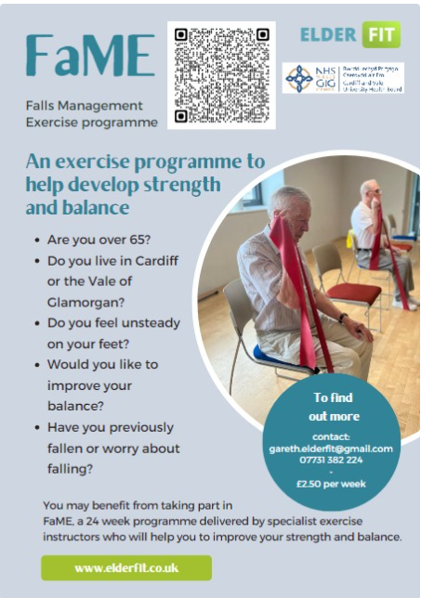

Inpatient
- Roll out of Falls Prevention and Management Training for clinical staff across Medicine.
- Review of various fall detection technologies and trial of 2 different products across 2 different ward settings in University Hospital Landough and St. David’s Hospital.

Suicide Prevention:
- The Suicide Mitigation and Awareness Training continues to roll out beyond mental health in-patient services and into MH community services.
- The Mental Health Clinical Board has set up a Suicide Training Implementation Group to oversee and support the rollout process. This group now includes representation from Lived Experience.

Improving End of Life Care:
- Health Board wide education is ongoing including provision by our commissioned services City hospice and Marie Curie to community nursing teams and nursing homes. The hospital specialist palliative care Clinical Nurse Specialists provided over 100 hours of formal education in 23-24 including topics such as symptom management, Health Care Support Worker and End of life care, grief and loss, complex communication and complex discharge planning.
- The development and roll out of a standardised, structured process and information resource for informal carers who are supporting patients to go home for End-of-life care. This can be used by healthcare professionals to guide the conversations needed and the way informal carers are prepared for discharge, it is tailored to each patient and then goes home with the patient to reinforce all the information and discussions that have taken place and the information resource also acts as a communication tool between hospital and community Health care professionals.

3.8 Patient Experience 

Cardiff and Vale University Health Board is committed to providing quality services in line with our strategic objectives and is therefore committed to improving patient experience. Whilst every effort is made to do what is right for our patients, there have been times when we have got it wrong, and it is essential that we listen to people’s feedback in order to learn. "Patient experience" encapsulates all aspects of our clinical and non-clinical care including the care environment, staff attitude and communication, team working, access issues, involvement in decisions about treatment choices and our ability to be responsive and resolve problems quickly. It is also about treating patients with honesty, dignity and respect. It applies across all services provided to patients in the Health Board.

A number of different tools are utilised to capture patients’ experiences including;

- Real time surveys
- Retrospective Surveys
- Proactive/Reactive Surveys

Under the National Health Service (Concerns, Complaints and Redress Arrangements) (Wales) Regulations 2011 (known as Putting Things Right or ‘PTR’) the Health Board is required to provide assurance and evidence to the organisation’s community and stakeholders that we are continuing to deal with and learn from concerns.

Performance Monitoring 2023-2024

Total number of complaints received | Total = 4,259  Formal = 2,136  Early Resolution = 2,123
Top Themes arising from Complaints | - Concerns around appointments (waiting times/cancellations)  - Communication  - Clinical Treatment and Assessment
Percentage of formal Complaints responded to in 30 working days (NHS Delivery framework target of 75%)
Never Events  Nationally Reported Incidents | 6  134
Legal Claims Registered | 130 new claims (Clinical negligence and Personal Injury)
Public Service Ombudsman requests for a further response | 3
Compliments received | 780

3.9 Patient Feedback
Patient Feedback 
We have continued to gather feedback from patients using our services during 2023-2024, with some key activity listed below;

- Approximately 800 text messages sent per day to gather hospital activity feedback
- 154,384 feedback texts sent in past 12 months with a response rate of 17%
- 85% of people surveyed are happy with their experience

Tell us in 2 Survey 
What do we do?
- Posters, stickers and signs are placed around hospital sites and at bed sides displaying a QR code, inviting patients to share their recent experiences of our services
- QR code gives the individual access to the “Tell Us In 2” survey - a short 2-minute anonymous questionnaire which can be completed in English or Welsh
- Questionnaire asks for open and honest opinion of patient experiences so the Health Board can share compliments, best practice or suggestions, to learn from experiences and help shape services for the future.
- The word cloud below based on the comments received in our feedback from our Tell us in 2 survey. The green highlights positive sentiments and the red highlights negative sentiments.

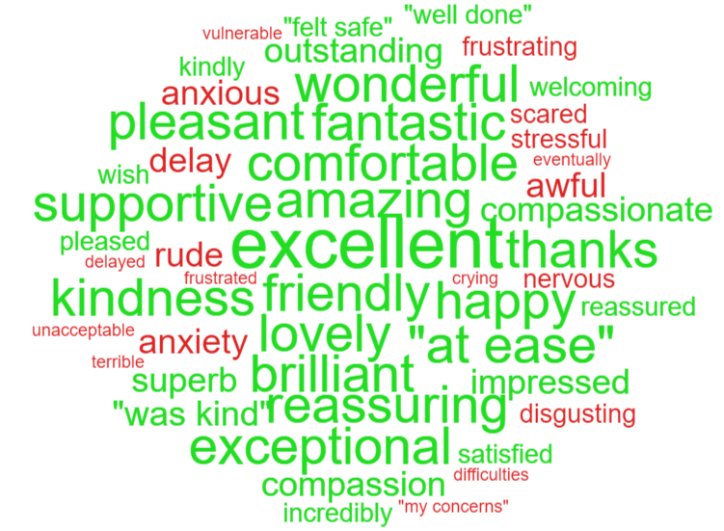

What You Said, What We Did, Initiatives for 2023-2024

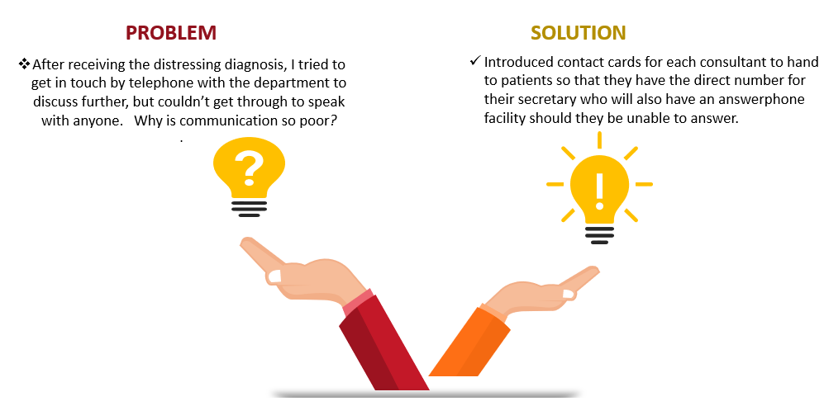

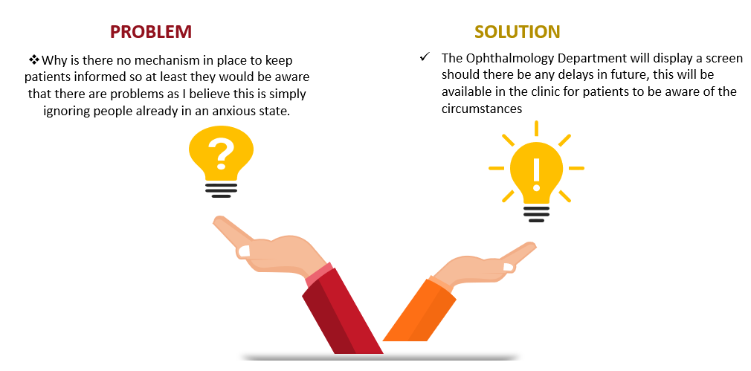

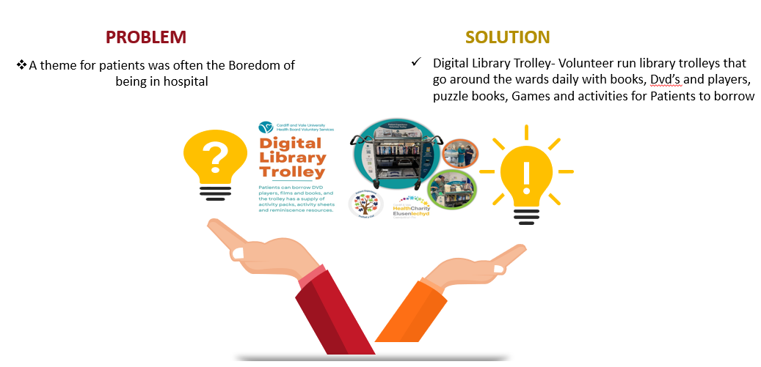


3.10 Well-being of Future Generations (WFG) (Wales) Act Wellbeing Statement and Annual Reporting
During 2023-24 we reviewed and updated our well-being objectives under the Well-being of Future Generations (WFG) Act, with our new objectives reflecting our refreshed long-term strategy (see below). Delivery of our strategy through our IMTP and annual plans, and monitoring through existing performance structures, is our mechanism for delivering our well-being objectives.
The strategy and objectives were developed following extensive consultation and feedback from local residents, partner organisations, and our staff. The strategy itself is underpinned by the principles of prevention and participation, and we have set clear milestones through to 2035 for improving health, reducing inequalities, and shifting more of our spend upstream towards prevention.

3.11 Governance Arrangements Relating to the WFG Act
As we start to implement our revised strategy, we have also taken the opportunity to review the internal governance arrangements for delivery of the WFG Act. Implementation of the Act in the UHB will sit within the governance structure for delivery of the Shaping our Future Well-being Strategy. The boards responsible for delivering each objective will also be responsible for one or more of the seven WFG goals, as mapped below. Our objectives also align with the objectives of the two Public Services Boards we sit on.
Well-being objective / strategic programme | WFG goal(s) responsible for
Putting people first | A prosperous Wales  A Wales of vibrant culture and thriving Welsh language
Providing outstanding quality | A healthier Wales  A more equal Wales
Delivering in the right places | A Wales of cohesive communities
Acting for the future | A globally responsible Wales  A resilient Wales  A prosperous Wales
This revised governance approach will be implemented from Q1 2024/25, with continued leadership by the Executive Director of Public Health, and liaison with the Office of the Future Generations Commissioner, both integral to our approach.
In the partnership arena, we contribute to the statutory Well-being Assessments and Well-being Plans (one for Cardiff; one for the Vale) through our participation in the Public Service Boards, and deliver key actions in the plans, individually and together with partner organisations.
When developing our IMTP or annual plan, we weave the requirements of the Act through the plan, and our decision-making processes require us to consider the implications of the legislation when making our decisions.
Prevention is embedded throughout our work, with additional specialist public health interventions described in our Local Public Health plan. In Q4 2023/24 we began work on a new long-term public health plan for our area, which will be further developed and finalised during 2024/25, in conjunction with key partners.

3.12 Progress Against our Well-Being Objectives
Because our corporate objectives are our well-being objectives, progress against our well-being objectives is demonstrated through our routine performance reporting against our IMTP or annual plan, and ten-year strategy. You can find out more about our performance, and where it is reported, in the Performance section of this report.

3.13 Case studies for ‘Long-Term’ and ‘Prevention’
Learning through the ‘Leekit’ - In February 2024, Food Sense Wales launched the ‘Leekit’ initiative, in collaboration with Brazil’s Instituto Maniva, as a pilot project to engage children with local produce through cooking and learning. The project, inspired by Instituto Maniva’s Tapiokit, was brought to Pentrebane Primary School in Cardiff, showcasing the importance of leeks in Welsh culture and nutrition. This international effort, funded by the UNDP’s Conscious Food Systems Alliance, aimed to merge Brazilian innovation food culture with Wales’ heritage, under the guidance of the Cardiff and Vale University Health Board Dietetic Team, food historian Carwyn Graves, and supported by notable Welsh figures. For more information, visit the Food Sense Wales website: Food Sense Wales works with food systems leaders in Brazil to develop and deliver the ‘Leekit’ project in Cardiff - foodsensewales.org.uk


QuickChange Animation: Collaborative Impact Intervention Project
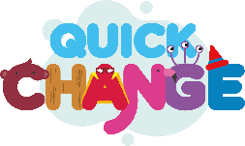

This collaborative project has explored innovative fresh ideas from Cardiff and Vale UHBs Podiatry and Local Public Health Team professionals, working across clinical/non-clinical boundaries to put prevention at the forefront of our healthcare service provisions. The success of the pilot project has been recognised by the UK Public Health Register when they awarded QuickChange for 'Improving Public Health Practice to Reduce Health Inequalities', in October 2023, with the judges highlighting that it was a well-planned project, with good partnership working demonstrated throughout.




3.14 Welsh Language Regulations 2018

The Welsh Language Standards have given the organisation the opportunity to improve the level of Welsh language services we provide for our patients, services users and the wider population.
In 2023/2024, we continued to work with to improve and strengthen our compliance to the Welsh Language Standards
All Standards have been reviewed by the Health Board uses the Microsoft List software to monitor the implementation and progress of our actions to meet the Welsh Language Standards. The Equity and Inclusion Team report on matters related to the Welsh Language Standards to the People and Culture Committee who in turn provide assurances to Board. This includes risks associated with non-compliance and what steps they will take to ensure improved compliance with the Standards. The Health Board are currently compliant with 83 of the 120 standards. The final 40 of these standards which the organisation is not compliant with requires long term planning. The People and Culture team are working with all areas to ensure that the organisation is compliant during 2024/2025.

Key activities which have taken place in 2023-24 include:

- Developed and distributed the Welsh Language Phrase card which shows basic Welsh Language phrases to use when greeting over the phone. Nearly a 15,00 have distributed across the board.
- Continued to encourage staff members to sign up to the Welsh Language learning courses on offer by the Welsh Language Learning Centre.
- Developed a ‘Building Confidence’ Welsh language course in partnership with the National Centre for Learning Welsh and Dysgu Cymraeg. The course aims to build the confidence of Welsh speaking staff to encourage them to use their Welsh language skills.
- Continued with promoting Welsh language lessons via specific awareness days including Shwmae Day, Welsh Language Rights Day, Welsh Language Music Day, Diwrnod Santes Dwynwen Day, and St David’s Day.
- Established Rhwydiaith, which is a staff network for the Welsh language users.
- Working with Clinical Boards to improve the Welsh Language service they provide for the patients and service users.
- The Welsh Language Translation Team continued to provide an effective translation service for the Health Board, having translated over one million words last year.
- We have received a total of four complaints in 2023/2024 from the Welsh Language Commissioner. All concerns have undergone investigations followed by recommendations that the Board is expected to comply with. The recommendations that have been carried out has meant that the Health Board has worked to improve its compliance with the Welsh Language Standards around reception areas, phone services, health visiting services, and recruitment of staff with Welsh Language skills
- The organisation has advertised the following number of vacancies as essential:

Total number of vacancies advertised 2023-204 as:
Welsh language skills are essential | 3
Welsh language skills are desirable | 2487
Welsh language skills need to be learnt when appointed to the post | 0
Welsh language skills are not necessary | 49
Total Number of vacancies advertised 01/04/2023 - 31/03/2024 | 2539



Workforce Welsh Language Skills registered 2023-2024

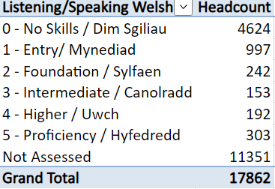
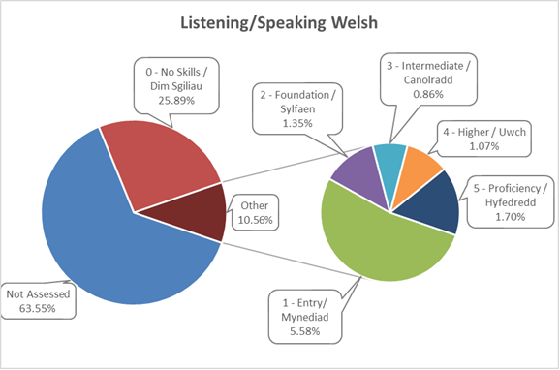
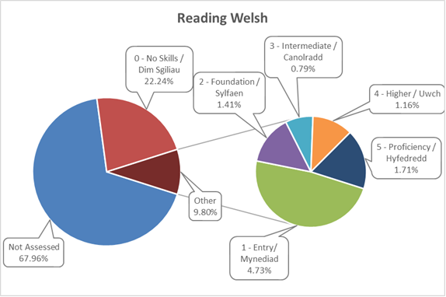
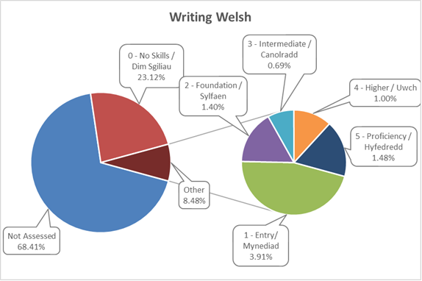
3.15 Sustainability Report
Environmental Sustainability

Delivering on our responsibilities to reduce our carbon footprint has been a priority for the Health Board since acknowledging the climate emergency in January 2019.
The impacts of climate change are already being felt globally including extreme weather events, sea level rises, mass species loss and extinction events. These impacts will have dramatic effects in the UK and Wales impacting infrastructure, food availability, health and migration. Cardiff & Vale University Health Board recognised that urgent measures are necessary to safeguard our planet and ensure a sustainable future for generations to come.
The need to safeguard our planet is also recognised under our revised Shaping our Future Wellbeing Strategy 2023-2035 strategy: Living Well, Caring Well, Working Together, and has set an ambition to reduce emissions in our control by 40% by 2027, 68% by 2035 and achieve carbon neutrality also by 2035.
Cardiff and Vale University Health Board has an abundance of talented and dedicated staff who are striving to improve the Environmental sustainability of their departments and the organisation. The Cardiff & Vale Green Group has been established who meet regularly to promote work and generate ideas and initiatives to improve environmental sustainability across the entire health board.
In March 2024, our Board approved our 2024/25 Decarbonisation Action Plan . This goes further than ever before in recognising the levers that need to be pulled to manage and reduce our carbon emissions.

Public Services Boards
The Vale of Glamorgan Public Services Board along with Public Sector partners in the Vale of Glamorgan have formally expressed their commitment to tackling climate change by agreeing a Vale Public Services Board Climate Change Charter (https://www.valepsb.wales/Documents/Climate-Change/Climate-Emergency-Charter-English-Final.pdf). The Charter signs partners up to a set of principles including leading by example, taking positive action and reducing our impact, while recognising that approaches and plans for implementation within individual Organisations may differ. Similarly, the Public Service Board in Cardiff has identified carbon reduction as a key priority and a partnership programme has been developed, led by the Council. The Health Board is an active participant in this work.

Cardiff and Vale Health Charity Impact
The Health Board’s Health Charity have supported an award-winning programme to improve our environment, linked to our Biodiversity Plan. The development of the Orchard and Horiatio’s Garden at UHL, and the meadow project at UHW are examples of the great work being done to use our outside green space for the health and wellbeing of our patients, staff and visitors.
Progress and Successes in 2023/24
- Over the course of the year, we have seen more engagement from clinical staff on decarbonisation agenda, where membership of our Cardiff and Vale Green Group have grown, we have leaders appointed in Nursing, Therapies and Clinical practices, plus a number of Sustainability fellows and champions across the organisation.

- We also have seen departmental green groups activate, including ICU, EU, Dental, Clinical Diagnostics and Therapies, the Therapies profession and anaesthetics to name a selection. Therapies, an organisation of c900 people have their own action plan.

- A number of projects have been successfully implemented within departments. Notable examples are:

- In our ICU department, where they’ve gathered a comprehensive view of their carbon impact and are slowly working through opportunities to save carbon. The gains are small such as the 600kg p/a that will be saved through giving patients tap rather than sterile water. ICU have shared their learning with the community of experts.

- A multi disciplinary team of anaesthetists, clinical engineers, estates pharmacists and estates colleagues have built on their previous success in reducing the use of nitrous oxide, but reducing the use of Entonox by around 40%. Delivered during the second half of 2023, it could save around 2,250 tonnes of carbon per year, which as around 1% of the Health Board’s annual carbon footprint.

- We have worked closely with national programmes, such as with the Nursing sustainability lead in Welsh Government and Bevan Commissions Let's Not Waste to support and implement actions.

- Our Value Based Healthcare team are embedding decarbonisation into their programme and a number of projects are expected to deliver in the coming year.

- The role that prevention can play in lowering carbon had been laid out in the second half of 23/24. An action around the carbon that could be saved through Diabetes prevention (amongst other things) appears in our 24/25 action plan.

- The carbon contribution of our operational priorities has been discovered this year, i.e. the carbon avoided through the running of the 6 Goals of Urgent and Emergency Care and Planned Care programmes. To the end of Q3, these were delivering a c1,100 tonne carbon avoidance. Continuing to track this contribution is part of our 24/25 action plan. A particular focus this year is on reducing length of stay for which a carbon avoidance figure can be estimated. Finally, our Financial Sustainability programme is estimated to have avoided c4,000 tonnes through the end of Q3 2023/24. Continuing to track the programme is an action in our 24/25 plan.

- New joiners to the Health Board are receiving a briefing about decarbonisation during monthly induction events.

In total it is estimated that over 5,000 tonnes of carbon, or 2% of our footprint will have been avoided through various initiatives in 2023/24.

Action Planning

The Health Board’s vision is to be an exemplar in the delivery of sustainable healthcare, setting the pace that others will follow and learn from. Low environmental impact will be a business-as-usual consideration where all of our colleagues will be encouraged to make changes to working practices that will see our carbon emissions reduce initiative by initiative.

Our latest action plan builds on our experience since 2020, in particular how a step change can be made in avoiding new and reducing existing emissions. A separate climate adaptation plan will be published to manage the risks of the changing climate already being experienced.

It has been our experience that initiatives to reduce our carbon emissions tend to deliver small results. To exemplify, even a 50% reduction in our electricity consumption would reduce our emissions by just 2%. Therefore, action is needed across a wide range of areas by a large number of people in order to have the impact required. A cultural shift is therefore required so that all 16,000 colleagues understand the responsibility to act and make a number of small but frequent contributions that make a difference. The Health Board needs to create the environment from the top which will equip and encourage our colleagues to make a difference.

Measurement of the overall macro impact of this plan will come through the annual reporting that gets delivered to Welsh Government each September, where a year-on-year comparison can be made. It is estimated that up to 8,000 tonnes of CO2e could be avoided, or around 3% of our emissions.

A summary of the actions to be undertaken over the next year include:
- Through a diabetes prevention programme, track the carbon saving potential
- We will monitor the carbon avoidance/savings from our high priority operational programmes such as the 6 Goals of Urgent and Emergency Care
- We will publish a climate adaptation plan
- We will continue to build decarbonisation into our key decision making.
- We will continue to ask our Executive team to take an annual objective to reduce carbon emissions.
- We will embed carbon into our Quality Excellence programme
- We will respond to any recommended actions articulated by internal audit expected which are expected in Q1 24/25
- We will seek ways in which carbon can be embedded in our clinical board performance monitoring
- We will seek to increase our energy efficiency.
- We will promote healthy travel
- We will ensure Decarbonisation is included in any clinical service redesign

These actions, taken together, will enable us to establish the environment for the organisation to deliver emissions reduction and develop the culture within the organisation, with the aim that every one of our employees is acting to contribute to the achievement of carbon reduction. Improvements in carbon literacy, leadership, supporting transition and some carbon savings will be achieved by the end of this plan.

Task Force on Climate-related Financial Disclosures (TCFD) Compliance Statement
CAVUHB considers climate change to be a principal risk, and has therefore complied with the TCFD recommendations and recommendations disclosures around as set out below:
Governance

The Senior Responsible Officer for decarbonisation is the Executive Director of Strategy & Planning. Climate change is currently being explored as a risk on our Strategic Planning risk register as the organisation is currently reviewing how risks are being managed strategically.

The Board’s approach to risk management will be re-engineered during 2024/25 and it has been recognised that climate change will be a Board level risk under a strategic theme of Equality.

In the meantime, within the Strategy team, leadership is being shown in identifying the actions that need to be undertaken to avoid emissions, culminating in the creation of annual decarbonisation action plans.

The progress against our action plan gets reported to Finance & Performance committee quarterly. There is a Decarbonisation Delivery Group that meets quarterly (executive and deputy director level) to monitor progress against the plan and also a Decarbonisation Working Group to deliver the plan. With our corporate strategy refreshed in 23/24, the way in which strategic programmes will be governed will be reviewed during 24/25.

Risk Management

Collaborative work is undertaken with our Public Health team to identify climate related risks as they relate to the health of our population. The proximity of these risks are necessitating action, therefore our 24/25 action plan commits to developing an adaptation plan.

It is recognised that climate change should be considered a Board level risk. A review of Board risk management is underway and climate will be included as a key risk to manage under the theme of Equalities.

Metrics and Targets

It cannot be said that metrics are used per se to identify climate related risks. Projects have tended to commence through individual clinicians recognising an opportunity to make a change which will have a climate benefit. These often originate through their peers elsewhere in the UK, or where alternative approaches are known.

Scope 1-3 emissions are disclosed below;

Scope 1: 24,400 tonnes
Scope 2: 5,700 tonnes
Scope 3: 188,000 tonnes

The NHS Wales set a target to reduce emissions (all scopes) by 16% by 2025 and 34% by 2030. There is no line of sight to the achievement of these target.

The Shaping Our Future Wellbeing Strategy has set an ambition that emissions under the control of Cardiff and Vale should reduce by 40% by 2027 and 68% by 2035. A plan is to be developed this year to understand how to tackle the 40% ambition.

Year on year emissions levels are calculated annually each September for submission to Welsh Government. A single method is used across the whole Welsh public sector to ensure consistency.
This is in line with the central government’s TCFD-aligned disclosure implementation timetable for Phase 2. CAVUHB plans to provide recommended disclosures for Strategy in future reporting periods in line with the central government implementation timetable.

Carbon Reduction
CAVUHB is committed to trying to achieve the challenging targets set out in the NHS Wales Decarbonisation Strategic Delivery Plan, which sets out a series of aims and initiatives for Health boards in Wales to address in order to contribute towards Wales decarbonisation targets, including the aim for the public sector in Wales to be net zero by 2030.
The organisation uses the emissions measurement method required by Welsh Government in order to calculate its carbon emissions.
It is estimated that the Health Board has generated c218,000 tonnes CO2e in 2023/2024.
Since 2018, for the emissions that are under the control of the Health Board (scope 1 and scope 2 emissions), it is estimated that carbon emissions have reduced by around 7%. Emissions are broken down in the following categories for 2022/23:
Sector | Emissions (tonnes CO2e) | % of total emissions
Buildings | 34,751 | 15.96%
Streetlighting | 76 | 0.03%
Fleet and equipment | 415 | 0.19%
Commuting | 5,664 | 2.6%
Business travel | 675 | 0.31%
Waste | 1,789 | 0.82%
Supply Chain | 173,412 | 79.66%
F-gases and anaesthetic gases | 908 | 0.42%
Total | 217,690

By far the largest source of emissions at c80% come from the products and services used in order to deliver health services. Products and services include items such as medication, personal protection equipment, surgical devices, catering, etc. Everything needed to run a health service. To impact upon these emissions, action is needed across the breadth of our organisation.

The emissions for 2023/24 will be reported to Welsh Government in September 2024. It should be noted that the way in which emissions data is being reported upon is evolving. For example, currently emissions associated with a product are estimated based upon an emissions factor associated with the Standard Industry Code for the organisation that sells that product and the money spent on that product. An exercise has taken place within NHS Wales Shared Services Partnership to review how vendors are allocated with emissions factors which could cause movements in supply chain emissions for 2023/24 when reported in September 2024 versus 2022/23. Furthermore, eventually, it is the aim of NHS Wales to be able to report on the actual emissions of a product.

Aims for 2024-2025

Our latest plan has built on previous plans but has evolved further over the past year. It is set out over a 3 year context, aligning with the 2027 ambitions of the Shaping Our Future Wellbeing strategy. Evolution has come about through the close study of the elements that make up our carbon footprint and simulating ‘what if’ scenarios against them to understand what needs to change. The evolution can be described in the following three ways:
- Even though the plan is focused on mitigating our emissions we have set out an action to begin to tackle the climate adaptation challenge, by publishing an adaptation plan within the next year, ahead of any mandatory request from Welsh Government to do so. The need to do this is because despite our efforts to reduce emissions we know that planetary warming is now locked in and we will see more frequent periods of extreme heat and flooding, just as we already have in the last 12 months, and forecast to get worse. Extreme weather affects our estate, our staff and our residents, particularly the most vulnerable.
- Being explicit about the role preventing ill health has to play in reducing our emissions. A new Prevention theme is presented with a specific intent to understand the carbon impact of prevention in the diabetes pathway initially. To create real change, we need a shift in our approach to health and healthcare, increasing the emphasis on preventing ill health and reducing the need for acute care. Doing so will create the greatest impact to our carbon footprint and environmental impact.
- The final new introduction this year is the recognition that our efforts to be more operationally efficient, through our response to Welsh Government’s ‘6 Goals of Urgent and Emergency Care’ for example, are having an impact upon our emissions. Utilising technology, changing the ways our population receive follow-up appointments, helping patients get optimised for surgery to reduce the likelihood of complications are just some of the ways our existing operational initiatives can impact upon our carbon footprint.
4. Quality Governance Arrangements

An essential feature of our control framework is ensuring there is a robust system for measuring and reporting on the quality of our services. Our Quality Safety and Experience Committee provides timely evidence-based advice to the Board to assist it in discharging its functions and meeting its responsibilities with regards to quality and safety as well as providing assurance in relation to improving the experience of all those that come into contact with our services. All groups in the QSE structure report through the Clinical Safety Group or Clinical Effectiveness.

There have been a number of visits from Healthcare Inspectorate Wales (HEIW) and Llais over the last year in maternity services and our Emergency Unit with a number of actions and improvements required. The detail of external inspections is outlined in our Duty of Quality report for 2023-2024 along with detail regarding how quality is being embedded across the organisation including in our patient safety areas of work.

4.1 Digital & Transformation Quality Work

Whilst the financial challenges in Wales are well publicised, progress continues to be made with digital plans as outlined in the Integrated Medium-Term Plan. Examples of digital, data and technology achievements contributing to Recovery in the last year include:
Regional Shared Care Record Views of Health and Social Care Data
To deliver integrated services to people, we need integrated care records and information. In what we believe is first of type in Wales, a joint programme with the Vale and Cardiff Councils has developed 3 projects, one of which is a shared care record view combining multiple health and social care data sets – a Child & Young Person Lookup Tool. This aims to deliver:
- An individual-focussed tool, bringing together data from various Council and partner IT systems, enabling practitioners to view all involvements with a young person by participating services.
- The information displayed will be identifiable and specific to one individual

To deliver benefits in the following areas:
- Safeguarding: Improved access to relevant information for practitioners that will aid in making decisions. The viewer will be in use in Vale CRT initially.
- Service planning: Improved access to integrated strategic information for managers to make decisions and plan services and interventions more effectively.
- Savings: we anticipate staff will save on average a day a week by having data readily available place in one place

Electronic Test Requesting – Radiology Inpatients
Two Microsoft apps were developed in-house (in lieu of national solutions) to enable electronic test requesting for radiology (inpatients), one app to raise a request (512 exams can be requested from a single screen) and the other to support vetting and approval used by the radiology department.
In 12 months over 130,000 electronic requests were made, releasing the equivalent of over 20,000 hours pa clinical time to care and an estimated 700kg of CO2 equivalent to c2800 kWh.
Scan4Safety
Scan4Safety is a national programme, delivered in partnership with NWSSP; it’s aims are:

This programme of work digitizes manual processes, reducing waste (expired products), improving efficiency (automatically order what we need, when we need it); saves time on materials management and has reduced fire risk, as well as the standards-based benefits outlined in programme aims. We have just finished in cardiology.
Desktop computing energy savings
By analysing our desktop estate energy consumption, we have identified and are working towards releasing a minimum saving of over £200k pa and 210 tonnes CO2 by automating power downs on equipment unused outside of the 5-day working week.

Planned Care - Patient Reported Outcome Measures (PROMS)
Over 10,000 patients are completing PROMS across a number of service areas. One of these is our Primary Mental Health Support Service (PMHSS), a service for people aged 18 or over living with common mental health difficulties, such as depression and anxiety.
As a wider transformation, the use of PROMS in PMHSS has improved turnaround from referral to assessment to under ten days and waiting targets are consistently met.

STAMP (system to track and manage patients)
In support of 6 Goals, a new system called STAMP was developed between Innovation and Improvement, Digital and Health Intelligence and clinical areas. This places the patient’s journey at the heart of the digital picture and allows teams to effectively see where patients are and what they are waiting for giving a real time picture of the bed profile across the whole Health Board.
As well as releasing efficiency equivalent to £200k pa, from a patient’s perspective, decisions are more rapid and delays for beds reduced, as we can more accurately forecast discharges across the week and aim to ensure more patients get to the right bed, first time.

5. Delivering in Partnership

In many areas, the Health Board works with partners to develop and deliver plans for improving the health and well-being of our population, and to deliver services collaboratively. Our partners include other NHS Wales organisations, the two local authorities (Cardiff Council and the Vale of Glamorgan Council), the Third Sector and independent providers.

5.1 Cardiff and Vale Regional Partnership Board (CVRPB)

The Health Board hosts the team that works on behalf of Regional Partnership Board (RPB) partners. During the year the team has supported health and care teams to deliver a range of initiatives and services designed to provide citizens with early help and support when they need it to keep people living safely and well in their own homes.

Cardiff and Vale Regional Partnership Board includes representatives from Cardiff and Vale University Health Board, Cardiff Council, the Vale of Glamorgan Council, the Welsh Ambulance Service NHS Trust, housing, third and independent sectors and unpaid carer representatives.

The Board is established under the requirements of the Social Services and Wellbeing Act (Wales) 2014 and operates with the following governance arrangements. Its purpose is to improve the wellbeing of the population and improve how health and care services are delivered.

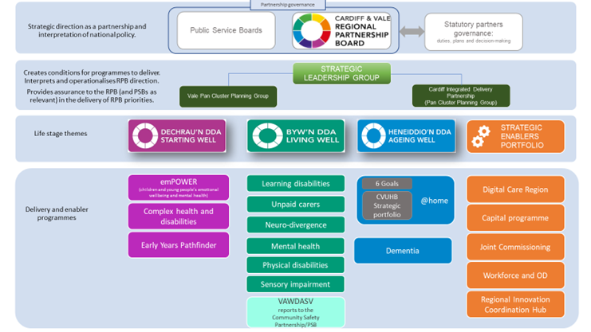

The leadership team for the RPB is comprised of:

The leadership team for the RPB is comprised of:
- Charles Janczewski, CVUHB Chair and RPB Chair,
- Sam Austin, Llamau Deputy Chief Executive and RPB Deputy Chair,
- Cllr Ash Lister, Cabinet Member for Social Services (Children), Cardiff Council and RPB Deputy Chair
- Cath Doman, Director of Health and Social Care Integration and RPB Regional Lead

CVUHB hosts the RPB partnership support team on behalf of the RPB and acts as the ‘banker’ and administrator for funding streams routed through the partnership, in particular the Regional Integration Fund of £19.2m.

The RPB’s annual report for 23/24 can be found here.

In the last 12 months, the RPB has achieved some significant milestones
on behalf of the partnership:
- Joint Area Plan 2023-28
- Strategic Capital Plan 2023-33
- Unpaid carers charter https://cavrpb.org/carers-charter/
- Launch of the Regional Information Sharing Site linking data across CVUHB, WAST and Cardiff Council

The RPB continues to lead significant partnership delivery programmes within the life stage portfolios of Starting Well, Living Well and Ageing Well, addressing its obligations to improve how health and care services are delivered. There are also a number of enabler programmes, in particular, the Digital Care Region and capital programmes.

5.2 Regional Healthcare Services

The last twelve months has seen the Health Board continue to work with neighbouring health boards to develop and implement regional service models where it makes sense to do so in order to ensure that a service is sustainable, meets key standards, and delivers the best outcomes for patients.

The governance arrangements associated with this regional working in South-East Wales has been further matured to reflect not only the ongoing development of a planned regional treatment and diagnostic centre in Llantristant but also that Velindre NHS Trust formally joined the collaboration in August 2023. This saw the historic work of the South East Wales Cancer Collaborative bought into scope under the guise of a new regional cancer programme.

During the last year we have seen particular progress with regards to Ophthalmology where an interim regional solution for the high-volume, low complexity cataract service was implemented. This resulted in a regional patient treatment list (PTL) being adopted and implemented through a regional booking and scheduling service. This culminated in the elimination of all over three year waits for the procedure across the region.

5.3 Specialised and Tertiary Services

The Health Board continues to work closely with its partner Swansea Bay University Health Board, on the planning and delivery of specialised and tertiary services, through the Regional Specialised Services Provider Planning Partnership.
Over the last year the partnership team has undertaken a refresh of the tertiary services baseline assessment in both organisations and has continued to progress the reviews on Hepato-Pancreato-Biliary Surgery and Oesophago-Gastric Cancer Surgery. The team have also worked with colleagues across Wales and NHS England to develop a service specification for Specialised Infectious Disease Services, and to develop an action plan to support the implementation of the service specification for Specialised Adult Endocrinology Services.

The team continues to progress the development of partnership models to ensure that all patients in South Wales have equitable access to safe, effective and sustainable specialised services.

This includes development of a governance framework to support the establishment of a South Wales Specialised Services Collaborative Partnership Board. The purpose of the Board will be to lead the development of a partnership strategy for specialised services, and to oversee the delivery of services provided in partnership between the two organisations.

The partnership team also administer the Health Board’s Tertiary Services Development Group. Over the last year, the group has considered a number of proposals to develop new services (Gene therapy for Haemophilia B) and secure existing services (Porphyria). Following review by the group, WHSSC have agreed to consider the following services for commissioning:

- Primary Ciliary Dyskinesia
- Selective Internal Radiation Therapy
- Transjugular Intrahepatic Portosystemic Stent-Shunt,

6. Our People
6.1 Workforce Management
Our staff are fundamental to ensuring we can do what we need to do for our patients, families and communities. We are immensely grateful for all that our staff do and the hard work and commitment they continue to show. As an organisation employing over 17,000 people, we cannot just depend on bringing new people into our workforce; we need to improve how we retain, manage, develop and look after the wellbeing of our existing workforce.
6.2 Attract & Recruit
The shortages of key professionals and workers in the NHS is well publicised and is a challenge faced by all NHS organisations nationally. The inability to recruit staff with the right skills and experience can be a serious constraint to providing high quality patient care. During 23-24 we have focused on the following 3 key themes to ensure we are able to attract and retain the staff required to deliver our services to a high standard:
Promotion of NHS Job Opportunities
A large number of the population are unaware that the NHS has over 350 different roles available for employment. There has been a large focus over the past year on ensuring that we reach as many prospective candidates as we can to promote the large and diverse number of job opportunities we have on offer. The response has been overwhelming and many of those we communicated with would now consider pursuing a career with Cardiff and Vale UHB.
Shortage Professions
We have worked closely with a number of universities, colleges, schools and many public sector career assistance organisations which has had a big impact on recruiting to many of our long-term vacancies. Our largest proportion of the workforce is nursing staff and there has been a great success in reducing our vacancy factor from over 13% to below 5%.
Inclusive Recruitment
A key focus in 2023-4 has been to continue developing and maintaining close links with those groups within the local community that are not represented as well within our workforce. We also wanted to improve the opportunities for those who may perceive they have a disadvantage when applying for jobs against other candidates.
Some of the key achievements over the past year have included:
- DFN Project Search – a alternative to traditional school-based education and helps people transition into work. Many people with learning disabilities and autism find the transition to the workplace difficult after leaving school. This initiative helps young people grow their confidence and secure meaningful, paid employment. In 2023/2024 we are hosting 14 interns over UHW and UHL sites, and hopefully the interns that are interested in being employed will achieve this at the end of the placements in their chosen areas.

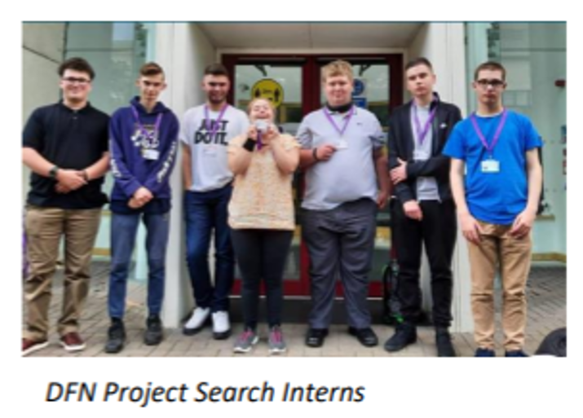
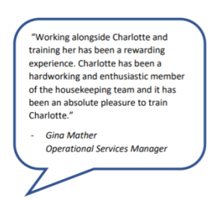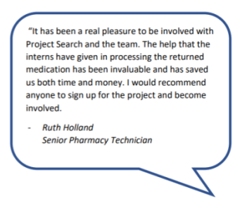

- Apprenticeships – 2023/24 has been a positive year for the Apprenticeship Academy, we are finalists in the Apprenticeship Awards Cymru 2024, and we have been awarded two ‘Engage to Change’ Awards. This year we have appointed 14 new recruit apprentices through administration, digital, build service engineer, healthcare support worker and healthcare science routes. In addition, 13 apprentices have completed and been offered permanent roles in their host department or in another area.

- Schools and Colleges – Partnered with Cardiff Commitment and Careers Wales to promote NHS roles to young people, we attended 26 school and college events. In addition, we presented virtually to over 2000 pupils to showcase the diverse roles and opportunities that the NHS offers, with many pupils in areas of deprivation. These events will plant the seeds of roles that are on offer for our future workforce.
- Cessation of Agency Health Care Support Workers (HCSW) - A comprehensive and continuous recruitment campaign for Bank HCSWs has enabled the UHB to cease the use of Agency HCSWs across the UHB where the monthly expenditure was around £500k per month.

6.3 Retaining our People
A wide range of initiatives have been developed and implemented to improve the retention of our people in the last year including;
- Appointment of a Retention and Organisational Development Lead to work with key stakeholders internally and externally, to utilise the retention toolkit, identify priority areas, implement the retention action plan, while ensuring best practice, effective monitoring and evaluation
- Enhancement and Development of the leadership and management development offer for the organisation
- Healthcare Support Worker (HCSW) Induction Programme- has continued to run at increased capacity to support the UHB’s recruitment needs. By the end of 2023/24 at least 565 HCSW will have attended this training this year

- Assistant Practitioner roles - 2023/24 has seen further significant progress in relation to the implementation of unregulated Assistant Practitioners (AP) at Agenda for Change Band 4.
6.4 Workforce Wellbeing
The health and wellbeing of our people remains our priority and we remain committed to supporting, and enhancing the wellbeing of our people.

Examples include:

- The launch of ‘My Health Passport’ in October 2023, to provide staff who have a long-term health condition or disability with a means to capture any support or adjustments that they feel would help them in the workplace. The passport can be shared by the individual with their line manager, enabling a conversation to generate a better understanding of their wellbeing needs in the workplace, and how these can be supported
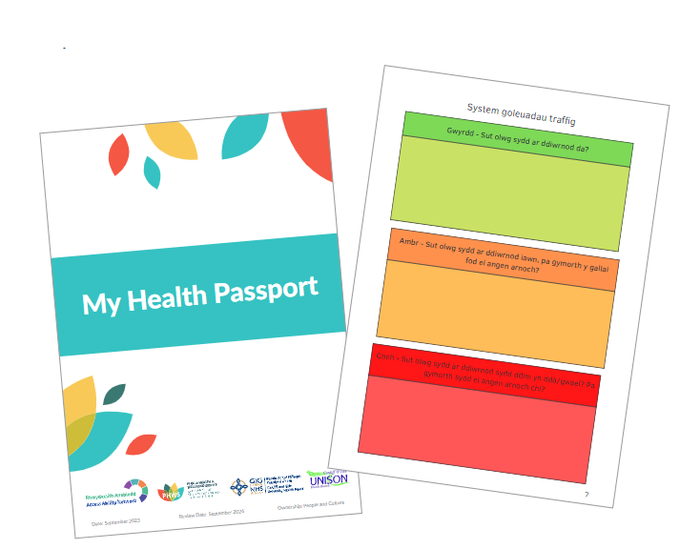

- Financial Wellbeing and the Cost of Living-the UHB has been pro-active in continuing to support its employees during these challenging times: The work of the UHB was recognised by being awarded the ‘payroll partner-public sector’ of the year by Wales Credit Union in October 2023.



6.5 Equity, Diversity and Inclusion

The current Strategic Equality Plan (SEP), Caring about Inclusion 2020-2024, has a number of key delivery objectives and demonstrates our commitment to embedding equality, diversity, human rights, and Welsh Language into Cardiff and Vale University Health Board business processes. The SEP is closely aligned to our ‘Shaping Our Future Wellbeing’, our ‘People and Culture’ plan, our Intermediate Medium-Term Plan, as well as the Well-being of Future Generations Act 2015. This is the final year of the current four-year plan.
During 2023-24, we continued to strive to create a more inclusive organisation for our staff and our communities through a range of means, including engaging with staff and community groups, raising awareness of inequalities through keynote speakers, awareness sessions and partnership working with Public Health Wales and community groups, and celebrating the diversity of our workforce and community. Some of the key highlights of the past year include:

- Creation and cross-organisation sharing of our third iteration of an Inclusion Calendar, which highlights key dates throughout the year to raise awareness and celebrate our diversity.
- Taking forward the Anti-racist Wales Action Plan through co-producing our CAVUHB Anti-racist Action Plan alongside our One Voice Staff Network and trade union partners.
- Attending Pride Cymru alongside colleagues from across NHS Wales.
- Supporting the development of our staff networks including:

  - One Voice Staff Network – for our staff from ethnic minority communities
  - Access Ability – for our staff with disabilities and long-term health conditions
  - LGBTQ+ Staff Network – for our LGBTQ+ staff
  - Rhwydiaith – for our staff who are Welsh users or learners
  - Future Generations Network – to support and develop our leaders of the future

- Facilitating an Equity & Inclusion Summit for our Senior Leadership Board.
- Engaging with our communities, including hosting Equity and Inclusion stalls at our career’s fayres.
- Continuing the development of our Inclusion Ambassador programme, aimed to support senior leaders, including at Executive and Board level, to better understand the lived experience of our diverse workforce. The programme to support each of the protected characteristics and Welsh language.

The Health Board will continue to go beyond our legal obligations, applying the principles that sit within the Equality Act and the Public Sector Equality Duty to all our thinking, planning and decision making for the benefit of all our people, both in our organisation and our communities.

6.6 The People and Culture Plan

Our strategy, Shaping Our Future Wellbeing, sets out our ambition to be a great place to train, work and live, where we listen to and empower people to live healthy lives. One of our strategic objectives is Putting People First - which includes our teams, patients and population - because we know that people are at the centre of everything we do.
The People and Culture Plan is key to this because we are dependent on our workforce if we are to meet our population’s health and care needs effectively but this won’t happen by keeping to the status quo; we need to transform the way we attract, retain, develop and support our workforce through a culture of compassionate and inclusive leadership and with a focus on wellbeing.
The People and Culture Plan sets out the actions we said we would take over the three-year period 2022-2025 and is made up of 7 themes:
- Seamless workforce models
- Engaged, motivated and healthy workforce
- Attract, recruit and retain
- Building a digitally ready workforce
- Excellent education and learning
- Leadership and succession
- Workforce supply and shape

We have just come to the end of the second year of the Plan. In the first year, progress was mainly focused around the work of the People and Culture team, but in 2023 we have seen a real difference with more emphasis on embedding the Plan across the organisation and it has become our ‘business as usual’.
In 2024-25 we will continue to build on what has been achieved in Years 1 and 2, focusing on the Health Board priorities and ensuring that quality, improvement and efficiencies are at the forefront of our activities. However, we continue to face a number of challenges and will address these by adopting a streamlined approach to maximise opportunities for collaborative working, reduce silo working and duplication, and ensure that our efforts are focused on the areas where they will make the most difference.
As an organisation we will aim to deliver excellence in all that we do so that staff, patients and our populations have the best experience and outcomes. Our People and Culture Plan will help us achieve this aim.

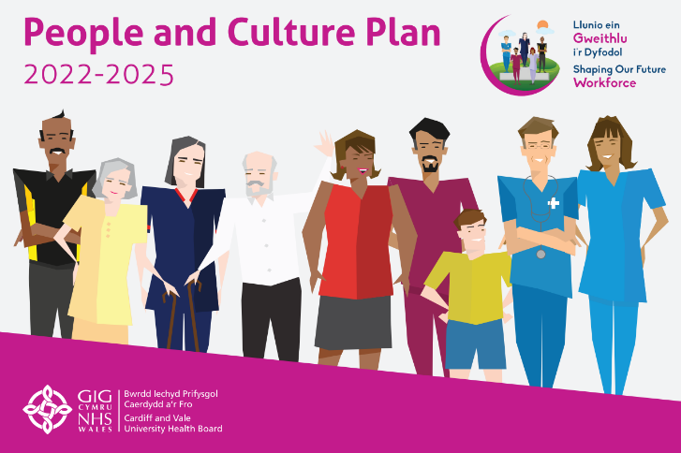

7.Conclusion and Forward Look

The Health Board is proud of the improvements we have made in the last year in particular we have delivered under the Six Goals programme throughout 2023/24 and this will continue in 2024/25. Our Medical Same Day Emergency Care (MSDEC) has achieved a significant milestone, surpassing the national set ambition for the percentage of the medical intake seen. Our stroke performance has seen a significant improvement and within this year we were awarded the highest rating (A) by the Sentinel Stroke National Audit Programme (SSNAP). Additionally, our Urgent Primary Care Centres (UPCC) have successfully covered 86% of the Health Board’s geographical area with UPCC appointments and it is our intention to ensure this level of coverage and utilisation is maintained.

The past year has been one of improving and shaping our future following the refresh of our strategy. We can now really focus on each of our strategic objectives and key milestones that we will aim to deliver on over the next five and ten years. As we look ahead, the work done to refresh our strategy has put is in good stead to bolster our unwavering commitment to rectifying disparities in access and outcomes. The next year will allow us to look at how we deliver our services and implement robust care models and have a focus on quality, adoption of innovative healthcare technologies, digitisation efforts, modern infrastructure, and adherence to best practice. We have challenging times ahead, but we are confident that by tackling these challenges together, we can support people to live healthier lives and reduce the unfair differences in the prevalence of illness and health outcomes we see in our communities today.
We will continue to place a particular focus on improving access to planned care and reducing waiting times for patients and we will aim to build on the positive progress made throughout the last year and we will continue to work to reduce our waiting lists and build on the good progress from this last year, including for those waiting for cancer treatment.
The Health Board continues to place a consistent and persistent focus on all aspects of urgent and emergency care. Our teams are showing sustained improvement in these areas, and we have maintained our commitment to our objectives.
Part 2
Accountability Report

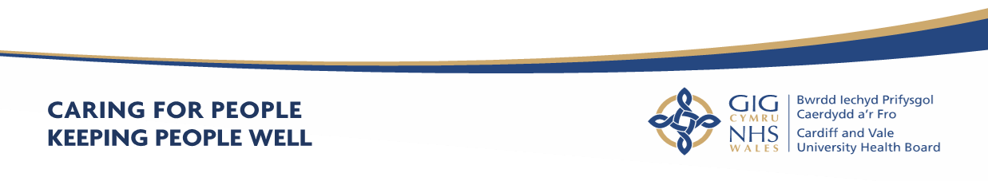
Part 2 - Accountability Report

- Scope of the Accountability Report
The purpose of the accountability section of the Annual Report is to meet key accountability requirements to the Welsh Government, and to provide an overview of the governance, accountability arrangements and structures that were in place across the Health Board during 2023-2024. It includes:
- Corporate Governance Report
- Remuneration and Staff Report
- Senedd Cymru/Welsh Parliament Accountability and Audit Report

8.1 Corporate Governance Report
8.2 The Composition of the Board
CAVUHB has 20 Board members consisting of 11 Independent Members (including the Chair and Vice-Chair), all of whom are appointed by the Minister for Health and Social Services and 9 Executive Directors (including the Chief Executive). All members of the Board have full voting rights.

There are also 2 Director posts, the Director of Corporate Governance and the Director of Digital Health and Intelligence, who form part of the Executive Team and the Board but have no voting rights.

In addition, Welsh Ministers may appoint up to 3 Board level Associate Members. Associate Members have no voting rights. CAVUHB currently has one Associate Member appointed by the Minister for Health and Social Services following a recommendation from CAVUHB in accordance with Standing Orders.

Before an individual may be appointed as a Member they must meet the relevant eligibility requirements, set out in Schedule 2 of the Local Health Boards (Constitution, Membership and Procedures) (Wales) Regulations 2009, and continue to fulfil the relevant requirements throughout the time that they hold office. The Regulations can be accessed via the following link:

https://www.legislation.gov.uk/wsi/2009/779/contents

8.3 Statement of the Chief Executive’s Responsibilities as the Accountable Officer of the Health Board

The Welsh Ministers have directed that the Chief Executive should be the
Accountable Officer of Cardiff & Vale University Health Board.

The relevant responsibilities of Accountable Officers, including their responsibility for
the propriety and regularity of the public finances for which they are answerable, and for the keeping of proper records, are set out in the Accountable Officer’s
Memorandum issued by the Welsh Government.

I can confirm that:

- As far as I am aware, there is no relevant audit information of which Cardiff & Vale University Health Board’s auditors are unaware, and I have taken all steps that ought to have been taken to make myself aware of any relevant audit information and to establish that the Health Board’s auditors are aware of that information.
- Cardiff & Vale University Health Board’s annual report and accounts as a whole are fair, balanced and understandable and I take personal responsibility for the annual report and accounts and the judgements required for determining that they are fair, balanced and understandable.

- I am responsible for authorising the issue of the financial statements on the date they were certified by the Auditor General for Wales.

To the best of my knowledge and belief, I have properly discharged the responsibilities set out in my letter of appointment as an Accountable Officer.

Signed by

Suzanne Rankin  Chief Executive |  | Date:

8.4 Statement of Directors’ Responsibilities in Respect of the Accounts

The directors are required under the National Health Service Act (Wales) 2006 to prepare accounts for each financial year. The Welsh Ministers, with the approval of the Treasury, direct that these accounts give a true and fair view of the state of affairs of the Cardiff & Vale University Health Board and of the income and expenditure of the Cardiff & Vale University Health Board for that period.

In preparing those accounts, the directors are required to:
- Apply on a consistent basis accounting principle laid down by the Welsh Ministers with the approval of the Treasury
- Make judgements and estimates which are responsible and prudent
- State whether applicable accounting standards have been followed, subject to any material departures disclosed and explained in the account.
The directors confirm that they have complied with the above requirements in preparing the accounts.
The directors are responsible for keeping proper accounting records which disclose with reasonable accuracy at any time the financial position of the authority and to enable them to ensure that the accounts comply with the requirements outlined in the above mentioned direction by the Welsh Ministers.
By Order of the Board
Signed:
Charles Janczewski  Chair |  | Date:
Suzanne Rankin  Chief Executive |  | Date:
Catherine Phillips  Director of Finance |  | Date:

8.5 Declaration of Interests

Details of company directorships and other significant interests held by members of
the Board which may conflict with their responsibilities are maintained and updated
on a regular basis. A Register of Interests is available on the Health Board’s website
by clicking on the following link https://cavuhb.nhs.wales/about-us/governance-and-assurance/register-of-interests-gifts-and-hospitality/ or a hard copy can be obtained from the Director of Corporate Governance on request.

ANNUAL GOVERNANCE STATEMENT

ANNUAL GOVERNANCE STATEMENT

9.1 Scope of Responsibility

The Board is accountable for Governance, Risk Management and Internal Control. As Chief Executive of the Board, I have responsibility for maintaining appropriate governance structures and procedures as well as a sound system of internal control that supports the achievement of the organisation's policies, aims and objectives, whilst safeguarding the public funds and the organisation's assets for which I am personally responsible. These are carried out in accordance with the responsibilities assigned by the Accountable Officer of NHS Wales.

The Annual Report outlines the different ways the organisation has had to work both internally and with partners in response to the unprecedented pressure in planning and providing services. It explains arrangements for ensuring standards of governance are maintained, risks are identified and mitigated and assurance has been sought and provided. Where necessary additional information is provided in the Annual Governance Statement. However, the intention has been to reduce duplication where possible. It is therefore necessary to review other sections in the Annual Report alongside this Annual Governance Statement (AGS).

This AGS details the arrangements in place during 2023-2024 to discharge my responsibilities as the Chief Executive Officer of the Health Board, and to manage and control the Health Board’s resources. It also details the extent to which the organisation complies with its own governance arrangements, in place to ensure that it fulfils its overall purpose, which is that it is operating effectively and delivering quality and safe care to patients, through sound leadership, strong stewardship, clear accountability, robust scrutiny and challenge, ethical behaviours and adherence to our set values and behaviours. It will set out some of the challenges and risks we encountered and those we will continue to face going
forward.

The Senior Leadership Board assist me as Chief Executive in discharging my accountabilities and meet fortnightly for formative discussion, support and decision-making. The Management Executive team meets weekly and has strong links to all relevant governance forums inside and outside CAVUHB.

9.2 Escalation and Intervention Arrangements

Under the Joint Escalation and Intervention Arrangements, the Welsh Government meets with Audit Wales and Healthcare Inspectorate Wales (Tripartite Group) twice a year to discuss the overall assessment of each Health Board, Trust and Special Health Authority in relation to the arrangements. A wide range of information and intelligence is considered to identify any issues and inform the assessment.
The framework has five escalation levels:
- Routine arrangements
- Area of Concern
- Enhanced monitoring
- Targeted intervention
- Special measures - Escalate Cardiff and Vale UHB from routine arrangements to enhanced monitoring for planning and finance.

On 5 October 2022 the Minister for Health and Social Services announced that the Health Board would be escalated from routine arrangements to enhanced monitoring arrangements on the basis that it was not able to submit a balanced and approvable Integrated Medium Term Plan (IMTP), specifically in relation to the Health Board’s planning and financial position. The Health Board received confirmation on the 23 January 2024 that the organisation remains in “enhanced monitoring” for planning and finance and “routine arrangements” for all other areas.

Governance Framework

9.3 Model Standing Orders and Scheme of Reservation and Delegation

At a local level, Health Boards in Wales must agree Standing Orders for the regulation of proceedings and business. They are designed to translate the statutory requirements set out in the LHB (Constitution, Membership and Procedures) (Wales) Regulations 2009 into day to day operating practice, and, together with the adoption of a scheme of matters reserved to the Board; a Scheme of Delegation to officers and others; and Standing Financial Instructions, they provide the regulatory framework for the business conduct of the Health Board and define - its ‘ways of working’. These documents, together with the range of corporate policies set by the Board, make up the Governance Framework.
These are available from https://cavuhb.nhs.wales/about-us/governance-and-assurance/policies-procedures-and-guidelines/

During 2023-2024, Welsh Government issued updated Model Standing Orders for NHS bodies in Wales, as outlined below:

Issued July 2023 - The main changes related to reflecting the provisions of the Health and Social Care (Quality and Engagement) Act 2020, including:

- Introduction of the duty of quality and duty of candour;
- Changes linked to the establishment of Llais and the dissolution of the Community Health Councils and the Board of Community Health Councils;

These amendments were approved by the Board at its meeting on the 30 November 2023.

Variation to standing Orders

The Board, subject to any directions that may be made by the Welsh Ministers, is
required to make appropriate arrangements for certain functions to be carried out on
its behalf so that the day-to-day business of the Health Board may be carried out effectively, and in a manner that secures the achievement of its aims and objectives.

Delegated financial limits were amend by Board at the meeting on the 30 November 2023.

9.4 The Board and its Committees

The Board provides leadership and direction to the organisation and is responsible for governance, scrutiny and public accountability. It ensures that its work is open and transparent by holding its meetings in public and where private meetings are held the meeting agendas are also published. The Board is supported by a number of Committees, each chaired by an Independent Member. All Committees are constituted to comply with The Welsh Government Good Practice Guide – Effective
Board Committees. The Committees, which meet in public (except the Remuneration and Terms of Service Committee), provide their minutes or a written report by the Committee Chair to each Board meeting. This enables all Board members to be sighted on the major issues and contribute to assessment of assurance and provide scrutiny against the delivery of strategic objectives.

Board papers are distributed to Independent Members 10 days prior to each meeting in line with Standing Orders. Public Board papers are also published on the website.

The papers for Board meetings can be accessed at https://cavuhb.nhs.wales/about-us/governance-and-assurance/board-meetings/ and papers for Committee meetings at https://cavuhb.nhs.wales/about-us/governance-and-assurance/committees-and-advisory-groups/

Each Committee produces an annual report for the Board. The Committees’ annual reports for 2023-2024 can be accessed at: https://cavuhb.nhs.wales/about-us/governance-and-assurance/annual-reports-and-accounts/

The Health Board’s Board and Committee structure in place during 2023-2024, is outlined in Figure 13 below.

Figure 13 – C&VUHB Governance Structure 2023-2024

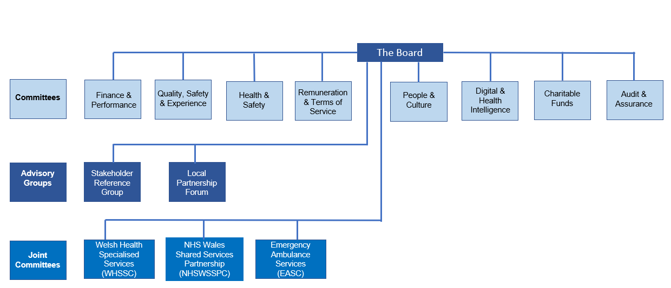

Changes to the C&VUHB Governance Structure from 1 April 2023

.
It is important to keep the effectiveness of the Board’s Committees under constant review to ensure that they are fit for purpose and support the Board in discharging its functions. Further, to ensure that the Board’s Committee arrangements reflect the risk profile of the organisation. The Health Board’s Board Assurance Framework highlighted significant risks for the Health Board to achieve its objectives, most notably in the areas of People, Quality and Performance. Accordingly, the Health Board reviewed its Committee arrangements and the following changes were made to Committee arrangements effective from 1 April 2023:

  - The Quality, Safety and Experience Committee met monthly from April 2023 until November 2023 and then met 6-weekly until March 2024 in order to ensure sufficient time was afforded to quality improvement
  - Finance and Performance – The delivery/ performance element that was previously reported to the Strategy and Delivery Committee was included in the business of the newly constituted Finance and Performance Committee. This Committee met monthly with its first meeting held on 19 April 2023.

9.5 Audit and Assurance Committee

The membership of the Audit and Assurance Committee during 2023-2024, providing the required expertise was as follows:

Name | Role | Dates
INDEPENDENT MEMBERS
John Union | Committee Chair and Independent Member - Finance | April 2023- February 2024
Rhian Thomas | Committee Chair and Independent Member – Capital & Estates | February 2024 – April 2024
David Edwards | Committee Vice Chair | April 2023- March 2024
Mike Jones | Independent Member Trade Union | April 2023 – March 2024
Ceri Phillips | Vice Chair | April 2023 – March 2024

9.6 Composition of The Board

Items Considered by the Board in 2023-2024 included:

- 6 Goals Improvement Programme
- Strategic Planning Updates
- Integrated Medium Term Plan / Annual Plan Updates
- Anti-Racist Action Plan
- Annual Review of Standing Orders and Standing Financial Instructions
- Annual Report
- Annual Accounts
- Digital Transformation
- Commissioning Intentions 2024-27
- Health & Safety Annual Report 2022-23
- Vaccination & Tackling Inequities
- Neonatal Care
- Shaping Our Future Wellbeing – Refreshed Strategy
- Equity, Equality, Experience and Patient Safety Framework
- Safeguarding Annual Report
- Board Assurance Framework
- Whitchurch Land Transfer

The Board and Committee membership and Champion Roles during 2023-2024 is
presented for information at Appendix 1 to this AGS.

There have been a number of changes to the composition of the Board over the past 12 months.

The Health Board said farewell to:

- James Quance – Interim Director of Corporate Governance on 31 July 2023
- Fiona Kinghorn – Executive Director of Public Health on 31 December 2023
- Meriel Jenney – Executive Medical Director on 31 March 2024
- Abigail Harris – Executive Director of Strategy & Planning on 31 March 2024 to take up a secondment as the Interim Chief Commissioner for new NHS Wales Joint Commissioning Committee (JCC)
- Michael Imperato- Independent Member Legal on 31 August 2023
- Susan Elsmore- Independent Member Local Authority on 31 October 2023
- Keith Harding- Independent Member University on 31 November 2023

We also warmly welcomed the following to the Executive Team:

- Matt Phillips- Director of Corporate Governance on 7 August 2023
- Claire Beynon – Executive Director of Public Health on 30 December 2023
- Richard Skone- Interim Executive Medical Director on 1 April 2024
- Marie Davies- Interim Executive Director of Strategy & Planning on 1 April 2024

9.7 Committees

In line with Section 2 of the Health Board’s Standing Orders which provide that “The Board may and, where directed by the WG, must appoint Committees of the Health Board either to undertake specific functions on the Board’s behalf or to provide advice and assurance to the Board in the exercise of its functions”, the Board has an established Committee structure, with each Statutory Committee chaired by an Independent Member.

The following Board Committees were in place during 2023-2024:

Committee | Items Considered
Audit and Assurance Committee  The role of the Audit and Assurance Committee is to advise and assure the Board, and the Accountable Officer, on whether effective arrangements are in place to support them in their decision taking and in discharging their accountabilities in accordance with the standards of good governance determined for the NHS in Wales. | - Internal Audit Plans were submitted to each meeting providing details relating to outcomes, key findings and conclusions  - Audit Wales reports on current and planned audits  - Declarations of Interest Reports  - Regulatory Compliance Tracking Reports  - Internal & External Audit Tracking Reports  - Procurement Compliance, Workforce Compliance and Counter Fraud Reports  - Assurance mapping and Risk Management Strategy  - Health Charity’s draft Accounts and Annual Report  - Annual Accounts, Accountability and Remuneration Reports for 2023-2024  - Losses and Special Payments.
Finance Committee  The purpose of this Committee is to advise and  assure the Board in discharging its responsibilities with regard to its current and forecast financial position, performance and delivery. | - Monthly Financial Reports  - Finance Risk Register;  - Financial Monitoring Returns  - IMTP Financial Plan  - BAF Risk – Financial Sustainability  - Financial Performance of Clinical Boards  - Various Business Cases (including Regional Cataracts Expansion, Development of Replacement Orthopaedic Theatres, South Wales Thrombectomy, All Wales Genomics, Interventional Radiology, Electronic Prescribing, Paediatrics Infectious Diseases.)
Mental Health Legislation and Mental Capacity Act Committee  This Committee advises the Board of any areas of concern relating to responsibilities under mental health legislation, and provides assurance that we are discharging our statutory duties under the relevant legislation. | - Mental Capacity Act and Mental Health Act Monitoring Reports;  - Deprivation of Liberty Safeguards;  - Mental Health Measure;  - Healthcare Inspectorate Wales MHA Inspection reports.  - Draft Mental Health Bill  - Section 117 Supreme Court Ruling Implications
Quality, Safety and Experience  Committee  The purpose of the Quality, Safety and Experience Committee is to provide advice to the Board with regard to the quality and safety of health services and the experience of patients, including public health, health promotion and health protection activities. | - Clinical Board Assurance Reports  - Board Assurance Framework  - Community Health Council (CHC) reports  - Patient Stories  - MBRRACE Report and National Neonatal Audit  - Looked After Children – Assessment Backlogs  - Duty of Candour  - COVID Investigation Programme Update  - Quality Indicators Report  - HIW Annual Report  - Safeguarding Annual Report  - Ombudsman Annual Letter
Charitable Funds Committee  The purpose of the Charitable Funds Committee is to make and monitor arrangements for the control and management of the Health Board’s Charitable Funds.  Cardiff and Vale Health Charity (the Charity) is the official charity supporting all the work of the Health Board. The Charity was created on 3 June 1996 by a Declaration of Trust and following reorganisation of health services, was amended by Supplementary Deeds on 12 July  2001 and 2 December 2010.  The Health Board is the Corporate Trustee for the Charity.  The Health Board delegates responsibility for the  management of the funds to the Charitable Funds Committee. The aim of the Corporate Trustee (Trustee) is to raise and use charitable funds to provide the maximum benefit to the patients of the Health Board and associated local health services in Cardiff and the Vale of Glamorgan, by supplementing and not substituting government funding of the core services of the NHS. | - Health Charity Financial Position  - Health Charity Annual Plan  - Our Health Meadow  - Over £25k bids for approval  - Fundraising Reports  - Staff Benefits Group Reports  - Staff Lottery Bids Panel Reports  - Health Charity Events Planner  - Charitable Funds Internal Audit  - Disposal of Rookwood Hospital  - Feedback on successful bids  - Rathbones Investment Updates
Digital Health Intelligence Committee  The purpose of this Committee is to provide assurance to the Board that:  • Appropriate processes and systems are in place for data, information management and governance to allow the Health Board to meet its stated objectives, legislative responsibilities and any relevant requirements and standards determined for the NHS in Wales;  • There is continuous improvement in relation to information governance within the Health Board and that risks arising from this are being managed appropriately;  • Effective communication, engagement and training is in place across the Health Board for Information Governance. | - Digital Transformation Progress reports  - Caldicott guardian requirements  - Freedom of Information  - General Data Protection Regulation (GDPR);  - Data breach reports;  - Clinical Coding Performance data  - Digital Strategy Refresh
Health and Safety Committee  The purpose of the Committee is to advise and assure the Board and Accountable Officer on whether effective arrangements are in place to ensure organisational wide compliance of the Health Board’s Health & Safety Policy, approve and monitor delivery against the Health and Safety Priority Improvement plan and ensure compliance with relevant standards for Health Services in Wales. | - Fire Enforcement  - Environmental Health Inspections  - Enforcement agencies inspections  - Waste management compliance  - Health and Safety Culture Plan  - Health and Safety Annual Report  - Regulatory and review body tracking report  - Health and Safety Risk register  - Policies (eg Latex Allegy, Sharps Management, Fire Safety).
Renumeration and Terms of Service Committee  The purpose of the Committee is to provide:  - advice to the Board on remuneration and terms of service for the Chief Executive, Executive Directors and other senior staff within the framework set by the Welsh Government; and  - assurance to the Board in relation to the Health Board’s arrangements for the remuneration and terms of service, including contractual arrangements, for all staff, in accordance with the requirements and standards determined for the NHS in Wales. | • Remuneration and terms of service matters

The reports, workplans and terms of reference for the Committees are published on our website: https://cavuhb.nhs.wales/about-us/governance-and-assurance/committees-and-advisory-groups/

The table at Appendix 1 to this AGS sets out details of the Chair, Chief Executive, Executive Directors and Independent Members and confirms Board and Committee membership for 2023-2024, meetings attended during the tenure of the individual and any Champion roles performed. Table 1 in Appendix 2 of the AGS sets out Board and Committee Dates for 2023-2024.

The Chair of each Committee reports to the Board on the Committee’s activities outlining key risks and highlighting areas which need to be brought to the Board’s attention in order to contribute to its assessment of assurance and provide scrutiny against the delivery of objectives. The Committees, as well as reporting to the Board, also work together on behalf of the Board to ensure, where required, that cross reporting and consideration takes place and assurance and advice is provided to the Board and the wider organisation.

Copies of Committee papers and minutes, a summary of each Committees’ responsibilities and Terms of Reference are available on the Health Board’s website:
https://cavuhb.nhs.wales/about-us/our-board/committees-and-advisory-groups/

Each Committee maintains an Action Log that is monitored at each meeting.
Each of the main Committees of the Board are supported by an underpinning subcommittee structure reflecting the remit of its roles and responsibilities.

9.8 Advisory Groups & Joint Committees

In support of the Board, the Health Board may have three Advisory Groups.

The Advisory Groups and Joint Committee include the following:

Advisory Groups

Stakeholder Reference Group (SRG)

The SRG is formed from a range of partner organisations from across the Health Board area. Its role is to provide independent advice on any aspect of Health Board business. It facilitates full engagement and active debate amongst stakeholders from across the communities served by the Health Board, with the aim of presenting a cohesive and balanced stakeholder perspective to inform Health Board planning and decision making.

Significant issues upon which the SRG was engaged during 2023-2024 included:
- Shaping Our Future Wellbeing Strategy refresh
- Transport and sustainable travel
- South Central Wales Stroke Delivery Network
- Co-production, Engagement and Consultation Framework and Toolkit
- Regional Ophthalmology services engagement
- All Wales Medical Genomics Service
- Annual Plan
- Clinical Services Plan
- Decarbonisation Action Plan
- Strategic Equality Objectives

Local Partnership Forum and Other Employee Engagement Groups
The UHB has a statutory duty to “take account of representations made by persons who represent the interests of the community it serves”. This is achieved in part by three Advisory Groups to the Board, one of which is the Local Partnership Forum (LPF).
LPF is co-chaired by the Chair of Staff Representatives and the Executive Director of People and Culture and meets 6 times a year. Members are Staff Representatives (including the Independent Member for Trade Unions), the Executive Team and Chief Executive, the Director of Corporate Governance, and senior members of the People and Culture team.
LPF is the formal mechanism for the Health Board and Trade Union/Professional Organisation Representatives to work together to improve health services.
Significant issues which the Local Partnership Forum considered during 2023-24 include:
- Regular operational updates, including the Winter Plan
- IMTP – engagement on UHB priorities and progress reports
- Cardiff and Vale UHB Anti-Racist Wales Action Plan
- Strategic Equality Plan
- Amplifying Prevention in Public Health
- Nurse Staffing Act annual report
- Equity, Equality, Experience and Patient Safety Framework
- People and Culture Communications Plan
- Estates Plan and approach to risk management
- Covid-19 Public Inquiry and the UHB

The LPF has 3 sub-groups:
- The Workforce Partnership Group
- The Employment Policies Sub-Group
- The Staff Benefits Group
Joint Committees

Welsh Health Specialised Services Committee (WHSSC)

WHSSC was established in 2010 by the seven health boards to ensure the population has fair and equal access to the full range of specialised services. Hosted by Cwm Taf Morgannwg University Health Board, the Health Board is represented on the Joint Committee by the Chief Executive and regular reports are received by the Board.

Emergency Ambulance Services Committee (EASC)

EASC is a Joint Committee of the seven health boards, with the three NHS trusts as associate members, and was established in April 2014. It has responsibility for the planning and commissioning of emergency ambulance services on an all-Wales basis. Hosted by Cwm Taf Morgannwg University Health Board, the Health Board is represented on the Joint Committee by the Chief Executive and regular reports are received by the Board.

NHS Wales Shared Services Partnership (NWSSP) Committee

The NWSSP Committee was established in 2012 and is hosted by Velindre NHS Trust. It looks after the shared functions for NHS Wales, such as procurement, recruitment and legal services. The Health Board’s representative is the Director of Workforce and OD and regular reports are received by the Board.

9.9 Public Appointments
Lani Tucker was appointed as the Chair of the Stakeholder Reference Group on the 17 January 2024 .
Independent Member Susan Lloyd-Selby joined our Board on 1 March 2024.
9.10 Public interest Declaration
Each Board Member has stated in writing that they have taken all the steps that they ought to have taken to make auditors aware of any relevant audit information. All Board Members and Senior Managers and their close family members (including Directors of all Hosted Organisations) are required to declare any pecuniary interests and positions of influence which may result in a conflict with their responsibilities.
A full register of interests for 2023-2024 is available upon request from the Director of Corporate Governance or via the following link https://cavuhb.nhs.wales/about-us/governance-and-assurance/register-of-interests-gifts-and-hospitality/

9.11 Board and Committee Membership & Attendance 2023-2024

The Board has been constituted to comply with the Local Health Boards (Constitution, Membership and Procedures) (Wales) Regulations 2009. The Table attached to Appendix 1 to this AGS outlines the Board and Committee Membership and the record of attendance for the period April 2023- March 2024.

10. Risk

The system of internal control is designed to manage risk to a reasonable level rather than to eliminate all risks; it can therefore only provide reasonable and not absolute assurances of effectiveness.

The system of internal control is based on an ongoing process designed to identify and prioritise the risks to the achievement of the policies, aims and objectives, to evaluate the likelihood of those risks being realised and the impact should they be realised, and to manage them efficiently, effectively and economically. The system of internal control has been in place for the year ended 31 March 2024 and up to the date of approval of the annual report and accounts.
The Health Board has a Risk Management and Board Assurance Framework that identifies, analyses, evaluates and controls the risks that threaten the delivery of its strategic objectives. The Health Board’s Board Assurance Framework (BAF) is used by the Board to identify, monitor and evaluate risks which impact upon Strategic Objectives and is considered alongside other key management tools, such as the Corporate Risk Register, performance and quality dashboards and financial reports, to give the Board a comprehensive picture of the organisational risk profile.
The Health Board’s Risk Management and Board Assurance Framework Strategy (the BAF Strategy) was updated and approved by the Board in July 2021 (and updated at the March 2023 Board meeting) and sets out responsibilities for strategic and operational risk management for the Board and staff throughout the organisation and describes the procedures to be used in identifying, analysing, evaluating and controlling risks to the delivery of strategic objectives.
Strategic risks are significant risks that have the potential to impact upon the delivery of strategic objectives and are raised and monitored by the Executive Team and the Board. Operational risks are key risks that affect individual Clinical Boards and Corporate Directorates and are managed within the Clinical Boards and Corporate Directorates and if necessary, escalated through the Health Board’s risk reporting structure (See Figure 14).

Figure 14 – Risk Management Reporting Structure
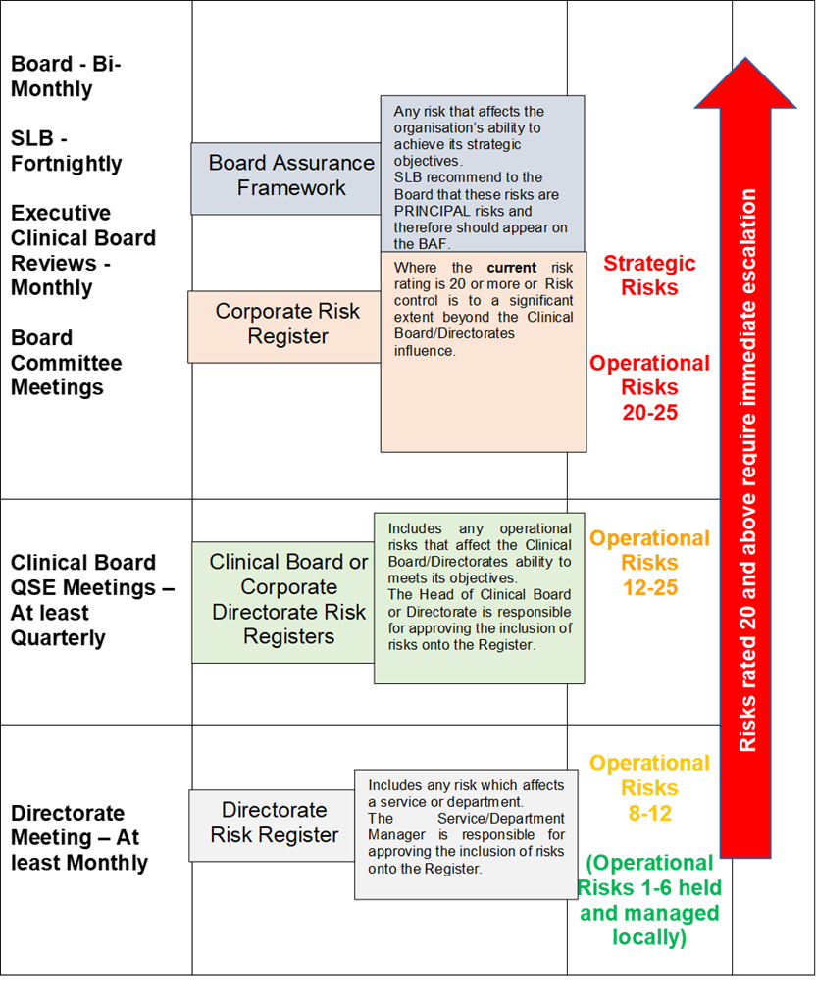

The BAF summarises the controls and assurances that are in place or plans to mitigate them. The BAF aligns principal risks, key controls and assurances on controls alongside each of the Health Board’s strategic objectives.
Gaps are identified where key controls and assurances are insufficient to reduce the risk of non-delivery of objectives. This enables the development of an action plan for closing the gaps and mitigating the risks which is subsequently monitored by the Board for implementation.
The BAF Strategy applies to those members of staff that are directly employed by the Health Board and for whom the Health Board has legal responsibility and is intended to cover all the potential risks that the organisation could be exposed to.
The objectives of the BAF Strategy are to:

- minimise the impact of risks, adverse incidents, and complaints by effective risk identification, prioritisation, treatment and management;
- maintain a risk management framework, which provides assurance to the Board that strategic and operational risks are being managed effectively;
- maintain a cohesive approach to corporate governance and effectively manage risk management resources;
- ensure that risk management is an integral part of the Health Board’s culture;
- minimise avoidable financial loss, or the cost of risk transfer through a robust financial strategy;
- ensure that the Health Board meets its obligations in respect of Health and Safety; and
- Describe the resources available for risk management in the organisation.

As of March 2024, the following risks were identified within the BAF as posing the greatest risk to the delivery of the Health Board’s strategic objectives:

- Workforce- Including risks associated with recruitment and retention.

- Patient Safety -There is a risk to patient safety due to post Covid-19 recovery resulting in a backlog of planned care, significant pressure on emergency services and sub-optimal workforce skill mix or staffing ratios related to reduced availability of specific expert workforce groups or related to the need to provide care in a larger clinical footprint in relation to post Covid-19 recovery.

- Sustainable Culture Change -Including risks that impact on the achievement of Health Board’s goals set out in the Health Board Strategy, Shaping our Future Wellbeing (2018).

- Capital Assets -Including risks associated with service continuity failures due to ageing infrastructure across Health Board sites.

- Delivery of 23/24 commitments within the IMTP -Including risks linked to the provision of high-quality health services and achievement of our mission; Caring for People, Keeping People Well, and vision that a person’s chance of leading a healthy life is the same wherever they live and whoever they are.

- Staff Wellbeing - Including risks associated with staff exposure to psychological and physical distress both at home and in the workplace.

- Exacerbation of Health Inequalities - Including risks posed by existing health inequalities that have been compounded by Covid-19.

- Financial sustainability - including risks posed by the energy crisis and challenges to providing best value health care.

- Urgent and Emergency Care - Including risks linked to achievement of the Welsh Government Six Goals for Urgent and Emergency Care.

- Maternity -Including risks to the achievement of recommendations made within the Ockenden Review into maternity services.

- Critical Care - Including patient safety risks linked to Critical Care capacity levels.

- Cancer - Including risks to achievement of the Health Board’s single cancer pathway standard to treat patients with a confirmed diagnosis of cancer within 62 days.

- Stroke - Including risks associated with an increase in demand for stroke service post pandemic.

- Planned Care - Including risks associated with achievement of waiting time standards and linked Ministerial Priorities.

- Digital Strategy and Road Map - Including risks that may impact on achievement of the Health Board’s five-year Digital Strategy for the period 2020-2025.

Alongside the BAF, the Health Board also maintains a Corporate Risk Register that identifies the extreme operational risks (those scored at 20/25 or higher) that the Health Board is facing.

As of March 2024, there were 91 extreme risks detailed on the Corporate Risk Register all of which recorded a score of 20/25.The BAF and Corporate Risk Register can be seen in any Board meeting agenda pack.

10.1 Audit Assurance on Risk Management

Audit Wales Structured Assessment Phase 2 Report received in December 2023, noted the following in relation to the Management of Risk within the Health Board:

“The Health Board’s continues to have clearly documented strategic risks in its Board Assurance Framework (BAF) and has maintained its well-established regime to ensure appropriate scrutiny by the Board, committees, and executive leads. As recommended last year, the Health Board has updated its BAF to ensure the strategic risks align with the refreshed strategic objectives, priorities, and workstreams”

NWSSP Assurance Services undertook an Internal Audit Review of Risk Management processes in April 2024 which received a Reasonable Assurance rating and concluded that “The Health Board has robust arrangements in place for managing strategic risks. The Board Assurance Framework (BAF) provides key information on the key strategic risks that could impact on the delivery of the Health Board’s Strategy ‘Shaping our Future Wellbeing’. The BAF is routinely reviewed by the Executive Team and is a standing agenda item at Board meetings. Our review of the Strategy and Risk Management Procedures confirmed that staff are provided with comprehensive information on the Health Board’s risk management system.”

10.2 Management of Risk

Overall responsibility for the Risk Management and Board Assurance Framework Strategy lies with the Director of Corporate Governance who has been delegated responsibility for managing the development and implementation of the Risk Management and Board Assurance Framework Strategy. Arrangements are in place to effectively assess and manage risks across the organisation, which includes the ongoing review and updating of the Board Assurance Framework and the Corporate Risk Register so that the Board maintains a line of sight on the Health Board’s key strategic and operational risks.

The BAF is a live document that is presented at every public Board meeting by the Director of Corporate Governance. It is track changed to show changes since the last meeting.

The Corporate Governance Department monitor and maintain the Corporate Risk Register. Each Corporate Department and Clinical Board has responsibility to maintain a comprehensive risk register which forms the basis of the risks that are reflected within the Corporate Risk Register. The Corporate Governance Department regularly meet with Clinical Board and Corporate Department risk leads to review and monitor their Clinical Board/Corporate Department and local level risk registers to ensure that they accurately record the risks that their areas are encountering and to assist those areas in considering new and emerging risks to their service. Following that exercise extreme operational risks, those scored 20/25 or higher, are recorded on the Corporate Risk Register and reported to the Board for scrutiny and approval on a bi-monthly basis. Any risks that are identified as having the potential to impact on the Health Board’s strategic objectives are added to the BAF. Each risk detailed on the Corporate Risk Register is also linked to a Strategic Risk contained in the BAF to ensure that risks are appropriately monitored and escalated.

The key risks detailed in the BAF and Corporate Risk Register are also shared at relevant Committees of the Board for further scrutiny and discussion and Risks are a standing item at the monthly Clinical Board reviews.
The Corporate Governance Department provide staff with training in the management of functional work place risk management processes and assessments.
The risks detailed in the BAF and Corporate Risk Register are considered when determining the Health Board’s risk appetite. The Health Board acknowledges that the delivery of healthcare cannot be achieved unless risks are taken, as well as the subsequent consequences and mitigating actions. It also ensures that risks are not considered in isolation and are taken following consideration of all the risks flowing through the organisation.
The Health Board has approved an overall Risk Appetite of ‘Cautious’ moving towards ‘Seek’ as recorded within the Health Board’s BAF. Within the BAF, individual Risk Appetite levels are also recorded against each of the articulated risks so that each can be managed proactively according to the risk presented.
Communicating and consulting with internal and external stakeholders and partners, as appropriate, at each stage of the risk management process and concerning the process as a whole is important. The frequency of the communication will vary depending upon the severity of the risk and is discussed and agreed with the stakeholders and partners as necessary. This process is led by the person nominated as the lead to manage the risk and for communication with external stakeholders this will be the appointed Executive Director lead for the risk. As the designated lead for Risk Management the Director of Corporate Governance also attends the Health Board’s Stakeholder Reference Group to brief public stakeholders on the activities of the Board including the management or risk.

11. MANDATORY DISCLOSURES

11.1 Revised Health and Care Standards

Health & Care standards have been revised under Duty of Quality and further information is available in our Duty of Quality report.
11.2 Emergency Preparedness

The Health Board had emergency and business continuity arrangements in place during the financial year 2023-24, in accordance with the Civil Contingencies Act 2004 and the Emergency Planning Guidance issued by Welsh Government.
The Major Incident Plan was updated and approved by the Board on 30 September 2021 and was scheduled for a review in September 2024. However, in light of ongoing lessons from the pandemic, the learning from the first stage of the Manchester Arena Inquiry and other national exercises, a review of the Major Incident Plan was undertaken in 2023 and an updated version of the Major Incident Plan was approved by the Board on 25 May 2023.
Business Continuity arrangements were activated in response to a number of incidents including sewage and water leaks due to the condition of our major hospital facilities, patient capacity issues, power failures and Industrial action. Our business continuity arrangements enable us to manage the continued delivery of our services following a business disruption.

11.3 Ministerial Directions and Welsh Health Circulars (WHCs)

Ministerial Directions and WHCs issued by the Welsh Government for the period April 2023- March 2024 have been considered and where appropriate implemented.. Details of the Ministerial Directions issued by the Welsh Government during 2023/24 are set out in Appendix 3 attached to this AGS

During the financial year 2023/24 regular updates on the implementation of Welsh Health Circular implementation and the detail of new WHCs has been shared with the Health Board’s Management Executive Team and the Audit and Assurance Committee to provide oversight of the process.

11.4 Regulatory and Inspection Reports

The Corporate Governance Department have a formal system in place to track regulatory and inspection reports against statutory requirements. This is achieved by means of a Legislative and Regulatory Tracker report which is presented to the Audit and Assurance Committee to provide assurance that recommendations made within such reports are being appropriately actioned. Prior to presentation to the Audit and Assurance Committee the tracker is populated with information from Executive Director Leads and individuals who are accountable for regulatory compliance.

The Legislative and Regulatory Tracker includes the following:

- All Regulatory Bodies who inspect the Health Board.
- The Regulatory Standard being inspected.
- An Executive Lead for each inspection.
- An assurance Committee where Regulatory reports may also be presented along with action plans for improvement where required.

The Legislative and Regulatory Tracker Process was last reviewed by Internal Audit in July 2023 and received a substantial assurance rating. The Corporate Governance Directorate also track all Internal Audit Recommendations and all Audit Wales Recommendations along with management responses. Recommendations are added to the trackers for monitoring once the reports have been signed off by the Audit and Assurance Committee.

11.5 Data Security and Information Governance

Risks relating to information are managed and controlled in accordance with the Health Board’s Information Governance Policy through the Digital Health and Intelligence Committee, which is chaired by an Independent Member.

The Executive Medical Director, as Caldicott Guardian, is responsible for the protection of patient information. All Information Governance issues are escalated through the Digital Health and Intelligence Committee (DHIC Committee).

The DHIC Committee papers can be viewed here: https://cavuhb.nhs.wales/about-us/governance-and-assurance/committees-and-advisory-groups/digital-and-health-intelligence-committee/

The following items were considered by the DHIC Committee in 2023-2024:
- Welsh Government Digital Strategy for Health & Social Care Refresh
- Digital Transformation and Digital Strategy Progress Report
- Joint IMT & IG Corporate Risk Register
- IG Data & Compliance (SIs, Data Protection, GDPR, FOI, SARs, Staffing & Mandatory Training)
- Digital Services Key Performance Indicators
The Director of Digital & Health Intelligence assumes the role of the Senior Information Risk Owner (SIRO) which provides an essential role in ensuring that identified information security risks are addressed and incidents properly managed.

The Board has strict responsibilities to ensure personal data and information is held securely. All information governance related incidents are investigated and reviewed by the Information Governance Group.

During the period April 2023 to March 2024, a total of seventeen data breaches met the threshold to report to the Information Commissioner’s Office, in line with the UK GDPR. A summary of the key themes are outlined below;

- Five breaches were caused by personal data being sent to the wrong address. This includes both postal and email correspondence. In these cases, we are recommending that services review their internal practices to ensure letters are double checked before being sent. With external emails, a warning alerts the sender that the email address is external before the email is sent.

- Four breaches were a result of members of staff accessing clinical records of patients in the absence of a legitimate business reason. In each case, the UHB has followed internal procedures and the breaches have been fully investigated.

- Three breaches were reported due to the unavailability of paper clinical records. Full searches for these records have been performed and for at least one case, we are aware that the medical records were subsequently located.

All of the reported data breaches have been closed by the ICO with no further action although in a number of cases, a number of recommendations were made and actioned.
During April 2023 to March 2024, Cardiff and Vale UHB did not suffer any recorded lapses of data security, other than those data breaches which are outlined in the above section which were reported to the Information Commissioner's Office.

11.6 NHS Pension Scheme
As an employer with staff entitled to membership of the NHS Pension Scheme, control measures are in place to ensure all employer obligations contained within the Scheme regulations are complied with. This includes ensuring that deductions from salary, employer’s contributions and payments in to the Scheme are in accordance with the Scheme rules, and that member Pension Scheme records are accurately updated in accordance with the timescales detailed in the Regulations.

11.7 UK Corporate Governance Code

The UK Corporate Governance Code (the Code) is the primary reference and overview of good practice for corporate governance in Central Government Departments. Whilst there is no requirement to comply with all elements of the Corporate Governance Code, the Health Board considers that it is complying with the main principles of the Code, where applicable, and follows the spirit of the Code to good effect, is conducting its business in an open and transparent manner, and in line with the Code.
An assessment against the Code was undertaken in April 2023. There were no reported/identified departures from the Corporate Governance Code during the year.

11.8 Review of Effectiveness

As Accountable Officer, I have responsibility for reviewing the effectiveness of the system of internal control. My review of the system of internal control is informed by the work of the internal auditors, and the Executive officers within the organisation who have responsibility for the development and maintenance of the internal control framework, and comments made by external auditors in their Annual Audit Letter and other reports.

Internal Sources | External Sources
- Performance management reports  - Service change management reports  - Workforce information and surveys  - Benchmarking  - Internal and clinical audit reports  - Board and Committee reports  - Local Counter Fraud work  - Health and Care Standards assessments  - Executive and Independent Member Safety Walk Rounds  - Results of internal investigations and Serious Incident reports  - Concerns and compliments  - Whistleblowing  - Infection prevention and control reports  - Information governance toolkit self-assessment  - Patient experience surveys and reports  - Compliance with legislation (e.g. Mental Health Act/Health and Safety, Data Protection) | - Population Health Information  - Audit Wales  - Welsh Risk Pool (WRP) Assessment reports  - Healthcare Inspectorate Wales (HIW) reports  - Community Health Council visits and scrutiny reports  - Feedback from healthcare and third sector partners  - Royal College and Deanery visits  - Regulatory, licensing and inspection bodies  - External benchmarking and statistics  - Accreditation Schemes  - National audits  - Peer reviews  - Feedback from service users  - Local networks (e.g. cancer networks)  - Welsh Government reports and feedback

Further sources of assurances are identified within the Board’s own performance management and assurance framework and include, but are not limited to:

- Direct assurances from management on the operation of internal controls through the upward chain of accountability
- Internally assessed performance against the Health and Care Standards
- Results of internal compliance functions including Local Counter-Fraud, Post Payment Verification, and risk management
- Reported compliance via the Welsh Risk Pool regarding claims standards and other specialty specific standards reviewed during the period
- Reviews completed by external regulation and inspection bodies including Audit Wales and Healthcare Inspectorate Wales (HIW).

The effectiveness of the system of internal control is maintained and reviewed by the Committees of the Board in respect of assurances received. This is also supported by the BAF with high risks being closely monitored by Board and the respective Committees.

Governance, Leadership and Accountability

11.9 Board and Committee Effectiveness

In order to evaluate and demonstrate the effectiveness of the Board and the Board’s Committees the following actions took place during 2023-2024:
- The Chair of the Board and the Chair of each Committee review the effectiveness of individual meetings as part of the agenda at each respective meeting.
- Each Committee of the Board developed an Annual Report which is reviewed by each Committee before presentation to Public Board. The Annual Reports are signed off by each Committee Chair and provide assurance to the Board that the Committees have met their Terms of Reference.
- The Board undertook an away day in December where it considered some of the lessons identified from Board meetings across Wales in recent years.

12. Internal Audit

Internal Audit provides me as Accountable Officer and the Board through the Audit and Assurance Committee with a flow of assurance on the system of internal control. I have commissioned a programme of audit work which has been delivered in accordance with public sector internal audit standards by the NHS Wales Shared Services Partnership. The scope of this work is agreed with the Audit and Assurance Committee and is focussed on significant risk areas and local improvement priorities.
The overall opinion by the Head of Internal Audit on governance, risk management and control are a function of this risk-based audit programme and contributes to the picture of assurance available to the Board in reviewing effectiveness and supporting our drive for continuous improvement.
The Head of Internal Audit is satisfied that there has been sufficient internal audit coverage during the reporting period in order to provide the Head of Internal Audit Annual Opinion. In forming the Opinion, the Head of Internal Audit has considered the impact of the audits that have not been fully completed.

12.1 The Head of Internal Audit Opinion

In accordance with the Public Sector Internal Audit Standards (PSIAS), the Head of Internal Audit (HIA) is required to provide an annual opinion, based upon and limited to the work performed on the overall adequacy and effectiveness of the organisation’s framework of governance, risk management and control. This is achieved through the delivery of an audit plan that has been focused on key strategic and operational risk areas and known improvement opportunities, agreed with executive management and approved by the Audit Committee, which should provide an appropriate level of assurance.
The purpose of the annual Head of Internal Audit opinion is to contribute to the assurances available to the Accountable Officer and the Board of Cardiff and Vale University Health Board which underpin the Board’s own assessment of the effectiveness of the organisation’s system of internal control.
The overall opinion is based primarily on the outcome of the work undertaken during the course of the 2023/24 audit year. We also consider other information available to us such as our overall knowledge of the organisation, the findings of other assurance providers and inspectors, and the work we undertake at other NHS Wales organisations. The Head of Internal Audit considers the outcomes of the audit work undertaken and exercises professional judgement to arrive at the most appropriate opinion for each organisation.
The Head of Internal Audit opinion on the overall adequacy and effectiveness of the organisation’s framework of governance, risk management, and control is set out below.
Reasonable Assurance |   - +  Yellow | The Board can take reasonable assurance that arrangements to secure governance, risk management and internal control, within those areas under review, are suitably designed and applied effectively. Some matters require management attention in control design or compliance with low to moderate impact on residual risk exposure until resolved.
The opinion does not imply that Internal Audit has reviewed all risks and assurances relating to the Health Board. The opinion is substantially derived from the conduct of risk-based audit work formulated around a selection of key organisational systems and risks. As such, it is a key component that the Board takes into account but is not intended to provide a comprehensive view.
Details of the audits undertaken in the year and the results are summarised in the following table:
Substantial Assurance | Reasonable Assurance
- Recommendation Tracking  - Refresh of the Health Board’s Strategy  - Urgent and Emergency Care – Welsh Government Six Goals Programme  - Core Financial Systems (Asset Register Management) | - ChemoCare IT System Follow-up  - Paris System  - Mental Health Clinical Board Governance Arrangements  - Capital Systems  - Technical Continuity  - Infection Prevention & Control  - Patient Safety Incident Management  - Information Governance  - UHL Endoscopy Development  - Follow-up: Cyber Security  - Financial Management within Clinical Boards  - Mortality Reviews  - Cancer Services  - Risk Management / Board Assurance Framework  - Medical Records Tracking (CD&T) Follow-up (Draft)  - Management of Health Board Policies Follow-up (Draft)  - Eye Care Digitisation Programme (Draft)
Limited Assurance | Advisory & Non-Opinion
- Surgery CB – Consultant job Plans (From 22/23 Plan)  - Estates Assurance – Estate Condition  - Alcohol Standards  - HealthRoster System  - Temporary Staffing Costs (Draft)  - Decarbonisation (Draft) | - Shaping Our Future Wellbeing – Future Hospitals Programme (From 22/23 Plan)  - Leadership and Management Training and Development  - Quality, Safety & Experience Governance  - Pentyrch Surgery Development – Site Evaluation Process
Unsatisfactory Assurance | Assurance yet to be determined
N/A | - PCIC Clinical Board Governance Arrangements (WiP)  - Medical Staff Additional Sessions (From 22/23 Plan) (WiP)  - Maternity Care – Ockenden Review (WiP)  - Implementation of People & Culture Plan (WiP)  - IMTP Development Process (WiP)  - Performance Reporting (WiP)

12.2 Limited Assurance
During the year Internal Audit issued six audit reports with a conclusion of limited assurance. They included:

- Surgery Clinical Board – Consultant Job Plans
- Estates Condition
- Health Roster System
- Alcohol Standards
- Temporary Staffing Costs (Draft)
- Decarbonisation (Draft)

Health Board management have agreed actions to implement the Internal Audit recommendations and therefore address the significant areas of weakness identified through these Limited assurance audit reports. Progress towards implementation of the agreed management actions is monitored via the Health Board’s recommendation tracking process and is periodically reported to the Audit & Assurance Committee.
There were no audited areas in which the Health Board received a “No assurance” assessment rating.

13. External Audit - Audit Wales

The Auditor General for Wales is the Health Board’s statutory External Auditor and the Wales Audit Office undertakes audits on his behalf. Since 1 April 2020 the Auditor General for Wales and the Wales Audit Office are known collectively as Audit Wales. Audit Wales scrutinises the Health Board’s financial systems and processes, performance management, key risk areas and the Internal Audit function (https://www.audit.wales/)

13.1 The Annual Audit Report for 2023

Audit Wales’ annual programme of work at the Health Board is set out in the Audit Plan. The 2023 Audit Wales Audit Plan was approved by the Audit and Assurance Committee on 4 April 2023.
Reports produced by Audit Wales in line with the Audit Plan are presented to the Audit and Assurance Committee. A Management Response is prepared for reports which contain recommendations. All recommendations are subsequently recorded in the External Audit Recommendations Tracker. A Tracking Report is provided to each Audit and Assurance Committee to provide assurance on their implementation.
The following reports relating directly to the work of the Health Board were presented to the Audit and Assurance Committee:

Report | Month
Financial Audit Updates | April, September & November 2023  February 2024
Performance Audit Updates | April, September & November 2023  February 2024
Audit of Accounts Report – Cardiff and Vale University Health Board | July 2023
Orthopaedic Services in Wales – Tackling the Waiting List Backlog | July 2023
Audit Wales Orthopaedic Report and Management Response | September 2023
Charitable Funds (2023-24 Accounts) | January 2024
Structured Assessment 2023 | February 2024
Annual Audit Report 2023  (A copy can be accessed using the following link:  Cardiff and Vale University Health Board – Annual Audit Report 2023 | Audit Wales | February 2024

The Audit and Assurance Committee also reviews the outcomes of national pan-sector reviews at the earliest possible meeting following their publication.
The Annual Audit Report 2023 did not identify any material weaknesses in the Health Board’s internal controls (as relevant to the audit)
A detailed Audit Plan was considered and approved by the Audit and Assurance Committee on 11 May 2023.
13.2 Cardiff and Vale University Health Board - Structured Assessment
The Audit Wales Structured Assessment for 2023 provides an assessment of the Health Board’s corporate arrangements for ensuring that resources are used efficiently, effectively and economically.

The Structured Assessment for 2023 made a number of findings some of which include:
- Whilst the Health Board has maintained good corporate systems of assurance, there are opportunities to enhance operational risk management arrangements, performance reporting, and overseeing recommendations tracking.

- The Board continues to have good arrangements for overseeing strategic and corporate risks and it has updated its Board Assurance Framework to align risks to the Health Board’s refreshed strategic objectives, priorities, and workstreams. However, opportunities remain to improve operational risk management arrangements. The Board maintains good oversight of organisational performance, but there are opportunities to strengthen the improved Integrated Performance Report as well as to review the Performance Management Framework to ensure it supports delivery of the refreshed strategic objectives. The Health Board is taking appropriate steps to ensure compliance with the new duties of quality and candour and is improving its overall approach to overseeing the quality and safety of services. Whilst the Health Board has strong arrangements for tracking audit and review recommendations, opportunities exist to enhance these arrangements further to support learning and improvement.

- It was found that despite clear processes for financial planning, management and monitoring, the Health Board’s financial position for 2023-24 is challenging.

- The Health Board did not achieve its financial duties and objectives for 2022-23, and the financial position for 2023-24 remains challenging. The Health Board has a good approach to financial planning, and has set an ambitions savings target with a clear focus on quality improvements and achieving financial sustainability. Arrangements for overseeing and scrutinising financial management and controls have been strengthened. The Health Board continues to have robust arrangements for overseeing and scrutinising financial performance, with clear financial reports which are open about financial challenges and risks.

The Structured Assessment can be accessed via the following link:
https://audit.wales/publication/cardiff-and-vale-university-health-board-structured-assessment-2022

14. Modern Slavery Act 2015 – Transparency in Supply Chains

The Welsh Government’s Code of Practice: Ethical Employment in Supply Chains was published in May 2017 to highlight the need, at every stage of the supply chain, to ensure good employment practices exist for all employees, both in the UK and overseas. It is expected that all NHS Wales organisations will sign up for the Code.

The Health Board fully endorses the principles and requirements of the Code and the Modern Slavery Act 2015 and is committed to playing its role as a major public sector employer, to eradicate unlawful and unethical employment practices, such as:

- Modern Slavery and Human rights abuses;
- The operation of blacklist/prohibited lists;
- False self-employment;
- Unfair use of umbrella schemes and zero hours’ contracts; and
- Paying the Living Wage.

The following actions are in place which meet the Code’s commitments:

- We have a Raising Concerns (Whistleblowing) Policy, which provides the workforce with a fair and transparent process, to empower and enable them to raise suspicions of any form of malpractice by either our staff or suppliers/contractors working on the Health Board premises;
- We have a target in place to pay our suppliers within 30 days of receipt of a valid invoice;
- We comply with the six NHS pre-employment check requirements to verify that applicants meet the preconditions of the role they are applying for. This includes a right to work check;
- We have introduced robust IR35 processes to ensure the fair and appropriate engagement of all workers and prevents individuals from avoiding paying Tax and National Insurance contributions;
- We do not engage or employ staff or workers on zero hours’ contracts;
- We have in place an Equality and Diversity Policy which ensures that no potential applicant, employee or worker engaged is in any way unduly disadvantaged in terms of pay, employment rights, employment or career opportunities;
- We also seek assurances from suppliers, via the tender process, that they do not make use of blacklists/prohibited lists. We are also able to provide confirmation and assurances that they do not make use of blacklist/prohibited list information;
- In accordance with Transfer of Undertaking (Protection of Employment) Regulations any Health Board staff who may be required to transfer to a third party will retain their NHS Terms and Conditions of Service;
- We use the Modern Slavery Act (2015) compliance tracker by way of contracts procured by NHS Wales Shared Services Partnership (NWSSP) on behalf of the Health Board. NWSSP is equally committed to ensuring that procurement activity conducted on behalf of NHS Wales is undertaken in an ethical way. On our behalf, they ensure that workers within the supply chains through which they source our goods and services are treated fairly, in line with Welsh Government’s Code of Practice for Ethical Employment in Supply Chains.

The Health Board continues to work in partnership with relevant stakeholders and trade union partners to develop and implement actions which set out our commitment to ensure the principles of ethical employment within our supply chains are implemented and adhered to.
15. Conclusion
As Accountable Officer, based on the assurance process outlined above, I have reviewed the relevant evidence and assurances in respect of internal control. I can confirm that the Board and its Executive Directors are alert to their accountabilities in respect of internal control.

During 2023-2024, we have again proactively identified areas requiring improvement and requested Internal Audit to undertake detailed assessments in order to manage and mitigate associated risks. A number of reports issued by Internal Audit concur with our view and have consequently provided the Health Board with clear recommendations to ensure that focussed and urgent management actions are in place to address identified shortcomings. These actions are then monitored through the Board and its Committees to ensure appropriate assurances can be provided. The Health Board’s Structured Assessment 2023 undertaken by Audit Wales provided a positive view of the organisation’s corporate arrangements to support good governance and the efficient, effective, and economical use of resources in most areas.

The response and ongoing recovery from the Covid-19 pandemic together with the cost of living crisis, very high inflation levels and the impact of the Ukrainian war on energy prices, have had a significant impact on the organisation, wider NHS and society as a whole. It has required a dynamic response which has presented a number of opportunities in addition to risks. The need to continue to recover from the pandemic will be with the organisation and wider society throughout 2024-2025 and beyond. I will ensure our Governance Framework considers and responds to this need.

The refresh of the Health Board’s long-term Strategy presents opportunities to strengthen our arrangements further by ensuring key structures, processes, and resources against what continues to be a very challenging environment to operate in. Our commitment to quality will be embedded within our Strategy and in our Annual Plan and governance, risk management and control processes will continue to evolve in support.
I am confident that our systems of internal control have remained robust throughout the pandemic and now into recovery and am assured that there have been no significant internal control or governance issues during 2023-24.

In summary, my review confirms that the Board has sound systems of internal control in place to support the delivery of policy aims and our corporate objectives and that there are no significant internal control or governance issues to report for 2023-2024.

Signed by

Suzanne Rankin  Chief Executive |  | Date:

Appendicies
Appendix 1
Board and Committee Membership & Attendance 2023-2024

Name | Position and dates | Area of Expertise/  Representation Role | Board Committee Membership and Record of Attendance | Champion Roles
Professor Charles Janczewski | Chair  1 April 2023 to 31 March 2024 |  | - Board 6/6  - Board of Trustees (BoT) 3/3  - QSE 1/10  - Finance & Performance (F&P) 10/12  - Audit & Assurance (A&A) 1/7 | Putting Things Right  Wellbeing of Future Generations Act
Professor Ceri Phillips | Vice Chair  1 April 2023 to 31 March 2024 |  | - Board 6/6  - BoT 3/3  - F&P 10/12  - A&A 5/7  - MHLMCA 4/4  - QSE 9/10 | Mental Health
Professor Keith Harding | 1 April 2023 to 30 November 2023 | University | - Board 3/4  - BoT 1/2  - F&P 5/8  - Charitable Funds 2/2  - Digital & Health Intelligence (DHI) 1/3  - F&P 5/8  - QSE 5/7
David Edwards | Independent Member  1 April 2023 to 31 March 2024 | Information Communication and Technology | - Board 5/6  - BoT 2/3  - F&P 8/12  - A&A 3/7  - DHI 4/4 | Armed Forces and Veterans
Councillor Susan Elsmore | Independent Member  1 April 2023 to 31 October 2023 | Local Authority | - Board 2/3  - BoT 1/2  - Charitable Funds 2/2  - MHLMCA 1/3  - P&C 3/3 | Social Services and Wellbeing (Wales) Act
Akmal Hanuk | Independent Member  1 April 2023 to 31 March 2024 | Local Community | - Board 6/6  - BoT 3/3  - QSE 10/10  - DHI 4/4  - P&C 4/6 | Infection Prevention and Control
Sara Moseley | Independent Member  1 April 2023 to 31 March 2024 | Third (Voluntary) Sector | - Board 5/6  - BoT 2/3  - Charitable Funds 4/5  - MHLMCA 4/4  - P&C 6/6 | Equality
Dr Rhian Thomas | Independent Member  1 April 2023 to 31 March 2024 | Capital & Estates | - Board 6/6  - BoT 3/3  - A&A 6/6  - MHLMCA 3/4  - QSE 9/10  - P&C 6/6 | Children and Young People
John Union | Independent Member  1 April 2023 to 31 March 2024 | Finance | - Board 5/6  - BoT 3/3  - F&P 12/12  - A&A 7/7  - Charitable Funds 5/5
Mike Jones | Independent Member  1 April 2023 to 31 March 2024 | Trade Union | - Board 6/6  - BoT 3/3  - A&A 7/7  - QSE 8/10  - P&C 5/6 | Raising Concerns
Michael Imperato | Independent Member  1 April 2023 – 31 August 2023 | Legal | - Board 1/2  - BoT 1/1  - F&P 5/5  - DHI 1/2
Sam Austin  Lani Tucker | Associate Member  1 April 2023 to 30 September 2023  1 January 2024 to 31 March 2024 | Chair, Stakeholder Reference Group | - Board 1/3  - Board 2/2
Lance Carver | Associate Member  1 April 2023 to 28 February 2024 | Director of Social Services, Vale of Glamorgan | - Board 0/5
Suzanne Rankin | Chief Executive Officer  1 April 2023 to 31 March 2024 |  | - Board 6/6  - BoT 1/3  - F&P 1/12  - MHLMCA 1/4  - QSE 3/10  - DHI 2/4
Catherine Phillips | Executive Director of Finance  1 April 2023 to 31 March 2024 | Finance | - Board 3/6  - BoT 3/3  - F&P 12/12  - A&A 7/7  - Charitable Funds 5/5
Professor Meriel Jenney | Executive Medical Director  1 April 2023 to 31 March 2024 | Medical / Quality & Safety | - Board 4/6  - BoT 1/3  - QSE 8/10  - DHIC 1/4 | Caldicott
Jason Roberts | Executive Director of Nursing  1 April 2023 to 31 March 2024 | Nursing / Quality & Safety | - Board 6/6  - BoT 2/3  - MHLMCA 1/4  - QSE 10/10  - P&C 2/6 | Children and Young People  Putting Things Right
Paul Bostock | Chief Operating Officer  1 April 2023 to 31 March 2024 | Operations | - Board 5/6  - BoT 2/3  - F&P 12/12  - MHLMCA 1/4  - QSE 6/10  - P&C 1/6 | Age protected characteristic
Abigail Harris | Executive Director of Strategic Planning  1 April 2023 to 31 March 2024 | Estates & Planning | - Board 5/6  - BoT 2/3  - F&P 9/12 | Emergency Planning
Dr Fiona Jenkins | Executive Director of Therapies and Health Sciences  1 April 2023 to 31 March 2024 | Therapies and Life Sciences | - Board 5/6  - BoT 2/3  - QSE 7/10  - Charitable Funds 3/5  - DHI 2/4  - P&C 2/6 | Armed Forces and Veterans
Rachel Gidman | Executive Director of People and Culture  1 April 2022 to 31 March 2023 | Workforce | - Board 6/6  - BoT 3/3  - A&A 5/7  - Charitable Funds 3/5  - P&C 4/6 | Fire Safety  Violence and Aggression  Welsh Language
Fiona Kinghorn  Claire Beynon | Executive Director of Public Health  1 April 2023 to 31 December 2023  1 January 2023 to 31 March 2024  Executive Director of Public Health | Public  Health | - Board 4/4  - BoT 2/2  - QSE 4/8  - P&C 4/4  - Board 1/2  - BoT 1/1  - QSE 1/2  - P&C 2/2 | Sex/Gender protected characteristic

Name | Position | Area of Expertise/  Representation Role | Board Committee Membership and Record of Attendance | Champion Roles
Non-Voting Members
James Quance  Matt Phillips | Interim Director of Corporate Governance  1 April 2023 to 31 July 2023  Director of Corporate Governance | Governance | - Board 2/2  - BoT 1/1  - F&P 4/4  - A&A 4/4  - DHI 1/1  - Charitable Funds 0/3  - MHLMCA 2/2  - QSE 3/3  - P&C 2/2  - Board 4/4  - BoT 1/2  - A&A 3/3  - F&P 8/8  - DHI 3/3  - QSE 5/6  - MHLMCA 2/2  - Charitable Funds 4/4  - P&C 4/4
David Thomas | Director of Digital and Health Intelligence  1 April 2023 to 31 March 2024 | Digital | - Board 6/6  - BoT 0/3  - DHI 4/4  - P&C 4/6  - A&A 2/7

Appendix 2

Dates of Board and Committee meetings held during 2023-2024

Tables 1 and 2 outlines respectively the (i) dates of Board and Committee meetings held during 2023-2024, and (ii) the dates of Advisory Group meetings held during 2023-2024, highlighting any meetings that were inquorate:

Table 1 - Dates of Board and Committee meetings held during 2023-2024

Board/Committee | April | May | June | July | Aug | Sep | Oct | Nov | Dec | Jan | Feb | March
Board |  | 25 |  | 27 |  | 28 |  | 30 |  | 25 |  | 28
Board of Trustee | 20 |  |  |  |  |  | 05 |  |  | 18
Audit and Assurance Committee | 04 | 11 |  | 04 & 25* |  | 05 |  | 07 |  |  | 06
Charitable Funds |  |  | 20 |  |  | 19 |  |  | 05 | 30* |  | 19
Digital Health & Intelligence |  | 30 |  |  | 15 |  | 03 |  |  |  | 13
Finance | 19 | 17 | 21 | 19 | 23 | 20 | 18 | 22 | 13 | 17 | 21 | 20
People & Culture |  | 16 |  | 11 |  | 12 |  | 14 |  | 23 |  | 12
Mental Health Legislation & Mental Capacity Act |  | 02 |  |  | 01 |  | 31 |  |  | 30
Quality, Safety & experience | 11 | 09 |  | 18 | 30 | 26 | 25 | 28 | 19 |  | 13 | 26

*Extraordinary Meetings

All meetings held were quorate.

Where meetings were inquorate, escalation arrangements were in place to ensure that any matters of significant concern that could not be brought to the attention of the Committee could be raised with the Health Board’s Chair.

Table 2 - Dates of Advisory Group meetings held during 2023-2024

Advisory Groups | April | May | June | July | Aug | Sep | Oct | Nov | Dec | Jan | Feb | March
Stakeholder Reference |  | 23 |  | 25 |  | 26 |  | 28 |  | 29 |  | 26
Local Partnership Forum | 13 |  | 08 |  |  |  | 12 |  | 12 |  | 08

The Health Board was also represented on the following Joint Committees:
- Welsh Health Specialised Services Committee (WHSSC)
- Emergency Ambulance Services Committee (EASC)
- NHS Wales Shared Services Partnership Committee (SSPC)

Assurance reports/bulletins from the above Committees are captured on the Board agenda as required

Appendix 3

Ministerial Directions

Ministerial Directions (MD) | Date / Year of Adoption | Action to Demonstrate Implementation / Response
(WG23-14)  Directions to Local Health Boards as to the Statement of Financial Entitlements (Amendment) (No. 2) Directions 2023 | 30.08.2023 | Disseminated
(WG23-27)  The Primary Care (E-Prescribing Pilot Scheme) Directions 2023 | 01.06.2023 | N/A This is a change in legislation that was required to enable a national e-prescribing pilot
(WG23-36)  The Primary Medical Services (Influenza and Pneumococcal Immunisation Scheme) (Directed Enhanced Service) (Wales) (No. 2) (Amendment) Directions 2023 | 28.07.2023 | Framework exists should Primary Care contractors intend to deliver the vaccine
(WG23-37)  The Nursery Milk Scheme (Wales) (Amendment) Directions 2023 | 31.07.2023 | Disseminated
(WG23-40)  Directions to Local Health Boards as to the Statement of Financial Entitlements (Amendment) (No. 3) Directions 2023 | 07.08.2023 | Disseminated
(WG23-47)  The National Health Service (Wales Eye Care Services) (Wales) Directions 2023 | 26.10.2023 | Disseminated to practices
(WG24-01)  Wales Eye Care Services (Administrative List) (Wales) Directions 2024 | 05.01.2024 | As above
(WG24-02)  The National Health Service (Wales Eye Care Services) (Wales) Directions 2024 | 05.01.2024 | Disseminated
(WG24-04)  Directions to Local Health Boards as to the Statement of Financial Entitlements (Amendment) Directions 2024 | 09.02.2024 | Disseminated
(WG24-06)  The National Health Service Joint Commissioning Committee (Wales) Directions 2024 | 07.02.2024 | N/A – for action by NHS Wales Joint Commissioning Committee
(WG24-08)  The Wales Infected Blood Support Scheme (Amendment) Directions 2024 | 01.04.2024 | N/A – for action by Velindre University NHS Trust
(WG24-09)  The National Health Service (Wales Eye Care Services) (Wales) (No. 2) Directions 2024 | 01.04.2024 | Disseminated
(2016 No. (W)  The Low Vision Service Committee (Wales) Directions 2016 (with consolidated amendments) | 26.10.2023 | Noted
(2016 No.10)  The Eye Health Examination Service Committee (Wales) Directions 2016 (with consolidated amendments) | 26.10.2023 | Noted
(2016 No 10)  The Eye Health Examination Service Committee (Wales) Directions 2016 (with consolidated amendments) | 05.01.2024 | Noted
(2016 No (W)  The Low Vision Service Committee (Wales) Directions 2016 (with consolidated amendments) | 05.01.2024 | Noted

Welsh Health Circulars
All Welsh Health Circulars are reviewed and triaged to Executive and Operational Leads within the organisation. The implementation of progress against each circular is tracked by the Health Board’s Risk and Regulation Team and periodically reported at Management Executive Meetings.
Welsh Health Circular | Date / Year of Adoption | Action to Demonstrate Implementation / Response
(WHC/2023/003)  Guideline for the investigation of moderate or severe early developmental impairment or intellectual disability (EDI/ID) | 04.04.2023 | Circular shared with Executive Lead for information and action.
(WHC/2023/008)  SaBTO FAIR III recommendations to tissue and cell donation process | 25.09.2023 | Circular shared with Executive Lead for information and action.
(WHC/2023/009)  COVID-19 vaccination of children aged 6 months to 4 years in a clinical risk group | 06.04.2023
(WHC/2023/010)  Certification of Vision Impairment in Primary and Community Care | 28.06.2023
(WHC/2023/011)  NICE Guidance on Self-harm: assessment, management and preventing recurrence | 21.04.2023 | Circular Shared with Executive Medical Director, Executive Nurse Director, Assistant Director, Quality, Safety and Improvement and the Mental Health and Primary, Community and Intermediate Care Clinical Boards for dissemination to Primary and Secondary Care Clinicians.
(WHC/2023/012)  NHS Wales financial monitoring returns, 2023 to 2024 | 26.04.2023 | Circular shared with Executive Lead for information and action.
(WHC/2023/013)  Health and Care Quality Standards 2023 | 02.05.2023
(WHC/2023/015)  COVID-19 vaccination observation periods/vaccination following recovery from COVID-19 | 09.05.2023 | Circular shared with Executive Lead for information and action.
(WHC/2023/016)  Implementing the move to one dose of the HPV vaccine in Wales | 10.05.2023 | Circular shared with Executive Lead for information and action.
(WHC/2023/017)  NHS Wales Executive National Policy on Patient Safety Incident Reporting and Management | 12.05.2023 | Circular shared with Executive Lead for information and action.
(WHC/2023/018)  Introduction of HL7 FHIR as a foundational standard in all NHS Wales Bodies | 14.06.2023 | Circular shared with Executive Lead for information and action.
(WHC/2023/019)  In support of prevention of suicide and self-harm: GMC and NICE Guidance on information disclosure for the protection of patients and others | 01.06.2023 | Circular shared with Executive Lead and colleagues for information and action.
(WHC/2023/021)  Consent to Examination or Treatment update | 08.08.2023 | Circular shared with Executive Lead for information and action.
(WHC/2023/022)  Armed Forces Covenant – Healthcare Priority / Special Consideration for Veterans / Ex-Armed Forces Personnel | 24.06.2023 | Circular shared with Executive Lead for information and action.
(WHC/2023/023)  The National Influenza Immunisation Programme 2023-24 | 22.06.2023 | Circular shared with Executive Lead for information and action.
(WHC/2023/024)  Change of Vaccine and Cohort Expansion for Shingles Vaccination Programme (from September 2023) | 28.06.2023 | Circular shared with Executive Lead for information and action.
(WHC/2023/025)  Suspected cancer pathway: guidelines | 20.07.2023 | Circular shared with Executive Lead and colleagues for information and action.
(WHC/2023/026)  NHS framework for research and development – Research Matters – what excellence looks like in NHS Wales | 28.07.2023 | Circular shared with relevant colleagues for information and action.
(WHC/2023/028)  Withdrawal of WHC/2019/042 regarding annual quality statements | 01.08.2023 | Circular shared with Executive Lead and colleagues for information and action.
(WHC/2023/029)  Winter Respiratory Vaccination Programme: Autumn and Winter 2023 to 2024 | 17.08.2023 | Circular shared with Executive Lead and colleagues for information and action.
(WHC/2023/030)  New 2023 National Safety Standards for Invasive Procedures (NatSSIPS2) by the Centre of Perioperative Care (CPOC) and Patient Safety Notice PSN 034 | 22.08.2023 | Circular shared with Executive Lead for information and action.
(WHC/2023/031)  Healthcare associated infections and antimicrobial resistance improvement goals 2023-24 | 22.08.2023 | Circular shared with Executive Lead for information and action.
(WHC/2023/032)  Amendments to Model Standing Orders and Model Standing Financial Instructions – NHS Wales | 24.10.2023 | Circular shared with Executive Lead for information and action.
(WHC/2023/033)  Vaccine Products to be used in the Autumn 2023 COVID-19 Vaccination programme | 01.09.2023 | Circular shared with Executive Lead for information and action.
(WHC/2023/034)  NHS Wales Sustainability Conference and Awards | 25.09.2023 | Circular shared with Executive Lead and colleagues for information and action.
(WHC/2023/035)  Update on guidance on clearance and management of healthcare workers living with a bloodborne virus (BBV) and a reminder of health clearance for Tuberculosis | 01.10.2023 | Circular shared with Executive Lead for information and action.
(WHC/2023/036)  Speaking Up Safely Framework – NHS Wales | 15.09.2023 | Circular shared with Executive Lead and colleagues for information and action.
(WHC/2023/037)  Patient Testing Framework for Autumn / Winter 2023 | 26.09.2023 | Circular shared with Executive Lead for information and action.
(WHC/2023/038)  Healthy Start eLearning course | 09.11.2023 | Circular shared with Executive Lead and colleagues for information and action.
(WHC/2023/039)  Independent authorisation of blood component transfusion (IABT) – 2023 to 2026 | 27.11.2023 | Circular shared with Executive Leads for information and action.
(WHC/2023/040)  The NHS Wales: Newborn and Infant Physical Examination Cymru (NIPEC) | 09.11.2023 | Circular shared with Executive Leads for information and action.
(WHC/2023/041)  Refresh of the rare disease action plan 2022 to 2026 | 05.01.2024
(WHC/2023/043)  Vaccination of Healthcare Staff to Protect Against Measles | 14.12.2023 | Circular shared with Executive Lead for information and action.
(WHC/2023/044)  Change to the influenza (flu) vaccination programme 2023 to 2024 | 11.12.2023 | Circular shared with Executive Lead for information and action.
(WHC/2023/045)  Recording dementia read codes | 21.02.2024
(WHC/2023/046)  All-Wales control framework for flexible workforce capacity | 13.12.2023 | Circular shared with Executive Leads for information and action.
(WHC/2023/047)  Influenza vaccines and eligible cohorts for the 2024 to 2025 season | 21.12.2023 | Circular shared with Executive Lead for information and action.
(WHC/2023/048)  2024-25 Health Board Revenue Allocation | 21.12.2023 | Circular shared with Executive Lead for information and action.
(WHC/2024/001)  Changes to the way individuals who are at highest risk from COVID-19 access lateral flow tests and COVID-19 treatments | 11.02.2024 | Circular shared with Executive Lead for information and action.
(WHC/2024/002)  Standards for Competency Assurance of Non-Medical Prescribers in Wales | 08.03.2024 | Circular shared with Executive Lead for information and action.
(WHC/2024/004)  Sterile preparation of medicine in NHS Wales | 12.02.2024 | Circular shared with Executive Lead for information and action.
(WHC/2024/005)  Private obesity surgery and the Welsh NHS | 01.02.2024 | Circular shared with Executive Lead for information and action.
(WHC/2024/006)  The national clinical guideline for stroke | 22.03.2024 | Circular shared with Executive Lead for information and action.
(WHC/2024/008)  Vaccination of children to protect against measles | 02.02.2024 | Circular shared with Executive Lead for information and action.
(WHC/2024/009)  COVID-19 spring booster 2024 | 08.02.2024 | Circular shared with Executive Lead for information and action.
(WHC/2024/010)  NHS Welsh Sustainability Conference and Awards: new date | 04.03.2024 | Circular shared with Executive Lead for information and action.
(WHC/2024/011)  Changes to Welsh Government dietary advice for young children | 06.03.2024 | Circular shared with Executive Lead for information and action.
(WHC/2024/012)  Nursing preceptorship and restorative clinical supervision: position statement | 21.03.2024 | Circular shared with Executive Lead for information and action.

Remuneration and Staff
Report

Part 2b

16. Remuneration and Staff Report

16.1 Staff Numbers

The Health Board’s workforce profile identifies that approximately 76% of the workforce is female. This is not representative of the local community where a little more than half the population is female. The numbers of female and male directors, managers and employees as at 31st March 2024 were as follows:

 | Female | Male | Total
Director | 9 | 8 | 17
Manager | 189 | 119 | 308
Employee | 13,335 | 4,202 | 17,537
Total | 13,533 | 4,329 | 17,862

16.2 Staff Composition

We have a diverse workforce of 17,862 staff working in many different types of roles, and together with volunteers, colleagues in social care and carers, we have a huge impact on our population. We must know and understand the shape of our workforce if we are to successfully monitor and revise plans that result in the right workforce at the right time, enabling and empowering the workforce to work to the ‘top of their licence’ or scope of practice. Our People and Culture Plan recognises that in addition to the challenges brought about by the pandemic and the necessary period of recovery, we, along with the broader NHS in Wales, face social, economic, technological and demographic changes. As a result of this the demographic of our workforce also needs to change, and we must adjust the way we recruit, retain and support our people.

The charts below indicate the following challenges when determining optimal ways to deploy the current and future workforce and how to consider future supply against service priorities:

- The UHB has an aging workforce with the largest age categories being aged 31-35 years (2,389 staff), 36-40 years (2,388 staff) and 41-45 (2,148 staff).

- The largest grade categories are staff in Agenda for Change Bands 2, 5 and 6. Continually reviewing skill mix and new ways of working is important in ensuring adequate future supply of skills in the right place and grade. There is also a need for further workforce modernisation, new roles and extended skills, supported by the improvement of workforce intelligence and workforce planning skills. This includes the development of appropriate efficiency and productivity measures that help facilitate benchmarking and demonstrate value as our workforce shape continues to change.

- The majority of the workforce is female (75.76%) with a fairly even split in this group of full-time (52.57%) and part-time working (47.42%). Use of our employment policies, such as the Adaptable Workforce Policy and Flexible Working Procedure, is crucial to retaining talent and keeping staff engaged.

- The majority of the workforce is white (73.98%) with 14.20% in Black and Minority Ethnic categories and 11.82% not stated. The Strategic Equality Plan has a number of actions to continue review of our workforce in this regard to ensure it strives to reflect the local population where relevant e.g. in recruiting practices.

- The nursing and midwifery registered staff and unregistered nursing staff make up just over 42% of the total workforce. Given there is a recognised national shortage of registered nurses, the UHB has made nurse sustainability a high priority on its workforce agenda. Although we can’t influence the actual supply of registered workforce in the short term, we can concentrate our efforts on attracting people by improving the branding of the UHB, promoting the benefits of working here, and targeting specific groups in society.

Workforce profile information collected for the UHB in March 2024 shows that 7% of staff consider themselves to have a disability, but this information is not known for a significant number of staff (19%).

In an effort to improve our workforce equality and Welsh language skills data, the People & Culture function launched an organisational wide campaign encouraging staff to update their individual Electronic Staff Record (ESR). The campaign highlighted the reasons why collecting data is important and how it would support the organisation in becoming more inclusive. To support the campaign, and improve the accuracy of our data, the UHB are also exploring alternative ways of supporting staff to update their information, including on-site ‘drop-in’ sessions.

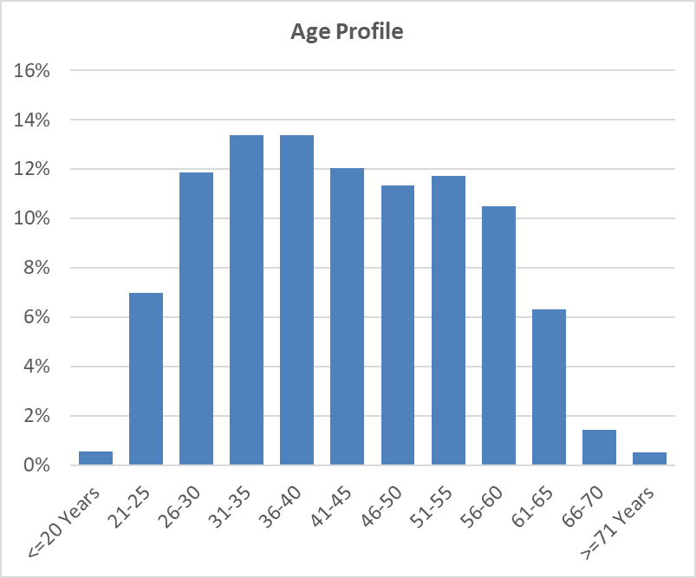

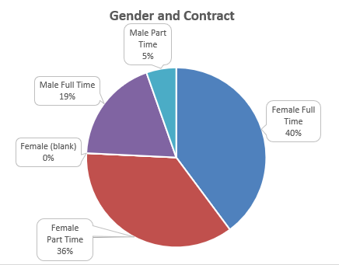

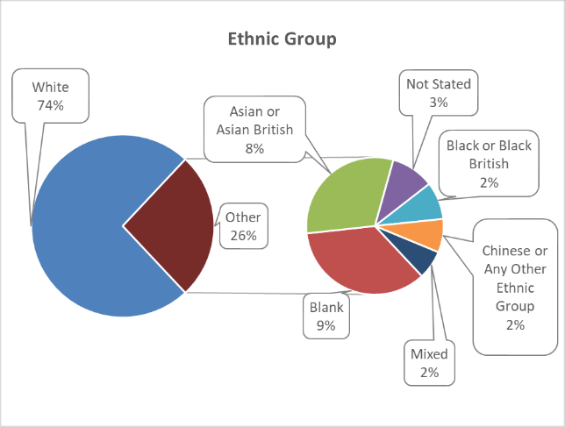

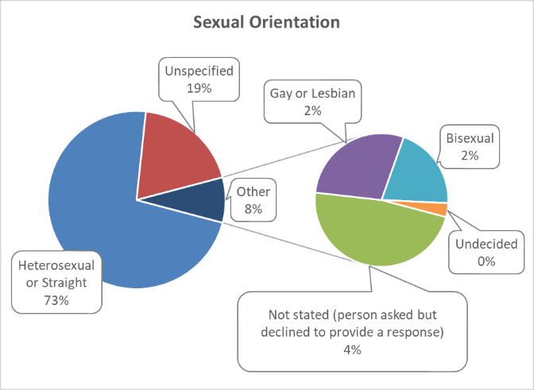

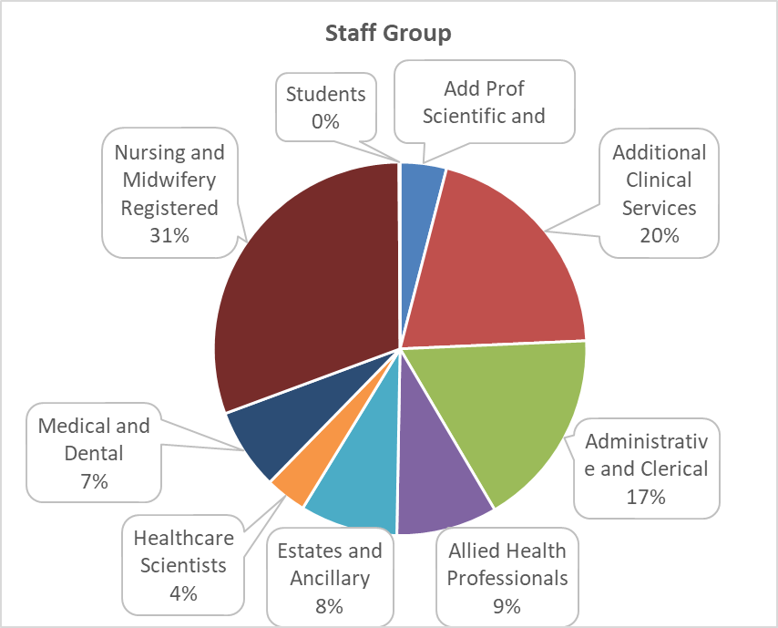

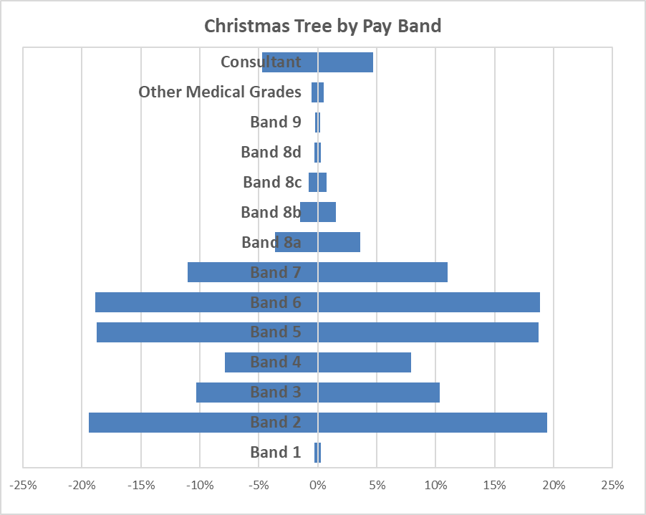

16.3 Sickness Absence Data

The health and wellbeing of Cardiff and Vale UHB staff is of upmost importance, especially at this unprecedented time and much of the work carried out in 2023-24 has been described in the Performance Report.

Sickness absence remains a priority for the UHB. The cumulative sickness rate for the 12-month period up to and including March 2024 is 6.22% which is 0.22% above the 2023-24 year-end target of 6.00%.

65.59% of this sickness was attributed to long-term absence and 34.41% to short-term absence. The UHB top reasons recorded for absence dring 2023-24 were Anxiety/Stress and Colds, Coughs & Influenza.

The following table provides information on the number of days lost due to sickness during 2022-23 and 2023-24

 | 2023-24 | 2022-23
 | Number | Number
Days lost (long term) | 220,631.64 | 232,000.47
Days lost (short term) | 115,748.36 | 124,923.33
Total days lost | 336,380.00 | 356,923.80
Total staff years | 14,813.19 | 14,154.02
Average working days lost | 22.72 | 25.22
Total staff employed in period (headcount) | 17,096 | 15,918
Total staff employed in period with no absence (headcount) | 5,404 | 5,250
Percentage staff with no sick leave | 31.61% | 31.25%

16.4 Staff Policies

At Cardiff and Vale UHB we have 6 local UHB employment Policies:

- Recruitment and Selection
- Adaptable Workforce
- Employee Health and Wellbeing
- Learning Education and Development
- Equality, Inclusivity and Human Rights Policy
- Maternity, Adoption, Paternity and Shared Parental Leave
These set out our organisational commitments and what we are aiming to achieve. Each of them is supported by a number of Procedures which describe the processes to follow, roles & responsibilities, and any entitlements or obligations. This means there is less duplication, more transparency and information which is easier to understand. These are in addition to the All-Wales Policies which apply to us and all other Health Boards in Wales
All employment and other related People Services (Human Resources) and People and Culture policies, procedures and guidelines are required to have at least two authors, i.e. a management and staff representative and they are subject to robust consultation processes. This includes publication on the UHB Sharepoint site for a period of at least 28 days and consideration at the Employment Policies Sub Group of the Local Partnership Forum.
As an employer we are committed to providing meaningful equality of opportunity and inclusion for all employees, regardless of their protected characteristics), as is demonstrated by our Equality, Inclusivity and Human Rights Policy. Its remit goes beyond strict compliance with the law and acts as a reference point in the event of any subsequent disputes.
The UHB is committed to equal opportunities in recruitment, and demonstrates this by displaying the Disability Confident Leader symbol (which replaces the ‘two ticks’ scheme) in all adverts, as well as Supporting Age Positive, Mindful Employer and Stonewall Cymru symbols.

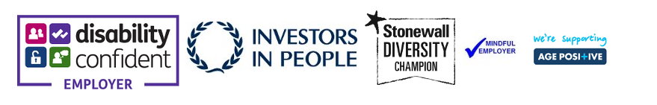
The Employee Health and Wellbeing Policy outlines our commitment to encouraging and empowering all staff to take personal responsibility for their lifestyle choices and health and wellbeing. It also sets out our commitment to guide and support managers in their roles and responsibilities around both supporting healthy workplaces and work practices, and in engaging in effective conversations with individuals and teams. The responsibility of the UHB in providing a workplace, culture and environment that enables being healthy and well at work is also recognised

The UHB were awarded Gold and Platinum Corporate Health Standards in April 2023 following re-assessment. The Health and Wellbeing Steering Group was refreshed in Autumn 2023 and is currently overseeing development of the UHB Health and Wellbeing Framework, as well as identifying organisational health and wellbeing priorities using intelligence emerging from across the UHB, research and best practice.
The NHS Wales Managing Attendance at Work Policy assists managers in supporting staff when they are ill, manage their absence and help facilitate their timely return to work in a compassionate way. The policy is proactive by placing responsibility on line managers to know their staff and focus on their health and wellbeing to keep them well and in work.

The Managing Attendance at Work Policy includes a number of toolkits. One of these deals with reasonable/tailored adjustments – it reminds managers of our legal duty to make reasonable adjustments to ensure workers with disabilities, or physical or mental health impairments, are not disadvantaged when doing their jobs or during the recruitment process. The Policy states that not all illnesses are disabilities, however, if an employee is asking for support with a health and wellbeing condition, it is best to provide the support accordingly, assuming it is proportionate to do so. There are many benefits to this including supporting the employee back into work and helping them remain in work.

Managing Attendance at Work training has been delivered virtually to over 200 managers in 2023, with regular sessions planned face to face and virtually in 2024. Toolkit Talk Sessions have been arranged for managers and staff to advise on the options and processes, which will also signpost them to various health, wellbeing and support networks. These include:

Ill Health Retirement Process/Support for Managers and Staff
Short Term Sickness and Review Prompts
Long Term Sickness Meetings
Injury Allowance Claims Procedure

In line with the UHBs People and Culture Plan, all our standard letters and guidance have been reviewed to help embed compassionate leadership and to include signposting to various support mechanisms. A suite of documents has been collated which additional support and guidance on returning to work after a period of long-term sickness with specific conditions. A central database for temporary roles in various departments that can be offered to staff who require a temporary alternative role. In order to address the highest reason for sickness, Stress, Anxiety and Depression, the People Services Team have centralised all available resources. These resources are distributed to managers to enable signposting of staff.

The Redeployment Procedure supports employees whose employment is at risk to find suitable alternative employment within Cardiff and Vale University Health Board, ensuring continuity of employment. Redeployment gives us the opportunity to be innovative, making full use of the skills and experience of all staff to respond to these challenges. The redeployment procedure was reviewed in 2023-24 and the focus has shifted to a more compassionate and positive approach. This has been achieved mainly through changing the language used and also outlining the main purpose and ethos of the procedure throughout. The focus has moved from just purely focusing on sickness redeployments to widening the context, to all other reasons for redeployment, as outlined above.

The ethos that has really been highlighted throughout this updated procedure is to retain and develop experienced and skilled staff and look at redeployment as a more positive process.

The Supporting Carer’s Guidelines were developed in September 2021 reviewed in March 2024. The Guidelines remain a supportive and relevant resource for managers and staff across the Health Board. We recognise that employees with caring responsibilities may require short term arrangements for either child or dependent care, or for longer term requirements have the ‘right to request’ flexible working arrangements. The caring responsibilities may potentially impact on a member of staff’s ability to do their job.
The purpose of the Guidelines is to support staff to achieve a positive work/ life balance with caring responsibilities, so that staff are likely to feel more valued, thus be more productive and satisfied at work. It ensures that staff are not unfairly disadvantaged by such responsibilities and are able to successfully combine their work and caring responsibilities.
16.5 Salary and Pension Entitlements of Senior Managers 2023-2024
Full details of senior managers’ renumerations for 2023-24 are provided in the audited tables that follow:

16.6 Consultancy Expenditure
As disclosed in note 3.3 of its annual accounts, the Health Board spent £1.207m on consultancy services during 2023-24 compared to £0.643m in 2022-23. The majority of this expenditure going towards projects aimed at delivering better clinical outcomes and efficiencies.

  - Tax Assurance for Off-payroll Appointees

Senedd Cymru/Welsh
Parliament Accountability
& Audit Report

17. Part 2c Senedd Cymru/Welsh Parliament Accountability and Audit Report

17.1 Regularity of Expenditure
The Health Board has a financial duty to break even over a three-year period.
The Integrated Medium Term Plan submitted for the period 2022-2025 did not include a balanced financial position and was not approved by Welsh Government. Consequently, the health board has not met its statutory duty to have an approved financial plan for the period 2022-23 to 2024-25.

In the absence of an approved Integrated Medium Term Plan, in March 2022, the health board submitted a one year Operational Plan in respect of the 2023-24 financial year with a planned deficit of £16.5m.

The financial performance for the year, as contained in the accounts is a year-end deficit of £16.404m for 2023/24.

The Health Board had a surplus of £0.232m in 2021/22 and a deficit of £26.789m in 2022/23. This means that over the three-year period, the aggregated deficit is £42.691m. This spend constitutes irregular expenditure.

17.2 Long Term Expenditure Plans 2019-2024

Performance Against the Revenue Resource Limit

The health board has not met its financial duty to break even against its Revenue Resource Limit over the 3 years 2021-22 to 2023-24.
The Health Board received £16.460m strategic cash support in 2023-24. The cash only support is provided to assist the Health Board with ensuring payments to staff and suppliers. There is no interest payable on strategic cash support.
Performance Against the Capital Resource Limit

Cardiff and Vale University health board has met its financial duty to break even against its Capital Resource Limit over the 3 years 2021-22 to 2023-24.

How the Health Board has received its Revenue Funding
2023/24

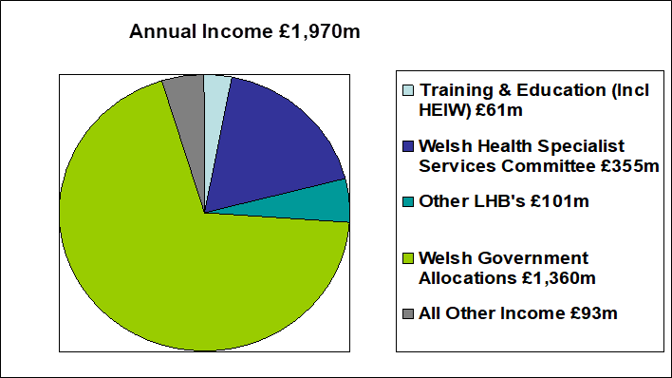

2022/23

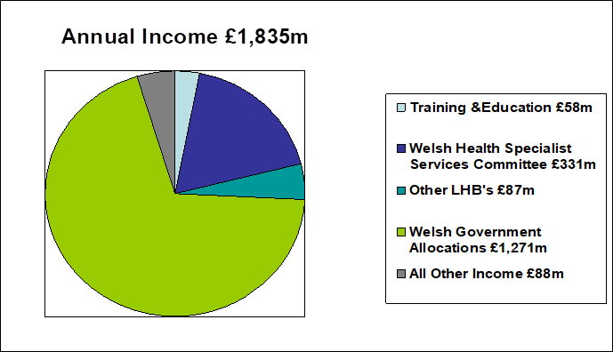

2021/22

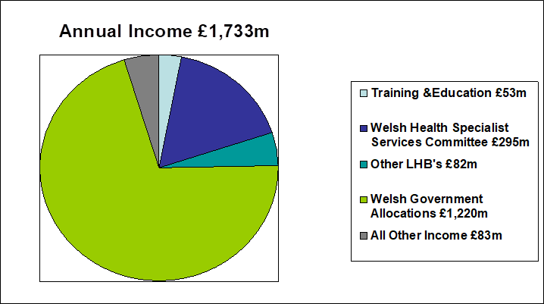

2020/21
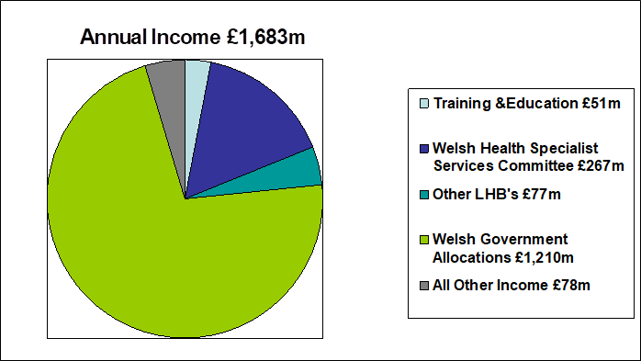
2019/20

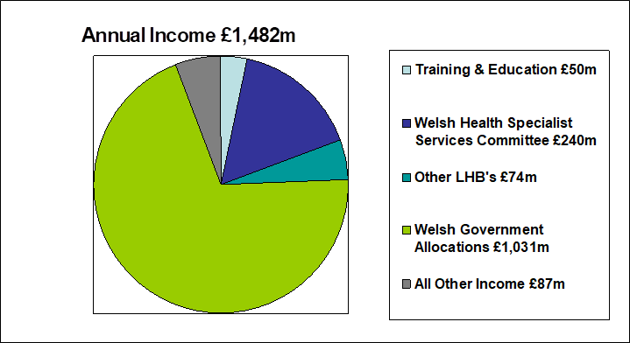

As disclosed in the performance against break even duty table above, the UHB is permitted to remove certain elements of expenditure (which it incurs but over which it doesn't have managerial control) when comparing its expenditure to its annual revenue resource limit. For the purposes of a meaningful comparison of income & cost, this has been treated as notional income in the above. Hence the expenditure figures shown below are shown gross (with no expenditure removed).

How the UHB has utilised its Revenue Funding

2023/24

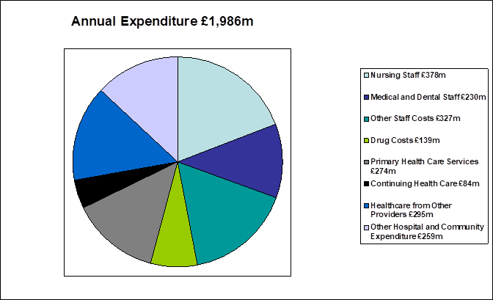

2022/23
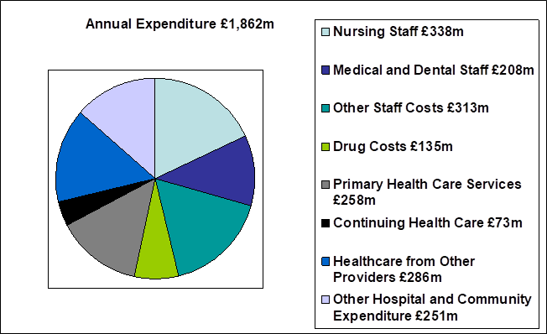
2021/22

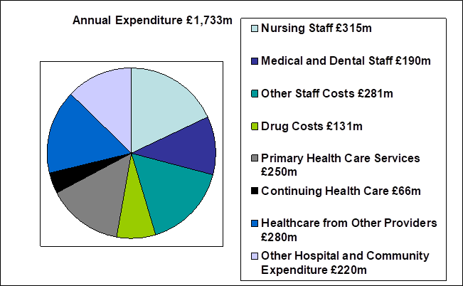

2020/21
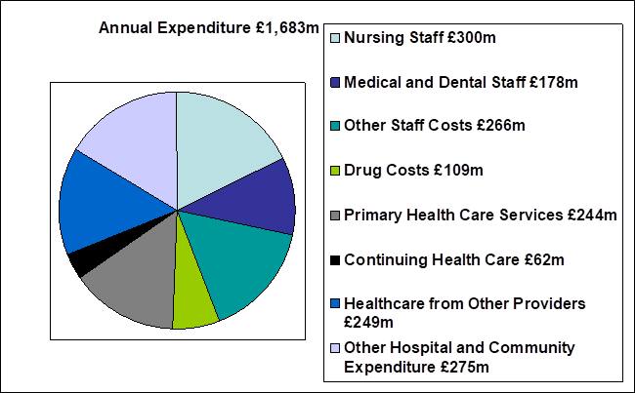

2019/20
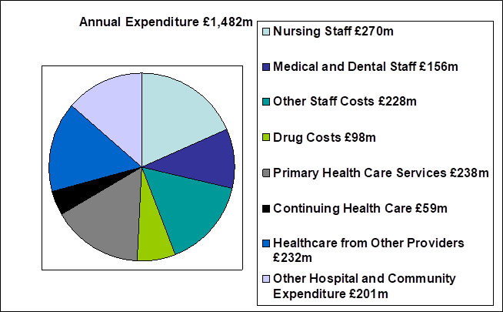

17.3 Fees and charges
The Health Board levies charges or fees on its patients in a number of areas. Where the Health Board makes such charges or fees, it does so in accordance with relevant Welsh Health Circulars and charging guidance.

Charges are generally made on a full cost basis. None of the items for which charges are made are by themselves material to the UHB, however details of some of the larger items (Dental Fees, Private and Overseas Patient income) are disclosed within Note 4 of the Annual Accounts.

17.4 Managing public money
This is the required Statement for Public Sector Information Holders as referenced at Section 10.1.7 (page 68) of the Directors’ Report. In line with other Welsh NHS bodies, the UHB has developed Standing Financial Instructions which enforce the principles outlined in HM Treasury on Managing Public Money. As a result the UHB should have complied with the cost allocation and charging requirements of this guidance and the UHB has not been made aware of any instances where this has not been done.

17.5 Material remote contingent liabilities

As disclosed in note 21.2 of its annual accounts, the Health Board had net remote contingent liabilities as at March 31st 2024 of £0.195m. This relates to Clinical Negligence & Personal Injury claims against the Health Board, where our legal advisors inform us that the claimants’ chance of success is remote.

17.6. The Certificate of the Auditor General for Wales to the Senedd- TO BE PROVIDED

Part 3
Audited Financial Statements (Annual Accounts)

18. Financial Statements
TO BE ADDED
Foreword

These accounts have been prepared by the Local Health Board under schedule 9 section 178 Para 3(1) of the National Health Service (Wales) Act 2006 (c.42) in the form in which the Welsh Ministers have, with the approval of the Treasury, directed.

Statutory background

The Local Health Board was established on 1 October 2009, following the merger of Cardiff & Vale NHS Trust, Cardiff Local Health Board and The Vale of Glamorgan Local Heath Board. The main purpose of the body being, the provision of healthcare to and the procurement of healthcare for the populations of Cardiff and the Vale of Glamorgan. In addition, as a Tertiary Centre the UHB serves the wider population across Wales (and the UK) via the provision of specialist and complex services.

Performance Management and Financial Results

Welsh Health Circular WHC/2016/054 replaces WHC/2015/014 ‘Statutory and Administrative Financial Duties of NHS Trusts and Local Health Boards’ and further clarifies the statutory financial duties of NHS Wales bodies and is effective for 2019-20. The annual financial duty has been revoked and the statutory breakeven duty has reverted to a three-year duty, with the first assessment of this duty in 2016-17.

Local Health Boards in Wales must comply fully with the Treasury’s Financial Reporting Manual to the extent that it is applicable to them. As a result, the Primary Statement of in-year income and expenditure is the Statement of Comprehensive Net Expenditure, which shows the net operating cost incurred by the LHB which is funded by the Welsh Government. This funding is allocated on receipt directly to the General Fund in the Statement of Financial Position.

Under the National Health Services Finance (Wales) Act 2014, the annual requirement to achieve balance against Resource Limits has been replaced with a duty to ensure, in a rolling 3-year period, that its aggregate expenditure does not exceed its aggregate approved limits.

The Act came into effect from 1 April 2014 and under the Act the first assessment of the 3 year rolling financial duty took place at the end of 2016-17.

© Cardiff & Vale University Health Board 2023
The text of this document (this excludes all departmental or agency logos) may be reproduced free of charge in any format or medium provided that permission is sought and it is reproduced accurately and not in a misleading context. The material must be acknowledged as Cardiff and Vale University Health Board* copyright and the document title specified. Where third party material has been identified, permission from the respective copyright holder must be sought.

