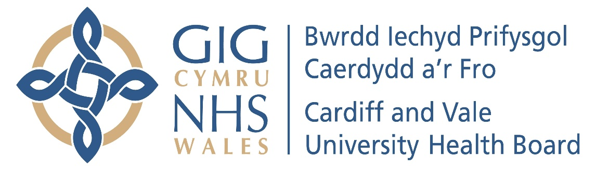

Annual Report of the Charitable Funds Committee
2023/24

- INTRODUCTION

In accordance with best practice and good governance, the Charitable Funds Committee produces an Annual Report to the Board setting out how the Committee has met its Terms of Reference during the financial year.

- MEMBERSHIP

The Committee membership is six Members comprising an Independent Member Chair, Independent Member Vice Chair, a further Independent Member and three Executive Directors who are the Executive Director of Finance (Lead Executive), Executive Director of People and Culture and the Executive Director of Therapies and Health Sciences. In addition to the Membership, the meetings are also attended by the Director of Corporate Governance, the Director of Communications, Arts & Health Charity and the Deputy Finance Director. The Chair of the Board is not a Member of the Committee but attends at least once annually after agreement with the Committee Chair. Other Executive Directors are required to attend on an ad hoc basis.

- MEETINGS & ATTENDANCE

The Committee met five times during the period 1 April 2023 to 31 March 2024. This is in line with its Terms of Reference.
The Charitable Funds Committee achieved an attendance rate of 76% (80% is considered to be an acceptable attendance rate) during the period 1st April 2023 to 31st March 2024 as set out below:
 | 20.06.2023 | 19.09.2023 | 05.12.2023 | 30.01.2024 | 19.03.2024 | Attendance
John Union (Chair) | Yes | Yes | Yes | Yes | tbc | tbc
Susan Elsmore (Vice Chair) * | Yes | Yes | N/A | N/A | N/A | 100%
Sara Moseley | Yes | Yes | Yes | Yes | tbc | tbc
Catherine Phillips | Yes | Yes | Yes | Yes | tbc | tbc
Fiona Jenkins | No | Yes | Yes | No | tbc | tbc
Rachel Gidman | Yes | No | Yes | No | tbc | tbc
Total | 83% | 83% | 100% | 60% | tbc | tbc

*Susan Elsmore left the Organisation on 31.10.2023

- TERMS OF REFERENCE

The Terms of Reference and annual Work Plan are reviewed and approved on an annual basis. The Terms of Reference for the year 2023/24 were reviewed by the Committee on the 21 March 2023 and were approved by the Board on 30 March 2023. The Work Plan for the year 2023/24 was reviewed by the Committee on 21 March 2023 and were approved by the Board on 30 March 2023.

- WORK UNDERTAKEN

The purpose of the Charitable Funds Committee is to provide advice to the Charity Trustee, with regards to the discharge of its duties and responsibilities for the Charitable Funds.
During the financial year 2023/24, the Charitable Funds Committee (“the Committee”) reviewed the following key items at its meetings:

- Health Charity Financial Position & Investment Update.

At each meeting, the Committee was advised of its responsibility for overseeing the financial management and stewardship of the Charitable Funds. The Charitable Funds Financial Position Report provided information on the year to date’s financial performance of the Cardiff and Vale Health Charity (“the Charity) and assessed the forecast financial position of the Charity against commitments already made and investments.

At every meeting the latest income position of the Charity was provided to the Committee.

At the meeting held on June 2023, the Committee were reminded that bids against the General Reserve remained closed because the General Reserve was overcommitted against outstanding approvals to the value of £0.685m. This closure continued for the remainder of the reporting year due to the ongoing over commitment.

- Over £25K bids for approval

At each meeting a number of bids, where the value of each individual bid was over £25,000, were presented to the Committee for discussion and/or approval. Each bid discussed by the Committee during the year, together with the outcome of the same, is listed below.

- Cardiology Funds allocated to ‘Our Health Meadow’ – Approved
- Health Meadow Roundhouses – Approved
- Breast Centre, University Hospital, Llandough Purchase of a Sonosite PX Ultrasound System – Approved
- Cystic Fibrosis Centre – Garden Development – Approved
- Endowments Expenditure Request – pending approval at March meeting

- Fundraising Report

A Fundraising Report was provided to the Committee on a quarterly basis.
The reports covered the progress and activities of the Health Charity Appeals for the period
1st April 2023 – 31st March 2024.
The report outlined various appeals, staff lottery updates, fundraising activities and any significant donations received by the Charity.

- Reporting Feedback on Successful CFC bids

At each meeting, the Committee was advised of feedback from the bids that had previously been approved by the Committee. These included:

- Covid-19 Patient Experience Support Project
- Recovery and Wellbeing College Senior Peer Trainer
- Grow Cardiff
- Staff Outdoor areas
- Our Health Meadow
- Staff Recognition Awards
- Keeping Me Well
- Welsh Transplant Games
- Psychology input in High Care areas
- March reporting tbc

- Staff Benefits Group Report

Cardiff and Vale University Health Board Staff Benefits Group was established in 2017, to explore and co-ordinate discounts and benefits offered by external organisations for Health Board employees. The Staff Benefits Group would ensure and agree ‘best deals’ for staff and in governance terms would report their work to the Committee and the Local Partnership Forum.

At each meeting, the Committee was informed of staff benefits discussed and agreed by the Staff Benefits Group between April 2023 – March 2024.

Staff benefits are displayed on a dedicated link on the Health Board’s website intranet page.

- Staff Lottery Bids Panel Report

The Board of Trustees has delegated responsibility for the Staff Lottery Bids Panel to consider and approve Charitable Funds bids up to a maximum of £10,000.

The Small Bids process, which also allows bids up to a value of £250 to be fast tracked for approval, was formally agreed by the Committee at their meeting on the 19th September 2017.

The Charity was pleased to report that the Staff Lottery Scheme income continued to grow month on month with the increased number of allocated numbers being at its highest level since its launch and which increased income for the Health Charity. The Lottery funds provide support to patients, staff and visitors and is extremely efficient in terms of its turnaround of fast-track bids for funding, which benefits services across the Health Board.

- Events Planner 2022/2023 Update

The Health Charity Team organises a wide range of fundraising events throughout the year to:
- Support individual appeals for Clinical Boards and fundraisers
- Involve and support staff members in their individual fundraising for the HC
- Raise awareness of the Health Charity’s fundraising activities to encourage staff and public involvement, improve sponsorship and partnership opportunities

The events planner for 2023/24 was received by the Committee at each of its meeting and provided a draft of the key events taking place for the year.

- Health Charity Strategy Update

The Health Charity’s Strategy for the period 2019 - 2024 was approved in principle by the Charitable Funds Committee in September 2019 and subsequently endorsed for publication by the Board of Trustees on 23.07.20 where it was revised to cover the period 2020 – 2025.

At the meeting held on 21st June 2022, the committee discussed the requirement for a review of the strategy, following on from the Covid-19 pandemic and all of the learnings and change that it had brought.

Subsequent workshops and meetings have taken place, with a series of recommendations on improving and developing the Health Strategy, to be more aligned to the post pandemic world and economic situation.

Additionally, it was considered appropriate to delay further progress, pending the publication of the Cardiff and Vale University Health Board’s strategy “Shaping Our Future Wellbeing” 2023 - 2035 in October 2023. The Health Charity’s draft strategy has subsequently been updated in alignment with the key aims and objectives of that document.

On 30 January 2024, a special meeting of the Charitable Funds Committee was held to discuss updates to the Health Charity strategy and will be received by the Committee on 19 March 2024 to recommend approval by the Board of Trustees.

- Other matters of business discussed during the year, included: -

- Prop Appeal Annual Update – 20.06.2023
- Our Health Meadow Updates – 20.06.2023 & 19.09.2023
- Third Sector Grants Scheme – 19.09.2023
- Bale Fund Balance – Proposals for Spend – 19.09.2023
- Disposal of Rookwood Hospital Summary Update – 19.09.2023
- Breast Centre Appeal Annual Update – 05.12.2023
- Food Sense Wales Update – 19.03.2024 – tbc
- Food Sense Wales Memorandum of Understanding for approval – 19.03.2024 – tbc
- Arts Annual Update – 19.03.2024 – tbc

- REPORTING RESPONSIBILITIES

The Committee has reported to the Board after each of its Committee meetings by presenting a summary report of the key discussion items at the Committee. The report is presented by the Chair of the Charitable Funds Committee.

- OPINION

The Committee is of the opinion that the draft Charitable Funds Committee Report 2023/24 is consistent with its role as set out within the Terms of Reference and that there are no matters that the Committee is aware of at this time that have not been disclosed appropriately.

John Union

Committee Chair

