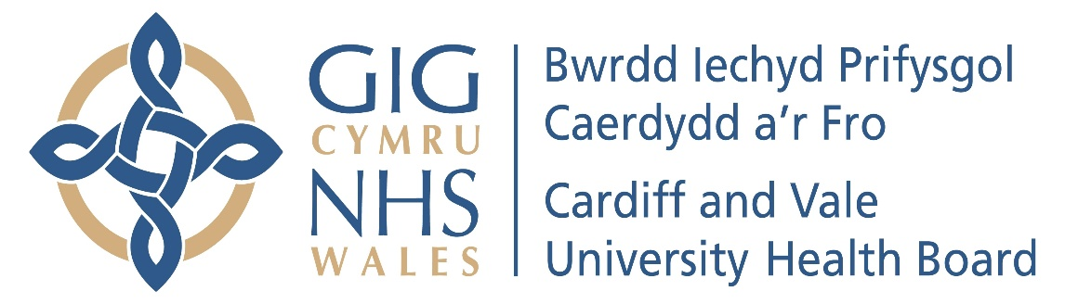

Annual Report of the Mental Health Legislation & Mental Capacity Act Committee
2023-24

- INTRODUCTION
In accordance with best practice and good governance, the Mental Health Legislation & Mental Capacity Act Committee (“the Committee”) produces an Annual Report to the Board setting out how the Committee has met its Terms of Reference during the financial year.
- MEMBERSHIP
The Committee membership is a minimum of three Independent Members. During the financial year 2021/22 the Committee comprised four Independent Members. In addition to the Membership, the meetings are also attended by the Chief Operating Officer (Executive Lead for the Committee), the Executive Nurse Director, the Director of Corporate Governance, the Clinical Board Director – Mental Health Clinical Board, the Director of Nursing – Mental Health Clinical Board, and the Director of Operations – Mental Health Clinical Board. The Chair of the Board is not a Member of the Committee but attends at least annually after agreement with the Committee Chair. Other Executive Directors are required to attend on an ad hoc basis.

- MEETINGS AND ATTENDANCE
The Committee met four times during the period 1 April 2023 to 31 March 2024. This is in line with its Terms of Reference. The Mental Health, Capacity and Legislation Committee achieved an attendance rate of 81.25% (80% is considered to be an acceptable attendance rate) during the period 1st April 2023 to 31st March 2024 as set out below:
 | 02.05.2023 | 01.08.2023 | 31.10.2023 | 30.01.2024 | Attendance %
Ceri Phillips  (Chair) |  |  |  |  | 100
Sara Moseley  (Vice Chair) |  |  |  |  | 100
Rhian Thomas |  |  | X |  | 75
Susan Elsmore* | X | X |  | N/A | 33.3
Total | 75 | 75 | 75 | 100

*Susan Elsmore left the organisation on the 31.10.2023
- TERMS OF REFERENCE
The Terms of Reference were reviewed by the Committee on 31st January 2023. The Terms of Reference approved by the Board on the 30 March 2023.

- WORK UNDERTAKEN
The principal remit of the Committee is to consider and monitor the use of the Mental Health Act 1983 (“MHA”), Mental Capacity Act 2005 (which includes the Deprivation of Liberty Safeguards (“DoLS”) and the Mental Health (Wales) Measure 2010 (“the Measure”). In particular, the Committee should seek and provide assurance to the Board or to escalate areas of concerns and advise on actions to be taken in relation to:

- Hospital Managers’ duties under the Mental Health Act 1983;
- the provisions set out in the Mental Capacity Act 2005, and
- in the Mental Health Measure (Wales) 2010

are all exercised in accordance with statute and that there is compliance with:
- the Mental Health Act 1983 Code of Practice for Wales
- the Mental Capacity Act 2005 Code of Practice
- the Mental Capacity Act 2005 Deprivation of Liberty Safeguards Code of Practice
- the associated Regulations

During the financial year 2022/23 the Mental Health, Capacity and Legislation Committee considered the following:

Mental Capacity Act Monitoring Report and DoLS Monitoring
The Committee received the Mental Capacity Act (MCA) and Deprivation of Liberty Safeguards (DoLS) Monitoring report which provided a general update on current issues related to the MCA and DoLS. The MCA and DoLS indicators provided an overview of the following:

- Mental Capacity IMCA Referral type
- Mental Capacity Training
- Additional training provision
- Progress following the appointment of MCA Practitioners
- DoLS applications and assessments over the previous year
- Consent to Examination and Treatment

Liberty Protection Safeguards Monitoring Report

In 2023, the UK Government announced their decision to not progress the Liberty Protection Safeguards (LPS) or implement the Mental Capacity (Amendment) Act 2019 within Parliament. Further to that announcement, the Welsh Government expressed their disappointment in the decision and committed to continue to provide increased funding to protect the rights of those who lack mental capacity.

As such, the focus for the Health Board remained upon improving understanding and application of the MCA in clinical practice, strengthening the current Deprivation of Liberty Safeguards (DoLS) arrangements and improving ongoing monitoring and reporting.

Mental Health Act Monitoring Exception Report
The report provided the Committee with further information relating to wider issues of the Mental Health Act. Any exceptions highlighted in the Mental Health Act Monitoring report were intended to raise the Committee’s awareness of matters relating to the functions of hospital managers and give assurance that the care and treatment of patients detained by Cardiff and Vale University Health Board and those subject to a community treatment order are only as the Act allows.

The report provided an overview of the following:

- Use of the Mental Health Act
- Fundamentally defective applications
- Section 136 – A&E, CAMHS
- Mental Health Review Tribunal for Wales (MHRT)
- Development Sessions
- Audits

Mental Health Measure Monitoring Report including Care and Treatment Plans Update Report

At all meetings, Members of the Committee were presented with an update report for the Mental Health Measure Monitoring Reporting including Care and Treatment Plans. An update was provided at each meeting outlining issues, concerns and solutions.

Parts 1 to 4 of the Measure set the main legislative requirements relating to Mental Health service provision, which included:

- Part 1: PMHSS
  - Part 1a – target: 28-day referral to assessment compliance target of 80% (Adult) and (Children & Young People)
  - Part 1b – 28-day assessment to intervention compliance target of 80% (Adult) and (Children & Young People)
- Part 2 – Care and Treatment Planning (over 18) and (Children & Young People)
- Part 3 – Right to request an assessment by self-referral
- Part 4 – Advocacy – standard to have access to an IMHA within 5 working days

Sub-Committee Meeting Minutes

Presented to the Committee were the minutes from the:
- Hospital Managers Power of Discharge Minutes
- Mental Health Legislation and Governance Group Minutes

Policies and Procedures
A number of policies and procedures were discussed & approved at the Committee as follows:
- Receipt of Applications for Detention under the Mental Health Act Procedure
- Mental Health Review Tribunal Procedure and Guidance

Other matters of business discussed during the year, included: -

- Health Inspectorate Wales (HIW) MHA Inspection Reports
- Draft Mental Health Bill – Joint Committee Report
- Committee Self-Assessment of Effectiveness
- Corporate Risk Register
- Hospital Managers Power of Discharge Sub-Committee Annual Report
- Public Service Ombudsman Wales Reports
- Feedback and Next Steps from the Community Mental Health Summit
- Section 117 Supreme Court Ruling Implications
- Development of a Recovery and Maintenance Protocol as part of a Part 1 Scheme under the Mental Health (Wales) Measure 2010
- Consent across the Welsh Health Boards
- Right Care, Right Person Update
- HIW Annual Report

- REPORTING RESPONSIBILITIES
The Committee reported to the Board after each of the Mental Health, Capacity and Legislation Committee meetings by presenting a summary report of the key discussion items at the Mental Health, Capacity and Legislation Committee. The report is presented by the Chair of the Committee.

- OPINION
The Committee is of the opinion that the draft Mental Health, Capacity and Legislation Committee Report 2023-24 is consistent with its role as set out within the Terms of Reference and that there are no matters that the Committee is aware of at this time that have not been disclosed appropriately.

CERI PHILLIPS
Committee Chair

SARA MOSELEY
Vice Committee Chair

