Cardiff and Vale University Health Board Business Case
For revenue investment proposals greater than £75,000
All business cases must be submitted in line with the timescales outlined in Annex d

Title | Cardiff and Vale Health Inclusion Service Expansion: Phase 1
Clinical /Service Board or Department | Primary, Community and Intermediate Care Board

Expected funding source (highlight/delete as appropriate) | Primary source of funding- UHB, with potential for joint funding from Cardiff Council where identified
Approval and scrutiny route

Has this case been signed off by the Clinical Board / Corporate Departments senior team? | Yes-Rachel Lee/Clare Evans
Has this case been signed off by the Clinical Board / Corporate Departments finance and workforce business partners? | Chris Markall/Nicola Robinson
Clinical Boards: Has the COOs office signed off this document?  Corporate Departments: Has the relevant Executive sponsor signed off this document? | Executive sponsor- Paul Bostock

Contents
1. Executive Summary 1
2. Introduction and Background 2
3. Strategic Context – Alignment to UHB strategic direction 3
4. Summary current service provision and case for change 5
5. Case of change - The evidence 8
6. Option Appraisal 20
7. The Preferred option 21
7.1 Benefits 22
7.1.1 Benefits tracker 25
7.2 Risk 26
7.3 Total Cost - Resource Implications and Affordability 29
Annex a: Workforce implications 30
Annex b: Non-pay, support service, infrastructure 31
Annex c: Capital requirements 31
Annex d: IG submission deadlines 31

Executive Summary
Inclusion health is a research, service, and policy agenda that aims to readdress extreme health and social inequities among the most vulnerable and marginalised in a community. The concept of inclusion health typically encompasses people experiencing homelessness, vulnerable migrants, sex workers, Gypsies and Travellers and those in contact with the criminal justice service. These marginalised populations share common overlapping risk factors for poor health that include poverty, adverse life experiences, discrimination, violence, and complex trauma. These risk factors, accompanied with multiple barriers and negative experiences when attempting to access health and care services, result in significantly poorer health outcomes, putting those affected beyond the extreme end of the gradient of health inequalities.

The impact of this extreme structural exclusion impacts on the ways in which health inclusion groups try to access care, often presenting reactively to urgent and emergency care services with complex presentations involving multiple, chronic conditions that are poorly controlled. This creates significant costs for public services, in addition to the human costs for individuals and their families. Yet inequitable access to healthcare and poor health outcomes are not inevitable or unalterable and can be prevented, or mitigated, by health and social care services working in partnership to provide tailored care that addresses the patient's total health, care, and social needs. Health, and its partners, have both a fundamental role and moral obligation to develop and invest in inclusion health interventions.
Under the sponsorship of the Chief Operating Officer, Multi-agency Health Inclusion Programme Board and support from Senior Partnership Boards (including Public Services Board and the Regional Partnership Board) this business case outlines the proposed expansion of the Cardiff and Vale Health Inclusion Service (CAVHIS) to deliver a Tier 3 Health Inclusion Service: a coordinated, integrated, responsive health and social care service model for those individuals who are at the ‘cliff edge’ of inequality. The proposed model will provide these individuals with timely accessible, proportionate, and personalised primary care treatment, thus reducing the risk of deterioration to a point where acute hospital assessment and/or admission is required.
To meet the full Tier 3 Health Inclusion Service aspiration, the phased development of a hub and spoke service model is proposed:
- Phase 1 (24/25): Resourcing required to make permanent and expand the ‘spoke elements’ of the model (In-Reach and Outreach services), which can be delivered within existing accommodation/use of council facilities.
- Phase 2 (25/26): Resourcing required to deliver a further step change and extension to the model by creating a centralised ‘service hub’ in a new facility, which will deliver both enhanced and extended hours of service, through colocation and integration with wider UHB, council and third sector services.
- Phase 3 (26/27): Commissioning of intermediate care beds-which potentially could be included as part 2 if suitable accommodation could be identified or alternatively, in a council provided residential facility.

In line with the above plan, this business case is seeking funding for phase 1 in 2024/25 and a commitment to prioritise funding to complete service expansion through 2025-2027 (additional business case will be submitted).

NB: This business case excludes any costs related to current or future Asylum Seeker and Refugee Resettlement Programmes which are coordinated via the Home Office/Welsh Government.

The proposal offers the opportunity to progress towards an integrated health, housing and social care model that could drive substantial and relatively rapid health gains for these groups as well as bringing significant ‘offsets’ for health and social care services by supporting the Health Board’s ambitions to improve access to primary care, reduce pressure on urgent and emergency care and reduce health inequalities.

From benchmarking both within the UK and on an international level, the proposed model offers Cardiff and the Vale and involved Partner Organisations the opportunity of a ‘flag ship’ service by which to demonstrate its commitment to addressing health inequalities.

Phase 1 Funding Requirements:

Annual Revenue Requirement | Current Year (£) 24/25 | Recurrent (£)
Annual Revenue Requirement | £846,543* | £1,426,777
Capital Requirement (£) | £50,000

* Current year net revenue requirement includes Winter funding assumptions of £100k in line with the financial plan. The PYE reflects recruitment plans and an associated financial profile.

Introduction and Background
Addressing health inequalities is a key priority for Cardiff and Vale UHB and partner organisations. Health inclusion groups are amongst the most vulnerable of individuals within our community and it is these individuals who often experience the poorest of health and higher levels of mortality. These groups include Asylum Seekers and Refugees, the homeless, sex workers, prison levers and Gypsy Roma Travellers (GRT).

People in health inclusion groups struggle to utilise traditional models of primary care, which are not easily accessible to them or appropriately commissioned to deal with their complex needs. This results in individuals developing significant levels of chronic and acute illness, often at a young age, with an increased risk of major health decline.

Health inclusion groups often present to the Emergency Department for conditions which should/could be managed in a community setting. On assessment, these individuals often prove complex to manage due to the multi-faceted aspects of their needs and are often discharged back into the community without robust arrangements for appropriate follow up and onward management. The potential for hospital reattendance following initial assessment/treatment is therefore high. If admission is required, the process by which to facilitate discharge can again be complex and result in extended lengths of hospital stay.

There is however significant potential by which to improve the care provided to health inclusion groups and address the issues identified through the expansion of the UHB’s Cardiff and Vale Health Inclusion Service to deliver a Tier 3 Health Inclusion Service for those individuals with the highest level of needs, whose lifestyle choices and challenges mean that they cannot/will not engage with traditional healthcare services.

Originally, commissioned to provide initial assessment and public health screening for asylum seekers and refugees only, CAVHIS has been gradually working to widen its remit and to trial (through opportunities for temporary funding) new models of care by which to better support the needs of wider health inclusion groups. A significant amount of this work has involved integrated working with Cardiff Council and local third sector organisations, who are also committed to tackling inequalities in health.
Having provided the UHB Executive Board with evidence as to the level of need within Cardiff and Vale in 2022, a multi-agency Health Inclusion Programme Board was established in January 2023, chaired by the UHBs Chief Operating Officer. Over the past year and based on the benefits identified through a range of short-term initiatives, this Board has been encouraging the service to develop a proposed model of care for health inclusion which spans primary, community and secondary care. Hence the development of this business case.
The proposed model of care has also gained full support from a series of strategic planning Boards including:
- Public Service Board
- Homeless and Vulnerable Person Board
- Regional Partnership Board
- UHB Executive Board
Having defined the service model and identified the expansion of CAVHIS as a priority within its IMTP, the Primary, Community and Intermediate Care Board is submitting this business case to secure investment to:
a) make permanent aspects of service which have been operating on a temporary basis over the past 2 years and
b) to further expand the ‘spoke elements’ of model, as a first step toward the development of a comprehensive specialist service for health inclusion groups with the greatest need in Cardiff and the Vale of Glamorgan.

Strategic Context – Alignment to UHB strategic direction
Reducing and addressing health inequalities is the subject of a range of legislation and policy objectives, at both a national and regional level and is key priority for the Regional Partnership Board in Cardiff and the Vale of Glamorgan.

The proposed expansion of the existing CAVHIS model aligns with the principles of Shaping our Future Wellbeing, A Healthier Wales, Value in Health, Welsh Health Circular and supports both the Six Goals for Urgent and Emergency care and @Home programme. It also supports the four strategic objectives of the UHB (see Table 1).

Investment in health inclusion is also an important element of both value- based care and proportionate universalism. Both concepts are envisioned as key elements of future health and care strategy in Wales. This model also aligns with a wide range of partner strategic goals– ‘everything is connected to everything else’ (see Appendix 1).

Table 1: Business Case Alignment with UHB Four Strategic Objectives

Objectives | How does this proposal support any of these objectives
  Putting  People  First | - The model has been developed in conjunction with people with lived experience, providing the direct opportunity for them to inform and shape its development.  - The model recognises the fact that for some individuals access and use of traditional health care services is extremely difficult. The model is predicated on a ‘team around the individual’ approach, delivering holistic, person-centred care at ‘touch points of opportunity’ – recognising the uniqueness of lifestyle, challenges, and routines amongst health inclusion groups.  - The model takes a trauma informed, strengths- based approach, with skilled practitioners working with individuals to enable them to lead healthier lives, through the provision of timely, accessible, and well-coordinate care with the long-term vision of an integrated health, council and third sector service model.  - The model has public health protection at its core.  - The model is reflective of the unique population needs within Cardiff as a Capital City.  - For staff, this model offers the opportunity to develop skills in a new and unique field of healthcare and as a service model, this development offers practitioners from a range of partner organisations to work collaboratively on delivery of a shared vision.  - The model recognises the importance of engagement with third sector as well as statutory services and investment in new roles.
  Providing Outstanding Quality | - Data and research demonstrate that health inclusion populations engage in unhealthy behaviours, present in crisis, have extremely poor health outcomes, and struggle to access health care because of barriers created by service design.  - The expansion of CAVHIS aims to improve the quality of care for individuals with multiple, complex needs and who find access to and use of traditional health services difficult.  - This model has been informed through benchmarking at national, UK and international level, a local Health Needs Assessment and by NICE guidelines.  - The model is predicated on prevention, early intervention and easy access to health, council and third sector services- through a ‘one stop shop/no wrong door’ approach.  - There is limited baseline data collected within the UHB as to outcomes for health inclusion groups. However, over the past 2 years, CAVHIS has been proactively seeking and developing ways in which to prove and support a case for change and provide a baseline or monitoring outcomes going forward.  - The service has used quality improvement methodology to trial and evaluate different aspects of the proposed service model- all of which have demonstrated improved outcomes for individuals and positive impacts for the UHB and Council.  - The Project Team leading the development includes representatives of the UHBs Change Hub and Value in Health Team.  - Pathways (the UK’s leading homeless healthcare charity) has been commissioned to support the development of the homelessness in-reach pathway and ensure best practice.  - The model has been developed in conjunction with Cardiff Council and affiliated third sector organisations, to ensure maximum opportunities for integration, alignment, and service efficiencies.  - The model contributes to the UHB’s approach to continuous quality to improvement by taking a strategic systems approach to understand how to best utilise resources, reduce waste, and work with partners to implement a model that reduces pressure on the current system, save lives and importantly improve health life expectancy.
  Delivering  In  the  Right  Places | - The model aligns fully with the UHBs Shaping Our Future Wellbeing in the Community Strategy and Six Goals Programme, in that the model seeks to provide more care closer to where individuals from health inclusion groups live/frequent.  - Through the delivery of both outreach and in-reach services, CAVHIS aims to take essential services ‘to the individual’ rather than rely on them to attend a service /stay for a protracted period awaiting treatment, which is often an unreliable expectation amongst health inclusion groups.  - This model is aimed at diverting individuals away from hospital services, where clinically appropriate and/or support timely turnaround/discharge through provision of alternative coordinated MDT care at a community level over 7 days.
  Acting  for  the  Future | - As the first development of its kind in Wales, the proposed expansion of CAVHIS represents a flag ship opportunity for the UHB.  - The model has already sparked the interest of the Bevan Commission and Cardiff University, resulting in the opportunity for engagement in national and international research projects along with investment opportunities.  - The model supports the Health Board’s contribution to the foundational economy by improving access to services, placing services together, creating opportunities for employment and reducing health inequalities.

Summary of Current Service Provision
4.1 The Core Service
CAVHIS is situated in CRI, operating between the hours of 0830-1700hrs (Monday-Friday, excluding bank holidays). It is accommodated in a shared space which is used by CAV247 overnight. There are also several other services/clinics which share the space throughout the week.
The original CAVHIS Model (previously known a Cardiff Health Access Practice) was only commissioned to provide:
- Public Health Screening for Asylum Seekers and Refuges arriving via the Home Office/Ready Homes pathway, including GP registration and access to medical, Health Visiting and Midwifery care for up to 3-4months and whilst individuals are supported in transitioning into traditional primary care services.
- A limited level of specialist nursing to work with the homeless in and around Cardiff Councils’ Housing Options Centre (now working from the Huggard Centre)
- An Alternative Treatment Service (Thursdays only, 1600-1830hrs) for individuals who have been de-registered from GP Practices due to risk of verbal and/or physical abuse but still require access to general medical services.
The care pathway for Asylum Seekers is as follows:
- CAVHIS is notified by the Home Office/Council Accommodation Provider of any new Asylum Seekers arrivals to Cardiff.
- CAVHIS then offers appointments to all new arrivals for public health screening in line with agreed clinical standards.
- Patients are then registered on a temporary basis for GP care in CAVHIS whilst the awaiting the outcome of health screening and until they are transitioned into core primary care (takes 3-4 months).
- Where clinically required, patients are referred onto specialist infectious disease services e.g., TB and/or mental health services.
- Whilst under temporary registration in CAVHIS, patients also have access to a midwife and health visitor.
The care pathway for the homeless is as follows:
- The Homeless Specialist Nurses are based in the Huggard Centre and provide daily drop in clinics for individuals located in and around the Centre.
- The majority of their work is undertaken onsite, but they are have the capability to follow individuals into the community
- The service operates 8.30-4.30pm/Monday to Friday

The care pathway for ATS patients is dictated by the All Wales Alternative Treatment Service protocol:
- All patients either immediately or given 7 days’ notice of de-registration are referred to the ATS provided by CAVHIS.
- These individuals are required to remain in the service for a minimum of 12 months.
- Following this time, a decision will be made as to whether their behaviour can be managed within core primary care or not and they will either be released to register with a GMS practice or retained within the scheme.
4.2 Service Evolution
Over the past 2 years, in response to identified needs, CAVHIS has sought to extend its remit within the field of health inclusion. Through a range of opportunities for closer working with Cardiff Council, successful grant applications and UHB Winter Funding bids, the service has had the opportunity to:
- Amalgamate with homeless nursing services to strengthen both governance arrangements and improve service efficiency.
- Provide more direct health input into the Councils Single Assessment Centre Homelessness MDT through secondment of a specialist Homeless Nurse
- Introduce and trial the benefits of GP Outreach Clinics within some of the Council’s High Needs Homeless Hostels.
- Work with the third sector to better support the needs of asylum seekers who require specialist support to transition from CAVHIS into traditional primary care.
- Introduce and trial the benefit of have specialist Health Inclusion Nurses based in the Emergency Unit to support the management and timely turnaround of individuals who do not require admission.
As requested by the Health Inclusion Programme Board, all of these initiatives remain in operation, however, permanent funding is required to secure their future.
4.3 Additional Service Demands
a) Resettlement Programmes: Over the past 3 years, CAVHIS has also been required to respond, at very short notice, to several resettlement programmes associated with wars in both Afghanistan and the Ukraine. The latest of these programmes is the Afghan Relocation Assistance Programme based in St Athan, which is necessitating the delivery of a further CAVHIS outreach service into the Vale. This business case does not include and resources/costs relating to current or future resettlement programmes.
b) Serving Needs within the Vale of Glamorgan
To date, CAVHIS has focused its activity on meeting the needs in Cardiff as this is where most of its patients reside. However, there are growing numbers of Asylum Seekers now being accommodated in the Vale of Glamorgan and GP Practices are raising concerns in terms of their ability to meet the needs of this patient cohort. CAVHIS is therefore being requested to consider options by which to serve the Vale as well as Cardiff.

4.4 Baseline Staffing Establishment and Budget

A range of practitioners are employed within the current service including salaried GPs, Adult and Paediatric trained registered nurses, a Health Visitor and Midwife, managerial and administration staff and third sector workers. Full details of whole time equivalents and budget are provided overleaf.

Table 2: Baseline Staff Establishment and Budget
 | WTE Budget | Budget
STAFF
Admin B2 | 2.22 | £162,042.00
Admin B3 | 1.00 | £162,042.00
Admin B4 | 1.00 | £162,042.00
Admin B5 | 1.00 | £162,042.00
GP Clinical | 1.26 | £204,830.00
GP Strategic | 0.20 | £204,830.00
Nurse B8a | 1.00 | £418,214.00
Nurse B7 | 2.36 | £418,214.00
Nurse B6 | 4.40 | £418,214.00
HCSW B3 | 0.84 | £23,115.00
Project Manager/Pathway Partnership |  | £54,404.00
STAFF TOTAL | 15.28 | £862,605.00
NON STAFF
Clinical Service and Supplies |  | £49,200
General Supplies and Services |  | £3,891
Establishment Expenses |  | £7,727
Premises and Fixed Plant |  | £2,221
Miscellaneous (e.g., Translation) |  | £66,808
SLA Velindre |  | £102
Third Sector Support |  | £26,292
NON STAFF TOTAL |  | £156,241
INCOME |  | -£1,000
Total |  | £1,017,846.00

Case of change - The evidence

5.1 The Overall Picture- Research and Evidence
The gap in life expectancy between those living in the least and most deprived areas in Wales is increasing. In Cardiff and Vale, healthy life expectancy for males living in the most deprived areas (Adamsdown) is 55 years, compared with 74 years in the least deprived (Lisvane); for females, these figures are 58 and 75 years respectively.
Whilst a consistent association has been found between ill health and increasing levels of social deprivation, such analyses do not adequality assess the extent of health inequity faced by individuals who experience considerable social exclusion. Chart 1 shows the SMR disparity between different neighbourhoods and excluded groups.

Chart 1: Standardised Mortality Rates by Deprivation and Exclusion
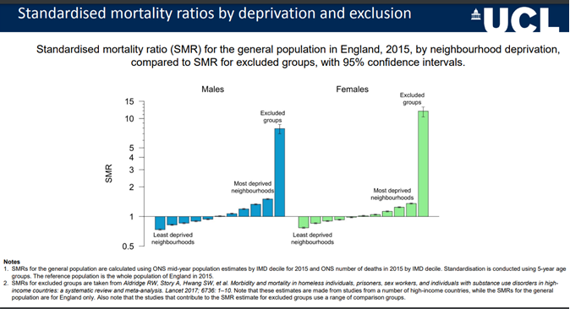
The graph demonstrates that whilst health outcomes across the general population are distributed across a social gradient, excluded groups instead experience a ‘cliff-edge’ effect. The excess mortality rates shown is extreme, displaying that health inequity seen within health inclusion groups greatly exceed populations in the least and most deprived areas.
Health inclusion groups have long experienced markedly worse health outcomes than the general population. What defines and unites inclusion health groups are common experiences of sustained social and economic marginalisation. Poorer health outcomes for these populations are the result of several inter-related factors across the life course, including wider determinants of health, such as income insecurity, unemployment, lack of community support, and poor living conditions.
There are varying levels of data available for each inclusion health group, with large research gaps due to issues with accessibility. However, the available evidence of poor health outcomes is compelling:

- Average age of death for homeless men is 45 and 43 for women (ONS, 2021).
- In 2021, across England and Wales, there were an estimated 741 deaths of people experiencing homelessness, an increase of 7.7% since 2020. The estimated number of deaths among homeless people has increased by 54% since records began in 2013 (ONS, 2021).
- Annual number of people dying whilst under probation services in Wales increased exponentially by 194% between 2018/19 and 2020/21 (PHW 2023). Accidental drug deaths were the leading cause of death.
- Gypsy, Roma and Traveller (GRT) people face life expectancies between 10 and 25 years shorter than the general population. Whilst the health of GRT person in their 60s is comparable to an average White British person in their 80s (Watkinson et al., 2021).
- An international systematic review found that among adult asylum seekers and refugees, the prevalence of PTSD was 31.46% and depression was 31.5%, compared to the general population which is 3.9% for PTSD and 12% for depression.
- Sex workers are at disproportionate risk of poor physical and mental health outcomes, with one study reporting that 68% of street based sex workers interviewed met the criteria for post-traumatic stress disorder – this is in the same range as victims of torture and combat veterans undergoing treatment (Litchfield et al., 2010).

A particular concern of the health inclusion agenda is healthcare access and quality. Health inclusion populations typically experience care characterised by crisis management at multiple disconnected points of episodic intervention. Difficulties accessing appropriate primary care results in heavy use of EU and acute secondary care. The high rate of EU attendance for people experiencing homelessness is well documented. Whilst reported attendance rates vary (Bowen et al., (2019) report as high as 60 times that of the general population) all studies agree a disproportionate and avoidable use of emergency services. Accessing care through this means is also a common theme for other identified health inclusion groups (e.g., sex workers attend 2.5 times the rate of the general population (Jeal and Sailsbury 2004)). These populations are also characterised by poor health expectations and low uptake of primary and preventive services, such as routine general practice, routine dental practice, screening programmes, and immunisations.
It is evident that health inclusion groups current health care provision is not cost-effective or prudent, leading to increased pressure on unscheduled care, increased length of hospital stays and failed discharges, all of which contributes to the widening of health inequalities across the city. The cost and consequences of these crisis presentations are striking. Public Health Wales estimated that, over a 6-month period, EU use by people experiencing homelessness in Wales cost £11 million more in healthcare costs than a general comparator group (PHW, 2021).
To address health inequalities and poorer health outcomes, inclusion health approaches are increasingly being used in higher income countries.
5.2 Understanding the Local Need
a) Demand
The level of baseline data in respect of health inclusion groups is very limited because these patients do not engage well with existing services and when they do, they are not coded correctly within Patient Administration Systems at either GP or hospital level. Therefore, it is difficult to accurately describe or predict the level of demand that exists within health inclusion groups.
However, to better understand the local picture, a series of data review exercises have been undertaken to indicate level of need/demands amongst the 5 health inclusion groups specific to this business case (please see Appendix 2 for additional data):
Review 1:
- UHB Business Intelligence System (BIS) reviewed 349 homeless patients’ EU and secondary activity between 2018-2023.
- 85% had attended EU and were at least 8 times more likely to attend than a general comparator group.
- Over the 5-year period, 19.5% of patients did not wait in EU.
- In 22/23, the cohort made 741 visits to the EU and had 152 inpatient admissions totaling 1965 bed days.
- 22/23 costs: Accident and Emergency £200,178, admitted patient care £1,366,146, outpatient £66,633.

Table 3: NHS Activity for 349 Patients experiencing homelessness.
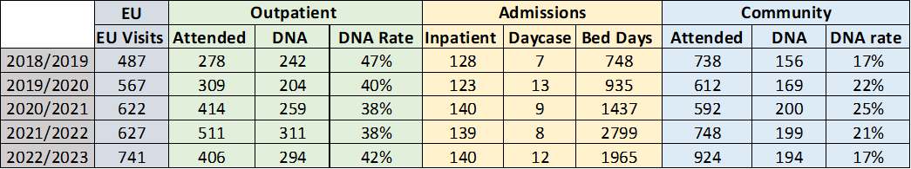

Review 2:
- In-depth review to understand public service costs associated with 25 people experiencing homelessness.
- 92% had one or more reported mental health condition, 100% were engaging in substance use, 72% had physical/chronic illness and 84% had been arrested at least once.
- Costs for temporary accommodation, emergency and secondary care activity, substance misuse support, benefits, mental health support and engagement with the criminal justice system were estimated at approximately £2,446,167 over a two-year period (March 2022-2024). It was estimated that £593,638 of this total was spent on emergency and secondary care.

Review 3:
- A review of Cardiff Council’s Single Person Gateway (SPG) and Young Person Gateway (YPG) revealed that between January 2020 and March 2024 there was a total of 84 individuals closed to the SPG and YPG with the end reason ‘deceased’.
- The average age of death was 45.

Chart 2: Average Age of Death
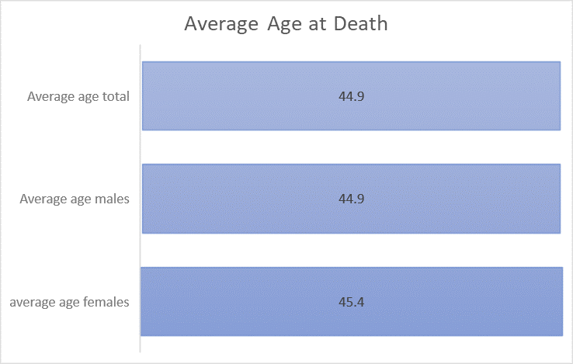

Review 4:
- UHB BIS reviewed 2,221 asylum seekers and 1,234 refugees (Ukrainian and Afghanistan) NHS activity between 2022-2023.
- Transient nature makes it difficult to paint an accurate picture. However, asylum seekers were, at least, 2 times more likely than a general comparator group to attend EU. Refugee EU attendance mirrored the general population.
- Community activity was exclusively mental health, with virtually all this activity linked to asylum seekers.
- 22/23 costs: EU £96,669 and admitted patient care £561,154.

Review 5:
- An analysis of the CAV Health Inclusion Needs Assessment, CAVHIS led surveys and Regional Partnership Board Population Needs Assessment has revealed the health priorities for both health inclusion patients and key stakeholder. The health inclusion Needs Assessment for and the Vale conducted in 2022, estimated that there is a stable population of 5,500-6,700 within the health inclusion groups previously listed. However, this proposal recognises that there is a spectrum of need and variation in individual’s ability to navigate systems of care- not all individuals within these groups will require a specialist service.

Review 6:
- An analysis of data and research, alongside stakeholder engagement, has provided a greater understanding of sub populations who are at the ‘Cliff Edge’ and who would benefit from a more specialist service in Cardiff and the Vale (see table 4 below).

Table 4: Estimate of ‘Cliff Edge’ Population Sizes
Population Type | Population Size  (approx.) | Source/Comment
People experiencing homelessness who are multiply excluded | Up to 1250 | Approximate number of supported accommodation and emergency units within the single person/young person gateway with the majority considered to be high/complex needs with a high turnover.
People leaving prison on short term sentencing (including IOM) | 400 | Current caseload in March 2024, provided by Her Majesties Prison and Probation Service (HMPPS).
People engaged in high-risk sex work | 300 | Figure provided by Street Life (third sector organisation working with sex workers).
People seeking asylum and Refugees | Up to 1,400 | Analysing peaks in demand from CAVHIS data.
Gypsy, Roma, and Travelling (GRT) people | 350 | Current number officially recorded on Council static GRT sites (Rover Way and Shirenewton). Mobile GRT approx. 3-4 unauthorized encampments a year. Scoping work ongoing to further establish need and demand.
ATS | 40 | CAVHIS data.
TOTAL | Approx 3,500

5.3 Current Capacity

CAVHIS is not monitored in line with Referral to Treatment times. There are no specific waiting time standards associated with the caseloads served by CAVHIS as it is a demand led service. Therefore, all staff capacity is used flexibly to meet variations in demand and patient need. The capacity levels outline below represents average activity levels across the various components of the current core model.

Table 5: Current CAVHIS Capacity and Performance within the Core Service Only (i.e. excludes activity associated with temporary initiatives)
 | CAVHIS Baseline Service | Number of available appointments per year | Waiting time (average)
CRI  (Nurses) | Monday-Friday (0830-1700hrs):  - Public Health Screening for Asylum Seekers/Refugees (Adult/Paeds)  - Limited Health Visiting and Midwifery Care | Public Health Screening:  Adult: 1,768  Paediatrics: 832  Midwifery: 312  Health Visitor: 780 | 11 working days for public health screening
CRI  (GP) | Monday-Friday (0830-1700hrs):  - x9 GP clinics for Refugee/Asylum  - x1 GP admin session | 3,952 | 12 working days
ATS | Thursday (1600-1830hrs):  - x1 GP clinic | 416 face-to-face  52 telephone | 5 working days
Homeless GP Outreach | Once a week (9am-1pm):  - x1 GP clinic (Ty Tres/Huggard) | 520 (varies depending on complexities of patient- based on 25 minutes per appointment) | N/A- drop in/same day appointments
Homeless Nurse Outreach | Monday-Friday (0800-1600hrs):  - Homeless nurse drop in clinics in Huggard/Ty Tresilian  Support provided by Homelessness MDT Nurse- Complex needs funded  (Monday-Friday 0800-1600hrs) | Demand led. Average 12 seen per day. | N/A- drop in/same day appointments

For further information on service outcomes, and future outcome measures, please see Appendix 3.

5.4 CAVHIS Caseloads

CAVHIS Overall Caseloads:
- Increased exponentially by 149% from April 2022 (n=462) to January 2024 (n=1027)- attributed to increasing levels of individuals seeking asylum through WG Resettlement Programmes, poverty within the city resulting in homelessness and more challenging patients being de-registered by GP Practices and referred to ATS.

Asylum Seeker/Refugees:
- Varying activity levels linked to people being displaced due to war/conflict and changes in Home Office process (e.g., the recent fast tracking of asylum claims).
- The needs of arrivals are becoming more complex, leading to a rise in onward referrals, longer appointment times, safeguarding issues, and staff pressures (including attending safeguarding meetings etc.).

Alternative Treatment Service:
- Increased by 46% between February 2022 (n=26) and January 2024 (n=38).
- Significant increase in complexity of case management, highlighting limitations of the current service model in terms of both access (i.e. the clinic only operates x 1 week) and the concerns around the safety of the current model.

Homelessness:
- Since April 2022, CAVHIS homelessness caseloads have risen by 96% (from 220 patients to 440).
- 6 month data analysis of 311 CAVHIS homeless patients: 64.6% required an appointment time longer than the average 10 minute slot, 34.4% presented with complaint related to substance misuse and 53.5% required 1 or more services to be contacted (please see figure appendix 4).
- In response to rising homelessness presentations, Cardiff Council has increased emergency accommodation units by 400% since 2020.
- Data gathered from showed the highest number of EU homeless presentations in a period of a week (30th April- 7th May 2023) was 53. However, number will be higher as not all hostels were listed and does not include ‘hidden homelessness’ (e.g., sofa surfing.
- On the 1^{st of} March 2024, the Homelessness MDT had a total of 716 cases open, meaning that 716 homeless individuals were accessing one or more service within the team.
- The average case length for homelessness MDT (in days) has grown by 131.5% since 2020. In addition, 346 individuals were referred more than once to the MDT, demonstrating several ‘revolving door’ cases- linked to complexity of cases, lack of move, time required to build rapport.

5.5 Benchmarking

There is no known comparable service operating in the UK or internationally by which to directly benchmark, however, the following benchmarking exercises and research have been completed:

- Review of a practice located in City and South Cluster of CAVUHB. Activity and workforce analysis showed that practice had a capitation of 3271 (correct as of 1/1/24) with the following workforce: 2 WTE GPs (plus 0.8 WTE locum support), 1 WTE Nurse, 3.7 WTE Admin and 1 WTE Manager. Activity information is provided in Appendix 5.
- ATS: all Health boards in Wales operate different models of service, some are commissioned through a GP practice, and some operate a service from with a Police Station. Irrespective of how the delivery models differ, the provision of only one clinic a week for management of ATS patients is at variance to all other areas in Wales where access is provided on a 5- day basis.
- Pathway Team (UK wide Programme) has provided guidance on the size and composition for an in-reach team. It recommends that areas with 400+ homeless patients a year, the team should include 5-6 WTE staff members. This figure is based on seeing inpatients only and additional capacity is required to cover EU, step-down and teams covering multiple hospital sites. At a minimum, the hospital team needs to include input from a GP, a fulltime Band 7 nurse and housing input. Further information team design recommendations (including information for teams receiving over 300 referrals per year) is provided in Appendix 6.
- Visit to Brighton and Hove’s Faculty for Homeless and Health Inclusion (specialist, homeless multidisciplinary in-reach Pathway team).
- Benchmarking meeting with Glasgow Complex Needs Service-provided guidance on their experience of integrated working.

Further research has shown that:

- Although there are ‘pockets of excellence’, there is no evidence of a sustainable, widespread, integrated service for health inclusion groups, meaning that only aspects of the proposed model are comparable to other services.
- Favourable health outcomes were achieved if models were well integrated with health and social care providers and homelessness sector services.
- Mobile outreach teams with no dedicated GP had less beneficial scores and poorer coordination between services. This led to multiple nurse contacts, but no management of chronic disease, preventative care, or medication reviews.
- Mobile teams are more effective if they operated as part of a general practice, rather than a separate service.
- Mobile teams cover a wide geographical area and maintain contact with people who are unsettled or reluctant to attend a GP practice.
- People’s health needs are closely intertwined with their housing and support needs, and the solutions require the involvement of the NHS, local authorities, and community sector.

5.6 The Proposed Service Model- A Tiered Approach
A three- tiered approach is required to better meet the needs of health inclusion groups within Cardiff and the Vale of Glamorgan (see figure 1). Although this business case is focused on the provision of a specialist service, action is also required at both a primary care and cluster level:
Tier 1 -Universal Primary Care Level- The ability for GPs to provide enhanced levels of service to health inclusion groups needs to be improved and encouraged via the UHB. The level of enhancements required will be dependent on the geographical area, health inclusion population sizes and resources available. Although an enhanced service is available for practices which serve the homeless and asylum seeker populations, they are very limited and do not allow for optimal management of patients with multi-faceted needs. This is a matter for Welsh Government and the Directors of Primary Care who are responsible for contract negotiations.
Tier 2- Intermediate Care, Cluster level-as demonstrated in one cluster within Cardiff and Vale, there is more that can be undertaken at cluster level to improve the support networks for health inclusion groups and assist them in maintaining health and wellbeing in the community – e.g., investment in more third sector capacity to develop community assets, training, and education of staff to better support individuals. The Pan Cluster Planning Groups should encourage clusters to include consideration of Health Inclusion as part of their Integrated Medium Terms Plans.
Tier 3 – Specialist Level Care- the provision of a multi-disciplinary, multi-agency comprehensive, ‘no wrong door’ service, which is targeted at individuals at the cliff edge of inequality and whose needs are so complex that they cannot be met by tier 1 and tier 2 services, either on an intermittent/short term or permanent basis. The development of this element of the model falls to the UHB and associated Local Authorities.
Figure 1: Provision of healthcare at universal Tier 1, intermediate Tier 2, and specialist Inclusion health service Tier 3 service
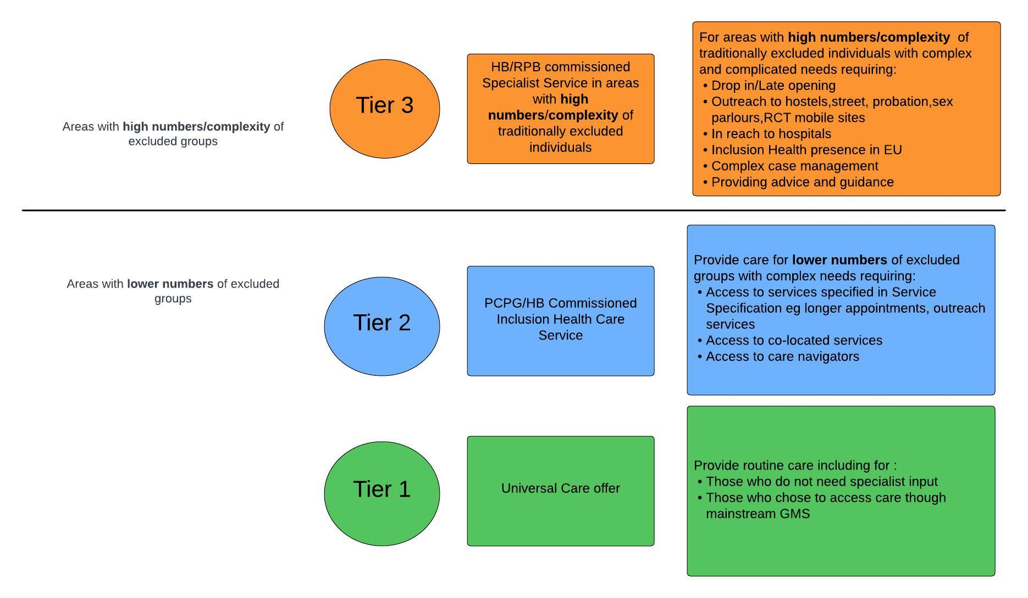
5.7 The Tier 3 Service Model Explained
a) Overview of the Model

The Tier 3 service model is founded on research and benchmarking both nationally and internationally. It has been further informed through initiatives that have been introduced and evaluated by CAVHIS over the past 2 years. An illustration of a proposed Tier 3 service is provided in figure 2 overleaf. In summary, in order to meet the needs of all health inclusion groups at the ‘cliff edge’ of need, CAVHIS needs to be resourced, expanded and re-configured to:

- Provide a ‘one stop/no wrong door service hub’, co-located and integrated with other relevant health, council and third sector organisations- operating extended hours to maximise opportunities for patient access.
- Deliver better and more timely access to a wider range of health care services that span the community, the Emergency Unit and Ward level and offer the potential for improved seamlessness and efficient pathways of care for individuals with highly complex needs
- Provide enhanced levels of public health screening/health protection, at an earlier stage with the aim of reducing levels of acute and chronic ill health, which without treatment, will result in escalating health problems
The above is predicated on continued and enhanced collaboration across the UHB, Cardiff and Vale Councils and the third sector, considering the ability to maximise/remodel existing services wherever possible, utilise the skills and experience of all staff working in the field of health inclusion, ensuring prudency, and considering Value for Health.

Figure 2: Proposed Tier 3 Health Inclusion Service Model for CAV
Referral Pathway Examples:
Self-referral
Home Office
Homeless MDT
Emergency Unit
Third sector
Department of Sexual Health
ENTRY: Tier 3 Eligible Populations:
*Refugees/asylum seekers
*Multiply excluded homeless
*High risk sex workers
*Short term sentenced prison leavers
*Gypsy, Roma Travellers (GRT)
Health/Oral Health needs assessment
Psychological Formulation
Housing/social care needs assessment
Screening
Primary care
EXIT: to GMS Tier 1 or Tier 2 registration and mainstream services once stable and appropriate
Sites to include:
High Need Homeless Hostels (SPG/YPG)
Probation Offices
Camp Sites
Street Medicine
Emergency Units:
UHW
Llandough
Hafan-Y-Coed
(holistic assessment
and discharge planning team)
In-reach Pathway Programme
Outreach
Public and Third Sector:
Local Authority Services (including Housing and Social Care)
DWP
Citizens Advice
Diversionary Activities Team
Third sector support services (e.g., drug and alcohol agencies)
Legal Advice
Health:
GP
Health Visitors
Midwifery
Mental Health Services
Podiatry
Occupational Therapist
Dietetics
Physiotherapists
Dental and Optometry
Pharmacy
TB/ID Services
Community Paediatrics
Substance Use
Hub(s) to co-locate services:

Intermediate Care Beds
Tier 3 Health Inclusion Service Hub(s)
(integrated Health and Social Care Service)
meeting the health needs of health inclusion groups with respect, dignity, and compassion.
A ‘no wrong door’ approach
b) Key Components of the Tier 3 Model
As illustrated in Figure 2, the Tier 3 service is based on a hub and spoke model;
The hub will act as the coordination centre for provision of care for individuals in all 5 health inclusion groups at tier 3 level (see appendix 7). The hub will accommodate an extended MDT and relevant service provided by the UHB, Council and third sector. This co-location will offer the potential to provide improved levels of integrated and responsive patient care and service efficiencies.

Services based in the hub will be expected to interface seamlessly with those elements of service provided on an in-reach and outreach basis. With those staff based in the ‘spokes’ being able to access and coordinate the provision of wrap around and ongoing care via staff and services based on site.

The hub will offer:
- Provision of suitable community- based facility, that will facilitate service expansion and integration with related council and third sector services. The facility will need to deliver the potential for disaggregated management of the individual patient cohorts (i.e. for safety and public acceptability reasons, patient cohorts will require separate entrance/reception facilities). NB: The potential for all services to be accommodated within one facility offers the most opportunities for service integration, critical mass efficiencies and efficient coordination of care. If a one site option proves unachievable, consideration could be given to use of 2 facilities within proximity of each other, however this will have an impact on costs for phase 2.
- Provision of a 5 -day, extended hour service from 0800-1830hrs, Monday to Friday to meet the needs of all health inclusion plus ATS patients (including General Medical Service Registration)
- Access to a wider range of allied health professionals from health, council and third sector, working as a ‘team around the individual)
- Access to wider health services including dental, optometry, and pharmacy services.
- Additional specialist community clinics e.g. infectious diseases
The Spokes of the Model include:

CAVHIS Inreach:

- Specialist health inclusion nurses working in the Emergency Department, 7 days a week, between the hours of 8am and 8pm. These nurses will be responsible for the identification and case management of individuals who require the tier 3 service to assist their timely turnaround after clinical assessment, ensuring proactive follow up to minimise the risk of reattendance.
- A specialist multi-agency team from CAVHIS (GP, Housing Officer, and Nurse) will attend the wards 3 days a week to support with the discharge of complex patients who would benefit from CAVHIS support to reduce the risk of readmission.
- Both of these services will have direct communication and care pathways which integrate with other key service provided by the council and third sector.

CAVHIS Outreach:

- The provision of drop in health clinics run by GP/Nurse at high need hostels (Monday-Friday, excluding bank holidays), with access to EU consultants for specialist opinions/fast track diagnostics, where required.
- Introduction of drop in health clinics run by GP/Nurse at probation sites including Westgate Street and Castle Street (agreed days between Monday-Friday, excluding bank holidays).
- Both of these services will have direct communication and care pathways which integrate with other key service provided by the council and third sector.
- Provision of street- based medicine to those who are unable to attend drop in clinics i.e. entrenched rough sleepers, mobile Gypsy Roma Travellers who have stopped for short periods etc.
- The potential to provide a level service to the Vale population is also included within the proposal.
CAVHIS Intermediate Care Beds
Based on benchmarking undertaken in Brighton, the potential to provide intermediate care beds offers system benefits in terms of diverting admissions/expediting hospital discharge for those individuals with complex needs. In Brighton, 7 beds are commissioned for a population size like Cardiff and the Vale. The average length of stay in 6 weeks. Whilst in the beds, council services operate to support the socio-economic needs of the patient, whilst health care services seek to optimise recovery/treat acute issue and plan for ongoing health care management.

Depending upon the size of estate identified for the hub, there is the potential to commission intermediate care beds as an integrated component of the model and include in phase 2 or alternatively, seek to provide beds from within existing council commissioned residential units.

c) Development of the Tier 3 Model- A Phased Approach
Given the extent of service aspirations outlined above a phased development approach is proposed spanning 2024-2027:

- Phase 1 (24/25): Make permanent and expand the ‘spoke elements’ of the model (In-Reach and Outreach services), which can be delivered within existing accommodation/use of council facilities
- Phase 2 (25/26): Develop the centralised ‘service hub’ in a new facility, which will deliver both enhanced and extended hours of service, through colocation and integration with wider UHB, council and third sector services
- Phase 3 (26/27): Commission intermediate care beds-which potentially could be included as part 2 if suitable accommodation could be identified or alternatively, in a council provided residential facility.
This business case is specifically seeking funding for implementation of phase 1 in 2024/25 and a commitment to prioritise funding to complete service expansion through 2025-2027. Indicative costings associated with phase 2 of the project are provided in section 7.3.

5.8 How the Proposal will Help to Reduce Strategic and Operational Risks
Strategic Risks:
- This proposal supports the UHB and Regional Partnership Board’s aspirations to reduce health inequalities and levels of homelessness in Cardiff and the Vale.
- This proposal supports the principles of delivering more care in the community and closer to home.
- This model is predicated on the principle of prevention and early intervention, with the overall aim of improving health outcomes for the most vulnerable of people living in the region.
- This model supports the principles of multi-agency collaboration, planning and integrated working, bringing benefits in terms of patient experience, improved level of care, service efficiency and financial savings.
- The model supports wider partner strategies i.e., ‘White Paper on Ending Homelessness’ which seeks to ensure that homelessness is rare, brief, and non-reoccurring by providing holistic, targeted prevention to those with complex needs.
Operational Risks:
- This proposal will provide the required levels of staff and service hours to meet core service demands and sustain a consistent level of service, within Cardiff and the Vale of Glamorgan.
- This proposal will provide more specialist community base capacity, thus reducing demands on the CAV247 and the Emergency Unit.
- This proposal will support the timelier discharge of patients from hospital and reduce the risk of readmission.
- There are growing concerns with regards to the safety of staff who work within the service, especially given the volitivity of some patients who attend ATS- attempt to access CAVHIS outside of ATS hours.
- The proposal includes allowance for annual leave and sickness- current allowance does not include.

An outline of actions taken to date to mitigate, where possible, operational, and strategic risks is outlined in Appendix 8.

Option Appraisal

In relation to Phase 1 of the proposed CAVHIS expansion, 3 options have been identified:

Option 1: Do nothing: The level of health inequalities across Cardiff and the Vale is stark and unacceptable. It is clear from the evidence, that patients with multiple needs cannot utilise traditional model of care within the community and as a result, they have poorer health outcomes and an escalated use of secondary care services. Deciding to ‘do nothing’ would not only halt the progress made by CAVHIS to work toward redressing this imbalance but would necessitate the withdrawal of those services, which were originally funded via temporary funding/slippage and have proven beneficial in terms of improving patient outcomes and reducing demands on secondary care services. CAVHIS is struggling to respond to the demands being placed on it. Given the precarious and escalating situation in Russia and Ukraine and in the Middle East, it would be remiss of the UHB to ignore the fact that Cardiff as the Capital City of Wales, will continue to be called upon to respond to humanitarian crises going forward.

Whilst the service continues to work hard to address health inequalities and respond to the fluctuating demands that are placed on it, the reality is that the current provision is cannot work to its optimum within current resources.

Option 2: Implement CAVHIS Outreach or CAVHIS In-reach Spoke Only

Although it would be feasible to implement one or other of the service ‘spokes’, the benefit realisation associated with the delivery of seamless service model spanning the community and hospital will be limited. There will be limits in terms of being able to safely manage individuals in the community and without direct access to the care pathways proposed as part of the phase 1 development.

Option 3: Implement Both CAVHIS Outreach and In-Reach

This option proposes investment in both the outreach and in-reach elements of phase 1, which will mitigate the limitations outlined in option 2 and:

- Take essential services ‘to the individual’ rather than rely on them to attend a service/stay for a protracted period awaiting treatment, which is often an unreliable expectation amongst health inclusion groups.
- Deliver right care, at the right time, in the right place via specialists in the field of health inclusion.
- Increase targeted, preventative care the community and divert individuals away from hospital services where clinically appropriate.
- Make more efficient use of resource, through coordination of care between the community and hospital.
- Support timely turnaround/discharge through provision of alternative coordinated MDT care at a community level over 7 days.
- Maximise benefits realisation (see section 7.1.1).

The Preferred option

The preferred option is to implement Option 3 and invest funding to make permanent and expand those services associated with both the CAVHIS Outreach and In-Reach Components.

- Impact on Other Services

In developing this service model, efforts have been made to engage with all relevent services (UHB, Council and third sector) to a) assess what they may be able to offer into the model and b) to ientify any risks on unintended impact/consequences. These discussions have proved beneficial in terms of identify areas of duplication, opportunities for shared use of staff resources, opportunities for streamling and potential opportunities in terms of other sources of potentail funding (e.g. Health Protection Funding, Area Planning Board funding and other grant opportunities). No significant impacts/risks to deliver have been identified to date.

- Dependencies: Partnership Working

Clearly, CAVHIS could not have expanded to its current level without close alignment and shared opportunities provided and encouraged by Cardiff Council. The delivery of phase 1 is totally reliant on the continued close working relationship between the council’s Homelessness, Housing and Social care teams as well as seamless working between CAVHIS and other relevent health provided services e.g. Infectious Diseases, Community Addictions and Mental Health Services.

- Dependencies: Commitment to full Tier 3 Model
Although this business case is seeking funding for phase 1 service expansion only, it is important to advise at this early stage, that the full potential of the model can be only be optimised through investment in the provision of the CAVHIS Hub, primarily because not all services required by health inclusion groups can be provided via an in-reach/outreach model from the perspective of both coordination and delivery of care but also on the basis of cost effectiveness.
The ability to develop a CAVHIS Hub, will depend upon the provision of alternative accommodation as well as further revenue investment and discussions are ongoing with Cardiff Council and associated third sector organisations to identify potential opportunities for collaboration and joint investment.
The service is aware of the need to develop a further business case by which to progress to phase 2 in 2025/26.

Benefits

- Additional Clinical Capacity/Outcomes to be Delivered

Details of the proposed staffing model are provide in section 7.3. Investment in Phase 1 will provide a range of additional clinical capacity to that which is currently provided through existing budget as detailed in table 6 below.

NB: It is recognised that performance metrics will need to be developed for some elements of service which are completely new to the model. Work is already underway to develop PARIS/Council systems to be able to better report/monitor activity.

Table 6: Phase 1 additional capacity provided and Outcomes.

 | Phase 1 Investment | Additional Capacity/Activity/Annum
CRI | Monday-Friday (0830-1700hrs):  - Additional Health Visiting and Midwifery Care  - High Intensity Therapist  - Adult Social Worker (potential joint post with Cardiff Council). | Midwifery: 780 contacts  Health Visitor: 1560 contacts  Will be developed to include number of patient contacts, outcomes, length of intervention etc..
CRI | Once a fortnight:  - x1 clinic Adult ID  - x1 clinic Paeds ID  - Support from Pharmacy | 120 Adult ID clinic appointments  Will include core Health Protection Measures eg Hep C levels with patient cohort
Outreach | Monday-Friday (between 0900-1300hrs) GP/Health inclusion nurse clinics:  - x5 GP clinics in high need Hostels (Ty Gobiath, Ty Ephraim, Adams Court, Single Assessment Centre, Northlands)  - x3 GP clinics in Westgate Street (Probation).  - x1 GP clinic in Castle Street (Safer Wales- Women’s Services including Probation and Street Life)  - x1 GP clinic in Nelsons Trust Office (Women’s Probation Centre)  Flexibility to for GP/Nurse outreach to mobile campsites/static caravan sites/parlours/street medicine. | 5,200 patient contacts  Will, where possible, include PROMS and PREM measures  Will include performance against key Health Protection Measures  Will include numbers of Individuals diverted away from Hospital Assessment
In-reach | 7 days a week (0800-2000hrs):  - Health inclusion nurse based in EU.  3 days a week to attend hospital wards:  - 3 GP sessions  - Housing Officer (Council Funded)  - Health inclusion nurse | Based on reported number of EU attendances, potential input into 50-60 cases per week who attend the EU  Based on benchmarking, potential to support with 400+ cases per year
Dentistry | 3 days a week (0845-1700hrs)  - Dedicated service utilising existing facility (Butetown Dentist Practice and Mobile Dental Van). | 1,872

- Additional Benefits Associated with Phase 1:

Following a benefits mapping exerecise, involving members of the UHB, Council, third sector and individauls with lived expereince, the following additional quantitative and qualitative benefits have been identified:

Quantifiable benefits | Non-quantifiable benefits
Staff recruitment, retention, and wellbeing:  - Skill development- number of courses attended.  - Applications into health inclusion- a new and unique field of healthcare.  - Inclusivity of workforce.  - Vacancy and sickness rates amongst staff.  - Staff complaints/concerns.  - Staff safeguarding incidents.  Cost releasing benefits:  - Potential for reduction in the numbers of unnecessary EU attendances/reattendances.  - Potential for reduction in admissions/readmissions (including bed days).  - Potential for a reduction in the self-discharge rate (linked to reattendance/readmission).  - Increased engagement with primary care health services.  Patient Experience:  - Patient reported satisfaction.  - Engagement rates (number attending clinics).  - Compliments/concerns.  - Personalised care planning.  Patient Outcomes:  - Uptake on national screening programmes.  - Access to primary care.  Partnership Working:  - Pathways between primary and secondary care.  - Joint funding/posts.  - Health Inclusion Programme Board attendance.  - Shared systems and data sharing agreements.  Data:  - Baselines to monitor performance.  - Evaluation and performance measures.  - Utilisation of data to inform service development.  - Data quality and availability.  Wider Partner Benefits:  - Temporary accommodation tenancy abandonments/evictions.  - Revolving door homelessness cases.  - Number rough sleeping. | Patient experience:  - Building of rapport and trust.  Health Inclusion Awareness:  - Raising awareness of the health inclusion, by highlighting the magnitude and consequences of extreme inequity.  - Reduce stigmatization.  - Improved understanding of the relationship between socio-economic deprivation, poverty, and social injustice.  Staff recruitment, retention, and wellbeing:  - Foster positive cultural change.  - Improved understanding of risk factors.  - Ability to embrace change and move away from outdated processes.  - Reputation as an exemplar for health inclusion.  Future Service Development:  - Impact on future policy and practice.  - Promote a whole of society approach to addressing health inequities and reversal of exclusionary processes.  - Encourage other areas to take action to improve outcome for health inclusion groups.  - Modernise ways of working through new approaches to delivery of care.

7.1.1 Benefits tracker

It is difficult to obtain a comprehensive picture of health inclusion groups due to lack of visibility of these groups within standardised datasets, making it complex to provide baseline data, targets, and timelines. However, a key benefit of this development is to provide more granular, routine information and data on these identified cohorts.

Benefits outlined below utilise data reviews outlined in section 5.2. Another baseline cohort which will be used is EU frequent attendees- work is ongoing to establish health inclusion cohorts within this group and to understand their NHS activity.

PHASE 1: BENEFITS TRACKER
Benefit Type | Benefit | Metric- how measuring | Baseline | Target | Timeline / Ambition
Improve patient access. | Increase access and engagement for Tier 3 populations via outreach. | % of individuals engaging with CAVHIS via outreach pre and post phase 1 implementation. Patient feedback to monitor experience of accessing healthcare. | Current caseload figures for homeless population supported via outreach e.g., January 2024- 430 (includes patients supported via temporary extensions) | 50% increase in current caseload figures. | Increase caseload figures by the end of March 2025.
Improve patient access. | Increased access to midwifery and health visiting | % of individuals seen pre and post phase 1 implementation. | Midwifery: 312  Health Visitor: 780 | 50% increase in current caseload figures. | Increase caseload figures by the end of March 2025.
Improve prevention. | Increased uptake on screening programmes and appropriate aftercare for positive cases. | % of individuals screened for BBV and proportion positive.  % of individuals screened for STI and proportion positive.  % of individuals screened for Latent and Active TB and proportion positive. | Working with PHW to understand if baseline data can be extracted from Harm Reduction Database. | 50% increase in screening uptake for individuals open to CAVHIS. | Increased number of screening tests conducted by December 2025.
Improve prevention. Better Patient Outcomes. | In conjunction with partner organisations, contribute to reducing the gap in life expectancy and health life expectancy in Cardiff and the Vale | Public Health Needs Assessment  ONS data  PHW information  Data re deaths rates amongst the homeless /per annum | As detailed in business case | Sustained reduction in number of deaths amongst the homeless/per annum from baseline 2023/24  Demonstrable increase in average life expectancy and health life expectancy amongst cohorts served by expanded CAVHIS | Likely to be 10 years based on availability of data sources, unless interim Health Needs Assessment is commissioned at an earlier point in time
Improve prevention. | Reduction in preventable EU attendances and reattendances. | % of EU attendances pre and post in-reach team.  % of EU reattendances pre and post in-reach team.  % of DNW pre and post in-reach team. | EU Attendances: 741  EU Reattendance with 7 days: 29%  DNW: 19.5%  Data based on 349 homeless patients in 22/23. | Reduction rates vary depending on in-reach research studies, e.g., between a 11-37% reduction on attendance | To reduce unnecessary pressure on EU and provide more cost-effective care by December 2025.
Improve prevention.  Better Patient Outcomes. | Reduction in the unplanned admissions and readmissions and total bed  days. | % of admissions pre and post in-reach team.  % of readmissions pre and post in-reach team.  Number of bed days. | Inpatient admissions: 152  Readmission within 30 days: 15.8%  Bed days: 1965  Data based on 349 homeless patients in 22/23. | Reduction rates vary depending on in-reach research studies examples included:  *66% reduction in admissions  *62% reduction in re-admissions within 28 days  *11% reduction in bed days | To reduce unnecessary pressure on UHW and provide more cost-effective care by December 2025.
Better patient outcomes. | Safer, and more effective discharges from hospital for homeless patients. | % of inpatients receiving a holistic assessment.  % of patients sleeping rough or sofa surfing on discharge from hospital.  % of patients assisted to register with GP to access on discharge.  Patient feedback to understand experience of in-reach pathway. | No in-reach team in EU- baselines are therefore unavailable. | Examples of outcomes from in-reach teams:  85% of inpatients receive a holistic assessment.  100% of consenting homeless patients seen are assessed by the LA.  85% of patients who do not have a GP are assisted to registered with a GP. | To reduced barriers to effective hospital discharges, thereby reducing delayed discharges.
Improve Workforce. | Motivated and Sustainable workforce that have access to training and development. | % of sickness absence rate of staff.  Turnover rate for registered staff.  % of staff who have had personal appraisal and development reviews. | CAVHIS sickness rate 8% | Turnover rate under 10%  Value based appraisals between 75-78%  Sickness less than 6% | To achieve the UHB key milestone by 2027.

Risks: Risk Assessed as Scored 12 and Above

Risk Title | Descriptor | Probability (1-5) | Impact  (1-5) | Total risk score (PxI) | Mitigating Action | Owner
Adressing Health Inequalities | The level of inequalities in heath within Cardiff and the Vale in unaccepatble and without advances in services specific to health inclusion groups, this problem will not be redressed. | 5 | 5 | 25 | Continued investment on a phased basis in specialist services for health inclusion groups to eventually deliver a tier 3 service | UHB
Funding | If funding is not agreeed for phase 1 service development, a number of initiatives that have been triallled by CAVHIS over the past 2 yearrs in support of improving health outcomes, reducing hospital admissions and ensuring timely turnaround of patients from the EU will have to be withdrwan. | 5 | 5 | 25 | To continue to work with partners to provide evidence of need and performance on fixed term funded roles where necessary. Continue to meet with partners regularly to understand any future risks attached to posts and action plan accordingly.  Submit investment cases to secure permanent funding | UHB
Funding | The core CAVHIS budget (nor this business case) includes any additionality to deal with surges in activity assoicated with National Resettlement Programmes | 4 | 4 | 16 | PCIC Clinical Board will need to identify measures/routes by which to deal with such situations | PCIC Clinical Board
Workforce | This business case also includes some additional infrastructure costs associated with maintenance of CAVHIS staff safety in CRI ie Security staff and CCTV | 5 | 4 | 20 | Reporting and escalation of key risks via appropriate channels, offer wellbeing support, involvement of case management team, additional security, risk assessments and regular reporting to staff. | Capital and Estates/PCIC CB

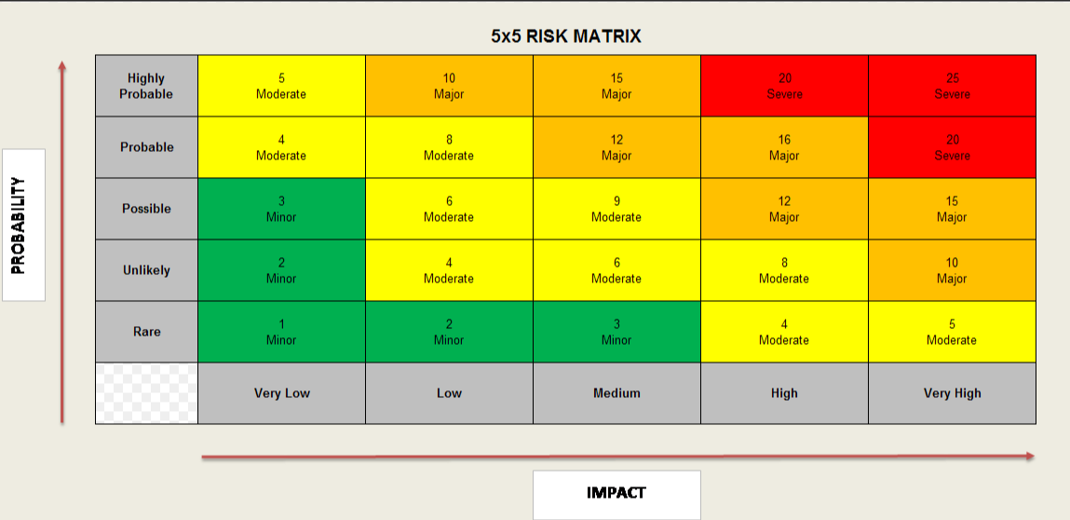

7.3 Total Cost - Resource Implications and Affordability

Phase 1 : Additional Investment Required to Deliver Phase 1

These costs are based on the recruitment plan as described in Appendix 10- noting that a number of staff are already in post as part of continuation of previous temporary schemes and some posts will be new.

Type | Cost Year 1- part costs 24/25 | Cost Year 2  25/26 | Cost Year 3  26/27
Recurrent: Revenue Direct Pay Staff Costs | £745,009 | £1,187,566 | £1,187,566
Recurrent: Revenue Direct Non Pay | £186,534 | £239,111 | £239,211
Non Recurrent: Revenue Direct Non Pay | £15,000 | £0 | £0
Non Recurrent: Capital | £50,000 | £0 | £0
Winter funding | -£100,000 | TBC | TBC
Total Required | £896,543 | £1,426,777 | £1,426,777

Assumed start date | Full Phase 1 implementation: October 2024
Funding Source Revenue: | Health Board Core Funds
Funding Source Capital:

NB: The phase 1 investment outlined above, does not consider costs associated with phase 2 (i.e. the development of a new CAVHIS hub/intermediate care beds). Further investment will be required. Indicative revenue costs for phase 2 are circa £1m, however there may be opportunities for cost efficiencies based on the level of integration that can be achieved with Cardiff Council. A second business case will be submitted.

Annex a: Workforce implications

Revenue: Direct Pay Staff Costs

NB:
- It should be noted that some of the above resource has been supported via Winter funding. This funding is assumed and netted down in the financial assessment.
- Where required, TOS costed roles include out of hours enhancements.
- The above additional WTE reflects leave and sickness cover for key clinical roles to ensure service sustainability (current baseline establishment has never included any recognition of leave).

Annex b: Non-pay, support service, infrastructure

Revenue: Direct Non Pay Costs

Please see appendix 10 for Recruitment Plan and Cost Projection Year 1 23/24.

Annex c: Capital requirements

.

Capital Costs

Annex d: IG submission deadlines

IG meets on the first Wednesday of every month. In order for cases to be considered at a meeting they must be with the secretariat in Strategy and Planning by close of play two weeks beforehand.

For 2023 this means:

Business Case Submission Deadline | Circulation of Papers to Investment Group | Date of Investment Group Meeting
18 January 2023 | 25 January 2023 | 1 February 2023
15 February 2023 | 22 February 2023 | 1 March 2023
4 April 2023 | 11 April 2023 | 18 April 2023
26 April 2023 | 3 May 2023 | 10 May 2023
24 May 2023 | 31 May 2023 | 7 June 2023
21 June 2023 | 28 June 2023 | 5 July 2023
19 July 2023 | 26 July 2023 | 2 August 2023
23 August 2023 | 30 August 2023 | 6 September 2023
20 September 2023 | 27 September 2023 | 4 October 2023
18 October 2023 | 25 October 2023 | 1 November 2023
21 November 2023 | 28 November 2023 | 5 December 2023

There is no flexibility without the express permission of the Director of Finance

For 2024 this means:

Business Case Submission Deadline | Circulation of Papers to Investment Group | Date of Investment Group Meeting
14 December 2023 | 3 January 2024 | 10 January 2024
24 January 2024 | 31 January 2024 | 07 February 2024
21 February 2024 | 28 February 2024 | 06 March 2024
20 March 2024 | 27 March 2024 | 03 April 2024
17 April 2024 | 24 April 2024 | 01 May 2024
22 May 2024 | 29 May 2024 | 05 June 2024
19 June 2024 | 26 June 2024 | 03 July 2024
24 July 2024 | 31 July 2024 | 07 August 2024
21 August 2024 | 28 August 2024 | 04 September 2024
18 September 2024 | 25 September 2024 | 02 October 2024
23 October 2024 | 30 October 2024 | 06 November 2024
20 November 2024 | 27 November 2024 | 04 December 2024

Appendices

Appendix 1: Health Inclusion Expansion Strategic Fit

Appendix 2: Understanding the Local Need

Review 1: 349 patients experiencing homelessness.

Table 7: EU Outcome Average
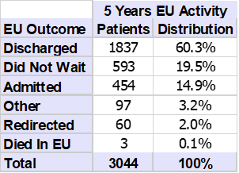

Table 8: All Inpatient Admissions (Inpatient and Day case)

Table 9: Readmissions with 30 days of discharge
Row Labels | Readmissions within 30 Days | Total Admissions | % Readmissions
2018/19 | 17 | 135 | 12.6%
2019/20 | 21 | 136 | 15.4%
2020/21 | 22 | 149 | 14.8%
2021/22 | 25 | 147 | 17.0%
2022/23 | 24 | 152 | 15.8%
Grand Total | 109 | 719 | 15.2%

Table 10: Reattendances within 7 days of discharge
Year | Reattendances within 7 Days | Total Attendances | % Reattendances
2018/19 | 120 | 487 | 24.6%
2019/20 | 140 | 567 | 24.7%
2020/21 | 139 | 622 | 22.3%
2021/22 | 144 | 627 | 23.0%
2022/23 | 215 | 741 | 29.0%
Grand Total | 758 | 3044 | 24.9%

Review 2: 25 people experiencing homelessness

Table 11: Estimated public service costs attributed to 25 people experiencing homelessness.
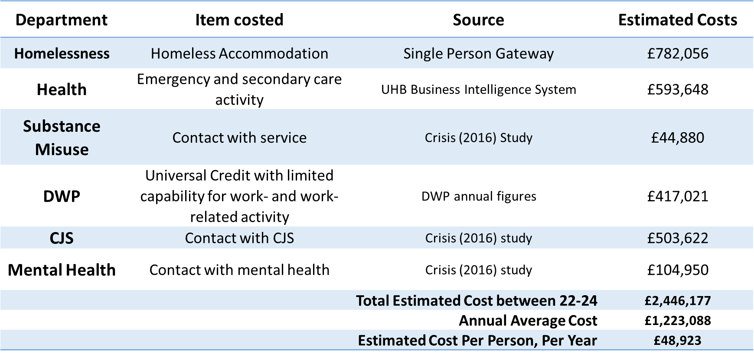

Breakdown of Health Costs:
Table 12: NHS Activity Cost for 25 individuals experiencing homelessness in Cardiff 22-23
 | EU | Community Services | Day cases | Inpatients | Outpatients | Total
22/23 Activity | 72 |  |  | 34 | 18 | 124
22/23 Average Cost Per Attendance | £272.86 |  |  | £3,458.56 | £303.34
22/23 Cost | £19,646 | £19,977 | £3,309 | £117,591 | £5,460 | £165,983

Table 13: NHS Activity cost for 25 individual experiencing homelessness in Cardiff 23-24.
 | EU | Community Services | Day cases | Inpatients | Outpatients | Total
23/24 Activity  April-Dec 2023 | 192 | Unknown | Unknown | 70 | 29 | 291
23/24 Estimated Cost  April-Dec 2023 | £52,388 |  |  | £242,099 | £8,797 | £303,284
23/24 Estimated Full  Year Cost | £69,851 | £19,977* | £3,309* | £322,799 | £11,729.07 | £427,665

Review 3: Homelessness Deaths
Chart 7: Reported SPG and YPG Deaths by Qtr 2020-2024
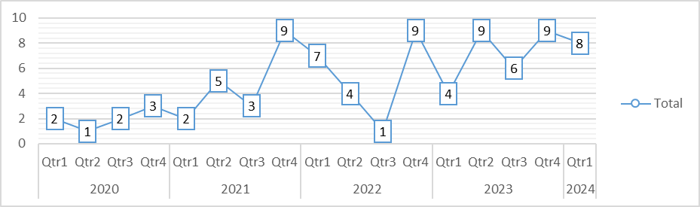

Review 4: 2,221 Asylum Seeker and 1,234 Refugees patients.

Chart 8: EU attendances broken down into Refugees (Afghan/Ukrainians) and Asylum Seekers (RH)

Review 5: Health Priorities

Table 14: Summary the health priorities of surveys and interviews from health excluded populations and relevant professional stakeholders.
Priority Area | Health Inclusion Population Priorities | Professional Stakeholder Priorities
Health Needs | Mental health (specifically severe mental health disorders and traumatic stress)  Dental health  Management of chronic conditions | Mental health (specifically  severe mental health disorders,  traumatic stress, suicide, and  substance/alcohol misuse)  Dental health  Reproductive/maternal health  STIs, BBV and TB
Health Barriers | Stigma and Discrimination  Access without fixed address  Healthcare system complexity  Lack of continuity of care  Long waiting times  Inconvenient opening hours  Primary care access | Stigma and Discrimination  Lack of trauma awareness  Street lifestyles  Poor service location  Low health education/expectations  Literacy/language barriers  Fragmentation of services  Referral difficulties/waits  Fixed, normal opening hours
Health Facilitators | Walk-in appointments  Flexible opening hours  Case management and advocacy  Staff friendliness  Continuity of care | Walk-in appointments  Flexible opening hours  Case management and advocacy  GP outreach  Co-location of services  Opportunistic testing and treatment provision

Appendix 3: Future Service Performance

As part of the development, CAVHIS is working closely with partners (e.g., Cardiff Council, Pathways etc.) to develop a quality framework to measure future service performance. This will ensure there is a clear approach to measuring value, quality, safety, patient, and staff experience across the model. The framework will incorporate a mixed method service evaluation, including Patient Reported Outcome Measures (PROMs), Patient Reported Experience Measures (PREMs) and Clinical Reported Outcome Measures (CROMs) and staff feedback. Joint reporting processes will be required and regularly reviewed to inform decisions, agree further actions, become data driven and incorporate the principles of co-production.

CROMs will include the number of avoided EU presentations/admissions and the cost saving attached. The 6-month data analysis of 311 homeless patients seen by the GP provides an indication of current performance. Figure 5 shows that the GP contact prevented (or potentially prevented) 65.8% individuals from using unscheduled care/EU. Using the average cost of an EU presentation, this would have saved £27,766.70 (n=106) and potentially saved £19,122.35 (n=73).

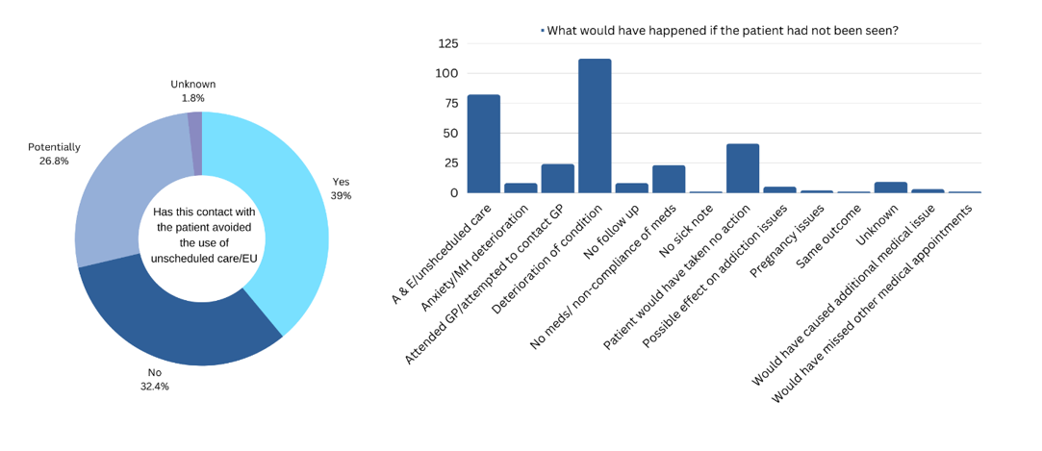
Figure 3: GP Homelessess Appointment Outcome

Appendix 4: Service Demand

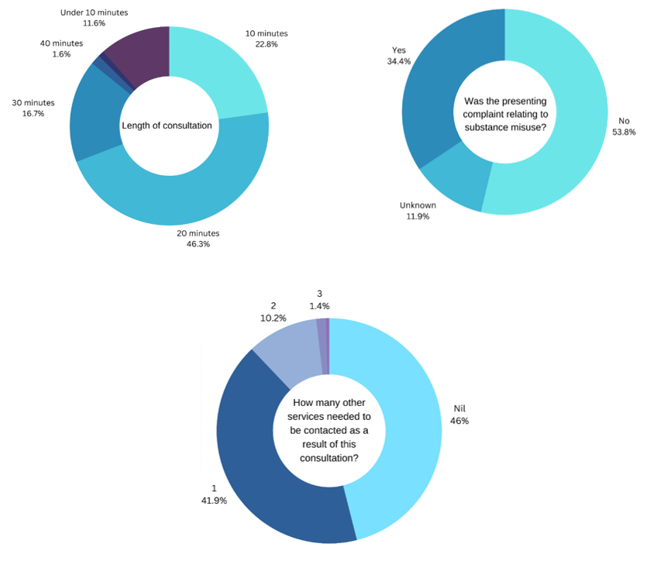
Figure 4: Homeless GP appointment information

Appendix 5: Benchmarking (Activity Data for January and February for a Practice in Cardiff and Vale)

Appendix 6: Benchmarking (Pathway Guidance (in-reach))

Table 15: Pathway In-reach Team Size Guidance
Homeless patients per year | Recommended staff numbers
200 to 300 | 3-4 FTE
300 to 400 | 4-5 FTE
400+ | 5-6 FTE
N.B. These estimates are based on seeing inpatients only. Extra capacity is needed to cover A&E patients, step down, teams covering multiple hospital sites, and where teams are providing extra community follow up. Staff numbers may need to be doubled or even trebled to cover these operational areas.

Team Design:
At a minimum, a Pathway hospital team needs to include:
- Input from a GP with experience of, or training in, homeless and/or inclusion health
- A full time Band 7 nurse or equivalent (for example, an occupational therapist or social worker)
- A housing sector specialist with advocacy capacity and ability to follow up with the most high-risk patients.
Outside of the core Pathway team defined above, and depending on workload:
- Ideally there should be 4 – 6 sessions GP input per week
- Pathway Occupational Therapists should have significant experience of cognitive assessments, functional assessments, and ideally experience in mental health.
- Pathway Social workers should be experts in Ordinary Residence disputes, Care Act, Domestic Violence, Safeguarding, Learning Disabilities, and Deprivation of Liberty Safeguards (DOLS)
- A peer support element can add significant value – befriending and supporting patients on the wards can reduce self-discharge and improve hospital systems and culture by engaging ward staff regularly.
- Where teams are receiving around over 300 referrals per year, it is recommended that service leads consider adding additional capacity to the team. For example:
  - A full time Band 8a service lead
  - Band 6 roles can be added (nurse, OT, social worker)
  - Additional staff with mental health experience
  - Additional housing workers
  - Pathway Care Navigators (people with lived experience of homelessness)
  - Admin support
  - Volunteers and capacity to manage them

Appendix 7: Tier 3 Eligible Populations
Tier 3 eligible populations will include:
- People experiencing homelessness who are multiply excluded and in the Cardiff Council’s Single Person/Young Person’s gateway:
Multiple Exclusion Homelessness (MEH) is defined as homeless and experiencing one or more of the following domains of deep social exclusion:
- Institutional care (prison, local authority)
- Substance misuse
- Street culture activities (street drinking, begging, survival shoplifting or sex work)

- People leaving prison on short term sentencing (including the Integrated Offender Management Cohort):
- Individuals who go through a regular cycle of admission and discharge from secure estates with rapidly changing accommodation.
- Individuals leaving prison into homelessness/front line hostels.
- Individuals leaving prison who are known to the Homeless MDT (adult and young person), Single Persons Gateway and Young Person Gateway.

- People engaged in high-risk sex work:
- Those engaged in street-based sex work.
- Those working in sex parlours with unclear immigration status and fear of authorities/Home Office.
- Sex workers experiencing homelessness.
- Sex workers with substance misuse problems.

- People seeking asylum and Refugees:
Initial public health and health screening to be offered to all people seeking asylum and refugees. However, Tier 3 asylum Seekers and refugees will include:
- Individuals seeking asylum who are under section 98 of the Immigration and Asylum Act 1999
- Individuals seeking asylum who are under section 95 of the Immigration and Asylum Act 1999 but who are not stable enough or too vulnerable to be able to navigate traditional GMS, e.g., those with active infectious disease who DNA, present a risk to themselves and a public health risk, deteriorating mental health linked to asylum system and need co-located third sector support, active safeguarding problems involving linking in with multiple external partners.
- Destitute asylum seekers
- Homeless refugees
- Individuals with ‘No recourse to public funds’

- Gypsy, Roma, and Travelling people:
- Those will mobile lifestyles who camp for short periods of time before moving on.
- Those who live in static accommodation (please note, scoping work is ongoing with this population to further establish health needs).

Appendix 8: Service Improvement and Joint Working
The following actions have been completed to, where possible, improve efficiency, partnership working and manage increasing demand to the health inclusion service:

Table 16: Service Improvement Actions
Action | Outcome
Improved partnership working with Homelessness MDT:  *Absorption of previously isolated homelessness MDT nurse  *Securing of x1 GP outreach clinic  *Pilot of x4 temporary GP outreach clinic | Provides better governance and allows for limited outreach primary care to high needs hostels.
Whole system review undertaken, which included engagement with key stakeholders and patients. | Developed a new hub and spoke model which meets UHB’s strategic priorities.
Extended the hours for ATS provision. | Decreased wait times for ATS from 2 weeks to 1 week. However, extending ATS provision as reduced the asylum seeker and refugee service provision and is therefore an unsustainable long-term solution.
Safer, more robust panel has been developed for ATS. | Ensures appropriate individuals are being accepted onto service. This has resulted in a decrease of inappropriate referrals being accepted onto scheme.
Developed the model of care for asylum seekers and refugees | Support now includes evidenced based screening, colocation of infectious disease clinics and appointment of third sector support.
Additional clinical room has been built within CAVHIS. | Additional space clinic space, yet this still does not provide enough clinical or administrative space to conduct a full service.
Purchased a van and remodelled to include medical equipment. | Support future outreach opportunities.
Identified training needs to up-skill Band 6 Nurses. | Allow make best use of resource by allowing for rotation across the services ensuring coverage.
Utilised existing resource to pilot a health inclusion nurse presence in the EU. | Understand demand and being to support safe turnaround in EU.
Developed a Programme Operational Group (POG) and Health Inclusion Programme Board. | Engages key stakeholders to provide strategic and service accountability.
Commissioned Pathways to support the development of the homelessness in-reach | Development of the in-reach aspect of the model is based on best practice.

Appendix 9: Examples of Tier 3 Model Benefits (Full Model)
Benefit Type | Benefit | Metric- how measuring | Baseline | Target | Timeline / Ambition
Better patient outcomes. | Reduce pressure on traditional primary care services (Tier 1) unable to the meet the need of Tier 3 individuals. | % of Tier 3 individuals registered at Tier 1 pre and post full model implementation. | Current CAVHIS figures suggest approx.2,500 Tier 3 patients are registered with Tier 1. | 100% of Tier 3 patients in Cardiff registered with the Tier 3 service. | Dependent on funding.
Better patient outcomes | Reduce preventable, premature deaths. | % of the number in preventable, premature deaths in Tier 3 populations. | Homeless average age of death: 45 years. | To reduce preventable, premature deaths. | Dependent on funding.
Improve prevention. | Improve identification, and reduce late presentations, of the five conditions driving premature mortality and morbidity. | % of cancer, cardiovascular, musculoskeletal, neurological, and mental disorders identified and referred for appropriate treatment. | Working ongoing to establish baseline figure. | Decrease relative rates of morbidity and mortality. | Dependent on funding.
Ending homelessness (wider partner benefits) | Reduction in revolving door homelessness, ensuring that people do not experience multiple episodes of homelessness. | % of people who receive a relief duty (S.73 or S.75) who alter submit a further homeless application. | Work ongoing to establish baseline figure. | Reduction in the number of people representing to the Council as homeless. | Dependent on funding.
Ending Homelessness | Reduction in street homelessness. | Number people street homeless in a month.  Number of new people street homeless in a month | March 2024: 22 people sleeping rough.  March 2024: 11 first case of rough sleeping. | Reduction in the number of people sleeping rough. | Dependent on funding

Appendix 10: Recruitment Plan and Cost Projection Year 1 23/24

