Cardiff and Vale University Health Board Business Case
For revenue investment proposals greater than £75,000
All business cases must be submitted in line with the timescales outlined in Annex d

Title | Implementation of a new Acute Stroke Clinical Model at UHW
Clinical /Service Board or Department | Medicine Clinical Board

Expected funding source (highlight/delete as appropriate) | UHB core funding
Where a business case is in regards to external funding sources this template must be used unless the source of funding requires their own template to be used.
Approval and scrutiny route

Has this case been signed off by the Clinical Board / Corporate Departments senior team? | 16.2.24  Alun Tomkinson, Clinical Board Director  Jane Murphy, Director of Nursing  Mike Bond / Hannah Mastafa, Director of Operations
Has this case been signed off by the Clinical Board / Corporate Departments finance and workforce business partners? | 16.2.24  Gareth Jenkins, Finance representative  Donna Davies, Workforce and OD
Clinical Boards: Has the COOs office signed off this document?  Corporate Departments: Has the relevant Executive sponsor signed off this document? | Please add name and signature of either  COO  Executive sponsor

Contents
1. Executive Summary 1
2. Introduction and Background 3
3. Strategic Context – Alignment to UHB strategic direction 5
4. Summary current service provision and case for change 8
5. Case of change - The evidence 22
6. Option Appraisal 24
7. The Preferred option 27
7.1 Benefits 29
7.1.1 Benefits tracker 30
7.2 Risk Error! Bookmark not defined.
7.3 Total Cost - Resource Implications and Affordability 5
Annex a: Workforce implications 1
Annex b: Non-pay, support service, infrastructure 6
Annex c: Capital requirements 7

Executive Summary

This business case, to the value of £1,385,852 sets out the resource requirements to right size the stroke service in order to deliver the optimal clinical model for acute stroke and Transient Ischaemic Attack (TIA) at the University Hospital of Wales (UHW).

Over the last 18 months, the stroke service has applied a sustained and focused improvement programme, which has included trialling elements of different working models and interventions for improving patient flow and the clinical pathway. The intended improvements have been somewhat realised with progressive change in performance indicators for stroke; the service was recently awarded a ‘A’ grade on the Sentinel Stroke National Audit Programme (SSNAP).

Despite these improvements, consistent delivery of the optimal stroke pathway remains vulnerable due to workforce constraints and large variability in the service across the week, and our outcomes from stroke are relatively poor. 30-day mortality from stroke at CAVUHB was 13.3% for the 12-month period to November 2023 (NHS Executive data). More than one third of patients with stroke at CAVUHB leave hospital with a dependency level requiring long term health and social care, many of these after a long period of recovery and rehabilitation in hospital. TIA patients currently wait an average of up to 12 weeks to be seen when the clinical standard for assessment is within 24 hours of referral.

The proposal in this business case is to reconfigure the clinical model for acute stroke and TIA care, enabling a sustainable upward performing trajectory, reducing variation in our service across the week, and delivering a sustainable and effective workforce model. The optimal pathway for stroke prioritises improving access for eligible patients to thrombolysis and thrombectomy treatments, with the aims of improving outcomes for patients, reducing the level of dependency and the length of hospital stay for this population.

This case presents the current gap in resources and ongoing requirements to enable the implementation of a new clinical model, supporting UHW to operate as the South Wales Thrombectomy Service (business case agreed by WHSSC January 2024 for service commencement Summer / Autumn 2024) and to be considered as the Comprehensive Regional Stroke Centre for the South Central Wales Regional Stroke Delivery Network.

The proposed improved patient pathway and clinical model has been developed with the Executive Management Team and colleagues from other Clinical Boards across the Health Board through regular Stroke Summit meetings during 2023. Three options for delivery are presented int his paper; the preferred option is Option 3.

Benefits expected in this case include:
- Implementation of the Health Board’s Stroke Improvement Action Plan
- Improvement against all measured stroke clinical standards and performance indicators
- Reduction in adverse events and patient safety concerns
- Reduction in investigations and diagnostics resources
- Supporting the management of the acute and emergency medicine caseload and improving flow of this patient group within the emergency department
- Avoidance of admission for a proportion of patients with TIA, stroke or suspected stroke
- Anticipated reduced length of stay for patients requiring admission
- Through reduction in admissions, investigations and diagnostics, reduced length of stay and reduced health and care dependency and treatment need, carbon emissions can be reduced.
- Improved patient and carer experience
- Improved staff experience and wellbeing through sustainable workforce delivery; better career pathways in stroke as a speciality and opportunity to build UHW as a centre of excellence

Risks include:
- Inability to recruit into new posts or delays to recruitment
- Demand on the service will exceed that anticipated in this case
- Fragility of neighbouring stroke services in other health boards, and developments in the regional stroke programme
- Progression of the Business Case to WHSSC for UHW to be commissioned as the South Wales Thrombectomy Centre.

Annual Revenue Requirement | Current Year 2024-25 (£) | Recurrent (£)
Annual Revenue Requirement | 654,237* | 1,385,852
Capital Requirement (£) | 0
*updated for May 2024 IG

Introduction and Background

Stroke is a life changing event; the fourth highest cause of death in Wales and the leading cause of disability. In the severest of cases, if survived, stroke carries a high level of disability and dependency with ongoing both physical and mental health needs.
There is a need for CAVUHB to review its service provision, quality and outcomes for people with stroke across the whole clinical pathway – from hyperacute care to specialist recovery and rehabilitation including into integrated community stroke services and long-term life after stroke support. This will require a longitudinal phased improvement programme imbedding the principles of value-based health care provision, aligned to developments of the National Stroke Programme and the regional South Central Wales Stroke Delivery Network. The totality of this work is outside of the scope of this business case; rather this case is the first step in addressing the identified gaps in the stroke service by starting at the emergency stroke and TIA part of the patient pathway.

CAVUHB’s stroke service assesses around 2,000 patients per year who present to hospital with suspected stroke. Around 1,000 of these are admitted to the acute stroke unit and 700-750 of these have a final diagnosis of stroke. In addition, approximately 1,200 patients are referred to stroke outpatients after a suspected TIA each year.

Following an acute stroke unit stay at UHW (median length of stay 3.5 days), just under half of stroke patients require further inpatient recovery and rehabilitation care at the Stroke Rehabilitation Centre (SRC) UHL. The median length of stay at SRC is 42 days and around a third of stroke patients leave hospital with a dependency level requiring long term care. Stroke is estimated to cost NHS Wales £220 million annually, and for all sectors of the Welsh economy, a combined £1.63 billion. The high costs are related to the large number of patients who survive their stroke but are left with a disability, often requiring a care package, or long-term institutional care. This cost is forecast to rise to £2.8bn by 2035 if no action is taken.

Developments in stroke care over the last 10 to 15 years have placed increased demand on clinicians to deliver a better hyperacute model for stroke and TIA. There is a need to provide an emergency ‘front door’ service working closely with emergency medicine and radiology to deliver an early diagnostic and treatment pathway for stroke and TIA, similar to that for emergency cardiology and major trauma.

Treatments for stroke are advancing.
- Patients treated with the time-dependent thrombolysis (clot-busting treatment) are less likely to be dependent afterwards, and the quicker the treatment is given the more likely it is to be effective.
- Mechanical Thrombectomy (clot removal by an Interventional Neuroradiologist) is associated with an increased chance of survival and a reduced risk of surviving with a significant disability
- The number needed to treat with thrombectomy for one patient to experience a good outcome, leaving hospital with little or no disability, is 2.8 - making it the most effective intervention in modern medicine.
- Thrombectomy, for eligible patients represents a saving of £47,000 per patient treated over a 5-year period. A 10% thrombectomy rate in Cardiff and Vale University Health Board would save £3.29million over 5 years (70 patients saving £47,000 each).

Patients are more likely to access these emergency stroke interventions when a stroke specialist team including a senior decision maker are involved at an early stage.

The optimal pathway for stroke prioritises improving access for eligible patients to thrombolysis and thrombectomy, with the aims of improving outcomes for patients, reducing the level of dependency and the length of hospital stay for this population. The optimal pathway for TIA sees TIA patients being managed within the emergency stroke service, in a ‘hot clinic’ or same day emergency care model. Changes are now required to CAVUHB’s clinical service for acute Stroke and TIA in order to place a dedicated stroke specialist team within the emergency pathway.

The current model involves emergency stroke cases being seen on an urgent bleep call basis by junior medical doctors on call in ED, with support from a clinical nurse specialist in stroke by day, and with a consultant available 24/7 for advice and decision-making support by telephone.

Reflecting the advances in stroke medicine internationally, the National Clinical Guideline for Stroke for the UK and Ireland was extensively updated in 2023, providing authoritative and evidence-based guidance to improve the quality of care delivered to every adult with stroke in the United Kingdom and Ireland (see p.21 for link). Implementing the guideline's ambitious recommendations poses a challenge however, especially given the current financial climate. The guideline sets high standards for stroke care, emphasising the importance of organisational structure, staffing levels, high quality rehabilitation and timely access to care. While the difficulty in meeting these targets is acknowledged, the potential long-term benefits for stroke survivors, their families, and our healthcare system far outweigh the initial challenges. There is a moral, clinical and fiscal responsibility on services to organise themselves around providing the recognised optimal clinical pathway in order to promote best possible outcomes for all affected by stroke.

Stroke as a speciality sits organisationally at CAVUHB in Integrated Medicine within Medicine Clinical Board. Clinically it is closely aligned with Neurology and Acute and Emergency Medicine, representing its complex service interactions and interdependencies. To this end, the development of stroke services in CAVUHB may determine the viability of a number of other services because of the relatively new and mutual dependency of stroke and Interventional Neuroradiology. Currently, in the majority of units in the UK, thrombectomy is done only by Interventional Neuroradiologists (INRs). This may change in the future but this means that thrombectomy is done only in Neurosciences centres where there are enough INRs to maintain 24/7 rotas, and they in turn need to be supported by a clinical stroke service that can reliably triage patients to ensure only those with large vessel occlusions are then referred to the INRs for an intervention.

Currently in Cardiff we have two INRs, both of whom are able to perform thrombectomy for stroke patients. However, the bulk of their work comes from Neurosurgery (e.g. coiling of aneurysms in patients who have had a subarachnoid haemorrhage, diagnostic and check angiography, treatment of complex vascular abnormalities). If CAVUHB does not have a comprehensive acute stroke service it will not be possible to reliably select patients for thrombectomy, the INRs may then be unable to maintain their thrombectomy skills, and they may then seek posts in units where clinical and radiological services in stroke are more developed. Tertiary services would be difficult - and in the long term impossible - to maintain in Cardiff without INRs.

This business case is intended to uplift CAVUHB’s acute stroke service, securing it as a platform on which to further build and establish UHW as a future Comprehensive Regional Stroke Centre and as the South Wales Thrombectomy Centre. The intended timeframe of implementing a new clinical model for acute stroke and TIA will be largely driven by recruitment to additional sessions and new posts. It is intended that this will be completed as soon as possible, with the aim of going live in a new clinical model from late Spring 2024, incrementally extending the hours of provision and building the clinical model as recruitment occurs and more sessions come online.

Strategic Context – Alignment to UHB strategic direction

Objectives | How does this proposal support any of these objectives
  Putting People First  - People will feel valued, developed, supported and engaged.  - We will have an inclusive culture, where the diversity of the health board’s people will be representative of the Health Board’s local populations  - Through our integrated population health improvement programme, we will enable and empower people to live healthy lives and reduce their risk of ill health | This case is about improvement opportunities for treatment and improving outcomes for the whole population.  Creating a sustainable workforce is one of the key benefits in this case – people will feel valued, supported and able to develop in their roles. Expansion of the stroke workforce has transferrable benefits across the emergency medical provision.  There will be more scope for training and development in stroke as a specialism, with increased attractiveness of the service to new staff.
  Providing Outstanding Quality  - Focus on minimising inequity in healthy behaviours, preventative services, access to clinical services, and health outcomes, to reduce current unfair, unjust differences experienced by people in the health board’s communities  - Deliver outstanding quality of care every time - care that is personalised, timely, safe, accessible and effective. Achieve the best outcomes for patients in line with what matters most to them, their families and carers  - Develop the Health Board’s approach to continuous quality to improvement and make the best use of the health board’s resources – people, assets (buildings and equipment) and money | Improving the quality of this service is the key driver for this business case. This model intends to improve the outcomes after stroke across the CAVUHB population.  Reducing stroke occurrence, delivering higher quality TIA and stroke prevention clinics.  There is potential for admission avoidance in this model with a senior decision maker at the forefront of the service.  This model offers opportunity to use resources allocated to stroke in the most prudent and effective way.
  Delivering in the Right Places  - To achieve digital maturity enabling the Health Board’s workforce, partners, patients and public to connect and communicate, supporting shared decision making in the planning and delivery of health care services.  - Refresh and deliver the Health Board’s programme (Shaping Our Future Wellbeing in the Community) for creating integrated health and care facilities in our local communities where people can access the information and support they need under one roof  - With Cardiff University and NHS partners, develop the Health Board’s plans for ensuring hospitals providing acute care are fit for the future (Shaping Our Future Hospitals). Develop more shared infrastructure with public and private sector partners to get best value for the health board’s investment | The TIA service moving into a Same Day Emergency Care model will provide a more appropriate setting for emergency assessments than an outpatient setting.  Patients will have improved access to senior clinical decision makers, reducing delays and potentially reducing length of hospital stay.
  Acting for the Future  - Develop and expand the Health Board’s research, teaching and innovation portfolios in collaboration with Cardiff University and other partners  - Contribute to the development of and adopt cutting-edge and novel treatment, techniques and technologies where they deliver improved patient outcomes and improved value  - Maximise the Health Board’s contribution to the foundational economy  - Deliver the Health Board’s carbon emissions targets and fully support active and sustainable travel for staff and visitors to patients. Promote, reward and embed successful waste reduction as part of our quality programme of continuous improvement | This model supports the sustainable development of the thrombectomy pathway, improving access for all patients with anticipated associated improved outcomes.  Increasing numbers of patients accessing thrombolysis and thrombectomy treatments for stroke offers potential savings for NHS Wales of up to £350 million over a 10-year period, with associated wider savings for the Welsh economy as a whole.  Through reduction in admissions, investigations and diagnostics, reduced length of stay and reduced health and care dependency and treatment need, carbon emissions can be reduced.

Rightsizing the workforce for the acute stroke and TIA service is included as a priority ambition in the Health Board’s Integrated Medium Term Plan for 2024-25. This business case provides the context and background to the required service reconfiguration.

This case truly aligns with both the Health Board’s Shaping Our Future Wellbeing strategy and Shaping our Future Clinical Services plan, by ensuring that patients with stroke have equitable access to care, focused on achieving the best possible outcomes with the highest opportunity for independence, surviving, thriving and living well after stroke. There will be better emphasis on stroke prevention though a reorganisation of TIA services, supporting the population to live healthier lives. Ensuring our stroke services are of the highest standard, comparing with the best in the world and developing UHW as a stroke centre of excellence will have far reaching impact, leading the way for NHS Wales and delivering the next generation of stroke care for the population of Cardiff and the Vale.

This case aligns with CAVUHB’s desire to lower its carbon footprint. Through capturing TIAs and preventing them having a subsequent stroke, emitting carbon through the use of products and drugs can be avoided. Whilst there is a fixed cost of energy bills, improved efficiency of the system will mean that less waste occurs in day to day service operation. The use of diagnostic equipment comes with a carbon footprint, by reducing the number of diagnostic tests required, there will be a proportionate emission reduction. Finally, patient dependency consumes medical products and services, thus avoiding and/or lowering dependency means a lower carbon footprint. Reducing dependency also has positive socioeconomic benefits especially for those of working age.

Summary of current service provision, proposed changes and the case for change

4.1 Patient Stories

Case 1 | NRI ID 38447, Arrival Monday 7th August 2023, 8:12pm.
Synopsis | A 56-year-old gentleman, Mr P, was brought to the Emergency Department (ED) by his family on a Monday evening having been found collapsed with right sided weakness and unable to speak; he had last been seen well at 3pm. On arrival to ED, he was triaged as suspected stroke, sent for scanning immediately and moved into the Resuscitation area. The Code Stroke 2 alert was used because the time of symptom onset was not clearly within the last 4.5 hours. Scans confirmed that he was suffering a stroke, with a clot in one of the main arteries of the brain.  There was no Stroke Clinical Nurse Specialist (CNS) on shift and the medical team’s junior doctors were busy with a large caseload in ED and their handover to the night team. There was a delay of almost 2 hours before this patient was assessed under the Code Stroke 2 pathway. Mr P was deemed appropriate to have been referred to the Stroke Thrombectomy service at Southmead Hospital, Bristol but by the time this was identified, it was too late to make the referral and he had already suffered a severe stroke. The stroke service reported this case as an NRI and a Patient Safety Learning Review (PSLR) was undertaken.  Mr P was admitted to the acute stroke unit and transferred a few days later to the Stroke Rehabilitation Centre at UHL where his health unfortunately deteriorated and he died from the complications of severe stroke 11 weeks after the event.
PSLR findings and recommendations | The key findings of the PSLR were that the delay to assessment of Mr P by the medical doctor in ED led to the missed opportunity to refer him for thrombectomy. The possible outcome of this if it had gone ahead is unknown but the patient missed an opportunity for potential improvement.  Recommendations to be included in the stroke improvement action plan included seeking investment into the dedicated stroke workforce, specifically the CNS team and junior doctor workforce, improving the stroke pathway and communication in ED, and delivering an education programme with a focus on identifying patients eligible for thrombectomy.  Mr P’s family were engaged and involved in this review process; they fully endorse our action plan and this business case to support the development of a new clinical model for stroke which is focused on delivering the optimal patient pathway in any similar future cases.

Case 2 | Arrival Tuesday 14th June 2022, 10:14am
Synopsis | Ms W, 50, collapsed at work at 9.15am whilst teaching a class of primary school children. After being told an ambulance would take several hours, colleagues brought her by car to ED. She had facial weakness, right arm weakness and language difficulty, was immediately identified as a suspected stroke and sent for scanning.  The Code Stroke 1 alert was attended to by the Stroke CNS and the medical registrar covering ED. Scans demonstrated that she was suffering a stroke, with an identified clot in one of the main arteries of the brain. The stroke consultant was contacted; Ms W was given thrombolysis and referred to the Interventional Neuroradiologist for thrombectomy treatment.  Ms W underwent a thrombectomy procedure within 3 ½ hours of her stroke symptoms with a good outcome. She stayed on the acute stroke unit for 13 days, receiving daily Occupational Therapy and Speech and Language Therapy. Her rehabilitation continued at home with the stroke Early Supported Discharge team.  Whilst Ms W is unable to return to her job as a primary school teacher after her stroke, she is able to live independently. She is active and well, and volunteers as a patient representative with the Stroke Association. She has since returned to UHW to visit the Interventional Neuroradiology department where her thrombectomy took place, and she has recorded a patient digital story with the Patient Experience team (See extract from this in Appendix 1).
Learning points and recommendations | This lady presented to hospital on a Tuesday morning. A Stroke CNS was involved in her care and coordinated her pathway in ED. Thrombectomy was available at UHW and able to be accessed quickly.  This case demonstrates how the optimal stroke pathway can be implemented when resources and timings align, as well as possible outcomes for patients if the service is modelled around promoting thrombolysis and thrombectomy treatment.

Case 3 | Arrival Sunday 11th February 2024, 9:46am
Synopsis | Mr T, 51, presented to ED after waking up with symptoms of slurred speech, arm weakness and numbness. This stroke event had possibly occurred during sleep, with an unknown onset time. He was seen on arrival to hospital by the Stroke CNS who identified that the patient may be a candidate for thrombolysis and/or thrombectomy, and called the stroke consultant who was on C4 doing the Sunday morning ward round.  The consultant attended in person to ED to assess Mr T and requested the advanced stroke imaging pathway which included a CT Perfusion scan. Scans showed that whilst the time of onset could not be determined, there was a large area of vulnerable yet potentially salvageable brain tissue and Mr T was deemed appropriate for thrombolysis and thrombectomy. This diagnosis and treatment plan were supported by AI through Brainomix e-stroke software.  Mr T was given thrombolysis treatment whilst being referred for thrombectomy in Bristol, and he was taken to Bristol as an emergency transfer. On arrival there he was reassessed; the stroke symptoms had improved and thrombectomy was no longer clinically indicated. He was brought back to UHW and admitted to C4 acute stroke unit at 4.15pm.  Mr T had a full recovery from the stroke event with no lasting neurological deficits. He was discharged home on the evening of Monday 12th February, with a total length of stay of less than 36 hours.
Learning points and recommendations | This patient attended to hospital at the weekend, but at a time of day when both the stroke CNS and stroke consultant were present and could deliver the optimal pathway for this patient quickly.  This case demonstrates the need to resource a clinical model which supports every patient eligible to access thrombolysis and thrombectomy. It also shows the value of the investment into AI stroke imaging interpretation software and its place in supporting the clinical team with decision making.

4.2 Patient Outcomes

Mortality
The 30-day mortality rate for stroke at CAVUHB for the 12-month period to November 2023 was 13.3%. The mortality rate for the whole of Wales for this period was 13.9% (NHS Executive Performance and Assurance team data). UHW is not an outlier for mortality after stroke within Wales.

UHW’s standardised mortality ratio after stroke for April 2019 to March 2020 was 0.95, and crude mortality 12% (SSNAP 2020). UHW is not an outlier for mortality after stroke in the UK.

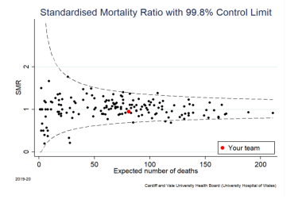
Length of Stay and Discharge Destination
Data from SSNAP and internal patient admission records show that the median length of stay at CAVUHB after stroke is:
C4 acute stroke unit, UHW 3.5 days
Stroke Rehabilitation Centre (SRC) 42 days

Discharge destinations for patients with confirmed stroke under our care during the SSNAP measured period of July to September 2023 are shown in Table 1 below. UHW received a SSNAP grade A within this audit period.

- 48.2% of stroke patients from this cohort went home directly from the acute stroke unit at UHW
- 44.4% were transferred to SRC for ongoing rehabilitation input.
- 73.1% of patients discharged from SRC during this period went home to their own home - most of these patients had ongoing rehabilitation and therapy needs; some had ongoing care needs.
- To note, very few patients were discharged to new care home placements (0% of C4 and 5.4% of SRC discharges)

Whilst it is seen as a good outcome to achieve discharge home for so many patients after stroke, this is with a relatively high level of dependency.

Table 1. Discharge Destinations from CAVUHB Stroke Service

Discharge Destinations  SSNAP Quarter Jul-Sep 2023 | C4 Acute Stroke Unit, UHW | Stroke Rehab Centre, UHL
Home without any ongoing rehab need | 27.5% | 19.6%
Home with stroke Early Supported Discharge team | 18.5% | 33.9%
Home with Community Resource Team | 2.2% | 19.6%
Transfer to further inpatient rehab | 44.4% | 10.8%
Transferred to another clinical service | 0.6% | 1.8%
Discharged to a new care home placement | 0.0% | 5.4%
Died | 6.7% | 8.9%

Level of dependency
Dependency level after stroke is measured using the modified Rankin score (mRs):
0 Independent, with no ongoing deficits after stroke
1-2 Able to mobilise independently, but requiring some support with performing activities of daily living
3-4 Assistance to mobilise and with all activities of daily living
5 Fully dependent for all care and reliant on manual handling equipment for transfers
6 Died

The mRs on discharge for the cohort of patients with confirmed stroke under our care during the SSNAP measured period of July to September 2023 is shown in Table 2 below.

Table 2. Modified Rankin score on discharge from CAVUHB Stroke Service

Modified Rankin score on discharge  SSNAP Quarter Jul-Sep 2023 | C4 Acute Stroke Unit, UHW | Stroke Rehab Centre, UHL
0 | 18.7% | 0.0%
1 | 39.3% | 3.6%
2 | 14.0% | 16.1%
3 | 11.2% | 46.4%
4 | 4.7% | 7.1%
5 | 0.9% | 12.5%
6 | 11.2% | 8.9%

- 18.7% of patients discharged from the service had an mRs of 0 after stroke
- No patients were discharged from SRC fully independent.
- An mRs of 2 or less is seen as a ‘good outcome’ towards independence after stroke, a measure used in stroke research and to indicate good outcomes after thrombolysis and thrombectomy treatment.
- 16.8% of patients discharged from C4, UHW and 66% of those discharged from SRC had an mRS of 3 or more.

In the current service model, approximately one third of all stroke patients are discharged from hospital with a dependency level requiring long term care and support. Many more have longstanding milder disabilities meaning they face long periods of recovery and rehabilitation after stroke. Many stroke survivors of working age do not return to meaningful occupation and employment. It is anticipated that by increasing the number of patients receiving thrombolysis and thrombectomy treatments, there will be a positive change in outcome for this patient group. By reaching the target rates of 20% thrombolysis rate and 10% thrombectomy, it is expected that more patients will be able to leave hospital directly from the acute stroke unit, and that a proportion of patients will have an accelerated pathway through rehabilitation, shortening the average length of stay and reducing the overall levels of dependency on discharge seen in this patient group.

4.3 Current Performance against key indicators

Stroke performance is measured by the SSNAP audit against standards of care as set out in national clinical guidelines, with quarterly reports offering a performance score rating based on 10 key domains. UHW’s SSNAP grade score over the last 3 years is as follows:

Table 3. UHW SSNAP grades 2021-23

 | Q1 Jan – Mar | Q2 Apr – Jun | Q3 Jul- Sep | Q4 Oct- Dec
2021 | C | B | C | C
2022 | C | D | C | C
2023 | C | B | A | B

In Wales, stroke performance for each Health Board is additionally monitored by the NHS Executive Performance and Assurance team (Formerly the NHS Wales Delivery Unit) against a group of Quality Improvement Measures.

The NHS Wales stroke performance dashboard is available here Dashboard and Observations (sharepoint.com)

UHW’s performance against key measures for the quarter Jul-Sep 2023 is shown in Table 4 below, along with the all Wales performance and that of the London Integrated Stroke Delivery Network for the same time period for comparison with a more developed service.

In the last year, UHW’s stroke performance has improved significantly, most notably in the admission to the stroke unit within 4 hours measure. Achieving an A grade on SSNAP deserves to be celebrated, however we meet just the minimum standard for this. It should be acknowledged that this has been achieved through intensive and focused improvement work and interim resource redirection (temporary CNS rota changes to cover weekends and moving sessions of stroke consultant time to the front door where possible). Achieving a sustainable A grade will require reconfiguration of the service to change the clinical model for stroke and TIA, as is proposed in this business case.

Table 4. Comparison of Stroke Performance Key Measures and Outcome Indicators

Stroke Performance Measure | Target for SSNAP grade A | All Wales  Jul-Sep 2023 | UHW  Jul-Sep 2023 | London stroke network  Jul-Sep 2023
Percentage of Patients given thrombectomy | Not currently measured on SSNAP | 2.0%  *NHS Wales data | 2.7%  *NHS Wales data | Data unavailable, but patients in this network have 24/7 thrombectomy access
Percentage of patients given thrombolysis | >16% | 13.2% | 8.0% | 13.0%
Median door to needle Thrombolysis treatment time | <45 mins | 1 hr 16 min | 1 hr 5 min | 44 min
Percentage of patients scanned within 1 hour of arrival | >50% | 58.0% | 56.9% | 72.6%
Median time to scan | <45 mins | 49 min | 53 min | 29 min
Percentage of patients admitted to the stroke unit within 4 hours of arrival | >80% | 30.7% | 60.8% | 53.4%
Percentage of patients having a swallow screen assessment within 4 hours of arrival | >80% | 73.3% | 77.1% | 84.1%
Percentage of patients seen by a stroke specialist consultant within 24 hours of arrival | >80% | 80.1% | 88.3% | 100%
Median time to stroke consultant | <6 hours | 12 hr 0 min | 11 hr 42 min | 4 hr 50 min
Median time to stroke specialist nurse | <30 mins | 2 hr 22 min | 1 hr 46 min | 0 min

Outcome indicators |  | All Wales | UHW | London network
Crude Mortality April 2019-March 2020 | SSNAP data | Range 10-18% | 12% | Range 8-15%
Median mRs on discharge from acute site April 22-Mar 23 | SSNAP data | 3 | 2 | 2

4.4 Current and Proposed Patient Pathways for Stroke and TIA

Figure 1. Current Emergency Stroke Assessment Pathway

Narrative Issues / Points of Delay
Patient is treated as appropriate with thrombolysis or thrombectomy, stabilised in ED and then admitted to Acute Stroke Unit for ongoing care
Patient presents to the Emergency department with suspected stroke
Junior Doctor and CNS complete patient assessment and confirm diagnosis / make plan for patient.
In cases who may be appropriate for thrombolysis or thrombectomy, the stroke consultant on call is contacted for telephone advice.
Call is attended to by a junior of the Emergency Dept Medical take team and Stroke Clinical Nurse Specialist.
Patient has emergency stroke imaging in ED CT scanner
CNS hours currently 0700 to 1930 7 days / week (unfunded interim rota) No CNS cover after 1930.

Junior doctor holding bleep is not specifically stroke trained, often with limited stroke experience. Risk of delay to assessment and treatment as this doctor is not exclusively holding the stroke bleep and has other clinical duties which presents a large caseload with competing priorities.

Thrombectomy referral (particularly out of hours to Bristol) requires sending images online, completion of online referral and booking transport via WAST trauma desk – time consuming, takes junior doctor away from other duties and more difficult when CNS is not present.

Senior clinical decision maker is not present with the team unless workload supports (telephone code stroke cover is doubled up with other clinical duties in current workforce model)

Risk that patients will miss treatment opportunities such as thrombolysis and thrombectomy
Multiple methods: Ambulance conveyance, GP referral, self-presenting
Stratifying urgency of stroke assessment by time of onset is no longer clinically appropriate.
Risk that patients will miss treatment opportunities such as thrombolysis and thrombectomy
On triage and ED screening, if stroke is still suspected, Code Stroke bleep alert call is Activated
Code Stroke 1: symptom onset within the last 4.5 hours
Code Stroke 2: symptom onset older than 4.5 hours
Figure 2. Proposed new Emergency

Figure 2. Proposed Emergency Single Stroke Pathway
Issue Resolution
Call is attended to by a dedicated Stroke junior doctor and Stroke Clinical Nurse Specialist.
Patient has emergency stroke imaging in ED CT scanner
Junior Doctor and CNS complete patient assessment. Support available from MSDEC based consultant to 10pm and then on call overnight.
Patient is treated as appropriate with thrombolysis or thrombectomy, stabilised in ED and then admitted to Acute Stroke Unit for ongoing care
On triage and ED screening, if stroke is still suspected and the patient is within 24 hours of the onset, Code Stroke bleep alert call is Activated
PVT will enable the stroke consultant to advise if stroke is unlikely, and alert the stroke team ready to receive a new patient when it is.
Stroke junior doctor and CNS will also be connected to PVT to support pathway planning.
Code stroke to be used for all patients within 24 hours of symptom onset, removing Code 1 and 2, promoting thrombolysis and thrombectomy treatment opportunity for all eligible patients
Patients with onset >24 hours may be redirected to MSDEC to be assessed by the stroke consultant as appropriate, reducing the suspected stroke cases going through the ED pathway. This is supported by PVT.
CNS cover extended and dedicated stroke junior doctor cover both phasing up to 24/7.
PVT will support the team being ready to receive patients, reducing delays at the start of the pathway
Dedicated stroke resource - standardising the pathway, reducing delay to assessment & maximising treatment opportunities.
Senior clinical decision maker can attend to support assessment and treatment as indicated (PVT will also support this as the consultant will have seen the patient before arrival)
Maximising opportunities for all eligible patients to be considered, referred and treated with thrombolysis and thrombectomy.
Patient presents to the Emergency department with suspected stroke.
Pre-hospital stroke pathway with WAST supported by Pre-Hospital Video Triage (PVT)
Figure 3. Current TIA Pathway in the Stroke Outpatient Service

Narrative Issues / Points of Delay
Referrals received and grouped for review by consultants – no dedicated time for this, ad hoc task amongst other duties.
TIA service is not on consultant connect as no ability to cover a consultant connect line
Limited ability to decline or redirect referrals unlikely to need TIA service.
Patient seen in Emergency department or Primary Care with suspected TIA
Patient attends as an outpatient and is managed in the planned care system for all investigations and referrals.
TIA Coordinator books patients into the first available TIA new patient slot in Stroke outpatient service
Referral made to TIA clinic via email or WAP
16 new patient slots per week, current wait time approx. 8-12 weeks

Clinical Standard: Patients should be assessed and investigated for TIA as soon as possible after the event and within 24 hours of the referral.
Patients with significant findings on urgent investigations are often referred to other services without having seen a Stroke Consultant, reducing opportunity for joint care decision making to optimise patient outcomes.
Urgent investigations completed, results reviewed by consultant, urgent referrals made to other specialties (e.g. vascular surgery or cardiology)
Referral reviewed by stroke consultant at earliest opportunity to prioritise and highlight any urgent investigations

Figure 4. Proposed new TIA Pathway in the Medical Same Day Emergency Care unit

Patient Pathway Issue Resolution

Patient seen in Emergency department or Primary Care with suspected TIA
Referrer able to speak directly to the Stroke Consultant to discuss the referral and confirm patient is most appropriately managed in MSDEC TIA clinic.

Referral made to TIA clinic via e-referral, WAP or consultant connect telephone call

Regular updating of patient list.
Coordinator able to make most efficient use of clinic capacity

Stroke consultant accepts or redirects referral. Twice daily list of new TIA patients collated.
TIA Coordinator books patients into the next available MSDEC TIA clinic slot
Urgent investigations and specialty reviews are conducted alongside TIA clinic assessment.

Patient attends MSDEC TIA clinic to be seen in person by Stroke Consultant. Urgent investigations completed as soon as possible. Follow up in planned care as indicated

These proposed clinical pathways have been designed around achieving the recognised clinical standards for stroke and TIA, meeting key performance indicators and SSNAP measures.

They have been developed in collaboration with colleagues from Acute and Emergency Medicine, complement the proposed Neurology Consultant of the Week model and have been endorsed by the Executive Management team through the stroke summits.
Clinical Standard will be met for all patients unless in exceptional circumstances.
Stroke Mimic Cases
All stroke services need to manage the cohort of patients who present with symptoms and signs suggestive of stroke but in whom the diagnosis is shown to be something other than a stroke. These patients are known as ‘Stroke mimics’ and make up just over half of the stroke department’s demand. In stark contrast to the simple and revealing ECG in patients with acute cardiac disease, the basic test in suspected stroke (a plain CT scan) can often be relatively normal for the first 2-3 hours after a blood vessel has become occluded, leaving the clinician with the story told and the findings on clinical examination as the main clues to the diagnosis.

The list of stroke mimicking conditions is long. It includes very common conditions e.g. fainting, seizures, sepsis and drug side effects, as well as rarer and more complex diseases the diagnosis of which requires repeat brain imaging or more complex investigations (e.g. lumbar puncture, Electroencephalogram, PET scanning).

There are multiple benefits of placing a senior decision maker as early as possible in the pathway, improving the management of patients with stroke mimicking conditions. The sooner a patient with a stroke mimicking condition can be seen and assessed by a stroke expert team, the sooner they can be placed onto the optimal pathway for their individual needs. It is expected that for this patient group there will be a reduction in the requesting of some investigations and imaging tests, a reduction in unnecessary treatment and the associated risk of harm from this, and a reduction in unnecessary admissions for observation or to wait to be seen by the right professional. More efficient management of stroke mimicking cases is expected to release capacity within the system, allowing the allocated resources (bed capacity, diagnostics and specialist staff) for stroke and TIA services to be optimised within the stroke pathway.

Recent pathway developments and digital innovations

Optimal Stroke Imaging Pathway: In response to updates to the National Clinical Guidelines for Stroke for the UK and Ireland (2023), the optimal stroke imaging pathway has been developed with radiology to include advanced imaging modalities supporting thrombolysis and thrombectomy treatment decisions.

Brainomix e-stroke: AI image interpretation software which provides a rapid graphical report of CT, CT Angiogram and CT Perfusion scan images to support emergency diagnostics. Since implementing e-stroke at UHW, more than 600 patient scans have been processed and there has been a clear increase in the number of patients receiving thrombolysis and being referred for thrombectomy.

Pre-hospital Video Triage (PVT) for Stroke: Innovation project with Welsh Ambulance Service NHS Trust (WAST). Development of a secure platform hosting PVT, connecting WAST clinicians and the hospital stroke consultant, allowing the stroke pathway to begin right at the scene of the 999 call. So far there have been 20 successful PVT calls; 7 of these progressed on the stroke pathway on arrival to hospital and 4 received thrombolysis or thrombectomy. 13 patients were diagnosed with a stroke mimic event before conveyance to hospital and were managed on the optimal pathway for their needs.

The use of these digital pathways requires the optimal workforce model to be in place.

4.5 Current and Proposed Clinical Models for Stroke and TIA

Current workforce model for acute stroke:

UHW Stroke Consultant workforce: | Mon – Fri  8am - 5pm | Mon – Fri 5pm – 10pm | Sat – Sun 8am - 5pm | Sat – Sun 5pm- 10pm | Overnight by telephone 10pm – 8am | Workforce
Acute stroke unit, Ward C4, UHW | X1 daily ward round and MDT board round |  | X1 daily ward round and MDT board round |  |  | 10 DCC sessions
Emergency stroke assessment pathway | x 4 sessions in person attending to code stroke calls  (1 unfunded at present)  x 6 remote advice by telephone  (3 of these can convert to in person in a new clinical model) |  |  |  | 3 sessions currently job planned | 9 DCC sessions
Pre-hospital video triage calls | No dedicated sessions |  |  |  |  | 0 DCC sessions
MSDEC stroke and TIA assessment | 2 sessions in current clinical model are able to convert to a new model |  |  |  |  | 2 DCC sessions
Total Stroke Consultant DCC sessions at UHW  3.0 WTE stroke consultants in current workforce |  |  |  |  |  | 21 DCC sessions

Junior Doctor workforce: | Mon – Fri  8am - 5pm | Mon – Fri 5pm – 10pm | Sat – Sun 8am - 5pm | Sat – Sun 5pm- 10pm | Overnight 10pm – 8am | Workforce
Acute stroke unit, Ward C4, UHW | 1.0 WTE Stroke Trainee  2.0 WTE foundation grade |  |  |  |  | 3.0 WTE
Total Junior Doctor Workforce for stroke, UHW |  |  |  |  |  | 3.0 WTE

Stroke CNS workforce: | Mon – Fri  7am – 7.30pm | Sat – Sun 7am – 7.30pm | Overnight 7.30pm – 7am | Workforce required
Emergency stroke assessment pathway | Establishment of 3.8 WTE for UHW | Temporary extension of rota to include weekends |  | 3.8 WTE
Total CNS Workforce |  |  |  | 3.8 WTE

Key issues with the current workforce model:
- Consultant cover to code stroke started in 2015 as an improvement initiative in implementing the thrombolysis urgent treatment pathway.
- No further resource has been allocated to the stroke consultant body since then; sessions have been reinvested from elsewhere in the pathway to reach the current level of cover.
- There are currently only 4 sessions per week of in person consultant attendance to emergency code stroke calls in ED.
- At all other points of the week, and out of hours, a consultant is only available for clinical advice by telephone, and during the week this is often as a secondary task alongside other clinical duties.
- The out-of-hours stroke rota, and weekend morning ward round shifts are staffed by those in substantive stroke consultant posts (5 individuals) plus volunteers from acute medicine and neurology with an interest in stroke. Approximately 20 weeks of the year are unable to be filled by this substantive rota; these weeks are covered on a voluntary basis at additional cost to Medicine Clinical Board of £8,500 per week.
- There is no dedicated middle grade junior doctor for stroke; the stroke bleep is delegated to one of the medical team in the on-call take team to hold.
- This doctor needs to respond as quickly as possible to code stroke in amongst their busy caseload of emergency medical referrals and the corresponding competing priorities this brings.
- Currently all thrombectomy referrals, image transfer and patient transfer arrangements fall to the medical registrar to coordinate outside of the CNS working hours.
- The Stroke CNS team have temporarily extended their rota to cover weekends (at a cost pressure to Medicine Clinical Board)
- Their establishment is not sufficient for 7-day cover and does not include allowance for annual leave and sickness. Only one CNS is able to be on shift on most days and there is no cover for breaks during the day
- As there is no CNS to handover to at shift end, the team frequently (average once per week) work over their shifts to ensure patients receive the best possible care.
- TIA patients are currently seen within the planned care stroke outpatient clinics. There are 16 new TIA appointments available per week, and the service receives between 20 and 25 referrals in an average week. There is a wait to be seen currently of 8-12 weeks.
- TIA is for many patients a warning event and possibly pre cursor of stroke and should be treated as a medical emergency in an emergency pathway. A proportion of TIA patients require time sensitive vascular surgery assessment, with surgical intervention most effective within 14 days of the TIA event.
- In others, detecting conditions such as atrial fibrillation requiring prophylactic anticoagulation treatment is time sensitive and urgent.
- To mitigate delays, currently the stroke consultants screen each referral to arrange urgent investigations in advance of a TIA clinic appointment, checking results intermittently so as to expedite referrals to other services.

4.6 Demand on the Service

Year | Code Stroke Calls | Admitted to C4 on the stroke pathway | Confirmed stroke cases | TIA clinic referrals
2022 | 1971 | 1056 | 744 | 1173
2023 | 2031 | 1022 | 694 | 1234

4.7 Evidence for Change

The evidence for the optimal stroke pathway and service standards is collated in the National Clinical Guidelines for Stroke for the UK and Ireland (2023), linked here National Clinical Guideline for Stroke (strokeguideline.org)

Staffing recommendations are included in these guidelines - for a centre providing hyperacute stroke care, consultant ward rounds on the stroke unit are recommended twice daily, with emergency access to a stroke consultant 24/7 and a minimum of 6 thrombolysis-trained physicians on a rota. Assumptions in this recommended model are that the emergency assessment pathway is supported by a team of junior doctors and specialist nurses or advanced clinical practitioners, and that a TIA service sits alongside or as part of the hyperacute stroke pathway. Suspected TIA patients should be treated with high dose aspirin immediately, unless contraindicated, and assessed urgently within 24 hours by a stroke specialist clinician.

In September 2023, Health Inspectorate Wales (HIW) published the
National Review of Patient Flow: a journey through the stroke pathway (hiw.org.uk)
The report highlighted where the optimal stroke pathway was not being followed. This was recognised as largely due to pressures across the system but also identified gaps in resource such as the CNS workforce and a dedicated emergency stroke medical team to facilitate thrombolysis and thrombectomy treatments.

Medicine Clinical Board have, with support of colleagues in Patient Flow and Site Services and the Integrated Discharge Service, raised actions against HIW’s recommendations; completion of these actions is reliant however on resource allocation in support of delivering an appropriate clinical model.

The evidence base for stroke management is expected to be represented in national stroke service specifications for Wales, due to be published in 2024.

Benchmarking
Most UK stroke services consistently achieving the top grades in SSNAP, including those in the London Integrated Stroke Delivery Network (ISDN), have a dedicated emergency stroke team delivering the recognised optimal pathway. Whilst this is a well-established model in the NHS England ISDNs, benchmarking elsewhere in Wales is not felt particularly useful at this point as no stroke centres in Wales operate in the described optimal model. All stroke services in Wales are currently involved in regional programmes to review the delivery of stroke crossing traditional Health Board boundaries to provide a centralised Comprehensive Regional Stroke Centre.

A useful exemplar is Southmead Hospital, North Bristol NHS Trust which runs a busy hyperacute stroke service and superregional thrombectomy centre, reporting 1211 confirmed stroke cases on SSNAP from October 2022 to September 2023. The out of hours stroke rota there is populated by 21 consultants, supported 24/7 by dedicated middle grade doctors and a well-established Advanced Practitioner and CNS team on a 24/7 rota.

4.8 The Proposed New Clinical Model for Stroke at UHW

The Stroke Service, with guidance from the Executive Management team and constructive support from colleagues around the health board at summit meetings, have designed the optimal clinical model for stroke at UHW. This includes:
- A dedicated consultant role for C4 acute stroke unit, able to provide twice daily ward rounds, phasing up to 7 days per week.
- A dedicated middle grade doctor or stroke trainee for the emergency code stroke pathway, plus extended CNS working hours, both phasing up to 24/7 cover.
- A dedicated Stroke Consultant role taking pre-hospital video triage calls for stroke, seeing TIA and stroke patients in Medical SDEC and providing senior support to the emergency code stroke team.
- This will be on a ‘consultant of the day’ daily rota pattern, and in a phased approach extend its hours to 8am-10pm 7 days per week, with overnight telephone support to the code stroke team.

This model will ensure that all patients presenting to UHW with suspected stroke are assessed either:
- In the emergency code stroke pathway if their symptoms are within 24 hours of onset on arrival to hospital, maximising opportunities to deliver thrombolysis and thrombectomy
- In MSDEC if their symptoms are older than 24 hours, either by GP referral, 111 advice or self-presenting to hospital with suspected stroke
- In addition, TIA cases will be seen in an emergency ‘hot clinic’ in MSDEC, phasing up to 7 days per week, meeting the 24-hour assessment standard for TIA.

In addition, TIA cases will be seen in an emergency ‘hot clinic’ in MSDEC, phasing up to 7 days per week which will meet the 24-hour assessment standard. Additional benefits of this model include:
- In those with confirmed TIA, expedited investigations and earlier identification of stroke risk factors; research indicates that expediting treatment has a significant impact on secondary prevention of stroke after TIA.
- Opportunity to treat risk factors in those who have experienced TIA, expediting secondary prevention, reducing risk of further episodes after TIA and thus reducing avoidable harm
- For those having treatment of risk factors after TIA, there is an expected reduction in the rates of subsequent stroke, reducing avoidable harm and leading to an overall reduction in the disabling impact of stroke achieved through optimal management of the TIA pathway.
- Early ruling out of TIA in cases where it is not the diagnosis, supporting patients to access the most appropriate pathways for their condition instead of remaining on an inappropriate planned care waiting list

- Option Appraisal – 3 Options of how to deliver the proposed clinical model are presented for consideration:

Option 1 – Do nothing: Do not change the clinical model, continue to deliver stroke and TIA as per the current service.

Option 2 – Implementation of the Proposed Clinical Model for UHW:

Stroke Consultant: | Mon – Fri  8am - 5pm | Mon – Fri 5pm – 10pm |  | Sat – Sun 8am - 5pm | Sat – Sun 5pm- 10pm |  | Overnight 10pm – 8am | Workforce required
Acute stroke unit, Ward C4, UHW | x2 daily ward round and MDT board round |  |  | x2 daily ward round and MDT board round |  |  |  | 14 DCC sessions
Emergency stroke assessment pathway | Consultant available for emergency consultation for emergency code stroke cases |  |  |  |  |  | On call by telephone | 35 DCC sessions
Pre-hospital video triage calls | Consultant available to take pre-hospital video triage calls |  |  |  |  |  |  | 35 DCC sessions
MSDEC stroke and TIA assessment | Consultant based in MSDEC for all sessions, provides cover to the above as part of the ‘consultant of the day’ front door stroke consultant role |  |  |  |  |  | On call by telephone | 35 DCC sessions
Total Consultant DCC sessions Required = 49 |  |  | Current DCC sessions in place = 21 |  |  | Gap in DCC sessions = 28  4.03 WTE  (1 post as associate specialist, remainder as consultant).

Junior Doctor: | Mon – Fri  8am - 5pm | Mon – Fri 5pm – 10pm |  | Sat – Sun 8am - 5pm | Sat – Sun 5pm- 10pm |  | Overnight 10pm – 8am | Workforce required
Acute stroke unit, Ward C4, UHW | 1.0 WTE Stroke Trainee  2.0 WTE foundation grade |  |  | Junior doctor cover to weekend ward round as per weekend rota |  |  |  | 3.0 WTE
Emergency stroke assessment pathway | 24/7 cover to code stroke team |  |  |  |  |  |  | 6.0 WTE
MSDEC stroke and TIA assessment | Support to Stroke clinic in MSDEC offered by either MSDEC junior doctors or one of the stroke team on a needs led basis |  |  |  |  |  |  | -
Total Junior Doctor Workforce required = 9.0 WTE |  |  | Current workforce in place = 3.0 WTE |  |  | Gap identified = 6.0 WTE

CNS: | Mon – Fri  8am - 5pm | Mon – Fri 5pm – 10pm |  | Sat – Sun 8am - 5pm | Sat – Sun 5pm- 10pm |  | Overnight 10pm – 8am | Workforce required
Emergency stroke assessment pathway | 24/7 cover to code stroke team |  |  |  |  |  |  | 8.52 WTE
Total CNS Workforce required  = 8.52 WTE |  |  | Current workforce in place = 3.8 WTE |  |  | Gap identified = 4.72 WTE

Option 3 – Full scale implementation of the Proposed Clinical Model for UHW to operate as a Comprehensive Regional Stroke Centre:

Stroke Consultant: | Mon – Fri  8am - 5pm | Mon – Fri 5pm – 10pm |  | Sat – Sun 8am - 5pm | Sat – Sun 5pm- 10pm |  | Overnight 10pm – 8am | Workforce required
Acute stroke unit, Ward C4, UHW | x2 daily ward round and MDT board round |  |  | x2 daily ward round and MDT board round |  |  |  | 14 DCC sessions
Emergency stroke assessment pathway | Consultant based within code stroke team for all sessions |  |  |  |  |  | On call by telephone | 35 DCC sessions
Pre-hospital video triage calls | Dedicated 2 sessions per day to take calls |  |  |  |  |  |  | 14 DCC sessions
MSDEC stroke and TIA assessment | Consultant based in MSDEC for all sessions |  |  |  |  |  | On call by telephone | 28 DCC sessions
Total Consultant DCC sessions Required = 91 |  |  | Current DCC sessions in place = 21 |  |  | Gap in DCC sessions = 70

Junior Doctor: | Mon – Fri  8am - 5pm | Mon – Fri 5pm – 10pm |  | Sat – Sun 8am - 5pm | Sat – Sun 5pm- 10pm |  | Overnight 10pm – 8am | Workforce required
Acute stroke unit, Ward C4, UHW | 1.0 WTE Stroke Trainee  2.0 WTE foundation grade |  |  | Junior doctor cover to weekend ward round as per weekend rota |  |  |  | 3.0 WTE
Emergency stroke assessment pathway | 24/7 cover to code stroke team |  |  |  |  |  |  | 6.0 WTE
MSDEC stroke and TIA assessment | Support to Stroke clinic in MSDEC |  |  |  |  |  |  | 3.5 WTE
Total Junior Doctor Workforce required = 12.5 WTE |  |  | Current workforce in place = 3.0 WTE |  |  | Gap identified = 9.5 WTE

CNS: | Mon – Fri  8am - 5pm | Mon – Fri 5pm – 10pm |  | Sat – Sun 8am - 5pm | Sat – Sun 5pm- 10pm |  | Overnight 10pm – 8am | Workforce required
Emergency stroke assessment pathway | 24/7 cover to code stroke team  Additional cover by day offering increased support to thrombectomy cases and CNS support to the stroke unit |  |  |  |  |  |  | 7.5 WTE
MSDEC stroke and TIA assessment | Support to Stroke clinic in MSDEC |  |  |  |  |  |  | 2.0 WTE
Total CNS Workforce required  = 9.5 WTE |  |  | Current workforce in place = 3.8 WTE |  |  | Gap identified = 5.7 WTE

5.2 Appraisal of the Options

Evaluation Criteria  Score 0 – option does not meet criteria  1 – option partially meets criteria  2 – option fully meets criteria | Option 1 | Option 2 | Option 3
Provides 7 day cover to C4 acute stroke unit (twice daily ward rounds) | 1 | 2 | 2
Provides ‘Consultant of the Day’ role in MSDEC  8am-10pm | 0 | 2 | 2
Provides In-person Consultant support to Code Stroke 8am-10pm | 1 | 1 | 2
Provides Consultant cover to Pre-Hospital Video Triage | 1 | 1 | 2
Provides dedicated Stroke middle grade junior doctor cover to code stroke (phased by recruitment) | 0 | 2 | 2
Provides 24/7 Stroke CNS cover (phased by recruitment) | 0 | 2 | 2
Supports TIA clinic in MSDEC 7 days per week | 0 | 2 | 2
Supports performance against SSNAP A grade targets | 1 | 2 | 2
Supports implementation of the Single Stroke Pathway | 0 | 2 | 2
Supports provision of TIA patient pathway – assessment within 24 hours | 0 | 2 | 2
Supports future development as Comprehensive Regional Stroke Centre | 0 | 1 | 2
Supports future development as South Wales Thrombectomy Centre | 0 | 1 | 2
Short term deliverability of clinical model (recruitment to new posts) | 0 | 2 | 1
Long term deliverability of clinical model | 0 | 2 | 2
Total score | 4 | 24 | 27
Estimated of cost of option | £0 | £1.39m | £2.84m

- The Preferred option

6.1 Outcome of the Options Appraisal

Option 1 is not supported as it does not enable the implementation of the agreed optimal clinical model for stroke.

Option 2 is supported as the preferred option from this appraisal exercise. It is felt that this option would most reasonably and most prudently support implementation of the optimal clinical model described in this business case. A phased approach to this model is felt to be more reasonably achievable than for Option 3; it is hoped that this model would take only 2 phases to reach full operation, covering the out of hours period in a shorter timescale with less resource required to reach this.

Assumptions in this option are that demand would be such that a dedicated consultant session for each of the code stroke team, MSDEC and pre-hospital video triage elements is not required and that the same consultant would perform each of these clinical duties when in the ‘consultant of the day’ role, if supported by the middle grade junior doctor and Stroke CNS roles.

It is felt that this option will enable the implementation of a new clinical model for stroke at UHW, offering many transferrable benefits across Medicine, particularly in ED but also providing a strong foundation stroke service on which regional stroke services and the South Wales Thrombectomy Centre can be built.

Option 3 on reflection represents the requirements of a regional service; this model is too large a service for the demand in stroke at UHW alone. Phasing up to this model will require 3 to 4 phases over 1 to 2 years, in line with thrombectomy service developments. The draft timeline for this is presented in Appendix 2.

6.2 Dependencies on Other Services
- Medical SDEC will need to accommodate the MSDEC based stroke and TIA pathway.
- Middle grade rotas will need to be developed which provide dedicated cover to code stroke. There is a need for the stroke service to collaborate with colleagues across medicine and neurology, and to review provision of training posts with HEIW.
- The consultant workforce requirement for this model has been calculated in direct care sessions and as a representative WTE - stroke as a specialty suits mixed specialty job planning and contribution of sessions from other clinical teams will be welcomed.
- In fact, the service is unlikely to recruit individuals who want to work exclusively in stroke. Collaboration with other services outside of Integrated Medicine (primarily Neurology and Acute and Emergency Medicine) will be essential in order to reach the most effective workforce format.

6.3 Additional Impact on Other Services
- This clinical model is predicted to impact positively on most other services, namely Emergency and Acute Medicine, Radiology, Stroke Rehabilitation services and those providing long term care and support.
- As a result of this clinical model, it is expected that more patients will survive stroke and with less severe disability. This will have a positive impact on rehabilitation and community services with ultimately reduced demand on long term care provision.
  - It is difficult to predict the true demand change on rehabilitation services – it is expected that more patients will survive with reduced secondary complications of stroke e.g. stroke associated pneumonia. This may present a larger than current cohort of patients requiring inpatient or community rehab, but with a large proportion of those having good potential to recover well and regain independence through rehabilitation, optimising outcomes.
  - The stroke rehabilitation demand will be monitored as the new acute stroke clinical model is introduced; this should be considered in any future inpatient stroke rehabilitation and community service review or redesign.
- It is acknowledged that there may be changes in demand on other clinical services, such as Pharmacy, Clinical Diagnostics and Therapeutics and Medical SDEC and so there will be a requirement to evaluate the implementation of this service at around 6 months, reviewing its impact in real time.
  - It is difficult to predict the true demand change on scanning and diagnostic tests - whilst suspected stroke patients may undergo additional scans as more patients will be considered on the thrombolysis and thrombectomy treatment pathways, those with suspected TIA will only undergo necessary urgent investigations in the MSDEC setting, and a reduction in unnecessary imaging and diagnostic tests is expected in those with stroke mimicking conditions.
  - This activity will be monitored for changes in demand in both outpatient and Medical SDEC settings.
  - It is possible that moving TIA clinic into the MSDEC model will place additional demand on the in-hospital pharmacy service; this activity will be monitored for changes in demand.
- It is expected that the changes to TIA management, bringing forwards the point of definitive diagnosis and secondary prevention treatment planning, will have a positive impact on medications usage and management.
  - Patients will be placed onto correct secondary prevention sooner, or a decision not to treat with medication made sooner, reducing unnecessary harm.
  - This will improve efficiency by reducing the ‘treat until seen’ approach currently adopted given the length of the referral to treatment times.
  - There will be expedited communication with primary care clinicians compared with the current outpatient model as an MSDEC attendance supports generation of a Discharge Advice Letter from an unscheduled care contact, more readily available to GPs for review.
- It is expected that moving to this clinical model for stroke will have positive impact on the current emergency and acute medical model at UHW. Suspected stroke cases make up approximately 15-20% of the demand for urgent medical assessment at UHW - doctors are often called away from other sick patients to attend to a stroke case due to the urgency required in stroke assessment.
- This model will support more timely assessment of stroke, supporting flow across the acute and emergency medical footprint and also freeing the medical team to see other patients more efficiently and safely. Medical trainees will still have contact with stroke patients and training opportunities, but in a more supportive environment which will enhance their experience.
- 24/7 presence of the CNS team will support the patient pathway to thrombectomy, particularly with referral to Bristol out of hours.

6.4 CAVUHB People and Culture Plan
People feel valued, developed, supported and engaged: This investment will promote the development of our stroke workforce in line with this principle. UHW will become recognised as a centre of excellence for stroke, a place where people feel valued and supported to deliver best care. Training opportunities will be maximised and people will feel invested in, valued and supported, having a positive impact on staff health and wellbeing.

Attract and recruit people with the right skills, abilities, values and experiences to meet the health and social care needs of our population: Developing this new clinical model will attract new staff, promoting UHW as a stroke specialist centre and a specialist training offer. This will extend outside of the stroke service, supporting opportunities for those with an interest in stroke from across acute and emergency medicine and neurology as well as those in core medical training. There will be opportunities for leadership roles across all professional groups with advanced practice development, supporting all staff to work to the top of their licence.

Ensure our services are provided by the right team: a workforce that is affordable, sustainable and integrated to meet current and future service needs and reflects our population: The stroke service is acutely aware of the need to plan the growth, development and succession of its staff group. The individuals making up the current consultant body are all very experienced, senior consultants and collectively they will likely have all retired in the next 15 years. Stroke as a specialty attracts individuals from different clinical backgrounds and suits fitting into job plans as a special interest speciality. For example, stroke sessions could be contributed by those in Neurology consultant roles, or Emergency and Acute Medicine physicians with an interest in stroke. Moving to a new clinical model will offer more opportunity for these hybrid roles to develop and contribute stroke sessions. This offers flexibility, supports individuals to job plan around other commitments or around a retirement plan for example, supporting the Health Board as employers to implement the flexible working and flexible retirement policies and to build the right capacity in our future workforce.

7. Benefits

Quantifiable benefits | Non-quantifiable benefits
Quality of care  Compliance with stroke pathway standards as measured by SSNAP. Specifically:  - Time to scan  - Time to stroke unit admission  - Time to specialist stroke consultant and nurse assessments  Access to emergency treatments  - Thrombolysis rates  - Thrombectomy rates  - Time to treatment  - Time to TIA assessment from referral  Patient Outcomes  - 30-day mortality  - Reduction in rates of stroke after TIA  - level of dependency on discharge  - length of hospital stay  Cost releasing benefits  - Reduction in bed days needed across the stroke pathway  - potential for reduction in spend on long term rehabilitation and care needs beyond hospital  - Reduction in unnecessary medication use in TIA pathway  Staff recruitment, retention and wellbeing  - Centre of Excellence status  - Applications into stroke training programmes  - Vacancy and sickness rates across professions  - Reduction in agency staffing  Patient Experience  - Civica  - Tendable  - Compliments & Concerns  - External audits / Health Inspectorate Wales | Quality of care  Improved governance processes as Stroke will be delivered by a defined team  Support to the thrombectomy referral and transfer process, particularly out of hours  Reduction in referral to treatment times for TIA  Patient Outcomes  Compliance with stroke pathway standards is expected to deliver improvements in healthy life expectancy and contribute significantly to secondary prevention.  Patient reported experience  Staff recruitment, retention and wellbeing  Staff reported experience  Service reputation  - Attraction as an employer  - Reputaiton as a good medical training experience  - Reputation as an exemplar stroke service to others in Wales

7.1 Benefits tracker

Benefit | Metric | Baseline (December 2023) | Target | Timeline / Ambition
Improved patient experience | Stroke PREMs qualitative data | Limited baseline data – dataset on June 22 to June 23 cohort obtained by South Central Wales regional stroke programme team |  | By December 2025
Improved compliance with stroke pathway standards as measured by SSNAP | Median time to first scan (hours:minutes) | 0:53 | 0:45 | By March 2025
 | Median time to stroke unit admission (hours:minutes) | 3:54 | 3:00 | By March 2025
 | Median time to specialist stroke consultant assessment (hours:minutes) | 13:55 | 4:00 | By March 2025
 | Median time to specialist stroke nurse assessment (hours:minutes) | 3:07 | 0:30 | By March 2025
Improved access to emergency treatments | Thrombolysis rates (% of stroke admissions) | 15.9% | 20.0% | By March 2025
Improved access to emergency treatments | Thrombectomy rates (% of stroke admissions) | 4.8% | 10% | By December 2025
Improved access to emergency treatments | Median door to needle time in thrombolysis treatment (hours:minutes) | 1:19 | 0:45 | By March 2025
Improved access to emergency treatments | Referral to TIA appointment time | 11 weeks | <48 hours | By December 2024
Patient Outcomes: population level | Crude Mortality | 12% (SSNAP data 2019-2020) | 10.5% | By December 2025
Patient Outcomes: service level | Median level of dependency on discharge from UHW for those with confirmed diagnosis of stroke (Modified Rankin score) | 3 | 2 | By December 2025
Patient Outcomes: service level | Median length of hospital stay at UHW for those with confirmed diagnosis of stroke (days) | 3.52 | 3.0 | By December 2025
Staff recruitment, retention and wellbeing | Number of Stroke trainee posts (deanery training places) within the stroke service | 1.0 WTE | 2.0 WTE | By December 2025
Staff recruitment, retention and wellbeing | Vacancy and sickness rates | Stroke CNS team sickness 8.84% in month (3.36% cumulative 2023) | 5% in month (<3.36%cumulative 2024) | By December 2025

The service will work in collaboration with finance colleagues to model the expected impact on acute bed occupancy as a result of meeting these stroke pathway standards. The median and mean will be used to predict the impact.

Additonal Impact Tracker

 |  | Population / Service | Potential Impact | Monitoring Method
 |  | Patients having subsequent stroke after TIA | Expected to reduce, having significant impact on healthy life expectancy | Audit patient group referred after first TIA episode
 |  | Diagnostics | Number of stroke & TIA related scan episodes | Audit scan requests for stroke and TIA in outpatients, MSDEC and ED
 |  | Pharmacy | Increased dispensing demand on UHW Pharmacy from MSDEC | Monitor MSDEC pharmacy dispensing activity
 |  | Patient Experience | Expected improvement in the TIA, emergency stroke and acute pathways | There are limitations with current baseline data; 2023 PREMs survey was pathway wide and so does not provide a true baseline. The service will explore opportunities to learn more about patient experience in this model
Healthy life expectancy by 2035
The gap in life expectancy between the most and least deprived areas of the Health Board is 8 years for women and 9 for men, this has increased over the last decade. The healthy life expectancy gap is 18 years for women and 14 for men.
Evidence suggests low socioeconomic status and ethnicity is associated with an increased risk and incidence of stroke and TIA.
Improvement in the acute stroke pathway is therefore expected to contribute to the Health Board’s objective of narrowing health inequalities.
Financial model
The service will work in collaboration with finance colleagues to review the costs of the acute pathway by using the PBR tariff as the benchmark. Using this model, we intend to forecast the cost implications of the change in pathway.
it
Improved patient experience
Stroke Service: Improved compliance with stroke pathway standards as measured by SSNAP
mproved access to emergency treatments

TIA service: Improved management of TIA
tient Outcomes: population level

Patient Outcomes: service level

Blank page

7.2 Risk TH = Dr Tom Hughes, Clinical Director for Stroke. NT = Niki Turner, Stroke Service Manager

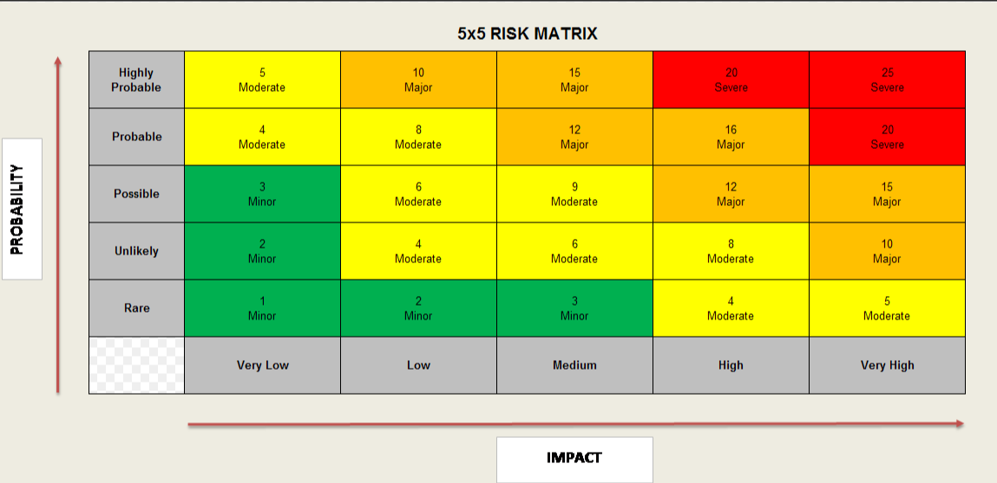
Risk Title | Descriptor | Probability (1-5) | Impact (1-5) | Total risk score (PxI) | Mitigating Action | Owner
Recruitment | There is a risk that additional posts will not be recruited to, or there will be a delay to recruitment | 3 | 4 | 12 | Phasing of clincal model can only progress in line with recruitment | TH
Demand | There is a risk that demand on the service will increase beyond that currently experineced and there will be unexpected impact on other services | 2 | 4 | 8 | Stroke service to monitor activity.  Close working with Acute and Emergency Medicine colleagues | NT / TH
Thrombectomy Centre | UHW becoming the South Wales Stroke Thrombectomy Centre may place increased demand on and destabilise the acute stroke and TIA service in its newly established clincial model | 3 | 4 | 12 | Clearly agreed timescales and phasing of thrombectomy centre  Clear pathways and referral processes for thrombectomy | TH
Neighbouring stroke services | Sustainability of currently fragile neighbouring stroke services may impact on UHW’s demand | 3 | 5 | 15 | Clear regional partnership working and engagement in the regional stroke programme. Foresight on any likely demand changes | Regional Stroke Programme Board
Key: 5x5 risk matrix

7.3 Total Cost - Resource Implications and Affordability

This table should be the sum of annex a,b and c which provides the detailed break.

 | Year 1  £ | Year 2  £ | Year 3  £
TOTAL RECURRENT (not formula driven - complete) | 654,236 | 1,385,852 | 1,385,852
TOTAL NON RECURRENT (not formula driven - complete) | 0 | 0 | 0

Assumed start date | June 2024
Funding Source Revenue: | Health Board Core funds
Funding Source Capital:

Annex a: Workforce implications

Revenue  Direct Pay Staff Costs | WTE | Band / Scale | Recurrent / Non-Recurrent | Cost year 1 *proportionate by recruitment | Cost year 2 | Cost year 3
Consultant sessions  28 direct care clinical sessions split between:  Associate Specialist  *incl 52 week cover  Stroke Consultant *incl SPA time, 52 week cover, out of hours intensity banding | 1.24*  2.79* | Top of scale  Top of scale | R  R | £104,733  £129,820  £234,553 | £139,645  £432,733  £572,378 | £139,645  £432,733  £572,378
Middle grade Junior Doctors**  Cost at middle scale | 6.0 | MN37 | R | £248,904 | £497,825 | £497,825
Clinical Nurse Specialists | 4.72 | Top of scale band 6 | R | £130,215 | £256,803 | £256,803
Admin & Clerical  TIA clinic coordinator  Support Secretary | 1.0  0.6 | Top of scale Band 3 | R | £20,352  £12,212  £32,564 | £30,529  £18,318  £48,847 | £30,529  £18,318  £48,847
TOTAL PAY |  |  |  | £646,236 | £1,375,852 | £1,375,852

** middle grade costs may be reduced if these posts can be supported by training programmes / HEIW funded posts

Annex b: Non-pay, support service, infrastructure

REVENUE | WTE | Band/ Scale | Recurrent/ Non Rec | Cost Year 1  Part Year | Cost Year 2 | Cost Year 3
Direct Non Pay | WTE |  | R / NR | £ | £ | £
Non-pay additional set-up costs |  |  |  | 8,000 | 10,000 | 10,000
Impact on Support Departments
Infrastructure
TOTAL PAY |  |  |  | £654,236 | £1,375,852 | £1,375,852

Annex c: Capital requirements

this should be identified and detailed and, if known, whether this is agreed as part of the UHB’s Capital Programme.

CAPITAL | Year 1 | Year 2 | Year 3
 | £ | £ | £
Space within MSDEC – no capital estates works needed but
accommodation not yet allocated
TOTAL | 0 | 0 | 0

Annex d: IG submission deadlines

IG meets on the first Wednesday of every month. In order for cases to be considered at a meeting they must be with the secretariat in Strategy and Planning by close of play two weeks beforehand.

For 2023 this means:

Business Case Submission Deadline | Circulation of Papers to Investment Group | Date of Investment Group Meeting
18 January 2023 | 25 January 2023 | 1 February 2023
15 February 2023 | 22 February 2023 | 1 March 2023
4 April 2023 | 11 April 2023 | 18 April 2023
26 April 2023 | 3 May 2023 | 10 May 2023
24 May 2023 | 31 May 2023 | 7 June 2023
21 June 2023 | 28 June 2023 | 5 July 2023
19 July 2023 | 26 July 2023 | 2 August 2023
23 August 2023 | 30 August 2023 | 6 September 2023
20 September 2023 | 27 September 2023 | 4 October 2023
18 October 2023 | 25 October 2023 | 1 November 2023
22 November 2023 | 29 November 2023 | 6 December 2023

There is no flexibility without the express permission of the Director of Finance

For 2024 this means:

Business Case Submission Deadline | Circulation of Papers to Investment Group | Date of Investment Group Meeting
13 December 2023 | 20 December 2023 | 03 January 2024
24 January 2024 | 31 January 2024 | 07 February 2024
21 February 2024 | 28 February 2024 | 06 March 2024
20 March 2024 | 27 March 2024 | 03 April 2024
17 April 2024 | 24 April 2024 | 01 May 2024
22 May 2024 | 29 May 2024 | 05 June 2024
19 June 2024 | 26 June 2024 | 03 July 2024
24 July 2024 | 31 July 2024 | 07 August 2024
21 August 2024 | 28 August 2024 | 04 September 2024
18 September 2024 | 25 September 2024 | 02 October 2024
23 October 2024 | 30 October 2024 | 06 November 2024
20 November 2024 | 27 November 2024 | 04 December 2024

APPENDICES

Appendix 1. Extract of Patient Story

Nia’s words:
“It was a bad day the day my stroke happened, everybody did what they needed to do and went above and beyond. The staff in the hospital, the people on the ward, and everything. I was extremely lucky on that day.
I’m a teacher of 25 years. On the day it happened I felt fine. I was in my class teaching, all of a sudden, my head banged and I felt lightening in my head, like the sun was in my eyes. I kept dropping my pen. My colleague noticed something was wrong, I fell on the floor and the next thing I know people were all around me and talking to me but I couldn’t speak to them at all. All I could say was “I’m fine”.
An ambulance was called but we were told it would be 3-4 hours, so I got myself up on a chair, I then walked out of the school and into a staff members van which took me to the Heath Hospital. When I arrived at the hospital, my brothers were there and I didn’t understand why. I remember going in for a scan and then in a side room, people were asking me questions but I don’t remember anything. All of a sudden, they called my brothers in and I was taken into theatre as soon as possible for treatment. I kept saying I was fine. I remember waking up and knowing something was wrong but I couldn’t explain what was happening.
I remember the nurses saying I was young for this to happen but I don’t remember much more than that.
It’s taken a while for it to sink in about having a stroke. I didn’t really understand what was happening to me or what was going on. My brothers explained and the nursing staff had explained but I still didn’t understand what had happened. I knew something had happened with my head but I didn’t know what. I feel that everything is now more sensitive with my head, is it a headache? Is it something else? It’ll be something that’ll be there for the rest of my life. I feel that something is wrong with my body and I panic, I have that fear that I’ll have a stroke again.
The Doctors don’t know why the stroke happened, there seems to be no reason for it. I’ll have to live the rest of my life without knowing.
I’m not the person that I was, I’m different now. I don’t know what the future is or what it holds. I hope that I’ll be able to get back to driving, I’d like to get back to working in some capacity. I just want to be happy and realise who I am now. What I was before isn’t there now.
Without the team I wouldn’t be here. If it hadn’t been for the treatment, support of family, friends, and therapists I wouldn’t be where I am today.
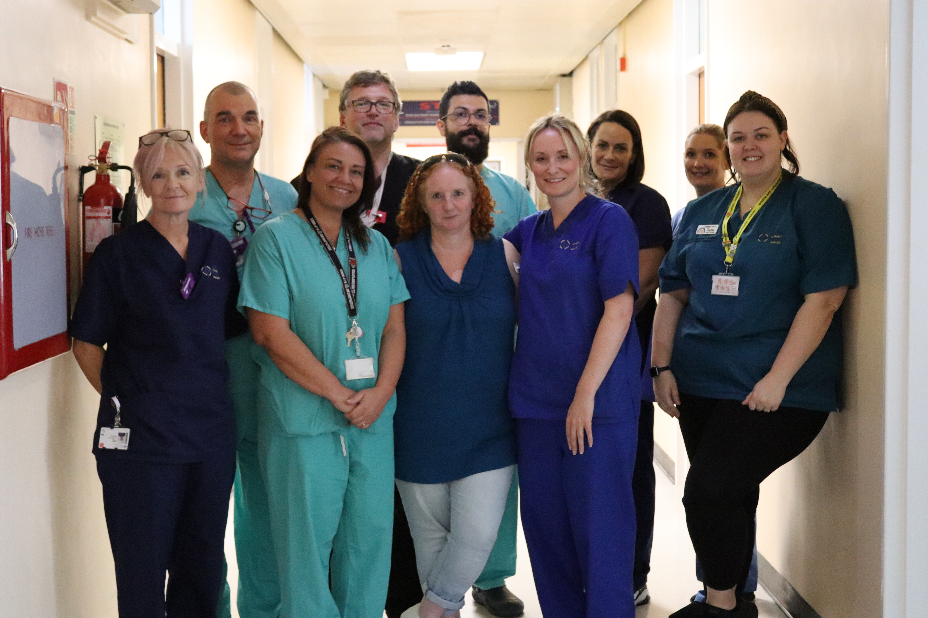
Several months after her stroke, Nia returned to meet the Interventional Neuroradiology team and the stroke team who looked after her at UHW.
A full digital patient story about Nia’s experience is still in production with colleagues from the Patient Experience team.

Appendix 2. Timeline of CAVUHB Stroke Service Developments

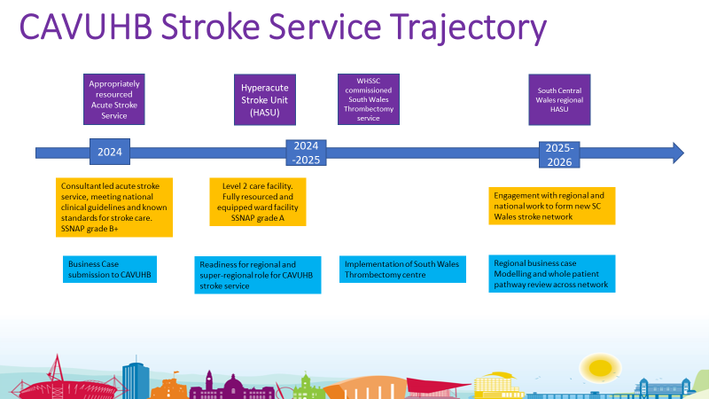

Appendix 3. Proposed Option – Year 1 Implementation Plan & Cost Projection
*updated for May 2024 IG

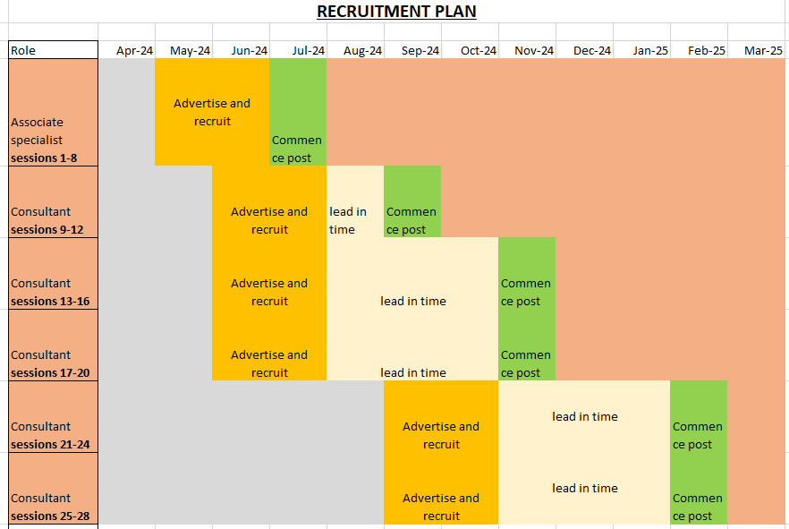
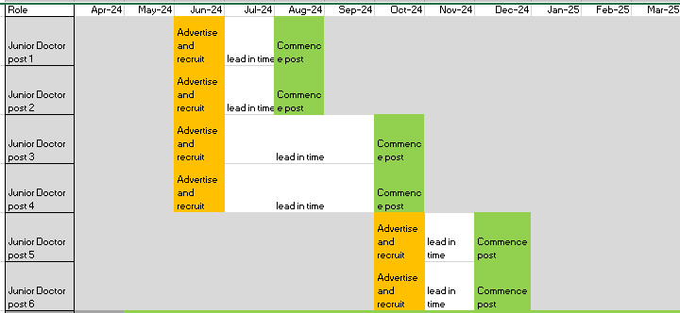
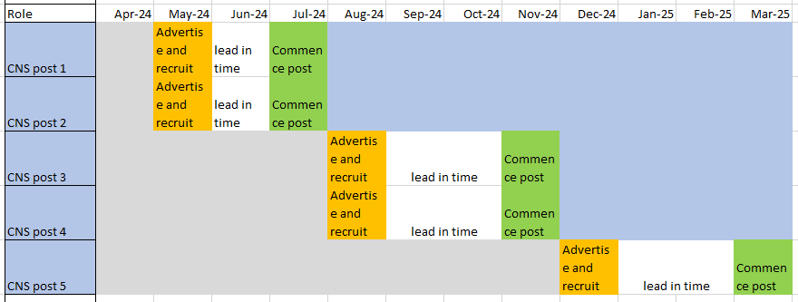
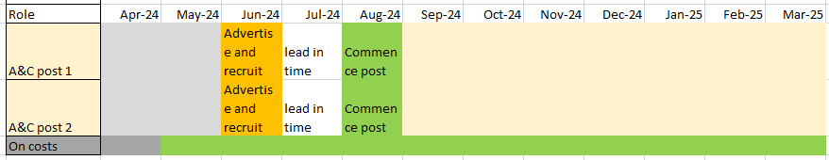

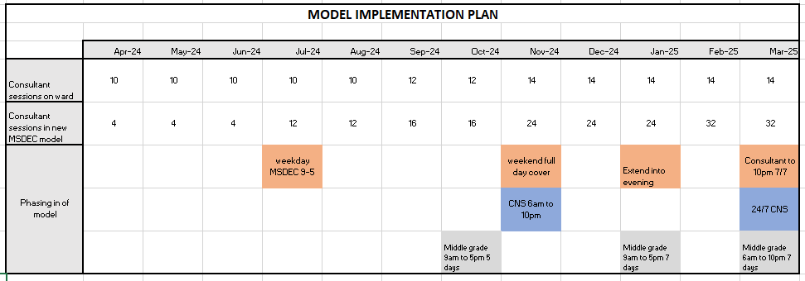

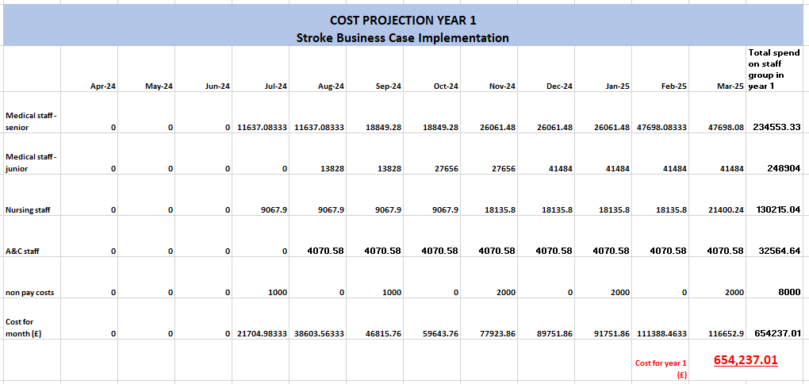

END OF DOCUMENT

