Report Title: |  |  |  | To discuss the actions from the Ombudsman's annual letter |  |  |  |  |  |  |  |  |  |  | Agenda Item no. |  |  | 6.9
Meeting: |  |  |  | Public Board |  |  |  |  |  | Public |  |  |  |  | Meeting Date: |  |  | November 2024
 |  |  |  |  |  |  |  |  |  | Private
Status  (please tick one only): |  |  |  | Assurance |  |  |  | X |  | Approval |  |  |  |  | Information
Lead Executive: |  |  |  | Executive Nurse Director
Report Author (Title): |  |  |  | Assitant Director of Patient Experience
Main Report
Background and current situation:
The Public Services Ombudsman for Wales (Ombudsman) writes annually to each Health Board in Wales, providing an overview of trends, performance, and key insights from the Ombudsman’s office over the past year. These letters are publicly available on the Ombudsman’s website.
A copy of the letter can be found in the Annual Letters section of the PSOW website.Annual Letters
The Annual Letter was presented to the Quality, Safety & Experience (QSE) Committee in October 2024 and will be presented to the Board in November 2024, and this paper outlines the actions in response.
For context, the data from the Annual Letter indicated that the Health Board was at the average level for complaints received and investigated, measured per 1,000 residents for each health board area.
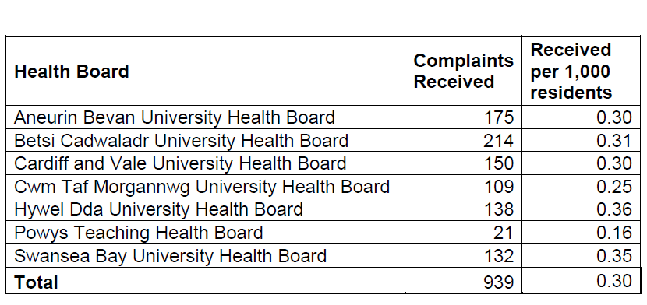

The subjects and themes resonate with those reported in our regular quality indicators reports to QSE –

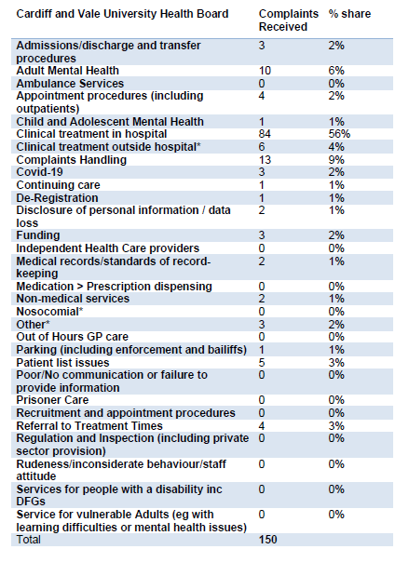
Clinical treatment in hospitals has been the most significant concern raised with the Ombudsman regarding Cardiff and Vale University Health Board.
The outcomes of the Ombudsman’s investigations are outlined below.
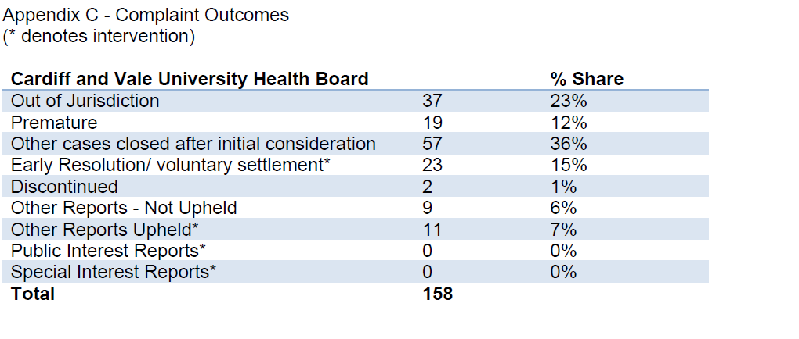
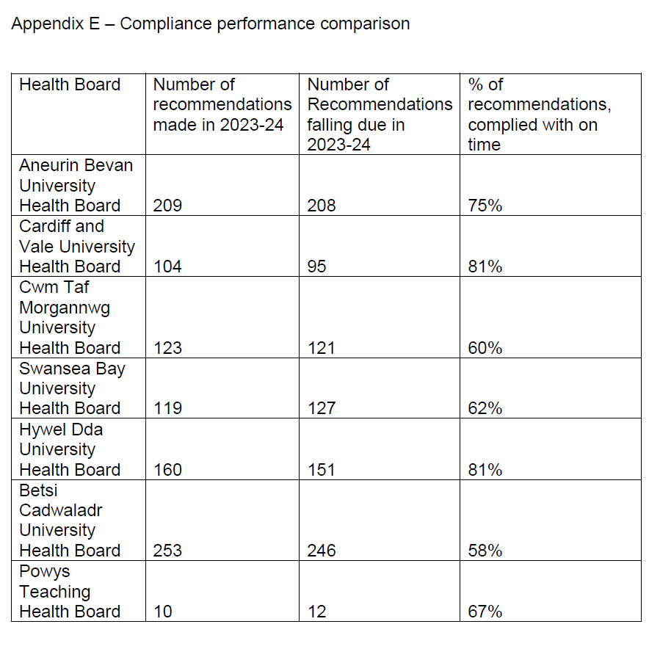
When a report is upheld, the Ombudsman’s recommendations aim to prevent or reduce the risk of recurrence by implementing robust actions to address the identified failings. While the Health Board currently demonstrates a compliance rate of 81% within the requested time frame, we recognise this as an area for improvement. The Patient Experience Team is utilising AMAT, an audit management and clinical tracking system, to monitor compliance with recommendations and escalate any issues to the weekly Executive meetings. We are optimistic that this will lead to an improvement in compliance rates.

Annual Letter actions

In response to the annual letter the Health Board was asked to take the following actions and these will be reported in detail through the Quality Safety and Experience Committee.

• Present my Annual Letter to the Board at the next available opportunity and notify me of when these meetings will take place. -November Board Meeting on 28th November 2024

• Consider the data in this letter, alongside your own data, to understand more about your performance on complaints, including any patterns or trends and your organisation’s compliance with recommendations made by my office. -to be discussed at the QSE-Quality. Safety and Experience Committee – January 2025

• Provide my office with a copy of the Health Board’s Annual Report for 2023/24 on the Duty of Candour and Quality. -We provide a regular Quality Indicators report to the QSE-Quality. Safety and Experience Committee in line with always on reporting. Some examples are linked below.

Quality Indictors to QSE August 23

Quality Indicators to QSE October 23

Quality Indicators to QSE March 24

The recent AGM-Annual General, meeting held on 11 September 2024 presented the Annual report 23/24 and the Annual Quality Report 23/24

As a Health Board we welcome the independent scrutiny of your office and the publications provided which help us to review our services. I

The Ombudsman’s office will be provided with a copy of the paper
he further actions are
Executive Director Opinion and Key Issues to bring to the attention of the Board/Committee:
The Annual letter will be discussed at the Board Meeting in November 2024

Recommendation:
The committee is requested to: Note the contents of the report

Link to Strategic Objectives of Shaping our Future Wellbeing:
Please tick as relevant
- Reduce health inequalities |  |  |  |  |  |  |  |  |  |  | - Have a planned care system where demand and capacity are in balance
- Deliver outcomes that matter to people |  |  |  |  |  |  |  |  |  |  | - Be a great place to work and learn
- All take responsibility for improving our health and wellbeing |  |  |  |  |  |  |  |  |  |  | - Work better together with partners to deliver care and support across care sectors, making best use of our people and technology
- Offer services that deliver the population health our citizens are entitled to expect |  |  |  |  |  |  |  |  |  |  | - Reduce harm, waste and variation sustainably making best use of the resources available to us
- Have an unplanned (emergency) care system that provides the right care, in the right place, first time |  |  |  |  |  |  |  |  |  |  | - Excel at teaching, research, innovation and improvement and provide an environment where innovation thrives
Five Ways of Working (Sustainable Development Principles) considered
Please tick as relevant
 | Prevention |  | Long term |  |  |  | Integration |  |  |  |  |  | Collaboration |  |  |  | Involvement
Impact Assessment:
Please state yes or no for each category. If yes please provide further details.
Risk: Yes
The review of compliance with recommendations will be undertaken

Safety: Yes
The Ombudsman provides an independent scrutiny of cases

Financial: Yes
The ombudsman can offer financial redress to people raising concerns

Workforce: Yes/No
Legal: Yes/No
Reputational: Yes
There is significant reputational risk from Public interest reports

Socio Economic: Yes/No
Equality and Health: Yes/No
Decarbonisation: Yes/No
Approval/Scrutiny Route:
Committee/Group/Exec |  |  |  |  | Date:

