Annual Assurance Report on compliance with the Nurse Staffing Levels (Wales) Act: Report for Board/Delegated Committee
Health board/trust | Cardiff and Vale University Health Board
Date annual assurance report is presented to Board | 30th May 2024  Reporting Period 6th April 2023- 5th April 2024
 | Adult acute medical inpatient wards | Adult acute surgical inpatient wards |  | Paediatric inpatient wards
During the last year the lowest and highest number of wards | 20-21 | 18 |  | 2
During the last year the number of occasions (wards where section 25B applies) where the nurse staffing level has been reviewed/ recalculated outside the bi-annual calculation periods | 1 | 0 |  | 0
The process and methodology used to calculate the nurse staffing level. | The process for calculating the nurse staffing levels are well established in Cardiff and Vale UHB. Using the prescribed method in Section 25C of the Nurse Staffing Levels (Wales) Act 2016 (the 2016 Act) a triangulated approach is used, captured on the All-Wales recording template. The recording templates are agreed and signed off through the nursing structure from Ward Sister or Charge Nurse to Executive Nurse Director (designated person). Within these templates the nurse staffing levels are calculated using:  Professional Judgement: The Ward Sister/ Charge Nurse and Lead and Senior Nurses in conjunction with the Clinical Board Director of Nursing use their knowledge of the clinical area to inform the levels of nurse staffing and provide professional judgement. Compliance data with mandatory training, vacancy and sickness rates, temporary staffing usage, bed occupancy and student feedback are considered as part of this process. This information is presented to the designated person within the All-Wales recording template as part of the bi-annual establishment reviews where further professional discussions takes place.  Patient acuity: In Cardiff and Vale UHB, using the Welsh Levels of Care acuity tool, patients are assigned an acuity score twice in a 24-hour period. Using the digital platform SafeCare; live operational decisions are made in relation to nurse staffing and patient acuity. Furthermore, this has provided a significantly improved opportunity to capture data. Using a power Bi-dashboard, trends in patient acuity are closely monitored and responded to. This provides much greater insight into patient acuity in each area and is used when calculating the nurse staffing levels. SafeCare is used in all 25B wards and many other additional areas, including the assessment unit, the critical care unit and recently across Mental Health.  Quality indicators – As part of the establishment review process and the bi-annual calculation the Ward Sister or Charge Nurse through to the Director of Nursing considers circumstances where patient well-being is sensitive to the care provided by a nurse. This is then shared with the designated person.  Using the quality indicators, data is reviewed on:  - Acute Medical/ Surgical Inpatient Wards: patient falls, pressure ulcers and medication errors.  - Paediatric Inpatient Wards: Pressure ulcers, Medication errors and Infiltration/ extravasation injuries  Furthermore, consideration is given to complaints made about care provided to patients by nurses. Only quality indicators which meet the reporting criteria are reported on and further detail is provided on page 16 of this report.  The infographic below has been taken from the SafeCare power-Bi dashboard and is the combination of data for all 25B wards for a month period. It contains information relating to SafeCare compliance by day and night, the acuity levels across the 25B wards, the nurse staffing levels and the professional judgment recorded by the nurse in charge as to whether the nurse staffing levels were appropriate. Across the organisation Ward Sisters and Charge Nurses through to Directors of Nurses and the Executive team have access to this monthly updated dashboard. Within the dashboard, there is the ability to review at directorate level through to individual ward areas. Greater insights into any emerging trends can be observed, offering opportunities to respond quickly to the data. Conversations around nurse staffing levels are therefore evolving with greater assurances around the appropriateness of the nursing establishments required to meet the needs of the patients.  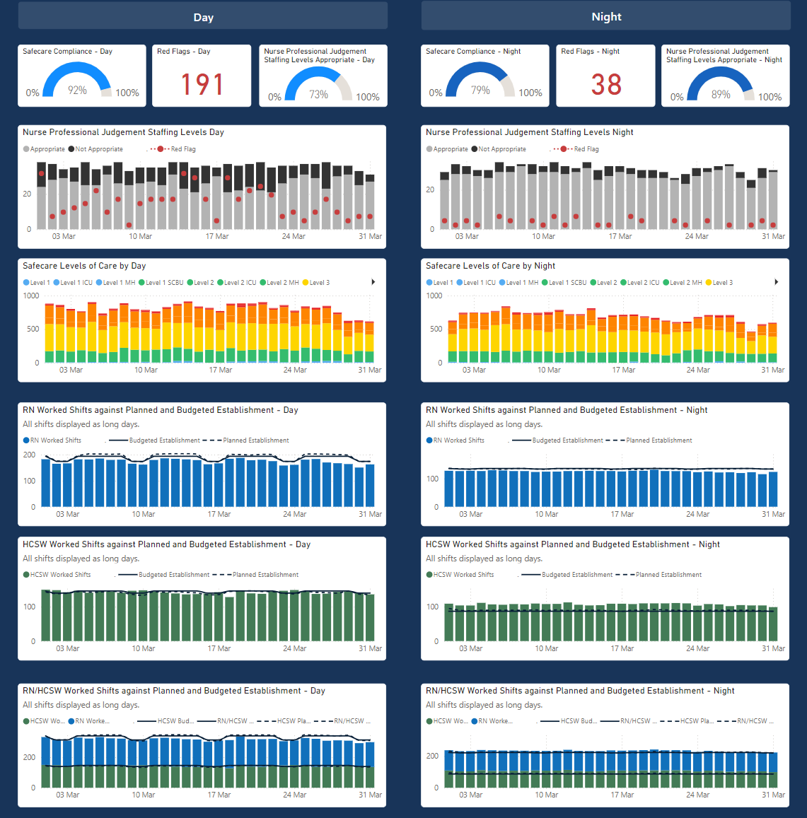  On all 25B wards, prior to triangulation an uplift of 26.9% is applied to support staff absences from the ward (26.9% was agreed in 2011 as the evidence-based uplift factor for use in Wales by Nurse Directors). Ward Sisters and Charge Nurses are supernumerary to the planned roster and the signed off establishment. There is one example on a 25B ward captured in Appendix 1 where the supernumerary status of the ward sister was not being protected due to an increase in the number of beds and the acuity of patients. During this reporting period this has been uplifted to ensure there is 1 WTE supernumerary ward sister.  Due to the current workforce challenges and short notice unavailability of staff, in order to mitigate risk, the Ward Sisters and Charge Nurses are required to work as part of the roster. This only occurs on a short notice basis and where other mitigating actions have been considered. The redeployment of Ward Sisters and Charge Nurses does not occur as part of roster planning and systems are in place to monitor the number of occasions where this redeployment has occurred. Furthermore, as part of the All-Wales Standard Operating Procedure in the use of SafeCare, a Red Flag can be raised when the Ward Sister/ Charge Nurse is not supernumerary to the planned roster.  CAVUHB has continued to see unprecedented demand on clinical services. Furthermore, there has been significant organisational change during this period with a number of wards moved. As a result, several establishment changes have occurred during the current reporting period as part of the bi-annual reviews and a summary of this can be seen in the table below (Appendix 1 has further details).  Stroke Rehabilitation Centre  The Stroke Rehabilitation Centre (SRC) is a busy stroke ward providing inpatient rehabilitation. Despite the rehabilitation nature of the ward, SRC still provides acute care to patients and is considered a 25B ward. During the most recent establishment review (April 2024), the current nursing establishment has not been agreed by the Ward Sister and Lead Nurse. This is due to concern that the Nurse Staffing Levels requires further in depth review due to the complexity and acuity of the patients being cared for on this unit. During the review meetings early discussions around multi-professional approaches to support the team around the patient model was highlighted and this needed further work and review. An SBAR has been completed by the Lead Nurse to progress this work. This work is being overseen by the Director of Nursing for the Clinical Board. The establishment will continue to be monitored and an out of cycle review will take place when this work is completed.  Mental Health  Mental Health does not fall under 25B of the 2016 Act and remains a 25A area. It has been acknowledged in previous Nurse Staffing Reports to Board the difficulty in aligning mental health areas to the financial envelope. This has been managed through redeployment of staff and underspends in other areas, for example due to vacancies. Work has been ongoing over the previous 6 months to review the establishments in Mental Health to understand the needs of the service; ensuring they are appropriate based on the professional judgment of the designated person in collaboration with the clinical board.  SafeCare was introduced in January 2023 across Mental Health inpatient wards. This allows the nurse in charge to enter information about the appropriateness of the nurse staffing levels and the acuity of patients using the Welsh Levels of Care tool for Mental Health. Through the use of dashboards this information is now becoming available to use as part of the establishment reviews. During the spring establishment reviews further discussions have taken place with the Executive Nurse Director, the Chief Operating Officer, Director of Finance and the Clinical Board. Through these discussions key priorities have been established. Some of the focus of this work includes reviewing the establishment of registered nurses on designated wards at night and also reviewing the shift patterns to ensure appropriate care is available to patients across the twenty-four-hour period.
  Ward | Reason for Establishment Change
  C1 | Increase in bed capacity.
  A6 South | Previously located on Duthie, reduction in beds from 24 to 19.
  B6 | Uplift in HCSW overnight to support patient care.
  West 3 | Reduction in beds from 20 to 16.
  B5 | Increase in RN workforce to support acute dialysis, reduction in Band 3 role.
  West 6 | Previous C5 cardiothoracic establishment split over to 2 areas. Uplift to West 6 as Bethan ward closed.
  C7 | Previous C6 establishment. Small increase in RN and decrease in Band 3 role.
  B2 Link | Change in location and out of cycle review. Increase in HCSW in due to additional capacity.
  Lakeside 2 | Change to workforce model with introduction of Band 4 role Spring 2023 and reduction in Band 3 role.
  Stroke Rehab Centre | Previously not included as a 25B ward due to the rehabilitation nature of the ward however due to the acuity and ongoing care needs are included as a 25B ward.
  C5 (Winter Ward) | Opened to support winter pressures.
  B1 | Uplift in supernumerary status of ward sister. Further increase in establishment due to additional beds required.
  B4 Haematology | Reduction in HCSW as A4 previously included within this establishment.
  Gwdihw | Increase in RN to support elective stream. Increase in establishment due to the re-location of beds from Island Ward.
  Island | Reduction in establishment due to the re-location of beds on Gwdihw.
Informing patients | The statutory guidance states that “LHBs and Trusts must make arrangements to inform patients of the nurse staffing level”. The Health Board is required to inform patients of the nurse staffing levels by ensuring that the most up to date information is displayed on wards in relation to the staffing levels agreed.  The Covid-19 pandemic significantly impacted on the Health Boards ability to inform patients of the nurse staffing levels for infection prevention and control reasons and due to the ongoing operational pressures. In March 2023 the Health Boards Internal Audit Department undertook a formal review of the Health Boards compliance with the 2016 Act and the report provided “reasonable assurance”. The report highlighted that in most cases the nurse staffing levels were being displayed on the wards however the establishment templates forms that were being used to display the nurse staffing levels were incorrect and in some cases the information was of the previous establishment reviews.  Work has been done to ensure the templates on display are the All-Wales Informing Patients templates and available bilingually. The frequently asked questions have been made available to all the Ward Sisters and Charge Nurses and can be accessed from the CAV Nurse Staffing Share Point page. Within the digital audit platform; Tendable, questions related to the informing patients’ templates have been created. Ward Sisters and Charge Nurses are able to audit their clinical area on compliance with this informing patients element of the 2016 Act. In February 2024 38 audits took place in Tendable, (35 wards to which section 25B pertains) and compliance across the questions was 89.5%.  There is still further work to be done in this area, particularly following the re-organisation of the wards in UHW. Additional questions have been added into Tendable, to audit whether the Frequently Asked Questions are displayed..
Section 25E (2a) Extent to which the nurse staffing level has been maintained
As the nurse staffing level is defined under the NSLWA as comprising of both the planned roster and the required establishment, this section should provide assurance of the extent to which the planned roster has been maintained and how the required establishments for Section 25B wards have been achieved/maintained during the period of this annual report
Extent to which the required establishment has been maintained within adult acute medical and surgical wards.

NB: First cycle: spring 2022 following January audit
Second cycle: autumn 2022: following June audit
 |  |  | Number of Wards: | RN (WTE) | HCSW (WTE)
 | Required establishment (WTE) of adult acute medical and surgical wards calculated during first cycle (May 2023) |  | 38 | 838.79  Please see below narrative | 650.61  Please see below narrative
 | WTE of required establishment of adult acute medical and surgical wards funded following first (May 2023) calculation cycle |  | 38 | 838.79 | 650.61
 | WTE Supernumerary band 7 sister/charge nurse (funded but excluded from planned roster) |  | WTE: 37.2
 | Required establishment (WTE) of adult acute medical and surgical wards calculated during second calculation cycle (Nov 2023) |  | 39 | 845.32 | 651.99
 | WTE of required establishment of adult acute medical and surgical wards funded following second (Nov 2023) calculation cycle |  | 39 | 845.32 | 651.99
 | WTE Supernumerary band 7 sister/charge nurse (funded but excluded from planned roster) |  | WTE: 39
 | Required establishment (WTE) of adult acute medical and surgical wards calculated for the proposed roster (May 2024) |  | 38 | 832.09 | 642.44
 | WTE of required establishment of adult acute medical and surgical wards funded for the proposed roster (May 2024) |  | 38 | 832.09 | 642.44
 | WTE Supernumerary band 7 sister/charge nurse (funded but excluded from planned roster) |  | WTE: 38
All Wales Paragraph:

In accordance with the requirements of the Nurse Staffing Levels (Wales) Act 2016 and its associated Statutory Guidance, the ‘nurse staffing level’ is the establishment of registered nurses - and other staff to whom nursing duties have been delegated by a registered nurse - required to deliver the planned roster. It is acknowledged that there is a range of additional healthcare professionals that contribute to the delivery and coordination of patient care and treatment. However, these staff are not included within the data for this report.

Cardiff and Vale UHB Update

In previous annual assurance reports the information reported to board within this section is the current (proposed) nurse staffing levels which have been approved by the Executive Director of Nursing during the most recent establishment review. The previously signed off establishment during the previous cycle is also reported on. The template above requires reporting on the previous two cycles and therefore to meet the needs of the 2016 Act and the ongoing requirements to inform the Cardiff and Vale Executive Board of the current establishments agreed by the Executive Director of Nursing, additional rows has have been added to the template.

25B Wards of the 2016 Act specifically includes acute surgical and medical inpatient wards across adults and paediatrics. The 2016 Act, Statutory Guidance contains a list of clinical areas that do not meet the definition of adult acute medical/surgical inpatient wards and therefore there are clinical areas excluded from this reporting. Some examples of areas excluded would be the Emergency Unit, Critical Care and Rehabilitation Units. Furthermore, the Assessment Unit and Same Day Surgical Decision Units are excluded and there has been a rise in demand for these services as models of care are developed to prevent patients being admitted into hospital. Across Cardiff and Vale UHB other areas, such as the Integrated Assessment Care Unit has been developed for patients not requiring acute care and therefore these areas are also not included within the 25B wards definition.

May 2023

The figures reported to board in May 2023 was RN 927.94 WTE and HCSW 666.86 WTE. There has been significant re-organisation of wards in UHW and there have been changes to the wards included as 25B wards. Of particular note A1 Link and A1 MDU (now located on A2) are included in the Emergency and Acute Medicine Directorate. A1 Link is now part of the assessment unit and it has been confirmed with the Lead Nurse that patients admitted to A2 have a hospital stay between 24 hours and 72 hours. These areas are not included as the 25B wards and therefore the reduction of RN should be noted with caution as these areas are still open. Furthermore, due to the requirements of the All-Wales template the supernumerary ward sister/ charge nurses were included within the total RN reported figures. The template has now changed, and have been separated out for all the reporting cycles to ensure consistency in reporting.

The figures reported above is based on the information in Appendix 1 provided within this report and for those wards that are considered to be 25B wards. The figures have been updated in the above template to ensure a consistent narrative and changes to nurse staffing levels are accurately reflected.

November 2023

These figures include the establishment required for C5 ward which opened in November 2023 to support winter pressures. This ward is due to close April 2024 and therefore no ongoing establishment was signed off in May 2024. However, it should be noted that to date, due to operational pressures ward C5 has been unable to close. If the ward remains open a new establishment template will be completed.

Extent to which the required establishment has been maintained within paediatric inpatient wards
NB: First cycle: spring 2022 following January audit
Second cycle: autumn 2022: following June audit
 |  |  | Number of Wards: | RN (WTE) | HCSW (WTE)
 | Required establishment (WTE) of paediatric inpatient wards calculated during first cycle (May 2023) |  | 2 | 104.21 | 25.02
 | WTE of required establishment of paediatric inpatient wards funded following first (May 2023) calculation cycle |  | 2 | 104.21 | 25.02
 | WTE Supernumerary band 7 sister/charge nurse (funded but excluded from planned roster) |  | WTE: 2
 | Required establishment (WTE) of paediatric inpatient wards calculated during second calculation cycle (Nov 2023) |  | 2 | 106.24 | 25.02
 | WTE of required establishment of paediatric inpatient wards funded following second (Nov 2023) calculation cycle |  | 2 | 106.24 | 25.02
 | WTE Supernumerary band 7 sister/charge nurse (funded but excluded from planned roster) |  | WTE: 2
 | Required establishment (WTE) of adult acute medical and surgical wards calculated for the proposed roster (May 2024) |  | 2 | 106.24 | 25.02
 | WTE of required establishment of adult acute medical and surgical wards funded for the proposed roster (May 2024) |  | 2 | 106.24 | 25.02
 | WTE Supernumerary band 7 sister/charge nurse (funded but excluded from planned roster) |  | WTE: 2
All Wales Paragraph

In accordance with the requirements of the Nurse Staffing Levels (Wales) Act 2016 and its associated Statutory Guidance, the ‘nurse staffing level’ is the establishment of registered nurses - and other staff to whom nursing duties have been delegated by a registered nurse - required to deliver the planned roster. It is acknowledged that there is a range of additional healthcare professionals that contribute to the delivery and coordination of patient care and treatment. However, these staff are not included within the data for this report.

Cardiff and Vale UHB Update:

The 2 paediatric 25B wards of the 2016 Act fully partake in the establishment reviews and receive a 26.9% uplift to ensure the supernumerary status of the Ward Sister/ Charge Nurse. This has been separated out across the reporting period to ensure consistency in reporting.

Within the appendix it can be seen that there is a change to the individual ward establishments. This is because of a relocation of beds from one ward to the other. There is also an increase in establishment required in Gwdihw ward during the November 2023 establishment review, required to support the elective stream.

Extent to which the planned roster has been maintained within adult acute medical and surgical wards
   | Total number of shifts | Shifts where planned roster met and appropriate | Shifts where planned roster met but not appropriate | Shifts where planned roster not met but appropriate | Shifts where planned roster not met and not appropriate | Data completeness
  TOTAL | 14870 | 50.3% | 8.5% | 27.0% | 14.2% | 83.8%
This includes all data on 25B adult wards from 1st August until the 31st March collected via SafeCare. This data is available on the SafeCare Census Staffing Assessment dashboard (infographic below). This dashboard is updated monthly and is available with ward level detail. This data is currently only available for 25B wards due to the adaptions made to SafeCare to accommodate other clinical areas (e.g. the Emergency Unit).

In the caveated three yearly report (provided to board in March 2024) over the previous three-yearly reporting period there has been a reduction in the percentage of shifts where the planned roster is met and appropriate. However there has also been an increase in the number of shifts with the planned roster is not met but the nurse in charge has still deemed the staffing as appropriate. Reasons for this may be due to closures of beds due to infection control or reduction in some services during industrial action. The way the dashboard is calculated, is based on any variation from the signed off establishment would mean that the planned roster would be considered as not met. It should also be noted the significant change in how this information is recorded and reported on during this 3-yearly period.

The professional judgment of nursing teams is recognised as being essential. In total 77.3% of shifts have been recorded as appropriate by the nurse in charge. Providing nursing teams with their data they enter in SafeCare supports the quality assurance of this data and also inform the professional nursing conversations outside of the formal establishment review process. A substantial proportion of shifts, 22.7% of shifts are recorded as not appropriate by the Nurse in Charge of the ward, whether the planned roster was met or not met. This represents the significant challenge faced by nursing teams. Evidence of risk mitigation and steps taken to review this on daily basis is documented below.
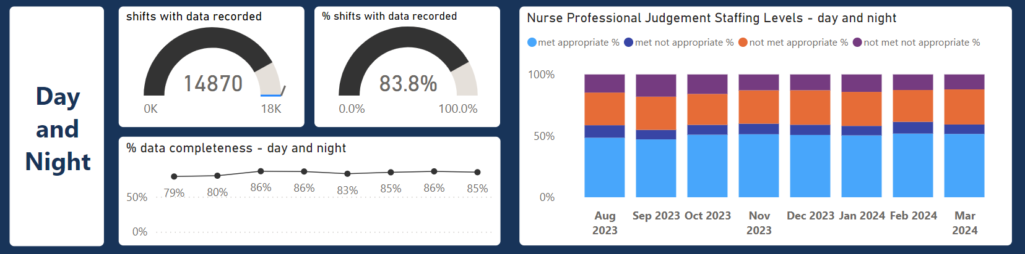
SafeCare Census Staffing Assessment Dashboard- Adult 25B Wards

Extent to which the planned roster has been maintained within paediatric inpatient wards
   | Total number of shifts | Shifts where planned roster met and appropriate | Shifts where planned roster met but not appropriate | Shifts where planned roster not met but appropriate | Shifts where planned roster not met and not appropriate | Data completeness
  TOTAL | 962 | 9.8% | 1.5% | 70.9% | 17.9% | 98.6%
Paediatric Inpatient Wards

There is a significant rise in the number of shifts reported in paediatrics as nurse staffing levels not met but appropriate using professional judgment. The data has been reviewed by the Lead Nurse and Director of Nursing and it is recognised that the established nurse staffing levels are not being met, however the nurse staffing levels have been professionally judged as appropriate. As part of winter planning and in a focused effort to reduce waiting lists there has been an increase in the number of day surgery cases, and hence a reduction in acuity. Furthermore 8 medical beds have been re-located to Gwdihw and the nursing establishment has been used flexibly across the ward locations during this transition period to ensure appropriate nurse staffing levels are in place. To reflect these changes there has been a change to the establishment in May 2024 to ensure this accurately reflects the staffing position on the wards. Whilst this change may not be permanent it reflects the current position and any further changes to capacity will have ongoing review of establishments. Paediatric inpatient areas have SafeCare in place and there is a flow co-ordinator role with oversight for nurse staffing levels across all areas.
SafeCare Census Staffing Assessment Dashboard- Paediatric 25B Wards

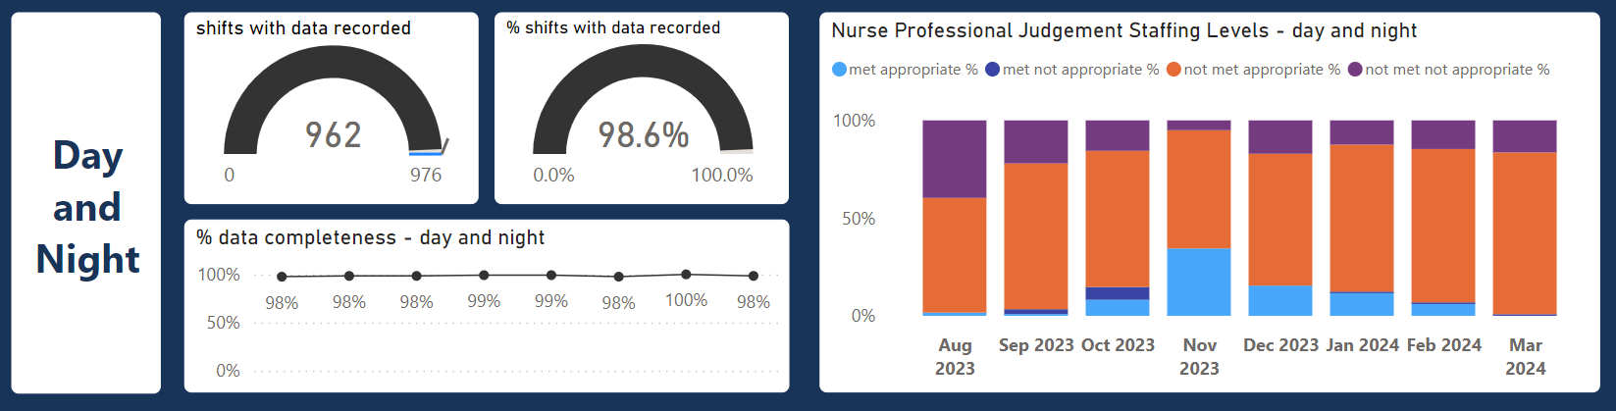

Process & systems for capturing data on the extent to which the planned roster has been maintained on wards where section 25B applies. | All Wales Paragraph:  NHS Wales is committed to utilising a national informatics system that can be used as a central repository for collating data to evidence the extent to which the nurse staffing levels have been maintained and to provide assurance that all reasonable steps have been taken to maintain the nurse staffing levels required. Extensive work has been undertaken across NHS Wales to implement a national informatics system to enable health boards/trust to meet the reporting requirements of the Act and follow the Once for Wales approach to ensure consistency.  Each health board/trust is committed to implementing Allocates Safecare system and each organisation is at different stages of implementing this system within their areas, prioritising section 25B wards. Health boards/Trusts have also been using the Health Care Monitoring system (HCMS) which has been adapted to ensure consistency in the data collection and analysis to aid reporting.  Due to the transitional arrangements whereby health boards/trusts are implementing Allocates Safecare system alongside the use of HCMS to capture the data required to inform the calculation and reporting of the nurse staffing level, the data presented in the above tables will be a combination of information generated from Safecare and HCMS.  Cardiff and Vale UHB Update:  SafeCare has been introduced to all 25B wards and was completed in early 2023. Due to issues with recording the professional judgment of the appropriateness of the nurse staffing levels in the SafeCare software this feature only became available in July 2023. Therefore, the data above is all the data available from SafeCare from the 1St August 2023. Data is inputted by the nurse in charge at the start of a day shift and night shift. SafeCare compliance in April 2024 by Day was 94% and 79% at Night across all 25B wards.  There is no national reporting solution currently available to report on the nurse staffing levels directly from HealthRoster/ SafeCare Allocate system. Significant work has been undertaken by the Corporate Nursing Team in CAVUHB to ensure a long-term solution to meet the reporting requirements of the 2016 Act. The dashboards available not only service the requirement to report on the nurse staffing levels but also supports the professional nursing conversation.  SafeCare has now been rolled out to over 90 clinical areas. More recently SafeCare has been introduced across 20 mental health inpatient wards. SafeCare is in use in Maternity in an adapted form for the clinical area and continues to be used in other areas such as community inpatient wards.
Process for maintaining the Nurse staffing level | As previously reported SafeCare has been adapted widely across the inpatient settings in Cardiff and Vale UHB. The system which allows live monitoring of patient acuity and nurse staffing, aids operational decision making and risk mitigation in relation to nurse staffing. This has supported changes to the way in which nurse staffing is reviewed on a daily basis. In addition to the Cardiff and Vale UHB Operating Framework, a Rostering Principles and Good Practice Guide has been produced and agreed by the Directors of Nursing. This provides information on SafeCare use and a quick guide to the operating framework in and out of hours.  The ‘reasonable steps’ taken to maintain the nurse staffing level across the organisation include:  - Daily review of nurse staffing levels throughout each Clinical Board by the Senior Nursing Team.  - Red Flags and Professional Judgements reviewed in SafeCare.  - Twice Daily staffing meetings, chaired by a Director of Nursing with representatives from the clinical board to provide organisation overview of any unresolved red flags or staffing concerns.  - Consideration of the redeployment of staff through the use of SafeCare.  - The use of temporary staffing where necessary.  - Senior Nurse Staffing Rota to provide weekend cover 07:00-21:00hrs.  Temporary Staffing  The challenging financial pressures across the Health Board has been well documented and there has been significant reliance on temporary staffing to cope with the effects of the pandemic and subsequent workforce challenges. Significant work has been undertaken across nursing to reduce the reliance on temporary staffing. In particular agency is no longer used for Health Care Support Workers and measures were put in place in August 2023 to reduce agency usage for registered nurses. A scheme of delegation has been introduced and authorisation from Senior Managers and Exec on call is required for some agency shifts. This focus on reducing agency use has increased the reviewing of the rosters and there are reports from Senior and Lead Nurses that there is an improvement in the accuracy of the rosters.
Section 25E(2b) Impact on care due to not maintaining the nurse staffing levels on adult acute medical and surgical inpatient wards

Incidents of patient harm with reference to quality indicators and complaints about nursing care | Hospital acquired pressure damage (grade 3, 4 and unstageable) | Falls resulting in serious harm or death (i.e. 4 and 5 incidents). | Medication errors never events | Any complaints received about nursing care  (NOTE: Complaints refers to those complaints managed under NHS Wales complaints regulations (Putting Things Right (PTR)
 | TOTAL | TOTAL | TOTAL | TOTAL
Number of closed incidents/complaints occurring during current year & those that were carried forward from the previous year. | 30 | 6 | 0 | 0
Total number of incidents/ complaints not closed and to be reported on/during the next year | 6 | 1 | 0 | 7
Number of closed incidents/ complaints occurring when the nurse staffing level (planned roster) was not maintained | 3 | 1 | 0 | 0
Number of closed incidents/  complaints where failure to maintain the nurse staffing level (planned roster)was considered to have been a contributing factor | 1 | 0 | 0 | 0
All Wales Paragraph

Based on a review of the Health Boards/Trusts first 3 yearly reports and feedback from operational leads on their experience completing the reports; an SBAR was presented to the Executive Nurse Directors and CNO in 2021, which included a series of recommendations to improve and refine the reporting process. Following this a sub-group of the All Wales Nurse Staffing Group was set up to improve and refine the reporting process to standardise reporting and be in line with the Duty of Candour set out in the Quality & Engagement Act (2020), and broaden the scope of incidences of harm to provide more meaningful data, by including moderate risk falls and medication error incidents.
The reporting sub group presented the recommendations for the amended measures to the Executive Nurse Directors in August 2023 who agreed to the changes being proposed with the intention that the amended measures come into effect at the beginning of the next reporting period i.e. April 2024.
The quality indicators for the adult medical and surgical wards will be as follows:
- Hospital acquired pressure damage (grade 3, 4 and unstageable) (avoidable and unavoidable)
- Falls resulting in moderate harm, serious harm or death (i.e. level 3, 4 and 5 incidents).
- Medication errors resulting in moderate harm, severe harm, death & never events (i.e. level 3, 4, 5 and never events incidents).
- Any complaints received about nursing care (Complaints refers to those complaints managed under NHS Wales complaints regulations (Putting Things Right (PTR))
The data to be reported for each of the above will be:
- Number of closed incidents/complaints occurring during current year & those that were carried forward from the previous year.
- Total number of incidents/ complaints not closed and to be reported on/during the next year
- Number of incidents/ complaints occurring when the nurse staffing level (planned roster) had not been maintained
- Number of those incidents/complaints where failure to maintain the nurse staffing level (planned roster) was considered to have been a contributing factor
- Number of incidents/complaints occurring when the nurse staffing level (planned roster) had been maintained
- Number of those incidents/complaints when the nurse staffing level was deemed to have been a contributing factor, even when planned roster had been maintained.
Cardiff and Vale UHB Update
The data in the above template is provided from incidents recorded within the Datix system. There are significant complexities in extracting the data from this system and it involves a manual process with a number of different field options. There is therefore some concern regarding the data, despite significant efforts to ensure all incidents are captured consistently across the UHB and across Wales. This has been raised as part of the All-Wales Nurse Staffing Programme and discussions are taking place to explore opportunities to create an All-Wales dashboard within datix to report on these metrics. This would provide greater assurance and consistency on the data being reported.
Pressure Ulcers
The data provided for Pressure Damage has been produced by filtering on the categories; Grade 3, Grade 4, Unstageable and then those that are recorded as avoidable. A further check was done on the data to review any Nationally Reported Incidents related to pressure damage.
In the previous year (April 22-23), following guidance from the All-Wales Nurse Staffing Programme both avoidable and unavoidable pressure ulcers were recorded. It has been confirmed that in this report and future reporting, only avoidable pressure damage will be recorded. It is difficult to provide a narrative of the trends due to the inconsistencies in the reporting. However, reviewing April 21-22 report, there were 25 pressure damage incidents on the above metrics recorded. In the current report 30 incidents are recorded which would suggest a rise. Pressure damage meeting the above criteria undergo a focus review and are discussed at clinical board scrutiny panels with learning and actions shared across the clinical area.
Falls
Similarly, in the previous year both avoidable and unavoidable falls resulting in serious harm or death was reported. In this report avoidable falls based on the above categories are recorded. 6 falls are recorded during the reporting period. It should be noted that this is 1 less than what was reported in the caveated 3 yearly report for Welsh Government. Despite reporting only on closed incidents, 1 of the incidents has been reviewed by the patient safety team, and no longer meets the reporting criteria. The number of falls recorded using these metrics in April 21-22 was 9, this would suggest in this reporting period a decrease in the number of falls recorded with serious harm or death.
Medication Errors
There were no medication errors recorded as to be reported across 25B wards.
Complaints
The patient safety team have reviewed complaints. There are no complaints which have been managed under PTR and upheld in relation to nursing care. There are 7 complaints open currently and these are still undergoing review.

Section 25E(2b) Impact on care due to not maintaining the nurse staffing levels on paediatric inpatient wards
Incidents of patient harm with reference to quality indicators and complaints about nursing care | Hospital acquired pressure damage (grade 3, 4 and unstageable) | Falls resulting in serious harm or death (i.e. 4 and 5 incidents). | Medication  errors never events | infiltration and extravasation injuries | Any complaints received about nursing care  (NOTE: Complaints refers to those complaints managed under NHS Wales complaints regulations (Putting Things Right (PTR)
 | TOTAL | TOTAL | TOTAL | TOTAL | TOTAL
Number of closed incidents/complaints occurring during current year & those that were carried forward from the previous year. | 0 | 0 | 0 | 0 | 0
Total number of incidents/ complaints not closed and to be reported on/during the next reporting period | 0 | 0 | 0 | 0 | 0
Number of closed incidents/ complaints occurring when the nurse staffing level (planned roster) was not maintained | 0 | 0 | 0 | 0 | 0
Number of closed incidents/  complaints where failure to maintain the nurse staffing level (planned roster) was considered to have been a contributing factor | 0 | 0 | 0 | 0 | 0

All Wales Paragraph

The work of the Reporting Sub-Group, mentioned previously, included the measures for the paediatric inpatient wards and these were presented to the Executive Nurse Directors in August 2023, along with the amended measures for the adult medical and surgical wards. The changes to the paediatric measures were agreed, with the intention that the amended measures come into effect at the beginning of the next reporting period i.e. April 2024.

The quality indicators for the paediatric inpatient wards will be as follows:
- Hospital acquired pressure damage (grade 3, 4 and unstageable) (avoidable and unavoidable)
- Falls resulting in moderate harm, serious harm or death (i.e. level 3, 4 and 5 incidents).
- Medication errors resulting in moderate harm, severe harm, death & never events (i.e. level 3, 4, 5 and never events incidents).
- Infiltration and extravasation injuries
- Any complaints received about nursing care (Complaints refers to those complaints managed under NHS Wales complaints regulations (Putting Things Right (PTR))

The data to be reported for each of the above will be:
- Number of closed incidents/complaints occurring during current year & those that were carried forward from the previous year.
- Total number of incidents/ complaints not closed and to be reported on/during the next year
- Number of incidents/ complaints occurring when the nurse staffing level (planned roster) had not been maintained
- Number of those incidents/complaints where failure to maintain the nurse staffing level (planned roster) was considered to have been a contributing factor
- Number of incidents/complaints occurring when the nurse staffing level (planned roster) had been maintained
- Number of those incidents/complaints when the nurse staffing level was deemed to have been a contributing factor, even when planned roster had been maintained.

Cardiff and Vale UHB Update

During the review of incidents in Datix, there were 2 incidents recorded on 25B paediatric wards relating to extravasation injuries. However, on review of these incidents both were closed and recorded as no harm and therefore not included in the above table due to the description of “infiltration and extravasation injuries”. There were no other incidents to be reported on against the above metrics across the paediatric 25B wards.

 | Section 25E (2c) Actions taken if the nurse staffing level is not maintained (or maintained but not appropriate *)
Actions taken if the nurse staffing level was not maintained in wards where section 25B applies | As noted in the previous annual assurance report, maintaining the planned rosters during the reporting period has continued to be challenging. This is further evidenced in the above reporting during this reporting period. The UHB has undergone significant reorganisation of wards and a rising level of acuity has been noted. Additional demand across the Emergency Department and rising length of stay has further strained the ability of the nursing workforce to maintain established staffing levels.  Actions taken in response to not maintaining established nurse staffing levels are varied. Within clinical boards, actions are captured as part of daily staffing ‘huddles’ and efforts to mitigate short staffing are shared across clinical board. SafeCare offers staff the opportunity to raise ‘Red Flags’ where there are nurse staffing concerns in clinical areas. These Red Flags are reviewed as part of the daily staffing meetings and Senior and Lead Nurse out of hours are able to quickly review and respond to these Red Flags.  Actions taken when nurse staffing levels not maintained include:  - Clear escalation from ward based clinical staff through to Senior Nurse and Director of Nursing.  - Rosters are reviewed by the ward manager. Additional shifts and overtime offered to substantive staff.  - Risk mitigation by redeployment of staff across clinical areas.  - Support of allied health professionals to meet patient needs.  - Review of enhanced supervision requirements and consideration of opportunities to cohort appropriate patients, maintaining patient safety.  - Number of beds are reviewed and closure of beds considered if appropriate particularly across paediatrics. Nurse Staffing concerns are shared with operational site team.  - Redeployment of the Ward Sister/ Charge Nurse into the planned roster.  - Consideration of temporary staffing such as bank and agency. Agency shifts requires authorisation by a Director of Nursing.  Since the introduction in SafeCare there has been anecdotal reports of improvement in the accuracy of the rosters. Furthermore, the Senior Nurse On-Call roster Monday- Friday out of hours has recently been stepped down due to a reduction in calls and the reduction in need to make staffing decisions out of hours. Ward teams are still able to contact the site teams if there are nurse staffing concerns. The Senior Nurse On-Call Roster remains in place at weekends.  For any incidents (above) where the failure to meet staffing levels were considered to be a factor, these incidents are reported to Welsh Government as part the normal reporting procedure.
 | Section 25A: Duty to have regard to provide sufficient nurses
Requirements of Section 25A  (NB: Section 25A refers to the Health Boards/Trusts overarching responsibility to ensure appropriate nurse staffing levels in any area where nursing services are provided or commissioned, not only wards where section 25B applies) | Across Cardiff and Vale UHB the biannual review process is well established and the Executive Nurse Director reviews all nursing establishments not just those in 25B areas. The process for this is set out above in the “process and methodology used to calculate the nurse staffing level” section of this template.  Evidence of the nursing workforce planning undertaken to maintain nurse staffing levels, include:  - Over 350 nurses have joined the Health Board through the overseas nurse recruitment programme.  - 700 Registered Nurses have joined CAVUHB through the student streamlining scheme over the last 3 years.  - Focused recruitment events held across a range of settings including attendance at student streamlining events.  - Recruitment events held specifically for HealthCare Support Workers.  - A Director of Nursing is in post responsible for Strategic Nursing Workforce Planning.  - The Assistant Practitioner role has been introduced and an educational programme to support this. Currently 56 Assistant Practitioners have been employed with opportunities for many of these staff to be registered nurses by the end of 2024.  - Consideration of other roles to support patient care such as pharmacy technicians and diet assistants.  - Review of rostering practices through monthly reports to the clinical boards.  - Temporary Staffing Reports provided weekly by the E-rostering teams.  - Strategic Direction provided through key groups such as Nursing Productivity Group and Nursing Midwifery Board.
 | Conclusion & Recommendations
Across Cardiff and Vale UHB there continues to be challenges in maintaining the nurse staffing levels both in the short term and long term. The Health Board continues to provide assurance its’ staffing calculations and reporting requirements have been fulfilled. Furthermore, across the organisation there are established processes in place to review changing acuity and nurse staffing levels. Appendix 1 provides a summary of the establishment reviews agreed by the designated person (Executive Nurse Director), noting both the previous establishments and the proposed establishments agreed for the forthcoming cycle.

Highlights of this report include:

- One 25B clinical area has not had their establishment signed off. The establishment has been reviewed and there is ongoing work underway to understand the needs of the clinical area and ensure appropriate nurse staffing levels are in place.

- Significant progress has been made in the ability to report on the Nurse Staffing Levels from Ward to Board with the introduction of dashboards available for the majority of inpatient areas.

- The use of the digital solutions is still evolving, however empowering nurses to record the appropriateness of their nurse staffing levels and raise red flags when concerned will support timely responses to minimise risks to patients.

- There has been significant re-organisation of wards in UHW and there has been changes to 25B wards as set out in November 2023 in the Annual Presentation of Nurse Staffing Levels to board. This has impacted on the calculation of required staff on 25B wards. It should be noted that these areas (e.g. assessment unit) are still open but not included in this calculation. These establishments have been reviewed and agreed as 25A areas by the Executive Director of Nursing.

The Board is asked to:

Receive the report as assurance that the statutory requirements relating the Nurse Staff Levels (Wales) Act have been fulfilled.
Note the funded nurse staffing establishments detailed in appendix 1, undertaken as part of bi-annual recalculations.

