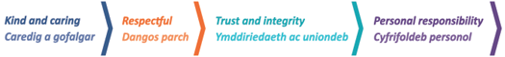
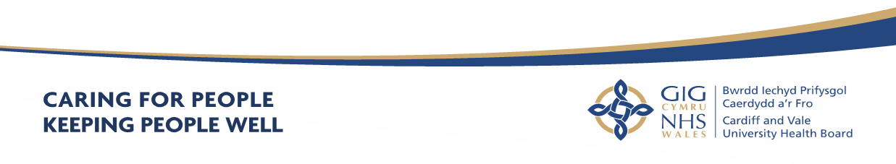
Cardiff and Value UHB
Annual Report
2022 - 2023
About Us
Cardiff and Vale University Health Board’s purpose is to care for people and keep people well. The Annual Report will outline the work of Cardiff and Vale University Health Board (the Health Board), highlight some of our key achievements and demonstrate how we are listening to the views and needs of our population, implementing many of these as part of our ambitious 10-year strategy: “Shaping our Future Wellbeing Strategy”. Our priorities, key objectives and plans are set out in our plans and the reports presented to the Board and its Committees and provide an overview of what we are doing well and how we are listening to our public, patients and staff in order to achieve the strategy.

What’s in this Annual Report?

Our Annual Report is part of a suite of documents that tell you about our organisation, the care we provide and what we do to plan, deliver and improve healthcare for you, in order to meet changing demands and future challenges. It provides information about our performance, what we have achieved in 2022-2023 and how we will improve next year. It also explains how important it is to work with you and listen to you to help you to take the best care of yourselves and to deliver better services that meet your needs and are provided as close to you as possible.

Our Annual Report for 2022-2023 includes:

- Our Performance Report which details how we have performed against our targets and actions planned to maintain or improve our performance.
- Our Accountability Report which details our key accountability requirements under the Companies Act 2006 and the Large and Medium-sized Companies and Groups (Accounts and Reports) Regulations 2008. The Accountability Report includes our Annual Governance Statement (AGS) which provides information about how we manage and control our resources and risks, and comply with governance arrangements, the Renumeration and Staff Report, and the Welsh Parliament Accountability and Audit Report.
- Our Financial Statements (Audited Accounts) which detail how we have spent our money and met our obligations under the National Health Service Finance (Wales) Act 2014.

The Annual Report should be read in conjunction with other supporting documents, signposted by means of web-links within this document.

Accessibility

If you require additional copies of this document, it can be downloaded in both English and Welsh versions from our website. Alternatively, if you require the document in an alternative format, we can provide a summary of this document in different languages, larger print or Braille, please contact us using the details below:

Corporate Governance Department Cardiff and Vale University Health Board, Corporate Headquarters
Woodland House
Maes-y-Coed Road
Heath
Cardiff CF14 4HH

Email: Corporate.Meetingcav@wales.nhs.uk
Website: www.cardiffandvaleuhb.wales.nhs.uk/
A full PDF version is available on our website.

Contact Us
Email: news@wales.nhs.uk
Website: http://www.cavuhb.nhs.wales/
Twitter: @CV_UHB
Facebook: www.facebook.com/cardiffandvaleuhb

Contents (page numbering to be inserted once graphic work completed)

Page
1.Welcome from Chair and Chief Executive
2.Cardiff and Vale Health Board Profile
2.1 About Us
2.2 Our Mission and Vision
2.3 Our Board
2.4 Our Structure
2.5 The Population We Serve
2.6 Principles of Remedy
2.7 Our Strategy
2.9 Research, Development, Innovation and Partnerships
Part 1 – Performance Report
3. Performance Overview
3.1 Introduction
3.2 Statement from the Chief Executive
3.3 Integrated Medium Term Plan (IMTP)
3.4 Financial Performance Trends
3.5 Performance Appraisal
3.6 Performance Assessment
3.7 Delivery and Performance Analysis
3.7.1 Monitoring our Performance
3.7.2 Operational Performance Analysis
3.7.3 Quality Performance Analysis
3.7.4 Putting Things Right (PTR)
3.7.5 The Duties of Quality and Candour
3.7.6 Improving safety – Learning from serious incidents, safeguarding issues and independent reviews
3.8 Delivery of essential services
4. Quality Governance Arrangements
5. Covid-19 Vaccination and test/tract/protect
6. Delivering in Partnership
7. Workforce Management and Wellbeing
7.1 People and Culture
7.2 Attract and Recruit
7.3 Retaining our People
7.4 Staff Wellbeing
7.5 Leadership and Management Development
7.6 Equity, Inclusion and Welsh Language
7.7 Shaping our Future Workforce
7.8 People and Culture Plan in 2023/2024
7.9 Local Partnership Forum and Other Employee Engagement Groups
7.10 Well-being of Future Generations (Wales) Act Wellbeing Statement and Annual Reporting
8. Sustainability Report
9. Conclusion and Forward Look
Part 2 Accountability Report
10. Part 2a Corporate Governance Report
10.1 Directors Report
10.1.1 The Composition of the Board
10.1.2 Voting Members of the Board During 2022-2023
10.1.3 Audit and Assurance Committee
10.1.4 Declaration of Interests
10.1.5 Personal Data Related Incidents
10.1.6 Environmental, Social and Community Benefits
10.1.7 Statement of Public Sector Information Holders
11.Statement of the Chief Executive’s Responsibilities as the Accountable Officer of the Health Board

12.Statement of Directors’ Responsibilities in Respect of the Accounts
13. Annual Governance Statement
13.1 Scope of Responsibility
13.2 Escalation and Intervention Arrangements
13.3 Integrated Medium Term Plan (IMTP)
13.4 Standing Orders and Scheme of Reservation and Delegation
13.5 The Board and its Committees
13.6 Board and Committee meetings during COVID-19
13.7 Composition of the Board
13.8 Committees
13.9 Advisory Groups & Joint Committees
13.10 Public Appointments
13.11 Public Interest Declaration
13.12 Board and Committee Membership and Attendance 2022-2023
13.13 The Purpose of the System of Internal Control
13.14 Capacity to handle risk
13.15 Management of Risk
14. Planning Arrangements
15. Mandatory Disclosures
15.1 Health and Care Standards
15.2 Equality, Diversity and Human Rights
15.3 Welsh Language Regulations – the Welsh Language Standards (No.7) Regulations 2018
15.4 Emergency Preparedness
15.5 Environmental, Social and Community Issues
15.6 Carbon Reduction Delivery Plans
15.7 Quality Governance Arrangements
15.8 Ministerial Directions and Welsh Health Circulars (WHCs)
15.9 Regulatory and Inspection Reports
15.10 Data Security and Information Governance
15.11 NHS Pension Scheme
15.12 UK Corporate Governance Code
15.13 Review of Effectiveness
15.14 Board and Committee Effectiveness
15.15 Committee Effectiveness Survey
15.16 Escalation and Intervention Arrangements
16. Internal Audit
16.1 The Head of Internal Audit Opinion
16.2 Limited Assurance
17. External Audit – Audit Wales
17.1 The Annual Audit Report for 2022
17.2 Cardiff and Vale University Health Board – Structured Assessment
18. Modern Slavery Act 2015 – Transparency in Supply Chains
19. Conclusion
Appendices
Appendix 1 - Dates of Board and Committee meetings held during 2022-2023

Appendix 2 – Dates of Board and Committee meetings held during 2022-2023
Appendix 3 – Ministerial Directions and Welsh Health Circulars
20. Part 2b Remuneration and Staff Report
20.1 Staff Numbers
20.2 Staff Composition
20.3 Sickness Absence Data
20.4 Staff Policies
20.5 Salary and Pension Entitlements of Senior Managers 2022-2023
20.6 Consultancy Expenditure
20.7 Tax Assurance for Off-payroll Appointees
21. Part 2c Senedd Cymru/Welsh Parliament Accountability & Audit Report

21.1 Regularity of Expenditure
21.2 Fees and Charges
21.3 Managing Public Money
21.4 Material remote contingent liabilities
21.5 The Certificate of the Auditor General for Wales to the Senedd
21.6 Report of the Auditor General to the Senedd
Part 3 Audited Financial Statement (Annual Accounts)
22. Financial Statements

- Welcome from our Chair and Chief Executive to be added (Ceri Knight)

- Cardiff and Vale Health Board Profile

2.1 About Us

Cardiff and Vale University Health Board is one of the largest NHS organisations in Europe. Established in 2009, it provides a range of health and wellbeing services to its population. We spend around £1.86 billion every year on providing our communities with the full range of health and wellbeing services including:
- Primary and community-based services: GP practices, Dentists, Pharmacy and Optometry and a host of community led therapy services via community health teams. We also provide step-down, step-up community hospital care from St Davids and Barry Hospitals.
- Acute services through our two main University Hospitals and Children’s Hospital: providing a broad range of medical and surgical treatments and interventions.
- Public Health: we support the communities of Cardiff and Vale with a range of public health and preventative health advice and guidance.
- Tertiary centre: we also serve a wider population across Wales and often the UK with specialist treatment and complex services such as neurosurgery and cardiac services.
The diagram below illustrates the various services we provide.
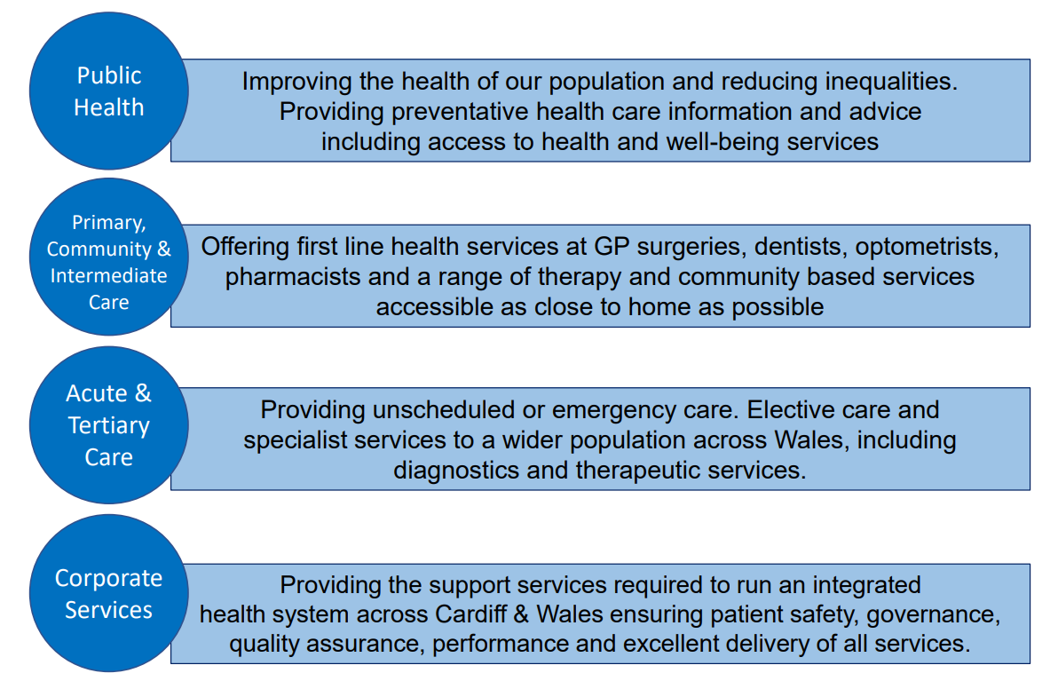

2.2 Our Mission and Vision

Our mission is “Caring for People, Keeping People Well”, and our vision for the people we serve is that everyone’s chance of leading a healthy life should be the same wherever they live and whoever they are.
The Health Board's 10-year transformation and improvement strategy, Shaping Our Future Wellbeing (“our Strategy”), is our chance to work collaboratively with the public and the Health Board’s workforce to make our health board more sustainable for the future. Together, we can improve equity for all of our patients - both today and tomorrow.
To find out more: https://cavuhb.nhs.wales/about-us/our-mission-vision/shaping-our-future-wellbeing-strategy/

This year we have been reviewing our Strategy, and at the time of writing this Annual Report, we have completed the first phase of engagement to enable our communities, colleagues and key stakeholders help us shape the next iteration of our strategy.

2.3 Our Board

Our Board consists of 25 members, including Chair, Vice Chair and Chief Executive. The Health Board has 9 Independent Members, all of whom are appointed by the Minister for Health and Social Services, and three Associate Members.

The Board provides leadership and direction to the organisation and is responsible for governance, scrutiny and public accountability, ensuring that its work is open and transparent by holding its meetings in public.

In addition to responsibilities and accountabilities set out in terms and conditions of
appointment, Board members also fulfil a number of Champion roles where they act
as ambassadors for these matters.

The Board is supported by a number of Committees, each chaired by an Independent Member.

Our Committee meetings have continued to be held virtually during the year. Members of the public have been able to view recordings of our virtual Committee meetings since February 2022 via our website. The Committees, which meet in public, provide their minutes to each Board meeting that contribute to its assessment of assurance and provide scrutiny against the delivery of objectives.

From May 2022 we resumed holding our Board meetings in public, with members of the public being able to observe public meetings of the Board in person since 26 May 2022.

Copies of the papers and minutes are available from the Director of Corporate Governance and are also on the Health Board’s website (see link: https://cavuhb.nhs.wales/about-us/governance-and-assurance/board-meetings/). The website also contains a summary of each Committee’s responsibilities and Terms of Reference. All actions required by the Board and Committees are included on an Action Log and at each meeting progress is monitored. These Action Logs are also published on the Health Board’s website.

All Committees annually review their Terms of Reference and Work Plans to support
the Board’s business in addition to producing an Annual Report to demonstrate compliance with their respective Terms of Reference. Committees also work together on behalf of the Board to ensure that work is planned cohesively and focusses on matters of greatest risk that would prevent us from meeting our mission and objectives. To ensure consistency and links between Committees, the Health Board has a Governance Co-ordinating Group, chaired by the Chair of the Health Board.


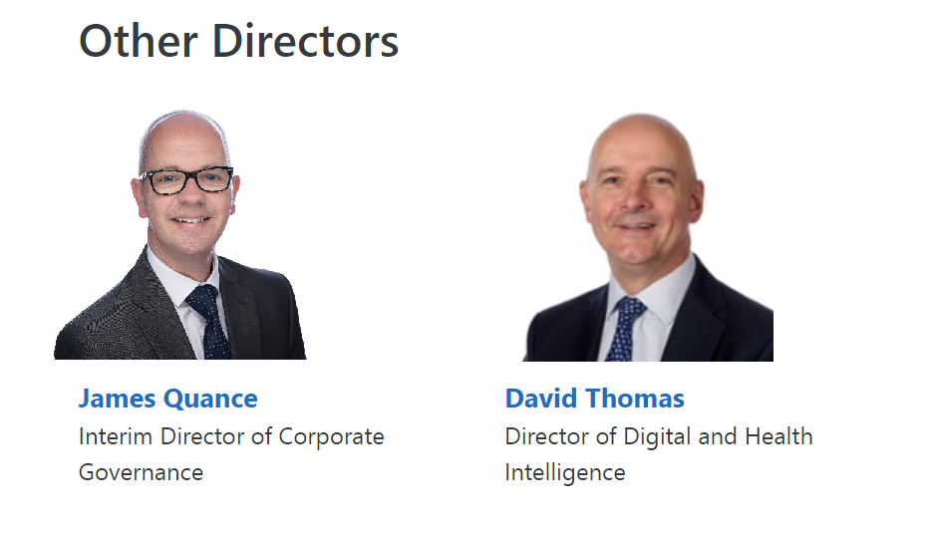


2.4 Our Structure

We have a workforce of around 17,200 staff who consistently deliver high quality services to all of our patients. Our organisation is structured and designed into seven Clinical Boards which were created in June 2013 and have been successful in providing strong leadership in clinical areas and have resulted in the acceleration of operational decision-making, greatly enhancing the outcomes for patients in their care. The Clinical Boards are held to account via the Executive Directors.
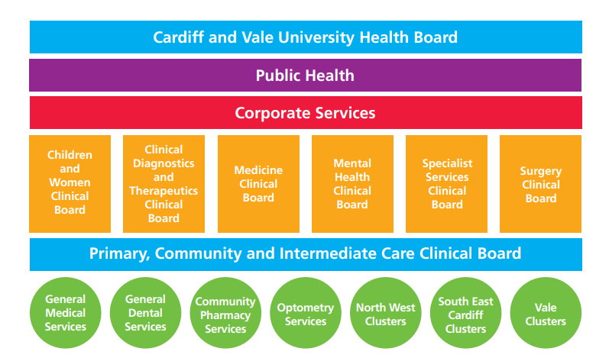

Our corporate and planning services are an integral part of the overall structure and smooth running of the Health Board and include:

- Strategy, Planning and Commissioning
- Finance including Capital, Estates and Facilities
- Workforce and Organisational Development
- Digital Health Intelligence
- Communications, Arts, Health Charity and Engagement
- Corporate Governance

Scrutiny of the Corporate Services directorates is through a combination of governance, executive director and senior management accountability and progress is mapped against key projects within their areas of expertise.

2.5 The Population We Serve

The Health Board is taking proactive action to respond to the health needs of the half million residents in our area, identified through assessments including those carried out for the Social Services and Well-being Act (https://cavrpb.org/about-us/ (Cardiff and Vale population needs assessment) and the Well-being of Future Generations Act (https://www.cardiff.gov.uk/ENG/Your-Council/Strategies-plans-and-policies/Local-Wellbeing-Assessment/Pages/default.aspx - Cardiff well-being assessment, ; https://www.valepsb.wales/en/Our-Evidence/Well-being-Assessment-2022.aspx - Vale well-being assessment). These include the needs listed below.

Health inequalities

There are long-standing inequities in outcomes between people living in our most and least deprived areas, within our ethnic minority communities, and other groups within our communities.

Variation in healthy behaviours and health outcomes are apparent in smoking rates, physical activity, diet and rates of unhealthy weight and obesity. Uptake of childhood vaccinations is also lower in more disadvantaged areas, and people are more likely to experience poor air quality. Life expectancy is around twelve years lower in our most deprived areas compared with our least deprived, and for healthy life expectancy the gap is more than double this. Deprivation is higher in neighbourhoods in South Cardiff and in Central Vale.

These inequalities have been exposed and further increased by the Covid-19 pandemic, and more recently the cost-of-living crisis, and are described in more detail in the 2020 Director of Public Health report, Let's leave no-one behind in Cardiff and the Vale of Glamorgan - https://cavuhb.nhs.wales/files/public-health/key-publications/dph-report-2020-pdf/.

Demographics

Our population is getting older on average, and previous trends in population growth have slowed; migration into our area during 2022 included the reception of Ukrainian refugees the Afghan Citizens Resettlement Scheme (ACRS) and other asylum seeker populations.

The most accurate assessment of the size of the population of our area in recent years was undertaken in 2021 with the national Census. These results were published in June 2022 and show that just over 492,000 people lived in Cardiff and Vale on Census Day, 21 March 2021, slightly lower than previous projections had indicated.

The population of our area continues to grow, though growth projections have not yet been updated nationally to reflect the data in the latest Census. Therefore while growth is estimated to be around 4% over the next 10 years, this may be revised in future years; actual population growth will also be highly dependent on progress with large housing development. The average age of people in our area is increasing rapidly, with a significant increase projected in people aged 85 and over, particularly in the Vale.

Cardiff in particular has a long history of being open and inclusive, and is the most ethnically diverse local authority in Wales, with around 17% of its population from ethnic minority groups.

Health behaviours and risk factors

Supporting and enabling our residents to live healthy lives requires action on the wider environment and determinants of health, as well as with supporting individuals themselves. Many of the following factors have been adversely affected by the pandemic, with additional impacts from changes in work patterns such as hybrid working:
- Healthy environments including the climate emergency
- Air quality
- Provision of healthy and affordable food
- Social isolation and loneliness
- Immunisation uptake
- Participation in physical activity
- Achieving and maintaining a healthy weight
- Tobacco use
- Alcohol consumption

One in eight adults (12%) in our area smoke. While this number continues to fall, which is encouraging, tobacco use remains a significant risk factor for many diseases, including cardiovascular disease and lung cancer, and early death.

Six in ten people in our area do not eat sufficient fruit and vegetables, and nearly the same proportion of adults are overweight or obese. In some disadvantaged areas access to healthy, affordable food is more difficult and food insecurity is more prevalent due to increasing living costs and low wages.

While nearly 7 in 10 adults undertake at least the recommended minimum 150 minutes of physical activity each week, for one in five (19%) adults this figure is less than 30 minutes physical activity each week.

Across Wales, 71% of adults reported feeling lonely some or all of the time in 2021-22. Social isolation is associated with reduced mental wellbeing and life expectancy.

Covid-19 and future infectious disease threats

We need to continue to protect vulnerable residents and mitigate against future variants of the virus; in addition we need to build on the learning from the pandemic to further strengthen local, regional and national systems to respond to future infectious disease threats.

We are addressing the needs listed above, to reduce inequity and improve health, through our Local Public Health and Shaping our Future Population Health plans (https://cavuhb.nhs.wales/patient-advice/local-public-health-team/key-publications/).

Welsh language

A quarter (26%) of people of all ages in Cardiff say they can speak Welsh, and 1 in 5 (20%) in the Vale (Annual Population Survey/StatsWales, 2022 - https://statswales.gov.wales/Catalogue/Welsh-Language/Annual-Population-Survey-Welsh-Language/annualpopulationsurveyestimatesofpersonsaged3andoverwhosaytheycanspeakwelsh-by-localauthority-measure).

Section 7.6 of the Annual Report provides more detail with regards the actions taken by the Health Board to further promote the Welsh Language.

Human Rights

The Health Board has an Equality, Diversity and Human Rights Policy which sets out the organisational commitment to promoting equality, diversity and human rights in relation to employment. It also ensures staff recruitment is conducted in an equal manner.

South Glamorgan Community Health Council (CHC)

We have worked closely with South Glamorgan Community Health Council (CHC), an independent statutory organisation that acted as a voice for patients and the public. It was also an NHS watchdog for all aspects of health care.

We worked together with the CHC to discuss the delivery and development of the services we provide. We welcomed reports from the CHC and are grateful for their advice, challenge and support.

From 1 April 2023, the CHC will cease to exist and the staff will have transitioned into the new Citizen Voice Body (Llais). Preparatory discussions with the CHC Chief Officer, who is now the Regional Director of Llais, have already taken place to ensure the smooth transition.

For more information, please contact:

Llais Cardiff
Parc Ty Glas, Llanishen
Cardiff
CF14 5DU
Telephone: 02920 750112
Email: enquiries@llaiscymru.org

2.6 Principles of Remedy

The Health Board has fully embraced the regulations which guide the handling and response to concerns (complaints and incidents) launched by Welsh Government in April 2011. In addition, the Health Board’s approach to dealing with concerns very much reflects the ‘Principles of Remedy’ published by the Public Services Ombudsman for Wales.

- Getting it right

- We acknowledge when we identify things that could have been improved.
- We consider all relevant factors when deciding the appropriate remedy, ensuring fairness for the complainant and, where appropriate, for others who have suffered injustice or hardship as a result of the same maladministration or poor service.
- We apologise and explain the maladministration or poor service.
- We try to understand and manage people’s expectations and needs.
- We always try to deal with people professionally and sensitively.

- Being customer focused

- We acknowledge and accept responsibility for failure if and when it occurs.
- We explain clearly why the failure happened and express sincere regret for any resulting injustice or hardship.

- Being open and accountable

- We try to be open and transparent
- We strive to treating people without bias, unlawful discrimination or prejudice.

- Acting fairly and proportionately

- We consider all forms of remedy (such as an apology, an explanation, remedial action, or financial compensation).

- Putting things right

- We are focussed upon using information on the outcome and themes from concerns to improve services.

- Seeking continuous improvement

- We seek to offer a proportionate, reasonable investigation and response that aims to identify the opportunities for service improvement.

2.7 Our Strategy

Shaping our Future Wellbeing, approved by the Board in 2015, is the 10-year strategy for transformation and improvement at Cardiff and Vale University Health Board. At the heart of the strategy is our vision, that everyone should have the opportunity to lead longer, healthier and happier lives. With an ageing population and changing lifestyle habits, our health and care systems are experiencing increasing demand. In order to be able to meet the needs of our population, we must transform how we deliver services across the whole of our health and care system, ensuring that people can access the support they need in a timely way, in home, or as close to home as possible. Where it is required, specialist hospital care – for secondary, tertiary and quaternary care – should be provided when the patient needs it, for both emergency and urgent care, and care that can be planned.

Our current Strategy has served us well but the time is right for us to undertake a review and develop the next iteration of our strategy. Whilst the direction of travel set out in our current strategy remains relevant today – reducing health inequities, delivering more care closer to home etc, we know that much has changed over the last two years and we need to reflect on this as we develop the next iteration of our strategy.

In the last part of the year, we set out to engage our colleagues, our communities and our stakeholders in a conversation about what is important for us to reflect in our next strategy. We asked questions about whether our current vision is still right, what our key strategic themes need to be and the strategic objectives need to be in order to achieve the ambitious vision we want for our communities, our teams and our stakeholders and partners. The refreshed strategy which will cover the period 2023 – 2033 will be finalised in the summer of 2023.

2.8 Research, Development, Innovation and Partnerships

Research and Development

The Health Board is proud of its long-standing University status designation and its history of delivering pioneering, high-quality clinical research and development (R&D). This upholds one of the core principles of the ongoing NHS and Health Board strategy, namely, to embrace R&D and innovation to generate new knowledge and drive change and transformation within healthcare.

Embracing research across the organisation not only allows patients better access to study participation but also the potential for novel therapeutics that can alter disease trajectory. The downstream benefits of trials include change in practice, education, clinical experience, financial gain, staff recruitment, retention and reputational growth.

Professor Keith Harding (Independent Member – University) has been appointed as Health and Care Research Wales Board Champion for Cardiff and Vale to ensure the importance of research is understood as a key driver for good health and social care services and to ensure research activity is supported, monitored and reported effectively at Board level.

Given the size of the budget, R&D punches well above its weight. Recruiting and retaining staff remains a challenge, as is the case across the whole NHS and healthcare system. Despite these constraints we have performed exceptionally well as an Organisation recruiting more than 7,000 patients into studies consecutively over the last 2 years. This is our best-ever period of recruitment to clinical studies. Our performance far exceeds other University Health Boards in Wales and accounts for approximately 40% of all recruitment in Wales.

153 ‘hosted’ studies were approved to open this year. However we believe we can achieve more. There is a need to expand the delivery team to be able to support the number of trials our investigators want to deliver. We plan to continue to explore opportunities to develop a larger, sustainable delivery workforce that can meet demand.

In part, this will be powered by developing our own investigators leveraging grant income. This year Cardiff and Vale researchers have secured large National Institute of Health Research (NIHR) Grants. The Health Board has secured £1.84 million from NIHR Health Technology Assessment (HTA) Grant for the POLARiS study, Pathway Of Low Anterior Resection syndrome relief after Surgery (POLARiS) trial. Colorectal cancer is the third commonest cancer worldwide with 14,000 patients in the UK being diagnosed with rectal cancer per year. Over half of those patients will undergo major resectional surgery. Whilst survival for rectal cancer has improved with advances in surgery and chemotherapy, the adverse consequences of surgery have become increasingly recognised. The study is looking to improve understanding of patient experience in order to offer better treatment options to our patients. The study will open next year and will be run across 20 centres in the UK and in collaboration with 10 centres in Australia.

18 investigator led research projects were developed and set up this year by Cardiff and Vale staff. It is hoped the success of our own investigators will continue to grow with the support of the Joint Research Office and collaboration with our academic partners at Cardiff University.

Building reputational resilience as a leading research active organisation is vital for attracting and retaining talented healthcare professionals. A manifestation of this is publishing in the best high impact journals. To this end our researchers have nine manuscripts in the New England Journal of Medicine, Journal of the American Medical Association and Lancet over the last year.

There are many additional opportunities around developing expertise in the delivery of unscheduled care trials, advanced therapies and using some of the excellent infrastructure that exists in Cardiff such as Cedar Health Technology Research Centre, High Consequence Infectious Diseases, CID, the Wales Research and Diagnostic PET Imaging Centre (PETIC) and Cardiff University Brain Research Imaging Centre (CUBRIC).
Innovation and Partnerships
Recognising the need to continue to embrace and grow innovation at a corporate level, the Health Board recently created the Shaping Change team through the merger of the existing and well-established Improvement and Implementation team with the nascent Innovation and Change Hub (strategic programme) teams. Working in partnership with Welsh Government, the Cardiff Capital Region (CCR), NHS and other non-NHS organisations, we have identified opportunities to explore, develop, adopt and implement novel solutions across all areas of the Health Board, in both clinical and non-clinical areas. There has been, and will continue to grow, a strong emphasis on truly collaborative partnership working, with a shared risk approach within local, regional and national contexts and initiatives to produce internationally recognised and acclaimed step-changes in healthcare approaches and practices. For example, partnership with and support from the CCR and small businesses, has enabled access to £1.2M in funding to develop novel virtual reality training materials for critical tracheostomy management and exploration of the development of ways to improve approaches and workflows within endoscopy services.
Under the banner of the Dragon’s Heart Institute, and with support from Welsh Government through the Intensive Learning Academy initiative, we have supported innovation through the development of leaders in our innovative Climb and the Spread and Scale Academy programmes. Shortly due to begin its 3rd cohort, Climb aims to develop and foster a vibrant community of self-supporting and continuously developing future leaders focussed upon addressing the current and future challenges of health and social care. The Spread and Scale Academy is designed to give people the tools and skills needed to implement improvements and innovations at scale across their organisations and beyond. This year, we have delivered the Spread and Scale Academy to over 200 delegates from across Wales working on 40 innovative projects, supporting them to reach as many people who could benefit from their work as possible.
Further, the Shaping Change team’s improvement and implementation function supported staff across the Health Board in delivering continuous quality improvement in a range of areas. These include taking a leadership role in the Health Board wide Winter Reset weeks, supporting a number of teams across the Health Board to achieve a fourfold increase in routine use of systems and approaches embed and utilise available systems and processes and that improve timely care and discharge for our patients. We worked to deliver high priority projects alongside colleagues across the Health Board including the 111 Press 2, which provides urgent mental health care via telephone and launched in February 2023.
Working in partnership with Welsh Government, we have led on the national See-on-Symptoms and Patient-Initiated Follow-up pathway campaign for managing outpatient follow-up appointments, designing and creating a national website for clinicians to implement them in their speciality across Wales. We have also designed and developed multiple programmes of work to support patient flow through our secondary care sites, working in partnership with the Patient Flow and Site Services team to streamline their processes, saving them over a whole working day every month, and implementing a new 6-week development programme for team efficiency and excellence called Releasing Time to Care. During its pilot phase, this programme reduced a ward’s open DATIX incidents by 89% and saved over £3400 of surplus stock.
The Change Hub has supported those Cardiff and Vale Health Board teams that are delivering our most ambitious, transformational programmes, putting in place best practice standards around programme governance to really drive progress towards the achievement of key organisational priorities. The Change Hub has also worked closely with Learning & Development colleagues to develop a suite of change, project and programme management courses together with the creation of leadership and management development programmes to help to create a courageous environment in which change can flourish.
We will continue to deliver this system-wide change by nurturing and growing a culture of trust, curiosity and learning, we will continue to support and empower our staff to drive sustainable transformation and change, whereby research and development, innovation and improvement will be coordinated, aligned and deployed in priority areas.

Part 1
Performance Report
3. Performance Overview

3.1 Introduction
The Health Board submitted its final Annual Plan set in a three year context in June 2022 after undertaking extensive additional work due to challenging financial position. Delivery of the plan over the last 12 months has continued to be challenging as we continued our recovery from the Covid-19 pandemic and worked hard, in conjunction with our partners, to recover and improve the delivery of Healthcare services. Our emphasis has been on ensuring that quality and value underpin our approach with a commitment to preserving or improving patient safety, quality, access to services and staff wellbeing. This Performance Overview section will provide a summary of some of the key organisational achievements, challenges and risks over the past year.
3.2 Statement from the Chief Executive
Our organisational performance over the 2022-23 period was characterised by gradual and steady recovery as the direct impact on the pandemic reduced and our teams balanced its lasting impact with the prerogative of recovery and redesigning our services for the future. The Health Board’s approach to performance was underpinned by the Ministerial Priorities. A note on our approach and delivery against each of these priorities is provided below, with the detail provided throughout the Performance Overview and wider content of the Annual Report.
A Healthier Wales - as the overarching policy context
A Healthier Wales sets out a long-term vision that everyone in Wales should have longer, healthier and happier lives. It proposes a whole-system approach to health and social care which is equitable, and where services are designed around individuals and groups based on their unique needs and what matters to them, as well as quality and safety outcomes. The delivery of this ethos has continued to be integral to both our planning and delivery of services.
Population health
Our commitment to improving population health has been shaped around our plan “Shaping our Future Population Health”. Published in February 2022, this plan has helped us to set out a system approach to identify and address current and future population health issues, improve health, prevent ill health, and reduce inequalities in health outcomes among residents and communities in our area.
Covid-19 response
The continued response to Covid-19 was informed through planning scenarios which highlighted the challenge of the delivering of both Covid-19 and non-Covid-19 services within our constrained estate and by a significantly fatigued workforce. As the year progressed, our teams adapted to the small peaks in Covid-19 activity as well continuing to deliver our vaccine programme to help reduce the impact of the pandemic. Further detail with regards to our Covid-19 response is set out in Section 5 (Covid-19 Vaccination and test/tract/protect) of this Annual Report.
NHS recovery
Our progress with recovering and redesigning services has been significant, despite the continued Covid-19 response and workforce challenges. Delivery of services has been in line, or ahead, of our Annual Plan commitments in the majority of areas. Further detail on our achievements and where we have further work to do, is provided within the Performance Appraisal section below.
Mental Health and emotional wellbeing
Mental Health and Emotional Wellbeing services have seen a significant increase in referrals over the past year and we are proud that despite this we have delivery of core targets for assessment and treatment. Our focus continues to be on improvements in services, such as Neurodevelopment where we have a need to reduce waiting times and continue to strengthen our cohesion with education services.
Supporting the health and care workforce
The health and wellbeing of our people continues to be of the utmost importance. The impact of the pandemic has had wide ranging and deep implications for our teams. Over the last year we have remained committed to supporting, and enhancing the wellbeing of our people. Our ambition continues to be to make the Health Board a great place to work and where staff can flourish. Our People and Culture Plan, launched in January 2022, sets out our ambition over a three-year period with progress made on all seven themes over 2022/23.
NHS Finance and managing within resources
The Annual Report sets out how the Health Board has managed its financial resources during the financial year 2022/2023, with paragraph 3.4 (Financial Performance Trends) providing a short synopsis of the same.
Working alongside Social Care
The challenges facing our Health and Social Care system can only be addressed through close, open and supportive partnership working. Over the last year the Health Board has embedded this approach throughout our partner organisations at operational, strategic and executive level. The development of a Regional Incident Management Team to address pressing shared issues, underscores the importance the Health Board has placed on close working with Local Authority partners, with senior teams meeting twice a month to work on initiatives including joint workforce planning and the commissioning of additional social care capacity over Winter.
3.3 Integrated Medium Term Plan (IMTP)
In 2022 – 2023, the Health Board developed an annual plan, which was submitted to Welsh Government at the end of June 2022 (the Health Board was given a further three months beyond the initial submission date to further develop the plan). The Health Board was not able to develop a plan that delivered an in-year financial balance without compromising the safety of the services we deliver. The final plan set out an overcommitment financially of £17m - so the Health Board was not able to submit an approvable plan to Welsh Government within the terms set out in the planning guidance and financial duties.

The Annual Plan was informed by a set out commissioning intentions (as summarised in the diagrams below) and which were signed off by the Board in July of the previous year.

Diagrams showing a summary of our Commissioning Intentions

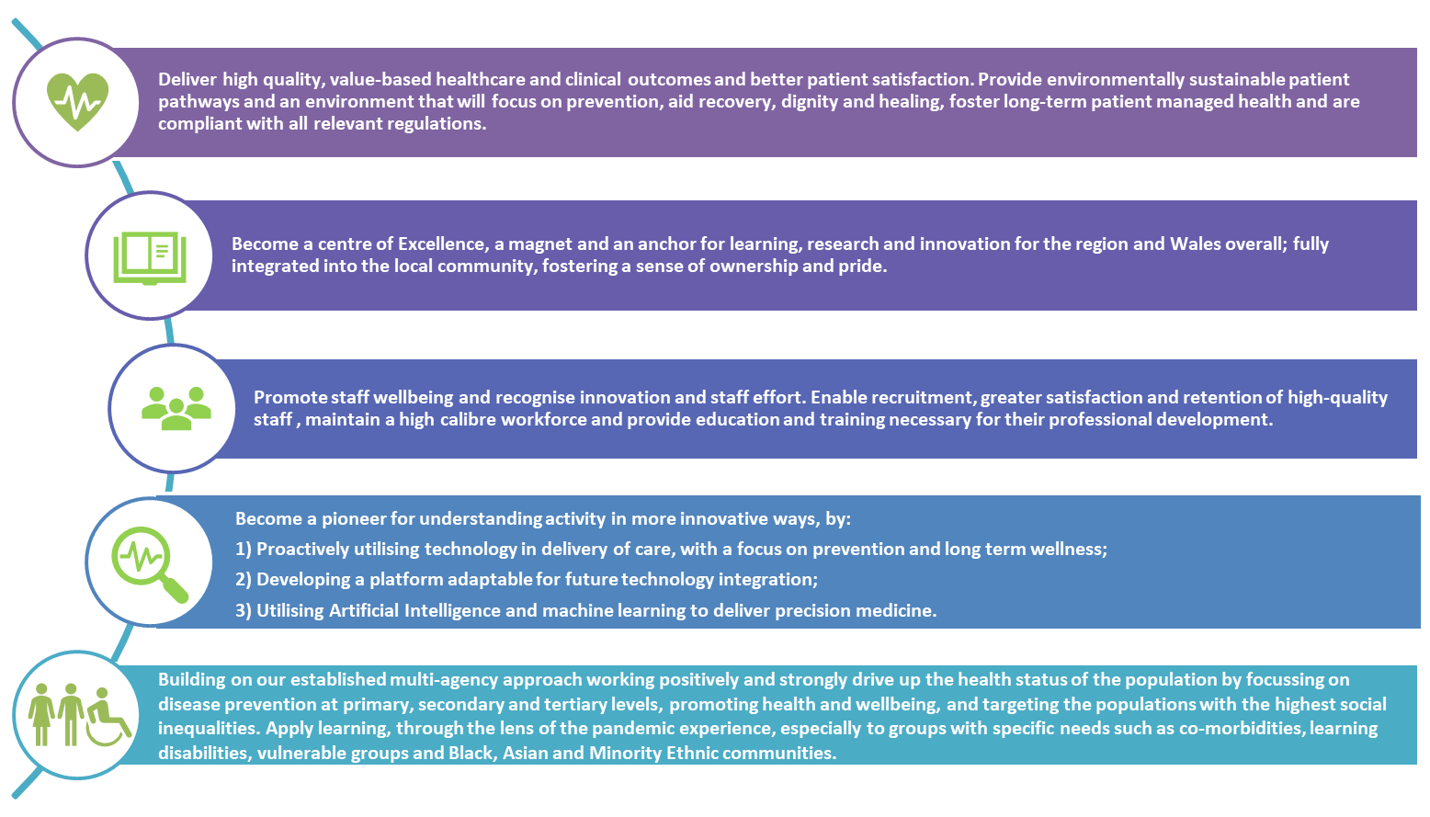

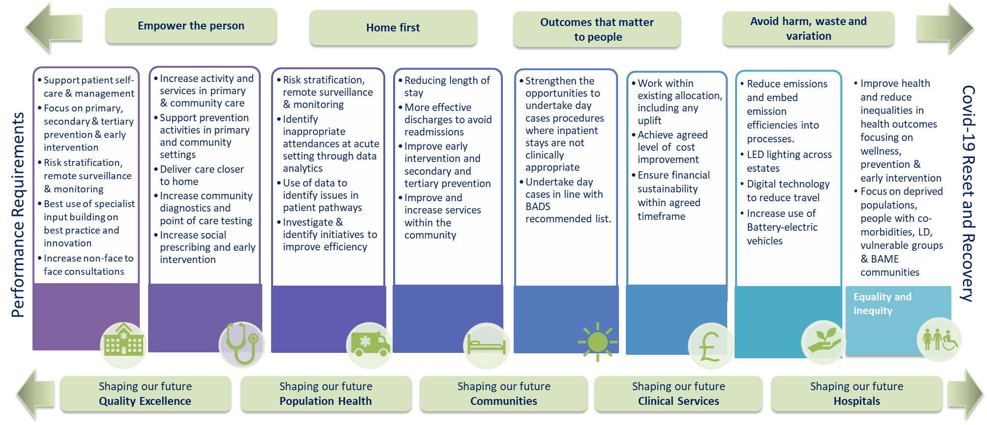

Similarly, our Annual Plan responds to the commissioning requirements of our neighbouring health boards and Welsh Health Specialised Services Committee (WHSSC) for the specialist and tertiary services we provide for their populations and patients. Paragraph 13.10 of the Annual Governance Statement provides more information with regards to WHSSC.

In response to the Health Board’s Annual Plan, the Welsh Government has issued a number of Accountability Conditions (set out below) which are required to be met and which require the following “Five Ways of Working” sustainable development principles of the Well-being of Future Generations Act to be central to the Health Board’s approach.

“Five Way of Working”
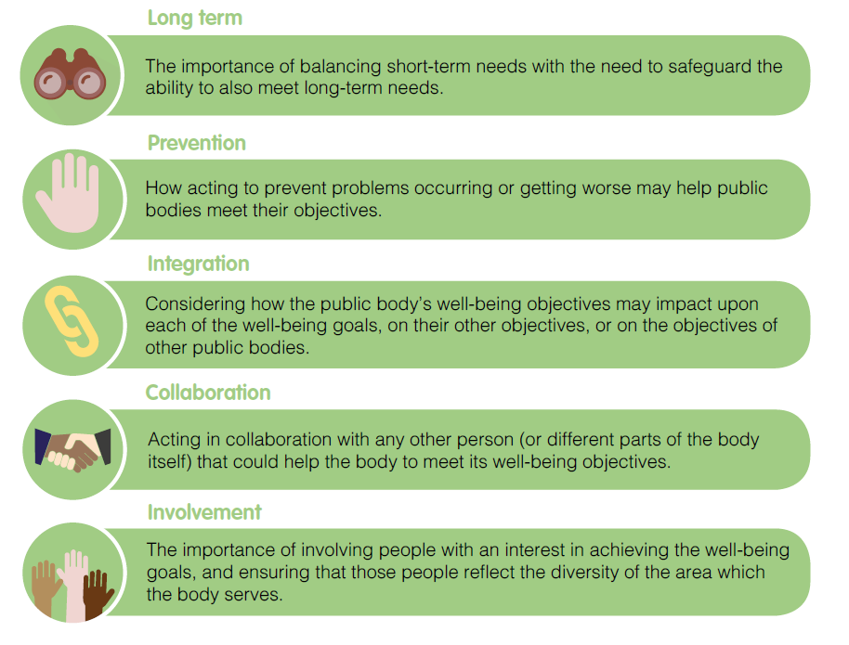

Accountability Conditions – to be updated to include actions taken to address conditions

Planned Care | Demonstrate how the published recovery plan ambitions will be met
Primary Care | Improve access to NHS Dental Services with progress evidenced by baseline data from activity levels and dental contract reform measures.
Primary Care | Improved access to General Medical Services (GMS). Progress to be evidenced using available data from GMS contract reform measures for the access commitment and data on chronic conditions management reviews.
Urgent and Emergency Care | Ensure adoption of Six Goals for Urgent Care, evaluating what changes in patterns of demand/treatment have occurred following adoption, including milestones for improvement.
Regional Planning | Provide detailed delivery plans for the regional planning projects/ programmes which the Health Board is supporting, setting out the objectives of the project, partner organisations and clear milestones for year 1.
 | Update on the development /implementation of the regional orthopaedics treatment service.
Financial Impacts | Demonstrate delivery of a robust savings plan supported by an opportunities pipeline that supports the organisation to maximize its improvement trajectory throughout 2022/23 and beyond.
Financial Impacts | Demonstrate actions are being taken to mitigate COVID costs throughout the year as the pandemic response continues to evolve.
Financial Impacts | Provide further detail on the investment plans for the Value Based Healthcare allocations, and the organisations Value Based Healthcare programme, with clarity on the benefits anticipated.
In-Year Considerations | Mental Health/Dementia:
 | - Demonstrate how NEST will be embedded.
 | - Demonstrate how the mental health needs of the population, all ages, are being met with trajectories for improvement.
 | - Ensure 111 press 2 for urgent mental health is implemented, evaluating changes in patterns of demand/ needs have been seen as a result.
 | Neurodevelopmental Sciences:
 | - Demonstrate how neuro-developmental pathways will be improved.
 | Digital and Health Intelligence:
 | - Demonstrate how digital developments will deliver national models.
 | Cost of Living:
 | - Give consideration to the contribution the Health Board makes to support people with the cost of living crisis.

3.4 Financial Performance Trends

The Health Board has a statutory obligation to remain within its resource limits (Revenue and Capital) on a three year rolling measure. After a number of years of Revenue financial deficit, the Health Board managed to meet this requirement at the end of 2021-22. The target was not met in 2022-23 as Covid-19 funding decreased at a time when the Health Board had to cope with wide ranging inflationary pressures and operational system pressures, in part incurred as a legacy of the Covid-19 pandemic period.

Performance against the 3 year financial break even duty

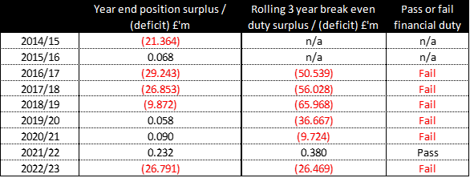

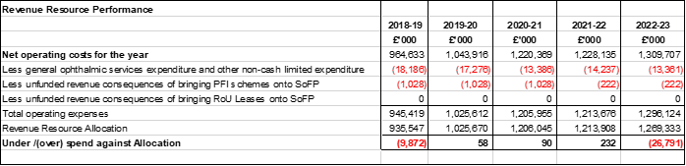

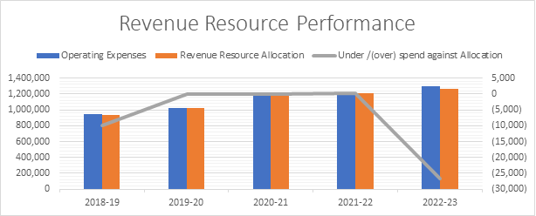

Capital Resource Limit

The Health Board continues to manage within its annual Capital Resource allocation through the proactive management of the Health Board Capital Management Group which oversees capital bids and progress on major capital projects to appropriately flex expenditure plans and utilise each year’s capital allocation effectively.

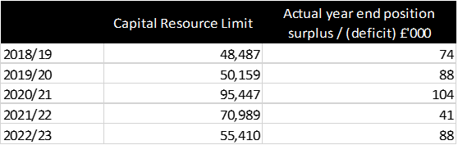

Public Sector Payment Performance

The Health Board met its Public Sector Payment Performance target in 2022-23 in terms of value paid to Non NHS and NHS creditors. The Health Board also met this target in terms of the number of invoices settled within 30 days of the due whilst continuing improving its performance in relation to NHS creditors.

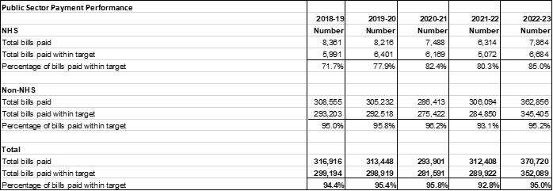

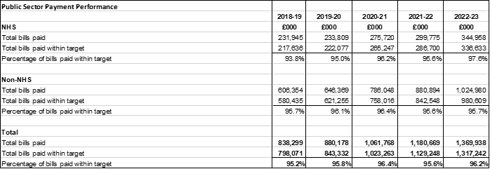

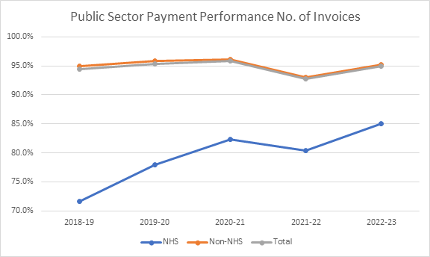

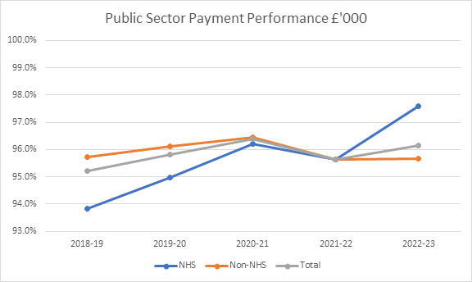

3.5 Performance Appraisal
The Health Board’s overall performance was characterised by a number of improvements in access and quality in urgent and emergency, specialist and mental health pathways alongside continued challenges in planned care services. The transitional nature of the year, where the direct impact of Covid-19 lessened and the indirect impacts were sustained, gives us cause for reassurance that the organisation is progressing towards its objectives albeit at a slower rate the originally planned. Challenges across Health and Social care, particularly in relation to workforce pressures and a reduction in social care capacity, have proved extremely difficult to overcome. In order to mitigate these as well as possible, the Health Board has sought to keep our focus on quality and candour at all times.

3.6 Performance Assessment
To assess our performance we have reviewed our delivery ambitions that were outlined in our IMTP. Table 1 below provides clear indication of which performance ambitions have been met. Where the ambition has not be achieved, the key challenges are outlined and where relevant further explanation of the performance can be found in the Performance Appraisal section. Of the 32 ambitions set, 17 have been achieved over the last year. The remaining measures require further work, particularly in relation to planned care performance and feature as revised priorities in our 2023/24 annual plan. Further details on the risks that have impacted performance can be found within the Annual Governance Statement under paragraphs 13.14 and 13.15.
Table 1

Our 2022/23 Delivery Ambitions and Performance
Priority | Ambitions | Performance | Key challenges and risks
Primary and Community Care | Increase in Eye Care Treatment by primary care | 21/22 = 746 vs 22/23 = 2339 | GMS sustainability and high levels of escalation  Legacy impact of covid for dental services  Impact of system wide pressures and social care availability
Primary and Community Care | Increase to 70% of dental activity vs. pre-Covid levels | Achieved
Primary and Community Care | Deliver option appraisal and develop plan for next UPCC centre | Two additional UPPC opened in Cardiff
Primary and Community Care | Reduction of emergency admissions for over 65s | 21/22 = 16427 vs 22/23 = 15782
Primary and Community Care | Delivery of diabetes performance measures (% patients received all 8 NICE recommended care processes) | 21/22 = 33.33% vs  Q3 22/23 = 42.6%
Urgent and Emergency Care | Reduce ambulance lost hours by 25% above March ’22 position | Mar 22 = 2728 vs March 23 = 1154 | Long lengths of stay and reduced discharges  Workforce pressures – including low morale and vacancies  Compliance with standards in priority services such as stroke and hip fracture
Urgent and Emergency Care | 90% surgery patients via surgical SDEC | March 23 = 70.1%
Urgent and Emergency Care | Reduce 21-day length of stay to pre-covid levels | 35% increase
Urgent and Emergency Care | Eliminate >4-hour handover delays | 0 for Feb 23, 2 for March 23
Urgent and Emergency Care | Medical SDEC at UHW open 7 days a week | Open 7 days
Urgent and Emergency Care | Compliance with latest SSNAP targets | Level C SSNAP compliance (Oct-Dec 22)
Urgent and Emergency Care | Eliminate 12-hour ED wait | 747 x12h breaches in March 23
Planned Care | Eliminate 104 week waits for outpatients | March 23 = 2111 | Long waiting times for non-urgent planned care  Cancer waiting times not in line with expected standard  Workforce pressures – including low morale, vacancies and industrial action
Planned Care | Eliminate 104 week waits for treatment | March 23 = 3659
Planned Care | 120% of pre-Covid levels of elective activity | 22/23 Q4 = 89% (inpatients/day cases)
Planned Care | 120% of pre-Covid levels for new OP | 22/23 Q4 = 112%
Planned Care | Achieve >65% Single Cancer Pathway target | 61.5% Feb 23
Planned Care | 30% reduction in delayed follow ups (>100%) | Increased from c41k to c50k
Planned Care | Maintain Level 2 & 3 surgery | Achieved
Planned Care | Achieve 33% of outpatients via virtual | 19%
Mental Health | Deliver 80% compliance with Part 1a 28-day assessment target | 96.5% March 23 | Long waiting times in neurodevelopment  Workforce pressures – including recruitment challenges for NHS 111 press 2  High out of area bed usage
Mental Health | Eating Disorders – reduce to 9 months longest wait | March 23 max wait = 24 weeks adult  March 23 max wait = 5 weeks paeds
Mental Health | Deliver combined intervention and assessment team for CAMHS | Achieved
Mental Health | Deliver NHS 111 (press 2) | Went live in February 2023
Mental Health | Implement repatriation plan for delivery of trauma informed care services close to home | Not achieved – planned for 23/24
Mental Health | Deliver sustained improvement trajectory for neurodevelopment assessments | Reduced overall waiting list from Sept 22
Mental Health | Go live with sanctuary provision for crisis care in adults | Go-live planned for Q1 2023/24.
Diagnostics and Therapies | Reduce 8 week waits for all modalities | 4% overall reduction | Demand for radiology  Workforce challenges – recruitment and retention  Endoscopy waiting times
Diagnostics and Therapies | 50% reduction of >8 week wait in endoscopy | March 22 = 1607 vs March 23 = 1563
Diagnostics and Therapies | Endoscopy activity to exceed 130% of pre-covid | Total activity >150% in March 23
Diagnostics and Therapies | 50% reduction of >14 week wait in Therapies | March 22 = 2292 vs. March 23 = 952
Diagnostics and Therapies | Eliminate > 8 week waits for US and Echo | March 22 = 2698 vs March 23 = 1289

3.7 Delivery and Performance Analysis

At Cardiff and Vale University Health Board we are committed to setting challenging standards that we know are necessary to improve services for our patients. For 2022-23 we set ourselves a number of key delivery ambitions across Primary and Community Care, Mental Health, Planned Care, Urgent and Emergency Care and Diagnostics. Despite the challenging context, our teams have gone above and beyond to ensure many of these have been met and exceeded. For those ambitions where we have fallen short, plans are in place to renew our focus and ensure delivery over future years.

The Delivery and Performance Analysis section will provide detail on how we have measured and monitored our performance throughout the year, including an overview of the Health Board’s key risks and how those have been monitored and impacted performance and further analysis across key areas such as finance, equality, concerns, quality and safety.

3.7.1 Monitoring our performance

The Health Board undertakes regular and consistent monitoring of performance across a number of domains including quality and safety, finance, operational performance, population health and workforce. Our approach to performance is to embed monitoring ensure there is clear visibility through clinical teams, Clinical Boards and to the Executive management team. Executive monitoring of performance occurs formally through monthly performance reviews with each Clinical Board using both quantitative and qualitive information. These fora provide leadership teams with the space to present a holistic view of performance across all domains of performance and thereby ensuring action plans are jointly developed and owned.

During the last year Board assurance on performance has been monitored through the monthly Integrated Performance Report. This report covers the key domains of population health, quality and safety, workforce and operational performance and highlights areas where the organisation has made significant improvements or has particular challenges, including the impact of Covid-19, together with areas where the Health Board is under formal escalation measures from the Welsh Government and/or where local progress is being monitored.

3.7.2 Operational Performance Analysis

Urgent and Emergency Care

Our 6 Goals Delivery Board has been central to a renewed focus on Urgent and Emergency Care. The Delivery Board is chaired by the Chief Operating Officer and each of the composite workstreams is clinically lead and outcomes focused.

Primary and community care teams continue to be the foundation of our urgent and emergency care system. During 2022/23 the Health Board provided over 190,000 districting nursing visits which have helped to support our patients receive care in their usual place of residence. Our community teams have increased the access options available to our patients. This has included the full roll out of the NHS 111 platform which has been aligned with our CAV24/7 and out of hours services. These changes had led to call volumes to CAV OOH services decreasing compared to last year with an average of over 11,000 per month. Urgent Primary Care Centres (UPCC), previously established in the Vale of Glamorgan, have now been expanded into two clusters within Cardiff. These centres have provided valuable additional capacity to help improve access for patients and to relieve pressure on General Medical Services (GMS) practices. There was now over 1000 UPCC appointments available per week in Cardiff and the Vale, with over 70% of GP practices having direct access.

Working with partners across Health and Social Care has continued to be of the highest organisational importance. Partnership working is embedded throughout the Health Board and includes daily operational meetings with Local Authority and Integrated Discharge Services. At an Executive level the establishment of joint fortnightly response meetings has helped to renew our strength of approach to joint working.

As a Health System we have faced similar pressures to other parts of Wales with a particular challenge in discharging patients and ensuring that there is availability of Social Care workforce and community support for patients no longer requiring acute hospital care. At the end of the year we had 247 patients who were delayed transfers out of hospital. This is a reduction from 300 in December 2022. This has contributed to our increased length of stay with the average number of University Hospital Wales (UHW) beds that are occupied by patients who have been in hospital longer than three weeks increasing to over 300 in December 2022. Despite these challenges our Community Resource Team in Cardiff and the Vale Community Resource Service have continued to utilise their multidisciplinary teams, to support people to remain at home and also to support discharges process. The Health Board has also worked closely with partners over the winter period and was able to leverage over 130 additional beds, or bed equivalents, including the commissioning of additional social care and nursing home capacity.

Avoiding unnecessary hospital admissions has been a focus over the last year and progress has been achieved through the implementation of our Same Day Emergency Care (SDEC) Units and the establishment of our virtual wards. Both our surgical and medical SDECs provide a 7-day services and over a three-month period at the end of 2022, nearly 3,000 patients were seen in these units with 83% of patients being discharge without requiring admission to hospital. Our team in Acute Medicine has rapidly increased the capacity of our virtual ward which allows up to 50 patients to be monitored at home and brought back in for scheduled appointments, rather than requiring admission or waiting for long periods in our emergency and assessment areas.

Our performance in some of the key emergency pathways, such as stroke and hip fractures, is below the standards we have set ourselves. Only 2.6% of hip fracture and 33% of stroke patients were admitted to a specialist ward within 4 hours in February 2023. These key indicators, alongside others such as time to theatre and thrombolysis rate, are being closely monitoring with trajectories showing improvement towards the end of the year and ambitious standards outlined in our plan for 2023/24.

One of our biggest successes in recent months has the been the improvements we have made in reducing the amount of time that ambulances are delayed when handing over patients to our Emergency Department. We are the only Health Board in Wales to have met the commitment to eliminate 4-hour handover delays and reduce the average lost handover minutes to consistently around 30 minutes. These improvements have been delivered by a system wide response but with significant clinical leadership from our front door team. Despite this improvement, we are focused on reducing these waits further as well as improving patient experience by reducing the time it takes to be assessed and treated or admitted in our emergency department.

Cancer

The Health Board has continued its recovery of cancer services following the impact of the pandemic. Referrals this year have been 16% higher than pre-Covid-19 and our teams have worked hard to improve waiting time performance. A number of internal cancer summits have been combined with the development of our Cancer Strategy to really ensure laser focus and prioritisation of the services we provide for cancer patients. Delivery against the Single Cancer Pathway stood at 61.5% which is in line with the performance 61.5% delivered at the end of 2021/22. The Health Board has reduced the backlog of patients waiting over 62 days for treatment from 582 in March 2022 to 189 in March 2023.

Planned Care and Diagnostics

The number of patients waiting for planned care continues to be impacted by the legacy of the pandemic and the wider pressures within the Health and Social Care system. Despite this, the total number of patients waiting for treatment on a Referral to Treatment (RTT) waiting list has reduced from 123,567 in March 2022 to 122,708 in March 2023. Whilst this is significantly higher than the 87,000 in March 2020 the Health Board has made progress in reducing the number patients waiting the longest periods of time.

The number of patients waiting over 52 weeks for treatment has reduced by 23% from 29,530 to 22,664 at the end of March 2023.This has been achieved through a combination of increased activity, delivery of new models of care and improvements in process and administration. There has been a significant focus on integration with primary care and the introduction of a number of Interface GP roles has helped to bridge the gap in to secondary care and also support the development of our Health Pathway approach.

Further detail on the improvements made to reduce waiting times can be found in figures 1, 2, and 3 below.

Figure 1 – number of patients waiting longer than 52 weeks for a new outpatient appointment

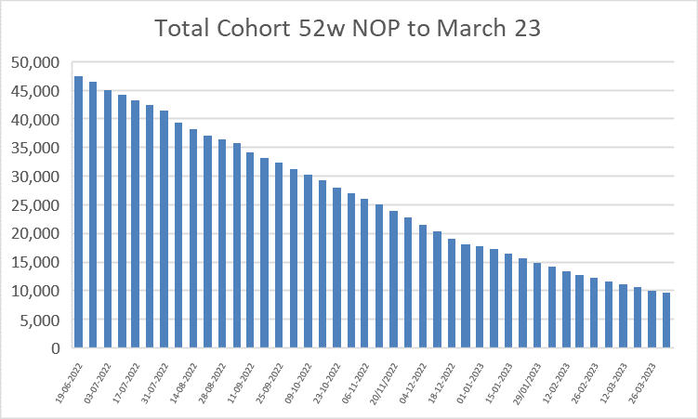
Figure 2 – number of patients with a total wait longer than two years

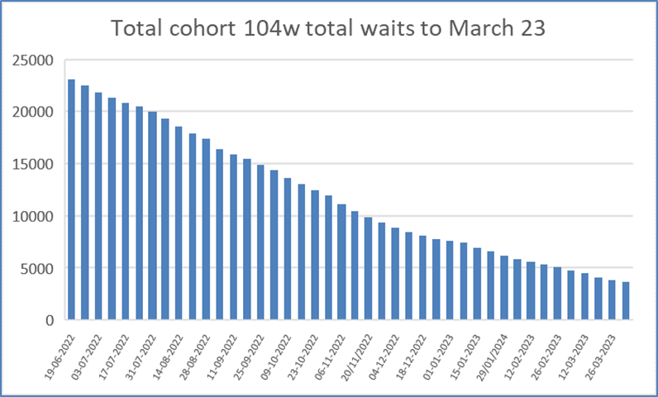

Figure 3 – number of patients with a total wait longer than three years

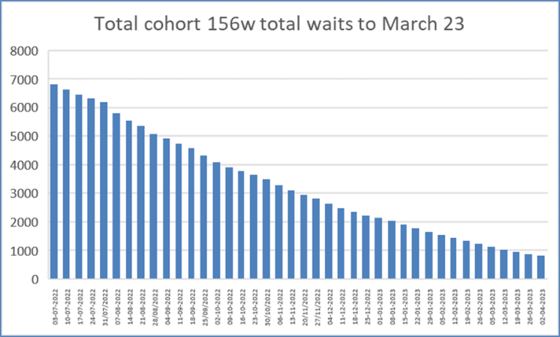

Children’s services have been an area of focus for the Health Board, particularly due to the disproportionate impact long waiting times can have on a child's development and opportunity to live a healthy life. The number of children on an RTT waiting list has reduced marginally to 11442 during the last year and this has in part been facilitated through the roll out of our integrated community paediatric clinics, a model which has reduced onwards referral to secondary care and reduce the need for children to attend hospital. The next phase of this model will be rolled out to additional groups of General Practices throughout 2023/24.

Diagnostics are a fundamental part of the planned care pathway and our overall performance in the last year has been below the standards we have aspired to. Figure 4 shows the total number of patients waiting over 8 weeks for a diagnostics test has decreased from 5001 in March 2022 to 4782 in March 2023.

Figure 4 – Diagnostic Waits

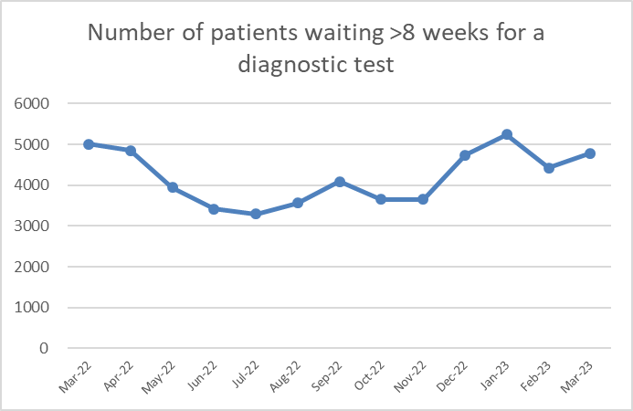

While the total number of patients waiting over 8 weeks for a diagnostic test has reduced, endoscopy and radiology continue to experience challenges but have improved their position in Q4. In endoscopy the demand for Cancer and Urgent services remains high but the service has maintained their two-week first appointments for Urgent Suspected Cancer patients.

Improvements have been seen in the delivery of our planned care therapy services. This has in part been facilitated through the full re-opening of our physiotherapy department in Lakeside Wing after it was displaced during the pandemic. Figure 5 shows the reduction in the number of patients waiting longer than 14 weeks for therapy which has reduced from 4492 in March 2022 to 952 in March 2023.

Figure 5 - >14 week therapy waits.

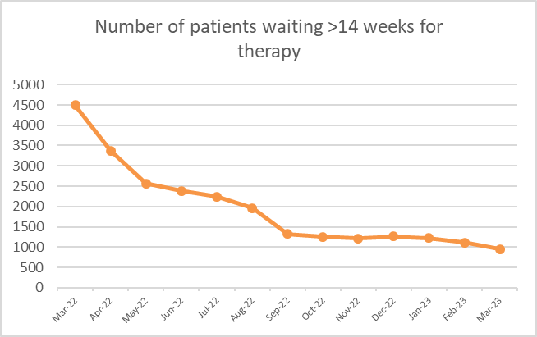

The delivery of planned care treatments across our primary and community care teams has continued to recover from the impact of the pandemic. Within Dental Services we have seen an increase in existing NHS patient appointments from less than 5000 in March 2022 to over 137,000 patients seen up to March 2023. December 2022. The availability of “in-hours” urgent dental appointments has also increased from 66 per week to 110 per week. Access to Pharmacy Services has been maintained during the year, with less than 10% of pharmacies reporting high levels of escalation and over 16,935 clinical community pharmacy consultations undertaken in Quarter 3. Access to NHS sight tests has been maintained, in addition an increase in the number patients seen in primary care through the NHS Wales University Eye Care Centre.

Mental Health

Demand for Adult and Children’s Mental Health Services has continued to be high with referrals regularly exceeding 140% of pre-Covid-19 levels. In spite of these pressures our teams have undertaken significant work to improve access times to adult primary Mental Health and Child and Adolescent Mental Health Services (CAMHS). The percentage of Mental Health assessments undertaken within 28 days increased to 96.8% in March 2023, Older persons performance was 100%, Adults performance was 97.6% and CAMHS performance was 92.7%. Strong performance was also seen in the delivery of therapeutic treatments – 99.5% started within 28 days following assessment at the end of March 2023.

Neurodevelopmental services provide multidisciplinary assessment, intervention, information and advice for children and young people who may have a neurodevelopmental disorder, and their families. Since the start of the pandemic the referrals to these services have increased by 55% and this had led to patients waiting a long time for assessment. Our teams have implemented a number of improvements in 2023 which have helped to reduce the overall number of patients waiting and we have plans to reduce the long waits significantly in 2023/24.

Adult and Paediatric Eating Disorder services have seen a reduction in the size of their waiting lists and the number weeks wait for their longest waiting patients. Psychological Therapy services have seen an increase in the number of patients on their waiting lists, but an increase in the proportion of patients waiting less than 26 weeks for an appointment.

The end of 2023 saw the Health Board extend the use NHS 111 by launching our Mental Health line which provides specialist support and onward direction for patients who would benefit from accessing primary or secondary mental health services. This service is planned to grow through the recruitment of a dedicated team in the coming year as we continue our drive to ensure Mental Health services get the organisational priority they deserve.

3.7.3 Quality Performance Analysis

The Health Board has embedded the regulations which guide the handling and response to concerns (complaints and incidents) launched by Welsh Government in April 2011. In addition, the Health Board’s approach to dealing with concerns very much reflects the ‘Principles of Remedy’ published by the Public Services Ombudsman for Wales.

Our process is compliant with the Complaints Standards Authority – Wales Concerns and Complaints Policy for Public Services Providers in Wales

This model policy is designed for public services providers in Wales. It represents a minimum standard of complaint handling for public bodies in Wales. The Policy is fully compatible with the Welsh Language Standards Regulations of 2018.

In Cardiff and Vale University Health Board we reviewed our process in line with the Model Concerns Policy. The Health Board is committed to dealing effectively with any concerns or complaints about our services.

Complaints Team staff can advise on the type and scope of complaints they can consider. We have amended our Concerns posters across the Health Board.

- Getting it right

- We acknowledge when we identify things that could have been improved.
- We consider all relevant factors when deciding the appropriate remedy, ensuring fairness for the complainant and, where appropriate, for others who have suffered injustice or hardship as a result of the same maladministration or poor service.
- We apologise and explain the maladministration or poor service.
- We try to understand and manage people’s expectations and needs.
- We always try to deal with people professionally and sensitively.

- Being customer focused

- We acknowledge and accept responsibility for failure if and when it occurs.
- We explain clearly why the failure happened and express sincere regret for any resulting injustice or hardship.

- Being open and accountable

- We try to be open and transparent
- We strive to treating people without bias, unlawful discrimination or prejudice.

- Acting fairly and proportionately

- We consider all forms of remedy (such as an apology, an explanation, remedial action, or financial compensation).

- Putting things right

- We are focussed upon using information on the outcome and themes from concerns to improve services.

- Seeking continuous improvement

- We seek to offer a proportionate, reasonable investigation and response that aims to identify the opportunities for service improvement.

3.7.4 Putting Things Right (PTR)

The central Concerns Team has continued to work in accordance with the Putting Things Right Regulations.

During 1st April 2022 to 31st March 2023, we have received in excess of 4,500 concerns. As anticipated, this is a significant increase in comparison to last year, when we received 4000 concerns. Some of the themes identified relate to poor communication, waiting times, discharge arrangements, and environment (social distancing).

A number of initiatives have been taken to improve communication between patients and staff. The Safer Bundle being piloted on one ward is an example of ward staff actively involving patients in their care. Patients are encouraged to ask:

What is the matter with me?
What is going to happen today?
What is needed to get me home?
When am I going home?

This fits in really well with the Quality Safety and Experience Framework by starting the “what matters to you” conversation with patients.

As anticipated, we have seen an increase in concerns this year relating to waiting times and a number of initiatives and different ways of working are being implemented to recover from the backlog caused by Covid-19. These include:-

- Clinical Boards are encouraged to re-engage with their patients to provide waiting list updates via letter.

- Clinical Boards have redesigned pathways to fast track patients who have been reluctant to access services/care during the pandemic.

- Introduced weekend clinics.

- Utilising Primary Care services so patients are seen sooner in Primary Care rather than in Secondary Care.

It is pleasing to note that during this period, the 30-working day performance level has ranged between 77% to 84 % which exceeds the Welsh Government target of 75%.

The structure below is our Quality, Safety and Experience (QSE) framework - the final committee being established is the Organisational Learning Committee to progress the whole systems approach to learning across Cardiff and the Vale.

Quality, Safety and Experience Framework
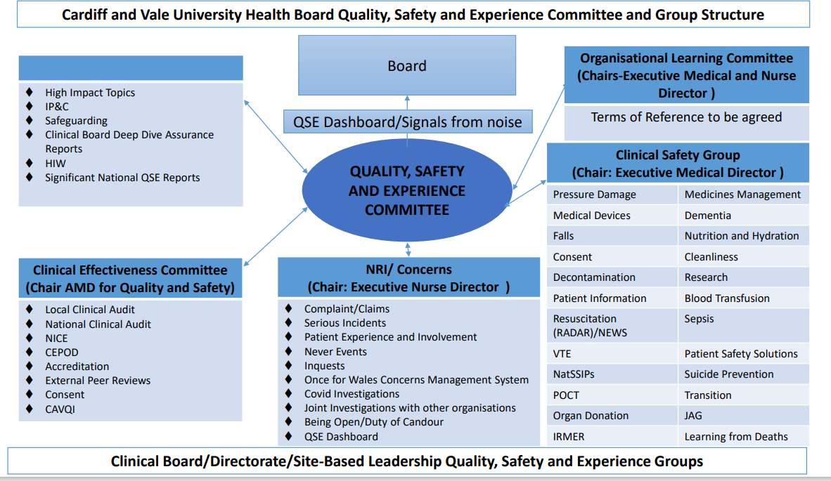

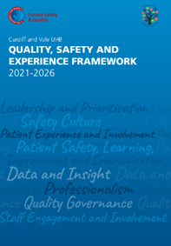

We believe that in focusing on these 8 key priorities, we can aspire to provide safe, effective services, that deliver an excellent user experience, equal to the best healthcare organizations in the world.

These eight key areas are:
• Safety Culture
• Leadership and the Prioritisation of QSE
• Patient Experience and Involvement
• Patient Safety Learning and Communication
• Staff Engagement and Involvement
• Data and Insight
• Professionalism of QSE
• Quality Governance Arrangement

The Organisational Learning Committee will be where the thematic reviews will be considered, to ensure that sustainable and measure improvements are put in place, utilising tested quality improvement methodology. Each of the Clinical Board Directors of Nursing will have a key area to concentrate upon through multi professional engagement, such as reduction in injurious falls, reduction in avoidable pressure ulcers, psychological safety etc.

3.7.5 The Duties of Quality and Candour
The Duty of Quality
The Duty of Quality, as part of the Health and Social Care (Quality and Engagement) (Wales) Act 2020, will come into force in April 2023. It is a lever for improving and protecting the health, care and wellbeing of the current and future population of Wales. It aims to ensure a stronger citizen voice and to improve the accountability of services to deliver a better experience and quality of care. Doing so contributes to a healthy and more prosperous country.

The Act is intended to have positive benefits for everyone in Wales, supporting a culture and the conditions needed to drive improvements in health care. The Duty of Quality requires the Welsh Ministers, with regards to their health-related functions and NHS bodies, to think and act differently by applying the concept of “quality” across all functions. They will need to consider quality within the context of the health service and health needs of their populations. The Duty of Quality requires quality driven decision making and planning to ultimately deliver better outcomes for all people who require health services. It requires involving people in decisions that affect them, balancing short-term needs with planning for the longer-term, with action to prevent problems occurring or getting worse. The prevailing intention is to build on the positive culture of quality at the heart of the Welsh health system, enacting a broader system-wide duty of quality, which strengthens decision making, action, improvement and ultimately, improved outcomes for the population. The Duty of Quality guidance document is currently undergoing public consultation. The guidance sets out a definition of quality alongside six domains of quality and five quality enablers. It is proposed that these become our Quality Standards 2023 which will replace the Health and Care Standards (April 2015). NHS bodies will be required to take these new standards into account, for the purpose of discharging the Duty of Quality.

Duty of Candour

The Duty of Candour will be in force from April 2023. The Duty applies to NHS bodies in Wales and requires them to be open and transparent with people when they come to harm whilst using services. The Duty will be triggered when there is an incident that causes harm that is more than minimal, the harm is unexpected or unintended and health care was or could have been a factor in causing the harm. When this type of incident occurs, the duty requires NHS organisations in Wales to notify the person involved offering a sincere apology for the harm and detailing what investigations will be done to learn from the incident. It also requires NHS bodies to produce an annual report on Duty of Candour incidents, summarising the number, type and learning from those incidents.

As part of the Regulatory Impact Assessment we have considered 9 months of data in relation to Health Board recorded incidents and in excess of 3000 would need consideration as to whether the Duty of Candour applies. These figures do not include Primary Care incidents which will be included from 1 April 2023. The initial work will be focused upon understanding the grading application at the initial recording of the incident and mandatory consideration of the grading on incident closure. The Duty of Candour will be managed through the Patient Experience Team, as the process somewhat mirrors the current management of complaints and there will be an interface with Redress, which is also part of the Patient Experience Team’s function

3.7.6 Improving safety - Learning from serious incidents, safeguarding issues and independent reviews.

Nationally Reportable Incidents (NRIs) are a key focus for the Clinical Boards and the Corporate Patient Safety Team. The performance and themes from NRIs are reported through the QSE Committee and through the Board Integrated Performance Report, all of which are in the public domain.

The Emergency Department remains under pressure as a result of the combined poor discharge profiles with more patients than there is capacity for being cared for within the Unit. This means that patients are also not always cared for in the most appropriate space. A robust plan is in place to manage the environment and improve outcomes that matter to patients. The Emergency Unit has been subject to Health Inspectorate Wales (HIW) and Community Health Council (CHC) visits and the most recent review by the CHC in February 2023 demonstrated the improvements in patient experience that were noted, despite the high level of activity which remains in the department. There is an increased focus upon facilitating discharge, alternatives to the Emergency Unit such as the Same Day Surgery Unit (SDEC) . We are making changes to building a workforce around our patients to care for those who do not need hospital care but are awaiting placement in local authority settings etc. However, recruitment of the workforce remains challenging

It is also important to review the near miss and low harm incidents relating to delay in access to services as a result of the current capacity constraints. There are Datix’s reporting the cancellation of surgery as no available bed, lack of capacity in the Intensive Treatment Unit (ITU) (Datix is an incident reporting system). This theme is reflected in the concerns raised by our patients and their families.

Learning from any patient safety incident is vital and to maximise and support this the Patient Safety Team have set up the Clinical Board QSE Lead forum whereby each Clinical Board will present learning from a case they feel has the opportunity for shared learning. This process also provides a network of support and co-operation for incidents that require input from multiple Clinical Boards. This forum also helps standardise processes around patient safety and risk management. The Clinical Boards also hold regular QSE meetings whereby patient stories and completed investigations are presented, again with an emphasis on learning.

We are implementing the Organisational Learning Committee which will provide a senior level overview of learning identified ensuring it is robust and sustainable as well as providing senior level support to Health Board wide learning. The learning committee will capture learning from patient and staff feedback. Compliments, incidents, complaints, redress cases, Ombudsman cases, claims, inquests, local and national audits, HIW reports and tendable data. The learning committee will work with the Innovation and Improvement team, universities, and other interested parties.

A regular Quality Indicators report is provided to the Quality, Safety and Experience Committee The report is presented in line with the Duty of Quality Act and the Safe Care provides information about Incident reporting, Nationally Reportable Incidents, Mortality, Maternity Outcomes, Infection Control. Timely we provide information about Ambulance handover times, Patient Experience in the Emergency Department with regard to waiting times, Effective we discuss indicators such as the stroke pathway compliance, Efficient -Values based Health Care, Equitable we discuss health inequalities, access to services and equity and Person Centred is where we share our Concerns and feedback statistics and themes.

4. Quality Governance Arrangements

An essential feature of our control framework is ensuring there is a robust system for measuring and reporting on the quality of our services. Our Quality Safety and Experience Committee provides timely evidence-based advice to the Board to assist it in discharging its functions and meeting its responsibilities with regards to quality and safety as well as providing assurance in relation to improving the experience of all those that come into contact with our services. All groups in the QSE structure report through the Clinical Safety Group or Clinical Effectiveness

5. Covid-19 Vaccination and test/tract/protect
Covid-19 vaccination

Over 163,000 Covid-19 autumn boosters were delivered in the 2022/23 period in Cardiff and Vale. Uptake among people aged 65 and over was 83%, in line with the Wales average.

Around 64% of healthcare staff working in the Cardiff and Vale area, over 17,000 people, took up the offer of the autumn booster, and over 4,500 social care workers were also vaccinated. 39% of people aged 5 to 49 in clinical risk groups were vaccinated.

By March 2023 we had delivered in total over 1.26 million Covid-19 vaccinations to our population since the start of the pandemic.

Planning has commenced for the Spring 2023 Covid-19 booster vaccination programmes in line with the Joint Committee for Vaccination and Immunisation (JCVI) recommendations published in March 2023. For a small group of people (e.g., those in older age groups, those living in care homes for older people and those who are immunosuppressed), an extra booster vaccine dose will be offered in Spring 2023. An Autumn 2023 booster dose for people at higher risk of severe Covid-19 is expected to be offered. Surge responses may also be required should a novel variant emerge.

The Holm View mass vaccination centre closed during 2022/23. Planning is underway for a new Vale provision for the Spring and Autumn 2023 programmes.
During 2022/2023 the programme moved towards the more integrated immunisation programme as outlined in the National Immunisation Framework for Wales. The programme aligned with the Welsh Government’s Winter Respiratory Vaccination Programme, with joint planning structures for Covid-19 and influenza vaccinations (co-administering where possible). Working in partnership with Health Board and Primary Care colleagues, as well as delivery of Covid-19 immunisation the services has also supported delivery of influenza, Polio, Human Papillomavirus (HPV), Monkeypox and Meningococcal B.

Test Trace Protect (TTP)

During the year, local and regional changes were made to TTP services in response to the Welsh Government plan, ‘Together for a safer future: Wales’ long-term Covid-19 transition from pandemic to endemic’, with a focus on supporting high risk settings. Contact tracing services followed national protocols, with specialist resource within the region organised to support these high risk settings. The use of Lateral Flow Tests (LFT) in the general population declined during the year as free kits were no longer available. The data on positive tests has become a less reliable indicator of population disease activity as a result. However, numbers of cases (in both staff and patients) and incidents in high risk settings (particularly hospitals and care homes) have tended to mirror the peaks identified by the Office for National Statistics (ONS) population study.

The multiagency regional team reduced its meeting frequency gradually to once per month, but continued to monitor new case data to identify clusters or settings of concern. The regional Standing Operational Procedure (SOP) was revised to ensure escalation mechanisms remained in place to respond to any risks identified. The Regional Incident Management Team (IMT) was stood down in summer 2022.

Partnership communication teams continued to work collaboratively to share updates on guidance with the people who live and work in Cardiff and the Vale of Glamorgan.

Welsh Government’s transition plan, Together for a Safer Future: Wales’ long-term Covid-19 transition from pandemic to endemic was published in March 2022. It set out the principles of the continued response to Covid-19 and other respiratory infections. Health Boards are required to implement a public health approach to respiratory viruses, including Covid-19, protecting the most vulnerable in our society from serious disease.

The focus from December 2022 has been on arrangements from April 2023. 2023/24 is anticipated to be a transition year, where the services and structures put in place by regional partners to manage the pandemic are further scaled back, and we build on the experience of the pandemic response to establish a more resilient system for managing ‘all-hazard’ health protection risks.

6. Delivering in Partnership

In many areas, the Health Board works with partners to develop and deliver plans for improving the health and well-being of our population, and to deliver services collaboratively. Our partners include other NHS Wales organisations, the two local authorities (Cardiff Council and the Vale of Glamorgan Council), the third sector and independent providers.

Cardiff and Vale Regional Partnership Board

The Health Board hosts the team that works on behalf of Regional Partnership Board (RPB) partners. During the year the team has supported health and care teams to deliver a range of initiatives and services designed to provide citizens with early help and support when they need it to keep people living safely and well in their own homes. This includes developing services for children and young people with more complex needs – including emotional health and mental health needs and needs resulting from being physically disabled, and those on the edge of care. We have seen an increase in the number of children exhibiting dysregulated behaviour accessing our services in a crisis and we have been working with the local authorities to develop services to meet the needs of these young people.
During the year the @home Programme has continued to develop, with Regional Integration Fund (RIF) allocations targeted to developing services which support independent living and to support people when their needs increase, or following an admission to hospital. Building on the successful of the transformation programme in the South West Cluster, we have been rolling out the cluster model in two more clusters in order to reduce preventable hospital admissions and to support people on discharge from hospital. Working with the third sector, particularly in relation to ‘social prescribing’ has been a key element of the model. Work has progressed to update and develop the Dementia Action Plan, with dedicated RIF allocation to further enhance this work.

During 2022 – 2023, the RPB completed a review of the governance arrangements and transitioned the work of the three partnerships – starting well, living well and ageing well – into programmes of work rather than partnerships, with each programme reporting into the RPB directly. During the year, the Health Board’s approach to delivering the six goals has accelerated and dovetails with the @home programme.

Regional Healthcare Services

The Health Board continues to work with neighbouring health boards to develop and implement regional service models where it makes sense to do so in order to ensure that a service is sustainable, meets key standards, and delivers the best outcomes for patients. The Health Board led the implementation of the regional model for vascular surgery, with the establishment of the regional hub for surgery at the University of Wales, with satellite hubs in each of the neighbouring health boards. The model is now well established, with vascular surgeons from across the region working together to deliver the regional model. The vascular network, which is hosted by Cwm Taf Morgannwg Health Board, oversees the running of the regional service on a daily basis to ensure that the patients flow into and out of the surgical hub in a timely manner, and that workforce challenges are addressed if they arise.
As part of the planned recovery programme, the Health Board is developing plans to look at potential regional solutions for addressing the backlog of people waiting for planned treatment which has built up during the pandemic. This includes looking at whether regional centres for high volume low complex activity could and should be developed. During the year we have seen progress made in the development of regional service delivery models for three areas with high-volume, low complexity patient services – ophthalmology, orthopaedics and diagnostic services.

The governance of the regional working in South East Wales has been strengthened, with the formation of the South East Wales Planning Collaborative – the Regional Portfolio Oversight Board of which is attended and chaired by the health board Chief Executive Officers from the region. To support the work, the planning directors (plus other key individuals) have formed a planning directors’ group to ensure progress is made. A programme director for the regional programme has been appointed, working directly to the three chief executives, and dedicated programme managers have been appointed to the programmes.

Work is ongoing to review the South East Wales Cancer Collaborative to bring it into line with the newly formed Regional Collaborative.

7. Workforce Management and Wellbeing
7.1 People and Culture
We pride ourselves on being a great place to train, work and live; with inclusion, wellbeing and development at the heart of everything we do. We know that in order to meet our population’s health and care needs effectively we are completely dependent on our people.

Our people have continued to respond to the challenges despite the impact the workforce crisis is having on Health and Social Care. Recent engagement surveys have told us that our people are leaving the sector and/or their profession due to stress, burnout, poor working conditions and lack of development opportunities. This has made recruitment and retention extremely challenging, resulting in staff shortages that have impacted negatively on the wellbeing of our people.

Our People and Culture Plan launched in January 2022 and set out our ambition over a three-year period. In 2022/23 good progress has been made with all seven themes in the plan but our priority and focus has been on improving recruitment, retention and wellbeing.
7.2 Attract and Recruit
Over the last 12 months we have significantly improved our employer brand, promoted the Health Board as an employer of choice and engaged with our local communities
Examples of how we have done this include:
- Recruitment Events and Careers Fairs
- Attended Events to engage with school children, Black, Asian and Minority Ethnic Groups, ex-military personnel, refugees, etc
- Collaborated with the Department for Work and Pensions (DWP) and implemented the hugely successful Kickstart Scheme.
- Embraced the opportunities that Project Search had to offer
- First Health Board in Wales to partner with the Prince’s Trust to facilitate work placements for diverse and under privileged young people.
- Successful International Nurse Recruitment Campaign
- Royal College of Nursing: Nursing Cadets Scheme.

7.3 Retaining our People
A wide range of initiatives have been developed and implemented to improve the retention of our people. Improving retention is multi-faceted and there is no quick fix. How we engage, listen and give our people a voice is at the top of our agenda, this year has seen the development of a range of information gathering tools/methods to obtain feedback for our people which will help us shape our focus and activity as we look to improve the experiences and engagement of our people. Examples below:
- Wellbeing Surveys focused on our Medical Workforce
- An engagement platform for Nursing and Midwifery Staff
- Information gathering through Trade Union Partners and targeted Retention Programmes
- Cultural assessments have commenced, this feedback will build upon what we have learned so far, and help shape our response, including building upon areas of good practice.
- Target interventions with action plans developed and agreed through co-production.
- A retention toolkit has been developed and is available for managers, this includes cultural surveys, engagement self-assessment tools, and examples of good practice.

- Career Clinics have been held and ‘New Starter’ surveys implemented.

7.4 Staff Wellbeing
The health and wellbeing of our people continues to be impacted as we recover from the impact of the pandemic. However we remain committed to supporting, and enhancing the wellbeing of our people. Our ambition continues to be to make the Health Board a great place to work and where staff can flourish, and we approach and address these challenges in a variety of different ways. This includes the provision of Occupational Health and Employee Wellbeing Services, flexible workplace policies and procedures, offering a wide range of development and career opportunities, improving our recruitment and retention strategies, and through the role modelling and promotion of healthy working relationships, actively promoting the Health Board’s values and behaviours.

2022/23 has seen many key achievements and developments that have, and will continue, to enhance staff wellbeing. Examples include:
- Provision of a high-quality in-house counselling service and reduced waiting times
- Development and delivery of wellbeing workshops and interventions;
- Targeted and focused interventions, helping teams effectively and safely debrief following challenging incidents;
- Enhancements in the provision of our Physiotherapy services
- Continued development of the Wellbeing Champion Training and Network Development, actively promoting and supporting wellbeing across the Health Board
- Continuation of psychoeducational training provision and menopause cafes
- The cost of living crisis has been a key priority and staff have been supported through, Financial Wellbeing roadshows, dedicated resources, provision of on-line MaPS training for Wellbeing Champions and line managers with plans to roll out the training further, On-line presentations on ‘Pensions’ and ‘Pensions and Menopause’, and the development of a staff ‘Financial Wellbeing’ framework.

7.5 Leadership and Management Development
During 2022 we have continued to enhance and develop the leadership and management development offer, focusing on compassionate and inclusive leaders and managers. Underpinned by the organisational values and the All Wales Leadership Principles of compassionate and inclusive leadership, through the Acceler8 Senior Leadership Programme.
The Collabor8 Leadership Programme was redesigned and relaunched, bringing together multi-disciplinary leaders from across the organisation to participate in experiential and explorative leadership development.
The existing Management Development Programmes continue to attract a range of individuals, providing the essential skills and knowledge necessary when starting a leadership and management journey to support, develop and motivate healthy, high performing teams delivering the highest standards of quality, care and innovation.
Continuing to focus on developing effective and compassionate leaders at all levels throughout the organisation, initial work has started on the development of leadership networks and alumni’s, creating opportunities for those attending different programmes to connect with peers and explore the role of leadership within the organisation, while shaping future development opportunities.
Leadership and Succession – we have participated in a Health Education and Improvement Wales (HEIW) Talent Management Practitioner Development scoping exercise to develop tools and resources to support Talent Management and Succession Planning in the NHS. Supported by the Health Board’s Values Based Assessment and Career Conversations Toolkit, this work will be embedded into practices to support the development of talent pipelines.
Leadership, Management and Wellbeing – Leaders/Managers have been trained to deliver the REACT Mental Health training, which has already been integrated into existing management development training. Future steps will see this roll-out as ‘bite-size’ learning, enabling a wider access across the organisation.
A range of management wellbeing support has also been delivered internally, through collaboration with the Employee Wellbeing Service, Clinical Psychology, People Services, Education, Culture and OD, and the Wellbeing and Recovery College.
Developing a Coaching Culture – A number of coaches have volunteered to undertake the accredited coaching qualifications which will add strength to our Coaching Network. Managers have also had the opportunity to attend ‘Manager as Coach’ development sessions, embedding a coaching approach to empower and motivate individuals and teams.

7.6 Equity, Inclusion and Welsh Language

The current Strategic Equality Plan (SEP), Caring about Inclusion 2020-2024, has a number of key delivery objectives and demonstrates our commitment to embedding equality, diversity, human rights, and Welsh Language into our business processes. The SEP is closely aligned to our ten-year strategy ‘Shaping Our Future Wellbeing’, our ‘People and Culture’ plan, our Integrated Medium-Term Plan, as well as the Well-Being of Future Generations Act 2015. This is the third year of the current four-year plan.
During 2022/23, we continued to strive to create a more inclusive organisation for our people and our communities through a range of means, including effective engagement, raising awareness of inequalities through keynote speakers, awareness sessions and partnership working with Public Health Wales and community groups, and celebrating the diversity of our workforce and community.

Some of the key highlights of the past year include:

- Creation and cross-organisation sharing of our second iteration of an Inclusion Calendar, which highlights key dates throughout the year to raise awareness and celebrate our diversity.
- Taking forward the Anti-racist Wales Action Plan through the facilitation of Board development sessions and co-producing a draft CAVUHB Anti-racist Action Plan alongside our One Voice Staff Network and trade union partners.
- Achieving a place in the top 100 in the Stonewall Workplace Equality Index, which ranks organisations throughout the UK in relation to LGBTQ+ inclusivity, and also earning the Gold Award for the second year running.
- Attending Pride Cymru for the first time since the pandemic alongside colleagues from across NHS Wales.
- Supporting the development of our staff networks including:
  - One Voice Staff Network – for our staff from ethnic minority communities
  - Access Ability – for our staff with disabilities and long-term health conditions
  - LGBTQ+ Staff Network – for our LGBTQ+ staff
  - Future Generations Network – to support and develop our leaders of the future
- Becoming a Level 3 Disability Confident Leader.
- Becoming members of Purple Space, the world's only professional development hub for disability network leaders.
- Developing an Equality Health Impact Assessment training package.
- Engaging with our communities, including hosting Equity and Inclusion stalls at our careers fayres and promoting career opportunities at local mosques.
- Continuing the development of our Inclusion Ambassador programme, aimed to support senior leaders, including at Executive and Board level, to better understand the lived experience of our diverse workforce. The programme to support each of the protected characteristics and Welsh language.



Although language is not a protected characteristic under the Equality Act 2010 - the protection of the Welsh language is taken forward under separate legislation (the Welsh Language (Wales) Measure 2011 and related Standards) - it has long been recognised that the equality and Welsh language policy agendas complement and inform each other. It is further supported through the goal within the Wellbeing of Future Generations Act – A Wales of vibrant culture and thriving Welsh language. Our aim is to sustain and reinforce that principle through our Strategic Equality Objectives and ensure they serve to promote and protect the Welsh language.
We will continue to go beyond our legal obligations, applying the principles that sit within the Equality Act and the Public Sector Equality Duty to all our thinking, planning and decision making for the benefit of all our people, both in our organisation and our communities. The Equality Strategy and Welsh Language Standards Group continues to support developments and improvements across the Health Board.

By March 2023 36% of our staff have registered their language skills and the organisation will continue to campaign for staff to register their language skills in 2023.

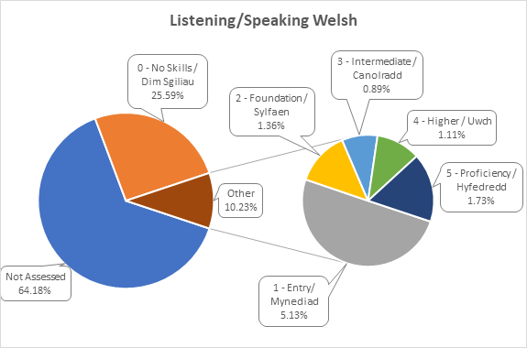

We have received a total of 3 complaints in 2022/23 from the Welsh Language Commissioner. Each of these concerns has been investigated and recommendations implemented. As a result, we have made improvements in our compliance with the Welsh Language Standards around social media, its website and phone services.

We have advertised the following amount of vacancies:

Total number of vacancies advertised as:
Welsh language skills are essential | 2
Welsh language skills are desirable | 3409
Welsh language skills need to be learnt when appointed to the post | 0
Welsh language skills are not necessary | 118
Total Number of vacancies advertised 01/04/2022 - 31/03/2023 | 3529

Compliance with the Standards has improved, 81 of the 120 standards have been completed, the outstanding standards require more longer-term planning. Improving compliance will remain a priority in 23/24.

Welsh Language Regulations – The Welsh Language Standards (No.7 and No.8 ) Regulations 2018

The Health Board produces a Welsh Language annual report each year which includes details on a range of mattes, including:-

- The amount of vacancies that have been advertised with Welsh as essential, desirable or not required

- The amount of concerns around compliance with the Welsh Language Standards

- A breakdown of the Welsh Language skills of our workforce.

The Welsh Language Annual Report 2021-22 was approved by the Board on 24 November 2022. A copy can be accessed at https://cavuhb.nhs.wales/files/welsh-language-in-healthcare/welsh-language-standards-annual-report-2021-2022/

7.7 Shaping our Future Workforce
Robust workforce planning is fundamental to our recovery post-pandemic and to help us achieve workforce sustainability. During 2022/2023 focus has been on developing a local and national workforce plan for our Nursing workforce, which is our largest staff group. Work was prioritised to address the large-scale vacancies caused by the long-standing national shortage and the pandemic. A nursing baseline has been developed across all areas which includes an analysis of the current workforce, future workforce needs and potential solutions to change the supply and shape of our future workforce.
This has resulted in the development and implementation of the newly created Assistant Practitioner role to support the nursing workforce. Our aim in 2023/2024 is to accelerate this work, moving away from more traditional workforce models into a more transformational way of thinking.
To support the Health Board knowledge and expertise in strategic workforce planning bespoke training has been arranged. This programme will continue throughout 2023/2024.
People Analytics - At the start of 2022 our goal was to start to create a strong people analytics culture where managers actively use people data to tackle business problems, have management teams that speak about the value and importance of people data and have line managers who seek out people data to make business decisions. Driving quality and efficiencies through systems was also a priority, ensuring we embed effective rostering principles across the Health Board. Good progress has been made in this area and will continue into 2023/2024.

7.8 People and Culture Plan in 2023/2024

In 2023/2024 we will build on what has been achieved in Year 1, focusing on the Health Board priorities, ensuring that quality, improvement and sustainability are at the forefront. We know that we are not providing the quality of services we could or should, so patients and staff don’t have the best experience or outcomes. Over the next 12 months we will develop strategic workforce planning capabilities to enable us to move toward a more patient centred approach built around the skills needed to care for our patients. We will also develop alternative workforce models by gaining a fuller understanding of our current and future workforce needs to release capacity, address gaps and build action plans. The number of staff in non-traditional roles will increase, to reflect the skills required to care for our population, e.g. peer support workers, apprentices, Physician Associates, Assistant Practitioners, and multi-skilled support workers. Strategic decision making will be supported by ensuring our workforce data is accurate, meaningful and accessible and by a move away from workforce reporting to people analytics. To enable this, in 2023 we will implement systems that provide the organisation with real time data for our workforce, including the roll out of Health Roster across all nursing areas and implementation of Safe Care.

As an organisation we will aim to deliver excellence in all that we do so that our staff, patients and our population have the best experience and outcomes. Our People and Culture Plan will help us achieve this aim.



7.9 Local Partnership Forum and Other Employee Engagement Groups
Local Partnership Forum (LPF) – We have a statutory duty to “take account of representations made by persons who represent the interests of the community it serves”. This is achieved in part by three Advisory Groups to the Board and the Local Partnership Forum (LPF) is one of these.

The LPF is co-chaired by the Chair of Staff Representatives and the Executive Director of People and Culture. Members are Staff Representatives (including the Independent Member for Trade Unions), the Executive Team and Chief Executive, the Director of Corporate Governance, and senior members of the People and Culture team. The Forum meets 6 times a year.
The LPF is the formal mechanism for the Health Board and Trade Union/Professional Organisation Representatives to work together to improve health services. Its purpose, as set out in the Terms of Reference, fall into four overarching themes: communicate, consider, consult and negotiate, and appraise.
Significant issues which the Local Partnership Forum considered during 2022-2023 include:

- Regular operational updates, including the Reset and Recovery Plan and the Winter Plan
- IMTP – engagement on Health Board’s priorities and progress reports
- Nurse Staffing Act annual report
- The Strategic Equality Plan
- Anti-Racist Wales Action Plan
- Move More Eat Well Plan
- TrAMs (Transforming Access to Medicines) Programme
- Shaping our Future Wellbeing Refresh
- Rehabilitation Programme
- Co-Production and the Recovery College
- Learning from Covid-19 and the UHB Response to the Covid Inquiry
- Review of year 1 of the People and Culture Plan

The LPF also receives an update on ‘hot topics’ from the Chief Executive and a copy of the Integrated Performance Report prepared for Board at each meeting. This report includes a summary position for the following areas:

- Population Health
- Quality and Safety
- People
- Operational Performance
- Finance

The LPF has 3 sub-groups - the Workforce Partnership Group, the Employment Policies Sub Group and the Staff Benefits Group:

The Workforce Partnership Group (WPG) is co-chaired by the Chair of Staff Representatives and the Executive Director of People and Culture. Members are senior representatives of the People and Culture team, Lead Clinical Board Staff Representatives, the Lead Staff Representative for Health and Safety and the Staff Side Secretary. The Independent Member – Trade Union also has a standing invitation to attend, as do Clinical Board and senior Nursing representatives.

The WPG generally meets 6 times a year, alternating with the LPF. In addition, in 2022/2023 a number of extraordinary meetings have been held to enable timely and detailed discussion. These extraordinary meetings have dealt with topics such as management of long Covid cases, retention and the deployment of staff.

WPG provides a forum for the Health Board and Trade Unions (including Professional Organisations and Staff Associations) to work together on issues of service development, engagement and communication specifically as they affect the workforce. Its purpose, as set out in the Terms of Reference, fall into three overarching themes: to communicate, to consider and to discuss matters which affect the workforce. The items discussed tend to be more operational or detailed than those brought to the LPF, and the LPF regularly refers matters to the WPG for follow up and further consideration.
Significant issues which the WPG has considered during 2022/2023 include:
- Employee Relations Activity
- People and Culture Plan
- Annual Leave Implementation
- Estates Plan
- Pay Progression
- Engagement and Retention
- Staff Welfare Project
- Enhanced Overtime Rates
- Disruptive HR

The Employment Policy Sub Group (EPSG) is made up of representatives from People and Culture and Trade Unions and is co-chaired by the Deputy Head of People Assurance and Experience and a Trade Union (TU) representative. The EPSG is the primary forum for the development and review of employment policies, procedures and guidelines. It usually meets 6 times a year. The Terms of Reference for this group were reviewed in July 2021 and the membership was widened to include representatives from inclusion, wellbeing and education.

Over the past year the following documents have been developed or reviewed and approved:

- Retire and Return Procedure
- Values Based Appraisals Procedure
- Management of Stress in the Workplace Guidelines
- Supporting Employee Mental Health Guidelines
- Parental Leave Procedure
- Flexible Working Procedure
- Working Times Procedure
- Injury Allowance Claim Procedure
- Professional Registration Procedure
- Fixed Term Contract Procedure
- Alcohol, Drugs and Substance Misuse Procedure
- Recruitment and Selection Procedure

In addition, in 2022/2023 EPSG reviewed, considered and recommended that the Strategy and Delivery Committee should approve the following Policies:

- Adaptable Workforce Policy
- Recruitment and Selection Policy
- Employee Health and Wellbeing Policy
- Learning, Education and Development Policy
- Maternity, Adoption, Paternity and Shared Parental Leave Policy

The Staff Benefits Group explores and co-ordinates discounts and benefits offered by external organisations for Health Board employees. The Staff Benefits Group meets quarterly and discusses and agrees ‘best deals’ for staff. Membership consists of Senior Management Representatives.
- Senior Health Charity representative
- Senior People and Culture Manager
- Staff Side representative
- Communications representative
- Sustainable Travel Manager
- Procurement Representative
The Business/Operational Manager of the Communication, Arts, Health Charity and Engagement Team facilitates the relationship and communications between the SBG and its partners/discount provider.
Their work is reported to the Charitable Funds Committee and the Local Partnership Forum.
At a more local level, each Clinical Board also has monthly or bi-monthly Local Partnership Forums which enable the Clinical Board leadership team to engage with trade union representatives on local matters.

7.10 Well-being of Future Generations (Wales) Act 2015 Wellbeing Statement and Annual Reporting

The Health Board has adopted the Shaping Our Future Wellbeing Strategic Objectives as our wellbeing objectives, as detailed below. Embedding of the goals, principles and ways of working advocated by the Act into our everyday business is overseen by our Wellbeing of Future Generations (WFG) Steering Group, and the Chair in his capacity as our WFG Champion.

During 2022/2023 an engagement exercise began within the Health Board and with our residents, patients and partners on updating the organisation’s ten year strategy, Shaping Our Future Well-being. Our WFG Steering Group meeting in March 2023 included a detailed discussion on the update to the strategy. The revised strategy will be based on learning from the implementation of the original strategy, including the framing of the well-being objectives. The updated strategy will be published during 2023/2024 at which point we anticipate updating our well-being objectives in line with the new strategy.

When developing our IMTP, we weave the requirements of the Act as a golden thread through the plan, and our decision-making processes require us to consider the implications of the legislation when making our decisions.

Governance arrangements in Cardiff and Vale University Health Board
A Cardiff and Vale UHB WFG Steering Group, chaired by the Executive Director of Public Health, reviews the actions required to embed the requirements into the Health Board, and supports the culture change required for the Health Board to routinely implement the sustainable development principle. Regular meetings of the group resumed during 2022/2023 following a period of reduced frequency in the preceding period due to the pandemic.

The Steering Group maintains and assesses progress against an annual work programme. The Chair of the Board acts as the Well-being of Future Generations Champion for the Board. We maintain a regular dialogue with the Office of the Future Generations Commissioner and one of the Changemakers from the Commissioner's office is a standing member and regular contributor to the Steering Group.

Areas of discussion for the Steering Group in the last year have included the organisation’s People and Culture plan, the sustainability action plan, communications and engagement, the House of Lords report on behaviour change for climate and environmental goals, as well as the update to our 10 year strategy.

In the partnership arena, we contribute to the statutory Well-being Assessments and Well-being Plans (one for Cardiff; one for the Vale) through our participation in the Public Service Boards, and deliver key actions in the plans, individually and together with partner organisations.

Our well-being objectives
Within the Health Board, our ten year strategy (Shaping our Future Well-being - https://cavuhb.nhs.wales/about-us/our-mission-vision/shaping-our-future-wellbeing-strategy/) objectives are the organisation's statutory well-being objectives under the WFG Act, and listed below. These objectives contribute to the seven national well-being goals:

- Reduce health inequalities
- Deliver outcomes that matter to people
- All take responsibility for improving our health and well-being
- Offer services that deliver the population health our citizens are entitled to expect
- Have an unplanned (emergency) care system that provides the right care, in the right place, first time
- Have a planned care system where demand and capacity are in balance
- Be a great place to work and learn
- Work better together with partners to deliver care and support across care sectors, making best use of our people and technology
- Reduce harm, waste and variation sustainably making best use of the resources available to us
- Excel at teaching, research, innovation and improvement and provide an environment where innovation thrives

The Annual Plan integrates and demonstrates the five ways of working and action against the well-being goals throughout the plan. Prevention is embedded throughout our work, with additional specialist public health interventions described in our Local Public Health and Shaping our Future Population Health plans (https://cavuhb.nhs.wales/patient-advice/local-public-health-team/key-publications/).

Progress against our well-being objectives
Because our corporate objectives are our well-being objectives, progress against our well-being objectives is demonstrated through our routine performance reporting against our IMTP or Annual Plan, and ten-year strategy. You can find out more about our performance, and where it is reported, in the Performance Section of this report.

During 2022/23 we again reviewed our Sustainability Action Plan, to ensure actions deliver - and go beyond - the requirements of the NHS Wales decarbonisation strategic delivery plan.

The action plan builds upon our previous two action plans from 2020 and 2021. We have learned much in the last few years, but there is still a long way to go to make a meaningful impact to our emissions levels. One of the aims of the action plan is to become much more mature and carbon literate as an organisation across the range of services we offer.

Reducing our carbon impact will be challenging as our experience has proven that gains from initiatives tend to be small. Actions in the plan fall under the themes of Leadership, Estates, Transport, Procurement, People and Communications and Clinical Practice.

Highlights of recent action taken in the Health Board include:

- Clear governance mechanism for sustainability action plan including Executive sponsor
- Hired a sustainability improvement manager
- Each Executive Director has a sustainability objective
- We are tracking our emissions annually using a Welsh Government approved method
- We are sending no waste to landfill
- We have improved our metering to better understand where electricity is being consumed
- We have invested in a new secure cycle facility at UHW, including drying racks and showers, and were one of the first organisations to complete the implementation of the commitments in the Cardiff Healthy Travel Charter, alongside public sector partners
- The main nitrous oxide (anaesthetic gas) manifold at University Hospital of Wales and University Hospital Llandough have been successfully decommissioned; studies show nitrous oxide has more than 265 times the global warming potential than CO2
- We relaunched the walking aids recycling scheme
- The Maelfa Wellbeing Hub opened. The new Wellbeing Hub has been built into Cardiff Council’s existing Powerhouse Community Hub. By being physically connected and sharing the space, it provides health and community services and a multi-functional service for patients, staff and the local community
- Ten sustainability scholars received training from the Centre for Sustainable Healthcare in Sustainable Quality Improvement and over a 10 month period saved a total of 40 tonnes of CO2
- Our Health Meadow at University Hospital Llandough received a Building with Nature Full Award, the first of its kind in Wales
- Food Sense Wales, hosted by Cardiff and Vale Health Charity, continued to support the development of sustainable food systems in Cardiff and Vale and more widely across Wales

You can read more about specific projects we have completed which demonstrate our commitment to the Act on our website.

8. Sustainability Report
It is estimated that the Health Board has generated 202,000 tonnes CO2e in 2021/2022. Since 2018, for the emissions that are under the control of the Health Board (scope 1 and scope 2 emissions), it is estimated that carbon emissions have reduced by 1%. Emissions are broken down in the following categories:

Sector | KG CO2e | % of total emissions
Buildings | 36,871,148.88 | 18.24%
Fleet | 457,584.15 | 0.23%
Business travel | 589,493.49 | 0.29%
Waste | 1,690,170.23 | 0.84%
Supply Chain | 162,541,053.31 | 80.41%

By far the largest source of emissions at 81% come from the products and services used in order to deliver health services. Products and services include items such as medication, personal protection equipment, surgical devices, catering, etc. Everything needed to run a health service. To impact upon these emissions, action is needed across the breadth of our organisation.

The emissions for 2022/23 will be reported on to Welsh Government in September 2023. It should be noted that the way in which emissions data is being reported upon is evolving. For example, currently emissions associated with a product are estimated based upon the Standard Industry Code for the organisation that sells that product and the money spent on that product. An exercise has taken place within NHS Wales Shared Services Partnership to review how vendors are allocated to Standard Industry Codes which could cause movements in supply chain emissions for 2022/23 when reported in September 2023 versus 2021/22. Furthermore, eventually, it is the aim of NHS Wales to be able to report on the actual emissions of a product.

Under the paragraph entitled Progress against our well-being objectives of section 7.10 of this Annual Report, we have set out some of the progress made so far in equipping the organisation to reduce its carbon footprint. There remains much still to do however.

Action Planning

The Health Board’s vision is to be an exemplar in the delivery of sustainable healthcare, setting the pace that others will follow and learn from. Low environmental impact will be a business as usual consideration where all of our colleagues will be encouraged to make changes to working practices that will see our carbon emissions reduce initiative by initiative.

In March 2023, our Board approved our 2023/24 Decarbonisation Action Plan ( <insert link> - to follow) . This action plan builds on our experience since 2020, in particular how a step change can be made in avoiding new emissions and reducing existing emissions. A separate climate adaption plan will be published to manage the risks of the changing climate already being experienced.

It has been our experience that initiatives to reduce our carbon emissions tend to deliver small results. To exemplify, even a 50% reduction in our electricity consumption would reduce our emissions by just 2%. Therefore, action is needed across a wide range of areas by a large number of people in order to have the impact required. A cultural shift is therefore required so that all 17,000 colleagues understand the responsibility to act and make a number of small but frequent contributions that make a difference. The Health Board needs to create the environment from the top which will equip and encourage our colleagues to make a difference.

Measurement of the overall macro impact of this plan will come through the annual reporting that gets delivered to Welsh Government, where a year on year comparison can be made.

A summary of the actions to be undertaken over the next year include:

• We will review the expected carbon and cost savings of this plan by autumn 2023.

• We will ensure decarbonisation and wider sustainability forms part of the Shaping Our Future Wellbeing strategy refresh.

• We will build decarbonisation into our key decision making. Additionally, by amending the Terms of Reference for relevant meetings led by executives we will ensure decarbonisation is given the focus it needs.

• We will explore ways to measure emissions at a more granular level than present, such as by department.

• We will value and encourage our teams to make improvements in carbon emissions. Allocate time for quality improvement initiatives or allocating Green Champions to undertake beneficial research or implementation work.

• We will continue to ask our executive team to take an annual objective to reduce carbon emissions.

• We will take on board the recommended actions articulated by Audit Wales in July 2022.

• We will recommend Board level decarbonisation/carbon literacy training.

• We will consider any emerging collaboration opportunities with our Public Sector Board colleagues.

• We will sponsor a decarbonisation education/ behaviour change / communications programme.

• We will support proposals to increase our energy efficiency.

• We will consider a costed proposal to adopt and implement the Level 2 Healthy Travel Charter which will encourage our staff to travel sustainably We will share our experience to any other Health Board in Wales to aid learning.

• We will ensure Decarbonisation is included in any clinical service redesign.

These actions, taken together will enable us to establish the environment for the organisation to deliver emissions reduction and develop the culture within the organisation, with the aim that every one of our employees is acting to contribute to the achievement of carbon reduction. Improvements in carbon literacy, leadership, supporting transition and some carbon savings will be achieved by the end of this plan.

9. Conclusion and Forward Look

The past year has been one of transition as we have continued to recover services following the pandemic and continue supporting and developing our people. The Health Board is proud of the improvements we have made in areas such as mental health waiting times, ambulance handover performance and mass immunisation. Our performance across many of our planned care and cancer pathways has been in line with our commitments, although we know that there is significant progress still to be made in these areas. Partnership working and a steadfast commitment to the development of integrated primary, community and social care services has been at the heart of our planning and delivery. The pressures on our teams have continued and we have worked hard to improve staff wellbeing services alongside increasing recruitment, focusing on retention and supporting the right of our staff to undertake industrial action.

Looking forward, the Health Board intends to build on our recent success whilst being conscious of the volatile planning environment within which we are operating. The Health Board faces significant financial challenges, workforce shortages and a degree of uncertainty across the wider Health and Social Care system. Despite this, we are committed to inspiring hope and confidence in our ability to deliver quality for our residents, patients and staff. Within this context we have set out our operational delivery priorities for 2023/24:

- To enable people with urgent or emergency care needs to access safe and high-quality care at the right time, in the right place, delivered by the right team;

- To recover, reset and transform planned care, cancer and diagnostic services;

- To deliver exceptional specialist and tertiary services for our local, regional and national populations;

- To ensure that every child has the opportunity for the best start in life and to provide high quality, safe and patient centred women’s services; and

- To continue our mental health transformation with a focus on the principles of home first, integration, safe hospital care and improving access to psychological support and specialist teams

In order to deliver these operational priorities, the Health Board has committed to an operating model that is centred on delivering quality. The model embeds quality and continuous improvement, learning and a value-based healthcare approach as the means to deliver our ambitions and deliver the very highest quality of care through prudent use of resources. To support this operating model, we are committed to developing our capability across five key enablers: Leadership; Culture and valuing people; Data to knowledge; Learning, improvement and research and Whole-systems perspective.

As we look forward it is vital that we have a healthy, safe and capable workforce to help us to transform patient care and provide better services and as such we are continuing to ensure focus on the opportunities to improve the safety and well-being of our staff that have been outlined in our People and Culture Plan.
.

Part 2
Accountability Report

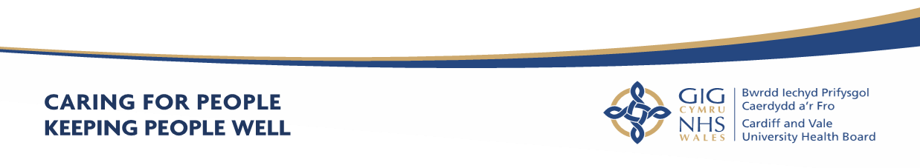
Part 2 - Accountability Report

Scope of the Accountability Report
The purpose of the accountability section of the Annual Report is to meet key accountability requirements to the Welsh Government, and to provide an overview of the governance, accountability arrangements and structures that were in place across the Health Board during 2022-2023. It includes:
- Corporate Governance Report
- Remuneration and Staff Report
- Senedd Cymru/Welsh Parliament Accountability and Audit Report

10. Part 2a - Corporate Governance Report
10.1 Directors Report
10.1.1 The Composition of the Board
Part 2 of the Local Health Boards (Constitution, Membership and Procedures)
(Wales) Regulations 2009 (the Regulations) sets out the required membership of the Boards of Local Health Boards, the appointment and eligibility requirements of members, the term of office of Independent Members and Associate Members. In line with these Regulations, our Board comprises of 20 voting members, with additional 3 non-voting Associate Members including:

- a Chair;
- a Vice-Chair;
- Officer members;
- Independent Members; and
- Associate Members.

The Board provides leadership and direction to the organisation and is responsible for governance, scrutiny and public accountability, ensuring that its work is open and transparent by holding its meetings in public. As a result of the continued public health risk linked to the pandemic and the need to ensure the risk of the spread of Covid-19 has remained a priority during the year, our Committee meetings have continued to be held virtually. Whilst this is not strictly in compliance with our Standing Orders with regards to allowing the public to attend meetings of our Board and Committees meetings, we took a number of steps to strengthen public transparency of our Board and Committee meetings (please refer to paragraph 13.6 (Board & Committee Meetings during Covid-19) of the AGS ). From 26 May 2022 we were pleased to resume our Board meetings in person, with the members of the public being welcome to attend the public sessions of our Board meetings. For the time being, our Committee meetings will continue to be held virtually.

The members of the Board are collectively known as “the Board” or “Board members”, the Officer and Independent Members (which includes the Chair) are referred to as Executive Directors and Independent Members respectively. All Independent Members and Executive Director Members have full voting rights.

The Health Board has 11 Independent Members (including the Chair and Vice-Chair), all of whom are appointed by the Minister for Health and Social Services. There are 9 Executive Directors (including the Chief Executive).

In addition, Welsh Ministers may appoint up to 3 Board level Associate Members. Associate Members have no voting rights. There are also 2 Director posts, namely the Director of Corporate Governance and the Director of Digital Health and Intelligence, who form part of the Executive Team and the Board but have no voting rights.

Before an individual may be appointed as a member or Associate Member they must meet the relevant eligibility requirements, set out in Schedule 2 of The Local Health Boards (Constitution, Membership and Procedures) (Wales) Regulation 2009, and continue to fulfil the relevant requirements throughout the time that they hold office. The Regulations can be accessed via the following link:

https://www.legislation.gov.uk/wsi/2009/779/contents

10.1.1 Voting Members of the Board During 2022-2023

Please refer to paragraph 13.13 (Board and Committee Membership & Attendance 2022/23) within the Accountability Report and Appendix 1 to the Annual Governance Statement.

10.1.2 Audit and Assurance Committee

The membership of the Audit Committee during 2022-2023, providing the required expertise was as follows:

Name | Role | Dates
INDEPENDENT MEMBERS
John Union | Committee Chair and Independent Member - Finance | April 2022- March 2023
David Edwards | Committee Vice Chair | April 2022- March 2023
Mike Jones | Independent Member Trade Union | April 2022 – March 2023
Ceri Phillips | Vice Chair | April 2022 – March 2023

10.1.4 Declaration of Interests

Details of company directorships and other significant interests held by members of
the Board which may conflict with their responsibilities are maintained and updated
on a regular basis. A Register of Interests is available on the Health Board’s website
by clicking on the following link https://cavuhb.nhs.wales/about-us/our-board/register-of-interests/ or a hard copy can be obtained from the Director of Corporate Governance on request.

10.1.5 Personal Data Related Incidents

Information on personal data related incidents which have been formally reported to the Information Commissioner’s office and “serious untoward incidents” involving data loss or confidentiality breaches and details of how the risks to information are managed are detailed in paragraph 15.10 (Data Security and Information Governance) of the Annual Governance Statement.

10.1.6 Environmental, Social and Community Issues

These are included in paragraph 15.5 (Environmental, Social and Community Issues) of the Annual Governance Statement.

10.1.7 Statement of Public Sector Information Holders

This is contained at paragraph 21.3 (Managing Public Money (page xx) of the Parliamentary Accountability and Audit Report.

Signed by ……………………………………….

Suzanne Rankin
Chief Executive and Accountable Officer

Date:

11. Statement of the Chief Executive’s Responsibilities as the Accountable Officer of the Health Board

The Welsh Ministers have directed that the Chief Executive should be the
Accountable Officer of Cardiff & Vale University Health Board.

The relevant responsibilities of Accountable Officers, including their responsibility for
the propriety and regularity of the public finances for which they are answerable, and
for the keeping of proper records, are set out in the Accountable Officer’s
Memorandum issued by the Welsh Government.

I can confirm that:

- As far as I am aware, there is no relevant audit information of which Cardiff & Vale University Health Board’s auditors are unaware, and I have taken all steps that ought to have been taken to make myself aware of any relevant audit information and to establish that the Health Board’s auditors are aware of that information.
- Cardiff & Vale University Health Board’s annual report and accounts as a whole are fair, balanced and understandable and I take personal responsibility for the annual report and accounts and the judgements required for determining that they are fair, balanced and understandable.

- I am responsible for authorising the issue of the financial statements on the date they were certified by the Auditor General for Wales.

To the best of my knowledge and belief, I have properly discharged the responsibilities set out in my letter of appointment as an Accountable Officer.

Signed by.....................................................................................................

Suzanne Rankin, Chief Executive

Date.............................................................................................................

12.Statement of Directors’ Responsibilities in Respect of the Accounts

The directors are required under the National Health Service Act (Wales) 2006 to prepare accounts for each financial year. The Welsh Ministers, with the approval of the Treasury, direct that these accounts give a true and fair view of the state of affairs of the Cardiff & Vale University Health Board and of the income and expenditure of the Cardiff & Vale University Health Board for that period.

In preparing those accounts, the directors are required to:
- apply on a consistent basis accounting principle laid down by the Welsh Ministers with the approval of the Treasury
- make judgements and estimates which are responsible and prudent
- state whether applicable accounting standards have been followed, subject to any material departures disclosed and explained in the account.
The directors confirm that they have complied with the above requirements in preparing the accounts.
The directors are responsible for keeping proper accounting records which disclose with reasonable accuracy at any time the financial position of the authority and to enable them to ensure that the accounts comply with the requirements outlined in the above mentioned direction by the Welsh Ministers.
By Order of the Board
Signed:
On behalf of the Chairman: Charles Janczewski……Dated: …............……2023
Chief Executive: Suzanne Rankin……………………… Dated: …….................2023
Director of Finance: Catherine Phillips ………..........Dated: ……................2023

Annual Governance
Statement

13 ANNUAL GOVERNANCE STATEMENT

13.1 Scope of Responsibility

The Board is accountable for Governance, Risk Management and Internal Control. As Chief Executive of the Board, I have responsibility for maintaining appropriate governance structures and procedures as well as a sound system of internal control that supports the achievement of the organisation's policies, aims and objectives, whilst safeguarding the public funds and the organisation's assets for which I am personally responsible. These are carried out in accordance with the responsibilities assigned by the Accountable Officer of NHS Wales.

The Annual Report outlines the different ways the organisation has had to work both internally and with partners in response to the unprecedented pressure in planning and providing services. It explains arrangements for ensuring standards of governance are maintained, risks are identified and mitigated and assurance has been sought and provided. Where necessary additional information is provided in the Annual Governance Statement. However, the intention has been to reduce duplication where possible. It is therefore necessary to review other sections in the Annual Report alongside this Annual Governance Statement (AGS).

This AGS details the arrangements in place during 2022-2023 to discharge my responsibilities as the Chief Executive Officer of the Health Board, and to manage and control the Health Board’s resources. It also details the extent to which the organisation complies with its own governance arrangements, in place to ensure that it fulfils its overall purpose, which is that it is operating effectively and delivering quality and safe care to patients, through sound leadership, strong stewardship, clear accountability, robust scrutiny and challenge, ethical behaviours and adherence to our set values and behaviours. It will set out some of the challenges and risks we encountered and those we will continue to face going
forward.

At the time of preparing this Annual Governance Statement, the Health Board and the NHS in Wales continue to face unprecedented challenge and increasing pressure as we emerge from the impact of Covid-19. This includes significant financial pressure. Further detail is provided under paragraph 3.4 of the Performance Report. Link with Finance section of Performance Report when provided.

13.2 Escalation and Intervention Arrangements

Under the Joint Escalation and Intervention Arrangements, the Welsh Government meets with Audit Wales and Healthcare Inspectorate Wales (Tripartite Group) twice a year to discuss the overall assessment of each Health Board, Trust and Special Health Authority in relation to the arrangements. A wide range of information and intelligence is considered to identify any issues and inform the assessment.
The framework has four escalation levels:
- Routine arrangements
- Enhanced monitoring
- Targeted intervention
- Special measures.
- Escalate Cardiff and Vale UHB from routine arrangements to enhanced monitoring for planning and finance,
On 5 October 2023 the Minister for Health and Social Services announced that the Health Board would be escalated from routine arrangements to enhanced monitoring arrangements on the basis that it was not able to submit a balanced and approvable Integrated Medium Term Plan (IMTP), specifically in relation to the Health Board’s planning and financial position. The Health Board remains in this escalation status at the end of this financial year.

13.3 Integrated Medium-Term Plans (IMTP)

Please refer to paragraph 3.3 of the Performance Report.

Our Governance Framework

13.4 Standing Orders and Scheme of Reservation and Delegation

At a local level, Health Boards in Wales must agree Standing Orders for the regulation of proceedings and business. They are designed to translate the statutory requirements set out in the LHB (Constitution, Membership and Procedures) (Wales) Regulations 2009 into day to day operating practice, and, together with the adoption of a scheme of matters reserved to the Board; a Scheme of Delegation to officers and others; and Standing Financial Instructions, they provide the regulatory framework for the business conduct of the Health Board and define - its ‘ways of working’. These documents, together with the range of corporate policies set by the Board, make up the Governance Framework. These are available from https://cavuhb.nhs.wales/about-us/policies-procedures-and-guidelines/. The Board approved the All Wales Model Standing Orders, Reservation and Delegation of Power for Standing Orders at its May 2021 Board Meeting. The next annual review of the Health Board’s Standing Orders and Standing Financial Instructions is due to be considered by the Board on 25 May 2023. The Board functions as a corporate decision-making body with Executive Directors and Independent Members being equal members, sharing corporate responsibility for all decisions and playing a key role in monitoring performance against strategic objectives and plans.
The principal role of the Board is to exercise effective leadership, direction and control, including:

- Setting the overall strategic direction of the Health Board;
- Establishing and maintaining high levels of corporate governance and accountability including risk management and internal control;
- Ensuring delivery of the Health Board’s aims and objectives through effective challenge and scrutiny of performance across all areas of responsibility;
- Ensuring delivery of high quality and safe patient care;
- Building capacity and capability within the workforce to build on the values of the Health Board and creating a strong culture of learning and development;
- Enacting effective financial stewardship by ensuring the Health Board is administered prudently and economically with resources applied appropriately and efficiently;
- Instigating effective communication between the Health Board and its community to ensure its services are planned and responsive to identified needs;

The Board, subject to any directions that may be made by the Welsh Ministers, is
required to make appropriate arrangements for certain functions to be carried out on
its behalf so that the day to day business of the Health Board may be carried out
effectively, and in a manner that secures the achievement of its aims and objectives.

13.5 The Board and its Committees

The Health Board has been constituted to comply with the Local Health Boards (Constitution, Membership and Procedures) (Wales) Regulations 2009. In addition to responsibilities and accountabilities set out in terms and conditions of appointment, Board members also fulfil a number of Champion Roles where they act as ambassadors for these matters. Board Leads and Champion Roles were agreed at the Board Meeting in January 2023, together with descriptions of the Board Champion Roles in order to ensure that the roles and responsibilities were clearly defined. The table in Appendix 1 to this AGS sets out which individual Independent Members have been allocated the Champion Roles and which Executive officers have been allocated Board Leads.

The Board provides leadership and direction to the organisation and is responsible for governance, scrutiny and public accountability. It ensures that its work is open and transparent by holding its meetings in public and where private meetings are held the meeting agendas are also published. The Board is supported by a number of Committees, each chaired by an Independent Member. All Committees are constituted to comply with The Welsh Government Good Practice Guide – Effective
Board Committees. The Committees, which meet in public (except the Remuneration and Terms of Service Committee), provide their minutes and a written report by the Committee Chair to each Board meeting. This enables all Board members to be sighted on the major issues and contribute to assessment of assurance and provide scrutiny against the delivery of strategic objectives.

Board papers are published on the Health Board’s website 10 clear days prior to each meeting in line with Standing Orders. For further information see paragraph 13.6 (Board and Committee Meetings during Covid -19).

A breach log is maintained to capture any departures from these timescales and reports delayed or not received. Please refer to section 2.3 of the Annual Report for information regarding the Committee’s responsibilities, Work Plans and Terms of Reference.

The papers for Board meetings can be accessed at https://cavuhb.nhs.wales/about-us/governance-and-assurance/board-meetings/ and papers for Committee meetings at https://cavuhb.nhs.wales/about-us/governance-and-assurance/committees-and-advisory-groups/

Each Committee produces an annual report for the Board. This is to demonstrate and provide assurance to the Board that the Committees have met the requirements of the respective Terms of Reference. The Committees’ annual reports for 2022-2023 can be accessed at: https://cavuhb.nhs.wales/about-us/governance-and-assurance/annual-reports-and-accounts/

Since March 2022, the Shaping our Future Hospitals Committee has been stood down as there was little to present to the Committee given that the programme work was still very much in its infancy and awaiting Welsh Government approval to proceed. At the moment, we do not know when the Shaping our Future Hospitals Committee will be resurrected.

The Health Board’s Board and Committee structure in place during 2022-2023, is outlined in Figure 1 below.

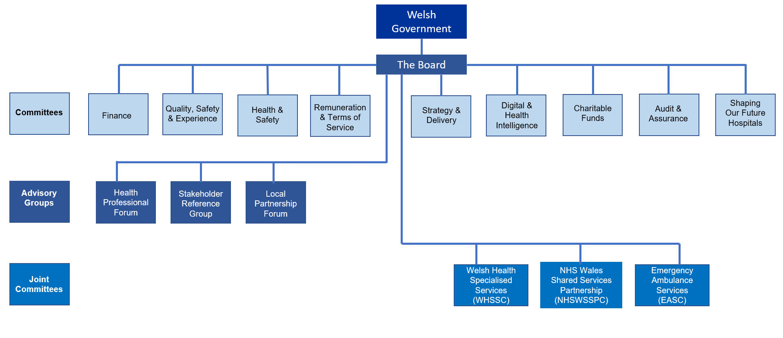
Figure 1 – C&VUHB Governance Structure 2022-2023
Changes to the C&VUHB Governance Structure from 1 April 2023

.
It is important to keep the effectiveness of the Board’s Committees under constant review to ensure that they are fit for purpose and support the Board in discharging its functions. Further, to ensure that the Board’s Committee arrangements reflect the risk profile of the organisation. The Health Board’s Board Assurance Framework highlighted significant risks for the Health Board to achieve its objectives, most notably in the areas of People, Quality and Performance. Accordingly, the Health Board reviewed its Committee arrangements and at its meeting on 30 March 2023 the Board agreed to make the following changes to its Committee arrangements from 1 April 2023:-

  - The Strategy and Delivery Committee ceased with strategy becoming a standing item for the first 1.5 hours of each Board Development session. This will provide the Board as a whole greater opportunity to develop and review the Health Board strategy and supporting strategic plans.
  - The delivery/performance element that was previously reported to the Strategy and Delivery Committee will be included in the business of a newly constituted Finance and Performance Committee. This will meet monthly for the foreseeable future with its first meeting on 19 April 2023 in recognition of the financial and delivery challenges that the Health Board faces.
  - A newly established People and Culture Committee will meet for the first time on 16 May 2023 and will met bi-monthly thereafter in order to apply specific focus to the people agenda.
  - The Health and Safety Committee will become a sub-committee of the People and Culture Committee, through which it will report to the Board and there will be increased focus on capital, estates and facilities assurance.
  - The Quality, Safety and Experience Committee will meet monthly for the foreseeable future in order to ensure sufficient time is afforded to quality improvement.
  - The Digital and Health Intelligence Committee will move from three times per year to quarterly in order to provide greater opportunity to explore whether the Health Board is making the most of digital opportunities.

A copy of the report which was considered by the Board on 30 March 2023 in relation to the changes made to the Board’s Committee arrangements can be accessed at : https://cavuhb.nhs.wales/files/board-and-committees/board-2022-23/2023-03-30-board-papers-v8pdf/ (see agenda item 7.10).

13.6 Board & Committee Meetings during Covid-19

During the financial year 2022-23, and as we emerged from the COVID-19 pandemic, we have continued to hold our Committee meetings virtually. For the time being, we intend to continue with this arrangement. From 26 May 2022 our Board meetings resumed to being “in person” meetings and members of the public were welcome to attend those meetings.

It is acknowledged that in these unprecedented times, there are limitations on Boards and Committees being able to physically meet where this is not necessary and can be achieved by other means. In accordance with the Public Bodies (Admissions to Meetings) Act 1960 the organisation is required to meet in public. As a result of the public health risk linked to the pandemic there have been limitations on public gatherings and it has not therefore been possible to allow the public to attend meetings of our Committees from April 2022 to March 2023. To ensure business was conducted in as open and transparent manner as possible during this time the following actions were taken: -

- A range of online video platforms was used to enable members of the Public to observe Committee meetings, thus ensuring openness and transparency. Links and recordings were published on our website.

- Recordings of our Committee meeting are made publicly available within a few days of the relevant meeting taking place.

- Agendas and associated papers were, as far as possible, published 10 days in advance of the Board meetings, and 7 days in advance of the Committee meetings.

- Our website pages and social media accounts signposted the dates of the Board and Committee meetings together with information that had been published.

- The Board and Committee meeting pages on the website (which constitutes our official notice of Board and Committee meetings) explained why the Board and Committees were not meeting in public, and that all meetings were being held virtually.

Throughout 2022/23 the Health Board continued with its preparations for the COVID-19 Public Inquiry. This included the continuation of the work of the COVID-19 Public Inquiry Steering Group which considers the strategy and approach that the Health Board should take to the Public Inquiry before making recommendations to the Board. The Steering Group’s membership comprises the Health Board Chair, Independent Member Legal, Independent Member Trade Union, Independent Member Capital and Estates, Chief Executive Officer, Executive Director of People and Culture, Executive Nurse Director, Executive Medical Director and the Director of Corporate Governance. Other key members of staff may be invited to attend the Steering Group as and when required.

13.7 Composition of The Board

Refer to paragraph 10.1.1 within the Corporate Governance Report.

Items Considered by the Board in 2022-2023 included:

- Approval of the Annual Accounts;
- Accountability and Remuneration Reports for 2021-2022;
- Board Assurance Framework;
- IMTP 2022-2025 and Annual Plan
- Capital Infrastructure Plan 2022-23
- Health and Safety Culture Plan
- WHSSC Specialised Services Strategy
- Shaping our Future Wellbeing Strategy refresh
- Assurance Strategy 2021-4 and Risk Management Strategy
- Regional Partnership Board Regional Unpaid Carers Charter
- Maternity Services
- Relocation of Fracture Clinic Facilities
- South Wales Cochlear Implant and BAHA Hearing Implant Device Service
- New Velindre Cancer Centre
- Welsh Language Annual Report
- Health Inclusion Health Needs Assessment
- Patient stories
- Financial performance
- Regular reports on Quality, Safety and Experience;
- Performance reports in relation to key national and local targets;
- Assurance reports from the Committees and Advisory Groups of the Board;
- Terms of Reference and Workplans;
- Nurse Staffing Levels (Wales) Act.

The Board and Committee membership and Champion Roles during 2022-2023 is
presented for information at Appendix 1 to this AGS.

There have been a number of changes to the composition of the Board over the past 12 months.

The Health Board said farewell to

- Ruth Walker – Executive Nurse Director on 31 May 2022
- Caroline Bird – Interim Chief Operating Officer on 22 July 2022
- Nicola Foreman – Director of Corporate Governance on 3 February 2023.

The above changes resulted in some officer level vacancies which led to the following:-

- Hannah Evans (Managing Director (Non Acute) and Mike Bond (Managing Director - Acute) jointly stepped into the role of interim Chief Operating Officer on 19 July 2022 when Caroline Bird left us on 22 July 2022.
- Jason Roberts stepped into the role of Interim Executive Nurse Director from 31 May to 10 July 2022.

We also warmly welcomed the following to the Executive Team: -

- Jason Roberts – Executive Nurse Director from 11 July 2022).
- Paul Bostock – Chief Operating Officer on 22 August 2022.
- James Quance – Interim Director of Corporate Governance on 18 January 2023.

13.9 Committees

In line with Section 2 of the Health Board’s Standing Orders which provide that “The Board may and, where directed by the WG, must appoint Committees of the Health Board either to undertake specific functions on the Board’s behalf or to provide advice and assurance to the Board in the exercise of its functions”, the Board has an established Committee structure, with each Statutory Committee chaired by an Independent Member. The Committee structure which was in place from 1 April 2022 to 31 March 2023 was approved at the Board meeting on 31 March 2022. On behalf of the Board, the Committees provide scrutiny, development discussions, assessment of current risks and performance monitoring in relation to a wide spectrum of the Health Board’s functions and its roles and responsibilities.

The following Board Committees were in place during 2022-2023:

Committee | Items Considered
Audit Committee  The role of the Audit Committee is to advise and assure the Board, and the Accountable Officer, on whether effective arrangements are in place to support them in their decision taking and in discharging their accountabilities in accordance with the standards of good governance determined for the NHS in Wales. | - Internal Audit Plans were submitted to each meeting providing details relating to outcomes, key findings and conclusions  - Audit Wales reports on current and planned audits  - Declarations of Interest Reports  - Regulatory Compliance Tracking Reports  - Internal & External Audit Tracking Reports  - Procurement Compliance, Workforce Compliance and Counter Fraud Reports  - Assurance mapping and Risk Management Strategy  - Health Charity’s draft Accounts and Annual Report  - Annual Accounts, Accountability and Remuneration Reports for 2021-2022  - Losses and Special Payments.
Finance Committee  The purpose of this Committee is to advise and  assure the Board in discharging its responsibilities with regard to its current and forecast financial position, performance and delivery. | - Monthly Financial Reports  - Finance Risk Register;  - Financial Monitoring Returns  - IMTP Financial Plan  - BAF Risk – Financial Sustainability  - High Level Resource Map  - Financial Performance of Clinical Boards  - Various Business Cases (including Velindre Cancer Centre, Mortuary Investment, UHW Lift Refurbishment, Fracture Clinic)  - Funding Nursing Care rate
Strategy and Delivery Committee  The purpose of this Committee is to advise  and assure the Board on the development and  implementation of the Health Board’s overarching strategy, “Shaping our Future Wellbeing”, and key enabling plans. This includes all aspects of delivery of the strategy through the IMTP and any risks that may hinder achievement of the objectives set out in the strategy, including mitigating actions against these. | - Shaping our Future Wellbeing Strategy – Programme update Reports  - Delivery of Capital Plan 2022/23  - Regional Partnership Board – quarterly plan updates  - Sustainability Action Plan  - Welsh Language Policy  - Employment Policies;  - Key Organisational Performance Indicators;  - Workforce Plan;  - IMTP  - Six Goals for Urgent and Emergency Care  - Deep dives including in relation to (i) Staff Retention, (ii) Cancer services, and (iii) Delayed Transfer of Care
Mental Health Legislation and Mental Capacity Act Committee  This Committee advises the Board of any areas of concern relating to responsibilities under mental health legislation, and provides assurance that we are discharging our statutory duties under the relevant legislation. | - Mental Capacity Act and Mental Health Act Monitoring Reports;  - Deprivation of Liberty Safeguards Internal  - Mental Health Measure;  - Children and Adolescent Mental Health Service;  - Healthcare Inspectorate Wales visit reports.  - Draft Mental Health Bill
Quality, Safety and Experience  Committee  The purpose of the Quality, Safety and Experience Committee is to provide advice to the Board with regard to the quality and safety of health services and the experience of patients, including public health, health promotion and health protection activities. | - Clinical Board Assurance Reports  - Community Health Council (CHC) reports  - Patient Stories  - Maternity Services  - Pressure Damage  - Duty of Candour  - Infected Blood Inquiry  - Quality Indicators Report  - HIW reports and progress  - Safeguarding Annual Report  - Ombudsman Annual Letter
Charitable Funds Committee  The purpose of the Charitable Funds Committee is to make and monitor arrangements for the control and management of the Health Board’s Charitable Funds.  Cardiff and Vale Health Charity (the Charity) is the official charity supporting all the work of the Health Board. The Charity was created on 3 June 1996 by a Declaration of Trust and following reorganisation of health services, was amended by Supplementary Deeds on 12 July  2001 and 2 December 2010.  The Health Board is the Corporate Trustee for the Charity.  The Health Board delegates responsibility for the  management of the funds to the Charitable Funds Committee. The aim of the Corporate Trustee (Trustee) is to raise and use charitable funds to provide the maximum benefit to the patients of the Health Board and associated local health services in Cardiff and the Vale of Glamorgan, by supplementing and not substituting government funding of the core services of the NHS. | - Charitable Funds Bids Panel Report  - Finance Monitoring Report  - Staff Benefits Group Report  - New Charitable Funds applications  - Health Charity Annual Report  - Investment update  - Health Charity’s Strategy refresh  - Fundraising Policy
Digital Health Intelligence Committee  The purpose of this Committee is to provide assurance to the Board that:  • Appropriate processes and systems are in place for data, information management and governance to allow the Health Board to meet its stated objectives, legislative responsibilities and any relevant requirements and standards determined for the NHS in Wales;  • There is continuous improvement in relation to information governance within the Health Board and that risks arising from this are being managed appropriately;  • Effective communication, engagement and training is in place across the Health Board for Information Governance. | - Digital Transformation Progress reports  - Caldicott guardian requirements  - Freedom of Information  - General Data Protection Regulation (GDPR);  - Data breach reports;  - Clinical Coding Performance data  - Digital Strategy Refresh
Health and Safety Committee  The purpose of the Committee is to advise and assure the Board and Accountable Officer on whether effective arrangements are in place to ensure organisational wide compliance of the Health Board’s Health & Safety Policy, approve and monitor delivery against the Health and Safety Priority Improvement plan and ensure compliance with relevant standards for Health Services in Wales. | - Fire Enforcement  - Environmental Health Inspections  - Enforcement agencies inspections  - Waste management compliance  - Health and Safety Culture Plan  - Health and Safety Annual Report  - Regulatory and review body tracking report  - Health and Safety Risk register  - Policies (eg Latex Allegy, Sharps Management, Fire Safety).
Renumeration and Terms of Service Committee  The purpose of the Committee is to provide: -  - advice to the Board on remuneration and terms of service for the Chief Executive, Executive Directors and other senior staff within the framework set by the Welsh Government; and  - assurance to the Board in relation to the Health Board’s arrangements for the remuneration and terms of service, including contractual arrangements, for all staff, in accordance with the requirements and standards determined for the NHS in Wales. | • Remuneration and terms of service matters
Shaping Our Future Hospitals Committee  This Committee oversees the development of the overall “Our Future Hospitals Programme”.  The Committee provides assurance that the leadership, management and governance arrangements are robust and appropriately discharged to deliver the outcomes and benefits of the Programme. | This Committee has been stood down since 1 April 2022.

The reports, workplans and terms of reference for the Committees are published on our website: https://cavuhb.nhs.wales/about-us/governance-and-assurance/committees-and-advisory-groups/

The table at Appendix 1 to this AGS sets out details of the Chair, Chief Executive, Executive Directors and Independent Members and confirms Board and Committee membership for 2022-2023, meetings attended during the tenure of the individual and any Champion roles performed. Table 1 in Appendix 2 of the AGS sets out Board and Committee Dates for 2022-2023.

The Chair of each Committee reports to the Board on the Committee’s activities outlining key risks and highlighting areas which need to be brought to the Board’s attention in order to contribute to its assessment of assurance and provide scrutiny against the delivery of objectives. The Committees, as well as reporting to the Board, also work together on behalf of the Board to ensure, where required, that cross reporting and consideration takes place and assurance and advice is provided to the Board and the wider organisation. Further, in line with Standing Orders, each Committee has produced an annual report, for 2022/23, setting out a helpful summary of its work.

All Committees undertake an annual review of their Terms of Reference. The Terms of Reference for 2022-2023 were formally approved by the Board at its meeting on 31 March 2022. At its Board meeting on 30 March 2023, the Committees’ Terms of Reference for 2023-2024 were approved.

Copies of Committee papers and minutes, a summary of each Committees’ responsibilities and Terms of Reference are available on the Health Board’s website: https://cavuhb.nhs.wales/about-us/our-board/committees-and-advisory-groups/

Each Committee maintains an Action Log that is monitored at each meeting.
Each of the main Committees of the Board are supported by an underpinning subcommittee structure reflecting the remit of its roles and responsibilities.

13.10 Advisory Groups & Joint Committees

In support of the Board, the Health Board is also required to have three Advisory Groups.

The Advisory Groups and Joint Committee include the following:

Advisory Groups

Stakeholder Reference Group (SRG)

The SRG is formed from a range of partner organisations from across the Health Board area. Its role is to provide independent advice on any aspect of Health Board business. It facilitates full engagement and active debate amongst stakeholders from across the communities served by the Health Board, with the aim of presenting a cohesive and balanced stakeholder perspective to inform Health Board planning and decision making.

This may include:

- Early engagement and involvement in the determination of the Health Board’s overall strategic direction;
- Provision of advice on specific service improvement proposals prior to formal consultation; and
- Feedback on the impact of the Health Board’s operations on the communities it serves.

Significant issues upon which the SRG was engaged during 2022-2023 included:

- Shaping Our Future Wellbeing Strategy refresh
- Health Board’s People and Culture Plan
- NHS111
- Same Day Emergency Care Units
- Regional Collaboration
- The Health Board’s Decarbonisation Plan

Local Partnership Forum (LPF)

Please refer to paragraph 7.9 of the Performance Overview section of this Annual Report.

Healthcare Professionals’ Forum (HPF)

The HPF comprises representatives from a range of clinical and healthcare professions within the Health Board and across primary care. This Advisory Group is currently undergoing review and therefore has not met during 2022- 23. The Health Board has a number of mechanisms to seek clinical input, for example a representative of the Consulting body attended Board meetings, feeding in comment from Consultant engagement on key issues such as major trauma and thoracic surgery. Reviewing this Advisory Group’s Terms of Reference, membership and developing its work programme and function to best use these mechanisms, establish a robust structure and avoid duplication will be a governance priority for 2023-24.

Terms of Reference and minutes of all the Advisory Groups are available via the following link:
https://cavuhb.nhs.wales/about-us/governance-and-assurance/committees-and-advisory-groups/

Joint Committees

Welsh Health Specialised Services Committee (WHSSC)

WHSSC was established in 2010 by the seven health boards to ensure the population has fair and equal access to the full range of specialised services. Hosted by Cwm Taf Morgannwg University Health Board, the Health Board is represented on the joint committee by the Chief Executive and regular reports are received by the Board.

Emergency Ambulance Services Committee (EASC)

EASC is a joint committee of the seven health boards, with the three NHS trusts as associate members, and was established in April 2014. It has responsibility for the planning and commissioning of emergency ambulance services on an all-Wales basis. Hosted by Cwm Taf Morgannwg University Health Board, the Health Board is represented on the joint committee by the Chief Executive and regular reports are received by the Board.

NHS Wales Shared Services Partnership (NWSSP) Committee

The NWSSP Committee was established in 2012 and is hosted by Velindre NHS Trust. It looks after the shared functions for NHS Wales, such as procurement, recruitment and legal services. The Health Board’s representative is the Director of Workforce and OD and regular reports are received by the Board.

13.11 Public Appointments
Independent Member Keith Harding joined our Board on 1 January 2023.
Sam Austin was appointed as the Chair of the Stakeholder Reference Group on 1st November 2022 until 31st October 2023.
13.12 Public interest Declaration
Each Board Member has stated in writing that they have taken all the steps that they ought to have taken as a Director in order to make auditors aware of any relevant audit information. All Board Members and Senior Managers and their close family members (including Directors of all Hosted Organisations) are required to declare any pecuniary interests and positions of authority which may result in a conflict with their responsibilities. A full register of interests for 2022-2023 is available upon request from the Director of Corporate Governance or via the following link https:/cavuhb.nhs.wales/about-us/our-board/register-of-interests/.

13.13 Board and Committee Membership & Attendance 2022-2023

The Board has been constituted to comply with the Local Health Boards (Constitution, Membership and Procedures) (Wales) Regulations 2009. The Table attached to Appendix 1 to this AGS outlines the Board and Committee Membership and the record of attendance for the period April 2022- March 2023.

13.14 The Purpose of the System of Internal Control
The system of internal control is designed to manage risk to a reasonable level rather than to eliminate all risks; it can therefore only provide reasonable and not absolute assurances of effectiveness.

The system of internal control is based on an ongoing process designed to identify and prioritise the risks to the achievement of the policies, aims and objectives, to evaluate the likelihood of those risks being realised and the impact should they be realised, and to manage them efficiently, effectively and economically. The system of internal control has been in place for the year ended 31 March 2023 and up to the date of approval of the annual report and accounts.
13.15 Capacity to handle risk

The Health Board is committed to developing and implementing a Risk Management and Board Assurance Framework that identifies, analyses, evaluates and controls the risks that threaten the delivery of its strategic objectives. The Health Board’s Board Assurance Framework (BAF) is used by the Board to identify, monitor and evaluate risks which impact upon Strategic Objectives and is considered alongside other key management tools, such as the Corporate Risk Register, performance and quality dashboards and financial reports, to give the Board a comprehensive picture of the organisational risk profile.
The Health Board’s Risk Management and Board Assurance Framework Strategy (the Strategy) was updated and approved by the Board in July 2021 (and updated at the March 2023 Board meeting) and sets out responsibilities for strategic and operational risk management for the Board and staff throughout the organisation and describes the procedures to be used in identifying, analysing, evaluating and controlling risks to the delivery of strategic objectives.
Strategic risks are significant risks that have the potential to impact upon the delivery of strategic objectives and are raised and monitored by the Executive Team and the Board. Operational risks are key risks that affect individual Clinical Boards and Corporate Directorates and are managed within the Clinical Boards and Corporate Directorates and if necessary, escalated through the Health Board’s risk reporting structure (See Figure 1).
Figure 1 – Risk Management Reporting Structure

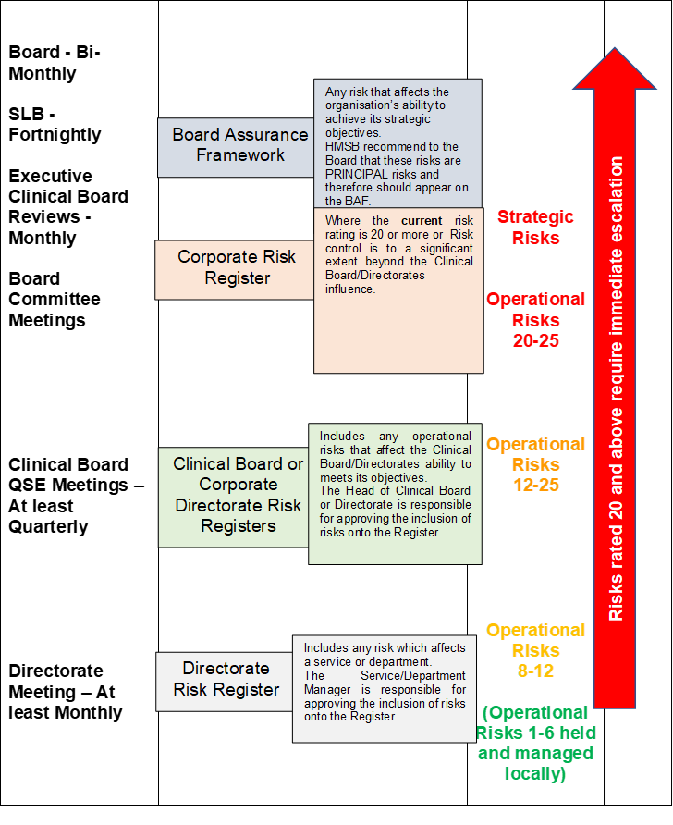

The BAF is an integral part of the system of internal control and defines the extreme potential risks which impact upon the delivery of strategic objectives. It also summarises the controls and assurances that are in place or plans to mitigate them. The BAF aligns principal risks, key controls and assurances on controls alongside each of the Health Boards strategic objectives.
Gaps are identified where key controls and assurances are insufficient to reduce the risk of non-delivery of objectives. This enables the development of an action plan for closing the gaps and mitigating the risks which is subsequently monitored by the Board for implementation.
The Strategy applies to those members of staff that are directly employed by the Health Board and for whom the Health Board has legal responsibility and is intended to cover all the potential risks that the organisation could be exposed to.
The objectives of the Strategy are to:

- minimise the impact of risks, adverse incidents, and complaints by effective risk identification, prioritisation, treatment and management;
- maintain a risk management framework, which provides assurance to the Board that strategic and operational risks are being managed effectively;
- maintain a cohesive approach to corporate governance and effectively manage risk management resources;
- ensure that risk management is an integral part of the Health Board’s culture;
- minimise avoidable financial loss, or the cost of risk transfer through a robust financial strategy;
- ensure that the Health Board meets its obligations in respect of Health and Safety; and
- Describe the resources available for risk management in the organisation.

As of March 2023, the following risks were identified within the BAF as posing the greatest risk to the delivery of the Health Board’s strategic objectives:

- Workforce
- Patient Safety
- Sustainable Culture Change
- Capital Assets
- Delivery of 22/23 commitments within the IMTP
- Staff Wellbeing
- Exacerbation of Health Inequalities
- Financial sustainability
- Urgent and Emergency Care
- Maternity
- Critical Care
- Cancer
- Stroke
- Planned Care
- Digital Strategy and Road Map

Alongside the BAF, the Health Board also maintains a Corporate Risk Register that identifies the extreme operational risks (those scored at 20/25 or higher) that the Health Board is facing.

Each of the risks detailed within the Corporate Risk Register is also linked to a Committee of the Board and the Board Assurance Framework for reporting and escalation purposes.

As of March 2023, there were 27 Extreme risks detailed on the Corporate Risk Register all of which recorded a score of 20/25 with 3 further risks recorded which were reported as closed or with reduced scores (two reported as 15/25).

Details of these risks and the Health Board’s Corporate Risk Register and Board Assurance Framework covering reports for March 2023 can be at the following link https://cavuhb.nhs.wales/files/board-and-committees/board-2022-23/2023-03-30-board-papers-v8pdf/ (see agenda items 6.4 and 8.2).

Throughout 2022/23 the need to plan and respond to the Covid-19 pandemic continued to present challenges to the organisation. A number of new and emerging risks were identified including the exacerbation of risks linked to Financial Sustainability, Workforce, Staff Wellbeing and the Exacerbation of Health Inequalities that are detailed with the BAF and reported to each Health Board, Board meeting and relevant Committee Meetings.

The organisation continues to work closely with a wide range of partners, including the Welsh Government as it continues with its response, and planning into the recovery phase. It will be necessary to ensure this is underpinned by robust risk management arrangements and the ability to identify, assess and mitigate risks which may impact on the ability of the organisation to achieve their strategic objectives. Accordingly the full BAF and Corporate Risk Register continued to be received at each Board
meeting during 2022-23. Where risks are assigned to Board Committees (as the assuring Committee) those assigned risks are routinely received at the respective Committee meetings as appropriate.

Community Health Council colleagues are routine attendees at Board as well as Quality and Safety Committee meetings where the BAF and Corporate Risk Register are reviewed.

The Health Board’s Stakeholder Reference Group and Local Partnership Forum have also been engaged on key areas of activity during the year including receipt of Board Meeting Minutes and Updates that summarise the Health Board’s Risk Profile.

Audit Assurance on Risk Management

Audit Wales Structured Assessment Phase 2 Report received in February 2023, noted the following in relation to the Management of Risk within the Health Board:

“The Health Board’s strategic risks are clearly documented in its Board Assurance Framework (BAF) and there is a well-established process in place to ensure they are adequately scrutinised and reviewed.” and “The Health Board actively manages its corporate risks as illustrated in the Board cover report, which details the total number of risks, new risks, removed risks, and a comparison to the previous report to the Board.”

NWSSP Assurance Services undertook an Internal Audit Review of Risk Management processes in April 2023 which received a Reasonable Assurance rating and concluded that “The Health Board is continuing its journey to strengthen and improve the maturity of the risk management system in place. The Strategy and associated Risk Management Procedures are up to date, document the Health Board’s current approach to risk management and provide guidance to staff to enable the effective delivery and operation of the risk management system.”

13.16 Management of Risk

Overall responsibility for the Risk Management and Board Assurance Framework Strategy lies with the Director of Corporate Governance who has delegated responsibility for managing the development and implementation of the Risk Management and Board Assurance Framework Strategy. Arrangements are in place to effectively assess and manage risks across the organisation, which includes the ongoing review and updating of the Board Assurance Framework and the Corporate Risk Register so that the Board maintains a line of sight on the Health Board’s key strategic and operational risks.

The Director of Corporate Governance retains control of the BAF and meets with Executive Leads for BAF risks on a bi-monthly basis to ensure that the risks detailed within the BAF are regularly updated to include new and emerging risks to service areas so that the entries provide an accurate and contemporaneous reflection of the risks faced by the Health Board.

The BAF is also presented to the Board for scrutiny and approval on a bi-monthly basis and the Audit and Assurance Committee, as a sub-committee of the Board, has oversight of the process through which the Board gains assurance in relation to the management of the BAF.

The Corporate Governance Department monitor and maintain the Corporate Risk Register. Each Corporate Department and Clinical Board has responsibility to maintain a comprehensive risk register which forms the basis of the risks that are reflected within the Corporate Risk Register. The Corporate Governance Department regularly meet with Clinical Board and Corporate Department risk leads to review and monitor their Clinical Board/Corporate Department and local level risk registers to ensure that they accurately record the risks that their areas are encountering and to assist those areas in considering new and emerging risks to their service. Following that exercise extreme operational risks, those scored 20/25 or higher, are recorded on the Corporate Risk Register and reported to the Board for scrutiny and approval on a bi-monthly basis. Any risks that are identified as having the potential to impact on the Health Board’s strategic objectives are added to the BAF. Each risk detailed on the Corporate Risk Register is also linked to a Strategic Risk contained in the BAF to ensure that risks are appropriately monitored and escalated.

The key risks detailed in the BAF and Corporate Risk Register are also shared at relevant sub-committees of the Board for further scrutiny and discussion. The BAF risks are reviewed at the following sub-committees of the Board:
- Workforce - Quality Safety and Experience Committee and Strategy and Delivery Committee
- Patient Safety – Quality Safety and Experience Committee
- Sustainable Culture Change - Strategy and Delivery Committee
- Capital Assets – Finance Committee and Strategy and Delivery Committee
- Delivery of 22/23 commitments within the Annual Plan - Strategy and Delivery Committee
- Staff Wellbeing - Strategy and Delivery Committee
- Exacerbation of Health Inequalities - Quality Safety and Experience Committee and Strategy and Delivery Committee
- Financial sustainability – Finance Committee
- Urgent and Emergency Care - Strategy and Delivery Committee
- Maternity - Quality Safety and Experience Committee
- Critical Care - Quality Safety and Experience Committee
- Cancer - Quality Safety and Experience Committee
- Stroke - Quality Safety and Experience Committee
- Planned Care - Quality Safety and Experience Committee
- Digital Strategy and Road Map – Digital Health Intelligence Committee

The Corporate Risk Register entries are also referred to those Committees to which they are linked on the Corporate Risk Register. Following the January 2023 Board meeting all Patient Safety Risks were shared at the March Quality, Safety and Experience Committee. Those risks linked to the Strategy and Delivery Committee were discussed at the March 2023 Committee meeting.
The Corporate Governance Department provide staff with training in the management of functional work place risk management processes and assessments. The management of the Health Board’s Corporate Risk Management Training is managed by the Corporate Governance Department.
The Corporate Governance Department offer training sessions to risk leads through targeted training programmes that are informed by the team’s regular interactions with Clinical Boards and Corporate Departments. The Corporate Governance Department’s training approach is designed to embed a consistent approach to the management, scoring and recording of risk from ward to board across the Health Board.
The risks detailed in the BAF and Corporate Risk Register are considered when determining the Health Board’s risk appetite. The Health Board acknowledges that the delivery of healthcare cannot be achieved unless risks are taken, as well as the subsequent consequences and mitigating actions. It also ensures that risks are not considered in isolation and are taken following consideration of all the risks flowing through the organisation.
The Health Board has approved an overall Risk Appetite of ‘Cautious’ moving towards ‘Seek’ as recorded within the Health Board’s BAF. Within the BAF, individual Risk Appetite levels are also recorded against each of the articulated risks so that each can be managed proactively according to the risk presented.
Communicating and consulting with internal and external stakeholders and partners, as appropriate, at each stage of the risk management process and concerning the process as a whole is important. The frequency of the communication will vary depending upon the severity of the risk and is discussed and agreed with the stakeholders and partners as necessary. This process is led by the person nominated as the lead to manage the risk and for communication with external stakeholders this will be the appointed Executive Director lead for the risk. As the designated lead for Risk Management the Director of Corporate Governance also attends the Health Board’s Stakeholder Reference Group to brief public stakeholders on the activities of the Board including the management or risk.

14. Planning Arrangements

The Health Board was not able to submit an Integrated Medium-Term Plan for 2022 – 2025 in accordance with the NHS Planning Framework. The Health Board approved a plan, for submission to Welsh Government, that achieved financial balance over a three-year period, and was not able to set out a plan to achieve financial break even in year. This resulted in an in-year plan with a small underlying deficit.

15. MANDATORY DISCLOSURES

15.1 Health and Care Standards

In 2017-18 a revised set of Health and Care Standards were issued to NHS Wales. In particular, a new standard for Governance, leadership and Accountability was introduced. The health service needs to consider the following criteria for meeting the standard:

- Health services demonstrate effective leadership by setting direction, igniting passion, pace and drive, and developing people.
- Strategy is set with a focus on outcomes, and choices based on evidence and people insight. The approach is through collaboration building on common purpose.
- Health services innovate and improve delivery, plan resource and prioritise, develop clear roles, responsibilities and delivery models, and manage performance and value for money.
- Health services foster a culture of learning and self-awareness, and personal and professional integrity.
- The Health and Care standards underpin all our QSE activity–we consider the impact and learning from all internal and external inspections and reports. With detailed status or improvement plans if required shared and monitored through the QSE process as described in section 15.7 (Quality Governance Arrangements).

Through the introduction of the Tendable digital audit system across clinical areas we will further develop, measure and monitor a suite of quality indicators. Tendable data has been integrated with other quality related metrics on a dashboard, live reporting from ward teams to executive board. In March 2023, the UHB launched a Ward Accreditation & Improvement programme (WAI). The Accreditation Framework uses Tendable as its source of evidence. As data and insights from other digital systems become available, they will also be Integrated within the WAI framework. Upcoming examples include Welsh Nursing Care Record (WNCR) and Electronic Prescribing & Medicines Administration (ePMA).

15.2 Equality, Diversity and Human Rights

Please refer to section 7.6 of the Performance Report.

15.3 Welsh Language Regulations - The Welsh Language Standards (No. 7) Regulations 2018 (WLO)

Please refer to paragraph 7.6 of the Performance Report.

15.4 Emergency Preparedness

The Major Incident Plan was updated and approved by the Board on 30 September 2021 and is scheduled for a review in September 2024. However, in light of ongoing lessons from the pandemic, the learning from the first stage of the Manchester Arena Inquiry and other national exercises, a review of the Major Incident Plan was undertaken in 2023 and an updated version of the Major Incident Plan will be taken to the Board for approval in May 2023.

Due to the condition of our major hospital facilities, business continuity arrangements we activated on a number of occasions in response to sewage and water leaks. In addition to this, our business continuity arrangements were put in place to enable us to manage the delivery of our services over the period of industrial action.

15.5 Environmental, Social and Community Issues

Our mission is “Caring for People, Keeping People Well”, and our vision is that a person’s chance of leading a healthy life should be the same wherever they live and whoever they are.
The Health Board's 10-year transformation and improvement strategy, Shaping Our Future Wellbeing, is our chance to work collaboratively with the public and the Health Board ‘s workforce to make our health board more sustainable for the future. Together, we can improve equity for all of our patients - both today and tomorrow click here to access the Strategy: https://cavuhb.nhs.wales/about-us/our-mission-vision/shaping-our-future-wellbeing-strategy/.
We believe that everyone should have the opportunity to lead longer, healthier and happier lives. But with an ageing population and changing lifestyle habits, our health and care systems are experiencing increasing demand.
Delivering on our responsibilities to reduce our carbon footprint has been a priority for the Health Board since acknowledging the climate emergency in January 2019. The Health Board has developed a Sustainability Action Plan which was updated to reflect the Welsh Government’s NHS Wales Decarbonisation Plan.
Vale of Glamorgan Public Services Board Climate Change Charter Public sector partners in the Vale of Glamorgan have formally expressed their commitment to tackling climate change by agreeing a Vale Public Services Board Climate Change Charter (https://www.valepsb.wales/en/Our-Progress/Tackling-Climate-Change-in-the-Vale-ofGlamorgan.aspx).
The development of the Charter follows discussions over the last 14 months including a workshop held in November 2019 with young people where we were joined by members of the Health Board’s Youth Board alongside enthusiastic youngsters from local schools and the Vale Council’s Youth Forum. Natural Resources Wales has taken a lead in this work, which fully aligns to the Health Board’s Sustainability Action Plan approved at the November 2020 Board. The Charter signs partners up to a set of principles including leading by example, taking positive action and reducing our impact, while recognising that approaches and plans for implementation within individual Organisations may differ. Similarly, the PSB in Cardiff has identified carbon reduction as a key priority and a partnership programme has been developed, led by the Council.
The Health Board is an active participant in this work and it is aligned with the Sustainability Action Plan. The Health Board’s Health Charity is supporting an award-winning programme to improve our environment, linked to our Biodiversity Plan. The development of the Orchard and Horiatio’s Garden at UHL, and the meadow project at UHW are examples of the great work being done to use our outside green space for the health and wellbeing of our patients, staff and visitors.
Our updated Sustainability Action Plan, completed in March 2022 reflected the action we committed to with public service partners to promote active and sustainable travel, protect the environment and to take action to reduce our carbon footprint, investing in initiatives to reduce our reliance on green-house gas generating power sources, and actively changing how we produce the goods and services needed to delivery our services. We also have clinical teams driving forward changes in clinical practice and service models to reduce our carbon footprint, as detailed in previous section on our Sustainability Action Plan (see paragraph 8 of the Performance Report). During 2022 – 2023 we agreed to host Green Health Wales, an initiative set up by clinicians championing green healthcare delivery. We have appointed a lead clinical for sustainability and a number of clinical fellows to support this work. One example of the progress we have made is in the initiative led by clinicians to reduce the green-house emissions associated with our use of nitrous-oxide. We have removed piped gas and now provide cylinders where necessary and have reduced waste, reduced our carbon emissions and reduced our costs.
All hospital grounds in Cardiff and Vale Health Board Area are now Smoke-Free Our hospital grounds are now smoke-free. New laws introduced across Wales on 1 March, build on the smoking ban introduced in 2007 and will protect more people from harmful second-hand smoke and help those trying to quit. Anyone found breaking the law by smoking in the hospital grounds could face a £100 fine. The health board has been instrumental in supporting a smoke-free hospital environment and was the first health board in Wales to introduce a full No Smoking Ban across all hospital sites.
15.6 Carbon Reduction Delivery Plans

As mentioned above (paragraph 15.5), we have updated our Sustainability Action Plan for 2022/23 and have made progress with delivering against the commitments set out in the plan. During the year, we also updated the plan to respond to the decarbonisation action plan developed by Welsh Government, including the targets for reducing carbon emissions by 16% by 2025. The Board approved the Decarbonisation Plan in March 2023 and a link is provided here - https://cavuhb.nhs.wales/files/board-and-committees/board-2022-23/2023-03-30-board-papers-v8pdf/ (see agenda 7.3).

15.7 Quality Governance Arrangements

An essential feature of our control framework is ensuring there is a robust system for measuring and reporting on the quality of our services. Our Quality Safety and Experience Committee provides timely evidence based advice to the Board to assist it in discharging its functions and meeting its responsibilities with regards to quality and safety as well as providing assurance in relation to improving the experience of all those that come into contact with our services. Please also refer to paragraphs 3.7.3, 3.7.4 and 4 of the Performance Report for further information.

15.8 Ministerial Directions and Welsh Health Circular’s (WHCs)

Ministerial Directions and WHCs issued by the Welsh Government for the period April 2022- March 2023 have been considered and where appropriate implemented. Full details of each WHC can be found at the following link: https://gov.wales/health-circulars.

During the financial year 2022/23 regular updates on the implementation of Welsh Health Circular implementation and the detail of new WHCs has been shared with the Health Board’s Management Executive Team and the Audit and Assurance Team to provide oversight of the process.

Details of the Ministerial Directions issued by the Welsh Government during 2022/23 which have been considered and, where appropriate, implemented are set out in Appendix 3 attached to this AGS.

15.9 Regulatory and Inspection Reports

The Corporate Governance Department have a formal system in place to track regulatory and inspection reports against statutory requirements. This is achieved by means of a Legislative and Regulatory Tracker report which is presented to the Audit and Assurance Committee to provide assurance that recommendations made within such reports are being appropriately actioned. Prior to presentation to the Audit and Assurance Committee the tracker is populated with information from Executive Director Leads and individuals who are accountable for regulatory compliance.

The Legislative and Regulatory Tracker includes the following:

- All Regulatory Bodies who inspect the Health Board.
- The Regulatory Standard being inspected.
- An Executive Lead for each inspection.
- An assurance Committee where Regulatory reports may also be presented along with action plans for improvement where required.

The Legislative and Regulatory Tracker Process was last reviewed by Internal Audit in July 2021 and received a reasonable assurance rating. The Corporate Governance Directorate also track all Internal Audit Recommendations and all Audit Wales Recommendations along with management responses. Recommendations are added to the trackers for monitoring once the reports have been signed off by the Audit and Assurance Committee. A further Internal Audit Review of these processes will be undertaken during the financial year 2023/24.

15.10 Data Security and Information Governance

Risks relating to information are managed and controlled in accordance with the Health Board’s Information Governance Policy through the Digital Health and Intelligence Committee, which is chaired by an Independent Member.

The Executive Medical Director, as Caldicott Guardian, is responsible for the protection of patient information. All Information Governance issues are escalated through the Digital Health and Intelligence Committee (DHIC Committee). The DHIC Committee papers can be viewed here: https://cavuhb.nhs.wales/about-us/governance-and-assurance/committees-and-advisory-groups/digital-and-health-intelligence-committee/.

The following items were considered by the DHIC Committee in 2022-2023:

- Digital Strategy Refresh including investment requirements
- Digital Transformation progress reports
- Clinical Coding performance data;
- IT Delivery Programme;
- Information Governance Compliance Reports;
- Information Governance Risk Register;

The Director of Digital & Health Intelligence assumes the role of the Senior Information Risk Owner (SIRO) which provides an essential role in ensuring that identified information security risks are addressed and incidents properly managed.

The Board has strict responsibilities to ensure personal data and information is held securely. All information governance related incidents are investigated and reviewed by the Information Governance Group.

During the period April 2022 and March 2023 there were six personal data security incidents which needed to be reported to the Information Commissioners Office (ICO).

Reportable breaches number 1 to 3

Three breaches related to emails which were sent inappropriately by not utilising the “bcc” functionality. In all three cases, emails were sent to patients and elements of health data related to the patients would have been disclosed.

Reportable breach number 4

A notebook belonging to a clinician was stolen from the back of their car. This contained patient demographics and limited health data.

Reportable breach number 5

A sensitive result was sent to the wrong patient in the post.

Reportable breach number 6

Two patient records were inadvertently sent in the external, rather than internal mail and were delivered to a patient’s address.

The Health Board continues to reinforce awareness of key principles of Data Protection legislation. This includes the overarching principle that users must only handle data in accordance with people’s data protection rights.

15.11 NHS Pension Scheme
As an employer with staff entitled to membership of the NHS Pension Scheme, control measures are in place to ensure all employer obligations contained within the Scheme regulations are complied with. This includes ensuring that deductions from salary, employer’s contributions and payments in to the Scheme are in accordance with the Scheme rules, and that member Pension Scheme records are accurately updated in accordance with the timescales detailed in the Regulations.

15.12 UK Corporate Governance Code

Corporate governance is, in simple terms, the way in which organisations are directed, controlled and led. Good corporate governance is fundamental to an effective and well managed organisation.
The UK Corporate Governance Code (the Code) is the primary reference and overview of good practice for corporate governance in Central Government Departments. Whilst there is no requirement to comply with all elements of the Corporate Governance Code, the Health Board considers that it is complying with the main principles of the Code, where applicable, and follows the spirit of the Code to good effect, is conducting its business in an open and transparent manner, and in line with the Code.
An assessment against the Code was undertaken in April 2023. There were no reported/identified departures from the Corporate Governance Code during the year.

15.13 Review of Effectiveness

As Accountable Officer, I have responsibility for reviewing the effectiveness of the system of internal control. My review of the system of internal control is informed by the work of the internal auditors, and the Executive officers within the organisation who have responsibility for the development and maintenance of the internal control framework, and comments made by external auditors in their Annual Audit Letter and other reports.

Internal Sources | External Sources
- Performance management reports  - Service change management reports  - Workforce information and surveys  - Benchmarking  - Internal and clinical audit reports  - Board and Committee reports  - Local Counter Fraud work  - Health and Care Standards assessments  - Executive and Independent Member Safety Walk Rounds  - Results of internal investigations and Serious Incident reports  - Concerns and compliments  - Whistleblowing and Safety Valve  - Infection prevention and control reports  - Information governance toolkit self-assessment  - Patient experience surveys and reports  - Compliance with legislation (e.g. Mental Health Act/Health and Safety, Data Protection) | - Population Health Information  - Audit Wales  - Welsh Risk Pool (WRP) Assessment reports  - Healthcare Inspectorate Wales (HIW) reports  - Community Health Council visits and scrutiny reports  - Feedback from healthcare and third sector partners  - Royal College and Deanery visits  - Regulatory, licensing and inspection bodies  - External benchmarking and statistics  - Accreditation Schemes  - National audits  - Peer reviews  - Feedback from service users  - Local networks (e.g. cancer networks)  - Welsh Government reports and feedback

Further sources of assurances are identified within the Board’s own performance management and assurance framework and include, but are not limited to:

- Direct assurances from management on the operation of internal controls through the upward chain of accountability
- Internally assessed performance against the Health and Care Standards
- Results of internal compliance functions including Local Counter-Fraud, Post Payment Verification, and risk management
- Reported compliance via the Welsh Risk Pool regarding claims standards and other specialty specific standards reviewed during the period
- Reviews completed by external regulation and inspection bodies including the Audit Wales and Healthcare Inspectorate Wales (HIW).

The effectiveness of the system of internal control is maintained and reviewed by the Committees of the Board in respect of assurances received. This is also supported by the BAF with high risks being closely monitored by Board and the respective Committees.

Governance, Leadership and Accountability

15.14 Board and Committee Effectiveness

Routine monitoring of the effectiveness of the Board and its Committees is a vital part of ensuring strong and effective governance within the Health Board’s governance structure. Under its Standing Orders, the Board is required to introduce a process of regular and rigorous self-assessment and evaluation of its own operations and performance and that of its Committees and Advisory Groups. Further, and where appropriate, the Board may determine that such evaluation may be independently facilitated.
In order to evaluate and demonstrate the effectiveness of the Board and the Board’s Committees the following actions took place during 2022-2023:-
- The Chair of the Board and the Chair of each Committee review the effectiveness of individual meetings as part of the agenda at each respective meeting.
- Each Committee of the Board developed an Annual Report which is reviewed by each Committee before presentation to Public Board in March. The Annual Reports are signed off by each Committee Chair and provide assurance to the Board that the Committees have met their Terms of Reference.
- A self-effectiveness review is undertaken by Committee Members, Committee Attendees and Board Members. These reviews were undertaken just after the end of the financial year and the results are summarised below (see paragraph 15.15 below).

15.15 Committee Effectiveness Survey

The Health Board undertook an annual review of the effectiveness of its Board and its Committees during February and March 2023 using survey questions derived from best practice guides, including the NHS Handbook, and using the following principles:
• the need for sub-Committees to strengthen the governance arrangements of the Health Board and support the Board in the achievement of the strategic objectives,
• the requirement for a Committee structure that strengthens the role of the Board in strategic decision making and supports the role of non-executive directors in challenging Executive management actions,
• maximising the value of the input from non-executive directors, given their limited time commitment,
• supporting the Board in fulfilling its role, given the nature and magnitude of the Health Board’s agenda.
The findings of the Annual Committee Effectiveness Survey 2022-2023 can be accessed here https://cavuhb.nhs.wales/files/board-and-committees/audit-assurance-committee-2022-23/12522-audit-public-final-boardbookpdff/ - see agenda item 7.4). The results and actions plans, where relevant, were presented to each Committee. At the time of writing this Annual Report, the results and actions plans for each Committee are due to be presented to the Audit and Assurance Workshop on 11 May 2023 so that the Audit and Assurance Committee members may discuss any common themes and wider learning which arose from the results of this year’s surveys.
The overall findings were positive and revealed some improvements following last year’s surveys, thus providing an assurance that the governance arrangements and Committee structure in place are effective, and that the Committees are effective in supporting the Board in fulfilling its role.

15.16 Escalation and Intervention Arrangements

Please refer to section 13.2 of the AGS.

16. Internal Audit

Internal Audit provides me as Accountable Officer and the Board through the Audit Committee with a flow of assurance on the system of internal control. I have commissioned a programme of audit work which has been delivered in accordance with public sector internal audit standards by the NHS Wales Shared Services Partnership. The scope of this work is agreed with the Audit and Assurance Committee and is focussed on significant risk areas and local improvement priorities.
The overall opinion by the Head of Internal Audit on governance, risk management and control are a function of this risk-based audit programme and contributes to the picture of assurance available to the Board in reviewing effectiveness and supporting our drive for continuous improvement.
The Head of Internal Audit is satisfied that there has been sufficient internal audit coverage during the reporting period in order to provide the Head of Internal Audit Annual Opinion. In forming the Opinion, the Head of Internal Audit has considered the impact of the audits that have not been fully completed.

16.1 The Head of Internal Audit Opinion

In accordance with the Public Sector Internal Audit Standards (PSIAS), the Head of Internal Audit (HIA) is required to provide an annual opinion, based upon and limited to the work performed on the overall adequacy and effectiveness of the Health Board’s framework of governance, risk management and control. This is achieved through an audit plan that has been focused on key strategic and operational risk areas and known improvement opportunities, agreed with Executive management and approved by the Audit and Assurance Committee, which should provide an appropriate level of assurance.
Our internal audit plan is agile and responsive to ensure that key developing risks to Cardiff & Vale are covered. As a result of this approach, and with the support of officers and independent members across the Health Board, the plan has been delivered substantially in accordance with the agreed schedule and changes required during the year, as approved by the Audit and Assurance Committee (the ‘Committee’). In addition, regular audit progress reports have been submitted to the Committee. Although changes have been made to the plan during the year, we can confirm that we have undertaken sufficient audit work during the year to be able to give an overall opinion in line with the requirements of the Public Sector Internal Audit Standards.
The Internal Audit Plan for 2022/23 year was initially presented to the Committee in April 2022. Changes to the plan have been made during the course of the year and these changes have been reported to the Committee as part of our regular progress reporting.
The Head of Internal Audit opinion on the overall adequacy and effectiveness of the Health Board’s framework of governance, risk management, and control is set out below.

Reasonable assurance |  | The Board can take Reasonable Assurance that arrangements to secure governance, risk management and internal control, within those areas under review, are suitably designed and applied effectively. Some matters require management attention in control design or compliance with low to moderate impact on residual risk exposure until resolved.

The opinion does not imply that Internal Audit has reviewed all risks and assurances relating to the Health Board. The opinion is substantially derived from the conduct of risk-based audit work formulated around a selection of key organisational systems and risks. As such, it is a key component that the Board takes into account but is not intended to provide a comprehensive view.

16.2 Limited Assurance
During the year Internal Audit issued three audit reports with a conclusion of limited assurance. They included:
Medical Records Tracking (Clinical Diagnostics & Therapeutics Clinical Board)
The report provided limited assurance for the tracking of acute (secondary care), medical records and made a number of recommendations. This included reviewing out of date policies and procedures which relate to management of medical records and strengthening the governance arrangements in relation to medical records, improving the security and storage of acute records and improving the ability to track records from the patient management system to their physical location.
The Director of Operations from the Clinical Diagnostics & Therapeutics Clinical Board attended the Audit and Assurance Committee on 1 April 2023 to provide an update on the actions the Clinical Board had put in place to address the recommendations made by Internal Audit.

Cyber Security
The Health Board received an audit report in relation to Cyber Security. Given the sensitive nature of the subject matter, this report was considered in private.

Management of Health Board Policies
The audit report highlighted a number of significant matters which required attention. These included reference to (i) a high percentage of the Health Board’s policies were overdue for review, (ii) staff were not notified when draft policies and procedures were published for consultation and (iii) the need to identify and implement an appropriate structure for policies and procedures on the Health Board’s website.
The Health Board has agreed a number of actions to address the recommendations made in the audit report.

17. External Audit - Audit Wales

The Auditor General for Wales is the Health Board’s statutory External Auditor and the Wales Audit Office undertakes audits on his behalf. Since 1 April 2020 the Auditor General for Wales and the Wales Audit Office are known collectively as Audit Wales. Audit Wales scrutinises the Health Board’s financial systems and processes, performance management, key risk areas and the Internal Audit function.

17.1 The Annual Audit Report for 2022

Audit Wales’ annual programme of work at the Health Board is set out in the Audit Plan. The 2022 Audit Wales Audit Plan was approved by the Audit and Assurance Committee on 5 April 2022.
Reports produced by Audit Wales in line with the Audit Plan are presented to the Audit and Assurance Committee. A Management Response is prepared for reports which contain recommendations. All recommendations are subsequently recorded in the External Audit Recommendations Tracker. A Tracking Report is provided to each Audit and Assurance Committee to provide assurance on their implementation.
The following reports relating directly to the work of the Health Board were presented to the Audit and Assurance Committee:

Report | Month
Financial audit reports
Charitable Funds (2021-22 Accounts) | February 2023
Audit of Financial Statements Report | June 2022
Opinion on the Financial Statements | June 2022
Audit of Financial Statements Report Addendum | August 2022
Performance audit reports
Tackling the Planned Care Backlog in Wales | May 2022
Review of Quality Governance Arrangements | June 2022
Estates Follow-up Review | November 2022
Structured Assessment 2022 | December 2022
Other
Annual Audit Report 2022  2023 Audit Plan | January 2023  March 2022

The Audit and Assurance Committee also reviews the outcomes of national pan-sector reviews at the earliest possible meeting following their publication.
The Annual Audit Report 2022 did not identify any material weaknesses in the Health Board’s internal controls (as relevant to the audit) and concluded that:

- Despite the additional investment in waiting list recovery, the significant growth in the numbers of people waiting was likely to mean that waiting lists would not return to pre-pandemic levels for many years.
- The Health Board had agreed quality and safety priorities at all levels of the organisation. Corporate and operational structures for quality governance were reasonably effective. However, there were opportunities to strengthen aspects of culture and quality improvement. Further investment was required to enable the Health Board to fully roll out and embed planned quality and safety improvements.
- The Health Board has increased its strategic focus on the future configuration of its estate, but there was insufficient Board-level visibility of the condition of the existing estate
- Generally, the Health Board’s corporate arrangements supported good governance and the efficient, effective, and economical use of resources in most areas. Plans to refresh the Health Board’s long-term strategy presented opportunities to strengthen those arrangements further by ensuring key structures, processes, and resources were fully aligned to strategic objectives and risks.
A detailed Audit Plan was considered and approved by the Audit and Assurance Committee on 11 May 2023.

17.2 Cardiff and Vale University Health Board - Structured Assessment
The Audit Wales Structured Assessment for 2022 provides an assessment of the Health Board’s corporate arrangements for ensuring that resources are used efficiently, effectively and economically.
The Structured Assessment for 2022 found that:

- Overall the Health Board’s corporate arrangements support good governance and the efficient, effective, and economical use of resources in most areas. Plans to refresh the long-term strategy present opportunities to strengthen those arrangements further by ensuring key structures, processes, and resources are fully aligned to strategic objectives and risks.
- The Health Board has a well-established vision and long-term strategy, underpinned by a clear programme for transforming clinical services. However, the Health Board recognises they need to be refreshed to reflect current opportunities, and challenges. The Health Board’s approach to planning is generally effective and inclusive, with good Board-level oversight. The Health Board has been unable to produce a financially balanced and Welsh Government approved Integrated Medium-Term Plan for 2022-25.
- Systems of assurance continue to mature at a corporate-level, and work is underway to strengthen arrangements at an operational-level. There is scope to make greater use of the Board Assurance Framework to shape Board and committee business. There are reasonably good arrangements in place to conduct Board business effectively and transparently. There is a full Executive Team in place which appears stable following a period of operating with interim appointments. The organisational structure remains stable and appropriate; however, it will need to be kept under constant review as the Health Board refreshes its long-term strategy, and rolls-out new clinical and workforce model.
- Whilst the Health Board achieved its financial duties for 2021-22, it is at risk of not achieving its financial duty to break-even at the end of 2022-23 given the need to manage its underlying deficit and growing cost pressures. Arrangements for financial management and controls are improving. Positive steps have been taken to enhance public transparency by ensuring detailed papers on counter fraud and procurement are discussed in public. Financial reports, which are regularly scrutinised by the Finance Committee, are clear and are open about financial challenges and risks.
- There is good Board-level oversight of the arrangements in place to support staff well-being, but the Board should seek greater assurances that these arrangements are making a positive difference. Whilst there are good arrangements for Boardlevel oversight of digital matters, a lack of detailed plans, funding and staffing challenges are hampering the Health Board’s pace in implementing its digital priorities. The Health Board has increased its strategic focus on the future configuration of its estate, but there is insufficient Board-level visibility of the condition of the existing estate.

The Structured Assessment can be accessed via the following link:
https://audit.wales/publication/cardiff-and-vale-university-health-board-structured-assessment-2022

18. Modern Slavery Act 2015 – Transparency in Supply Chains

The Welsh Government’s Code of Practice: Ethical Employment in Supply Chains was published in May 2017 to highlight the need, at every stage of the supply chain, to ensure good employment practices exist for all employees, both in the UK and overseas. It is expected that all NHS Wales organisations will sign up for the Code.

The Health Board fully endorses the principles and requirements of the Code and the Modern Slavery Act 2015 and is committed to playing its role as a major public sector employer, to eradicate unlawful and unethical employment practices, such as:

- Modern Slavery and Human rights abuses;
- The operation of blacklist/prohibited lists;
- False self-employment;
- Unfair use of umbrella schemes and zero hours’ contracts; and
- Paying the Living Wage.

The following actions are in place which meet the Code’s commitments:
- We have a Raising Concerns (Whistleblowing) Policy, which provides the workforce with a fair and transparent process, to empower and enable them to raise suspicions of any form of malpractice by either our staff or suppliers/contractors working on the Health Board premises;
- We have a target in place to pay our suppliers within 30 days of receipt of a valid invoice;
- We comply with the six NHS pre-employment check requirements to verify that applicants meet the preconditions of the role they are applying for. This includes a right to work check;
- We have introduced robust IR35 processes to ensure the fair and appropriate engagement of all workers and prevents individuals from avoiding paying Tax and National Insurance contributions;
- We do not engage or employ staff or workers on zero hours’ contracts;
- We have in place an Equality and Diversity Policy which ensures that no potential applicant, employee or worker engaged is in any way unduly disadvantaged in terms of pay, employment rights, employment or career opportunities;
- We also seek assurances from suppliers, via the tender process, that they do not make use of blacklists/prohibited lists. We are also able to provide confirmation and assurances that they do not make use of blacklist/prohibited list information;
- In accordance with Transfer of Undertaking (Protection of Employment) Regulations any Health Board staff who may be required to transfer to a third party will retain their NHS Terms and Conditions of Service;
- We use the Modern Slavery Act (2015) compliance tracker by way of contracts procured by NHS Wales Shared Services Partnership (NWSSP) on behalf of the Health Board. NWSSP is equally committed to ensuring that procurement activity conducted on behalf of NHS Wales is undertaken in an ethical way. On our behalf, they ensure that workers within the supply chains through which they source our goods and services are treated fairly, in line with Welsh Government’s Code of Practice for Ethical Employment in Supply Chains.

The Health Board continues to work in partnership with relevant stakeholders and trade union partners to develop and implement actions which set out our commitment to ensure the principles of ethical employment within our supply chains are implemented and adhered to.
19. Conclusion
As Accountable Officer, based on the assurance process outlined above, I have reviewed the relevant evidence and assurances in respect of internal control. I can confirm that the Board and its Executive Directors are alert to their accountabilities in respect of internal control.

During 2022-2023, we have again proactively identified areas requiring improvement and requested Internal Audit to undertake detailed assessments in order to manage and mitigate associated risks. A number of reports issued by Internal Audit concur with our view and have consequently provided the Health Board with clear recommendations to ensure that focussed and urgent management actions are in place to address identified shortcomings. These actions are then monitored through the Board and its Committees to ensure appropriate assurances can be provided. The Health Board’s Structured Assessment 2022 undertaken by Audit Wales provided a positive view of the organisation’s corporate arrangements to support good governance and the efficient, effective, and economical use of resources in most areas.

The response and ongoing recovery from the COVID-19 pandemic has had a significant impact on the organisation, wider NHS and society as a whole. It has required a dynamic response which has presented a number of opportunities in addition to risks. The need to continue to recover from the pandemic will be with the organisation and wider society throughout 2023-2024 and beyond. I will ensure our Governance Framework considers and responds to this need.

The refresh of the Health Board’s long-term strategy presents opportunities to strengthen our arrangements further by ensuring key structures, processes, and resources against what continues to be a very challenging environment to operate in. Our commitment to quality will be embedded within our strategy and in our Annual Plan and governance, risk management and control processes will continue to evolve in support.
I am confident that our systems of internal control have remained robust throughout the pandemic and now into recovery and am assured that there have been no significant internal control or governance issues during 2022-23.

In summary, my review confirms that the Board has sound systems of internal control in place to support the delivery of policy aims and our corporate objectives and that there are no significant internal control or governance issues to report for 2022-2023.

Signed by

Chief Executive:

Date:

Appendix 1

Board and Committee Membership & Attendance 2022-2023

Name | Position and dates | Area of Expertise/  Representation Role | Board Committee Membership and Record of Attendance | Champion Roles
Professor Charles Janczewski | Chair  1 April 2022 to 31 March 2023 | Chair | - Board 7/8  - Board of Trustees (BoT) 3/3  - RATS 6/7  - Audit & Assurance 1/7  - Charitable Funds (CFC) 1/4  - Finance 8/12  - Mental Health Legislation & Mental Capacity Act (MHLMCA) 2/4  - Strategy & Delivery (S&D) 1/6 | Putting Things Right  Wellbeing of Future Generations Act
Professor Ceri Phillips | Vice Chair  1 April 2022 to 31 March 2023 |  | - Board 8/8  - BoT 1/3  - RATS 7/7  - Audit & Assurance 6/7  - H&S 3/4  - MHLMCA 3/4  - QSE 7/7  - S&D 5/6 | Mental Health
Professor Gary Baxter  Keith Harding | Independent Member  1 April 2022 to 31 December 2022  1 January 2023 to 31 March 2023 | University | - Board 5/6  - BoT 0/2  - DHIC 2/2  - QSE 5/5  - S&D 2/4  - Board 1/2  - BoT 1/1  - DHIC 1/1  - Finance 1/1  - QSE 1/2 | Older Persons  Older Persons  Research and Development
Michael Imperato | Independent Member  1 April 2022 to 31 March 2023 | Legal | - Board 8/8  - BoT 1/3  - DHIC 3/3  - H&S 2/4  - S&D 6/6  - RATS 6/7
David Edwards | Independent Member  1 April 2022 to 31 March 2023 | Information Communication and Technology | - Board 7/8  - BoT 2/3  - Audit & Assurance 6/7  - DHIC 3/3  - Finance 9/12 | Armed Forces and Veterans
Councillor Susan Elsmore | Independent Member  1 April 2022 to 31 March 2023 | Local Authority | - Board 5/8  - BoT 1/3  - CFC 3/4  - QSE 4/7  - RATS 4/7 | Social Services and Wellbeing (Wales) Act
Akmal Hanuk | Independent Member  1 April 2022 to 31 March 2023 | Local Community | - Board 6/8  - BoT 1/3  - CFC 3/4  - H&S 2/4  - MHLMCA 3/4  - QSE 3/7 | Infection Prevention and Control
Sara Moseley | Independent Member  1 April 2022 to 31 March 2023 | Third (Voluntary) Sector | - Board 7/8  - BoT 1/3  - CFC 1/4  - DHIC 3/3  - MHLMCA 4/4  - S&D 6/6 | Equality
Dr Rhian Thomas | Independent Member  1 April 2022 to 31 March 2023 | Capital & Estates | - Board 8/8  - BoT 3/3  - Finance 11/12  - S&D 6/6  - RATS 5/7 | Children and Young People
John Union | Independent Member  1 April 2022 to present | Finance | - Board 8/8  - BoT 3/3  - Audit & Assurance 6/7  - Finance 12/12  - RATS 6/7
Mike Jones | Independent Member  1 April 2022 to 31 March 2023 | Trade Union | - Board 7/8  - BoT 3/3  - Audit & Assurance 7/7  - CFC 4/4  - H&S 4/4  - MHLMCA 1/1  - QSE 7/7 | Raising Concerns
Sam Austin | Associate Member  1 April 2022 to 31 March 2023 | Chair, Stakeholder Reference Group | - Board 0/8
Lance Carver | Associate Member  1 April 2022 to 31 March 2023 | Director of Social Services, Vale of Glamorgan | - Board 1/8
Suzanne Rankin | Chief Executive Officer  1 April 2022 to 31 March 2023 |  | - Board 7/8  - BoT 1/3  - DHIC 3/3  - Finance 4/12  - MHLMCA 1/4  - QSE 2/7  - S&D 3/6  - RATS 5/5
Catherine Phillips | Executive Director of Finance  1 April 2022 to 31 March 2023 | Finance | - Board 7/8  - BoT 1/3  - Audit & Assurance 7/7  - CFC 4/4  - Finance 11/12  - H&S 1/4
Professor Meriel Jenney | Executive Medical Director  1 April 2022 to 31 March 2023 | Medical / Quality & Safety | - Board 6/8  - BoT 1/3  - Audit & Assurance 1/7  - QSE 7/7  - S&D 1/6 | Caldicott
Ruth Walker  Jason Roberts | Executive Director of Nursing  1 April 2022 to May 31st 2022  Executive Director of Nursing  1st June to 31 March 2023 | Nursing / Quality & Safety | - Board 0/1  - BoT 1/1  - Finance 1/1  - MHLMCA 0/1  - QSE 1/1  - S&D 0/1  - Board 5/7  - BoT 1/2  - Finance 6/11  - MHLMCA 3/3  - QSE 6/6  - S&D 5/5 | Children and Young People  Putting Things Right  Children and Young People  Putting Things Right
Caroline Bird  Paul Bostock | Chief Operating Officer  1 April 2022 to 22nd July 2022  Chief Operating Officer  22nd August to 31 March 2023 | Operations | - Board 1/3  - BoT 0/1  - Finance 3/3  - MHLMCA 1/1  - QSE 1/2  - S&D 2/2  - Board 4/4  - BoT 1/2  - Finance 5/8  - MHLMCA 1/3  - QSE 4/5  - S&D 2/4 | Age protected characteristic
Abigail Harris | Executive Director of Strategic Planning  1 April 2022 to 31 March 2023 | Estates & Planning | - Board 7/8  - BoT 0/3  - Finance 10/12  - QSE 1/7  - S&D 5/6 | Emergency Planning
Dr Fiona Jenkins | Executive Director of Therapies and Health Sciences  1 April 2022 to 31 March 2023 | Therapies and Life Sciences | - Board 7/8  - BoT 3/3  - CFC 2/4  - QSE 2/7 | Armed Forces and Veterans
Rachel Gidman | Executive Director of People and Culture  1 April 2022 to 31 March 2023 | Workforce | - Board 7/8  - BoT 1/3  - Audit & Assurance 4/7  - CFC 2/4  - H&S 4/4  - S&D 4/6 | Fire Safety  Violence and Aggression  Welsh Language
Fiona Kinghorn | Executive Director of Public Health  1 April 2022 to 31 March 2023 | Public Health | - Board 7/8  - BoT 1/3  - H&S 4/4  - QSE 6/7  - S&D 4/6 | Sex/Gender protected characteristic

Name | Position | Area of Expertise/  Representation Role | Board Committee Membership and Record of Attendance | Champion Roles
Non-Voting Members
Nicola Foreman  James Quance | Director of Corporate Governance  1 April 2022 to 3rd February 2023  Interim Director of Corporate Governance  18th January 2023 to 31 March 2023 | Governance | - Board 6/7  - BoT 2/2  - Audit & Assurance 6/6  - CFC 3/3  - DHIC 2/2  - Finance 9/10  - H&S 3/4  - MHLMCA 2/4  - QSE 4/6  - S&D 4/5  - Board 2/2  - BoT 1/1  - Audit & Assurance 1/1  - CFC 1/3  - DHIC 1/1  - Finance 1/2  - MHLMCA 1/1  - QSE 1/1  - S&D 2/2
David Thomas | Director of Digital and Health Intelligence  1 April 2022 to 31 March 2023 | Digital | - Board 8/8  - BoT 0/3  - Audit & Assurance 3/7  - DHIC 3/3

Appendix 2

Dates of Board and Committee meetings held during 2022-2023

Tables 1 and 2 outlines respectively the (i) dates of Board and Committee meetings held during 2022-2023, and (ii) the dates of Advisory Group meetings held during 2022-2023, highlighting any meetings that were inquorate:

Table 1 - Dates of Board and Committee meetings held during 2022-2023

Board/Committee | April | May | June | July | Aug | Sep | Oct | Nov | Dec | Jan | Feb | March
Board |  | 26 | 14 and 30 (both Special) | 28 |  | 29 |  | 24 |  | 26 |  | 30
Board of Trustee | 21 |  |  |  |  | 01 |  |  |  |  | 09
Audit Committee | 05 | 12  (Workshop) | 14 (Special) | 05 |  | 06 |  | 08 |  |  | 07
Charitable Funds |  |  | 21 |  |  | 20  inquorate |  |  | 06 |  |  | 21
Digital Health & Intelligence |  |  | 07 |  |  |  | 04 |  |  |  | 14
Finance | 27 | 25 | 29 | 27 | 24 | 28 | 19 | 16 | 14 | 18 | 15 | 22
Health & Safety | 19 |  |  | 19 |  |  | 18 |  |  | 17
Mental Health Legislation & Mental Capacity Act | 26 |  |  | 26 |  |  | 25 |  |  | 31  inquorate
Quality, Safety & experience | 12 |  | 15 |  | 30 |  | 11 (Special) | 29 |  | 10 |  | 07
Remuneration & Terms of Service |  | 10 | 23 |  | 24 |  |  | 22 |  | 4 and 17 | 21
Strategy & Delivery |  | 17 |  | 12 |  | 27 |  | 15 |  | 24  inquorate |  | 14
Shaping Our Future Hospital

All meetings held were quorate, except the following:

Charitable Funds Committee held on 20 September 2022
Strategy & Delivery Committee held on 24 January 2023
Mental Health Legislation and Mental Capacity Act Committee meeting held on 31 January 2023

Where meetings were inquorate, escalation arrangements were in place to ensure that any matters of significant concern that could not be brought to the attention of the Committee could be raised with the Health Board’s Chair.

Table 2 - Dates of Advisory Group meetings held during 2022-2023

Advisory Groups | April | May | June | July | Aug | Sep | Oct | Nov | Dec | Jan | Feb | March
Stakeholder Reference |  | 24 |  | 26 |  |  | 04 | 29
Local Partnership Forum | 13 |  | 16 |  | 10 |  | 20 |  | 08 |  | 08

The Health Board was also represented on the following Joint Committees:
- Welsh Health Specialised Services Committee (WHSSC)
- Emergency Ambulance Services Committee (EASC)
- NHS Wales Shared Services Partnership Committee (SSPC)
Assurance reports/bulletins from the above Committees are captured on the Board agenda as required
Appendix 3

Ministerial Directions

Ministerial Directions (MDs) | Date/Year of Adoption | Action to demonstrate implementation/response
WG22-16  The Directions to Local Health Boards as to the Personal Dental Services Statement of Financial Entitlements (Amendment)  Directions 2022 | 7 April 2022 | Updated directions received and applied with effect from 1st April 2022.
WG22-17  The Directions to Local Health Boards as to the General Dental  Services Statement of Financial Entitlements (Amendment)  Directions 2022 | 7 April 2022 | Updated directions received and applied with effect from 1st April 2022.
WG22-25  Directions to Local Health Boards as to the Statement of Financial Entitlements (Amendment) (No. 2) Directions 2022 | 8 June 2022 | Directions received and applied with effect from the 1st April 2022 in relation to relevant GMS Contract payments.
WG22-32  The Pharmaceutical Services  (Advanced Services) (Appliances) (Wales) (Amendment) Directions  2022 | 29 July 2022 | Directions received and applied with effect from the 1st August 2022.
WG22-31  The Primary Medical Services (Influenza and Pneumococcal Immunisation Scheme) (Directed Enhanced Service) (Wales) (No. 2) (Amendment) Directions 2022 | 8 August 2022 | Directions received and applied with effect from the 1st August 2022.
WG22-24  The Primary Care (Contracted Services: Outpatient Waiting List  Scheme) Directions 2022 | 12 August 2022 | Directions received and applied with effect from the 12th August 2022 to support the Outpatient Waiting List Scheme.
WG22-37  The Primary Care (Contracted Services: Immunisations) (Amendment) (No. 2) Directions 2022 | 24 August 2022 | Directions received and applied with effect from the 24th August 2022.
WG22-44  Directions to Local Health Boards as to the Statement of Financial Entitlements (Amendment) (No. 3) Directions 2022 | 5 November 2022 | Directions received and applied with effect from the 5th November 2022.
WG22-45  Directions to Local Health Boards as to the Statement of Financial Entitlements (Amendment) (No. 4) Directions 2022 | 30 November 2022 | Directions received and applied with effect from the 30th November 2022.
WG22-46  The Wales Infected Blood Support Scheme (Amendment) (No. 2)  Directions 2022 | 8 December 2022 | Directions received – It was noted that the Directions were addressed to Velindre University NHS Trust to apply.
WG22-47  The Local Health Boards (Directed Functions) (Wales) Directions 2022 | 15 December 2022 | Directions received and applied with effect from the 1st August 2022.
WG23-01  The Directions to Local Health Boards as to the General Dental Services Statement of Financial Entitlements (Amendment) Directions 2023 | 13 January 2023 | Directions received and applied with effect from the 14th January 2023.
WG23-02  The Directions to Local Health Boards as to the Personal Dental Services Statement of Financial Entitlements (Amendment) Directions 2023 | 13 January 2023 | Directions received and applied with effect from the 14th January 2023.
WG23-07  Directions to Local Health Boards as to the Statement of Financial Entitlements (Amendment) Directions 2023 | 21 February 2023 | Directions received and applied with effect from the 21st February 2023.
WG23-08  Local health boards and NHS Trusts reporting on the introduction of new medicines into the National Health Service in Wales Directions 2023 | 24 March 2023 | Directions received and applied with effect from the 1st April 2023

Welsh Health Circulars
All Welsh Health Circulars are reviewed and triaged to Executive and Operational Leads within the organisation. The implementation of progress against each circular is tracked by the Health Board’s Risk and Regulation Team and periodically reported at Management Executive Meetings.

Ministerial Directions/Date of Compliance | Date/Year of Adoption | Action to Demonstrate implementation/response
Recording of Dementia READ codes (WHC/2022/07) | 15 February 2022 | Circular shared with Management Executive Team on 28.03.2022 for escalation and implementation.
Healthcare Associated Infections and Antimicrobial Resistance Improvement Goals (WHC/2022/014) | 1 March 2022 | Circular shared with Executive Lead and cascaded to colleagues for information and action.
Welsh Value in Healthcare - Data Requirements (WHC/2022/05) | 24 March 2022 | Circular shared with executive lead and cascaded to colleagues for information and action.
Patient Testing Framework - Updated Guidance (WHC/2022/011) | 24 March 2022 | Circular shared with executive and operational leads. Guidance also shared with entire Organisation through Staff Update on 25.03.02022.
Reimbursable Vaccines and Eligible Cohorts for the 2022-23 NHS Seasonal influenza Vaccine Programme (WHC/2022/010) | 29 March 2022 | Circular shared with Lead Executive and all actions implemented as part of the 2022/2023 influenza vaccination delivery plan.
Direct Pandemic referral to same day emergency care: All Wales Policy (WHC/2022/06) | 21 April 2022 | Circular and Policy shared with Executive and operational leads to implement
Health Boards, Special Health Authorities and Trusts Financial Monitoring Guidance 2022 to 2023 (WHC/2022/013) | 26 April 2022 | Shared with Executive Lead for review and action and presented to the Management Executive team on 30.05.2022. Compliance with requirements of the Circular is an ongoing monthly requirement which is a monthly compliance task for the Finance Department. This includes a formal written feedback loop between the Health Board and Welsh Government to clarify and improve the quality of monthly returns on a rolling basis.
Prioritisation of COVID-19 patient episodes by NHS Wales Clinical Coding Departments (WHC/2022/09) | 30 April 2022 | Circular shared with Lead Executive and presented to Management Executive Team on 30.05.2022 for escalation and implementation.
NHS Wales National Clinical Audit Programme Review Plan Annual Rolling Programme for 2022/2023 (WHC/2022/02) | 1 June 2022 | Circular shared with Executive Lead and cascaded to colleagues for information and action.
Changes to the vaccine for the HPV immunisation programme (WHC/2022/015) | 1 June 2022 | Circular shared with the Executive Lead and cascaded to colleagues for information and action.  Circular also shared with the Immunisation Strategic Oversight Group and discussed at Immunisation Operational Group. Further WHC received in September 2022 to provide further clarity.  Plan to deliver from 2023/24 academic year as part of the school-based immunisation programme.
The National Influenza Immunisation Programme 2022-23 (WHC/2022/016) | 1 June 2022 | Circular shared with the Executive Lead and all flu vaccination programme leads for implementation.
Welsh Health Circular - Donation and Transplantation Plan for Wales 2022-2026 (WHC/2022/012) | 16 June 2022 | Circular shared with Lead executive and cascaded to colleagues for information and action
Wales Rare Diseases Action Plan 2022 – 2026 (WHC/2022/017) | 16 June 2022 | Circular shared with the Executive and operational leads for implementation. Work remains ongoing within the Health Board and with external bodies to ensure that the Action Plan is delivered.  Work within C+V, external bodies and focus groups addressed the priorities.
Non-Specialised Paediatric Orthopaedic Service Specification (WHC/2022/019) | 29 June 2022 | Circular shared with Executive Lead and cascaded to colleagues for information and action.
Guidelines for managing patients on the suspected cancer pathway (WHC/2022/018) | 30 June 2022 | Circular hared with Executive Lead and cascaded to operational leads. Patients referred to the Suspected Cancer Pathway are monitored via the Health Board Cancer Tracking Module.
Never Events: Policy and Incident List July 2022 (WHC/2022/020) | 22 July 2022 | Circular shared with Executive Lead and cascaded to colleagues for information and action.
National Optimised Pathways for Cancer (2022 update) (WHC/2022/021) | 28 July 2022 | Circular shared with Executive Lead and cascaded to colleagues for information and action. A local Cancer Improvement Plan is being developed as part of the focus on cancer services led by the Chief Operating Officer and through discussion with MDTs, Directorates and Clinical Boards. The plan will set out the incremental improvements needed to fully implement the national optimal pathways by March 2026.
New Records Management Code of Practice for Health and Care 2022 (WHC/2022/08) | 31 July 2022 | Circular shared with executive lead and cascaded to colleagues for information and action.
The Role of the Community Dental Service (WHC/2022/022) | 22 August 2022 | Circular shared with Executive Lead and cascaded to colleagues for information and action.
Changes to the vaccine for the HPV immunisation programme (WHC/2022/023) | 9 September 2022 | Circular shared with the Executive Lead and cascaded to colleagues for information and action.  Plan to deliver from 2023/24 academic year as part of the school-based immunisation programme.
Guidance for the provision of continence containment products for adults in Wales 2022 (WHC/2022/003) | 1 October 2022 | Updated Guidance issued to operational leads for this area internally and via NHS Wales Shared Services Partnership with directions on implementation.
Guidance for the care of children and young people with continence problems (WHC/2022/004) | 1 October 2022 | Updated Guidance issued to operational leads for this area internally and via NHS Wales Shared Services Partnership with directions on implementation.
Urgent polio catch-up programme for children under 5 (WHC/2022/027) | 24 October 2022 | Circular shared with Executive Lead and cascaded to colleagues for information and action.  See further update for WHC/2022/029.
Approach for respiratory viruses: technical guidance for healthcare planning (WHC/2022/026) | 31 October 2022 | Circular shared with Executive Lead and cascaded to operational leads and the Health Board Communications Team who play an integral part in the Health Board Public Health response. The Circular has also been shared with and actioned by the Health Board’s Infection Prevention and Control Cell.
More than just words Welsh language awareness course (WHC/2022/028) | 10 November 2022 | Cascaded to relevant colleagues.
Urgent polio catch-up programme for children under 5 (WHC/2022/029) | 22 November 2022 | Circular shared with Executive Lead and cascaded to colleagues for information and action.  National Enhanced Service (NES) specification offered to 57 GMS practices. 39 practices accepted the specification and will commence work to identify, appointed and deliver vaccinations within their practice. The patients from the remaining practices will be identified, appointed and vaccinated by the CAVUHB Mass Immunisation and Testing service.
Reimbursable Vaccines and Eligible Cohorts for the 2023 to 2024 NHS seasonal Influenza vaccination Programme (WHC/2022/031) | 8 December 2022 | Circular shared with Executive Lead and cascaded to colleagues for information and action.
Health Board Allocations for 2023-24 (WHC/2022/034) | 22 December 2022 | Circular shared with Executive Lead and cascaded to colleagues for information and action.
Influenza (flu) Vaccination programme deployment 'mop up' 2022-3023 (WHC/2022/035) | 22 December 2022 | Circular shared with Executive Lead and cascaded to colleagues for information and action.
Eliminating hepatitis (B and C) as a public health threat: actions for 2022 to 2023 and 2023 to 2024 (WHC/2023/001) | 1 January 2023 | Circular shared with Executive Lead and cascaded to colleagues for information and action.  A UHB wide Hepatitis B and C group has been established with a joint high-level process plan agreed across Health Boards. A Hepatitis B and C Conference has taken place with plans discussed for a more detailed joint recovery plan which will be shared with Welsh Government once finalised.
Faecal immunochemical testing (FIT) in symptomatic colorectal cancer referral (WHC/2023/02) | 31 January 2023 | Circular shared with Executive Lead and cascaded to colleagues for information and action.
COVID-19 spring booster 2023 (WHC/2023/04) | 8 March 2023 | Circular shared with Executive Lead and cascaded to colleagues for information and action.
Patient testing framework, updated guidance (WHC/2023/07) | 31 March 2023 | Circular shared with Executive Lead and cascaded to colleagues for information and action.

Remuneration and Staff
Report

Part 2b
20. Remuneration and Staff Report

  - Staff Numbers

The UHB workforce profile identifies that approximately 76% of the workforce is female. This is not representative of the local community where a little more than half the population is female. The numbers of female and male directors, managers and employees as at 31st March 2023 were as follows:

 | Female | Male | Total
Director | 11 | 12 | 23
Manager | 178 | 112 | 290
Employee | 12,937 | 3,971 | 16,908
Total | 13,126 | 4,095 | 17,221

  - Staff Composition

We have a diverse workforce of over 17,200 staff working in many different types of roles, and together with volunteers, colleagues in social care and carers, we have a huge impact on our population. We must know and understand the shape of our workforce if we are to successfully monitor and revise plans that result in the right workforce at the right time, enabling and empowering the workforce to work to the ‘top of their licence’ or scope of practice. Our People and Culture Plan recognises that in addition to the challenges brought about by the pandemic and the necessary period of recovery, we, along with the broader NHS in Wales, face social, economic, technological and demographic changes. As a result of this the demographic of our workforce also needs to change, and we must adjust the way we recruit, retain and support our people.

The charts below indicate the following challenges when determining optimal ways to deploy the current and future workforce and how to consider future supply against service priorities:

- The Health Board has an aging workforce with the largest age categories being aged 31-35 years (2311 staff), 36-40 years (2183 staff) and 51-55 (2107 staff). The impact of employees retiring from service critical areas is key in Clinical Boards undertaking local workforce planning.

- The largest grade categories are staff in Agenda for Change Bands 2, 5 and 6. Continually reviewing skill mix and new ways of working is important in ensuring adequate future supply of skills in the right place and grade. There is also a need for further workforce modernisation, new roles and extended skills, supported by the improvement of workforce intelligence and workforce planning skills. This includes the development of appropriate efficiency and productivity measures that help facilitate benchmarking and demonstrate value as our workforce shape continues to change.

- The majority of the workforce is female (76%) with a fairly even split in this group of full-time (40%) and part-time working (36%). Use of our employment policies, such as the Adaptable Workforce Policy and Flexible Working Procedure, is crucial to retaining talent and keeping staff engaged.

- The majority of the workforce is white (75%) with 13% in Black and Minority Ethnic categories and 12% not stated. The Strategic Equality Plan has a number of actions to continue review of our workforce in this regard to ensure it strives to reflect the local population where relevant e.g. in recruiting practices.

- The nursing and midwifery registered staff and unregistered nursing staff make up just over 42% of the total workforce. Given there is a recognised national shortage of registered nurses, the Health Board has made nurse sustainability a high priority on its workforce agenda. Although we cannot influence the actual supply of registered workforce in the short term, we can concentrate our efforts on attracting people by improving the branding of the Health Board, promoting the benefits of working here, and targeting specific groups in society.

Workforce profile information collected for the Health Board in March 2023 shows that 6% of staff consider themselves to have a disability, but this information is not known for a significant number of staff (23%).

In an effort to improve our workforce equality and Welsh language skills data, the People & Culture team launched an organisational wide campaign encouraging staff to update their individual Electronic Staff Record (ESR). The campaign highlighted the reasons why collecting data is important and how it would support the organisation in becoming more inclusive. To support the campaign, and improve the accuracy of our data, the Health Board is also exploring alternative ways of supporting staff to update their information, including on-site ‘drop-in’ sessions.

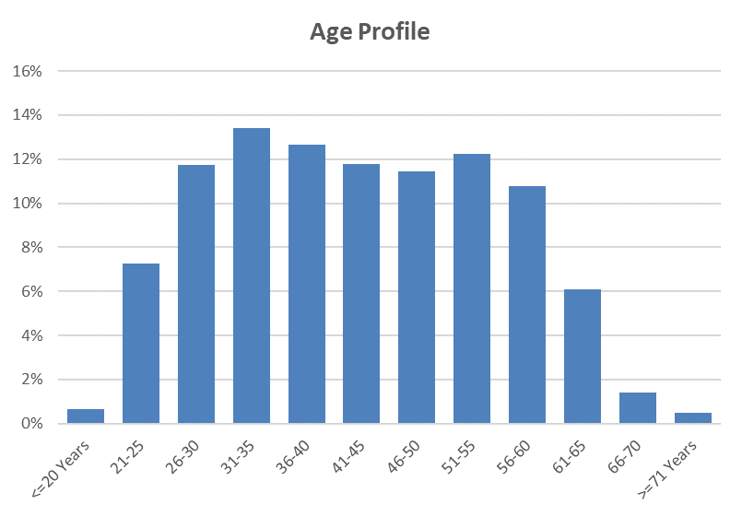

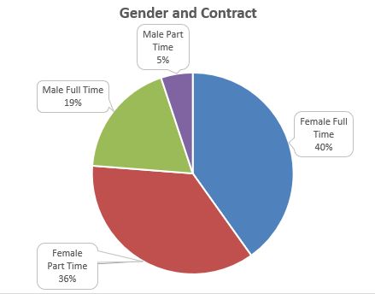

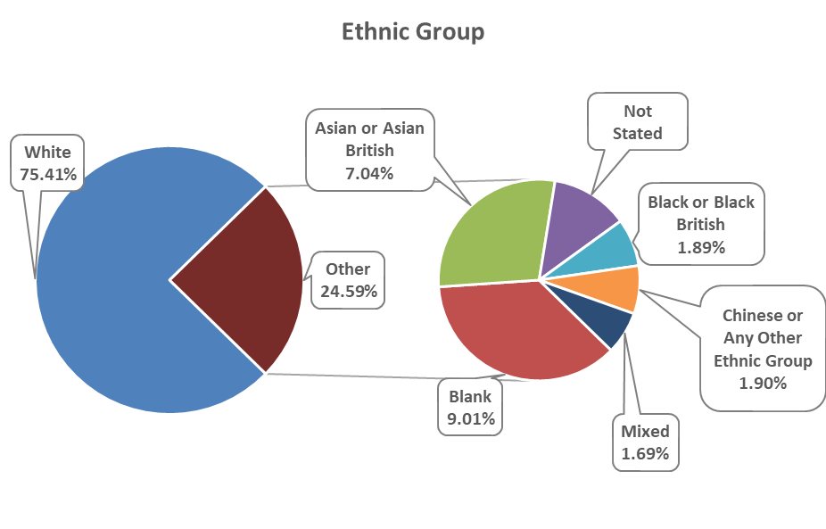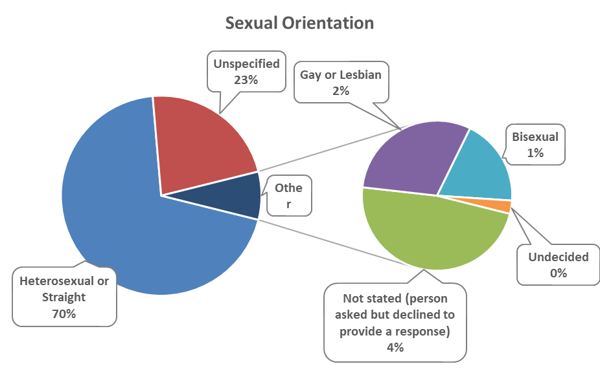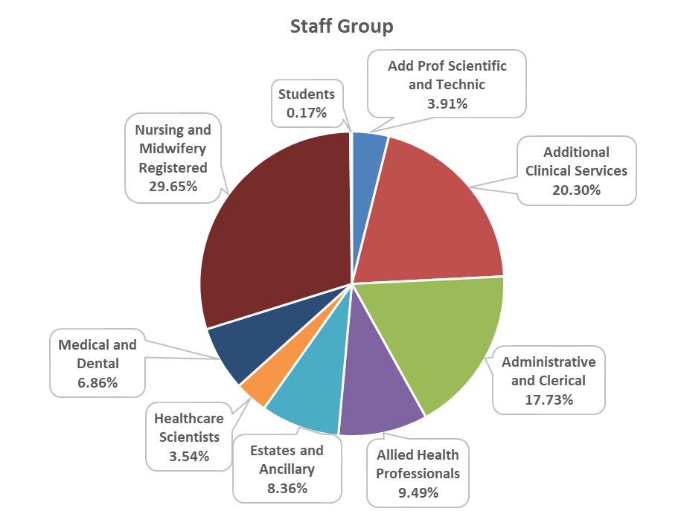

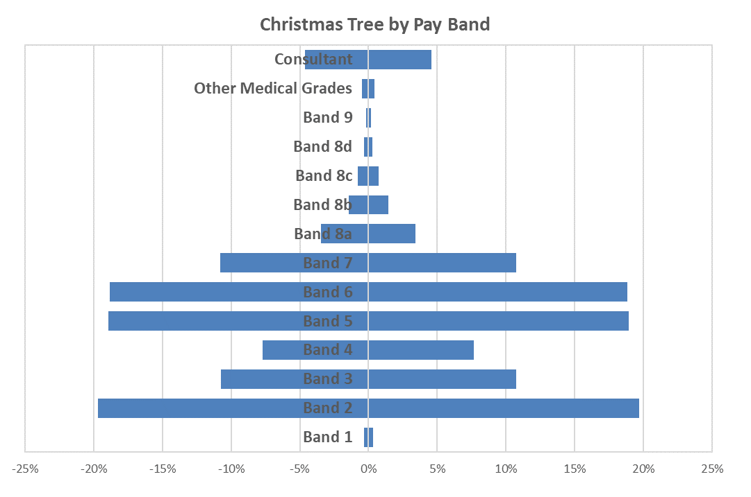

  - Sickness Absence Data

The health and wellbeing of Cardiff and Vale Health Board staff is of upmost importance, especially at this unprecedented time and much of the work carried out in 2022/23 has been described in the Performance Report.

Sickness absence remains a priority for the Health Board. The cumulative sickness rate for the 12-month period up to and including March 2023 is 6.90% which is 0.90% above the 2022-23 year-end target of 6.00%. 12.41% of the total sickness recorded has been attributed to Covid-19.

65% of this sickness was attributed to long-term absence and 35% to short-term absence. The Health Board’s top reasons recorded for absence during 2022-233 were Anxiety/Stress and Colds, Coughs & Influenza.

The following table provides information on the number of days lost due to sickness during 2021-22 and 2022-23.

 | 2022-23 | 2021-22
 | Number | Number
Days lost (long term) | 232,000.47 | 247,568.4
Days lost (short term) | 124,923.33 | 101,921.9
Total days lost | 356,923.80 | 349,490.38
Total staff years | 14,154.02 | 13828.4
Average working days lost | 25.22 | 15.78
Total staff employed in period (headcount) | 15,918 | 15,915
Total staff employed in period with no absence (headcount) | 5,250 | 6,274
Percentage staff with no sick leave | 31.25% | 39.42%

  - Staff Policies

At Cardiff and Vale Health Board we have 6 local UHB employment Policies:

- Recruitment and Selection
- Adaptable Workforce
- Employee Health and Wellbeing
- Learning Education and Development
- Equality, Inclusivity and Human Rights Policy
- Maternity, Adoption, Paternity and Shared Parental Leave
With the exception of the Equality, Inclusivity and Human Rights Policy (which was reviewed in 2021), all of these Policies were reviewed during 2022-23.
These set out our organisational commitments and what we are aiming to achieve. Each of them is supported by a number of Procedures which describe the processes to follow, roles & responsibilities, and any entitlements or obligations. This means there is less duplication, more transparency and information which is easier to understand. These are in addition to the All-Wales Policies which apply to us and all other Health Boards in Wales.
All employment and other related People Services (Human Resources) and People and Culture policies, procedures and guidelines are required to have at least two authors, i.e. a management and staff representative and they are subject to robust consultation processes. This includes publication on the Health Board’s intranet for a period of at least 28 days and consideration at the Employment Policies Sub Group of the Local Partnership Forum.

As an employer we are committed to providing meaningful equality of opportunity and inclusion for all employees, regardless of their protected characteristics (i.e. gender identity, marital status, race, ethnic origin, maternity status, nationality, national origin, sex, disability, sexual orientation, religion or age), as is demonstrated by our Equality, Inclusivity and Human Rights Policy. Its remit goes beyond strict compliance with the law and acts as a reference point in the event of any subsequent disputes.
The Health Board is committed to ensuring that the recruitment and selection of staff is conducted in a systematic, comprehensive and fair manner, promoting equality of opportunity at all time, eliminating discrimination and promoting good relations between all. The Recruitment and Selection Policy sets out how we will attract, appoint and retain qualified, motivated staff with the right skills and experience to ensure the delivery of a quality service and support its values. This is supported by a number of procedures including the Recruitment and Selection Procedure, Fixed Term Contract Procedure and Professional Registration Procedure, all of which were reviewed in 2022-23. Recruiting, Attracting and Retaining employees is one of the themes of the People and Culture Plan. The ability to deliver high quality, compassionate care is dependent on recruiting and retaining individuals with the right skills, abilities, values and experiences. This has become increasingly difficult following the service pressure and workforce resilience associated with the Covid-19 pandemic. The current climate has created a shortage of suitable candidates in many professions, and we need to think differently about how we attract and recruit our current and future workforce, including working with social care partners to develop an integrated workforce, and to support a diverse workforce and inclusive culture.
However, we cannot just depend on bringing new people into our workforce; we need to improve how we retain, manage, develop and look after the wellbeing of our existing workforce. This has been one of the key objectives over the past year and has included a review of the current retention plans we have in the Health Board to create one plan that can be used across the organisation. We have also been working with HEIW on development of a retention ‘toolkit’ for managers. In addition, we have been targeting areas where retention is an issue and providing organisational development interventions to help them improve.

We have also been working on enhancing our Leadership and Management training for managers which support aspiring, new and senior managers and leaders to develop compassionate leadership principles to support retention, wellbeing, innovation, performance and patient experience. Equity and inclusion form part of the programmes to support the organisation in building an inclusive culture.

The Health Board is committed to equal opportunities in recruitment, and demonstrates this by displaying the Disability Confident symbol (which replaces the ‘two ticks’ scheme) in all adverts, as well as Supporting Age Positive, Mindful Employer and Stonewall Cymru symbols.
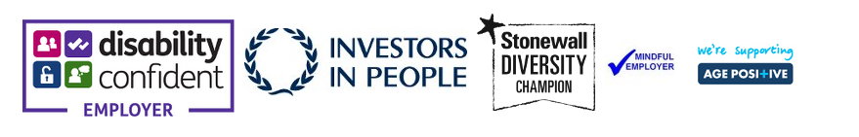

The Health Board is committed to supporting its employees and keeping them well. The Employee Health and Wellbeing Policy sets out our commitment to encourage and empower employees to take personal responsibility for their lifestyle choices, health and wellbeing, and to guide managers on their roles and responsibilities.

The Health Board will be under-going the Gold and Platinum Corporate Health Standards reassessment in March 2023 and aims to maintain the standards to be recognised as an exemplar organisation. The Wellbeing Strategy Group continues to oversee the delivery of the priorities and actions resulting from the Corporate Health Standard, and much progress has been made over the past year, including staff room and nursery facility refurbishments, provision of financial wellbeing education, signposting and roadshows, and the continued development of peer support. Work has also commenced on developing managers and leaders to effectively support the wellbeing of their teams through effective conversations and a compassionate leadership approach.

The NHS Wales Managing Attendance at Work Policy assists managers in supporting staff when they are ill, manage their absence and help facilitate their timely return to work in a compassionate way. The policy is proactive by placing responsibility on line managers to know their staff and focus on their health and wellbeing to keep them well and in work.

The Managing Attendance at Work Policy includes a number of toolkits. One of these deals with reasonable/tailored adjustments – it reminds managers of our legal duty to make reasonable adjustments to ensure workers with disabilities, or physical or mental health impairments, are not disadvantaged when doing their jobs or during the recruitment process. The Policy states that not all illnesses are disabilities, however, if an employee is asking for support with a health and wellbeing condition, it is best to provide the support accordingly, assuming it is proportionate to do so. There are many benefits to this including supporting the employee back into work and helping them remain in work.

A Managing Attendance at Work specialist team was formed in December 2021 as a response to the operational workforce pressures including Covid-19 and winter pressures. The purpose of the team was to provide specialist advice and support managers and colleagues on all matters in relation to managing attendance. The objectives of the team were to review all long-term sickness cases, manage redeployments, review long COVID cases finding alternative roles where possible and work with Health and Wellbeing Team to assist the wellbeing strategy to help prevent sickness. The team have supported and coached managers, during a difficult and unpredictable time of Covid-19 recovery.

Managing Attendance at Work training has been delivered virtually to over 200 managers in 2022, with regular sessions planned face to face and virtually in 2023. A recorded session will be developed for staff, which will also signpost them to various health, wellbeing and support networks.

Staff off on long term with post Covid-19 syndrome sickness have been supported by managers and have been signposted to resources available to assist their recovery. Overall absence the Health Board has been reducing with the focused and dedicated approach of the Managing Attendance at Work Team.

Toolkit Talk Sessions have been arranged for managers and staff to advise on the options and processes around Ill Health Retirement to support those who are unable to return to work from long term sick leave.
The Work and Wellbeing Passport has been implemented across the Health Board in collaboration with the Equality, Diversity and Inclusion Team.
The Redeployment Procedure sets out the process by which suitable alternative employment is sought for employees who are unfit or no longer able to carry out the duties of their current post, either on a temporary or permanent basis. This can be for a number of reasons, including health. It is important that staff and managers are clear about their responsibilities and the process to be followed to ensure that everyone is treated fairly and equitably. One important change was that individuals who require to be redeployed due to their health are not reliant on Workforce and OD advising them of vacancies, or responding to vacancies once they have already reached the advert stage. Staff needing alternative roles are entered onto the Trac recruitment system and they are automatically advised of potentially suitable alternative employment before the vacancy request is allowed to progress further in the system. Although the process of finding a redeployment opportunity is initially coordinated by Human Resources, the responsibility and ownership for actions taken is shared with the individual concerned and their substantive line manager, who are both expected to take all possible steps to find and pursue suitable opportunities. The Procedure has strengthened the accountability of managers who do not accept a suitable candidate for a trial redeployment. The Procedure aims to ensure that clear advice, support and guidance is provided to managers and employees regarding their role(s) in managing situations where employees need to be transferred into suitable alternative posts.

By making reasonable adjustments for staff with disabilities we have been able to retain a number of valued employees in their substantive role. Typical changes include reviewing caseloads, changes to equipment used, purchase of specialist equipment and modifying their workplaces. We have worked with organisations such as Access to Work to support our disabled employees.
The Supporting Carer’s Guidelines were developed in September 2021. The Health Board recognises that employees with caring responsibilities may require short term arrangements for either child or dependent care, or for longer term requirements have the ‘right to request’ flexible working arrangements. The caring responsibilities may potentially impact on a member of staff’s ability to do their job.
The purpose of the Guidelines is to support staff to achieve a positive work/ life balance with caring responsibilities, so that staff are likely to feel more valued, thus be more productive and satisfied at work. It ensures that staff are not unfairly disadvantaged by such responsibilities and are able to successfully combine their work and caring responsibilities. The organisation values each individual and strives to retain staff and accommodate where possible their changing circumstances whilst balancing the needs of the service.
These guidelines set out a range of short- and long-term options available to staff through agreement with their line manager. The responsibilities of the line manager, member of staff, Workforce & OD and Trade Union Representative are outlined in the guidelines. There is a carer’s plan that can be completed by the member of staff with caring responsibilities and their line manager. The plan can detail the caring responsibilities and the arrangements agreed together about short- and long-term arrangements. The application of these guidelines is in accordance with the principles of the Health Board’s Equality, Inclusion & Human Rights Policy, Special Leave Policy and Flexible Working Procedure.

The Injury Allowance Claims Procedure applies to employees who are claiming that they have sustained an injury or have contracted a disease or other health condition that they believe is wholly or mainly attributable to their NHS employment and is not due to or aggravated by their own negligence or misconduct. The procedure was updated in December 2022 to include a process for claims for Covid-19 related sickness absence.
The Health Board has undertaken the opportunity to develop a partnership approach with DFN Project Search. DFN Project Search is a one year, employment preparation programme that takes place entirely in the workplace. This will help to deliver the best employment outcomes for young adults from SEN education providers with learning disabilities and/or autism across the Cardiff and the Vale who are under-represented in the workforce. This will assist achieving part of the widening access into employment agenda. In 2021/22 we hosted 7 interns, 6 of which have now gained employment within Cardiff and Vale and the remaining individual chose to return to Further Education, in 2022/2023 we are hosting 9 interns, and currently 2 of those individuals are working on the Bank for their chosen departments.

Due to the current economic landscape as a result of Covid-19, many people were out of work. A high proportion of these individuals are young people, and the government launched an innovative KICKSTART scheme in March 2021 running until March 2022 to give 16-24 year olds who were in receipt of Universal Credit a future of opportunity by creating high-quality, government-subsidised jobs across the UK. The Kickstart placements lasted for six months, during this period the individual gained extra employability skills and mentoring to help them become successful in gaining long term employment. Cardiff and Vale recruited a total of 162 individuals into the organisation, of these, 2 have gone onto apprenticeship schemes, 64 have gained roles within the Health Board, and the remaining 96 have now finished their placements with us either going into alternative employment, education or not known. The scheme ended on 31 March 2022.
During 2022 we undertook our first Cohort of the Prince's Trust "Get Into" Programme in partnership with the DWP who funded the programme. This partnership is building a diverse and sustainable workforce whilst supporting the many young people disproportionally impacted during unprecedented and challenging times. The Prince's Trust is committed to supporting every young person to succeed, regardless of their background, social status or the challenges they face. The "Get Into" programme, hosted 10 young people, and consisted of a Taster Day, Induction course (included Basic Health Care Skills), employability days and a 4-week work placement as Patient Environment Support Workers. The programme ended with a Celebration Event where all the young people were presented with a certificate by the Charles Janczewski (the Health Board’s Chair) and 7 of those individuals are now working on our Bank as Healthcare Support Workers.

During the month of September the Health Board hosted a 2 hour Pharmacy Taster session in conjunction with Llandough Pharmacy Department for school pupils in their final year of GCSE's who are interested in looking to enter employment in a pharmacy setting after their education. It provided an opportunity to find out what happens inside a hospital pharmacy, and they received information on the different types of jobs that are available within the pharmacy and what a typical day looks like for some of our staff. It was also explained to them the wide variety of career pathways within pharmacy and the qualifications and experience that is needed for the different types of roles, (ie Managers, Pharmacists, Technicians, Assistants and Administrative staff). This day was well received and the next event has now been arranged.
Visits to the local mosques and refugee events have also taken place to promote the availability of roles and positions that are available to all groups of individuals.
2022/23 has been a really positive year for the Apprenticeship Academy with increased engagement across the service which has led to a significant boost to the number of entry level apprentices recruited and the introduction of different pathways. Departments are more open to the possibilities of recruiting apprentices and looking at the skill mix of their teams differently. This year we have appointed 23 apprentices through administration, building service engineer, IT roles. The expansion into new routes is providing more opportunities to the local economy and the intention is to build on this success by introducing more variety. This year has seen 5 apprentices complete and be offered roles within their host department or in another area. We are proud to confirm that we have an 84% success rate in apprentices securing permanent employment. A pilot has been confirmed for the introduction of Healthcare Support Worker Apprentices in the Mental Health Clinical Board and recruitment for this will start shortly. We are actively involved in the work across Wales in the development and review of frameworks and how these can benefit our workforce. Support for our current and past apprentices is continuing with the Future Generations Network, this is now being chaired by a member of the group and they are actively setting agendas and agreeing the programme of activities.

Existing staff uptake of apprenticeships has increased with a further 171 new starts covering subjects such as Management, Health, Business Administration, Digital Application Support, CIPD, Project Management, Information, Advice and Guidance, Facilities and IT Users. During this period, we have also had 59 existing staff complete their qualifications.

  - Salary and Pension Entitlements of Senior Managers 2022-2023

Full details of senior managers’ renumerations for 2022-23 are provided in the audited tables that follow:
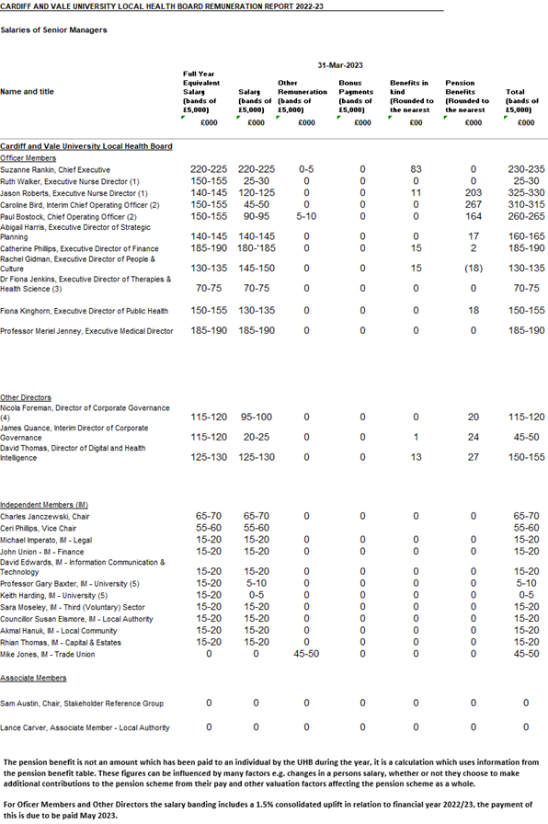
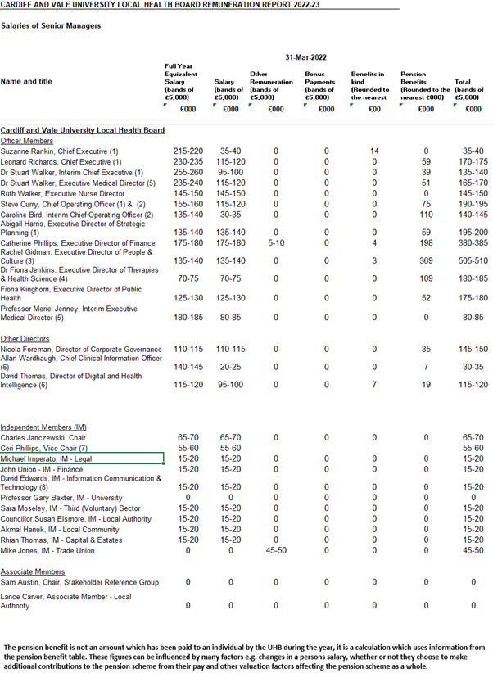

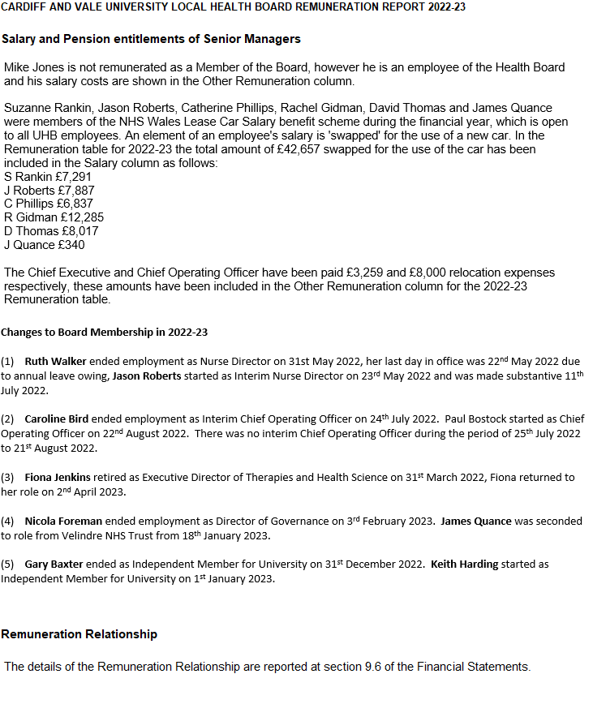
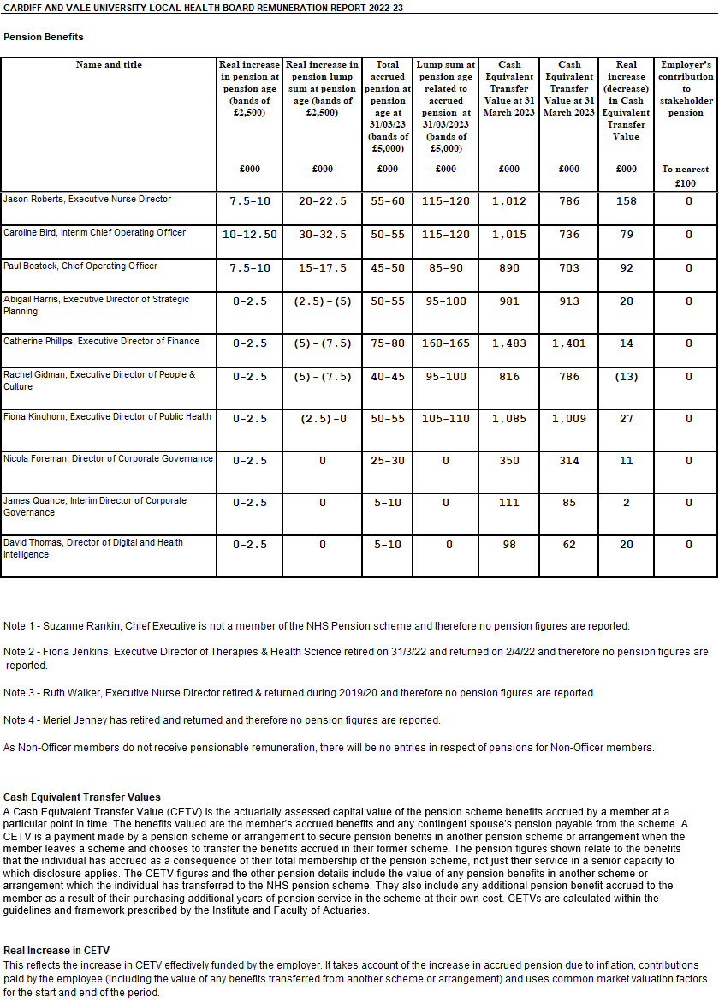
20.6 Consultancy Expenditure

As disclosed in note 3.3 of its annual accounts, the Health Board spent £0.643m on consultancy services during 2022-23 compared to £7.479m in 2021-22. The majority of this expenditure going towards projects aimed at delivering better clinical outcomes and efficiencies.

  - Tax Assurance for Off-payroll Appointees

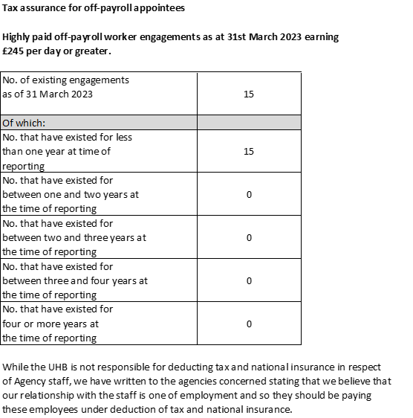

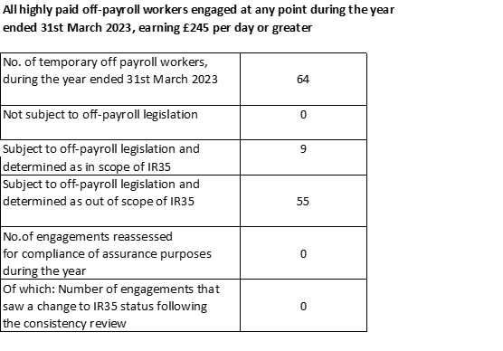

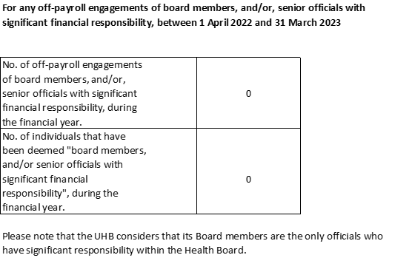

Senedd Cymru/Welsh
Parliament Accountability
& Audit Report

21. Part 2c Senedd Cymru/Welsh Parliament Accountability and Audit Report – to be updated May

21.1 Regularity of Expenditure
The Health Board has a financial duty to break even over a three year period. This has been achieved for the period 2019-20 to 2021-22 with a £380k underspend achieved of the three year resource limit. This is therefore deemed to be regular.

Between March 2020 and March 2022 the Integrated Medium-Term Plan (IMTP) process was paused due to the COVID-19 pandemic. The requirement for an approvable IMTP was replaced by the need for quarterly plans for 2020-2021 and an annual plan for 2021- 2022.

The LHB will be returning to a three year planning cycle in accordance with Welsh Government directives from 2022-2025

21.1.1 Long Term Expenditure Plans 2018-2023

Performance Against the Revenue Resource Limit

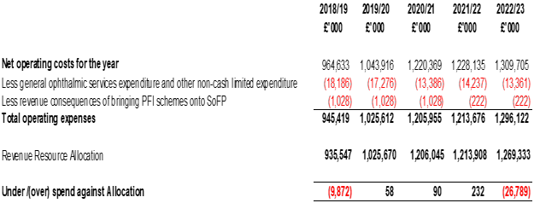

The Health Board has not met its financial duty to break even against its Revenue Resource Limit over the 3 years 2020-21 to 2022-23.

The Health Board received £26.900m strategic cash support in 2022-23. The cash only support is provided to assist the Health Board with ensuring payments to staff and suppliers. There is no interest payable on strategic cash support.

Performance Against the Capital Resource Limit

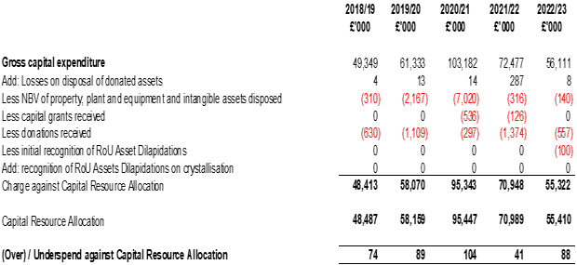
The Health Board has met its financial duty to break even against its Capital Resource Limit over the 3 years 2020-21 to 2022-23.

How the UHB Has received its Revenue Funding

2022/23

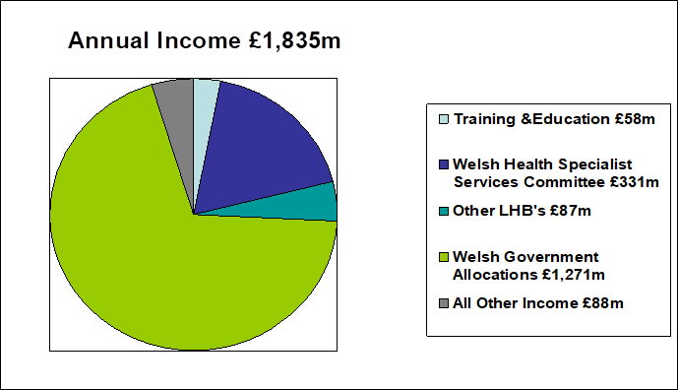
2021/22

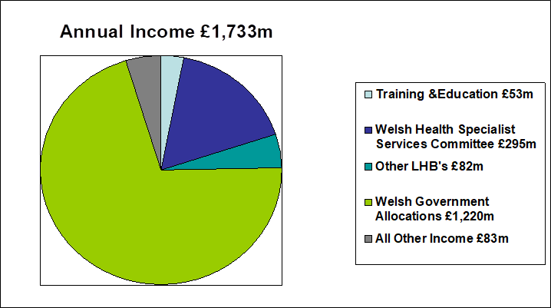

2020/21
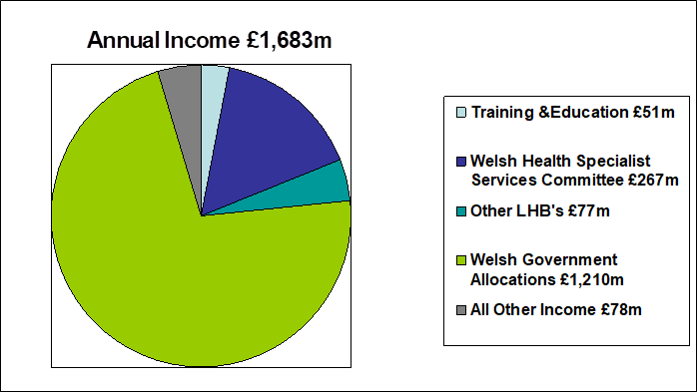

2019/20

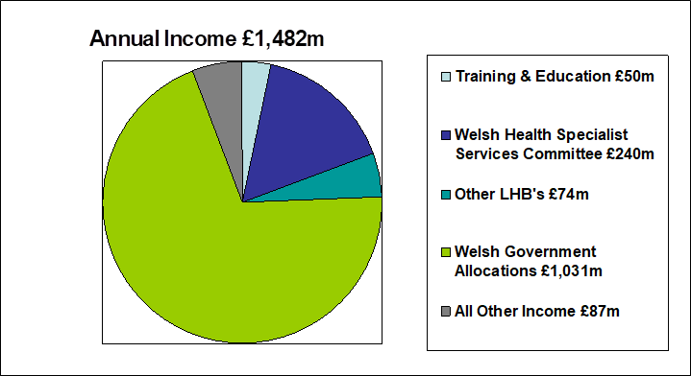

2018/19

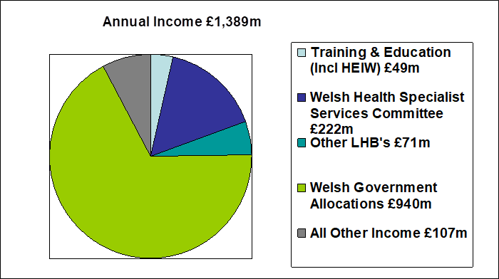
As disclosed in the performance against break even duty table above, the Health Board is permitted to remove certain elements of expenditure (which it incurs but over which it doesn't have managerial control) when comparing its expenditure to its annual revenue resource limit. For the purposes of a meaningful comparison of income & cost, this has been treated as notional income in the above. Hence the expenditure figures shown below are shown gross (with no expenditure removed).

How the UHB has utilised its Revenue Funding

2022/23

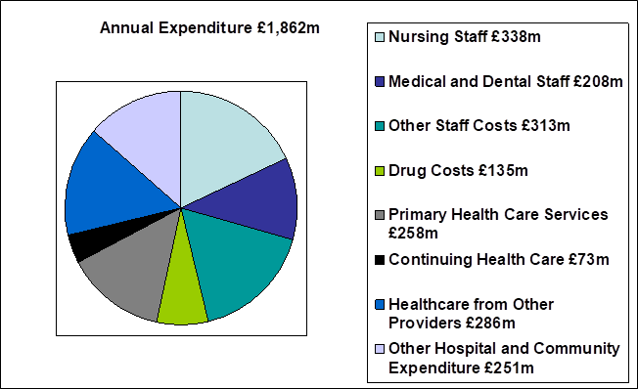
2021/22
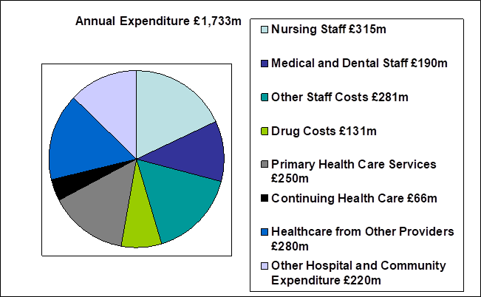

2020/21
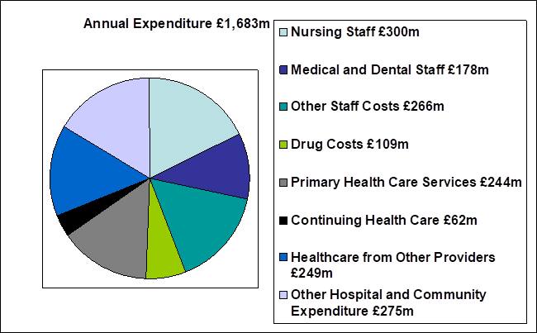

2019/20

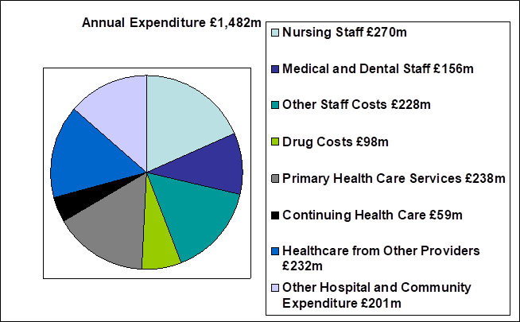
2018/19
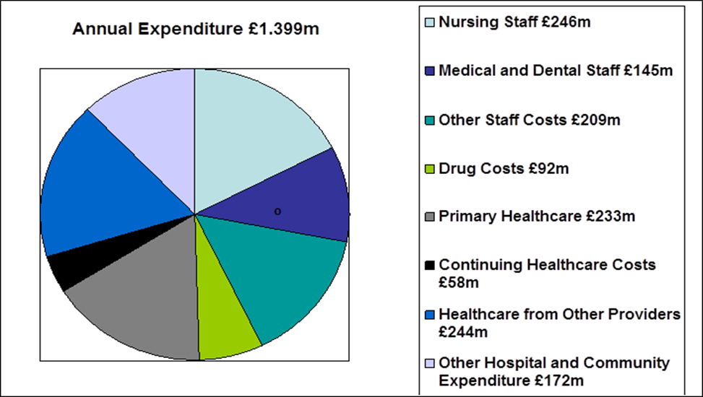

21.2 Fees and charges
The Health Board levies charges or fees on its patients in a number of areas. Where the Health Board makes such charges or fees, it does so in accordance with relevant Welsh Health Circulars and charging guidance.

Charges are generally made on a full cost basis. None of the items for which charges are made are by themselves material to the UHB, however details of some of the larger items (Dental Fees, Private and Overseas Patient income) are disclosed within Note 4 of the Annual Accounts.

21.3 Managing public money
This is the required Statement for Public Sector Information Holders as referenced at Section 10.1.7 (page xxx) of the Directors’ Report. In line with other Welsh NHS bodies, the UHB has developed Standing Financial Instructions which enforce the principles outlined in HM Treasury on Managing Public Money. As a result the UHB should have complied with the cost allocation and charging requirements of this guidance and the UHB has not been made aware of any instances where this has not been done.

21.4 Material remote contingent liabilities

As disclosed in note 21.2 of its annual accounts, the Health Board had net remote contingent liabilities as at March 31st 2022 of £0.155m. This relates to Clinical Negligence & Personal Injury claims against the Health Board, where our legal advisors inform us that the claimants’ chance of success is remote.

21.5 The Certificate of the Auditor General for Wales to the Senedd

21.6 Report of the Auditor General to the Senedd

Part 3
Audited Financial Statements (Annual Accounts)

22. Financial Statements
TO BE ADDED MAY 2023
Foreword

These accounts have been prepared by the Local Health Board under schedule 9 section 178 Para 3(1) of the National Health Service (Wales) Act 2006 (c.42) in the form in which the Welsh Ministers have, with the approval of the Treasury, directed.

Statutory background

The Local Health Board was established on 1 October 2009, following the merger of Cardiff & Vale NHS Trust, Cardiff Local Health Board and The Vale of Glamorgan Local Heath Board. The main purpose of the body being, the provision of healthcare to and the procurement of healthcare for the populations of Cardiff and the Vale of Glamorgan. In addition, as a Tertiary Centre the UHB serves the wider population across Wales (and the UK) via the provision of specialist and complex services.

Performance Management and Financial Results

Welsh Health Circular WHC/2016/054 replaces WHC/2015/014 ‘Statutory and Administrative
Financial Duties of NHS Trusts and Local Health Boards’ and further clarifies the statutory financial
duties of NHS Wales bodies and is effective for 2019-20. The annual financial duty has been revoked and the statutory breakeven duty has reverted to a three-year duty, with the first assessment of this duty in 2016-17.

Local Health Boards in Wales must comply fully with the Treasury’s Financial Reporting Manual to the extent that it is applicable to them. As a result, the Primary Statement of in-year income and expenditure is the Statement of Comprehensive Net Expenditure, which shows the net operating cost incurred by the LHB which is funded by the Welsh Government. This funding is allocated on receipt directly to the General Fund in the Statement of Financial Position.

Under the National Health Services Finance (Wales) Act 2014, the annual requirement to achieve balance against Resource Limits has been replaced with a duty to ensure, in a rolling 3-year period, that its aggregate expenditure does not exceed its aggregate approved limits.

The Act came into effect from 1 April 2014 and under the Act the first assessment of the 3 year rolling financial duty took place at the end of 2016-17.

© Cardiff & Vale University Health Board 2023
The text of this document (this excludes all departmental or agency logos) may be reproduced free of charge in any format or medium provided that permission is sought and it is reproduced accurately and not in a misleading context. The material must be acknowledged as Cardiff and Vale University Health Board* copyright and the document title specified. Where third party material has been identified, permission from the respective copyright holder must be sought.

