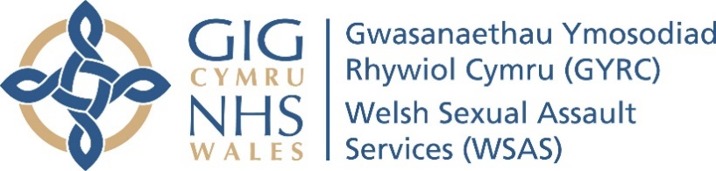

Welsh Sexual Assault Services (WSAS)

Programme Governance
Author(s):
Joanna Williams WSAS Programme Director

Date: October 2023 | Version: 0.1
Purpose and Summary of Document:
This document provides an overview of the current governance structure for the Welsh Sexual Assault Services Programme.

SITUATION

Health boards, police forces, Police and Crime Commissioners, in partnership with the third sector, are taking forward a new service model for the delivery of sexual assault services in South Wales, Dyfed Powys and Gwent. This will provide a more integrated service that is driven by the needs of victims and patients and supports the provision of services that meet clinical, forensic, quality and safety standards and guidance, and ensures robust governance arrangements.

The ambition is to deliver patient and victim centred sexual assault services with health needs as the key priority, to provide the best outcomes for victims of sexual violence, to be achieved through a health-led programme, with the NHS working in partnership with policing and others. The agreed regional model in South Wales is based on a hub and spoke approach with three adult sexual assault referral centre (SARC) hubs in Cardiff, Swansea and Aberystwyth and two paediatric SARC hubs in Cardiff and Swansea.

The SARC hubs will also act as a spoke for the local population and will be supported by additional spokes in Risca, Merthyr Tydfil, Newtown and Carmarthen.

BACKGROUND

The Welsh Sexual Assault Services Board (WSAS Board) will provide scrutiny and assurance to NHS Wales Health Collaborative Leadership Group which consists of the CEOs and Chairs for the Health Boards in Wales and other stakeholders through their respective governance arrangements in relation to quality, sustainability, safety and delivery of the Sexual Assault Service model for Wales.

The overarching aim of the Board is to facilitate the development and implementation of a robust service model, ensuring a consistent, high-quality approach to the delivery of services that secure the best outcomes for victims of sexual assault and meets the agreed clinical and operational standards.

Governance Structure (Appendix 1)

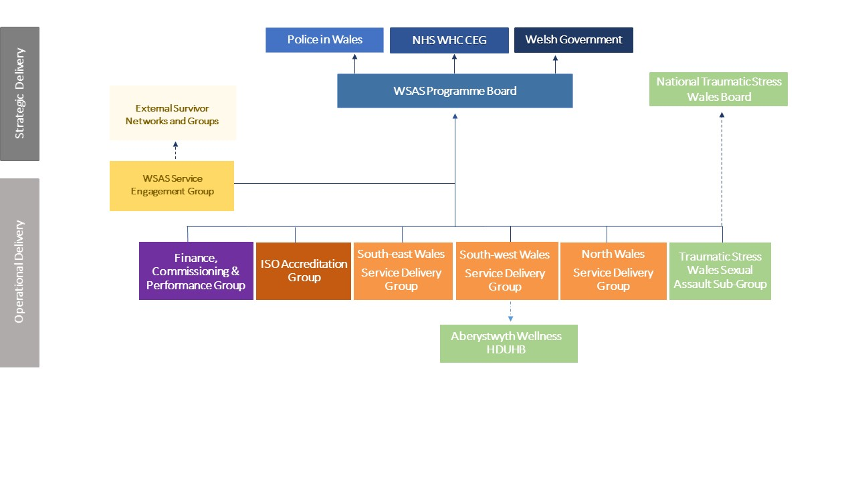

The Board is responsible for:
- Setting the direction
- Service models meeting accepted best clinical practice and relevant forensic, quality and safety standards.
- Demonstrating value for money in comparison to reasonable benchmarks
- Delivery of the workplan and associated objectives
- Ensuring that risks to the service/programme are identified
- Overseeing the governance arrangements and ensuring that they are fit for purpose
- Approving key recommendations in relation to development of Sexual Assault Services across the region and ensuring that the resources needed are made available to the programme when required
- Delegating authority to the Programme Director to lead the Programme development
- Reporting progress to the NHS Wales Health Collaborative and other stakeholders through their respective governance arrangements.

ASSESSMENT

Membership

The Welsh Sexual Assault Services Board will, when required, be split into two distinct sections the operational service delivery and the strategic oversight and decision making. The health boards in some areas function as both providers and commissioners and will ensure that there is from different individuals for the operational elements and the strategic updates and decisions. The Board is chaired by the Managing Director of the National Collaborative Commissioning Unit.

- Health Boards:
  - Aneurin Bevan University Health Board (UHB)
  - Cardiff & Vale UHB
  - Cwm Taf Morgannwg UHB
  - Hywel Dda UHB
  - Powys Teaching Health Board (THB)
  - Swansea Bay UHB
  - Betsi Cadwaladr UHB
- Police and Crime Commissioner offices:
  - Gwent
  - South Wales
  - Dyfed Powys
  - North Wales
- Police forces:
  - Gwent
  - South Wales
  - Dyfed Powys
  - North Wales
- Regional clinical leads
- National Collaborative Commissioning Unit
- NHS Wales Collaborative
- Welsh Government
- New Pathways (Operational only).
Supporting Groups

Finance, Commissioning and Performance Group (FCPG)

The overarching aim of the Finance, Commissioning and Performance Group is to ensure that appropriate processes and documents are put in place to support the finance, commissioning and performance of sexual assault services as the implementation component of the Welsh Sexual Assault Services (WSAS) programme. These documents are to be approved by the Board prior to the submission to the WSAS Board. The membership comprises of commissioners &/or finance representatives from health, police and the Offices of the Police and Crime Commissioners (OPCCs).

Service Delivery Groups (SDG)

The Regional Service Delivery Group will be responsible for implementation and day to day delivery of the operational service model for Sexual Assault Referral Centre (SARC) hubs within the region. The overarching aim of the SDG is as follows:

- A focus on improving outcomes and client experience from the outset.
- Undertaking planning for the development and delivery of an integrated SARC hub service within the region
- Ensuring accommodation for the regional SARC hub is fit for purpose and meets required standards including capital, ISO etc.
- Ensuring sustainable workforce is in place to meet the requirements of the SARC hub within the region
- Ensuring services meet and are delivered in line with agreed policies, procedures and the service specification.
- Monitor capacity within regional SARC hub raising any concerns with the WSAS Board.
- Adopting a culture of integrated collaborative working across sectors and across the region
- Ensuring clients attending SARC receive the best care by the most appropriate individual, in the most appropriate location and in a timely manner.
- Ensure the service model facilitates improved access and equity of access to SARC services.

The Service Delivery Group will comprise service providers and operational leads from health and the police within the region and will include Health, Police and 3rd sector operational leads.

ISO Accreditation Group

This group has been stood down with the appointment of a new project lead for South Wales ISO (International Organisation for Standardization) accreditation. It is proposed that a new group is developed on an all-Wales basis and the governance will need to be agreed. This will require further discussion with Police colleagues who lead on the accreditation of the SARCs.

Service and Survivor Engagement

The WSAS Service Engagement Group will provide scrutiny, advice, and feedback to the WSAS Programme as it implements changes to sexual assault referral services in Wales and delivers the new ‘Hub and Spoke’ service model. The new service model is driven by the needs of victims and will ensure that relevant clinical, forensic, quality and safety standards, and guidance are being met, and that robust governance arrangements are in place. Meetings and workshops will be run for Service Engagement Group members to discuss, develop, and shape a range of WSAS Programme activities.

Traumatic Stress Wales Sexual Assault Steering Group (TSW)

The Steering Group will identify existing provision and gaps, and develop, implement and monitor the delivery of integrated care pathways for sexual assault, in conjunction with the Local Health Board Leads, and with oversight from the TSW National Steering Group. It will bring together relevant stakeholders with relevant experience and expertise in this area to provide optimal input to ensure the TSW plans and delivers appropriate services across Wales for sexual assault, in line with its agreed principles and objectives.

Project Groups

There are a number of project groups that have been set up in order established to address specific areas including:

- Forensic Medical Examiners project
- Paediatric Services Project
- Independent Sexual Violence Advisor (ISVA) Oversight Board
- Performance Group
- Spokes subgroup
- Commissioning Task and Finish Group

In addition to these groups, there are a number of other regular meetings that the WSAS team attend including:

- Violence against Women Domestic Abuse and Sexual Violence (VAWDASV) National Board
- VAWDASV Children and Young People (CYP) Blueprint Group
- VAWDASV Research Network
- Rape and Serious Sexual Offences (RASSO) Strategic Delivery Group
- Criminal Justice Victims and Witnesses Taskforce
- Honour Based Violence leadership Group
- Traumatic Stress Wales (TSW) National Steering Group Meeting
- Four Nations meeting
- Childrens Commissioner Round table
- Welsh Government cross departmental sexual assault meeting.

Financial Governance

In order to implement phase one of the model and to meet the ISO accreditation standards, there has been a new service model agreed that has been phased over a 3-year period. The Health Boards’ 50% contribution to phase one of this model is an uplift of £347k in year one and £506k over the 3 years to the full implementation. The required funding contribution has been included in the NCCU plan through the WHSSC /EASC planning process. The 50% Police funding already having been agreed through their internal governance processes.

Table One: Health phase one totals and uplift from baseline

Year | Health 50% funding £000’s | Uplift from baseline (£000)
2023-24 | 1,149 | 347
2024-25 | 1,274 | 124
2025-26 | 1,308 | 35

It is anticipated that there will be elements of the model that will be provided by Health and elements that will be provided by independent/third sector providers, the phase one model has however been costed based on NHS pay scales. It should be noted that the composition of the funding contained within the baseline payment is not known. There are currently services contained within phases 2 and 3 which are additional and still need to be paid directly to providers until these costs and splits are agreed.

RECOMMENDATION
Further information or clarification on the programme governance can be provided on request from Jo Williams, Programme Director WSAS.

Appendix 1 – Governance Structure

