Cardiff and Vale
Pan Cluster Planning Group

Partnership Delivery Plan (Combined)
2024/2025

Contents:
Section 1: Introduction
Section 2: Cardiff Region
Section 3: Vale Region
Section 4: Population Needs
Section 5: Planning Approach & Delivery priorities for 2024/25
Section 6: Planning Governance – Implementation & Monitoring

Section 1: Introduction
Introduction
The Accelerated Cluster Development (ACD) Programme, the Primary Care component of Place Based Care, was introduced to ensure more rapid implementation of the Primary Care Model for Wales (PCMW) and to address system barriers. Pan Cluster Planning Groups (PCPG) bring together Cluster analysis and priorities with the decision makers in health boards and local authorities who have statutory responsibility for planning and funding services.
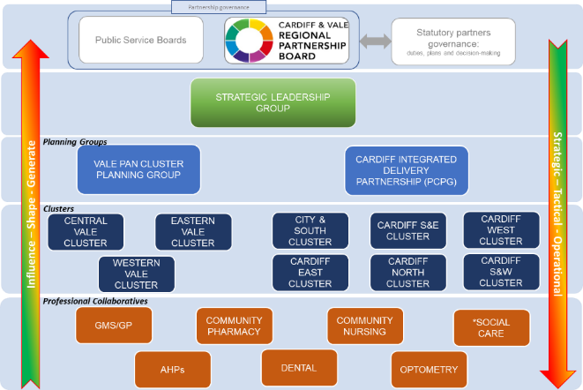
One of the aims of the ACD programme was to enable a clear line of sight from the local front-line health and care services through to the Regional Partnership Board (RPB) in terms of understanding the needs of the local population and being able to translate this into meaningful strategic priorities.
The following governance structure was adopted as an interim to support the embedding of PCPGs into the architecture of partnership and healthboard planning functions, however we recognise further work is required to ensure PCPGs are able to fulfil their anticipated remit.

Purpose of Pan Cluster Planning Groups
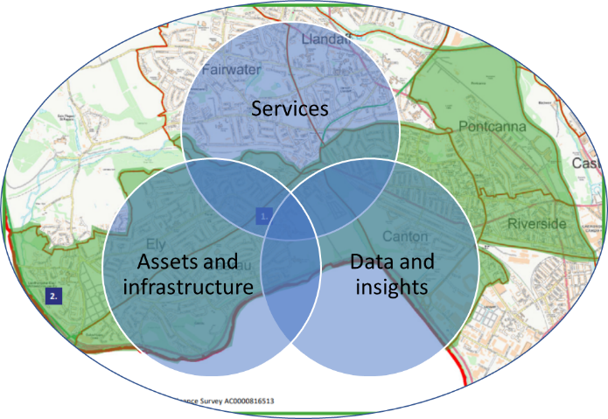
Pan Cluster Planning Groups are required to lead the development of integrated county level plans which considers the level of services needed and the opportunities to make prudent use of all funding, workforce, and other resources which address the health, care and wellbeing needs of the population.
During 2023, the idea of a Place-based planning concept was introduced as a methodology that could underpin the PCPG partnership:
‘A joined-up approach that treats the ‘place’, and not just individual problems or issues’
Place based planning seeks to
- understand the issues, interconnections and relationships in a place,
- coordinate action and investment to improve the quality of life for that community
- draws together separate organisational capital and service plans in to one.

Section 2: Cardiff Region

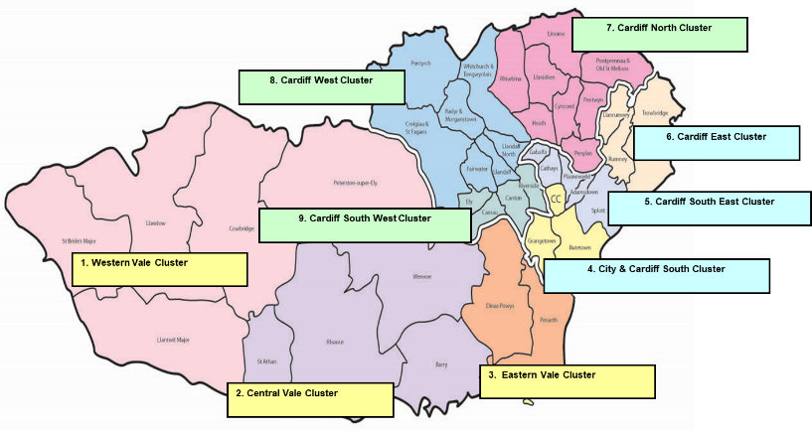
The Cardiff region aligns to the footprint of Cardiff Local Authority, consisting of two distinct Locality areas (Cardiff North & West and Cardiff South & East) and six Clusters.
Cardiff West, Cardiff South West and Cardiff North align to the North & West Locality, whilst Cardiff East, Cardiff South East and Cardiff City & South align to South & East Locality.
Census data (2021) indicates that for Cardiff:
- The population size has increased by 4.7%, from around 346,100 in 2011 to 362,400 in 2021.
- Around one-fifth of residents live in the most deprived 10% LSOAs, and approximately 50% of Cardiff's population live in the 50% least deprived LSOAs (105 LSOAs).
- There has been an increase of 15.3% in people aged 65 years and over, an increase of 2.6% in people aged 15 to 64 years, and an increase of 5.3% in children aged under 15 years
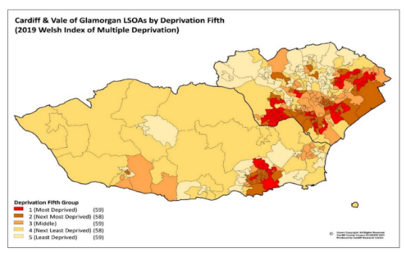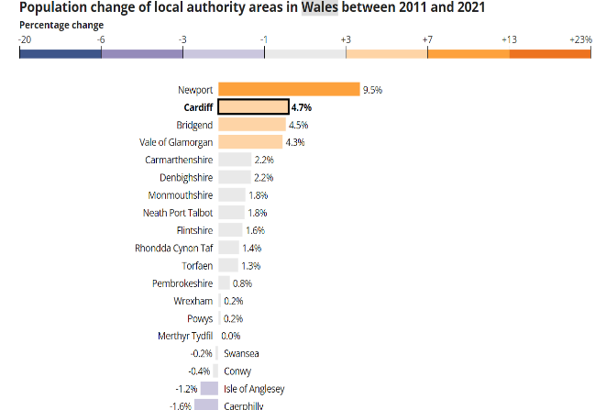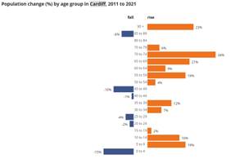
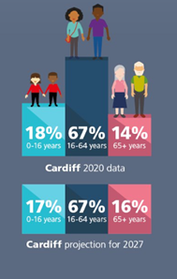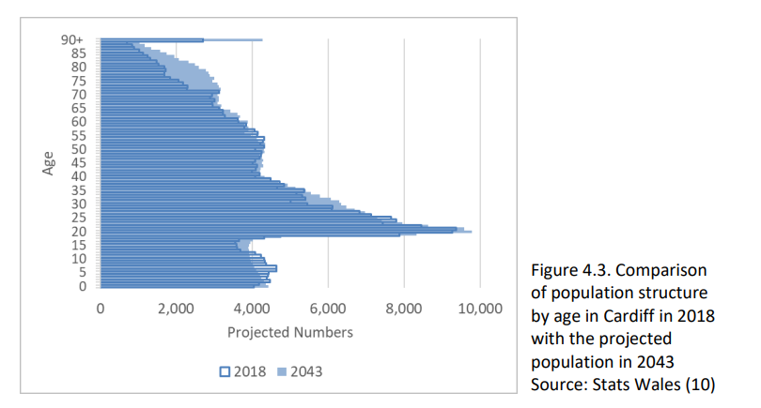
Cardiff is projected to see an increase in the number of people aged 65years+ by 2027 and this trend is currently projected to continue.

Section 3: Vale Region

The Vale region aligns to the footprint of Vale of Glamorgan Local Authority, consisting of one Locality area and three Clusters;
Central Vale,
Eastern Vale,
Western Vale.
Census data (2021) indicates that for the Vale of Glamorgan:
- The population size has increased by 4.3%, from around 126,300 in 2011 to 131,800 in 2021.
- 65% of the Vale of Glamorgan’s population lives in the 50% least deprived areas (28 LSOAs) (21).
- There has been an increase of 24.9% in people aged 65 years and over, a decrease of 1.5% in people aged 15 to 64 years, and an increase of 4.3% in children aged under 15 years
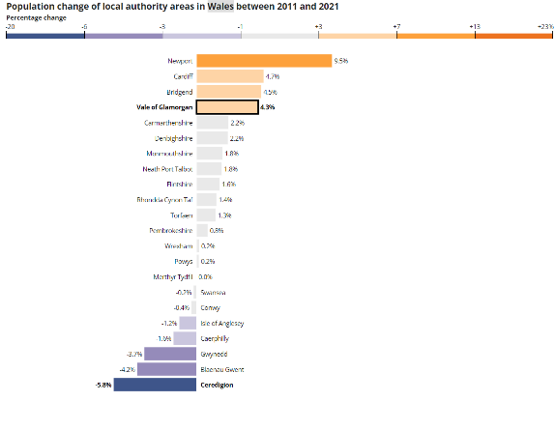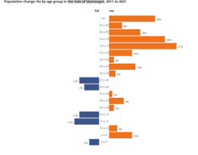

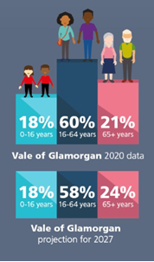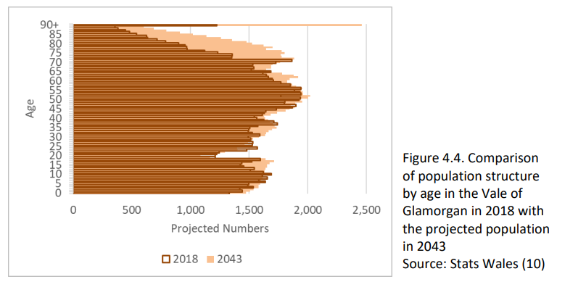
The Vale of Glamorgan is projected to see an increase in the number of people aged 65years+ by 2027 and this trend is currently projected to continue.

Section 4: Population Needs
The 2022 Regional Population Needs Assessment for Cardiff and the Vale highlighted the following priorities facing our population.
- Growing and ageing population
- Ethnically diverse – especially in South Cardiff
- Increasing levels of chronic disease; impacted by Covid pandemic – 5 harms, long Covid and ‘syndemic’ effect
- Modifiable risk factors – of concern before pandemic, but again impacted by Covid, mostly in less favourable direction
- Wider determinants, social isolation – impact of Covid and Cost of living crisis
- Impact of Climate Change and Climate Emergency
A summary of needs facing our Communities informed by Cluster and professional Collaboratives includes;
- Increasing population growth aligned to Local Development Plans
- Diabetes
- Adult mental health – improved access to services
- Growing population now - increase in chronic conditions, multi-morbidities, and frailty
- Long waiting lists for secondary care services
- Many areas struggling with workforce vacancies and difficulties recruiting
- General lifestyle (adults and children)
- Children’s mental health and neurodiversity
- Unstable periodontal disease rates
- Limitations caused by collaborative systems / patient records not speaking to one another.
- Pressures facing contractor services
- Increased crisis facing our communities ‘Cost of Living’ pressures
- Social isolation
- Disproportionate Deprivation levels
- Immunisation and screening uptake

Section 5: Planning Approach & Delivery priorities for 2024/25
Context
Set within the planning architecture of the HealthBoard, the regional planning priorities of PCPGs are informed by a range of strategic planning priorities, demonstrating the clear line of sight and alignment to the core priorities of the RPB; Starting Well, Living Well, Ageing Well
- Regional Partnership Board (RPB)Area Plan (2018-2023) and emerging plan for 2023-2028
- Cardiff Local Authority Annual Delivery Plan (Cardiff Council Corporate Plan 2022-25)
- Cardiff and Vale University Health Board IMTP and Strategic Priorities
- Cardiff and Vale Population Needs Assessment
- Primary Care Model for Wales
- Cluster Plans
A summary of the overarching priorities for each of these is provided below to demonstrate the connectivity between our planning priorities and to further establish PCPGs as a place-based planning vehicle to have more meaningful collaborative planning discussions across the region.
RPB | Cardiff Local Authority | Cardiff & Vale UHB
Three core areas of focus:  - Starting Well  - Living Well  - Aging Well  Regional Outcomes Framework  - Increasing time for people to live their lives  - Increased living well within their own communities  - Improved environment that enables people’s choices  - More empowered workforce  - Better start for children and young people  - People get a safe response when in urgent need  - Decrease avoidable harm and mortality  - Reduced wasted system resource | Cardiff Capital Ambition ‘Working for Cardiff, Working for you’. Wellbeing Objectives  - Cardiff is a great place to grow up  - Cardiff is a great place to grow older  - Supporting people out of poverty  - Safe, confident & empowered communities  - A capitol city that works for Wales  - Cardiff grows in a resilient way  - Modernising & integrating our public services | Caring for People, Keeping People Well.  Putting People First  Providing Outstanding Quality  Delivering in the Right Places  Acting for the Future  Strategic Priorities  - @Home Programme for Out of Hospital Care  - 6 Goals for Emergency and Urgent Care  - 5 Goals for Planed Care  - Primary Care Model for Wales  - Ministerial priorities
Cardiff and the Vale Population Needs assessment | Primary Care Model for Wales | Cluster Plans
Demographics:  - Population growth  - Aging  - Ethnic & cultural diversity  - Changing patterns of disease  Staying Healthy:  - Tobacco  - Food  - Physical activity  - Alcohol  - Building healthy relationships  - Substance misuse  Wider Determinants:  - Health inequalities  - Healthy environment  - Social isolation & loneliness | - An informed public  - Empowered Communities  - Support for well-being, prevention & self-care  - Local services  - Seamless working  - Safe & Effective call handling, signposting & triage  - Quality OOH Care  - Directly accessed services  - Integrated care for people with multiple care needs  - Cluster estates & facilities support multi-professional working  - Cluster IT systems enable cluster communications & data sharing  - Ease of access to community diagnostics supporting high-quality care  - Finance systems designed to drive whole system transformative change | Chronic disease – e.g. Diabetes (incl. Prevention)  Social Prescribing  Falls/Frailty  High Risk Adults/Anticipatory Care Planning  Children Services & Safeguarding  Prevention – Immunisation, Screening, Oral Health  Digital & Information Governance  Workforce Sustainability

Priorities for 2024/2025
Through our Partnership discussions, the following priority areas have been identified across both Cardiff and Vale regions which will underpin the PCPGs in;
- informing and influencing the delivery of services at Cluster/Pan Cluster population levels,
- supporting whole system efficiency & effectiveness (resource shift).
- Identify optimum delivery models to progress the priorities within the plan (who is best placed to deliver and how?)

ANNUAL DELIVERY PLAN 2024/25
Plan Theme/Area | Contribution/  Alignment | Milestones
Plan Theme/Area | Contribution/  Alignment | Q1 | Q2 | Q3 | Q4
To further develop and mature as system leadership partnership as part of the UHBs planning architecture | CAV Executive Team  RPB/SLB | Define our decision-making responsibilities as part of the UHB governance arrangements | Understand and develop our data needs across the region aligned to planning, and delivery priorities | Refine regional planning priorities informed by Cluster plans | Develop/refine implementation plans for delivery
Prevention  Identify collaborative solutions to improve health outcomes;  - Diabetes  - Heart Failure  - Immunisation  - Screening | Health Inclusion Programme  Immunisation Programme  Values Based Healthcare Programme  Public Health  RPB Living Well | Engage with CAV UHB Immunisation Programme Board recommendations relating to vaccine equity | Consider the findings of the Kings Fund reports and implementing actions based on recommendation | Establish learning from Custer based models to inform regional delivery priorities  Identify business cases for development for investment | Prepare implementation plans for delivery
To engage with the design and delivery of an integrated place-based model of community care for the region via the @Home programme  - High Risk Adults  - Falls/Frailty  - Future Care Planning | @ Home Programme  6 Goals for UEC  SOFCS  SOFW  RPB Living Well/Aging Well | Delivery in line with RPB Annual Plan and programme arrangement of @Home
Children & Young Persons  Identify collaborative solutions to meets needs and gaps in service provision | RPB Starting Well |  | Assess the unmet need for Children and Young persons across the region, including the current evidence base | Establish optimum delivery models – Cluster/Pan Cluster and investment sources | Prepare implementation plans for delivery
Whole system efficiency & effectiveness | @ Home Programme6 Goals for UEC  SOFCS  SOFW  RPB Living Well/Aging Well  RPB Starting Well | Confirm legacy/recurrent Cluster schemes that should be scaled across the region | Establish prioritisation methodology and prioritisation of schemes for investment | Develop outline business cases for investment for inclusion in UHB Annual planning process | Prepare implementation plans for delivery
Digital & Information Governance | Digital Care Region Strategic Programme for Primary Care | To identify and support solutions to meet Information Governance requirements of current and future Cluster/Pan-Cluster developments
Workforce | Strategic Workforce plan for Primary Care  Community Infrastructure  Strategic Programme for Primary Care | Develop a robust understanding of the workforce needs and priorities for the region informed by Clusters and Professional Collaboratives  Identify local/regional solutions to constraints identified and work with partners to develop workforce plans to sustain the current and future Primary & Community care workforce needs.
Capital Development Plans | Cardiff Capitol Development Plan  Local Development Plans – Cardiff & Vale | Contribute and engage in regional capital development;  - Wellbeing Centres & Hub Development  - Shared facilities

Limitations of the Plan
As we continue to review the governance structures to ensure it both enables and supports the delivery ambitions of PCPGs, we recognise and acknowledge that the full ACD infrastructure is not yet embedded with Clusters still transitioning and Professional Collaboratives still forming and developing.

Section 6: Planning Governance – Implementation and Monitoring

The Chair of both Cardiff and Vale PCPGs will be accountable for monitoring delivery of the plan, supported by the wider PCPG Membership.
Progress and outputs from meeting will be reported to the Regional Partnership Board via the Strategic Leadership Group.
PCPGs will also contribute to the Health Board Strategy and Delivery Group, to ensure the influence and priorities of the region is reflected in the planning architecture of the organisation.

