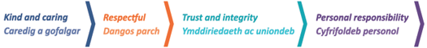
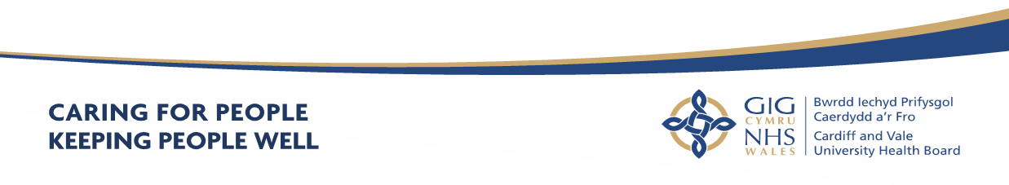
Annual Report
2021 - 2022
About Us
Cardiff and Vale University Health Board’s aim is to care for people and keep people well. The Annual Report will outline the work of Cardiff and Vale University Health Board (the Health Board), highlight some of our key achievements and demonstrate how we are listening to the views and needs of our population, implementing many of these as part of our ambitious 10-year strategy: “Shaping our Future Wellbeing Strategy”. Our priorities, key objectives and plans are set out in our quarterly plans and the reports presented to the Board and its Committees and provide an overview of what we are doing well and how we are listening to our public, patients and staff in order to achieve the strategy.

What’s in this Annual Report?

Our Annual Report is part of a suite of documents that tell you about our organisation, the care we provide and what we do to plan, deliver and improve healthcare for you, in order to meet changing demands and future challenges. It provides information about our performance, what we have achieved in 2021-2022 and how we will improve next year. It also explains how important it is to work with you and listen to you to help you to take the best care of yourselves and to deliver better services that meet your needs and are provided as close to you as possible.

Our Annual Report for 2021-2022 includes:

- Our Performance Report which details how we have performed against our targets and actions planned to maintain or improve our performance.
- Our Accountability Report which details our key accountability requirements under the Companies Act 2006 and the Large and Medium-sized Companies and Groups (Accounts and Reports) Regulations 2008. The Accountability Report includes our Annual Governance Statement (AGS) which provides information about how we manage and control our resources and risks, and comply with governance arrangements, the Renumeration and Staff Report, and the Parliamentary Accountability and Audit Report.
- Our Financial Statements (Audited Accounts) which detail how we have spent our money and met our obligations under the National Health Service Finance (Wales) Act 2014.

The Annual Report should be read in conjunction with other supporting documents, signposted by means of web-links within this document.

Accessibility

If you require additional copies of this document, it can be downloaded in both English and Welsh versions from our website. Alternatively, if you require the document in an alternative format, we can provide a summary of this document in different languages, larger print or Braille, please contact us using the details below:

Corporate Governance Department Cardiff and Vale University Health Board, Corporate Headquarters Woodland House Maes-y-Coed Road Heath Cardiff CF14 4HH
Email: Corporate.Meetingcav@wales.nhs.uk
Website: www.cardiffandvaleuhb.wales.nhs.uk/
A full PDF version is available on our website.

Contact Us
Email: news@wales.nhs.uk
Website: http://www.cavuhb.nhs.wales/
Twitter: @CV_UHB
Facebook: www.facebook.com/cardiffandvaleuhb

Contents (page numbers to be inserted once graphic work completed)

Page
1.Welcome from Chair and Chief Executive
2.Cardiff and Vale Health Board Profile
2.1 About Us
2.2 Our Mission and Vision
2.3 Our Board
2.4 Our Structure
2.5 The Population We Serve
2.6 Principles of Remedy
2.7 Our Population’s Health
2.8 Our Strategy
2.9 Integrated Medium Term Plan (IMTP)
2.10 Research, Development, Innovation and Partnerships
Part 1 – Performance Report
3. Performance Overview
3.1 Impact of COVID-19 on delivery of services
3.2 Planning and delivery of safe, effective and quality services for COVID-19 and non COVID care
3.3 Redesigning primary care services to deliver emergency care during acute phase of COVID-19
3.4 Design and implementation of testing and immunisation for COVID-19
3.5 Redesign of acute services to provide COVID-19 care
3.6 Planning and delivery of safe, effective quality services for non-COVID-19 care
Delivery of infection control measures to deliver both COVID-19 and non COVID-19 care
3.7 Delivery of essential services
3.8 Summary of capacity constraints lesson learnt throughout the year
4. Putting Things Right
5. Delivering in Partnership
6. Workforce Management and Wellbeing
6.1 Identifying and Training Staff to Undertake New Roles
6.2 COVID-19 Staff Deaths
6.3 Local Partnership Forum and Other Employee Engagement Groups
6.4 Equality, Diversity and Human Rights
6.5 Welsh Language Regulations – The Welsh Language Standards (No7) Regulations 2018
6.6 Well-being of Future Generations (Wales) Act (WBFGA) 2015
7. Quality Governance and Performance
8. Sustainability Report
9. Conclusion and Forward Look
Part 2 Accountability Report
10. Part 2a Corporate Governance Report
10.1 Directors Report
10.1.1 The Composition of the Board
10.1.2 Voting Members of the Board During 2021-2022
10.1.3 Audit and Assurance Committee
10.1.4 Declaration of Interests
10.1.5 Personal Data Related Incidents
10.1.6 Environmental, Social and Community Benefits
10.1.7 Statement of Public Sector Information Holders
11.Statement of the Chief Executive’s Responsibilities as the Accountable Officer of the Health Board

12.Statement of Directors’ Responsibilities in Respect of the Accounts
13. Annual Governance Statement
13.1 Scope of Responsibility
13.2 Escalation and Intervention Arrangements
13.3 Integrated Medium Term Plan (IMTP)
13.4 Standing Orders and Scheme of Reservation and Delegation
13.5 The Board and its Committees
13.6 Effective Governance during the COVID-19 Pandemic
13.7 Board and Committee meetings during COVID-19
13.8 Composition of the Board
13.9 Committees
13.10 Advisory Groups & Joint Committees
13.11 Public Appointments
13.12 Public Interest Declaration
13.13 Board and Committee Membership and Attendance 2021-2022
13.14 The Purpose of the System of Internal Control
13.15 Capacity to handle risk
13.16 Management of Risk
13.17 Risk Management During COVID-19
14. Planning Arrangements
15. Mandatory Disclosures
15.1 Health and Care Standards
15.2 Equality, Diversity and Human Rights
15.3 Welsh Language Regulations – the Welsh Language Standards (No.7) Regulations 2018
15.4 Emergency Preparedness
15.5 Environmental, Social and Community Issues
15.6 Carbon Reduction Delivery Plans
15.7 Quality Governance Arrangements
15.8 Ministerial Directions and Welsh Health Circulars (WHCs)
15.9 Regulatory and Inspection Reports
15.10 Data Security and Information Governance
15.11 NHS Pension Scheme
15.12 UK Corporate Governance Code
15.13 Review of Effectiveness
15.14 Board and Committee Effectiveness
15.15 Committee Effectiveness Survey
15.16 Escalation and Intervention Arrangements
16. Internal Audit
16.1 The Head of Internal Audit Opinion
16.2 Limited Assurance
17. External Audit – Audit Wales
17.1 The Annual Audit Report for 2021
17.2 Cardiff and Vale University Health Board – Structured Assessment
18. Modern Slavery Act 2015 – Transparency in Supply Chains
19. Conclusion
20. Part 2b Remuneration and Staff Report
20.1 Staff Numbers
20.2 Staff Composition
20.3 Sickness Absence Data
20.4 Staff Policies
20.5 Salary and Pension Entitlements of Senior Managers 2021-2022
20.6 Consultancy Expenditure
20.7 Tax Assurance for Off-payroll Appointees
21. Part 2c Parliamentary Accountability & Audit Report

21.1 Regularity of Expenditure
21.2 Fees and Charges
21.3 Managing Public Money
21.4 Material remote contingent liabilities
21.5 The Certificate of the Auditor General for Wales to the Senedd
21.6 Report of the Auditor General to the Senedd
Part 3 Audited Financial Statement (Annual Accounts)
22. Financial Statements
Appendices
Appendix 1 - Dates of Board and Committee meetings held during 2021-2022

Appendix 2 – Dates of Board and Committee meetings held during 2021-2022
Appendix 3 – Ministerial Directions and Welsh Health Circulars

- Welcome from our Chair and Chief Executive

Thank you for reading Cardiff and Vale University Health Board’s annual report for 2021 – 2022.
It has now been over two years since the UK entered the first lockdown of the COVID 19 pandemic (the pandemic) where life as we knew it changed and we needed to embrace and adapt to a new reality and ways of living and communicating with others.
The past two years have affected everyone in different ways and the NHS along with other public services had to adapt quickly to changes and decisions that were made, so that patients, colleagues and the public remained safe.
It is important to recognise the impact of the pandemic on patients, communities and healthcare workers alike throughout Cardiff and the Vale of Glamorgan, across the nation and globally and while restrictions have eased the full impact on people’s mental health and physical wellbeing is yet to be fully seen or understood. Especially those who have suffered the loss of loved ones, friends or colleagues and have suffered loneliness or isolation. As we navigate our way through the recovery phase and seek to address the back log in patient care and need it’s important to treat each other with kindness, respect and compassion.
The launch of the Cardiff Joint Research Office between Cardiff University and the Health Board is a considerable step forward for the future of research projects, clinical trials and new healthcare treatments as it brings the two organisations together to do the best for patients, our communities and the wider population. It firmly positions Cardiff as a research active and capable city attracting more investment, trials and innovation.
The Health Board has been instrumental in further research trials in collaboration with Cardiff University to improve the response to COVID-19 including the use of the vaccination to treat a patient with COVID-19 in what is thought to be the first instance of the vaccine being used for therapy instead of prevention. The patient had a long period of COVID-19 positivity, which was detected for at least 218 days. Researchers used two doses of the vaccine and very quickly saw a strong antibody response, much stronger than had been induced by the prolonged natural infection. The team also saw a strong T-cell response – the arm of the immune system thought to be crucial to fighting off the virus. As a result the patient was cleared from having COVID-19 72 days after receiving two doses of the vaccination.
The Health Board’s teams worked innovatively to find new ways of delivering services digitally, with the emergence of video consultations to enable remote appointments, the development of digital support for patients such as the Keeping Me Well digital rehabilitation resource, and the expedited roll out of home working capabilities.
Some of these initiatives have remained and now outpatients’ clinics and services can offer hybrid access for appointments including face to face, telephone and online which can be beneficial to patients and save unnecessary journeys to hospital sites.
The Ophthalmology teams have shown great success by joining together Primary and Secondary Health Care, and maximising the use of digital advancements to reduce waiting times and improve outcomes for patients with urgent eye conditions. Through the mobilisation of four independent prescribing qualified optometrists the Health Board was able to move 94% of unscheduled care patients into Primary Care.
The prescribing optometrists would assess high priority patients using the OpenEyes electronic system to upload images and digitally share patient data with consultants for their virtual review and confirmation of treatments. More complex cases that could not be treated within Primary Care would then be referred to a consultant, minimising the need for hospital appointments and ensuring that only those requiring immediate intervention attended eye casualty.
This meant that the majority of eye conditions were able to be managed and treated by independent prescribing optometrists in the local community.
The Health Board has also played a crucial role in turning the tide against the virus, delivering in excess of 1.1 million vaccinations as part of the COVID-19 Mass Vaccination programme, including the booster dose to children aged 5-11 with underlying health conditions.
The vaccine teams and the COVID-19 Test, Trace and Protect Programme delivered locally by Health Board staff in collaboration with Cardiff Council, Vale of Glamorgan Council and colleagues in the Armed Forces, quickly became an essential part of limiting the spread of the virus to help keep people safe and reduce pressure on health services. All teams have worked tirelessly and have adapted very quickly to changes in guidance to keep the population safe.
Currently a key focus of the organisation is to restore and improve access to services that have been impacted by the pandemic, transform clinical pathways and in doing so, enhance services for patients and communities through the ambitious Recovery and Redesign programme.
The programme aims to identify and implement innovative approaches to health care to help reshape the way services deliver care for people in Cardiff and the Vale of Glamorgan, and beyond.
While this work is still being implemented we are already seeing great progress with the Same Day Emergency Care service, the new Ophthalmology theatres at UHW and the increase in service provision and access for gynaecology and endoscopy to improve diagnostics for patients.
We still have a long way to go in reducing the waiting lists that have grown as a result of the delays caused by the pandemic but we are working collaboratively across the Health Board, our partners and communities to address challenges, recover the situation and continue to improve access to care and treatment for all those who need it and to promote health and wellbeing and the avoidance of preventable illness, injury and disease. We are incredibly proud of the whole team at the Cardiff and Vale University Health Board. Every single member of the team has made an important and unique contribution over the last two years without whom much great care, treatment and support would simply not have been possible or delivered. We would like to take this opportunity to acknowledge the extraordinary efforts of our colleagues and thank them and their families and loved ones sincerely for their continued dedication, professionalism and compassion.
In addition, we would like to thank our partners and most of all the local citizens and communities for all your support over the past year and we look forward to deepening our collaboration and continuing to listen, understand and learn so that we can continue to improve in order to make a real difference for all we serve.

- Cardiff and Vale Health Board Profile

2.1 About Us

Cardiff and Vale University Health Board is one of the largest NHS organisations in Europe. Established in 2009, it provides a range of health and wellbeing services to its population. We spend around £1.7 billion every year on providing our communities with the full range of health and wellbeing services including:
- Primary and community-based services: GP practices, Dentists, Pharmacy and Optometry and a host of community led therapy services via community health teams.
- Acute services through our two main University Hospitals and Children’s Hospital: providing a broad range of medical and surgical treatments and interventions.
- Public Health: we support the communities of Cardiff and Vale with a range of public health and preventative health advice and guidance.
- Tertiary centre: we also serve a wider population across Wales and often the UK with specialist treatment and complex services such as neurosurgery and cardiac services.
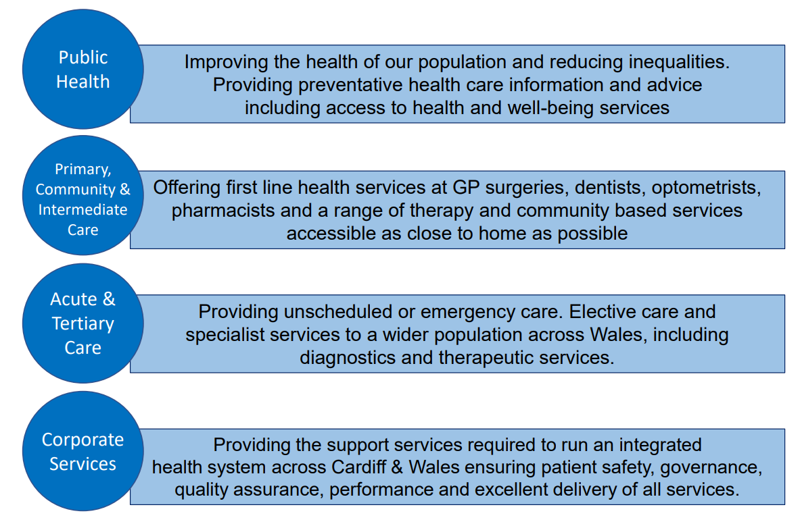

2.2 Our Mission and Vision

Our mission is “Caring for People, Keeping People Well”, and our vision for the people we serve is that everyone’s chance of leading a healthy life should be the same wherever they live and whoever they are.
The Health Board's 10-year transformation and improvement strategy, Shaping Our Future Wellbeing, is our chance to work collaboratively with the public and the Health Board’s workforce to make our health board more sustainable for the future. Together, we can improve equity for all of our patients - both today and tomorrow.
To find out more: https://cavuhb.nhs.wales/about-us/our-mission-vision/shaping-our-future-wellbeing-strategy/

2.3 Our Board

Our Board consists of 25 members, including Chair, Vice Chair and Chief Executive. The Health Board has 9 Independent Members, all of whom are appointed by the Minister for Health and Social Services, and three Associate Members.

The Board provides leadership and direction to the organisation and is responsible for governance, scrutiny and public accountability, ensuring that its work is open and transparent by holding its meetings in public.

In addition to responsibilities and accountabilities set out in terms and conditions of
appointment, Board members also fulfil a number of Champion roles where they act
as ambassadors for these matters.

The Board is supported by a number of Committees, each chaired by an Independent Member. All Committees are constituted to comply with The Welsh Government Good Practice Guide – Effective Board Committees. The Committees, which meet in public, provide their minutes to each Board meeting that contribute to its assessment of assurance and provide scrutiny against the delivery of objectives.

Copies of the papers and minutes are available from the Director of Corporate Governance and are also on the Health Board’s website (see link: https://cavuhb.nhs.wales/about-us/governance-and-assurance/board-meetings/). The website also contains a summary of each Committee’s responsibilities and Terms of Reference. All actions required by the Board and Committees are included on an Action Log and at each meeting progress is monitored. These Action Logs are also published on the Health Board’s website.

All Committees annually review their Terms of Reference and Work Plans to support
the Board’s business in addition to producing an Annual Report to demonstrate compliance with their respective Terms of Reference. Committees also work together on behalf of the Board to ensure that work is planned cohesively and focusses on matters of greatest risk that would prevent us from meeting our mission and objectives. To ensure consistency and links between Committees, the Health Board has a Governance Co-ordinating Group, chaired by the Chair of the Health Board.



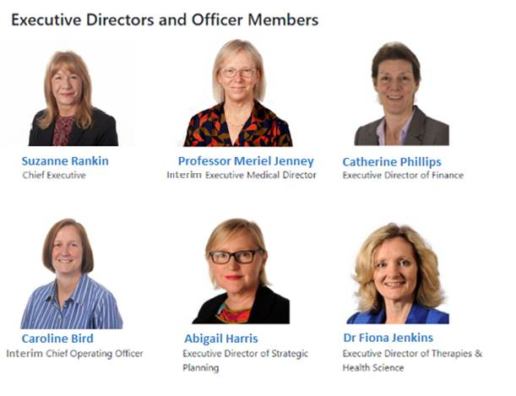
2.4 Our Structure

We have a workforce of around 16,000 staff who consistently deliver high quality services to all of our patients. Our organisation is structured and designed into seven Clinical Boards which were created in June 2013 and have been successful in providing strong leadership in clinical areas and have resulted in the acceleration of operational decision-making, greatly enhancing the outcomes for patients in their care. The Clinical Boards are held to account via the Executive Directors.
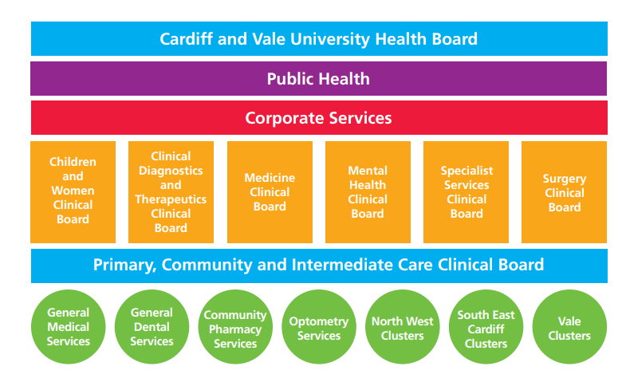

Our corporate and planning services are an integral part of the overall structure and smooth running of the Health Board and include:

- Strategy, Planning and Commissioning
- Finance including Capital, Estates and Facilities
- Workforce and Organisational Development
- Digital Health Intelligence
- Communications, Arts, Health Charity and Engagement
- Corporate Governance

The progress and scrutiny of the Corporate Services directorates are through a combination of governance, executive director and senior management accountability and progress mapped against key projects within their areas of expertise.

2.5 The Population We Serve
Understanding the needs of our population is essential for robust and effective planning. The population needs assessment (PNA) undertaken under the Social Services and Wellbeing (Wales) Act and developed with our regional partners, provides a collective view of the population challenges on which we are basing our plans. This assessment was fully refreshed and presented to the Board on 30 September 2022, with key health and care needs identified including:
Individual
• People’s independence must be maintained and facilitated within decisions for care and support, employment and accommodation. Any such decisions should be based on consultation and co-production with the person they affect.
Community
• Social isolation was identified in the 2017 PNA and has been exacerbated for many due to COVID-19 (sometimes referred to as “Covid” in this Annual Report), with far-reaching consequences for physical and mental health and well-being.
• Holistic approach to physical and mental health, which includes improved access to services including reduction in waiting lists.
• Information provision: many people were unaware of support available to them and would benefit from increased signposting.
Wider determinants
• Employment (paid or voluntary) was desired by many – to improve personal finances, as well as to provide a sense of purpose, reduce isolation, and to help protect people’s mental health and well-being.
• Housing and accommodation need to be available, accessible, safe, and supportive of what matters most to the individual. For example, an enabling employment. Prevention and early help for homeless people needs to be enhanced.
• Inequalities were discussed in all chapters, especially in terms of socio-economic deprivation, access to services, and health outcomes. COVID-19 has had a disproportionate impact across the population, in part due to pre-existing inequalities in the social determinants of health that have been exacerbated by COVID-19 and restrictions.
It is important that we also consider the wider wellbeing of our population too, which encompasses environmental, social, economic, and cultural wellbeing. Well-being assessments for Cardiff and the Vale of Glamorgan have also been updated over the year, with final findings published in Spring 2022.
Population growth and diversity

The population of Cardiff and Vale continues to grow, with the latest Office for National Statistics/Welsh Government projections estimating an increase from 504,000 in 2022 to 523,000 in 2032, around 4%. In contrast to the previous projections published 4 years ago, the rate of growth in the Vale is predicted to exceed that of Cardiff, with growth in the Vale of 5.0% over 10 years compared with 3.5% in Cardiff. Actual population growth, particularly in Cardiff, will be highly dependent on progress with large housing development.

The city region in particular has a long history of being open and inclusive, and is the most ethnically diverse local authority in Wales, with around 15% of its population from ethnic minority groups.

Ageing population

The average age of people in both Cardiff and the Vale is increasing rapidly, with a projected increase in people aged 85 and over in the Vale of 43% over the next 10 years, and 17% in Cardiff.

Health inequalities

There is considerable variation in healthy behaviours and health outcomes in our area, with variation in smoking rates, physical activity, diet and rates of overweight and obesity. Uptake of childhood vaccinations is also lower in more disadvantaged areas, and people are more likely to experience poor air quality. Life expectancy is around ten years lower in our most deprived areas compared with our least deprived, and for healthy life expectancy the gap is more than double this. Deprivation is higher in neighbourhoods in South Cardiff, and in Central Vale.
The pandemic exposed these deep-seated inequalities, with impacts seen more heavily in our more deprived areas, and amongst ethnic minority communities. This is explored in depth in the Annual Director of Public Health Report for 2020 (published in 2021).

Systematically tackling health inequalities is one of the key programmes of work in our Shaping Our Future Population Health plan, with other programmes including Healthy weight: Move More, Eat Well; vaccination and immunisation; and sustainable and healthy environment.

Changing patterns of disease

There are an increasing number of people in our area with diabetes, as well as more people with dementia in our area as the population ages. The number of people with more than one long-term illness is increasing. Impacts of COVID-19 include adverse effects on mental well-being, and 'long' Covid; we also anticipate significant negative impacts on the wider determinants of health, such as educational attainment, which may take a number of years to become apparent. There are some examples of positive impacts from the pandemic too, including increases in walking and cycling.

Tobacco

One in seven adults (14%) in our area smoke. While this number continues to fall, which is encouraging, tobacco use remains a significant risk factor for many diseases, including cardiovascular disease and lung cancer, and early death.
Food

Over six in ten people in our area don’t eat sufficient fruit and vegetables, and over half of adults are overweight or obese. In some disadvantaged areas access to healthy, affordable food is more difficult and food insecurity is becoming more prevalent due to increasing living costs and low wages.

Physical activity

Over 40% of adults in our area don’t undertake regular physical activity, including one in five (22%) who are considered inactive.
Social isolation and loneliness

Around a quarter of vulnerable people in our area reported being lonely some or all of the time, prior to the pandemic). We don’t yet know the longer-term impact of the pandemic on isolation and loneliness, but emerging evidence suggests that loneliness has increased over the last 2 years. Social isolation is associated with reduced mental wellbeing and life expectancy.

Welsh language

A quarter (26%) of people of all ages in Cardiff say they can speak Welsh, and 1 in 5 (20%) in the Vale.

Human Rights

The Health Board has an Equality, Diversity and Human Rights Policy which sets out the organisational commitment to promoting equality, diversity and human rights in relation to employment. It also ensures staff recruitment is conducted in an equal manner.

South Glamorgan Community Health Council (CHC)

We work closely with South Glamorgan Community Health Council (CHC), an independent statutory organisation that acts as a voice for patients and the public. It is also an NHS watchdog for all aspects of health care.

We work together to discuss the delivery and development of the services we provide. We welcome reports from the CHC and are grateful for their on-going advice, challenge and support.

For more information, please contact:

Unit 3, Pro-Copy Business Centre
Parc Tŷ Glas
Llanishen
Cardiff
CF14 5DU
Telephone: 02920 750112
Email: SouthGlam.Chiefofficer@waleschc.org.uk

2.6 Principles of Remedy

The Health Board has fully embraced the regulations which guide the handling and response to concerns (complaints and incidents) launched by Welsh Government in April 2011. In addition, the Health Board’s approach to dealing with concerns very much reflects the ‘Principles of Remedy’ published by the Public Services Ombudsman for Wales.

- Getting it right

- We acknowledge when we identify things that could have been improved.
- We consider all relevant factors when deciding the appropriate remedy, ensuring fairness for the complainant and, where appropriate, for others who have suffered injustice or hardship as a result of the same maladministration or poor service.
- We apologise and explain the maladministration or poor service.
- We try to understand and manage people’s expectations and needs.
- We always try to deal with people professionally and sensitively.

- Being customer focused

- We acknowledge and accept responsibility for failure if and when it occurs.
- We explain clearly why the failure happened and express sincere regret for any resulting injustice or hardship.

- Being open and accountable

- We try to be open and transparent
- We strive to treating people without bias, unlawful discrimination or prejudice.

- Acting fairly and proportionately

- We consider all forms of remedy (such as an apology, an explanation, remedial action, or financial compensation).

- Putting things right

- We are focussed upon using information on the outcome and themes from concerns to improve services.

- Seeking continuous improvement

- We seek to offer a proportionate, reasonable investigation and response that aims to identify the opportunities for service improvement.

2.7 Our population’s health

Please refer to paragraph 2.5 above.

2.8 Our Strategy

Shaping our Future Wellbeing, approved by the Board in 2015, is the 10-year strategy for transformation and improvement at Cardiff and Vale University Health Board. At the heart of the strategy is our vision, that everyone should have the opportunity to lead longer, healthier and happier lives. With an ageing population and changing lifestyle habits, our health and care systems are experiencing increasing demand. In order to be able to meet the needs of our population, we must transform how we deliver services across the whole of our health and care system, ensuring that people can access the support they need in a timely way, in home, or as close to home as possible. Where it is required, specialist hospital care – for secondary, tertiary and quaternary care – should be provided when the patient needs it, for both emergency and urgent care, and care that can be planned.

We need to rapidly evolve to best serve the needs of the public and ensure that we’re able to offer sustainable health services for everyone, no matter their circumstance.

We want to achieve joined-up care based upon the ‘home-first’ approach, empowering Cardiff and Vale citizens to feel responsible for their own health, with access to the support they need to do so. Our services should be delivered in the most efficient ways, that optimise the resources we have available to us, and give us the very best patient outcomes and experience. Improving the quality of the care we provide is at the heart of our service transformation programme. We want to deliver outcomes that really matter to patients and the public, ensuring that we all work together to create a health system that we’re proud of.

There will be challenges along the way; we need to take a balanced approach to achieving change for our population based upon service priorities, sustainability and cultural values. But we’re committed to ‘Caring for People, Keeping People Well’, ensuring that the Health Board and its many citizens thrive not just today, but for the many years to come.

Achieving our vision requires us to work with many partners and stakeholders: our local communities, our Primary Care teams, local authorities, neighbouring health boards and NHS Trusts, and Cardiff University and other academic/research partners.

2.9 Integrated Medium Term Plan (IMTP)
Between March 2020 and March 2022, the Integrated Medium-Term Plan (IMTP) process was paused due to the pandemic. The requirement for an approvable IMTP was replaced by the need for quarterly plans for 2020-2021 and an annual plan for 2021- 2022, which reflected the need for agile planning to reflect the changing landscape as the pandemic progressed. Whilst our planning needed to remain dynamic, we also paid attention to the priorities set out in the 2020-2021 IMTP which was approved by the Board in January 2020, and which was deemed approvable by Welsh Government, before the pandemic hit.
In October 2021 the Welsh Government signalled a return to a three year planning approach and accordingly the Health Board has developed a new three year IMTP for 2022 to 2025. In March 2022, the Board approved the draft 2022 – 2025 IMTP. The plan sets out an ambitious programme of work aimed to accelerate our journey of transforming services, taking a significant step forward in the recovery of the planned care treatments delayed as a result of COVID-19, and to improve our emergency and urgent care service which has been under significant pressure throughout the last two years. With agreement from Welsh Government, we confirmed that further work would be completed in quarter 1 on the actions required, along with stretching but realistic timescales, to reduce the financial gap that remains in our plan. This work is underway and an updated IMTP will be submitted to Welsh Government at the beginning of quarter 2.

Our Commissioning Intentions (as summarised in the diagram below) set out the key areas of priorities for commissioning services – both internally from our Clinical Boards, and externally from the wide range of partners who deliver services for our local population.

Similarly, our IMTP responds to the commissioning requirements of our neighbouring health boards and WHSSC for the specialist and tertiary services we provide for their populations and patients.

2.10 Research, Development, Innovation and Partnerships

One of the core principles of the NHS and the Health Board strategy is to bring benefits to patients through Research and Development (R&D) and innovation. Effective R&D performance is essential if the Health Board is to meet its values and objectives as it brings many benefits:

Benefits to patients:

- Access to latest therapies and novel treatments
- Access to latest diagnostic and prognostic tests
- Patients who are invited to participate in clinical trials show overall increased satisfaction and better outcomes when compared to patients not given this opportunity
- Hospitals with a strong R&D portfolio have better outcomes even for patients not in trials.
- Recruitment and retention of high calibre staff is often more sustainable in large teaching and tertiary hospitals and health systems, where clinicians are able to participate in research and trials for the benefit of their patients and their services.

Benefits to staff:

- A research-literate workforce is primed to participate in the process of continual change and service improvement required for meeting the challenges of modern healthcare delivery
- Staff development, which leads to increased enthusiasm, motivation, and high quality recruitment into the organisation

Benefits to the Health Board:

- Fulfils the Health Board’s statutory responsibilities
- Enables links with similar institutions in the rest of the world, sharing best practice and increasing the status of the Health Board
- Exemplar as the leading Health Care provider in Wales
- Attract and retain staff
- Financial offset of staff costs (through provision from R&D income), drug/device savings through study participation, access to commercial income through research and trial participation
- Direct R&D income – Welsh Government.

The Health Board has a strong R&D ethos and historical track record. Ongoing changes to how R&D are funded and approved in Wales and the United Kingdom present major challenges but also major opportunities for the Health Board. The Health Board is developing a structure which encourages generation of funding and resources for R&D.

UHW has the only dedicated inpatient clinical research unit in Wales which enables us to undertake the full range of clinical trials including first-in-human trials. During 2021/22, we established a joint R&D office with Cardiff University under the leadership of a Joint Director of R&D, and we brought the teams from both teams together into newly refurbished facilities (which will be fully utilised when Covid rules allow).

Part 1
Performance Report
- Performance Overview

Introduction
In response to the pandemic, the traditional planning cycle for NHS Wales was paused – and in 2021/22 the direction given by Welsh Government was for Health Boards to develop an annual plan. The Health Board submitted its overarching Annual Plan with an addendum focused on ‘Planning for Recovery and Redesign’ on 30th June 2021. The main plan took a strategic holistic overview of the whole Health Board, its strategic ambitions and direction of travel whilst the addendum set out a more granular level of detail on plans to recover and redesign our services as we moved into the next phased of the pandemic.

Overall, 2021/22 has been another challenging year for the Health Board. Whilst we have made good progress against a significant number of our Recovery and Redesign Programme plans, continued system-wide operational pressures have impacted on our performance. The Operational pressures experienced this year have been atypical, with unusual sustained pressure throughout the summer period. This resulted in the Health Board entering into the usually more challenging winter period in a more difficult place.

The Health Board remained ‘Covid-ready’ throughout the year, a principle at the heart of our operating model. Our planning and response continued to focus on the five harms of COVID-19. This was particularly pertinent with the emergence of new variants and specifically the Omicron variant in November / December 2021. The impact of COVID-19 on the delivery of services, along with progress made in our Recovery and Redesign programme, is outlined in more detail in the sections below.

The New Duties of Quality and Candour

The new Duty of Quality and the new Duty of Candour are due to come into legal force in April 2023, in line with the Health and Social Care (Quality and Engagement) (Wales)(Act) 2020. The new Duties will require the Health Board to report annually on compliance with those Duties and to publish their reports in the annual accounts and performance report. These new reporting requirements will therefore be captured in the reporting period 2023/24.

In the interim it is anticipated that there will be: -
          - A non-statutory implementation of the Duty of Quality in Autumn 2022.
This will allow for testing the quality reporting indicators, measures and narrative framework concepts being developed during the Duty of Quality implementation phase as a hybrid reporting process for 2022/23. In the meantime quality reporting requirements are embedded in the Performance Section of this Annual Report, specifically in sections 7 and 15.7 of this Annual Report.

(ii)_ A non statutory implementation lead up period during the Autumn/Winter 2022 regarding the Duty of Candour to allow NHS bodies, including Primary Care providers to prepare for the new reporting requirements under the Duty of Candour and also undertake and roll out training and awareness sessions.

Areas of responsibility
Employing circa 16,000 staff and with an annual income of circa £1.7 billion, the Health Board is one of Wales’ seven fully integrated health boards, and is one of the largest health care organisations in the UK. It delivers Primary, Intermediate and Community Care, Mental and Public Health and Acute Hospital Services to 500,000 people across 11 sites in Cardiff and the Vale of Glamorgan. The Health Board is the main provider of Tertiary care across South Wales and works actively to collaboratively develop regional services, including with Swansea Bay University Health Board in respect of tertiary services.
The organisation’s vision is to enable everyone to have the same chance of a healthy life, irrespective of who they are and where they live; and to create a sustainable healthcare system with a greater focus on care closer to home, illness prevention, enhanced health and well-being, empowering people and delivering outcomes that matter to them and an improved quality of life. In order to achieve this vision, the Health Board works in partnership with Cardiff Council and the Vale of Glamorgan Council, the third sector and wider public service partners to deliver plans to improve the health and wellbeing of our local communities.

Our performance

3.1 Impact of COVID-19 on delivery of services
The pandemic continued to have a significant and sustained impact on the delivery of services during 2021/22. Whilst the beginning of the year saw us accelerate our plans to recover and redesign services, our teams were also still caring for significant numbers of COVID-19 patients. As we moved towards the end of the year the emergence of the Omicron variant required us to adapt our approach to ensure we were able to continue to deliver essential services alongside rapidly scaling up delivery of the COVID-19 booster programme and meeting the needs of an increasing number of COVID-19 positive patients. There were a number of service delivery risks encountered during the year in relation to COVID-19, including:
· Continued variation and uncertainty of the demand profile of both Covid and non-Covid patient groups – with some services receiving exceptional demand and others where demand was suppressed.
· Services where the Health Board has had to reduce its levels of activity in order to re-prioritise resources for the COVID-19 response, especially in relation to the Omicron variant.
· The emergence of the Omicron variant, the associated uncertainty it created and subsequent increase in demand.
· Continued reduced efficiency as a result of Infection, Prevention and Control (IP&C) measures in place to minimise COVID-19 transmission.
· Working with continued complexity and inefficiency due to the necessity to separate patient groups to minimise the risk of virus transmission.
· Growth in waiting times as a result of reduced delivery activity.
The Health Board continued to utilise its COVID-19 operating model which provided the framework for quick decision making and flexibility to coordinate services for both Covid and non-Covid patient groups. Local, regional and national modelling were used to ensure our operational decisions were based on a range of indicators and adapted to the specific circumstances at each point. At the heart of the operating model is the need to remaining “COVID ready” and we ensured this approach was closely correlated with the NHS Wales COVID Control Plan.

Our assurance and accountability arrangements were updated to help balance the five harms from COVID-19 e.g. direct harm; indirect harm; population-based protection measures harm; economic harms and harms arising from exacerbating inequalities. In order to set out our ambitions we developed a one-year annual plan which included a Recovery and Redesign approach which was framed around five key programmes of work in Planned Care, Urgent and Emergency Care, Primary and Community Care, Mental Health and Diagnostics and Therapies. The focus of these programmes included service delivery across a range of imperatives including maintaining essential services and recovering services through the delivery of additional capacity, increased efficiency and transformation around improved patient pathways. Activity data and performance against key indicators, in line with national guidance, has been used for management information and to provide assurance against the delivery of the plan with particular focus on ensuring our approach is risk based to meet the needs of our most clinically urgent patients.

3.2 Planning and delivery of safe, effective and quality services for COVID-19 and non-COVID care
At all stages of the pandemic the Health Board has responded quickly to clinically redesign the delivery of services, repurpose and reconfigure the footprint and create the capacity needed to maintain access to essential services and provide more routine services when safe to do so.

3.3 Redesigning primary care services to deliver emergency care during acute phase of COVID-19
Our teams across Primary Care have continued to deliver services through innovative methods in order to keep patients and staff safe. Our teams have continued with the phone first, triage models which help to provide virtual appointments where appropriate whilst facilitating rapid access to face to face appointments when required.

Our approach to delivery has followed the national ‘traffic light’ system developed for the four Primary Care contracted services with red, amber and green phases. Delivery of services has varied depending on the prevalence of cases in the community and in line with infection, prevention and control guidance. Over the course of the year services have been moving through the ‘amber’ phase and most services are now reinstated and operating in line with the ‘green’ phase, with activity levels generally back to pre-pandemic levels. The exception is dentistry, as activity has remained around 40-50% of pre-Covid levels due to the IPC requirements. Addressing this position rapidly, in line with the most recent IPC guidance, forms a central part of our plan for the coming year.

Whilst General Medical Services (GMS) were not suspended through the pandemic, GMS Contract relaxations were in place in various forms up to 30 September 2021. From 1 October, all contractual relaxation measures were ceased. There has continued to be pressure on GMS practices with up to a fifth of practices reporting high level of escalation pressures at various stages during the year. This has primarily been related to staff absences during Covid.

Optometry Services have returned to near pre-Covid levels with the slight reductions due to IPC measures (e.g. social distancing and PPE). Delivery of care through Optometric Diagnostic and Treatment Centres and independent prescribing has enabled patients to be seen in Primary Care settings and reduce footfall and demand on Secondary Care services. Pharmacy services have not been suspended during the pandemic and pharmacies have remained open throughout.

There has been significant pressure on the Urgent Primary Care/CAV247 Out of Hours service during the year, with call levels of more than 16,000 per month. The Urgent Primary Care hubs, established in the three clusters in the Vale of Glamorgan, have provided valuable additional capacity (mainly during the ‘in hours’ period) to improve access for patients and to ease pressure on GMS practices. This has included both triage and face to face appointments, with capacity of around 2,500 appointments per month.

Community teams have continued to provide services during the pandemic. There have been significant pressures on the district nursing teams as a result of increased demand and staff absence as well as the requirement to support the delivery of the Covid immunisation programme and supporting the pressures in Secondary Care. As a result, there has been a need to work more flexibly across the district nursing teams and to prioritise services based on clinical need. There has been significant support to care homes, working effectively in partnership with local authority colleagues. Our district nursing teams undertook over 16,00 visits and community nursing team undertook over 3000.

Our Community Resource Team in Cardiff and the Vale Community Resource Service have continued to utilise the multidisciplinary teams, including a range of therapists, to support people to remain at home and avoid hospital admission and also to support the higher number of discharges due to more people requiring hospital care. There has been ongoing review of packages of care to release resource where appropriate to deal with new cases. Whilst there has always been an ‘in reach’ model to pull patients from hospital there has been an increased focus on the community teams working with the ward staff to maximise discharges

3.4 Design and implementation of testing and immunisation for COVID-19
Our success in establishing testing services at the start of the pandemic has continued during the last year through close partnership with our two local authorities in Cardiff and the Vale of Glamorgan. The Welsh Government Test, Trace, Protect (TTP) Strategy, including the delivery of the contract tracing service, has been central to our ability to identify cases and reduce onward transmission. Over the year of 2021/22 the TTP has identified 144,758 positive results which generated 141,817 follow up contact traces. Throughout the year the Health Board responded to changes in the Welsh Government Alert Levels to ensure congruence of our testing and tracking regimes. This included a change in the provision of PCR testing in January 2022 which was introduced in order to reduce pressure in the system and provide increased access for those with symptoms.
The roll out of the Mass Immunisation Programme across Cardiff and Vale was a true example of what can be achieved through focused and collaborative partnership working. The success of the programme is attributed to the efforts across partners in Health, Local Authority, Academia, our amazing volunteers and many more. Following the initial phases of the vaccination programme our teams across Primary and Secondary Care again stepped up during December to meet the challenge of the Omicron variant and ensure all eligible adults were offered a booster vaccine before the end of 2021. Our programme has been delivered through a multi-disciplinary approach with people receiving vaccines in Mass Vaccination Centres, Primary Care and through our Community Pharmacies. Our mobile teams have delivered vaccinations to people in care homes, the housebound and also to some of our more vulnerable groups (asylum seekers, homeless, travellers, sex workers) and those from BAME (Black, Asian and Minority ethnic) groups, as well as visiting universities and colleges.

Our vaccination campaign continues with good progress being made in the immunisation of eligible children including those aged 5 -11 with 36% having received one dose. Up to the end of March 2022, the Health Board has delivered more than 1 million vaccinations, which include more than 300,000 boosters. 73% of the eligible population have received first doses, of these 94% have had their second dose. Of those aged over 18 who have had a second dose, 82% have had a booster.

Test Trace Protect (TTP)

TTP services in Cardiff and the Vale of Glamorgan were set up as part of the response to the pandemic, following the publication of the Welsh Government’s Test Trace Protect Strategy. First published in May 2020, this strategy required local health boards and local authorities to work together to deliver systems which ‘enhance health surveillance in the community, undertake effective and extensive contact tracing, and support people to self-isolate where required to do so’

The last two years has seen an unprecedented level of partnership working to deliver this, achieving a coordinated and effective response across the region. Partners included Cardiff Council, Vale of Glamorgan Council, Shared Regulatory Services and Public Health Wales (PHW), as well as local volunteers and voluntary organisations. A Regional Incident Management Team (IMT) involving all partners has met at least fortnightly, and sometimes more frequently, to review the current case and cluster data, and the impact on local services, in order to inform the regional response. The IMT reports to a Regional Leadership Board, which provides strategic oversight. A comprehensive set of local surveillance indicators has been developed to complement nationally produced surveillance data. This high quality information is used by both the Regional IMT and Leadership Board to inform the decision making of local partner organisations.

The following provides an update on what has been achieved in the last year.

Test

Led by the Health Board, and working with PHW Microbiology and local authorities, as well as Welsh Government and PHW nationally, local testing capacity has been managed flexibly to deliver the aims of the COVID-19 Testing Strategy for Wales. Regional, Community and Mobile Testing Units have offered PCR testing for those who require it, in line with the current guidance, and a team of specialist nurses has also been available to test people in their place of residence in cases where they are unable to travel to a testing centre. In the last year, testing capacity has needed to be scaled up to manage the increase in cases associated with both Delta and Omicron variants. Despite significant demand at times, testing performance has generally been good with over 90% of test results being received within 24 hrs.

As well as testing people who are displaying symptoms, testing services have also had a significant role in testing those who are due to have surgery, allowing increasing volumes of elective care to take place safely.

In the last year, Lateral Flow Device (LFD) testing has been expanded to support not only health, social care and educational settings, but also to permit safer ‘day to day’ activities in the general population; a network of distribution centres in local pharmacies and libraries has been established to enable easy access to the free test kits.

Trace

Contact tracing of COVID-19 cases started in Wales on 1st June 2020 and has continued ever since. In Cardiff and the Vale of Glamorgan, the contact tracing service is hosted by Cardiff Council on behalf of the partnership. Contact tracing staff are trained to provide advice on isolation to anybody who has tested positive for COVID-19, and identify their contacts so that they can also be provided with the correct advice. Contact tracing has also needed to be scaled up to deal with the high number of cases associated with successive waves of infection, and our local teams have worked to nationally agreed protocols throughout. Over the last year, digital methods of contact tracing have been introduced which has further increased capacity and flexibility. In addition, specialised teams of tracers have been established, including a dedicated All Wales team to oversee the testing and isolation requirements of arriving international travellers.

All new cases are monitored by the regional Cardiff and Vale Supertracer team in order to identify clusters or settings of concern. Specialised teams also provide support to higher risk settings such as care homes, hospitals and schools. A multiagency regional team has met daily (weekdays) throughout most of the year to discuss any risks identified and provide advice on improving mitigations where necessary. Clusters identified by these mechanisms are usually managed by the multiagency regional meeting, but a specific Incident Management Team can be convened if required.

Protect

Both local authorities have continued to provide support, where necessary, to those who have needed to isolate, as well as other vulnerable groups such as those who are experiencing homelessness or sleeping rough.

Partnership communication teams have worked collaboratively throughout the pandemic to share updates on guidance, and engage with the people who live and work in Cardiff and the Vale of Glamorgan. A notable success has been the formation of a highly successful Ethnic Minority Subgroup, where key partners from the local community co-produced an effective communications and engagement programme with TTP partner organisations. A full report of this work can be found here –

Test Trace Protect supporting ethnic minority communities (office.com) https://sway.office.com/JPSiiWHrHeTjdfSf?ref=Link .

This work has led to the appointment of a dedicated Engagement Coordinator (Ethnic Minority/Health) so that the successful approach can be to carry on and focus on other health issues.

Welsh Government published the 'Together for a safer future' COVID-19 plan in early March 2022, setting out how Wales will transition from Covid as a pandemic to endemic disease. Key milestones include the end to routine use of PCR by the public and removal of the legal duty to self-isolate. Welsh Government has also signalled its intention to cease contact tracing and self-isolation payments by the end of June 2022.

COVID-19 mass vaccination programme
The Health Board commenced its COVID-19 mass vaccination programme in December 2020. This has continued throughout 2021/22 in response to the changing patterns of the pandemic. Vaccinations have continued to be delivered through four mass vaccination centres across the region in addition to Primary Care (Community Pharmacies, General Practices and Primary Care Clusters) mobile teams and a mobile unit. The booster programme commenced in September 2021 and has been delivered alongside the annual influenza vaccination programme. By the end of December, all eligible adults aged 18 years and over had been offered a booster vaccination. Up to the end of February 2022, the Health Board had delivered over 1,080,000 vaccination doses in total. Of those who have received a completed primary course of vaccination, 82% of adults aged 18 years and over had also received a booster vaccination.
The Seldom Heard Voices group continued to work with many of the most vulnerable groups in our communities to address vaccine hesitancy and provide targeted pop up clinics where appropriate. The clear relationship between areas of socio-economic deprivation and vaccine uptake was somewhat addressed through listening to our communities and providing initial clinics in specific sites or for particular communities.

The annual influenza vaccination programme has been delivered by a range of partners across Primary Care, School Health Nursing and Health Board staff in parallel with the COVID-19 vaccination programme, with the offer of co-administration where this has been practical and feasible (for example, for the Health Board staff programme). In line with the rest of Wales, rates have been generally lower compared with last year, although uptake in people aged 65y and over has exceeded 75%. The latest flu vaccination rates for eligible groups is summarised in Table 1:

Table 1: Flu vaccination uptake rates as at 14 April 2022 (PHW National Influenza Immunisation Summary - Update 23)
Priority Group | Uptake (data as at 14 April)
People aged 65y and older | 76.1%
People aged 6m to 64y at risk | 41.9%
People aged 5 to 64 | 39.4%
Children aged 2-3 years | 44.5%
Children aged 4-10 (Reception to Y6) | 60.6%
Children aged 11-15 (Year 7-11) | 57.4%
UHB Frontline Staff | 53.2%

3.5 Redesign of acute services to provide COVID-19 care
The volume of Covid patients requiring care across our acute hospitals was characterised by a sustained number of attendances and admissions across the year with significant peaks during the winter months. Our ability to respond to Covid demand was achieved through the reorganising of our existing capacity, including the modification of our zoning and streaming approach, and the utilisation of additional surge bed capacity. Our key achievements include:
- The utilisation of our 400-bed temporary surge facility, the Lakeside Wing, which has housed a number of inpatient and outpatient services which have released capacity in UHW for the care of Covid patients.

- The installation of a number of individual cubicles and dividing screens within our Emergency and Assessment Units to improve our ability to stream patients, flex capacity and reduce the risk of infection.

- A focus on joint working with our partners including WAST and Local Authorities, particularly as part of our “Main Effort” programme which worked to reduce ambulance handover delays, avoid admissions and discharge patients to more appropriate settings

- The availability of our critical care expansion plan which could provide up to 85 beds if required.

- The delivery of an ambulatory treatment pathway for Covid positive patients to be able to access the latest anti-viral Covid treatments which has temporarily been delivered from our High Consequence Infectious Disease (HCID) Unit.

- A number of services have remained in temporary locations in order to facilitate an expansion of Covid capacity. These include our Fracture Clinics and Physiotherapy Outpatients Expansion of CAV 24/7 – an innovative phone first approach to encourage non-emergency patients to phone ahead and, if required, they will get a booked timeslot for attending our Emergency Department. The service has been receiving, on average, 250 calls per day.

- The implementation of NHS 111, including integration with CAV 24/7, to provide seamless advice, guidance and direction for patients.

- The flexible deployment of our clinical and non-clinical workforce in order to open additional inpatient capacity

  - Planning and delivery of safe, effective and quality services for non- COVID-19 care.
Delivery of infection control measures to deliver both COVID-19 and non- COVID-19 care
The ability of the Health Board to respond and adapt to the infection control challenges presented by the pandemic has been central to our successful delivery of care over the year across essential and non-essential services. Guided by our IP&C and PPE cells (groups of senior clinical experts) the Health Board has worked closely with colleagues across Public Health Wales and NHS Wales to deliver to and also influence policy in this area in response to the changing profile of the virus.
The continued delivery of “green”, “amber” and “red” zones across our acute sites has supported the segregation of Covid and non Covid patients and ensured reduced transmission of the virus. The Protected Elective Surgical Units (Green Zones) at both UHW and UHL remain in place to provide dedicated Covid free environments to those patients undergoing elective surgery and our systematic audit process has provided reassurance on the success of this approach.
Social distancing and public health measures, such as mask wearing, have been in place throughout the year and our departments have worked hard to ensure that our patient and staff areas are set up to minimise the risk of transmission and provide confidence for both patients and staff.
3.7 Delivery of essential services
Throughout the pandemic the Health Board has maintained access to urgent and emergency essential services including urgent and emergency surgery, eye care, cancer treatments, unscheduled care and mental health.

Urgent and emergency surgery has been delivered through our Protective Elective Surgical Units with over 10,800 patients receiving surgery in our units across the year and a much-reduced cancellation rate (9% compared to 18% pre-pandemic). Our utilisation of the independent sector has again proved helpful in providing additional capacity and over 1,000 patients have undergone surgery during the last year using this route. The Health Board has also continued to use an insourcing arrangement for endoscopy which has seen over 5,700 patients undergo procedures this year.

One of our key principles for recovery non-Covid services has been “risk orientated” and this means that prioritisation of patients has been based on clinical urgency rather than time-based targets. For patients waiting for surgical treatments, the Health Board has used Royal College of Surgeon’s Clinical guide to surgical prioritisation during the pandemic to support assigning priority levels and timeframes for each surgical procedure.

Digital solutions have been key enabler of service delivery during the pandemic with the Health Board accelerating the use of virtual working through the adoption and rollout of AttendAnywhere, a video consultation platform, and telephone appointments. Around a quarter of our outpatient activity is now undertaken virtually and plans are being developed to expand the availability of these services from appropriate patient groups. The Health Board has also continued its use of the Consultant Connect platform which supports timely advice and guidance between Primary and Secondary Care clinicians. Work is underway to spread and scale our approach to provide support to patients who are waiting for treatments particularly in relation to self-management and promoting the importance of prehabilitation which has been successfully implement across many of our cancer pathways.

Within our approach to outpatients’ services we have focused on developing our See on Symptoms and Patient-Initiated Follow-up, models of care which reduce unnecessary follow-up appointments and help provide capacity for those patients who do need to be seen. The use of virtual appointments and video group clinics is another example of how our teams have adapted to maximise capacity for patients.
The approaches outlined above have ensured the Health Board has safely delivered as much non-Covid elective activity as possible, although we know that there is much more to do. Some key activity indicators include:

- New outpatient activity is at 90% of pre-Covid levels
- Elective inpatient admissions and day cases are at 80% of pre-Covid levels
- Radiology activity has recovered to over 100% of pre-Covid levels
- Endoscopy activity is at over 120% of pre-Covid levels
The last year saw an increase in referrals when compared to the first year of the pandemic. Whilst not yet at pre-pandemic levels the increase has led to a growth of our waiting lists with patients waiting longer to be seen across outpatients, diagnostics and treatments. As at the end of March 2022:
- There were 123,567 patients on the Referral to Treatment Times (RTT) waiting list, of which 44,083 patients were waiting greater than 36 weeks - an increase of 12,354 since the end of March 2021.

- Patients waiting greater than 8 weeks for a diagnostic test increased from 4,547 in March 2021 to 5,004.

- Whilst the volume of patients waiting for a follow-up appointment increased from 170,453 in March 2021 to 172,909 in March 2022, the number of patients delayed >100% over their target follow up date has reduced from 49,862 to 41,939.
The Health Board continued to provide essential Eye Care services throughout the pandemic. At the end of March 2022, 95.23% of patients % assessed as Health Risk Factor R1 had a target date allocated with 69.53% of patients waiting within their target date or within 25% beyond their target date.
Referrals for patients with suspected cancer were significantly reduced at the start of the pandemic but, following a proactive Primary Care led communication campaign, have steadily increased. Referrals for the last year were over 20% higher than the pre-Covid level with treatments at 103%. Although the Health Board has been successful in maintaining treatment activity and referral rates, backlog work and timeliness of treatment has led to challenges in our delivery against the Single Cancer Pathway target which currently stands at 59.1%.
Attendances at our Emergency Department continued to increase throughout the year and we saw some of the traditional peaks of activity during the Winter period. Whilst attendances overall are still below pre-pandemic levels, 2021/22 saw 135,773 patients attend our Emergency Unit in comparison to 106,350 in 2020/21. Due to significant challenges across the Health and Social Care system, including a reduction in our ability to discharge patients, a number of our Key Performance Indicators were challenged during the year. 67.03% of our patients were seen, admitted or discharged within 4 hours, with 92.74% within 12 hours. Ambulance handover delays increased and we continue to work closely with our partners across the ambulance service and social care to implement changes which will improve patient flow and improve performance. We are aware that some patients have experienced long delays in the Emergency Department. We have introduced a number of innovative schemes to improve patient experience, expedite investigations and reduce time in hospital including the ‘virtual ward’ and accelerated community support for elderly patients attending EWD who would otherwise need admission. We have introduced more volunteers into the area and utilised some of our PESW (Patient Experience Support Workers) to attend the EU daily and support with communication and any hydration and nutrition needs. We review on a daily basis the feedback from the Happy or not kiosks in the unit to monitor any trends and action feedback in real time.
Mental Health services have continued to react innovatively to some significant increases in activity. Referrals to Mental Health have been above pre-pandemic levels throughout the year, peaking in February 2022 were levels reached over 1,400. Our teams have continued to strive to provide services to patients in mental health crisis with a focus on community-based assessments and support in order to partially mitigate the increases in demand.
Within Older People services the use of technology has enabled patients to be seen remotely via telephone or video calls. Referrals into this service is now through a single point of entry (SPOE) system, meaning all referrals will be discussed and triaged so that the most appropriate person will see the patient, reducing duplication of referrals and the information that patients are asked to provide to different professionals.
The support we have been able to give to patients, carers, families and staff over the last year has been significantly enhanced through the establishment of our Recovery College. Enrolments have increased from 209 in Autumn 2020 to 596 in Autumn 2021 with student registrations increasing from 130 to 197 in the same time. The College has provided 225 workshops equating to 605 teaching hours. 49% of registered students identify as currently accessing mental health services or having a lived experience of mental health challenges. Over 68% of students strongly agree that attending a course has increased hope, self-awareness, thoughts of a brighter future and confidence. More than 79% of students felt the workshop they attended was inclusive, safe, supportive, co-produced and collaborative.
Bereavement, Spiritual & Support Care
In response to the COVID-19 pandemic the Senior Bereavement Nurse and Chaplaincy Manager developed comprehensive guidance for staff supporting patients at end of life or who are significantly unwell as a result of COVID-19 or other possibly life-limiting illnesses.
In April 2020 a bereavement helpline was implemented and we contacted all people who had suffered a bereavement. The aim was to provide someone to listen, signpost to other organisations and initiatives, such as our Chatter line, and address any queries where possible around the death of their loved one. To date, the team has contacted over 4,000 bereaved families to offer support.
Throughout the pandemic the Chaplaincy Team, due to infection control measures, has had to adapt the way in which they provide some of their services. However, they have continued to offer spiritual and pastoral care to both patients and staff.
Part of the Chaplaincy Team’s role is to support staff as well as patients and in these times the chaplains have been supporting staff when, very sadly, a colleague has died. Funerals have been live streamed on multiple sites, sometimes in several places, to allow colleagues to observe the funeral service and pay their respects in a safe, socially distanced manner. The relationships within our multi faith community have been strengthened in these difficult times and mutual support has been demonstrated.

3.8 Summary of capacity constraints lesson learnt throughout the year

Concerns
As anticipated, we have seen an increase in concerns this year relating to waiting times and cancelled appointments/admissions and a number of initiatives and different ways of working are being implemented to recover from the backlog caused by Covid.
- Encouraged Clinical Boards to re-engage with their patients to provide waiting list updates via letter.
- Clinical Boards have redesigned pathways to fast track patients who have been reluctant to access services/care during the pandemic.
- Introduced weekend clinics
- Utilising Primary Care services effectively for patients to be seen sooner in Primary Care rather than Secondary Care.
Changes to visiting - impact and lessons learnt
In line with Welsh Government guidance, visiting has been restricted during the pandemic. Since the beginning of April 2021, the Concerns Team has been hosting a 7-day booking line (including Bank Holidays) for relatives to arrange a visit which is consistently extremely busy. We receive, on average, 500 visiting requests a week, with approximately 70% of calls resulting in a visit being arranged. The Concerns Team work closely with the clinicians to provide advice regarding safe visiting practices and to collate the required contact information
Improving safety - Learning from serious incidents, safeguarding issues and independent reviews.

Serious Incidents, or Nationally Reportable Incidents (NRIs) as they are now known, are a big focus for the Corporate Patient Safety Team. We have reported to Delivery Unit (DU) delays in, for example, cancer diagnosis, due to the current capacity constraints. Significant work is underway within the Clinical Boards to reduce waiting times utilising initiatives such as weekend outsourcing lists, waiting list initiatives and reviewing demand and capacity to ensuring all is maximised and utilised.

The Emergency Unit (EU) has clearly been under pressure as a result of the poor discharge profiles with more patients than there is capacity for being cared for within the Unit. This means that patients are also not always cared for in the most appropriate space. A robust plan is in place to manage the environment and improve outcomes that matter to patients.
We have seen an increase in the number of significant incidents reported to WAST (Welsh Ambulance Service NHS Trust) relating to delayed response to 999 calls and patients coming to harm in the community as a result. Delayed ambulance handover times across all Health Boards have an impact on the number of available ambulances to be able to respond in a timely manner to 999 calls. The Emergency Unit are working with WAST to implement initiatives to address this urgently. An example of this is Onboarding which has shown a reduction in the length of wait of ambulances to hand over patients to EU. The Corporate Patient Safety Team also meet with WAST, EU and the Operation and Transformation Team (OPAT) to review each case and ensure a robust approach to investigation and learning.
During the early stages of the pandemic, NRI reporting to the Delivery Unit was stopped nationally but an expectation remained that Health Boards would continue to review with a proportionate investigation. Since June 2021 this restriction was lifted and we have seen NRI numbers increase, however not significantly, above reporting figures prior to the pandemic. The operational pressures had an impact on the timeliness of investigation and therefore closure of the NRIs with DU. The Health Board was an outlier in the number of overdue NRIs. It is important to note that the Health Board is also a high reporter which shows an open reporting culture but also reflects the complexity of care being delivered, which again can impact upon the timescales for investigation. The Health Board’s Patient Safety Team has worked very closely with the Clinical Boards over the last 2 months to significantly reduce the number of overdue NRIs with DU.
It is also important to review the near miss and low harm incidents relating to delay in access to services as a result of the current capacity constraints. There are Datix’s reporting the cancellation of surgery as no available bed, lack of capacity in ITU.

Learning from any patient safety incident is vital and to maximise and support this the Patient Safety Team has set up the Clinical Board Quality Safety and Experience Lead forum whereby each Clinical Board will present learning from a case they feel has the opportunity for shared learning. This process also provides a network of support and co-operation for incidents that require input from multiple Clinical Boards. This forum also helps standardise processes around patient safety and risk management. The Clinical Boards also hold regular QSE (Quality Safety and Experience) meetings whereby patient stories and completed investigations are presented, again with an emphasis on learning.
The Corporate Patient Safety Team is also implementing the Organisational Learning Committee which will provide a senior level over view of learning identified ensuring it is robust and sustainable as well as providing senior level support to the Health Board’s wide learning

4. Putting Things Right (PTR)
The central Concerns Team has continued to work in accordance with the Putting Things Right Regulations.
During the pandemic, the Concerns Team has written to everyone who had an active concern to advise that, whilst during this time, our responses may take longer than we would like, we had not forgotten about them and we were committed to responding to their concerns, and provided assurance that we would respond as soon as possible.
During 1st April 2021 to 31st March 2022, we have received in excess of 4,000 concerns. As anticipated this is a significant increase in comparison to last year, when we received 2,974 concerns (April 2020 to 31st March 2021). Some of the themes identified relate to poor communication, waiting times, discharge arrangements, and environment (social distancing).
During the pandemic, it was recognised that poor communication was a recurring theme across all areas including:
- Poor communication between staff and relatives
With families, not being able to visit loved ones in hospital, communication between staff and relatives was important. Therefore, to facilitate better communication, the Concerns Team provided a 7-day service.
- Patients did not know what was happening with their treatment/waiting times
Clinical Boards wrote to patients with updates regarding their services.
- Poor communication regarding visiting and guidance on vaccinations
We introduced 7-day telephone helplines for patient visiting and mass vaccination information and introduced virtual visiting.
- Patients did not feel involved in their care/discharge
A number of initiatives have been taken to improve communication between patients and staff. The Safer Bundle being piloted on one ward is an example of ward staff actively involving patients in their care. Patients are encouraged to ask:

What is the matter with me?
What is going to happen today?
What is needed to get me home?
When am I going home?

This fits in really well with the Quality Safety and Experience Framework by starting the “what matters to you” conversation with patients.
The impact of COVID-19 on our hospital environment cannot be underestimated. The requirements of social distancing have put a huge pressure on our departments and has led to a number of concerns relating to lack of social distancing and unhygienic conditions being raised.
Whilst it is very difficult to decrease capacity in our busier departments, such as the Emergency Unit, we have taken a number of actions to raise awareness of the issues raised and to improve hygiene.
Reminders are sent out via “CEO Connects” (the Chief Executive’s weekly newsletter issued to the Health Board’s staff) and staff emails to remind staff of the importance of maintaining social distancing where possible.
- Designed Materials to help with social distancing
- Enhanced Cleaning procedures and rotas
- Brightened up areas with redecoration
As anticipated, we have seen an increase in concerns this year relating to waiting times and a number of initiatives and different ways of working are being implemented to recover from the backlog caused by COVID-19. Please refer to the “Concerns” paragraph under Section 3.8 above.
It is pleasing to note that during this period, the 30-working day performance has ranged between 77 to 82 % which exceeds the Welsh Government target of 75%.

5. Delivering in Partnership

In many areas, the Health Board works with partners to develop and deliver plans for improving the health and well-being of our population, and to deliver services collaboratively. Our partners include other NHS Wales organisations, the two local authorities (Cardiff Council and the Vale of Glamorgan Council), the third sector and independent providers.

As part of our response to the pandemic, a range of services were set up rapidly with the local authorities as detailed under Section 3.4 above.

Cardiff and Vale Regional Partnership Board

The Health Board hosts the team that works on behalf of Regional Partnership Board (RPB) partners. During the year the team has supported health and care teams to deliver a range of initiatives and services designed to provide citizens with early help and support when they need it to keep people living safely and well in their own homes. This includes developing services for children and young people with more complex needs – including emotional health and mental health needs, needs resulting from being physically disabled, and those on the edge of care. During the year the @home Programme has been established under the direction of the Ageing Well Partnership to ensure that we have the right range of services in place in the community to support independent living and to support people when their needs increase, or following an admission to hospital. The South West Cardiff Primary Care Cluster has formed a key part of this work, and through the nationally funded Transformation Programme has implemented a multidisciplinary model of care, and a very active social prescribing model – both of which are preventing avoidable admissions to hospital and increasing wellbeing. The Ageing Well Partnership also oversees the delivery of the Dementia Action Plan.

The Living Well Partnership, still being formally established, has provided a focus on improving services for people with a learning disability, through the implementation of the Joint Learning Disability Commissioning Strategy that was developed with people with a learning disability and their families and carers.

The Starting Well Partnership has focused on consolidating delivery of the Integrated Autism Service and developing a ‘no-wrong door’ approach to access to emotional wellbeing and mental health services. Work has also continued in relation to the ‘team around the family’ model supporting young people on the edge of care.

Regional Healthcare Services

The Health Board continues to work with neighbouring health boards to develop and implement regional service models where it makes sense to do so in order to ensure that a service is sustainable, meets key standards, and delivers the best outcomes for patients. The Health Board has led the establishment of the Major Trauma Centre at UHW, which forms part of the newly established Major Trauma Network, and the development of the SE Wales Regional Vascular Services model which will see all vascular surgery centralised at UHW. Both of these developments were informed by engagement/consultation processes,

As part of the planned recovery programme, the Health Board is developing plans to look at potential regional solutions for addressing the backlog of people waiting for planned treatment which has built up during the pandemic. This includes looking at whether regional centres for high volume low complex activity could and should be developed.

The Health Board has also formed partnerships with the Velindre NHS Trust, Cwm Taf Morgannwg UHB, Aneurin Bevan UHB and Swansea UHB to progress joint agendas.

6. Workforce management and Wellbeing

Over the past 2 years the Health Board has faced one of its most significant staffing challenges for each wave of the pandemic. In addition to record staff sickness levels of over 8% there has also been a higher demand for more staff to assist with the COVID-19 Vaccination Programme and for the Health Board’s recovery schemes which aimed to reduce the increasing patient waiting lists that arose as a result of the pandemic. A further challenge was the increase in Covid patients and the additional staff required to open additional wards at the main hospitals and at Lakeside Wing.
Staffing the wards was particularly challenging at times as the vacancy rate for Registered Nurses was over 13% and with other staff absence due to sickness, self-isolation, shielding and maternity leave, it rose to 22%. The need for staff to work flexibly at different locations within the Health Board was paramount to ensure risks were managed appropriately. The staff worked incredibly flexibly and under significant pressure to ensure safe patient care.
Despite these challenges, the Health Board developed a clear plan to ensure we would continue to provide safe staffing levels for our patients. This was achieved by the following actions:
- Identifying those staff who could be redeployed to care for the additional capacity required for the Covid patients. This included staffing areas where elective activity either reduced or ceased.
- Deploying non-ward based nurses to ward areas following refresher training undertaken at very short notice. For example, Clinical Nurse Specialists.
- Appealing to those clinicians who had retired and could return to work on a temporary basis.
- Developing a workforce hub whose sole purpose was to recruit large volumes of staff in a very short period. Over 2,000 staff have been recruited and a large number of them have secured substantive appointments within the Health Board.
- A rolling programme of nurse recruitment which included over 200 nurses from overseas.
- Using both nursing and medical students as a temporary pool of staff.
- Deploying medical staff where the clinical need was greatest.
There were times during the past 2 years where providing enough staff to maintain safe levels of care was very challenging. However, the amount of effort by those working in and managing these areas ensured everything was done to keep our patients safe, whilst also maintaining the safety of our staff.

6.1 Identifying and Training Staff to Undertake New Roles
Healthcare Support Worker (HCSW)
Delivery of the shortened 2.5-day Healthcare Support Worker (HCSW) induction programme has continued to support ongoing phases of mass recruitment which covered the fundamentals of care. Over 600 new HCSWs have been trained in the last two years.
New HCSW roles
Extensive scoping and development work have been undertaken to support the development of new HCSW roles in 2021/22. The Learning Education and Development (LED) team supporting role development and the development and delivery of training to support Band 3 senior HCSW working in the Transitional Care Units and Band 4 assistant Practitioner for Perioperative Directorate and Community Nursing. Working in conjunction with the Health Board HCSW Workforce Group and the National Band 4 Assistant Practitioner Group (Nursing), the Health Board has the necessary infrastructure in place to support the continued development of new HCSW roles into 2022. Health Education and Improvement Wales (HEIW) funding has been secured for 2022/23 for a post to support the development of support workers across therapies and other services, such as operational services and estates.

Patient Environment Support Workers
A new Kickstarter role called “the Patient Environment Support Worker” has been developed to support ward areas with non-clinical tasks. A total of 12 young people has been recruited into the role. Training and ongoing support is being provided by the LED team.

The Overseas Nurses Programme
This programme has continued to support the Health Board’s international nurse recruitment workstream with cohort sizes increasing to 28 nurses per month. A total of 245 nurses have completed the programme and joined the Health Board since the programme’s inception.

The Future Nurse and Midwife Standards
In 2021 the LED Nurse Education Team led a National collaborative workstream to develop an ‘All Wales Practice Learning Framework’ to support the implementation of the Nursing and Midwifery Council’s Future Nurse Standards. These standards are enabling student nurses to develop an enhanced skill set which was traditionally developed post registration. The Framework was launched in January 2022 and is helping us to develop our future workforce.
These new standards required nursing mentors to transition over to new Practice Assessor and Practice Supervisor roles. In 2021 the Health Board achieved a 93% transition training compliance with a total of 1,450 mentors having completed the training over the last 3 years. 800 new practice assessors and practice supervisors have also been trained, which is an extraordinary achievement in view of COVID-19 constraints.

Preceptorship Programme
A review of the nursing preceptorship programme was undertaken to ensure that the Health Board complies with the Nursing and Midwifery Council’s preceptorship principles, which were launched in 2021. As part of the review an interprofessional leadership and team working day led, by the Army reserves, has been introduced to support clinical healthcare staff from all professions who are in their first-year post registration.

Skills training
Urgent work has been undertaken to change model of skills development of essential clinical skills in the face of the pandemic pressures. E-learning programmes for venepuncture and cannulation and the development of clinically based skills trainers have enabled an extremely flexible approach to the acquisition of these skills. A suite of virtual learning resources has been developed for medicines management, leadership and management programmes and the Overseas Nurses’ Adaptation Programme which are being hosted on a platform known as Learning@Wales. A virtual learning pathway was also launched which supports off Ward Nurses to upskill when they are required to work clinically.

Leadership and management development
It is well recognised that there have been large numbers of leaders and managers appointed or promoted during the pandemic, particularly in clinical teams. For this reason the management programmes have been redesigned and relaunched. The first phase of a coaching network has been established to provide support to staff who require inward support.

At the start of the pandemic in 2020, the UK Government introduced emergency legislation which allowed professional bodies to support the response to the COVID-19 pandemic by creating a temporary register. This legislation meant that bodies, such as the GMC and NMC, could temporarily re-register fit, proper and suitably experienced individuals, so they could help with the Coronavirus pandemic if they wished and felt able to do so. This included staff who had retired but wanted to return to practice temporarily.
There was good response from local healthcare professionals offering their skills and services to help with this unprecedented challenge, with 4 retired Consultants and 10 nurses being recruited. However, in line with the Government’s “Living with Covid” plan, the professional bodies will no longer be able to accept new applicants onto the COVID-19 temporary register as of 24 March 2022, and the temporary registers will close on 30 September 2022. This means that if they wish to continue working the individuals will need to join the relevant permanent register.

The Health Board is passionate about caring for the wellbeing of its staff members. After a successful bid to the Health Charity in November 2020 the Health Intervention Team (HIT) was established in March 2021. The two-year team consists of four professionals drawn together to promote and integrate a proactive approach to wellbeing within the organisation. The skill sets within the team range from HR, data analysis, grass roots development programmes, stakeholder engagement, management and nursing; together these skills have allowed the team to question routine practices and procedures and develop bespoke pieces of work across the organisation.
The team’s initial focus was to understand the wellbeing needs of the workforce. This involved a four-month scoping exercise listening to a range of staff ranging including, but not limited to; Domestic Staff, HCSWs, Nurses, Midwives, Doctors, Laboratory staff, receptionists, Administrators and Allied Health Professionals. To support the qualitative responses a workforce wide questionnaire was completed by over 1,000 staff members. These wellbeing views and expectations were collated into the Health Intervention Team’s Report. The report contains six themes: -
- Wellbeing - Integrated, accessible & normalised.
- Respect - Multidirectional & embedded
- Management and leadership - Supported, effective & visible
- Training and education - Prepare, develop, accessible.
- IT & communication - Clear, fair & consistent
- Facilities and environment - Modern & fit for purpose

The findings from the staff consultations and questionnaires were presented to the Health Board’s Executive Team and have been reflected in the Health Board’s People and Culture Plan. The HIT team’s action plans are being addressed in conjunction with colleagues from across the Health Board.
The HIT team has also organised wellbeing events for international nurses, Time to Talk today (encouraging discussions on mental health), junior doctors and ward managers. The team has always been eager to take the wellbeing message to the staff, travelling to community sites and offering listening sessions to all locality teams. The HIT team is currently planning introductory trials of Schwartz rounds, MedTRiM and Sustaining Resilience at Work. The HIT team continues to balance outreach support to individual departments whilst developing interventions that will benefit the workforce on a whole system.
Over the past year the Health Board has continued to focus on the wellbeing of its staff, reviewing, adapting and introducing interventions and resources to support the health and well-being of our workforce during the ongoing pandemic. Balancing on-going and increasing service pressures, COVID-19 infection and isolation requirements, and staff shortages alongside the wellbeing of our workforce, continues to be a challenge.

The Strategic Wellbeing Group set up in 2020 and chaired by the Executive Director of People and Culture, has worked well to highlight where the Health Board focuses its attention when responding to our staff wellbeing needs. With representatives from across the organisation, from a range of roles and professions and trade union partners, this group has enabled decisions and actions to take place at pace for the benefit of staff wellbeing.

Examples of actions taken forward by the group which are currently in development include:

- Introduction of additional peer support in pilot areas, e.g. Schwartz Rounds
- Collaborative work with the Recovery and Wellbeing College to enhance Peer Support
- Investment in additional water stations across hospital sites
- Enhanced leadership and management development and support
- Staff room refurbishments and improvements to staff nursery facilities
- Wellbeing retreats for staff at risk of, or experiencing, symptoms of burnout
- Equality, Diversity and Inclusion awareness raising, education and development sessions.

The Health Board investment in the increased capacity of its Employee Wellbeing Service which includes counselling staff, advanced practitioners and a Health Intervention Team, continues to support the emerging wellbeing needs of our workforce. Examples of work undertaken over the year includes:

- Delivery of over 2,400 individual counselling sessions and 252 guided self help sessions
- Online education and awareness sessions focusing on wellbeing themes
- Development of recorded wellbeing workshops enabling access at any time
- Monthly menopause cafes and menopause awareness sessions
- Online long Covid peer support group sessions
- Delivery of over 80 different workshops to more than 630 staff
- Continuation of the Wellbeing Champions programme with over 230 Wellbeing Champions trained across the Health Board.
- Monthly support to line managers via on-line Q&A sessions
- Provision of wellbeing drop-in sessions across Health Board sites and teams
- Develop of targeted support, in collaboration with Dr Julie Highfield, to support staff experiencing particular challenges and pressures

This year has also seen the development and launch of the Health Board’s ‘People and Culture Plan’, setting out the overarching themes and actions we will take over the next three years, with a clear focus on improving the wellbeing, inclusion, capability and engagement of our workforce. The Plan is built around 7 themes which are based on the themes set out in the Workforce Strategy for Health and Social Care, and aims to ensure a workforce that is happy, healthy and supported, so that they can in turn, support the wellbeing of the people in their care.

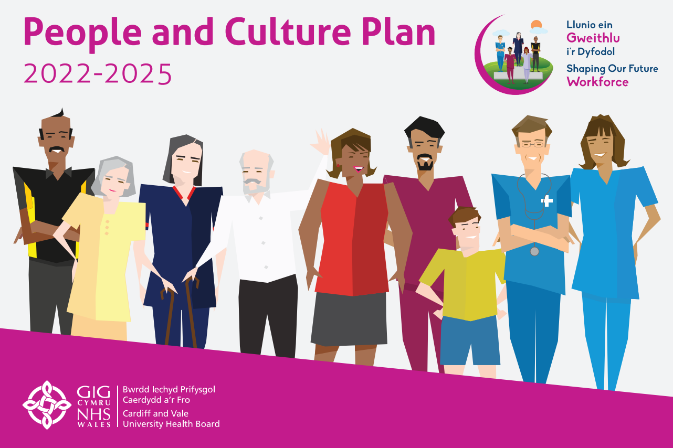
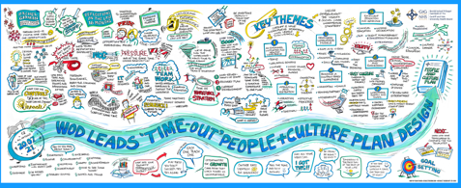

‘Shielding’ means protecting those people who are Clinically Extremely Vulnerable to the serious complications of coronavirus because they have a particular existing health condition. These individuals received a shielding letter from the Welsh Government (or an equivalent letter from their GP/Specialist) advising them that they must remain shielded at home. Some staff may have received this letter because they care for someone who is considered clinically extremely vulnerable (i.e. shielding a family member. At the peak, during the first wave, there were 637 staff (517.64 whole time equivalent/wte) staff who were shielding, but shielding officially came to an end on 31 March 2021.
Actions taken to support staff to return work following shielding include:
- Providing a phased return to work back to their substantive post, discussing any concerns with them and supporting them back into their familiar work environment.
- Temporarily moving staff into an alternative role if they remained unable to return to their substantive role, with support to work in a new area.
- After temporarily moving staff into an alternative role, discussing and assessing the situation with and helping them remain in an alternative and more suitable role permanently when a vacancy became available.
- Enabling staff to work at home for a period of time prior to returning the work site and carrying out their role.

In March 2022 there were three members of staff who while not ‘shielding’, were unable to attend work. These are all clinical staff who are more than 28 weeks pregnant and for whom suitable, alternative roles have not been found.

A key tool for supporting all staff, but also those who were shielding was the All-Wales COVID-19 Workforce Risk Assessment Tool. This was developed to help individuals and their managers understand if they were at higher risk of developing more serious symptoms if they came into contact with the COVID-19 virus and to agree the right actions for them based on their level of risk. The real value of the tool is that it should stimulate a discussion between the member of staff and their manager about their personal circumstances. In March 2022 there were 1,588 risk assessment records recorded in ESR (an increase from 1083 in March 2021). However, the completion of the risk assessment is not mandatory, nor is the recording of the outcomes in ESR for those who completed it.
In addition to the All-Wales risk assessment, the Health Board developed a separate Risk Assessment for Pregnant Staff with Potential Coronavirus Exposure to be completed by managers together with their pregnant employees at least twice during the pregnancy. This was updated in March 2022 to reflect changes to national guidance and clinical data which suggests that the risk of complications from COVID-19 increase from around 26 weeks’ gestation.

6.2 COVID 19 Staff Deaths
Once again it has been a challenging year for staff in managing the global pandemic. Thankfully there have been no further staff deaths as a result of COVID-19 but we continue to offer support mechanisms to staff who have lost colleagues through the Patient Experience/chaplaincy team. Please refer to the paragraph entitled Bereavement, Spiritual & Support Care under Section 3.7 for further information.

6.3 Local Partnership Forum and Other Employee Engagement Groups
Local Partnership Forum (LPF)

The Health Board has a statutory duty to “take account of representations made by persons who represent the interests of the community it serves”. This is achieved in part by three Advisory Groups to the Board and the Local Partnership Forum (LPF) is one of these.
LPF is co-chaired by the Chair of Staff Representatives and the Executive Director of People and Culture. Members are Staff Representatives (including the Independent Member for Trade Unions), the Executive Team and Chief Executive, the Director of Corporate Governance, the Assistant Directors of Workforce and OD and the Head of Workforce Governance. The Forum meets 6 times a year.
LPF is the formal mechanism for the Health Board and Trade Union/Professional Organisation Representatives to work together to improve health services. Its purpose, as set out in the Terms of Reference, fall into four overarching themes: communicate, consider, consult and negotiate, and appraise.
Significant issues which the Local Partnership Forum considered during 2021-22 include:
- Shaping Our Future Clinical Services.
- Regular operational updates, including: The Reset and Recovery Plan; the impact of COVID-19 and transformation work in Mental Health Clinical Board, the PCIC Clinical Board position; and operational pressures.
- IMTP – engagement on Health Board priorities and progress reports.
- Nurse Staffing Act annual report.
- Implementation of Respect and Resolution Policy and culture shift required.
- Health and Wellbeing, including the work of the Health Intervention Team.
- The revised Partnership and Recognition Agreement including LPF Terms of Reference.
- The work of the Dragon’s Heart Institute.
- The Director of Public Health’s annual report - ‘Let’s leave no one behind in Cardiff and the Vale of Glamorgan’ – Tackling inequities and prioritising prevention through recovery from COVID-19.
- The Strategic Equality Plan.
- Workforce Resourcing – Attract, Recruit and Retain.
- A number of ‘deep dives’ into WOD KPIs and initiatives: turnover: sickness; statutory and mandatory training; employee relations; and Values Based Appraisals.
- Changes to Agenda for Change Terms and Conditions.
- Implementation of the smoke free premises and vehicles regulations – enforcement options.
- Approval of the revised Employment Policy Sub Group Terms of Reference.

LPF also regularly receives an update on ‘hot topics’ from the Chief Executive and standing reports on WOD Key Performance Indicators, finance and patient quality, safety and experience.

The LPF has 3 sub-groups - the Workforce Partnership Group, the Employment Policies Sub Group and the Staff Benefits Group:

The Workforce Partnership Group (WPG) is co-chaired by the Chair of Staff Representatives and the Executive Director of Workforce and OD (WOD). Members are senior representatives of the WOD team, Lead Clinical Board Staff Representatives, the Lead Staff Representative for Health and Safety and the Staff Side Secretary. The Independent Member – Trade Union also has a standing invitation to attend. In 2021/22 the membership was widened to include senior Clinical Board representation and senior Nursing representation.

The WPG generally meets 6 times a year, alternating with the LPF, but due to the COVID-19 pandemic and operational pressures the WPG has been meeting more frequently.

WPG provides a forum for the Health Board and Trade Unions (including Professional Organisations and Staff Associations) to work together on issues of service development, engagement and communication specifically as they affect the workforce. Its purpose, as set out in the Terms of Reference, fall into three overarching themes: to communicate, to consider and to discuss matters which affect the workforce. The items discussed tend to be more operational or detailed than those brought to the LPF, and the LPF regularly refers matters to the WPG for follow up and further consideration.
Significant issues which the WPG has considered during 2020/21 include:
- Employee Health and Wellbeing
- Employee Relations Activity
- Workforce resourcing, including inclusive recruitment and project search
- Estates infrastructure and car parking
- Allocate e-rostering system
- Enhanced payments for COVID-19 recovery
- People and Culture Plan
- Sustainability Action Plan
- Welsh Language Standards
- Deployment of staff due to COVID-19
- Implementation of the Annual Leave Carry Over / Selling Scheme

The Employment Policy Sub Group (EPSG) is made up of representatives from Workforce and OD and Trade Unions and is co-chaired by the Workforce Governance Manager and a TU representative. EPSG is the primary forum for the development and review of employment policies, procedures and guidelines. It usually meets 6 times a year. The Terms of Reference for this group were reviewed in July 2021 and the membership was widened to include representatives from inclusion, wellbeing and education.

Over the past year the following documents have been developed or reviewed and approved:

- Relocation Expenses Procedure
- New and Changed Jobs Procedure
- Working Remotely Guidelines
- Death in Service Procedure
- Maternity, Adoption and Shared Parental Leave Procedures
- Retirement Procedure
- Retire and Return Procedure

The Staff Benefits Group explores and co-ordinates discounts and benefits offered by external organisations for Health Board employees. The Group ensures and agrees ‘best deals’ for staff and reports their work to the Charitable Funds Committee and the Local Partnership Forum.
The Staff Benefits Group meets on a bi-monthly basis and has the following membership:
- Executive Director (Chairperson)
- Senior Management Representative
- Senior Health Charity representative
- Senior Workforce Manager
- Staff Side representative
- Communications representative
- Sustainable Travel Manager
- Procurement Representative
- Finance and Payroll representatives

Businesses and suppliers who wish to provide discounted goods or services to staff are invited to email the Communication and Engagement Team and new proposals are taken to the Staff Benefits Group for discussion where these are considered in line with the approvals criteria. Approved proposals are promoted via a variety of staff engagement platforms including the Staff Benefits website, Staff Connects and social media.
In 2021/22, the group continued to hold virtual meetings (in line with COVID-19 restrictions and guidance) and progressed the following:

- Circulated written and electronic communications to local and national businesses and suppliers to acknowledge their support to Health Board staff during the pandemic, and invite participation in the staff benefit scheme.
- Received and reviewed suitability of new staff benefit schemes including Home Benefits salary sacrifice proposals.
- Renewed the Memorandum of Understanding between Nathaniel Car Sales and Cardiff and Vale Health Charity to provide sponsorship and fundraising support.
- Renewed the Memorandum of Understanding between Nathaniel Car Sales and the Health Board to provide staff transport to/from work in the event of adverse weather.
- Worked collaboratively with the Digital Communications Team to create a dedicated staff benefits page in the Staff Connects App, circulated offers in the Weekly Staff Update plus promoted offers via all staff engagement platforms.
- Staff benefits pages on the Health Board Intranet site have been redesigned and are refreshed weekly with new offers and promotions and occasionally aligned to topical events, i.e. Christmas, Easter, Valentines Day etc
- Approved the inclusion of Health Board Staff Benefits schemes in a national ‘Health Service Heroes Discount Booklet’ (retaining editorial control of content).

At a more local level, each Clinical Board also has monthly or bi-monthly Local Partnership Forums which enable the Clinical Board leadership team to engage with trade union representatives on local matters. Some of these have been suspended due to operational pressures and the inability to release staff to attend, and replaced with more informal discussions with the Lead Clinical Board Representatives but have either restarted or are due to do so in the early part of 2022/23.

6.4 Equality, Diversity and Human Rights
The current Strategic Equality Plan (SEP), Caring about Inclusion 2020-2024, has a number of key delivery objectives and demonstrates our commitment to embedding equality, diversity, human rights, and Welsh Language into the Health Board’s business processes. The SEP is closely aligned to our ten year strategy ‘Shaping Our Future Wellbeing’, our newly launched ‘People and Culture’ plan, our Intermediate Medium Term Plan, as well as the Well-being of Future Generations Act 2015. This is the second year of the current four year plan.
During 2021/22, we continued to strive to create a more inclusive organisation for our staff and our communities through a range of means, including engaging with staff and community groups, raising awareness of inequalities through keynote speakers, awareness sessions and partnership working with Public Health Wales and community groups, and celebrating the diversity of our workforce and community. Some of the key highlights of the past year include:

- Creation and cross-organisation sharing of an Inclusion Calendar, which highlights key dates throughout the year to raise awareness and celebrate our diversity.
- Achieving our highest ever ranking by reaching 37th place in the Stonewall Workplace Equality Index, which ranks organisations throughout the UK in relation to LGBTQ+ inclusivity, and also earning the Gold Award. Work that contributed to this exceptional performance included playing a key role in the NHS Wales Virtual Pride event and supporting our trans community through the delivery of a ‘First Steps to Trans Inclusion’ session.
- Development of two new staff networks; OneVoice, our Black Asian and Minority Ethnic staff network, and Access Ability, our staff network for people with disabilities and long-term health conditions.
- Becoming a Level 2 Disability Confident Employer.
- Development of Executive sponsors to support each of the protected characteristics and Welsh language. This is being cascaded across our Clinical Boards and has already seen the introduction of a ‘CD&T Allies’ programme within Clinical Diagnostic & Therapies Clinical Board.

Although language is not a protected characteristic under the Equality Act 2010 - the protection of the Welsh language is taken forward under separate legislation (the Welsh Language (Wales) Measure 2011 and related Standards) - it has long been recognised that the equality and Welsh language policy agendas complement and inform each other. It is further supported through the Goal within the Wellbeing of Future Generations Act – A Wales of vibrant culture and thriving Welsh language. Our aim is to sustain and reinforce that principle through our new Strategic Equality Objectives and ensure they serve to promote and protect the Welsh language.

The Health Board will continue to go beyond our legal obligations, applying the principles that sit within the Equality Act and the Public Sector Equality Duty to all our thinking, planning and decision making for the benefit of all our people, both in our organisation and our communities. The Equality Strategy and Welsh Language Standards Group continues to support developments and improvements across the Health Board.

6.5 Welsh Language Regulations – The Welsh Language Standards (No.7) Regulations 2018

Please refer to paragraph 15.3 within the Accountability Report.

6.6 Well-being of Future Generations (Wales) Act (WBFGA) 2015

The Health Board has adopted the Shaping Our Future Wellbeing Strategic Objectives as our wellbeing objectives, as detailed below. Embedding of the goals, principles and ways of working advocated by the Act into our everyday business is overseen by our Wellbeing of Future Generations Working Group, and the Chair in his capacity as our Wellbeing of Future Generations Champion.
When developing our IMTP, we ensure that weave the requirements of the Act through the plan like a golden thread, and our decision-making processes require us to consider the implications of the legislation when making our decisions.
Key areas of focus for the Steering Group have included plans to ensure we honour our commitments to carbon reduction, including active and sustainable travel, ensuring we continue to move upstream to ensure the prevention of disease, and early intervention when it occurs in order to improve outcomes.
Engaging with children and young people, who are our future generations, has also been strengthened to ensure that we hear loudly the voices of young people so they influence how we shape and develop our services into the future.

Our Governance arrangements in relation to the Well-being of Future Generations (Wales) Act 2015
A Cardiff and Vale UHB WFG Steering Group, chaired by the Executive Director of Public Health, reviews the actions required to embed the requirements into the Health Board, and supports the culture change required for the Health Board to implement routinely the sustainable development principle. In order to focus on the acute response to the pandemic, this group met intermittently during 2021/22, with regular routine meetings expected to fully resume during 2022/23.
The Steering Group maintains and assesses progress against an annual work programme, and reports to the Strategy and Delivery Committee of the Board. The Chair of the Board acts as the Well-being of Future Generations Champion for the Board. We maintain a regular dialogue with the Office of the Future Generations Commissioner and one of the Changemakers from the Commissioner's office joined the Steering Group as a regular member in 2021/22.
In the partnership arena, we contribute to the statutory Well-being Assessments and Well-being Plans (one for Cardiff; one for the Vale) through our participation in the Public Service Boards, and deliver key actions in the Plans, individually and together with partner organisations.

Our well-being objectives
Within the Health Board, the statutory well-being objectives under the WBFGA are reflected in our ten year strategy (Shaping our Future Well-being) objectives, which are listed below. These objectives contribute to the seven national well-being goals. The Strategy is implemented through the annually updated three-year plan, our integrated medium term plan (IMTP), which contains our annual well-being statement.
- Reduce health inequalities
- Deliver outcomes that matter to people
- All take responsibility for improving our health and well-being
- Offer services that deliver the population health our citizens are entitled to expect
- Have an unplanned (emergency) care system that provides the right care, in the right place, first time
- Have a planned care system where demand and capacity are in balance
- Be a great place to work and learn
- Work better together with partners to deliver care and support across care sectors, making best use of our people and technology
- Reduce harm, waste and variation sustainably making best use of the resources available to us
- Excel at teaching, research, innovation and improvement and provide an environment where innovation thrives

The IMTP integrates and demonstrates the five ways of working and action against the well-being goals throughout the plan. Prevention is embedded throughout our work, with additional specialist public health interventions described in the Shaping Our Future Population Health plan.
In developing the IMTP for 2022-25, the organisation's well-being objectives were reviewed, with no changes made. As the overarching Shaping our Future Well-being strategy is reviewed in depth during 2022/23, there will be an opportunity to undertake a further assessment of whether any changes need to be made to the objectives.

Progress against our well-being objectives
Because our corporate objectives are our well-being objectives, progress against our well-being objectives is demonstrated through our routine performance reporting against our IMTP and ten-year strategy. You can find out more about our performance, and where it is reported, in the Summary of our performance and key achievements section, above.
During 2021/22 we reviewed our Sustainability Action Plan, to ensure actions deliver - and go beyond - the requirements of the NHS Wales decarbonisation strategic delivery plan. We also continued to support and nurture sustainability projects through our Ideas Incubator and the Dragons Heart Institute, including Green Health Wales, sustainable procurement, and the SFERIC (sustainability fellowship for engagement, research, innovation and co-ordination) programme. In September 2021, Food Cardiff, which is hosted by the Local Public Health team, was awarded a Sustainable Food Places Silver award, one of only six places in the UK to achieve the award. Other developments in the year included:
- Recertified to ISO14001 standard twice in 21/22
- 6,800 LED light bulbs installed
- Sustainable healthcare concepts being introduced to Cardiff University medical students
- Staff survey ran which indicated more could be done to improve awareness of what we’re doing regarding the green agenda
- Environmental sustainability manager recruited
- Cohort of ‘sustainability’ volunteers recruited to receive Sustainable QI training and apply that knowledge to clinical service
- C&V’s second sustainability fellow was brought on board in September 2021

You can read more about specific projects we have completed which demonstrate our commitment to the Act on the Shaping our Future Sustainable Healthcare web pages.
Other developments in relation to the WFBGA
Throughout much of 2021-22 the Health Board has been focused on its response to the pandemic. We have tried to do this in a way which aligns with the sustainable development principle and the five ways of working (integration, involvement, long-term, prevention, collaboration), including:
- Extensive daily partnership working directly with statutory partners, in delivering the Test, Trace, Protect (TTP) programme in Cardiff and the Vale. This has been a true partnership endeavour, with teams made up of staff from across the partnership leading on strategy and surveillance through to contact tracing. Staff and budgets have been shared with fully integrated working on a daily basis
- Working closely with our ethnic minority communities and community leaders to increase engagement and reduce the unequal impacts of COVID-19
- Planning and implementation of the mass vaccination programme, to prevent future cases of COVID-19
- Enabling a large increase in remote clinical consultations
- Maintaining facilities for staff to work from home wherever possible, while balancing this with safe face to face meetings to promote well-being and prevent isolation. This contributes to increased flexibility for staff, along with a reduction in carbon emissions from commuting

7. Quality Governance and Performance

The Operation and Transformation team was set up in Autumn 2021 to oversee the operational delivery of the organisation, through winter 2021 and the third COVID-19 wave. This included a senior Manager, Nurse and Medical triumvirate. As part of the operational delivery, the IPC (infection prevention and control) incident and outbreaks were discussed daily with OPAT senior team, site teams and operational nursing structures. This enabled constant oversight across all Clinical Boards to ensure all risk-based decision-making regarding patient movement was understood.

QUALITY, SAFETY AND PATIENT EXPERIENCE (QSE)

During the pandemic we have developed our five-year Quality Safety Experience Framework with our frontline staff, patients, carers, relatives and external regulators. Our focus on quality, safety and the patient experience extend across all settings where healthcare is provided. This includes our responsibility as a commissioner of services from a wide range of providers to have the necessary assurances in place where care is being provide by others for our population.
The chart below highlights our committee and group structures to support the delivery of the framework.
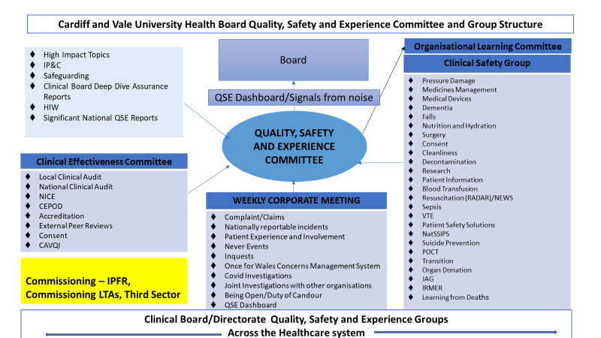

As an integrated healthcare organisation, our focus on quality, safety and the patient experience must extend across all settings where healthcare is provided as we look to be one of the safest organisations in the NHS. We will ensure there is no undue bias towards Secondary Care, recognising that the majority of care received by patients is provided in a Primary or Community Care setting and that the Primary and Community Care element of the patient’s pathway is as key to delivering safe, high quality care as that part of the pathway which is provided in more acute settings.

We have eight key enablers in our revised QSE Framework for the next five years: These are:
- Safety Culture
- Leadership for QSE
- Patient Experience and Involvement
- Patient Safety learning and communication
- Staff engagement and Involvement
- Data and Insight
- Professionalism of QSE
- Quality Governance
What really matters for our patients’ carers and people in our communities must be central to our decision making, so that we can use our time, skills and other resources more wisely.
The challenge to commission services that improve the health of our residents in Cardiff & Vale and provide prudent, integrated health and social care for a growing local population whist providing increasingly complex emergency, elective and tertiary care to meet local and regional demand within the resources available, has never been greater.
We are always mindful that we are a Statutory organisation and are also bound by primary legislation, statutory instruments and Standing Orders (which are the rules by which the organisation works and makes decisions).
Our public, communities, staff and partners are at the centre of everything we do. There is no better and more important way of developing or improving services than by listening to what individuals think, feel and experience throughout their journey of using any of the NHS Wales services, programmes, functions and beyond. Whether this is in a hospital ward, outpatient appointment, any of the national Screening programmes, GP practice (Primary Care), engaging with health promotion practitioners or at any event delivered by an NHS Wales organisation. It is a key element of quality, alongside providing governance assurance and safer services. The way that the wider health and prevention/promotion system delivers its service and supports the wider systems – from the way the phone is answered, to the way cleaning staff speak with you all the way to managers engage with the public and staff– has an impact on the experience and should be used for quality improvement and governance assurance. If clinical and general excellence is the ‘what’ of healthcare and health prevention, then experience is the ‘how’. Starting with and listening to the needs, and designing the experience to meet these needs is achievable and results in an environment where individual feel valued and supported.
One of the most important lessons learnt in the last few years is that organisations need to be ambitious. The experience we deliver for our service users will only ever improve when an entire organisation examines and re-creates its culture which is more than just words, leadership, public and community engagement, staff engagement and cross-organisational measurement systems in order to improve quality and strive for excellence.

These are the key messages from our enablers
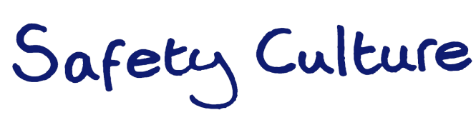
‘Quality, Safety and Experience is everybody’s business’
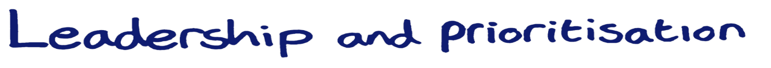
Management is doing things right; leadership is doing the right things”.
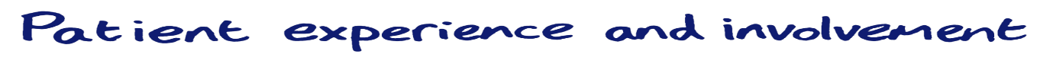
‘No decision about me, without me’
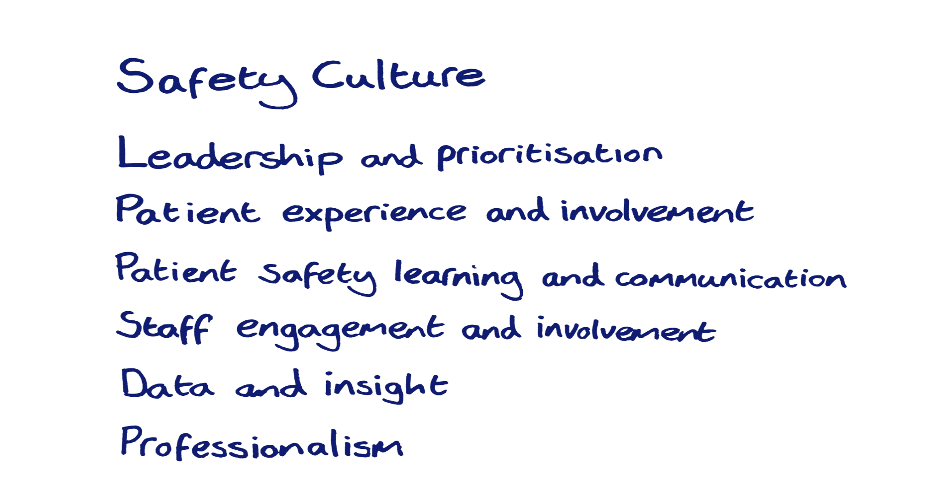Inspire, educate, skill and protect health workers to contribute to the design and delivery of healthcare systems’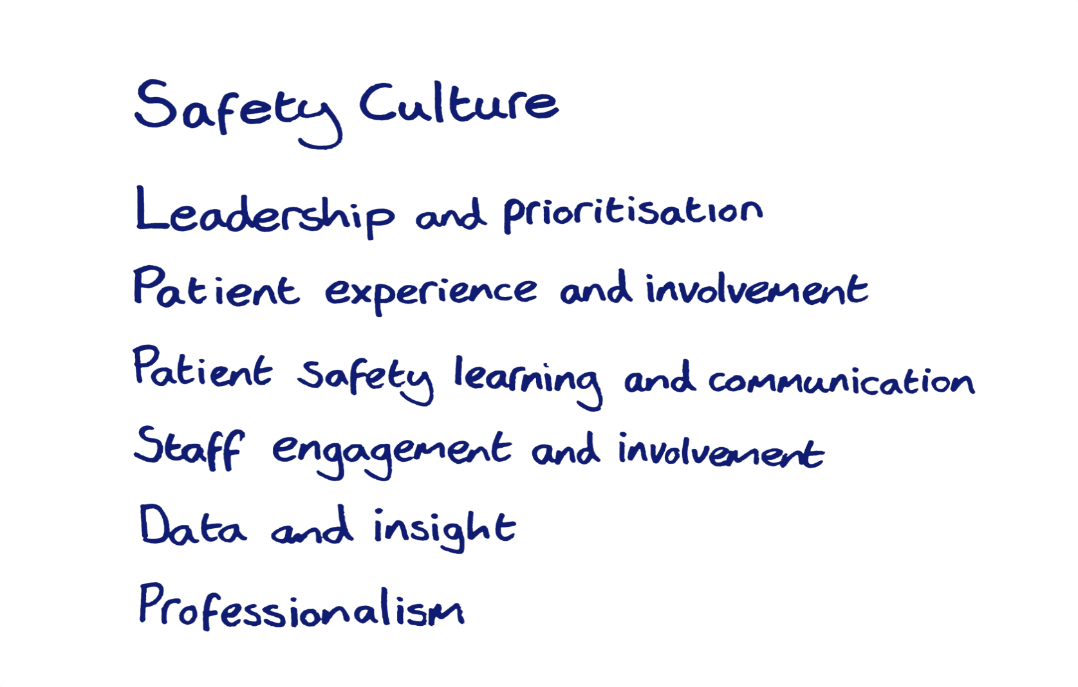
let’s focus on systems and human factors; not on individuals’
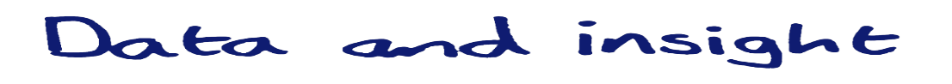
If you don’t measure, you don’t know’
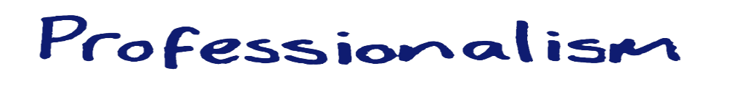
‘ if we always do what we’ve always done, we’ll always get what we’ve always gotten’
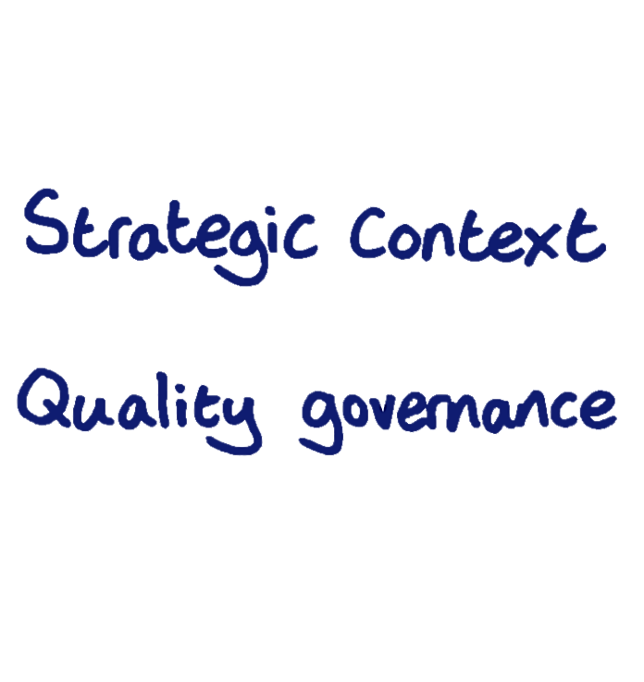
The Standard you walk past is the standard you accept’

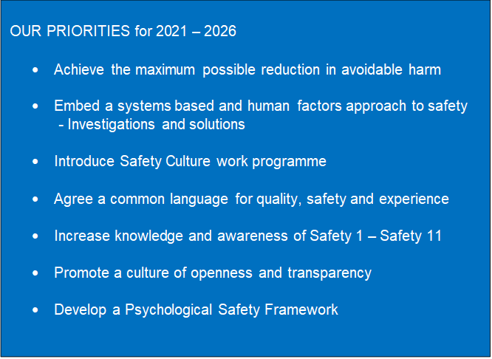

8. Sustainability Report
In January 2020, the Health Board declared a climate emergency, and gave a commitment to redoubling our efforts to reduce our carbon footprint. We produced our first sustainability action plan which set out the actions we would take to significantly reduce our carbon use. Following the publication of the Welsh Government Decarbonisation Strategy, with the commitment to reach carbon zero by 2030, we refreshed the Sustainability Action Plan and approved the revised plan at our Board meeting in November 2021. This latest plan uses the NHS Wales Decarbonisation Strategic Delivery Plan as a base plus builds upon the learning from the first Action Plan in order to challenge the Health Board to further mature its reaction to the Climate Crisis.

During 2021/22, and in addition to the developments referred to under Section 6.6 above (Progress against our well-being objectives), circa 33% of outpatient appointments taking place virtually, homeworking commonplace which reduces congestion and traffic pollution and Health Board colleagues leading the formation of a Green Health Wales network of healthcare professionals.

More needs to be done. Therefore in the coming year an emphasis is being put into providing leadership in order to make a difference to our carbon footprint and consideration to be put into how we will bring all of our colleagues onto the journey with us. To this end, there has been a significant and consistent increase in communications about the subject of decarbonisation. Not forgetting our desire to consume less energy, the continued Re:Fit program will include further widespread LED installation, carbon reducing ventilation upgrades, control improvements and solar PV installations.

We now report annually on progress with our carbon reduction plan, and an Executive level oversight group is being established to ensure that key milestones are delivered on time.

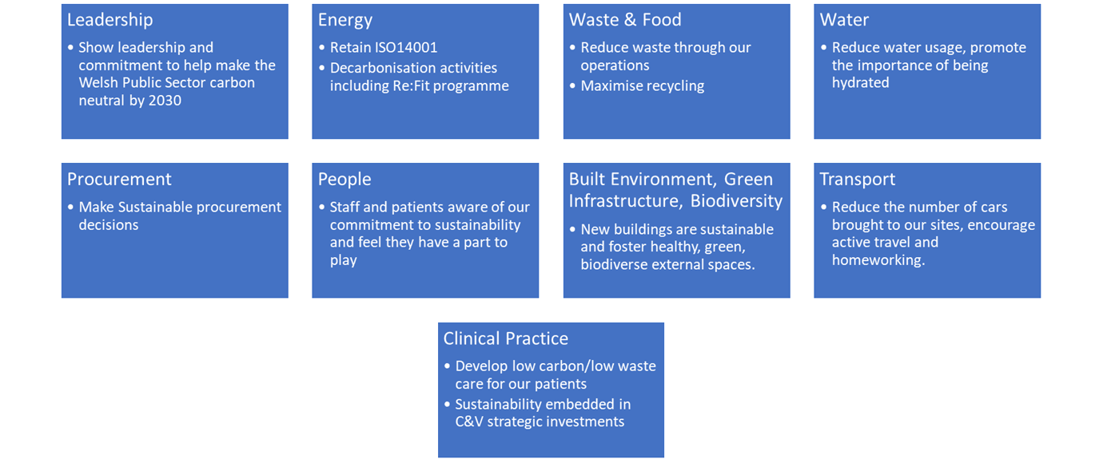

Themes for 22/23 Sustainability Action Plan

20% of NHS Wales emissions come from our buildings and energy consumed. 60% comes from the products used to deliver healthcare services. An exciting initiative being trialled this year involves volunteers from our teams working on quality improvement initiatives with a view to improving the carbon impact of products we use or reducing consumption of them. As an example of a reduction in consumption project, the Health Board has been working towards turning off the supply of nitrous oxide around our facilities and instead delivering the gas on demand where required in cylinder form. It is expected that considerably less of this dangerous greenhouse gas can be consumed saving on our emissions and money.

Data concerning energy consumption, water usage and waste is expected to be available in August 2022.

9. Conclusion and Forward Look

As the Health Board has sought to accelerate its plans to recover and redesign services this year, the past year has been another challenging time for the Health Board given the ongoing and unpredictable nature of the pandemic. However, it has also paved the way for a number of innovative practices to be put in place and we are pleased to see that some of our services have returned to near pre-COVID-19 levels.
Looking forward, the Health Board intends to build upon some of the innovative ways of working to improve healthcare quality and the safety of patients and staff across the whole patient pathway. Under our newly adopted Quality, Safety and Experience Framework 2021-2026 we will continue to aspire to provide safe, effective services that deliver excellent user experience equal to the best healthcare organisations in the world.
As we progress through our recovery and redesign phase, we will reflect on the experiences of governing during the pandemic and ensure that we continue to retain and refine some of our new ways of working to ensure an effective and efficient health care service, including:-
- We will continue to hold virtual Committee meetings as they have proven to be an efficient and effective way of working. We will be returning to “in person” Board meetings from May 2022 in an attempt to return to some normality.
- We will retain and refine the agile approaches to decision making to enable and facilitate innovation, transformation and learning on an ongoing basis.
- Digital solutions have been a key enabler of service delivery during the pandemic. For example, the use of virtual appointments and video group clinics has helped to maximise capacity for our outpatients’ services. The “virtual ward” has helped to reduce patient time in hospital. We have plans in progress to expand the use of digital solutions to support other patient groups awaiting treatment.
- Maintaining and enhancing new forms and ways of communication introduced during the pandemic to sustain collaboration, partnership working, and public engagement while we recover from the effects of the pandemic. For example, the South West Cardiff Primary Care Cluster has formed a key part of the work undertaken by the Cardiff and Vale Regional Partnership Board under the nationally funded Transformation Programme. We hope to roll out further Clusters over the coming year.
We intend to further strengthen our relationships with our partners. The past year has seen some very successful collaborative working with our partners and volunteers (for example, the Mass Vaccination Programme) and we will focus more upon working jointly with our partners across Social Care and the Ambulance Service in order to implement changes which will improve patient care, reduce ambulance handover delays, avoid hospital admissions and discharge patients to more appropriate settings.
The recovery and redesign phase has given us the opportunity to transform patient-care, learn from patient and staff feedback over the last year and lock in operational improvements to make access easier. This is reflected in our ambitious draft IMTP for 2022-2025 which aims to accelerate our journey of transforming services and to take significant steps in recovery of planned care treatments delayed due to COVID-19, improve emergency and urgent care service due to pressures of last 2 years. Further, as part of our Recovery and Redesign programme, we are developing plans to look at potential regional solutions in order to address the back log of people waiting for planned treatment.
We recognise that the last couple of years have also been very challenging for our staff. The safety and well-being of our staff remains a primary concern for the Health Board. We are implementing our People and Culture Plan 2022-2025 which sets out the actions we will take over the next three years, with a clear focus on improving the wellbeing, inclusion, capability and engagement of our workforce. As we continue to navigate our way through and out of the pandemic, it is vital that we have a healthy, safe and capable workforce to help us to transform patient care and provide better services.

Part 2
Accountability Report

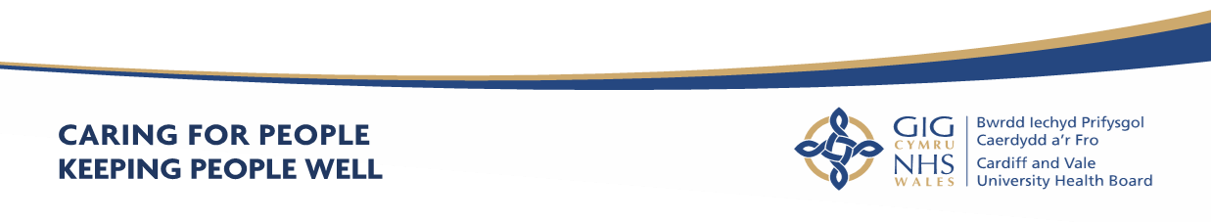
Part 2 - Accountability Report

Scope of the Accountability Report
The purpose of the accountability section of the Annual Report is to meet key accountability requirements to the Welsh Government, and to provide an overview of the governance, accountability arrangements and structures that were in place across the Health Board during 2021-2022. It includes:
- Corporate Governance Report
- Remuneration and Staff Report
- Parliamentary Accountability and Audit Report

10. Part 2a - Corporate Governance Report
10.1 Directors Report
10.1.1 The Composition of the Board
Part 2 of the Local Health Boards (Constitution, Membership and Procedures)
(Wales) Regulations 2009 (the Regulations) sets out the required membership of the Boards of Local Health Boards, the appointment and eligibility requirements of members, the term of office of Independent Members and Associate Members. In line with these Regulations, our Board comprises of 20 voting members, with additional 3 non-voting Associate Members including:

- a Chair;
- a Vice-Chair;
- Officer members;
- Independent Members; and
- Associate Members.

The Board provides leadership and direction to the organisation and is responsible for governance, scrutiny and public accountability, ensuring that its work is open and transparent by holding its meetings in public. As a result of the public health risk linked to the pandemic the UK and Welsh Government (WG) stopped public gatherings of more than two people and it was therefore not possible to allow the public to attend meetings of our Board and Committees since March 2020. However, we are intending to resume our Board meetings in person with effect from 26 May 2022, whilst our Committee meetings will continue to be held virtually for the time being.

The members of the Board are collectively known as “the Board” or “Board members”, the Officer and Independent Members (which includes the Chair) are referred to as Executive Directors and Independent Members respectively. All Independent Members and Executive Director Members have full voting rights.

The Health Board has 11 Independent Members (including the Chair and Vice-Chair), all of whom are appointed by the Minister for Health and Social Services. There are 9 Executive Directors (including the Chief Executive).

In addition, Welsh Ministers may appoint up to 3 Board level Associate Members. Associate Members have no voting rights. There are also 2 Director posts, namely the Director of Corporate Governance and the Director of Digital Health and Intelligence, who form part of the Executive Team and the Board but have no voting rights.

Before an individual may be appointed as a member or Associate Member they must meet the relevant eligibility requirements, set out in Schedule 2 of The Local Health Boards (Constitution, Membership and Procedures) (Wales) Regulation 2009, and continue to fulfil the relevant requirements throughout the time that they hold office. The Regulations can be accessed via the following link:

https://www.legislation.gov.uk/wsi/2009/779/contents

10.1.1 Voting Members of the Board During 2021-2022

Please refer to paragraph 13.13 (i.e. paragraph headed Board and Committee Membership & Attendance 2021/22) within the Accountability Report and Appendix 1 to the Annual Governance Statement.

10.1.2 Audit and Assurance Committee

The membership of the Audit Committee during 2021-2022, providing the required expertise was as follows:

Name | Role | Dates
INDEPENDENT MEMBERS
John Union | Committee Chair | April 2021- March 2022
David Edwards | Committee Vice Chair | April 2021- March 2022
Mike Jones | Independent Member Trade Union | April 2021 – March 2022
Ceri Phillips | Vice Chair | April 2021 – March 2022

10.1.4 Declaration of Interests

Details of company directorships and other significant interests held by members of
the Board which may conflict with their responsibilities are maintained and updated
on a regular basis. A Register of Interests is available on the Health Board’s website
by clicking on the following link https://cavuhb.nhs.wales/about-us/our-board/register-of-interests/ or a hard copy can be obtained from the Director of Corporate Governance on request.

10.1.5 Personal Data Related Incidents

Information on personal data related incidents which have been formally reported to the Information Commissioner’s office and “serious untoward incidents” involving data loss or confidentiality breaches and details of how the risks to information are managed are detailed in paragraph 15.10 of the Annual Governance Statement.

10.1.6 Environmental, Social and Community Issues

These are included in paragraph 15.5 of the Annual Governance Statement.

10.1.7 Statement of Public Sector Information Holders

This is contained at section 21.3 (Managing Public Money (page xx) of the Parliamentary Accountability and Audit Report.

Signed by ……………………………………….

Suzanne Rankin
Chief Executive and Accountable Officer

Date:

11. Statement of the Chief Executive’s Responsibilities as the Accountable Officer of the Health Board

The Welsh Ministers have directed that the Chief Executive should be the
Accountable Officer of Cardiff & Vale University Health Board.

The relevant responsibilities of Accountable Officers, including their responsibility for
the propriety and regularity of the public finances for which they are answerable, and
for the keeping of proper records, are set out in the Accountable Officer’s
Memorandum issued by the Welsh Government.

I can confirm that:

- As far as I am aware, there is no relevant audit information of which Cardiff & Vale University Health Board’s auditors are unaware, and I have taken all steps that ought to have been taken to make myself aware of any relevant audit information and to establish that the Health Board’s auditors are aware of that information.
- Cardiff & Vale University Health Board’s annual report and accounts as a whole are fair, balanced and understandable and I take personal responsibility for the annual report and accounts and the judgements required for determining that they are fair, balanced and understandable.

- I am responsible for authorising the issue of the financial statements on the date they were certified by the Auditor General for Wales.

To the best of my knowledge and belief, I have properly discharged the responsibilities set out in my letter of appointment as an Accountable Officer.

Signed by.....................................................................................................

Suzanne Rankin, Chief Executive

Date.............................................................................................................

12.Statement of Directors’ Responsibilities in Respect of the Accounts

The directors are required under the National Health Service Act (Wales) 2006 to prepare
accounts for each financial year.

The Welsh Ministers, with the approval of the Treasury, direct that these accounts give
a true and fair view of the state of affairs of the Cardiff & Vale University Health Board
and of the income and expenditure of the Cardiff & Vale University Health Board for
that period.

In preparing those accounts, the directors are required to:
- apply on a consistent basis accounting principle laid down by the Welsh Ministers with the approval of the Treasury
- make judgements and estimates which are responsible and prudent
- state whether applicable accounting standards have been followed, subject to any material departures disclosed and explained in the account.
The directors confirm that they have complied with the above requirements in preparing the accounts.
The directors are responsible for keeping proper accounting records which disclose with reasonable accuracy at any time the financial position of the authority and to enable them to ensure that the accounts comply with the requirements outlined in the above mentioned direction by the Welsh Ministers.
By Order of the Board
Signed:
On behalf of the Chairman: Charles Janczewski……Dated: …............……2022
Chief Executive: Suzanne Rankin……………………… Dated: …….................2022
Director of Finance: Catherine Phillips ………..........Dated: ……................2022

Annual Governance
Statement

13 ANNUAL GOVERNANCE STATEMENT

13.1 Scope of Responsibility

The Board is accountable for Governance, Risk Management and Internal Control. As Chief Executive of the Board, I have responsibility for maintaining appropriate governance structures and procedures as well as a sound system of internal control that supports the achievement of the organisation's policies, aims and objectives, whilst safeguarding the public funds and the organisation's assets for which I am personally responsible. These are carried out in accordance with the responsibilities assigned by the Accountable Officer of NHS Wales.

The Annual Report outlines the different ways the organisation has had to work both internally and with partners in response to the unprecedented pressure in planning and providing services. It explains arrangements for ensuring standards of governance are maintained, risks are identified and mitigated and assurance has been sought and provided. Where necessary additional information is provided in the Annual Governance Statement. However, the intention has been to reduce duplication where possible. It is therefore necessary to review other sections in the Annual Report alongside this Annual Governance Statement (AGS).

This AGS details the arrangements in place during 2021-2022 to discharge my responsibilities as the Chief Executive Officer of the Health Board, and to manage and control the Health Board’s resources. It also details the extent to which the organisation complies with its own governance arrangements, in place to ensure that it fulfils its overall purpose, which is that it is operating effectively and delivering quality and safe care to patients, through sound leadership, strong stewardship, clear accountability, robust scrutiny and challenge, ethical behaviours and adherence to our set values and behaviours. It will set out some of the challenges and risks we encountered and those we will continue to face going
forward.

At the time of preparing this Annual Governance Statement, the Health Board and the NHS in Wales continues to face unprecedented challenge and increasing pressure, due to responding to COVID-19, in planning and providing services whilst the Health Board moves towards a recovery position after the second and third waves of COVID-19.

13.2 Escalation and Intervention Arrangements

Under the Joint Escalation and Intervention Arrangements, the Welsh Government meets with Audit Wales and Healthcare Inspectorate Wales (Tripartite Group) twice a year to discuss the overall assessment of each Health Board, Trust and Special Health Authority in relation to the arrangements.
In March 2022, following the outcome of that Tripartite Group meeting, we were informed that the Director General Health and Social Services/NHS Wales Chief Executive would be recommending to the Minister for Health and Social Services that Cardiff and Vale University Health Board remains at ‘routine arrangements’.
The Group acknowledged the Health Board’s continued openness and transparency of conversations with the regulators and the improved governance arrangements
Whilst no serious issues were identified, some concerns were raised by the Tripartite Group for the Health Board’s consideration, namely:
• There have been a number of changes at Executive officer level, so it is important to stabilise the position and to ensure the vacant posts are filled;
• There is a need to monitor the current financial position. It is important to maintain regular conversations with Welsh Government colleagues on the plans the Health Board has in place;
• Concerns have been raised over the suicide levels reported in mental health services;
• Urgent and emergency care performance has deteriorated over recent months and concerns have also been raised around stroke performance and performance against Part 1 of the adult mental health Measure;
• There are concerns around the sustainability of General Medical Services (GMS) noting a number of practices have handed their GMS contracts back to the Health Board.
The Health Board is actively addressing those concerns and further information can be accessed here
https://cavuhb.nhs.wales/files/board-and-committees/board-2021-22/2022-03-31-public-board-papers-v14-pdf/ (see agenda item 6.7)

13.3 Integrated Medium-Term Plans (IMTP)

Please refer to paragraph 2.9 of this Annual Report.

Our Governance Framework

13.4 Standing Orders and Scheme of Reservation and Delegation

At a local level, Health Boards in Wales must agree Standing Orders for the regulation of proceedings and business. They are designed to translate the statutory requirements set out in the LHB (Constitution, Membership and Procedures) (Wales) Regulations 2009 into day to day operating practice, and, together with the adoption of a scheme of matters reserved to the Board; a Scheme of Delegation to officers and others; and Standing Financial Instructions, they provide the regulatory framework for the business conduct of the Health Board and define - its ‘ways of working’. These documents, together with the range of corporate policies set by the Board, make up the Governance Framework. These are available from https://cavuhb.nhs.wales/about-us/policies-procedures-and-guidelines/. The Board approved the All Wales Model Standing Orders, Reservation and Delegation of Power for Standing Orders at its May 2021 Board Meeting. The Board functions as a corporate decision-making body with Executive Directors and Independent Members being equal members, sharing corporate responsibility for all decisions and playing a key role in monitoring performance against strategic objectives and plans.
The principal role of the Board is to exercise effective leadership, direction and control, including:

- Setting the overall strategic direction of the Health Board;
- Establishing and maintaining high levels of corporate governance and accountability including risk management and internal control;
- Ensuring delivery of the Health Board’s aims and objectives through effective challenge and scrutiny of performance across all areas of responsibility;
- Ensuring delivery of high quality and safe patient care;
- Building capacity and capability within the workforce to build on the values of the Health Board and creating a strong culture of learning and development;
- Enacting effective financial stewardship by ensuring the Health Board is administered prudently and economically with resources applied appropriately and efficiently;
- Instigating effective communication between the Health Board and its community to ensure its services are planned and responsive to identified needs;

The Board, subject to any directions that may be made by the Welsh Ministers, is
required to make appropriate arrangements for certain functions to be carried out on
its behalf so that the day to day business of the Health Board may be carried out
effectively, and in a manner that secures the achievement of its aims and objectives.

13.5 The Board and its Committees

The Health Board has been constituted to comply with the Local Health Boards (Constitution, Membership and Procedures) (Wales) Regulations 2009. In addition to responsibilities and accountabilities set out in terms and conditions of appointment, Board members also fulfil a number of Champion Roles where they act as ambassadors for these matters. Board Leads and Champion Roles were agreed at the Board Meeting in September 2021, together with descriptions of the Board Champion Roles in order to ensure that the roles and responsibilities were clearly defined. The table in Appendix 1 to this AGS sets out which individual Independent Members have been allocated the Champion Roles and which Executive officers have been allocated Board Leads.

The Board provides leadership and direction to the organisation and is responsible for governance, scrutiny and public accountability. It ensures that its work is open and transparent by holding its meetings in public and where private meetings are held the meeting agendas are also published. The Board is supported by a number of Committees, each chaired by an Independent Member. All Committees are constituted to comply with The Welsh Government Good Practice Guide – Effective
Board Committees. The Committees, which meet in public (except the Remuneration and Terms of Service Committee), provide their minutes and a written report by the Committee Chair to each Board meeting. This enables all Board members to be sighted on the major issues and contribute to assessment of assurance and provide scrutiny against the delivery of strategic objectives.

Board papers are published on the Health Board’s website 10 clear days prior to each meeting in line with Standing Orders. For further information see paragraph 13.7 (Board and Committee Meetings during COVID -19).

A breach log is maintained to capture any departures from these timescales and reports delayed or not received. Please refer to section 2.3 of the Annual Report for information regarding the Committee’s responsibilities, Work Plans and Terms of Reference.

The papers for Board meetings can be accessed at https://cavuhb.nhs.wales/about-us/governance-and-assurance/board-meetings/ and papers for Committee meetings at https://cavuhb.nhs.wales/about-us/governance-and-assurance/committees-and-advisory-groups/.

Each Committee produces an annual report for the Board. This is to demonstrate and provide assurance to the Board that the Committees have met the requirements of the respective Terms of Reference. The Committees’ annual reports for 2021-2022 can be accessed at: https://cavuhb.nhs.wales/about-us/governance-and-assurance/annual-reports-and-accounts/

The Health Board’s Board and Committee structure in place during 2021-2022, is outlined in Figure 1 below.

Figure 1 – C&VUHB Governance Structure 2021-2022
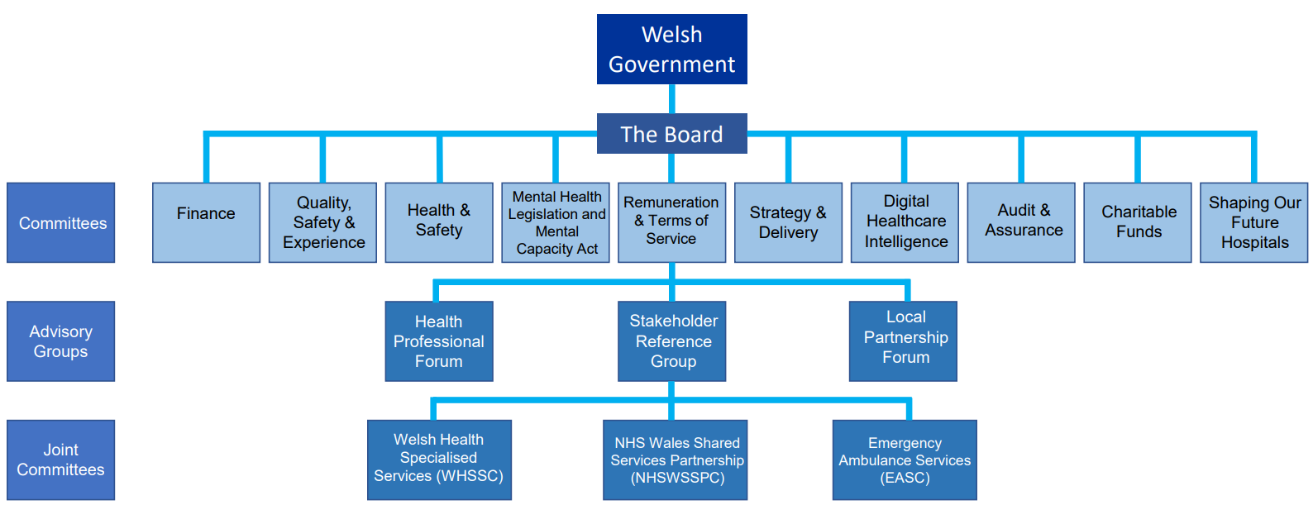

13.6 Effective Governance During the COVID 19 Pandemic

In March 2020 and as part of its response to the pandemic, the Health Board focused upon essential business only, and established a COVID 19 Command and Control Governance Structure to facilitate its planning and preparations as the global pandemic emerged. This was supported by a COVID-19 Board Governance Group.
The purpose of the COVID-19 Board Governance Group was to ensure that there was appropriate scrutiny and governance over the decision-making process during the COVID-19 period and to provide assurance to the Board that this was taking place. The COVID-19 Board Governance Group was able to sign off Chair’s actions plus other significant decisions which would normally be presented to the Board.
At the start of the new financial year and as the Health Board moved towards a recovery position after the second COVID-19 wave, our Governance arrangements returned to ‘business as usual’ from April 2021. Under those arrangements: -

- Board meetings in Public resumed on a bi-monthly basis.

- The new COVID-19 report (which was successfully introduced in November 2020) continued to be used to report at each meeting of the Board;

- The COVID-19 Board Governance Group was stood down.

- The Committees of the Board returned to business as usual in line with their approved Terms of Reference and work plans for 2021/2022.

- The Management Executives continued to meet on a Monday each week – standing items on the agenda included reporting on COVID-19 (such as Policy Updates etc) and consideration of COVID-19 recovery plans.
Given the fast moving and unpredictable nature of the pandemic, we continued to keep our Governance arrangements under review and they remained flexible. Due to the Winter operational pressures the Health Board was experiencing, in December our governance arrangements were temporarily updated. During the Winter period: -

- Additional Public Board meetings were added so that the Board met every month. The additional meetings focused upon COVID-19 recovery and Winter pressures.

- A report on system pressures (Covid and non Covid) was developed and presented at each meeting of the Board to ensure that the Board and the Public were kept abreast of key system pressures over the Winter period.

- Executive attendance at Committee meetings was reviewed to release Executive Directors’ time to focus on the system pressure priorities, with only Executive Leads required to attend Committees.

- Committee agendas were kept to the key priorities of the Committees.

- The COVID-19 Board Governance Group was re-established on 6 January 2022.

- The COVID-19 Operational Meeting was re-established and met twice a week.

- The Health Board moved to a site-based leadership model at UHW, UHL and Primary, Community and Social Care.

The Figure below shows how the Governance Structure was stepped up to support the operational pressures during the Winter period.
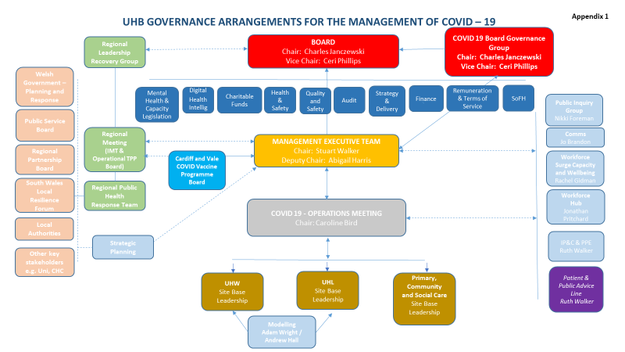

A full report on the Governance arrangements was discussed at the COVID-19 Board governance Group on 6th January 2022. It was also be reported to the Audit and Assurance Committee on 8th February 2022 (see agenda item 7.8 on the following link:

https://cavuhb.nhs.wales/files/board-and-committees/audit-and-assurance-committee-2021-22/audit-080222-final-boardbook-v7-0-pdf/

The COVID-19 Board Governance Group was stood down at the end of February 2022 and the Board has now returned to its usual cycle of meetings being every other month. The Systems Resilience Report continues to be presented to the Board at each bi-monthly meeting and the Committee business has returned to ‘business as usual’. Governance arrangements and reporting structures continue to be monitored and kept under review with the ability, after discussion and agreement of the Board, to stand the arrangements up or down as and when required.
This year the Health Board commenced preparations in readiness for an impending Public Inquiry into the COVID-19 pandemic. This included the establishment of the COVID-19 Public Inquiry Steering Group (which held its first meeting on 1 February 2022). The purpose of the Steering Group is to consider the strategy and approach to the Public Inquiry before making recommendations on the same to the Board. The Steering Group’s membership will comprise of the Independent Member Legal, Independent Member Trade Union, Chief Executive Officer, Executive Director of People and Culture, Executive Nurse Director, Medical Director and the Director of Corporate Governance. Other key members of staff may be invited to attend the Steering Group as and when required.

13.7 Board & Committee Meetings during COVID-19

During the financial year 2021-22, all meetings continued to be held virtually to enable full Board and Committee attendance and to ensure openness and transparency.

It is acknowledged that in these unprecedented times, there are limitations on Boards and Committees being able to physically meet where this is not necessary and can be achieved by other means. In accordance with the Public Bodies (Admissions to Meetings) Act 1960 the organisation is required to meet in public. As a result of the public health risk linked to the pandemic there have been limitations on public gatherings and it has not therefore been possible to allow the public to attend meetings of our Board and Committees from April 2021 to March 2022. To ensure business was conducted in as open and transparent manner as possible during this time the following actions were taken: -

- A range of online video platforms was used to enable members of the Public to observe Board meetings, thus ensuring openness and transparency. Links and recordings were published on our website.

- The agendas for the Board and for the Committees of the Board were kept to a minimum and they were agreed between the Chair and Executive Lead as per normal arrangements.

- Agendas and associated papers were, as far as possible, published 10 days in advance of the Board meetings, and 7 days in advance of the Committee meetings.

Verbal updates given at meetings were captured in the meeting minutes and, wherever possible, draft public Board minutes were made available within 1 week of the meeting.

- Provision for written questions to be taken from Board Members who were
unable to attend a Board meeting and response was provided immediately
following the meeting.

- Our website pages and social media accounts signposted the dates of the Board and Committee meetings together with information that had been published.

- The Board and Committee meeting pages on the website (which constitutes our official notice of Board and Committee meetings) explained why the Board and Committees were not meeting in public, and that all meetings were being held virtually.

As Accountable Officer, given the ongoing COVID-19 situation this approach remained under constant review with the Chair and the Board Secretary. From May 2022 onwards the Board has agreed to resume in person meetings. The Committees will continue to meet virtually whilst we continue to respond to COVID-19 and try to resume and maintain normal business throughout the year.

13.8 Composition of The Board

Refer to section 10.1.1 within the Corporate Governance Statement.

Items Considered by the Board in 2020-2021 included:

- Approval of the Annual Accounts;
- Accountability and Remuneration Reports for 2020-2021;
- Board Assurance Framework;
- Draft IMTP 2022-2025;
- Public Engagement Reports;
- Vascular Services;
- All Wales Robotic Surgery Partnership;
- Patient stories;
- Pharmaceutical Needs Assessment;
- Financial performance;
- Regular reports on Quality, Safety and Experience;
- Regular Corona Virus Reports and System Resilience Briefings;
- Performance reports in relation to key national and local targets;
- Assurance reports from the Committees and Advisory Groups of the Board;
- Terms of Reference and Workplans;
- Nurse Staffing Levels (Wales) Act.

The Board and Committee membership and Champion Roles during 2021-2022 is
presented for information at Appendix 1 to this AGS.

There have been a number of changes to the composition of the Board over the past 12 months.

The Health Board said farewell to

- Len Richards, Chief Executive on 30 September 2021.
- Steve Curry – Chief Operating Officer on 31 December 2021.
- Stuart Walker – Executive Medical Director and Deputy Chief Executive on 18 February 2022.

We also warmly welcomed the following to the Executive Team: -

- David Thomas, Director of Digital and Health Intelligence from 1 June 2021.
- Meriel Jenney – Interim Medical Director from 1 October 2021.
- Caroline Bird – Interim Chief Operating Officer from 1 January 2022.
- Suzanne Rankin – Chief Executive from 1 February 2022.

13.9 Committees

In line with Section 2 of the Health Board’s Standing Orders which provide that “The Board may and, where directed by the WG, must appoint Committees of the Health Board either to undertake specific functions on the Board’s behalf or to provide advice and assurance to the Board in the exercise of its functions”, the Board has an established Committee structure, with each Statutory Committee chaired by an Independent Member. The current Committee structure was approved at the Board meeting on 31 March 2022. On behalf of the Board, the Committees provide scrutiny, development discussions, assessment of current risks and performance monitoring in relation to a wide spectrum of the Health Board’s functions and its roles and responsibilities.

The following Board Committees were in place during 2021-2022:

Committee | Items Considered
Audit Committee  The role of the Audit Committee is to advise and assure the Board, and the Accountable Officer, on whether effective arrangements are in place to support them in their decision taking and in discharging their accountabilities in accordance with the standards of good governance determined for the NHS in Wales. | - Internal Audit Plans were submitted to each meeting providing details relating to outcomes, key findings and conclusions;  - Audit Wales reports on current and planned audits;  - Declarations of Interest Reports;  - Regulatory Compliance Tracking Reports;  - Internal & External Audit Tracking Reports;  - Procurement Compliance, Workforce Compliance and Counter Fraud Reports;  - Annual Accounts, Accountability and Remuneration Reports for 2020-2021;  - Losses and Special Payments.
Finance Committee  The purpose of this Committee is to advise and  assure the Board in discharging its responsibilities with regard to its current and forecast financial position, performance and delivery. | - Cost Reduction Programme;  - Finance Risk Register;  - Financial Monitoring Returns  - IMTP.
Strategy and Delivery Committee  The purpose of this Committee is to advise  and assure the Board on the development and  implementation of the Health Board’s overarching strategy, “Shaping our Future Wellbeing”, and key enabling plans. This includes all aspects of delivery of the strategy through the IMTP and any risks that may hinder achievement of the objectives set out in the strategy, including mitigating actions against these. | - Shaping our Future Wellbeing Progress Reports;  - Capital Plan;  - Clinical Services Plan;  - A Healthier Wales;  - Commercial Developments;  - Employment Policies;  - Key Organisational Performance Indicators;  - Workforce Plan;  - IMTP.
Mental Health Legislation and Mental Capacity Act Committee  This Committee advises the Board of any areas of concern relating to responsibilities under mental health legislation, and provides assurance that we are discharging our statutory duties under the relevant legislation. | - Mental Capacity Act and Mental Health Act Monitoring Reports;  - Deprivation of Liberty Safeguards Internal  - Audit Report;  - Mental Health Measure;  - Children and Adolescent Mental Health Service;  - Healthcare Inspectorate Wales visit.
Quality, Safety and Experience  Committee  The purpose of the Quality, Safety and Experience Committee is to provide advice to the Board with regard to the quality and safety of health services and the experience of patients, including public health, health promotion and health protection activities. | - Community Health Council (CHC) reports  - Patient Stories  - Quality, Safety and Experience framework  - HIW reports and progress  - Concerns Annual report  - Ombudsman Annual Letter
Charitable Funds Committee  The purpose of the Charitable Funds Committee is to make and monitor arrangements for the control and management of the UHB’s Charitable Funds.  Cardiff and Vale Health Charity (the Charity) is the official charity supporting all the work of the Health Board. The Charity was created on 3 June 1996 by a Declaration of Trust and following reorganisation of health services, was amended by Supplementary Deeds on 12 July  2001 and 2 December 2010.  The Health Board is the Corporate Trustee for the Charity.  The Health Board delegates responsibility for the  management of the funds to the Charitable Funds Committee. The aim of the Corporate Trustee (Trustee) is to raise and use charitable funds to provide the maximum benefit to the patients of the Health Board and associated local health services in Cardiff and the Vale of Glamorgan, by supplementing and not substituting government funding of the core services of the NHS. | - Charitable Funds Bids Panel Report  - Finance Monitoring Report  - Staff Benefits Group Report  - New Charitable Funds applications  - Charitable funds strategy  - Health Charity annual report  - Arts annual report  - Investment update
Digital Health Intelligence Committee  The purpose of this Committee is to provide assurance to the Board that:  • Appropriate processes and systems are in place for data, information management and governance to allow the Health Board to meet its stated objectives, legislative responsibilities and any relevant requirements and standards determined for the NHS in Wales;  • There is continuous improvement in relation to information governance within the Health Board and that risks arising from this are being managed appropriately;  • Effective communication, engagement and training is in place across the Health Board for Information Governance. | - Caldicott guardian requirements;  - Freedom of Information;  - General Data Protection Regulation (GDPR);  - Data breach reports;  - Policies & procedure;  - Digital Strategy
Health and Safety Committee  The purpose of the Committee is to advise and assure the Board and Accountable Officer on whether effective arrangements are in place to ensure organisational wide compliance of the Health Board’s Health & Safety Policy, approve and monitor delivery against the Health and Safety Priority Improvement plan and ensure compliance with relevant standards for Health Services in Wales. | - Fire Enforcement;  - Environmental Health Inspections;  - Enforcement agencies inspections;  - Waste management compliance;  - Lone worker devices;  - Regulatory and review body tracking report;  - Risk register
Renumeration and Terms of Service Committee  The purpose of the Committee is to provide: -  - advice to the Board on remuneration and terms of service for the Chief Executive, Executive Directors and other senior staff within the framework set by the Welsh Government; and  - assurance to the Board in relation to the Health Board’s arrangements for the remuneration and terms of service, including contractual arrangements, for all staff, in accordance with the requirements and standards determined for the NHS in Wales. | • Remuneration and terms of service matters
Shaping Our Future Hospitals Committee  This Committee oversees the development of the overall “Our Future Hospitals Programme”.  The Committee provides assurance that the leadership, management and governance arrangements are robust and appropriately discharged to deliver the outcomes and benefits of the Programme. | - Programme Business case  - Scoping of Strategic Outline case  - Programme Risk Register

The reports, workplan and terms of reference for the Committees are published on our website: https://cavuhb.nhs.wales/about-us/governance-and-assurance/committees-and-advisory-groups/

The table at Appendix 1 to this AGS sets out details of the Chair, Chief Executive, Executive Directors and Independent Members and confirms Board and Committee membership for 2021-2022, meetings attended during the tenure of the individual and any Champion roles performed. Table 1 in Appendix 2 of the AGS sets out Board and Committee Dates for 2021-2022.

The Chair of each Committee reports to the Board on the Committee’s activities outlining key risks and highlighting areas which need to be brought to the Board’s attention in order to contribute to its assessment of assurance and provide scrutiny against the delivery of objectives. The Committees, as well as reporting to the Board, also work together on behalf of the Board to ensure, where required, that cross reporting and consideration takes place and assurance and advice is provided to the Board and the wider organisation. Further, in line with Standing Orders, each Committee has produced an annual report, for 2021/22, setting out a helpful summary of its work.

All Committees have undertaken a review of their Terms of Reference in 2021-2022 and these were formally approved by the Board at its meeting on 31 March 2022.

Copies of Committee papers and minutes, a summary of each Committees’ responsibilities and Terms of Reference are available on the Health Board’s website: https://cavuhb.nhs.wales/about-us/our-board/committees-and-advisory-groups/

Each Committee maintains an Action Log that is monitored at each meeting.
Each of the main Committees of the Board are supported by an underpinning subcommittee structure reflecting the remit of its roles and responsibilities.

13.10 Advisory Groups & Joint Committees

In support of the Board, the Health Board is also required to have three Advisory Groups.

The Advisory Groups and Joint Committee include:

Stakeholder Reference Group (SRG)

The SRG is formed from a range of partner organisations from across the Health Board area. Its role is to provide independent advice on any aspect of Health Board business. It facilitates full engagement and active debate amongst stakeholders from across the communities served by the Health Board, with the aim of presenting a cohesive and balanced stakeholder perspective to inform Health Board planning and decision making.

This may include:

- Early engagement and involvement in the determination of the Health Board’s overall strategic direction;
- Provision of advice on specific service improvement proposals prior to formal consultation; and
- Feedback on the impact of the Health Board’s operations on the communities it serves.

Significant issues upon which the SRG was engaged during 2021-2022 included:

- Recovery Planning
- Shaping Our Clinical Services
- Integrated Medium Term Plan 2022-25
- Priority Setting,
- Acute Cancer Services
- Quality, Safety and Experience Framework
- University Hospital of Wales 2.

Local Partnership Forum (LPF)

Please refer to paragraph 6.3 of the Performance Overview section of this Annual Report.

Healthcare Professionals’ Forum (HPF)

The HPF comprises representatives from a range of clinical and healthcare professions within the Health Board and across primary care. This Advisory Group is currently undergoing review and therefore has not met during 2021- 22. The Health Board has a number of mechanisms to seek clinical input, for example a representative of the Consulting body attended Board meetings, feeding in comment from Consultant engagement on key issues such as major trauma and thoracic surgery. Reviewing this Advisory Group’s Terms of Reference, membership and developing its work programme and function to best use these mechanisms, establish a robust structure and avoid duplication will be a governance priority for 2022-23.

Terms of Reference and minutes of all the Advisory Groups are available via the following link:
https://cavuhb.nhs.wales/about-us/governance-and-assurance/committees-and-advisory-groups/

Welsh Health Specialised Services Committee (WHSSC)

WHSSC was established in 2010 by the seven health boards to ensure the population has fair and equal access to the full range of specialised services. Hosted by Cwm Taf Morgannwg University Health Board, the Health Board is represented on the joint committee by the Chief Executive and regular reports are received by the Board.

Emergency Ambulance Services Committee (EASC)

EASC is a joint committee of the seven health boards, with the three NHS trusts as associate members, and was established in April 2014. It has responsibility for the planning and commissioning of emergency ambulance services on an all-Wales basis. Hosted by Cwm Taf Morgannwg University Health Board, the Health Board is represented on the joint committee by the Chief Executive and regular reports are received by the Board.

NHS Wales Shared Services Partnership (NWSSP) Committee

The NWSSP Committee was established in 2012 and is hosted by Velindre NHS Trust. It looks after the shared functions for NHS Wales, such as procurement, recruitment and legal services. The Health Board’s representative is the Director of Workforce and OD and regular reports are received by the Board.

13.11 Public Appointments
Lance Carver, Director of Social Services Vale of Glamorgan Council, was reappointed as an Associate Member of our Board on 2nd November 2021.
Sam Austin was appointed as the Chair of the Stakeholder Reference Group on 1st November 2020 until 31st October 2022 which was a retrospective appointment due to COVID-19.
13.12 Public interest Declaration
Each Board Member has stated in writing that they have taken all the steps that they ought to have taken as a Director in order to make auditors aware of any relevant audit information. All Board Members and Senior Managers and their close family members (including Directors of all Hosted Organisations) have declared any pecuniary interests and positions of authority which may result in a conflict with their responsibilities. A full register of interests for 2021-2022 is available upon request from the Director of Corporate Governance.

13.13 Board and Committee Membership & Attendance 2021-2022

The Board has been constituted to comply with the Local Health Boards (Constitution, Membership and Procedures) (Wales) Regulations 2009. The Table attached to Appendix 1 to this AGS outlines the Board and Committee Membership and the record of attendance for the period April 2021- March 2022.

13.14 The Purpose of the System of Internal Control
During the year, thought our systems of internal control, breaches were identified in relation capital schemes and expenditure in particular around the procurement, governance and financial monitoring of capital schemes and capital expenditure. A review was undertaken by the Health Board and an action plan put in place to ensure that lessons were learnt and the breaches did not reoccur in the future. Please see agenda item 8.1 on the following link: https://cavuhb.nhs.wales/files/board-and-committees/board-2021-22/2021-11-25-final-boardbook-v9-pdf1/.
The Chair of the Board and Chair of Audit Committee were briefed on the issues as soon as they were identified and the Board were briefed at the Private Board Meeting in July 2021. The Chief Executive has also had a ‘no surprises’ conversation with Dr Andrew Goodall, Director General of Health and Social Services/Chief Executive NHS Wales. Audit Wales were also briefed on the situation and after discussion and review of the action plan which had been put in place agreed that no further action was required. The Health Board’s Internal Auditors have also undertaken a review of the action plan which was approved by the Board.
13.15 Capacity to handle risk

The Health Board’s systems of control are designed to manage risk to a reasonable level rather than to eliminate all risks; it can therefore only provide reasonable and not absolute assurance of effectiveness.

The Health Board’s system of control is based on an ongoing process designed to identify and prioritise the risks to the achievement of its policies, aims and objectives, to evaluate the likelihood of those risks being realised and the impact should they be realised, and to manage them efficiently, effectively and economically. The system of internal control has been in place for the year ended 31 March 2021 and up to the date of approval of the annual report and accounts.
The Health Board is committed to developing and implementing a Risk Management and Board Assurance Framework that identifies, analyses, evaluates and controls the risks that threaten the delivery of its strategic objectives. The Health Board’s Assurance Framework (BAF) is used by the Board to identify, monitor and evaluate risks which impact upon Strategic Objectives and is considered alongside other key management tools, such as the Corporate Risk Register, performance and quality dashboards and financial reports, to give the Board a comprehensive picture of the organisational risk profile.
The Health Board’s Risk Management and Board Assurance Framework Strategy (the Strategy) was updated and approved by the Board in July 2021 and sets out responsibilities for strategic and operational risk management for the Board and staff throughout the organisation and describes the procedures to be used in identifying, analysing, evaluating and controlling risks to the delivery of strategic objectives.
Strategic risks are significant risks that have the potential to impact upon the delivery of strategic objectives and are raised and monitored by the Executive Team and the Board. Operational risks are key risks that affect individual Clinical Boards and Corporate Directorates and are managed within the Clinical Boards and Corporate Directorates and if necessary, escalated through the Health Board’s risk reporting structure (See Figure 1).

Figure 1 – Risk Management Reporting Structure

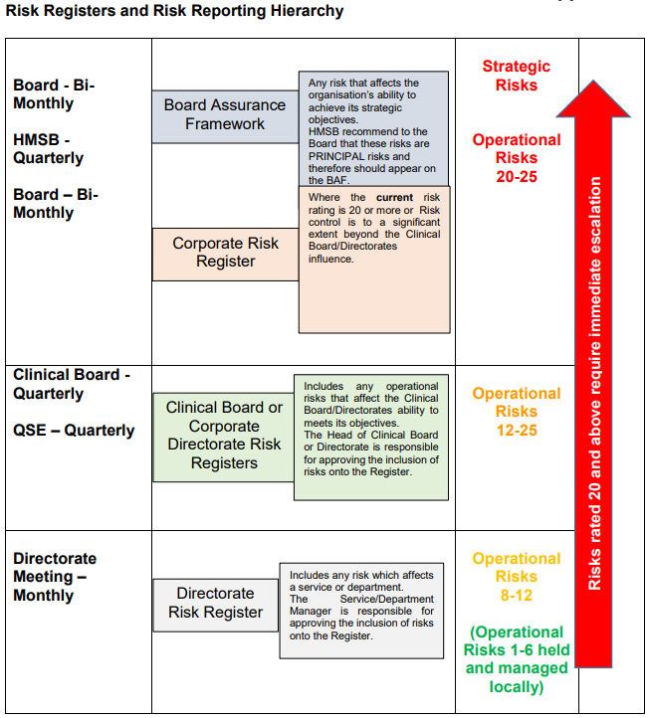

The Board Assurance Framework (BAF) is an integral part of the system of internal control and defines the extreme potential risks which impact upon the delivery of strategic objectives. It also summarises the controls and assurances that are in place or plans to mitigate them. The BAF aligns principal risks, key controls and assurances on controls alongside each of the Health Boards strategic objectives.
Gaps are identified where key controls and assurances are insufficient to reduce the risk of non-delivery of objectives. This enables the development of an action plan for closing the gaps and mitigating the risks which is subsequently monitored by the Board for implementation.
The Strategy applies to those members of staff that are directly employed by the Health Board and for whom the Health Board has legal responsibility and is intended to cover all the potential risks that the organisation could be exposed to.
A copy of the Strategy can be found at the following link:

https://cavuhb.nhs.wales/files/policies-procedures-and-guidelines/corporate-policy/r-corporate-policy/risk-management-and-baf-strategy/

The objectives of Strategy are to:

- minimise impact of risks, adverse incidents, and complaints by effective risk identification, prioritisation, treatment and management;
- maintain a risk management framework, which provides assurance to the Board that strategic and operational risks are being managed effectively;
- maintain a cohesive approach to corporate governance and effectively manage risk management resources;
- ensure that risk management is an integral part of the Health Board’s culture;
- minimise avoidable financial loss, or the cost of risk transfer through a robust financial strategy;
- ensure that the Health Board meets its obligations in respect of Health and Safety; and
- Describe the resources available for risk management in the organisation.

As of March 2022, the following risks were identified as posing the greatest risk to the delivery of the Health Board’s strategic objectives:

- Workforce
- Sustainable Primary and Community Care
- Patient Safety
- Sustainable Culture Change
- Capital Assets
- Planned Care Capacity
- Delivery of Annual Plan
- Staff Wellbeing
- Exacerbation of Health Inequalities in Cardiff and Vale

In addition to the above risk, the Health Board’s Financial Sustainability is kept under constant review and is reported to the Board at each Board meeting. As of the end of March 2022 Financial Sustainability is not listed as a risk in the BAF due to the fact that the Health Board has achieved it target rating by expected delivery of the Financial Plan for 2021/22.

Alongside the Board Assurance Framework, the Health Board also maintains a Corporate Risk Register that identifies the extreme operational risks (those scored at 20/25 or higher) that the Health Board is facing.

Each of the risks detailed within the Corporate Risk Register is also linked to a Committee of the Board and the Board Assurance Framework.

As of March 2022, there were 17 Extreme risks detailed on the Corporate Risk Register with the following score profile:

- 1 risk rated at 15/25 which had reduced from a score of 20/25 at the January 2022 Board meeting; and

- 16 risks rated 20/25.

Details of these risks and the Health Board’s Corporate Risk Register Report and the Health Board’s Board Assurance Framework and covering report for March 2022 can be found at the following link:

https://cavuhb.nhs.wales/files/board-and-committees/board-2021-22/2022-03-31-public-board-papers-v14-pdf/

As previously highlighted the need to plan and respond to the COVID-19 pandemic presented a number of challenges to the organisation. A number of new and emerging risks where identified. Whilst the organisation did have a major incident and business continuity plan in place, as required by the Civil Contingencies Act 2004, the scale and impact of the pandemic has been unprecedented. Significant action has been taken at a national and local level to prepare and respond to the likely impact on the organisation and population. This has also involved working in partnership on the multi-agency response as a key member of the Strategic Co-ordination Group. There does remain a level of uncertainty about the overall impact this will have on the immediate and longer term delivery of services by the organisation, although I am confident that all appropriate action is being taken.

The organisation continues to work closely with a wide range of partners, including the Welsh Government as it continues with its response, and planning into the recovery phase. It will be necessary to ensure this is underpinned by robust risk management arrangements and the ability to identify, assess and mitigate risks which may impact on the ability of the organisation to achieve their strategic objectives.

13.16 Management of Risk

Overall responsibility for the Risk Management and Board Assurance Framework Strategy lies with the Director of Corporate Governance who has delegated responsibility for managing the development and implementation of the Risk Management and Board Assurance Framework Strategy. Arrangements are in place to effectively assess and manage risks across the organisation, which includes the ongoing review and updating of the Board Assurance Framework and the Corporate Risk Register so that the Board maintains a line of sight on the Health Board’s key strategic and operational risks.

The Director of Corporate Governance retains control of the BAF and meets with Executive Leads for BAF risks on a bi-monthly basis to ensure that the risks detailed within the BAF are regularly updated to include new and emerging risks to service areas so that the entries provide an accurate and contemporaneous reflection of the risks faced by the Health Board.

The BAF is also presented to the Board for scrutiny and approval on a bi-monthly basis and the Audit and Assurance Committee, as a sub-committee of the Board, has oversight of the process through which the Board gains assurance in relation to the management of the BAF.

The Corporate Governance Department monitor and maintain the Corporate Risk Register. Each Corporate Department and Clinical Board has responsibility to maintain a comprehensive risk register which forms the basis of the risks that are reflected within the Corporate Risk Register. The Corporate Governance Department regularly meet with Clinical Board and Corporate Department risk leads to review and monitor their Clinical Board/Corporate Department and local level risk registers to ensure that they accurately record the risks that their areas are encountering and to assist those areas in considering new and emerging risks to their service. Following that exercise extreme operational risks, those scored 20/25 or higher, are recorded on the Corporate Risk Register and reported to the Board for scrutiny and approval on a bi-monthly basis (in public since January 2021). Any risks that are identified as having the potential to impact on the Health Board’s strategic objectives are added to the BAF. Each risk detailed on the Corporate Risk Register is also linked to a Strategic Risk contained in the BAF to ensure that risks are appropriately monitored and escalated.

The key risks detailed in the BAF and Corporate Risk Register are also shared at relevant sub-committees of the Board for further scrutiny and discussion. The BAF risks are reviewed at the following sub-committees of the Board:
- Workforce – Strategy and Delivery Committee
- Sustainable Primary and Community Care – Strategy and Delivery Committee
- Patient Safety – Quality, Safety and Experience Committee
- Sustainable Culture – Strategy and Delivery Committee
- Capital Assets - Finance Committee and Strategy and Delivery Committee
- Planned Care Capacity - Strategy and Delivery Committee
- Delivery of Annual Plan - Strategy and Delivery Committee
- Staff Wellbeing – Strategy and Delivery Committee
- Exacerbation of Health Inequalities in Cardiff and Vale - Strategy and Delivery Committee

The Corporate Risk Register entries are also referred to those Committees to which they are linked on the Corporate Risk Register. Following the January 2022 Board meeting all Mental Health Risks recorded within the Corporate Risk Register were discussed and scrutinised at the February 2022 Mental Health Legislation and Mental Capacity Act Committee and all Patient Safety Risks were shared at the February Quality, Safety and Patient Experience Committee. Those risks linked to the Strategy and Delivery Committee were discussed at the March 2022 Committee meeting.
The Corporate Governance Department provide staff with training in the management of functional work place risk management processes and assessments. The management of the Health Board’s Corporate Risk Management Training is managed by the Corporate Governance Department.
The Corporate Governance Department offer training sessions to risk leads through targeted training programmes that are informed by the team’s regular interactions with Clinical Boards and Corporate Departments. Alongside this, since March 2021 the team has provided a weekly virtual Risk Management online training session which is available to all staff members. The Corporate Governance Department’s training plan is designed to embed a consistent approach to the management, scoring and recording of risk from ward to board across the Health Board.
The risks detailed in the BAF and Corporate Risk Register are considered when determining the Health Board’s risk appetite. The Health Board acknowledges that the delivery of healthcare cannot be achieved unless risks are taken, as well as the subsequent consequences and mitigating actions. It also ensures that risks are not considered in isolation and are taken following consideration of all the risks flowing through the organisation.

The Board also revisited its Risk Appetite at a Board Development session in June 2021. This was to discuss Risk Appetite and to check that the direction of travel was right and that the Board were moving in the right direction from a position of ‘Cautious’ to ‘Seek’.
Communicating and consulting with internal and external stakeholders and partners, as appropriate, at each stage of the risk management process and concerning the process as a whole is important. The frequency of the communication will vary depending upon the severity of the risk and is discussed and agreed with the stakeholders and partners as necessary. This process is led by the person nominated as the lead to manage the risk and for communication with external stakeholders this will be the appointed Executive Director lead for the risk. As the designated lead for Risk Management the Director of Corporate Governance also attends the Health Board’s Stakeholder Reference Group to brief public stakeholders on the activities of the Board including the management or risk.
13.17 Risk Management During COVID-19
Please refer to section 13.16 (Management of Risk) above.

14. Planning Arrangements

For 2021/2022 the Health Board was not required to develop a full three-year IMTP because Welsh Government had suspended the requirement for and IMTP in response to the pandemic. The Health Board submitted an annual plan for 2021/2022 which was approved by the Board, and was in line with the planning guidance produced by Welsh Government.

The 2019 – 2022 IMTP was still in existence so the duty to achieve balance over the three-year period was achieved by the end of 2022.

In the Autumn of 2021, Welsh Government confirmed that the National Planning Framework was being re-commenced and planning guidance was published. Planning work was started on the 2022 – 2025 IMTP well in advance of the publication of the planning guidance, and a draft IMTP was approved by the Board in March 2022 for submission to Welsh Government. The Health Board had agreed with Welsh Government officials an extension of three months to enable further work to be done on finalising the financial recovery plan with a view to submitting a final IMTP for Welsh Government consideration at the beginning of quarter 2.

15. MANDATORY DISCLOSURES

15.1 Health and Care Standards

In 2017-18 a revised set of Health and Care Standards were issued to NHS Wales. In particular, a new standard for Governance, leadership and Accountability was introduced. The health service needs to consider the following criteria for meeting the standard:
- Health services demonstrate effective leadership by setting direction, igniting passion, pace and drive, and developing people.
- Strategy is set with a focus on outcomes, and choices based on evidence and people insight. The approach is through collaboration building on common purpose.
- Health services innovate and improve delivery, plan resource and prioritise, develop clear roles, responsibilities and delivery models, and manage performance and value for money.
- Health services foster a culture of learning and self-awareness, and personal and professional integrity
- The Health and Care Standards underpin all our QSE activity–we consider the impact and learning from all internal and external inspections and reports. With detailed status or improvement plans if required shared and monitored through the QSE process as described in section 15.7 (Quality Governance Arrangements).
- Through the introduction of Tendable across clinical areas we will further develop, measure and monitor a suite of quality indicators.
.

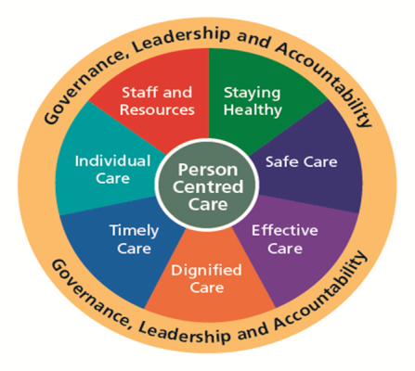

15.2 Equality, Diversity and Human Rights

Please refer to section 6.4 of the Performance Report.

15.3 Welsh Language Regulations - The Welsh Language Standards (No. 7) Regulations 2018 (WLO)

The Welsh Language Standards have given the organisation the opportunity to improve the level of Welsh language services we provide for our patients, services users and the wider population. However, COVID-19 and the subsequent recovery period has meant that the implementation has been slower than anticipated in some key areas.
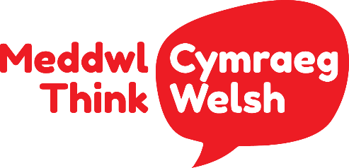

In 2021/22 we continued with the internal campaign to raise awareness of the language, asking staff to ‘Think’ about how considering the Welsh Language may improve the service that they provide. This encourages staff to consider how they can incorporate the Welsh Language into their everyday roles, and about the role they can play in encouraging the growth of the language within the Health Board and amongst colleagues.
The following have been implemented in line with the ideals and aspirations of the Welsh Language Standards and the Meddwl Cymraeg – Think Welsh campaign:
- All Standards have been reviewed and updates provided by the standard owners by utilising ‘Verto’ project management software which monitors the implementation and progress of our actions to meet the Welsh Language Standards. The system will allow us to determine the success of both the campaign and the implementation of the standards using a RAG rating system that outlines the closed, open and progressing standards. The overall plan will be successful when the ‘Closed’ green standards outnumber the ‘Open’ and ‘Progressing’ standards meaning the Health Board is progressing towards full compliancy. We have now completed the work on 79 of the 120 Standards and continue to review the outstanding Standards. The Equality Strategy and the Welsh Language Standards Group was established to receive assurances from the Clinical Boards that they are complying with the Standards. They also report back on risks associated with non-compliance and what steps they will take to ensure they comply with the Standards. We have been working will local frontline services, such as telephone service (the main telephone switchboard), to ensure that it provides the best level of services in Welsh. It has also worked with the Patient Records team to ensure that it can offer correspondence (I.e. patient appointment letters) to patients and service users who prefer to receive it in Welsh.
- We have ensured that our COVID 19 vaccination programme complies with the Standards by offering a bilingual service on its appointment booking system via an automated messaging and a Welsh speaking booking agent.
- Pioneered the patient admission pack for Welsh speaking patients within Mental Health, Paediatrics and Intensive Care Unit. The pack assists patients in ensuring that they receive healthcare in their preferred language of Welsh.
- Continued with promoting the ‘Think Welsh’ campaign via specific awareness days including Shwmae Day, Welsh Language Rights Day, Welsh Language Music Day, Diwrnod Santes Dwynwen Day and St David’s Day.
- Working with the Cedar Team in the all-Wales service ‘NHS Value in Health’ organisation to establish a Welsh Language Co-ordinator role to assist with ensuring that their PROMS (Patient-Reported Outcome Measures) process complies with the Welsh Language Standards.
- The organisations’ two Senior Welsh Language Translators have translated over 1 million words since joining the organisation.
- The Health Board’s website is now available in a bilingual format.
- Established an Eisteddfod within the organisation. It was a competition open to staff to win a prize in four different categories.
- A bilingual welcome and phrase wall place on the Woodland House stairwell, which provides simple Welsh phrases that staff can learn whilst walking around the office.
We have received a total of 9 complaints in 2021/2022 from the Welsh Language Commissioner. All concerns have undergone investigations followed by recommendations that the Board is expected to comply with. The recommendations that have been carried out has meant that the organisation has improved its compliance on the Welsh Language standards around social media, its website and phone services.
Work on all of the concerns has been completed as of 17/03/2022.
31% of members of staff have registered their language skills and in April 2022 there will be a campaign to encourage staff to register their Welsh Language skills.

The organisation is still working on categorising which posts require Welsh as desirable or essential. Guidance has been developed but the implementation of it was delayed by operational pressures faced due to COVID-19 and the recovery from it. This guidance and the requirement to advertise bilingually will be rolled out on a phased basis, starting with Corporate departments, from April 2022.

15.4 Emergency Preparedness

As previously highlighted the need to plan and respond to the pandemic presented a number of challenges to the organisation. A number of new and emerging risks where identified. Whilst the organisation did have a major incident and business continuity plan in place, as required by the Civil Contingencies Act 2004, the scale and impact of the pandemic has been unprecedented. Significant action has been taken at a national and local level to prepare and respond to the likely impact on the organisation and population. This has also involved working in partnership on the multi-agency response as a key member of the Strategic Co-ordination Group. There does remain a level of uncertainty about the overall impact this will have on the immediate and longer-term delivery of services by the organisation, although we are confident that all appropriate action is being taken.

The organisation continues to work closely with a wide range of partners, including the Welsh Government as it continues with its response, and planning into the recovery phase. It will be necessary to ensure this is underpinned by robust risk management arrangements and the ability to identify, assess and mitigate risks which may impact on the ability of the organisation to achieve their strategic objectives.

During 2021/2022 the Major Incident Plan was updated and approved by the Board on 30 September 2021.

15.5 Environmental, Social and Community Issues

Our mission is “Caring for People, Keeping People Well”, and our vision is that a person’s chance of leading a healthy life should be the same wherever they live and whoever they are.
The Health Board's 10-year transformation and improvement strategy, Shaping Our Future Wellbeing, is our chance to work collaboratively with the public and the Health Board ‘s workforce to make our health board more sustainable for the future. Together, we can improve equity for all of our patients - both today and tomorrow click here to access the Strategy: https://cavuhb.nhs.wales/about-us/our-mission-vision/shaping-our-future-wellbeing-strategy/.
We believe that everyone should have the opportunity to lead longer, healthier and happier lives. But with an ageing population and changing lifestyle habits, our health and care systems are experiencing increasing demand.
Delivering on our responsibilities to reduce our carbon footprint has been a priority for the Health Board since acknowledging the climate emergency in January 2019. The Health Board has developed a Sustainability Action Plan which was updated to reflect the Welsh Government’s NHS Wales Decarbonisation Plan.
Vale of Glamorgan Public Services Board Climate Change Charter Public sector partners in the Vale of Glamorgan have formally expressed their commitment to tackling climate change by agreeing a Vale Public Services Board Climate Change Charter https://www.valepsb.wales/en/Our-Progress/Tackling-Climate-Change-in-the-Vale-ofGlamorgan.aspx.
The development of the Charter follows discussions over the last 14 months including a workshop held in November 2019 with young people where we were joined by members of the Health Board’s Youth Board alongside enthusiastic youngsters from local schools and the Vale Council’s Youth Forum. Natural Resources Wales has taken a lead in this work, which fully aligns to the Health Board’s Sustainability Action Plan approved at the November 2020 Board. The Charter signs partners up to a set of principles including leading by example, taking positive action and reducing our impact, while recognising that approaches and plans for implementation within individual Organisations may differ. We wanted to bring this work to the attention of the Board and for the Board to support the Charter ahead of a formal launch by the Public Service Board (PSB) in February; the aim is for this to provide a catalyst for engagement with the wider community on the issues and how we can make a difference in line with the commitments in the charter.
Similarly, the PSB in Cardiff has identified carbon reduction as a key priority and a partnership programme has been developed, led by the Council. The Health Board is an active participant in this work and it is aligned with the Sustainability Action Plan. The Health Board’s Health Charity is supporting an award-winning programme to improve our environment, linked to our Biodiversity Plan. The development of the Orchard and Horiatio’s Garden at UHL, and the meadow project at UHW are examples of the great work being done to use our outside green space for the health and wellbeing of our patients, staff and visitors.
We also have clinical teams driving forward changes in clinical practice and service models to reduce our carbon footprint, as detailed in previous section on our Sustainability Action Plan (see paragraph 8 of the Performance Report).
We also work with a wide range of third sector and community groups and the social prescribing work being led by the Cardiff SW Cluster which provides examples of the health benefits of undertaking activities outside, as seen by the outcomes achieved through community gardening and walking initiatives.
All hospital grounds in Cardiff and Vale Health Board Area are now Smoke-Free Our hospital grounds are now smoke-free. New laws introduced across Wales on 1 March, build on the smoking ban introduced in 2007 and will protect more people from harmful second-hand smoke and help those trying to quit. Anyone found breaking the law by smoking in the hospital grounds could face a £100 fine. The health board has been instrumental in supporting a smoke-free hospital environment and was the first health board in Wales to introduce a full No Smoking Ban across all hospital sites.
15.6 Carbon Reduction Delivery Plans
Please refer to section 8 (Sustainability Report) of the Performance Report.

15.7 Quality Governance Arrangements

An essential feature of our control framework is ensuring there is a robust system for measuring and reporting on the quality of our services. Our Quality Safety and Experience Committee provides timely evidence based advice to the Board to assist it in discharging its functions and meeting its responsibilities with regards to quality and safety as well as providing assurance in relation to improving the experience of all those that come into contact with our services. Please also refer to section 7 of the Performance Report for further information.

15.8 Ministerial Directions and Welsh Health Circular’s (WHCs)

Ministerial Directions and WHCs issued by the Welsh Government for the period April 2022- March 2022 have been considered and where appropriate implemented. Full details of each WHC can be found at the following link: https://gov.wales/health-circulars.

During the financial year 2021/22 regular updates on the implementation of Welsh Health Circular implementation and the detail of new WHCs has been shared with the Health Board’s Management Executive Team to provide oversight of the process.

Details of the Ministerial Directions issued by the Welsh Government during 2021/22 which have been considered and, where appropriate, implemented are set out in Appendix 3 attached to this AGS.

15.9 Regulatory and Inspection Reports

The Corporate Governance Department track all regulatory and inspection reports by means of a Legislative and Regulatory Tracker report which is presented to each meeting of the Audit Committee. Prior to presentation to the Audit Committee the tracker is populated with information from Executive Director Leads and individuals who are accountable for regulatory compliance.

The Legislative and Regulatory Tracker includes the following:

- All Regulatory Bodies who inspect the Health Board.
- The Regulatory Standard being inspected.
- An Executive Lead for each inspection.
- An assurance Committee where Regulatory reports may also be presented along with action plans for improvement where required.

The Legislative and Regulatory Tracker was last reviewed by Internal Audit in July 2021 and received a reasonable assurance rating. The Corporate Governance Directorate also track all Internal Audit Recommendations and all Audit Wales Recommendations along with management responses. Recommendations are added to the trackers for monitoring once the reports have been signed off by the Audit and Assurance Committee.

A formal system is in place to track regulatory and inspection reports against statutory requirements.
These reports are made available to the appropriate Board Committee and are discussed at Management Executives and Health System Management Board which includes the entire leadership team of the organisation. Quarterly follow ups also take place with the Executive Leads.

15.10 Data Security and Information Governance

Risks relating to information are managed and controlled in accordance with the Health Board’s Information Governance Policy through the Digital Health and Intelligence Committee, which is chaired by an Independent Member.

The Executive Medical Director, as Caldicott Guardian, is responsible for the protection of patient information. All Information Governance issues are escalated through the Digital Health and Intelligence Committee (DHIC Committee). The DHIC Committee papers can be viewed here: https://cavuhb.nhs.wales/about-us/governance-and-assurance/committees-and-advisory-groups/digital-and-health-intelligence-committee/.

The following items were considered by the DHIC Committee in 2021-2022:

- Digital Strategy;
- GDPR Audit Action Plan;
- IT Delivery Programme;
- Information Governance Compliance Reports;
- Information Governance Risk Register;
- Information Governance Policy.

The Director of Digital & Health Intelligence assumes the role of the Senior Information Risk Owner (SIRO) which provides an essential role in ensuring that identified information security risks are addressed and incidents properly managed. Following the ICO audit, which took place in February 2020, the Health Board has received ‘reasonable assurance’ on its assurance and compliance, which incorporated outstanding recommendations from the ICO audit in 2016, the Internal Audit on GDPR compliance, the Audit Wales 2018 Structured Assessment and the Caldicott Principles in Practice (CPiP), has been superseded by recommendations from the ICO 2020 audit. The action plan is regularly reviewed at the DHIC Committee. During 2021/2022, the Information Governance Department continued to work to complete the outstanding actions.

The ICO conducted a follow up review in November 2021. The number of recommendations closed was 15 with 10 remaining open, of which 5 were ‘high’ but the ‘urgent’ recommendation had been closed.

The Board has strict responsibilities to ensure personal data and information is held securely. All information governance related incidents are investigated and reviewed by the Information Governance Group.

During the period April 2021 and March 2022 there were 4 personal data security incidents which needed to be reported to the Information Commissioners Office (ICO).

Reportable breach number 1

A member of staff disclosed criminal offence data relating to a patient.

Reportable breach number 2

A member of staff viewed a relative’s record on a regular basis.

Reportable breach number 3

A member of staff accessed the health records of their manager on three occasions.

Reportable breach number 4

An off-site storage facility containing Health Board archived records flooded.

There has been a focus on keys areas that have the most impact in terms of compliance with the following key areas being progressed:

- A National Intelligent Integrated Audit Solution (NIIAS) work plan
- Reducing the number of outstanding Freedom of Information Requests accrued during the pandemic
- Reducing the number of outstanding subject access requests accrued during the pandemic
- Regular and formal reviews of suppliers who provide the Health Board new and existing data processing activities.
- Development work with South Wales Police to ensure Data Protection obligations are met in relation to Police requests.

The Health Board continues to reinforce awareness of key principles of Data Protection legislation. This includes the overarching principle that users must only handle data in accordance with people’s data
protection rights.

15.11 NHS Pension Scheme
As an employer with staff entitled to membership of the NHS Pension Scheme, control measures are in place to ensure all employer obligations contained within the Scheme regulations are complied with. This includes ensuring that deductions from salary, employer’s contributions and payments in to the Scheme are in accordance with the Scheme rules, and that member Pension Scheme records are accurately updated in accordance with the timescales detailed in the Regulations.

15.12 UK Corporate Governance Code

Corporate governance is, in simple terms, the way in which organisations are directed, controlled and led. Good corporate governance is fundamental to an effective and well managed organisation.
The UK Corporate Governance Code (the Code) is the primary reference and overview of good practice for corporate governance in Central Government Departments. Whilst there is no requirement to comply with all elements of the Corporate Governance Code, the Health Board considers that it is complying with the main principles of the Code, where applicable, and follows the spirit of the Code to good effect, is conducting its business in an open and transparent manner, and in line with the Code.
An assessment against the Code was undertaken in April 2021, and a further assessment undertaken as part of the Committee Effectiveness Survey in April 2022. There were no reported/identified departures from the Corporate Governance Code during the year.

15.13 Review of Effectiveness

As Accountable Officer, I have responsibility for reviewing the effectiveness of the system of internal control. My review of the system of internal control is informed by the work of the internal auditors, and the Executive officers within the organisation who have responsibility for the development and maintenance of the internal control framework, and comments made by external auditors in their audit letter and other reports.

Internal Sources | External Sources
- Performance management reports  - Service change management reports  - Workforce information and surveys  - Benchmarking  - Internal and clinical audit reports  - Board and Committee reports  - Local Counter Fraud work  - Health and Care Standards assessments  - Executive and Independent Member Safety Walk Rounds  - Results of internal investigations and Serious Incident reports  - Concerns and compliments  - Whistleblowing and Safety Valve  - Infection prevention and control reports  - Information governance toolkit self-assessment  - Patient experience surveys and reports  - Compliance with legislation (e.g. Mental Health Act/Health and Safety, Data Protection) | - Population Health Information  - Audit Wales  - Welsh Risk Pool (WRP) Assessment reports  - Healthcare Inspectorate Wales (HIW) reports  - Community Health Council visits and scrutiny reports  - Feedback from healthcare and third sector partners  - Royal College and Deanery visits  - Regulatory, licensing and inspection bodies  - External benchmarking and statistics  - Accreditation Schemes  - National audits  - Peer reviews  - Feedback from service users  - Local networks (e.g. cancer networks)  - Welsh Government reports and feedback

Further sources of assurances are identified within the Board’s own performance management and assurance framework and include, but are not limited to:

- Direct assurances from management on the operation of internal controls through the upward chain of accountability
- Internally assessed performance against the Health and Care Standards
- Results of internal compliance functions including Local Counter-Fraud, Post Payment Verification, and risk management
- Reported compliance via the Welsh Risk Pool regarding claims standards and other specialty specific standards reviewed during the period
- Reviews completed by external regulation and inspection bodies including the Audit Wales and Healthcare Inspectorate Wales (HIW).

The effectiveness of the system of internal control is maintained and reviewed by the Committees of the Board in respect of assurances received. This is also supported by the BAF with high risks being closely monitored by Board and the respective Committees.

Governance, Leadership and Accountability

15.14 Board and Committee Effectiveness

Routine monitoring of the effectiveness of the Board and its Committees is a vital part of ensuring strong and effective governance within the Health Board’s governance structure. Under its Standing Orders, the Board is required to introduce a process of regular and rigorous self-assessment and evaluation of its own operations and performance and that of its Committees and Advisory Groups. Further, and where appropriate, the Board may determine that such evaluation may be independently facilitated.
In order to evaluate and demonstrate the effectiveness of the Board and the Board’s Committees the following actions took place during 2021-2022:-
- The Chair of the Board and the Chair of each Committee review the effectiveness of individual meetings as part of the agenda at each respective meeting.
- Each Committee of the Board developed an Annual Report which is reviewed by each Committee before presentation to Public Board in March. The Annual Reports are signed off by each Committee Chair and provide assurance to the Board that the Committees have met their Terms of Reference.
- A self-effectiveness review is undertaken by Committee Members, Committee Attendees and Board Members. These reviews were undertaken just after the end of the financial year and the results are summarised below (see paragraph 15.15).

15.15 Committee Effectiveness Survey

The Health Board undertook an annual review of the effectiveness of its Board and its Committees in April 2022 using survey questions derived from best practice guides, including the NHS Handbook, and using the following principles:
• the need for sub-Committees to strengthen the governance arrangements of the Health Board and support the Board in the achievement of the strategic objectives,
• the requirement for a Committee structure that strengthens the role of the Board in strategic decision making and supports the role of non-executive directors in challenging Executive management actions,
• maximising the value of the input from non-executive directors, given their limited time commitment,
• supporting the Board in fulfilling its role, given the nature and magnitude of the Health Board’s agenda.
The findings of the Annual Committee Effectiveness Survey 2021-2022 can be accessed here https://cavuhb.nhs.wales/files/board-and-committees/audit-assurance-committee-2022-23/12522-audit-public-final-boardbookpdff/ - see agenda item 7.2). The results and actions plans, where relevant, will be presented to each Committee and then to the Board.
The overall findings were positive and revealed some improvements following last year’s surveys, thus providing an assurance that the governance arrangements and Committee structure in place are effective, and that the Committees are effective in supporting the Board in fulfilling its role.

15.16 Escalation and Intervention Arrangements

Please refer to section 13.2 of the AGS.

16. Internal Audit

Internal Audit provides me as Accountable Officer and the Board through the Audit Committee with a flow of assurance on the system of internal control. I have commissioned a programme of audit work which has been delivered in accordance with public sector internal audit standards by the NHS Wales Shared Services Partnership. The scope of this work is agreed with the Audit and Assurance Committee and is focussed on significant risk areas and local improvement priorities.
The overall opinion by the Head of Internal Audit on governance, risk management and control are a function of this risk-based audit programme and contributes to the picture of assurance available to the Board in reviewing effectiveness and supporting our drive for continuous improvement.
The programme has been impacted by the need to respond to the COVID-19 pandemic with some audits deferred, cancelled or curtailed as the organisation responded to the pandemic. The Head of Internal Audit is satisfied that there has been sufficient internal audit coverage during the reporting period in order to provide the Head of Internal Audit Annual Opinion. In forming the Opinion, the Head of Internal Audit has considered the impact of the audits that have not been fully completed.

16.1 The Head of Internal Audit Opinion

In accordance with the Public Sector Internal Audit Standards (PSIAS), the Head of Internal Audit (HIA) is required to provide an annual opinion, based upon and limited to the work performed on the overall adequacy and effectiveness of the Health Board’s framework of governance, risk management and control. This is achieved through an audit plan that has been focused on key strategic and operational risk areas and known improvement opportunities, agreed with Executive management and approved by the Audit and Assurance Committee, which should provide an appropriate level of assurance.

Due to the considerable impact of COVID-19 on the Health Board, the internal audit plan has needed to be agile and responsive to ensure that key developing risks are covered. As a result of this approach, and with the support of officers and independent members across the Health Board, the plan has been delivered substantially in accordance with the agreed schedule and changes required during the year, as approved by the Audit and Assurance Committee (the ‘Committee’). In addition, regular audit progress reports have been submitted to the Committee. Although changes have been made to the plan during the year, I can confirm that I have undertaken sufficient audit work during the year to be able to give an overall opinion in line with the requirements of the Public Sector Internal Audit Standards.

The Internal Audit Plan for 2021/22 year was initially presented to the Committee in April 2021. Changes to the plan have been made during the course of the year and these changes have been reported to the Committee as part of our regular progress reporting.

The Head of Internal Audit opinion on the overall adequacy and effectiveness of the Health Board’s framework of governance, risk management, and control is set out below.

Reasonable Assurance |   - +  Yellow | The Board can take reasonable assurance that arrangements to secure governance, risk management and internal control, within those areas under review, are suitably designed and applied effectively. Some matters require management attention in control design or compliance with low to moderate impact on residual risk exposure until resolved.

In reaching this opinion I have identified that the majority of reviews during the year concluded positively with robust control arrangements operating in some areas.
From the opinions issued during the year, six were allocated Substantial Assurance, ten were allocated Reasonable Assurance and seven were allocated Limited Assurance. No reports were allocated a ‘no assurance’ opinion. In addition, three advisory or non-opinion reports were also issued in relation to: -

- Arrangements to support the delivery of Mental Health Services – Mental Health Clinical Board.
- Major Capital Scheme – UHW II
- Development of Integrated Audit Plans
At the time of producing the draft Annual Report, six audits were still work in progress with the assurance rating yet to be confirmed.

16.2 Limited Assurance
During the year Internal Audit issued seven audit reports with a conclusion of limited assurance. They included:
• Ultra sound governance Clinical Diagnostics and Therapeutics Clinical Board
The audit report identified a lack of communication of the revised Medical Ultrasound Risk Management Policy and Procedure. It also concluded that the Ultrasound governance arrangements required a review.
In response to the recommendations the Health Board put in place an action plan which included the following actions:
- To promote of the Medical Ultrasound Risk Management Policy and Procedure through the appropriate groups within the Health Board.

- To implement an Ultrasound Clinical Governance Group (UCGG) chaired by the Executive Director of Therapies and Health Science, with membership of the UCGG sourced from all Directorates which used ultrasound. The Terms of Reference for the UCGG would to be reviewed to ensure it had appropriate governance arrangements.

- Clinical Audit

The limited assurance rating reflected the enhancements that are required to the Health Board’s Clinical Audit structures and governance arrangements. The key areas the Health Board has to address relate to (i) the development and introduction of a Clinical Audit Strategy, Policy and Procedures, and (ii) the development of resources and systems to effectively monitor all Clinical Audit activity.

The Health Board agreed to the following actions to address the recommendations made in the Audit report.

- To develop a Clinical Audit Strategy, a Clinical Audit Policy and subsequent Procedure, and mandate staff to implement the same on a consistent basis.
- To secure the provision of a management system for monitoring and tracking clinical audits.

- Five Steps to Safer Surgery

The overall assurance rating reflected the enhancements that were required to the Health Board’s systems and processes to ensure that the Five Steps to Safer Surgery is complied with, and that compliance can be evidenced.

The Internal Audit report stated that the key areas the Health Board had to address were to (i) put in place mechanisms to record two out of the Five Steps to Safer Surgery (specially step one – briefing, and step five – debriefing), and (ii) ensure full completion of patient files to evidence Five Steps to Safer Surgery (Steps 2, 3 & 4).
The Health Board’s agreed action plan to address the recommendations made included: -

- the development (in collaboration with a third party) of the theatre operating software so that it records all 5 stages of the ‘5 Steps to Safer Surgery’ electronically; and
- to ensure staff are aware of the change in process and provide any necessary training.

- IT Service Management (ITIL)
The audit found that there are poor controls in place over the IT Service Desk function. The report acknowledged that the Health Board are planning major improvements by implementing a new call handling system, restructuring the service desk department and introducing new ways of working based on the ITIL Framework.

- Network & Information Systems (NIS) Directive
The audit identified a small number of measures for improvement with regards to the Cyber Assessment Framework. The Health Board is actively addressing those measures.
At the time of writing this Annual Report, the Health Board had just received audit reports with limited assurance in relation to the following: -

- Nurse Bank (Temporary Staffing Department)
The overall assessment for this audit was of limited assurance due to the lack of resilience within the current structure of the Temporary Staffing Department, which impacts upon the operational effectiveness of the Nurse Bank. The audit also identified issues around recruitment to the Nurse Bank, payment to agencies, and a general lack of engagement with service users.

- ChemoCare IT System
Whilst the audit report noted that there is a framework for control over the ChemoCare system and there were areas of good practice, it also identified some areas for improvement. This includes, updating some out-of-date versions of software, strengthening weaknesses within the Business Continuity Plan, Hosting and Backup arrangements and password policy. There is also a lack of formal supplier's performance monitoring mechanism.

There were no audited areas in which the Health Board received a “No assurance” assessment rating.

17. External Audit - Audit Wales

The Auditor General for Wales is the Health Board’s statutory External Auditor and the Wales Audit Office undertakes audits on his behalf. Since 1 April 2020 the Auditor General for Wales and the Wales Audit Office are known collectively as Audit Wales. Audit Wales scrutinises the Health Board’s financial systems and processes, performance management, key risk areas and the Internal Audit function.

17.1 The Annual Audit Report for 2021

Audit Wales’ annual programme of work at the Health Board is set out in the Audit Plan. The 2021 Audit Wales Audit Plan was approved by the Audit and Assurance Committee on 9 February 2021.
Reports produced by Audit Wales in line with the Audit Plan are presented to the Audit and Assurance Committee. A Management Response is prepared for reports which contain recommendations. All recommendations are subsequently recorded in the External Audit Recommendations Tracker. A Tracking Report is provided to each Audit and Assurance Committee to provide assurance on their implementation.
The following reports relating directly to the work of the Health Board were presented to the Audit and Assurance Committee:

Report | Month
Financial audit reports
Charitable Funds (2019-20 Accounts) - Audit of Financial Statements Report | January 2021
Audit of Financial Statements Report | June 2021
Opinion on the Financial Statements | June 2021
Audit of Financial Statements Report Addendum | August 2021
Performance audit reports
Doing it Differently, Doing it Right? (Structured Assessment 2020 All-Wales themes, lessons and opportunities relating to NHS governance during COVID-19 | January 2021
Test, Trace, Protect in Wales: An Overview of Progress to Date | March 2021
Structured Assessment 2021: Phase 1 Operational Planning Arrangements | April 2021
Welsh Health Specialised Services Committee Governance Arrangement | May 2021
Rollout of the COVID-19 vaccination programme in Wales | June 2021
Taking care of the carers? (Structured Assessment 2020 All-Wales themes, lessons and opportunities relating to NHS staff wellbeing during COVID-19) | October 2021
Radiology Services: Update on Progress | December 2021
Structured Assessment 2021: Phase 2 Corporate Governance and Financial Management Arrangements | December 2021
Other
2021 Audit Plan | January 2021

The Audit and Assurance Committee also reviews the outcomes of national pan-sector reviews at the earliest possible meeting following their publication.
The Annual Audit Report 2021 did not identify any material weaknesses in the Health Board’s internal controls (as relevant to the audit) and concluded that:

- whilst the Test, Trace, and Protect programme had struggled to cope with earlier peaks in virus transmission, it had demonstrated an ability to rapidly learn and evolve in response to the challenges it had faced.
- The COVID-19 vaccination programme in Wales has been delivered at significant pace with local, national and UK partners working together to vaccinate a significant proportion of the Welsh population. A clear plan is now needed for the challenges which lie ahead.
- In relation to the Welsh Health Specialised Services Committee Governance Arrangements, the governance, management and planning arrangements have improved, but the impact of COVID-19 will now require a clear strategy to recover services and there would still be benefits in reviewing the wider governance arrangements for specialised services in line with the commitments within ‘A Healthier Wales.
- All NHS bodies have maintained a clear focus on staff wellbeing throughout the pandemic and implemented a wide range of measures to support the physical health and mental wellbeing of their staff during the crisis. It is vital that these activities are built upon, and that staff wellbeing remains a central priority for NHS bodies as they deal with the combined challenges of recovering services, continuing to respond to the COVID-19 pandemic, and also managing seasonal pressures.
- In relation to the conclusions draw from the Audit Wales’ Structured Assessment, please see paragraph 17.2 below.

Whist the audit report did not identify any material weaknesses in the Health Board’s internal controls, it drew attention to the impact of a Ministerial Direction to the Permanent Secretary of the Welsh Government, instructing her to fund NHS clinicians’ pension tax liabilities incurred by NHS Wales bodies in respect of the 2019-20 financial year.
The Health Board’s accounts were properly prepared and materially accurate which resulted in an unqualified audit opinion on the accounts. However, whilst the Health Board achieved financial balance for its capital expenditure for the three-year period to 31 March 2021, it did not achieve financial balance for its revenue expenditure for the same period, with a three-year deficit of £9.724 million. This has resulted in a qualified opinion on the regularity of the financial transactions within the Health Board’s 2020-21 accounts. Other than the Health Board’s failure to meet financial balance for its revenue expenditure, there were no material elements of income or expenditure which the Health Board did not have the power to receive or incur.
The Annual Audit Plan for 2022 was presented to the Audit and Assurance Committee on 5 April 2022. The Audit Plan sets out an initial timetable for the completion of Audit Wales’ audit work. However, given the on-going uncertainties around the impact of COVID-19 on the sector, some timings may need to be revisited. Any changes will be reported to the Audit and Assurance Committee accordingly.
The planned work on the IM&T Control & Risk Assessment was Deferred as the last assessment was only finalised in May 2022 and the agreed actions are being monitored through the Health Board’s tracker.
The Planned work on the Digital Strategy Roadmap was deferred to the 22/23 plan and will be included in the scope of the Digital Strategy audit.

17.2 Cardiff and Vale University Health Board - Structured Assessment
The Audit Wales Structured Assessment for 2021 provides an assessment of the Health Board’s corporate arrangements for ensuring that resources are used efficiently, effectively and economically.
The Audit Wales Structured Assessment was carried out in two phases during 2021/22.
Phase 1 considered the operational planning arrangements at Cardiff & Vale University Health Board.
Phase 2 considered how corporate governance and financial management arrangements have adapted over the last 12 months.
The Structured Assessment for 2021 found that:
- Overall, the Health Board’s arrangements for developing operational plans are effective, but opportunities to strengthen arrangements for monitoring and reporting on delivery of operational plans remain.
- The Health Board has effective Board and Committee arrangements which are underpinned by maturing systems of assurance, but opportunities to strengthen public transparency of Board business remain.
- The Board maintains robust oversight of Health Board’s finances. The Health Board identified certain weaknesses in financial controls relating to procurement and expenditure on major capital projects which it is addressing.
- The pandemic continues to pose a risk to the Health Board’s ability to break even.
The Structured Assessment can be accessed via the following links:
Phase 1
https://audit.wales/sites/default/files/publications/cvuhb_sa.pdf
Phase 2
https://www.audit.wales/sites/default/files/publications/cardiff_vale_health_board_structured_assessment_2021_phase_two_english_0.pdf

18. Modern Slavery Act 2015 – Transparency in Supply Chains

The Welsh Government’s Code of Practice: Ethical Employment in Supply Chains was published in May 2017 to highlight the need, at every stage of the supply chain, to ensure good employment practices exist for all employees, both in the UK and overseas. It is expected that all NHS Wales organisations will sign up for the Code.

The Health Board fully endorses the principles and requirements of the Code and the Modern Slavery Act 2015 and is committed to playing its role as a major public sector employer, to eradicate unlawful and unethical employment practices, such as:

- Modern Slavery and Human rights abuses;
- The operation of blacklist/prohibited lists;
- False self-employment;
- Unfair use of umbrella schemes and zero hours’ contracts; and
- Paying the Living Wage.

The following actions are in place which meet the Code’s commitments:
- We have a Raising Concerns (Whistleblowing) Policy, which provides the workforce with a fair and transparent process, to empower and enable them to raise suspicions of any form of malpractice by either our staff or suppliers/contractors working on the Health Board premises;
- We have a target in place to pay our suppliers within 30 days of receipt of a valid invoice;
- We comply with the six NHS pre-employment check requirements to verify that applicants meet the preconditions of the role they are applying for. This includes a right to work check;
- We have introduced robust IR35 processes to ensure the fair and appropriate engagement of all workers and prevents individuals from avoiding paying Tax and National Insurance contributions;
- We do not engage or employ staff or workers on zero hours’ contracts;
- We have in place an Equality and Diversity Policy which ensures that no potential applicant, employee or worker engaged is in any way unduly disadvantaged in terms of pay, employment rights, employment or career opportunities;
- We also seek assurances from suppliers, via the tender process, that they do not make use of blacklists/prohibited lists. We are also able to provide confirmation and assurances that they do not make use of blacklist/prohibited list information;
- In accordance with Transfer of Undertaking (Protection of Employment) Regulations any Health Board staff who may be required to transfer to a third party will retain their NHS Terms and Conditions of Service;
- We use the Modern Slavery Act (2015) compliance tracker by way of contracts procured by NHS Wales Shared Services Partnership (NWSSP) on behalf of the Health Board. NWSSP is equally committed to ensuring that procurement activity conducted on behalf of NHS Wales is undertaken in an ethical way. On our behalf, they ensure that workers within the supply chains through which they source our goods and services are treated fairly, in line with Welsh Government’s Code of Practice for Ethical Employment in Supply Chains.
The Health Board continues to work in partnership with relevant stakeholders and trade union partners to develop and implement actions which set out our commitment to ensure the principles of ethical employment within our supply chains are implemented and adhered to.
19. Conclusion
As Accountable Officer, based on the assurance process outlined above, I have reviewed the relevant evidence and assurances in respect of internal control. I can confirm that the Board and its Executive Directors are alert to their accountabilities in respect of internal control.
During 2021-2022, we have again proactively identified areas requiring improvement and requested Internal Audit to undertake detailed assessments in order to manage and mitigate associated risks. A number of reports issued by Internal Audit concur with our view and have consequently provided the Health Board with clear recommendations to ensure that focussed and urgent management actions are in place to address identified shortcomings. These actions are then monitored through the Board and its Committees to ensure appropriate assurances can be provided. The Health Board’s Structured Assessments 2021 undertaken by Audit Wales provided a positive view of the organisation’s arrangements in relation to Corporate Governance, Financial Management and the planning arrangements underpinning the development of the Operational Plan. The Health Board also identified issues in relation to capital schemes and expenditure in particular around the procurement, governance and financial monitoring of capital schemes and capital expenditure. A review was undertaken by the Health Board and an action plan put in place to ensure that lessons were learnt and the breaches did not reoccur in the future.
As indicated throughout this statement and the Annual Report effective governance remained in place throughout the pandemic with appropriate scrutiny and governance over the decision-making process during the COVID-19 Pandemic. At the start of the new financial year the Health Board moved towards a recovery position with Governance arrangements returning to ‘business as usual’. However, given the fast moving and unpredictable nature of the pandemic, we continued to keep our Governance arrangements under review to ensure they remain flexible to adapt to any situation which may arise.
The need to plan and respond to the COVID-19 pandemic has had a significant impact on the organisation, wider NHS and society as a whole. It has required a dynamic response which has presented a number of opportunities in addition to risks. The need to continue to recover from the pandemic will be with the organisation and wider society throughout 2022-2023 and beyond. I will ensure our Governance Framework considers and responds to this need.
I am confident that our systems of internal control have remained robust throughout the pandemic and now into recovery and am assured that there have been no significant internal control or governance issues during 2021-22.
In summary, my review confirms that the Board has sound systems of internal control in place to support the delivery of policy aims and our corporate objectives and that there are no significant internal control or governance issues to report for 2021-2022
Signed by

Chief Executive:

Date:

Appendix 1

Board and Committee Membership & Attendance 2021-2022

Name | Position and dates | Area of Expertise/  Representation Role | Board Committee Membership and Record of Attendance | Champion Roles
Charles Janczewski | Chair  1 April 2021 to present | Chair | - Board 9/9  - Board of Trustee 3/3  - RATs 6/6 | Putting Things Right  Wellbeing of Future Generations Act
Professor Ceri Phillips | Vice Chair  1 April 2021 to present |  | - Board 8/9  - Board of Trustees 2/3  - Audit 6/7  - QSE 3/4  - Strategy & Delivery 2/4  - MHLC 4/4  - Health & Safety 1/2  - CFC 1/1  - DHIC 1/1  - RATs 6/6 | Mental Health
Professor Gary Baxter  Michael Imperato | Independent Member  1 April 2021 to present  Independent Member  1 April 2021 to present | University  Legal | - Board 9/9  - Board of Trustee 2/3  - QSE 6/6  - DHIC 3/3  - Strategy & Delivery 4/6  - Shaping our Future Hospitals (SOFH) 4/4  - Board 8/9  - Board of Trustee 3/3  - Health & Safety 3/3  - Mental Health Legislation and Mental Capacity Act (MHLC) 2/2  - QSE 2/2  - DHIC 3/3  - RATS 5/6  - Strategy & Delivery 6/6 | Older Persons
David Edwards | Independent Member  1 April 2021 to present | Information Communication and Technology | - Board 7/9  - Board of Trustee 1/3  - MHCL 3/3  - Audit 4/7  - DHIC 3/3  - SoFH 3/4  - Finance 4/8
Councillor Susan Elsmore | Independent Member  1 April 2021 to present | Local Authority | Board 7/9  Board of Trustee 1/3  - Charitable Funds  - QSE 5/6  - RATS 2/6 | Social Services and Wellbeing (Wales) Act
Akmal Hanuk | Independent Member  1 April 2021 to present | Local Community | - Board 7/9  - Board of Trustee 3/3  - Charitable Funds 4/4  - Health and Safety 3/3  - MHLC 0/4  - QSE 2/4  - RATS 1/6 | Infection Prevention and Control

Name | Position | Area of Expertise/  Representation Role | Board Committee Membership and Record of Attendance | Champion Roles
Sara Moseley | Independent Member  1 April 2021 to present | Third (Voluntary) Sector | - Board 9/9  - Board of Trustee 1/3  - Charitable Funds 2/4  - MHLC 2/4  - Strategy & Delivery 6/6  - DHIC 1/2 | Equality
Dr Rhian Thomas | Independent Member  1 April 2021 to present | Capital & Estates | - Board 9/9  - Board of Trustee 3/3  - Health & Safety 1/1  - RATS 6/6  - Strategy & Delivery 6/6  - Health & Safety 1/1  - SOFH 4/4  - Finance 11/12 | Children and Young People
John Union | Independent Member  1 April 2021 to present | Finance | - Board 8/9  - Board of Trustee 3/3  - Audit 7/7  - RATS 4/6  - Finance 12/12  - SOFH 3/4
Mike Jones | Independent Member  1 April 2021 to present | Trade Union | - Board 9/9  - Board of Trustee 1/3  - Health and Safety 3/3  - QSE 5/6  - CFC 4/4  - Audit 7/7 | Raising Concerns
Sam Austin | Associate Member  1 April 2021 to present | Chair, Stakeholder Reference Group | - Board 7/9
Lance Carver | Associate Member  1 April 2021 to present | Director of Social Services, Vale of Glamorgan | - Board 5/9
Len Richards  Dr Stuart Walker  Suzanne Rankin | Chief Executive  April 2021 to 30 September 2021  Interim Chief Executive  1 October 2021 to 31 January 2022  Deputy Chief Executive 1 March 2021 to 30 September 2021 and 1 February 2022 to 18 February 2022  1 February 2022 to present |  | - Board 3/3  - Audit 0/5  - Finance 4/6  - SoFH 0/2  - RATS 3/3  - Board 6/6  - Audit 0/2  - Finance 6/10  - SofH 1/3  - RATS 2/3  - Board 2/2  - Finance 1/2  - RATS 1/1
Catherine Phillips | Executive Director of Finance  1 April 2021 – to present | Finance | - Board 8/9  - Board of Trustee 1/3  - Audit 7/7  - Finance 9/12  - QSE  - Strategy & Delivery 3/6  - SOFH 4/4
Dr Stuart Walker  Professor Meriel Jenney | Executive Medical Director  April 2021 to 30 September 2021  Interim Executive Medical Director  1 October to present | Medical / Quality & Safety  Medical / Quality & Safety | - QSE 3/5  - MHLC 0/3  - SoFH 1/1  - Board 4/6  - QSE 3/3  - MHLC 0/1  - Audit 1/1  - Strategy & Delivery 1/1  - SoFH 0/3 | Caldicott
Ruth Walker | Executive Director of Nursing  1 April to present | Nursing / Quality & Safety | - Board 9/9  - Board of Trustee 1/3  - Charitable Funds 4/4  - QSE 5/6  - MHCL 3/4  - Finance 4/12  - Strategy & Delivery 1/6 | Children and Young People  Putting Things Right
Steve Curry  Caroline Bird | Chief Operating Officer (1 April to 31 December 2021)  Interim Deputy Chief Executive  1 October to 31 December 2021  Interim Chief Operating Officer (1 January 2021 to present) | Operations  Operations | - Board 6/6  - MHCL 2/3  - QSE 3/5  - Finance 7/8  - Audit 1/7  - Strategy & Delivery 2/4  - Finance 7/8  - Board 3/3  - MHLC 2/2  - QSE 0/2  - Finance 3/4  - Strategy and Delivery 1/2 | Age protected characteristic
Abigail Harris | Executive Director of Strategic Planning  1 April 2021 to present  Interim Deputy Chief Executive 1 January – 31 January 2021 | Estates & Planning | - Board 9/9  - Board of Trustee 0/3  - Strategy & Delivery 5/6  - QSE 1/6  - Finance 8/12  - SOFH 4/4  - Health & Safety 0/3 | Emergency Planning
Dr Fiona Jenkins | Executive Director of Therapies and Health Sciences  1 April 2021 to present | Therapies and Life Sciences | - Board 9/9  - Board of Trustee 3/3  - Charitable Funds 3/4  - QSE 5/6  - Strategy & Delivery 1/1  - Health & Safety 0/3 | Armed Forces and Veterans
Rachel Gidman | Interim Director of People and Culture  1 April 2021 to 2 May 2021  Executive Director of People and Culture  3 May 2021 to present | Workforce | - Board 5/9  - Board of Trustee 1/3  - Health and Safety 2/3  - Audit 6/7  - CFC 0/4  - RATS 4/6  - Finance 4/12  - Strategy & Delivery 5/6 | Fire Safety  Violence and Aggression  Welsh Language
Fiona Kinghorn | Executive Director of Public Health  1 April 2021 to present | Public Health | - Board 9/9  - Board of Trustee3/3  - QSE 2/6  - Health & Safety 2/3  - Strategy & Delivery 4/6 | Sex/Gender protected characteristic

Name | Position | Area of Expertise/  Representation Role | Board Committee Membership and Record of Attendance | Champion Roles
Non-Voting Members
Nicola Foreman | Director of Corporate Governance  1 April 2021 to present | Governance | - Board 9/9  - Board of Trustee 3/3  - Charitable Funds 2/4  - Health and Safety 2/3  - MHLC 4/4  - QSE 5/6  - Audit 7/7  - DHIC 3/3  - RATS 6/6  - Strategy & Delivery 6/6  - SoFH 4/4  - Finance 10/12
David Thomas | Director of Digital and Health Intelligence  1 June 2021 to present | Digital | - Board 8/9  - DHIC 3/3  - Strategy & Delivery 3/5
Allan Wardaugh | Chief Clinical Information Officer  1 April 2021 to 31 May 2021 | Digital | Board 1/1

Appendix 2

Dates of Board and Committee meetings held during 2021-2022

Tables 1 and 2 outlines respectively the (i) dates of Board and Committee meetings held during 2021-2022, and (ii) the dates of Advisory Group meetings held during 2021-2022, highlighting any meetings that were inquorate:

Table 1 - Dates of Board and Committee meetings held during 2021-2022

Board/Committee | April | May | June | July | Aug | Sep | Oct | Nov | Dec | Jan | Feb | March
Board | 29 | 27 | 10 and 24  Both Special | 29 | 26  (Private Board only) | 30 | x | 25 | 16 | 27 | 24 | 31
Board of Trustee |  |  |  | 15  Special |  |  | 12 |  |  | 20
Audit Committee | 06 | 13  Workshop | 10  Special | 06 |  | 07 |  | 09 |  |  | 08
Charitable Funds |  |  | 29 |  |  | 21 |  |  | 07 |  |  | 01
Digital Health & Intelligence |  |  | 01 |  |  |  | 05 |  |  |  | 01
Finance | 28 | 26 | 23 | 28 | 25 | 29 | 27 | 24 | 30 | 05 and 26 | 16 | 23
Health & Safety |  |  |  | 27 |  |  | 12 |  |  | 25 |  | 30
Mental Health Legislation & Mental Capacity Act | 20 |  |  | 20 |  |  | 19 |  |  |  | 09  Inquorate
Quality, Safety & experience | 13 |  | 15 |  |  | 15 | 26  Special |  | 14 |  | 22
Remuneration & Terms of Service |  | 25 |  | 14 |  | 15 |  |  | 16 | 27 | 09
Strategy & Delivery |  | 11 |  | 13 |  | 14 |  | 16 |  | 01 |  | 15
Shaping Our Future Hospital |  |  |  | 21 |  |  | 13 |  |  | 12 |  | 09

All meetings held were quorate, except the Mental Health Legislation and Mental Capacity Act Committee meeting held on 9 February 2022.
Where meetings were inquorate, escalation arrangements were in place to ensure that any matters of significant concern that could not be brought to the attention of the Committee could be raised with the Health Board’s Chair.

Table 2 - Dates of Advisory Group meetings held during 2021-2022

Advisory Groups | April | May | June | July | Aug | Sep | Oct | Nov | Dec | Jan | Feb | March
Stakeholder Reference |  | 25 |  | 27 |  | 29 |  | 23 |  | 25 |  | 22
Healthcare Professional Forum
Local Partnership Forum | 22 |  | 17 |  | 18 |  | 21 |  | 01 |  | 17

The Health Board was also represented on the following Joint Committees:
- Welsh Health Specialised Services Committee (WHSSC)
- Emergency Ambulance Services Committee (EASC)
- NHS Wales Shared Services Partnership Committee (SSPC)
Assurance reports/bulletins from the above Committees are captured on the Board agenda as required.

Appendix 3
Ministerial Directions and Welsh Health Circulars

Ministerial Directions/Date of Compliance | Date/Year of Adoption | Action to Demonstrate implementation/response
National Health Service Directions on cross border healthcare and reimbursement of costs of treatment within the EU (WHC/2021/005) | 06 Apr 2021 | Circular shared with Executive lead and cascaded to colleagues.
Protocol for dealing with violence and aggression towards NHS staff (WHC/2021/012) | 22 Apr 2021 | Circular shared with Executive lead and cascaded to colleagues.
2021/2022 LHB, SHA & Trust Monthly Financial Monitoring Return Guidance WHC/2021/011 | 23 Apr 2021 | Circulated to key staff and managers and discussed at appropriate meeting.
Revised national steroid treatment card (WHC/2021/008) | 27 May 2021 | Circular shared with Executive lead and appropriate colleagues. New Treatment card is in use across the Health Board and featured in the August 2021 edition of the UHB Medicines Safety Newsletter.
The national influenza immunisation programme 2021 to 2022 (WHC/2021/019) | 04 Aug 2021 | The actions detailed within the Circular have been referred to the Executive Director of Public Health and her team. Reported
Introduction of Shingrix® for immunocompromised individuals from September 2021 (WHC/2021/021) | 01 Sept 2021 | Circular referred to Executive Lead and colleagues for action – From September 2021 actions managed by GP Practices.
NHS Wales’ contribution towards a net-zero public sector by 2030 (WHC/2021/024) | 08 Sept 2021 | Circular shared with Executive Lead and Decarbonisation Programme Manager to progress in line with the Health Board’s Decarbonisation plans.
All Wales Carpal tunnel syndrome pathway (WHC 2021/025) | 15 Sept 2021 | Circular shared and pathway implemented and signed off by hand surgeons and GP leads. Feedback shared with Welsh Government regarding the referral pathway
Review of standing orders, reservation and delegation of powers (WHC/2021/010) | 16 Sept 2021 | Circular Shared with Director of Corporate Governance and Head of Corporate Governance who have implemented required changes.
Publication of the quality and safety framework (WHC/2021/022) | 17 Sept 2021 | Circular shared with Executive colleagues and cascaded to Corporate nursing team to ensure that the document and the recommendations were included within plans for the Health Board’s Framework roll out plans.
Care decisions for the last days of life (WHC/2021/023) | 23 Sept 2021 | Circular shared with Executive lead and cascaded to clinical colleagues.
Healthcare associated infections and antimicrobial resistance improvement goals (WHC/2021/028) | 27 Sept 2021 | Circular shared with Executive lead and cascaded to clinical colleagues and Infection Prevention and Control Leads.
NHS Wales blood health plan (WHC/2021/027) | 27 Sept 2021 | Circular shared with Executive Leads and cascaded to clinical leads and areas for review and implementation.
Overseas visitors' eligibility to receive free primary care (WHC/021/026) | 06 Oct 2021 | Circular shared with Executive Leads and cascaded to appropriate operational leads for review and implementation.
NHS Wales Planning Framework 2022 to 2025 (WHC/2021/031) | 09 Nov 2021 | Circular shared with Executive Lead and cascaded to planning leads for review and incorporation into the Health Board’s IMTP processes.
Role and provision of dental public health in Wales (WHC/2021/032) | 16 Nov 2021 | Circular shared with Executive Leads and cascaded to clinical leads and areas for review and implementation.
Role and provision of oral surgery in Wales (WHC/2021/033) | 14 Dec 2021 | Circular shared with Executive Leads and cascaded to clinical leads and areas for review and implementation. Feedback received confirms that the direction of the dental service within the Health Board is in line with the future of Shaping our Future Health Services.
Health board allocations 2022 to 2023 (WHC/2021/034) | 09 Feb 2022 | Circular received and shared with Executive Leads.
Recording of dementia read codes (WHC/2022/007) | 15 Feb 2022 | Circular shared with Executive Leads and cascaded to clinical leads and areas for review and implementation.
Welsh Value in Health Centre: data requirements (WHC/2022/005) | 24 Mar 2022 | Circular shared with Executive Leads and cascaded to clinical leads and areas for review and implementation.
Patient Testing Framework – Updated guidance (WHC/2022/011) | 24 Mar 2022 | A copy of the Circular was shared by global email to all Health Board colleagues for review.
Reimbursable vaccines and eligible cohorts for the 2022 to 2023 NHS seasonal influenza (flu) vaccination programme (WHC/2022/010) | 29 Mar 2022 | Circular shared with Executive Leads and cascaded to clinical leads and areas for review and implementation.

Renumeration and Staff
Report

Part 2b
20. Remuneration and Staff Report

  - Staff Numbers

The Health Board workforce profile identifies that approximately 76% of the workforce is female. This is not representative of the local community where a little more than half the population is female. The numbers of female and male directors, managers and employees as at 31st March 2022 were as follows:

 | Female | Male | Total
Director | 12 | 9 | 21
Manager | 167 | 99 | 263
Employee | 12548 | 3852 | 16403
Total | 12727 | 3960 | 16687

  - Staff Composition

We have a diverse workforce of almost 16,000 staff working in many different types of roles, and together with volunteers, colleagues in social care and carers, we have a huge impact on our population. We must know and understand the shape of our workforce if we are to successfully monitor and revise plans that result in the right workforce at the right time, enabling and empowering the workforce to work to the ‘top of their licence’ or scope of practice. Our People and Culture Plan recognises that in addition to the challenges brought about by the pandemic and the necessary period of recovery, we, along with the broader NHS in Wales, face social, economic, technological and demographic changes. As a result of this the demographic of our workforce also needs to change, and we must adjust the way we recruit, retain and support our people.

The charts below indicate the following challenges when determining optimal ways to deploy the current and future workforce and how to consider future supply against service priorities:

- The Health Board has an aging workforce with the largest age categories being aged 31-35 years (2,193 staff) and 51-55 years (2,122 staff). The impact of employees retiring from service critical areas is key in Clinical Boards undertaking local workforce planning.

- The largest grade categories are staff in Agenda for Change Bands 2, 5 and 6. Continually reviewing skill mix and new ways of working is important in ensuring adequate future supply of skills in the right place and grade. There is also a need for further workforce modernisation, new roles and extended skills, supported by the improvement of workforce intelligence and workforce planning skills. This includes the development of appropriate efficiency and productivity measures that help facilitate benchmarking and demonstrate value as our workforce shape continues to change.

- The majority of the workforce is female (76%) with an even split in this group of full-time (39%) and part-time working (37%). Use of our employment policies, such as the Adaptable Workforce Policy and Flexible Working Procedure, is crucial to retaining talent and keeping staff engaged.

- The majority of the workforce is white (77%) with 11% in Black and Minority Ethnic categories and 12% not stated. The Strategic Equality Plan has a number of actions to continue to review of our workforce in this regard to ensure it strives to reflect the local population where relevant e.g. in recruiting practices.

- The nursing and midwifery registered staff and unregistered nursing staff make up just over 42% of the total workforce. Given there is a recognised national shortage of registered nurses, the Health Board has made nurse sustainability a high priority on its workforce agenda. Although we can’t influence the actual supply of registered workforce in the short term, we can concentrate our efforts on attracting people by improving the branding of the Health Board promoting the benefits of working here, and targeting specific groups in society.

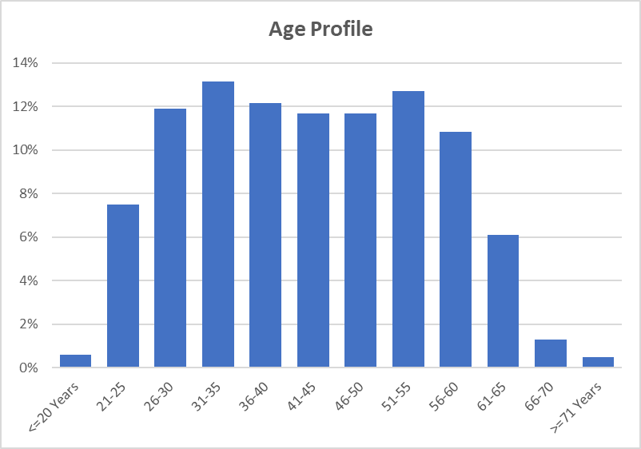

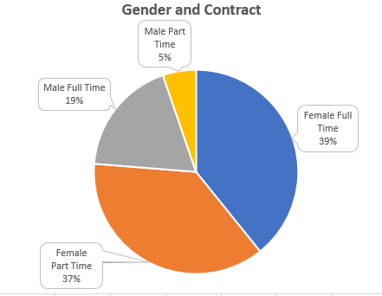

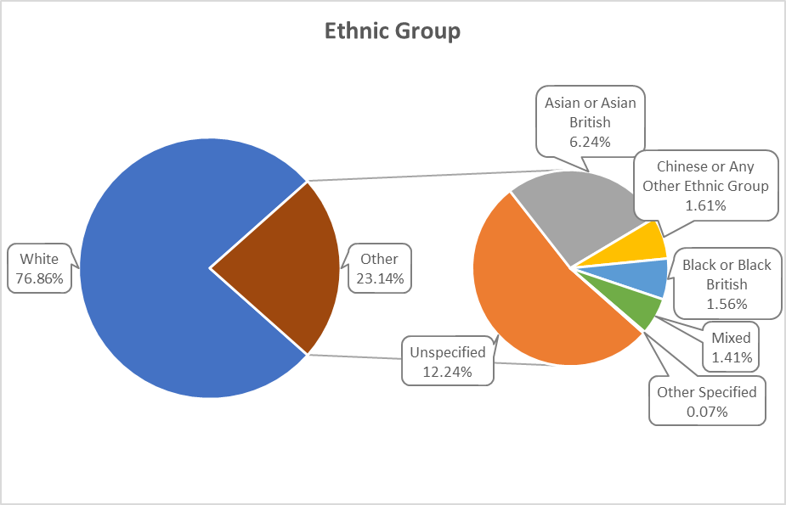

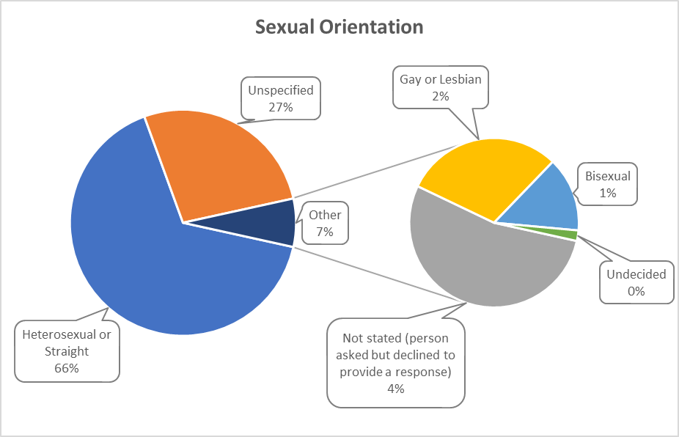

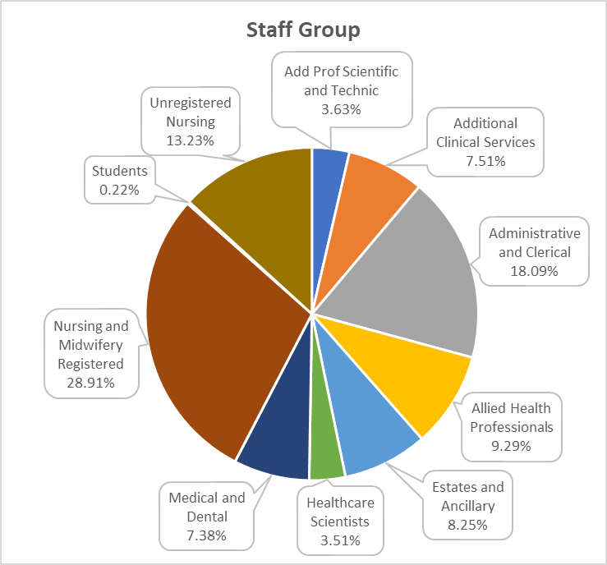

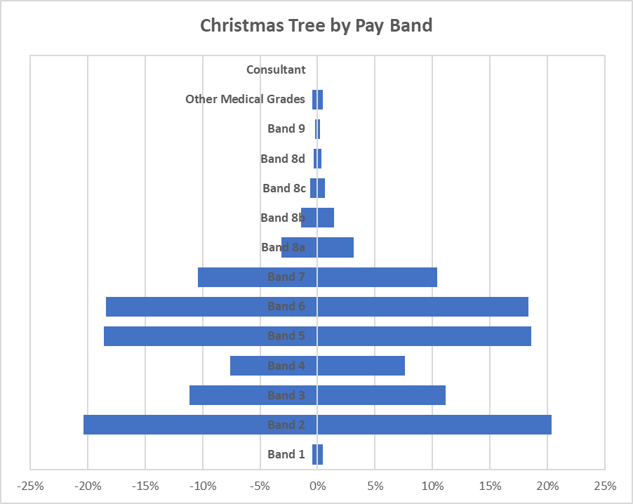

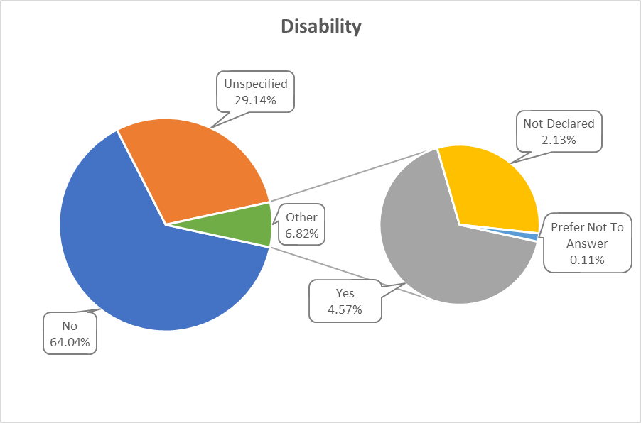

Workforce profile information collected for the Health Board in March 2022 shows that 5% of staff consider themselves to have a disability, but this information is not known for a significant number of staff (31%).

  - Sickness Absence Data

The health and wellbeing of Health Board staff is of upmost importance, especially at this unprecedented time and much of the work carried out in 2021/22 has been described in the Performance Report.

Sickness absence remains a priority for the Health Board. The cumulative sickness rate for the 12-month period up to and including March 2022 is 6.92% which is 2.32% above the 2021-22 year-end target of 4.60%. 12.57% of the total sickness recorded has been attributed to COVID-19.

70% of this sickness was attributed to long-term absence and 30% to short-term absence. The Health Board’s top reasons recorded for absence during 2021-22 were Anxiety/Stress and Chest & Respiratory Problems.

The following table provides information on the number of days lost due to sickness during 2020-21 and 2021-22.

 | 2021-22 | 2020-21
 | Number | Number
Days lost (long term) | 247,568.4 | 213,428.31
Days lost (short term) | 101,921.9 | 83,687.6
Total days lost | 349,490.38 | 297,115.98
Total staff years | 13828.4 | 13,560.93
Average working days lost | 15.78 | 13.68
Total staff employed in period (headcount) | 15,915 | 15,580
Total staff employed in period with no absence (headcount) | 6,274 | 7,602
Percentage staff with no sick leave | 39.42% | 47.49%

  - Staff Policies

At the Health Board we have 6 local Health Board employment Policies:

- Recruitment and Selection
- Adaptable Workforce
- Employee Health and Wellbeing
- Learning Education and Development
- Equality, Inclusivity and Human Rights Policy
- Maternity, Adoption, Paternity and Shared Parental Leave
These set out our organisational commitments and what we are aiming to achieve. Each of them is supported by a number of Procedures which describe the processes to follow, roles & responsibilities, and any entitlements or obligations. This means there is less duplication, more transparency and information which is easier to understand. These are in addition to the ALL-WALES Policies which apply to us and all other Health Boards in Wales
All employment and other related Human Resources (HR) and Workforce and Organisational Development (WOD) policies, procedures and guidelines are required to have at least two authors, i.e. a management and staff representative and they are subject to robust consultation processes. This includes publication on the Health Board’s intranet for a period of at least 28 days and consideration at the Employment Policies Sub Group of the Local Partnership Forum.
As an employer we are committed to providing meaningful equality of opportunity and inclusion for all employees, regardless of their protected characteristics (i.e. gender identity, marital status, race, ethnic origin, maternity status, nationality, national origin, sex, disability, sexual orientation, religion or age), as is demonstrated by our Equality, Inclusivity and Human Rights Policy. Its remit goes beyond strict compliance with the law and acts as a reference point in the event of any subsequent disputes.
The Health Board is committed to ensuring that the recruitment and selection of staff is conducted in a systematic, comprehensive and fair manner, promoting equality of opportunity at all time, eliminating discrimination and promoting good relations between all. The Recruitment and Selection Policy sets out how we will attract, appoint and retain qualified, motivated staff with the right skills and experience to ensure the delivery of a quality service and support its values. This is supported by a number of procedures including the Recruitment and Selection Procedure, Fixed Term Contract Procedure and Professional Registration Procedure. Recruiting, Attracting and Retaining employees is one of the themes of the People and Culture Plan. The ability to deliver high quality, compassionate care is dependent on recruiting and retaining individuals with the right skills, abilities, values and experiences. This has become increasingly difficult following the service pressure and workforce resilience associated with the pandemic. The current climate has created a shortage of suitable candidates in many professions, and we need to think differently about how we attract and recruit our current and future workforce, including working with social care partners to develop an integrated workforce, and to support a diverse workforce and inclusive culture. However, we cannot just depend on bringing new people into our workforce; we need to improve how we retain, manage, develop and look after the wellbeing of our existing workforce.
- Establishing a new Workforce Resourcing Team
- Developing ‘fast track’ recruitment processes for certain posts
- Employment Satisfaction Survey (‘starter survey’) for newly qualified nurses issued
- Links made with job centre re long term unemployed
- 3 days of mock interviews arranged at Whitchurch High School in February 2022
- Discussions held to improve Temporary Staffing Office recruitment processes
- Draft Retention Strategy/plan developed
- Contact made with Wallich, an organisation supporting the homeless and Shelter Cymru to support their clients into employment.
- Meeting held with Career Transition Partnership (CTP) to support ex- military to work. (Bristol careers event planned for June 22).
- Participated in 2 ‘Into Work’ Recruitment fairs with 4 further booked
The Health Board is committed to equal opportunities in recruitment, and demonstrates this by displaying the Disability Confident symbol (which replaces the ‘two ticks’ scheme) in all adverts, as well as Supporting Age Positive, Mindful Employer and Stonewall Cymru symbols.

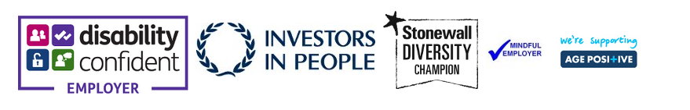

The Health Board is committed to supporting its employees and keeping them well. The Employee Health and Wellbeing Policy which sets out our commitment to encourage and empower employees to take personal responsibility for their lifestyle choices, health and wellbeing, and to guide managers on their roles and responsibilities.

Following a re-assessment in Autumn 2021, the Health Board has retained both the Gold and Platinum Corporate Health Standards and has been recognised as an exemplar organisation. This award will cover the next 12 months with a full assessment rescheduled for Autumn 2022. The now established Wellbeing Strategy Group oversees delivery of the priorities and actions resulting from the Corporate Health Standard, and much progress has been made over the past year, including implementing hydration stations, supported by the Health Charity, and the development of peer support.

The NHS Wales Managing Attendance at Work Policy assists managers in supporting staff when they are ill, manage their absence and help facilitate their timely return to work in a compassionate way. The policy is proactive by placing responsibility on line managers to know their staff and focus on their health and wellbeing to keep them well and in work.

The Managing Attendance at Work Policy includes a number of toolkits. One of these deals with reasonable/tailored adjustments – it reminds managers of our legal duty to make reasonable adjustments to ensure workers with disabilities, or physical or mental health impairments, are not disadvantaged when doing their jobs or during the recruitment process. The Policy states that not all illnesses are disabilities, however, if an employee is asking for support with a health and wellbeing condition, it is best to provide the support accordingly, assuming it is proportionate to do so. There are many benefits to this including supporting the employee back into work and helping them remain in work.

A Managing Attendance at Work specialist team was formed in December 2021 as a response to the operational workforce pressures including COVID-19 and winter pressures. The purpose of the team was to provide specialist advice and support managers and colleagues on all matters in relation to managing attendance. The objectives of the team were to review all long term sickness cases, manage redeployments, review long Covid cases finding alternative roles where possible and work with Health and Wellbeing Team to assist the wellbeing strategy to help prevent sickness. The team has supported and coached managers, during a difficult and unpredictable time of COVID-19 recovery. Managing Attendance at Work training has been delivered virtually to 90 managers, with regular sessions planned face to face and virtually in 2022. Staff off long term with post COVID-19 syndrome sickness have been supported by managers and have been signposted to resources available to assist their recovery. Overall absence at the Health Board has been reducing with the focused and dedicated approach of the Managing Attendance at Work Team.

The Redeployment Procedure sets out the process by which suitable alternative employment is sought for employees who are unfit or no longer able to carry out the duties of their current post, either on a temporary or permanent basis. This can be for a number of reasons, including health. It is important that staff and managers are clear about their responsibilities and the process to be followed to ensure that everyone is treated fairly and equitably. One important change was that individuals who require to be redeployed due to their health are not reliant on Workforce and OD advising them of vacancies, or responding to vacancies once they have already reached the advert stage. Staff needing alternative roles are entered onto the Trac recruitment system and they are automatically advised of potentially suitable alternative employment before the vacancy request is allowed to progress further in the system. Although the process of finding a redeployment opportunity is initially coordinated by Human Resources, the responsibility and ownership for actions taken is shared with the individual concerned and their substantive line manager, who are both expected to take all possible steps to find and pursue suitable opportunities. The Procedure has strengthened the accountability of managers who do not accept a suitable candidate for a trial redeployment. The Procedure aims to ensure that clear advice, support and guidance is provided to managers and employees regarding their role(s) in managing situations where employees need to be transferred into suitable alternative posts.

By making reasonable adjustments for staff with disabilities we have been able to retain a number of valued employees in their substantive role. Typical changes include reviewing caseloads, changes to equipment used, purchase of specialist equipment and modifying their workplaces. We have worked with organisations such as Access to Work to support our disabled employees.

The Supporting Carer’s Guidelines were developed in September 2021. The Health Board recognises that employees with caring responsibilities may require short term arrangements for either child or dependent care, or for longer term requirements have the ‘right to request’ flexible working arrangements. The caring responsibilities may potentially impact on a member of staff’s ability to do their job.
The purpose of the Guidelines is to support staff to achieve a positive work/ life balance with caring responsibilities, so that staff are likely to feel more valued, thus be more productive and satisfied at work. It ensures that staff are not unfairly disadvantaged by such responsibilities and are able to successfully combine their work and caring responsibilities. The organisation values each individual and strives to retain staff and accommodate where possible their changing circumstances whilst balancing the needs of the service.
These guidelines set out a range of short and long term options available to staff through agreement with their line manager. The responsibilities of the line manager, member of staff, Workforce & OD and Trade Union Representative are outlined in the guidelines. There is a carer’s plan that can be completed by the member of staff with caring responsibilities and their line manager. The plan can detail the caring responsibilities and the arrangements agreed together about short- and long-term arrangements. The application of these guidelines is in accordance with the principles of the Health Board’s Equality, Inclusion & Human Rights Policy, Special Leave Policy and Flexible Working Procedure.

The Health Board has undertaken the opportunity to develop a partnership approach with DFN Project Search. DFN Project Search is a one year, employment preparation programme that takes place entirely in the workplace. This will help to deliver the best employment outcomes for young adults from SEN education providers with learning disabilities and/or autism across the Cardiff and the Vale who are under-represented in the workforce. This will assist achieving part of the widening access into employment agenda. This year there was 7 interns, 2 of which have now gained employment within Cardiff and Vale, and we are currently recruiting for approximately 12 interns for the next year.
Due to the current economic landscape as a result of COVID-19, many people are out of work. A high proportion of these individuals are young people. The government has launched an innovative new KICKSTART scheme, giving 16-24 year olds who are in receipt of Universal Credit a future of opportunity by creating high-quality, government-subsidised jobs across the UK. Cardiff and Vale successfully became a direct employer since January 2020. The Kickstart placements will last for six months, during this period the individual will gain extra employability skills and mentoring to help them become successful in gaining long term employment. The Health Board has recruited a total of 162 individuals into the organisation, of these, 2 have gone onto apprenticeship schemes, 32 have gained roles within the Health Board, 66 are still on the scheme and the remaining 62 have now finished their placements with us. The scheme ended on 31 March 2022.

Over the past year the Apprenticeship Academy has continued to build some momentum as we recover from the effects of the pandemic. We have successfully recruited a further 8 apprentices and 1 has completed and successfully gained a position within their host department. Positive discussions are taking place in Estates, Health Records and Digital and we expect to be recruiting for these positions in the Spring. We are also in early discussions with our colleagues within Allied Health Professions, Finance, Dental Nursing, Patient Experience and Rehabilitation engineering as there are qualifications and progression pathways that can now support these areas of the workforce. We are continuing to review qualifications as they become available and targeting the areas were these can be utilised. The introduction of Healthcare Support Worker apprentices is still firmly on the agenda and conversations are ongoing with nursing colleagues on how these can be introduced and the support required. To support our current and past apprentices they have been invited to join a Future Leaders Network which is being initially supported by the Executive Director of People and Culture, but will eventually be led by the group who will shape the agenda going forward. This network will provide them with additional support and development to allow them to thrive and become our Leaders of the Future.

Existing staff uptake of apprenticeships has grown significantly since the summer of 2021 with 236 new starters covering subjects such as management, health, Business Administration and IT Users. During this period, we have also had 134 existing staff complete their qualifications. Throughout the pandemic our existing staff and entry level apprentices have been supported to complete their qualifications. Working with training providers, to offer alternative ways for assessments. Breaks in learning have also be agreed with individuals to ensure they are not disadvantaged during this unprecedented time.

  - Salary and Pension Entitlements of Senior Managers 2021-2022

Full details of senior managers’ renumerations for 2021-22 are provided in the audited tables that follow:

20.6 Consultancy Expenditure

As disclosed in note 3.3 of its annual accounts, the Health Board spent £7.479m on consultancy services during 2021-22 compared to £5.562m in 2020-21. The majority of this expenditure going towards projects aimed at delivering better clinical outcomes and efficiencies.

20.7 Tax Assurance for Off-payroll Appointees

Parliamentary Accountability
& Audit Report

21. Part 2c Parliamentary Accountability and Audit Report

21.1 Regularity of Expenditure
The Health Board has a financial duty to break even over a three year period. This has been achieved for the period 2019-20 to 2021-22 with a £380k underspend achieved of the three year resource limit. This is therefore deemed to be regular.

Between March 2020 and March 2022 the Integrated Medium-Term Plan (IMTP) process was paused due to the COVID-19 pandemic. The requirement for an approvable IMTP was replaced by the need for quarterly plans for 2020-2021 and an annual plan for 2021- 2022.

The LHB will be returning to a three year planning cycle in accordance with Welsh Government directives from 2022-2025

21.2 Fees and charges
The Health Board levies charges or fees on its patients in a number of areas. Where the Health Board makes such charges or fees, it does so in accordance with relevant Welsh Health Circulars and charging guidance.

Charges are generally made on a full cost basis. None of the items for which charges are made are by themselves material to the UHB, however details of some of the larger items (Dental Fees, Private and Overseas Patient income) are disclosed within Note 4 of the Annual Accounts.

21.3 Managing public money
This is the required Statement for Public Sector Information Holders as referenced at Section 10.1.7 (page xxx) of the Directors’ Report. In line with other Welsh NHS bodies, the UHB has developed Standing Financial Instructions which enforce the principles outlined in HM Treasury on Managing Public Money. As a result the UHB should have complied with the cost allocation and charging requirements of this guidance and the UHB has not been made aware of any instances where this has not been done.

21.4 Material remote contingent liabilities

As disclosed in note 21.2 of its annual accounts, the Health Board had net remote contingent liabilities as at March 31st 2022 of £0.155m. This relates to Clinical Negligence & Personal Injury claims against the Health Board, where our legal advisors inform us that the claimants’ chance of success is remote.

21.5 The Certificate of the Auditor General for Wales to the Senedd

21.6 Report of the Auditor General to the Senedd

Part 3
Audited Financial Statements (Annual Accounts)

22. Financial Statements
TO BE ADDED APRIL/MAY 2022
Foreword
These accounts have been prepared by the Local Health Board under schedule 9 section 178 Para 3(1) of the National Health Service (Wales) Act 2006 (c.42) in the form in which the Welsh Ministers have, with the approval of the Treasury, directed.

Statutory background
The Local Health Board was established on 1 October 2009, following the merger of Cardiff & Vale NHS Trust, Cardiff Local Health Board and The Vale of Glamorgan Local Heath Board. The main purpose of the body being, the provision of healthcare to and the procurement of healthcare for the populations of Cardiff and the Vale of Glamorgan. In addition, as a Tertiary Centre the UHB serves the wider population across Wales (and the UK) via the provision of specialist and complex services.

Performance Management and Financial Results
Welsh Health Circular WHC/2016/054 replaces WHC/2015/014 ‘Statutory and Administrative
Financial Duties of NHS Trusts and Local Health Boards’ and further clarifies the statutory financial
duties of NHS Wales bodies and is effective for 2019-20. The annual financial duty has been revoked and the statutory breakeven duty has reverted to a three-year duty, with the first assessment of this duty in 2016-17.

Local Health Boards in Wales must comply fully with the Treasury’s Financial Reporting Manual to the extent that it is applicable to them. As a result, the Primary Statement of in-year income and expenditure is the Statement of Comprehensive Net Expenditure, which shows the net operating cost incurred by the LHB which is funded by the Welsh Government. This funding is allocated on receipt directly to the General Fund in the Statement of Financial Position.

Under the National Health Services Finance (Wales) Act 2014, the annual requirement to achieve balance against Resource Limits has been replaced with a duty to ensure, in a rolling 3-year period, that its aggregate expenditure does not exceed its aggregate approved limits.

The Act came into effect from 1 April 2014 and under the Act the first assessment of the 3 year rolling financial duty took place at the end of 2016-17.

© Cardiff & Vale University Health Board 2022
The text of this document (this excludes all departmental or agency logos) may be reproduced free of charge in any format or medium provided that permission is sought and it is reproduced accurately and not in a misleading context. The material must be acknowledged as Cardiff and Vale University Health Board* copyright and the document title specified. Where third party material has been identified, permission from the respective copyright holder must be sought.

