

Assurance Strategy

Cardiff and Vale University Health Board
Assurance Strategy

Document Reference No: |  | C&V UHB TBC |  | Version No: | 1 |  | Previous C&V UHB Ref No: | N/A
Document Type: |  | Corporate Strategy |  |  |  |  | Non-Clinical
Issue Date: |  | Xxxx 2021
Implementation Date: |  | Xxxx 2021
Review Date: |  | Xxxx 2022 (1 year post issue date).
Documents to be read alongside this policy: |  | - Standing Orders  - Scheme of Reservation and Delegation  - Standing Financial Instructions  - UHB 024 - Risk Management Procedure  - UHB 435 - SOP Managing Concerns  - UHB 043 – Raising Concerns (Whistleblowing Policy)  - UHB470 – Risk Management and Board Assurance Framework Strategy
Executive Summary: |  | This strategy sets out the UHB’s approach to the Assurance Strategy. For more information on the Assurance Strategy please contact the Director of Corporate Governance

Disclaimer

The latest version of this document is located on the UHB’s intranet. Please check the review date and if there are any doubts contact the author.

Proprietary Information
This document contains proprietary information belonging to Cardiff and Vale University Health Board. All or any part of this document should not be reproduced without the permission of the Document Owner.

Author/Reviewer: | Director of Corporate Governance
Document Owner: | Director of Corporate Governance
Accountable Executive: | Director of Corporate Governance
Consultation method/time period:

Consultees:

Approved by:

Date approved:
Scope: | UHB Wide

Engagement has taken place with:
Name |  |  | Title |  |  | Date Consulted

Version Control Table
Version |  |  | Issue Date |  |  | Summary of Amendment
1 |  |  | 25.11.2021 |  |  | New Strategy to be approved by the Board in November 2021
Important Note:
The Intranet version of this document is the only version that is maintained.

Any printed copies should therefore be viewed as ‘uncontrolled’ and, as such, may not necessarily contain the latest updates and amendments.

Contents

Page
Introduction…………………………………………………………………………………… | 4
Aim
Our Assurance Vision………………………………………………………………………… | 4
The Assurance System………………………………………………………...................... | 4
Benefits of an Assurance System…………………………………………………………… | 5
Implementation of the Assurance Strategy………………………………………………….. | 6
Types, Sources, and Levels of Assurance…………………………………………………. | 6
Assurance Values…………………………………………………………………………….. | 6
Assurance Reporting / Use of the Assurance Information………………………………… | 7
Assurance Tools………………………………………………………………………………. | 7
Training………………………………………………………………………………………….. | 9
Monitoring Compliance………………………………………………………………………… | 9
Review…………………………………………………………………………………………... | 9
References……………………………………………………………………………………… | 10
Equality Impact Assessment………………………………………………………………….. | 11
Appendices:  Appendix 1 – Assurance Principles and Application ……………………………………… Appendix 2 – Sources of Assurance (examples only)…………………………………….. Appendix 3 – Responsibilities……………………………………………………………….. Appendix 4 – Glossary and definitions of terms used…………………………………….. Appendix 5 – Using Assurance Sources in Practice……………………………………….  A | 12  14  16  17  18  A
Appendix 4 – Example Assurance Map,,,,,,,,,,,,,,,,,,,,,,,,,,,,,,,,,,,,,,,,,,,,,,,,,,,,,,,,,,,,,,,,,,,,,,,,,,, 20

Introduction

1. Assurance is term that is often used although not always fully defined. Within the NHS it has become an ever increasingly important concept. The introduction over a decade ago of the requirement for the Chief Executive, on behalf of the Board, to write and publish an Annual Governance Statement, made sure public sector organisations were able to demonstrate that they are properly informed about the totality of their risks. Put simply they needed to have confidence in their governance framework.

2. Over a number of years organisational failures, within both the public and private sector have been attributed to poor governance or failings in risk management. The response to this has been heightened control in these areas via legislation and publications of governance codes. Yet the failures continue to happen and therefore concentration has shifted to assurance and how Boards of Directors know what is being undertaken in their name.

3. The Health Board understands the challenges that large and complex organisations face when developing robust governance, risk management and assurance systems that are both proportionate and fit for purpose.

Aim

4. The aim of this strategy is to ensure that there is a common understanding throughout the Health Board of what is meant by assurance and its importance in a well- functioning organisation.

5. Assurance is underpinned by a number of elements: a robust governance framework with clearly defined and understood strategic objectives, a developed maturity in relation to risk management and effective internal controls. Assurance is about getting the right balance of strategy, risk and control. It is acknowledged that it is never possible to provide complete and absolute assurance and as such the concept of reasonable assurance is adopted.

Our Assurance Vision

6. Our vision is to ensure an assurance system exists that adds value to the Health Board by eliminating duplication of effort and resources, reducing the burden of bureaucracy and providing a central point of expertise in relation to governance, risk management and assurance.

7. We aspire to provide guidance on how to assess the value of assurance more widely across the Health Board. The promotion of a better understanding of assurance should lead to improved knowledge of the systems and processes in place. This should in turn lead to an improvement in the assurance tools used in the Health Board and the ability the Health Board has to address identified gaps.

The Assurance System

8. The assurance system will enable the Board and senior management to review the corporate governance, risk management and internal control framework and address any weaknesses identified.

9. It is the policy of the Health Board to ensure that there is a robust methodology for enabling evidence based assurance to be provided to the Health Board on the key risks and the key controls within the organisation as well as stakeholders as required and at the appropriate levels.

10. The methodology is based on the principles of assurance in relation to risk management as defined by the HM Treasury Orange Book, Management of Risk – Principles and Concepts. These principles, which have been expanded to cover all areas of governance, and the method of application within Cardiff and Vale University Health Board, can be found at Appendix 1.

11. The following diagram summarises a model of assurance within the NHS, considered applicable for the Health Board

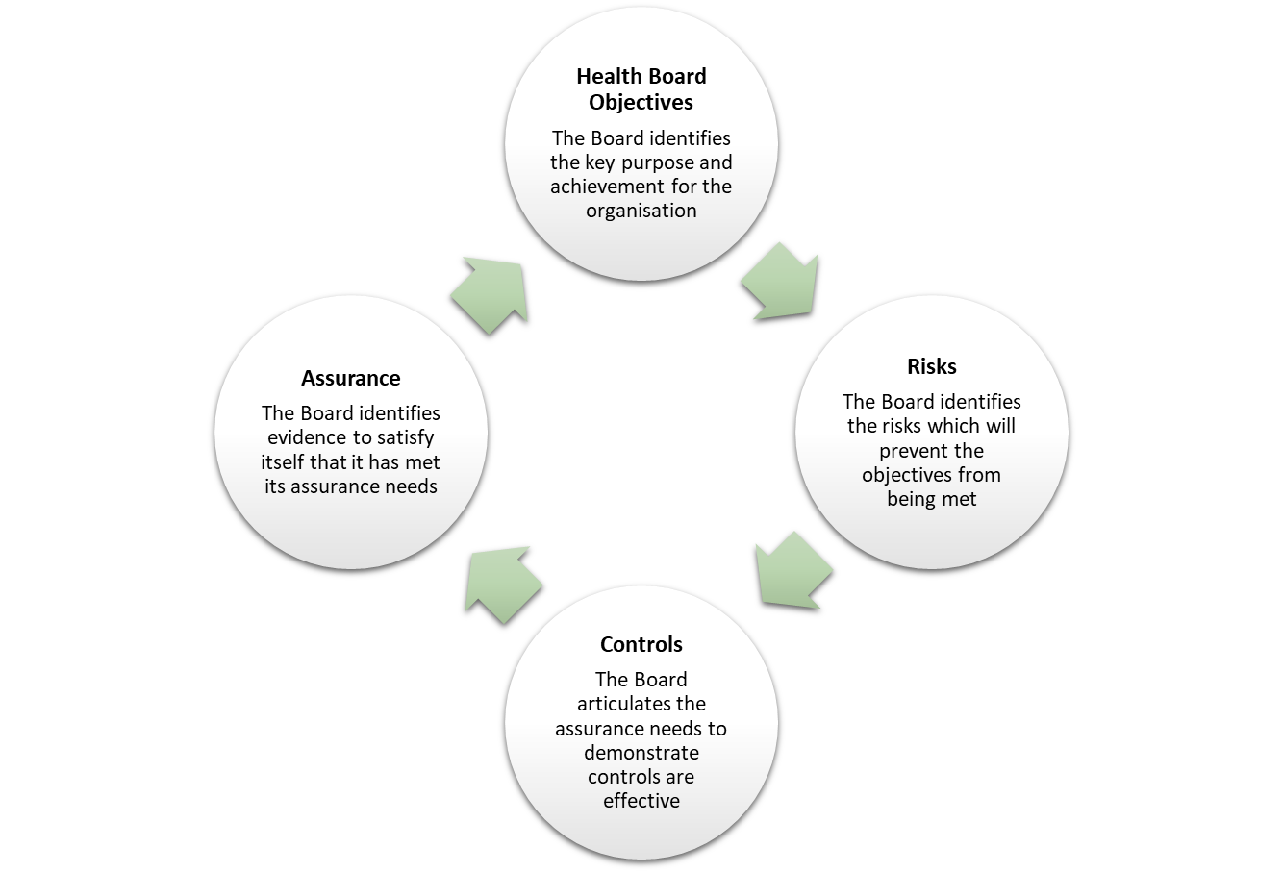

Benefits of an Assurance System

12. An assurance system achieves a number of benefits:

• Provides confidence in the operational working of the Health Board.
• Maximises the use of resources available in terms of audit planning, avoiding duplication of effort.
• Ensures assurances are appropriately gathered, reported and that the governance structure is working as intended
• Identifies any potential gaps in assurances relating to key risks and key controls, and that these are understood and accepted or addressed as necessary
• Supports the preparation of the Annual Governance Statement within the Annual Report and regular assurance reports to the Audit and Assurance Committee.

Implementation of the Assurance Strategy

13. The implementation of this strategy will be achieved through clear leadership, effective delivery and defined roles and responsibilities. Roles and responsibilities in relation to assurance within the Health Board can be found in Appendix 3. This document applies to all areas of activity within the Health Board. All employees of the Health Board, including individuals employed by a third party, by external contractors, as voluntary workers, as students, as locums or as agency staff are required to comply with any requirements in relation to assurance noted within this Strategy.

14. The Director of Corporate Governance acts as a champion for this area, providing support across the Health Board.

15. All members of the Health Board will be involved in the evaluation of assurance, except where delegated to Committees of the Board.

16. The Health Board will ensure that the appropriate infrastructure in terms of Committee and individual responsibilities is in place to facilitate the embedding of the Assurance Strategy. The Corporate Governance Directorate will deliver education and training across the organisation on an on-going basis, ensuring that guidance follows best practice.

Types, Sources and Levels of Assurance

17. There are three types of assurance that can be sought: verbal, written and empirical.
All can be of use depending on the circumstances. Each will be valued differently depending on other factors. There are many sources of assurance, examples of
which can be found in Appendix 2.
18. The Health Board has defined the overarching Lines of Defence (levels of assurance) within its Risk Management and Board Assurance Framework Strategy as noted below:
Level 1 – Operational (Management)
Level 2 – Oversight functions (Compliance/Risk Management/Quality and Assurance/Health and Safety)
Level 3 – Independent (Audits / Reviews / Inspections etc.)

19. Supplementary assurance processes developed within the Health Board will have their levels of assurance cross matched using the overarching levels set out above.

20. Management has the primary responsibility for providing assurance on the adequacy of risk management and internal control, which is often subject to challenge from the oversight functions for example the Audit and Assurance Committee. It is however essential that there are robust frameworks in place to support the managerial assertions about the adequacy and effectiveness of internal control.

21. Independent assurance is used to confirm management assertions and is often seen as of highest value. This is however dependent on many other factors as noted below.

Assurance Values

22. Regardless of the type, source and level of assurance there are a number of issues that impact on its value, all of which need to be considered:

Age – the time elapsed since assurance was obtained, this may erode the value of assurance.

Durability – whether it endures as a permanent assurance on an historical matter e.g. Auditors Report on Financial Statements, or loses relevance over passage of time e.g. clinical audit.

Relevance – the degree to which assurances aligns to specific area or objective over which it is required.

Reliability – trustworthiness of the source of assurance.

Independence – the degree of separation between the function over which assurance is sought and the provider of assurance.

23. The value of assurances used for the Board will be assessed by the Corporate governance Directorate.

Assurance Reporting / Use of the Assurance Information

24. The various mechanisms and tools described in the strategy will enable the assurance process and the assurance information that is produced as a result to be assessed in terms of value and enable any gaps in assurance identified to be reported, at an appropriate level, and addressed, where considered necessary.

Assurance Tools

25. A number of mechanisms, known as Assurance Tools, will be used as part of the methodology for providing evidence based assurance.

26. There are various assurance tools which feed into the overall system of assurance.
Through the mapping of sources of assurance, issues can be identified relating to gaps in control or gaps in assurance, and duplication of effort. Where the need for
additional control measures or assurances are recognised, these will be reported through an appropriate mechanism, e.g. addition to risk register, performance
reporting, or the Board Assurance Framework.

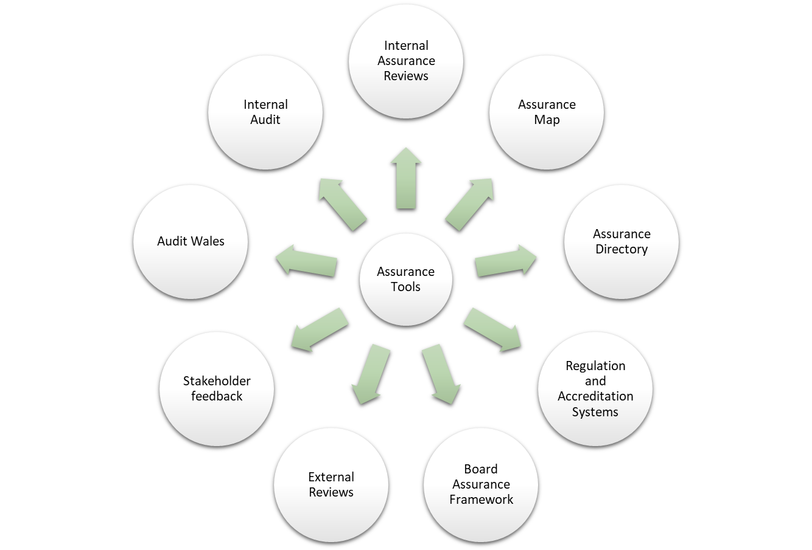Assurance Directory

27. An Assurance Directory is a central register of assurances, detailing the types and value of assurance. This will maintained by the Corporate Governance Directorate. The information held within the Directory is used to create a map of assurances.

Assurance Map

28. An Assurance Map is created in order to obtain clarification in relation to assurance currently provided. There is more than one purpose for such a map and this will depend on who wants the map and why. One map should not be everything to everyone and therefore a number of different maps at various levels can be produced. Assurance Maps can be used at different levels and for different reasons as determined by need. The starting point can also vary depending on purpose. Initially the Corporate Governance Directorate will develop and maintain an Assurance Map that aims to provide assurance to the Board that those risks reported within the Corporate Risk Register, from time to time, are being appropriately treated, mitigated and/or controlled.

29. Gaps, including where assurance has been provided but is deemed to be insufficient and duplications of assurance can be identified and addressed thereby consolidating assurance and reducing the amount of irrelevant information provided. Assurance maps will be created and maintained by the Corporate Governance Directorate.

Internal Assurance Reviews

30. Internal assurance reviews may be undertaken in any area of the Health Board and are one of the ways the Health Board assures itself that relevant standards, regulation and other requirements including best practice are being met. Whenever internal assurance reviews are undertaken, terms of reference are prepared and agreed by all parties. The Corporate Governance Directorate provides support for such reviews. E.g. Health and Safety Review.

Internal Regulation and Accreditation Systems

31. Internal regulation and accreditation systems ensure that suitable evidence exists to support adherence with regulation and accreditation standards. The Risk and Regulation Team track Legislative, Regulatory and Alerts compliance which is then reported to the Audit and Assurance Committee.

Board Assurance Framework

32. The Board Assurance Framework, sets out the strategic objectives, identifies risks in relation to each strategic objective and the controls to mitigate these risks. The details of the assurances on the effectiveness of these controls are also included. As such gaps in controls and assurances can be identified and acted upon. This forms an integral part of the risk management reporting system. This document is then used as a tool for further discussion in relation to the levels of assurance received and required at Board and Board Committee level as set out in the Risk Management and Board Assurance Framework Strategy. The Board Assurance Framework also provides the starting point for the Health Board to record the risks in relation to the strategic objectives that then link and are cross referenced to the Corporate Risk Register.

Internal Audit

33. Internal Audit is an independent objective function which can help the Health Board accomplish its objectives by bringing a systematic, disciplined approach to evaluate and improve the effectiveness of risk management, internal control, and governance processes. The scope of reviews are agreed in advance with relevant Executive Directors and Management Executive, and the annual Internal Audit plan agreed by the Audit and Assurance Committee. Contingency days may be built into the Internal Audit plan to allow for any issues identified where review or further assurance may be required.

Clinical Audit

34. Clinical audit is a quality improvement process that seeks to improve patient care and outcomes through systematic review of care against explicit criteria and the implementation of change. Where indicated, changes are implemented at an individual, team, or service level and further monitoring is used to confirm improvement in healthcare delivery and improve the overall quality of services.

Audit Wales

35. The Auditor General is the statutory external auditor of most of the Welsh public sector. This means that he audits the accounts of county and county borough councils, police, fire and rescue authorities, national parks and community councils, as well as the Welsh Government, its sponsored and related public bodies, the Senedd Commission and National Health Service bodies.
The Auditor General’s role includes examining how public bodies manage and spend public money, including how they achieve value in the delivery of public services. The Auditor General publishes reports on that work, some of which are considered by the Welsh Parliament’s Public Accounts Committee

Stakeholder Feedback

36. Valuable assurance is provided to the organisation through feedback from stakeholders, including patients, visitors, our staff, and partner organisations. The views of our patients are captured through various including patient safety visits. Additionally, internal feedback processes provide additional sources of assurance, including:
• Surveys carried out with patients and staff
• Reactive risk processes, such as complaints, claims, inquests or incidents
• Monitoring and compliance information received from other organisations such as the Community Health Council (CHC) an Independent watchdog and Healthcare Inspectorate Wales (HIW) an independent inspectorate and regulatory of healthcare in Wales.

External Reviews

37. The Corporate Governance Directorate administer the coordination and evaluation of recommendations arising from external agency visits, inspections and accreditations and the process for disseminating and performance managing the implementation of actions arising from the recommendations and providing assurance against them.

Training

38. There is no mandatory training associated with this policy. Ad hoc training sessions based on an individual’s training needs will be defined within their annual appraisal or job plan. The Risk and Regulation Team will also provide targeted training to Executive Colleagues, Risk Management, Clinical and Corporate Leads.

Monitoring Compliance

39. Compliance with the document will be monitored in line with the key principles and applications as set out in Appendix 1 as summarised below.

Aspect of compliance or  effectiveness being monitored | Monitoring method | Responsibility  for monitoring  (job title) | Frequency  of monitoring | Group or Committee  that will review the findings and monitor completion of any resulting action plan
System of internal  control/effectiveness of assurance strategy | Internal audit of  Board Assurance  Framework | Head of Risk and Regulation | Annual | Audit Committee

Review

40. This policy will be reviewed in 3 years, unless best practice dictates the need for an earlier review.

References

41. The Assurance Strategy forms a key component of the wider Health Board governance framework and links closely to the Risk Management and Board Assurance Strategy.

- COSO (2017). Enterprise Risk Management – Integrating with Strategy and Performance. Available at: https://www.coso.org/Documents/2017-COSO-ERM-Integrating-with-Strategy-and-Performance-Executive-Summary.pdf
- COSO (2020). Compliance Risk Management: Applying the COSO ERM Framework. Available at: https://www.coso.org/Documents/Compliance-Risk-Management-Applying-the-COSO-ERM-Framework.pdf
- Good Governance Institute (2010). ‘What every healthcare board needs to understand
- about patient safety. Available at: https://www.good-governance.org.uk/services/what-every-healthcare-director-needs-to-know-about-patient-safety/
- Good Governance Institute (2019). Risk Appetite for NHS Organisations: A Matrix to support better risk sensitivity in decision taking. Available at: https://www.good-governance.org.uk/services/risk-appetite-for-nhs-organisations-a-matrix-to-support-better-risk-sensitivity-in-decision-taking/
- Government Finance Function (2020). Risk Appetite: Guidance Note. Available at: https://assets.publishing.service.gov.uk/government/uploads/system/uploads/attachment_data/file/929385/Risk_Appetite_Guidance_Note_v1.0_FINAL.pdf
- Health and Safety Executive (2010). Leading Health and Safety at Work. Available at: https://www.hse.gov.uk/pubns/indg417.pdf
- HM Government (2020). The Orange Book: Management of risk principles and concepts. Available at: https://www.gov.uk/government/publications/orange-book
- HM Treasury (2014). Assurance frameworks. Available at: https://assets.publishing.service.gov.uk/government/uploads/system/uploads/attachment_data/file/270485/assurance_frameworks_191212.pdf
- Institute of Internal Auditors (2013). Position Paper: The three lines of defence in effective risk management and control. Available at: https://na.theiia.org/standards-guidance/Public%20Documents/PP%20The%20Three%20Lines%20of%20Defense%20in%20Effective%20Risk%20Management%20and%20Control.pdf
- Institute of Risk Management (2011). Risk Appetite and Tolerance Guidance Paper. Available at: https://www.theirm.org/resources/find-a-resource/risk-appetite-and-tolerance-guidance-for-practitioners/

- Institute of Risk Management (2018). Standard Deviations: A Risk Practitioners Guide to ISO 31000. Available at https://www.theirm.org/resources/find-a-resource/standard-deviations-a-risk-practitioners-guide-to-iso-31000-2018

- National Patient Safety Agency (2004). Seven Steps to Patient Safety. Available at: https://www.publichealth.hscni.net/sites/default/files/directorates/files/Seven%20steps%20to%20safety.pdf
- National Patient Safety Agency (2008). A Risk Matrix for Risk Managers. London: NPSA.
- The Institute of Internal Auditors (2013). The Three Lines of Defence in Effective Risk Management and Control. Available at: https://na.theiia.org/standards-guidance/Public%20Documents/PP%20The%20Three%20Lines%20of%20Defense%20in%20Effective%20Risk%20Management%20and%20Control.pdf

- The International Standards Organisation (2018). ISO 31000:2018 Risk Management-Guidelines. Available at: https://www.iso.org/standard/65694.html
- Welsh NHS Confederation (2009). The Pocket Guide to Governance in NHS Wales. Available at: http://www.wales.nhs.uk/sitesplus/documents/1064/NHS%20Wales%20Confed%20-%20Governance%20Pocket%20Book%20FINAL%5B1%5D.pdf

42. Equality Impact Assessment

C&V UHB aims to design and implement services and policies that are fair and equitable. As part of its development, this Strategy and its impact on staff, patients and the public have been reviewed in line with the Cardiff and Vale’s Equality Impact Assessment. The purpose of the assessment is to improve service delivery by minimising and if possible removing any disproportionate adverse impact on employees, patients and the public on the grounds of race, socially excluded groups, gender, disability, age, sexual orientation or religion/belief.

The equality impact assessment has been completed and has identified impact or potential impact as “no impact”.

Appendix 1: Assurance Principles and Application

Assurance Principle | Application within the Health Board
- Planning to gain assurance  Overall assurance will only be gained if there is a strategy for obtaining it. The  Assurance Strategy should be approved by  the Board and the Audit and Assurance Committee. Supporting processes for obtaining  assurance should be embedded into  existing processes. | An Assurance Strategy, which reflects the assurance system in operation within the Health Board and therefore the supporting processes, has been approved at Board Level after consultation with the Audit Committee. The Assurance Strategy has been prepared to align with the other key strategies such as the Risk Management and Board Assurance Framework Strategy.
- Making explicit the scope of the assurance boundaries  To form an overall opinion the scope of the processes need to include the whole of the  organisation’s governance, risk and performance management lifecycle. Whilst this does not reflect the need to review  every risk and internal control it should cover:  Assurance on the Risk Management Strategies and how these work in practice (the extent to which line managers review the risks and controls within their responsibility and maintain dynamic risk and performance management arrangements)  Assurance on management of risks and controls themselves.  Assurance on the adequacy of the assurance processes. | The Corporate Governance Directorate will be responsible for ensuring that there is adequate assurance on the risk management system and the risks / controls themselves. The overall Assurance and Risk Management system is subject to Annual Audit.
- Evidence  The evidence supporting assurance should be sufficient in scope and weight to support the conclusion and be:  - Relevant  - Reliable  - Understandable  - Free from material misstatement  - Neutral / free from bias  - Such that another person would reasonably come to the same  conclusion  All evidence does not carry the same weight and should be weighted in accordance to  independence and relevance. Evidence  may be flawed in terms of both quality and quantity, leading to limitations in the  assurance that can be provided. | The Corporate Governance Directorate will define ‘what good evidence looks like’, ensuring that the details within this principle are adhered to.

Appendix 1: Assurance Principles and Application
(continued)

Assurance Principle | Application within the Health Board
- Evaluation  The objective is to evaluate the adequacy of:  - the governance and risk policies and strategies to achieve their objectives;  - the risk management processes  designed to constrain residual risk to the risk appetite;  - Identify limitations in the evidence provided or in the depth or scope of the  reviews undertaken  - Identify gaps in control and / or over control and provide the opportunity for  continuous improvement  - Support the preparation of the Annual  Governance Statement as part of the Annual Report. | The independent review of all key areas will be co-ordinated by the Corporate Governance Directorate. The Audit and Assurance Committee will approve the internal and external audit plans.  Gaps and duplications in assurance will be identified by the development of an assurance map, the responsibility for which falls within the remit of the Corporate Governance Directorate. A directory of sources of external assurances will be maintained. This will populate, in part, the assurance directory, which will also contain internal sources of assurance.  Central reviews of evidence held will be undertaken by the Corporate Governance Directorate. Training and guidance will be provided across the Health Board to enable Clinical Boards and Corporate Directorates to be the first line of evidence assessment.
- Reviewing and Reporting  Assurances are reported from many different sources within an organisation and therefore the Assurance Strategy needs to define stages where assurances will be evaluated and opinions reported through the various layers of management to the Health Board.  Assurance opinions need to be reported clearly and worded so as to clearly communicate the scope and criteria used in arriving at those conclusions. | The Assurance Strategy makes it clear that assurances for the Health Board will be assessed in terms of value by the Corporate Governance Directorate. Training and education will be undertaken across the Health Board in relation to reporting of assurances.

Source: The Orange Book (Management of Risk – Principles and Concepts), HM Treasury
(2004)

Appendix 2: Sources of Assurance (examples only)

Source | Assurance Scope | Assurance Process | Type | Level
Audit Wales | Financial accounts and Governance Arrangements  reviews as determined | Financial audit and  review reports | Written | 3 - Independent  Assurance
Internal Audit | All areas related to  corporate governance, risk management and internal control. Will be limited by number of days in audit plan and expertise of staff | Head of Internal Audit  Opinion and individual review reports. Scope of reviews agreed in advance with relevant Executive Directors. Internal Audit Plan agreed with Audit and Assurance Committee | Written | 3 - Independent  Assurance
Clinical Audit | Area under review,  defined by the Clinical  Audit Plan | Report to Quality, Safety and Effectiveness Committee with oversight through Audit and Assurance Committee | Written | 1 - Operational Assurance / 3 - Independent  Assurance
Audit  Committee | All areas related to  corporate governance, risk management and internal control, as determined by Terms of Reference | Report to Health Board  annually through Annual Report to the Board and update to Health Board via issue of minutes after each meeting and Chairs report to the Board | Written and  Verbal | 2 - Oversight function
Management  Executive | All areas related to  corporate governance, risk management and internal control | Report relevant areas to Health Board | Written or  Verbal | 2 - Oversight Function
Other  Accreditation  Systems | Restricted to area of  accreditation | Report to relevant Committee and regulatory compliance tracked through Audit and Assurance Committee | Written | 3 - Independent  Assurance
Integrated  Performance report | Specific to identified targets, internal and  external, for finance, performance, quality and workforce | Reports to relevant Committees of the Board culminating in integrated report to Board | Written | 1 – Operational  Assurance  2 – Oversight function
Walkabouts | Specific to area of visit | Reports to Patient Safety and Experience Team | Empirical | 1 - Operational  Assurance
Information  Governance  Toolkit | Specific to area of  responsibility | Reports to  Management Executive and, DHI Committee etc. | Written | 1 - Operational  Assurance, 2 – Oversight function
Patient  Feedback | Specific where internally driven | Reports Quality, Safety and Experience Committee | Written | 3 - Independent  Assurance

Appendix 3: Responsibilities

The Chief Executive Officer has overall responsibility for the system of internal control within the Health Board and for preparing an Annual Governance Statement within the Annual Report.

The Director of Corporate Governance has delegated authority for the assurance system that underpins the Annual Governance Statement.

The Head of Risk and Regulation is accountable to the Director of Corporate Governance for the overall delivery of the Health Board’s Assurance strategy and the Risk Management and Board Assurance Framework Strategy and is responsible for overseeing the systems for assuring compliance with regulatory standards.

The Head of Corporate Governance is accountable to the Director of Corporate Governance for the overall performance of corporate governance functions including the system of internal control.

The Corporate Governance Directorate is responsible for the:

• maintenance of key assurance tools

• education and training programme in relation to assurance processes, accreditation, assessment and supporting evidence

• assessment of assurance and evidence in relation to compliance with
regulations

• provision of consultancy and advice in relation to assurance, accreditation, assessment and supporting good evidence processes.

All Executive Directors are responsible for the related management assurances in relation to those strategic objectives delegated to them by the Chief Executive.

All Clinical Board Directors are responsible for the management of risks and internal controls and assurance within their Clinical Boards

All Managers are responsible for the management of risks and internal controls within their area.

All members of staff are responsible for adhering to internal controls in the undertaking of their work.

The Health Board is responsible for clarifying expectations around the scope and depth of
Board assurance requirements.

The Audit and Assurance Committee supports the Board by critically reviewing the governance, risk and assurance processes on which the Board places reliance. At the corporate level these include systems of internal control, including the risk management system and the Board Assurance Framework.

Appendix 4: Glossary and definitions of terms used

The terms in use in this document are defined as follows:

Assurance – ‘confidence based on sufficient evidence, that internal controls are in place, operating effectively and objectives are being achieved’ (Building the Assurance Framework: A Practical Guide for NHS Boards (2003), Department of Health)

Reassurance – the process of telling others that risks are controlled without providing reliable evidence in support of this assertion

Risk – the uncertainty of outcome, whether positive opportunity or negative threat, of actions and events

Risk Management – the system for identifying, assessing and responding to risks

Corporate Governance – the ‘system by which organisations are directed and controlled in order to achieve their objectives and meet the necessary standards of accountability and probity’ (Department of Health). Governance refers to many areas including clinical, information, human resources; all of which fall under the remit of the phrase ‘corporate governance’ in relation to this document

Internal Control – a method of restraint or check used to ensure that systems and processes operate as intended and in doing so mitigate risks to the organisation; the result of robust planning and good direction by management

Key Risk / Key Control – risk to the achievement of a strategic objective / control to mitigate key risks

Evidence – information that allows a conclusion to be reached

Sufficient – in relation to the definition of assurance given above sufficient is defined as whatever is adequate to provide the level of confidence required for the Health Board

Reasonable – based on sound judgement
Empirical based on observation or experience
Accreditation – to be awarded official recognition
Assessment – a review of evidence in order to form an opinion; this can be undertaken either internally in the form of a self-assessment or by a third party

Compliance – to act in accordance with requirements

Stewardship – entrusted with the responsibility for and on-going management of a particular area

Stakeholders – person or persons with an interest in the Health Board

Management assertions – a statement made, whether verbal or written

Appendix 5: Using Assurance Sources in Practice

Assurance maps can be created in a variety of different ways, depending on the required purpose. Maps may be used to show:

• Sources of assurance for a given area, topic or target

• Sources of assurance on identified risks e.g. against specific targets or across different areas of business

• Sources of assurance on the effectiveness of control measures

• How the assurances are reported and at what level of the organisation

• Areas where further assurance may be required, or areas of duplication

The examples below demonstrate different functions of an assurance map, and how these can be used by different audiences.

Example 1: Identified Sources of Assurance for a Integrated Performance Report target
e.g. RTT waiting time over 36 weeks
Source | Assurance Scope | Assurance Process | Type | Level
Integrated  Performance report | Specific monitoring of  performance against the target and assessment of data quality | Reports to Strategy and Delivery Committee and  The Health Board | Written | 1 – Operational  Assurance
Audit Wales | Review of data quality  for all NHS Delivery Framework targets | Data quality audit and  review reports. Scope of review agreed nationally. | Written | 3 - Independent  Assurance
Internal Audit | Testing of process for recording clock stops  and breaches along the pathway by random sample basis. Scope of reviews agreed in advance with  relevant directors.  Internal Audit Plan agreed with Audit Committee | Report to Audit Committee | Written | 3 - Independent  Assurance
Adult Inpatient  Survey | Sample interview  survey conducted on a quarterly basis. | Report to Quality, Safety and Experience Committee and Health Board | Written | 3 - Independent  Assurance
Clinical Audit | Review of adherence  to admission criteria in theatres. Scope agreed as part of local clinical audit plan | Report to Quality Safety and Experience Committee | Written | 1 - Operational  Assurance / Independent Assurance

Example 2: Identified Sources of Assurance for Information Governance

Source | Assurance Scope | Assurance Process | Type | Level
Integrated  Performance report | Specific monitoring of performance against the target and assessment of data quality | Reports to Digital Health Intelligence Committee and Health Board | Written | 1 – Operational  Assurance
External Audit | Review of data quality for all NHS Delivery Framework targets | Data quality audit and review reports. Scope of review agreed nationally. | Written | 3 - Independent  Assurance
Internal Audit | Independent review of Information  Governance as required by the Information Commissioner. Scope of reviews agreed in advance with relevant directors. Internal Audit Plan agreed with Audit and Assurance Committee | Report to Audit  Committee | Written | 3 - Independent  Assurance
Clinical Audit | Review of adherence  to Health Records Policy Scope agreed as part of local clinical audit plan | Report to Quality, Safety and Effectiveness Committee. | Written | 1 - Operational  Assurance / Independent Assurance

Appendix 6 – Example Assurance Map
