The South East Wales Regional Collaborative

- Overview
Following a renewed commitment of the Chief Executives across Cardiff & Vale UHB (CAVUHB), Cwm Taf Morgannwg (CTMUHB) and Aneurin Bevan (ABUHB) to work regionally where clinically appropriate, a portfolio of programmes across Orthopaedics, Ophthalmology and Diagnostics has been agreed along with the creation of Regional Programme Director role to facilitate delivery.

- Objectives
The objective of the regional collaboration is to;
Working collaboratively across South East Wales either bilaterally and/or across all organisations to bring together our collective resources, talent and expertise in order to achieve the best outcomes, initially across the three identified specialities, for the populations we collectively serve by giving colleagues the mandate to co-create solutions and plans to meet the collective challenge.
It is accepted that the need to do this in the context of the current climate is not debatable but the way in which this is achieved is very much territory for discussion and engagement with our teams and with our communities.
- Principles

A number of principles to guide this work have been agreed by the three Chief Executives.

- Reduce unwarranted variation and inequality in health outcomes and access to services and experience.
- Improve resilience.
- Make effective use of capacity and capability in whichever organisation it sits.
- Create critical mass for effective high-quality care
- Accepting service delivery occurs when and where it makes sense to do so and accepting that may not reside in every organisation.
- Take all opportunities to use the evidence base and best practice to improve quality, efficiency, productivity, and use of finite resources.
- Enable clinical leaders, and others, to work together, lead together and learn together.
- Approach all aspects of the collaboration with benign intent, honesty, transparency, and integrity in order to build trusting and effective relationships.
- Agree approaches to engagement and communications together.
- Avoid leaving anyone behind.
- Establish an effective but not overly bureaucratic governance structure
- Learn from past regional initiatives in an open, honest and humble way.

Accountability and Reporting Arrangements

Embracing the principle to establish an effective but not overly bureaucratic governance structure and early governance structure and approach is proposed which looks, where possible to evolve existing forum(s) that are already operating in the regional planning sphere across the three health boards.

The below represents a schematic of the proposed initial structure to progress this work.

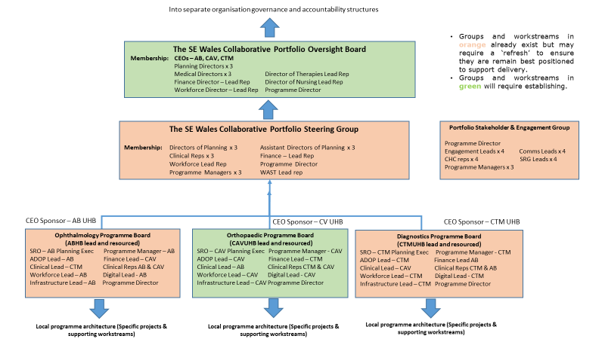

The roles of the of the Portfolio Oversight Board, Steering Group and supporting Programmes are outlined below:
SE Wales Collaborative Portfolio Oversight Board:
Scope:
The Portfolio Oversight Board (POB) will provide strategic direction to and seek assurance for the delivery of the agreed programmes within the regional portfolio to enable these services to provide safe, sustainable and equitable care across the region by optimising the collaborative opportunity.
Role:
The POB will provide the strategic direction as well as regional and local leadership for the regional programmes and to agree the programmes that should be included within the Portfolio. The POB will also seek assurance for delivery of the programmes within the portfolio against the agreed objective and milestones. The POB will provide assurance to Welsh Government of the partner UHBs’ commitment to the development and delivery of effective regional service redesign and delivery.

SE Wales Collaborative Portfolio Steering Group:
Scope:
The Portfolio Steering Group (PSG) will ensure effective planning and coordination of the programmes within the regional portfolio and ensure the Programme Director, Health Boards lead reps and the programme managers are enabled to progress, at pace, the agreed programmes and supporting projects.
Role:
The PSG will ensure the programmes:
- Develop clear objectives and measurable outcomes/benefits for each programme
- Develop consistent and joint approaches to communication, engagement and planning – at programme and implementation level
- Share workforce, infrastructure and other appropriate resources
and, in doing so, get the best possible outcomes for all patients within the regional partners’ catchment populations.

Specifically, the PSG will:

- Ensure that the appropriate governance and resources are appropriately identified for each of the programmes and secured from the appropriate sources within partner UHBs and expert national resources e.g. NHS Finance & Delivery Unit, Welsh Modelling Collaborative and Digital Health Improvement Wales lead reps to ensure that effective data extraction, demand and capacity analysis and operational modelling methodology is lead and supported by these national expert teams across the programmes within the regional portfolio.

- Receive formal Programme Assurance Updates from each of the Programme Board leads to report to POB.
- Ensure the critical risks and interdependencies between the programme plans are clearly identified and either:
  - Explicitly managed within the relevant programmes’ plans
  - Escalated to POB with a recommendation for action
- Ensure alignment in the planning and delivery of the Regional Portfolio with the partner UHBs’ strategies and statutory corporate plans e.g. Strategic & Operational Programmes, IMTP/Annual Plans, Major and/or Discretionary Capital Business cases.

Programme Boards:
Ophthalmology Programme -
Scope: Regional Eye Service Model, Low Risk Cataract Centre
Role:
To develop the programme governance, programme plan and implementation plan to deliver agreed objectives and measurable outcomes agreed with the POB.
Specifically, the Programme will:

- Develop a clear programme plan with key milestones to meet the agreed objectives for the programme.

- Confirm the key products and timescales required within the programme plan e.g. stakeholder mapping, comms and engagement plan, development of service specification, options appraisal, business case(s), implementation plan

- Ensure that the appropriate governance and resources are deployed to enable the programme and supporting projects and/or workstreams (e.g. clinical modelling, digital, workforce, finance, estates) to operate effectively.

- Ensure that the critical activities to deliver the programme plan milestones are explicitly defined within project/workstream plans and allocated to appropriate leads with delivery timescale and outputs agreed (what/who/when).

- Ensure that risks and dependencies within the programme are clearly identified and reported with proposed mitigation or management plans or escalated to PSG if executive support is required.

Orthopaedics Programme –
Scope: TBC
Role: As Ophthalmology above.

Diagnostics Programme –
Scope: Projects include – Endoscopy, Pathology (Phase 1), Community Diagnostics Centres
Role: As Ophthalmology above

