Shaping Our Future Sustainable Healthcare
Introduction
Climate Change is the single biggest issue facing humanity. With a warming earth, rising water levels and increased incidence of extreme weather events leading to flooding, Cardiff is predicted to be impacted heavily as we move towards the end of the century. With the certain health impacts linked to a more extreme climate, the time has come to act.
Our Health Board colleagues and Board are passionate about improving our impact on the environment. This brochure sets out an action plan to be completed by March 2023 that learns from and builds on what was achieved in our first Sustainability Action Plan, signed off by the University Health Board (UHB) Board in November 2020.
Context
Like many countries around the world, the Welsh Government has declared a climate emergency and has been taking action as a globally responsible Wales for many years. A target of a net zero public sector by 2030 has been set.

For the Health Board to play a part in this target, we need to take action to accelerate reduction in our carbon impact, and to embed sustainable principles into everything that we do.
Cardiff & Vale University Health Board has a strong track record of reducing our carbon footprint. This is largely thanks to Welsh Government funding through the Re:fit programme. The Re:fit programme is a procurement initiative for public bodies wishing to implement energy efficiency measures and local energy generation projects on their assets. We successfully bid for funding and have a pipeline of projects planned to make further efficiency improvements.
Where have we been?
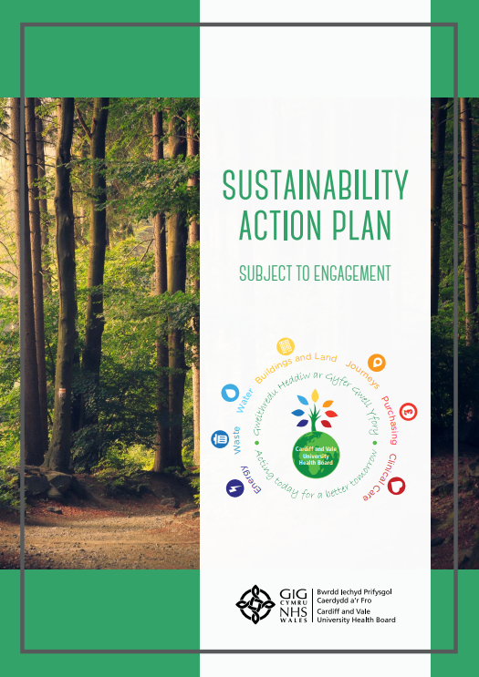
At the beginning of 2020, Cardiff and Vale University Health Board declared a climate emergency and that same year we created our first Sustainability Action Plan.
Across the 8 dimensions of Energy; Waste & Food; Water; Procurement; People; Built Environment Green Infrastructure Biodiversity; Transport; Clinical – we set out a number of action’s we were looking to achieve. In the year since our plan was drafted some of the highlight achievements include:
- ISO14001 re-certification
- 6,800 LED lights installed, 100% renewable electricity purchased
- Zero waste sent to landfill
- Reduction in energy used over the last year
- Funding for water fountains in several thanks to our Health Charity
- Funding for bike maintenance thanks to our Health Charity
- Homeworking commonplace
- Average of c33% of outpatient appointments are now virtual
- Creation of a health professionals community of interest
- Sustainable healthcare introduced to year 2, 3, 4 and 5 medical students at Cardiff University
- Creation of a ‘programme business case’ for a potential University Hospital Wales (UHW) replacement and University Hospital Llandough (UHL) refurbishment
- Ran a survey of colleagues – assessed awareness and the messages back included tackling simple things like turning lights off

Learning

Although our first Sustainability Action Plan worked well for us, it was always seen as just a beginning. We realise that doing the same again will not move the dial on our environmental impact, so we looked at what improvements we can make across the Health Board and the barriers that need to be addressed in order to accelerate improvements to our environmental impact.

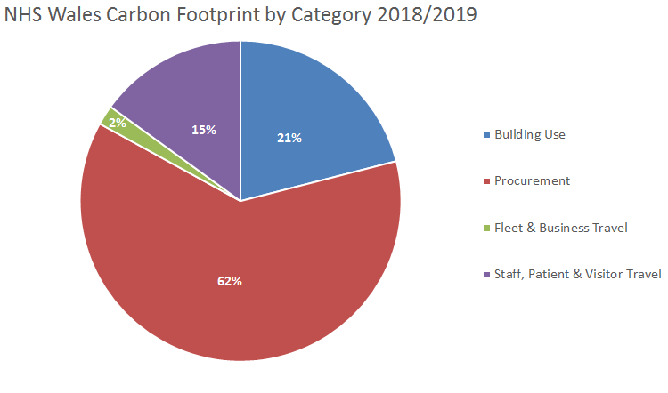
Research undertaken by NHS Wales Shared Services Partnership and the Carbon Trust indicated that 62% of the NHS Wales carbon emissions are as a result of the products we use in the delivery of healthcare. Building Use accounts for 21%, so whilst it is important to make improvements on top of those already made to our buildings and the energy used to operate them, we determined that more needs to be done to reduce the impact of our overall operations as a healthcare provider.
The products we use every day in the Health Board create carbon emissions: for example, syringes, PPE, wound dressings, and medicines to name but a few.
Whilst some of the products that we use are designed to be disposed of after use, opportunities exist to substitute these products for ones that can be reused and sterilised over and over. Some of the medicines that we prescribe patients contain environmentally harmful gases so there are instances where we could prescribe ones that are more environmentally friendly, whilst ensuring they are still safe to use and have the same impact.
We also learned over the last year that some change needs to come from the top, where the Health Board is making decisions with sustainability as a key criteria and is actively being seen to promote and deliver sustainable outcomes.
A survey was conducted in May 2021 which found that there was support for Cardiff & Vale UHB doing more to improve its environmental impact, but not widespread awareness of our efforts so far so we need to do more to mobilise our colleagues to make change.
Finally, we learned that although sustainability is important, our colleagues may need help to envision what part they can play.
NHS Wales Decarbonisation Plan
In March 2021, NHS Wales published its decarbonisation strategy, showing how the NHS in Wales will contribute to a net-zero public sector by 2030. With 46 initiatives and over 100 actions, with around 70 delegated to Health Boards and Trusts in Wales, it ‘ups the game’ on progress and scrutiny.
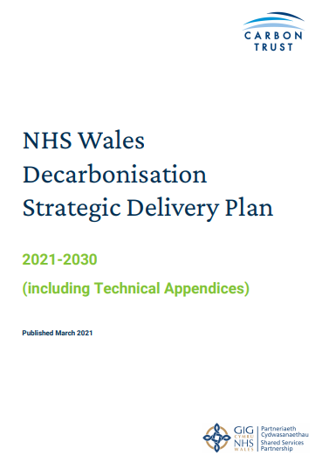
In the Decarbonisation Strategy, it highlights significant effort being put into procurement in an attempt to tackle the 62% of carbon emissions in Wales that originate from the products we use.
It also requires sustainability to be deeply embedded into NHS Wales organisations.
NHS organisations need to create action plans to show how the actions within the delivery plan are being implemented, these actions will be embedded into Integrated Medium Term Plans.
Cardiff & Vale UHB’s base position is that we will adopt all actions delegated to Health Boards and Trusts in this document.
NHS Wales Target
- Against a 2018/19 baseline of 1,001,378 tCO₂e
- Reduce emissions by 16% on/before 2025
- Reduce emissions by 34% on/before 2030
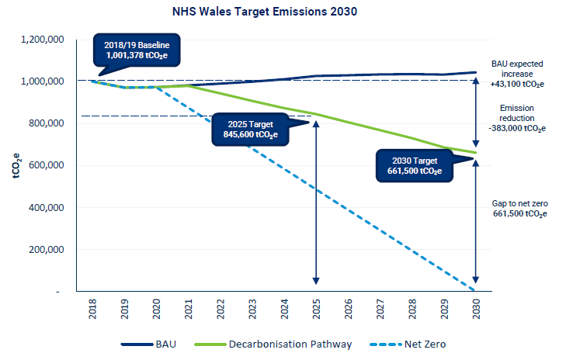

Public Health Wales highlights the health impacts of climate change
Public Health Wales has recently published several infographics highlighting the significance of climate change and its impact on the health and wellbeing of the population of Wales, and to support public bodies and business to take action to address any impacts.
These infographics coincided with the launch of the Council of Parties 26 (COP26) in November 2021 and focus on the relationships between the natural environment and health, the population groups affected and some of the key health and wellbeing impacts of climate change, and those population groups who could be affected.
For further information regarding the infographics, please visit the Public Health Wales website.

Vision
Our vision is to be considered a top 10 health system globally.
This will be realised through the execution of an ambitious clinical strategy called Shaping Our Future Clinical Services and a Programme Business Case which considers our future infrastructure requirements, Shaping Our Future Hospitals. Both of these put sustainability front and centre.
We operate in old buildings, but have an ambition to modernise our community and hospital infrastructure, putting in the right services in the right locations for the benefit of our population.
These are long term strategies so in the meantime, we realise that we need to work hard now to lay strong foundations to play our part in the net-zero by 2030 goal.
In the meantime, we have also developed our sustainability brand, Shaping Our Future Sustainable Healthcare.
We want to remain ahead of the actions delegated to Cardiff & Vale UHB through the NHS Wales Decarbonisation plan.
Through the learning from running our first Sustainability Action Plan, adopting the actions contained within the NHS Wales Decarbonisation Strategic Delivery Plan, talking to colleagues and thinking about how we set ourselves up for future success, we have developed a Cardiff and Vale UHB action plan for execution by March 2023.
The approach to this action plan is that we spread responsibility across the organisation, begin to build sustainability into corporate decision making, ensure there is Board oversight of our progress and do more to communicate how colleagues can make a difference within their day to day activity.
We believe this is a challenging, but realistic plan that will set us out as leaders within Wales.
Our Action Plan
Our 21/22 action plan inherits the actions defined in the NHS Wales Decarbonisation Plan but goes further. Some highlights include:
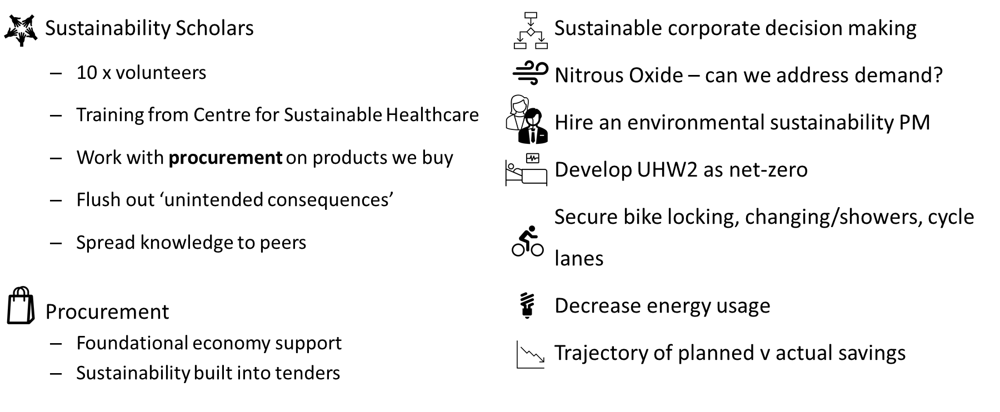
Highlights
Through the execution of our Action Pan for 22/23, we will have taken a step change in our maturity and started to have reduced our carbon emissions. We will have ownership from the Board and with a nominated Board lead to drive the agenda. In particular, we would like this action plan to stimulate our colleagues to make a difference within their sphere of influence, whether that is to turn off a light switch, or to make clinically appropriate but lower carbon decisions for our patients.

Action Plan Detail
This section outlines what we would like to achieve over the next year on top of the NHS Wales actions.
Leadership
Objectives:
- Show leadership and commitment to help make the Welsh Public Sector carbon neutral by 2030.
Key Success Measures:
- A qualitative view of a cultural shift in attitudes and demonstrable examples where ‘green’ decision making has been enacted.
Actions | Action Owner | Date | Metrics
Develop a means to embed sustainability into corporate decision making. | Dir Corp Gov | 31/03/2023 | Demonstration of where decisions have been made.
Have formal Board recognition for Sustainability by appointing a lead and enable Board oversight on action plan delivery. | CAVUHB | 01/12/2021 | Sign off action plan at 11/21 Board Meeting.  Sustainability part of IMTP.
Each Executive Director has a Sustainability action for 21/22 and to take a Sustainability Objective for 22/23. | Executives | 30/06/2022  &  31/3/2023 | Actions monitored and delivered.  An agreed objective for sustainability improvement agreed with Chief Executive.  Outcomes reported on.
Implement the Digital Sustainability Model from HIMMS to demonstrate sustainable decision making | Dir Digital | 31/03/2022 | Implemented and proof of practical application
Publish a trajectory of where we are with emissions using a Welsh Gov model and where we need to be | SAG | 30/11/2022 | Be ahead of WG expectations of a 16% reduction by 2025
If there is another wave of COVID during winter 2021, commit to continuing with sustainability as a priority | Board | 31/03/2022 | Qualitative assessment
Recovery transformation programmes/projects capture the positive environmental impacts (forecast and actual) | Hannah Evans (Ops) | 30/11/2022 | As programmes are defined, use the opportunity to set out sustainability benefits and yield those benefits as programmes are delivered.
Set up an awards scheme to celebrate sustainable projects | Workforce | 31/03/2022  &  31/3/2023 | Recognise and value our peoples' efforts
Hire a sustainability project manager | Dir Strategy | 01/12/2021 | Appointment

Energy
Objectives:
- Retain ISO14001
Key Successes:
- Recertification of ISO14001
Actions | Action Owner | Date | Metrics
Maintain the good management of the environment with commitment, following legislation and improvements across energy, waste, transport, etc. | CEF | 31/03/2022  &  31/3/2023 | ISO14001 recertification

Food & Waste
Objectives:
- Reduce waste through our operations
- Maximise recycling
- Send no waste to landfill
Key successes
- Zero waste to landfill
- Reduction in waste generated
Actions | Action Owner | Date | Metrics
Maintain zero waste to landfill | CEF | 31/03/2022  & 31/03/2023 | Total waste in tonnes segregated
Halve food waste by 2025 from a 2007 baseline | CEF | 31/03/2022 | Zero waste to landfill
Maximise waste incinerated with energy recovery | CEF | 31/03/2022  &  31/03/23 | Tonnes waste incinerated with energy recovery
Encourage recycling amongst staff and patients/visitors | CEF | 31/03/2022  &  31/03/2023 | % waste recycled as portion of total

Water
Objectives:
- Reduce water usage, promote the importance of being hydrated
Key Successes:
- To accurately measure water usage and seek any available reduction strategies through programmes such as Re:fit
Actions | Action Owner | Date | Metrics
Encourage service improvement programmes related to waste/water | CEF | 31/03/2022  &  31/03/2023 | Water use mᶟ

Procurement
Objectives:
- Make sustainable procurement decisions.
Key Successes:
- Reduction in single use devices and wasteful packaging.
- Increased proportion of £s spent in Wales.
Actions | Action Owner | Date | Metrics
Create Specific questions within tenders to select based upon sustainability, foundation economy and WBFG criteria. Test effectiveness and learn from implementation. | Claire Salisbury | 30/09/2022 | Create lessons learned, e.g. who captures/owns benefits, re-develop questions over time, etc. Monitoring delivery against commitments.
Train 10x Sustainability Scholars in SusQI, funded by NWSSP Procurement. | I&I | 30/11/2022 | Training delivered.
Follow NWSSP Sustainable Procurement Code of Practice. | Claire Salisbury | 31/03/2023 | To form part of contracts – evidence where happened for Cardiff and Vale led procurement.
Search for foundation economy and decarbonisation opportunities in contracts being tendered and re-tendered. | Claire Salisbury | 31/03/2023 | Evidence of contracts where foundation economy and/or sustainability benefits have been achieved.

People
Objectives:
- Staff and patients aware of our commitment to sustainability and feel they have a part to play.
Key Successes:
- Staff recognise our commitment to sustainable healthcare service delivery and have a role to play.

Actions | Action Owner | Date | Metrics
Communicate successes and plans. | Comms | 31/03/2022  &  31/03/2023 | Number of comms stories. Awareness measured by survey.
Fund a sustainability fellow full time for 21/22. | MD | 31/03/2022  &  31/03/2023 | Fellow confirmed in post.
Commence a bottom up culture change programme for Cardiff and Vale staff focussed around basic sustainable behaviour, for example, light off, recycle etc. | Claire Whiles | 31/03/2023 | Staff survey showing increased awareness of sustainability using 2021 survey as a baseline.

Built Environment, Green Infrastructure, and Biodiversity
Objectives:
- New buildings are sustainable and foster healthy, green, biodiverse external spaces.
Key Successes:
All new builds and major refurbishments include sustainable design features as standard and our external space is healthy, green, and biodiverse.

Actions | Action Owner | Date | Metrics
Express the Shaping Our Future Hospitals opportunity with an aspirational set of sustainability credentials. | PD SOFH | 31/03/2023 | Strategic Outline Case completed with sustainability credentials set out.

Transport
Objectives:
- Reduce the number of cars brought to our sites, and encourage active travel and homeworking.
Key Successes:
- Increase use of active travel
- Increase number of ULEVs in our fleet
Actions | Action Owner | Date | Metrics
Meet the commitments of the Healthy Travel Charter: reduce car usage, increase cycle usage and the amount of staff using ULEV’s during the day, as well as increased bus usage. | C McMillan | 31/03/2022  &  31/03/2023 | Positive behaviour change progress through the Healthy Travel Survey.
Scope the potential for measurement of air quality at UHW and UHL. | Dr Tom Porter | 31/03/2022 | Creation of scope/proposal to implement.
Scope the increase safe bike locking across our sites, changing/showers and segregated cycle lanes – these are in the charter. | C McMillan | 31/03/2022 | Creation of options/feasibility.

Clinical
Objectives:
- Develop low carbon/low waste care for our patients
- Sustainability embedded in Cardiff and Vale strategic investments.
- Promote prudent healthcare, self-care, prevention, pre-hab and rehab.
- Consume less/reuse more
Key Successes:
- To be recognised as a benchmark/case study health system for sustainable health policy and practice.
- Sustainability is embedded into our service planning arrangements.
- Health professionals are driving procurement decisions.

Actions | Action Owner | Date | Metrics
At least a third of non f2f consultations by 31/3/22 | COO | 31/03/2022 | 33% target
Define tranche of lean and green pathways as part of Shaping Our Clinical Services and expressed in Shaping Our Future Hospitals. | VLeG, Dr NM | 30/11/2022 | Described in next stage SOCS strategy and SOFH business case.
Develop sustainability as an element of the new Podiatry strategy. | Fiona Jenkins | 30/11/2022 | Operational strategy and demonstrating how lessons are being shared with other therapies.
Search for opportunities to transform the use of nitrous oxide | CD&T (and clinical fellow) | 30/11/2022 | Reduced supply of nitrous oxide into C&V.
To advocate the work of the Centre for Sustainable Healthcare - embed into learning of medical students and trainees. Generate SSE projects. Potentially collaborate with HEIW. | Clinical Fellow | 30/09/2022  &  31/03/2023 | Evidence of projects undertaken by students in the university medical school, materials prepared and delivered to trainees
Grow and build on a cross functional community/network of interest to grow sustainable practices | Clinical Fellow | 30/11/2022  &  31/03/2023 | Numbers of active participants from a range of disciplines
Include sustainability as a criteria with measurement for Perfect Ward accreditation | Dir Nursing | 31/03/2022 | Included in assessment criteria reflecting maturity at bronze v silver.
Spread the SW Cluster model of avoiding hospital re-admissions through MDTs and social prescribing to 2 x Clusters. | Cath Doman | 30/11/2022 | Evidence of reduced hospital readmissions through implementation.
Recruit 10 x Sustainability Scholars | I&I | 01/12/2022 | Scholars in place
Define a clinical leadership role that influences across medical, nursing and therapies. | MD | 31/03/2022 | Appointment made and demonstrable leadership being shown along with influence.
Working with procurement, sustainability scholars explore opportunities to reduce consumption or substitute single use devices/products for reusable | I&I | 30/11/2022 | Benefits captured of running pilot projects.
Create space for 10 x Sustainability Scholars to make healthcare sustainability gains, be beacons and spread capability. | Execs | 31/03/2022 | Named scholars that have received SusQI training and have written up their results.

Looking Ahead
Looking towards 2025 when NHS Wales expects to have reduced its carbon emissions by 16%, the following long-term actions/outcomes are outlined to demonstrate our ambition:
- 2023 – Learn the lessons from our 22/23 action plan and enhance overall UHB ownership of the carbon reduction agenda where decisions are being made with sustainability in mind
- 2023 - High levels of awareness amongst colleagues through communications and culture change activities that their day to day actions, no matter where they sit in the organisation, have a part to play in reducing our carbon footprint and understand the benefits of doing this.
- 2023 – Learning from and enhancing the sustainability scholar (Sferic) initiative
- 2023 – Clinical colleagues (nurses, therapists, doctors) understand that sustainability is a fundamental part of day to day quality improvement and patients benefit from this – Sustainable Quality Improvement (SusQI from the Centre for Sustainable Healthcare) considered as a standard model.
- 2023 – Results being delivered through appointing clinical leadership with responsibility for setting and driving outcomes from policy
- 2023 – Using our carbon footprint data to pick out hot spots for action
- 2023 - A large body of case studies created by Cardiff and Vale UHB colleagues which others can learn from, both successes and the describing of initiatives that yielded unexpected consequences
- 2023 – Delivery impact of level 2 Healthy Travel Charter. Sustainable transport approaching a default way to access our sites
- 2023 – All NHS Decarbonisation due in 2023 actions showing compliance
- 2023 & 2024 - Further tangible reductions in energy usage from non-green sources
- 2023 & 2024 – Results from Shaping Our Future Population Health beginning to be seen in our population, with further impacts anticipated over time
- 2023 & 2024 – Shaping Our Future Hospitals and the contributing clinical model (Shaping Our Future Clinical Services) have low carbon and sustainable development principles at their heart
- 2024 – Organisational maturity in Cardiff and Vale UHB’s proactive management of carbon reduction
- 2024 - Being seen as a leader internationally on our impact on sustainable healthcare
- 2024 - That each department/speciality are undertaking reviews of the medicines and products they use in the delivery of healthcare and making clinically expedient but sustainable choices, e.g. increase in re-usable devices. Giving time to people in support of this aim.
- 2024 - >10% reduction in carbon emissions from a 2018 baseline (as per NHS Wales Decarbonisation strategy)
- 2025 - > 16% reduction in carbon emissions from a 2018 baseline (as per NHS Wales Decarbonisation strategy)
Governance
A Programme Board will be created, comprising leaders from across the organisation. This Board will monitor and control progress against our action plan.
The Board’s Strategy & Delivery Committee will provide oversight.
What can people do?
We can all play a part. The small, simple things can really add up.
- Turn your PC and monitor off at the end of the day. If you have a laptop, don’t charge it overnight.
- Turn off lights if you’re no longer in the room.
- Place rubbish in the most appropriate bin. Recycle what you can.
- Bring your own cup (which has been cleaned) to one of Cardiff & Vale’s Aroma cafes.
- Each year we will be celebrating success at an awards ceremony. Consider entering your project which has a sustainability benefit to it.
- If you have a suggestion for improvement, email news@wales.nhs.uk and our team may consider it for implementation.
- Become a Green Champion!

You can visit our new Shaping Our Future Sustainable Healthcare​ website for further information. This is an engagement hub for the Cardiff and Vale University Health Board Sustainability Action Plan and sustainability in healthcare delivery.

https://gov.wales/nhs-wales-decarbonisation-strategic-delivery-plan

