Cardiff and Vale University Health Board pharmaceutical needs assessment

October 2021

This document is available in Welsh / Mae’r ddogfen hon ar gael yn Gymraeg.

Contents

1 Introduction 7
2 Overview of Cardiff and Vale University Health Board 38
3 General health needs of Cardiff and Vale University Health Board 58
4 Identified patient groups – particular health issues 79
5 Provision of pharmaceutical services 94
6 Other NHS services 132
7 Health needs that can be met by pharmaceutical services 138
8 Cardiff East cluster 144
9 Cardiff South East cluster 154
10 Cardiff City and South cluster 165
11 Cardiff North cluster 176
12 Cardiff South West cluster 189
13 Cardiff West cluster 199
14 Central Vale cluster 211
15 Eastern Vale cluster 223
16 Western Vale cluster 233
17 Conclusions for the purpose of schedule 1 of the NHS (Pharmaceutical Services) (Wales) Regulations 2020 244
Appendix A – policy context and background papers 251
Appendix B – essential services 255
Appendix C – advanced services 258
Appendix D – enhanced services 260
Appendix E – terms of service for dispensing appliance contractors 263
Appendix F – PNA steering group membership 266
Appendix G – patient and public engagement survey 267
Appendix H – full results of the patient and public questionnaire 276
Appendix I – pharmacy contractor questionnaire 301
Appendix J – dispensing practice questionnaire 304
Appendix K – Consultation report 307
Appendix L – opening hours 308

Executive summary

The National Health Service (Pharmaceutical Services) (Wales) Regulations 2020 sets out the statutory duty placed upon each health board to prepare and publish a pharmaceutical needs assessment (PNA) by 1st October 2021. The purpose of the PNA is to improve the planning and delivery of pharmaceutical services in Cardiff and Vale University Health Board by considering the pharmaceutical needs of the population and aligning services more closely with them. It will allow for improvement in the quality and consistency of pharmaceutical services across the health board’s area. Furthermore, it will be used to determine whether to approve applications for the opening of new pharmacies, appliance contractors and dispensing doctor practices, based on current and future needs that have been identified in the health board’s PNA, as well as applications to change existing services.

A PNA Steering Group was formed to oversee the PNA development and ensure that the PNA meets the statutory requirements. Membership of the group included a wide range of stakeholders (Appendix F). For the purposes of the PNA, localities have been defined as the nine clusters which make up Cardiff and Vale University Health Board.

In developing the PNA, several sources of information were used to gain an overview of the demographic characteristics and the health profile of Cardiff and Vale University Health Board residents to determine their pharmaceutical needs.

The views of residents on their use of pharmacies, and information provided by contractors which could not be nationally sourced, was obtained through the use of surveys. The information gained was used, in conjunction with other data sources, to inform the PNA.

In addition, a consultation, which ran from Friday 21st May until Tuesday 20th July 2021, was undertaken on the draft PNA and the feedback received used to inform the final PNA (Appendix K).

An overview of the demographic characteristics of the residents of Cardiff and Vale University Health Board and their general health needs has been set out at the health board and local authority level. In addition, any specific groups identified as present in Cardiff and Vale University Health Board including those who share a protected characteristic under the Equality Act 2010, and their likely health needs have been included. Consideration has been given as to how these health needs can be met by the pharmaceutical contractors in the health board’s area.

The current provision of pharmaceutical services has been identified and mapped. Those providers who are located outside of Cardiff and Vale University Health Board’s area but who provide services to its residents, were also considered. Furthermore, there are some services which affect the need for pharmaceutical services either by increasing or reducing demand. Such services include the hospital pharmacies, the Out of Hours and CAV 24/7 and Minor Injury Units and these have been considered as part of the PNA.
While an overview has been considered at the health board and local authority level, a cluster level review has also been undertaken of the demographic characteristics, health needs and the current provision of pharmaceutical services to residents. This has been used to identify whether current pharmaceutical service provision meets the needs of those residents. Consideration has also been given as to whether there are any gaps in service delivery that may arise during the five year lifetime of the PNA.

There are 106 pharmacies in Cardiff and Vale University Health Board all providing the full range of essential services. In 2019 to 2020, 96.3% of all prescription items written by GP practices were dispensed by the pharmacies in the health board. Pharmacies also provide a range of advanced and enhanced services.

There are four appliance contractors, which dispense prescriptions for appliances within and outside of the health board’s area. All four appliance contractors offer either the Appliance Use Review (AUR) advanced service or the Stoma Appliance Customisation (SAC) advanced service or both.

There is one GP dispensing doctor practice in Cardiff and Vale University Health Board, who dispenses to eligible patients and who dispensed or personally administered less than 0.1% of all items prescribed in Cardiff and Vale University Health Board. The non-dispensing practices personally administered 1.9% of the total.

While there is very good service provision within the health board area, some residents may choose to access pharmaceutical contractors outside of the health board’s area. In 2019 to 2020, 1.8% of prescriptions were dispensed outside of Cardiff and Vale University Health Board. Whilst many were dispensed by pharmaceutical contractors in neighbouring health boards, some were dispensed as far afield as England. This suggests that that some residents prefer to use a specific dispensing appliance contractor or a specialist provider, with some prescriptions being dispensed whilst the person is on holiday or near to their place of work.

Access to pharmaceutical services for the residents of Cardiff and Vale University Health Board is very good, with an overwhelming majority able to access a pharmacy during normal working hours within 20 minutes. The majority can access a pharmacy within five to 10 minutes by car. Whilst noting that not all households have access to a car, the nature of the clusters means that walking to a pharmacy will be a realistic option for many residents and regular public transport services are available for those who are unable to undertake the whole journey on foot. However, in the more rural areas of Western Vale cluster and Central Vale cluster, public transport services are limited. Although car ownership is likely to be high, those without a car and in particular the elderly, may find it difficult to access a pharmacy. The majority of pharmacies in these clusters will have arrangements in place that enable timely access to medicines to those who are housebound or who may find it difficult to access a pharmacy. Therefore, the main conclusion of this PNA is that there are currently no gaps in the provision of pharmaceutical services.

When considering whether there will be any future needs for pharmaceutical services that may arise during the five year lifetime of the PNA, consideration has been given to the predicted population growth, planned housing developments and the capacity and distribution of service providers across the health board. The Cardiff and Vale University Health Board concludes that the current provision will be sufficient to meet the future needs of the residents and the health board has not identified any services that would secure improvements, or better access, to the provision of pharmaceutical care either now or within the lifetime of the PNA.

1 Introduction

1.1 Purpose of a pharmaceutical needs assessment

The purpose of the pharmaceutical needs assessment (PNA) is to assess and set out how the provision of pharmaceutical services can meet the health needs of the population of a health board’s area for a period of up to five years, linking closely to the ‘Cardiff and Vale Population Needs Assessment For Social Services and Well-being (Wales) Act 2014’ and the Public Services Board Well-being Assessment (2017) for Cardiff and for the Vale of Glamorgan. Whilst these respectively focus on the care and support needs of the population, and on improving the well-being of communities, the PNA looks at how the population health needs can be met by pharmaceutical services commissioned by the health board.

If a person (a pharmacy or a dispensing appliance contractor) wants to provide pharmaceutical services, they are required to apply to the health board, in whose area the premises are to be located, to be included in its pharmaceutical list. Their application must offer to meet a need that is set out in that health board’s PNA. There are however some exceptions to this e.g., change of ownership applications.

If a GP wishes to dispense to a new area or from new or additional premises, they are also required to apply to the health board to be included in its dispensing doctor list or for a new area or new or additional premises to be listed in relation to them. Their application must also offer to meet a need that is set out in that health board’s PNA.

As well as identifying if there is a need for additional premises, the PNA will also identify whether there is a need for an additional service or services. Identified needs could either be current or will arise within the five year lifetime of the PNA.

1.2 Health board duties in respect of the pharmaceutical needs assessment

Further information on the health board’s specific duties in relation to PNAs and the policy background to PNAs can be found in appendix A, however in summary the health board must:

- Publish its first PNA by 1 October 2021;
- Publish revised statements (i.e., subsequent PNAs), on a five yearly basis, which comply with the regulatory requirements;
- Publish a subsequent PNA sooner when it identifies changes to the need for pharmaceutical services which are of a significant extent, unless to do so would be a disproportionate response to those changes; and
- Produce supplementary statements which explain changes to the availability of pharmaceutical services in certain circumstances.

1.3 Pharmaceutical services

The services that a PNA must include are defined within both the National Health Service (Wales) Act 2006 and the NHS (Pharmaceutical Services) (Wales) Regulations 2020.

Pharmaceutical services may be provided by:

- A pharmacy contractor who is included in the pharmaceutical list for the area of the health board;
- A dispensing appliance contractor who is included in the pharmaceutical list held for the area of the health board; and
- A doctor or GP practice that is included in a dispensing doctor list held for the area of the health board.

Each health board is responsible for preparing, maintaining and publishing its lists. In Cardiff and Vale University Health Board there are 106 pharmacies, four dispensing appliance contractors and one dispensing practice.

Contractors may operate as either a sole trader, partnership or a body corporate. The Medicines Act 1968 governs who can be a pharmacy contractor, but there is no restriction on who can operate as a dispensing appliance contractor.

1.3.1 Pharmaceutical services provided by pharmacy contractors

Unlike for GPs, dentists and optometrists, Cardiff and Vale University Health Board does not hold contracts with the pharmacy contractors in its area. Instead, they provide services under a contractual framework, sometimes referred to as the community pharmacy contractual framework, details of which (the terms of service) are set out in schedule 5 of the NHS (Pharmaceutical Services) (Wales) Regulations 2020, the Pharmaceutical Services (Advanced and Enhanced Services) (Wales) Directions 2005, and the Pharmaceutical Services (Advanced Services) (Appliances) (Wales) Directions 2010.

Pharmacy contractors provide three types of service that fall within the definition of pharmaceutical services and the community pharmacy contractual framework. They are:

- Essential services – all pharmacies must provide these services
  - Dispensing of prescriptions, including urgent supply of a drug or appliance without a prescription
  - Dispensing of repeatable prescriptions
  - Disposal of unwanted drugs
  - Promotion of healthy lifestyles
  - Signposting, and
  - Support for self-care

- Advanced services – pharmacies may choose whether to provide these services or not. If they choose to provide one or more of the advanced services, they must meet certain requirements and must also be fully compliant with the essential services and clinical governance requirements.
  - Medicines use review and prescription intervention services (more commonly referred to as the medicines use review or MUR service)
  - Discharge medicines review service (DMR) service
  - Stoma appliance customisation (SAC) service
  - Appliance use review (AUR) service

- Enhanced services – service specifications for this type of service are developed nationally or by the health board and then commissioned to meet specific health needs.
  - Anticoagulation monitoring
  - Care home service
  - Disease specific medicines management service
  - Gluten free food supply service
  - Home delivery service
  - Language access service
  - Medication review service
  - Medicines assessment and compliance support service
  - Minor ailment scheme
  - Needle and syringe exchange
  - On demand availability of specialist drugs service
  - Out of hours service
  - Patient group direction service
  - Prescriber support service
  - Schools service
  - Screening service
  - Stop smoking service
  - Supervised administration service
  - An anti-viral collection service
  - An emergency supply service

Further information on the essential, advanced and enhanced services requirements can be found in appendices B, C and D respectively.

Underpinning the provision of all of these services is the requirement on each pharmacy contractor to participate in a system of clinical governance. This system is set out within the NHS (Pharmaceutical Services) (Wales) Regulations 2020 and includes:

- A patient and public involvement programme
- A clinical audit programme
- A risk management programme
- A clinical effectiveness programme
- A staffing and staff management programme,
- An information governance programme, and
- A premises standards programme.
Pharmacies are required to open for not less than 40 hours per week, and these are referred to as core opening hours, but many choose to open for longer and these additional hours are referred to as supplementary opening hours. Under the NHS (Pharmaceutical Services) (Wales) Regulations 2020 it is possible for pharmacy contractors to successfully apply to open a pharmacy with a greater number of core opening hours in order to meet a need identified in a PNA.

The proposed opening hours for each pharmacy are set out in the initial application, and if the application is granted and the pharmacy subsequently opens these form the pharmacy’s contracted opening hours. The contractor can subsequently apply to change their core opening hours and the health board will assess the application against the needs of the population of its area as set out in the PNA to determine whether to agree to the change in core opening hours or not. If a pharmacy contractor wishes to change their supplementary opening hours, they simply notify the health board of the change, giving at least three months’ notice.

1.3.2 Pharmaceutical services provided by dispensing appliance contractors

As with pharmacy contractors, Cardiff and Vale University Health Board does not hold contracts with dispensing appliance contractors. Their terms of service are set out in schedule 6 of the NHS (Pharmaceutical Services) (Wales) Regulations 2020 and the Pharmaceutical Services (Advanced Services) (Appliances) (Wales) Directions 2010.

Dispensing appliance contractors provide the following services for appliances (not drugs), for example catheters and colostomy bags, which fall within the definition of pharmaceutical services:

- Dispensing of prescriptions, including urgent supply without a prescription
- Dispensing of repeatable prescriptions
- Home delivery service for some items
- Supply of appropriate supplementary items (e.g., disposable wipes and disposal bags)
- Provision of expert clinical advice regarding the appliances, and
- Signposting

They may also choose to provide advanced services. If they do choose to provide them then they must meet certain requirements and must also be fully compliant with their terms of service and the clinical governance requirements. The two advanced services that they may provide are:

- Stoma appliance customisation (SAC) service
- Appliance Use Review (AUR) service

As with pharmacies, dispensing appliance contractors are required to participate in a system of clinical governance. This system is set out within the NHS (Pharmaceutical Services) (Wales) Regulations 2020 and includes:

- A patient and public involvement programme
- A clinical audit programme
- A risk management programme
- A clinical effectiveness programme
- A staffing and staff programme,
- An information governance programme, and
- A premises standards programme.

Further information on the requirements for these services can be found in appendix E.

Dispensing appliance contractors are required to open not less than 30 hours per week and these are referred to as core opening hours. They may choose to open for longer and these additional hours are referred to as supplementary opening hours. Under the NHS (Pharmaceutical Services) (Wales) Regulations 2020 it is possible for dispensing appliance contractors to successfully apply to open premises with a greater number of core opening hours in order to meet a need identified in a PNA.

The proposed opening hours for each dispensing appliance contractor are set out in the initial application, and if the application is granted and the dispensing appliance contractor subsequently opens then these form the dispensing appliance contractor’s contracted opening hours. The contractor can subsequently apply to change their core opening hours. The health board will assess the application against the needs of the population of its area as set out in the PNA to determine whether to agree to the change in core opening hours or not.

1.3.3 Pharmaceutical services provided by doctors

The NHS (Pharmaceutical Services) (Wales) Regulations 2020 allow doctors to dispense to eligible patients in certain circumstances. The regulations are complicated on this matter but in summary:

- Patients must live in a ‘controlled locality’ (an area which has been determined by the health board or a preceding organisation as rural in character, or on appeal by the Welsh Ministers), more than 1.6km (measured in a straight line) from a pharmacy, and
- Their practice must have premises approval and outline consent to dispense to that area.

There are some exceptions to this, for example patients who have satisfied the health board that they would have serious difficulty in accessing a pharmacy by reason of distance or inadequacy of means of communication.
1.4 Other NHS services

Other services which are commissioned or provided by Cardiff and Vale University Health Board which affect the need for pharmaceutical services are also included within the PNA.

1.5 How the assessment was undertaken

1.5.1 PNA steering group

Cardiff and Vale University Health Board has overall responsibility for the publication of the PNA, and the Executive Director of Public Health is accountable for its development. Cardiff and Vale University Health Board established a PNA steering group whose purpose was to ensure that the development of a robust PNA that complies with the NHS (Pharmaceutical Services) (Wales) Regulations 2020 and meets the needs of the local population. The membership of the steering group ensured all the main stakeholders were represented and can be found in appendix F.

1.5.2 PNA localities

In Wales there are 64 primary care clusters, each serving a population between 25,000 and 100,000. The clusters are tasked with improving access to, and the quality of, primary care to deliver improved local health and wellbeing and reduced health inequalities. In Cardiff and Vale University Health Board there are nine primary care clusters.

The PNA localities that have been used for the PNA match the boundaries of these nine clusters that make up the combined Cardiff and Vale University Health Board area, namely:

- Cardiff North
- Cardiff West
- Cardiff South West
- Cardiff East
- Cardiff South East
- Cardiff City and South
- Western Vale
- Central Vale
- Eastern Vale

Within Cardiff and Vale University Health Board area, the nine clusters are divided evenly between three localities, which fall within two Borough Councils or local authorities as shown below in table 1.1.

Table 1.1: Clusters, localities and local authorities within Cardiff and Vale University Health Board
Cardiff and Vale University Health Board
North-West Locality | South-East Locality |  | Vale Locality
Cardiff North | Cardiff East |  | Western Vale
Cardiff West | Cardiff South East |  | Central Vale
Cardiff South West | Cardiff City and South |  | Eastern Vale
Cardiff  Local Authority |  | The Vale of Glamorgan  Local Authority

Throughout this document the PNA localities will be referred to as clusters to match the terminology used by Cardiff and Vale University Health Board and to prevent confusion with the health board’s three localities.

1.5.3 Patient and public engagement

In order to gain the views of patients and the public on pharmaceutical services, a questionnaire was developed and made available from 19th January 2021 to 15th February 2021. The questionnaire was promoted through social media, with at least one media post for each week the questionnaire was open. It was sent out at different times of the day to capture a cross section of patients and the public. It was also shared with Community Health Councils. A news item about the patient and public questionnaire was featured on the Health Board’s website. Two news items were also included in the Chief Executive’s Weekly Connect blog which is seen by staff, patients and the public. As Cardiff and Vale University Health Board has a large student population, the questionnaire was promoted through the three universities. The StaffConnect app was also used to promote the questionnaire to staff that live in the health board area.

A copy, which shows the questions asked, can be found in appendix G. The full results can be found in appendix H.

It is worth noting that at the time the survey was undertaken, Wales was in lockdown due to the Coronavirus (COVID-19) pandemic. As community pharmacies are designated as an essential service, they were required to remain open during this time to provide for the pharmaceutical needs of the population. Many changes to working practice were swiftly undertaken to enable this. Social distancing measures were implemented, restricting patient numbers entering the pharmacy premises. Changes to opening hours meant many pharmacies were permitted to work behind closed doors at lunchtime and for the first and last hour of the day. These measures resulted in longer waiting times for patients, contributing to patient anxiety and frustration. With large numbers of patients shielding, the demand for deliveries from community pharmacies also increased. Many volunteers and voluntary agencies
stepped forward to help meet this demand in many areas. Pharmacy staff themselves also faced increased stress during this time, due to the Coronavirus (COVID-19) pandemic pressures at work and at home.

A total of 311 people or respondents completed the questionnaire; however, not all 311 respondents answered every question. 80% of respondents (247 out of 308 people) were female, 18% (55 people) were male and 1% (2 people) were non-binary. 2 respondents preferred not to say, 2 respondents selected other and three skipped the question.

All respondents who provided information about their age (309 people) were over 16 years old. A quarter of respondents (25%, 78 people) were aged between 16 to 44 years old. Almost three quarters of respondents were aged 45 years and over (74%, 229 people), with the age group 45 to 54 years having the largest number of responses overall (29%, 89 people), followed by the age group 55 to 64 years (27%, 82 people). Two respondents preferred not to say.

Figure 1.1: Age range of respondents

96% of respondents (296 out of 308 people) said their preferred language was English when they accessed services at a pharmacy. Only 4% (11 people) said their preferred language was Welsh. One respondent commented that they preferred either language to be used.

When asked why they usually visit a pharmacy, 309 people answered the question and a total of 888 responses were received. Multiple answers could be given to this question and the number of responses received indicates that some people chose more than one reason for visiting a pharmacy. The majority of responses received show that people visit a pharmacy to get or collect a prescription for themselves (280 responses) or to get or to collect a prescription for someone else (172 responses). Of the five people who responded other, two comments referred to buying cosmetics and general toiletries or both as a reason for visiting a pharmacy. The remaining three comments were related to how the Coronavirus (COVID-19) pandemic and guidance on shielding requirements had forced respondents to change how they usually collect their dispensed medicines from a pharmacy:
- “Collect myself until shielding was in place.”
- “Currently husband collects medication to allow me to shield.”
Figure 1.2: Reasons for vising a pharmacy

Most respondents (63%, 194 out of 308 people) visit a pharmacy on a monthly basis, reflecting the length of their prescription. Of the 23 people who responded other, nine visited a pharmacy to collect their two monthly repeat prescription, one person visited the pharmacy every six weeks and 11 visited a pharmacy rarely or whenever needed:
- “When necessary, depending on levels of illness. I’m healthy therefore I don’t attend regularly.”

One commented how the frequency had changed due to a prescription item not being available:
- “Usually monthly but as often a seven times recently (last quarter) due to prescription items not being Avalon [available on] time.”

One person responded that they were shielding so someone else collected on their behalf.

Figure 1.3: Frequency of using a pharmacy

The majority of respondents (37%, 113 out of 307 people) do not have a preference about when is the best time to use a pharmacy. Of the remaining responses, 42% preferred to use a pharmacy between 9am and 6pm, with 2pm to 6pm being the most popular choice followed by 6pm to 9pm.

Figure 1.4: The most convenient time to use a pharmacy

Similarly, the majority of respondents (52%, 160 out of 308 people) did not have a preference about the most convenient day to use a pharmacy. Of the remaining responses, 19% found the weekdays in general the most convenient time to access a pharmacy and 11% found the weekends in general the most convenient time to access a pharmacy. Other respondents preferred a specific day of the week, with Saturday being the most popular choice (6%).

Figure 1.5: The most convenient day to use a pharmacy

When asked whether there had been a time recently when they were not able to use their normal pharmacy, 25% (76 out of 307 people) responded ‘yes’, 73% (223 people) responded ‘no’ and 3% (8 people) said the question was ‘not applicable’. When asked what they had done, 76 people answered the question and a total of 83 responses were received. Multiple answers could be given to this question and the number of responses indicates that some people chose more than one course of action. The majority of responses received, show that people went to another pharmacy (47 responses) or waited until the pharmacy was open (26 responses). Three responses show that people went to their GP and one contacted the Out of Hours service. Of the six people who responded other: one did not have a usual pharmacy they used, one went home, and one had problems with the pharmacy not being open at the weekend and the next pharmacy being closed due to the Coronavirus (COVID-19) pandemic. Two other comments were linked to the delivery service and Coronavirus (COVID-19) pandemic:
- “The person who usually picks up my prescriptions because I am housebound was unable to get them due to illness himself. I had to phone to ask them to deliver and was told they don't usually deliver - but they would do it this once. I was shocked by this attitude.”

One person commented:
- “Went to on call pharmacy.”

Figure 1.6: What respondents did when they were not able to use their normal pharmacy

Most respondents prefer to use the same pharmacy. Of the 308 responses received, 197 respondents (64%) said they always use the same pharmacy and 101 respondents (33%) said they use different pharmacies but prefer to visit one most often. Three respondents said that they always use different pharmacies and seven respondents said they rarely use a pharmacy.

There are many reasons that influence the choice of pharmacy. Multiple answers (1664 responses) were given by the 308 people who answered the question as to what influences choice of pharmacy. The most popular reasons were close to home (229 responses) followed by close to my doctor (157 responses) and the location of the pharmacy is easy to get to (144 responses). Of the 22 respondents who answered other, 10 comments were received about the repeat dispensing system, including ordering and collecting prescriptions:
- “They provide telephone updates when my prescription is ready to be collected.”
- “Collect my prescription from GP and I pick up from the pharmacy once completed.”

Two comments were about the delivery service offered during the Coronavirus (COVID-19) pandemic:
- “They've been great during lockdown and have delivered our prescriptions when my husband was shielding.”
- “[Name of pharmacy] collects my prescription BUT WILL NOT DELIVER - even though I am shielding.”

Two comments were about opening times.
- “If only they would open at hours that people who work (in the NHS) could access them, I would go to the one that’s 30 seconds walk from my house, instead of having to track to [name of pharmacy].”

- “Open on a Saturday.”

One comment received was about ease of parking. Other comments include:
- “This is pharmacy that the drs told me I had to use this one.”
• “I go to the pharmacy that is open but this has been harder lately since my local pharmacy has moved further away and I have to delay my treatment till the next day.”
- “They get preferred brands.”
- “The other local pharmacy is closed but service is appalling.”
- “After negative experiences with other pharmacies, this one is the best in [name of location].”

Figure 1.7: Reasons that Influence the choice of pharmacy

The majority of respondents (67%, 207 out of 307 people), use the pharmacy that is most convenient or closest for them to use. 11 respondents said they did not know whether there was a closer or more convenient pharmacy. However, for 29% of respondents (89 people) there was a more convenient or closer pharmacy that they were choosing not to use. When asked why they did not use that pharmacy, 90 people answered the question (one more than previously responded) and a total of 164 responses were received. Multiple answers could be given to this question and the number of responses received indicates that some people chose more than one reason. The top three reasons provided were around ease of parking (29 responses), speed of service (22 responses) and having a bad experience in the past (21 responses).

Figure 1.8: Reasons for not using a nearer pharmacy

Of the 29 people who selected other, the following themes emerged from the comments received:

Five comments were about having built up a relationship with that particular pharmacy or being satisfied with the service received from the pharmacy they were using or both:
- “I moved house and am still within the catchment area for my GP and current pharmacy, so preferred not to change it as I like the staff and service, they know my medications (I take some unusual ones).”
- “I’ve always been happy with the one I use.”

Five comments were related to the proximity of pharmacy to the GP practice:
- “The pharmacy I do use is attached to my GP surgery so my script is passed to the pharmacy for me so it’s just easier to go there than the pharmacy nearest my home which is not attached to my GP.”
- “It's further away from the doctor's.”

Three comments were about where the GP sends the prescription suggesting that the patient is not given a choice by their GP:
- “My go [GP] sends my prescription there.”
- “My doctors won't use it.”

Two comments mentioned opening times:
- “I only go elsewhere when its closed for lunch.”

Eight comments mentioned the quality of service received such as the inefficiency of staff, mistakes made (one comment), prescriptions not being ready on time, and the pharmacy staff not being as approachable or as personable as the one they were choosing to use:
- “[Name of pharmacy] inefficient & need customer service training.”
- “Have made mistakes on more than one occasion. Dangerous as life threatening medicines.”
- Confined spaces in many pharmacies and the staff don’t always treat you with respect and dignity.”

One comment was related to the pharmacy not holding in stock the required prescription item:
- “Altho within walking distance it means 2 visits as one of my monthly items is not held in stock. Other pharmacies carry this drug.”

Two comments were about pharmacies being busy:
- “Very busy, have to wait a long time.”

Two comments were about personal service:
- “Part if a chain with no sense of community.”
- “No personal service.”

Two comments related directly to the Coronavirus (COVID-19) pandemic situation and staff not wearing face masks:
- “Staff not wearing face masks behind the counter. Visors have been proven to offer little or no protection and users of a pharmacy should be safe in Knowledge that all PPE is being worn. Last time there were two people in no masks!”

The most popular way of travelling to a pharmacy was by car (51%, 158 out of 308 people) and then on foot (44%). 1% (2 people) travelled by bus and the same by taxi. These travel modes are likely to have been skewed by the Coronavirus (COVID-19) pandemic travel restrictions in place at the time of the survey. Of the five people who responded other, two comments were about walking as well as using another method of traveling to the pharmacy.

Nearly all respondents (96%, 293 people out of a total of 304) could get to a pharmacy in less than 20 minutes. Only for 4% of respondents (11 people) did it take more than 20 minutes. 38% of respondents (114 people) could get to a pharmacy in less than 5 minutes. The most popular response was between 5 minutes and 15 minutes (52%, 159 people).

Figure 1.9: Length of time taken to travel to a pharmacy

The majority of respondents (90%, 276 out of 308 people) said they didn’t have difficulty getting to a pharmacy. Only 7% (23 people) replied that they did and 3% (9 people) said the question was not applicable. Of the 25 people who responded other:

Seven comments were related to poor health or mobility issues due to a disability, injury or a health condition, as the main reason which made getting to a pharmacy difficult:
- “I am disabled and it is now too far for me to walk. This is recent (in the last 5 years).”
- “Sometimes I am too I'll to collect my prescription so.my dad goes for me.”

Eight comments mentioned opening times, often related to work commitments and one specifically mentioning limited hours due to Coronavirus (COVID-19) pandemic, which made getting to a pharmacy difficult:
- “My work hours and family commitments and their opening hours give small windows of opportunity to get there.”
- “They no longer open on Saturday.”

Two comments were related to the need to queue, most likely related to social distancing measures in place due to Coronavirus (COVID-19) pandemic:
- “There is always a queue and I am unable to stand for long. Also the queue outside is very close to a busy bus stop.”

Another comment mentioned the Coronavirus (COVID-19) pandemic and the need to shield:
- “Currently isolating as much as possible. My pharmacy recommend calling to make sure script is filled, they then ensure its in the to collect box so he picks it very easily.”
Six comments were about ease of getting to a pharmacy, including travel distance or pharmacy closure or both:
- “I often have late afternoon appointments with my gp in [name of location]. my usual pharmacy in [name of pharmacy] has now closed. Other pharmacies in the area are not open by the time i go there, so i can’t get my medication on the same day. If i am working the next day i often don’t start my medication for a few days.”
- “Too far away and not easy to get to.”
- “I do not drive and have to walk to my surgery and to a pharmacy to collect my medication. I used to use the pharmacy on [name of location] but as that has now closed I struggle to get to a pharmacy near my gp. Because of this I have on occasions had to wait a day or two before I can get my medication which has resulted in my condition worsening. I suffer with chest infections and starting antibiotics and steroids is very important for me.”

One comment mentioned parking difficulties and another the ongoing road works.

When asked how they find out information about a pharmacy such as opening times or the service being offered, 308 people answered the question and a total of 562 responses were received. Multiple answers could be given to this question and the number of responses received indicates that some people use more than one method. Overall, the internet or use of a smart phone app (221 responses) was the most common way respondents used to find out information about a pharmacy, followed by the calling them (105 responses) and social media (61 responses). Less than 1% (2 responses) would find out from reading the local newspaper or magazine. This mirrors the wider trend of people switching to the internet and social media to find news and information and the declining reach of printed newspapers. Of the seven people who responded other, three comments were about checking the pharmacy website. One respondent commented:
- “It is advertised however during the pandemic they post their varied times on social media.”

Figure 1.10: Most common ways to find out information on pharmacies

When it comes to being able to discuss something in private with their pharmacist, 10% of respondents (30 people out of 308) did not feel able to as opposed to 56% (171 people) who did feel able to discuss something private with their pharmacist. 31% had never needed to and 3% responded that they did not know.

When asked whether they were aware that they may be able to access certain services from pharmacies as part of the NHS, 305 people responded to the question and a total of 1264 responses were received. Multiple answers could be given to this question and the number of responses received indicates that some people were aware of more than one service. Flu vaccinations (269 responses) followed by the Common Aliments Scheme (221 responses) are the services most respondents are aware of as being offered by pharmacies as part of the NHS. In general, there was limited awareness of the Appliance Use Review service (36 responses); however, this specialist service would only be used by those in need of appliances such as stomas and colostomies rather than the wider patient group. 14 people were not aware of any of the services offered from pharmacies as part of the NHS.

Figure 1.11: Awareness of availability of services from pharmacies as part of the NHS

When asked whether they had used any of the services, 281 people responded to the question and a total of 377 responses were received. Multiple answers could be given to this question and the number of responses received indicates that some people had used more than one service. The most popular service that respondents said they had used was the Common Ailments Scheme (88 responses) followed by Medicines Use Review service (60 responses) and then flu vaccination service (57 responses). However, the majority of respondents, 110 people said they had never used any of these services.

Figure 1.12: Have you used any of the services listed in question

When asked if there was anything else respondents would like to share about their experience of their local pharmacy, a total of 131 comments were received. Nine of these comments said no or not applicable. Of the remaining comments, several main themes emerged with some comments containing more than one theme. These were:

Ten comments referred to opening times with four mentioning closing at lunchtime, four requesting opening over the weekend and two in the evening as well:
- “It would be useful if pharmacy opening hours could reflect the opening hours of Gp surgeries.”
- “Stop closing at lunchtime, sometimes it's the only time I can go.”
- “Would prefer they opened weekends - even if shorter hours. My prescription becomes available on a Friday. There have been a couple of times when its been delayed and had to wait until Monday.”
- “Only open 9-6 Monday - Friday. Evening and weekend opening needed.”

Five comments mentioned the lack of privacy amongst other themes:
- “Find it difficult to have confidential conversations, and difficult to access the pharmacist. I don’t think the consultations rooms are well used or offered a lot. Wish I could order my medicine online, its very time consuming to use the paper slips or phone up. I’ve moved from England where things were much more efficient in terms of ordering and getting my repeat.”
- “Small space, limited privacy even though there is a separate room, risk of being overheard.”
- “Local pharmacies are very confined. It’s not easy to have a private conversation nor time because they’re busy. I feel that requesting advice is an annoyance for pharmacists.”
Six comments mentioned issues due to medication being out of stock or items missing from the prescription:
- “Recently my experience has not been good. One pharmacy didn't have my medication in stock. They did not inform me. When I arrived after waiting 20 minutes to be served then I found out and they seemed to think that ordering it in by the next week was good enough. At another occasion at a different pharmacy they had outsourced the packaging of my medication to [name of location] Again I wasn't informed until I arrived (both times after waiting 48hours after sending in my prescription) and I had to wait 2 more days for the medication. In general I do not understand why it takes pharmacies so long to bag up my medication once I take in the prescription.”
- “They seem to be not the best in terms of organisation and their always seems to be items missing or wrong when picking up my family meds.”
- “Don't always have what I need and aren't always helpful in finding it elsewhere. A staff issue.”

Six comments mentioned the quality of the service in relation to staffing issues:
- “The pharmacy we go to as it is near our GP is generally shot staffed and feels a bit chaotic as they have too much to do and are constantly firefighting. Not very comfortable for those using the service.”
- “It used to be an excellent service but it is now very hit and miss. Constantly different staff who are not aware of what is needed.”
- “[Name of pharmacy]. Poor experience with the pharmacy. Poor customer service (lack of compassion) and long wait times (appears to be understaffed/ poor systems in place)”

Three comments mentioned errors that had been made by the pharmacy:
- “We are thinking of moving to another pharmacy, errors and unhappy staff don’t help.”
- “They have made some errors, 4, recently which has made me worry about getting the correct medication. I can’t access the pharmacy and I’d like to change but I'm not confident to so that at the moment as I don't know if others will deliver.”

Four comments addressed the organisation within the pharmacy:
- “It’s a very long wait and they are very disorganised.”
- “Disorganised. Deal with one customer at a time in spite of several staff behind counter.”
- “They are always busy, often disorganised. I always ring ahead to make sure they have my prescription as before now they have mislaid it.”

Seven comments were based around the repeat ordering system:
- “Gp doesn’t always send prescription to pharmacy in time .. but they chase it.”
- The nearest pharmacy to my house in [name of location] is on the high street so parking is difficult. They have recently started charging extra for delivery and no longer let me order repeat medicines through them. They say I have to call the doctors but the surgery say they can’t take repeat requests by phone. It hopeless! I would like there to be more choices of pharmacy in [name of location]
- “The wait for phone ordered repeat medication has increased from a 48 hour turnaround to 96 which has been hard to organise as I take insulin. Was not informed until I spoke to them but luckily I had enough supply. Queues outside are sometimes 15 people deep and as I am a frontline nurse this can be hard to waiting when your busy.”
- “It's frustrating having to collect a prescription from the doctors and take it to the pharmacy and then wait for the medicine to be dispensed. They are next door to one another so I have no idea why the doctor can't pass the prescriptions to the pharmacy as soon as the doctor has written the prescription so the medicine is ready for collection. Makes much more sense with covid to only have to go to the pharmacy rather than both the surgery and the pharmacy and then have to wait around at the pharmacy. There needs to be a more streamlined process particularly for repeat prescriptions.”

Five comments mentioned prescription medicines not being ready in time for collection:
- “Very poor service, often told to return after lunch and find items still not ready. Told on a phone items are ready to collect and on arrival told not in stock yet. Often long queues.
- “It's got far worse. [Name of pharmacy] seem to wait ages for them to get your prescription ready but friends of staff who visit seem to get theirs a lot quicker while you are still waiting. [Name of pharmacy] never answer the phone when you are chasing to see if your prescription is actually ready and order medication that you have said you do not need next time as seasonal but ones you do need regularly they don't order in time and is never ready.”
- “Service from gp to pharmacy appalling. During pandemic, new prescriptions are sent direct to pharmacy are not made up in good timescale. I often pop in about 4 days to a week later and not made up which results in me waiting for it to be processed (10 mins to 30 mins wait) defeats the purpose of covid19 safety.”
- “We collect out prescriptions from the same Chemist but every month they never have our medicines ready and although it is bagged ready they only give some. I really need to check I have everything whilst I am there as I always have to go back and they always say they forgot to hand everything over. Very frustrating.”
- “Lying about Dr's request for example my Step Father needed urgent medication, which Dr made house call & marked as urgent. The front of house staff count have careless saying nope not ready, come back tomorrow. When investigated yes the dr had written urgent on there, dr enquired as he was concerned by this. We had an apology but was so upsetting my Mum refused to go there. I guess my frustration was the pharmacy knew my Step Dad was seriously ill, he took this medication but the dose was increased but they refused to deal with it urgently. They even showed the paper at a distance to my Mum who by now reduced to tears. Which is conflicting when say don’t bother GP go see the pharmacist!”

Five comments mentioned, amongst other things, difficulties with collecting prescriptions:
- “They make it as awkward as possible to collect medication. Opening hours are difficult. They only collect prescriptions from the go once per day. If a prescription is handed in you are asked to wait outside in the rain even if it is empty.”
- “Slow service, queues outside. Doesn’t seem fair to only have 1 person on the counter to deal with collecting and queries. During this time, I think a quicker collection service would be better.”
- “They don't contact me when repeat prescription in, so food on prescription was out of date & not given too me -what a waste of public money!! I assume the pharmacy would be paid for administering an incorrect prescription!!”
Three comments were about the location of the pharmacy:
- “The locations of the nearest pharmacies to my GP are not convenient and I find it difficult when walking.”
- “Would be useful if my own gp had pharmacy attached to it. [Name of surgery].”

Three comments mentioned ‘fitness for purpose’ to meet growing needs of the area:
- “It’s too small and too busy. A new housing estate with several thousand new residents hasn’t been planned for. There is higher staff turnover and supplies if needed prescription medicines aren’t always available on time. This can be stressful if supplies of a medicine runs now. Missing items mean repeat visits to the pharmacy, often multiple visits and this is an increasingly frequent issue.”
- “Run down not fit for purpose for a growing area.”

Three comments were about the advice provided by pharmacies:
- “I think generally counselling service when issuing meds could be better.”
- “The pharmacists themselves are usually very busy and often out of sight of the main counter. It's therefore more likely that if I need advice I would initially have to discuss this with a member of sales staff who would then refer a question on to the pharmacist. This seems reasonable but I don't always feel that I'm getting 'expert' advice in the same way, despite the fact that I'm sure sales staff have a degree of training. There is no direct access to the pharmacist, either by phone or in person. One pharmacy I use nearby doesn't even answer the phone, no doubt due to the number of calls they would need to take if they did.”
- “I feel that I can get advice from them quicker than with a GP, more approachable.”

Three comments were about other pharmacy services available on the NHS:
- “I’ve been getting a flu vaccine since 2017 when my mum and brother both developed cancer as I didn’t want to put them at greater risk. I pay for my flu jab.”
- “Feel that the medicine review was forced on me. Was of no use at all and had the impression it was a money making box ticking opportunity for the pharmacy and of more benefit to them than me.”
- “One medication review ever. I didn't know what it was. It was of no use whatsoever. Advice is to ask at the hospital. Basically I make it up as I go or ask on twitter. “

One comment mentioned a request for a service that is not routinely available on the NHS, except following an assessment under the Equality Act and where a reasonable adjustment is identified as required, such as the provision of a compliance aid:
- “My mother has her regular medication delivered by the pharmacy next door to her GP Practice, however, quite often, medication is not delivered or pumps left in the fridge in the pharmacy. My 85 year old mother has been in hospital for the past 4 weeks with Covid and is due to come home on Monday 15th February, once a care package has been put in place. We have been asked by the Social Worker to arrange for mum's medication to be put into 'Blister Packs' so that the care workers can help her with her medication, but, despite phoning every chemist in [name of location], none of them are able to help us and mum's usual pharmacy doesn't even offer this service.”

Three comments made suggestions as to how the service could be improved:
- “It would be good to be able to order prescriptions by email directly to the pharmacy.”
- “During the pandemic the pharmacy should set up an area by the door to dispense repeat prescriptions rather than having to walk through the hole shop and queue - social distancing is present however many are keen to reduce time spent indoors.”
- “1)HOME DELIVERY OF MEDCINES WILL VERY USEFUL IF PROVIDED THROUGH SOME CENTRAL CARDIFF WIDE DELEIVERY SERVICE RATHER LEAVING IT AS AN OPTION AVAILABLE WITH SOME PHARMACIES ONLY.
  - 2) ONLINE CUSTOMER SATISFACTION SURVEY BY THE HEALTH BOARD FOR EACH PHARMACY, PUBLICLY DISPLAY IN FRONT OF EVERY PHARMACY SHOULD BE STARTED. JUST SIMILAR TO HYGEINE RATING FOR RESTAURANTS.
  - 3) We should be able to comment, provide feedback in the case of poor service or good service to the Health Board or Cardiff Council. Otherwise behave with little accountability as a supply dominant service with no quality control. they may.”
Three comments mentioned that pharmacies could offer more services:
- “They should not close every lunchtime. Need to offer more services. They could take a lot of pressure off GPs. They could monitor iron. I've got chronic anaemia could be monitored by pharmacist. Also my thyroid function could be monitored by pharmacist. Most contraception services. Services for young people as they are more accessible and approachable. C card schemes. The list is endless they should not be dispensing machines.”
- “The pharmacist is a valuable and essential clinician in the community. The pharmacists are so knowledgeable and friendly. Staff easy to talk to. The turnaround of repeats is too slow. They should offer more services to take pressure off GPs. Pharmacies should do c card scheme, contraception, etc. They need more respect.”
- “Generally good and could do more.”

Five comments were overall positive about the quality of service received:
- “They discard items safely on my behalf when applicable.”
- “If product not available they will order it in for me usually same day!”
- I order my prescription once a month via MyHealthOnline, it takes approx. 5 days. The Pharmacy sends me a text to let me know when my medication is available to collect. I find this system works really well.”
- “Never usually a problem. Have never been told whether I can get prescription medication delivered to my address or if it’s mandatory to collect in person.”
- “My pharmacy – [name of pharmacy] - are great they pick up my prescriptions and are helpful if I ring and make inquiries BUT the fact they do not deliver especially with the lock down rules is APPALLING.”

Four comments referred to the accessibility of pharmacies and how they have been used or can be used:
- “Would prefer to use my local pharmacy in the first instance, before trying to obtain a doctor's appointment.”
- “Community pharmacy has provided a consistently high-quality service during COVID-19 pandemic, with open access when other services have been closed or had very restricted accessibility. Responded very positively as a profession to help manage chronic illness and deal with minor ailments, thus reducing the burden elsewhere in NHS.”
- “Our local pharmacy was very helpful when I had a swollen leg. I couldn't get a GP appointment until the next day, so went to the pharmacy and they advised me to get it looked at immediately. As I couldn't get a GP appointment, despite going into the surgery and explaining that my leg was swelling up, I then went to A & E and was diagnosed with cellulitis. If it hadn't been for the pharmacist, and in the absence of a GP consultation, I would have probably gone home and left it until the next day, therefore delaying use of antibiotics. I was on them for 3 weeks and off work for 2 weeks. At the GPs, there was a large notice suggesting that some medical ailments could be dealt with by the pharmacist. At A & E there was a large notice telling people to go to their GPs rather than A & E. I think this is a good example of how a pharmacist can help, but also an example which shows why people may well end up in A & E, despite their best intentions of going to the right place.”
- It would be very useful to be able to pick up prescriptions from consultants in clinic in the local pharmacy rather than have to wait a long time in the hospital pharmacy (sometimes well over an hour) to pick up new medications.”

50 positive comments were received, praising pharmacies:
- “Amazing efficient staff, always friendly and never have any problems 10/10.”
- “They are EXCELLANT!! Fab customer service and advise.”
- “All of the staff are very welcoming and friendly, good knowledge and will always try and help in any way they can.”
- “Very friendly staff. My tablets are already ready for collection. No problems, I've been using this pharmacy for over 20 years.”
- “Always helpful and happy to offer advice. Will source things quickly if not immediately available.”

When asked if there are any barriers to accessing services at their pharmacy, which had not already been mentioned, a total of 90 people answered this question. Of those that answered, 47 people replied with either a response of no, not applicable, as above or none. A total of 43 other comments were received. Several main themes emerged from the comments, with some comments containing more than one theme. These were:

11 comments were related to opening times of pharmacies, some in relation to the changes in opening times due to the Coronavirus (COVID-19) pandemic:
- “Closed Saturday and lunch times between 1 and 2 which can be inconvenient for people.”
- “They should be open more in the evenings and weekends.”
- “My old pharmacy are now only open 9-12 and 2-4 so there are really long queues down the high street for people to get their medicines. As the doctor is open their normal hours I think the chemist should be too. I was given a prescription for my sick child at 6pm and ended up driving to a supermarket in another county to get it made up as nowhere in [name of location] was open.”

Six comments mentioned the need to queue, most likely due to the social distancing measures in place at the time due to Coronavirus (COVID-19) pandemic:
- “Currently with restrictions there's sometimes a queue outdoors and while that's not a big problem for me it's not good for the frail, elderly or ill. Maybe they need one of those ticketing systems where says how long to wait and or a shelter outside.”
- “They can be very slow at serving so the que outside gets long very quickly.”
- “Queues outside, especially in winter months.”

Four comments related to privacy or confidentiality:
- “Not sure it is as confidential as a doctor with other customers in their shop!”
- “As above confidentially, and not fully aware what the Pharmacist knows about so don’t want to divulge private information for them to just send me to GP or nurse.”
- “I wouldn’t feel comfortable discussing private matters due to lack of privacy.”
- “Asking for address or postcode in front of other people/reading address in front of others(DV survivor and hate crime victim don’t want my address public knowledge) Not accepting ID as an alternative to saying said address. Requirement to talk (I use BSL to communicate).”

Four comments related to travelling to pharmacies, including travel distance, time or travel mode:
- “Apart from the travelling time by car. We have to travel for the doctors surgery as well.”
- “nearest pharmacy is miles away from me in [name of location].”
- “Travel distance and access via bus.”

Two comments were about access into the pharmacy:
- “They have a ramp but it's very rickety and I don't feel confident using it.”
- “Heavy door - this is difficult in a wheelchair.”

Eight comments mentioned the quality of service received, including issues with communication, personability and approachability of pharmacy staff, collecting prescriptions or prescription items being out of stock often requiring a further visit to the pharmacy:
- “Yes, as a result of covid, my medications are now random and I've had problems for months. Due to staff problems before Christmas, they were 3 weeks late with medication and rude/stressed to me on the phone. I was promised meds on Christmas Eve but that didn't happen. Consequently I ran out of one particular medication over Christmas until pharmacy was open. I continue to experience ongoing issues i.e. this month I was told I can't pick up a one off prescription until it's time for my regular medication at the end of the month. I'm worried about phoning because I'm clearly in the way. I understand it's pandemic related, but I don't know what to do”.
- “Some of my medicines are available to pick up on a monthly basis but others are not. This means that I have to ring my Doctor every month to ask for a repeat prescription. I am unsure why some medicines are issued automatically whilst others are not”.
- “Long long queues then because the staff are so busy they lost my prescription and I had to come back the next day and queue again and even then there were things missing which I will have to wait another 4 days!!”

Five comments mentioned the potential of community pharmacies or made service suggestions:
- “Historically Cardiff had rota of pharmacies that were on call 24 hours a day, I believe this should happen again. I work for a 24 hour service and pts can't access medication overnight and often end up in A&E as a large city having 24 hour access to pharmacies is vital.”
- “They should be given opportunity to do more. Clusters should engage with them more. WG provide funding & opportunities. Consulting rooms etc.”
- “Would be much easier if there was electronic prescribing from surgery to pharmacy.”
- “It’s a service that has great potential to help people live well. Many pharmacies are local and they’re all very important shops in the community. But they haven’t been set out in a way that makes advisory work easy.”

Other comments included:
- “Due to a mental health issue I struggle to enter the shop when there are a few people in there. I generally wait outside and observe fir the right opportunity to enter.”
- “There are pharmacies closer to me but they are small, cramped, no privacy, difficult to park and one of them is really dirty.”
- “The pharmacist is not interested in engaging with the public”
- “They have a very old fashioned air about them. I can’t imagine young people feeling encouraged to go in there and ask for contraception for example.”
- “Is it not always easy to make a GP appointment to obtain prescriptions.”

Two comments related to the lack of pharmacy staff wearing masks. However, this may be for legitimate medical reasons.

Responses to the questionnaire were received from people living across the health board’s area as can be seen from the map below. The least number of responses came from CF72. Fourteen postcodes provided were invalid.

Map 1: Location of respondents
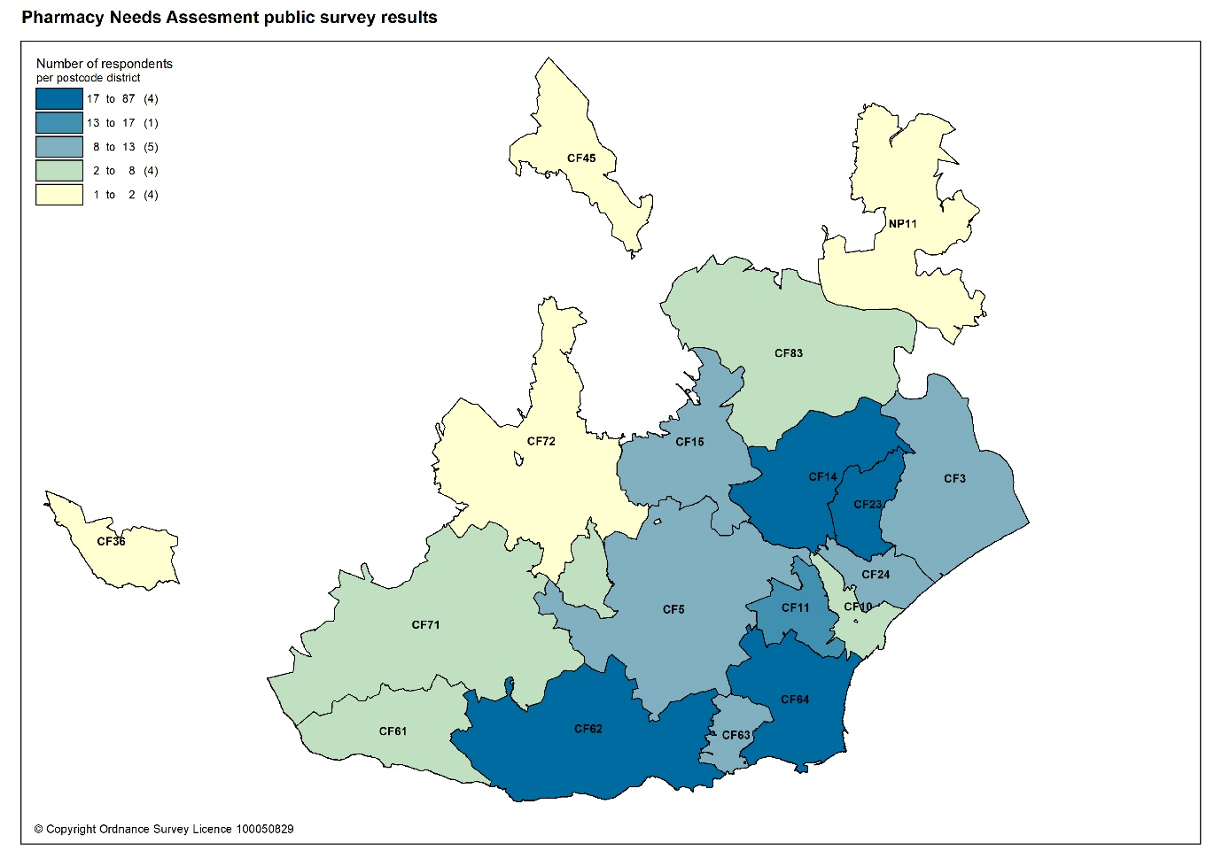
1.5.4 Contractor engagement

An online questionnaire for pharmacies was undertaken via the All Wales Pharmacy Database validation exercise, and the approach was taken to only ask contractors for information that could not be sourced elsewhere.

A copy of the questionnaire can be found in appendix I.

The questionnaire was open from 18 November to 20 December 2020 and the results are summarised below.

All 106 pharmacies in Cardiff and Vale University Health Board area responded, a response rate of 100%. The Cardiff and Vale University Health Board is grateful for the support of Community Pharmacy Wales in encouraging contractors to complete the questionnaire.

95% (101) of pharmacies said that their premises where accessible by wheelchair and five pharmacies said they were not accessible by wheelchair.

Consultation rooms are a pre-requisite for providing the advanced services and are often included as a requirement for a wider range of pharmacy commissioned services. In Cardiff and Vale University Health Board, 103 of the 106 pharmacies said that they had a consultation area on the premises:
- 87 pharmacies confirmed the presence of a consultation area with wheelchair access.
- 15 pharmacies confirmed the presence of a consultation area without wheelchair access.
- One pharmacy confirmed that they had “access for 'normal' wheel chair but not mobility scooter.”

Of the three pharmacies that did not have a consultation area, two said that they had alternative arrangements in place for confidential discussions. One replied negatively.

When considering whether the consultation area met the minimum requirements:
- 102 respondents confirmed their consultation area is a closed room.
- 101 respondents confirmed that the consultation area is a designated area where both the pharmacist and the patient are able to sit down together.
- 100 responded that the patient and the pharmacists are able to talk at normal volumes without being overheard by pharmacy staff or visitors to the pharmacy.
- 101 respondents confirmed that their consultation area is clearly designated as an area for confidential consultation, distinct from the general public areas of the pharmacy.

Nine languages, in addition to English, are spoken across 18 pharmacies in the area. These are:
- Arabic (two pharmacies)
- Czech
- French
- Gujarati (two pharmacies)
- Hindi (two pharmacies)
- Polish
- Punjabi (two pharmacies)
- Tamil
- Welsh (11 pharmacies, including one pharmacy where Welsh is only spoken one day a week.)

It should be noted that four pharmacies listed more than one language.

When considering whether the pharmacy dispenses appliance:
- 84 respondents (79%) confirmed that prescriptions for all types of appliances are dispensed from the premises.
- One pharmacy responded that they dispense appliances except stoma and incontinence appliances.
- 17 pharmacies only dispense dressings.
- Four pharmacies responded that they don’t dispense any appliances.

When asked about collection and delivery services offered:
- 100 pharmacies responded that they collect prescriptions from their GP practices.
- 68 pharmacies said that they provide a free delivery service for dispensed medicines on request.
- 39 pharmacies said they provided a free delivery service to selected patients such as housebound patients, those aged over 70 years, disabled patients or those with mobility issues, those with a clinical need or who are clinically vulnerable, elderly and vulnerable, and those who are self-isolating or shielding due to Coronavirus (COVID-19) pandemic, with no support or means of collecting as per national guidance.
- 24 pharmacies said they provided a free delivery service to selected areas.
- 12 pharmacies said they charged for the delivery of dispensed medicines. Further analysis showed that eight of those also offered a free of charge service. However, this again may be in line with national guidance due to Coronavirus (COVID-19) pandemic.

It should be noted that collection and delivery services are not contractual services and are therefore provided privately by pharmacies at their discretion. During the Coronavirus (COVID-19) pandemic, a community pharmacy home delivery service was commissioned to ensure the delivery of medicines to eligible shielding patients who should not present in the pharmacy.

When asked whether there is a requirement for an existing enhanced service which is not currently provided in the area, 18 responders replied positively:
- Emergency contraception (eight pharmacies)
- Common Ailment Service
- Sore Throat Test and Treat (seven pharmacies)
- Independent prescribing (five pharmacies)
- Monitored Dosage System (MDS)
- Smoking cessation (two pharmacies)
- Palliative care
- Needle exchange

It should be noted that eight pharmacies listed more than one suggestion, and that MDS is not an existing enhanced service.

When asked if there is a requirement for a new service that is currently not available 11 pharmacies replied:
- Independent Prescribing (four pharmacies)
- Palliative Care
- Monitored Dosage System (MDS) (three pharmacies)
- Deliveries
- Coronavirus (COVID-19) testing
- Coronavirus (COVID-19) vaccination
- Pre-exposure prophylaxis (PrEP)
- Patient Group Direction (PGD) services for UTI, Contraception, Ear infection and Strep throat

It should be noted that two pharmacies listed more than one suggestion.

The demand for pharmaceutical services in general is increasing. Pharmacy contractors were asked about their ability to meet future needs. The responses were as follows:

- 89% (94) of pharmacies have sufficient capacity within their existing premises and staffing levels to manage the increase in demand in the area.
- 8% (9) of pharmacies don’t have sufficient premises and staffing capacity at present but could make adjustments to manage the increase in demand in the area.
- 3% (3) of pharmacies don’t have sufficient premises and staffing capacity and would have difficulty in managing an increase in demand in the area.

When asked whether pharmacies have any plans to develop or expand their premises or service provision, 24 pharmacies responded positively with all 24 pharmacies providing further details. The themes of the responses are as follows:

Five pharmacies had plans to expand their pharmacy premises:
- Pharmacy refit
- Consultation rooms (two pharmacies)
- Exploring options to relocate into GP practice sites (two pharmacies)

Three pharmacies had plans to automate parts of their pharmacy service around collection of completed prescriptions/ medicines and deliveries.

Fifteen pharmacies had plans to expand their service provision, and the following examples were provided:
- Independent prescribing (nine pharmacies)
- More enhanced services as they become available (three pharmacies)
- Smoking cessation
- More vaccination services
- Triage and treat services

One pharmacy planned to offer more private services.

Two comments were received from pharmacies saying they would be willing to provide more services depending on funding being provided. One pharmacy mentioned having a business continuity plan in place for 2020 to 2021.

An online questionnaire for dispensing practices was also undertaken using Smart Survey. As with pharmacies the approach was taken to only ask contractors for information that could not be sourced elsewhere.

A copy of the questionnaire can be found in appendix J.

The questionnaire was initially open from 22nd December 2020 to 24th January 2021. The closing date was further extended until 15th February 2021 to encourage participation and in acknowledgement of the increased work pressures all healthcare staff and providers were facing as a result of the ongoing Coronavirus (COVID-19) pandemic. The results are summarised below.

There is only one dispensing practice in Cardiff and Vale University Health Board. The dispensing practice responded to the questionnaire giving a response rate of 100%. Cardiff and Vale University Health Board is grateful for the support of the Medical Secretary of the Bro Taf Local Medical Committee in encouraging the contractor to complete the questionnaire.

The dispensing GP practice’s opening hours are limited to Monday and Thursday only. The dispensing practice provides a dispensing service, as well as a delivery service for dispensed medicines, to the students living in Atlantic College, St. Donats. The dispensing GP practice does not dispense appliances from the premises. The other dispensing related services the practice provides is the disposal of patient sharps. The only language available to patients from staff at the premise, on a daily basis is English. The practice confirmed that it has sufficient capacity within its existing premises and staffing levels to manage an increase in demand in its area if required. However, this would be dependent upon the terms set out in the NHS (Pharmaceutical Services) (Wales) Regulations 2020.

1.5.5 Other sources of information

Cardiff and Vale University Health Board provided information on:

- Services provided to residents of the health board area.
- Changes to current service provision.
- Known housing developments within the lifetime of the pharmaceutical needs. assessment.
- Any other developments which may affect the need for pharmaceutical services.
- Background information on the health needs of the population.

Information on the population, employment and labour market and health needs of the population was also obtained through:

- Public Health Wales - Welsh Cancer Intelligence Unit, Cover of Vaccination Evaluation Rapidly Report (COVER), screening programmes, and Influenza.
- Public Health Wales Observatory – public health information and data, including key public health topics and the Public Health Outcomes framework.
- Office of National Statistics (ONS) - a wide range of statistics relating to the population, economy and society at national, health board and local level.
- StatsWales – statistical data.
- Welsh Government - National Survey for Wales.
- Health Maps Wales – mortality data.
- Quality and Outcomes Framework – GP practice register informed disease prevalence.

Information on pharmaceutical contractors and services was also obtained through:
- NHS Wales Shared Partnership Services – dispensing data, prescribing data, dispensing contractor activity by service.
- Community Pharmacy Wales – community pharmacy contract, service details and supporting the contractor questionnaire.

Maps were produced by NHS Wales Informatics Service (NWIS). Cardiff and Vale University Health Board would like to thank them for their support.

1.5.6 Consultation

The responses to the patient and public engagement and contractor questionnaires informed the draft pharmaceutical needs assessment.

The statutory 60 day consultation on the draft pharmaceutical needs assessment commenced on Friday 21st May and ran until Tuesday 20th July 2021. The statutory consultees were written to regarding the consultation, provided with a link to the health board’s website where the draft pharmaceutical needs assessment was published and invited to respond online.

A report of the consultation including any changes to the PNA can be found at appendix K.

2 Overview of Cardiff and Vale University Health Board

2.1 Introduction

Cardiff and the Vale of Glamorgan have a rich historic past; from the Romans to the Normans to the transformations that came with the coal industry, establishing Cardiff as a major port and the future capital of Wales. All have contributed to making Cardiff and the Vale of Glamorgan one of the most popular tourist destinations in Wales.

Cardiff is a thriving international capital city, with many cultural sites, a long association with sport and a large student population; being home to four major institutions of higher education. The city boasts more castles and green spaces per person than any other UK city.

The Vale of Glamorgan is a diverse and beautiful part of Wales, with rolling countryside, coastal communities, rural villages and busy towns. Barry, Wales’s largest town can be found here as well as Wales’s only airport.

Cardiff and Vale University Heath Board is one of the largest health boards in Wales and is responsible for the planning and delivery of NHS services to Cardiff local authority and the Vale of Glamorgan local authority, and all its residents. Its mission is “Caring for People, Keeping People Well”, and its vision is that a person’s chance of leading a healthy life should be the same wherever they live and whoever they are.

2.2 Population

Cardiff is the largest local authority in Wales in terms of population, with an estimated 366,903 residents in 2019. The Vale of Glamorgan has a smaller population of 133,578 residents.

The age-gender profile differs between that of Cardiff and the Vale of Glamorgan (figure 2.1). Cardiff has a much larger proportion of its population in the age groups between 19 years to 40 years, with the highest percentage being between the ages of 19 to 22 years due to its high student population. In contrast, the population of the Vale of Glamorgan decreases around the age of 19 years most likely due to people leaving home to study outside of the area. After which, the population increases gradually with age. Around the age of 60, the percentage of the population reduces steadily with age for of both Cardiff and the Vale of Glamorgan. There is a small noticeable percentage increase around the age of 70 and a much larger noticeable increase in the over 90s group. Overall, there is a fairly even gender balance in both Cardiff and the Vale of Glamorgan, with the most noticeable difference being in the over 90 age group, where the female percentage of the population is much higher.

In the Vale of Glamorgan, the median age (the age at which half the population is older than and half the population is younger than), is 43.8 years. This is 1.3 years above the average for Wales at 42.5 years. In Cardiff, the median age is much younger at 33.6 years, which is 10.2 years lower than the Vale of Glamorgan and 8.9 years lower than the average for Wales.

Figure 2.1: Population pyramid for Cardiff and Vale of Glamorgan local authority, 2019

Cardiff Vale of Glamorgan
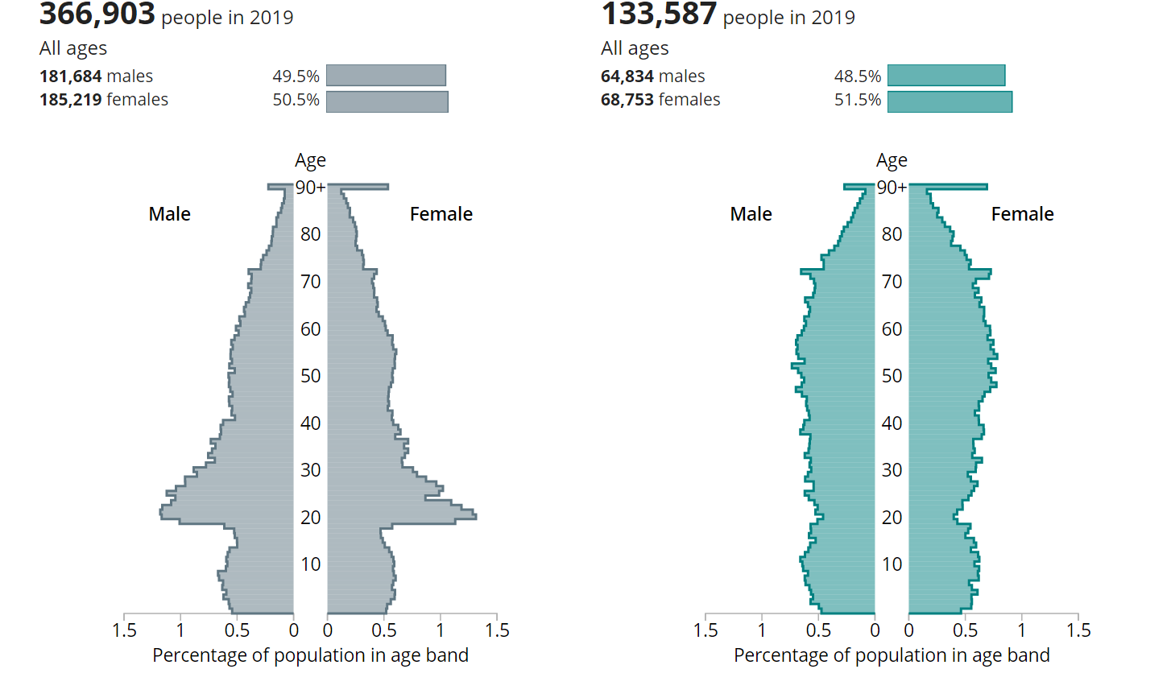Source: – Office for National Statistics - Population estimates for the UK, England and Wales, Scotland and Northern Ireland, 2020 (interactive population pyramid, 2019)

Of all the local authorities in Wales, Cardiff has the lowest proportion of its population aged over 65 years old (14.2%) and has the highest proportion of its population aged between 16 to 64 years (67.4%). The proportion of the population aged 65 years and over in the Vale of Glamorgan (21.2%) is similar to the average for Wales (21.0%). For the age group 16 to 64 years, the Vale of Glamorgan (60.3%) is slightly lower than the average for Wales (61.1%). The proportion of the population aged 15 years and younger is similar in Cardiff (18.4%) and the Vale of Glamorgan (18.5%) and is higher than the average for Wales (17.9%).
Figure 2.2: Population percentages by age group and by local authority, health board and Wales, 2019

Source: StatsWales - Mid-year population estimates, Office for National Statistics

Since 2018, the population of Cardiff increased by 2,655 (0.7%) from 364,248 to 366,903. This was mainly due to international migration (2653) where there were more international immigrants than international emigrants. There were also more births than deaths in Cardiff, leading to a natural change of 1112. When looking at internal migration, more people moved out of Cardiff to other areas of Wales or to other countries within the United Kingdom than moved in (-1102). In the last year, changes to special populations (home armed forces, foreign armed forces and the prison population) reduced the population of Cardiff only marginally (-8).

Table 2.1: Components of population change by local authority, health board and Wales, 2018 to 2019.
Area | Population mid-year 2018 | Natural change | Internal migration net | International migration net | Population mid-year 2019
Cardiff | 364248 | 1112 | -1102 | 2653 | 366903
Vale of Glamorgan | 132165 | -23 | 1243 | 210 | 133587
Cardiff & Vale UHB | 496413 | 1089 | 141 | 2863 | 500490
Wales | 3138631 | -2437 | 8685 | 7812 | 3152879
Source: Mid-year population estimates, Office for National Statistics
Over the same period, the population of the Vale of Glamorgan increased by 1,422 (1.1%) from 132,165 to 133,587. In contrast to Cardiff, this was mainly due to internal migration (1243). A smaller proportion of the population increase was due to international migration (210). Similarly to Wales, there were more deaths than births in the Vale of Glamorgan resulting in a negative natural change (-23). Changes due to special populations (home armed forces, foreign armed forces and the prison population) was the same as for Cardiff (-8).

The figures 2.3 and 2.4 below show how natural change, net internal migration and net international migration have influenced population change in Cardiff and the Vale of Glamorgan since 2012.

Figure 2.3: Compenents of population change for Cardiff, 2012 to 2019

Source: Analysis of Population Estimates Tool, Office of National Statistics (June 2020)

Figure 2.4: Compenents of population change for Vale of Glamorgan, 2012 to 2019

Source: Analysis of Population Estimates Tool, Office of National Statistics (June 2020)

2.2.1 Population projections 2018 to 2028 (2018 based)
Between 2018 to 2028, the population of Cardiff is projected to increase by up to 3.2%, the sixth largest percentage increase of all the local authorities within Wales. It is expected to have a population of around 375,700 by 2028, making it the largest local authority in Wales. Unlike all other local authorities, the increase in population will mainly be driven by natural change i.e. more births than deaths and a smaller proportion of the increase will be due to net migration i.e. more people moving into the area than out. Cardiff has the highest level of projected international migration of all the local authorities. The population is expected to increase across all broad age groups, except the 0 to 15 years old where a decrease is predicted. The largest population increases will be in the over 65 age group followed by the working-age population aged 16 to 64 years. The population is projected to continue to age in the local authority.

Figure 2.5: Population projections (2018 based) by broad age groups for Cardiff local authority, 2018 to 2028

Source: StatsWales Welsh Government

Between 2018 to 2028, the population of the Vale of Glamorgan is projected to increase by up to 6%, the second largest percentage increase of all the local authorities within Wales. It is expected to have a population of around 140,000 by 2028, making it the tenth largest local authority in Wales. The increase in population will mainly be driven by net migration i.e. more people moving into the area than out. The number of births is expected to increase over this period as is the number of deaths, resulting in a negative natural change (more deaths than births). The population is expected to increase across all broad age groups. Overall, there will be a small increase in the number of children and young people aged 0 to 15 years old and in the working-age population aged 16 to 64 years old. The largest population increases will be in the over 65 age group, where the Vale of Glamorgan is expected to have the largest increase of all local authorities at up to 20.5%. This is followed by the 75 or over age group. The population is projected to continue to age in the local authority.

Figure 2.6: Population projections (2018 based) by age groups for Vale of Glamorgan local authority, 2018 to 2028

Source: StatsWales Welsh Government

Cardiff is by far the most densely populated local authority in Wales with 2,604 persons per square kilometre (2019). For comparison, Newport is the second most densely populated authority with 812 persons per square kilometre. The Vale of Glamorgan is less densely populated with 403 persons per square kilometre and is the tenth most densely populated area in Wales in 2019. Both Cardiff and the Vale of Glamorgan have a much higher population density when compared to Wales (152 persons per square kilometre). Between 2014 and 2019 and 2018 and 2019, the Vale of Glamorgan had the second highest percentage increase in population density of all the local authorities.

Table 2.2: Population density (persons per square kilometre) and percentage change by local authority and Wales, mid-year 2014, 2018 and 2019
Area | 2014 | 2018 | % Increase | 2019 | % Increase
Cardiff | 2518.3 | 2585.2 | 2.7 | 2604.0 | 0.7
Vale of Glamorgan | 386.6 | 399.1 | 3.2 | 403.4 | 1.1
Wales | 149.1 | 151.4 | 1.5 | 152.0 | 0.5
Source: StatsWales - Mid-year population estimates, and Standard area measurements, Office for National Statistics

2.3 Ethnicity

Cardiff has the most ethnically diverse population in Wales with 21.1% of its population estimated to be Black, Asian and minority ethnic.

In the Vale of Glamorgan, 2.3% of the population are estimated to be Black, Asian and minority ethnic. This is less than the average for Wales at 5.9%.

Table 2.3: Ethnicity by ethnic group and by local authority, health board and Wales, 2019 to 2020
Area | White | Black, Asian and minority ethnic | Total | % of Black, Asian and minority ethnic
Cardiff | 291700 | 78100 | 370600 | 21.1
Vale of Glamorgan | 124200 | 3000 | 127200 | 2.3
Cardiff & Vale UHB | 415900 | 81100 | 497800 | 16.3
Wales | 2934100 | 184500 | 3121500 | 5.9
Source: Stats Wales – Annual Population Survey (year ending June 2020)

2.4 Household language

In Cardiff and Vale University Health Board, 23.8% of its population aged three and over can speak Welsh. This is lower than the average for Wales. The percentage of Welsh speakers is higher in Cardiff than the Vale of Glamorgan.

Table 2.4: People aged three or more who say they can speak Welsh, by local authority, health board and Wales, 2019 to 2020
Area | All aged 3 or over | Yes, can speak Welsh | Percentage of people who say they can speak Welsh
Cardiff | 357500 | 89700 | 25.1
Vale of Glamorgan | 124000 | 25000 | 20.2
Cardiff and Vale UHB | 481500 | 114700 | 23.8
Wales | 3030700 | 861700 | 28.5
Source: Stats Wales – Annual Population Survey (year ending 30 June 2020)

2.5 Religion

Just over half of the population of Cardiff (51.4%) and the Vale of Glamorgan (58.1%) are estimated to be Christian. Around a third have no religion. Muslim is the second most common religion in both Cardiff (6.8%) and the Vale of Glamorgan (0.6%).

Figure 2.7: Religion of Welsh residents by local authority, health board and Wales, 2011

Source: StatsWales – 2011 Census: Religion of Welsh residents

2.6 Index of multiple deprivation

Deprivation is the lack of access to opportunities and resources which might be expected in society. The Welsh Index of Multiple Deprivation (WIMD) 2019, is the method used in Wales to identify the small areas of Wales that are the most deprived. It brings together eight different types of deprivation: income, employment, health, education, access to services, housing, community safety and physical environment, to produce a set of indices and an overall index. This allows for the ranking of small areas according to their relative deprivation score to determine whether an area is more or less deprived compared to all other small areas in Wales. There are 1,909 small areas or Lower layer Super Output Areas (LSOAs) in Wales, which are ranked form 1 (most deprived) to 1,909 (least deprived).

Overall, Cardiff and Vale University Health Board has some of the most deprived and least deprived areas in Wales. 293 of the 1,909 LSOAs are in Cardiff and Vale University Health Board, of which 14% are within the 10% most deprived LSOAs in Wales. Proportionally, this is the second highest of all the seven health boards in Wales. However, when considering the 20% most deprived LSOAs in Wales, Cardiff and Vale University Health Board drops down to fourth highest with 24%. 133 (45%) of all LSOAs in Cardiff and Vale University Health Board lie within the 50% most deprived LSOAs in Wales, fifth highest compared to other health boards in Wales.

Within the health board area, Cardiff (18%) has the highest percentage of LSOAs in the most deprived 10% of LSOAs in Wales, the fourth highest of all the 22 local authorities. 49% of all LSOAs in Cardiff lie within the 50% most deprived LSOAs in Wales, the tenth highest of all local authorities. The most deprived LSOAs in Cardiff are Splott 6 (rank 12), Trowbridge 8 (rank 13) and Ely 5 (rank 14). The least deprived area in Cardiff is Radyr & Morganstown 3 (rank 1900).

Overall, the Vale of Glamorgan is less deprived than Cardiff, with only four percent of its LSOAs in the most deprived 10% of LSOAs in Wales. 35% of all LSOAs in the Vale of Glamorgan lie within the 50% most deprived LSOAs in Wales. The two LSOAs with the highest deprivation are Gibbonsdown 2 (rank 105) and Court 3 (rank 142). The least deprived area is Plymouth (The Vale of Glamorgan)1 (rank 1899).

Table 2.5: Number and percentage of LSOAs by deprivation fifth by local authority and health board, 2019
Area | Total LSOAs | % LSOAs in most deprived 10%  (ranks 1-191) | % LSOAs in most deprived 20%  (ranks 1 - 382) | % LSOAs in most deprived 30%  (ranks 1 - 573) | % LSOAs in most deprived 50%  (ranks 1 - 955)
Cardiff | 214 | 39 | 59 | 74 | 105
 | 11% | 18% | 28% | 35% | 49%
Vale of Glamorgan | 79 | 3 | 10 | 15 | 28
 | 4% | 4% | 13% | 19% | 35%
Cardiff and Vale UHB | 293 | 42 | 69 | 89 | 133
 | 15% | 14% | 24% | 30% | 45%
Source: StatWales - Welsh Index of Multiple Deprivation 2019, Welsh Government

The health domain of the Welsh Index of Multiple Deprivation 2019 captures deprivation relating to the lack of good health. Cardiff has 16% of its LSOAs within the 10% most deprived LSOAs in Wales and the Vale of Glamorgan has just 5%.

2.7 Births

In 2019, there were 4,939 live births in Cardiff and Vale University Health Board, a decrease of 7.7% since 2018. Cardiff had 3,738 live births in 2019, a decrease of 7.2% from 2018. The Vale of Glamorgan had 1,201 live births, a decrease of 9.2% since 2018.

In 2019, the total fertility rate (the average number of children a woman gives birth to during reproductive years) for Wales was 1.54 children per women. This was a decrease from 1.63 children per women in 2018 and the lowest since records began in 1982.. When considering the age-specific fertility rates, the rates decreased in all age groups except for women aged 40 years and over, where it increased from 11.2 to 11.6 births per 1,000 women. This suggests that women may be delaying childbearing to older ages and reflects the trend seen in the UK.
The total fertility rate for Cardiff decreased form 1.45 children per women in 2018 to 1.35 children per women in 2019. When considering the age-specific fertility rates, the decrease was in all age groups except for women aged 40 years and over. There was also an increase in age-specific fertility rates in the 18 to 19 age group.

Over the same period, the total fertility rate for the Vale of Glamorgan was higher than both Wales and Cardiff at 1.60 children per women, a decrease from 1.79 children per women from the previous year. When considering the age-specific fertility rates, the decrease was across all age groups except the 18 to 19 age group, where there was no change.

In 2019, the standardised mean age of mother at childbirth was 32.1 years in Cardiff and 30 years for the Vale of Glamorgan, slightly higher than the average for Wales at 29.9 years.

Table 2.6: Percentage change in live births, and total fertility rate (TFR) by local authority and Wales, 2018 and 2019
 | 2018 |  | 2019 |  | Live births
Area | Live births | TFR | Live births | TFR |  | Percent change
Cardiff | 4,027 | 1.45 | 3,738 | 1.35 |  | -7.2%
Vale of Glamorgan | 1,322 | 1.79 | 1,201 | 1.60 |  | -9.2%
Wales | 31,274 | 1.63 | 29,704 | 1.54 |  | -5.0%
Source: Nomis – Office of National Statistics

2.8 Life expectancy

In Wales, the average life expectancy for females at birth was 82.3 years and 78.3 years for men between 2016 to 2018. The gap between local authorities across Wales was 4.5 years for men (80.8 years to 76.3 years) and 3.6 years for females (84.2 years to 80.6 years).

The average life expectancy at birth in Cardiff and Vale University Health Board is 83.1 years for females and 78.6 years for males, a difference of 4.5 years between genders. The average life expectancy is higher than the average for Wales and significantly higher for females at birth. Life expectancy at 65 in Cardiff and Vale University Health Board is 21.1 years for females and 18.1 years for males. Again, this is higher than the average for Wales and significantly higher for females at 65.

Overall, females in Cardiff can expect to live longer compared to the average population of Wales, with life expectancy at birth for females being significantly higher. However, men in Cardiff have a shorter life expectancy, significantly so for males at 65 years.

Table 2.7: Life expectancy at birth and age 65 by local authority, health board and Wales, 2016 to 2018
Area | Female at birth  Years | Male at birth  Years | Female at 65  Years | Male at 65  Years
Cardiff | 82.9 | 78.2 | 20.8 | 17.7
Vale of Glamorgan | 83.4 | 79.3 | 21.6 | 18.5
Cardiff and Vale UHB | 83.1 | 78.6 | 21.1 | 18.1
Wales | 82.3 | 78.3 | 20.6 | 18.2
Source: Office of National Statistic- Life expectancy, healthy life expectancy and disability-free life expectancy at birth and age 65 by sex, UK, 2016 to 2018

Overall, males and females in the Vale of Glamorgan can expect to live longer than in Cardiff, Cardiff and Vale University Health Board and Wales. Life expectancy is significantly higher than the average for Wales except for males at 65 years.
Further details on life expectancy, healthy life expectancy and the inequalities gap for 2015 to 2017, can be found in the cluster level chapters.

2.9 Deaths

For Wales, the age-standardised mortality rate per 100,000 population was higher for both females (915.9) and males (1,231.0) compared with the UK in 2018. Cardiff and Vale University Health Board had a higher age-standardised mortality rate per 100,000 population for both females (931.3) and males (1,342.5) than the average for Wales.

At the local authority level, Cardiff had a higher age-standardised mortality rate per 100,000 population for males (1327.8) compared to the average for Wales but a lower rate for females (880.9). The Vale of Glamorgan had the lowest age-standardised mortality rates per 100,000 population for both females (821.2) and males (1151.2) within the health board area. Both rates were lower than the average for Wales.

Table 2.8: Age-standardised mortality rate per 100,000 population by local authority, health board, Wales and UK, 2018
 | Age-standardised mortality rate per 100,000
Area | Persons | Females | Males
Cardiff | 1,073.7 | 880.9 | 1,327.8
Vale of Glamorgan | 959.0 | 821.2 | 1,151.2
Cardiff and Vale UHB | 1,111.2 | 931.3 | 1,342.5
Wales | 1,058.7 | 915.9 | 1231.0
UK | 981.2 | 852.9 | 1,138.4
Source: Office of National Statistics – Death registered by area of usual residence, 2018

The avoidable mortality rate (deaths defined as either preventable or treatable) for females in Wales was 206.1 deaths per 100,000 female population and for males it was 330.5 deaths per 100,000 male population, between 2016 to 2018. In Wales, 57.3% of avoidable deaths in women were attributed to preventable conditions (through effective public health and primary prevention interventions) and 67.5% in males.
The Vale of Glamorgan had one of the lowest avoidable mortality rates for females (165.6 deaths per 100,000 female population) and males (271.6 deaths per 100,000 male population) of the 22 local authorities and was significantly lower than the average for Wales. It also had one of the lowest preventable deaths rates and treatable death rates for males and females. All were significantly lower than the average for Wales except for female treatable mortality rate.

Cardiff (123.8 deaths per 100,000 male population) had the fifth highest treatable mortality rate for males out of all the 22 local authorities and was significantly higher than the average Wales. It also had a higher avoidable and preventable age-standardised mortality rate for males compared to the average for Wales.

Of note, the mortality figures here do not capture the impact of the Coronavirus (COVID-19) pandemic, which increased mortality above historic levels across the UK.

Table 2.9: Number and age-standardised avoidable, preventable and treatable mortality rates by sex and by local authority and Wales, 2016 to 2018
 |  | Avoidable |  | Preventable |  | Treatable
 |  | Rate | Deaths | Rate | % | Rate | %
Female | Cardiff | 195.4 | 766 | 111.5 | 57.1 | 83.8 | 42.9
Male | Cardiff | 350.4 | 1,309 | 226.6 | 65.4 | 123.8 | 34.6
Female | Vale of Glamorgan | 165.6 | 326 | 85.6 | 51.7 | 80.1 | 48.3
Male | Vale of Glamorgan | 271.6 | 486 | 184.7 | 67.9 | 86.9 | 32.1
Female | Wales | 206.1 | 9,316 | 118.1 | 57.3 | 88.0 | 42.7
Male | Wales | 330.5 | 14,124 | 223.9 | 67.5 | 106.6 | 32.5
Source: Office of National Statistics – avoidable mortality in the UK

2.10 People with disabilities

The National Survey for Wales (NSW) collects self-reported data on the general health and illness among adults. It provides estimates of population characteristics rather than exact measures. For the combined year of 2018 to 2019 and 2019 to 2020, 7.8% of adults in Cardiff and 7.1% in the Vale of Glamorgan reported being in ‘bad or very bad’ health. This was lower than the average for Wales (8.8%).

Figure 2.8: Adult general health by local authority, health board and Wales, 2018 to 2019 and 2019 to 2020

Source: StatsWales – National Survey for Wales

For Cardiff, 44.8% reported having a longstanding illness. 17.5% reported having two or more longstanding illnesses, which was significantly lower than the average for Wales (19.7%). The most commonly reported complaints were, musculoskeletal disorders (15.8%), heart and circulatory related illnesses (12%) and mental health disorders (9.3%).

For the Vale of Glamorgan, 47.8% reported having a longstanding illness and 21.0% reported having two or more longstanding illnesses. The most commonly reported complaints were, musculoskeletal disorders (16.4%), heart and circulatory related illnesses (12.9%) and mental health disorders (10.7%).
In Cardiff and Vale University Health Board (16.2%) and Cardiff (15.6%), a significantly lower proportion of adults reported an illness which limited their activity a lot compared to Wales (18.4%). In the Vale of Glamorgan, 18.8 % reported an illness(es) that limited their activity a lot, which was higher than the average for Wales.

Table 2.10: Adult general health and illness by local authority, health board and Wales, 2018 to 2019 and 2019 to 2020
 | Longstanding illness
Area | Any | 2 or more | Limited at all by | Limited a lot by
Cardiff | 44.8 | 17.5 | 32.4 | 15.6
Vale of Glamorgan | 47.8 | 21.0 | 36.6 | 18.8
Cardiff and Vale UHB | 45.5 | 18.5 | 33.4 | 16.2
Wales | 46.6 | 19.7 | 34.1 | 18.4
Source: StatsWales – National Survey for Wales

2.11 Households

In Cardiff and Vale University Health Board, 11.5 % of the population aged 65 years and over live alone, which is lower than the average for Wales (13.7%). Within the health board area, the Vale of Glamorgan (13.2%) has the highest proportion of its population aged 65 and over that live alone.

Table 2.11: Household composition, number and percentage of one person households, local authority, health board and Wales, 2011
 | One Person household
 | Aged 65 and over |  | Aged under 65 years
Area | Number | Percentage | Number | Percentage
Cardiff | 15,436 | 10.8 | 31,705 | 22.2
Vale of Glamorgan | 7057 | 13.2 | 8,794 | 16.4
Cardiff & Vale UHB | 22,493 | 11.5 | 40,499 | 20.7
Wales | 178,334 | 13.7 | 222,434 | 17.1
Source: Nomis – Census, 2011

2.12 Car ownership

Just over a quarter of households in Cardiff and Vale University Health Board (26.4%) do not have a car or van at the time of the 2011 Census. The percentage is slightly higher in Cardiff (29%) than the Vale of Glamorgan (19.4%).

Table 2.12: Number & percentage of households with no cars or vans by local authority, health board and Wales, 2011
Area | Number of households with no cars or vans | Percentage of households with no cars or vans
Cardiff | 41,400 | 29.0
Vale of Glamorgan | 10,368 | 19.4
Cardiff and Vale UHB | 51,768 | 26.4
Wales | 298,519 | 22.9
Source: Nomis – Census, 2011

2.13 Economic activity

For the year ending June 2019, both Cardiff and the Vale of Glamorgan have similar unemployment rates (percentage of the economically active population who are unemployed), which are lower than the average for Wales.

Table 2.13: Summary of economic activity by local authority and Wales, 2019
 | Population Age
 | 16 years and over |  | 16 to 64 years
Area | Unemployment Rate (percentage) | Employment level (number of people) | Employment Rate (percentage) | Inactivity (percentage)
Cardiff | 3.7 | 193,000 | 76.3 | 14.7
Vale of Glamorgan | 3.8 | 63,600 | 78.6 | 15.5
Wales | 4.2 | 1,459,700 | 73.2 | 19.8
Source: StatsWales - Annual Population Survey / Local Labour Force Survey, Office of National Statistics
Cardiff has the highest employment level (the total number of people aged 16 and over that are in employment) in Wales at 193,000. This reflects the fact it has the largest population in Wales. When considering the employment rate (the percentage of the population aged 16 to 64 that are in employment), the Vale of Glamorgan has the highest rate in Wales at 78.6% over this period.

The graph below shows the change in employment rate between the years ending June 2014 to June 2019. Overall, each local authority has shown an increase in employment rate since 2014. Between June 2018 and 2019, Cardiff saw the biggest increase in employment rate of all the local authorities in Wales. The Vale of Glamorgan had the fourth biggest increase.

Figure 2.9: Employment rate by local authority and Wales, 2014 to 2019

Source: StatsWales – Annual Population Survey, Office of National Statistics

The economic inactivity rate is the percentage of the population aged 16 to 64 years who are not working and not seeking nor available to work. Economically inactive people include people looking after the family or home, retirees and people with a sickness or disability. It does not include students. For the year ending June 2019, Cardiff (14.7%) had the lowest economic inactivity rate, and the Vale of Glamorgan (15.5%) had the second lowest economic inactivity rate of all the local authorities.

Of note the economic activity data here do not include the impact of the Coronavirus (COVID-19) pandemic, the long-term effects of which are not yet clear.

2.14 Sexual orientation

In the UK, 94.6% of people aged 16 and over identified as heterosexual/straight in 2018. Of the 2.2% who identified as lesbian, gay or bisexual (LGB):

- Men (2.5%) were more likely to identify as LGB than women (2.0%).
- Younger people (aged 16 to 24 years) were most likely to identify as LGB (4.4%).
- More than two-thirds (68.7%) of people who identified as LGB were single (never married or in a civil partnership).

In 2018, 95.2% of people in Wales aged 16 and over identified as heterosexual/straight. This compares to 1.5% who identified as gay/lesbian, 0.8% who identified as bisexual, and 0.8% who identified as other. 1.7% responded that they didn’t know or refused to say.

Figure 2.10 shows that in 2018, the percentage of people who identified as lesbian, gay or bisexual (LGB) was similar for England (2.3%), Wales (2.4%), Scotland (2.0%) and the UK (2.2%).

Figure 2.10: UK constituent countries by lesbian, gay or bisexual population, 2014 and 2018

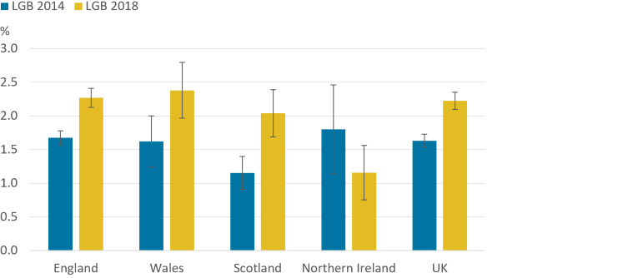
Source: Office for National Statistics – Annual Population Survey

When considering sexual orientation at the local authority level, data from the Annual Population Survey 3-year pooled dataset for 2016 to 2018, showed that in Cardiff, 93.8% of the population identified themselves as heterosexual compared to 96.1% in the Vale of Glamorgan. The percentage of people who identified as lesbian, gay or bisexual (LGB) was highest in Cardiff (5.2%) and third highest in Vale of Glamorgan (2.8%) compared to the other local authorities in Wales.

Table 2.14: Sexual orientation by local authority, 2016-2018
Area | Heterosexual or straight | Gay or lesbian | Bisexual | Other | Do not know or refuse
Cardiff | 93.8 | 3.3 | 1.9 | 0.3 | 0.7
Vale of Glamorgan | 96.1 | 2.5 | 0.3 | 0.5 | 0.6
Source: Annual Population Survey (APS), Office for National Statistics

2.15 Carers

At the 2011 Census, 50,580 adults self-reported as being an unpaid carer in Cardiff and the Vale of Glamorgan. This represented a 12% rise over the number in the previous Census 10 years earlier. The percentage of people in the population who identified as carers providing 50 hours or more a week of unpaid care was below the Wales average in both Cardiff and the Vale of Glamorgan.

Figure 2.11: Percentage of the population providing 50 hours or more of unpaid care a week, by local authority, health board and Wales, 2011

Source: Nomis – Census 2011
A survey of adult carers in Cardiff and the Vale was undertaken in 2011, with 292 respondents. Of the respondents, the majority were female (72%) and caring full time (72%). Most people cared for one person (87%) although over one in ten (13%) cared for two or more. Two thirds of carers (67%) had been caring for more than 5 years, including nearly half (46%) caring for over 10 years. Three quarters (77%) were aged 40 or over, including a quarter (24%) who were aged 75 or over.

A young carer is someone aged 18 or under who helps look after a relative who has a condition, such as a disability, illness, mental health condition, or a drug or alcohol problem. Most young carers look after one of their parents or care for a brother or sister. At the 2011 Census, 1,579 young carers were identified in Cardiff and the Vale of Glamorgan, although this is likely to be an underestimation.

Young adult carers are defined as carers aged between 18 to 25 years. This group is particularly vulnerable to transition on leaving school, and are more likely to be not in education, employment or training, or experience difficulties balancing caring with college or university.

2.16 Traveller and gypsy communities

In January 2020, there were 227 Gypsy and Traveller caravans and 13 sites (nine authorised and four sites unauthorised) reported in Cardiff and Vale University Health Board. Of the total number of caravans, 89% (203 caravans) were on authorised sites. Of these, 164 (81%) were on local authority sites and 39 (19%) were on private sites.

Cardiff had the highest number of caravans of all the 22 local authorities at a count of 202. All of the caravans in Cardiff were reported to be on the six available authorised sites.

The Vale of Glamorgan had 25 caravans with only one reported to be on the three available authorised sites. The remaining 24 caravans were reported to be on four unauthorised ‘tolerated’ sites, where removal of encampment had not been sought by the authority. This was the highest number of all the local authorities. 19 of these caravans were on lands not owned by Gypsies and Travellers.

Table 2.15: Count of Gypsy and Traveller Caravans by local authority, health board and Wales, January 2020
Area | Local Authority | Private | Authorised Sites | Unauthorised Sites | All Caravans
Cardiff | 164 | 38 | 202 | 0 | 202
Vale of Glamorgan | 0 | 1 | 1 | 24 | 25
Cardiff and Vale UHB | 164 | 39 | 203 | 24 | 227
Wales | 614 | 358 | 972 | 120 | 1092
Source: StatsWales - Gypsy and traveller caravan count, Welsh Government
Cardiff had the highest number of pitches provided by local authorities with 80 residential pitches. The Vale of Glamorgan had no pitches. Of the 80 residential pitches available in Cardiff, 78 (98%) were occupied. This is slightly less than 2019, where 100% were occupied.

Table 2.16: Number of pitches by residential status, occupied status and local authority, at January 2019 and January 2020
 | January 2019 |  |  | January 2020
Area | Residential occupied | Residential vacant | Total of all pitches | Residential occupied | Residential vacant | Total of all pitches
Cardiff | 80 | 0 | 80 | 78 | 2 | 80
Vale of Glamorgan | 0 | 0 | 0 | 0 | 0 | 0
Source: StatsWales - Gypsy and traveller caravan count, Welsh Government

2.17 Offenders

Cardiff and Vale University Health Board has one prison HMP Cardiff, a category B local prison for adult male prisoners. It is a traditional prison, situated in the heart of the city, and serving the courts of Southeast Wales. In general, the prison holds unconvicted and remand prisoners and short-term prisoners serving up to 12 months. Cardiff and Vale University Health Board provides health services to the prison.

An unannounced inspection by HM Inspectorate of Prisons, was carried out between 15 to 26 July 2019. The information below is taken from the inspection report and provides an insight into the prison’s population and the health needs at the prison during this time.

At the time of the inspection, the prison held just under 750 prisoners. About 20% of prisoners were serving short sentences and 70% had been at Cardiff for less than three months. The prison has a high turnover, releasing on average over 200 prisoners a month. The minimum and maximum age at the prison is 18 years and 75 years. The vast majority of prisoners were aged between 21 years to 49 years (89%), with the highest proportion aged between 30 years to 39 years (39%). 92% of prisoners were British. Key findings from the report included:

- 65% of prisoners arriving at the prison reported having a mental health problem.
- 44% reported they had a disability.
- 33% said they had an alcohol problem before they came into prison. In the six months prior to the inspection more than 350 prisoners required alcohol detoxification.
- 51% said they had a drug problem before they came into prison. 20% said they had developed an illicit drug problem while in prison.
- 40% of the prison population had been accused or convicted of domestic violence.
- The incidence of self-harm had tripled since the previous inspection in 2016, with a small number of prisoners repeatedly self-harming.
- Over the previous six months, 47% of prisoners had been released without having a home to go to.

2.18 Homeless and rough sleepers

The national rough sleeper monitoring exercise consists of a one night snapshot count, as well as data collected over a two week period, to gain a better understanding of rough sleeping across Wales. A range of factors can impact on the monitoring exercise, especially on the single night count, including location, timing, weather and service engagement, and it is important to bear this in mind when considering the results.

The estimated count is based on data collected over a two week period, between 14th and 27th October 2019, with assistance from the voluntary sector, faith groups, local businesses/residents, health and substance misuse agencies, and the police. Over this period, Cardiff had the highest estimated number of rough sleepers (92) in Wales, which was a decrease of eight persons since 2018. The Vale of Glamorgan had one of the lowest estimated numbers of rough sleepers, with only one rough sleeper, the same as 2018.

The one night snapshot count was carried out between the hours of 10pm on Thursday 7th November and 5am on Friday 8th November 2019. Cardiff (57) had the highest total count of rough sleepers (57) of all the local authorities in Wales. It also had the highest number of emergency bed spaces (114), which were fully occupied on the night of the count. In comparison, the Vale of Glamorgan had one of the lowest total counts of rough sleepers (one) and as such has no emergency bed spaces.

The Coronavirus (COVID-19) pandemic has had an impact on the number of rough sleepers, with more people supported into accommodation and fewer rough sleepers during the pandemic.

Table 2.17: Rough sleeper count by local authority, health board, Wales, 2019-2020.
Area | Total count of rough sleepers | Total number of emergency bed spaces | Number available on the count night | Estimated number of rough sleepers
Cardiff | 57 | 114 | 0 | 92
Vale of Glamorgan | 1 | 0 | 0 | 1
Cardiff and Vales UHB | 58 | 114 | 0 | 93
Wales | 176 | 210 | 16 | 405
Source: StatsWales - National Rough Sleeper Count, Welsh Government

3 General health needs of Cardiff and Vale University Health Board

Throughout this chapter, rates have been age-standardised unless otherwise stated, to adjust for the effect of age between areas and allow for better comparison. Where age-standardised rates are presented, the rates are directly standardised to the European standard population 2013.

Where Quality and Outcomes Framework (QOF) data has been used, caution should be taken when interpreting the data. Reported QOF data is dependent on diagnosis and recording within the general practice. It is also dependent on the social and demographic characteristics of the population and their readiness to seek healthcare services.

3.1 Long-term conditions
DALY (disability-adjusted life years) take into account both premature death and health-related suffering to portray the total years of healthy life lost from all causes. In Wales, ischaemic heart disease remains the leading cause of death and disability in Wales in 2019, though this has reduced since 2009. Since 2009, the greatest increase can be seen in lower respiratory infection, Chronic Obstructive Pulmonary Disease (COPD), falls and Alzheimer’s disease.

Figure 3.1: Top 10 causes of death and disability (DALYs) in Wales in 2019 and percent change 2009 to 2019, all ages combined
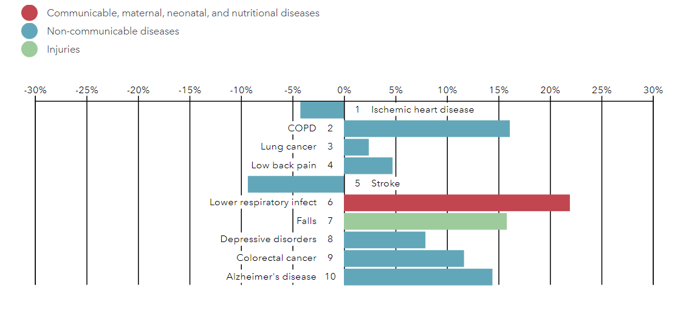
Source: Institute for Health Metrics and Evaluation (IHME). Wales profile.

Chronic health conditions tend to become more common with age. Based on QOF 2019 reported GP practice data, Cardiff and Vale University Health Board has a lower estimated prevalence of chronic health conditions when compared to the average for Wales. At the local authority level, Cardiff also has a lower prevalence of chronic health conditions while the Vale of Glamorgan has a lower estimated prevalence of chronic conditions except for heart failure, and stroke and transient ischaemic attacks, which are the same as the average for Wales. Overall, the Vale of Glamorgan has a higher estimated prevalence of chronic health conditions than Cardiff, reflecting its older population.

Table 3.1: Estimated percentage prevalence of chronic conditions based on patients on GP practice registers by local authority, health board and Wales, 2019
 | Percentage
Area | Asthma | Coronary Heart Disease | COPD | Diabetes | Heart Failure | Stroke and TIA
Cardiff | 6.6 | 2.5 | 1.6 | 4.9 | 0.8 | 1.6
Vale of Glamorgan | 6.8 | 3.3 | 1.9 | 5.5 | 1.1 | 2.1
Cardiff & Vale UHB | 6.7 | 2.7 | 1.7 | 5.0 | 0.9 | 1.7
Wales | 7.1 | 3.6 | 2.4 | 6.1 | 1.1 | 2.1
Source: QOF 2019

3.1.1 Cancer

The most common forms of cancer in Wales, Cardiff University Health Board and Cardiff are prostate, breast, lung, colorectal, and colon (2013 to 2017). In the Vale of Glamorgan, the incidence rate for colorectal cancer is higher than lung cancer.

Figure 3.2: Cancer incidence European Age-standardised Rates (EASR) by cancer types in Cardiff and Vale University Health Board, 2013 to 2017
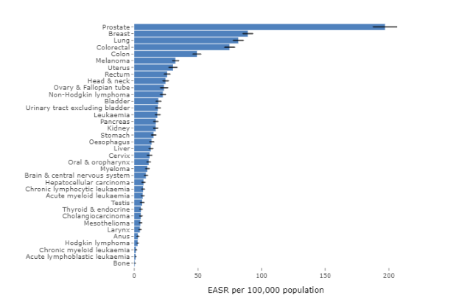
Source: Welsh Cancer Intelligence and Surveillance Unit's cancer registry
In Wales, Cardiff and Vale University Health Board and Cardiff, the most common forms of cancer in women are breast, lung, colorectal, colon and uterus. In the Vale of Glamorgan, colorectal cancer is more common than lung cancer and melanoma is more common than cancer of the uterus. This is reflected in the fact that when compared to other local authorities:

- The Vale of Glamorgan (58.2 per 100,000 females) has the fourth lowest rate of lung cancer, significantly lower than the average for Wales (69.1 per 100,000 females).
- The Vale of Glamorgan (34.2 per 100,000 females) has the highest incidence of melanoma, significantly higher than the average for Wales (24.8 per 100,000 females).

The most common types of cancers for men in Wales and the Vale of Glamorgan are prostate, colorectal, lung, colon and rectum. This differed from Cardiff and Vale University Health Board and Cardiff where lung cancer is the second highest cancer followed by colorectal cancer, and head and neck cancer is more common than rectum cancer. When compared to other local authorities:

- The Vale of Glamorgan (208.2 per 100,000 males) has the fourth highest incidence rate of prostate cancer, which is significantly higher than the average for Wales (184.5 per 100,000 males).
- Both Cardiff (19.9 per 100,000 males) and Cardiff and Vale University Health Board (19.8 per 100,000 males) have the highest incidence of liver cancer in men out of all the local authorities and health boards. This is significantly higher than the average for Wales (14.3 per 100,000 males). The Vale of Glamorgan has the second highest rate (19.2 per 100,000 males).
- The Vale of Glamorgan (38.2 per 100,000 males) has the second highest incidence of melanoma of all the local authorities, significantly higher than the average for Wales (29.9 per 100,000 males). Cardiff and Vale University Health Board (35.9 per 100,000 males) has the highest rate of all health boards and is significantly higher than the average for Wales. Cardiff (34.8 per 100,000 males) has the third highest rate.
- Cardiff (101.7 per 100,000 males) has the fifth highest incidence of lung cancer in Wales and the Vale of Glamorgan (81.7 per 100,000 males) has the fourth lowest.
- The Vale of Glamorgan (100.8 per 100,000 males) has the fifth highest incidence of colorectal cancer in Wales.
- Cardiff and Vale University Health Board (725.3 per 100,000 males) has a significantly higher rate of all malignancies excluding nonmelanoma skin cancer than the average for Wales (699 per 100,000 males), second highest of all the health boards.

Between 2015 to 2017, the Vale of Glamorgan had a lower death rate for most types of cancers except colorectal cancer (31.1 per 100,000 population) when compared to the average for Wales. It had a significantly lower cancer death rate for trachea, bronchus and lung cancer (48.0 per 100,000 population) compared to the average for Wales (59.7 per 100,000 population).

Cardiff had a slightly higher cancer death rate than the average for Wales across most cancer types except prostate cancer (42.1 per 100,000 males) where it was lower than the average for Wales (45.5 per 100,000 males).

Table 3.2: Cancer death rates (age-standardised per 100,000) for all cancers, colorectal cancer, female breast cancer, prostate cancer and trachea, bronchus and lung cancer by local authority, health board and Wales, 2015 to 2017
 | Death Rates (Age-standardised) per 100,000 population
Area | All cancers | All cancers - under 75 years | Colorectal cancer | Female breast cancer | Prostate cancer | Trachea, bronchus and lung cancer
Cardiff | 279.0 | 146.8 | 29.4 | 36.1 | 42.1 | 62.5
Vale of Glamorgan | 270.8 | 132.8 | 31.1 | 29.3 | 43.2 | 48.0
Cardiff and Vale UHB | 275.7 | 141.8 | 29.8 | 33.8 | 42.4 | 57.4
Wales | 278.6 | 144.4 | 28.9 | 33.9 | 45.5 | 59.7
Source: Health Maps Wales

3.1.2 Mental health

In 2012, the Welsh Government published a ten year strategy called “Together for Mental Health – A Mental Health and Wellbeing Strategy for Wales”. Its overall aim was to improve the mental health of everyone across Wales and ensure that people can get the right support at the right time and in the right place.

Based on QOF 2019 reported prevalence rates, the percentages of patients registered as having a mental health condition in Cardiff and Vale University Health Board is below the average for Wales.

Table 3.3: Percentage of patients registered as having a mental health condition by local authority, health board and Wales, 2019
Area | Percentage
Cardiff | 0.90
Vale of Glamorgan | 0.90
Cardiff and Vale UHB | 0.90
Wales | 1.00
Source: QOF 2019

Mental well-being is an important factor in an individual’s overall health. To measure mental well-being, the National Survey for Wales uses the Warwick-Edinburgh Mental Well-being Scale (WEMWBS), which contains 14 self-assessed questions. Scores range from 14 to 70, where higher scores suggest higher mental well-being. Of all the health boards in Wales, Cardiff and Vale University Health Board reported the highest mean WEMWBS score of 52.5 out of 70, which was significantly higher than the average for Wales (51.4). Cardiff (53.2) had the third highest score of all the local authorities and was also significantly higher than the average for Wales. The Vale of Glamorgan had a lower mean WEMWBS score of 50.0 out of 70, which was a decrease from the previous year and the fourth lowest of all the local authorities. This suggests that people in Cardiff have a higher mental well-being than those in the Vale of Glamorgan.

Table 3.4: National Survey for Wales – age-standardised mean Warwick-Edinburgh Mental Well-being Scale (WEMWBS) for adults aged 16 years and over, by local authority, health board and Wales, 2016 to 2019
Area | 2016 to 2017 | 2018 to 2019
Cardiff | 51.8 | 53.2
Vale of Glamorgan | 51.0 | 50.0
Cardiff and Vale UHB | 51.6 | 52.5
Wales | 50.9 | 51.4
Source: StatsWales - National Survey for Wales, Welsh Government

The National Survey for Wales also measures levels of loneliness in Wales. In 2019 to 2020, 15% of people aged 16 years and over in Wales reported that they were lonely. Cardiff was slightly higher at 17% and the Vale of Glamorgan slightly lower at 14%. In addition, the survey results showed that 44% of those with a mental illness (including anxiety and depression) were lonely, while just 12% of those without such an illness were lonely, further supporting the link between mental health conditions and loneliness. Other significant factors for loneliness identified included poor general health and material deprivation. In turn, lonely people reported much lower satisfaction with life than those who were not lonely. Younger people reported being more likely to be lonely than older people. This may explain the higher percentage of loneliness reported in Cardiff compared to the Vale of Glamorgan and Wales. The long-term impact of the Coronavirus (COVID-19) pandemic on levels of loneliness is not yet clear.

Raising awareness of and reducing suicide and self- harm has been a priority in Wales since the launch of the national action plan, ‘Talk to Me’ in 2009 followed by ‘Talk to Me 2’, five years later. Over the period 2014 to 2018, the age-standardised rate of suicide in Wales was 12 per 100,000 persons aged 10 years and over. Cardiff and Vale University Health Board had a similar age-standardised rate of 11.8 per 100,000 persons aged 10 years and over. At the local authority level, Cardiff (11.4 per 100,000) was slightly lower and the Vale of Glamorgan (13.7 per 100,000) was higher than the average for Wales. All the rates had decreased since 2013 to 2017; however, caution should be used when interpreting suicide rates due to the small numbers involved.

The Five Ways to Wellbeing are a set of evidence-based public mental health messages aimed at improving the mental health and wellbeing of the whole population. It encourages individuals to do five things each day to improve their personal well-being: connect; be active; take notice; keep learning; and give.

3.2 Lifestyle behaviours

Tobacco use, high blood pressure, unhealthy diets, obesity and the harmful use of alcohol have been identified as the top risk factors for noncommunicable diseases in Wales in 2019.

Figure 3.3: Top 10 risks contributing to total number of DALYs in 2019 and percent change 2009 to 2019, all ages combined
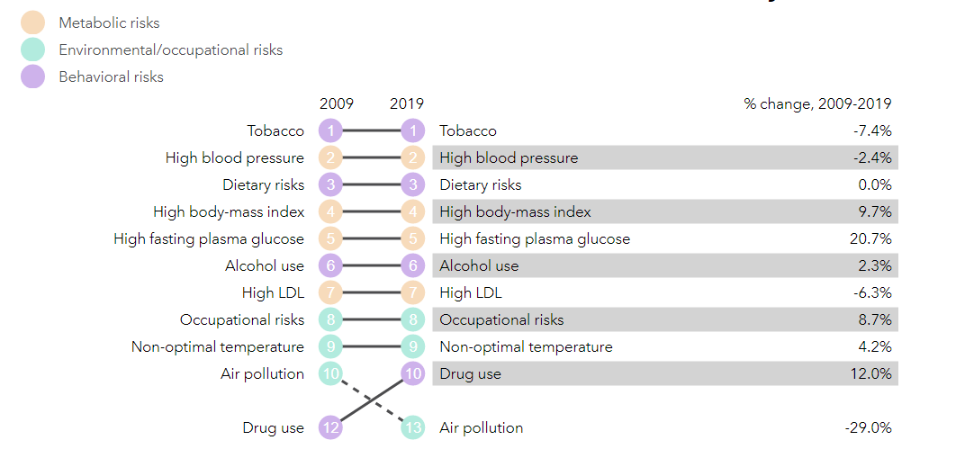
Source: Institute for Health Metrics and Evaluation (IHME). Wales profile

3.2.1 Smoking

Cigarette smoking remains the biggest driver for combined deaths and disabilities in Wales in 2019. Both smoking and passive smoking are linked to a range of serious illnesses including cancers and heart disease. The Welsh Government has introduced several policies and legislations in its commitment to reduce this, including the smoking ban in 2007, the smoking in vehicles with children ban in 2015 and the Tobacco Control Delivery Plan for Wales 2017 to 2020. This has successfully contributed to lowering the burden of disease due to smoking between 2009 and 2019. From March 2021, new legislation extends the smoke free requirements to include hospital grounds, school grounds and public playgrounds, as well as outdoor day care and child-minding settings. Furthermore, from March 2022, smoking bedrooms in hotels, guest houses, self-contained holiday accommodation will be required to be smoke-free. In addition, Mental Health Units will be required to phase out any smoking rooms by 1 September 2022, and amendments will be made to who can use designated smoking rooms in adult care homes and adult hospices.
Based on data collected between 2018 to 2019 and 2019 to 2020 as part of the National Survey for Wales, 14.4% of adults report that they smoke in Cardiff and Vale University Health Board. This was the lowest rate of all the health boards and was significantly lower than the average for Wales (17.4%). At the local authority level, 14.2% of people report that they smoke in Cardiff, the second lowest of all the local authorities. 16.2% of people said they smoke in the Vale of Glamorgan. The Vale of Glamorgan (11.2%) had the highest reported rate of e-cigarette users, which was significantly higher than the average for Wales (6.4%).

Table 3.5: Adult smoking patterns by local authority, health board and Wales, 2018 to 2020
Area | Percentage Smoker | Percentage  Ex-smoker | Percentage Never smoked | Percentage  E-cigarette user
Cardiff | 14.2 | 31.1 | 54.7 | 6.2
Vale of Glamorgan | 16.2 | 31.1 | 52.7 | 11.2
Cardiff and Vale UHB | 14.4 | 31.3 | 54.3 | 7.1
Wales | 17.4 | 29.4 | 53.2 | 6.4
Source: StatsWales – National Survey for Wales

Results taken from School Health Research Network (SHRN) health and wellbeing survey for the academic year 2017 to 2018, showed that both Cardiff (2.8%) and the Vale of Glamorgan (2.7%) had a significantly lower prevalence of adolescent smokers (aged 11 to 16 years) compared to the average for Wales (3.6%). The Cardiff and Vale University Health Board (2.8%) had the lowest prevalence of all the health boards and was also significantly lower than the average for Wales. For e-cigarettes, Cardiff (2.6%) had a significantly lower rate of use in adolescents than the average for Wales (3.3%). The use of e-cigarettes in adolescents was higher in the Vale of Glamorgan (3.5%).

Table 3.6: Percentage of adolescent smokers and E-cigarette users by local authority, health board and Wales, 2017 to 2018
Area | Percentage smoker  Children aged 11 to 16 years | Percentage E cigarette user  Children aged 11 to 16 years
Cardiff | 2.8 | 2.6
Vale of Glamorgan | 2.7 | 3.5
Cardiff and Vale UHB | 2.8 | 3.0
Wales | 3.6 | 3.3
Source: Public Health Observatory Wales – HBSC and SHRN (DECIPHer)
Provider based data collected between 2017 to 2018, showed that Cardiff and Vale University Health Board (13.4%) had a significantly lower rate of smoking in pregnancy than the average for Wales (17.8%).
Although smoking rates are declining in Wales, there remains a considerable difference between socio-economic groups. The smoking rate in the most deprived fifth remains more than double the rate in the least deprived fifth.

Figure 3.4: Adult smoking prevalence, age-standardised percentage, persons 16 years and over, by deprivation fifth, Wales, 2016 to 2017 and 2018 to 2019

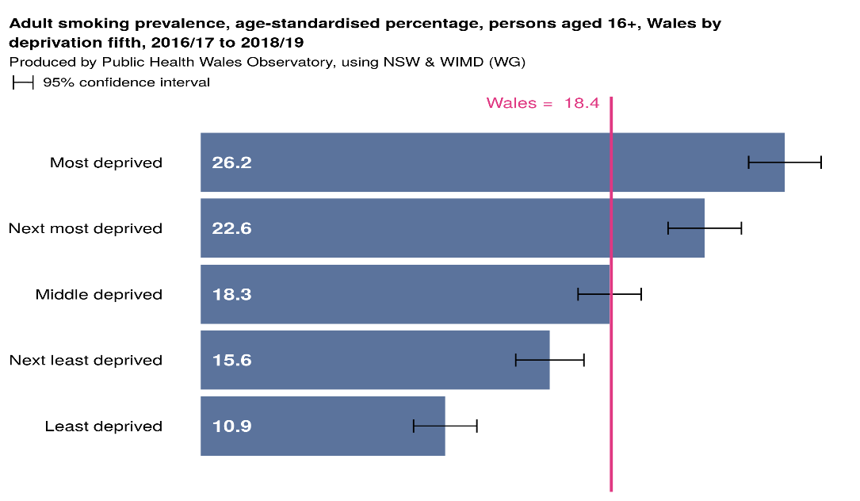

As well as changes to legislation, smoking cessation services have contributed to the lowering of the burden of disease due to smoking between 2009 and 2019. The Welsh Level 3 pharmacy based smoking cessation service has the highest percentage of treated smokers (50.6%) and CO-validated quitters (46.2%).

Table 3.7: Treated smokers and those achieving a 4 week CO-validated quit, count and percentage, persons aged 16+, Wales, 2018 to 2019
Service | CO-validated quitters | Percentage CO-validated quitters | Treated smokers | Percentage Treated Smokers
All services | 6753 |  | 15599
In house GP based services | 58 | 0.9 | 110 | 0.7
In house hospital based services | 824 | 12.2 | 1703 | 10.9
Level 3 pharmacy based services | 3117 | 46.2 | 7889 | 50.6
Specialist Maternity Service | 71 | 1.1 | 238 | 1.5
Stop Smoking Wales | 2683 | 39.7 | 5659 | 36.3

Source: Produced by Public Health Wales, using Smoking Cessation Services Data Collection (WG)

3.2.2 Hypertension
In Wales, hypertension or high blood pressure is the second biggest risk factor for disability and disease in 2019. It is a major risk factor for heart disease, stroke, kidney disease, peripheral arterial disease and vascular dementia. Early detection and effective management can prevent progression to cardiovascular disease. Although hypertension is classed as more of a clinical risk factor, its prevention or reduction is affected by life-style choices such as excessive salt intake, poor diet and obesity, excess alcohol consumption, lack of physical activity, mental well-being and stress. The burden of high blood pressure is greatest among individuals from low-income households and those living in deprived areas.

Based on QOF 2019 reported prevalence rates, Cardiff and Vale University Health Board (12.6%) has a lower prevalence of hypertension than the average for Wales (15.8%). Cardiff (11.8%) has the lowest prevalence of hypertension within the health board area reflecting its younger population and the Vale of Glamorgan has the highest at 14.9%.

Table 3.8: Estimated percentage prevalence of hypertension based on patients on GP practice registers by local authority, health board and Wales, 2019
Area | Hypertension percentage prevalence
Cardiff | 11.8
Vale of Glamorgan | 14.9
Cardiff and Vale UHB | 12.6
Wales | 15.8
Source: QOF 2019

3.2.3 Diet, Physical Activity and Obesity

Being overweight or obese increases the risk of a wide range of chronic diseases, principally type 2 diabetes, hypertension, cardiovascular disease including stroke, as well as some types of cancer. It can also impair a person’s well-being, quality of life and ability to earn. Poor diet and a sedentary lifestyle are the main causes of overweight and obesity.

Based on combined data for 2018 to 2019 and 2019 to 2020 collected from the National Survey for Wales, 41.7% of the adult population in Cardiff and Vale University Health Board self-reported that they are of a healthy weight, with a Body Mass Index between 18.5kg/m² and under 25kg/m². Only 20.2% reported being obese, which was the second lowest of all the health boards and was significantly lower than the average for Wales (24.1%). At the local authority level, Cardiff has the second highest proportion of people reporting to be of a healthy weight (43.2%), which is significantly higher than the average for Wales. It also has the second lowest proportion of people reporting to be obese (18.4%), which was also significantly lower than the average for Wales. The Vale of Glamorgan has a higher proportion of its population self-reporting to be obese (25.6%) and a lower proportion reporting to have a healthy weight (36.5%) compared to the average for Wales.

Table 3.9: Percentage of adults (aged 16 years and over) reporting lifestyle behaviours by local authority, health board and Wales, 2018 to 2019 and 2019 to 2020
 | Percentage
 | Fruit & vegetable |  |  | Physical activity |  |  | Body mass index (kg/m2)
Area | None | At least 5 portions | Less than 30 minutes |  | At least 150 minutes | 18.5 - under 25 (healthy weight) |  | 25+  (overweight or obese) | 30+ (obese)
Cardiff | 4.3 | 33.9 | 29.4 |  | 56.9 | 43.2 |  | 55.3 | 18.4
Vale of Glamorgan | 6.2 | 26.4 | 29.7 |  | 55.2 | 36.5 |  | 60.3 | 25.6
Cardiff and Vale UHB | 4.8 | 32.1 | 29.4 |  | 56.8 | 41.7 |  | 56.3 | 20.2
Wales | 7.9 | 24.3 | 33.0 |  | 53.2 | 38.2 |  | 59.9 | 24.1
Source: StatsWales – National Survey for Wales
Poor diet and nutrition are recognised as major contributory risk factors for ill health and premature death. Of all the health boards, Cardiff and Vale University Health Board has the highest reported rate for those who ate at least five portions of fruit and vegetables a day (32.1%), significantly higher than the average for Wales (24.3%). It also has the lowest population proportion reporting to have eaten no fruit and vegetables on the previous day (4.8%), significantly lower than the average for Wales (7.9%). Compared to Wales, Cardiff (33.9%) has a significantly higher proportion claiming to eat at least five portions of fruit and vegetables a day, highest of all the local authorities. It has a significantly lower proportion (4.3%) self-reporting to have eaten none on the previous day, the second lowest of all the local authorities. The Vale of Glamorgan has a lower proportion of its population self-reporting to eat at least five portions of fruit and vegetables a day (26.4%) and a higher proportion (6.2%) reporting to have eaten no fruit and vegetables on the previous day.

In general, the more time spent being physically active, the greater the health benefits. For adults, at least 150 minutes (2 1/2 hours) of moderate intensity activity (such as brisk walking or cycling); or 75 minutes of vigorous intensity activity (such as running); or even shorter durations of very vigorous intensity activity (such as sprinting or stair climbing); or a combination of moderate, vigorous and very vigorous intensity activity are recommended each week. It is also recommended that adults should do activities to develop or maintain strength in the major muscle groups and should aim to minimise the amount of time spent being sedentary.

The population of Cardiff and Vale University Health Board are generally more physically active than most in Wales. Cardiff (56.9%) and the Vale of Glamorgan (55.2%) had a higher percentage of its population self-reporting to be active at least 150 minutes a week compared to the average for Wales (53.2%). Cardiff (29.4%) and the Vale of Glamorgan (29.7%) also had a lower proportion of their population reporting to be active less than 30 minutes a week compared to the average for Wales (33.0%).
3.2.4 Alcohol

Alcohol use remains a major public health challenge in Wales. It is associated with the development of many health conditions such as high blood pressure, heart disease, cirrhosis of the liver and cancers of the mouth, throat and breast cancer. Alcohol misuse is a cause of falls, accidents and injuries, as well as social problems such as assaults and crimes.

In 2016, the UK Chief Medical Officer published new guidelines that advise drinking no more than 14 units of alcohol a week to keep health risks low. Based on combined data for 2018 to 2019 and 2019 to 2020, collected from the National Survey for Wales, nearly one in five adults (18.6%) nationally drink more than the recommended weekly limit of 14 units of alcohol a week.

Of all the health boards, Cardiff and Vale University Health Board (21.6%) has the highest proportion of its population reporting to drink above the recommended weekly units. The Vale of Glamorgan (25.2%) has the highest proportion of all local authorities, significantly higher than the average for Wales. Cardiff has a lower proportion (20.2%), although still higher than the average for Wales.

Table 3.10: Weekly average alcohol consumption above the recommended guidelines by local authority, health board and Wales, 2018 to 2020
Area | Average weekly alcohol consumption - above 14 units (over the guidelines)
Cardiff | 20.2
Vale of Glamorgan | 25.2
Cardiff and Vale UHB | 21.6
Wales | 18.6
Source: StatsWales – National Survey for Wales
The chart below highlights the reported drinking patterns in the Cardiff and Vale University Health Board area compared to Wales.

Figure 3.5: Adult weekly drinking levels by local authority, health board and Wales
Drinking levels
Non-drinker - Usual 0 units
Moderate - Up to and including 14 units
Hazardous - > 14 to 50 units for males or >14 to 35 units for females
Harmful – 50 units a week or more for men and 35 units a week or more for women
Source: StatsWales – National Survey for Wales

The Vale of Glamorgan (15.0%) has a significantly lower percentage of non-drinkers compared to the average for Wales (20.9%). It also has a significantly higher proportion of its population (21.5%) reporting to drink at a hazardous level compared to the average of Wales (16.1%), the highest of all local authorities.

Alcohol-related hospital admissions are used as a way of understanding the impact of alcohol on the health of the population. In 2017 to 2018, there was around 14,600 alcohol-specific hospital admissions (wholly attributable to alcohol) in Wales, with almost double the number of admissions being for men than women.

Cardiff and Vale University Hospital Board (428 per 100,000 persons) and Cardiff (415 per 100,000 persons) had significantly lower alcohol-specific admissions rates than the average for Wales (477 per 100,000 persons). The Vale of Glamorgan had an alcohol-specific admissions rate of 462 per 100,000 persons, lower than the average for Wales.

Figure 3.6: Alcohol-specific admissions (wholly attributable to alcohol - either as a primary or secondary diagnosis), European age-standardised rates per 100,000 persons by local authority, 2017 to 2018
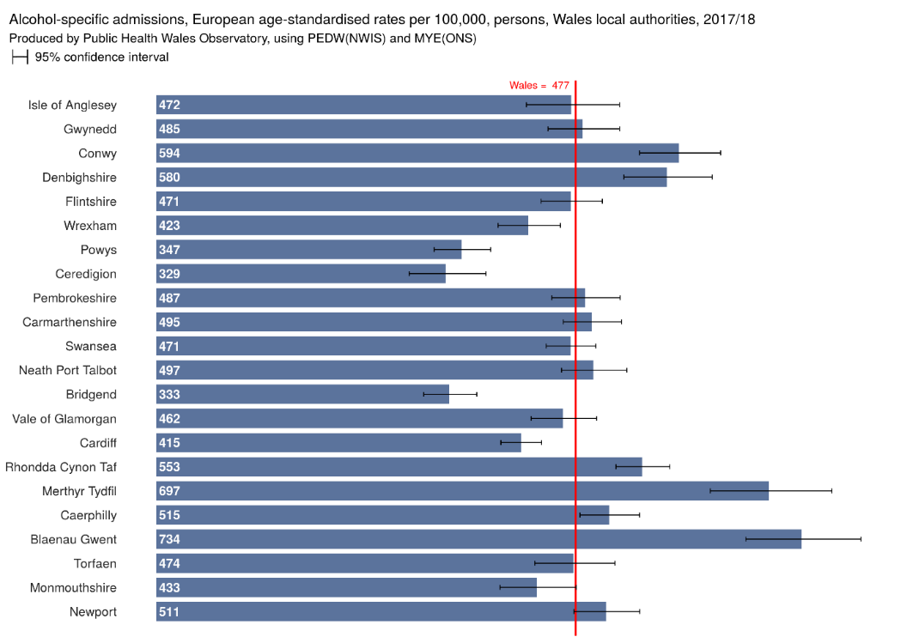

Alcohol-specific mortality represents deaths which are considered to be entirely caused by alcohol. The overwhelming majority of the 1,170 alcohol-specific deaths in Wales in 2015 to 2017 were caused by alcoholic liver disease - nearly nine in 10 males and over eight in 10 females. Other causes include mental and behavioural conditions and accidental poisoning by/and exposure to alcohol.

In 2015 to 2017, Cardiff and Vale University Hospital Board had an alcohol-specific mortality rate of 11.5 per 100,000 persons, which was lower than the average for Wales (12.7 per 100,000 persons).

Figure 3.7: Alcohol-specific mortality European age-standardised rates per 100,000 persons by health board and Wales, 2015 to 2017.
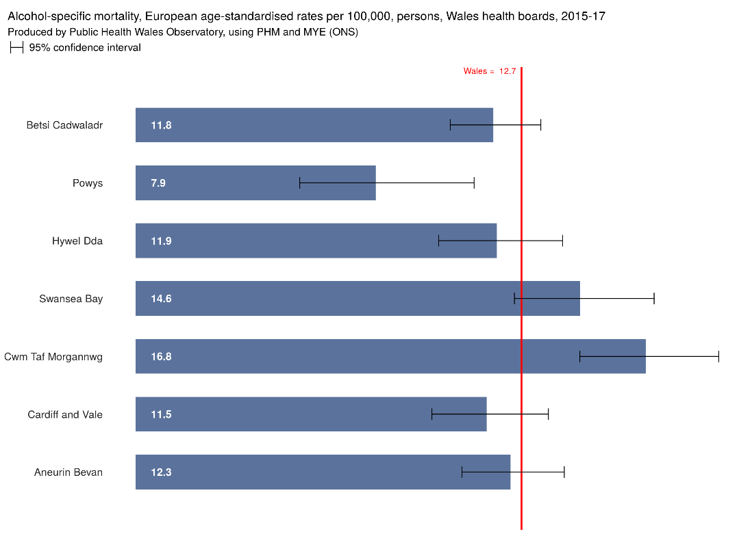
Alcohol-attributable mortality captures deaths which can be partially attributed to alcohol use, based on the underlying cause of death. Both Cardiff and the Vale of Glamorgan have the same alcohol-attributable mortality rate (50.50 per 100,000 persons), which is less than the average for Wales (52.6 per 100,000 persons).6

3.3 Healthy Ageing

3.3.1 Low birth weight

Low birth weight is influenced by maternal lifestyle issues such as smoking. Birth weight is inversely associated with infant mortality, life expectancy, and is predictive of the onset of chronic conditions in adult life.

In 2018, Cardiff and Vale University Health Board (4.6%) had the lowest percentage of low birth weights of all the health boards. The Vale of Glamorgan (4.1%) had the second lowest percentage of low birth weights of all the local authorities and Cardiff had the third lowest rate of 4.7%. All were significantly lower than the average for Wales (5.6%).

Table 3.11: Percentage of low birth weight (below 2500g) births by local authority, health board and Wales, 2018
Area | Percentage
Cardiff | 4.7
Vale of Glamorgan | 4.1
Cardiff and Vale UHB | 4.6
Wales | 5.6
Source: Public Health Wales Observatory

3.3.2 Breast feeding

Breastfeeding provides the best nutritional start in life for a baby. The percentage of babies that were exclusively breast fed at 10 days following birth in Cardiff and Vale University Health Board (46.1%) was significantly higher than the average for Wales (35.2%). Additionally, both Cardiff (47.5%) and the Vale of Glamorgan (41.9%) had a significantly higher percentage of babies that were exclusively breast fed at 10 days following birth than the average for Wales.

Table 3.12: Percentage breast feeding at 10 days by local authority, health board and Wales, 2018
Area | Percentage
Cardiff | 47.5
Vale of Glamorgan | 41.9
Cardiff and Vale UHB | 46.1
Wales | 35.2
Source: Public Health Wales Observatory

3.3.3 Children living in poverty

In Cardiff and Vale University Health Board, 27% of people in Cardiff aged under 18 years live in poverty. This is higher than the average for Wales (24%) and fifth highest of all the local authorities. The Vale of Glamorgan has a lower proportion at 19%.

Table 3.13: Percentage of persons aged 0 to 18 years living in poverty by local authority and Wales, 2017
Area | Percentage
Cardiff | 27
Vale of Glamorgan | 19
Wales | 24
Source: Public Health Wales Observatory

3.3.4 Oral health

Tooth decay in young children is largely preventable. It can lead to pain, infections and difficulties with eating, sleeping and socialising. Oral health is an important aspect of a child’s overall health status and of their school readiness. It is seen as a marker of wider health and social care issues including poor nutrition and obesity.

In Cardiff and Vale University Health Board (1.0), the average number of decayed, missing or filled teeth in children aged five years was significantly lower than the average for Wales (1.2). The Vale of Glamorgan (0.5) was also significantly lower and had the lowest average number of decayed, missing or filled teeth in children aged five years of all local authorities.

Table 3.14: The average number of decayed, missing or filled teeth in children aged five years, by local authority, health board and Wales, 2015 to 2016
Area | Average number of decayed, missing or filled teeth in 5 year olds
Cardiff | 1.1
Vale of Glamorgan | 0.5
Cardiff and Vale UHB | 1.0
Wales | 1.2
Source: Public Health Observatory Wales

3.3.5 Sexual health

In 2018, the teenage pregnancy rate in Cardiff was 19.2 conceptions per 1,000 females under 18 years. This is higher than the teenage pregnancy rate for the Vale of Glamorgan (13.3 conceptions per 1,000 females under 18 years) and Wales (18.9 conceptions per 1,000 females under 18 years).

Table 3.15: Teenage pregnancies, crude rate per 1,000 females aged 15 to 17 year by local authority, health board and Wales, 2018.
Name | Conception rate per 1,000 females under aged 15 to 17
Cardiff | 19.2
Vale of Glamorgan | 13.3
Wales | 18.9
Source: Office of National Statistics - Conception Statistics, England and Wales, 2018
Rates in the Cardiff and Vale University Health Board area have continued to decrease over the last 10 years.
Figure 3.8: Conceptions per 1,000 females aged under 18 by local authority, 2009 to 2018

Source: Office of National Statistics
There is continued transmission of sexually transmitted infections in Wales. Between 2011 and 2017, there were increases in syphilis, gonorrhoea, chlamydia, HIV, and herpes, whilst warts decreased. Between 2016 and 2017, the diagnoses of syphilis and gonorrhoea increased markedly, whilst diagnoses of chlamydia and HIV remained stable and first episodes of warts and first episode of genital herpes decreased.

Within Wales, there is geographical variation in the incidence of sexually transmitted infections, as well as in the rates of testing. In 2017, similarly to previous years, the rate of gonorrhoea was highest in Cardiff, and the rates of chlamydia were highest in Newport, followed by Torfaen and Cardiff. The percentage of gonorrhoea tests from sexual health clinics for which a positive diagnosis was reported was highest in those living in Cardiff and Conwy local authorities. For chlamydia, the percentage positivity was highest in those living in the Vale of Glamorgan, Wrexham, and Merthyr Tydfil.

3.3.6 Frailty and Falls in older people

In Wales, falls is the seventh highest cause of disability and death in Wales in 2019. Older people are more likely to fall. They are also more likely to suffer significant consequences, such as a loss of independence and confidence, leading to physical and mental deterioration and frailty. Frailty itself can cause falls. Frailty can be either physical or psychological, or a combination of the two. It typically means a person is at a higher risk of a sudden deterioration in their physical and mental health. Identifying people who may be living with frailty is a key intervention in the prevention of falls.

In the UK, almost a third of people aged over 65 fall at least once and there are an estimated 500,000 fragility fractures each year. Osteoporosis is a condition which causes bones to weaken and become more fragile. People with osteoporosis are more likely to suffer a fragility fracture.

Cardiff and Vale University Health Board and Cardiff have the same percentage of patients registered as having osteoporosis as Wales (0.3%). The Vale of Glamorgan is slightly lower at 0.2%.

Table 3.16: Percentage of patients registered as having osteoporosis by local authority, health board and Wales, 2019
Area | Percentage of patients registered with osteoporosis
Cardiff | 0.3
Vale of Glamorgan | 0.2
Cardiff and Vale UHB | 0.3
Wales | 0.3
Source: QOF 2019
A hip fracture is one of the most common fragility fractures. It is a major public health issue due to an ever-increasing ageing population. The National Hip Fracture Database (NHFD) reported that in 2016, 6.7% of people had died within 30 days of presentation with a hip fracture. Up to a third of people die within a year. This is in part because many of these people have other long-term conditions or may be living with frailty, rather than the hip fracture itself.

Cardiff and Vale University Health Board (569.6 per 100,000 population) has a lower hip fracture rate for persons aged 65 years and over than the average for Wales (579.0 per 100,000 population). The Vale of Glamorgan has the lowest rate (548.9 per 100,000 population) within the health board area and Cardiff has the highest (582.7 per 100,000 population), which is higher than the average for Wales.

Table 3.17: Hip fractures, European age-standardised rate per 100,000 population, all persons aged 65 years and over by local authority, health board and Wales, 2018 to 2019
Area | Rate
Cardiff | 582.7
Vale of Glamorgan | 548.9
Cardiff and Vale UHB | 569.6
Wales | 579.0
Source: Public Health Observatory Wales

3.3.7 Dementia

Dementia is a term used to describe a collection of symptoms including memory loss, problems with reasoning, perception and communication skills. It is caused by different brain diseases, most commonly Alzheimer’s disease. Dementia is a significant health and social care issue which impacts not only on those living with dementia, but on their families, friends and carers too. It is more common in older people.

Alzheimer’s disease is the tenth top cause of disabilities and death (burden of disease) in Wales in 2019.
Cardiff and Vale University Health Board and the Vale of Glamorgan have the same prevalence rate for dementia as Wales (0.7%). Cardiff is slightly lower at 0.6%.
Table 3.18: Percentage of patients registered as having dementia by local authority, health board and Wales, 2019
Area | Percentage
Cardiff | 0.6
Vale of Glamorgan | 0.7
Cardiff and Vale UHB | 0.7
Wales | 0.7
Source: QOF 2019

3. 4 Health Protection

In 2019 to 2020, Cardiff and Vale University Health Board had the lowest percentage vaccine uptake of all the health boards for age one schedule vaccines. Cardiff had the lowest uptake in Wales, with the Vale of Glamorgan being only slightly higher, except for the ‘6 in 1’ DTaP/IPV/Hib/HepB1 vaccine. Uptake of all three doses in children reaching their first birthday was 95.3% in the Vale of Glamorgan, higher than the national target of 95%. Cardiff and Vale University Health Board (94.2%) and Cardiff (93.9%) had the lowest uptake of all the health boards and local authorities, not meeting the national target. However, it is worth noting that percentage vaccine uptake rate is relatively narrow across the 22 local authorities, ranging from 93.9% in Cardiff to 98.3% in Anglesey.

Meningococcal serotype B vaccination (MenB) was introduced in September 2015 for those born 1st May 2015 onwards. Uptake of a complete course in children at two years of age was 93.8% for the average for Wales, with Cardiff and Vale University Health Board (90.4%) having the lowest percentage uptake of all the health boards. At the local authority level, Cardiff (89.3%) had the lowest percentage uptake and was the only local authority to be below 90%. The uptake range was again relatively narrow, ranging from 89.3% in Cardiff to 96.7% in Caerphilly.

The percentage of resident children reaching their 4th birthday and who are up to date with all scheduled vaccines was 86.7% for Cardiff and Vale University Health Board. This was lower than the average for Wales (88%) as was Cardiff (85.6%). The Vale of Glamorgan was higher (89.8%). Of all the immunisations that are included in this composite measure, uptake of the second dose of MMR remains the lowest. The percentage of children who were up to date with their routine vaccinations by four years of age varied according to the national quintile of deprivation of the LSOA in which they resided. Nationally, the percentage of children up to date with their routine immunisations by four years of age ranged from 84.0% in the most deprived quintile of LSOAs to 91.7% in the least deprived quintile of LSOAs. The difference in uptake between the least deprived quintile and the most deprived quintile was 7.7%.

MMR uptake of two doses in children at five years of age was 92.1% for the health board, the same as the average for Wales. MMR coverage of two doses in teenagers turning 16 years of age between 01/09/2019 and 31/08/2020 was 91.5% for the average for Wales and 88.3% for Cardiff and Vale University Health Board. Cardiff (87.8%) had the lowest uptake rate of all the local authorities. The Vale of Glamorgan (89.6%) was also lower than the average for Wales but had the highest rate within the health board area. The uptake range was again relatively narrow, ranging from 87.8% in Cardiff to 95.9% in Blaenau Gwent.

Table 3.19: Percentage vaccine uptake in children by local authority, health board and Wales, 2019 to 2020
 | Immunisation
Area | '6 in 1' | Men B | Update | MMR 2 | MMR 2
 | 1 years | 2 years | 4 years | 5 years | 16 years
Cardiff | 93.9 | 89.3 | 85.6 | 91.7 | 87.8
Vale of Glamorgan | 95.3 | 93.6 | 89.8 | 93.3 | 89.6
Cardiff and Vale USB | 94.2 | 90.4 | 86.7 | 92.1 | 88.3
Wales | 95.8 | 93.8 | 88.0 | 92.1 | 91.5
Source: COVER – Vaccine Uptake in Children in Wales. Annual report 2020

Uptake of influenza vaccine in those aged 65 years and older in Wales was 69.4%, an increase compared to 68.3% in the 2018 to 2019. Of all influenza immunisations given to those aged 65 years and over, 90% were delivered by the week ending 1st December 2019. In Cardiff and Vale University Health Board, uptake was higher at 71.2%, an increase compared to 69.9% the previous year. The Vale of Glamorgan (71.7%) had a higher uptake than Cardiff (71%). The national target of 75% was not met by any health board or local authority in Wales.

In Wales, the uptake in those aged six months to 64 years in a clinical risk group was 44.1%, the same as 2018 to 2019. Of all immunisations given to those aged six months to 64 years in clinical risk groups, 90% were delivered by the week ending 5th January 2020²¹. In Cardiff and Vale University Health Board, uptake was lower at 43.8.%, a slight decrease compared to 44.0% the previous year. The Vale of Glamorgan (42.8%) had a lower uptake than Cardiff (44.2%). The national target of 55% was not met by any health board or local authority.

In Wales, 50.7% of children aged two and three years old (as of 31 August 2019), were immunised against influenza in general practice between 1st Sept 2019 and 31st March 2020. Cardiff and Vale University Health Board (46.2%) had the lowest percentage uptake of all the health boards.

Table 3.20: Percentage uptake of influenza immunisation by age group, by local authority, health board and Wales, 2019 to 2020
 | Patients 65 years and older |  | Patients 6 months to 64 years at risk |  | Patients 2 and 3 years
Area | Number | Percentage | Number | Percentage | Number | Percentage
Cardiff | 39,116 | 71.0 | 22,108 | 44.2 | 3,981 | 45.8
Vale of Glamorgan | 19,654 | 71.7 | 7,279 | 42.8 | 1,364 | 47.3
Cardiff and Vale UHB | 58,770 | 71.2 | 29,387 | 43.8 | 5,345 | 46.2
Wales | 469,497 | 69.4 | 197,481 | 44.1 | 34,504 | 50.7

Source: Public Health Wales - Seasonal influenza in Wales 2019 to 2020 Annual Report

4 Identified patient groups – particular health issues

The following patient groups have been identified as living within, or visiting the Cardiff and Vale University Health Board’s area:

- Those sharing one or more of the following Equality Act 2010 protected characteristics,
- Age
- Disability, which is defined as a physical or mental impairment that has a substantial and long-term adverse effect on a person’s ability to carry out normal day-to-day activities.
- Pregnancy and maternity
- Race, which includes colour, nationality, ethnic or national origins
- Religion (including a lack of religion) or belief (any religious or philosophical belief)
- Sex
- Sexual orientation
- Gender re-assignment
- Marriage and civil partnership.
- University students
- Offenders and children and young people in contact with the Youth Justice System
- Homeless and rough sleepers
- Traveller and gypsy communities
- Asylum seekers, refugees and migrants
- Military veterans
- Visitors to tourist attractions:
- Major attractions e.g., Wales Millennium Centre.
- Major sporting and cultural events e.g. Principality Stadium.
- Areas of natural beauty e.g., Glamorgan Heritage Coast.
- Heritage attractions e.g., Cardiff Castle.

Whilst some of these groups are referred to in other parts of the PNA, this section focusses on their particular health issues.

4.1 Age

Health issues tend to be greater amongst the very young and the very old. The demography of Cardiff and the Vale of Glamorgan differ considerably. In general, Cardiff has a younger population while the Vale has a larger older age population more in line with the Wales average. In both areas, however, there is projected to be a continued increase in the number of people aged over 65, and over 85.

For older people:

- Age is the single biggest factor associated with having a long-term condition. The number of people with two or more chronic illnesses is increasing, and as people age, they are more likely to experience multiple conditions at the same time (‘multi-morbidity’).
- Unhealthy behaviours are common in older people too, just as with the rest of the population. Behaviours such as smoking, excessive alcohol consumption, unhealthy diets and physical inactivity are major cause of long-term conditions. In particular, there is concern over significant numbers of older people who drink excessive alcohol.
- Falls prevention is a key issue in the improvement of health and wellbeing amongst older people. Falls are a major cause of disability and death in older people in Wales, and result in significant human costs in terms of pain, loss of confidence and independence. It is estimated that between 230,000 and 460,000 people over the age of 60 fall in Wales each year. Between 11,500 and 45,900 of these suffer serious injury: fracture, head injury, or serious laceration.
- Feeling lonely or unconnected to friends can have a very negative effect on well-being and health. It is associated with poor mental health and conditions such as cardiovascular disease, hypertension and dementia. Loneliness also has a much wider public health impact too, as it is associated with a number of negative health outcomes including mortality, morbidity, depression and suicide. The lockdown restrictions imposed during the Coronavirus (COVID-19) pandemic are likely to have exacerbated these issues across all age groups. Lonely people tend to make more use of health and social care services and are more likely to have early admission to residential or nursing care. Looking at different ways of making sure that older people stay in touch with the things that matter to them and that there are opportunities for older people to stay active and connected are important.
- Information from the Census 2011 showed that in Cardiff and Vale University Health Board, around 22,493 people aged 65 years and over live alone, around 11.5% of the population. In the Vale of Glamorgan, the percentage is higher at 13.2%. Without the means to leave their homes, or with fewer visits from community workers and service providers, an increasing number of older people will feel lonely and isolated resulting in damaging effects to their mental health.
- Depression is the most common mental health need for older people and prevalence rises with age. Women are more often diagnosed with depression than men. At any one time, around 10% to 15% of the over 65s population nationally will have depression and 25% will show symptoms of depression. The prevalence of depression among older people in acute hospitals is 29% and among those living in care homes is 40%. More severe depression is less common, affecting 3 to 5% of older people.
- The risk of developing dementia increases as you get older, and the condition usually occurs in people over the age of 65. A health needs assessment of people with dementia in Cardiff and Vale University Health Board highlighted that dementia has overtaken heart disease as the leading cause of death among women in England and Wales. There are estimated to be 5,000 people with dementia in Cardiff and the Vale of Glamorgan, nearly 6 in 10 (58%) of whom have a diagnosis. Due to a growing and ageing population this number is expected to increase to nearly 7,000 by 2025. One in five cases of dementia may be preventable with exercise, diet, diabetes prevention, and early treatment of depression.
- The older you are, the greater your risk of sight loss. One in five people aged 75 and over are living with sight loss.

For young people:

- There is evidence that the first one thousand days of life (this includes before the child is born, up until they are two years old) have a significant effect on the rest of the child’s life. As Cymru Well Wales has explained it; “these years have a long-lasting impact on individuals and families. They shape the destiny for children as they grow up: their educational achievements, their ability to secure an income, their influences on their own children, and their health in older age.”
- Children born into poverty are more likely to be adults with poor health than those born into affluence.
- The importance of breast feeding is well evidenced to provide health benefits for both mother and baby and to promote attachment; however, young mothers are among the groups least likely to breast feed.
- Being born to a mother who is obese and smokes throughout pregnancy, puts a baby at greater risk of developing unhealthy lifestyle behaviours in the future and serious chronic conditions. This will impact on their quality of life and life expectancy.
- Adverse Childhood Experiences (ACEs) are stressful experiences occurring during childhood that directly harm a child (e.g., sexual or physical abuse) or affect the environment in which they live (e.g., growing up in a house with domestic violence). Nearly half (47%) of adults in Wales experienced at least one ACE during childhood, and 14% suffered 4 or more. Compared to people with no ACEs, people with 4 or more ACEs are 6 times more likely to smoke; 6 times more likely to have had underage sex; 15 times more likely to have committed violence against another person in the previous year; 16 times more likely to have used heroin or crack cocaine; and 20 times more likely to be incarcerated during their lifetime. In Wales, a quarter (23%) of adults were exposed to verbal abuse as a child; a fifth (20%) to parental separation; 17% to physical abuse; 16% to domestic violence; 14% to mental illness; 14% to alcohol abuse; 10% to sexual abuse; and 5% each to drug use or incarceration of a parent. ’Trauma-informed’ services can provide a supportive environment for people who have experienced ACEs, encouraging engagement and improved management of conditions.
- Teenage years are also important and there is strong evidence that teenage lifestyle behaviours impact on future longer-term health and social care outcomes. Many children are developing unhealthy behaviours in terms of physical activity and diet. Over a quarter of children in Wales are overweight or obese, including 12.4% who are obese. 40% of adult smokers started smoking regularly before the age of 16.
- Untreated sexually transmitted infections can have a longer-term health impact including infertility. Young people’s sexual behaviour may also lead to unplanned pregnancy which has significant health risks and damages the longer-term health and life chances of both mothers and babies. Teenage pregnancies, while falling in Cardiff, remain above the Wales average. Teenage pregnancies in the Vale of Glamorgan are below the average.
- Furthermore, it is known that low birth weight can be linked to teenage pregnancy and mothers who smoke while pregnant. To reduce the risk of babies being born early, with a low birth weight, and the risk of disabilities that this brings, it is important that help is available to those who may be at risk.
- Around 50% of lifetime mental illness starts by the age of 14. Children and young people who are at greater risk of mental health problems include those going through family breakdown; those in the Looked After System and those showing behavioural problems; and children who have experienced trauma.
- The number of people aged 15 and under with a long-term illness is predicted to increase significantly over the next 20 years, with a period of particularly high growth starting in 2020. A similar increase is projected for rates of severe disability in Cardiff. The rates of both long-term illness and severe disability in the Vale of Glamorgan are projected to be stable.
- Influencing positive health behaviours in teenagers will impact on health outcomes for young people and on future demand for a wide range of services by adults.

4.2 Disability ,

Between 2018 and 2020, 7.8% of adults in Cardiff and 7.1% in the Vale of Glamorgan self-reported being in ‘bad or very bad’ health. Around a third of people (33.4%) in the health board’s area reported having an illness which limited their day-to-day activities.

Sensory impairment is reduced or loss of sight, hearing or both. A disability may be present from birth or occur during a person's lifetime. In 2020, there were an estimated 10,700 people (2.8% prevalence) living with some degree of sight loss in Cardiff, and 5,210 people (4% prevalence) in the Vale of Glamorgan. This is expected to increase over the next five years.

The most common sight threatening conditions include age-related macular degeneration (AMD), cataract, glaucoma and diabetic retinopathy. In 2020, the estimated number of people with these conditions were 13,500 in Cardiff and 6,850 in the Vale of Glamorgan. Both areas are predicted to see a 16% increase by 2030, higher than the average for Wales.

Sight loss can be linked to poor health and other health conditions. People are also more likely to experience a stroke as they get older which can result in sight loss or visual dysfunction. Certain risk factors can also increase the chance of sight loss. For example, smoking can double the risk of AMD and obesity increases the risk of developing diabetes which can cause sight loss. Falls are more common and more likely to have serious outcomes amongst older people and can be directly caused by sight loss. It is estimated 45 severe falls each year are directly attributable to sight loss in Cardiff, and 25 in the Vale of Glamorgan.

It is estimated (2020) that 33,000 people have a moderate or severe hearing impairment in Cardiff, and 16,500 in the Vale of Glamorgan and 2,080 people are living with dual sensory loss (i.e., sight and hearing) of any severity in Cardiff, and 990 in the Vale of Glamorgan.

In 2018 to 2019, there were 1,389 people registered with a learning disability in Cardiff and 496 people in the Vale of Glamorgan. People with learning disabilities are more likely to develop both physical and mental health problems when compared with the general population. For example, there is a high prevalence of dementia in people with Down's syndrome. Research suggests people with learning disabilities are 58 times more likely to die before the age of 50. They are also more likely to have diabetes, sensory impairments, mental health problems or epilepsy and to have an increased mortality from conditions associated with their learning conditions. People with learning disabilities may also have poorer health resulting from lifestyle issues such as diet and exercise for which they have not received enough advice and support.

People with learning disabilities are now living longer and a significant increase is projected in the number of older people with learning disability in both Cardiff and the Vale of Glamorgan. Older people with a learning disability need more support to age well, to remain active and healthy for as long as possible.

Increases are also projected in the number of children and young people with learning difficulty or autism spectrum disorder.

Social isolation and feeling lonely is an issue for people with disabilities including physical disabilities, sensory impairment and people with learning disabilities. Access to accessible communication and information, including on services available, is required.

4.3 Pregnancy and maternity

There are many common health problems that are associated with pregnancy. Some of the more common ones are:

- Urinating a lot
- Pelvic pain
- Piles (haemorrhoids)
- Skin and hair changes
- Sleeplessness
- Stretch marks
- Swollen ankles, feet and fingers
- Swollen and sore gums, which may bleed
- Tiredness
- Vaginal discharge
- Vaginal bleeding
- Varicose veins

4.4 Race

Public Health Wales has found that ethnicity is an important issue because, as well as having ‍specific needs relating to language and culture, persons from ethnic minority backgrounds are more likely to come from low income families, suffer poorer living conditions and gain lower levels of educational qualifications.

In addition, certain ethnic groups have higher rates of some health conditions. For example, South Asian and Caribbean-descended populations have a substantially higher risk of diabetes; Bangladeshi-descended populations are more likely to avoid alcohol but ‍to smoke, and sickle cell anaemia is an inherited blood disorder, which mainly affects people of African or Caribbean origin.

Ethnic differences in health are most marked in the areas of mental wellbeing, cancer, heart disease, Human Immunodeficiency Virus, tuberculosis and diabetes.

The Ethnicity and Health in Wales report provides a description of the ethnic make-up of Wales, together with information on the determinants of health and health outcomes they experience, using 2011 Census as the data source. It identifies that:
- The White British or Irish population account for almost 94% of the population.
- The age structure of the White British or Irish population is much older than the other groups. The younger age structures in other groups reflect patterns of immigration and, in some cases, higher birth rates.
- After accounting for age, the White British or Irish group has a higher percentage of its population reporting limiting illness than the other groups with the exception of the Mixed multiple ethnic group.
- The Mixed multiple ethnic group reported the highest levels of bad or very bad general health, but the differences between groups were not stark.
- The White British or Irish group were more likely to be providing unpaid care than those in other ethnic groups. This reflects the older age structure of this group.

Uptake of childhood immunisations is lower in some Black, Asian and minority ethnic (BAME) groups in Cardiff and the Vale and work is ongoing through primary care clusters serving BAME communities to increase engagement and uptake.

Most recently, the impacts of Coronavirus (COVID-19) have been seen at a greater level in BAME communities.

4.5 Religion and belief

Beliefs about health, illness and healthcare can vary between religions and cultures and within any given religious or cultural group. Religious belief may affect the acceptability of aspects of medical care, for example diagnostic procedures and certain types of treatment, and of the potential impact of religious observances on health and treatment plans such as periods of fasting.

It should never be assumed that an individual belonging to a specific religious group will necessarily be compliant with or completely observant of all the views and practices of that group. Individual patients’ reactions to a particular clinical situation can be influenced by several factors, including what branch of a particular religion or belief they belong to, and how strong their religious beliefs are (for example, orthodox or reformed, moderate or fundamentalist). For this reason, each person should be treated as an individual.

Beliefs, rites and rituals around pregnancy and birth, ‘coming of age’, menstruation, marriage, and death are highly variable between religions and cultures, and may all impact on health and health seeking behaviours.

Female genital mutilation is related to cultural, religious and social factors within families and communities although there is no direct link to any religion or faith. It is an illegal practice that raises serious health related concerns.

‘Honour based violence’ which is a type of domestic violence motivated by the notion of honour, occurs in those communities where the honour concept is linked to the expected behaviours of families and individuals.

There is a possibility of hate crime related to religion and belief.

4.6 Sex

- The average life expectancy at birth in Cardiff and Vale University Health Board is 83.1 years for females and 78.6 years for males, a difference of 4.5 years between genders.
- Men tend to use health services less than women and present later with diseases than women do. Consumer research by the Department of Health and Social Care into the use of pharmacies in 2009 showed men aged 16 to 55 tend to be ‘avoiders’ i.e., they actively avoid going to pharmacies, feel uncomfortable in the pharmacy environment as it currently stands due to perceptions of the environment as feminised/for older people/lacking privacy and of customer service being indiscreet.
- Men are more likely to die from coronary heart disease prematurely and are also more likely to die during a sudden cardiac event. Women’s risk of cardiovascular disease in general increases later in life and women are more likely to die from stroke.
- The percentage of adults reporting to be overweight or obese is higher in men than women for each age group.
- Women are more likely to report, consult for and be diagnosed with depression and anxiety. It is possible that depression and anxiety are under-diagnosed in men. Suicide is more common in men, as are all forms of substance abuse.
- 19% of adults in Wales were drinking above the weekly guidelines in 2018 to 2019 and 2019 to 2020. Drinking above guidelines was more prevalent in males than females.
- Morbidity and mortality are consistently higher in men for virtually all cancers that are not sex specific.

4.7 Sexual orientation

The public health white paper ‘Healthy Lives, Healthy People’ identified poor mental health, sexually transmitted infections, problematic drug and alcohol use and smoking as the top public health issues facing the UK.

All of these disproportionately affect Lesbian Gay Bisexual Transgender (LGBT) populations:

- Illicit drug use amongst LGB people is at least eight times higher than in the general population.
- Around 25% of LGB people indicate a level of alcohol dependency.
- Nearly half of LGBT individuals smoke, compared with a quarter of their heterosexual peers.
- Lesbian, gay and bisexual people are at higher risk of mental disorder, suicidal ideation, substance misuse and deliberate self-harm.
- 41% of trans people reported attempting suicide compared to 1.6% of the general population.

4.8 Gender re-assignment

- Drugs and alcohol are processed by the liver as are cross-sex hormones. Heavy use of alcohol and/or drugs whilst taking hormones may increase the risk of liver toxicity and liver damage.
- Alcohol, drugs and tobacco and the use of hormone therapy can all increase cardiovascular risk. Taken together, they can also increase the risk already posed by hormone therapy.
- Smoking can affect oestrogen levels, increasing the risk of osteoporosis and reducing the feminising effects of oestrogen medication.
- Transgender people face a number of barriers that can prevent them from engaging in regular exercise. Many transgender people struggle with body image and as a result can be reluctant to engage in physical activity.
- Gender dysphoria is the medical term used to describe this discomfort. Transgender people are likely to suffer from mental ill health as a reaction to the discomfort they feel. This is primarily driven by a sense of difference and not being accepted by society. If a transgender person wishes to transition and live in the gender role they identify with, they may also worry about damaging their relationships, losing their job, being a victim of hate crime and being discriminated against. The fear of such prejudice and discrimination, which can be real or imagined, can cause significant psychological distress.

4.9 University students

For many university students, this will be the first time they have moved away from home to live independently. It is a time of transition and the challenges of university life can impact on health care. Health needs identified include:

- Screening for, and treatment of, sexually transmitted diseases.
- Smoking cessation.
- Meningitis vaccination.
- Alcohol and substance use support.
- Contraception, including emergency hormonal contraception, provision.
- Mental health problems are increasing within the student population. 94% of universities in the UK have experienced a sharp increase in the number of people trying to access support services, with some institutions noticing a threefold increase. This is likely to have been exacerbated by the Coronavirus (COVID-19) pandemic
- According to Unite Students Insight report 2019, the percentage of students who consider that they have a mental health condition has risen, and now stands at 17%. This has risen from 12% in 2016 when the question was first asked. As in previous years, anxiety and depression – often both – were the most commonly reported conditions.
- The number of students dropping out of university with mental health problems has more than trebled in recent years.

4.10 Offenders and children and young people in contact with the Youth Justice System

The HMP Cardiff health needs assessment identified a number of key issues among prisoners. Those which relate specifically to need which impacts on or is affected by the community, include:

- Substance misuse
- Mental health
- Sexual health

Children and young people in contact with the youth justice system can have more health and well-being needs than other children of their age. A recent report based on experimental statistics of the assessed needs of sentenced children in the Youth Justice System in England and Wales (March 2020), showed that the number of concerns each child had increased with the severity of the type of sentence received. For five of the 19 concerns, 71% of children were accessed to have a concern present. These were:

- Safety and Wellbeing (90%),
- Risk to Others (87%),
- Substance Misuse (76%),
- Mental Health (72%)
- Speech, Language and Communication (71%).

Furthermore, over half of children were assessed to be a current or previous ‘Child in Need’; almost a third as having a high or very high risk of serious harm; and almost half as having a high or very high Safety and Wellbeing rating.

4.11 Homeless and rough sleepers

Sleeping rough is dangerous and is seriously detrimental to a person’s physical and mental health. Research by the homeless charity Crisis, found that people who sleep rough are 17 times more likely to be victims of violence than the general public. More than one in three people sleeping rough have been deliberately hit or kicked or experienced some other form of violence whilst homeless. Homeless people are over nine times more likely to take their own life than the general population.

The mean age at death for someone who is homeless in England and Wales is 45 years for men and 43 for women compared to the mean age at death for the general population of England and Wales which is 76 years and 81 years respectively (2018). Two in five deaths of homeless people were related to drug poisoning (294 estimated deaths), and the number of deaths from this cause has increased by 55% since 2017. The majority of identified deaths were in urban areas (95%), consistent with data showing higher concentrations of rough sleeping in urban areas of England and Wales.

In Wales, the national rough sleeper monitoring exercise is undertaken to provide a better understanding of rough sleeping. In 2019, it showed that Cardiff had the highest estimated number of rough sleepers (92) in Wales and the Vale of Glamorgan (1) had one of the lowest estimated numbers of rough sleepers.

According to report by Centrepoint, homeless young people are amongst the most socially disadvantaged in society. Previous research has shown that many have complex problems including substance misuse, mental and physical health problems, and have suffered abuse or experienced traumatic events. 42% of homeless young people have a diagnosed mental health problem or report symptoms of poor mental health, 18% have attempted suicide, 31% have a physical health problem (such as problems with their breathing, joints and muscles, or frequent headaches), 21% have a history of self-harm, 52% report problems with their sleep, 55% smoke, and 50% use illegal substances.

4.12 Traveller and gypsy communities

Gypsies and Travellers are among the UK’s longest established minority ethnic populations. Romani Gypsies and Irish Travellers are recognised racial groups under Equality Act 2010. An estimated 2,785 Gypsies and Travellers live in Wales. This is 0.1% of the total population and they live within just over 1,000 households (Census 2011).

In Wales, Gypsies and Travellers are entitled to access GP treatment as a permanent or temporary resident. Studies have shown that Gypsies and Travellers face challenges in accessing services, which may be due to:

- Transient nature of being in the area.
- Location of sites
- Transport – particularly related to women who often cannot drive.
- Low levels of health literacy of what services they are entitled to use or how to access them.

The Gypsy and Traveller population faces poorer health outcomes when compared to the general population:

- Live shorter lives.
- Suffer from chronic ill health such as cardiovascular disease, cancers, diabetes asthma and other respiratory conditions. There are also higher rates of stroke.
- Have poorer mental health, from mild to moderate to severe and enduring conditions.
- Have poorer dental health.
- Have higher rates of stillbirths, perinatal mortality and post-natal depression.
- Have higher rates of hereditary conditions as a result of consanguineous marriages.
- Have lower levels of childhood vaccinations/immunisations.
- Smoke and drink more.
- Have poorer diets.
- Have higher rates of accidents; and
- Have higher rates of domestic violence.

These issues are representative of various lifestyle factors alongside issues of poor education, lack of integration with mainstream support services and a lack of trust in such institutions.

Being Gypsy, Roma or Traveller is usually an important part of someone’s identity. Cultural beliefs include considering that health problems should be dealt with by household members or kept within the extended family unit. There is also a strong gender divide in Gypsy and Traveller culture and a value of privacy.

4.13 Asylum seekers, refugees and migrants

An asylum seeker is a person who has come to the UK to exercise his or her right to claim asylum under the 1951 Convention relating to the Status of Refugees and is waiting for a decision about whether they will be granted refugee status. Examples of people claiming asylum are those who have left a country at war or where they are persecuted because of their place in society. A refugee is a person who has been recognised by the UK government as needing protection under the 1951 Convention and has been granted leave to remain in the UK, initially for a period of five years although this may be extended indefinitely. There are many ways to interpret the term ‘migrant’ and there is no definition of a ‘migrant’ in law.

Cardiff is a both an initial accommodation centre and dispersal centre for UK asylum seekers. The number of entrants is linked to population size, with a ceiling level in place. The current number of new asylum seekers is below that level.

Many asylum seekers have complex health and social care needs. Pregnant women, unaccompanied children, those with significant mental health problems, and those who have experienced traumatic events such as rape or torture, are likely to be particularly vulnerable. Asylum seekers are located across Cardiff, but with the highest concentration in South Cardiff. The Syrian Resettlement Programme operates in Cardiff and the Vale of Glamorgan. In Cardiff, the Cardiff Health Access Practice (CHAP) provides healthcare advice and support to refugees and asylum seekers.

There is evidence that non-UK born individuals residing in the UK have poorer outcomes for physical and mental health than other residents, although this varies by migration history. Socioeconomic circumstances and immigration regulations affecting some migrant groups impact negatively on their access and use of health care. Rates of infectious diseases, including tuberculosis and HIV, are higher than for non-migrants. A lack of awareness of eligibility for healthcare, language issues, and a fear of being reported to the UK Border Agency, can be barriers to accessing care.

There is evidence of higher levels of depression and anxiety among asylum seekers and refugees compared with the national population, and much research has focused on the physical and mental impact of conflict and war in countries of origin. Particularly vulnerable groups are children, and women who have suffered sexual and physical abuse.

Reported hate crimes have increased by in Cardiff. While it is likely that actual cases of hate crime have risen in Cardiff, it is thought that people are now more likely to report it too.

Main needs
- Lack of fluency in English or Welsh
- Access to ESOL (English for speakers of other languages)
- Routine access to interpretation for public services
- Access to information and accessibility of services
- Access to labour market
- Establishing links in the community - integration and community cohesion, tackling hate crime
- Childcare
- Transport
- Engaging with schools
- Improved access to community mental health services

4.14 Military veterans

Veterans are defined as anyone who has served for at least one day in Her Majesty’s Armed Forces (Regular or Reserved) or Merchant Mariners or who have seen duty on legally defined military operations. There are around 5.61 veterans per 1000 residents in Cardiff and Vale, below the Wales average of 6.24 and the second lowest rate in Wales. However, this masks a very low rate in Cardiff (3.29) compared with the highest rate in Wales in the Vale of Glamorgan, at 11.96 per 1000 residents.

The Royal British Legion (RBL) carried out an extensive household survey in 2014 of the ex-service community. The ‘ex-Service community’ includes both veterans (of whom 89% are men) and their dependants (of whom 96% are women). Overall, the survey estimates that around 1 in 10 (9.5-9.6%) of the total UK population are veterans. This notes that veterans especially from Iraq and Afghanistan have a higher prevalence of heavy drinking compared with the rest of the population. PTSD (post-traumatic stress disorder) rates are around 1 in 25 (4%) of veterans. The survey identifies that the majority of the ex-Service community are older people: nearly half are over 75 and two thirds (64%) are over 64. This corresponds to the finding that the average time since a veteran left service was 41 years. The total number of veterans is also declining in size and together with the changes currently occurring in the UK Armed Forces, this means a greater proportion of the veteran population will be made up of younger people in the near future. As such their health needs are likely to be different than those of the older veteran population.

Among the working age ex-Service community, the survey found that unemployment rates were higher than the rest of the population (8% compared with 5%) and more likely to be economically inactive (32% compared with 22%). Working-age ex-Service community are also more likely to report long-term limiting illness compared with the rest of the population (24% compared with 13%), including higher rates of depression, back problems, limb problems, heart problems, diabetes, hearing and sight problems. Working-age veterans are also twice as likely to report having unpaid caring responsibilities than the rest of the population (23% compared with 12%). Issues highlighted among over 75s include loneliness and isolation, mobility problems and self-care difficulties. Interestingly health problem among veterans in this age group are less common than in the rest of the population of a similar age - in contrast to the higher rates seen among working age veterans.

Main needs
- Mental health - diagnosis and care
- Social isolation
- Housing
- Financial advice
- Ensure adequate provision for conditions other than PTSD
- Substance misuse and self-medication
- Early diagnosis & preventative treatment
- Transition support
- Improved access to services
- Safeguarding issues relating to domestic violence

4.15 Visitors to tourist attractions

Visitors and holiday makers to the area are likely to have the same health needs as the general population of the health board’s area. As they may only be in the area for a short stay, their health needs are likely to be:
- Treatment of an acute condition which requires the dispensing of a prescription.
- Services for alcohol intoxication e.g. at major sporting events (Alcohol Treatment Centre in Cardiff)
- The need for repeat medication
- Support for self-care, or
- Signposting to other health services such as a GP or dentist.

5 Provision of pharmaceutical services

The maps used in this chapter combined with the full list of pharmacy contractors by cluster found in Appendix L and the GP dispensing site at 5.1.21 identify the premises at which pharmaceutical services and GP dispensing services are provided in the area of Cardiff and Vale University Health Board. In subsequent chapters and in particular those providing cluster level information, any maps should be considered indicative of premises locations and read in conjunction with relevant data. It should be noted that due to the size of the area covered by the health board, and the small scale of these maps, many of the premises are not separately identifiable.

5.1 Current provision within Cardiff and Vale University Health Board area

There are 106 pharmacies included in the pharmaceutical list for the area of the health board as of March 2021, operated by 42 different contractors. There are four dispensing appliance contractors located within the health board which provide services for Wales and England and are operated by four contractors.

Of the 60 GP practices in the health board area, one dispenses to eligible patients from one site within the health board’s area. As of August 2020, the GP practice dispensed to 372 of their registered patients (5% of the total list size of the practice).

The map below shows the location of the pharmacy, dispensing appliance contractor and dispensing practice premises within the health board’s area compared to population density. As can be seen from the map, the majority of pharmacies are located in or near areas of higher population density. The dispensing doctor practice, as can be expected, can be found in a more rural area with lower population density. Due to the size of the area covered by the health board many of the premises are not shown individually.

Map 5.1: Location of pharmacies, dispensing appliance contractors and dispensing practice premises compared to population density
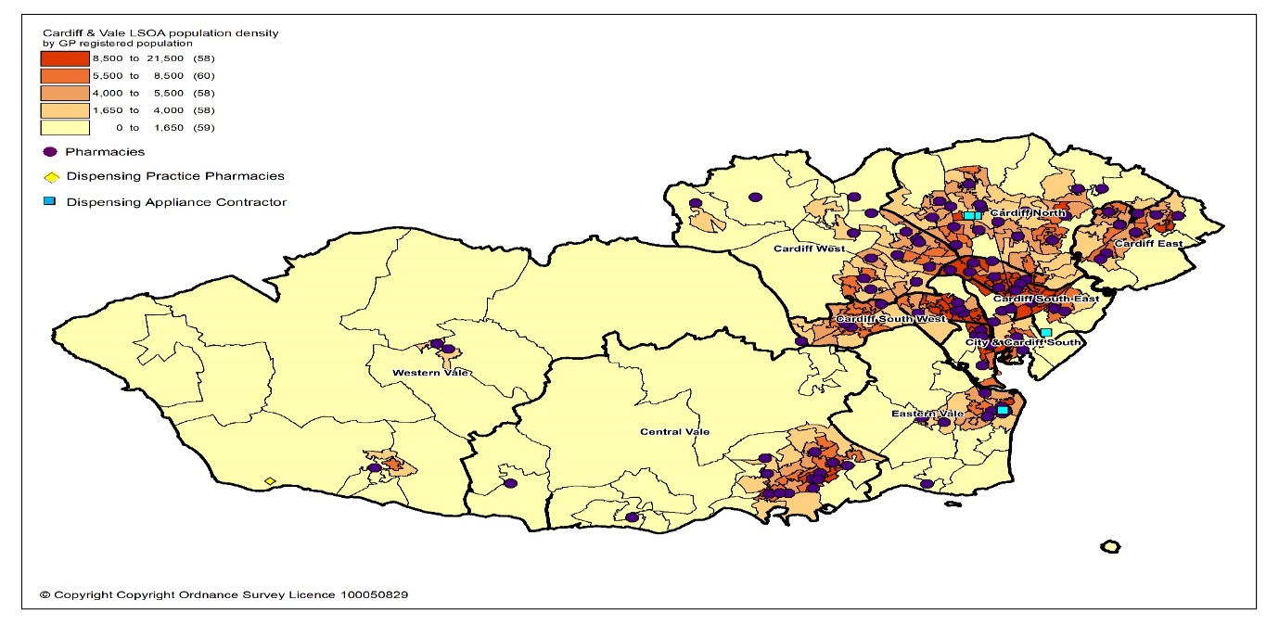

The map below shows the location of the pharmacy, dispensing appliance contractor and dispensing practice premises within the health board’s area compared to levels of deprivation. As can be seen, the majority of pharmacy and appliance contractor premises can be found in or close to areas of higher deprivation. The dispensing doctor practice is found in one of the least deprived areas, however this area is rural in nature.

Map 5.2: Location of pharmacies, dispensing appliance contractors and dispensing practice premises compared to levels of deprivation
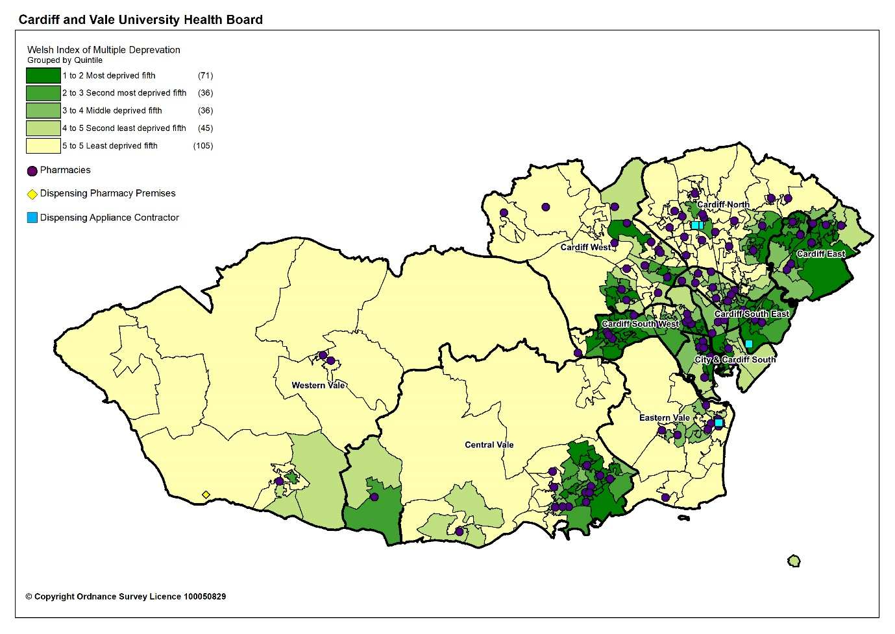
When considering all the prescription items that were prescribed by GPs in Cardiff and Vale University Health Board and dispensed in 2019 to 2020, 96.3% were dispensed by pharmacies within the health board's area. The one dispensing GP practice dispensed or personally administered less than 0.1% and the non-dispensing GP practices personally administered 1.9%.

5.1.1 Access to premises

The ‘access to services’ domain in the Welsh Index of Multiple Deprivation captures deprivation as a result of a household’s inability to access a range of services considered necessary for day-to-day living, including pharmacies. It uses an average return travel time to a pharmacy rather than a one way journey. The average return travel (in minutes) is from the residential dwelling to the nearest pharmacy by public transport or active travel (bus, train, foot or coach) or private transport i.e., by car. In Cardiff and Vale University Health Board the average return travel time to a pharmacy by public transport or active travel is 26 minutes and four minutes by car. Both local authorities in Cardiff and Vale University Health Board have a shorter average return travel time to a pharmacy than the average for Wales.

Table 5.1: Travel time to a pharmacy by public and private transport by local authority, health board and Wales, 2019
Area | Average return travel time by public transport | Range of return travel time by public transport | Average return time by private transport | Range of return travel time by private transport
Cardiff | 24 minutes | 17 to 41 minutes | 4 minutes | 2 to 8 minutes
Vale of Glamorgan | 33 minutes | 16 to 136 minutes | 6 minutes | 1 to 25 minutes
Cardiff and Vale UHB | 26 minutes |  | 4 minutes
Wales | 38 minutes |  | 7 minutes
Source: StatsWales - WIMD 2019 Indicator Data Local Authority
For access by car, a travel time of 20 minutes by car was used as a reasonable or standard time for residents to take to access a pharmacy. In order to assess whether residents are able to access a pharmacy within the standard 20 minutes’ drive time, maps were drawn up at the health board and cluster level. These were based on an analyses of drive time and distance using the RouteFinder plugin for MapInfo Professional and the Ordnance Survey Highways transport network, with a custom average road speed file estimated using a study by Ordnance Survey and South Central Ambulance Service. As can be seen from the map below, all residents in Cardiff and Vale University Health Board can access a pharmacy within 20 minutes by car.

Map 5.3: Time taken to access a pharmacy by car
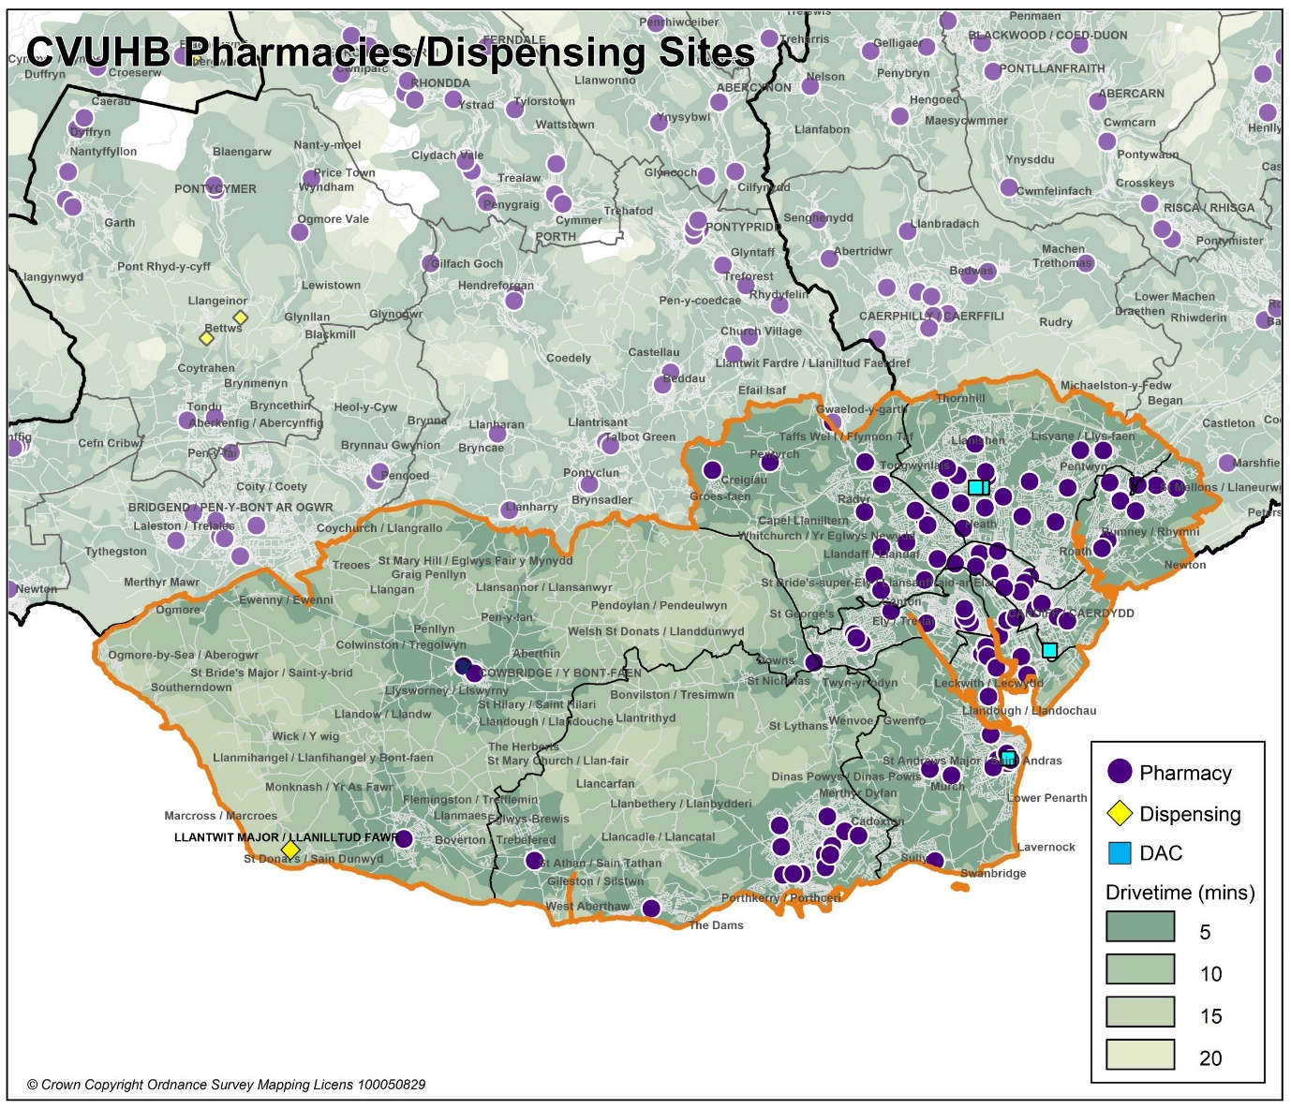

Based on information from the 2011 Census, just over a quarter of households in Cardiff and Vale University Health Board (26.4%) do not have a car or van. The percentage is slightly higher in Cardiff (29%) than the Vale of Glamorgan (19.4%).

Responses to the public and patient questionnaire provide the following insights into accessing pharmacies:

The most popular way of travelling to a pharmacy was by car (51%, 158 out of 308 people) and then on foot (44%). 1% (2 people) travelled by bus and the same by taxi. It is worth noting that these travel modes are likely to have been skewed by the Coronavirus (COVID-19) pandemic travel restrictions in place at the time of the survey. Of the five people who responded other, two comments were about also walking as well as using another method of traveling to the pharmacy.

Nearly all respondents (96%, 293 people out of a total of 304) could get to a pharmacy in less than 20 minutes. Only for 4% of respondents (11 people) did it take more than 20 minutes. 38% of respondents (114 people) could get to a pharmacy in less than 5 minutes. The most popular response was between 5 minutes and 15 minutes (52%, 159 people).

Figure 5.1: Length of time taken to travel to a pharmacy

The majority of respondents (90%, 276 out of 308 people) said they didn’t have difficulty getting to a pharmacy. Only 7% (23 people) replied that they did and 3% (9 people) said the question was not applicable. Comments received included:

Seven comments were related to poor health or mobility issues due to a disability, injury or a health condition, as the main reason which made getting to a pharmacy difficult:
- “I am disabled and it is now too far for me to walk. This is recent (in the last 5 years).”
- “Sometimes I am too I'll to collect my prescription so.my dad goes for me.”

Six comments were about ease of getting to a pharmacy, including travel distance or pharmacy closure or both:
- “I often have late afternoon appointments with my gp in [name of location]. my usual pharmacy in [name of pharmacy] has now closed. other pharmacies in the area are not open by the time i go there, so i cant get my medication on the same day. if i am working the next day i often dont start my medication for a few days.”
- “Too far away and not easy to get to.”
- “I do not drive and have to walk to my surgery and to a pharmacy to collect my medication. I used to use the pharmacy on [name of location] but as that has now closed I struggle to get to a pharmacy near my gp. Because of this I have on occasions had to wait a day or two before I can get my medication which has resulted in my condition worsening. I suffer with chest infections and starting antibiotics and steroids is very important for me.”

One comment mentioned the ongoing road works.

5.1.2 Access to essential services and dispensing appliance contractor equivalent services

Whilst the majority of people will visit a pharmacy during the 8.30am to 6.30pm period, Monday to Friday, following a visit to their GP or another healthcare professional, there will be times when people will need, or choose, to access a pharmacy outside of those times. This may be to have a prescription dispensed after being seen by the Out of Hours and CAV 24/7 service, or to collect dispensed items on their way to or from work, or it may be to access one of the other services provided by a pharmacy outside of a person’s normal working day.

The patient and public engagement questionnaire showed that most respondents do not have a preference about when is the best time or day to use a pharmacy. Of the remaining responses, 42% preferred to use a pharmacy between 9am and 6pm, with 2pm to 6pm being the most popular choice (21%), followed by 6pm to 9pm (17%). Where a day was indicated, the weekdays was the most convenient time for respondents to visit a pharmacy (19%), followed by the weekends in general (11%) rather than a specific day.

Pharmacies are required to open for not less than 40 hours per week (excluding bank and public holidays), and these are referred to as core opening hours. Many pharmacies choose to open for longer and these additional hours are referred to as supplementary opening hours. Appendix L provides information on the pharmacies and dispensing appliance contractor opening hours as of 30th September 2021 and at that point in time there were:

- 15 pharmacies open seven days a week
- 19 pharmacies open Monday to Saturday
- 33 pharmacies open Monday to Friday, and part of Saturday
- 39 pharmacies that open Monday to Friday.

The latest opening hours can be found on the NHS111 website.

Dispensing appliance contractors are required to open not less than 30 hours per week and these are referred to as core opening hours. The opening times of the four appliance contractors, as of March 2021 are:

Respond – Greypoint, Cardiff Business Park, Cardiff, CF14 5WF

Opening times: 8:00am to 5:00pm Monday to Friday.
Salts Healthcare Ltd – 3 Hickman Road, Penarth. CF64 2AJ.
- Opening times: 9.00am to 5.00pm Monday to Saturday
Great Bear Healthcare - 1 Lambourne Crescent, Cardiff Business Park, Cardiff, CF14 5GF
- Opening times: 8.30am to 5.00pm Monday to Friday
Fittleworth Medical Ltd – 9-11 Castle Street, Cardiff, CF10 1BS
- Opening times: Open 6 days a week (Except Bank Holidays).
- Monday to Friday 8.00am to 8.00pm. Saturday 9.00am to 1.00pm

GP practices provide primary medical services during core hours, which are between 8.00am and 6.30pm, Monday to Friday, excluding bank and public holidays.

In addition, the Minor Injuries Unit (MIU) based at Barry Hospital, Colcot Road, Barry, South Glamorgan, CF62 8YH, is open 8.30am to 3.30pm Monday to Friday.

Cardiff & Vale University Health Board has developed a Strategic Clinical Services Plan setting out the vision for how healthcare services will be provided, including providing more treatment and care in the community in Wellbeing Hubs in each locality within Cardiff & Vale University Health Board. This may affect need for pharmaceutical services in those areas.

The health board has the ability to invite and/or direct existing pharmaceutical contractors to adjust their opening hours to meet any future needs as necessary.

At the time of writing the following sections 5.1.3 to 5.1.19, the data available related to 107 pharmacies in Cardiff and Vale University Health Board instead of 106 (due to closure of a pharmacy in September 2020) and the information contained in these sections reflects this. The maps used throughout these sections provide an indication of the location of relevant pharmaceutical contractors within the health board’s area providing advanced and enhanced services. Due to the size of the area covered by the health board many of the premises are not shown individually.

5.1.3 Access to Medicines Use Review (MUR) Advanced Service

The underlying purpose of the MUR service is to improve the patient’s knowledge and use of medicines. In 2018 to 2019, a total of 30,049 MURs were provided by 101 of the 107 pharmacies. Up to 400 MURs can be provided at each pharmacy per year, giving a potential maximum number of 42,800 reviews per annum. However, with six pharmacies not providing the service, the actual number of MURs that could have been undertaken is 40,400 reviews per annum. Only 42 pharmacies claimed the maximum number of 400 MURs in 2018 to 2019.

In 2019 to 2020, a total of 27,060 eligible MURs were provided by 103 of the pharmacies. Up to 400 MURs can be provided at each pharmacy per year, giving a potential maximum number of 42,800 per annum. However, with four pharmacies not providing the service the actual number of MURs that could have been undertaken is 41,200. Only 21 pharmacies claimed for the maximum number of 400 MURs in 2019 to 2020.

The Welsh Government formally suspended the MUR service on 13 March 2020. At the time of writing, it is not known if the service will re-commence.

The map below shows the location of those pharmacies that provided the service in 2019 to 2020.

Map 5.4: Location of the pharmacies providing MURs in 2019 to 2020 by local authority
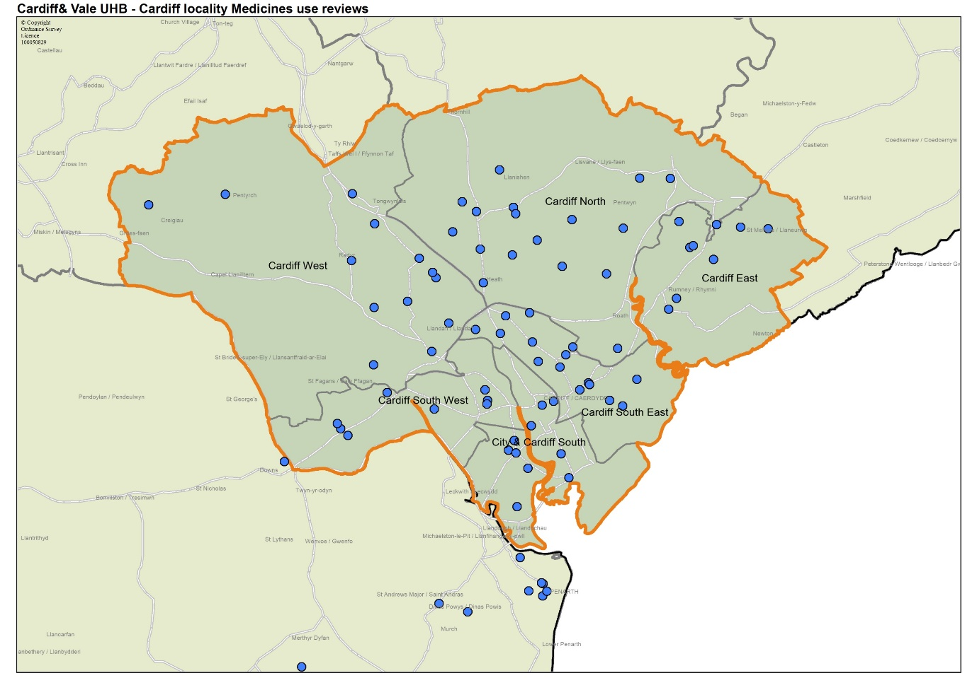
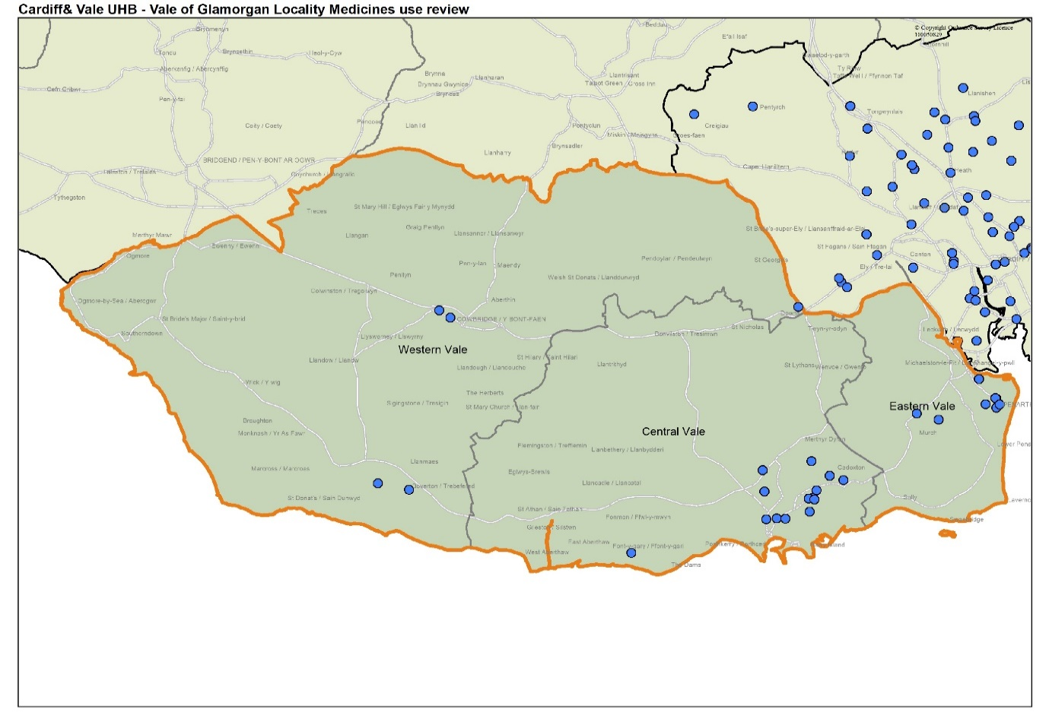

Based upon the level of provision in 2018 to 2019 and 2019 to 2020 Cardiff and Vale University Health Board is satisfied that there is sufficient capacity within existing contractors to provide more MURs:

- In 2019 to 2020, four pharmacies did not provide the service.
- Of the 103 pharmacies that did provide the service, 82 pharmacies (80%) provided less than the maximum annual number of MURs of which 32 pharmacies (31%) provided less than 200 MURs.

However, this may not be the case at the cluster level and further analysis is undertaken within the cluster chapters.

5.1.4 Access to the Discharge Medicines Review (DMR) Advanced Service

The DMR service aims to provide support to patients recently discharged from hospital by ensuring that changes made to their medicines are enacted as intended in the community.

In 2018 to 2019, 85 of the 107 pharmacies provided this service, and a total of 2,195 full service interventions were claimed over the year. Up to 140 DMRs can be provided at each pharmacy per year, giving a potential maximum number of 14,980 per annum. However, with 22 pharmacies not providing the service the actual number of DMR interventions that could have been undertaken is 11,900. Only two pharmacies provided the maximum number of 140 DMR service interventions.

In 2019 to 2020, 91 pharmacies provided this service, and a total of 2,752 full service interventions were claimed over the year. Up to 140 DMRs can be provided at each pharmacy per year, giving a potential maximum number of 14,980 per annum. However, with 16 pharmacies not providing the service the actual number of DMRs interventions that could have been undertaken is 12,740. Only four pharmacies provided the maximum number of 140 DMR service interventions.

Map 5.5: Location of the pharmacies providing DMRs in 2019 to 2020
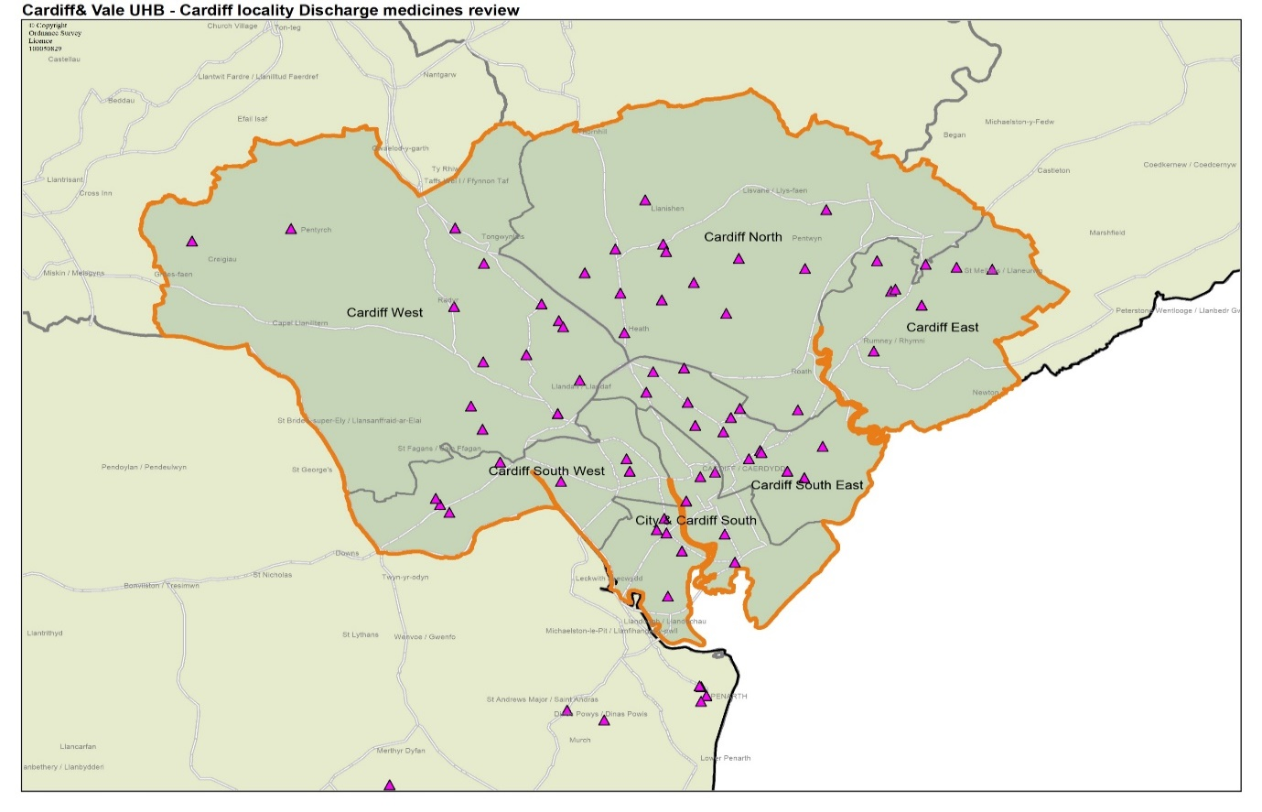
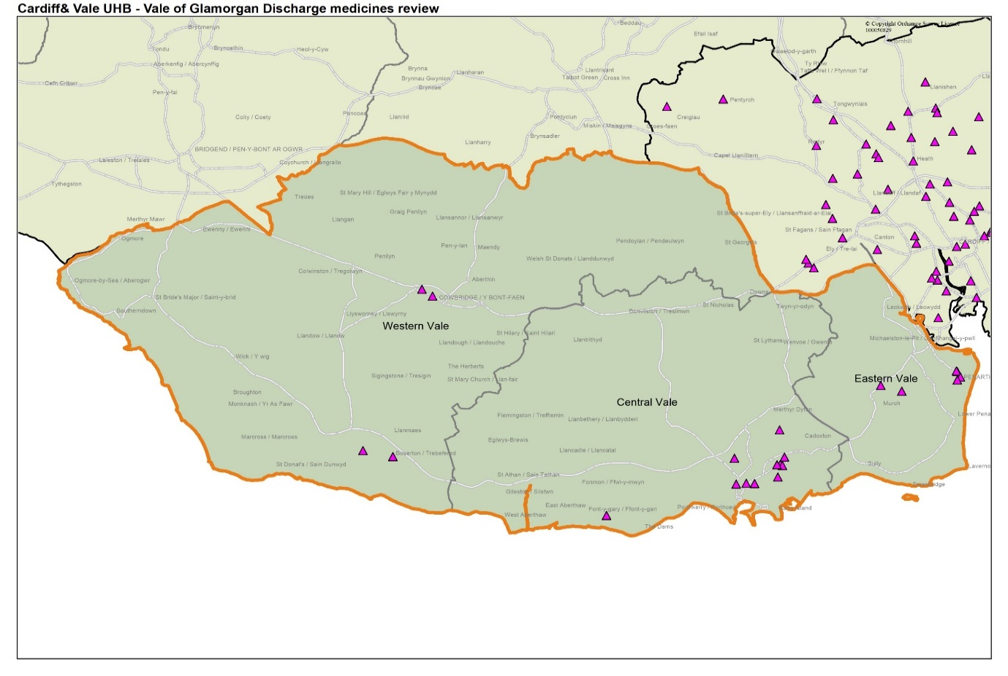
Based upon the level of provision in 2018 to 2019 and 2019 to 2020, the health board is satisfied that there is sufficient capacity within existing contractors to provide more DMRs:

- In 2019 to 2020,16 pharmacies did not provide the service.
- Of the 91 pharmacies that did, 87 pharmacies (96%) provided less than the maximum annual number of 140 DMRs of which 78 pharmacies (86%) provided less than 70 DMRs.

Furthermore, as part of the changes to the Community Pharmacy Contractual Framework for 2021, the cap for the number of paid DMRs has now been removed enabling pharmacies to provide more than 140 DMRs each year. There is no reason to suggest that service capacity has changed during 2020 to 2021. However, it is acknowledged that the Coronavirus (COVID-19) pandemic will have affected the provision and need for this service during 2020 to 2021. Further analysis is undertaken within the cluster chapters.
.

5.1.5 Access to Appliance Use Review Advanced Service

No pharmacies provided this service between 2018 to 2019 and the first five months of 2020 to 2021.

Of the four appliance contractors based in Cardiff and Vale University Health Board, only one offers the AUR service and provided a total of 2,526 AURs in 2018 to 2019, 1,578 AURs were provided in 2019 to 2020 and 326 AURs as of October 2020. However, due to the fact that the dispensing appliance contractor provides services across Wales and into England, not all of these will have been provided for residents of the health board’s area. Due to the way the data is collated and published it is not known how many of these were provided for the health board’s residents.

5.1.6 Access to Stoma Appliance Customisation (SAC) Advanced Service

No pharmacies provided this service in 2018 to 2019 to the first months of 2020 to 2021.

All four appliance contractors based in Cardiff and Vale University Health Board offer the SAC service. A total of 39,264 SACs were provided in 2018 to 2019, 39,111 SACs were provided in 2019 to 2020 and 21,078 SACs were provided as of October 2020. However due to the fact that dispensing appliance contractors provide services across Wales and into England, not all of these will have been provided for residents of the health board’s area. Due to the way the data is collated and published it is not known how many of these were provided for the health board’s residents.

5.1.7 Access to the Emergency Contraception Enhanced Service
In 2011, a national Emergency Contraception service was commissioned from community pharmacies. This allows levonorgestrel to be obtained by women and girls from the age of 13 years free of charge under a patient group direction (PGD). In April 2015, the service was extended to allow ulipristal acetate to be supplied between 72 and 120 hours after unprotected sexual intercourse (UPSI). As of April 2021, 75 pharmacies are commissioned by Cardiff and Vale University Health Board to provide the Emergency Contraception enhanced service.

In 2018 to 2019, 66 pharmacies provided a total of 8,869 consultations under this service over the year. The figure below shows the total number of consultations provided under the service by pharmacies in the health board’s area over this period.

Figure 5.2: Number of emergency contraception consultations claimed in 2018 to 2019

In 2019 to 2020, 68 pharmacies provided a total of 8,105 consultations under this service over the year. The figure below shows the total number of consultations claimed under the service by pharmacies in the health board’s area in 2019 to 2020.

Figure 5.3: Number of emergency contraception consultations claimed in 2019 to 2020

The map below shows the location of those pharmacies that provided the service in 2019 to 2020.

Map 5.6: Location of pharmacies providing Emergency Contraception Enhanced Service in 2019 to 2020
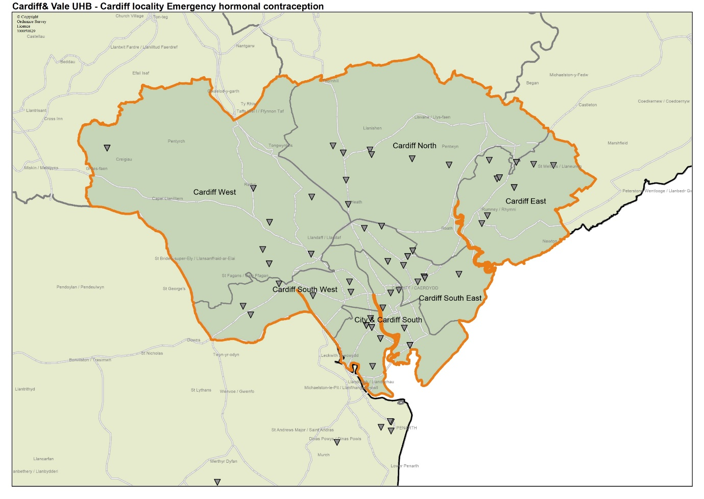
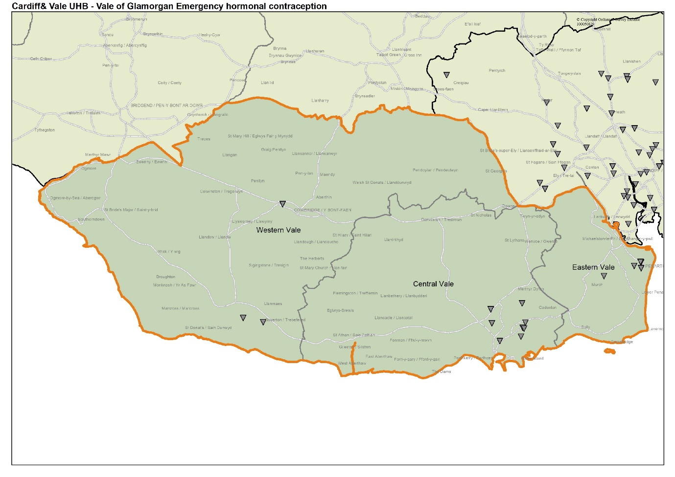
In the first five months of 2020 to 2021, 63 pharmacies provided a total of 2,246 consultations under this service.

The figure below shows the total number of emergency contraception consultations claimed under the service by pharmacies in the health board’s area in the first five months of 2020 to 2021.

Figure 5.4: Number of emergency contraception consultations claimed in 2020 to 2021

The figure below compares provision of the service over the last three financial years.

Figure 5.5: Number of emergency contraception consultations by year from April 2018 to August 2021

Based upon the level of provision in 2018 to 2019 and 2019 to 2020, Cardiff and Vale University Health Board is satisfied that there is sufficient capacity within existing contractors to provide more emergency contraception consultations.

From the data available for 2020 to 2021, there is no evidence to support a different conclusion. However, it is acknowledged that the Coronavirus (COVID-19) pandemic will have affected the provision and need for this service during 2020 to 2021. Further analysis is undertaken within the cluster chapters.

5.1.8 Access to the Smoking Cessation Level 2 Enhanced Service
The Smoking Cessation Level 2 Enhanced Service links pharmacies with the intensive behavioural support service provided by Help Me Quit (HMQ). Under this arrangement, pharmacy contractors supply nicotine replacement therapy to smokers who are receiving smoking cessation behavioural support from Help Me Quit, in response to a referral letter or appointment card that indicates the client’s dependence on nicotine. Following successful completion of the six weeks programme, Help Me Quit will issue a discharge referral letter to a pharmacy for a further six week supply of nicotine replacement therapy to be supplied at fortnightly intervals.

The service commenced in May 2020, and there are 34 pharmacies commissioned to provide the Smoking Cessation Level 2 Enhanced Service.

As of August 2020, four pharmacies provided a total of 13 consultations. The figure below shows the total number of consultations claimed under the service by pharmacies in the health board’s area in 2020 to 2021.

Figure 5.6: Number of consultations claimed in 2020 to 2021

Based on the fact that the service only commenced in May 2020 and only four pharmacies were providing the service at that stage, Cardiff and Vale University Health Board is satisfied that there is sufficient capacity within existing contractors to provide more Smoking Cessation Level 2 services.

5.1.9 Access to the Smoking Cessation Level 3 Enhanced Service
The Smoking Cessation Level 3 Enhanced Service was commissioned in 2015 and is designed to provide patients with a comprehensive support and treatment service to help them stop smoking over a 12 week programme, involving eight consultations with an accredited pharmacist. The service involves an initial assessment to determine the client’s readiness to stop smoking; motivational interviewing techniques to assist clients in their attempt to stop smoking; supply and support in use of nicotine replacement therapy (NRT) products to maximise therapeutic benefits and Carbon monoxide monitoring to support a stop smoking attempt. As of April 2021, there are 39 pharmacies commissioned by Cardiff and Vale University Health Board to provide the smoking cessation level 3 enhanced service.

In 2018 to 2019, 20 pharmacies provided a total of 279 consultations over the year. The figure below shows the total number of consultations claimed under the service by pharmacies in the health board’s area in 2018 to 2019.

Figure 5.7: Number of consultations claimed in 2018 to 2019

In 2019 to 2020, 22 pharmacies provided a total of 407 consultations under this service over the year. The figure below shows the total number of consultations claimed under the service by pharmacies in the health board’s area in 2019 to 2020.

Figure 5.8: Number of consultations claimed in 2019 to 2020

The map below shows the location of those pharmacies that provided the service in 2019 to 2020.
Map 5.7: Location of pharmacies providing the Smoking Cessation Level 3 Enhanced Service in 2020 to 2021
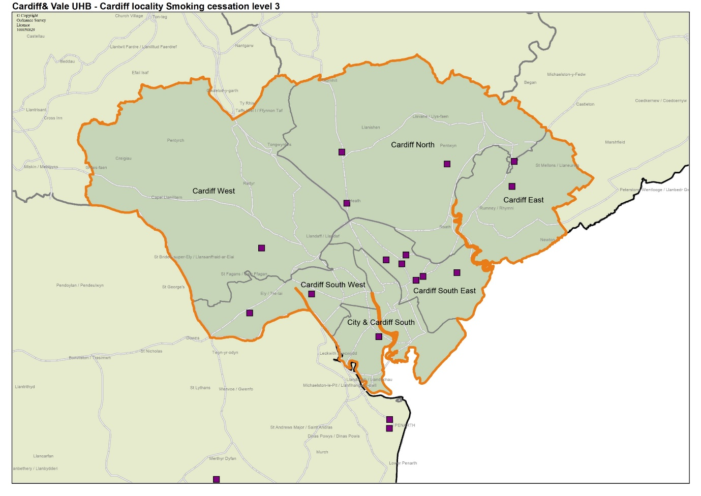
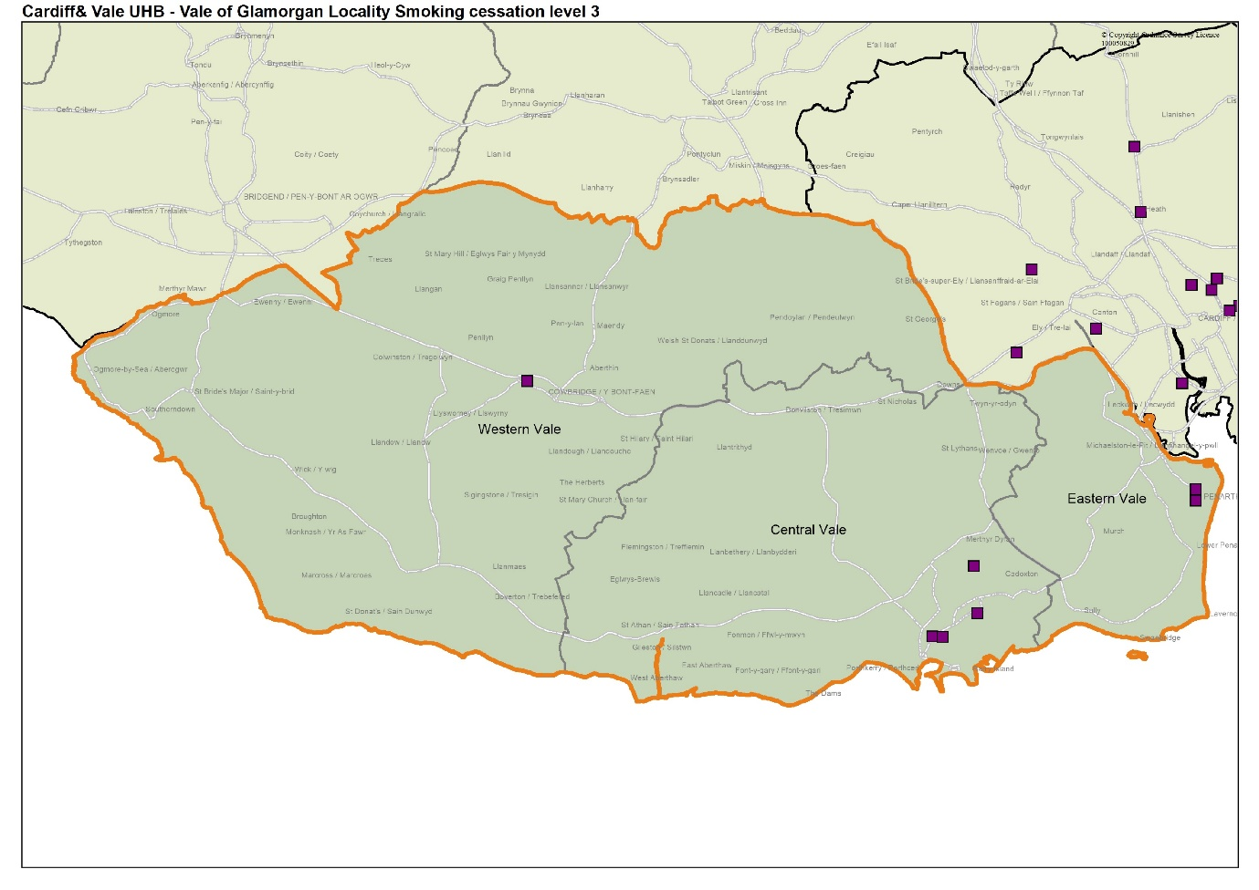
14 pharmacies provided a total of 87 consultations in the first five months of 2020 to 2021. The figure below shows the total number of consultations claimed under the service by pharmacies in the health board’s area in the first five months of 2020 to 2021.
Figure 5.9: Number of consultations claimed in 2020 to 2021

The figure below compares provision of the service over the last three financial years.
Figure 5.10: Number of consultations from April 2018 to August 2021

Based upon the level of provision in 2018 to 2019 and 2019 to 2020, Cardiff and Vale University Health Board is satisfied that there is sufficient capacity within existing contractors to provide more smoking cessation level 3 consultations.

From the data available for 2020 to 2021 there is no evidence to support a different conclusion. However, it is acknowledged that the Coronavirus (COVID-19) pandemic will have affected the provision and need for this service during 2020 to 2021. Further analysis is undertaken within the cluster chapters.

5.1.10 Access to the Flu Vaccination Enhanced Service
The Flu Vaccination Enhanced Service was commissioned in 2012. This service allows pharmacies to provide influenza immunisation for those patients in nationally and locally agreed at risk groups. It supports the wider provision of influenza immunisation and aims to increase the proportion of at risk individuals who receive immunisation thus helping to reduce morbidity and mortality.
In 2020 to 2021, 88 pharmacies were commissioned by Cardiff and Vale University Health Board to provide the flu vaccination enhanced service.
In 2018 to 2019, 88 pharmacies provided a total of 8,274 vaccinations over the flu season (September to March). The figure below shows the total number of vaccinations claimed under the service by pharmacies in the health board’s area in 2018 to 2019.

Figure 5.11: Number of flu vaccinations claimed in 2018 to 2019

In 2019 to 2020, 86 of the pharmacies provided a total of 9,164 vaccinations during the flu season. The figure below shows the total number of vaccinations claimed under the service by pharmacies in the health board’s area in 2019 to 2020.

Figure 5:12 Number of flu vaccinations claimed in 2019 to 2020

The map below shows the location of those pharmacies that provided the service in 2019 to 2020.

Map 5.8: Location of pharmacies providing the Flu Vaccination Enhanced Service in 2019 to 2020
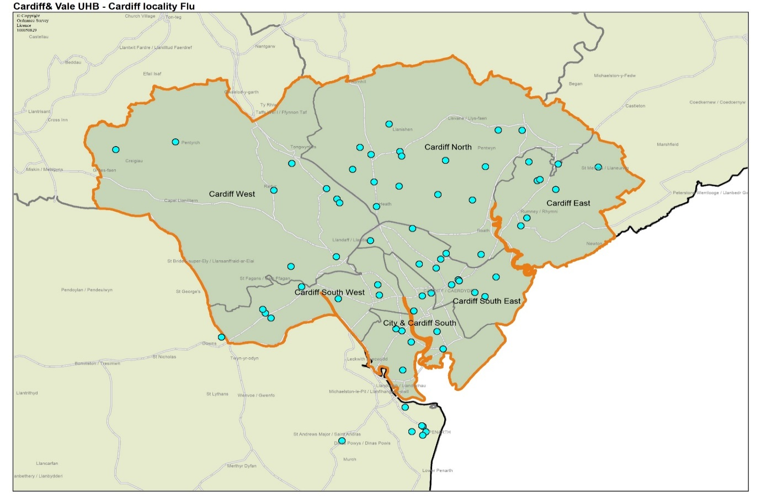
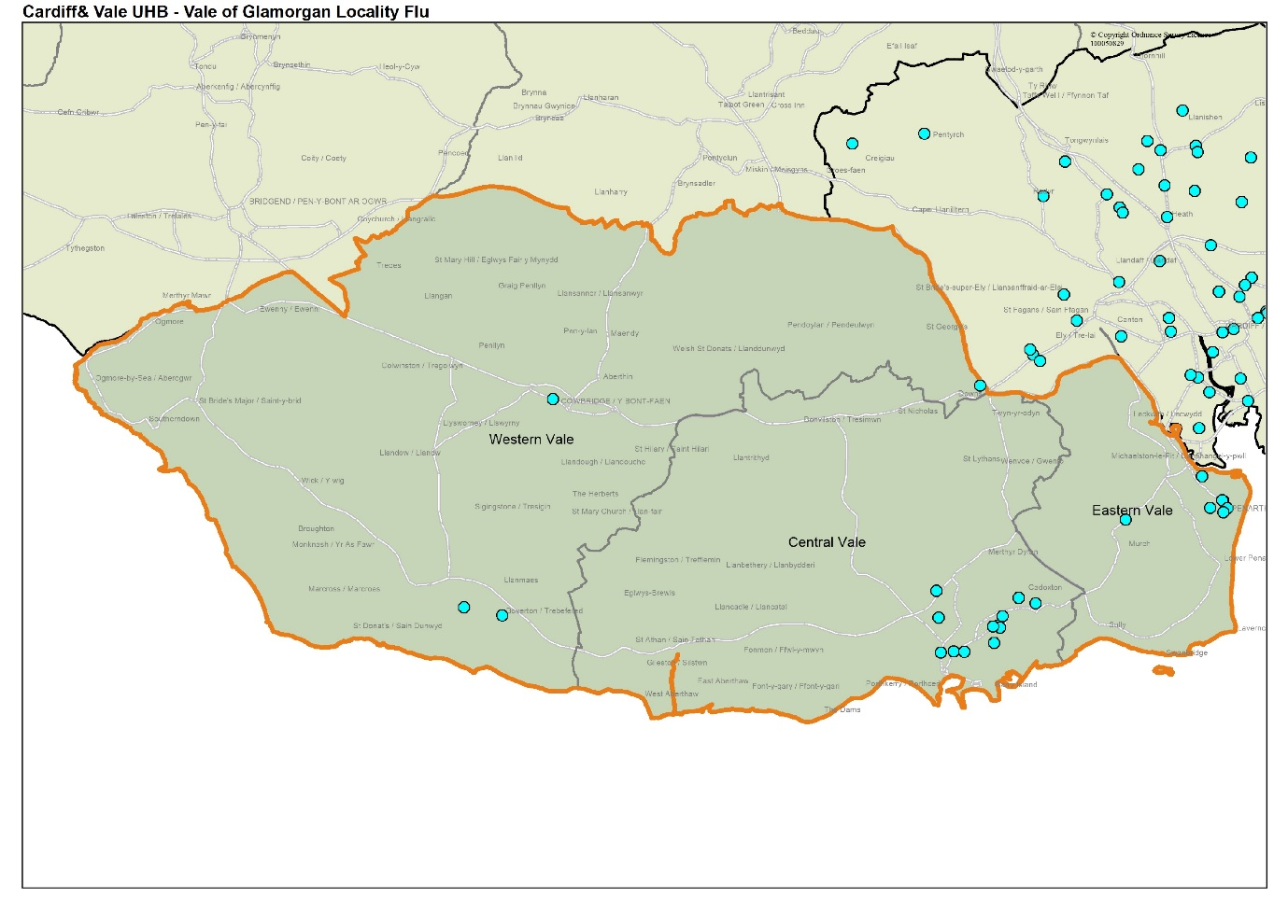
The figure below compares provision of the service over two flu seasons.
Figure 5.13: Number of vaccinations claimed each year for flu seasons 2018 to 2019 and 2019 to 2020

Based upon the level of provision in 2018 to 2019 and 2019 to 2020, Cardiff and Vale University Health Board is satisfied that there is sufficient capacity within existing contractors to provide more flu vaccination consultations.

However, it is acknowledged that the Coronavirus (COVID-19) pandemic will have affected the provision and need for this service during 2020 to 2021. Further analysis is undertaken within the cluster chapters.

5.1.11 Access to the Common Ailment Service (CAS) Enhanced Service
The CAS service provides advice and treatment on a range of specified conditions such as acne, chickenpox, conjunctivitis, head lice, sore throat/tonsillitis and verrucae. Patients register with a pharmacy and receive a consultation with a pharmacist and advice on management and treatment where required, or referral if necessary, and is provided as an alternative to making a GP appointment.
There are 102 pharmacies commissioned by Cardiff and Vale University Health Board to provide the common ailment service of which 24 were able to provide the additional Sore Throat Test and Treat (STTT) element of the service prior to the Coronavirus (COVID-19) pandemic.
In 2019 to 2020, 102 of the pharmacies provided a total of 6,597 consultations over the year. The figure below shows the total number of consultations claimed under the service by pharmacies in the health board’s area in 2019 to 2020.

Figure 5.14: Number of consultations claimed in 2019 to 2020

The map below shows the location of those pharmacies that provided the service in 2019 to 2020.

Map 5.9: Location of pharmacies providing the CAS Enhanced Service in 2019 to 2020
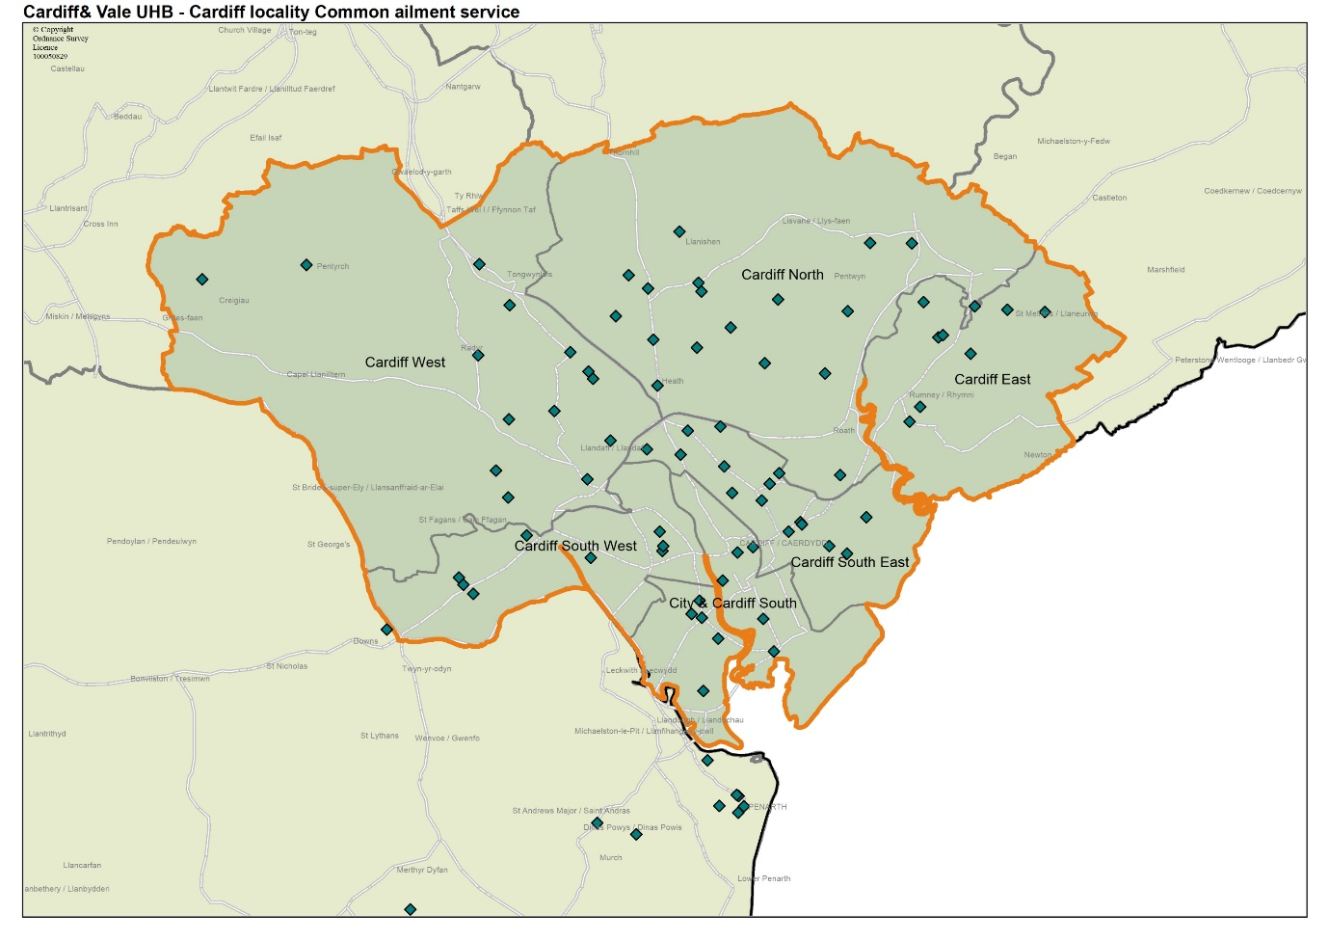
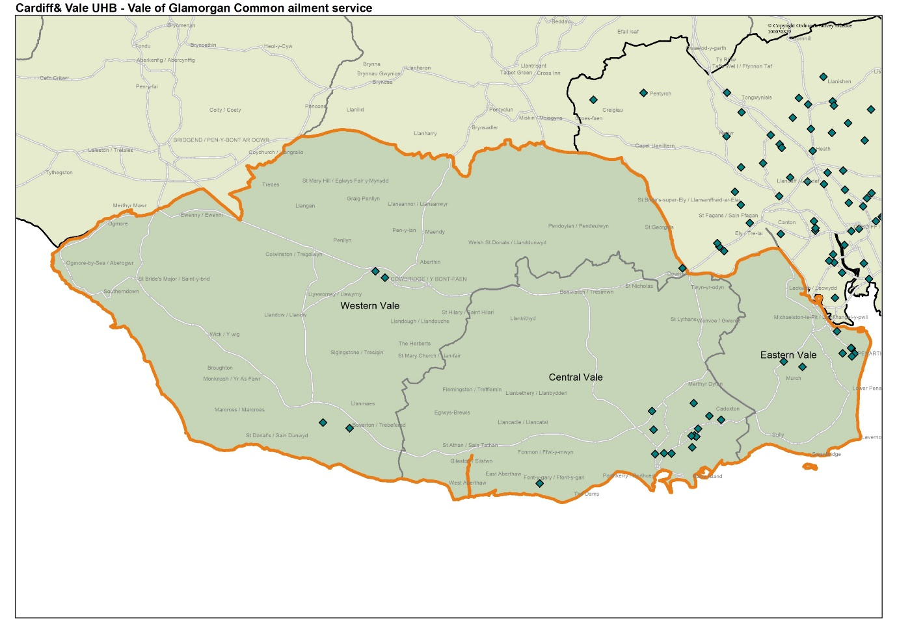
97 pharmacies provided a total of 3,409 consultations in the first five months of 2020 to 2021. The figure below shows the total number of consultations claimed under the service by pharmacies in the health board’s area in the first five months of 2020 to 2021.
Figure 5.15: Number of consultations claimed in 2020 to 2021

The figure below compares provision of the service between April 2019 and August 2021.
Figure 5.16: Number of consultations each year from April 2019 to August 2021

Based upon the level of provision in 2019 to 2020, Cardiff and Vale University Health Board is satisfied that there is sufficient capacity within existing contractors to provide the CAS service.

From the data available for 2020 to 2021 there is no evidence to support a different conclusion. However, it is acknowledged that the Coronavirus (COVID-19) pandemic will have affected the provision and need for this service during 2020 to 2021. Further analysis is undertaken within the cluster chapters.

5.1.12 Access to the Emergency Medicines Supply (EMS) Enhanced Service
The EMS enhanced service was initially commissioned in 2015 to enable patients to access emergency supplies of medication via community pharmacies with the cost of the supply being met by the NHS. The purpose of this service is to reduce the burden on Out of Hours and Emergency Care services in relation to managing patient requests for emergency supplies of medication outside of normal GP working hours.
The Human Medicines Act 2012 remains the primary legislation governing the emergency supply of medication at the request of a patient and all supplies of medication made must be made in accordance with these regulations.
As of April 2021, there are 93 pharmacies commissioned by Cardiff and Vale University Health Board to provide the EMS service as part of the Coronavirus (COVID-19) response.
In 2019 to 2020, 33 pharmacies provided a total of 681 consultations over the year.
The figure below shows the total number of consultations claimed under the service by pharmacies in the health board’s area in 2019 to 2020.
Figure 5.17: Number of consultations claimed in 2019 to 2020

The map below shows the location of those pharmacies that provided the service in 2019 to 2020.

Map 5.10: Location of the pharmacies providing EMS Enhanced Service in 2019 to 2020
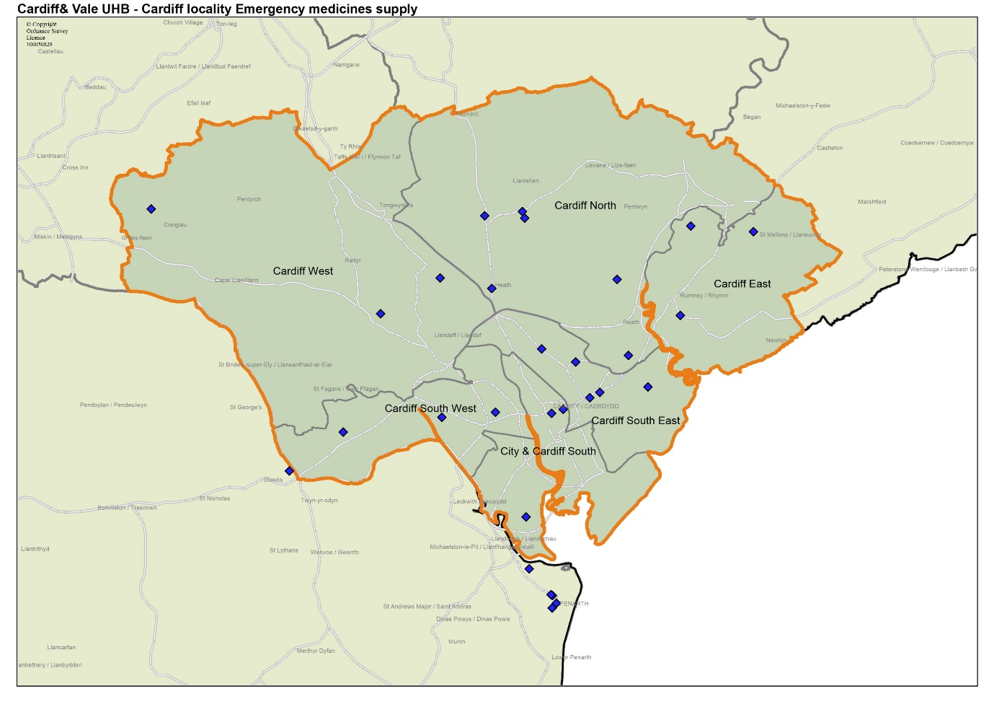
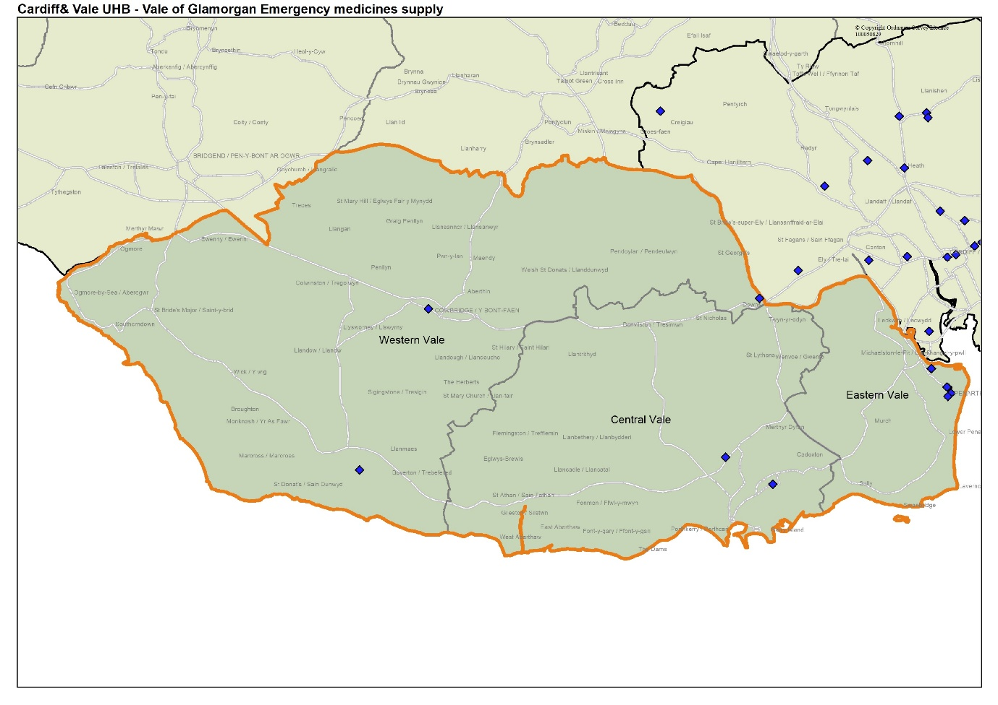

53 pharmacies provided a total of 819 consultations in the first five months of 2020 to 2021. The figure below shows the total number of consultations claimed under the service by pharmacies in the health board’s area in the first five months of 2020 to 2021.
Figure 5.18: Number of consultations claimed in 2020 to 2021

The figure below compares provision of the service between April 2019 and August 2021.
Figure 5.19: Number of consultations from April 2019 to August 2020

Based upon the level of provision in 2019 to 2020, the Cardiff and Vale University Health Board is satisfied that there is sufficient capacity within existing contractors to provide more EMS consultations.

From the data available for 2020 to 2021, there is no evidence to support a different conclusion. However, it is acknowledged that the Coronavirus (COVID-19) pandemic and resultant changes in access to GPs will have driven the delivery of this service during 2020 to 2021. Further analysis is undertaken within the cluster chapters.

5.1.13 Access to Supervised Administration of Medicines Enhanced Service
The aim of this enhanced service is to provide, in accordance with an appropriate prescription, supervised administration of medication such as methadone and Buprenorphine, contributing to a reduction in risks associated with inappropriate use or diversion of prescribed medicines

As of April 2021, there are 52 pharmacies commissioned to provide the Supervised Administration of Medicines service in Cardiff and Vale University Health Board.

In 2019 to 2020, 49 pharmacies provided this service and a total of 4,531 patients accessed this service. Based upon the level of provision Cardiff and Vale University Health Board is satisfied that there is sufficient capacity within existing contractors to provide more supervised administrations of medication.

However, it is acknowledged that the Coronavirus (COVID-19) pandemic will have affected the provision and need for this service during 2020 to 2021. Further analysis is undertaken within the cluster chapters.

5.1.14 Access to Needle Syringe Provision Enhanced Service

The Needle Syringe Provision Enhanced Service aims to reduce the spread of HIV, Hepatitis C and other blood borne diseases amongst injecting drug misusers by providing service users with convenient access to sterile injecting equipment and a facility for the safe disposal of used equipment. To be effective the scheme must operate on an exchange basis and participating pharmacies must make all efforts to encourage service users to return used equipment in exchange for new kits. In 2019 to 2020, 14 pharmacies were commissioned by the Area Planning Board in conjunction with Cardiff and Vale University Health Board to provide this service.

Whilst Needle and Syringe Provision is provided by pharmacies, it is also provided by specialist services, hostel and outreach services. Pharmacies provided Needle and Syringe provision to 39% of clients in Cardiff and Vale University Health Board over this period.

5.1.15 Access to Blood Borne Virus Enhanced Service

The service supports the detection and early diagnosis of those at risk from blood borne viruses such as HIV, hepatitis B and C and ensures treatment is commenced at an early stage, preventing further virus transmission. The group of clients considered to be at risk of infection are regularly accessing services provided by pharmacies such as needle and syringe provision and supervised consumption.
Cardiff and Vale University Health Board have a small scale local enhanced service pilot of Blood Borne Virus testing service in four pharmacies across the area. At the time of writing, this service is currently suspended due to Coronavirus (COVID-19) pandemic.

5.1.16 Access to Care Home Support Enhanced Service (Level One)

The enhanced service supports the safe ordering, supply, storage and administration of medicines and appliances within care homes. It involves a systematic review of all medicine management processes in the care home and the development of medicines protocols and procedures to support effective use of medicines, reduction of risk and reductions of avoidable waste.

The level one care home support service was introduced in the health board area in 2018 to support 20 of the 129 care homes in Cardiff.

5.1.17 Palliative Care Enhanced Service
Access to palliative care medications in hours is required to support the care of patients whose condition is deteriorating unexpectedly. Palliative care medicines are not necessarily stocked routinely by all pharmacies, meaning that sometimes patients must visit more than one pharmacy to access all the medicines needed. This service ensures prompt and effective access to a range of palliative care medicines within normal working hours with minimal inconvenience to patients and professionals, by identifying key pharmacies that have agreed to hold a specific stock list of palliative care medicines.

There are 31 pharmacies commissioned to provide the palliative care service in Cardiff and Vale University Health Board and in 2019 to 2020, 29 pharmacies actively provided this service.

5.1.18 Independent Prescribing

Pharmacist independent prescribers may prescribe any licensed medicine for any medical condition, within their therapeutic area of competence.
Community pharmacy and health boards across Wales were given the opportunity
by the Welsh Government to develop pathfinder sites and pilot new services that could utilise community pharmacists and independent pharmacist prescribers in community pharmacy.
In conjunction with the Department of Sexual Health (DOSH), Cardiff and Vale University Health Board developed a community pharmacy oral contraceptive service. In 2020, the health board launched an independent prescriber oral contraception service within four community pharmacies, with plans to extend to six sites by 2022.
Cardiff and Vale University Health Board also plan to launch an independent prescriber acute conditions service within an additional four community pharmacies in 2021. The acute conditions service will provide patients presenting in the community pharmacy with a relevant acute condition access to effective advice and treatment, provided by a community pharmacist independent prescriber. The service will support a ‘community pharmacy first’ model of care, to reduce the number of patients consulting their GP for acute conditions that can be appropriately managed in the community pharmacy setting.

5.1.19 Access to pharmaceutical services on public and bank holidays

The health board has a duty to ensure that residents of its area are able to access pharmaceutical services every day. Pharmacies and dispensing appliance contractors are not required to open on public and bank holidays, or Easter Sunday, although some choose to do so. Cardiff and Vale University Health Board has a bank holiday rota system in place to ensure that a certain number of pharmacies are open for a restricted time throughout the health board’s area on public and bank holidays.

5.1.20 Mass immunisation program Primary Care Contractor Immunisation Service (PCCIS) via community pharmacy

Throughout 2020 and into 2021, pharmacies have played an integral part in supporting the health board’s primary care response to the Coronavirus (COVID-19) pandemic through their ongoing Essential, Advanced and Enhanced pharmaceutical service provision. The development of the Primary Care Contractor Immunisation Service (PCCIS) by the Welsh Government has meant that pharmacies can be included as vaccination sites. Cardiff and Vale University Health Board has currently commissioned three pharmacies to provide this service with a further seven sites identified and with around 40 pharmacies being interested in providing this service. Pharmacies will continue to be a part of the mass immunisation program in primary care as we move through 2021 and beyond.

5.1.21 Dispensing service provided by some GP practices

Dispensing GP practices provide the dispensing service during their core hours which are 8.00am to 6.30pm from Monday to Friday excluding public and bank holidays. The service may also be provided during any extended opening hours provided by the practices.

The dispensing GP practice at Cowbridge & Vale Medical Practice, Cowbridge Health Centre, Vale of Glamorgan, CF71 7DA, had 372 people registered as a dispensing patient with their practice in August 2020. This was 5% of the total list size of the practice.

The dispensing GP practice has premises approval to provide a dispensing service from Atlantic College, St Donats Castle, Llantwit Major, Vale of Glamorgan CF71 1WF to the students living in Atlantic College. No appliances are dispensed from the premises. This is a residential college.

The practice has informed Cardiff and Vale University Health Board that it has sufficient capacity within its existing premises and staffing levels to manage an increase in demand in its area if required. However, this would dependent upon the terms set out in the NHS (Pharmaceutical Services) (Wales) Regulations 2020.

5.2 Current provision outside Cardiff and Vale University Health Board area

5.2.1 Access to essential services and dispensing appliance contractor equivalent services

Patients have a choice of where they access pharmaceutical services; this may be close to their home, their GP practice, their place of work or where they go for shopping, recreational or other reasons. Consequently, not all the prescriptions written for residents of the health board’s area are dispensed within the same area although as noted in the previous section, the vast majority of items are. In 2019 to 2020, 1.8% of items were dispensed outside of the health board’s area, of which 1.2% were dispensed elsewhere in Wales by 505 different pharmacy contractors (trading during this period). 0.6% were dispensed in England.

Of the 121,774 items dispensed elsewhere in Wales:

- 78,128 were dispensed by 129 contractors in Aneurin Bevan University Health Board’s area,
- 605 were dispensed by 78 contractors in Betsi Cadwaladr University Health Board’s area,
- 34,185 were dispensed by 108 contractors in Cwm Taf Morgannwg University Health Board’s area,
- 2,488 were dispensed by 90 contractors in Hywel Dda University Health Board’s area,
- 224 were dispensed 20 contractors in Powys Teaching Health Board’s area, and
- 6,144 were dispensed by 80 contractors in Swansea Bay University Health Board’s area.

The following types of pharmaceutical contractors dispensed the 64,576 items in England:
- Pharmacies
- Dispensing appliance contractors
- Distance selling premises (also known as an internet pharmacy)

In general, there were three main reasons for a prescription to be dispensed outside of the health board’s area:
- the prescription was dispensed by a dispensing appliance contractor (either in Wales or England), or
- by a pharmacy based just over the border within another health board’s area or in England, or
- they were dispensed whilst the person was on holiday, at work or shopping.

5.2.2 Access to advanced services

Information on the type of advanced services provided by pharmacies outside the health board’s area to its residents is not available. When claiming for advanced services contractors merely claim for the total number provided for each service. The exception to this is the stoma appliance customisation service where payment is made based on the information contained on the prescription. However even with this service just the total number of relevant appliance items is noted for payment purposes. It can be assumed however that residents of the health board’s area will access these services from contractors outside of the area.

5.2.3 Access to enhanced services

As with advanced services information on the provision of enhanced services by pharmacies outside the health board’s area to its residents is not available. It can be assumed however that residents of the health board’s area will access these services from contractors outside of the area.

5.2.4 Dispensing service provided by some GP practices

Some residents of the health board’s area will choose to register with a GP practice outside of the area and will access the dispensing service if offered by their practice.

5.3 Choice with regard to obtaining pharmaceutical services

As can be seen from sections 5.1 and 5.2, the residents of the health board’s area currently exercise their choice of where to access pharmaceutical services to a considerable degree. Within the health board’s area, they have a choice of 106 pharmacies, operated by 39 different contractors and four dispensing appliance contractors operated by four different contractors. Outside of the health board’s area residents chose to access a further 402 contractors, although many are not used on a regular basis.

When asked what influences their choice of pharmacy the most common responses in the patient and public questionnaire were close to home followed by close to my doctor and the location of the pharmacy is easy to get to. Please note that more than one option could be provided to this question.

Of the 22 respondents who answered other, 10 comments were received about the repeat dispensing system, including ordering and collecting prescriptions:
- “They provide telephone updates when my prescription is ready to be collected.”
- “Collect my prescription from GP and I pick up from the pharmacy once completed.”

One comment received was about ease of parking and another comment was about previous negative experiences with pharmacies and finding the best one in their location.

Two comments were about the delivery service offered during the Coronavirus (COVID-19):
- “They've been great during lockdown and have delivered our prescriptions when my husband was shielding.”
- “[Name of pharmacy] collects my prescription BUT WILL NOT DELIVER - even though I am shielding.”

Two comments were about opening times.
- “If only they would open at hours that people who work (in the NHS) could access them, I would go to the one that’s 30 seconds walk from my house, instead of having to track to [name of pharmacy].”

- “Open on a Saturday.”

Other comments include:
- “This is pharmacy that the drs told me I had to use this one.”
· “I go to the pharmacy that is open but this has been harder lately since my local pharmacy has moved further away and I have to delay my treatment till the next day.”

Figure 5.20: Reasons that Influence the choice of pharmacy

The majority of respondents (67%, 207 out of 307 people), use the pharmacy that is most convenient and / or closest for them to use. 11 respondents said they did not know. However, for 29% of respondents (89 people) there was a more convenient and / or closer pharmacy that they were choosing not to use. When asked why they did not use that pharmacy, 90 people answered the question (one more than previously responded) and a total of 164 responses were received. Multiple answers could be given to this question and the number of responses received indicates that some people chose more than one reason. The top three reasons provided were around ease of parking, speed of service and having a bad experience in the past.

Figure 5.21: Reasons for not using a nearer pharmacy

Of the 29 people who selected other, the following comments were received:

Five comments were about loyalty and / or being satisfied with the service received from the pharmacy they were using.
- “When I moved to the area the one I used was recommended so I have remained with them however the other was also very good on the occasions I have used it.”
- “I moved house and am still within the catchment area for my GP and current pharmacy, so preferred not to change it as I like the staff and service, they know my medications (I take some unsual ones).”
- “I’ve always been happy with the one I use.”

Five comments were related to proximity of pharmacy to GP practice:
- “The pharmacy I do use is attached to my GP surgery so my script is passed to the pharmacy for me so it’s just easier to go there than the pharmacy nearest my home which is not attached to my GP.”
- “It's further away from the doctor's.”

Three comments were about where the GP sends the prescription:
- “My go [GP] sends my prescription there.”
- “My doctors won't use it.”

Two comments related to opening times.
“I only go elsewhere when its closed for lunch.”

Eight comments mentioned the quality of service received such as the inefficiency of staff, mistakes made (one comment), prescriptions being ready on time, and the pharmacy staff not being as approachable or as personable as the one they were choosing to use:
- “[Name of pharmacy] inefficient & need customer service training.”
- “Have made mistakes on more than one occasion. Dangerous as life threatening medicines.”
- “I need to request the repeat prescription from my doctor every time I need it - the pharmacy don’t do it for me.”
- Confined spaces in many pharmacies and the staff don’t always treat you with respect and dignity.”
One comment received was particularly related to lack of a stock item held at the pharmacy:
- “Altho within walking distance it means 2 visits as one of my monthly items is not held in stock. Other pharmacies carry this drug.”

Two comments were about pharmacies being busy:
- “Very busy, have to wait a long time.”

Two comments were about personal service:
- “Part if a chain with no sense of community.”
- “No personal service.”

Two comments related directly to the Coronavirus (COVID-19) pandemic situation and staff not wearing face masks:
- “Staff not wearing face masks behind the counter. Visors have been proven to offer little or no protection and users of a pharmacy should be safe in Knowledge that all PPE is being worn. Last time there were two people in no masks!”

6 Other NHS services

The following NHS services are deemed, by Cardiff and Vale University Health Board, to affect the need for pharmaceutical services within its area:

- Hospital pharmacies – reduce the demand for the dispensing essential service as prescriptions written in hospitals are dispensed by the hospital pharmacy service.
- Personal administration of items by GPs – similar to hospital pharmacies, this also reduces the demand for the dispensing essential service. Items are sourced and personally administered by GPs and other clinicians at the practice thus saving patients having to take a prescription to a pharmacy, for example for a vaccination, in order to then return with the vaccine to the practice so that it may be administered.
- Urgent Primary Care - Out of Hours Service (CAV24/7) – whether a patient is given a full or part course of treatment after being seen by the Out of Hours Service or the Minor Injuries Unit at Barry Hospital, will depend on the nature of their condition. This service will therefore affect the need for pharmaceutical services, in particular the essential service of dispensing. Furthermore, as patients are directed to the right services through the one call system, this also has the potential to increase the need for all pharmaceutical services.
- Prison pharmacies - reduce the demand for the dispensing of essential service as prescriptions written in HMP Cardiff prison are not dispensed by community pharmacies or dispensing appliance contractors.
- Independent prescribers – are likely to increase in number over the next five years, which may have a subsequent effect on the need for pharmaceutical services, in particular the essential service of dispensing, as more patients are treated.
- The Online Non Prescription Ordering Service (ONPOS) dressings system – this will reduce the need for dressings on prescriptions for many patients and therefore the demand for the dispensing essential service. However, non-formulary dressings will still need to be prescribed.

6.1 Hospital pharmacies

There are 8 hospitals in the health board area:

    - University Hospital of Wales (UHW), Heath Park, Cardiff, CF14 4XW

University Hospital of Wales is a major 1,000-bed hospital in the Heath district of Cardiff, Wales. The hospital provides secondary care to the population of North and East Cardiff and tertiary level care in nephrology, neurosciences, haematology, paediatrics and neonatology, and critical care. The hospital provides the only emergency service (A&E) to the area. It has a pharmacy dispensary based on site.

    - University Hospital Llandough (UHL), Penlan Road, Llandough, CF64 2XX

Located near Penarth in the Vale of Glamorgan, the University Hospital Llandough provides medical secondary care services to West Cardiff and the Vale of Glamorgan. It is home to the Cardiff and Vale Orthopaedic Centre (CAVOC), which provides elective orthopaedic services; tertiary respiratory services, including the cystic fibrosis service; and the Hafan y Coed, Adult Mental Health Unit. It also provides cardiothoracic services. The hospital has a pharmacy dispensary based on site.

    - Noah’s Ark Children’s Hospital for Wales (CHfW), Heath Park, Cardiff, CF14 4XW

The Noah's Ark Children's Hospital for Wales is based at the University Hospital of Wales at the Heath Park site and provides secondary care for the children of Cardiff and the Vale of Glamorgan and tertiary care for children across Mid, West and South Wales. There is a satellite pharmacy dispensary at the children’s hospital serviced by University Hospital of Wales main pharmacy dispensary.

    - Cardiff Royal Infirmary, Glossop Terrace, Cardiff, CF24 0SZ

The hospital is currently under development. Clinics are still being held at the hospital such as Mental Health, Department of Sexual Health clinics, Podiatry and Radiology Department, Physiotherapy Department and the Drug and Alcohol Team. There is a satellite pharmacy dispensary at the hospital serviced by University Hospital of Wales main pharmacy dispensary for the Department of Sexual Health clinics only. Clifton City pharmacy is also based within the hospital.

    - University Dental Hospital (UDH), Heath Park, Cardiff, CF14 4XW

The Dental Hospital has several specialist departments, including Oral Maxillofacial Surgery, Oral Medicine, Restorative, Paediatrics and Orthodontics. Each specialty sees new patients for assessments which may lead on to treatment within the hospital. The Dental Hospital also runs an Examination and Emergency Department which offers pain relief and temporary treatment after referral from the Dental Helpline (029 20 444 500).

    - Barry Hospital, Colcot Road, Barry, CF62 8YH

Barry Community Hospital provides a Minor Injuries Unit, day hospitals, inpatient care, and outpatient clinics. Other services provided include radiology, phlebotomy, physiotherapy, occupational therapy, podiatry, speech and language therapy and a dietitian service.

    - St David’s Hospital, Cowbridge Road East, Cardiff, CF11 9XB

The hospital is based in the Canton area of Cardiff. It provides general and specialist outpatient services, inpatient facilities for older people, community children’s services and a variety of other specialist clinics. The West Cardiff Community Mental Health Team (CMHT) is based here.

    - Rookwood Hospital, 18-20 Fairwater Road, Llandaff, Cardiff, CF5 2YN

This is a specialist hospital based in West Cardiff. It houses Cardiff’s Parkinson’s Disease service, the Welsh spinal injuries rehabilitation centre, regional neuro rehabilitation unit, Artificial Limb and Appliance Service, The Electronic Assistive Technology Service, Headway (brain injury charity), South Wales Mobility and Driving Assessment Service and several specialist neurology outpatient clinics (e.g., Multiple sclerosis, Motor neurone disease, Dementia, Parkinson’s) as well as some outpatient gerontology services.

Patients attending these hospitals, on either an inpatient or outpatient basis, may require prescriptions to be dispensed in the community. In general, inpatients at University Hospital of Wales, University Hospital Llandough and Noah’s Ark Children’s Hospital for Wales, will have their medicines dispensed by their hospital pharmacy dispensary. On discharge, patients receive up to four weeks supply of their medicines. Patients attending the hospitals for outpatient appointments, will also receive a four week supply of medicines in general.

Outpatient clinics and the A&E department may provide patients with a hospital issue prescription (WP10HP) to be dispensed in the community, especially when there is no pharmacy dispensary on site or when seeing patients outside of the hospital pharmacy department operating hours.

The number of hospital issue prescription (WP10HP) items dispensed by community pharmacies has increased each year from 616,598 in 2016 to 2017 to 715,242 in 2019 to 2020.

6.2 Personal administration of items by GPs

Under their primary medical services contract with the health board there will be occasion where a GP or other healthcare profession at the practice personally administers an item to a patient.

Generally, when a patient requires a medicine or appliance their GP will give them a prescription which is dispensed by their preferred pharmacy or dispensing appliance contractor. In some instances, the GP or practice nurse will supply the item against a prescription, and this is referred to as personal administration as the item that is supplied will then be administered to the patient by the GP or the nurse. This is different to the dispensing of prescriptions and only applies to certain specified items for example vaccines, anaesthetics, injections, intra-uterine contraceptive devices, and sutures.

For these items, the practice will produce a prescription; however, the patient is not required to take it to a pharmacy, have it dispensed and then return to the practice for it to be administered. Instead, the practice will retain the prescription and submit it for reimbursement to the NHS Wales Shared Services Partnership at the end of the month.
It is not possible to quantify the total number of items that were personally administered by GP practices in Wales as the published figures include items which have been either personally administered or dispensed by dispensing practices. However, as a minimum in 2019 to 2020, 187,850 of items were personally administered by practices that do not also dispense.
6.3 Urgent Primary Care - Out of Hours Service (CAV24/7)

CAV24/7 is a phone first model that was set up for people living in the Cardiff and Vale University Health Board region in August 2020, in response to the Coronavirus (COVID-19) pandemic. It enables people to receive a consultation remotely and be guided to the most appropriate care. This may include visiting a community pharmacy.

The CAV 24/7 dedicated phone number is 0300 10 20 247 and is available 24 hours a day, 7 days a week. It provides a single point of access for unscheduled care services including the Out of Hours Service, the Emergency Unit at University Hospital of Wales, and the Minor Injuries Unit at Barry Hospital.

Calls are taken by trained call handlers based at the CAV 24/7 triage centre at Cardiff Royal Infirmary. Callers are asked a set of questions to determine the nature of the problem and to make an initial assessment. If it is a life-threatening emergency, the call is escalated to 999. If not, a clinician (a doctor, nurse, or paramedic) will then call-back within 20 minutes if the needs are urgent or 60 minutes if they are less urgent. The clinician may provide health advice, advice to visit an alternative service such as a community pharmacy or advice to contact their GP during normal working hours. An appointment may be required with an appropriate clinician within the Emergency Unit, Minor Injuries Unit, an Urgent Primary Care Centre, or another appropriate healthcare facility. If, after an assessment it is decided that any medication is required, a prescription will be issued for dispensing at a community pharmacy.

The Urgent Primary Care - Out of Hours Service operates during the times when GP practices are closed. It provides healthcare for those with urgent (but not emergency) medical problems that cannot wait until their GP practices next opens. The service covers the whole of Cardiff and the Vale of Glamorgan and can be accessed through CAV 24/7 by calling on 0300 10 20 247. The Urgent Primary Care - Out of Hours Service operates from three Primary Care Centres:

- University Hospital Wales - Heath Park, Cardiff, CF14 4XW
- Cardiff Royal Infirmary - Glossop Terrace, Cardiff, CF24 0SZ
- Barry Hospital - Colcot Road, Barry, CF62 8YH

The service is available:
- Weekdays: 6:30pm to 8am
- Weekends: 6:30pm Friday to 8am Monday
- Bank Holidays: 24 hour cover

The Minor Injuries Unit (MIU) based at Barry Hospital, Colcot Road, Barry, South Glamorgan, CF62 8YH, can be accessed through CAV 24/7 by calling on 0300 10 20 247.

The following injuries can be treated at the unit:
- cuts and grazes
- sprains and strains
- broken bones of limbs (fractures)
- bites and stings (including human bites)
- infected wound
- minor head injuries
- eye problems such as scratches or something that is stuck in the eye.

The service is available:
- Monday to Friday 8.30am - 3.30pm.

The Unit is closed on Saturdays and Sundays.

6.4 Prisons

HMP Cardiff is a category B prison holding male adult prisoners on remand or those sentenced to usually less than two years. It is situated in the heart of the city and serves the courts of the South East Wales region.

Cardiff and Vale University Health Board provides health services in the prison, including mental health and substance misuse services. HMP Cardiff has an inhouse pharmacy service commissioned and employed directly by Cardiff and Vale University Health Board. The pharmacy uses a wide range of patient group directions (PGD’s) covering vaccinations and minor ailment remedies, including treatment for drug and alcohol withdrawal symptoms. On discharge, prisoners are provided with a supply of their medication or have provisions made for them to obtain medication from a community pharmacy.

6.5 Online Non Prescription Ordering Service (ONPOS) dressings system

ONPOS is a wound dressing procurement system and has been introduced in Cardiff and Vale University Health Board to improve the management of wound care and to reduce waste. It allows community services to order formulary agreed dressings through an online portal for supply through participating community pharmacies, without the need for a prescription. It allows for stocks of dressings to be kept at permitted bases, enabling patients to be treated more efficiently. It also prevents wastage as, unlike prescribed dressings, wound care products sourced through ONPOS can be used on any patient within a team’s caseload. This prevents the need for part used boxes of dressings to be thrown away if they are not suitable for the patient, as is the current practice with prescribed dressings to comply with legal requirements.

It likely that the use of the ONPOS system with expand over the next five years.

6.6 Non-medical prescribers

The Welsh Government’s ‘Our plan for a primary care service for Wales up to March 2018 (2014)’, encouraged non-medical healthcare professionals working in primary care to train as independent prescribers. Further to this, the more recent Welsh Pharmaceutical Committee plan ‘Pharmacy: Delivering a Healthier Wales (2019)’, sets the goal that by 2030, there will be an independent prescriber in every community pharmacy and an increased focus on prevention and early detection of illness. The plan is aligned with and supports the long-term vision for health and social care set out in the Welsh Government’s ‘A Healthier Wales (2018)’.

In line with these national plans, the number of independent prescribers within Cardiff and Vale University Health Board is expected to increase over the next five years.

7 Health needs that can be met by pharmaceutical services

In Wales, over 11,000 advice consultations occur every day across the community pharmacy network. These provide a valuable opportunity to support behaviour change through making every one of these contacts count. Making healthy choices such as stopping smoking, improving diet and nutrition, increasing physical activity, losing weight, and reducing alcohol consumption could make a significant contribution to reducing the risk of disease, improving health outcomes for those with long-term conditions, reducing premature death and improving mental wellbeing. Pharmacies are ideally placed to encourage and support people to make these healthy choices as part of the provision of pharmaceutical services.

7.1 Need for drugs and appliances

Everyone will at some stage require prescriptions to be dispensed irrespective of whether or not they are in one of the groups identified in section four. This may be for a one-off course of antibiotics or for medication that they will need to take, or an appliance that they will need to use, for the rest of their life in order to manage a long-term condition. This health need can only be met within primary care by the provision of pharmaceutical services be that by pharmacies, dispensing appliance contractors or dispensing doctors.

Coupled with this is the safe collection and disposal of unwanted or out of date dispensed drugs. Both the health board and pharmacies have a duty to ensure that people living at home or in a residential care home can return unwanted or out of date dispensed drugs for their safe disposal.

It should be noted that collection and delivery services are not contractual services and are therefore provided privately by pharmacies at their discretion.

7.2 Substance misuse

The provision of a supervised consumption enhanced service by pharmacists can:

- Assist prescribing clinicians in the provision of community based prescribing;
- Ensure that the patient takes the correct doses of medication as prescribed;
- Prevent prescribed medication being diverted to the illegal market;
- Reduce the possibility of accidental poisoning, particularly of children; and
- Reduce incidents of accidental death through overdose.

A needle and syringe provision enhanced service will assist in the reduction of the sharing of needles (and equipment) which can consequently result in blood-borne viruses and other infections (such as Human Immunodeficiency Virus (HIV), hepatitis B and C) being transmitted. In turn this could lead to a reduction in the prevalence of blood-borne viruses, therefore also benefiting wider society.

There are also elements of essential service provision which will help address this health need:

- Pharmacies are required to participate in up to six public health campaigns each calendar year by promoting public health messages to users. They are usually undertaken over a four-week period but some can be extended. The topics for these campaigns are selected by the health board and could include drug and alcohol abuse. Public health campaigns could include raising awareness about the risks of alcohol consumption through discussing the risks of alcohol consumption over the recommended amounts, displaying posters, and distributing leaflets, scratch cards and other relevant materials. It is worth noting that at the time of writing, the public health campaigns were suspended due to Coronavirus (COVID-19) pandemic.
- Where the pharmacy does not provide the enhanced services of needle and syringe exchange and the supervised consumption of substance misuse medicines, signposting people using the pharmacy to other providers of the services.
- Signposting people who are potentially dependent on alcohol to local specialist alcohol treatment providers.
- Using the opportunity presented by Medicines Use Reviews, e.g. for anti-hypertensive medicines and medicines for the treatment of diabetes, to discuss the risks of alcohol consumption and in particular, during public health campaigns or in discussion with customers requesting particular over the counter medicines, to raise awareness of the risks of alcohol misuse.
- Providing healthy living advice during Medicines Use Reviews consultations.

7.3 Cancer

In addition to dispensing prescriptions, pharmacies can contribute to many of the public health issues relating to cancer care as part of the essential services they provide:

- Disposal of unwanted drugs, including controlled drugs.
- Pharmacies are required to participate in up to six public health campaigns each calendar year by promoting public health messages to users. The topics for these campaigns are selected by the health board and could include cancer awareness and/or screening.
- Providing appropriate advice to people who use the pharmacy and appear to smoke or are overweight with the aim of increasing that person’s knowledge and understanding of the health issues which are relevant to their personal circumstances.
- Signposting people using the pharmacy to other providers of services or support.
- Smoking cessation services, including those provided by pharmacies, are part of prehabilitation prior to admission for cancer treatments.
The smoking cessation enhanced services also supports public health issues relating to cancer.

7.4 Long-term conditions

In addition to dispensing prescriptions, pharmacies can contribute to many of the public health issues relating to long-term conditions as part of the essential services they provide:

- Where a person presents a prescription, and they appear to have diabetes, be at risk of coronary heart disease (especially those with high blood pressure), smoke or are overweight, the pharmacy is required to give appropriate advice with the aim of increasing that person’s knowledge and understanding of the health issues which are relevant to their circumstances.
- Pharmacies are required to participate in up to six public health campaigns each calendar year by promoting public health messages to users. The topics for these campaigns are selected by the health board and could include long-term conditions.
- Signposting people using the pharmacy to other providers of services or support.
- Providing healthy living advice during Medicine Use Review consultations.

Provision of the Medicines Use Reviews, Appliance Use Reviews, stoma appliance customisation and Discharge Medicines Review advanced services, and the flu vaccination enhanced service will also assist people to manage their long-term conditions in order to maximise their quality of life.

7.5 Overweight and obesity

Four elements of the essential services will address this health need:

- Where a person presents a prescription, and they are overweight, the pharmacy is required to give appropriate advice with the aim of increasing the person’s knowledge and understanding of the health issues which are relevant to their circumstances.
- Pharmacies are required to participate in up to six public health campaigns each calendar year by promoting public health messages to users. The topics for these campaigns are selected by the health board and could include obesity.
- Signposting people using the pharmacy to other providers of services or support.
- Providing healthy living advice during Medicines Use Review consultations.

7.6 Sexual health

Alongside emergency contraception enhanced services, there are elements of essential service provision which will help address this health need:

- Pharmacies are required to participate in up to six public health campaigns each calendar year by promoting public health messages to users. The topics for these campaigns are selected by the health board and could include sexually transmitted infections and HIV.
- Signposting people using the pharmacy to other providers of sexual health services, including chlamydia testing and treatment services.
- Providing healthy living advice during Medicines Use Review consultations.

7.7 Teenage pregnancy

An emergency contraception enhanced service coupled with elements of essential service provision will help address this health need:

- Pharmacies are required to participate in up to six public health campaigns each calendar year by promoting public health messages to users. The topics for these campaigns are selected by the health board and could include teenage pregnancy
- Where the pharmacy does not provide an emergency contraception enhanced service, signposting people using the pharmacy to other providers of the service.

The independent pharmacy prescriber oral contraception service launched in 2020 in the health board area, further addresses this need.

7.8 Smoking

In addition to a smoking cessation enhanced service there are elements of essential service provision which will help address this health need:

- Where a person presents a prescription, and they appear to have diabetes, be at risk of coronary heart disease (especially those with high blood pressure), smoke or are overweight, the pharmacy is required to give appropriate advice with the aim of increasing that person’s knowledge and understanding of the health issues which are relevant to their circumstances.
- Pharmacies are required to participate in up to six public health campaigns each calendar year by promoting public health messages to users. The topics for these campaigns are selected by the health board and could include smoking.
- Where the pharmacy does not provide the smoking cessation enhanced service, signposting people using the pharmacy to other providers of the service.
- Routinely discussing stopping smoking when selling relevant over the counter medicines.
- Providing healthy living advice during Medicines Use Review consultations.

7.9 Support for self-care

Support for self-care is both an essential and enhanced service, with the latter referred to as the common ailment service. The common ailment service is a scheme whereby patients are encouraged to consult a participating pharmacy, rather than their GP, for a defined list of common ailments. The pharmacist will supply medication from an agreed formulary, give advice or refer the patient to the GP if necessary. Medicines are supplied free of charge thereby removing the payment barrier, which can prevent patients choosing to see a pharmacist instead of their GP.

Ailments covered by the enhanced service include:

- Acne
- Athletes foot
- Back pain
- Colic
- Conjunctivitis
- Constipation
- Diarrhoea
- Dry eyes
- Dry skin
- Haemorrhoids
- Hay fever
- Head lice
- Indigestion and reflux
- Intertrigo/ringworm
- Mouth ulcers
- Nappy rash
- Oral thrush
- Scabies
- Sore throat
- Teething
- Threadworms
- Vaginal thrush
- Verrucae

The planned introduction of an independent prescriber acute conditions service in 2021, will further support this service.

The Community Pharmacy Sore Throat Test and Treat Service (STTT) is a service building on the existing Sore Throat service available within the NHS Wales Common Ailments Service. The service will enable eligible patients to have access to clinical assessment and the provision of advice and appropriate medication, at the expense of the NHS, when presenting with symptoms of acute sore throat. This provides an alternative location from which patients can seek advice and treatment, rather than seeking treatment via a prescription from their GP or out of hours (OOH) provider or accident and emergency. It is worth noting that the service is currently suspended due to the Coronavirus (COVID-19) pandemic.

7.10 Blood Borne Virus

The enhanced service supports the detection and early diagnosis of those at risk from blood borne viruses such as HIV, hepatitis B and C and ensures treatment is commenced at an early stage, preventing further virus transmission. The group of clients considered to be at risk of infection are regularly accessing services provided by pharmacies such as needle and syringe provision and supervised consumption.

7.11 Care home support

The enhanced service supports the safe ordering, supply, storage and administration of medicines and appliances within care homes. It involves a systematic review of all medicine management processes in the care home and the development of medicines protocols and procedures to support effective use of medicines, reduction of risk and reductions of avoidable waste.

7.12 Independent Prescribing

Pharmacist independent prescribers may prescribe any licensed medicine for any medical condition, within their therapeutic area of competence.
Community pharmacy and health boards across Wales were given the opportunity by the Welsh Government to develop pathfinder sites and pilot new services that could utilise community pharmacists and independent pharmacist prescribers in community pharmacy. In conjunction with the Department of Sexual Health (DOSH), Cardiff and Vale University Health Board developed a community pharmacy oral contraceptive service. In 2020, the health board launched an independent prescriber oral contraception service within four community pharmacies, with plans to extend to six sites by 2022.
Cardiff and Vale University Health Board also plan to launch an independent prescriber acute conditions service within an additional four community pharmacies in 2021. The acute conditions service will provide patients presenting in the community pharmacy with a relevant acute condition access to effective advice and treatment, provided by a community pharmacist independent prescriber. The service will support a ‘community pharmacy first’ model of care, to reduce the number of patients consulting their GP for acute conditions that can be appropriately managed in the community pharmacy setting.

7.13 Palliative Care Service
Access to palliative care medications in hours is required to support the care of patients whose condition is deteriorating unexpectedly. Palliative care medicines are not necessarily stocked routinely by all pharmacies, meaning that sometimes patients must visit more than one pharmacy to access all the medicines needed. This service ensures prompt and effective access to a range of palliative care medicines within normal working hours with minimal inconvenience to patients and professionals, by identifying key pharmacies that have agreed to hold a specific stock list of palliative care medicines.

8 Cardiff East cluster

8.1 Key facts

8.1.1 Population and population projections 2018 to 2028 (2018 based)

As cluster level population data is not routinely collected on an annual basis,
GP registered patient data has been used to provide an indication of cluster population, and local authority based data has been used to provide an indication of population projections.

Note that GP registered population data is higher than the corresponding census based mid-year population estimates provided by the Office of National Statistics (ONS) at the local authority and health board level, as outlined in section 2.2. This is most likely due to over registered or ‘ghost patients’ caused by many different factors.

Table 8: Number of GP registered patients by gender and broad age groups and by cluster, local authority and health board (2019)
 | Year | Gender |  | Age range
 | 2019 | Female | Male | Under 65 | 65 to 84 | 85 and over
Cardiff East | 57775 | 29116 | 28659 | 49479 | 7226 | 1070
Cardiff | 389619 | 193044 | 196575 | 335252 | 46599 | 7768
Cardiff and Vale UHB | 521177 | 260027 | 261150 | 439365 | 70412 | 11400
Source: StatsWales - NHS Wales Shared Services Partnership.

Between 2018 to 2028, the population of Cardiff is projected to increase by up to 3.2%, the sixth largest percentage increase of all the local authorities within Wales. It is expected to have a population of around 375,700 by 2028, making it the largest local authority in Wales. Unlike all other local authorities, the increase in population will mainly be driven by natural change i.e. more births than deaths and a smaller proportion of the increase will be due to net migration i.e. more people moving into the area than out. Cardiff has the highest level of projected international migration of all the local authorities. The population is expected to increase across all broad age groups, except the 0 to 15 years old where a decrease is predicted. The largest population increases will be in the over 65 age group followed by the working-age population aged 16 to 64 years. The population is projected to continue to age in the local authority.

8.1.2 Life expectancy, healthy life expectancy and the ‘inequality gap’

Life expectancy at birth in Cardiff is better than the average for Wales for both females and males. The difference in life expectancy that exists across an area between the most and least deprived areas is referred to as the ‘inequality gap’. The inequality gap in life expectancy at birth between the most and least deprived fifth, for Cardiff is wider than the average for Wales for both males and females. The healthy life expectancy (the number of years a person can expect to live in good health) in Cardiff is lower than the average for Wales for both females and males.
Table 8.1: Life expectancy, healthy life expectancy and the ‘inequality gap’ (2015 to 2017)
 | Life expectancy at birth (years) |  | Healthy life expectancy (years) |  | Inequality gap  (years)
 | Females | Males | Females | Males | Females | Males
Cardiff | 82.7 | 78.5 | 61.1 | 61.2 | 6.9 | 9.2
Cardiff and Vale UHB | 83.0 | 78.7 | 62.0 | 61.9 | 6.6 | 8.6
Wales | 82.3 | 78.3 | 62.0 | 61.4 | 6.1 | 7.4
Source: Public Health Wales Observatory PHOF Tool (2017) using ONS and WG data

8.1.3 Deprivation

Deprivation is the lack of access to opportunities and resources which might be expected in society. The Welsh Index of Multiple Deprivation (WIMD) allows for the ranking of small areas, called Lower layer Super Output Areas (LSOAs) in Wales to determine whether an area is more or less deprived compared to all other small areas in Wales.

Overall, Cardiff East cluster has a higher percentage of LSOAs in the most deprived 10% and 20% of LSOAs in Wales relative to Cardiff, except for the access to services domain in the most deprived 10% LSOAs.

Table 8.2: Percentage of LSOAs within the 10% and 20% most deprived LSOAs in Wales by cluster and local authority for the domains of income, health, employment and access to services, Welsh Index of Multiple Deprivation 2014.
Percentage of LSOAs within the 10% and 20% most deprived LSOAs in Wales
 | Income |  | Health |  | Employment |  | Access to services
 | 10% | 20% | 10% | 20% | 10% | 20% | 10% | 20%
Cardiff East | 43.5 | 69.6 | 30.4 | 52.5 | 21.7 | 47.8 | 0.0 | 8.7
Cardiff | 19.2 | 30.8 | 14.5 | 22.0 | 12.1 | 20.1 | 0.0 | 0.9
Source: Welsh Index of Multiple Deprivation 2014, Welsh Government

The map below provides an indication of the overall levels of deprivation within the cluster. As can be seen from the map, all pharmacies are located within or near areas of higher deprivation.

Map 8.1: Lower Super Output Areas (LSOAs) in Cardiff East cluster, grouped into quintiles by Welsh index of Multiple Deprivation 2019
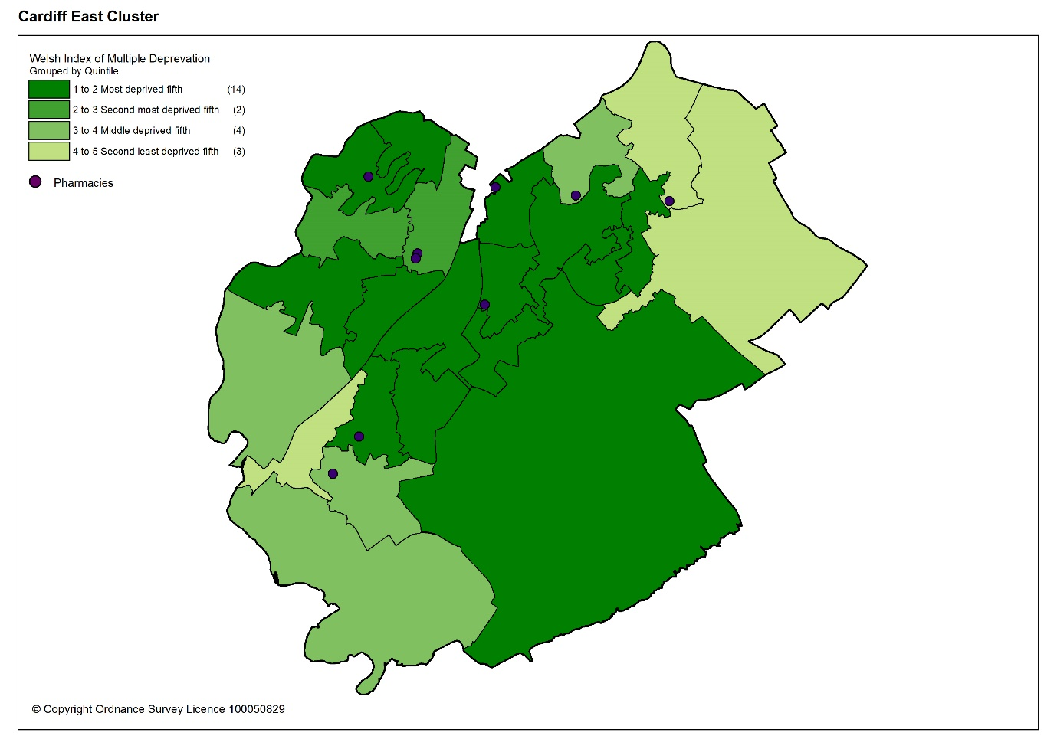

8.1.4 Health profile

Overall, the prevalence of chronic disease in Cardiff East cluster is lower than the average for Wales. When compared to Cardiff and Vale University Health Board, the estimated prevalence of chronic disease is in general higher, except for heart failure and stroke and transient ischaemic attacks. The estimated prevalence of chronic obstructive pulmonary disease (COPD) is the joint highest of all the clusters in the health board’s area, diabetes is the second highest and coronary heart disease is the third.

Table 8.3: Estimated percentage prevalence of chronic conditions based on patients on GP practice registers by cluster, local authority, health board and Wales, 2019.
 | Percentage
Area | Asthma | Coronary heart disease | COPD | Diabetes | Heart failure | Stroke and transient ischaemic attacks
Cardiff East | 6.8 | 2.9 | 2.3 | 5.6 | 0.9 | 1.6
Cardiff | 6.6 | 2.5 | 1.6 | 4.9 | 0.8 | 1.6
Cardiff and Vale UHB | 6.7 | 2.7 | 1.7 | 5.0 | 0.9 | 1.7
Wales | 7.1 | 3.6 | 2.4 | 6.1 | 1.1 | 2.1
Source: QOF 2019
Cardiff East cluster has a higher estimated prevalence of dementia than the average for Wales. It has the joint second highest prevalence of all the clusters in the health board. The estimated prevalence of mental health conditions is lower than the average for Wales and the health board.

Table 8.4: Percentage of patients registered as having a mental health condition, and dementia by cluster, local authority, health board and Wales, 2019
 | Dementia (percentage) | Mental Health (percentage)
Cardiff South East | 0.8 | 0.8
Cardiff | 0.6 | 0.9
Cardiff & Vale UHB | 0.7 | 0.9
Wales | 0.7 | 1.0
Source: QOF 2019
Cardiff East cluster has a lower estimated prevalence of atrial fibrillation than the average for Wales. Although the estimated prevalence of hypertension is lower than the average for Wales, it is higher than the average for the health board.

Table 8.5: Estimated percentage prevalence of hypertension and atrial fibrillation based on patients on GP practice registers by cluster, local authority, health board and Wales, 2019
 | Atrial Fibrillation (percentage) | Hypertension (percentage)
Cardiff East | 1.6 | 13.7
Cardiff | 1.6 | 11.8
Cardiff & Vale UHB | 1.8 | 12.6
Wales | 2.3 | 15.8
Source: QOF 2019
Many of the factors that contribute to the inequalities in health and well-being are preventable. Table 8.6 shows the percentage of adults self-reporting five behaviours, where a lower percentage for smoking and drinking above the guidelines is seen as more beneficial to health and well-being as is a higher percentage for working age adults of healthy weight, meeting the physical activity guidelines and consuming five a day.

Overall, the percentage of adults reporting behaviours which support healthy outcomes in Cardiff East cluster is lower than Cardiff and Vale University Health Board and the average for Wales, except for drinking above the guidelines.

Table 8.6: Percentage of adults (aged 16 years and over) reporting behaviours by cluster, health board and Wales, 2016 to 2018
 | Count |  |  | Prevalence
GP Cluster Name | GP cluster population aged 16+ | Smoking | Drinking the above guidelines | Working age adults of healthy weight | Meeting physical activity guidelines | Consuming 5 a day
Cardiff East | 45,353 | 23.4 | 16.9 | 37.9 | 51.5 | 21.8
Cardiff and Vale UHB | 420,119 | 19.3 | 18.9 | 40.8 | 55.1 | 24.2
Wales | 2,642,152 | 19.2 | 18.9 | 39.1 | 52.8 | 23.4
Source: Public Health Wales Observatory, using NSW (WG), WDS (NWIS) and WIMD 2014 (WG). Please note, the calculation of the healthy weight indicator only accounts for working age adults (aged 16-64)

8.1.5 Cluster developments

There is a large strategic employment development planned within Cardiff East cluster to be completed by 2026 in line with the Cardiff Local Development Plan 2006 to 2026. The area South of St Mellons Business Park has been identified as an important employment site which contributes to the necessary range and choice of types of employment opportunities in the city. Its location is particularly well placed to provide accessible job opportunities to areas of known deprivation. Key proposed developments include:

- Provision of transport hub including new rail station served by relief line rail services connecting to the city centre and services to Cardiff Airport and London via Cardiff Central
- Provision of park and ride facility
- Integration of the site with key bus links and corridors
- Provision of walking and cycling links and facilities to maximise walking and cycling access to the site from neighbouring communities including Trowbridge and St Mellons
- Retaining the area of land for green space
- Strengthen flooding mitigation and enhancement measures

As at Autumn 2020 monitoring information, no formal planning applications have been submitted to Cardiff Council.

The spring 2021 LDP monitoring document highlights that there is a live outline planning application in progress with Cardiff Council.

8.2 Current provision of pharmaceutical services within the cluster

There are 10 pharmacies in Cardiff East cluster (see table 8.7). It should be noted that one pharmacy, Hopwoods pharmacy, sits just outside of the Cardiff East cluster boundary in Cardiff North. Due to its close proximity to a branch surgery of a Cardiff East GP practice it has historically been considered as part of Cardiff East cluster.

In 2019 to 2020, 79.7% of prescription items written by the four GP practices in Cardiff East cluster were dispensed by one of the pharmacies within the cluster and 1.8% were personally administered items.

Table 8.7: Pharmacies in Cardiff East cluster
Pharmacy | Address
G S Bhogal T/A GS Bhogal Pharmacy | Rumney Primary Care Centre Barmouth Road | Rumney | CF3 3LA
Boots UK Limited | 48 Countisbury Avenue | Llanrumney | CF3 5SL
Hopwoods Ltd | 19 Maelfa Shopping Centre | Llanedeyrn | CF23 9PL
Lloyds Pharmacy Ltd T/A Lloydspharmacy | 347-349 St Mellons District Shopping Centre | St Mellons | CF3 0EF
Lloyds Pharmacy Ltd T/A Lloydspharmacy | Llanrumney Medical Centre Ball Road | Llanrumney | CF3 5NP
Well | 106 Wentloog Road | Rumney | CF3 3EA
Well | Unit 3,Trowbridge Local Centre Abergele Road | Trowbridge | CF3 1RR
Boots UK Limited T/A Your Local Boots Pharmacy | 4 Strathy Road Willowbrook Drive | St Mellons | CF3 0SH
Well | 60 Countisbury Avenue | Llanrumney | CF3 5SP
P C Bullen | St Mellons Pharmacy Seaview Stores Newport Road | St Mellons | CF3 5UA

The pharmacies are located in areas of greater population density as shown by the darker shaded areas in the map below.

Map 8.2: Location of pharmacy premises compared to population density
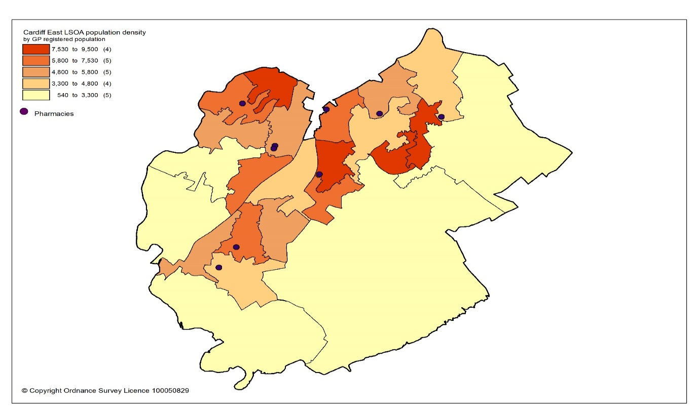
All residents of the cluster can access one of the pharmacies by car within 10 minutes. The majority can access a pharmacy within 5 minutes, as shown in the map below. However, some households do not have access to a car and may have a longer journey.
Map 8.3: Access to pharmacies in the cluster
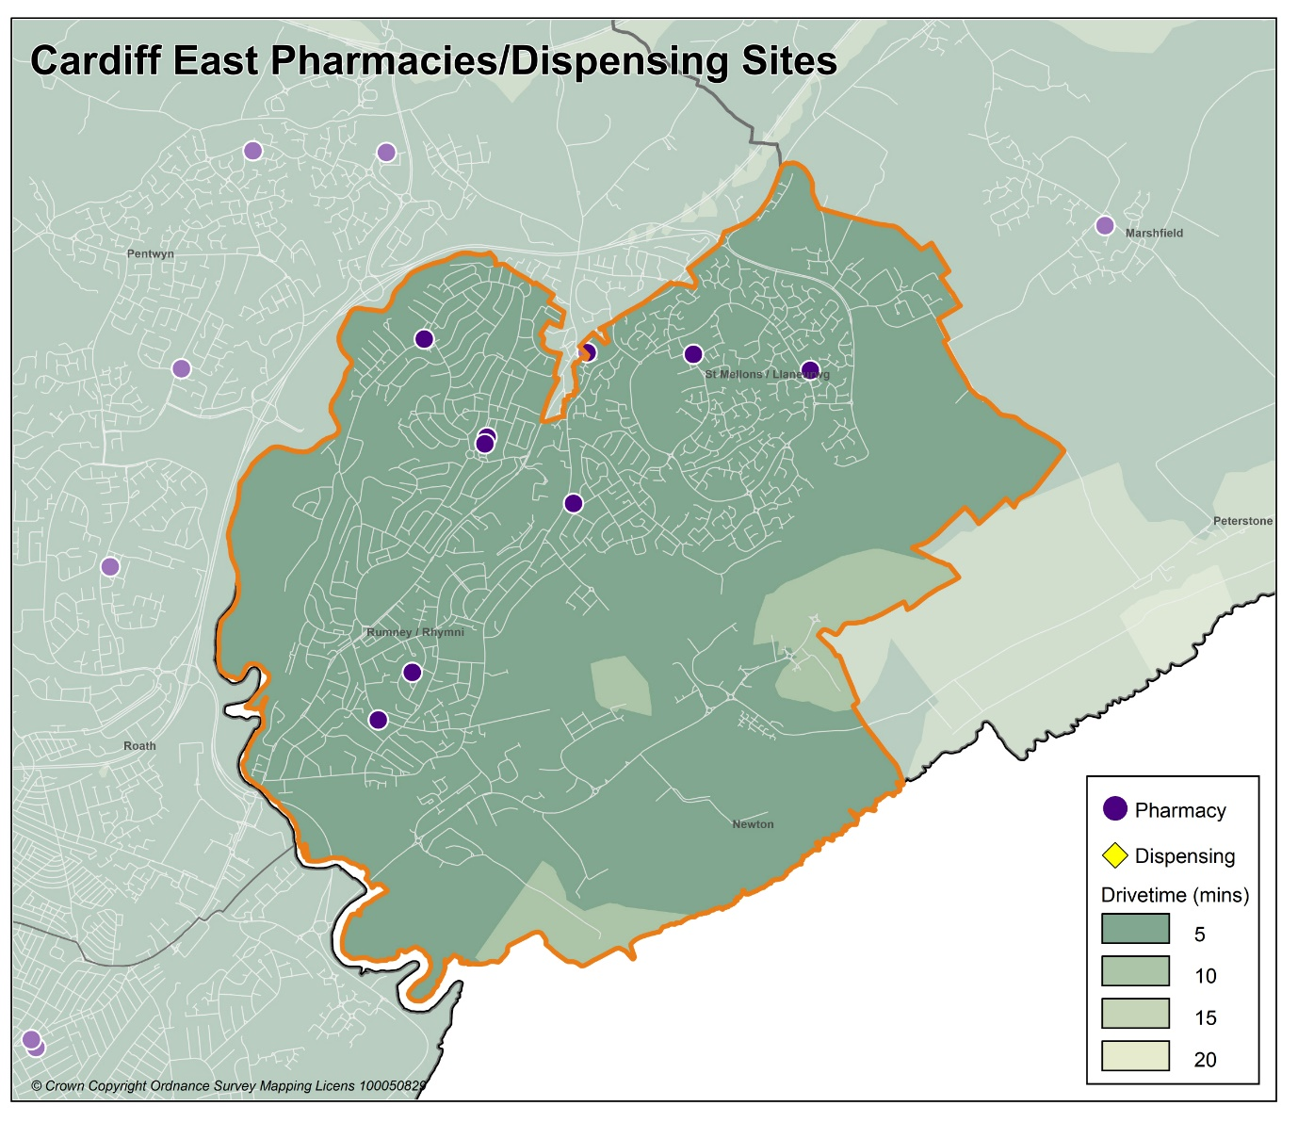

Looking at the opening hours for the pharmacies:

- One pharmacy is open seven days a week
- One pharmacy is open Monday to Saturday
- Five pharmacies are open Monday to Friday and Saturday morning
- Three pharmacies are open Monday to Friday

All pharmacies must open for their core contractual hours, which are 40 hours a week. These can only be amended with approval by the health board. All additional hours or supplementary hours can be amended by the pharmacy following the provision of 90 days’ notice to the health board. Within the cluster, opening hours and closing hours range from:

Days | Opening hours range | Closing hours range
Monday to Friday | 08.00am to 09.00am | 17.30pm to 19.00pm
Saturday | 09.00am | 13.00pm to 17.30pm
Sunday | 10.00am | 16.00pm
Full details of when the pharmacies are open can be found in Appendix L.

All 10 pharmacies responded to the contractor questionnaire, of which all 10 dispense all appliances listed in Part IX of the Drug Tariff.

In 2019 to 2020, all 10 pharmacies offered the MUR service and a total of 3,573 reviews were provided out of a possible 4,000 reviews. Two pharmacies provided the maximum number of reviews. The Welsh Government formally suspended the MUR service on 13 March 2020. At the time of writing, it is not known if the service will re-commence.

In 2019 to 2020, eight pharmacies offered the DMR service and a total of 254 reviews were provided out of a possible 1,120 reviews. One pharmacy provided the maximum number of 140 reviews. As part of the changes to the community pharmacy contractual framework for 2021, the cap of the number of paid DMRs has since been removed.

In 2019 to 2020, the following enhanced services were provided by pharmacies in the cluster area:

- Nine pharmacies provided a total of 288 emergency contraception consultations, with a range of three to 108 consultations.
- Two pharmacies provided a total of 27 smoking cessation level 3 consultations, with a range of three to 24 consultations.
- Nine pharmacies provided a total of 591 flu vaccinations, with a range of 17 to 138 vaccinations.
- 10 pharmacies provided a total of 637 CAS consultations, with a range of 12 to 162 consultations.
- Four pharmacies provided a total of 11 EMS consultations, with a range of one to seven consultations.

Other enhanced services included:
- Six pharmacies provided the Supervised Administration of Medicines Enhanced Service.
- One pharmacy provided the Needle Syringe Provision Enhanced Service.
- Two pharmacies provided the Palliative Care Enhanced Service.

8.3 Current provision of pharmaceutical services outside the cluster

Some residents choose to access contractors outside both the cluster and the health board’s area in order to access services:

- Offered by dispensing appliance contractors.
- Which are located near to where they work, shop or visit for leisure or other purposes.

Whilst the majority of prescriptions written by the cluster GP practices in 2019 to 2020 were dispensed by the pharmacies in the cluster, around 18.5% were dispensed outside the cluster, most notably:

- 5.9% by pharmacies in Cardiff North cluster
- 4.4% by pharmacies in Cardiff South East cluster
- 3.9% by pharmacies in Cardiff City & South cluster
- 0.9% by pharmacies in Cardiff West cluster
- 0.1% by pharmacies in Cardiff South West cluster
- 2.4% in Aneurin Bevan University Health Board
- 0.2% in Cwm Taf Morgannwg University Health Board
- 0.1% in Swansea Bay University Health Board
- 0.6% by contractors in England

In addition, residents may have accessed one or more pharmaceutical services provided by another pharmacy outside of both the cluster and the health board’s area; however, it is not possible to quantify this activity from the recorded data.

Taking into account pharmacies in the neighbouring clusters and pharmacies over the border in other health board areas in Wales, all residents in the cluster of Cardiff East can access a pharmacy by car within 10 minutes and the majority can access a pharmacy by car within five minutes.

8.4 Other NHS services

No other key NHS services were identified within this cluster.

8.5 Choice with regard to obtaining pharmaceutical services

As can be seen from sections 8.2 and 8.3, those living within the cluster area and registered with one of the GP practices generally choose to access one of the pharmacies in the cluster in order to have their prescriptions dispensed. Those that look outside the cluster usually do so to access a neighbouring pharmacy within the health board’s area. A minority choose to have their prescription dispensed by a pharmacy or an appliance contractor outside of the health board’s area.

A total of 388 pharmacy contractors that were trading in Wales during 2019 to 2020, dispensed items written by one of the GP practices in the Cardiff East cluster, of which 281 were outside of the health board’s area. 8,033 prescription items were dispensed in England.

8.6 Gaps in provision

The Cardiff and Vale University Health Board has noted the locations of pharmacies across the cluster, and the fact that the population can access a pharmacy by car within 10 minutes, with the majority within five minutes. However, some households do not have access to a car and may have a longer journey. Walking to a pharmacy will be a realistic option for many residents and regular public transport services are available for those who are unable to undertake the whole journey on foot.

The Cardiff and Vale University Health Board has noted the opening hours of the existing pharmacies and is of the opinion that they are sufficient to meet the likely needs of residents in the cluster. The Cardiff and Vale University Health Board has therefore concluded that there are no current needs in relation to the provision of essential services by pharmacies in the cluster.

The Cardiff and Vale University Health Board is also satisfied that there are no current needs in relation to the provision of advanced services. Whilst none of the pharmacies provide the Appliance Use Review service or the Stoma Appliance Customisation service, it is noted that there are four appliance contractors based in Cardiff and Vale University Health Board who offer these services. One of the reasons why prescriptions are dispensed outside of the cluster is because they have been sent to a dispensing appliance contractor elsewhere in the health board or to England, which provide these services. Patients will therefore be able to access these two services via those contractors. The Cardiff and Vale University Health Board has therefore not identified any current or future gap or better access in relation to the provision of these two advanced services in the cluster.

All 10 pharmacies responded to the question in the contractor questionnaire regarding capacity to meet demand from any future housing developments in the cluster. All 10 pharmacies responded that they have sufficient capacity within their existing premises and staffing levels to manage the increase in demand in the area.

The Cardiff and Vale University Health Board noted the developments planned for the cluster, with regard to the strategic employment site South of St Mellons Business Park. Furthermore, with regard to any housing that is due to be built during the lifetime of this document, Cardiff and Vale University Health Board is satisfied, based upon the responses to the contractor questionnaire, that the demand that this will create can be met by the existing pharmacies. The Cardiff and Vale University Health Board has therefore concluded that there are no future needs in relation to the provision of essential services by pharmacies in the cluster.

The Cardiff and Vale University Health Board is also satisfied that, based upon the information contained in the preceding sections, there are no current or future gaps in the provision of advanced services and enhanced services.

The Cardiff and Vale University Health Board will keep service provision under review but has concluded that there is no current or future need identified which requires an application for new or additional premises.

9 Cardiff South East cluster

9.1 Key facts

9.1.1 Population and population projections 2018 to 2028 (2018 based)

As cluster level population data is not routinely collected on an annual basis,
GP registered patient data has been used to provide an indication of cluster population, and local authority based data has been used to provide an indication of population projections.

Note that GP registered population data is higher than the corresponding census based mid-year population estimates provided by the Office of National Statistics (ONS) at the local authority and health board level, as outlined in section 2.2. This is most likely due to over registered or ‘ghost patients’ caused by many different factors.

Table 9: Number of GP registered patients by gender and broad age groups and by cluster, local authority and health board (2019)
 | Year | Gender |  | Age range
 | 2019 | Female | Male | Under 65 | 65 to 84 | 85 and over
Cardiff South East | 63416 | 30468 | 32948 | 57624 | 5029 | 763
Cardiff | 389619 | 193044 | 196575 | 335252 | 46599 | 7768
Cardiff and Vale UHB | 521177 | 260027 | 261150 | 439365 | 70412 | 11400
Source: StatsWales - NHS Wales Shared Services Partnership.

Between 2018 to 2028, the population of Cardiff is projected to increase by up to 3.2%, the sixth largest percentage increase of all the local authorities within Wales. It is expected to have a population of around 375,700 by 2028, making it the largest local authority in Wales. Unlike all other local authorities, the increase in population will mainly be driven by natural change i.e. more births than deaths and a smaller proportion of the increase will be due to net migration i.e. more people moving into the area than out. Cardiff has the highest level of projected international migration of all the local authorities. The population is expected to increase across all broad age groups, except the 0 to 15 years old where a decrease is predicted. The largest population increases will be in the over 65 age group followed by the working-age population aged 16 to 64 years. The population is projected to continue to age in the local authority.

9.1.2 Life expectancy, healthy life expectancy and the ‘inequality gap’

Life expectancy at birth in Cardiff is better than the average for Wales for both females and males. The difference in life expectancy that exists across an area between the most and least deprived areas is referred to as the ‘inequality gap’. The inequality gap in life expectancy at birth between the most and least deprived fifth, for Cardiff is wider than the average for Wales for both males and females. The healthy life expectancy (the number of years a person can expect to live in good health) in Cardiff is lower than the average for Wales for both females and males.
Table 9.1: Life expectancy, healthy life expectancy and the ‘inequality gap’ (2015 to 2017)
 | Life expectancy at birth (years) |  | Healthy life expectancy (years) |  | Inequality gap  (years)
 | Females | Males | Females | Males | Females | Males
Cardiff | 82.7 | 78.5 | 61.1 | 61.2 | 6.9 | 9.2
Cardiff and Vale UHB | 83.0 | 78.7 | 62.0 | 61.9 | 6.6 | 8.6
Wales | 82.3 | 78.3 | 62.0 | 61.4 | 6.1 | 7.4
Source: Public Health Wales Observatory PHOF Tool (2017) using ONS and WG data

9.1.3 Deprivation

Deprivation is the lack of access to opportunities and resources which might be expected in society. The Welsh Index of Multiple Deprivation (WIMD) allows for the ranking of small areas, called Lower layer Super Output Areas (LSOAs) in Wales to determine whether an area is more or less deprived compared to all other small areas in Wales.

Overall, Cardiff South East cluster has a higher percentage of LSOAs in the most deprived 10% of LSOAs in Wales for the domains of income, health, and employment relative to Cardiff. It also has a higher percentage of LSOAs in the most deprived 20% of LSOAs in Wales for the domain of health.

Table 9.2: Percentage of LSOAs within the 10% and 20% most deprived LSOAs in Wales by cluster and local authority for the domains for income, health, employment and access to services, Welsh Index of Multiple Deprivation 2014.
Percentage of LSOAs within the 10% and 20% most deprived LSOAs in Wales
 | Income |  | Health |  | Employment |  | Access to services
 | 10% | 20% | 10% | 20% | 10% | 20% | 10% | 20%
Cardiff South East | 19.4 | 30.6 | 19.4 | 30.6 | 13.9 | 19.4 | 0.0 | 0.0
Cardiff | 19.2 | 30.8 | 14.5 | 22.0 | 12.1 | 20.1 | 0.0 | 0.9
Source: Welsh Index of Multiple Deprivation 2014, Welsh Government

The map below provides an indication of the overall levels of deprivation within the cluster. As can be seen from the map, all pharmacies are located within or near areas of higher deprivation.

Map 9.1: Lower Super Output Areas (LSOAs) in Cardiff South East cluster, grouped into quintiles by Welsh index of Multiple Deprivation 2019
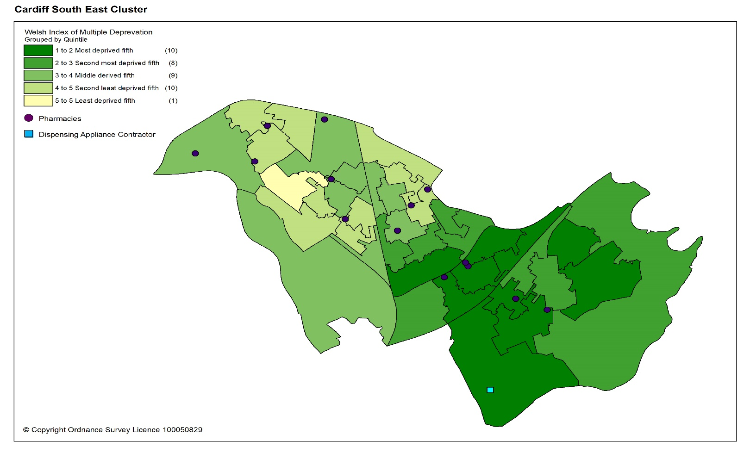

9.1.4 Health profile

Cardiff South East cluster has the lowest estimated prevalence of chronic disease of all the clusters in Cardiff and Vale University Health Board, with the exception of heart failure (second lowest) and chronic obstructive pulmonary disease (COPD). The estimated prevalence of chronic disease in the cluster is lower than the average for Wales.

Table 9.3: Estimated percentage prevalence of chronic conditions based on patients on GP practice registers by cluster, local authority, health board and Wales, 2019.
 | Percentage
Area | Asthma | Coronary heart disease | COPD | Diabetes | Heart failure | Stroke and transient ischaemic attacks
Cardiff South East | 5.2 | 1.8 | 1.5 | 4.2 | 0.6 | 1.1
Cardiff | 6.6 | 2.5 | 1.6 | 4.9 | 0.8 | 1.6
Cardiff and Vale UHB | 6.7 | 2.7 | 1.7 | 5.0 | 0.9 | 1.7
Wales | 7.1 | 3.6 | 2.4 | 6.1 | 1.1 | 2.1
Source: QOF 2019
The estimated prevalence of dementia in Cardiff South East cluster is lower than the average for Wales and the lowest of all the clusters in the health board. The estimated prevalence of mental health conditions is higher than the average for Wales and is the joint second highest of all the clusters in the health board.

Table 9.4: Percentage of patients registered as having a mental health condition, and dementia by cluster, local authority, health board and Wales, 2019
 | Dementia (percentage) | Mental Health (percentage)
Cardiff South East | 0.4 | 1.1
Cardiff | 0.6 | 0.9
Cardiff & Vale UHB | 0.7 | 0.9
Wales | 0.7 | 1.0
Source: QOF 2019
The estimated prevalence of hypertension in Cardiff South East cluster is lower than the average for Wales and the lowest of all the clusters in the health board. The estimated prevalence of atrial fibrillation is the second lowest of all the clusters in the health board.

Table 9.5: Estimated percentage prevalence of hypertension and atrial fibrillation based on patients on GP practice registers by cluster, local authority, health board and Wales, 2019
 | Atrial Fibrillation (percentage) | Hypertension (percentage)
Cardiff South East | 1.0 | 8.1
Cardiff | 1.6 | 11.8
Cardiff & Vale UHB | 1.8 | 12.6
Wales | 2.3 | 15.8
Source: QOF 2019
Many of the factors that contribute to the inequalities in health and well-being are preventable. Table 9.6 shows the percentage of adults self-reporting five behaviours; where a lower percentage for smoking and drinking above the guidelines is seen as more beneficial to health and well-being as is a higher percentage for working age adults of healthy weight, meeting the physical activity guidelines and consuming five a day.

Overall, the percentage of adults reporting behaviours which support healthy outcomes in Cardiff South East cluster is higher than Cardiff and Vale University Health Board and the average for Wales, except for smoking and eating the recommended five portions of fruit and vegetables a day.

Table 9.6: Percentage of adults (aged 16 years and over) reporting behaviours by cluster, health board and Wales, 2016 to 2018
 | Count |  |  |  |  |  | Prevalence
GP Cluster Name | GP cluster population aged 16+ | Smoking |  | Drinking the above guidelines |  | Working age adults of healthy weight |  | Meeting physical activity guidelines |  | Consuming 5 a day
Cardiff South East | 54,093 | 23.5 |  | 17.5 |  | 41.9 |  | 55.3 |  | 21.9
Cardiff and Vale UHB | 420,119 | 19.3 |  | 18.9 |  | 40.8 |  | 55.1 |  | 24.2
Wales | 2,642,152 | 19.2 |  | 18.9 |  | 39.1 |  | 52.8 |  | 23.4
Source: Public Health Wales Observatory, using NSW (WG), WDS (NWIS) and WIMD 2014 (WG). Please note, the calculation of the healthy weight indicator only accounts for working age adults (aged 16-64)

9.2 Current provision of pharmaceutical services within the cluster

There are 16 pharmacies in Cardiff South East cluster. There is also one appliance contractor.

Table 9.7: Pharmacies in Cardiff South East cluster
Pharmacy | Address
Alkamoosi Ltd T/A Crwys Pharmacy | 128 Crwys Road | Cathays | CF24 4NR
Boots UK Limited | 77-79 Albany Road | Roath | CF24 3LN
Clifton Pharmacy Ltd T/A City Pharmacy | Cardiff Royal Infirmary, Newport Road | Roath | CF24 0SZ
Clifton Pharmacy Ltd | 7-8 Clifton Street | Roath | CF24 1PW
WJ Powell Limited T/A WJ Powell Chemists | 49 Gabalfa Avenue | Gabalfa | CF14 2SH
Tesco Stores Limited | Tesco Instore Pharmacy | Western Avenue | CF14 3AT
Well | 1,2 & 3 Upper Clifton Street | Roath | CF24 1PU
Well | 219 - 221 City Road | Roath | CF24 3JF
Well | 180 City Road | Roath | CF24 3JF
North Road Pharmacy Ltd | 144 North Road | Gabalfa | CF14 3BH
Pearn's Pharmacies Ltd | 21 South Park Road | Tremorfa | CF24 2QZ
Rhys Williams T/A Woodville Road Pharmacy | 74 Woodville Road | Cathays | CF24 4EB
MW Phillips Chemists | 52 Splott Road | Splott | CF24 2DA
MW Phillips Chemists | 71 Whitchurch Road | Gabalfa | CF14 3JP
MW Phillips Chemists | 7 South Park Road | Splott | CF24 2LU
Superdrug Ltd | 81-83 Albany Road | Roath | CF24 3LN

In 2019 to 2020, 75.0% of items on prescriptions written by the eight GP practices in Cardiff South East cluster were dispensed by one of the pharmacies within the cluster and 1.7% were personally administered items.

The pharmacies, in general, are located in or near areas of greater population density as shown by the darker shaded areas in the map below.

Map 9.2: Location of pharmacy and appliance contractor premises compared to population density
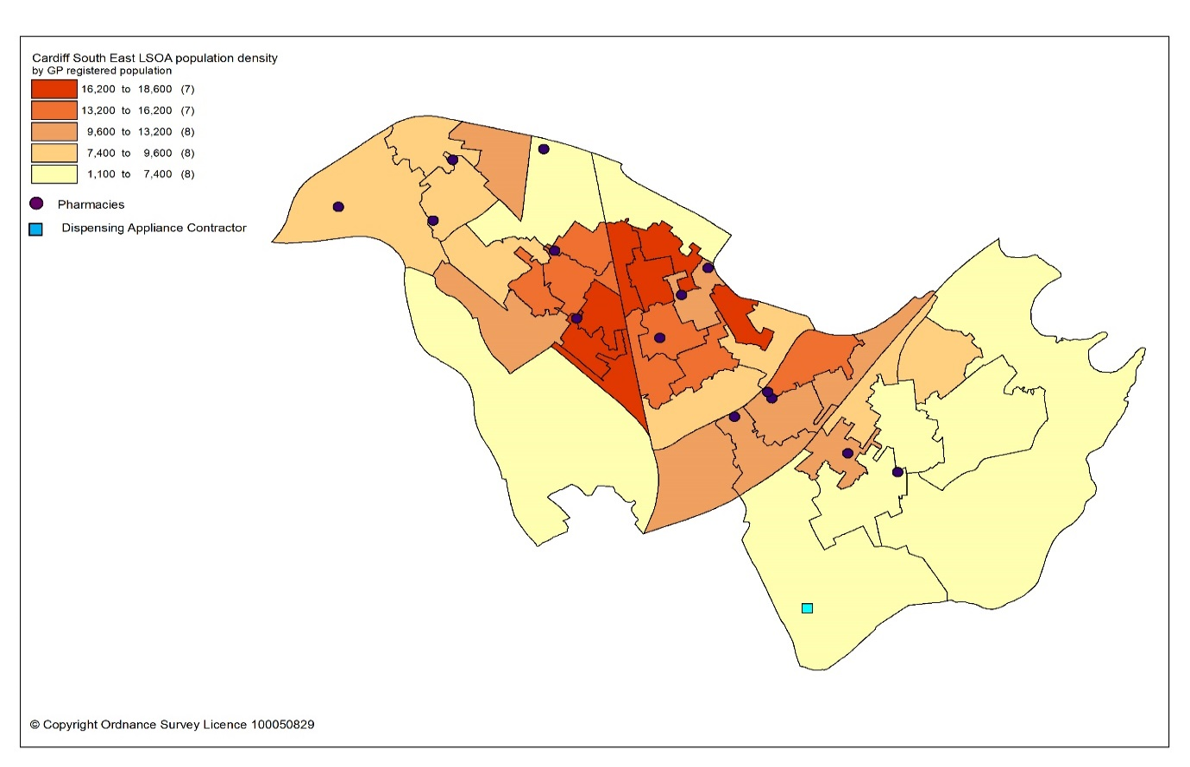

All residents of the cluster can access one of the pharmacies by car within 10 minutes. The majority can access a pharmacy within five minutes, as shown in the map below.

Map 9.3: Access to pharmacies and appliance contractor in the cluster
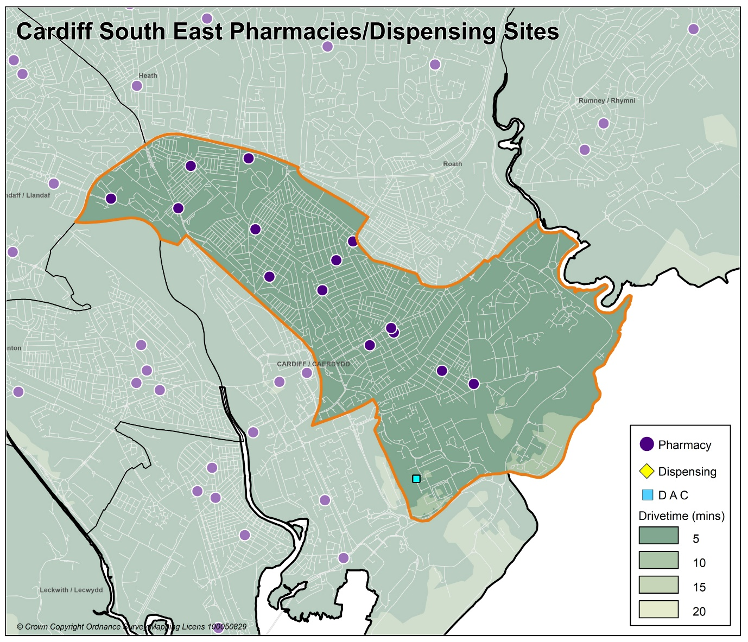
Looking at the opening hours for the pharmacies:

- Two pharmacies are open seven days a week
- Three pharmacies are open Monday to Saturday
- Five pharmacies are open Monday to Friday and Saturday morning
- Six pharmacies are open Monday to Friday

All pharmacies must open for their core contractual hours, which are 40 hours a week. These can only be amended with approval by the health board. All additional hours or supplementary hours can be amended by the pharmacy following the provision of 90 days’ notice to the health board. Within the cluster, opening hours and closing hours range from:

Days | Opening hours range | Closing hours range
Monday to Friday | 08.00am to 09.00am | 17.30pm to 21.00pm*
Saturday | 08.00am to 09.30am | 11.30pm to 22.00pm
Sunday | 10.00am to 10.30am | 16.00pm to 16.30pm

*Three pharmacies close earlier at 17.00 on Wednesday
Full details of when the pharmacies are open can be found in Appendix L.

All 16 pharmacies responded to the contractor questionnaire, of which 12 pharmacies dispense all appliances listed in Part IX of the Drug Tariff and three just dispense dressings. One pharmacy does not dispense any appliances.

In 2019 to 2020, all 16 pharmacies offered the MUR service and a total of 4,246 reviews were provided out of a possible 6,400 reviews. Four pharmacies provided the maximum number of 400 reviews. The Welsh Government formally suspended the MUR service on 13 March 2020. At the time of writing, it is not known if the service will re-commence.

In 2019 to 2020, 14 pharmacies offered the DMR service and a total of 417 reviews were provided out of a possible 1,960 reviews. Two pharmacies provided the maximum number of 140 reviews. As part of the changes to the community pharmacy contractual framework for 2021, the cap of the number of paid DMRs has since been removed.

In 2019 to 2020, the following enhanced services were provided by pharmacies in the cluster area:

- Nine pharmacies provided a total of 1366 emergency contraception consultations, with a range of 18 to 662 consultations.
- Six pharmacies provided a total of 89 smoking cessation level 3 consultations, with a range of four to 29 consultations.
- 11 pharmacies provided a total of 961 flu vaccinations, with a range of one to 299 vaccinations.
- 15 pharmacies provided a total of 961 CAS consultations, with a range of five to 177 consultations.
- Five pharmacies provided a total of 200 EMS consultations, with a range of one to 144 consultations.

Other enhanced services included:
- Eight pharmacies provided the Supervised Administration of Medicines Enhanced Service.
- Three pharmacies provided the Needle Syringe Provision Enhanced Service.
- Three pharmacies provided the Palliative Care Enhanced Service.

9.3 Current provision of pharmaceutical services outside the cluster

Some residents choose to access contractors outside both the locality and the health board’s area in order to access services:

- Offered by dispensing appliance contractors.
- Which are located near to where they work, shop or visit for leisure or other purposes.

Whilst the majority of prescriptions written by the GP practices in 2019 to 2020 were dispensed by the pharmacies in the cluster, around 23.2% were dispensed outside the cluster, most notably:

- 8.5% by pharmacies in Cardiff North cluster
- 4.6% by pharmacies in Cardiff East cluster
- 7.3% by pharmacies in Cardiff City & South cluster
- 1.0% by pharmacies in Cardiff West cluster
- 0.2% by pharmacies in Cardiff South West cluster
- 0.8% in Aneurin Bevan University Health Board
- 0.1% in Cwm Taf Morgannwg University Health Board
- 0.6% by contractors in England

In addition, residents may have accessed one or more pharmaceutical services provided by another pharmacy outside of both the cluster and the health board’s area; however, it is not possible to quantify this activity from the recorded data.

Taking into account pharmacies in the neighbouring clusters and pharmacies over the border in other health board areas in Wales, all residents in the cluster of Cardiff South East can access a pharmacy by car within 10 minutes and the majority can access a pharmacy by car within five minutes.

9.4 Other NHS services

Cardiff Royal Infirmary is located within the cluster of Cardiff South East. However, the hospital serves a much wider population than that of the cluster.

9.5 Choice with regard to obtaining pharmaceutical services

As can be seen from sections 9.2 and 9.3, those living within the cluster area and registered with one of the GP practices generally choose to access one of the pharmacies in the cluster in order to have their prescriptions dispensed. Those that look outside the cluster usually do so to access a neighbouring pharmacy within the health board’s area. A minority choose to have their prescription dispensed by a pharmacy or an appliance contractor outside of the health board’s area.

A total of 372 pharmacy contractors that were trading in Wales during 2019 to 2020, dispensed items written by one of the GP practices in the Cardiff South East cluster, of which 267 were outside of the health board’s area. 6,521 prescription items were dispensed in England.

9.6 Gaps in provision

The Cardiff and Vale University Health Board has noted the locations of pharmacies across the cluster, and the fact that the population can access a pharmacy by car within 10 minutes, with the majority within five minutes. Whilst noting that not all households have access to a car throughout the day, the nature of the cluster means that walking to a pharmacy will be a realistic option for many residents and regular public transport services are available for those who are unable to undertake the whole journey on foot.

The Cardiff and Vale University Health Board has noted the opening hours of the existing pharmacies and is of the opinion that they are sufficient to meet the likely needs of residents in the cluster. The Cardiff and Vale University Health Board has therefore concluded that there are no current needs in relation to the provision of essential services by pharmacies in the cluster.

The Cardiff and Vale University Health Board is also satisfied that there are no current needs in relation to the provision of advanced services. Whilst none of the pharmacies provide the Appliance Use Review service or the Stoma Appliance Customisation service, it is noted that there are four appliance contractors based in Cardiff and Vale University Health Board, one which is based within the cluster, who offer these services. One of the reasons why prescriptions are dispensed outside of the cluster is because they have been sent to a dispensing appliance contractor elsewhere in the health board or to England, which provide these services. Patients will therefore be able to access these two services via those contractors. The Cardiff and Vale University Health Board has therefore not identified any current or future gap or better access in relation to the provision of these two advanced services in the cluster.

All 16 pharmacies responded to the question in the contractor questionnaire regarding capacity to meet demand from any future housing developments in the locality. Their responses were as follows:

- 15 pharmacies have sufficient capacity within their existing premises and staffing levels to manage the increase in demand in the area.
- One pharmacy does not have sufficient premises and staffing capacity at present but could make adjustments to manage the increase in demand in the area.

The Cardiff and Vale University Health Board noted that there were no large housing developments due to be built during the lifetime of this document within the cluster. With regard to any small units of housing that are due to be built during the lifetime of this document, Cardiff and Vale University Health Board is satisfied, based upon the responses to the contractor questionnaire, that the demand that this will create can be met by the existing pharmacies. The Cardiff and Vale University Health Board has therefore concluded that there are no future needs in relation to the provision of essential services by pharmacies in the cluster.

The Cardiff and Vale University Health Board is also satisfied that, based upon the information contained in the preceding sections, there are no current or future gaps in the provision of advanced services and enhanced services.

The Cardiff and Vale University Health Board will keep service provision under review but has concluded that there is no current or future need identified which requires an application for new or additional premises.

10 Cardiff City and South cluster

10.1 Key facts

10.1.1 Population and population projections 2018 to 2028 (2018 based)
As cluster level population data is not routinely collected on an annual basis,
GP registered patient data has been used to provide an indication of cluster population, and local authority based data has been used to provide an indication of population projections.

Note that GP registered population data is higher than the corresponding census based mid-year population estimates provided by the Office of National Statistics (ONS) at the local authority and health board level, as outlined in section 2.2. This is most likely due to over registered or ‘ghost patients’ caused by many different factors.

Table 10: Number of GP registered patients by gender and broad age groups and by cluster, local authority and health board (2019)
 | Year | Gender |  | Age range
 | 2019 | Female | Male | Under 65 | 65 to 84 | 85 and over
Cardiff City & South | 41246 | 18885 | 22361 | 37589 | 3147 | 510
Cardiff | 389619 | 193044 | 196575 | 335252 | 46599 | 7768
Cardiff and Vale UHB | 521177 | 260027 | 261150 | 439365 | 70412 | 11400
Source: StatsWales - NHS Wales Shared Services Partnership.
Between 2018 to 2028, the population of Cardiff is projected to increase by up to 3.2%, the sixth largest percentage increase of all the local authorities within Wales. It is expected to have a population of around 375,700 by 2028, making it the largest local authority in Wales. Unlike all other local authorities, the increase in population will mainly be driven by natural change i.e. more births than deaths and a smaller proportion of the increase will be due to net migration i.e. more people moving into the area than out. Cardiff has the highest level of projected international migration of all the local authorities. The population is expected to increase across all broad age groups, except the 0 to 15 years old where a decrease is predicted. The largest population increases will be in the over 65 age group followed by the working-age population aged 16 to 64 years. The population is projected to continue to age in the local authority.

10.1.2. Life expectancy, healthy life expectancy and the ‘inequality gap’

Life expectancy at birth in Cardiff is better than the average for Wales for both females and males. The difference in life expectancy that exists across an area between the most and least deprived areas is referred to as the ‘inequality gap’. The inequality gap in life expectancy at birth between the most and least deprived fifth, for Cardiff is wider than the average for Wales for both males and females. The healthy life expectancy (the number of years a person can expect to live in good health) in Cardiff is lower than the average for Wales for both females and males.
Table 10.1: Life expectancy, healthy life expectancy and the ‘inequality gap’ (2015 to 2017)
 | Life expectancy at birth (years) |  | Healthy life expectancy (years) |  | Inequality gap  (years)
 | Females | Males | Females | Males | Females | Males
Cardiff | 82.7 | 78.5 | 61.1 | 61.2 | 6.9 | 9.2
Cardiff and Vale UHB | 83.0 | 78.7 | 62.0 | 61.9 | 6.6 | 8.6
Wales | 82.3 | 78.3 | 62.0 | 61.4 | 6.1 | 7.4
Source: Public Health Wales Observatory PHOF Tool (2017) using ONS and WG data

10.1.3. Deprivation

Deprivation is the lack of access to opportunities and resources which might be expected in society. The Welsh Index of Multiple Deprivation (WIMD) allows for the ranking of small areas, called Lower layer Super Output Areas (LSOAs) in Wales to determine whether an area is more or less deprived compared to all other small areas in Wales.

Overall, Cardiff City and South cluster has a lower percentage of LSOAs in the most deprived 10% and 20% of LSOAs in Wales relative to Cardiff, except for the income domain in the most deprived 20% LSOAs, which is higher.

Table 10.2: Percentage of LSOAs within the 10% and 20% most deprived LSOAs in Wales by cluster and local authority for the domains of income, health, employment and access to services, Welsh Index of Multiple Deprivation 2014.
Percentage of LSOAs within the 10% and 20% most deprived LSOAs in Wales
 | Income |  | Health |  | Employment |  | Access to services
 | 10% | 20% | 10% | 20% | 10% | 20% | 10% | 20%
Cardiff City & South | 13.0 | 43.5 | 13.0 | 17.4 | 4.3 | 8.7 | 0.0 | 0.0
Cardiff | 19.2 | 30.8 | 14.5 | 22.0 | 12.1 | 20.1 | 0.0 | 0.9
Source: Welsh Index of Multiple Deprivation 2014, Welsh Government

The map below provides an indication of the overall levels of deprivation within the cluster. As can be seen from the map, the majority of pharmacies are located within or near areas of higher deprivation.

Map 10.1: Lower Super Output Areas (LSOAs) in Cardiff City and South cluster, grouped into quintiles by Welsh index of Multiple Deprivation 2019
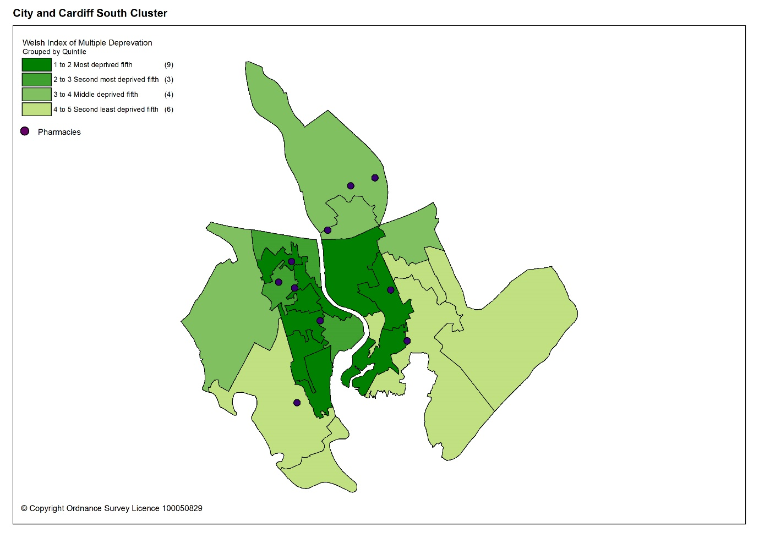

Cardiff City and South cluster has one of the lowest estimated prevalence of chronic disease of all the clusters in Cardiff and Vale University Health Board and is lower than the average for Wales. It has the joint lowest estimated prevalence for chronic obstructive pulmonary disease (COPD) and stroke and transient ischaemic attacks, and the lowest for heart failure. It has the second lowest prevalence for coronary heart disease. However, it has the third highest estimated prevalence of diabetes of all the clusters in the health board, although this is lower than the average for Wales.

Table 10.3: Estimated percentage prevalence of chronic conditions based on patients on GP practice registers by cluster, local authority, health board and Wales, 2019.
 | Percentage
Area | Asthma | Coronary heart disease | COPD | Diabetes | Heart failure | Stroke and transient ischaemic attacks
Cardiff City and South | 5.6 | 1.9 | 1.2 | 5.5 | 0.5 | 1.1
Cardiff | 6.6 | 2.5 | 1.6 | 4.9 | 0.8 | 1.6
Cardiff and Vale UHB | 6.7 | 2.7 | 1.7 | 5.0 | 0.9 | 1.7
Wales | 7.1 | 3.6 | 2.4 | 6.1 | 1.1 | 2.1
Source: QOF 2019
The estimated prevalence of dementia in Cardiff City and South cluster is lower than the average for Wales and the health board. The estimated prevalence of mental health conditions is higher than the average for Wales and is the highest of all the clusters in the health board.

Table 10.4: Percentage of patients registered as having a mental health condition, and dementia by cluster, local authority, health board and Wales, 2019
 | Dementia (percentage) | Mental Health (percentage)
Cardiff City & South | 0.6 | 1.2
Cardiff | 0.6 | 0.9
Cardiff & Vale UHB | 0.7 | 0.9
Wales | 0.7 | 1.0
Source: QOF 2019
The estimated prevalence of atrial fibrillation in Cardiff City and South cluster is the lowest in the health board and is lower than the average for Wales. The estimated prevalence of hypertension in Cardiff City and South cluster is lower than the average for Wales and is the second lowest of all the clusters in the health board.

Table 10.5: Estimated percentage prevalence of hypertension and atrial fibrillation based on patients on GP practice registers by cluster, local authority, health board and Wales, 2019
 | Atrial Fibrillation (percentage) | Hypertension (percentage)
Cardiff City & South | 0.8 | 9.3
Cardiff | 1.6 | 11.8
Cardiff & Vale UHB | 1.8 | 12.6
Wales | 2.3 | 15.8
Source: QOF 2019
Many of the factors that contribute to the inequalities in health and well-being are preventable. Table 10.6 shows the percentage of adults self-reporting five behaviours; where a lower percentage for smoking and drinking above the guidelines is seen as more beneficial to health and well-being as is a higher percentage for working age adults of healthy weight, meeting the physical activity guidelines and consuming five a day.

Overall, the percentage of adults reporting behaviours which support healthy outcomes in Cardiff City and South cluster is lower than Cardiff and Vale University Health Board and the average for Wales, except for drinking above the guidelines. For meeting the physical activity guidelines, Cardiff City and South cluster if higher that the average for Wales but lower than the health board.

Table 10.6: Percentage of adults (aged 16 years and over) reporting behaviours by cluster, health board and Wales, 2016 to 2018
 | Count |  |  |  |  |  | Prevalence
GP Cluster Name | GP cluster population aged 16+ | Smoking |  | Drinking the above guidelines |  | Working age adults of healthy weight |  | Meeting physical activity guidelines |  | Consuming 5 a day
Cardiff City & South | 32,510 | 26.1 |  | 16.8 |  | 37.2 |  | 53.0 |  | 21.5
Cardiff and Vale UHB | 420,119 | 19.3 |  | 18.9 |  | 40.8 |  | 55.1 |  | 24.2
Wales | 2,642,152 | 19.2 |  | 18.9 |  | 39.1 |  | 52.8 |  | 23.4
Source: Public Health Wales Observatory, using NSW (WG), WDS (NWIS) and WIMD 2014 (WG). Please note, the calculation of the healthy weight indicator only accounts for working age adults (aged 16-64)

10.1.5 Cluster developments

There are two major developments planned within this Cardiff City & South cluster to be completed by 2026 in line with the Cardiff Local Development Plan 2006 to 2026. These are:

The Cardiff Central Enterprise Zone

This site is a major employment-led initiative including a Regional Transport Hub together with other mixed uses and approximately 2,150 homes. The development will provide major employment focused on financial and business services and maximise the advantages of its central location.

- Central, public transport hub providing access to and interchange between rail network, the rapid transit and strategic bus corridors, the city-wide bus network and the strategic cycle network.
- Improving existing bus routes and services.
- Enhance pedestrian and cycle.
- Provide a central cycle parking hub with associated facilities.
- Provide secure cycle parking and associated facilities in locations which encourage cycling to the city centre and integration with public transport services.
- Create continuous river walk on Taff East bank.
- One new Primary School and contribution to existing Secondary Schools
- Open Space including formal recreation, playground, teen facility, allotment site.

As at the 1st April 2019, there were 102 completions on this site.
The spring 2021 LDP monitoring document highlights that the developments at Central Square and Capital Quarter are well progressed, with several areas being completed over the last few years, including 102 apartments at Trade Street.
Construction has started on the transport interchange at Central Square and offices at Brewhouse, Central Quay. Plot J apartments are now under construction in the Capital Quarter and on the site of the former Browning Jones and Morris.
The sites nominated for planned hotels and other buildings at John Street, Custom House Street and Westgate Street are also under construction.

The Former Gas Works, Ferry Road
This site is a major housing based scheme of 500 homes and other associated community uses, with supporting infrastructure:

- Improving pedestrian access to public transport facilities in the vicinity of the site.
- Providing new and enhancing existing pedestrian/cycle links from the site to the Ely Trail, Grangemoor Park, Cardiff Bay Retail Park, and other community facilities within the area including Channel View Centre.
- Contribution to off-site community facility provision.
- Contribution to existing Primary and Secondary Schools.
- Open Space including one playground, one teen facility, plus contributions to formal open space, allotment provision and play provision.

As at autumn 2020 monitoring information stated no formal planning applications had been submitted to Cardiff Council.

The spring 2021 LDP monitoring document has not identified any formal planning applications received by the Cardiff Council. It does outline that a “temporary ‘meanwhile use’ is currently being constructed, which will see the provision of 48 high quality sustainable modular homes to help tackle housing need. The development consists of a mix of 1, 2 and 3 bedroom flats and will provide temporary homes for families while more permanent housing solutions are found.”

10.2 Current provision of pharmaceutical services within the cluster

There are 10 pharmacies in Cardiff City & South cluster.

Table 10.7: Pharmacies in Cardiff City & South cluster
Pharmacy | Address
National Co-Operative Chemists Ltd T/A The Co-operative Pharmacy | 213 Bute Street | Butetown | CF10 5HR
Boots UK Limited | Unit 17 The Capitol Centre | Queen Street | CF10 2HQ
Boots UK Limited | 36 Queen Street | Cardiff | CF10 2RG
Boots UK Limited | Units1 & 2 Broadcasting House, Central Square | Cardiff | CF10 1FS
Boots UK Limited | Unit D | Cardiff Bay Retail Park | CF11 0JR
Lloyds Pharmacy Ltd T/A Lloydspharmacy | Grange Medical Centre Bishop Street | Grangetown | CF11 6PG
Well | 100 Holmesdale Street | Grangetown | CF11 7BW
National Co-Operative Chemists Ltd T/A The Co-operative Pharmacy | 178 Clare Road | Grangetown | CF11 6YG
National Co-Operative Chemists Ltd T/A The Co-operative Pharmacy | Unit 2B Bute Place Quayside | Cardiff Bay | CF10 5AB
B S Virdee T/A The Pharmacy | 54 Clare Road | Grangetown | CF11 6RT

In 2019 to 2020, 87.5% of items on prescriptions written by the seven GP practices in Cardiff City and South cluster were dispensed by one of the pharmacies within the cluster and 1.4% were personally administered items.

The majority of pharmacies are located in or near areas of greater population density as shown by the darker shaded areas in the map below.

Map 10.2: Location of pharmacy premises compared to population density
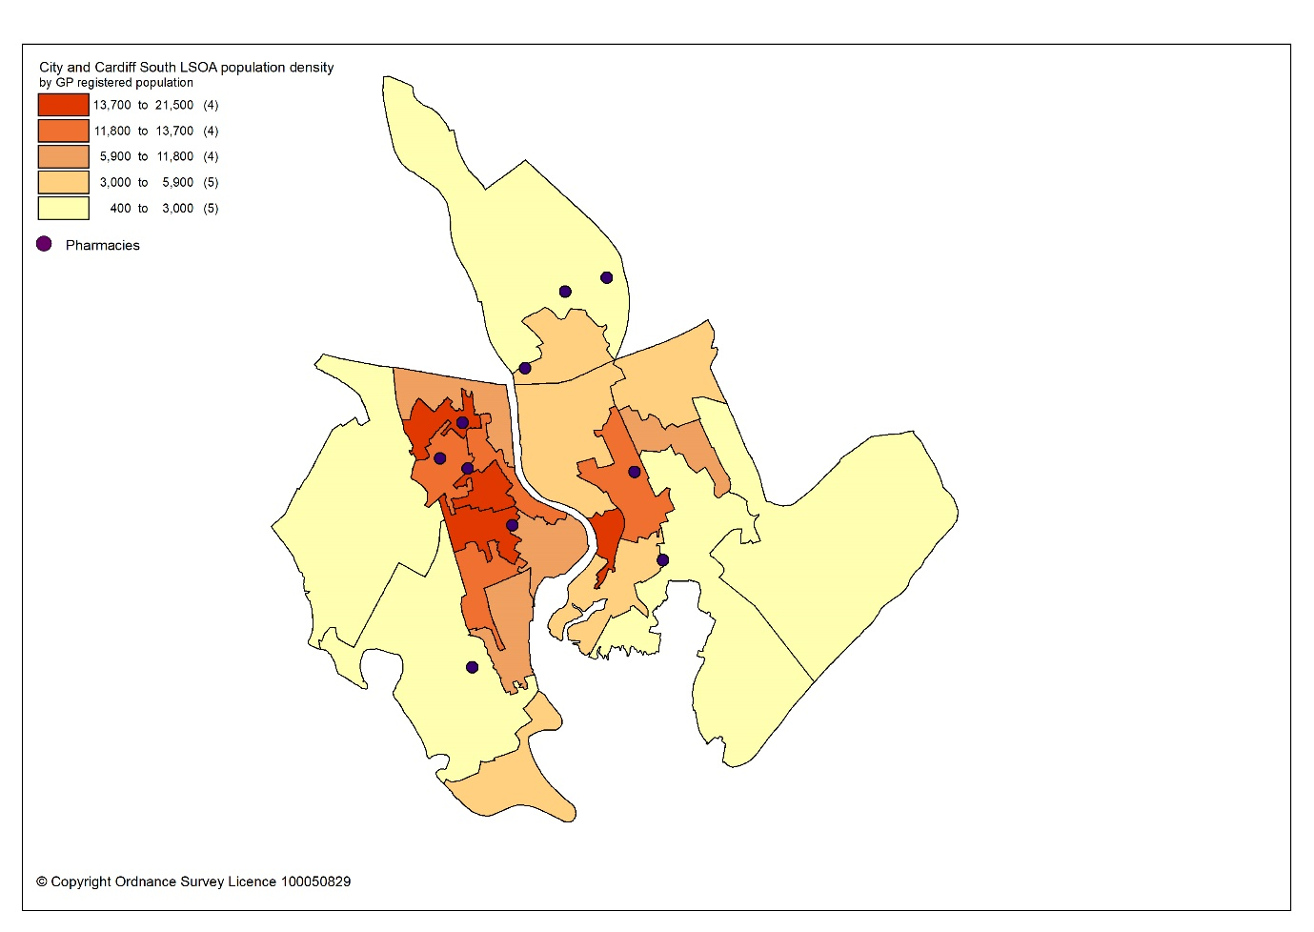
All residents of the cluster can access one of the pharmacies by car within 10 minutes. The majority can access a pharmacy within five minutes, as shown in map 10.3.

Map 10.3: Access to pharmacies in cluster
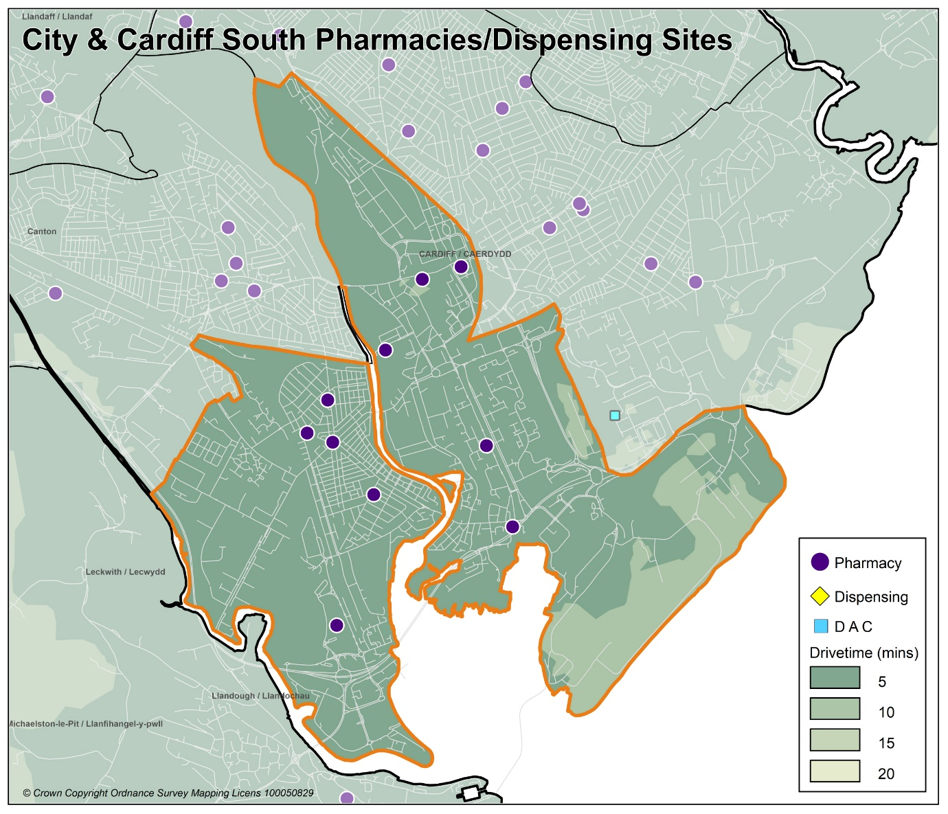

Looking at the opening hours for the pharmacies:

- Three pharmacies are open seven days a week
- One pharmacy is open Monday to Saturday
- One pharmacy is open Monday to Friday and Saturday morning
- Five pharmacies are open Monday to Friday

All pharmacies must open for their core contractual hours, which are 40 hours a week. These can only be amended with approval by the health board. All additional hours or supplementary hours can be amended by the pharmacy following the provision of 90 days’ notice to the health board. Within the cluster, opening hours and closing hours range from:

Days | Opening hours range | Closing hours range
Monday to Friday | 07.00am to 09.00am | 17.30pm to 22.30pm
Saturday | 08.00am to 09.00am | 13.00pm to 22.30pm
Sunday | 10.00am to 11.00am | 16.00pm to 21.00pm

Full details of when the pharmacies are open can be found in Appendix L.

All 10 pharmacies responded to the contractor questionnaire, of which six dispense all appliances listed in Part IX of the Drug Tariff, one pharmacy dispenses everything excluding stoma and incontinence appliances and three just dispenses dressings.

In 2019 to 2020, all 10 pharmacies offered the MUR service and a total of 2,629 reviews were provided out of a possible 4,000 reviews. Two pharmacies provided the maximum number of 400 reviews. The Welsh Government formally suspended the MUR service on 13 March 2020. At the time of writing, it is not known if the service will re-commence.

In 2019 to 2020, all 10 pharmacies offered the DMR service and a total of 278 reviews were provided out of a possible 1,400 reviews. No pharmacies provided the maximum number of 140 reviews. As part of the changes to the Community Pharmacy Contractual Framework for 2021, the cap for the number of paid DMRs has been removed.

In 2019 to 2020, the following enhanced services were provided by pharmacies in the cluster area:

- 10 pharmacies provided a total of 4223 emergency contraception consultations, with a range of seven to 2599 consultations.
- One pharmacy provided a total of 8 smoking cessation level 3 consultations.
- Nine pharmacies provided a total of 1480 flu vaccinations, with a range of one to 386 vaccinations.
- 10 pharmacies provided a total of 772 CAS consultations, with a range of four to 184 consultations.
- Three pharmacies provided a total of 67 EMS consultations, with a range of five to 56 consultations.

Other enhanced services included:
- Five pharmacies provided the Supervised Administration of Medicines Enhanced Service.
- Two pharmacies provided the Needle Syringe Provision Enhanced Service.
- Four pharmacies provided the Palliative Care Enhanced Service.

10.3 Current provision of pharmaceutical services outside the cluster

Some residents choose to access contractors outside both the cluster and the health board’s area in order to access services:

- Offered by dispensing appliance contractors.
- Which are located near to where they work, shop or visit for leisure or other purposes.

Whilst the majority of prescriptions written by the cluster GP practices in 2019 to 2020 were dispensed by the pharmacies in the cluster, around 11.1% were dispensed outside the cluster, most notably:

- 3.7% by pharmacies in Cardiff North cluster
- 1.7% by pharmacies in Cardiff South East cluster
- 0.8% by pharmacies in Cardiff West cluster
- 0.2% by pharmacies in Cardiff East cluster
- 2.7% by pharmacies in Cardiff South West cluster
- 0.8% by pharmacies in Eastern Vale cluster
- 0.1% by pharmacies in Central Vale cluster
- 0.1% in Aneurin Bevan University Health Board
- 0.8% by contractors in England

In addition, residents may have accessed one or more pharmaceutical services provided by another pharmacy outside of both the cluster and the health board’s area; however, it is not possible to quantify this activity from the recorded data.

Taking into account pharmacies in the neighbouring clusters and pharmacies over the border in other health board areas in Wales, all residents in the cluster of Cardiff City and South can access a pharmacy by car within 10 minutes and the majority can access a pharmacy by car within five minutes.

10.4 Other NHS services

No key other NHS services are located within this cluster.

10.5 Choice with regard to obtaining pharmaceutical services

As can be seen from sections 10.2 and 10.3, those living within the cluster area and registered with one of the GP practices generally choose to access one of the pharmacies in the cluster in order to have their prescriptions dispensed. Those that look outside the cluster usually do so to access a neighbouring pharmacy within the health board’s area. A minority choose to have their prescription dispensed by a pharmacy or an appliance contractor outside of the health board’s area.

A total of 254 pharmacy contractors that were trading in Wales during 2019 to 2020 dispensed items written by one of the GP practices in the Cardiff City and South cluster, of which 148 were outside of the health board’s area. 6,241 prescription items were dispensed in England.

10.6 Gaps in provision

The Cardiff and Vale University Health Board has noted the locations of pharmacies across the cluster, and the fact that the population can access a pharmacy by car within 10 minutes, with the majority within five minutes. Whilst noting that not all households have access to a car throughout the day, the nature of the cluster means that walking to a pharmacy will be a realistic option for many residents and regular public transport services are available for those who are unable to undertake the whole journey on foot.

The Cardiff and Vale University Health Board has noted the opening hours of the existing pharmacies and is of the opinion that they are sufficient to meet the likely needs of residents in the cluster. The Cardiff and Vale University Health Board has therefore concluded that there are no current needs in relation to the provision of essential services by pharmacies in the cluster.

The Cardiff and Vale University Health Board is also satisfied that there are no current needs in relation to the provision of advanced services. Whilst none of the pharmacies provide the Appliance Use Review service or the Stoma Appliance Customisation service, it is noted that there are four appliance contractors based in Cardiff and Vale University Health Board who offer these services. One of the reasons why prescriptions are dispensed outside of the cluster is because they have been sent to a dispensing appliance contractor elsewhere in the health board or to England, which provide these services. Patients will therefore be able to access these two services via those contractors. The Cardiff and Vale University Health Board has therefore not identified any current or future gap or better access in relation to the provision of these two advanced services in the cluster.

All 10 pharmacies responded to the question in the contractor questionnaire regarding capacity to meet demand from any future housing developments in the cluster. Their responses were as follows:

- Nine pharmacies have sufficient capacity within their existing premises and staffing levels to manage the increase in demand in the area.
- One pharmacy does not have sufficient premises and staffing capacity at present but could make adjustments to manage the increase in demand in the area.

The Cardiff and Vale University Health Board noted the employment led and large housing development planned for Cardiff Central Zone and the housing development at the former gas works Ferry Road and other smaller units of housing that are due to be built during the lifetime of this document. Cardiff and Vale University Health Board is satisfied, based upon the responses to the contractor questionnaire, that the demand that this will create can be met by the existing pharmacies. The Cardiff and Vale University Health Board has therefore concluded that there are no future needs in relation to the provision of essential services by pharmacies in the cluster.

The Cardiff and Vale University Health Board is also satisfied that, based upon the information contained in the preceding sections, there are no current or future gaps in the provision of advanced services and enhanced services.

The Cardiff and Vale University Health Board will keep service provision under review but has concluded that there is no current or future need identified which requires an application for new or additional premises.

11 Cardiff North cluster

11.1 Key facts

11.1.1 Population and population projections 2018 to 2028 (2018 based)

As cluster level population data is not routinely collected on an annual basis,
GP registered patient data has been used to provide an indication of cluster population, and local authority based data has been used to provide an indication of population projections.

Note that GP registered population data is higher than the corresponding census based mid-year population estimates provided by the Office of National Statistics (ONS) at the local authority and health board level, as outlined in section 2.2. This is most likely due to over registered or ‘ghost patients’ caused by many different factors.

Table 11: Number of GP registered patients by gender and broad age groups and by cluster, local authority and health board (2019)
 | Year | Gender |  | Age range
 | 2019 | Female | Male | Under 65 | 65 to 84 | 85 and over
Cardiff North | 102641 | 52463 | 50178 | 85786 | 14147 | 2708
Cardiff | 389619 | 193044 | 196575 | 335252 | 46599 | 7768
Cardiff and Vale UHB | 521177 | 260027 | 261150 | 439365 | 70412 | 11400
Source: StatsWales - NHS Wales Shared Services Partnership.

Between 2018 to 2028, the population of Cardiff is projected to increase by up to 3.2%, the sixth largest percentage increase of all the local authorities within Wales. It is expected to have a population of around 375,700 by 2028, making it the largest local authority in Wales. Unlike all other local authorities, the increase in population will mainly be driven by natural change i.e. more births than deaths and a smaller proportion of the increase will be due to net migration i.e. more people moving into the area than out. Cardiff has the highest level of projected international migration of all the local authorities. The population is expected to increase across all broad age groups, except the 0 to 15 years old where a decrease is predicted. The largest population increases will be in the over 65 age group followed by the working-age population aged 16 to 64 years. The population is projected to continue to age in the local authority.

11.1.2. Life expectancy, healthy life expectancy and the ‘inequality gap’

Life expectancy at birth in Cardiff is better than the average for Wales for both females and males. The difference in life expectancy that exists across an area between the most and least deprived areas is referred to as the ‘inequality gap’. The inequality gap in life expectancy at birth between the most and least deprived fifth, for Cardiff is wider than the average for Wales for both males and females. The healthy life expectancy (the number of years a person can expect to live in good health) in Cardiff is lower than the average for Wales for both females and males.

Table 11.1: Life expectancy, healthy life expectancy and the ‘inequality gap’ (2015 to 2017)
 | Life expectancy at birth (years) |  | Healthy life expectancy (years) |  | Inequality gap  (years)
 | Females | Males | Females | Males | Females | Males
Cardiff | 82.7 | 78.5 | 61.1 | 61.2 | 6.9 | 9.2
Cardiff and Vale UHB | 83.0 | 78.7 | 62.0 | 61.9 | 6.6 | 8.6
Wales | 82.3 | 78.3 | 62.0 | 61.4 | 6.1 | 7.4
Source: Public Health Wales Observatory PHOF Tool (2017) using ONS and WG data

11.1.3 Deprivation

Deprivation is the lack of access to opportunities and resources which might be expected in society. The Welsh Index of Multiple Deprivation (WIMD) allows for the ranking of small areas, called Lower layer Super Output Areas (LSOAs) in Wales to determine whether an area is more or less deprived compared to all other small areas in Wales.

Overall, Cardiff North cluster has a much lower percentage of LSOAs in the most deprived 10% and 20% of LSOAs in Wales relative to Cardiff.

Table 11.2: Percentage of LSOAs within the 10% and 20% most deprived LSOAs in Wales by cluster and local authority for the domains of income, health, employment and access to services, Welsh Index of Multiple Deprivation 2014
Percentage of LSOAs within the 10% and 20% most deprived LSOAs in Wales
 | Income |  | Health |  | Employment |  | Access to services
 | 10% | 20% | 10% | 20% | 10% | 20% | 10% | 20%
Cardiff North | 5.1 | 8.5 | 0.0 | 3.4 | 3.4 | 5.1 | 0.0 | 0.0
Cardiff | 19.2 | 30.8 | 14.5 | 22.0 | 12.1 | 20.1 | 0.0 | 0.9
Source: Welsh Index of Multiple Deprivation 2014, Welsh Government

The map below provides an indication of the overall levels of deprivation within the cluster. As can be seen from the map, Cardiff North cluster has relatively low levels of deprivation. Where there are pockets of deprivation, pharmacies in general are located within or near these areas.

Map 11.1: Lower Super Output Areas (LSOAs) in Cardiff North cluster, grouped into quintiles by Welsh index of Multiple Deprivation 2019
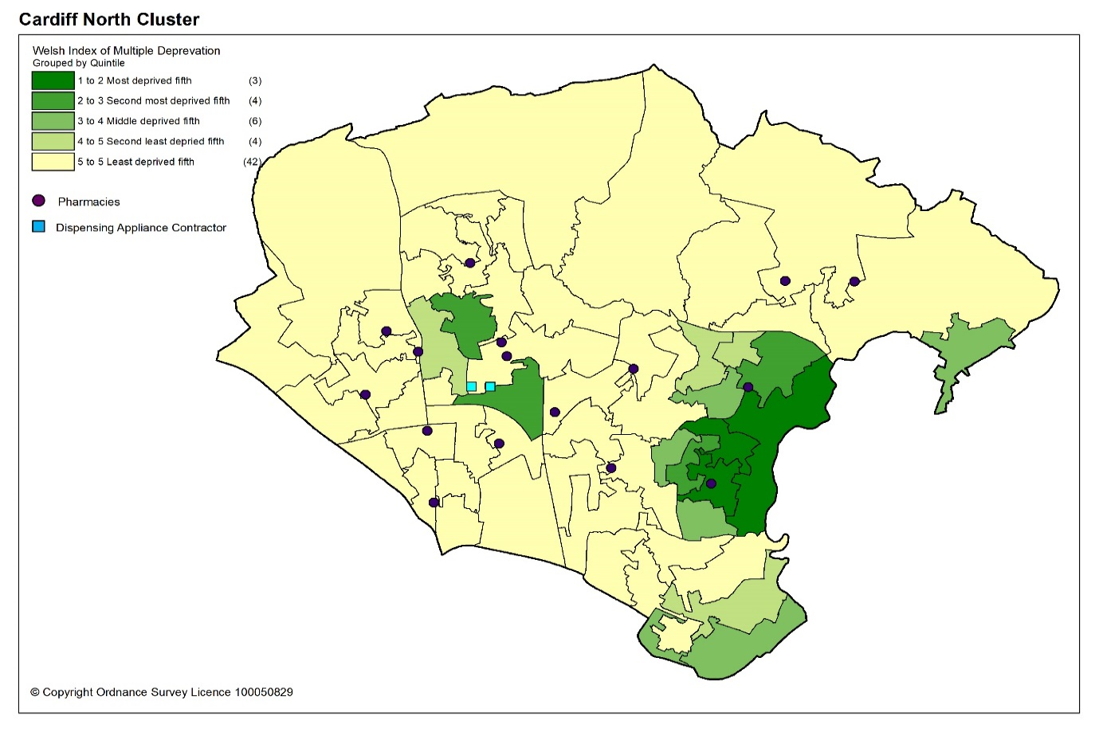

11.1.4 Health profile

Overall, the prevalence of chronic disease in Cardiff North cluster is lower than the average for Wales. When compared to Cardiff and Vale University Health Board, the estimated prevalence of asthma is higher and is the third highest of all the clusters within the health board. The prevalence of heart failure is also higher than that of the health board. The prevalence of diabetes is the second lowest of all the clusters within the health board and the prevalence of chronic obstructive pulmonary disease (COPD) is the joint lowest of all the clusters within the health board.

Table 11.3: Estimated percentage prevalence of chronic conditions based on patients on GP practice registers by cluster, local authority, health board and Wales, 2019
 | Percentage
Area | Asthma | Coronary heart disease | COPD | Diabetes | Heart failure | Stroke and transient ischaemic attacks
Cardiff North | 7.0 | 2.6 | 1.2 | 4.3 | 1.0 | 1.7
Cardiff | 6.6 | 2.5 | 1.6 | 4.9 | 0.8 | 1.6
Cardiff and Vale UHB | 6.7 | 2.7 | 1.7 | 5.0 | 0.9 | 1.7
Wales | 7.1 | 3.6 | 2.4 | 6.1 | 1.1 | 2.1
Source: QOF 2019
In Cardiff North cluster, the estimated prevalence of dementia is the same as the average for Wales and the health board. The estimated prevalence of mental health conditions is the joint lowest of all clusters within the health board and lower than the average for Wales.

Table 11.4: Percentage of patients registered as having a mental health condition, and dementia by cluster, local authority, health board and Wales, 2019
 | Dementia (percentage) | Mental Health (percentage)
Cardiff North | 0.7 | 0.7
Cardiff | 0.6 | 0.9
Cardiff & Vale UHB | 0.7 | 0.9
Wales | 0.7 | 1.0
Source: QOF 2019
The estimated prevalence of atrial fibrillation in Cardiff North cluster is lower than the average for Wales but higher than the health board. The estimated prevalence of hypertension is lower than the average for Wales and the health board.

Table 11.5: Estimated percentage prevalence of hypertension and atrial fibrillation based on patients on GP practice registers by cluster, local authority, health board and Wales, 2019
 | Atrial Fibrillation (percentage) | Hypertension (percentage)
Cardiff North | 1.9 | 12.4
Cardiff | 1.6 | 11.8
Cardiff & Vale UHB | 1.8 | 12.6
Wales | 2.3 | 15.8
Source: QOF 2019
Many of the factors that contribute to the inequalities in health and well-being are preventable. Table 11.6 shows the percentage of adults self-reporting harmful behaviours; where a lower percentage for smoking and drinking above the guidelines is seen as more beneficial to health and well-being as is a higher percentage for working age adults of healthy weight, meeting the physical activity guidelines and consuming five a day.

Overall, the percentage of adults reporting behaviours which support healthy outcomes in Cardiff North cluster is higher than Cardiff and Vale University Health Board and the average for Wales, except for drinking above the guidelines.

Table 11.6: Percentage of adults (aged 16 years and over) reporting behaviours by cluster, health board and Wales, 2016 to 2018
 | Count |  |  |  |  |  | Prevalence
GP Cluster Name | GP cluster population aged 16+ | Smoking |  | Drinking the above guidelines |  | Working age adults of healthy weight |  | Meeting physical activity guidelines |  | Consuming 5 a day
Cardiff North | 84,059 | 14.7 |  | 20.6 |  | 45.2 |  | 59.0 |  | 26.5
Cardiff and Vale UHB | 420,119 | 19.3 |  | 18.9 |  | 40.8 |  | 55.1 |  | 24.2
Wales | 2,642,152 | 19.2 |  | 18.9 |  | 39.1 |  | 52.8 |  | 23.4
Source: Public Health Wales Observatory, using NSW (WG), WDS (NWIS) and WIMD 2014 (WG). Please note, the calculation of the healthy weight indicator only accounts for working age adults (aged 16-64)

11.1.5. Cluster developments

There are two large developments planned within Cardiff North cluster to be completed by 2026 in line with the Cardiff Local Development Plan 2006 to 2026.

North East Cardiff (West of Pontprennau)

The site relates to countryside located between Lisvane to the west, Pontprennau to the east and the M4 Motorway to the north. The development is for a mixed-use comprehensive development of a minimum of 4,500 homes, employment and other associated community uses, together with supporting infrastructure:

- Provision of new bus-based Rapid Transit Corridors through the site providing links between the District/Local Centres including Bus Gates at access point to Cardiff Gate Business Park and St Mellons Road at the eastern edge of the site.
- Extension of bus networks and increase in the frequency and reliability of site service.
- Provision of safe, attractive, and convenient walking routes within the site, linking to key local services, facilities and destinations including existing local centres and Schools at Pontprennau, Pentwyn, Lisvane and Cardiff Gate Business Park.
- Provision of one centrally located District Centre and one Local Centre including Primary Care facility, multifunctional community leisure facility including library facility, and financial contribution to upgrading of Llanishen and Pontprennau Leisure Centres.
- Provision of one new Secondary School and three new Primary Schools.
- Provision of open space including formal recreation, playgrounds including destination play area, teen facility, and allotment sites.

Construction work started in late 2018 on the Churchlands (Land North and East of Lisvane) site and the development is being built in a series of phases.

By autumn 2019, 45 houses were under construction. 2020 site monitoring was put on hold due to Coronavirus (COVID-19) pandemic restrictions.

The spring 2021 LDP monitoring document highlights that there have been around 77 completions on site and further 45 in progress.

The spring 2021 LDP monitoring document also highlights that there is a live outline planning application in progress with Cardiff Council.

East of Pontprennau Link Road

The site relates to Land East of countryside located between the Pontprennau Link Road to the West, River Rhymney valley to the east, the A48 to the south and the M4 Motorway to the north. The development is for a housing-based scheme of a minimum of 1,300 homes with associated community uses, together with supporting infrastructure:

- Provision of new bus-based Rapid Transit Corridors through the site including links to the Local Centre and provision of Bus Gates at St Mellons Road at the north western edge of the site and Bridge Road to the south east of the site.
- Extension of bus networks and increasing the frequency and reliability of site services.
- Provision of a network of high quality, safe, attractive, and convenient walking and cycling routes within the site, linking to key local services, facilities and destinations including employment in Pontprennau, Pentwyn and Cardiff Gate Business Park.
- One centrally located Local Centre linked to rapid transit infrastructure and school facilities including Primary Care facility (branch surgery), multifunctional community facility.
- One new Primary School located in or adjacent to the Local Centre.
- Open Space including formal recreation, playgrounds, a teen facility, and allotment site.

Construction work started in 2015 and the development is being built in a series of phases.

As of 1st April 2019, there were 337 completions on the housing site. 2020 site monitoring was put on hold due to Coronavirus (COVID-19) pandemic restrictions.

The spring 2021 LDP monitoring document highlights approximately that there have been over 700 completions on the Edeyrns Village site, with a further 89 under construction.

A further 156 completed houses have been built on the Highfields site.

The Maelfa Wellbeing Hub is currently under development and will house community services as well as the GP practice and so may have some impact on services needed. As previously noted for the purposes of the PNA Hopwoods community pharmacy and GP practice at Maelfa are considered as part of Cardiff East cluster as that is where the main GP premises is situated; however, they will serve people in Cardiff North cluster also.

11.2 Current provision of pharmaceutical services within the cluster

There are 18 pharmacies in Cardiff North cluster.

Table 11.7: Pharmacies in Cardiff North cluster
Pharmacy | Address
Asda Stores Ltd T/A Asda Pharmacy | 8 Derring Road | Pontprennau | CF23 8NL
Boots UK Ltd T/A Boots | Unit 2 Ty Glas Retail Park | Llanishen | CF14 5DY
Mr A Brookes T/A Brookes Pharmacy | 3 Fidlas Road | Llanishen | CF14 0LW
R K Aggarwal Ltd T/A Central Pharmacy | 63 Wellfield Road | Roath | CF24 3PA
Thornes Pharmacy Ltd T/A Cyncoed Pharmacy | 372 Cyncoed Road | Cyncoed | CF23 6SA
Tandy Inc Ltd T/A AJ Hales Pharmacy | 35 St Isan Road | Heath | CF14 4LU
Insync Healthcare Pharmacy Ltd T/A Insync Healthcare Pharmacy | 67 Thornhill Road | Cardiff | CF14 6PE
Lloyds Pharmacy Ltd T/A Lloydspharmacy | 45 Wellfield Road | Roath | CF24 3PA
Lloyds Pharmacy Ltd T/A Lloydspharmacy | 99 Caerphilly Road | Birchgrove | CF14 4AE
Lloyds Pharmacy Ltd T/A Lloydspharmacy | 4C Heol Y Deri | Rhiwbina | CF14 6HF
Lloyds Pharmacy Ltd @ Sainsburys Thornhill | Sainsburys Store Excalibur Drive | Thornhill | CF14 9BB
Rajja Ltd T/A M W Phillips | 44 Station Road | Llanishen | CF14 5LT
Well | St Davids Medical Centre Pentwyn Drive | Pentwyn | CF23 7EY
Well | 119 Heol Llanishen Fach | Rhiwbina | CF14 6RE
Pearns Pharmacies Ltd | Wedal Road | Heath | CF14 3QX
Thornes Pharmacy Ltd. | Pontprennau Pharmacy 32 Kenmare Mews | Pontprennau | CF23 8RJ
National Co-Operative Chemists Ltd T/A The Co-operative Pharmacy | Birchgrove Medical Centre Caerphilly Road | Birchgrove | CF14 4QF
Clifton Pharmacy T/A Lakeside Pharmacy | 33 Clearwater Way | Lakeside | CF23 6DL

In 2019 to 2020, 82.1% of items on prescriptions written by the 10 GP practices in Cardiff North cluster were dispensed by one of the pharmacies within the cluster and 2.1% were personally administered items.
There are also two appliance contractors based within the cluster area.

The pharmacies are located in or near areas of greater population density as shown by the darker shaded areas in the map below.

Map 11.2: Location of pharmacy and appliance contractor premises compared to population density
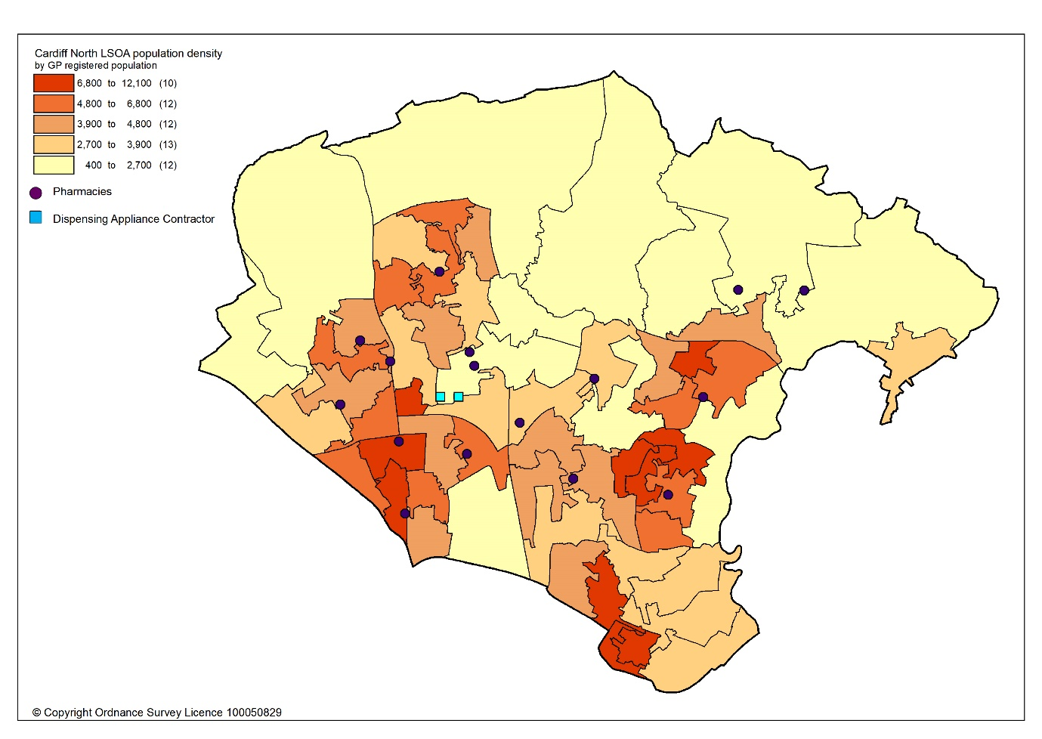

All residents of the cluster can access one of the pharmacies by car within 10 minutes. The majority can access a pharmacy within five minutes, as shown in map 11.3.

Map 11.3: Access to pharmacies and appliance contractors in the cluster
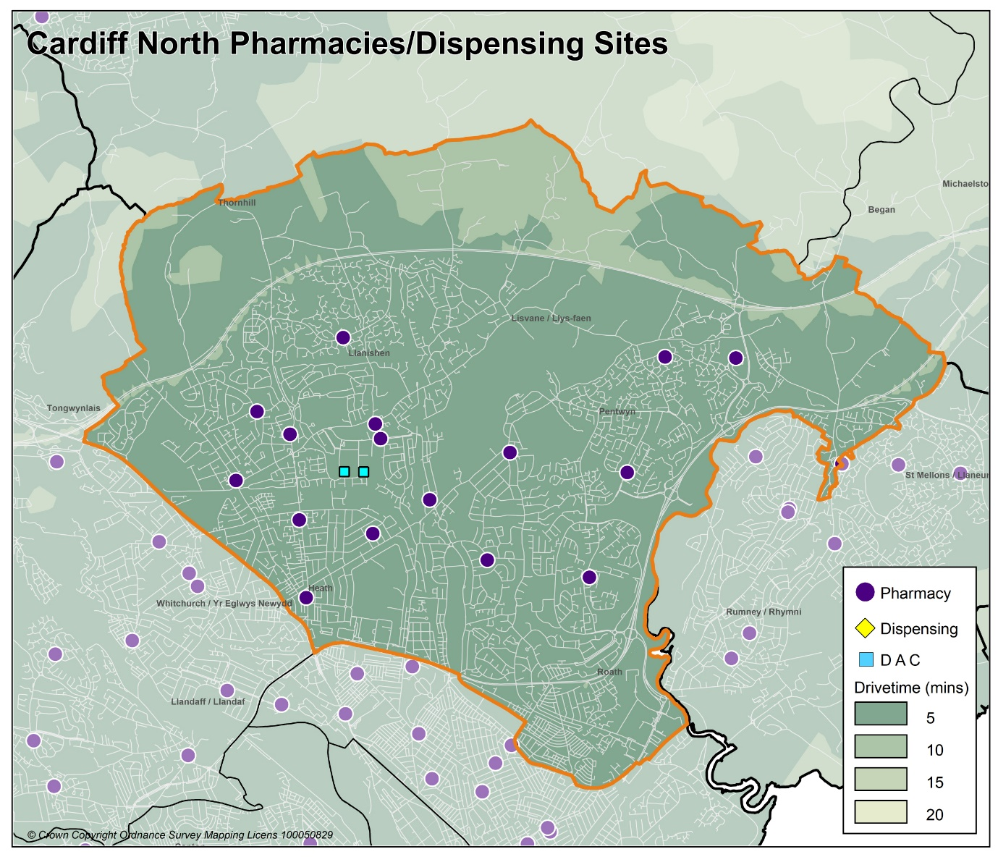

Looking at the opening hours for the pharmacies:

- Three pharmacies are open seven days a week
- Three pharmacies are open Monday to Saturday
- Two pharmacies are open Monday to Friday and Saturday morning
- Ten pharmacies are open Monday to Friday

All pharmacies must open for their core contractual hours, which are 40 hours a week. These can only be amended with approval by the health board. All additional hours or supplementary hours can be amended by the pharmacy following the provision of 90 days’ notice to the health board. Within the cluster, opening hours and closing hours range from:

Days | Opening hours range | Closing hours range
Monday to Friday | 08.00am to 09.00am | 17.30pm to 22.00pm*
Saturday | 08.00am to 09.00am | 12.00pm to 22.00pm
Sunday | 10.00am to 10.30am | 16.00pm to 16.30pm

*One pharmacy closes at 17.00pm on Wednesday.
Full details of when the pharmacies are open can be found in Appendix L.

All 18 pharmacies responded to the contractor questionnaire, of which 16 dispense all appliances listed in Part IX of the Drug Tariff, one just dispenses dressings and one pharmacy did not dispense appliances.

In 2019 to 2020, 19 pharmacies* offered the MUR service and a total of 5,237 reviews were provided out of a possible 7,600 reviews. Five pharmacies provided the maximum number of 400 reviews. The Welsh Government formally suspended the MUR service on 13 March 2020. At the time of writing, it is not known if the service will re-commence.

In 2019 to 2020, 17 pharmacies offered the DMR service and a total of 685 reviews were provided out of a possible 2,380 reviews. One pharmacy provided the maximum number of 140 reviews. As part of the changes to the Community Pharmacy Contractual Framework for 2021, the cap for the number of paid DMRs has been removed.

In 2019 to 2020, the following enhanced services were provided by pharmacies in the cluster area:

- 11 pharmacies provided a total of 747 emergency contraception consultations, with a range of one to 399 consultations.
- Three pharmacies provided a total of 44 smoking cessation level 3 consultations, with a range of six to 28 consultations.
- 18 pharmacies provided a total of 2047 flu vaccinations, with a range of four to 251 vaccinations.
- 19 pharmacies* provided a total of 1289 CAS consultations, with a range of nine to 300 consultations.
- Five pharmacies provided a total of 267 EMS consultations, with a range of one to 158 consultations.

Other enhanced services included:
- Four pharmacies provided the Supervised Administration of Medicines Enhanced Service.
- Five pharmacies provided the palliative care service.

*In 2019 to 2020 there were 19 pharmacies operating within the cluster area. One pharmacy closed in September 2020 for business reasons and did offer the contract for sale.

11.3 Current provision of pharmaceutical services outside the cluster

Some residents choose to access contractors outside both the cluster and the health board’s area in order to access services:

- Offered by dispensing appliance contractors.
- Which are located near to where they work, shop or visit for leisure or other purposes.

Whilst the majority of prescriptions written by the GP practices in 2019 to 2020 were dispensed by the pharmacies in the cluster, around 15.8% were dispensed outside the cluster, most notably:

- 10.0% by pharmacies in Cardiff South East cluster
- 2.7% by pharmacies in Cardiff City & South cluster
- 1.2% by pharmacies in Cardiff West clusters
- 0.7% by pharmacies in Cardiff East cluster
- 0.1% by pharmacies in Cardiff South West cluster
- 0.2% in Aneurin Bevan University Health Board
- 0.1% in Cwm Taf Morgannwg University Health Board
- 0.1% in Swansea Bay University Health Board
- 0.6% by contractors in England

In addition, residents may have accessed one or more pharmaceutical services provided by another pharmacy outside of both the cluster and the health board’s area; however, it is not possible to quantify this activity from the recorded data.

Taking into account pharmacies in the neighbouring clusters and pharmacies over the border in other health board areas in Wales, all residents in the cluster of Cardiff North can access a pharmacy by car within 10 minutes and the majority can access a pharmacy by car within five minutes.

11.4 Other NHS services

University Hospital of Wales is located within the cluster of Cardiff North. However, the hospital serves a much wider population than that of the cluster.

11.5 Choice with regard to obtaining pharmaceutical services

As can be seen from sections 11.2 and 11.3, those living within the cluster area and registered with one of the GP practices generally choose to access one of the pharmacies in the cluster in order to have their prescriptions dispensed. Those that look outside the cluster usually do so to access a neighbouring pharmacy within the health board’s area. A minority choose to have their prescription dispensed by a pharmacy or an appliance contractor outside of the health board’s area.

A total of 423 pharmacy contractors that were trading in Wales during 2019 to 2020, dispensed items written by one of the GP practices in the Cardiff North cluster, of which 318 were outside of the health board’s area. 11677, prescription items were dispensed in England.

11.6 Gaps in provision

The Cardiff and Vale University Health Board has noted the locations of pharmacies across the cluster, and the fact that the population can access a pharmacy by car within 10 minutes, with the majority within five minutes. Whilst noting that not all households have access to a car throughout the day, the nature of the cluster means that walking to a pharmacy will be a realistic option for many residents and regular public transport services are available for those who are unable to undertake the whole journey on foot.

The Cardiff and Vale University Health Board has noted the opening hours of the existing pharmacies and is of the opinion that they are sufficient to meet the likely needs of residents in the cluster. The Cardiff and Vale University Health Board has therefore concluded that there are no current needs in relation to the provision of essential services by pharmacies in the cluster.

The Cardiff and Vale University Health Board is also satisfied that there are no current needs in relation to the provision of advanced services. Whilst none of the pharmacies provide the Appliance Use Review service or the Stoma Appliance Customisation service, it is noted that there are four appliance contractors based in Cardiff and Vale University Health Board who offer these services. One of the reasons why prescriptions are dispensed outside of the cluster is because they have been sent to a dispensing appliance contractor elsewhere in the health board or to England, which provide these services. Patients will therefore be able to access these two services via those contractors. The Cardiff and Vale University Health Board has therefore not identified any current or future gap or better access in relation to the provision of these two advanced services in the cluster.

The Cardiff and Vale University Health Board is also noted the closure of one pharmacy in the cluster in 2020.

All 18 pharmacies responded to the question in the contractor questionnaire regarding capacity to meet demand from any future housing developments in the cluster. Their responses were as follows:

- 15 pharmacies have sufficient capacity within their existing premises and staffing levels to manage the increase in demand in the area.
- Two pharmacies do not have sufficient premises and staffing capacity at present but could make adjustments to manage the increase in demand in the area.
- One pharmacy does not have sufficient premises and staffing capacity and would have difficulty in managing an increase in demand.

The Cardiff and Vale University Health Board noted the developments planned for the cluster, with regards to the housing developments west and east of Pontprennau. At this time Cardiff and Vale University Health Board have no information or reason to conclude, during the lifetime of this PNA and development, that there would be an unmet need so as to require additional pharmaceutical services.

Furthermore, with regard to any smaller units of housing that are due to be built during the lifetime of this document, Cardiff and Vale University Health Board is satisfied, based upon the responses to the contractor questionnaire, that the demand that this will create can be met by the existing pharmacies. The Cardiff and Vale University Health Board has therefore concluded that there are no future needs in relation to the provision of essential services by pharmacies in the cluster.

The Cardiff and Vale University Health Board is also satisfied that, based upon the information contained in the preceding sections, there are no current or future gaps in the provision of advanced services and enhanced services.

The Cardiff and Vale University Health Board will keep service provision under review but has concluded that there is no current or future need identified which requires an application for new or additional premises.

12 Cardiff South West cluster

12.1 Key facts

12.1.1 Population and population projections 2018 to 2028 (2018 based)
As cluster level population data is not routinely collected on an annual basis,
GP registered patient data has been used to provide an indication of cluster population, and local authority based data has been used to provide an indication of population projections.

Note that GP registered population data is higher than the corresponding census based mid-year population estimates provided by the Office of National Statistics (ONS) at the local authority and health board level, as outlined in section 2.2. This is most likely due to over registered or ‘ghost patients’ caused by many different factors.

Table 12: Number of GP registered patients by gender and broad age groups and by cluster, local authority and health board (2019)
 | Year | Gender |  | Age range
 | 2019 | Female | Male | Under 65 | 65 to 84 | 85 and over
Cardiff South West | 66618 | 32748 | 33870 | 57588 | 7847 | 1183
Cardiff | 389619 | 193044 | 196575 | 335252 | 46599 | 7768
Cardiff and Vale UHB | 521177 | 260027 | 261150 | 439365 | 70412 | 11400
Source: StatsWales - NHS Wales Shared Services Partnership.

Between 2018 to 2028, the population of Cardiff is projected to increase by up to 3.2%, the sixth largest percentage increase of all the local authorities within Wales. It is expected to have a population of around 375,700 by 2028, making it the largest local authority in Wales. Unlike all other local authorities, the increase in population will mainly be driven by natural change i.e. more births than deaths and a smaller proportion of the increase will be due to net migration i.e. more people moving into the area than out. Cardiff has the highest level of projected international migration of all the local authorities. The population is expected to increase across all broad age groups, except the 0 to 15 years old where a decrease is predicted. The largest population increases will be in the over 65 age group followed by the working-age population aged 16 to 64 years. The population is projected to continue to age in the local authority.

12.1.2. Life expectancy, healthy life expectancy and the ‘inequality gap’

Life expectancy at birth in Cardiff is better than the average for Wales for both females and males. The difference in life expectancy that exists across an area between the most and least deprived areas is referred to as the ‘inequality gap’. The inequality gap in life expectancy at birth between the most and least deprived fifth, for Cardiff is wider than the average for Wales for both males and females. The healthy life expectancy (the number of years a person can expect to live in good health) in Cardiff is lower than the average for Wales for both females and males.

Table 12.1: Life expectancy, healthy life expectancy and the ‘inequality gap’ (2015 to 2017)
 | Life expectancy at birth (years) |  | Healthy life expectancy (years) |  | Inequality gap  (years)
 | Females | Males | Females | Males | Females | Males
Cardiff | 82.7 | 78.5 | 61.1 | 61.2 | 6.9 | 9.2
Cardiff and Vale UHB | 83.0 | 78.7 | 62.0 | 61.9 | 6.6 | 8.6
Wales | 82.3 | 78.3 | 62.0 | 61.4 | 6.1 | 7.4
Source: Public Health Wales Observatory PHOF Tool (2017) using ONS and WG data

12.1.3 Deprivation

Deprivation is the lack of access to opportunities and resources which might be expected in society. The Welsh Index of Multiple Deprivation (WIMD) allows for the ranking of small areas, called Lower layer Super Output Areas (LSOAs) in Wales to determine whether an area is more or less deprived compared to all other small areas in Wales.

Overall, Cardiff South West cluster has a higher percentage of LSOAs in the most deprived 10% and 20% of LSOAs in Wales relative to Cardiff, except for the access to services domain.

Table 12.2: Percentage of LSOAs within the 10% and 20% most deprived LSOAs in Wales by cluster and local authority for the domains of income, health, employment and access to services, Welsh Index of Multiple Deprivation 2014
Percentage of LSOAs within the 10% and 20% most deprived LSOAs in Wales
 | Income |  | Health |  | Employment |  | Access to services
 | 10% | 20% | 10% | 20% | 10% | 20% | 10% | 20%
Cardiff South West | 44.1 | 52.9 | 38.2 | 41.2 | 35.3 | 41.2 | 0.0 | 0.0
Cardiff | 19.2 | 30.8 | 14.5 | 22 | 12.1 | 20.1 | 0.0 | 0.9
Source: Welsh Index of Multiple Deprivation 2014, Welsh Government

The map below provides an indication of the overall levels of deprivation within the cluster. As can be seen from the map, all pharmacies are located within or near areas of higher deprivation.

Map 12.1: Lower Super Output Areas (LSOAs) in Cardiff South West cluster, grouped into quintiles by Welsh index of Multiple Deprivation 2019
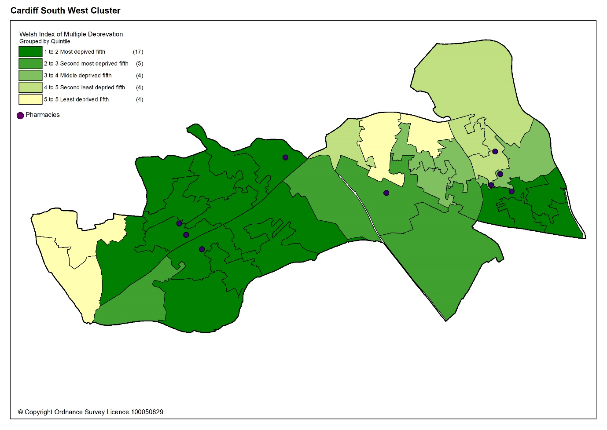

Overall, the estimated prevalence of chronic disease in Cardiff South West cluster is lower than the average for Wales, except for asthma, which is the joint highest of all the clusters in the health board. The estimated prevalence of chronic obstructive pulmonary disease (COPD) is higher than the health board and the third highest of all the clusters within the health board. The estimated prevalence of diabetes is also higher than the health board.

Table 12.3: Estimated percentage prevalence of chronic conditions based on patients on GP practice registers by cluster, local authority, health board and Wales, 2019
 | Percentage
Area | Asthma | Coronary heart disease | COPD | Diabetes | Heart failure | Stroke and transient ischaemic attacks
Cardiff South West | 7.3 | 2.6 | 2.1 | 5.4 | 0.8 | 1.6
Cardiff | 6.6 | 2.5 | 1.6 | 4.9 | 0.8 | 1.6
Cardiff and Vale UHB | 6.7 | 2.7 | 1.7 | 5.0 | 0.9 | 1.7
Wales | 7.1 | 3.6 | 2.4 | 6.1 | 1.1 | 2.1
Source: QOF 2019
The estimated prevalence of dementia in Cardiff South West cluster is lower than the average for Wales and the health board. The estimated prevalence of mental health conditions the same as the average for Wales and higher than the health board.

Table 12.4: Percentage of patients registered as having a mental health condition, and dementia by cluster, local authority, health board and Wales, 2019
 | Dementia (percentage) | Mental Health (percentage)
Cardiff South West | 0.6 | 1.0
Cardiff | 0.6 | 0.9
Cardiff & Vale UHB | 0.7 | 0.9
Wales | 0.7 | 1.0
Source: QOF 2019
The estimated prevalence of atrial fibrillation is lower than the average for Wales and the health board. The estimated prevalence of hypertension is lower than the average for Wales but higher than health board.

Table 12.5: Estimated percentage prevalence of hypertension and atrial fibrillation based on patients on GP practice registers by cluster, local authority, health board and Wales, 2019
 | Atrial Fibrillation (percentage) | Hypertension (percentage)
Cardiff South West | 1.5 | 12.9
Cardiff | 1.6 | 11.8
Cardiff & Vale UHB | 1.8 | 12.6
Wales | 2.3 | 15.8
Source: QOF 2019
Many of the factors that contribute to the inequalities in health and well-being are preventable. Table 12.6 shows the percentage of adults self-reporting five behaviours, where a lower percentage for smoking and drinking above the guidelines is seen as more beneficial to health and well-being as is a higher percentage for working age adults of healthy weight, meeting the physical activity guidelines and consuming five a day.

Overall, the percentage of adults reporting behaviours which support healthy outcomes in Cardiff South West cluster is lower than Cardiff and Vale University Health Board and the average for Wales, except for drinking above the guidelines.

Table 12.6: Percentage of adults (aged 16 years and over) reporting behaviours by cluster, health board and Wales, 2016 to 2018
 | Count |  |  |  |  |  | Prevalence
GP Cluster Name | GP cluster population aged 16+ | Smoking |  | Drinking the above guidelines |  | Working age adults of healthy weight |  | Meeting physical activity guidelines |  | Consuming 5 a day
Cardiff South West | 52,673 | 23.1 |  | 17.7 |  | 37.2 |  | 52.3 |  | 22.5
Cardiff and Vale UHB | 420,119 | 19.3 |  | 18.9 |  | 40.8 |  | 55.1 |  | 24.2
Wales | 2,642,152 | 19.2 |  | 18.9 |  | 39.1 |  | 52.8 |  | 23.4
Source: Public Health Wales Observatory, using NSW (WG), WDS (NWIS) and WIMD 2014 (WG). Please note, the calculation of the healthy weight indicator only accounts for working age adults (aged 16-64)

12.2 Current provision of pharmaceutical services within the cluster

There are 10 pharmacies in Cardiff South West cluster. For the purposes of the PNA the pharmacy at Tesco Culverhouse Cross is considered part of Cardiff South West as it sits within the borders of Cardiff Council.

Table 12.7: Pharmacies in Cardiff South West cluster
Pharmacy | Address
Boots UK Limited | Health Centre Lansdowne Surgery Sanatorium Road | Canton | CF11 8DG
Boots UK Limited | 213-215 Cowbridge Road East | Canton | CF11 9AL
Boots UK Limited | The Pharmacy | Riverside Health Centre | CF11 9SH
Pearns Pharmacies Ltd | 40 Caerau Lane | Ely | CF5 5HQ
Tesco Stores Limited | Tesco Instore Pharmacy | Culverhouse Cross | CF5 6XQ
Lloyds Pharmacy Ltd T/A Lloydspharmacy | 35 Wilson Road | Ely | CF5 4LL
Pearns Pharmacies Ltd | 3 Wilson Road | Ely | CF5 4LJ
Pearns Pharmacies Ltd | 23A Mill Road | Ely | CF5 4AE
Nik Pharma T/A Canna Pharmacy | 27 Wyndham Crescent | Canton | CF11 9EE
Pontcanna Pharmacy | 171 Kings Road | Pontcanna | CF11 9DE

In 2019 to 2020, 82.0% of items on prescriptions written by the 10 GP practices in Cardiff South West cluster were dispensed by one of the pharmacies within the cluster and 1.7% were personally administered items.

The pharmacies are located in areas of greater population density as shown by the darker shaded areas in the map below.

Map 12.2: Location of pharmacy premises compared to population density
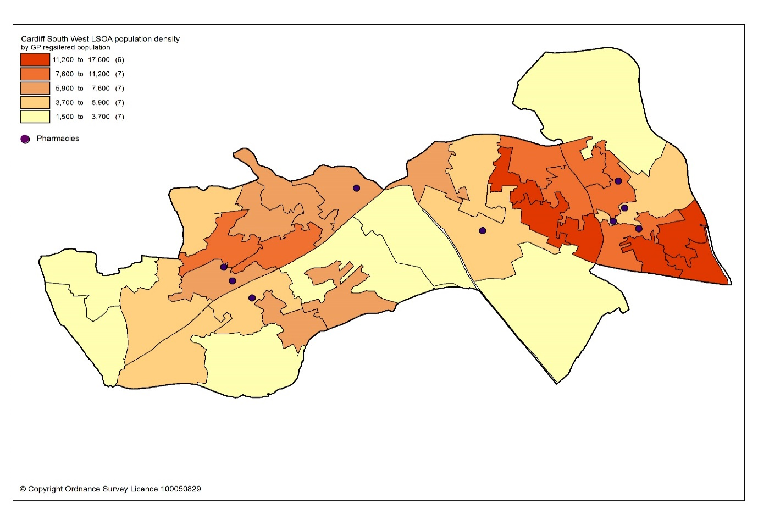
All residents of the cluster can access one of the pharmacies by car within 10 minutes. The majority can access a pharmacy within five minutes, as shown in map 12.3.

Map 12.3: Access to pharmacies in the cluster
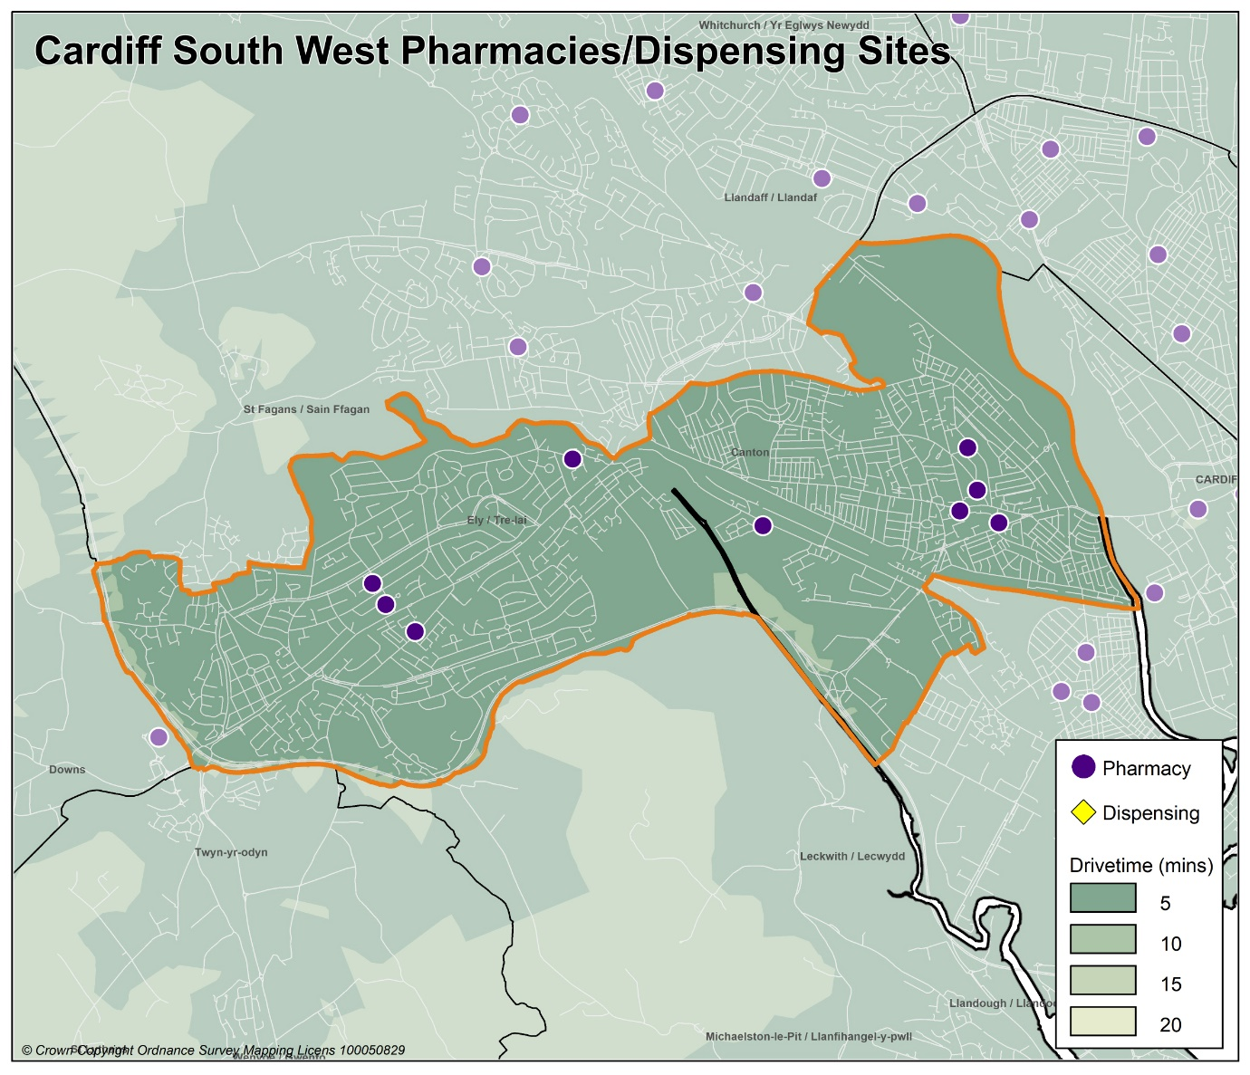
Looking at the opening hours for the pharmacies:

- One pharmacy is open seven days a week
- Two pharmacies are open Monday to Saturday
- Two pharmacies are open Monday to Friday and Saturday morning
- Five pharmacies are open Monday to Friday

All pharmacies must open for their core contractual hours, which are 40 hours a week. These can only be amended with approval by the health board. All additional hours or supplementary hours can be amended by the pharmacy following the provision of 90 days’ notice to the health board. Within the cluster, opening hours and closing hours range from:

Days | Opening hours range | Closing hours range
Monday to Friday | 08.00am to 09.00am | 17.30pm to 20.00pm*
Saturday | 08.00am to 09.00am | 12.00pm to 20.00pm
Sunday | 10.00am | 16.00pm

*One pharmacy closes early on Wednesday at 14.30pm and another at 16:30pm.
Full details of when the pharmacies are open can be found in Appendix L.

All 10 pharmacies responded to the contractor questionnaire, of which six pharmacies dispense all appliances listed in Part IX of the Drug Tariff and four pharmacies just dispense dressings.

In 2019 to 2020, all 10 pharmacies offered the MUR service and a total of 2,100 reviews were provided out of a possible 4,000 reviews. Two pharmacies provided the maximum number of 400 reviews. The Welsh Government formally suspended the MUR service on 13 March 2020. At the time of writing, it is not known if the service will re-commence.

In 2019 to 2020, eight pharmacies offered the DMR service and a total of 124 reviews were provided out of a possible 1,400 reviews. No pharmacies provided the maximum number of 140 reviews. As part of the changes to the Community Pharmacy Contractual Framework for 2021, the cap for the number of paid DMRs has been removed.

In 2019 to 2020, the following enhanced services were provided by pharmacies in the cluster area:

- Six pharmacies provided a total of 477 emergency contraception consultations, with a range of 13 to 161 consultations.
- Two pharmacies provided a total of 42 smoking cessation level 3 consultations, with a range of three to 39 consultations.
- Eight pharmacies provided a total of 758 flu vaccinations, with a range of 15 to 219 vaccinations.
- 10 pharmacies provided a total of 663 CAS consultations, with a range of two to 179 consultations.
- Four pharmacies provided a total of 14 EMS consultations, with a range of one to six consultations.

Other enhanced services included:
- Five pharmacies provided the Supervised Administration of Medicines Enhanced Service.
- Two pharmacies provided the Needle Syringe Provision Enhanced Service.
- One pharmacy provided the Palliative Care Enhanced Service.

12.3 Current provision of pharmaceutical services outside the cluster

Some residents choose to access contractors outside both the cluster and the health board’s area in order to access services:

- Offered by dispensing appliance contractors.
- Which are located near to where they work, shop or visit for leisure or other purposes.

Whilst the majority of prescriptions written by the GP practices in 2019 to 2020 were dispensed by the pharmacies in the cluster, around 16.3% were dispensed outside the cluster, most notably:

- 0.5% by pharmacies in Cardiff North cluster
- 0.1% by pharmacies in Cardiff East cluster
- 1.8% by pharmacies in Cardiff South East cluster
- 7.5% by pharmacies in Cardiff City & South cluster
- 4.1% by pharmacies in Cardiff West cluster
- 0.1% by pharmacies in Central Vale cluster
- 0.2% by pharmacies in Eastern Vale cluster
- 1.0% in Aneurin Bevan University Health Board
- 0.3% in Cwm Taf Morgannwg University Health Board
- 0.1% in Swansea Bay University Health Board
- 0.5% by contractors in England

In addition, residents may have accessed one or more pharmaceutical services provided by another pharmacy outside of both the cluster and the health board’s area; however, it is not possible to quantify this activity from the recorded data.

Taking into account pharmacies in the neighbouring clusters and pharmacies over the border in other health board areas in Wales, all residents in the cluster of Cardiff South West can access a pharmacy by car within 10 minutes and the majority can access a pharmacy by car within five minutes.

12.4 Other NHS services

St David’s Hospital is located within the cluster of Cardiff South West. However, the hospital serves a much wider population than that of the cluster.
12.5 Choice with regard to obtaining pharmaceutical services

As can be seen from sections 12.2 and 12.3, those living within the cluster area and registered with one of the GP practices generally choose to access one of the pharmacies in the cluster in order to have their prescriptions dispensed. Those that look outside the cluster usually do so to access a neighbouring pharmacy within the health board’s area. A minority choose to have their prescription dispensed by a pharmacy or an appliance contractor outside of the health board’s area.

A total of 336 pharmacy contractors that were trading in Wales during 2019 to 2020, dispensed items written by one of the GP practices in the Cardiff South West cluster, of which 228 were outside of the health board’s area. 6,774 prescription items were dispensed in England.

12.6 Gaps in provision

The Cardiff and Vale University Health Board has noted the locations of pharmacies across the cluster, and the fact that the population can access a pharmacy by car within 10 minutes, with the majority within five minutes. Whilst noting that not all households have access to a car throughout the day, the nature of the cluster means that walking to a pharmacy will be a realistic option for many residents and regular public transport services are available for those who are unable to undertake the whole journey on foot.

The Cardiff and Vale University Health Board has noted the opening hours of the existing pharmacies and is of the opinion that they are sufficient to meet the likely needs of residents in the cluster. The Cardiff and Vale University Health Board has therefore concluded that there are no current needs in relation to the provision of essential services by pharmacies in the cluster.

The Cardiff and Vale University Health Board is also satisfied that there are no current needs in relation to the provision of advanced services. Whilst none of the pharmacies provide the Appliance Use Review service or the Stoma Appliance Customisation service, it is noted that there are four appliance contractors based in Cardiff and Vale University Health Board who offer these services. One of the reasons why prescriptions are dispensed outside of the cluster is because they have been sent to a dispensing appliance contractor elsewhere in the health board or to England, which provide these services. Patients will therefore be able to access these two services via those contractors. The Cardiff and Vale University Health Board has therefore not identified any current or future gap or better access in relation to the provision of these two advanced services in the cluster

All 10 pharmacies responded to the question in the contractor questionnaire regarding capacity to meet demand from any future housing developments in the cluster. Their responses were as follows:

- Nine pharmacies have sufficient capacity within their existing premises and staffing levels to manage the increase in demand in the area.
- One pharmacy does not have sufficient premises and staffing capacity at present but could make adjustments to manage the increase in demand in the area

The Cardiff and Vale University Health Board noted that there were no large housing developments due to be built during the lifetime of this document within the cluster. With regard to any small units of housing that are due to be built during the lifetime of this document, Cardiff and Vale University Health Board is satisfied, based upon the responses to the contractor questionnaire, that the demand that this will create can be met by the existing pharmacies. The Cardiff and Vale University Health Board has therefore concluded that there are no future needs in relation to the provision of essential services by pharmacies in the cluster

The Cardiff and Vale University Health Board is also satisfied that, based upon the information contained in the preceding sections, there are no current or future gaps in the provision of advanced services and enhanced services.

The Cardiff and Vale University Health Board will keep service provision under review but has concluded that there is no current or future need identified which requires an application for new or additional premises.

13 Cardiff West cluster

13.1 Key facts

13.1.1 Population and population projections 2018 to 2028 (2018 based)
As cluster level population data is not routinely collected on an annual basis,
GP registered patient data has been used to provide an indication of cluster population, and local authority based data has been used to provide an indication of population projections.

Note that GP registered population data is higher than the corresponding census based mid-year population estimates provided by the Office of National Statistics (ONS) at the local authority and health board level, as outlined in section 2.2. This is most likely due to over registered or ‘ghost patients’ caused by many different factors.

Table 13: Number of GP registered patients by gender and broad age groups and by cluster, local authority and health board (2019)
 | Year | Gender |  | Age range
 | 2019 | Female | Male | Under 65 | 65 to 84 | 85 and over
Cardiff West | 56840 | 29073 | 27767 | 46110 | 9196 | 1534
Cardiff | 389619 | 193044 | 196575 | 335252 | 46599 | 7768
Cardiff and Vale UHB | 521177 | 260027 | 261150 | 439365 | 70412 | 11400
Source: StatsWales - NHS Wales Shared Services Partnership.

Between 2018 to 2028, the population of Cardiff is projected to increase by up to 3.2%, the sixth largest percentage increase of all the local authorities within Wales. It is expected to have a population of around 375,700 by 2028, making it the largest local authority in Wales. Unlike all other local authorities, the increase in population will mainly be driven by natural change i.e. more births than deaths and a smaller proportion of the increase will be due to net migration i.e. more people moving into the area than out. Cardiff has the highest level of projected international migration of all the local authorities. The population is expected to increase across all broad age groups, except the 0 to 15 years old where a decrease is predicted. The largest population increases will be in the over 65 age group followed by the working-age population aged 16 to 64 years. The population is projected to continue to age in the local authority.

13.1.2 Life expectancy, healthy life expectancy and the ‘inequality gap’

Life expectancy at birth in Cardiff is better than the average for Wales for both females and males. The difference in life expectancy that exists across an area between the most and least deprived areas is referred to as the ‘inequality gap’. The inequality gap in life expectancy at birth between the most and least deprived fifth, for Cardiff is wider than the average for Wales for both males and females. The healthy life expectancy (the number of years a person can expect to live in good health) in Cardiff is lower than the average for Wales for both females and males.

Table 13.1: Life expectancy, healthy life expectancy and the ‘inequality gap’ (2015 to 2017)
 | Life expectancy at birth (years) |  | Healthy life expectancy (years) |  | Inequality gap  (years)
 | Females | Males | Females | Males | Females | Males
Cardiff | 82.7 | 78.5 | 61.1 | 61.2 | 6.9 | 9.2
Cardiff and Vale UHB | 83.0 | 78.7 | 62.0 | 61.9 | 6.6 | 8.6
Wales | 82.3 | 78.3 | 62.0 | 61.4 | 6.1 | 7.4
Source: Public Health Wales Observatory PHOF Tool (2017) using ONS and WG data

13.1.3 Deprivation

Deprivation is the lack of access to opportunities and resources which might be expected in society. The Welsh Index of Multiple Deprivation (WIMD) allows for the ranking of small areas, called Lower layer Super Output Areas (LSOAs) in Wales to determine whether an area is more or less deprived compared to all other small areas in Wales.

Overall, Cardiff West cluster has a lower percentage of LSOAs in the most deprived 10% and 20% of LSOAs in Wales relative to Cardiff.

Table 13.2: Percentage of LSOAs within the 10% and 20% most deprived LSOAs in Wales by cluster and local authority for the domains for income, health, employment and access to services, Welsh Index of Multiple Deprivation 2014
 | Number of LSOAs within the 10% and 20% most deprived LSOAs in Wales
 | Income |  | Health |  | Employment |  | Access to services
 | 10% | 20% | 10% | 20% | 10% | 20% | 10% | 20%
Central Vale | 5 | 13 | 4 | 8 | 4 | 11 | 0 | 0
Eastern Vale | 0 | 0 | 0 | 0 | 0 | 0 | 0 | 0
Western Vale | 0 | 0 | 0 | 0 | 0 | 0 | 3 | 6
Vale of Glamorgan | 5 | 13 | 4 | 8 | 4 | 11 | 3 | 6
Cardiff and Vale UHB | 46 | 72 | 38 | 64 | 34 | 51 | 3 | 15
Source: Welsh Index of Multiple Deprivation 2014, Welsh Government

The map below provides an indication of the overall levels of deprivation within the cluster. As can be seen from the map, the majority of pharmacies are located within or near areas of higher deprivation.

Map 13.1: Lower Super Output Areas (LSOAs) in Cardiff West cluster, grouped into quintiles by Welsh index of Multiple Deprivation 2019
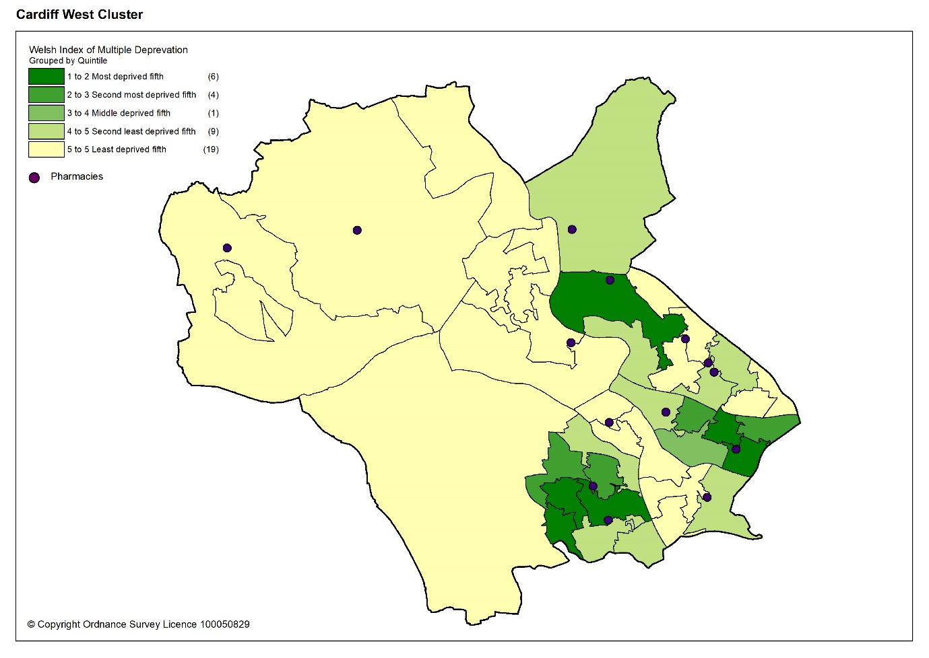

Overall, the estimated prevalence of chronic disease in Cardiff West cluster is lower than the average for Wales, except for asthma, which is the joint highest of all the clusters in the health board. The estimated prevalence of coronary heart disease, heart failure and stroke and transient ischaemic attacks is higher than the health board.

Table 13.3: Estimated percentage prevalence of chronic conditions based on patients on GP practice registers by cluster, local authority, health board and Wales, 2019.
 | Percentage
Area | Asthma | Coronary heart disease | COPD | Diabetes | Heart failure | Stroke and transient ischaemic attacks
Cardiff West | 7.3 | 3.1 | 1.6 | 4.7 | 1.0 | 2.0
Cardiff | 6.6 | 2.5 | 1.6 | 4.9 | 0.8 | 1.6
Cardiff and Vale UHB | 6.7 | 2.7 | 1.7 | 5.0 | 0.9 | 1.7
Wales | 7.1 | 3.6 | 2.4 | 6.1 | 1.1 | 2.1
Source: QOF 2019
The estimated prevalence of dementia in Cardiff West is the same as the average for Wales and Cardiff and Vale University Health Board. The estimated prevalence of mental health condition is higher than the average for Wales and the joint second highest of all the clusters in the health board.

Table 13.4: Percentage of patients registered as having a mental health condition, and dementia by cluster, local authority, health board and Wales, 2019
 | Dementia (percentage) | Mental Health (percentage)
Cardiff West | 0.7 | 1.1
Cardiff | 0.6 | 0.9
Cardiff & Vale UHB | 0.7 | 0.9
Wales | 0.7 | 1.0
Source: QOF 2019
The estimated prevalence of atrial fibrillation in Cardiff West cluster is the same as the average for Wales but higher than the health board. The estimated prevalence of hypertension is lower than the average for Wales but higher than the health board.

Table 13.5: Estimated percentage prevalence of hypertension and atrial fibrillation based on patients on GP practice registers by cluster, local authority, health board and Wales, 2019
 | Atrial Fibrillation (percentage) | Hypertension (percentage)
Cardiff West | 2.3 | 13.5
Cardiff | 1.6 | 11.8
Cardiff & Vale UHB | 1.8 | 12.6
Wales | 2.3 | 15.8
Source: QOF 2019
Many of the factors that contribute to the inequalities in health and well-being are preventable. Table 13.6 shows the percentage of adults self-reporting harmful behaviours, where a lower percentage for smoking and drinking above the guidelines is seen as more beneficial to health and well-being as is a higher percentage for working age adults of healthy weight, meeting the physical activity guidelines and consuming five a day.

Overall, the percentage of adults reporting behaviours which support healthy outcomes in Cardiff West cluster is higher than Cardiff and Vale University Health Board and the average for Wales, except for drinking above the guidelines.

Table 13.6: Percentage of adults (aged 16 years and over) reporting behaviours by cluster, health board and Wales, 2016 to 2018
 | Count |  |  |  |  | Prevalence
GP Cluster Name | GP cluster population aged 16+ | Smoking |  | Drinking the above guidelines |  |  | Working age adults of healthy weight | Meeting physical activity guidelines |  | Consuming 5 a day
Cardiff West | 45,977 | 15.9 |  | 20.2 |  |  | 42.0 | 56.4 |  | 26.3
Cardiff and Vale UHB | 420,119 | 19.3 |  | 18.9 |  |  | 40.8 | 55.1 |  | 24.2
Wales | 2,642,152 | 19.2 |  | 18.9 |  |  | 39.1 | 52.8 |  | 23.4
Source: Public Health Wales Observatory, using NSW (WG), WDS (NWIS) and WIMD 2014 (WG). Please note, the calculation of the healthy weight indicator only accounts for working age adults (aged 16-64)

13.1.5 Cluster developments

There are three large developments planned within Cardiff West cluster to be completed by 2026 in line with the Cardiff Local Development Plan 2006 to 2026. These are:

North West Cardiff

The site relates to countryside to the west of Radyr, Fairwater and Pentrebane, and to the north of the village of St Fagans. The development is for a mixed-use comprehensive development including a minimum of 5,000 homes and local employment opportunities and supporting infrastructure:

- Provision of new bus-based Rapid Transit Corridors through the site providing links between the District/Local Centres and a new Transport Hub in the Easternmost District/Local Centre.
- Extension of bus networks and increasing the frequency and reliability of site services.
- Provision of a network of high quality, safe, attractive, and convenient walking and cycling routes, linking to key local services, facilities and destinations.
- Improving walking and cycling links to public transport destinations.
- Provision of one District Centre and 3 Local Centres (including provision of business and local employment uses), Primary Care facility, multifunctional community leisure facility including library facility.
- Provision of one new Secondary School, three to four new Primary Schools located in or adjacent to District/Local Centres,
- Open Space including formal recreation, playgrounds including destination play area, teen facilities, and allotment sites.

As of 1st April 2019, there were 128 completions on the site.

The development is being built on four key sites in a series of phases. The spring 2021 LDP monitoring document highlights that:

Goitre Fach Farm – construction started in 2018. There are around 241 properties completed/under construction.

Land North and South of Llantrisant Road – construction started in early 2017. There are around 126 completions, 145 completions/under construction and 27 under construction on the site.

Land South of Pentrebane Road – construction work started in late 2017/ early 2018. There are around 120 completions and a further 37 completions/under construction on the site.

North of Junction 33 on M4 and South Creigiau

The two sites relate to:

- North of Junction 33 on the M4. The development is for a mixed-use development of approximately 2,000 homes, employment, other associated community uses and a strategic park and ride site.
- South of Creigiau. The development is for a housing-based scheme of approximately 650 homes representing a southern extension to the village.

The sites are adjacent to one another and separated only by Llantrisant Road. The sites will help bring forward new homes, jobs and supporting infrastructure including a new strategic park and ride facility.

- Provision of new bus-based Rapid Transit Corridors through the site North of Junction 33 linking directly to the Western Bus Corridor.
- Extension of bus networks and increasing the frequency and reliability of site services.
- Strategic park and ride facility North of Junction 33 and park & ride facility and Local Centre to the south of the site.
- Improvement of key junctions and provide safe crossings.
- Provision of a network of high quality, safe, attractive, and convenient walking and cycling routes within the site, linking to key local services, facilities and destinations
- One Local Centre including Primary Care facility and multifunctional community leisure facility including library facility.
- One to two new Primary Schools with one located in or adjacent to Local Centre, and
- Open Space including formal recreation, playgrounds, teen facility, and allotment site; Improve community facilities in the existing neighbourhood centre in Creigiau to provide new facilities for existing and new residents.

As of 1st April 2019, there were no completions on these sites. Site monitoring was suspended in 2020 due to Coronavirus (COVID-19) pandemic restrictions.

For the North of Junction 33 on the M4 site, construction work started in autumn 2019 and the development is being built in a series of phases. The spring 2021 LDP monitoring document highlights that there have been no completions and around 179 homes are under construction.

The spring 2021 LDP monitoring document highlights that for the South of Creigiau site, there is a live outline planning application in progress with Cardiff Council.

13.2 Current provision of pharmaceutical services within the cluster

There are 13 pharmacies in Cardiff West cluster.

Table 13.7: Pharmacies in Cardiff West cluster
Pharmacy | Address
Asda Stores Ltd T/A Asda Pharmacy | Asda Superstore Longwood Drive | Coryton | CF14 7EW
H Bainbridge Ltd T/A Bainbridge Pharmacy | 68 Plasmawr Road | Fairwater | CF5 3JX
Boots UK Limited | 15 Merthyr Road | Whitchurch | CF14 1DA
Parc Canol Ltd T/A Creigiau Pharmacy | 69 Parc y Bryn | Creigiau | CF15 9SE
Pearn's Pharmacies Ltd T/A Danescourt Pharmacy | 2 Rachel Close | Danescourt | CF5 2SH
The Handpost Ltd T/A Llandaff Pharmacy | 18A High Street | Llandaff | CF5 2DZ
Seren Ltd. Health Plus Pharmacy | 93 Station Road | Llandaff North | CF14 2FD
Lloyds Pharmacy Ltd T/A Lloydspharmacy | Ground Floor, Rear of 42a Merthyr Road | Whitchurch | CF14 1DJ
Lloyds Pharmacy Ltd T/A Lloydspharmacy | 8 Park Road | Whitchurch | CF14 7BQ
Lloyds Pharmacy Ltd T/A Lloydspharmacy | 1-2 Chestnut Road | Fairwater | CF5 3HR
Well | 12 Station Road | Radyr | CF15 8AA
Pentyrch Pharmacy Limited | Unit 3 Temperance Court Bronllwyn Road | Pentyrch | CF15 9TN
Clifton Pharmacy T/A Tongwynlais Pharmacy | 17 Merthyr Road | Tongwynlais | CF15 7LF

In 2019 to 2020, 82.1% of items on prescriptions written by the seven GP practices in Cardiff West cluster were dispensed by one of the pharmacies within the cluster and 2.3% were personally administered items.

In general, the pharmacies are located in or near areas of greater population density as shown by the darker shaded areas in the map below.

Map 13.2: Location of pharmacy premises compared to population density
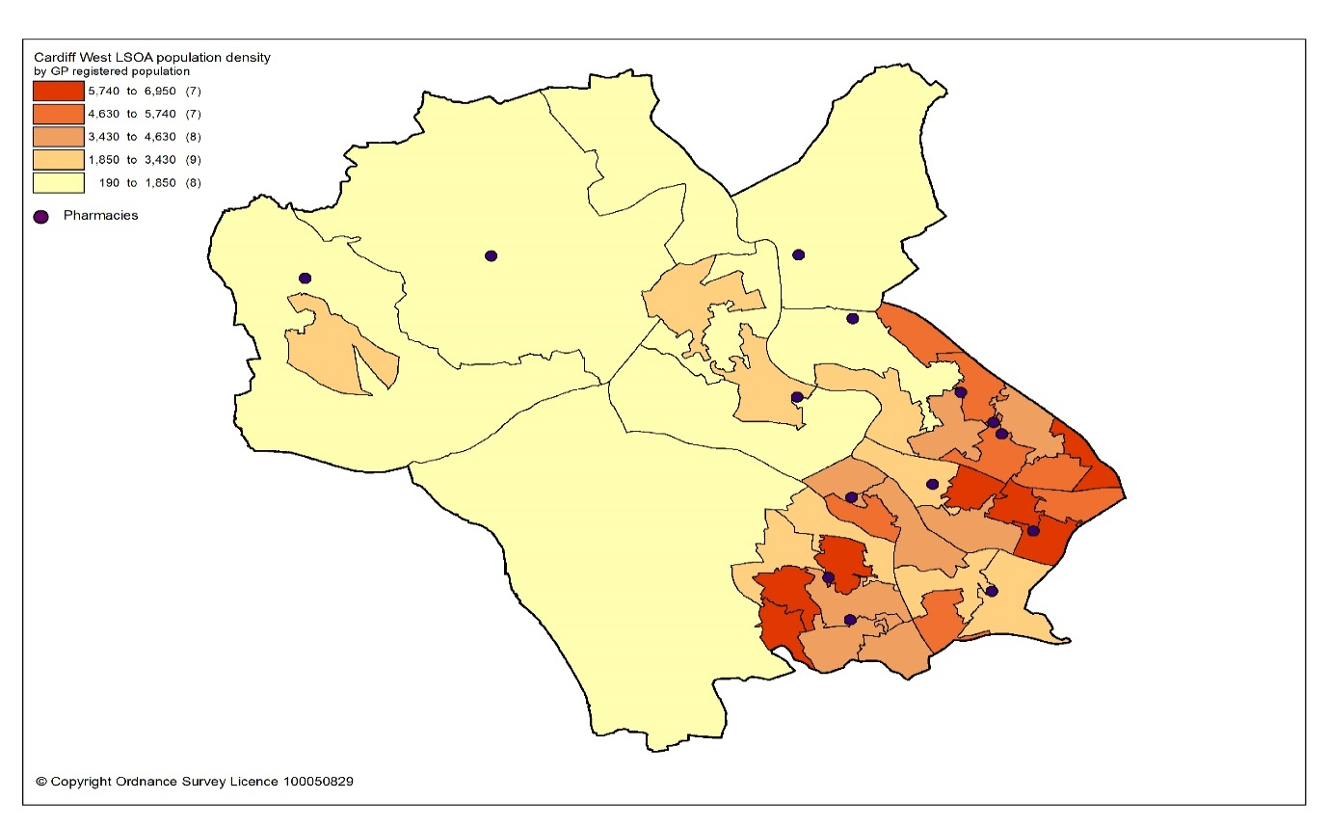

All residents of the cluster can access one of the pharmacies by car within 10 minutes. The majority can access a pharmacy within five minutes.

Map 13.3: Access to pharmacies in the cluster
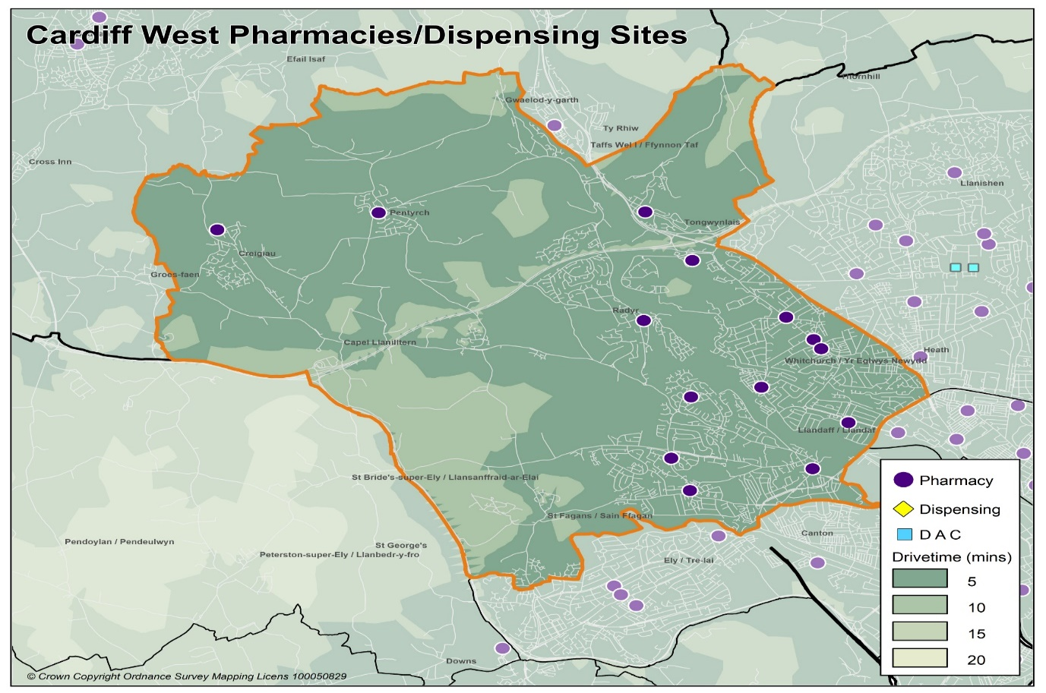

Looking at the opening hours for the pharmacies:

- One pharmacy is open seven days a week
- Three pharmacies are open Monday to Saturday
- Six pharmacies are open Monday to Friday and Saturday morning
- Three pharmacies are open Monday to Friday

All pharmacies must open for their core contractual hours, which are 40 hours a week. These can only be amended with approval by the health board. All additional hours or supplementary hours can be amended by the pharmacy following the provision of 90 days’ notice to the health board. Within the cluster, opening hours and closing hours range from:

Days | Opening hours range | Closing hours range
Monday to Friday | 08.00am to 09.00am | 17.30pm to 22.00pm
Saturday | 08.00am to 09.00am | 12.00pm to 22.00pm
Sunday | 10.00am | 16.00pm

Full details of when the pharmacies are open can be found in Appendix L.

All 13 pharmacies responded to the contractor questionnaire, of which 10 dispense all appliances listed in Part IX of the Drug Tariff, two just dispenses dressings and one does not dispense any appliances.

In 2019 to 2020, 12 pharmacies offered the MUR service and a total of 2,764 reviews were provided out of a possible 4,800 reviews. Two pharmacies provided the maximum number of 400 reviews. The Welsh Government formally suspended the MUR service on 13 March 2020. At the time of writing, it is not known if the service will re-commence.

In 2019 to 2020, all 13 pharmacies offered the DMR service and a total of 237 reviews were provided out of a possible 1,820 reviews. No pharmacies provided the maximum number of 140 reviews. As part of the changes to the Community Pharmacy Contractual Framework for 2021, the cap for the number of paid DMRs has been removed.

In 2019 to 2020, the following enhanced services were provided by pharmacies in the cluster area:

- Seven pharmacies provided a total of 249 emergency contraception consultations, with a range of five to 95 consultations.
- One pharmacy provided a total of 28 smoking cessation level 3 consultations.
- Nine pharmacies provided a total of 750 flu vaccinations, with a range of eight to 185 vaccinations.
- 13 pharmacies provided a total of 466 CAS consultations, with a range of one to 187 consultations.
- Three pharmacies provided a total of 10 EMS consultations, with a range of one to seven consultations.

Other enhanced services included:
- Six pharmacies provided the Supervised Administration of Medicines Enhanced Service.
- Two pharmacies provided the Palliative Care Enhanced Service.

13.3 Current provision of pharmaceutical services outside the cluster

Some residents choose to access contractors outside both the cluster and the health board’s area in order to access services:

- Offered by dispensing appliance contractors.
- Which are located near to where they work, shop or visit for leisure or other purposes.

Whilst the majority of prescriptions written by the GP practices in 2019 to 2020 were dispensed by the pharmacies in the cluster, around 15.6% were dispensed outside the cluster, most notably:

- 4.0% by pharmacies in Cardiff North cluster
- 3.2% by pharmacies in Cardiff South East cluster
- 3.3% by pharmacies in Cardiff City & South cluster
- 1.7% by pharmacies in Cardiff South West cluster
- 0.1% by pharmacies in Cardiff East cluster
- 1.2% in Aneurin Bevan University Health Board
- 1.2% in Cwm Taf Morgannwg University Health Board
- 0.2% in Swansea Bay University Health Board
- 0.7% by contractors in England

In addition, residents may have accessed one or more pharmaceutical services provided by another pharmacy outside of both the cluster and the health board’s area; however, it is not possible to quantify this activity from the recorded data.

Taking into account pharmacies in the neighbouring clusters and pharmacies over the border in other health board areas in Wales, all residents in the cluster of Cardiff West can access a pharmacy by car within 10 minutes and the majority can access a pharmacy by car within five minutes.

13.4 Other NHS services

Rookwood Hospital is located within the cluster of Cardiff West. However, the hospital serves a much wider population than that of the cluster.

13.5 Choice with regard to obtaining pharmaceutical services

As can be seen from sections 13.2 and 13.3, those living within the cluster area and registered with one of the GP practices generally choose to access one of the pharmacies in the cluster in order to have their prescriptions dispensed. Those that look outside the cluster usually do so to access a neighbouring pharmacy within the health board’s area. A minority choose to have their prescription dispensed by a pharmacy or an appliance contractor outside of the health board’s area.

A total of 343 pharmacy contractors that were trading in Wales during 2019 to 2020, dispensed items written by one of the GP practices in the Cardiff West cluster, of which 236 were outside of the health board’s area. 6,923 prescription items were dispensed in England.

13.6 Gaps in provision

The Cardiff and Vale University Health Board has noted the locations of pharmacies across the cluster, and the fact that the population can access a pharmacy by car within 10 minutes, with the majority within five minutes. Whilst noting that not all households have access to a car throughout the day, the nature of the cluster means that walking to a pharmacy will be a realistic option for many residents and regular public transport services are available for those who are unable to undertake the whole journey on foot.

The Cardiff and Vale University Health Board has noted the opening hours of the existing pharmacies and is of the opinion that they are sufficient to meet the likely needs of residents in the cluster. The Cardiff and Vale University Health Board has therefore concluded that there are no current needs in relation to the provision of essential services by pharmacies in the cluster.

The Cardiff and Vale University Health Board is also satisfied that there are no current needs in relation to the provision of advanced services. Whilst none of the pharmacies provide the Appliance Use Review service or the Stoma Appliance Customisation service, it is noted that there are four appliance contractors based in Cardiff and Vale University Health Board who offer these services. One of the reasons why prescriptions are dispensed outside of the cluster is because they have been sent to a dispensing appliance contractor elsewhere in the health board or to England, which provide these services. Patients will therefore be able to access these two services via those contractors. The Cardiff and Vale University Health Board has therefore not identified any current or future gap or better access in relation to the provision of these two advanced services in the cluster

All 13 pharmacies responded to the question in the contractor questionnaire regarding capacity to meet demand from any future housing developments in the cluster. Their responses were as follows:

- 11 pharmacies have sufficient capacity within their existing premises and staffing levels to manage the increase in demand in the area.
- One pharmacy does not have sufficient premises and staffing capacity at present but could make adjustments to manage the increase in demand in the area
- One pharmacy does not have sufficient premises and staffing capacity and would have difficulty in managing an increase in demand.
The Cardiff and Vale University Health Board noted the developments planned for the cluster, with regards to the large housing developments planned for north of junction 33 on M4 and South Creigiau, and North West Cardiff. At this time Cardiff and Vale University Health Board has no information or reason to conclude, during the lifetime of this PNA and development, that there would be an unmet need so as to require additional pharmaceutical service.

With regard to any smaller units of housing that are due to be built during the lifetime of this document, Cardiff and Vale University Health Board is satisfied, based upon the responses to the contractor questionnaire, that the demand that this will create can be met by the existing pharmacies. The Cardiff and Vale University Health Board has therefore concluded that there are no future needs in relation to the provision of essential services by pharmacies in the cluster

The Cardiff and Vale University Health Board is also satisfied that, based upon the information contained in the preceding sections, there are no current or future gaps in the provision of advanced services and enhanced services.

The Cardiff and Vale University Health Board will keep service provision under review but has concluded that there is no current or future need identified which requires an application for new or additional premises.

14 Central Vale cluster

14.1 Key facts

14.1.1 Population and population projections 2018 to 2028 (2018 based)
As cluster level population data is not routinely collected on an annual basis,
GP registered patient data has been used to provide an indication of cluster population, and local authority based data has been used to provide an indication of population projections.

Note that GP registered population data is higher than the corresponding census based mid-year population estimates provided by the Office of National Statistics (ONS) at the local authority and health board level, as outlined in section 2.2. This is most likely due to over registered or ‘ghost patients’ caused by many different factors.

Table 14: Number of GP registered patients by gender and broad age groups and by cluster, local authority and health board (2019)
 | Year | Gender |  | Age range
 | 2019 | Female | Male | Under 65 | 65 to 84 | 85 and over
Central Vale | 65768 | 33297 | 32471 | 53722 | 10541 | 1505
Vale of Glamorgan | 131558 | 66983 | 64575 | 104113 | 23813 | 3632
Cardiff and Vale UHB | 521177 | 260027 | 261150 | 439365 | 70412 | 11400
Source: StatsWales - NHS Wales Shared Services Partnership.

Between 2018 to 2028, the population of the Vale of Glamorgan is projected to increase by up to 6%, the second largest percentage increase of all the local authorities within Wales. It is expected to have a population of around 140,000 by 2028, making it the tenth largest local authority in Wales. The increase in population will mainly be driven by net migration i.e. more people moving into the area than out. The number of births is expected to increase over this period as is the number of deaths, resulting in a negative natural change (more deaths than births). The population is expected to increase across all broad age groups. Overall, there will be a small increase in the number of children and young people aged 0 to 15 years old and in the working-age population aged 16 to 64 years old. The largest population increases will be in the over 65 age group, where the Vale of Glamorgan is expected to have the largest increase of all local authorities at up to 20.5%. This is followed by the 75 or over age group. The population is projected to continue to age in the local authority.

14.1.2 Life expectancy, healthy life expectancy and the ‘inequality gap’

Life expectancy at birth in the Vale of Glamorgan is higher than the average for Wales and the health board for both females and males, for 2015 to 2017. The difference in life expectancy that exists across an area between the most and least deprived areas is referred to as the ‘inequality gap’. The inequality gap in life expectancy at birth between the most and least deprived fifth, for the Vale of Glamorgan is narrower than the average for Wales and the health board for both females and males. The healthy life expectancy (the number of years a person can expect to live in good health) in the Vale of Glamorgan is also higher than the average for Wales and the health board for both females and males.

Table 14.1: Life expectancy, healthy life expectancy and the ‘inequality gap’ (2015 to 2017)
 | Life expectancy at birth (years) |  |  | Healthy life expectancy (years) |  |  | Inequality gap  (years)
 | Females | Males | Females |  | Males | Females |  | Males
Vale of Glamorgan | 83.4 | 78.9 | 64.2 |  | 63.1 | 6.0 |  | 7.0
Cardiff and Vale UHB | 83.0 | 78.7 | 62.0 |  | 61.9 | 6.6 |  | 8.6
Wales | 82.3 | 78.3 | 62.0 |  | 61.4 | 6.1 |  | 7.4
Source: Public Health Wales Observatory PHOF Tool (2017) using ONS and WG data

14.1.3 Deprivation

Deprivation is the lack of access to opportunities and resources which might be expected in society. The Welsh Index of Multiple Deprivation (WIMD) allows for the ranking of small areas, called Lower layer Super Output Areas (LSOAs) in Wales to determine whether an area is more or less deprived compared to all other small areas in Wales.

Overall, the Vale of Glamorgan (13%) has a lower percentage of LSOAs in the most deprived 10% and 20% of LSOAs in Wales relative to Cardiff and Vale University Health Board (24%). When considering the domains for income, health and employment, all the LSOAs in the most deprived 10% and 20% of LSOAs in Wales for the Vale of Glamorgan can be found in and around Barry.

Table 14.2: Number of LSOAs within the 10% and 20% most deprived LSOAs in Wales by cluster, local authority, and health board for the domains of income, health, employment and access to services, Welsh Index of Multiple Deprivation 2019
 | Income |  | Health |  | Employment |  | Access to services
 | Number of LSOAs in most deprived
 | 10% | 20% | 10% | 20% | 10% | 20% | 10% | 20%
Central Vale | 5 | 13 | 4 | 8 | 4 | 11 | 0 | 0
Eastern Vale | 0 | 0 | 0 | 0 | 0 | 0 | 0 | 0
Western Vale | 0 | 0 | 0 | 0 | 0 | 0 | 3 | 6
Vale of Glamorgan | 5 | 13 | 4 | 8 | 4 | 11 | 3 | 6
Cardiff and Vale UHB | 46 | 72 | 38 | 64 | 34 | 51 | 3 | 15
Source: Welsh Index of Multiple Deprivation 2019, Welsh Government

The map below provides an indication of the overall levels of deprivation within the cluster.

For the purposes of the PNA the pharmacies at Rhoose and St Athan will be considered in the Western Vale cluster chapter as historically this is how they have been allocated as all are rural in area and share GP practices.

For the purposes of cluster working Sully Surgery is considered part of Central Vale, therefore Sully Pharmacy will be considered under Central Vale for the purposes of the PNA.

The areas with the highest deprivation in Central Vale cluster can be found in and around Barry. As can be seen from the map, the majority of pharmacies are located within or near areas of higher deprivation.

Map 14.1: Lower Super Output Areas (LSOAs) in Central Vale cluster, grouped into quintiles by Welsh index of Multiple Deprivation 2019
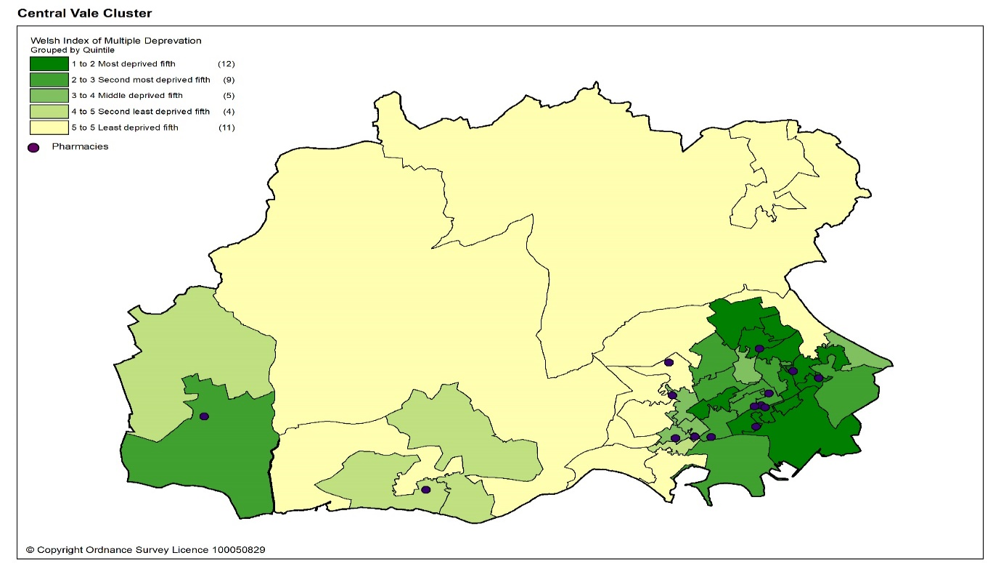
14.1.4 Health profile
Overall, the estimated prevalence of chronic disease in Central Vale cluster is lower than the average for Wales. When compared to the health board, the estimated prevalence of chronic disease is higher. Central Vale cluster has the joint highest estimated prevalence for coronary heart disease and chronic obstructive pulmonary disease (COPD) and the highest estimated prevalence for diabetes out of all the clusters in the health board.
Table 14.3: Estimated percentage prevalence of chronic conditions based on patients on GP practice registers by cluster, local authority, health board and Wales, 2019
 | Percentage
 | Asthma | Coronary heart disease | COPD | Diabetes | Heart failure | Stroke and transient ischaemic attacks
Central Vale | 6.9 | 3.3 | 2.3 | 5.8 | 1.0 | 2.0
Vale of Glamorgan | 6.8 | 3.3 | 1.9 | 5.5 | 1.1 | 2.1
Cardiff & Vale UHB | 6.7 | 2.7 | 1.7 | 5.0 | 0.9 | 1.7
Wales | 7.1 | 3.6 | 2.4 | 6.1 | 1.1 | 2.1
Source: QOF 2019
The prevalence of dementia in Central Vale cluster is lower than the average for Wales and the health board. The prevalence of mental health condition is the same as the average for Wales and the higher than the health board.

Table 14.4: Percentage of patients registered as having a mental health condition, and dementia by cluster, local authority, health board and Wales, 2019
 | Dementia (percentage) | Mental Health (percentage)
Central Vale | 0.6 | 1.0
Vale of Glamorgan | 0.7 | 0.9
Cardiff & Vale UHB | 0.7 | 0.9
Wales | 0.7 | 1.0
Source: QOF 2019
The prevalence of atrial fibrillation in Central Vale cluster is lower than the average for Wales and higher than the health board. The prevalence of hypertension is lower than the average for Wales and the highest of all the clusters in the health board.

Table 14.5: Estimated percentage prevalence of hypertension and atrial fibrillation based on patients on GP practice registers by cluster, local authority, health board and Wales, 2019
 | Atrial Fibrillation (percentage) | Hypertension (percentage)
Central Vale | 2.1 | 15.4
Vale of Glamorgan | 2.3 | 14.9
Cardiff & Vale UHB | 1.8 | 12.6
Wales | 2.3 | 15.8
Source: QOF 2019
Many of the factors that contribute to the inequalities in health and well-being are preventable. Table 14.6 shows the percentage of adults self-reporting five behaviours, where a lower percentage for smoking and drinking above the guidelines is seen as more beneficial to health and well-being as is a higher percentage for working age adults of healthy weight, meeting the physical activity guidelines and consuming five a day.

Overall, the percentage of adults reporting behaviours which support healthy outcomes in Central Vale cluster is lower than Cardiff and Vale University Health Board and the average for Wales, except for drinking above the guidelines.

Table 14.6: Percentage of adults (aged 16 years and over) reporting behaviours by cluster, health board and Wales, 2016 to 2018
 | Count |  |  |  |  |  | Prevalence
GP Cluster Name | GP cluster population aged 16+ | Smoking |  | Drinking the above guidelines |  | Working age adults of healthy weight |  | Meeting physical activity guidelines |  | Consuming 5 a day
Central Vale | 51,644 | 20.6 |  | 18.6 |  | 37.8 |  | 52.3 |  | 23.0
Cardiff and Vale UHB | 420,119 | 19.3 |  | 18.9 |  | 40.8 |  | 55.1 |  | 24.2
Wales | 2,642,152 | 19.2 |  | 18.9 |  | 39.1 |  | 52.8 |  | 23.4
Source: Public Health Wales Observatory, using NSW (WG), WDS (NWIS) and WIMD 2014 (WG). Please note, the calculation of the healthy weight indicator only accounts for working age adults (aged 16-64)

14.1.5. Cluster developments

There are several planned housing developments within Central Vale cluster to meet the housing needs of the predicted growth in population in the Vale of Glamorgan. The largest developments are the phase 2 Barry Waterfront development and land west of Swanbridge Road, Sully, which are expected to be completed by 2026 in line with the Vale of Glamorgan Local Development Plan 2006 to 2026. Other housing developments in the cluster are smaller and include:

Strategic housing sites
Housing site | Number | Complete at April 2020
Phase 2, Barry Waterfront | 1,700 | 1,020
Total | 1,700 | 1,020

Key settlement: Barry
Housing site | Number | Complete at April 2020
Barry Island Pleasure Park | 25 | 0
White Farm | 177 | 177
Land to the east of Pencoedtre Lane | 67 | 67
Land to the west of Pencoedtre Lane | 137 | 0
Ysgol Maes Dyfan | 81 | 81
Barry Magistrates Court | 52 | 52
Court Road Depot, Barry | 50 | 0
15 Holm View | 50 | 0
16 Hayes Wood, The Bendricks | 55 | 0
Total | 694 | 377

Key settlement: Sully
Housing site | Number | Complete at April 2020
Land West of Swanbridge Road, Sully | 500 | 0
Total | 500 | 0

14.2 Current provision of pharmaceutical services within the cluster

There are 14 pharmacies in Central Vale cluster.

In 2019 to 2020, 84.8% of items on prescriptions written by the seven GP practices in Central Vale cluster were dispensed by one of the pharmacies within the cluster and 2.1% were personally administered items.

Table 14.7: Pharmacies in Central Vale cluster
Pharmacy | Address
Aneurin Evans Ltd | West Quay Medical Centre Hood Road | Barry | CF62 5QN
Boots UK Limited | 121/125 Holton Road | Barry | CF63 4SW
Evans Pharmacy - Barry | 8 Park Crescent | Barry | CF62 6HD
Mobec Pharmacy Limited T/A Brockway Pharmacy | Unit 3 Plas Cleddau Cwm Talwg | Barry | CF62 7FG
High Street Pharmacy Gwawr Davies Jones | 88 High Street | Barry | CF62 7DX
Lloyds Pharmacy Limited T/A Lloydspharmacy | Court Road Surgery 29-31 Court Road | Barry | CF63 4YD
Lloyds Pharmacy Limited T/A Lloydspharmacy | Waterfront Medical Centre Heol Y Llongau | Barry | CF63 4AR
Lloyds Pharmacy Limited T/A Lloydspharmacy | Stirling Road Shopping Precinct Port Road | Barry | CF62 8NX
Lloyds Pharmacy Limited T/A Lloydspharmacy | 99-101 Holton Road | Barry | CF63 4HG
National Co-Operative Chemists Ltd T/A The Co-operative Pharmacy | 148 Holton Road | Barry | CF63 4HL
RAJJA Ltd T/A  M W Phillips Chemist | 9 Vere Street Cadoxton | Barry | CF63 2YE
RAJJA Ltd T/A  M W Phillips Chemist | 8 Barry Road Cadoxton | Barry | CF63 1BA
PharmaMed Limited T/A St Brides Pharmacy | 1 St Anns Court Ramsey Road | Barry | CF62 9DN
Unicare Pharmacy Limited T/A Sully Pharmacy | 106 South Road | Sully | CF64 5SN

In general, the pharmacies are located in or near areas of greater population density as shown by the darker shaded areas in the map below.

Map 14.2: Location of pharmacy premises compared to population density
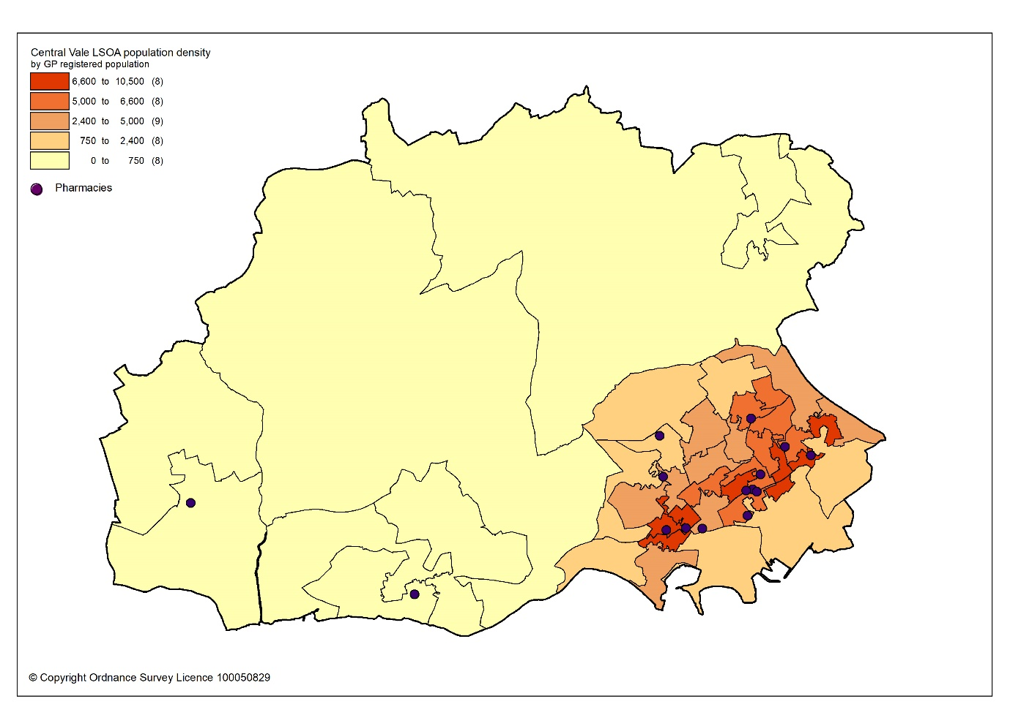

All residents of the cluster can access one of the pharmacies by car within 15 minutes. The majority can access a pharmacy within 10 minutes, as shown in map 14.3.

Map 14.3: Access to pharmacies in the cluster
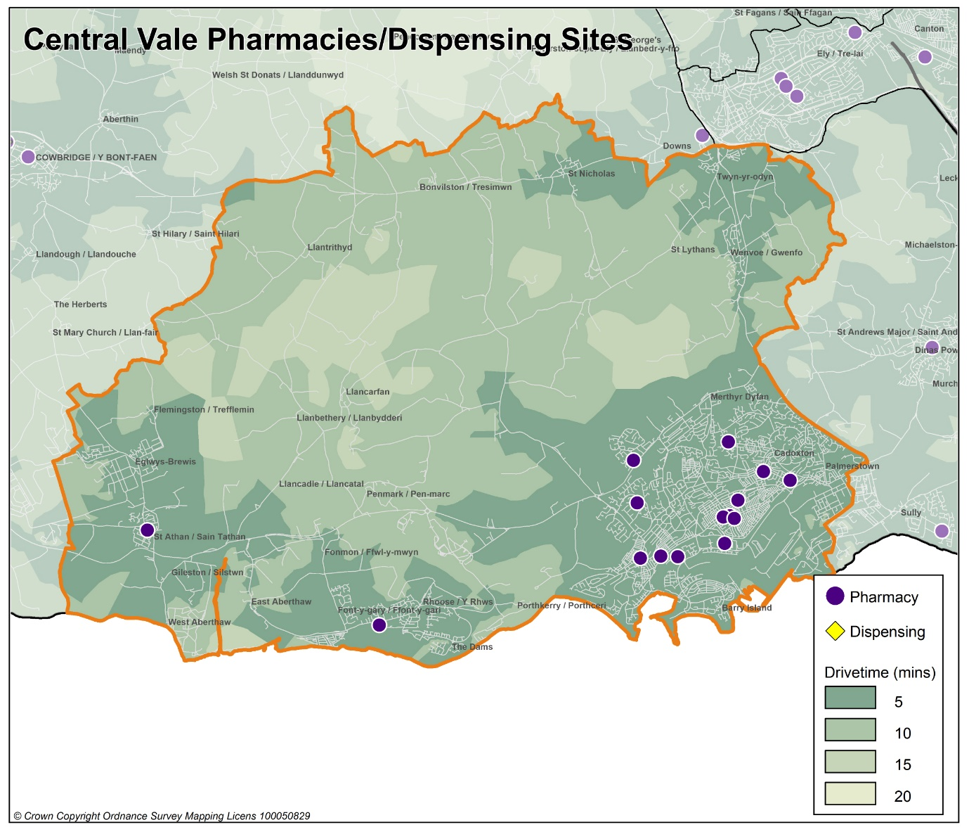

Looking at the opening hours for the pharmacies:

- Two pharmacies are open seven days a week
- One pharmacy is open Monday to Saturday
- Six pharmacies are open Monday to Friday and Saturday morning
- Five pharmacies are open Monday to Friday

All pharmacies must open for their core contractual hours, which are 40 hours a week. These can only be amended with approval by the health board. All additional hours or supplementary hours can be amended by the pharmacy following the provision of 90 days’ notice to the health board. Within the cluster, opening hours and closing hours range from:

Days | Opening hours range | Closing hours range
Monday to Friday | 08.30am to 09.00am | 17.00pm to 19.00pm*
Saturday | 08.30am to 09.00am | 12.00pm to 17.30pm
Sunday | 10.00am | 16.00pm

*One pharmacy close at 16.30pm on Tuesday and one closes at 12.30pm on Wednesday

Full details of when the pharmacies are open can be found in Appendix L.

All 14 pharmacies responded to the contractor questionnaire, of which 12 pharmacies dispense all appliances listed in Part IX of the Drug Tariff, one pharmacy just dispenses dressings and one does not dispense any appliances.

In 2019 to 2020, 13 pharmacies offered the MUR service and a total of 3,518 reviews were provided out of a possible 5,200 reviews. Two pharmacies provided the maximum number of 400 reviews. The Welsh Government formally suspended the MUR service on 13 March 2020. At the time of writing, it is not known if the service will re-commence.

In 2019 to 2020, 10 pharmacies offered the DMR service and a total of 193 reviews were provided out of a possible 1,400 reviews. No pharmacies provided the maximum number of 140 reviews. As part of the changes to the Community Pharmacy Contractual Framework for 2021, the cap for the number of paid DMRs has been removed.

In 2019 to 2020, the following enhanced services were provided by pharmacies in the cluster area:

- Eight pharmacies provided a total of 399 emergency contraception consultations, with a range of three to 183 consultations.
- Four pharmacies provided a total of 146 smoking cessation level 3 consultations, with a range of 21 to 54 consultations.
- 12 pharmacies provided a total of 892 flu vaccinations, with a range of one to 272 vaccinations.
- 13 pharmacies provided a total of 1194 CAS consultations, with a range of 24 to 325 consultations.
- Two pharmacies provided a total of 47 EMS consultations, with a range of 15 to 32 consultations.

Other enhanced services included:
- Eight pharmacies provided the Supervised Administration of Medicines Enhanced Service.
- Two pharmacies provided the Needle Syringe Provision Enhanced Service.
- Five pharmacies provided the Palliative Care Enhanced Service.

14.3 Current provision of pharmaceutical services outside the cluster

Some residents choose to access contractors outside both the cluster and the health board’s area in order to access services:

- Offered by dispensing appliance contractors.
- Which are located near to where they work, shop or visit for leisure or other purposes.

Whilst the majority of prescriptions written by the GP practices in 2019 to 2020 were dispensed by the pharmacies in the cluster, around 13.1% were dispensed outside the cluster, most notably:

- 0.5% by pharmacies in Cardiff South West cluster
- 2.1% by pharmacies in Cardiff City and South cluster
- 5.6% by pharmacies in Western Vale cluster
- 3.3% by pharmacies in Eastern Vale cluster
- 0.5% in Aneurin Bevan University Health Board
- 0.3% in Cwm Taf Morgannwg University Health Board
- 0.7% by contractors in England

In addition, residents may have accessed one or more pharmaceutical services provided by another pharmacy outside of both the cluster and the health board’s area; however, it is not possible to quantify this activity from the recorded data.

Taking into account pharmacies in the neighbouring clusters and pharmacies over the border in other health board areas in Wales, all residents in the cluster of Central Vale can access a pharmacy by car within 15 minutes and the majority can access a pharmacy by car within 10 minutes.

14.4 Other NHS services

Barry Hospital and the Minor Injuries Unit are located within the cluster of Central Vale. However, the hospital serves a much wider population than that of the cluster.

14.5 Choice with regard to obtaining pharmaceutical services

As can be seen from sections 14.2 and 14.3, those living within the cluster area and registered with one of the GP practices generally choose to access one of the pharmacies in the cluster in order to have their prescriptions dispensed. Those that look outside the cluster usually do so to access a neighbouring pharmacy within the health board’s area. A minority choose to have their prescription dispensed by a pharmacy or an appliance contractor outside of the health board’s area.

A total of 298 pharmacy contractors that were trading in Wales during 2019 to 2020, dispensed items written by one of the GP practices in the Central Vale cluster, of which 195 were outside of the health board’s area. 9,569 prescription items were dispensed in England.

14.6 Gaps in provision

The Cardiff and Vale University Health Board has noted the locations of pharmacies across the cluster, and the fact that the population can access a pharmacy by car within 15 minutes, with the majority within 10 minutes. Whilst noting that not all households have access to a car throughout the day, the nature of the cluster means that walking to a pharmacy will be a realistic option for many residents and regular public transport services are available for those who are unable to undertake the whole journey on foot. However, in the more rural areas of Central Vale cluster, public transport services are limited. Although car ownership is likely to be high in these areas, those without a car and in particular the elderly, may find it difficult to access a pharmacy. The majority of pharmacies will have arrangements in place that enable timely access to medicines to those who are housebound or who may find it difficult to access a pharmacy.

The Cardiff and Vale University Health Board has noted the opening hours of the existing pharmacies and is of the opinion that they are sufficient to meet the likely needs of residents in the cluster. The Cardiff and Vale University Health Board has therefore concluded that there are no current needs in relation to the provision of essential services by pharmacies in the cluster.

The Cardiff and Vale University Health Board is also satisfied that there are no current needs in relation to the provision of advanced services. Whilst none of the pharmacies provide the Appliance Use Review service or the Stoma Appliance Customisation service, it is noted that there are four appliance contractors based in Cardiff and Vale University Health Board who offer these services. One of the reasons why prescriptions are dispensed outside of the cluster is because they have been sent to a dispensing appliance contractor elsewhere in the health board or to England, which provide these services. Patients will therefore be able to access these two services via those contractors. The Cardiff and Vale University Health Board has therefore not identified any current or future gap or better access in relation to the provision of these two advanced services in the cluster

All 14 pharmacies responded to the question in the contractor questionnaire regarding capacity to meet demand from any future housing developments in the cluster. Their responses were as follows:

- 11 pharmacies have sufficient capacity within their existing premises and staffing levels to manage the increase in demand in the area.
- Two pharmacies do not have sufficient premises and staffing capacity at present but could make adjustments to manage the increase in demand in the area
- One pharmacy does not have sufficient premises and staffing capacity and would have difficulty in managing the increase in demand.

The Cardiff and Vale University Health Board noted the developments planned for the cluster, in particular the larger phase 2 Barry Waterfront development and other smaller units of housing that are due to be built during the lifetime of this document, Cardiff and Vale University Health Board is satisfied, based upon the responses to the contractor questionnaire, that the demand that this will create can be met by the existing pharmacies. The Cardiff and Vale University Health Board has therefore concluded that there are no future needs in relation to the provision of essential services by pharmacies in the cluster

The Cardiff and Vale University Health Board is also satisfied that, based upon the information contained in the preceding sections, there are no current or future gaps in the provision of advanced services and enhanced services.

The Cardiff and Vale University Health Board will keep service provision under review but has concluded that there is no current or future need identified which requires an application for new or additional premises.

15 Eastern Vale cluster

15.1 Key facts

15.1.1 Population and population projections 2018 to 2028 (2018 based)
As cluster level population data is not routinely collected on an annual basis,
GP registered patient data has been used to provide an indication of cluster population, and local authority based data has been used to provide an indication of population projections.

Note that GP registered population data is higher than the corresponding census based mid-year population estimates provided by the Office of National Statistics (ONS) at the local authority and health board level, as outlined in section 2.2. This is most likely due to over registered or ‘ghost patients’ caused by many different factors.

Table 15: Number of GP registered patients by gender and broad age groups and by cluster, local authority and health board (2019)
 | Year | Gender |  | Age range
 | 2019 | Female | Male | Under 65 | 65 to 84 | 85 and over
Eastern Vale | 36727 | 18817 | 17910 | 28231 | 7208 | 1288
Vale of Glamorgan | 131558 | 66983 | 64575 | 104113 | 23813 | 3632
Cardiff and Vale UHB | 521177 | 260027 | 261150 | 439365 | 70412 | 11400
Source: StatsWales - NHS Wales Shared Services Partnership.
Between 2018 to 2028, the population of the Vale of Glamorgan is projected to increase by up to 6%, the second largest percentage increase of all the local authorities within Wales. It is expected to have a population of around 140,000 by 2028, making it the tenth largest local authority in Wales. The increase in population will mainly be driven by net migration i.e. more people moving into the area than out. The number of births is expected to increase over this period as is the number of deaths, resulting in a negative natural change (more deaths than births). The population is expected to increase across all broad age groups. Overall, there will be a small increase in the number of children and young people aged 0 to 15 years old and in the working-age population aged 16 to 64 years old. The largest population increases will be in the over 65 age group, where the Vale of Glamorgan is expected to have the largest increase of all local authorities at up to 20.5%. This is followed by the 75 or over age group. The population is projected to continue to age in the local authority.

15.1.2 Life expectancy, healthy life expectancy and the ‘inequality gap’

Life expectancy at birth in the Vale of Glamorgan is higher than the average for Wales and the health board for both females and males, for 2015 to 2017. The difference in life expectancy that exists across an area between the most and least deprived areas is referred to as the ‘inequality gap’. The inequality gap in life expectancy at birth between the most and least deprived fifth, for the Vale of Glamorgan is narrower than the average for Wales and the health board for both females and males. The healthy life expectancy (the number of years a person can expect to live in good health) in the Vale of Glamorgan is also higher than the average for Wales and the health board for both females and males.

Table 15.1: Life expectancy, healthy life expectancy and the ‘inequality gap’ (2015 to 2017)
 | Life expectancy at birth (years) |  |  | Healthy life expectancy (years) |  |  | Inequality gap  (years)
 | Females | Males | Females |  | Males | Females |  | Males
Vale of Glamorgan | 83.4 | 78.9 | 64.2 |  | 63.1 | 6.0 |  | 7.0
Cardiff and Vale UHB | 83.0 | 78.7 | 62.0 |  | 61.9 | 6.6 |  | 8.6
Wales | 82.3 | 78.3 | 62.0 |  | 61.4 | 6.1 |  | 7.4
Source: Public Health Wales Observatory PHOF Tool (2017) using ONS and WG data

15.1.3 Deprivation

Deprivation is the lack of access to opportunities and resources which might be expected in society. The Welsh Index of Multiple Deprivation (WIMD) allows for the ranking of small areas, called Lower layer Super Output Areas (LSOAs) in Wales to determine whether an area is more or less deprived compared to all other small areas in Wales.

Overall, the Vale of Glamorgan (13%) has a lower percentage of LSOAs in the most deprived 10% and 20% of LSOAs in Wales relative to Cardiff and Vale University Health Board (24%). When considering the domains for income, health, employment and access to services at the cluster level, Eastern Vale cluster has none of its LSOAs in the most deprived 10% and 20% of LSOAs in Wales, making it one of the least deprived areas in the health board and Wales.

Table 15.2: Number of LSOAs within the 10% and 20% most deprived LSOAs in Wales by cluster, local authority and health board for the domains of income, health, employment, and access to services, Welsh Index of Multiple Deprivation 2019
 | Number of LSOAs within the 10% and 20% most deprived LSOAs in Wales
 | Income |  | Health |  | Employment |  | Access to services
 | 10% | 20% | 10% | 20% | 10% | 20% | 10% | 20%
Central Vale | 5 | 13 | 4 | 8 | 4 | 11 | 0 | 0
Eastern Vale | 0 | 0 | 0 | 0 | 0 | 0 | 0 | 0
Western Vale | 0 | 0 | 0 | 0 | 0 | 0 | 3 | 6
Vale of Glamorgan | 5 | 13 | 4 | 8 | 4 | 11 | 3 | 6
Cardiff and Vale UHB | 46 | 72 | 38 | 64 | 34 | 51 | 3 | 15
Source: Welsh Index of Multiple Deprivation 2019, Welsh Government

The map below provides an indication of the overall levels of deprivation within the cluster. As can be seen from the map, Eastern Vale cluster has relatively low levels of deprivation. The majority of pharmacies are located within or near areas of higher deprivation.

Map 15.1: Lower Super Output Areas (LSOAs) in Eastern Vale cluster, grouped into
quintiles by Welsh index of Multiple Deprivation 2019
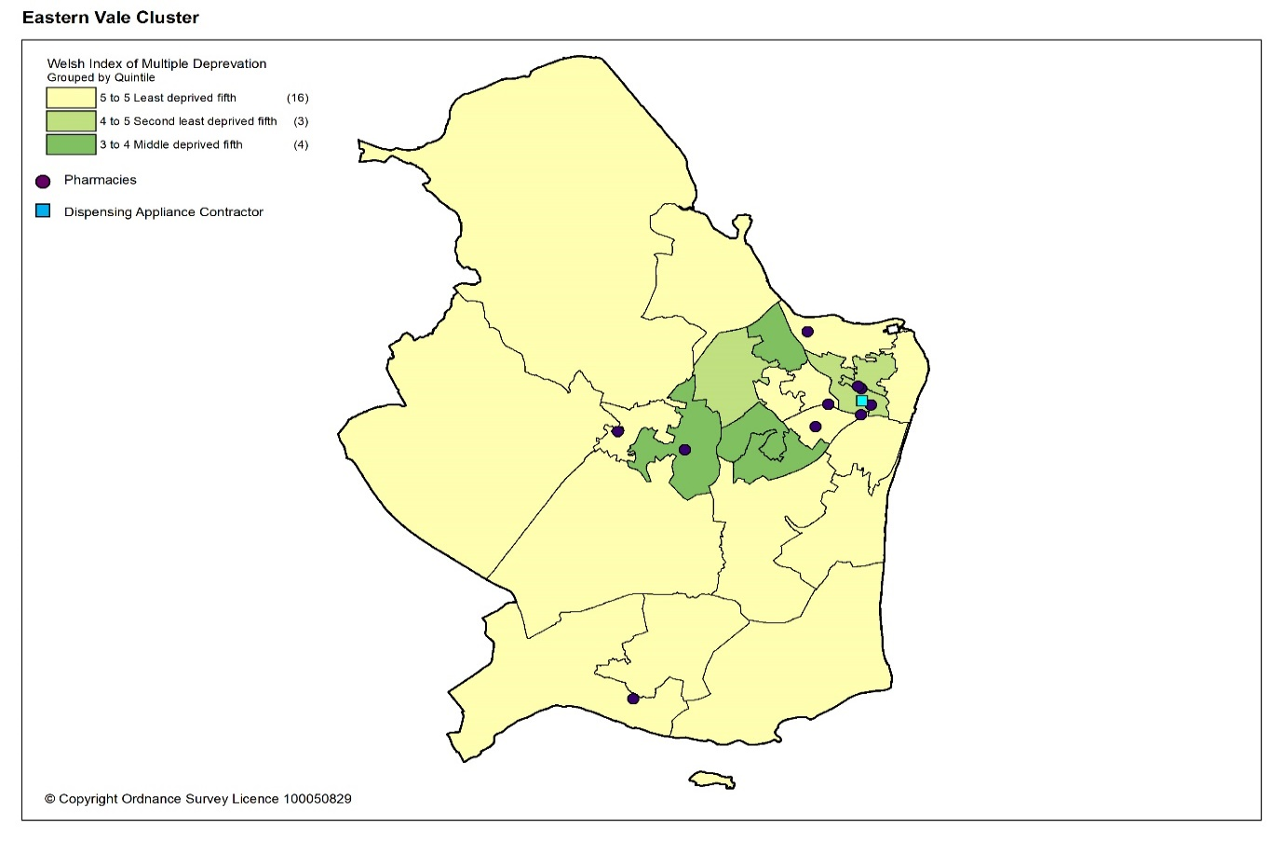

15.1.4 Health profile

Overall, the estimated prevalence of chronic disease in Eastern Vale cluster is lower than the average for Wales, except for stroke and transient ischaemic attacks where it is the same. When compared to the health board, the estimated prevalence of chronic disease is in general higher, except for chronic obstructive pulmonary disease (COPD). Eastern Vale cluster has the joint highest estimated prevalence for coronary heart disease out of all the clusters in the health board and the second highest estimated prevalence of stroke and transient ischaemic attacks.

Table 15.3: Estimated percentage prevalence of chronic conditions based on patients on GP practice registers by cluster, local authority, health board and Wales, 2019
 | Percentage
 | Asthma | Coronary heart disease | COPD | Diabetes | Heart failure | Stroke and transient ischaemic attacks
Eastern Vale | 6.8 | 3.3 | 1.5 | 5.2 | 1.0 | 2.1
Vale of Glamorgan | 6.8 | 3.3 | 1.9 | 5.5 | 1.1 | 2.1
Cardiff & Vale UHB | 6.7 | 2.7 | 1.7 | 5.0 | 0.9 | 1.7
Wales | 7.1 | 3.6 | 2.4 | 6.1 | 1.1 | 2.1
Source: QOF 2019
The estimated prevalence of dementia in Eastern Vale cluster is higher than the average for Wales and the highest of all the clusters in the health board. The estimated prevalence for mental health is lower than the average for Wales and the health board average.

Table 15.4: Percentage of patients registered as having a mental health condition, and dementia by cluster, local authority, health board and Wales, 2019
 | Dementia (percentage) | Mental Health (percentage)
Eastern Vale | 0.9 | 0.8
Vale of Glamorgan | 0.7 | 0.9
Cardiff & Vale UHB | 0.7 | 0.9
Wales | 0.7 | 1.0
Source: QOF 2019
The estimated prevalence of atrial fibrillation in Eastern Vale cluster is higher than the average for Wales and the second highest of all the clusters in the health board. The estimated prevalence of hypertension is lower than the average for Wales and the second highest of all the clusters in the health board.

Table 15.5: Estimated percentage prevalence of hypertension and atrial fibrillation based on patients on GP practice registers by cluster, local authority, health board and Wales, 2019
 | Atrial Fibrillation (percentage) | Hypertension (percentage)
Eastern Vale | 2.4 | 14.7
Vale of Glamorgan | 2.3 | 14.9
Cardiff & Vale UHB | 1.8 | 12.6
Wales | 2.3 | 15.8
Source: QOF 2019
Many of the factors that contribute to the inequalities in health and well-being are preventable. Table 15.6 shows the percentage of adults self-reporting five behaviours, where a lower percentage for smoking and drinking above the guidelines is seen as more beneficial to health and well-being as is a higher percentage for working age adults of healthy weight, meeting the physical activity guidelines and consuming five a day.

Overall, the percentage of adults reporting behaviours which support healthy outcomes in Eastern Vale cluster is higher than Cardiff and Vale University Health Board and the average for Wales, except for drinking above the guidelines.

Table 15.6: Percentage of adults (aged 16 years and over) reporting behaviours by cluster, health board and Wales, 2016 to 2018
 | Count |  |  |  |  |  | Prevalence
GP Cluster Name | GP cluster population aged 16+ | Smoking |  | Drinking the above guidelines |  | Working age adults of healthy weight |  | Meeting physical activity guidelines |  | Consuming 5 a day
Eastern Vale | 30,400 | 12.8 |  | 21.3 |  | 42.8 |  | 57.6 |  | 27.3
Cardiff and Vale UHB | 420,119 | 19.3 |  | 18.9 |  | 40.8 |  | 55.1 |  | 24.2
Wales | 2,642,152 | 19.2 |  | 18.9 |  | 39.1 |  | 52.8 |  | 23.4
Source: Public Health Wales Observatory, using NSW (WG), WDS (NWIS) and WIMD 2014 (WG). Please note, the calculation of the healthy weight indicator only accounts for working age adults (aged 16-64)

15.1.5 Cluster developments
There are several housing developments planned within the cluster to meet the housing needs of the predicted growth in population in the Vale of Glamorgan. The biggest housing development is on land on the Upper Cosmeston Farm in Lavernock, which is expected to be completed within the lifetime of this PNA. Other housing developments in the cluster are smaller and include:

Key settlement: Penarth
Housing site | Number | Complete at April 2020
Land at Upper Cosmeston Farm, Lavernock | 576 | 0
Land adjoining St. Josephs School, Sully Road | 74 | 74
Headlands School, St. Augustine’s Road | 65 | 0
Land adjacent to Oak Court, Penarth | 145 | 0
Total | 860 | 74

Key settlement: Dinas Powys
Housing site | Number | Complete at April 2020
Land at and adjoining St. Cyres School, Murch Road | 300 | 103
Land off Caerleon Road, Dinas Powys | 70 | 64
Land at Ardwyn, Pen-y-Turnpike | 18 | 18
Land at Cross Common Road | 50 | 49
Total | 438 | 234

Key settlement: Llandough (Penarth)
Housing site | Number | Complete at April 2020
Land south of Llandough Hill / Penarth Road | 130 | 0
Land north of Leckwith Road | 8 | 0
Llandough Landings | 120 | 0
Total | 258 | 258

There are plans for a Wellbeing Hub in Cogan, which will house some other community services as well as current Penarth GP practice.
15.2 Current provision of pharmaceutical services within the cluster

There are nine pharmacies in Eastern Vale. There is also one appliance contractor.

Table 15.7: Pharmacies in Eastern Vale cluster
Pharmacy |  | Address
Boots UK Limited | 24 Winsdor Road |  | Penarth | CF64 1YJ
Tesco Stores Limited | Tesco Instore Pharmacy Penarth Haven |  | Penarth | CF64 1SA
Pearns Pharmacies Ltd T/A Ivor Owen Pharmacy | 5a Cornerswell Road |  | Penarth | CF64 2UW
Pearn's Pharmacies Ltd | 36 Windsor Road |  | Penarth | CF64 1YD
Mayberry Pharmacy | Mayberry pharmacy 3 Royal Buildings Stanwell Road |  | Penarth | CF64 3EB
TH & L Jones | 26 Cardiff Road |  | Dinas Powys | CF64 4JS
TH & L Jones | The Murch Pharmacy Dinas Powys Medical Ctre Murch Rd |  | Dinas Powys | CF64 4RE
Pearns Pharmacies T/A Varus Pharmacy | The Health Centre Stanwell Road |  | Penarth | CF64 3XE
Pearns Pharmacies T/A Washington Pharmacy | Stanwell Road |  | Penarth | CF64 2AD

In 2019 to 2020, 90.6% of items on prescriptions written by the four GP practices in Eastern Vale cluster were dispensed by one of the pharmacies within the cluster and 1.8% were personally administered items.

The pharmacies are located in areas of greater population density as shown by the darker shaded areas in the map below.

Map 15.2: Location of pharmacy and appliance contractor premises compared to population density
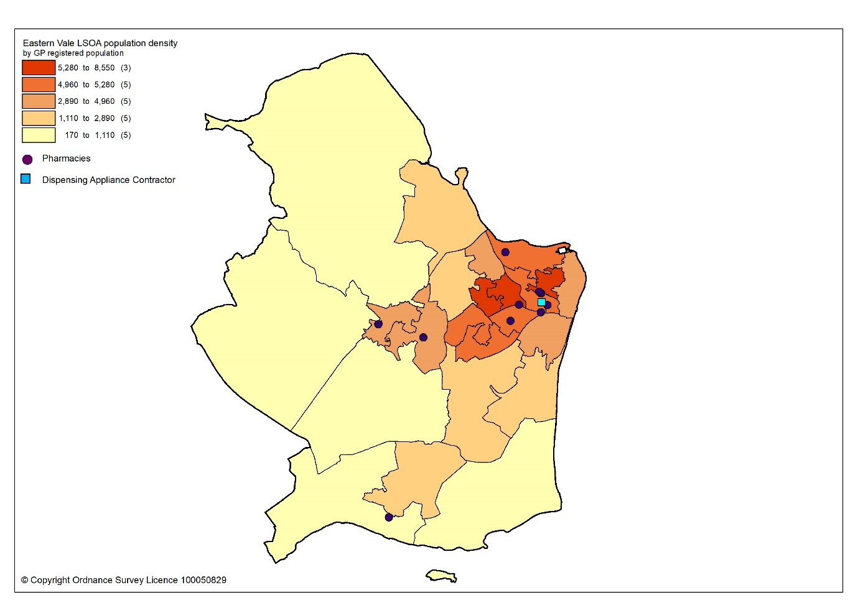
All residents of the cluster can access one of the pharmacies by car within 10 minutes. The majority can access a pharmacy within five minutes, as shown in map 15.3.

Map 15.3: Access to pharmacies and appliance contractor in the cluster
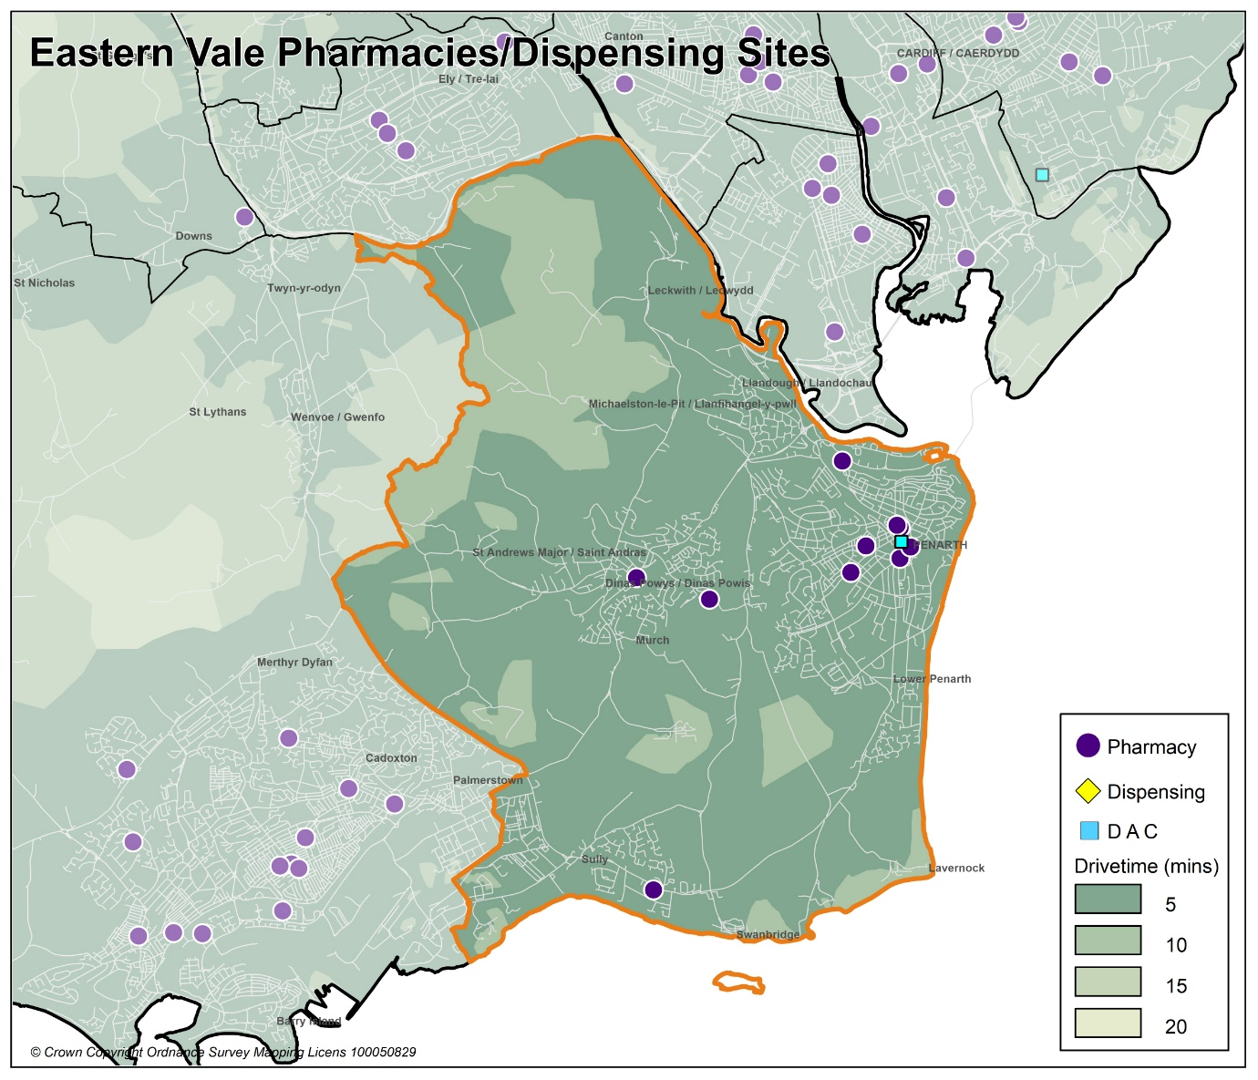

Looking at the opening hours for the pharmacies:

- Two pharmacies are open seven days a week
- Two pharmacies are open Monday to Saturday
- Three pharmacies are open Monday to Friday and Saturday morning
- Two pharmacies are open Monday to Friday

All pharmacies must open for their core contractual hours, which are 40 hours a week. These can only be amended with approval by the health board. All additional hours or supplementary hours can be amended by the pharmacy following the provision of 90 days’ notice to the health board. Within the cluster, opening hours and closing hours range from:

Days | Opening hours range | Closing hours range
Monday to Friday | 08.00am to 09.00am | 17.30pm to 20.00pm
Saturday | 08.00am to 09.00am | 13.00pm to 20.00pm
Sunday | 10.00am | 16.00pm

Full details of when the pharmacies are open can be found in Appendix L.

All nine pharmacies responded to the contractor questionnaire, of which six dispense all appliances listed in Part IX of the Drug Tariff and three just dispense dressings.

In 2019 to 2020, eight pharmacies offered the MUR service and a total of 1,546 reviews were provided out of a possible 3,200 reviews. One pharmacy provided the maximum number of 400 reviews. The Welsh Government formally suspended the MUR service on 13 March 2020. At the time of writing, it is not known if the service will re-commence.

In 2019 to 2020, six pharmacies offered the DMR service and a total of 323 reviews were provided out of a possible 840 reviews. No pharmacies provided the maximum number of reviews. As part of the changes to the Community Pharmacy Contractual Framework for 2021, the cap for the number of paid DMRs has been removed.

In 2019 to 2020, the following enhanced services were provided by pharmacies in the cluster area:

- Five pharmacies provided a total of 254 emergency contraception consultations, with a range of eight to 176 consultations.
- Two pharmacies provided a total of 22 smoking cessation level 3 consultations, with a range of seven to 15 consultations.
- Seven pharmacies provided a total of 1307 flu vaccinations, with a range of 23 to 596 vaccinations.
- Eight pharmacies provided a total of 259 CAS consultations, with a range of four to 77 consultations.
- Five pharmacies provided a total of 39 EMS consultations, with a range of two to 23 consultations

Other enhanced services included:
- Four pharmacies provided the Supervised Administration of Medicines Enhanced Service.
- Two pharmacies provided the Needle Syringe Provision Enhanced Service.
- Two pharmacies provided the Palliative Care Enhanced Service.

15.3 Current provision of pharmaceutical services outside the cluster

Some residents choose to access contractors outside both the cluster and the health board’s area in order to access services:

- Offered by dispensing appliance contractors.
- Which are located near to where they work, shop or visit for leisure or other purposes.

Whilst the majority of prescriptions written by the GP practices in 2019 to 2020 were dispensed by the pharmacies in the cluster, around 7.6% were dispensed outside the cluster, most notably:

- 4.5% by pharmacies in Cardiff City & South cluster
- 0.1% by pharmacies in Cardiff South West cluster
- 1.9% by pharmacies in Central Vale cluster
- 0.1% in Aneurin Bevan University Health Board
- 0.1% in Cwm Taf Morgannwg University Health Board
- 0.7% by contractors in England

In addition, residents may have accessed one or more pharmaceutical services provided by another pharmacy outside of both the cluster and the health board’s area; however, it is not possible to quantify this activity from the recorded data.

Taking into account pharmacies in the neighbouring clusters and pharmacies over the border in other health board areas in Wales, all residents in the cluster of Eastern Vale can access a pharmacy by car within 10 minutes and the majority can access a pharmacy by car within five minutes.

15.4 Other NHS services

Llandough Hospital is located within the cluster of Eastern Vale. However, the hospital serves a much wider population than that of the cluster.

15.5 Choice with regard to obtaining pharmaceutical services

As can be seen from sections 15.2 and 15.3, those living within the cluster area and registered with one of the GP practices generally choose to access one of the pharmacies in the cluster in order to have their prescriptions dispensed. Those that look outside the cluster usually do so to access a neighbouring pharmacy within the health board’s area. A minority choose to have their prescription dispensed by a pharmacy or an appliance contractor outside of the health board’s area.

A total of 212 pharmacy contractors that were trading in Wales during 2019 to 2020, dispensed items written by one of the GP practices in the Eastern Vale cluster, of which 109 were outside of the health board’s area. 5,416 prescription items were dispensed in England.

15.6 Gaps in provision

The Cardiff and Vale University Health Board has noted the locations of pharmacies across the cluster, and the fact that the population can access a pharmacy by car within 10 minutes, with the majority within five minutes. Whilst noting that not all households have access to a car throughout the day, the nature of the cluster means that walking to a pharmacy will be a realistic option for many residents and regular public transport services are available for those who are unable to undertake the whole journey on foot.

The Cardiff and Vale University Health Board has noted the opening hours of the existing pharmacies and is of the opinion that they are sufficient to meet the likely needs of residents in the cluster. The Cardiff and Vale University Health Board has therefore concluded that there are no current needs in relation to the provision of essential services by pharmacies in the cluster.

The Cardiff and Vale University Health Board is also satisfied that there are no current needs in relation to the provision of advanced services. Whilst none of the pharmacies provide the Appliance Use Review service or the Stoma Appliance Customisation service, it is noted that there are four appliance contractors based in Cardiff and Vale University Health Board, one of which is based within the cluster, who offer these services. One of the reasons why prescriptions are dispensed outside of the cluster is because they have been sent to a dispensing appliance contractor elsewhere in the health board or to England, which provide these services. Patients will therefore be able to access these two services via those contractors. The Cardiff and Vale University Health Board has therefore not identified any current or future gap or better access in relation to the provision of these two advanced services in the cluster

All nine pharmacies responded to the question in the contractor questionnaire regarding capacity to meet demand from any future housing developments in the cluster. All nine pharmacies have sufficient capacity within their existing premises and staffing levels to manage the increase in demand in the area.

The Cardiff and Vale University Health Board noted the developments planned for the cluster, in particular the bigger housing developments on land on the Upper Cosmeston Farm in Lavernock, and other smaller units of housing that are due to be built during the lifetime of this document. Cardiff and Vale University Health Board is satisfied, based upon the responses to the contractor questionnaire, that the demand that this will create can be met by the existing pharmacies. The Cardiff and Vale University Health Board has therefore concluded that there are no future needs in relation to the provision of essential services by pharmacies in the cluster

The Cardiff and Vale University Health Board is also satisfied that, based upon the information contained in the preceding sections, there are no current or future gaps in the provision of advanced services and enhanced services.

The Cardiff and Vale University Health Board will keep service provision under review but has concluded that there is no current or future need identified which requires an application for new or additional premises.

16 Western Vale cluster

16.1 Key facts

16.1.1 Population and population projections 2018 to 2028 (2018 based)
As cluster level population data is not routinely collected on an annual basis,
GP registered patient data has been used to provide an indication of cluster population, and local authority based data has been used to provide an indication of population projections.

Note that GP registered population data is higher than the corresponding census based mid-year population estimates provided by the Office of National Statistics (ONS) at the local authority and health board level, as outlined in section 2.2. This is most likely due to over registered or ‘ghost patients’ caused by many different factors.

Table 16: Number of GP registered patients by gender and broad age groups and by cluster, local authority and health board (2019)
 | Year | Gender |  | Age range
 | 2019 | Female | Male | Under 65 | 65 to 84 | 85 and over
Western Vale | 29063 | 14869 | 14194 | 22160 | 6064 | 839
Vale of Glamorgan | 131558 | 66983 | 64575 | 104113 | 23813 | 3632
Cardiff and Vale UHB | 521177 | 260027 | 261150 | 439365 | 70412 | 11400
Source: StatsWales - NHS Wales Shared Services Partnership.
Between 2018 to 2028, the population of the Vale of Glamorgan is projected to increase by up to 6%, the second largest percentage increase of all the local authorities within Wales. It is expected to have a population of around 140,000 by 2028, making it the tenth largest local authority in Wales. The increase in population will mainly be driven by net migration i.e. more people moving into the area than out. The number of births is expected to increase over this period as is the number of deaths, resulting in a negative natural change (more deaths than births). The population is expected to increase across all broad age groups. Overall, there will be a small increase in the number of children and young people aged 0 to 15 years old and in the working-age population aged 16 to 64 years old. The largest population increases will be in the over 65 age group, where the Vale of Glamorgan is expected to have the largest increase of all local authorities at up to 20.5%. This is followed by the 75 or over age group. The population is projected to continue to age in the local authority.

16.1.2 Life expectancy, healthy life expectancy and the ‘inequality gap’

Life expectancy at birth in the Vale of Glamorgan is higher than the average for Wales and the health board for both females and males, for 2015 to 2017. The difference in life expectancy that exists across an area between the most and least deprived areas is referred to as the ‘inequality gap’. The inequality gap in life expectancy at birth between the most and least deprived fifth, for the Vale of Glamorgan is narrower than the average for Wales and the health board for both females and males. The healthy life expectancy (the number of years a person can expect to live in good health) in the Vale of Glamorgan is also higher than the average for Wales and the health board for both females and males.

Table 16.1: Life expectancy, healthy life expectancy and the ‘inequality gap’ (2015 to 2017)
 | Life expectancy at birth (years) |  |  | Healthy life expectancy (years) |  |  | Inequality gap  (years)
 | Females | Males | Females |  | Males | Females |  | Males
Vale of Glamorgan | 83.4 | 78.9 | 64.2 |  | 63.1 | 6.0 |  | 7.0
Cardiff and Vale UHB | 83.0 | 78.7 | 62.0 |  | 61.9 | 6.6 |  | 8.6
Wales | 82.3 | 78.3 | 62.0 |  | 61.4 | 6.1 |  | 7.4
Source: Public Health Wales Observatory PHOF Tool (2017) using ONS and WG data

16.1.3 Deprivation

Deprivation is the lack of access to opportunities and resources which might be expected in society. The Welsh Index of Multiple Deprivation (WIMD) allows for the ranking of small areas, called Lower layer Super Output Areas (LSOAs) in Wales to determine whether an area is more or less deprived compared to all other small areas in Wales.

Overall, the Vale of Glamorgan (13%) has a lower percentage of LSOAs in the most deprived 10% and 20% of LSOAs in Wales relative to Cardiff and Vale University Health Board (24%). When considering the domains for income, health and employment at the cluster level, Western Vale cluster has none of its LSOAs in the most deprived 10% and 20% of LSOAs in Wales. When considering the domain for access to services at the cluster level, all the LSOAs in the Vale of Glamorgan in the most deprived 10% and 20% of LSOAs in Wales are within Western Vale cluster and can be found around Cowbridge, Wales St Donats, Rhoose and Ogmore by Sea. Overall, Western Vale is one of the least deprived areas in the Vale of Glamorgan, health board and Wales.

Table 16.2: Number of LSOAs within the 10% and 20% most deprived LSOAs in Wales by cluster, local authority and health board for the domains of income, health, employment and access to services, Welsh Index of Multiple Deprivation 2019
 | Number of LSOAs within the 10% and 20% most deprived LSOAs in Wales
 | Income |  | Health |  | Employment |  | Access to services
 | 10% | 20% | 10% | 20% | 10% | 20% | 10% | 20%
Central Vale | 5 | 13 | 4 | 8 | 4 | 11 | 0 | 0
Eastern Vale | 0 | 0 | 0 | 0 | 0 | 0 | 0 | 0
Western Vale | 0 | 0 | 0 | 0 | 0 | 0 | 3 | 6
Vale of Glamorgan | 5 | 13 | 4 | 8 | 4 | 11 | 3 | 6
Cardiff and Vale UHB | 46 | 72 | 38 | 64 | 34 | 51 | 3 | 15
Source: Welsh Index of Multiple Deprivation 2019, Welsh Government
The map below provides an indication of the overall levels of deprivation within the cluster. As can be seen from the map, Western Vale has relatively low levels of deprivation.

Map 16.1: Lower Super Output Areas (LSOAs) in Western Vale cluster, grouped into quintiles by Welsh index of Multiple Deprivation 2019
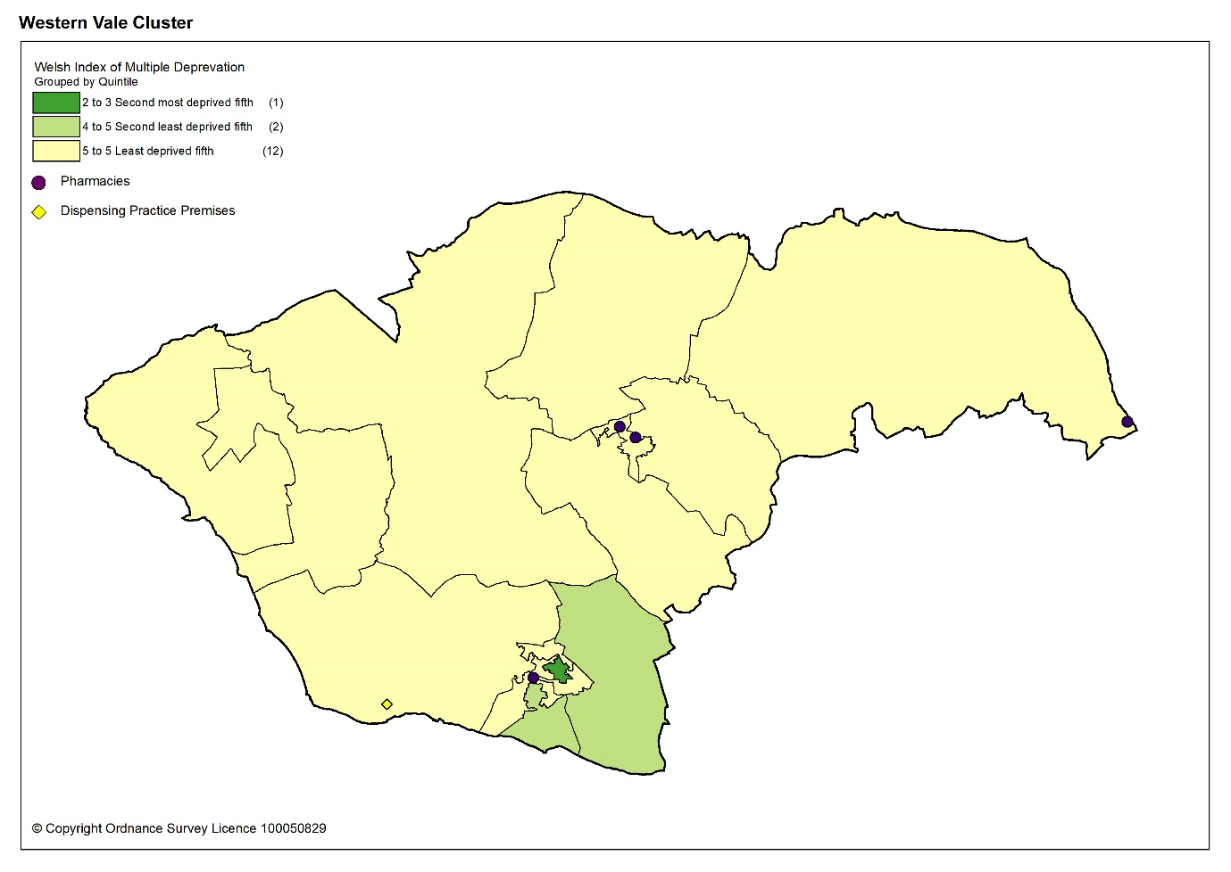

Overall, the estimated prevalence of chronic disease in Western Vale cluster is lower than the average for Wales, except for stroke and transient ischaemic attacks, and heart failure.

When compared to the health board, the estimated prevalence of chronic disease is in general higher, except for asthma and chronic obstructive pulmonary disease (COPD). The estimated prevalence of coronary heart disease is the joint highest, and the estimated prevalence of heart failure and stroke and transient ischaemic attacks is the highest, of all the clusters in the health board.

Table 16.3: Estimated percentage prevalence of chronic conditions based on patients on GP practice registers by cluster, local authority, health board and Wales, 2019
 | Percentage
 |  | Asthma | Coronary heart disease | COPD | Diabetes | Heart failure | Stroke and transient ischaemic attacks
Western Vale |  | 6.3 | 3.3 | 1.4 | 5.2 | 1.4 | 2.5
Vale of Glamorgan |  | 6.8 | 3.3 | 1.9 | 5.5 | 1.1 | 2.1
Cardiff & Vale UHB |  | 6.7 | 2.7 | 1.7 | 5.0 | 0.9 | 1.7
Wales |  | 7.1 | 3.6 | 2.4 | 6.1 | 1.1 | 2.1
Source: QOF 2019
The estimated prevalence of dementia in Western Vale cluster is higher than the average for Wales and the joint second highest of all the clusters in the health board. The estimated prevalence for mental health is lower than the average for Wales and the joint lowest within the health board.

Table 16.4: Percentage of patients registered as having a mental health condition, and dementia by cluster, local authority, health board and Wales, 2019
 | Dementia (percentage) | Mental Health (percentage)
Western Vale | 0.8 | 0.7
Vale of Glamorgan | 0.7 | 0.9
Cardiff & Vale UHB | 0.7 | 0.9
Wales | 0.7 | 1.0
Source: QOF 2019
The estimated prevalence of atrial fibrillation in Western Vale cluster is higher than the average for Wales and the highest of all the clusters in the health board. The estimated prevalence of hypertension is lower than the average for Wales and is the third highest in the health board.

Table 16.5: Estimated percentage prevalence of hypertension and atrial fibrillation based on patients on GP practice registers by cluster, local authority, health board and Wales, 2019
 | Atrial Fibrillation (percentage) | Hypertension (percentage)
Western Vale | 2.8 | 14.3
Vale of Glamorgan | 2.3 | 14.9
Cardiff & Vale UHB | 1.8 | 12.6
Wales | 2.3 | 15.8
Source: QOF 2019
Many of the factors that contribute to the inequalities in health and well-being are preventable. Table 16.6 shows the percentage of adults self-reporting five behaviours, where a lower percentage for smoking and drinking above the guidelines is seen as more beneficial as is a higher percentage for working age adults of healthy weight, meeting the physical activity guidelines and consuming five a day.

Overall, the percentage of adults reporting behaviours which support healthy outcomes in Western Vale cluster is higher than Cardiff and Vale University Health Board and the average for Wales, except for drinking above the guidelines.

Table 16.6: Percentage of adults (aged 16 years and over) reporting behaviours by cluster, health board and Wales, 2016 to 2018
 | Count |  |  |  |  |  | Prevalence
GP Cluster Name | GP cluster population aged 16+ | Smoking |  | Drinking the above guidelines |  | Working age adults of healthy weight |  | Meeting physical activity guidelines |  | Consuming 5 a day
Western Vale | 23,410 | 13.2 |  | 21.4 |  | 43.3 |  | 57.3 |  | 27.3
Cardiff and Vale UHB | 420,119 | 19.3 |  | 18.9 |  | 40.8 |  | 55.1 |  | 24.2
Wales | 2,642,152 | 19.2 |  | 18.9 |  | 39.1 |  | 52.8 |  | 23.4
Source: Public Health Wales Observatory, using NSW (WG), WDS (NWIS) and WIMD 2014 (WG). Please note, the calculation of the healthy weight indicator only accounts for working age adults (aged 16-64)

16.1.5 Cluster developments

The biggest housing developments in the Western Vale cluster are on land to the north and west of Darren Close, Cowbridge and land north of the Railway Line, Rhoose. As of 1st April 2020, work had started on both sites with the remainder expected to be completed within the lifetime of this PNA. Other housing developments in the cluster include:

Strategic housing sites
Housing site | Number | Complete at April 2020
Land at Higher End, St. Athan | 220 | 100
Land at Church Farm, St. Athan | 250 | 0
Former Stadium Site / Land adjacent to Burley Place, St. Athan | 65 | 0
Land to the east of Eglwys Brewis, St Athan | 255 | 0
Land adjacent to Froglands Farm, Llantwit Major | 90 | 0
Land between new Northern Access Road and Eglwys Brewis Road, Llantwit Major | 375 | 0
Total | 1,255 | 100

Key settlement: Cowbridge
Housing site | Number | Complete at April 2020
Cowbridge Comprehensive Lower School | 21 | 21
Cowbridge Comprehensive 6th Form Block, Aberthin Road | 20 | 0
Land adjoining St. Athan Road, Cowbridge | 130 | 0
Land to the north and west of Darren Close, Cowbridge | 475 | 43
Total | 646 | 63

Key settlement: Llantwit Major
Housing site | Number | Complete at April 2020
Llantwit Major 21 Plasnewydd Farm, Llantwit Major | 149 | 136
Land adjacent to Llantwit Major Bypass | 89 | 63
Former Eagleswell Primary School | 72 | 0
Total | 310 | 199

Key settlement: Rhoose
Housing site | Number | Complete at April 2020
Land north of the Railway Line, Rhoose | 700 | 223
Land south of the Railway Line, Rhoose | 87 | 97
Total | 787 | 320

16.2 Current provision of pharmaceutical services within the cluster

For the purposes of the PNA the pharmacies at Rhoose and St Athan will be considered in the Western Vale cluster chapter as historically this is how they have been allocated as all are rural in area and share GP practices.

There are six pharmacies in Western Vale cluster. There is also one dispensing doctor practice in the cluster.

Table 16.7: Pharmacies in Western Vale cluster
Pharmacy | Address
Byrom (South Wales) Ltd T/A Rhoose Pharmacy | 53 Fontygary Road | Rhoose | CF62 3DT
Lloyds Pharmacy Limited T/A Lloydspharmacy | The Broad Shoard | Cowbridge | CF71 7DA
National Co-Operative Chemists Ltd T/A The Co-operative Pharmacy | 5 Boverton Road | Llantwit Major | CF61 1TX
Boots UK Limited T/A Your Local Boots Pharmacy | 7 Boverton Road | Llantwit Major | CF61 1XZ
DJ & RA Griffiths Ltd.,T/A St Athan Pharmacy | The Square | St Athan | CF62 4PF
Sylvia Williams | 34 High Street | Cowbridge | CF71 7AG

In 2019 to 2020, 95.4% of items on prescriptions written by the three GP practices in Western Vale cluster were dispensed by one of the pharmacies within the cluster. The one dispensing doctor practice in the cluster dispensed and personally administered 0.5% and the non-dispensing practices personally administered 1.7% of items.

The pharmacies and dispensing doctor practice are located in areas of greater population density as shown by the darker shaded areas in the map below.

Map 16.2: Location of pharmacy and dispensing doctor premises in the cluster compared to population density
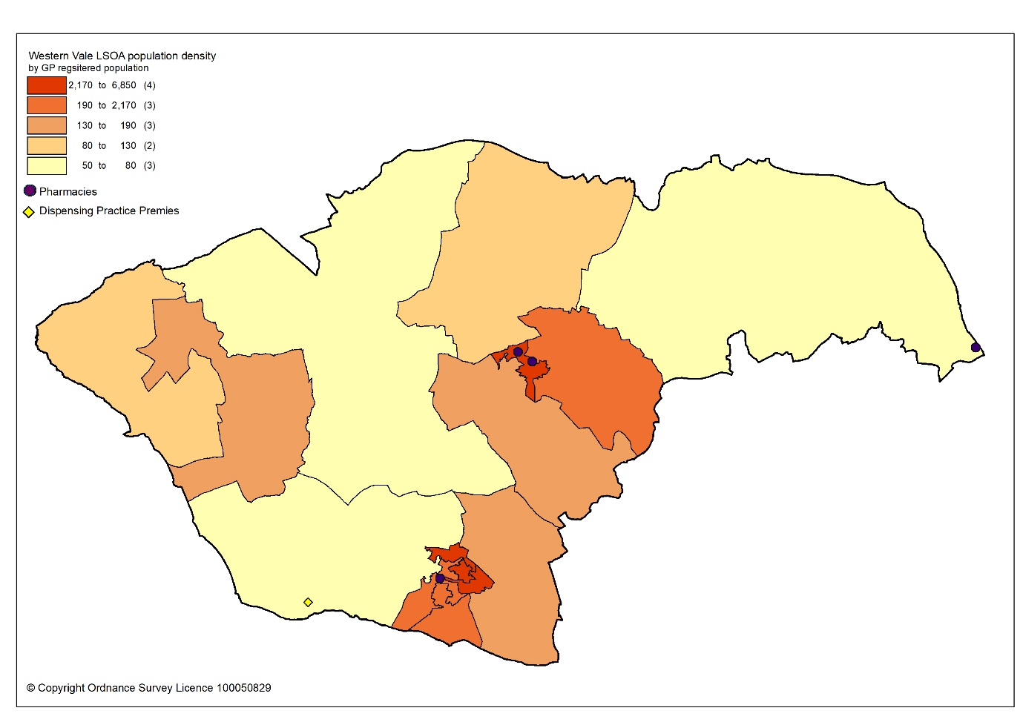

All residents of the cluster can access one of the pharmacies and the dispensing doctor practice by car within 20 minutes. The majority can access a pharmacy within 10 minutes, as shown in map 16.3.

Map 16.3: Access to pharmacies in the cluster
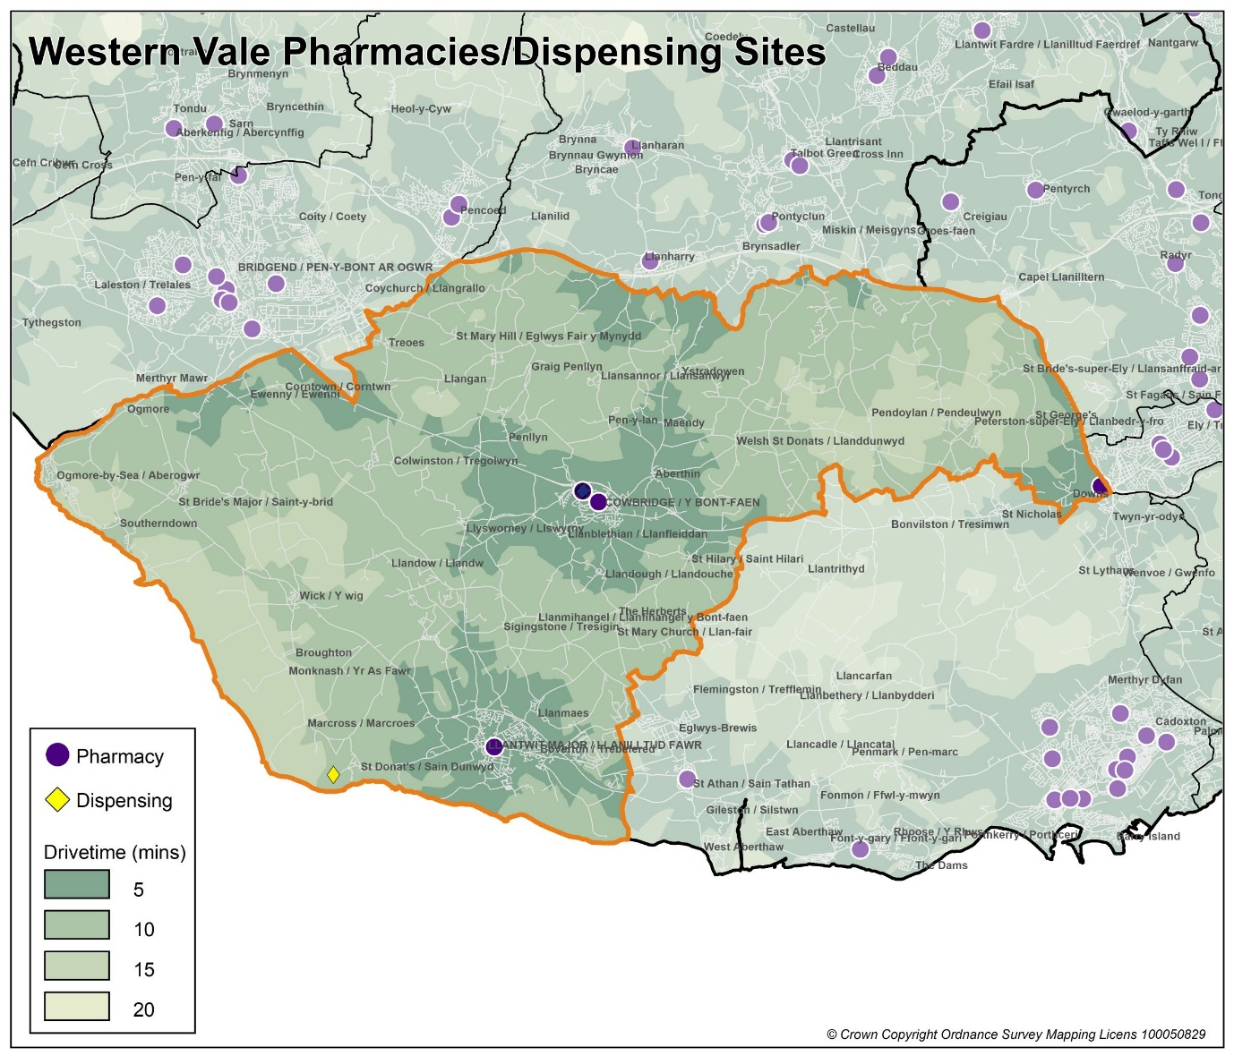
Looking at the opening hours for the pharmacies:

- No pharmacies are open seven days a week
- Three pharmacies are open Monday to Saturday
- Three pharmacies are open Monday to Friday and Saturday morning

All pharmacies must open for their core contractual hours, which are 40 hours a week. These can only be amended with approval by the health board. All additional hours or supplementary hours can be amended by the pharmacy following the provision of 90 days’ notice to the health board. Within the cluster, opening hours and closing hours range from:

Days | Opening hours range | Closing hours range
Monday to Friday | 08.30am to 09.00am | 17.00pm to 18.30pm
Saturday | 08.30am to 09.00am | 12.00pm to 17.30pm
Sunday | Closed | Closed

Full details of when the pharmacies are open can be found in Appendix L.

Residents of Western Vale cluster can access pharmacy services that are open seven days a week in neighbouring areas such as Barry in Central Vale cluster and Bridgend in Cwm Taf Morgannwg University Health Board.

The dispensing GP practice’s opening hours are limited to Monday and Thursday only. They dispense for residents of Atlantic College only.

All six pharmacies responded to the contractor questionnaire, of which all six dispense all appliances listed in Part IX of the Drug Tariff and one just dispenses dressings.

In 2019 to 2020, five pharmacies offered the MUR service and a total of 1,447 reviews were provided out of a possible 2,000 reviews. One pharmacy provided the maximum number of 400 reviews. The Welsh Government formally suspended the MUR service on 13 March 2020. At the time of writing, it is not known if the service will re-commence.

In 2019 to 2020, five pharmacies offered the DMR service and a total of 241 reviews were provided out of a possible 700 reviews. No pharmacies provided the maximum number of reviews. As part of the changes to the Community Pharmacy Contractual Framework for 2021, the cap for the number of paid DMRs has been removed.

In 2019 to 2020, the following enhanced services were provided by pharmacies in the cluster area:

- Three pharmacies provided a total of 132 emergency contraception consultations, with a range of 23 to 65 consultations.
- One pharmacy provided a total of one smoking cessation level 3 consultations.
- Three pharmacies provided a total of 378 flu vaccinations, with a range of 51 to 237 vaccinations.
- Five pharmacies provided a total of 356 CAS consultations, with a range of 18 to 227 consultations.
- Two pharmacies provided a total of 26 EMS consultations, with a range of one to 25 consultations.

Other enhanced services included:
- Three pharmacies provided the Supervised Administration of Medicines Enhanced Service.
- Two pharmacies provided the Needle Syringe Provision Enhanced Service.
- Five pharmacies provided the Palliative Care Enhanced Service.

16.3 Current provision of pharmaceutical services outside the locality’s area

Some residents choose to access contractors outside both the cluster and the health board’s area in order to access services:

- Offered by dispensing appliance contractors.
- Which are located near to where they work, shop or visit for leisure or other purposes.

Whilst the majority of prescriptions written by the GP practices in 2019 to 2020 were dispensed by the pharmacies in the cluster, around 2.4% were dispensed outside the cluster, most notably:

- 0.1% by pharmacies in Cardiff North cluster
- 0.2% by pharmacies in Cardiff South West cluster
- 0.2% by pharmacies in Cardiff City & South cluster
- 0.2% by pharmacies in Central Vale cluster
- 1.1% in Cwm Taf Morgannwg University Health Board
- 0.5% by contractors in England

In addition, residents may have accessed one or more pharmaceutical services provided by another pharmacy outside of both the cluster and the health board’s area; however, it is not possible to quantify this activity from the recorded data.

Taking into account pharmacies in the neighbouring clusters and pharmacies over the border in other health board areas in Wales, all residents in the cluster of Western Vale can access a pharmacy by car within 20 minutes and the majority can access a pharmacy by car within 10 minutes.

16.4 Other NHS services

No key other NHS services are located within this cluster.

16.5 Choice with regard to obtaining pharmaceutical services

As can be seen from sections 16.2 and 16.3, those living within the cluster area and registered with one of the GP practices generally choose to access one of the pharmacies in the cluster in order to have their prescriptions dispensed. Those that look outside the cluster usually do so to access a neighbouring pharmacy within the health board’s area. A minority choose to have their prescription dispensed by a pharmacy or an appliance contractor outside of the health board’s area.

A total of 198 pharmacy contractors that were trading in Wales during 2019 to 2020, dispensed items written by one of the GP practices in the Western Vale cluster, of which 115 were outside of the health board’s area. 3,503 prescription items were dispensed in England.

16.6 Gaps in provision

The Cardiff and Vale University Health Board has noted the locations of the pharmacies across the cluster and the dispensing doctor practice, and the fact that the population can access a pharmacy by car within 20 minutes, with the majority within 10 minutes. Whilst noting that not all households have access to a car throughout the day, the nature of the cluster means that walking to a pharmacy will be a realistic option for many residents and regular public transport services are available for those who are unable to undertake the whole journey on foot. However, in the very rural areas of Western Vale cluster, public transport services are limited. Although car ownership is likely to be high in these areas, those without a car and in particular the elderly, may find it difficult to access a pharmacy. The majority of pharmacies will have arrangements in place that enable timely access to medicines to those who are housebound or who may find it difficult to access a pharmacy.

The Cardiff and Vale University Health Board has noted the opening hours of the existing pharmacies and is of the opinion that they are sufficient to meet the likely needs of residents in the cluster. The Cardiff and Vale University Health Board has therefore concluded that there are no current needs in relation to the provision of essential services by pharmacies in the cluster.

The Cardiff and Vale University Health Board is also satisfied that there are no current needs in relation to the provision of advanced services. Whilst none of the pharmacies provide the Appliance Use Review service or the Stoma Appliance Customisation service, it is noted that there are four appliance contractors based in Cardiff and Vale University Health Board who offer these services. One of the reasons why prescriptions are dispensed outside of the cluster is because they have been sent to a dispensing appliance contractor elsewhere in the health board or to England, which provide these services. Patients will therefore be able to access these two services via those contractors. The Cardiff and Vale University Health Board has therefore not identified any current or future gap or better access in relation to the provision of these two advanced services in the cluster

All six pharmacies responded to the question in the contractor questionnaire regarding capacity to meet demand from any future housing developments in the cluster. Their responses were as follows:

- Five pharmacies have sufficient capacity within their existing premises and staffing levels to manage the increase in demand in the area.
- One pharmacy does not have sufficient premises and staffing capacity at present but could make adjustments to manage the increase in demand in the area.

The Cardiff and Vale University Health Board noted the housing developments planned for the cluster, in particular on land to the north and west of Darren Close, Cowbridge and land north of the Railway Line, Rhoose,.and other smaller units of housing that are due to be built during the lifetime of this document, Cardiff and Vale University Health Board is satisfied, based upon the responses to the contractor questionnaire, that the demand that this will create can be met by the existing pharmacies. The Cardiff and Vale University Health Board has therefore concluded that there are no future needs in relation to the provision of essential services by pharmacies in the cluster.

The Cardiff and Vale University Health Board is also satisfied that, based upon the information contained in the preceding sections, there are no current or future gaps in the provision of advanced services and enhanced services.

The Cardiff and Vale University Health Board will keep service provision under review but has concluded that there is no current or future need identified which requires an application for new or additional premises.

17 Conclusions for the purpose of schedule 1 of the NHS (Pharmaceutical Services) (Wales) Regulations 2020

The PNA has considered the current provision of pharmaceutical services across the health board and specifically the demography and health needs of the population. It has analysed whether current provision meets the needs of the population of Cardiff and Vale University Health Board and whether there are any potential gaps in pharmaceutical service provision either now or within the lifetime of the document.

17.1 Current provision

Cardiff and Vale University Health Board has identified the following services as those that are necessary to meet the need for pharmaceutical services in its area:

- Essential, advanced and enhanced services provided at all premises included in the pharmaceutical lists
- The dispensing service provided by those GP practices included in the dispensing doctor list.

Preceding sections of this document have set out the provision of these services in each locality.

It has also identified the provision of the above services by contractors outside of its area, whether that is in Wales or England, as contributing towards meeting the need for pharmaceutical services in its area.

17.2 Other NHS services

In undertaking this PNA the Cardiff and Vale University Health Board considers the following other NHS services as affecting the need for pharmaceutical services and has taken them into account:

- Hospital pharmacies – reduce the demand for the dispensing essential service as prescriptions written in hospitals are dispensed by the hospital pharmacy service.
- Personal administration of items by GPs – similar to hospital pharmacies, this also reduces the demand for the dispensing essential service. Items are sourced and personally administered by GPs and other clinicians at the practice thus saving patients having to take a prescription to a pharmacy, for example for a vaccination, in order to then return with the vaccine to the practice so that it may be administered.
- Urgent Primary Care - Out of Hours Service (CAV24/7) – whether a patient is given a full or part course of treatment after being seen by the Out of Hours Service or the Minor Injuries Unit at Barry Hospital, will depend on the nature of their condition. This service will therefore affect the need for pharmaceutical services, in particular the essential service of dispensing. Furthermore, as patients are directed to the right services through the one call system, this also has the potential to increase the need for all pharmaceutical services.
- Prison pharmacies - reduce the demand for the dispensing of essential service as prescriptions written in HMP Cardiff prison are not dispensed by community pharmacies or dispensing appliance contractors.
- Independent prescribers – are likely to increase in number over the next five years, which may have a subsequent effect on the need for pharmaceutical services, in particular the essential service of dispensing, as more patients are treated.
- The Online Non Prescription Ordering Service (ONPOS) dressings system – this will reduce the need for dressings on prescriptions for many patients and therefore the demand for the dispensing essential service. However, non-formulary dressings will still need to be prescribed.

17.3 Current gaps in provision

17.3.1 Current access to essential services

In order to assess the provision of essential services against the needs of the population, Cardiff and Vale University Health Board considered access (travelling times and opening hours) as the most important factor in determining the extent to which the current provision of essential services meets the needs of the population.

17.3.1.1 Access to essential services during normal working hours

Cardiff and Vale University Health Board has identified that the overwhelming majority of the population is able to access a pharmacy during normal working hours within 20 minutes. The majority can access a pharmacy within five to 10 minutes by car. Whilst noting that not all households have access to a car, the nature of the clusters means that walking to a pharmacy will be a realistic option for many residents and regular public transport services are available for those who are unable to undertake the whole journey on foot. However, in the very rural areas of Western Vale cluster and Central Vale cluster, public transport services are limited. Although car ownership is likely to be high, those without a car and in particular the elderly, may find it difficult to access a pharmacy. The majority of pharmacies in these clusters will have arrangements in place that enable timely access to medicines to those who are housebound or who may find it difficult to access a pharmacy.

With regards to opening hours, all pharmacies must open for a minimum of 40 hours to meet their contractual obligation. In general, these core hours fall within normal working hours.

Based on the information available at the time of developing this PNA no current gaps in the provision of essential services during normal working hours have been identified in any of the nine clusters (PNA localities).

17.3.1.2 Access to essential services outside normal working hours

There is good access to essential services outside normal working hours through the provision of extended evening and weekend opening hours offered by pharmacies:

- 15 pharmacies open seven days a week
- 19 pharmacies open Monday to Saturday
- 33 pharmacies open Monday to Friday, and part of Saturday
- 39 pharmacies that open Monday to Friday

The table below identifies the number of pharmacies by cluster where pharmaceutical services are provided.

Cluster | Open 7 days | Open Mon-Sat | Open Mon-Fri, part Sat | Open Mon-Fri
Cardiff North | 3 | 3 | 2 | 10
Cardiff East | 1 | 1 | 5 | 3
Cardiff West | 1 | 3 | 6 | 3
Cardiff South West | 1 | 2 | 2 | 5
Cardiff South East | 2 | 3 | 5 | 6
Cardiff City and South | 3 | 1 | 1 | 5
Central Vale | 2 | 1 | 6 | 5
Eastern vale | 2 | 2 | 3 | 2
Western Vale | 0 | 3 | 3 | 0

Outside normal working hours the Out of Hours and CAV 24/7 service will provide courses of treatment where appropriate.

The patient and public engagement questionnaire showed that most respondents do not have a preference about when is the best time (37%) or day (52%) to use a pharmacy. Of the remaining responses, 42% preferred to use a pharmacy between 9am and 6pm, with 2pm to 6pm being the most popular choice (21%), followed by 6pm to 9pm (17%). Where a day was indicated, the weekdays was the most convenient time for respondents to visit a pharmacy (19%), followed by the weekends in general (11%) rather than a specific day. Other respondents preferred a specific day of the week, with Saturday being the most popular choice (6%).

Based on the information available at the time of developing this pharmaceutical needs assessment, no current gaps in the provision of essential services outside normal working hours have been identified in any of the nine clusters (PNA localities).

17.3.2 Current access to advanced services

Cardiff and Vale University Health Board deemed the following advanced services to be necessary:

• Medicines Use Reviews
• Discharge Medicines Review service

Cardiff and Vale University Health Board noted that at the time of drafting the pharmaceutical needs assessment, the MUR service had been suspended by the Welsh Government due to Coronavirus (COVID-19) pandemic and it was still unclear if the service would re-commence. Although the DMR service had not been suspended, Cardiff and Vale University Health Board noted that service provision and need for this advanced service would have been affected by the Coronavirus (COVID-19) pandemic.

Demand for the Appliance Use Review advanced service and Stoma Appliance Customisation advanced services will be lower than for the other advanced services due to the much smaller proportion of the population that may require these services. Further to this, these services are generally being provided by appliance contractors based in Cardiff and Vale University Health Board or England.

Based on the data available, the Cardiff and Vale University Health Board Health is satisfied that there is sufficient capacity to meet the demand for advanced services

Based on the information available at the time of developing this pharmaceutical needs assessment no current gaps in the provision of the Medicines Use Review and Discharge Medicines Review advanced services have been identified in any of the nine clusters (PNA localities).

17.3.3 Current access to enhanced services

The Cardiff and Vale University Health Board noted that at the time of drafting the pharmaceutical needs assessment, the provision of some enhanced services had been suspended due to Coronavirus (COVID-19) pandemic. Based on the data available, Cardiff and Vale University Health Board Health is satisfied that there is sufficient capacity to meet the demand for enhanced services.

Based on the information available at the time of developing this pharmaceutical needs assessment no current gaps in the provision of enhanced services have been identified in any of the nine clusters (PNA localities).

17.3.4 Current access to the GP dispensing service

The Cardiff and Vale Health Board noted that NHS (Pharmaceutical Services) (Wales) Regulations 2020 allow doctors to dispense to eligible patients in certain circumstances:

- Patients must live in a ‘controlled locality’ (an area which has been determined by the health board or a preceding organisation as rural in character, or on appeal by the Welsh Ministers), more than 1.6km (measured in a straight line) from a pharmacy, and
- Their practice must have premises approval and outline consent to dispense to that area.

It noted that the one dispensing doctor practice dispensed to 372 of their registered patients (5% of the total list size of the practice) and provided a specific dispensing service to students living in Atlantic College, St. Donats. The practice confirmed that it has sufficient capacity within its existing premises and staffing levels to manage an increase in demand in its area if required. However, this would be dependent upon the terms set out in the NHS (Pharmaceutical Services) (Wales) Regulations 2020.

Based on the information available at the time of developing this pharmaceutical needs assessment no current gaps in the provision of GP dispensing services have been identified.

17.4 Future gaps in provision

Cardiff and Vale University Health Board has taken into account the following known future developments:

- Forecasted population growth
- Cluster developments such as housing

17.4.1 Future access to essential services

17.4.1.1 Access to essential services during normal working hours

The Cardiff and Vale University Health Board noted the strategic employment and housing developments planned within the health board’s clusters and respective monitoring information. Cardiff and Vale University Health Board is satisfied that at this time there is no information or reason to conclude, during the lifetime of this PNA and developments, that there would be an unmet need so as to require additional pharmaceutical services. Further to this, Cardiff and Vale University Health Board is satisfied, based upon the responses to the contractor questionnaire, that the demand that this may create can be met by the existing pharmacies. The Cardiff and Vale University Health Board has therefore concluded that there are no future needs in relation to the provision of essential services by pharmacies within the health board.

Based on the information available at the time of developing this PNA no future gaps in the provision of essential services during normal working hours have been identified in any of the nine clusters (PNA localities).

17.4.1.2 Access to essential services outside normal working hours

Cardiff and Vale University Health Board considered the current provision as set out in this document and has not identified services that would, if provided either now or in future specified circumstances, secure improvements to or better access to essential services

With regards to opening times, the Health Board retains the right to invite and/or direct existing pharmaceutical contractors to adjust their opening hours to meet any future access requirements.

Based on the information available at the time of developing this PNA no future gaps in the provision of essential services outside of normal working hours have been identified in any of the nine clusters (PNA localities).

17.4.2 Future access to advanced services

From the data available not all pharmacies are providing all the advanced services. Furthermore, of those currently providing the advanced services, not all pharmacies are completing the maximum amount that they may do each year. In addition, as part of the changes to the Community Pharmacy Contractual Framework for 2021, the cap for the number of paid DMRs has been removed allowing for more DMRs to be undertaken each year.

Demand for the Appliance Use Review advanced service and Stoma Appliance Customisation advanced services will be lower than for the other advanced services due to the much smaller proportion of the population that may require these services. Further to this, these services are generally being provided by appliance contractors based in Cardiff and Vale University Health Board or England.

Based on the information available at the time of developing this pharmaceutical needs assessment no future gaps in the provision of the Medicines Use Reviews and Discharge Medicines Review service advanced services have been identified in any of the nine clusters (PNA localities).

17.4.3 Future access to enhanced services

Cardiff and Vale University Health Board has not identified any enhanced services that are not currently provided but that will, in specified future circumstances, need to be provided in order to secure improvements or better access to pharmaceutical services.

Based on the information available at the time of developing this pharmaceutical needs assessment, no gaps in respect of securing improvements, or better access, to enhanced services in specified future circumstances have been identified in any of the nine clusters (PNA localities).

17.4.4 Future access to the GP dispensing service

Cardiff and Vale University Health Board considered the current provision as set out in this document and has not identified services that would, if provided either now or in future specified circumstances, secure improvements to or better access to essential services.

Based on the information available at the time of developing this pharmaceutical needs assessment, no gaps in respect to future access of the GP dispensing service have been identified in any of the nine clusters (PNA localities).

Appendix A – policy context and background papers

Welsh Government establishes the overall structure in which community pharmacies, dispensing appliance contractors and dispensing doctors operate by providing the legislative and policy framework. Within the framework, the responsibility for planning and providing pharmaceutical services is vested in health boards who must plan health services to meet the needs of their resident populations. This includes determining the number and location of pharmacies and dispensing appliance contractors in their areas.

The general duty to ensure the provision of pharmaceutical services, as with other aspects of NHS primary care services, is conferred directly on health boards under the NHS (Wales) Act 2006 (the 2006 Act). Health boards manage local lists of approved providers, referred to as pharmaceutical lists, and the inclusion of pharmacy and dispensing appliance contractor premises on pharmaceutical lists entitles contractors to provide NHS pharmaceutical services at those premises.

These arrangements govern the provision of pharmaceutical services and not the right to open and conduct a pharmacy business in Wales. That is dealt with under separate UK-wide legislation, the Medicines Act 1968.

The Welsh Ministers have extensive powers and duties to make regulations and to issue directions to health boards, which govern the detail of the pharmaceutical services system in Wales. This includes specifying the terms of service for pharmacies and dispensing appliance contractors and the application of the control of entry test, which is the test that until 1 October 2021 had to be satisfied before a health board would grant an application for entry, or amend an entry, on the pharmaceutical list.

Under the NHS (Pharmaceutical Services) (Wales) Regulations 2013 (the 2013 Regulations), and preceding regulations, those persons wishing to provide pharmaceutical services submitted an application to the health board in accordance with the 2013 Regulations. The health board then decided whether or not the application satisfied the relevant test. The 2013 Regulations allowed for the health board’s decision to be challenged by lodging an appeal with the Welsh Ministers.

The previous system of pharmaceutical services delivery was therefore driven by those who wished to provide pharmaceutical services. It is they who decided which services they wished to provide and from what location.

That meant that the system was reactive to applications and health boards were not able to plan where pharmacies or dispensing appliance contractors were located or direct which services must be provided from those locations.

Rationale for change

In 2010 the then Minister for Health and Social Services established a Task and Finish Group to review the regulatory framework, to consider Welsh Government policy on control of entry and the provision of pharmaceutical services by health professions other than pharmacists (e.g. doctors) and to make recommendations for changes to legislation, if appropriate, to bring about a long term, cost effective and sustainable system which would afford patients appropriate access to pharmaceutical services.

In 2011 Welsh Government consulted on the recommendations of the Task and Finish group. The consultation “Proposals to reform and modernise the National Health Service (Pharmaceutical Services) Regulations 1992” sought views on proposals to deliver a new approach for determining applications to provide pharmaceutical services in Wales based more on an assessment of local needs by health boards. However, it was recognised that to make such a change required the creation and inclusion of appropriate powers in the 2006 Act.

Following the consultation, the 2013 Regulations came into force on 10 May 2013 but did not contain provisions to introduce PNAs.

The Public Health (Wales) Act 2017 (the 2017 Act) inserted section 82A into the 2006 Act which makes provision for a new duty for health boards in Wales to prepare and publish an assessment of need for pharmaceutical services. Section 82A gave the Welsh Ministers powers to make regulations setting out the requirements for PNAs in Wales.

Intended effect and beneficial outcomes

The intended effect of introducing PNAs is to improve the planning and delivery of pharmaceutical services by ensuring the health boards robustly consider the pharmaceutical needs of their populations and align services more closely with them. This will require health boards to take a more integrated approach to identifying the pharmaceutical needs of populations, including considering the contribution of all pharmaceutical services providers (e.g., pharmacies and dispensing doctors). Health boards will use these assessments to identify where additional premises are required, where existing providers are adequately addressing pharmaceutical needs, and where additional services are required from existing premises.

The change will provide contractors with increased certainty, reducing business risk and allowing them to invest in the delivery of wider services than they do currently. Importantly, pharmacies in particular will also become more responsive to the needs of the populations they serve and provide services effectively to address identified pharmaceutical needs.

Policy, legislative framework and regulation

Section 80 of the 2006 Act places a duty on health boards to make arrangements for the provision of the pharmaceutical services that are set out in subsections 80(3)(a) to (d). These core pharmaceutical services are essentially dispensing services. There is a duty on Welsh Ministers to make regulations governing the way in which health boards make these arrangements.

Section 81 of the 2006 Act sets out the arrangements that Welsh Ministers may make for the provision of additional pharmaceutical services. ‘Additional pharmaceutical services’ are defined as services of a kind that do not fall within section 80 i.e., advanced and enhanced services. Section 81 gives Welsh Ministers the power to give directions to a health board:

- requiring it to arrange for the provision of additional pharmaceutical services, or
- authorising the health board to arrange for the provision of pharmaceutical services if it wishes.

Section 83 of the 2006 Act contains the core of the Welsh Ministers’ regulation making powers in relation to the provision of the pharmaceutical services and, amongst other things, sets out the requirement for regulations to require a health board to prepare and publish a pharmaceutical list, and sets out the tests which those persons wishing to provide pharmaceutical services must pass in order to do so (known as the ‘control of entry test’).

Section 84 sets out a requirement for Welsh Ministers to provide for rights of appeal against decisions that are made by health boards in exercise of powers conferred upon them by regulations made under section 83.

Part 7 of the 2017 Act made provision to amend the 2006 Act in respect of pharmaceutical services. Section 111 of the 2017 Act inserted a new section 82A in to the 2006 Act conferring powers on the Welsh Ministers to make regulations in respect of PNAs. The Public Health (Wales) Act 2017 (Commencement No.4) Order 2019 brought Part 7 of the 2017 Act into force on 1 April 2019. As a result, the Welsh Ministers have now made subordinate legislation setting out requirements for PNAs in Wales.

The 2013 Regulations were revoked and replaced by the NHS (Pharmaceutical Services) (Wales) Regulations 2020. Part 2 of the NHS (Pharmaceutical Services) (Wales) Regulations 2020 imposes the legal requirements on health boards to complete PNAs.

The NHS (Pharmaceutical Services) (Wales) Regulations 2020 came into force on 1st October 2020 and health boards have until 1 October 2021 to publish their first PNA.

In summary the NHS (Pharmaceutical Services) (Wales) Regulations 2020 set out the:

- Services that are to be covered by the PNA
- Information that must be included in the PNA (it should be noted that health boards are free to include any other information that they feel is relevant)
- Date by which health boards must publish their first PNA
- Requirement on health boards to publish further PNAs on a five yearly basis
- Requirement to publish a revised assessment sooner than on a five yearly basis in certain circumstances
- Requirement to publish supplementary statements in certain circumstances
- Requirement to consult with certain people and organisations at least once during the production of the PNA, for at least 60 days; and
- Matters the health board is to have regard to when producing its PNA.

Once a health board has published its first PNA it is required to produce a revised PNA within five years or sooner if it identifies changes to the need for pharmaceutical services which are of a significant extent. The only exception to this is where the health board is satisfied that producing a revised PNA would be a disproportionate response to those changes.

In addition, a health board may publish a supplementary statement where it identifies changes to the availability of pharmaceutical services which are relevant to the granting of applications referred to in Section 83 of the 2006 Act, and

- It is satisfied that making a revised assessment would be a disproportionate response to those changes, or
- It is in the course of making a revised assessment and is satisfied that immediate modification of its PNA is essential in order to prevent detriment to the provision of pharmaceutical services in its area.

Developing the detailed requirements

A working group was established in November 2015 to develop the detailed requirements for conducting a PNA and to review and amend the tests and procedures as they apply to the provision of NHS pharmaceutical services. The group, which met on a number of occasions, consisted health board pharmacy leads with knowledge of the previous control of entry system and expertise in community pharmacy, NHS Shared Services Partnership primary care (pharmacy) leads, who have expertise in the process of determining control of entry applications, and Welsh Government staff. The group has made a significant contribution to the development of Welsh Government’s policy on PNAs, including the resultant proposals contained within the NHS (Pharmaceutical Services) (Wales) Regulations 2020.

Appendix B – essential services

- Dispensing of prescriptions

Service description

The supply of medicines and appliances ordered on NHS prescriptions, together with information and advice, to enable safe and effective use by patients, and maintenance of appropriate records.

Aims and intended outcomes

To ensure patients receive ordered medicines and appliances safely and appropriately by the pharmacy:

- Performing appropriate legal, clinical and accuracy checks
- Having safe systems of operation, in line with clinical governance requirements
- Having systems in place to guarantee the integrity of products supplied
- Maintaining a record of all medicines and appliances supplied which can be used to assist future patient care
- Maintaining a record of advice given, and interventions and referrals made, where the pharmacist judges it to be clinically appropriate.

To ensure patients are able to use their medicines and appliances effectively by pharmacy staff:

- Providing information and advice to the patient or their representative on the safe use of their medicine or appliance
- Providing when appropriate broader advice to the patient on the medicine, for example its possible side effects and significant interactions with other substances.

- Dispensing of repeatable prescriptions

Service description

The management and dispensing of repeatable NHS prescriptions for medicines and appliances in partnership with the patient and the prescriber.

This service includes requirements additional to those for dispensing, such that the pharmacist ascertains the patient’s need for a repeat supply and communicates any clinically significant issues to the prescriber.

Aims and intended outcomes
- To increase patient choice and convenience, by allowing them to obtain their regular prescribed medicines and appliances directly from a community pharmacy for a period agreed by the prescriber
- To minimise wastage by reducing the number of medicines and appliances dispensed which are not required by the patient
- To reduce the workload of general medical practices, by lowering the burden of managing repeat prescriptions.

- Disposal of unwanted drugs

Service description

Acceptance by community pharmacies, of unwanted medicines which require safe disposal from private households and people living in a residential care home. The health board is required to arrange for the collection and disposal of waste medicines from pharmacies.

Aims and intended outcomes

- To ensure the public has an easy method of safely disposing of unwanted medicines
- To reduce the volume of stored unwanted medicines in people’s homes by providing a route for disposal thus reducing the risk of accidental poisonings in the home and diversion of medicines to other people not authorised to possess them
- To reduce the risk of exposing the public to unwanted medicines which have been disposed of by non-secure methods
- To reduce environmental damage caused by the inappropriate disposal methods for unwanted medicines.

- Promotion of healthy lifestyles

Service description

The provision of opportunistic healthy lifestyle and public health advice to patients receiving prescriptions who appear to:

- Have diabetes; or
- Be at risk of coronary heart disease, especially those with high blood pressure; or
- Who smoke; or
- Are overweight,

and pro-active participation in national/local campaigns, to promote public health messages to general pharmacy visitors during specific targeted campaign periods

Aims and intended outcomes

- To increase patient and public knowledge and understanding of key healthy lifestyle and public health messages so they are empowered to take actions which will improve their health.
- To target the ‘hard to reach’ sectors of the population who are not frequently exposed to health promotion activities in other parts of the health or social care sector.

- Signposting

Service description

The provision of information to people visiting the pharmacy, who require further support, advice or treatment which cannot be provided by the pharmacy, but is available from other health and social care providers or support organisations who may be able to assist the person. Where appropriate, this may take the form of a referral.

Aims and intended outcomes

- To inform or advise people who require assistance, which cannot be provided by the pharmacy, of other appropriate health and social care providers or support organisations
- To enable people to contact and/or access further care and support appropriate to their needs
- To minimise inappropriate use of health and social care services.

- Support for self-care

Service description

The provision of advice and support by pharmacy staff to enable people to derive maximum benefit from caring for themselves or their families.

Aims and intended outcomes
- To enhance access and choice for people who wish to care for themselves or their families
- People, including carers, are provided with appropriate advice to help them self-manage a self-limiting or long-term condition, including advice on the selection and use of any appropriate medicines
- People, including carers, are opportunistically provided with health promotion advice when appropriate, in line with the advice provided in essential service – promotion of healthy lifestyles service
- People, including carers, are better able to care for themselves or manage a condition both immediately and in the future, by being more knowledgeable about the treatment options they have, including non-pharmacological ones
- To minimise inappropriate use of health and social care services.

Appendix C – advanced services

- Medicines use review and prescription intervention service

Service description

This service includes MURs undertaken periodically, as well as those arising in response to the need to make a significant prescription intervention during the dispensing process. A MUR is about helping patients use their medicines more effectively.

Recommendations made to prescribers may also relate to the clinical or cost effectiveness of treatment.

Aims and intended outcomes

To improve patient knowledge and use of medicines by:

- Establishing the patient’s actual use, understanding and experience of taking their medicines;
- Identifying, discussing and assisting in resolving poor or ineffective use of their medicines;
- Identifying side effects and drug interactions that may affect patient compliance;
- Improving the clinical and cost effectiveness of prescribed medicines thereby reducing medicine wastage.

As of November 2020 this service is currently suspended until further notice.

- Discharge medicines review service

Service description

The DMR service will provide support to patients recently discharged between care settings by ensuring that changes to patients’ medicines made in one care setting (e.g., during a hospital admission) are enacted as intended in the community helping to reduce the risk of preventable medicines related problems and supporting adherence with newly prescribed medication. The service, which builds on the existing MUR service, will provide an opportunity to support patients to improve their knowledge and use of drugs.

Aims and intended outcomes

The underlying purpose of this service is, with the patient’s agreement, to contribute to a reduction in risk of medication errors and adverse drug events by, in particular –

- Increasing the availability of accurate information about a patient’s medicines,
- Improving communication between healthcare professionals and others involved in the transfer of patient care, and patients and their carers,
- Increasing patient involvement in their own care by helping them to develop a better understanding of their medicines, and
- Reducing the likelihood of unnecessary or duplicated prescriptions being dispensed thereby reducing wastage of medicines.

Pharmacy contractors may claim a maximum of 140 discharge medicines reviews per pharmacy for the period commencing 1 April and ending 31 March of any financial year.

- Stoma appliance customisation

Service description

Stoma appliance customisation is the customisation of a quantity of more than one stoma appliance, where:

- The stoma appliance to be customised is listed in Part IXC of the Drug Tariff
- The customisation involves modification to the same specification of multiple identical parts for use with an appliance; and
- Modification is based on the patient’s measurement or record of those measurements and if applicable, a template.

Aims and intended outcomes

The underlying purpose of the service is to:

- Ensure the proper use and comfortable fitting of the stoma appliance by a patient; and
- Improve the duration of usage of the appliance, thereby reducing wastage of such appliances.

- Appliance use review

Service description

An appliance use review is about helping patients use their appliances more effectively. Recommendations made to prescribers may also relate to the clinical or cost effectiveness of treatment.

Aims and intended outcomes

The underlying purpose of the service is, with the patient’s agreement, to improve the patient’s knowledge and use of any specified appliance by, in particular:

- Establishing the way the patient uses the specified appliance and the patient’s experience of such use
- Identifying, discussing and assisting in the resolution of poor or ineffective use of the specified appliance by the patient
- Advising the patient on the safe and appropriate storage of the specified appliance
- Advising the patient on the safe and proper disposal of the specified appliances that are used or unwanted.

The total number of appliance use reviews that an appliance or pharmacy contractor may claim fees for is limited to one for every 35 Part IXA (qualifying items), Part IXB and Part IXC prescription items dispensed for the period commencing on 1 April and ending on 31 March in any one year.

Appendix D – enhanced services

- An anticoagulant monitoring service, the underlying purpose of which is for the pharmacy contractor to test the patient’s blood clotting time, review the results and adjust (or recommend adjustment to) the anticoagulant dose accordingly.

- A care home service, the underlying purpose of which is for the pharmacy contractor to provide advice and support to residents and staff in a care home relating to—

- The proper and effective ordering of drugs and appliances for the benefit of residents in the care home
- The clinical and cost effective use of drugs
- The proper and effective administration of drugs and appliances in the care home
- The safe and appropriate storage and handling of drugs and appliances, and
- The recording of drugs and appliances ordered, handled, administered, stored or disposed of.

- A disease specific management service, the underlying purpose of which is for the pharmacy contractor to advise on, support and monitor the treatment of patients with specified conditions, and where appropriate to refer the patient to another health care professional.

- A gluten free food supply service, the underlying purpose of which is for the pharmacy contractor to supply gluten free foods to patients.

- A home delivery service, the underlying purpose of which is for the pharmacy contractor to deliver drugs and appliances (other than ‘specified appliances’) to patients at their home.

- A language access service, the underlying purpose of which is for the pharmacy contractor to provide, either orally or in writing, advice and support to patients in a language understood by them relating to—

- Drugs which they are using
- Their health, and
- General health matters relevant to them,

and where appropriate referral to another health care professional.

- A medication review service, the underlying purpose of which is for the pharmacy contractor to —

- Conduct a review of the drugs used by a patient on the basis of information and test results included in the patient’s care record, with the objective of considering the continued appropriateness and effectiveness of the drugs for the patient,
- Advise and support the patient regarding their use of drugs, including encouraging the active participation of the patient in decision making relating to their use of drugs, and
- Where appropriate, to refer the patient to another health care professional.

- A medicines assessment and compliance support service, the underlying purpose of which is for the pharmacy contractor to —

- Assess the knowledge of compliance with and use of, drugs by vulnerable patients and patients with special needs, and
- Offer advice, support and assistance to vulnerable patients and patients with special needs regarding the use of drugs with a view to improving their knowledge of compliance with and use of, such drugs.

- A minor ailment scheme, the underlying purpose of which is for the pharmacy contractor to provide advice and support to eligible patients complaining of a minor ailment, and where appropriate to supply drugs to the patient for the treatment of the minor ailment.

- A needle and syringe exchange service, the underlying purpose of which is for the pharmacy contractor to —

- Provide sterile needles, syringes and associated materials to drug misusers
- Receive from drug misusers used needles, syringes and associated materials, and
- Offer advice to drug misusers and where appropriate referral to another health care professional or a specialist drug treatment centre.

- An on demand availability of specialist drugs service, the underlying purpose of which is for the pharmacy contractor to ensure that patients or health care professionals have prompt access to specialist drugs.

- Out of hours services, the underlying purpose of which is for the pharmacy contractor to dispense drugs and appliances in the out of hours period (whether or not for the whole of the out of hours period).

- A patient group direction service, the underlying purpose of which is for the pharmacy contractor to supply a prescription only medicine to a patient under a patient group direction.

- A prescriber support service, the underlying purpose of which is for the pharmacy contractor to support health care professionals who prescribe drugs, and in particular to offer advice on—

- The clinical and cost effective use of drugs
- Prescribing policies and guidelines, and
- Repeat prescribing.

- A schools service, the underlying purpose of which is for the pharmacy contractor to provide advice and support to children and staff in schools relating to—

- The clinical and cost effective use of drugs in the school
- The proper and effective administration and use of drugs and appliances in the school
- The safe and appropriate storage and handling of drugs and appliances, and
- The recording of drugs and appliances ordered, handled, administered, stored or disposed of.

- A screening service, the underlying purpose of which is for the pharmacy contractor to —

- Identify patients at risk of developing a specified disease or condition
- Offer advice regarding testing for a specified disease or condition
- Carry out such a test with the patient’s consent, and
- Offer advice following a test and refer to another health care professional as appropriate.

- A stop smoking service, the underlying purpose of which is for the pharmacy contractor to —

- Advise and support patients wishing to give up smoking, and
- Where appropriate, to supply appropriate drugs and aids.

- A supervised administration service, the underlying purpose of which is for the pharmacy contractor to supervise the administration of prescribed medicines at their premises.

- A supplementary prescribing service, the underlying purpose of which is for the pharmacy contractor to prescribe medicines in circumstances specified by the relevant local health board.

- An anti-viral collection service, the underlying purpose of which is for the chemist to supply anti-viral medicines, in accordance with regulation 247 of the Human Medicines Regulations 2012 (Exemption for supply in event of or in anticipation of Pandemic disease), to patients for treatment or prophylaxis.

- An emergency supply service, the underlying purpose of which is to ensure that in cases of urgency, patients, at their request have prompt access to drugs or appliances –

- which have previously been prescribed for them in an NHS prescription but for which they do not have an NHS prescription, and
- where in the case of prescription only medicines the requirements of regulation 225(1) of the Human Medicines Regulations 2012 (emergency sale etc by Pharmacist: at patient’s request), are satisfied.

Appendix E – terms of service for dispensing appliance contractors

- Dispensing of prescriptions

Service description

The supply of appliances ordered on NHS prescriptions, together with information and advice and appropriate referral arrangements in the event of a supply being unable to be made, to enable safe and effective use by patients, and maintenance of appropriate records.

Aims and intended outcomes

To ensure patients receive ordered appliances safely and appropriately by the dispensing appliance contractor:

- Performing appropriate legal, clinical and accuracy checks
- Having safe systems of operation, in line with clinical governance requirements
- Having systems in place to guarantee the integrity of products supplied
- Maintaining a record of all appliances supplied which can be used to assist future patient care
- Maintaining a record of advice given, and interventions and referrals made, where the dispensing appliance contractor judges it to be clinically appropriate
- Providing the appropriate additional items such as disposable bags and wipes
- Delivering the appropriate items if required to do so in a timely manner and in suitable packaging that is discreet.

To ensure patients are able to use their appliances effectively by staff providing information and advice to the patient or carer on the safe use of their appliance(s).

- Dispensing of repeatable prescriptions

Service description

The management and dispensing of repeatable NHS prescriptions appliances in partnership with the patient and the prescriber.

This service includes the requirements that are additional to those for dispensing, such that the dispensing appliance contractor ascertains the patient’s need for a repeat supply and communicates any clinically significant issues to the prescriber.

Aims and intended outcomes

- To increase patient choice and convenience, by allowing them to obtain their regular prescribed appliances directly from a dispensing appliance contractor for a period agreed by the prescriber
- To minimise wastage by reducing the number of appliances dispensed which are not required by the patient
- To reduce the workload of GP practices, by lowering the burden of managing repeat prescriptions.

- Home delivery service

Service description

To provide a home delivery service in respect of certain appliances.

Aims and intended outcomes

To preserve the dignity of patients by ensuring that certain appliances are delivered:

- With reasonable promptness, at a time agree with the patient
- In a package that displays no writing or other markings which could indicate its content; and
- In such a way that it is not possible to identify the type of appliance that is being delivered.

- Supply of appropriate supplementary items

Service description

The provision of additional items such as disposable wipes and disposal bags in connection with certain appliances.

Aims and intended outcomes

To ensure that patients have a sufficient supply of wipes for use with their appliance and are able to dispose of them in a safe and hygienic way.

- Provide expert clinical advice regarding the appliances

Service description

The provision of expert clinical advice by a suitably trained person who has relevant experience in respect of certain appliances.

Aims and intended outcomes

To ensure that patients are able to seek appropriate advice on their appliance to increase their confidence in choosing an appliance that suits their needs as well as gaining confidence to adjust to the changes in their life and learning to manage an appliance.

- Where a telephone care line is provided, during the period when the dispensing appliance contractor is closed advice is either to be provided via the care line or callers are directed to NHS Direct Wales

Service description

Provision of advice on certain appliances via a telephone care line outside of the dispensing appliance contractor’s contracted opening hours. The dispensing appliance contractor is not required to staff the care line all day, every day, but when it is not staffed callers must be given a telephone number or website contact details for NHS Direct Wales who may be consulted for advice.

Aims and intended outcomes

Callers to the telephone care line are able to access advice 24 hours a day, seven days a week on certain appliances in order to manage their appliance.

- Signposting

Service description

Where a patient presents a prescription for an appliance which the dispensing appliance contractor does not supply the prescription is either:

- With the consent of the patient, passed to another provider of appliances, or
- If the patient does not consent, they are given contact details for at least two other contractors who are able to dispense it.

Aims and intended outcomes

To ensure that patients are able to have their prescription dispensed.

Appendix F – PNA steering group membership

Name | Role | Organisation
Lisa Dunsford | Director of Primary Care | Cardiff & Vale UHB
Darrell Baker | Director of Pharmacy & Medicines Management | Cardiff & Vale UHB
Jenna Llewellyn | Senior Communication & Engagement Officer | Cardiff & Vale UHB
Tom Porter | Consultant in Public Health | Cardiff & Vale UHB
Steve Watkins | Finance representative | Cardiff & Vale UHB
Jonathan Watts | Assistant Director of Planning | Cardiff & Vale UHB
Karen May | Head of Medicines Management Primary Care | Cardiff & Vale UHB
Louise Allen | Community Pharmacy Advisor | Cardiff & Vale UHB
Jayne Howard | Community Pharmacy Wales representative | Community Pharmacy Wales
Kevin Thomas | Bro Taf LMC representative | Local Medical Committee (LMC)
Stephen Allen | South Glamorgan CHC representative | Community Health Council (CHC)
Elaine Lewis | Project Support | Cardiff & Vale UHB

Fiona McGonigle Associate PCC and Paul Burns Adviser PCC - Primary Care Commissioning Community Interest Company - provided support and advice to the Steering Group and PNA project overall.

Appendix G – patient and public engagement survey

Patient and public survey for Cardiff and Vale University Health Board pharmaceutical needs assessment (PNA)

We are inviting you to tell us about pharmacy services in your area. This is to help us plan for services for our patients now and in the future to make sure they meet your needs, using a process called a ‘pharmaceutical needs assessment’.
Your answers will help us identify if there are any service gaps, for example whether a pharmacy (also called a ‘chemist’) is needed in a particular area, or whether more pharmacies need to provide a particular service.
Looking to the future, we will look at what may change over the next five years and whether there will be enough pharmacies in the right places, providing the services that people need as, for example, more houses are built.
Your views are important to us so please spare a few minutes to complete this questionnaire. We estimate it will take you about 10 to 15 minutes to complete.
The questionnaire is anonymous and any information you give will not be linked to you.
If you would like more information about the questionnaire or have questions on how to complete the questionnaire, please contact Cav.Justintime@wales.nhs.uk with “PNA questionnaire” in the subject header.

If you would like to complete this questionnaire in Welsh please click here

About you

Please tell us your postcode

By providing us with the first four digits of your postcode, you are consenting for us to use this information to understand which part of Cardiff and Vale University Health Board area you usually live in. This information will only be used for the purposes of this questionnaire so that we can identify whether we have received responses from across the health board area or from particular areas. Please do not provide us with your full postcode.

For example, if your postcode is CF14 4HH just type CF14 in the box below.

Preferred language

1. Please could you tell us your preferred language when you access services at a pharmacy? Please tick one.

- Welsh
- English
- Other [text box]

How you use your pharmacy - either in person or by having someone else go there for you

- Why do you usually visit a pharmacy? Please tick any or all that apply.

- To get or collect a prescription for myself
- To buy medicines for myself
- To get advice for myself
- For other services such as flu vaccination
- To get or collect a prescription for someone else
- To buy medicines for someone else
- To get advice for someone else
- I don’t visit a pharmacy as I use an online/internet pharmacy (go to question 22)
- I don’t visit a pharmacy as I use a dispensing doctor (go to question 22)
- I don’t visit a pharmacy as I use an appliance contractor (go to question 22)
- I don’t visit a pharmacy as my medicines are delivered to me
- I don’t go to a pharmacy; someone goes on my behalf
- Other [text box]

3. How often do you use a pharmacy? Please tick one.

- Daily
- Weekly
- Fortnightly
- Monthly
- Quarterly
- I don’t use a pharmacy
- Other [text box]

4. What time is the most convenient for you to use a pharmacy? Please tick one.

- 7am to 9am
- 9am to 12 noon
- 12 noon to 2pm
- 2pm to 6pm
- 6pm to 9pm
- 9pm to midnight
- I don’t have a preference

5. What day is the most convenient for you to use a pharmacy? Please tick one.

- Monday
- Tuesday
- Wednesday
- Thursday
- Friday
- Saturday
- Sunday
- Weekdays in general
- Weekends in general
- I don’t have a preference

6. Has there been a time recently when you, or a person on your behalf, were not able to use your usual pharmacy? Please tick one.

- Yes
- No (go to question 8)
- Not applicable (go to question 8)

7. If you answered ‘yes’ to question 6 can you tell us what you / they did? Please tick all statements that apply.

- Went to another pharmacy
- Waited until the pharmacy was open
- Went to my GP
- Went to the A&E / casualty
- Went to a minor injury unit
- Contacted the GP Out of Hours (OOH) service
- Called NHS 111 Wales
- Called CAV 24/7
- Other [text box]

Your choice of pharmacy

8. Please could you tell us whether you (please tick one):

- Always use the same pharmacy?
- Use different pharmacies but I prefer to visit one most often?
- Always use different pharmacies?
- Rarely use a pharmacy?
- Never use a pharmacy?
9. We would like to know what influences your choice of pharmacy. Please could you tell us why you use this pharmacy? Please tick all the statements that apply to you.

- Close to my home
- Close to work
- Close to my doctor
- Close to children’s school or nursery
- Close to other shops
- The location of the pharmacy is easy to get to
- It is easy to park at the pharmacy
- I can speak to the staff in my preferred language
- I like and trust the staff who work there
- The staff know me and look after me
- The staff don’t know me
- I’ve always used this pharmacy
- The service is quick
- They usually have what I need in stock
- The pharmacy has good opening hours
- The pharmacy collects my prescription and delivers my medicines
- The pharmacy was recommended to me
- The pharmacy provide good advice & information
- The customer service
- It is very accessible i.e. wheelchair/baby buggy friendly
- It’s a well-known big chain
- It’s not one of the big chains
- There is a private area if I need to talk to the pharmacist
- I can order my repeat medicines online or by using their app
- Other [text box]

10. Is there a more convenient and/or closer pharmacy that you don’t use? Please tick one.

- Yes
- No (go to question 12)
- Don’t know (go to question 12)

11. ...and if you have answered yes to question 10, please could you tell us why you do not use that pharmacy? Please tick all that apply.

- It is not easy to park at the pharmacy
- I have had a bad experience in the past
- The service is too slow
- The staff are always changing
- The staff don’t know me
- I know the staff and would prefer them not to know what medicines I am taking
- They don’t have what I need in stock
- The pharmacy does not deliver medicines
- There is not enough privacy
- It’s not open when I need it
- It’s not wheelchair/baby buggy friendly
- Other [text box]

Travelling to a pharmacy

12. If you go to the pharmacy by yourself or with someone, how do you usually get there? Please tick one.

- On foot/wheelchair
- By bus
- By car
- By bike
- By taxi
- Other [text box]
- Not applicable (go to question 14)

13. ...and how long does it usually take to get there? Please tick one.

- Less than 5 minutes
- Between 5 and 15 minutes
- More than 15 minutes but less than 20 minutes
- More than 20 minutes

14. Would you say that you usually have difficulty in getting to a pharmacy? Please tick one.

- Yes
- No
- Not applicable

15. If you have difficulty getting to a pharmacy please tell us why.

[Text box]

Pharmacy services in general

16. We would like to know how you find out information about a pharmacy such as opening times or the service being offered. Please tick any or all that apply.

- I would call them
- I would call NHS 111 Wales or use their website
- I would call CAV 24/7
- I would search the Cardiff and Vale University Health Board website
- I would search the internet or use a smartphone app e.g. Google Maps or Facebook
- I would use social media
- I would ask a friend
- I would just pop in and ask them
- Look in the window
- I would find out from reading the local newspaper or magazine
- Not applicable
- Other [text box]

17. Do you feel able to discuss something private with your pharmacist? Please tick one.

- Yes
- No
- Never needed to
- Don’t know

18. Are you aware that you may be able to access the following services from pharmacies as part of the NHS? Please select those that you are aware of.

- Flu vaccinations (for those who are in one of the at risk groups)
- Medicines use review service – this is an opportunity for you to sit down with the pharmacist and discuss all the medicines you are taking to help you get the maximum benefit from them.
- Discharge medicines review service – this service is for people whose medicines have changed during a hospital stay, to help them understand the changes that have been made and to make sure future prescriptions are for the right medicines.
- Appliance use review service - this is an opportunity to discuss appliances such as those for stomas and colostomies with a pharmacist or a specialist nurse to ensure your appliances are doing what you need them to do.
- Emergency contraception, also referred to as the ‘morning after pill’
- Help to stop smoking
- Common ailments scheme – pharmacists can provide you with advice and free treatment for common minor illnesses and ailments so that you do not need to see a GP.
- Needle and syringe exchange – this is a substance misuse harm reduction service where pharmacists can supply sterile injecting equipment packs and dispose of used equipment
- Supervised administration of medicines - – this service is to support people receiving treatment for substance misuse
- Emergency medicines supply – this service enables people to access emergency supplies of their medication through their pharmacy
- No (go to question 20)
19. Have you used any of the services listed in question 18? Please tick all that apply.

- Flu vaccinations (for those who are in one of the at risk groups)
- Medicines use review service
- Discharge medicines review service
- Appliance use review service
- Emergency contraception, also referred to as the ‘morning after pill’
- Help to stop smoking
- Common ailments scheme
- Needle and syringe exchange
- Supervised administration of medicines
- Emergency medicines supply
- No

20. Is there anything else you would like to tell us about your experience of your local pharmacy?

[Text box]

21. Are there any barriers to you accessing services at your pharmacy that you have not mentioned?

[Text box]

Cardiff and Vale University Health Board Equality Questions
We are committed to ensuring all our service users and staff are treated fairly and with dignity and respect. We can only achieve this if we know more about the people who work for us and/or use the services we provide. We would be grateful if you completed the following questionnaire. Your background information will be used for monitoring purposes only and held in strictest confidence.
- What was your age on your last birthday? Please tick one box
Under 16 | ☐ | 45-54 | ☐
16-24 | ☐ | 55-64 | ☐
25-34 | ☐ | 65+ | ☐
35-44 | ☐ | Prefer not to say | ☐

- Which term best describes your gender? Please tick one box
Female | ☐ | Male | ☐
Non-binary | ☐ | Prefer not to say | ☐
Other (specify if you wish) | ☐ ________________

- Do you identify as Trans? Please tick one box
Yes | ☐ | No | ☐
Prefer not to say | ☐

- Do you identify as a disabled person? Please tick one box
Yes | ☐ | No | ☐
Prefer not to say | ☐

- Please tick any of the following that apply to you
Deaf/Deafened/ Hard of hearing | ☐ | Mental health difficulties | ☐ | Learning impairment/difficulties | ☐
Visual impairment | ☐ | Wheelchair user | ☐ | Mobility impairment | ☐
Long-standing illness or health condition (e.g. cancer, diabetes or asthma) | ☐ | Prefer not to say | ☐ | Other | ☐

- Are you a carer for a friend or family member who due to illness, disability, a mental health problem or an addiction, cannot cope without your support? Please tick one box
Yes | ☐ | No | ☐

- Do you regard yourself as belonging to any particular religion? Please tick one box
Yes | ☐ |  |  | No |  | ☐
Prefer not to answer |  |  |  | ☐
If ‘Yes’, please specify
Buddhist |  | ☐ | Christian (including Church in Wales, Catholic, Protestant and all other Christian denominations) |  |  |  | ☐
Hindu |  | ☐ | Jewish | ☐ | Muslim |  | ☐
Sikh |  | ☐ | Other | ☐
If ‘Other’ please specify:

- How would you describe your sexual orientation? Please tick one box
Bisexual | ☐ | Gay woman/ Lesbian | ☐ | Gay man | ☐
Heterosexual/ Straight | ☐ | Other | ☐ | Prefer not to answer | ☐
If ‘Other’ please specify:

- Do you consider yourself to be Welsh? Please tick one box
Yes | ☐ | No | ☐

- What is your ethnic group? Please tick one box
Where the term ‘British’ is used, this refers to any of the four home nations of Wales, England, Northern Ireland and Scotland, or any combination of these.
White - Welsh/English/ Scottish/Northern Irish/British | ☐ | White - Irish | ☐ | White - Gypsy or Irish Traveller | ☐
White - Any other white background  (please specify below) | ☐ | Mixed/Multiple Ethnic Groups - White & Asian | ☐ | Mixed/Multiple Ethnic Groups - White and Black Caribbean | ☐
Mixed/Multiple Ethnic Groups  - White and Black African | ☐ | Mixed/Multiple Ethnic  Groups - Any other  (please specify below) | ☐ | Asian/Asian Welsh/  British - Chinese | ☐
Asian/Asian Welsh/  British – Pakistani | ☐ | Asian/Asian Welsh/  British - Bangladeshi | ☐ | Asian/Asian Welsh/  British - Indian | ☐
Asian/Asian Welsh/British -  Any other  (please specify below) | ☐ | Black/African/Caribbean/  Black Welsh/British -  African | ☐ | Black/African/Caribbean/  Black Welsh/British –  Caribbean | ☐
Black/African/Caribbean/Black  Welsh/British - Any other  (please specify below) | ☐ | Arab | ☐ | Any other ethnic group  (please specify below) | ☐
Prefer not to say | ☐ | Any other ethnic group  (please specify below) | ☐
If ‘Other’ please specify:

Appendix H – full results of the patient and public questionnaire

1. Please could you tell us your preferred language when you access services at a pharmacy? Please tick one.
 |  |  | Response
 |  |  | Percent | Total
1 | Welsh |  | 3.57% | 11
2 | English |  | 96.10% | 296
3 | Other (please specify): |  | 0.32% | 1
 |  | Total | 100.00% | 308
 |  | Skipped |  | 3

Total of one comment was received:
- “Either.”

2. Why do you usually visit a pharmacy? Please tick any or all that apply.
(Multiple answers could be given to this question)
 |  |  |  | Response
 |  |  | Percent Responses | Percent Respondents | Total
1 | To get or collect a prescription for myself |  | 31.53% | 90.61% | 280
2 | To buy medicines for myself |  | 17.68% | 50.81% | 157
3 | To get advice for myself |  | 12.05% | 34.63% | 107
4 | For other services such as flu vaccination |  | 4.39% | 12.62% | 39
5 | To get or collect a prescription for someone else |  | 19.37% | 55.66% | 172
6 | To buy medicines for someone else |  | 9.01% | 25.89% | 80
7 | To get advice for someone else |  | 3.83% | 11.00% | 34
8 | I don’t visit a pharmacy as I use an online/internet pharmacy |  | 0.34% | 0.97% | 3
9 | I don’t visit a pharmacy as I use a dispensing doctor |  | 0.00% | 0.00% | 0
10 | I don’t visit a pharmacy as I use an appliance contractor |  | 0.00% | 0.00% | 0
11 | I don’t visit a pharmacy as my medicines are delivered to me |  | 1.01% | 2.91% | 9
12 | I don’t go to a pharmacy; someone goes on my behalf |  | 0.23% | 0.65% | 2
13 | Other |  | 0.56% | 1.62% | 5
 |  | Total Responses |  |  | 888
 |  | Total Respondents |  |  | 309
 |  | Skipped |  |  | 2

Total of five comment were received:
- “Shielding so someone collects my prescription. Cannot understand why my internet deliveries from an English GP cannot be used now I've moved to Wales.”
- “To buy other items like cosmetics, shampoo, etc.”
- “Currently husband collects medication to allow me to shield.”
- “To get general toiletries.”
- “Collect myself until shielding was in place.”

3. How often do you use a pharmacy? Please tick one.

 |  |  |  | Response
 |  |  |  | Percent | Total
1 | Daily |  |  | 0.32% | 1
2 | Weekly |  |  | 7.14% | 22
3 | Fortnightly |  |  | 12.34% | 38
4 | Monthly |  |  | 62.99% | 194
5 | Quarterly |  |  | 9.74% | 30
6 | I don’t use a pharmacy |  |  | 0.00% | 0
7 | Other |  |  | 7.47% | 23
 |  |  | Total | 100.00% | 308
 |  |  | Skipped |  | 3

Total of twenty three comments were received:
- “Every two months.”
- “Every two months.”
- “Rarely.”
- “Bimonthly.”
- “If needed.”
- “Every 2nd month.”
- “Shielding so someone collects my prescription monthly.”
- “Annually for flu jab & as when needed.”
- “Usually monthly but as often a seven times recently (last quarter) due to prescription items not being Avalon time.”
- “Bi monthly.”
- “When needed.”
- “When I need to.”
- “6 weeks.”
- “At least every 2 months.”
- “Every 8 weeks.”
- “As and when - once a year.”
- “Occasionally.”
- “About once a year.”
- “Occasionally.”
- “Bi-monthly.”
- “Every 2months.”
- “Varies depending on circumstances.”
- “When necessary, depending on levels of illness. I’m healthy therefore I don’t attend regularly.”

4. What time is the most convenient for you to use a pharmacy? Please tick one.

 |  |  |  | Response
 |  |  |  | Percent | Total
1 | 7am to 9am |  |  | 3.58% | 11
2 | 9am to 12 noon |  |  | 13.03% | 40
3 | 12 noon to 2pm |  |  | 5.54% | 17
4 | 2pm to 6pm |  |  | 23.78% | 73
5 | 6pm to 9pm |  |  | 17.26% | 53
6 | 9pm to midnight |  |  | 0.00% | 0
7 | I don’t have a preference |  |  | 36.81% | 113
 |  |  | Total | 100.00% | 307
 |  |  | Skipped |  | 4

5. What day is the most convenient for you to use a pharmacy? Please tick one.

 |  |  | Response
 |  |  | Percent | Total
1 | Monday |  | 2.92% | 9
2 | Tuesday |  | 0.65% | 2
3 | Wednesday |  | 2.27% | 7
4 | Thursday |  | 1.30% | 4
5 | Friday |  | 3.57% | 11
6 | Saturday |  | 6.49% | 20
7 | Sunday |  | 0.32% | 1
8 | Weekdays in general |  | 19.16% | 59
9 | Weekends in general |  | 11.36% | 35
10 | I don’t have a preference |  | 51.95% | 160
 |  | Total | 100.00% | 308
 |  | Skipped |  | 3

6. Has there been a time recently when you, or a person on your behalf, were not able to use your usual pharmacy? Please tick one.

 |  |  | Response
 |  |  | Percent | Total
1 | Yes |  | 24.76% | 76
2 | No |  | 72.64% | 223
3 | Not applicable |  | 2.61% | 8
 |  | Total | 100.00% | 307
 |  | Skipped |  | 4

7. If you answered yes to question 6 can you tell us what you / they did? Please tick all statements that apply.

(Multiple answers could be given to this question)
 |  |  |  | Response
 |  |  | Percent Responses | Percent Respondents | Total
1 | Went to another pharmacy |  | 56.63% | 61.84% | 47
2 | Waited until the pharmacy was open |  | 31.33% | 34.21% | 26
3 | Went to my GP |  | 3.61% | 3.95% | 3
4 | Went to the A&E / casualty |  | 0.00% | 0.00% | 0
5 | Went to a minor injury unit |  | 0.00% | 0.00% | 0
6 | Contacted the GP Out of Hours (OOH) service |  | 1.20% | 1.32% | 1
7 | Called NHS 111 Wales |  | 0.00% | 0.00% | 0
8 | Called CAV 24/7 |  | 0.00% | 0.00% | 0
9 | Other |  | 7.23% | 7.89% | 6
 |  | Total Responses |  |  | 83
 |  | Total Respondents |  |  | 76
 |  | Skipped |  |  | 235

A total of six comments were received:
- “Used the delivery service.”
- “Went to on call pharmacy.”
- “The pharmacy is not open at weekends. Also another local pharmacy was shut during covid.”
- “I don't have a 'usual' pharmacy. The two closest are about a mile away and there is another one I sometimes use if we are out in the car anyway.
- Went home.”
- “The person who usually picks up my prescriptions because I am housebound was unable to get them due to illness himself. I had to phone to ask them to deliver and was told they don't usually deliver - but they would do it this once. I was shocked by this attitude.”

8. Please could you tell us whether you (please tick one):

 |  |  | Response
 |  |  | Percent | Total
1 | Always use the same pharmacy? |  | 63.96% | 197
2 | Use different pharmacies but I prefer to visit one most often? |  | 32.79% | 101
3 | Always use different pharmacies? |  | 0.97% | 3
4 | Rarely use a pharmacy? |  | 2.27% | 7
5 | Never use a pharmacy? |  | 0.00% | 0
 |  | Total | 100.00% | 308
 |  | Skipped |  | 3

9. We would like to know what influences your choice of pharmacy. Please could you tell us why you use this pharmacy? Please tick all the statements that apply to you.

(Multiple answers could be given to this question)
 |  |  |  | Response
 |  |  | Percent Responses | Percent Respondents | Total
1 | Close to my home |  | 13.76% | 74.35% | 229
2 | Close to work |  | 1.80% | 9.74% | 30
3 | Close to my doctor |  | 9.44% | 50.97% | 157
4 | Close to children’s school or nursery |  | 0.84% | 4.55% | 14
5 | Close to other shops |  | 3.73% | 20.13% | 62
6 | The location of the pharmacy is easy to get to |  | 8.65% | 46.75% | 144
7 | It is easy to park at the pharmacy |  | 6.25% | 33.77% | 104
8 | I can speak to the staff in my preferred language |  | 0.42% | 2.27% | 7
9 | I like and trust the staff who work there |  | 7.51% | 40.58% | 125
10 | The staff know me and look after me |  | 4.39% | 23.70% | 73
11 | The staff don’t know me |  | 0.12% | 0.65% | 2
12 | I’ve always used this pharmacy |  | 4.69% | 25.32% | 78
13 | The service is quick |  | 3.73% | 20.13% | 62
14 | They usually have what I need in stock |  | 5.05% | 27.27% | 84
15 | The pharmacy has good opening hours |  | 4.39% | 23.70% | 73
16 | The pharmacy collects my prescription and delivers my medicines |  | 1.74% | 9.42% | 29
17 | The pharmacy was recommended to me |  | 0.24% | 1.30% | 4
18 | The pharmacy provide good advice & information |  | 4.57% | 24.68% | 76
19 | The customer service |  | 5.35% | 28.90% | 89
20 | It is very accessible i.e. wheelchair/baby buggy friendly |  | 0.78% | 4.22% | 13
21 | It’s a well-known big chain |  | 1.20% | 6.49% | 20
22 | It’s not one of the big chains |  | 3.79% | 20.45% | 63
23 | There is a private area if I need to talk to the pharmacist |  | 3.97% | 21.43% | 66
24 | I can order my repeat medicines online or by using their app |  | 2.28% | 12.34% | 38
25 | Other |  | 1.32% | 7.14% | 22
 |  | Total Responses |  |  | 1664
 |  | Total Respondents |  |  | 308
 |  | Skipped |  |  | 3

A total of twenty two comments were received:
- “They collect my prescription.”
- “Prescriptions can be automatically sent to our pharmacy.”
- “I order on My Health Online but collect at the pharmacy.”
- “I can park nearby.”
- “This is pharmacy that the drs told me I had to use this one.”
- “After negative experiences with other pharmacies, this one is the best in [name of location].”
- “Repeat prescription - easy to telephone and order.”
- “They've been great during lockdown and have delivered our prescriptions when my husband was shielding.”
- “I go to the pharmacy that is open but this has been harder lately since my local pharmacy has moved further away and I have to delay my treatment till the next day.”
- “They get preferred brands.”
- “Pharmacy orders and collects repeat prescription which I then collect.”
- “My wife works there.”
- “It would be nice to have kore pharmacy staff speak Welsh and other languages and promote it.”
- “Collect my prescriptions from GP and I pick up from pharmacy once completed”.
- “I receive texts when my repeat prescription is ready.”
- “The other local pharmacy is closed but service is appalling.”
- “They collect my prescriptions from the doctor.”
- “They provide telephone updates when my prescription is ready to be collected.”
- “I can order my repeat prescriptions in the pharmacy or by phone.”
- “Open on a Saturday.”
- “[Name of pharmacy] collects my prescription BUT WILL NOT DELIVER - even though I am shielding.”
- “If only they would open at hours that people who work (in the NHS) could access them, I would go to the one that’s 30 seconds walk from my house, instead of having to track to [name of pharmacy].”

10. Is there a more convenient and/or closer pharmacy that you don’t use? Please tick one.

 |  |  | Response
 |  |  | Percent | Total
1 | Yes |  | 28.99% | 89
2 | No |  | 67.43% | 207
3 | Don’t know |  | 3.58% | 11
 |  | Total | 100.00% | 307
 |  | Skipped |  | 4

11. ...and if you have answered yes to question 10, please could you tell us why you do not use that pharmacy? Please tick all that apply.

(Multiple answers could be given to this question)
 |  |  |  | Response
 |  |  | Percent Responses | Percent Respondents | Total
1 | It is not easy to park at the pharmacy |  | 17.68% | 32.22% | 29
2 | I have had a bad experience in the past |  | 12.80% | 23.33% | 21
3 | The service is too slow |  | 13.41% | 24.44% | 22
4 | The staff are always changing |  | 4.88% | 8.89% | 8
5 | The staff don’t know me |  | 8.54% | 15.56% | 14
6 | I know the staff and would prefer them not to know what medicines I am taking |  | 1.83% | 3.33% | 3
7 | They don’t have what I need in stock |  | 7.93% | 14.44% | 13
8 | The pharmacy does not deliver medicines |  | 1.83% | 3.33% | 3
9 | There is not enough privacy |  | 4.88% | 8.89% | 8
10 | It’s not open when I need it |  | 8.54% | 15.56% | 14
11 | It’s not wheelchair/baby buggy friendly |  | 0.00% | 0.00% | 0
12 | Other |  | 17.68% | 32.22% | 29
 |  | Total Responses |  |  | 164
 |  | Total Respondents |  |  | 90
 |  | Skipped |  |  | 221

A total of twenty nine comments were received:
- “One I use is next to my gp.”
- “Staff not wearing face masks behind the counter. Visors have been proven to offer little or no protection and users of a pharmacy should be safe in Knowledge that all PPE is being worn. Last time there were two people in no masks!”
- “It opened relatively recently and I've got used to my usual pharmacy.”
- “Inefficient staff.”
- “It's further away from the doctor's.”
- “Too busy.”
- “[Name of pharmacy] inefficient & need customer service training.”
- “The pharmacy I do use is attached to my GP surgery so my script is passed to the pharmacy for me so it’s just easier to go there than the pharmacy nearest my home which is not attached to my GP.”
- “Part if a chain with no sense of community.”
- “When I moved to the area the one I used was recommended so I have remained with them however the other was also very good on the occasions I have used it.”
- “It’s not attached to my GP practice.”
- “My go sends my prescription there.”
- “No personal service.”
- “I moved house and am still within the catchment area for my GP and current pharmacy, so preferred not to change it as I like the staff and service, they know my medications (I take some unsual ones).”
- “Other one is closer to doctors.”
- “Very busy, have to wait a long time.”
- “I’ve always been happy with the one I use.”
- “One pharmacy has been closed and the other is in a supermarket.”
- “I prefer the pharmacy that I currently use.”
- “Altho within walking distance it means 2 visits as one of my monthly items is not held in stock. Other pharmacies carry this drug.”
- “I only go elsewhere when its closed for lunch.”
- “Only just got the surgery to send prescriptions there.”
- “Too many people not wearing face masks. Prescription is never ready on time. They never answer the phone.”
- “Have made mistakes on more than one occasion. Dangerous as life threatening medicines.”
- “I need to request the repeat prescription from my doctor every time I need it - the pharmacy don’t do it for me.”
- “Always having trouble finding my prescription that been left.”
- “Inconvenient times and unfriendly staff.”
- “My doctors won't use it.”
- “Confined spaces in many pharmacies and the staff don’t always treat you with respect and dignity.”

12. If you go to the pharmacy by yourself or with someone, how do you usually get there? Please tick one.

 |  |  | Response
 |  |  | Percent | Total
1 | On foot |  | 44.48% | 137
2 | By bus |  | 0.65% | 2
3 | By car |  | 51.30% | 158
4 | By bike |  | 0.32% | 1
5 | By taxi |  | 0.65% | 2
6 | Not applicable |  | 0.97% | 3
7 | Other |  | 1.62% | 5
 |  | Total | 100.00% | 308
 |  | Skipped |  | 3

A total of five comments were received:
- “Shielding so prescription collected normally by car.”
- “Loo.”
- “My husband picks up meds on way back from work.”
- “When the weather is good. I will walk.”
- “Or walk.”

13. ...and how long does it usually take to get there? Please tick one.

 |  |  | Response
 |  |  | Percent | Total
1 | Less than 5 minutes |  | 37.50% | 114
2 | Between 5 and 15 minutes |  | 52.30% | 159
3 | More than 15 minutes but less than 20 minutes |  | 6.58% | 20
4 | More than 20 minutes |  | 3.62% | 11
 |  | Total | 100.00% | 304
 |  | Skipped |  | 7

14. Would you say that you usually have difficulty in getting to a pharmacy? Please tick one.

 |  |  | Response
 |  |  | Percent | Total
1 | Yes |  | 7.47% | 23
2 | No |  | 89.61% | 276
3 | Not applicable |  | 2.92% | 9
 |  | Total | 100.00% | 308
 |  | Skipped |  | 3

15. If you have difficulty getting to a pharmacy, please tell us why.

A total of twenty five comments were received:
- “Sometimes I am too I'll to collect my prescription so.my dad goes for me.”
- “They no longer open on Saturday.”
- “I don’t have a car.”
- “My work hours and family commitments and their opening hours give small windows of opportunity to get there.”
- “I am disabled and it is now too far for me to walk. This is recent (in the last 5 years).”
- “The hours are limited due to COVID restrictions.”
- “Difficult to park so have to go back at a different time. Not open on a weekend or overnight.”
- “I'm a wheelchair user and my local area is hilly with poor pavements. Additionally, the pharmacy is not accessible.”
- “There is a closer site... [Name of location], but it isnt a registered pharmacy yet.”
- “My GP is in [name of location], Cardiff. The closest pharmacy was over a mile away and has recently moved further away. If I am offered an appointment late in the afternoon I can not get to this pharmacy by foot in time and have to wait till the next day.”
- “I often have late afternoon appointments with my gp in [name of location]. my usual pharmacy in [name of pharmacy] has now closed. other pharmacies in the area are not open by the time i go there, so i cant get my medication on the same day. if i am working the next day i often dont start my medication for a few days.”
- “Too far away and not easy to get to.”
- “I do not drive and have to walk to my surgery and to a pharmacy to collect my medication. I used to use the pharmacy on [name of location] but as that has now closed I struggle to get to a pharmacy near my gp. Because of this I have on occasions had to wait a day or two before I can get my medication which has resulted in my condition worsening. I suffer with chest infections and starting antibiotics and steroids is very important for me.”
- “Currently isolating as much as possible. My pharmacy recommend calling to make sure script is filled, they then ensure its in the to collect box so he picks it up very easily.”
- “Opening hours not suited to my work hours.”
- “Severe anxiety.”
- “I have 2 slipped discs and depending how bad my back is I either use crutches or a wheelchair.”
- “Sometimes, due to illness - when this occurs, the pharmacist delivers my medication to my house.”
- “Working hours.”
- “Opening times around childcare/work.”
- “Due to queue of people.”
- “Roadworks and barriers in {name of location] - been ongoing for months.”
- “There is always a queue and I am unable to stand for long. Also the queue outside is very close to a busy bus stop.”
- “I suffer from severe agoraphobia and I am also shielding due to a compromised immune system.”
- “I work full time.”

16. We would like to know how you find out information about a pharmacy such as opening times or the service being offered. Please tick any or all that apply.

(Multiple answers could be given to this question)
 |  |  | Response
 |  |  | Percent Responses | Percent Respondents | Total
1 | I would call them |  | 18.68% | 34.09% | 105
2 | I would call NHS 111 Wales or use their website |  | 1.42% | 2.60% | 8
3 | I would call CAV 24/7 |  | 0.00% | 0.00% | 0
4 | I would search the Cardiff and Vale University Health Board website |  | 3.91% | 7.14% | 22
5 | I would search the internet or use a smartphone app e.g. Google Maps or Facebook |  | 39.32% | 71.75% | 221
6 | I would use social media |  | 10.85% | 19.81% | 61
7 | I would ask a friend |  | 3.02% | 5.52% | 17
8 | I would just pop in and ask them |  | 9.96% | 18.18% | 56
9 | Look in the window |  | 10.68% | 19.48% | 60
10 | I would find out from reading the local newspaper or magazine |  | 0.36% | 0.65% | 2
11 | Not applicable |  | 0.53% | 0.97% | 3
12 | Other |  | 1.25% | 2.27% | 7
 |  | Total Responses |  |  | 562
 |  | Total Respondents |  |  | 308
 |  | Skipped |  |  | 3

A total of seven comments were received:
- “Look at the pharmacy website at opening hrs.”
- “It is advertised however during the pandemic they post their varied times on social media.”
- “I would search the internet for a specific pharmacies web site.”
- “Can't remember, always used the pharmacy.”
- “Look on a search engine.”
- “Ask my wife.”
- “Check their website.”

17. Do you feel able to discuss something private with your pharmacist? Please tick one.

 |  |  | Response
 |  |  | Percent | Total
1 | Yes |  | 55.52% | 171
2 | No |  | 9.74% | 30
3 | Never needed to |  | 31.49% | 97
4 | Don’t know |  | 3.25% | 10
 |  | Total | 100.00% | 308
 |  | Skipped |  | 3

18. Are you aware that you may be able to access the following services from pharmacies as part of the NHS? Please select those that you are aware of.

(Multiple answers could be given to this question)
 |  |  |  | Response
 |  |  | Percent Responses | Percent Respondents | Total
1 | Flu vaccinations (for those who are in one of the at risk groups) |  | 21.28% | 88.20% | 269
2 | Medicines use review service |  | 12.03% | 49.84% | 152
3 | Discharge medicines review service |  | 4.91% | 20.33% | 62
4 | Appliance use review service |  | 2.85% | 11.80% | 36
5 | Emergency contraception (‘morning after pill’) |  | 12.10% | 50.16% | 153
6 | Help to stop smoking |  | 10.13% | 41.97% | 128
7 | Common ailments scheme |  | 17.48% | 72.46% | 221
8 | Needle and syringe exchange |  | 5.38% | 22.30% | 68
9 | Supervised administration of medicines |  | 5.46% | 22.62% | 69
10 | Emergency medicines supply |  | 7.28% | 30.16% | 92
11 | No (go to question 20) |  | 1.11% | 4.59% | 14
 |  | Total Responses |  |  | 1264
 |  | Total Respondents |  |  | 305
 |  | Skipped |  |  | 6

19. Have you used any of the services listed in question 18? Please tick all that apply.

(Multiple answers could be given to this question)
 |  |  |  | Response
 |  |  | Percent Responses | Percent Respondents | Total
1 | Flu vaccinations |  | 15.12% | 20.28% | 57
2 | Medicines use review service |  | 15.92% | 21.35% | 60
3 | Discharge medicines review service |  | 1.33% | 1.78% | 5
4 | Appliance use review service |  | 0.27% | 0.36% | 1
5 | Emergency contraception |  | 5.84% | 7.83% | 22
6 | Help to stop smoking |  | 1.59% | 2.14% | 6
7 | Common ailments scheme |  | 23.34% | 31.32% | 88
8 | Needle and syringe exchange |  | 0.53% | 0.71% | 2
9 | Supervised administration of medicines |  | 0.00% | 0.00% | 0
10 | Emergency medicines supply |  | 6.90% | 9.25% | 26
11 | No |  | 29.18% | 39.15% | 110
 |  | Total Responses |  |  | 377
 |  | Total Respondents |  |  | 281
 |  | Skipped |  |  | 30

20. Is there anything else you would like to tell us about your experience of your local pharmacy?
A total of 131 comments were received:
- “There isn't really a space suitable for a more confidential or private conversation, which would be really helpful. I would like the pharmacy to be open at some point over weekends.”
- “Always find the staff very helpful.”
- “Always find the staff very helpful.”
- “My local pharmacy is friendly and efficient.”
- “Community pharmacy has provided a consistently high-quality service during COVID-19 pandemic, with open access when other services have been closed or had very restricted accessibility. Responded very positively as a profession to help manage chronic illness and deal with minor ailments, thus reducing the burden elsewhere in NHS.”
- “They are EXCELLANT!! Fab customer service and advise.”
- “Always very helpful.”
- “Their storage of prescriptions that they have made up from the automatic supply by the doctors is somewhat chaotic and cluttered. It takes them quite a while to look through several drawers even though they are alphabetically grouped.”
- “Very friendly staff. My tablets are already ready for collection. No problems, I've been using this pharmacy for over 20 years.”
- “It would be useful if pharmacy opening hours could reflect the opening hours of Gp surgeries.”
- “It would be good to be able to order prescriptions by email directly to the pharmacy.”
- “Computer system link to gp not always good when ordering many medications via pharmacy on more than one occasion medication missing.”
- “Clearwater Way, lakeside pharmacy is wonderful!”
- “The nearest pharmacy to my house in [name of location] is on the high street so parking is difficult. They have recently started charging extra for delivery and no longer let me order repeat medicines through them. They say I have to call the doctors but the surgery say they can’t take repeat requests by phone. It hopeless! I would like there to be more choices of pharmacy in the rural areas of [name of location].”
- “The wait for phone ordered repeat medication has increased from a 48 hour turnaround to 96 which has been hard to organise as I take insulin. Was not informed until I spoke to them but luckily I had enough supply. Queues outside are sometimes 15 people deep and as I am a frontline nurse this can be hard to waiting when your busy.”
- “I’ve been getting a flu vaccine since 2017 when my mum and brother both developed cancer as I didn’t want to put them at greater risk. I pay for my flu jab.”
- “No.”
- “Wish the pharmacy was open on a Saturday morning.”
- “Closed for lunch which is pretty bizzare these days.”
- “It's frustrating having to collect a prescription from the doctors and take it to the pharmacy and then wait for the medicine to be dispensed. They are next door to one another so I have no idea why the doctor can't pass the prescriptions to the pharmacy as soon as the doctor has written the prescription so the medicine is ready for collection. Makes much more sense with covid to only have to go to the pharmacy rather than both the surgery and the pharmacy and then have to wait around at the pharmacy. There needs to be a more streamlined process particularly for repeat prescriptions.”
- “No.”
- Would be useful if my own gp had pharmacy attached to it. [Name of surgery]
- [Name of pharmacy] so efficient compared to [name of pharmacy] - internet service for repeat medication ie text message is great
- “The pharmacist is a valuable and essential clinician in the community. The pharmacists are so knowledgeable and friendly. Staff easy to talk to. The turnaround of repeats is too slow. They should offer more services to take pressure off GPs. Pharmacies should do c card scheme, contraception, etc. They need more respect.”
- “Stop closing at lunchtime, sometimes it's the only time I can go.”
- “Quick, efficient, friendly.”
- “It’s too small and too busy. A new housing estate with several thousand new residents hasn’t been planned for. There is higher staff turnover and supplies if needed prescription medicines aren’t always available on time. This can be stressful if supplies of a medicine runs now. Missing items mean repeat visits to the pharmacy, often multiple visits and this is an increasingly frequent issue.”
- “They shouldn’t close for lunch.”
- “The staff are excellent, always helpful and pleasant.”
- “Very poor service, often told to return after lunch and find items still not ready. Told on a phone items are ready to collect and on arrival told not in stock yet. Often long queues.
- “An item for someone else that's a slow release formulation was not available at the usual.” pharmacy [name of pharmacy] and no help offered other than trying elsewhere but when as part of checking round other pharmacies in the area I got great advice from [name of pharmacy] Bridgend that if the doctor changed the description to be generic rather than a brand name there were alternatives available which they could supply. The patient contacted doctor again, the doctor had by now given her an alternative non slow release version, and it got sorted with delivery by [name of pharmacy] that evening. It seems to me [name of pharmacy] and the doctor could have sorted that out earlier. I know for some drugs it's important to stick to one but where not then why make life difficult.”
- “Would prefer they opened weekends - even if shorter hours. My prescription becomes available on a Friday. There have been a couple of times when its been delayed and had to wait until Monday.“
- “No.”
- “They make it as awkward as possible to collect medication. Opening hours are difficult. They only collect prescriptions from the go once per day. If a prescription is handed in you are asked to wait outside in the rain even if it is empty.”
- “During the pandemic, the pharmacy should set up an area by the door to dispense repeat prescriptions rather than having to walk through the hole shop and queue - social distancing is present however many are keen to reduce time spent indoors.”
- “They have made some errors, 4, recently which has made me worry about getting the correct medication. I cant access the pharmacy and id like to change but I'm not confident to so that at the moment as I don't know if others will deliver.”
- “We are thinking of moving to another pharmacy, errors and unhappy staff don’t help.”
- “The pharmacy we go to as it is near our GP is generally shot staffed and feels a bit chaotic as they have too much to do and are constantly firefighting. Not very comfortable for those using the service.”
- “Our local Pharmacy staff are always helpful and friendly”.
- “No local pharmacy accessible to me in [name of location] [name of pharmacy] isnt registered yet.”
- “I feel that I can get advice from them quicker than with a GP, more approachable.”
- “Always helpful and happy to offer advice. Will source things quickly if not immediately available.”
- “The locations of the nearest pharmacies to my GP are not convenient and I find it difficult when walking.”
- “Generally good and could do more.”
- “Recently my experience has not been good. One pharmacy didn't have my medication in stock. They did not inform me. When I arrived after waiting 20 minutes to be served then I found out and they seemed to think that ordering it in by the next week was good enough. At another occasion at a different pharmacy they had outsourced the packaging of my medication [name of location]! Again I wasn't informed until I arrived (both times after waiting 48hours after sending in my prescription) and I had to wait 2 more days for the medication. In general I do not understand why it takes pharmacies so long to bag up my medication once I take in the prescription.”
- “No.”
- “The pharmacy I use is brilliant. The people are great and really helpful.”
- “My pharmacy is always busy, but always friendly and helpful.”
- “Great and friendly staff, always happy to help.”
- “No.”
- “It’s a very long wait and they are very disorganised.”
- “No”
- “Lying about Dr's request for example my Step Father needed urgent medication, which Dr made house call & marked as urgent. The front of house staff count have careless saying nope not ready, come back tomorrow. When investigated yes the dr had written urgent on there, dr enquired as he was concerned by this. We had an apology but was so upsetting my Mum refused to go there. I guess my frustration was the pharmacy knew my Step Dad was seriously ill, he took this medication but the dose was increased but they refused to deal with it urgently. They even showed the paper at a distance to my Mum who by now reduced to tears. Which is conflicting when say dont bother GP go see the pharmacist!”
- “Fantastic SAFE and efficient service [name of pharmacy].”
- “No I'm happy with pharmacy.”
- “Very helpful nice staff the pharmacy is always clean.”
- “The staff at the pharmacy are very helpful and always chat to and the pharmacy is always clean.”
- “Amazing efficient staff, always friendly and never have any problems 10/10.”
- “[Name of pharmacy] is an amazing pharmacy. Always a brilliant service from friendly, experienced staff.”
- “I’ve only used the pharmacy I do now for the last 3 years approximately and yes sometimes there’s queues or have to wait to see someone whether it’s to collect a prescription or put one in but I feel more comfortable there and [name of pharmacist] has always made me feel welcome, and shows that he genuinely cares for his customers and people in general.”
- “They have been very helpful since my mum has fallen ill. We have recently had to move my mum drs/pharmacy and they helped with her repeat prescription.”
- “Good.”
- “No I always had great help and advice.”
- “[Name of pharmacy team] have worked tirelessly during the pandemic, and are always helpful. It maybe worth looking into getting some sort of shelter or cover to be put up during the pandemic, waiting outside in all sorts of elements for young and old are uncomfortable.”
- “Friendly helpful staff.”
- “N/a”
- “Very helpful and efficient.”
- “Friendly staff and always helpful with advice.”
- “Always been good service.”
- “No.”
- “Excellent pharmacy. 10/10.”
- “Helpful and knowledgeable friendly never made to feel you’re a nuisance.”
- “Its great. [Name of pharmacy] has been in our area for as long as I can remember. [Name of pharmacist] the pharmacist there, is always very helpful, and he now works with [name of company], which has been most helpful to me.”
- “They need to organise a way for people to just hand in/collect prescriptions without waiting outside in a queue for half an hour while someone else is having one made up (due to 2 customer limit with covid restrictions). My previous chain pharmacy made loads of mistakes but closed 6 months ago just as I moved to the independent one that I'm answering about. The good thing about them was their opening hours, until 8pm weekdays and on sat and sun. Now I have to rush from work at 5 to get there before 6 and get told off for leaving it to the last minute like everyone else in the queue!!”
- “My local pharmacy which I have previously always used is an in-store pharmacy, so there is no privacy whatsoever. In the current circumstances with Covid I am also not comfortable going there because of the number of people in store, so have had to use a pharmacy much further away from home. I would prefer a local stand-alone pharmacy.”
- “Website suddenly became unavailable, have had issues with repeat prescriptions.”
- “Very professional, and friendly.”
- “Personal service known to chemist and they know our needs.”
- “They are always helpful.”
- “My pharmacy can’t do enough to help, the staff are excellent and work extremely hard.“
- “Slow service, queues outside. Doesn’t seem fair to only have 1 person on the counter to deal with collecting and queries. During this time, I think a quicker collection service would be better.“
- “My local pharmacy is brilliant but in the midst of a pandemic I can’t understand why they close for lunch every day - I understand the staff are busy and deserve a break but the last time I was collecting a prescription the entire team were having a tea/ coffee break (which meant a massive queue outside) plus they have recently closed on a Saturday morning. It feels as if they don’t care. Do they need to take breaks at the same time? There were more staff on duty than I have ever seen so they could stagger the beaks.”
- “Find it difficult to have confidential conversations, and difficult to access the pharmacist. I dont think the consultations rooms are well used or offered a lot. Wish I could order my medicine online, its very time consuming to use the paper slips or phone up. Ive moved from England where things were much more efficient in terms of ordering and getting my repeat.”
- “Staff aren't very friendly and a lot of the time, the medicines aren't in stock, so you have to go back for a second time to collect medicines.”
- “In the past [name of pharmacy] had advised me twice to go to the EU for conjunctivitis because I wear contact lenses. I don't find her very approachable or helpful - or even visible.”
- “If product not available they will order it in for me usually same day!”
- “All the staff in my local [name of pharmacy] are great, all very nice people and easy to speak today.”
- “They don't contact me when repeat prescription in, so food on prescription was out of date & not given too me -what a waste of public money!! I assume the pharmacy would be paid for administering an incorrect prescription!!”
- “The staff are so friendly and very helpful.”
- “My local and usual chemist offers good customer service and all the staff are very helpful, courteous and informative.”
- “It used to be an excellent service but it is now very hit and miss. Constantly different staff who are not aware of what is needed.”
- “Very heavy doors which make it difficult with small children and pram.”
- “Small space, limited privacy even though there is a separate room, risk of being overheard.”
- “Would prefer to use my local pharmacy in the first instance, before trying to obtain a doctor's appointment.”
- “All of the staff are very welcoming and friendly, good knowledge and will always try and help in any way they can.”
- “There are a lot of new houses being built in this area and it is unlikely there will be additional pharmacies so this will be a problem in the near future.”
- “Disorganised. Deal with one customer at a time in spite of several staff behind counter.”
- “My mother has her regular medication delivered by the pharmacy next door to her GP Practice, however, quite often, medication is not delivered or pumps left in the fridge in the pharmacy. My 85 year old mother has been in hospital for the past 4 weeks with Covid and is due to come home on Monday 15th February, once a care package has been put in place. We have been asked by the Social Worker to arrange for mum's medication to be put into 'Blister Packs' so that the care workers can help her with her medication, but, despite phoning every chemist in [name of location], none of them are able to help us and mum's usual pharmacy doesn't even offer this service.”
- “Gp doesn’t always send prescription to pharmacy in time .. but they chase it.”
- “Feel that the medicine review was forced on me. Was of no use at all and had the impression it was a money making box ticking opportunity for the pharmacy and of more benefit to them than me.”
- “They should not close every lunchtime. Need to offer more services. They could take a lot of pressure off GPs. They could monitor iron. I've got chronic anaemia could be monitored by pharmacist. Also my thyroid function could be monitored by pharmacist. Most contraception services. Services for young people as they are more accessible and approachable. C card schemes. The list is endless they should not be dispensing machines.”
- “I order my prescription once a month via MyHealthOnline, it takes approx 5 days. The Pharmacy sends me a text to let me know when my medication is available to collect. I find this system works really well.”
- “Our local pharmacy was very helpful when I had a swollen leg. I couldn't get a GP appointment until the next day, so went to the pharmacy and they advised me to get it looked at immediately. As I couldn't get a GP appointment, despite going into the surgery and explaining that my leg was swelling up, I then went to A & E and was diagnosed with cellulitis. If it hadn't been for the pharmacist, and in the absence of a GP consultation, I would have probably gone home and left it until the next day, therefore delaying use of antibiotics. I was on them for 3 weeks and off work for 2 weeks. At the GPs, there was a large notice suggesting that some medical ailments could be dealt with by the pharmacist. At A & E there was a large notice telling people to go to their GPs rather than A & E. I think this is a good example of how a pharmacist can help, but also an example which shows why people may well end up in A & E, despite their best intentions of going to the right place.”
- “Always helpful, friendly, knowledgeable.”
- “Living in a village, with a large elderly population, it is the only pharmacy accessible by foot, there is a very limited bus service but none going directly past another pharmacy. Not having this local pharmacy will greatly, and adversely, affect those in the village who do not have their own transport.”
- “They discard items safely on my behalf when applicable.”
- “Although it is just a [number of pharmacists] pharmacy in [name of area] the service is as good as any and the pharmacist is efficient, professional and friendly.”
- “1)HOME DELIVERY OF MEDCINES WILL VERY USEFUL IF PROVIDED THROUGH SOME CENTRAL CARDIFF WIDE DELIVERY SERVICE RATHER LEAVING IT AS AN OPTION AVAILABLE WITH SOME PHARMACIES ONLY.
  - 2) ONLINE CUSTOMER SATISFACTION SURVEY BY THE HEALTH BOARD FOR EACH PHARMACY, PUBLICLY DISPLAY IN FRONT OF EVERY PHARMACY SHOULD BE STARTED. JUST SIMILAR TO HYGEINE RATING FOR RESTAURANTS.
  - 3) We should be able to comment, provide feed back in the case of poor service or good service to the Health Board or Cardiff Council. Otherwise behave with little accountability as a supply dominant service with no quality control. they may.”
- “[Name of pharmacy]. Poor experience with the pharmacy. Poor customer service (lack of compassion) and long wait times (appears to be understaffed/ poor systems in place)”
- “I like to use the [name of pharmacy] in [name of location] - it's less than 10 minutes’ walk from my home. However, it is not a dispensing pharmacy and although they will dispense from their in the pharmacy from [name of location] and deliver to [name of location], this takes time and sometimes I want the prescription quickly.”
- “They seem to be not the best in terms of organisation and their always seems to be items missing or wrong when picking up my family meds.”
- “Don't always have what I need and aren't always helpful in finding it elsewhere. A staff issue.”
- “It's got far worse. [Name of pharmacy] seem to wait ages for them to get your prescription ready but friends of staff who visit seem to get theirs a lot quicker while you are still waiting. [Name of pharmacy] never answer the phone when you are chasing to see if your prescription is actually ready and order medication that you have said you do not need next time as seasonal but ones you do need regularly they don't order in time and is never ready.”
- “Based in [name of pharmacy] - not high street chain.”
- “It would be very useful to be able to pick up prescriptions from consultants in clinic in the local pharmacy rather than have to wait a long time in the hospital pharmacy (sometimes well over an hour) to pick up new medications.”
- “Never usually a problem. Have never been told whether I can get prescription medication delivered to my address or if it’s mandatory to collect in person.”
- “One medication review ever. I didn't know what it was. It was of no use whatsoever. Advice is to ask at the hospital. Basically I make it up as I go or ask on twitter. “
- “Run down not fit for purpose for a growing area.”
- “Service from gp to pharmacy appalling. During pandemic, new prescriptions are sent direct to pharmacy are not made up in good timescale. I often pop in about 4 days to a week later and not made up which results in me waiting for it to be processed (10 mins to 30 mins wait) defeats the purpose of covid19 safety.”
- “It’s important to have a local pharmacy.”
- “Only open 9-6 Monday - Friday. Evening and weekend opening needed.”
- “My pharmacy – [name of pharmacy] - are great they pick up my prescriptions and are helpful if I ring and make inquiries BUT the fact they do not deliver especially with the lock down rules is APPALLING.”
- “I think generally counselling service when issuing meds could be better.”
- “The pharmacists themselves are usually very busy and often out of sight of the main counter. It's therefore more likely that if I need advice I would initially have to discuss this with a member of sales staff who would then refer a question on to the pharmacist. This seems reasonable but I don't always feel that I'm getting 'expert' advice in the same way, despite the fact that I'm sure sales staff have a degree of training. There is no direct access to the pharmacist, either by phone or in person. One pharmacy I use nearby doesn't even answer the phone, no doubt due to the number of calls they would need to take if they did.”
- “[Name of pharmacy] need to modernise access and stock. Seems they fully rely on daytime clientele from the GP surgery across the road, but are not themselves serving the local community. For example working people can only access them Saturday morning, and they usually don’t have what you need (v limited stock), so if they order it, that’s another week gone. I’m fit and well so I just bike to [name of pharmacy], but I think it’s very poor community service.“
- “I have been having my medicines delivered since COVID and am not currently working, but previously not having a Saturday service as the pharmacy was closed/had limited hours was a problem.”
- “n/a.”
- “Very helpful and approachable.”
- “We collect out prescriptions from the same Chemist but every month they never have our medicines ready and although it is bagged ready they only give some. I really need to check I have everything whilst I am there as I always have to go back and they always say they forgot to hand everything over. Very frustrating.”
- “Local pharmacies are very confined. It’s not easy to have a private conversation nor time because they’re busy. I feel that requesting advice is an annoyance for pharmacists.”
- “They are always busy, often disorganised. I always ring ahead to make sure they have my prescription as before now they have mislaid it.”

21. Are there any barriers to you accessing services at your pharmacy that you have not mentioned?
A total of 90 people answered this question. Of those that answered, 47 people replied with either a response of no, not applicable, as above or none.

A total of 43 other comments were received.
- “It does not open on weekends [name of location].”
- “If I want to call in at lunch time it can be difficult as they close.”
- “Yes. Lack of masks being used by several members of staff. [Name of pharmacy and location].”
- “They should be open more in the evenings and weekends.”
- “My old pharmacy are now only open 9-12 and 2-4 so there are really long queues down the high street for people to get their medicines. As the doctor is open their normal hours I think the chemist should be too. I was given a prescription for my sick child at 6pm and ended up driving to a supermarket in another county to get it made up as nowhere in the [name of location] was open.”
- “Long long queues then because the staff are so busy they lost my prescription and I had to come back the next day and queue again and even then there were things missing which I will have to wait another 4 days!!”
- “Doesn’t cause me a problem but weekend opening would be good at one local pharmacy.”
- “Closing at lunchtimes.”
- “Closed Saturday and lunch times between 1 and 2 which can be inconvenient for people.”
- “Personal preference.”
- “Due to a mental health issue I struggle to enter the shop when there are a few people in there. I generally wait outside and observe fir the right opportunity to enter.”
- “Currently with restrictions there's sometimes a queue outdoors and while that's not a big problem for me it's not good for the frail, elderly or ill. Maybe they need one of those ticketing systems where says how long to wait and or a shelter outside.”
- “You have to phone the pharmacy before picking up the medication but the phone is constantly busy or they just don’t pick up. Or if you go around there your repeat is never available or partly missing.”
- “Historically Cardiff had rota of pharmacies that were on call 24 hours a day, I believe this should happen again. I work for a 24 hour service and pts can't access medication overnight and often end up in A&E as a large city having 24 hour access to pharmacies is vital.”
- “They have a ramp but it's very rickety and I don't feel confident using it.”
- “Apart from the travelling time by car. We have to travel for the doctors surgery as well.”
- “Not sure it is as confidential as a doctor with other customers in their shop!”
- “Some of my medicines are available to pick up on a monthly basis but others are not. This means that I have to ring my Doctor every month to ask for a repeat prescription. I am unsure why some medicines are issued automatically whilst others are not”.
- “nearest pharmacy is miles away from me in [name of location].”
- “Travel distance and access via bus.”
- “As I do not own a car I tend to walk most places. On occasion I use public transport, I cannot afford taxis. Cardiff Bus have reduced bus services so I cannot rely on public transport to get to a pharmacy”.
- “There are pharmacies closer to me but they are small, cramped, no privacy, difficult to park and one of them is really dirty.”
- “I don’t want to queue in the cold.”
- “They can be very slow at serving so the que outside gets long very quickly.”
- “The hours local pharmacies are open are the same as the hospital pharmacy I work in so difficult to get prescriptions for myself without missing work.”
- “Opening hours as in previous question, lots of things wouldn't be done during the time approaching closing.”
- “As above confidentially, and not fully aware what the Pharmacist knows about so dont want to divulge private information for them to just send me to GP or nurse.”
- “Heavy door - this is difficult in a wheelchair.”
- The pharmacist is not interested in engaging with the public
- “Is it not always easy to make a GP appointment to obtain prescriptions.”
- “Times it's open.”
- “Queues outside, especially in winter months.”
- “I wouldn’t feel comfortable discussing private matters due to lack of privacy.”
- “They should be given opportunity to do more. Clusters should engage with them more. WG provide funding & opportunities. Consulting rooms etc.”
- “Communication with staff and them retaining message and acting on it. Unfortunately this is not a systemic /process issue. We feel trapped in to a pharmacy due to its convenient location for eg in [name of pharmacy], [name of location]. It is convenient but does not look like providing good service. There is no other Pharmacy nearby. There is no quality control or feedback requested for improvement.”
- “Would be much easier if there was electronic prescribing from surgery to pharmacy.”
- “Some staff are rude.
- “Covid changing opening times.”
- “Yes, as a result of covid, my medications are now random and I've had problems for months. Due to staff problems before Christmas, they were 3 weeks late with medication and rude/stressed to me on the phone. I was promised meds on Christmas Eve but that didn't happen. Consequently I ran out of one particular medication over Christmas until pharmacy was open. I continue to experience ongoing issues ie this month I was told I can't pick up a one off prescription until it's time for my regular medication at the end of the month. I'm worried about phoning because I'm clearly in the way. I understand it's pandemic related, but I don't know what to do”.
- “Asking for address or postcode in front of other people/reading address in front of others(DV survivor and hate crime victim dont want my address public knowledge) Not accepting ID as an alternative to saying said address. Requirement to talk (I use BSL to communicate).”
- “Mask wearing - I am deaf. No email options to check of prescriptions are ready. Staff very stressed and not very welcoming, if prescriptions are mislaid an excuse is often given.”
- “They have a very old fashioned air about them. I can’t imagine young people feeling encouraged to go in there and ask for contraception for example.”
- “It’s a service that has great potential to help people live well. Many pharmacies are local and they’re all very important shops in the community. But they haven’t been set out in a way that makes advisory work easy.”

22. What was your age on your last birthday? Please tick one

 |  |  | Response
 |  |  | Percent | Total
1 | Under 16 |  | 0.00% | 0
2 | 16-24 |  | 2.59% | 8
3 | 25-34 |  | 6.80% | 21
4 | 35-44 |  | 15.86% | 49
5 | 45-54 |  | 28.80% | 89
6 | 55-64 |  | 26.54% | 82
7 | 65+ |  | 18.77% | 58
8 | Prefer not to say |  | 0.65% | 2
 |  | Total | 100.00% | 309
 |  | Skipped |  | 2

23. Which term best describes your gender? Please tick one.

 |  |  |  | Response
 |  |  |  | Percent | Total
1 | Female |  |  | 80.19% | 247
2 | Male |  |  | 17.86% | 55
3 | Non-binary |  |  | 0.65% | 2
4 | Prefer not to say |  |  | 0.65% | 2
5 | Other |  |  | 0.65% | 2
 |  |  | Total | 100.00% | 308
 |  |  | Skipped |  | 3

A total of two comments were received:
- There are only 2 genders
- Gender is a social construct. Biology matters for medicine, ask the right question.
24. Do you identify as Trans? Please tick one.

 |  |  | Response
 |  |  | Percent | Total
1 | Yes |  | 0.33% | 1
2 | No |  | 98.68% | 300
3 | Prefer not to say |  | 0.99% | 3
 |  | Total | 100.00% | 304
 |  | Skipped |  | 7

25. Do you identify as a disabled person? Please tick one.

 |  |  | Response
 |  |  | Percent | Total
1 | Yes |  | 12.17% | 37
2 | No |  | 85.53% | 260
3 | Prefer not to say |  | 2.30% | 7
 |  | Total | 100.00% | 304
 |  | Skipped |  | 7

26. Please tick any of the following that apply to you.

(Multiple answers could be given to this question)
 |  |  |  |  | Response
 |  |  |  | Percent Responses | Percent Respondents | Total
1 | Deaf/Deafened/ Hard of hearing |  |  | 10.38% | 13.66% | 22
2 | Visual impairment |  |  | 1.42% | 1.86% | 3
3 | Long-standing illness or health condition (e.g. cancer, diabetes or asthma) |  |  | 49.06% | 64.60% | 104
4 | Mental health difficulties |  |  | 17.92% | 23.60% | 38
5 | Wheelchair user |  |  | 1.89% | 2.48% | 4
6 | Learning impairment/difficulties |  |  | 0.47% | 0.62% | 1
7 | Mobility impairment |  |  | 10.38% | 13.66% | 22
8 | Prefer not to say |  |  | 5.19% | 6.83% | 11
9 | Other |  |  | 3.30% | 4.35% | 7
 |  |  | Total Responses |  |  | 212
 |  |  | Total Respondents |  |  | 161
 |  |  | Skipped |  |  | 150

A total of seven comments were received:
- Longstanding high blood pressure
- Regular warfarin
- Coeliac
- ASD
- Hypertension
- Autistic
- Skin condition and digestive problem for which I have long term medication

27. Are you a carer for a friend or family member who due to illness, disability, a mental health problem or an addiction, cannot cope without your support? Please tick one.

 |  |  | Response
 |  |  | Percent | Total
1 | Yes |  | 19.41% | 59
2 | No |  | 79.28% | 241
3 | Prefer not to say |  | 1.32% | 4
 |  | Total | 100.00% | 304
 |  | Skipped |  | 7

28. Do you regard yourself as belonging to any particular religion? Please tick one

 |  |  | Response
 |  |  | Percent | Total
1 | Buddhist |  | 0.74% | 1
2 | Christian (including Church in Wales, Catholic, Protestant and all other Christian denominations) |  | 94.12% | 128
3 | Hindu |  | 2.21% | 3
4 | Jewish |  | 0.74% | 1
5 | Muslim |  | 0.74% | 1
6 | Sikh |  | 0.00% | 0
7 | Other (please specify): |  | 1.47% | 2
 |  | Total | 100.00% | 136
 |  | Skipped |  | 175

A total of two responses were received:
- Wiccan
- Salvation Army

29. How would you describe your sexual orientation? Please tick one

 |  |  | Response
 |  |  | Percent | Total
1 | Bisexual |  | 2.96% | 9
2 | Gay woman/ Lesbian |  | 1.64% | 5
3 | Gay man |  | 1.97% | 6
4 | Heterosexual/ Straight |  | 87.83% | 267
5 | Prefer not to say |  | 5.59% | 17
6 | Other (please specify): |  | 0.00% | 0
 |  | Total | 100.00% | 304
 |  | Skipped |  | 7

30. Do you consider yourself to be Welsh? Please tick one

 |  |  | Response
 |  |  | Percent | Total
1 | Yes |  | 75.82% | 232
2 | No |  | 22.55% | 69
3 | Prefer not to say |  | 1.63% | 5
 |  | Total | 100.00% | 306
 |  | Skipped |  | 5

31. What is your ethnic group? Please tick one. Where the term British is used, this refers to any of the four home nations of Wales, England, Northern Ireland and Scotland, or any combination of these.

 |  |  | Response
 |  |  | Percent | Total
1 | White - Welsh/English/ Scottish/Northern Irish/British |  | 91.88% | 283
2 | White - Irish |  | 0.65% | 2
3 | White - Gypsy or Irish Traveller |  | 0.32% | 1
4 | White - Any other white background (please specify below) |  | 1.30% | 4
5 | Mixed/Multiple Ethnic Groups - White & Asian |  | 0.65% | 2
6 | Mixed/Multiple Ethnic Groups - White and Black Caribbean |  | 0.32% | 1
7 | Mixed/Multiple Ethnic Groups - White and Black African |  | 0.32% | 1
8 | Mixed/Multiple Ethnic Groups - Any other (please specify below) |  | 0.00% | 0
9 | Asian/Asian Welsh/British - Chinese |  | 0.97% | 3
10 | Asian/Asian Welsh/British – Pakistani |  | 0.00% | 0
11 | Asian/Asian Welsh/British - Bangladeshi |  | 0.32% | 1
12 | Asian/Asian Welsh/British - Indian |  | 1.30% | 4
13 | Asian/Asian Welsh/British - Any other (please specify below) |  | 0.00% | 0
14 | Black/African/Caribbean/Black Welsh/British - African |  | 0.00% | 0
15 | Black/African/Caribbean/Black Welsh/British – Caribbean |  | 0.00% | 0
16 | Black/African/Caribbean/Black Welsh/British - Any other (please specify below) |  | 0.00% | 0
17 | Arab |  | 0.00% | 0
18 | Prefer not to say |  | 1.95% | 6
19 | Any other ethnic group (please specify below) |  | 0.00% | 0
 |  | Total | 100.00% | 308
 |  | Skipped |  | 3

A total of five comments were received:
- Welsh white
- Cornish
- Mixed race
- Greek
- Dutch

Appendix I – pharmacy contractor questionnaire

Premises details

Contractor code (ODS code)
Name of contractor (i.e., name of individual, partnership or company owning the pharmacy business)
Trading name
Address of pharmacy
Pharmacy email address
Pharmacy telephone
Pharmacy fax (if applicable)
Pharmacy website address (if applicable)
Can the health board store the above information and use it to contact you? | Yes No

Consultation facilities

Are the premises accessible by wheelchair? Yes/No

There is a consultation area (tick as appropriate)

No, or
Available (including wheelchair access), or
Available (without wheelchair access), or
Planned within the next 12 months, or
Other (specify)
Where there is a consultation area;
Is it a closed room? |  | Yes No
Is it a designated area where both the patient and pharmacist can sit down together? |  | Yes No
Are the patient and pharmacist able to talk at normal volumes without being overheard by pharmacy staff or visitors to the pharmacy? |  | Yes No
Is it clearly designated as an area for confidential consultations, distinct from the general public areas of the pharmacy? |  | Yes No
If there is no consultation area are there alternative arrangements for confidential discussions? |  | Yes No

Languages spoken (in addition to English)

Services

Does the pharmacy dispense appliances?

Yes – All types, or
Yes, excluding stoma appliances, or
Yes, excluding incontinence appliances, or
Yes, excluding stoma and incontinence appliances, or
Yes, just dressings, or
Other [identify]
None

Non-commissioned services

Does the pharmacy provide any of the following?

Collection of prescriptions from GP practices
Delivery of dispensed medicines – Free of charge on request
Delivery of dispensed medicines – Selected patient groups (list criteria)
Delivery of dispensed medicines – Selected areas (list areas)
Delivery of dispensed medicines - Chargeable

In your opinion is there a requirement for an existing enhanced service which is not currently provided in your area? If so, what is the particular requirement and why.
In your opinion is there a requirement for a new service that is currently not available? If so, what is the particular requirement and why.

Capacity

The demand for pharmaceutical services in general is increasing. Thinking of your pharmacy do you:

YES
Have sufficient capacity within your existing premises and staffing levels to manage the increase in demand in your area?
Don’t have sufficient premises and staffing capacity at present but could make adjustments to manage the increase in demand in your area?
Don’t have sufficient premises and staffing capacity and would have difficulty in managing an increase in demand?
(Please tick one option)

Business development

Do you have any plans to develop or expand your premises or service provision? Yes/No

If yes, please can you provide details?

Details of the person completing this form:

Contact name of person completing questionnaire, if questions arise | Contact telephone number

Appendix J – dispensing practice questionnaire

Pharmaceutical needs assessment for Cardiff and Vale University Health Board
Cardiff and Vale University Health Board is preparing its first pharmaceutical needs assessment or PNA which is due to be published by 1 October 2021 and we need your help to gather some information to supports its development.
In developing the questionnaire we are only asking for information that is needed but is not routinely held or collected. As you will see we have kept the questionnaire as short as possible.

While available until [insert date] we would encourage you to complete the questionnaire now.
For queries relating to the information requested or the answers required please email [email address] with a subject title of ‘CVUHB PNA dispensing practice survey’.
Please insert the name of the practice you are completing the questionnaire on behalf of:

Please insert the address or addresses of the premises for which the practice has premises approve to dispense from:

1 Please complete the table below in respect of the times at which the dispensary is open using the 24 hour clock.

 | Address - | Address – | Address -
Monday
Tuesday
Wednesday
Thursday
Friday
Saturday
Sunday

2 Are appliances dispensed from the premises?

Range of appliances: one answer ‘yes’ only | YES
Yes - All types, or
Yes, excluding stoma appliances, or
Yes, excluding incontinence appliances, or
Yes, excluding stoma and incontinence appliances, or
Yes, just dressings, or
None

3 Delivery of dispensed items

Does the dispensary provide any of the following?

Delivery of dispensed medicines – Free of charge on request
Delivery of dispensed medicines – Selected patient groups (list criteria)
Delivery of dispensed medicines – Selected areas (list areas)
Delivery of dispensed medicines - Chargeable

4 Which languages are available to patients from staff at the premises every day – please list the main languages spoken

List of languages spoken:

5 Capacity
The demand for health services in general is increasing. Thinking of your dispensing service only, do you:
YES
Have sufficient capacity within your existing premises and staffing levels to manage the increase in demand in your area?
Don’t have sufficient premises and staffing capacity at present but could make adjustments to manage the increase in demand in your area?
Don’t have sufficient premises and staffing capacity and would have difficulty in managing an increase in demand?

(Please tick one option)
6 Other dispensing related services
Please can you provide details of any other activities that you provide related to your dispensing service, for example MARs charts, ‘just in case packs’ and patient sharps.

7 Provision of services post Covid-19
We recognise that you will have made a number of changes to how your dispensing service is provided as a result of Covid-19. Please can you give us information on those changes that you will be taking into the ‘new normal’?

8 Please provide us with your contact details.
Name:
Job title:
Email:
Telephone number:

Appendix K – consultation report

- Introduction

As part of the PNA process the health board is required to undertake a consultation of at least 60 days with certain organisations. The purpose of the consultation is to establish if the pharmaceutical providers and services supporting the population of the health board’s area are accurately reflected in the final PNA document. This report outlines the considerations and responses to the consultation and describes the overall process of how the consultation was undertaken.

- Consultation process

In order to complete this process, the health board has consulted with those parties identified under regulation 7 of the NHS (Pharmaceutical Services) (Wales) Regulations 2020, to establish if the draft PNA addresses issues that they considered relevant to the provision of pharmaceutical services:

- Community Pharmacy Wales
- The Bro Taf Local Medical Committee
- Contractors included in its pharmaceutical list
- GPs included in its dispensing doctor list
- GP practices
- The Cardiff and Vale Community Health Council
- The Cardiff and Vale Regional Partnership Board
- Cardiff Council
- Vale Council
- Cwm Taf Morgannwg UHB
- Aneurin Bevan UHB
- Welsh Ambulance NHS Trust
- Velindre NHS Trust
- One Voice Wales
- SE Wales Carers Trust
- Health and Social Care Facilitators in Cardiff Third Sector Council and Glamorgan Voluntary Services

Statutory consultees were contacted by email to advise them of the PNA and consultation period. Information was also available via the Cardiff and Vale website and social media accounts.

Consultees were given the opportunity to respond by completing a set of questions and/or submitting additional comments. This was undertaken by completing the questions online.

The questions derived were to assess the current provision of pharmaceutical services, have regard to any specified future circumstance where the current position may materially change and identify any current and future gaps in pharmaceutical services.

The consultation ran from 21st May to the 20^{th of} July 2021.

This report outlines the responses, comments made and considerations to the consultation. It should be noted that participants in the consultation were not required to complete every question.

In total, the online consultation received 12 responses. In addition, two responses were received via e mail directly to the health board. However, one respondent submitted three online responses and one response directly to the health board. As these responses were all identical, the decision was taken to consider them just once resulting in 10 online responses and one response directly to the health board.

The 11 respondents identified themselves as the following:

Answer options | Response percent | Response count
On behalf of a pharmacy/dispensing appliance contractor/dispensing practice | 9.09 | 1
On behalf of an organisation | 45.45 | 5
A personal response | 45.45 | 5
Answered question |  | 11

- Summary of online questions, responses and the health board’s considerations

Only the responses received to the online questions by the 10 respondents have been summarised in a table under each question. As one respondent replied directly to the health board and did not directly answer the questions, they have not been included.

All comments made to the questions by the 11 respondents have been listed as received. [X] indicates a redaction, where considered appropriate to do so.

Cardiff and Vale University Health Board has considered and responded to matters raised in relation to these questions and in accordance with the PNA.

Q1. Has the purpose of the pharmaceutical needs assessment been explained?
 |  |  | Response
 |  |  | Percent | Total
1 | Yes |  | 90.00% | 9
2 | No |  | 10.00% | 1
3 | Don't know |  | 0.00% | 0
 |  | Total | 100% | 10
 |  | Skipped |  | 0

Comments

- Explained clearly on document
- Explanation within the PNA document
- The consultation response document appears to be a thorough assessment of existing resource and future needs for community pharmacy provision in Cardiff and Vale
- Fully outlined, clear in report
- Firstly, it appears that the introduction to this question has not cited the correct Regulations - those being "National Health Service (Pharmaceutical Services) (Wales) Regulations 2020" with appropriate reference to section 82A of the 2006 Act - and not "National Health Service (Pharmaceutical Services) (Wales) Regulations 2013" as above.
Secondly, in accordance with these Regulations (2020), the LHB is obliged to seek views from a determined list of organisations or individuals as stated in Part 2 Regulation 7 of the Act. This questionnaire does not seek to identify all respondents or organisations (inviting personal responses without request for identification) and thereby appears to contravene the Regulation (albeit, perhaps, with good intention).
Furthermore, the published consultation document does not indicate that it is a draft document and is dated October 2021 and is written as if it were/is the final version with any feedback received through the consultation period delivered in an appendix (Appendix K). The draft is in excess of 300 pages (in advance of any additional materials included in Appendix K) with, unfortunately, multiple elements of duplication (e.g. demographic data included in the respective Cluster headers). This appears to be an inappropriate manner in which to develop and deliver a document of such importance and whilst the purpose of the PNA is apparent, both the wider context and content have not been provided in a manner to support that purpose.
- CPW is aware of the purpose of a pharmaceutical needs assessment and feels this has been made clear in the PNA document. However, in the introduction 1.1 Purpose of the Pharmaceutical Needs Assessment it is stated:
“In general, their application must offer to meet a need that is set out in that health board’s PNA. There are however some exceptions to this e.g., change of ownership applications”.

The words “in general” could possibly be misinterpreted to mean there is an exceptional scenario that could allow someone to apply for a new pharmacy; similar to the Unforeseen Benefit in England, where even if a PNA does not identify a current or future need for a new pharmacy an application can be made to secure improvements or better access to services.

It may be beneficial early on to outline in this section all the types of application which are determined against the PNA to avoid any confusion. Whereas change of ownership applications is mentioned relocations for business type reasons (e.g. lease has expired and need new premises) under Reg 15(1)9b) (ii) aren’t determined against PNA so it may be worth making this clear.

Cardiff and Vale University Health Board’s consideration

Nine positive responses were received to this question. Although one respondent replied ‘no’ to this question, they did acknowledge that “the purpose of the PNA is apparent”, as part of their comments.

- In response to the comments raised around the regulatory requirements and the length of the draft PNA:

- Statutory consultees, identified under regulation 7 of the NHS (Pharmaceutical Services) (Wales) Regulations 2020, were contacted by email to advise them of the draft PNA and consultation period as outlined in section 2 above. The covering email set out the correct 2020 Regulations, which were outlined in the draft PNA.

- The PNA contains the necessary information to meet the statutory requirements and to serve its complex purposes. As a result, the PNA is a lengthy document due to the breadth and level of detail provided.

- As the words “in general” have been highlighted as having the potential of being misinterpreted, this has been removed from section 1.1 as suggested.

The Regulations are clear as to applications determined having regard to the PNA, and which have specific regulatory tests.

Q2. Does the pharmaceutical needs assessment reflect the current provision of pharmaceutical services within your area?

 |  |  | Response
 |  |  | Percent | Total
1 | Yes |  | 40.00% | 4
2 | No |  | 40.00% | 4
3 | Don't know |  | 20.00% | 2
 |  | Total | 100% | 10
 |  | Skipped |  | 0

Comments

- Comments on p283 of the Patient and Public Engagement Survey have not been reflected in the body of the PNA document.
How can you identify which area the comments are referring too?
From the patient and public survey, it appears their comments have not been considered. How can you tell that the PNA has addressed the concerns raised?
- St Athan is in the Western Vale and not the central Vale this is an ongoing issue with incorrect boundary placement that disadvantages patients as <5% of patients in St Athan are registered in practices in the central vale.
- Deliveries in Western VOG seem to be in high demand due to an aging housebound population and patient feedback has been this is not been met with paid deliveries being delayed by days. I feel with the huge increase in housing planned in the local area our pharmacies will find it very difficult to cope.
- As currently drafted the PNA relies heavily on a public survey to which there were 311 respondents out of a total LHB population of approximately 500,000 - the associated inferences and conclusions have limited if any validity on this basis. This is inappropriately amplified in the conclusion delivered within the Executive Summary - final paragraph page 5 - which, whilst initially relating to "Access to pharmaceutical services" concludes with - "Therefore, the main conclusion of this PNA is that there are currently no gaps in the provision of pharmaceutical services".
There are a number of sweeping and unsubstantiated claims within the Executive Summary of "very good service provision" and statements about car ownership and access to public transport that at are not supported in the body of the document.
- The survey carried out only had 311 responses. Out of a LHB population of 500,000 this is 0.06% of the population.
Highlighted in Map 1 on page 33 the spread of the responses is also varied. I have issue with this map as the colours and bands used are misleading.
There is more emphasis on areas with 1-17 responses with 4 grades and the last band has 17-87 responses. This 87 figure must mean one postcode had 87 responses? So I assume of the 311 responses 87 (27.9%) were in one postcode. This is not highlighted in any part of the document or addressed?
Responses are also grouped by postcode and not by cluster. Why? The rest of the document uses either cluster or in some cases local wards (most of the maps).
As all responses are collated together. It is impossible to highlight areas where a lack of service may occur. This means that although there could have been a group of comments around a lack of service in a specific area it is impossible to tell from this document.
If the LHB is going to use this survey as a true reflection of the state of pharmacy services, it therefore needs to draw correct conclusions and highlight its limitations. It does not.
Appendix H has huge number of errors in its data analysis with multiple responses not being considered.
Example: Table 2: 280/308 people responded that they visit the pharmacy "To get or collect a prescription for myself". However, the table states this is 31.53% of responses?!?!?! When the correct figure is 91%.
This error is continued in Table 7, 9, 11, 16, 18, 19 and 26. So not an isolated incident.
The layout of these tables is also very confusing as results are not ranked so therefore it can easily be misinterpreted if not heavily scrutinised.
The error is continued in the main document with tables 1.7, 1.8, 1.11, 1.12 etc on pages 18-24 with the incorrect percentages being used to produce an incorrect presentation.
Comments like "(18%, 29 responses), speed of service (13%, 22 responses) and having a bad experience in the past (13%, 21 responses)." when there were "90 people" questions the maths used to interpret the figures.
Overall, this survey and its conclusions can NOT be used as a true reflection of the current experiences of the population. If the authors do however want to use this as a true reflection, they MUST extrapolate the data to the population levels.
For example: Table 11 where 29/90 responded that "It is not easy to park at the pharmacy" this is 32%. So, when applied to a population of 500,000 the result would mean 161,111 people are experiencing this issue. I would say this is a significant proportion of the population and a concern.
The questionnaire either needs to be redone or at least interpretations and discussion around the results reflect the results.

- CAVUHB has used the information submitted by pharmacy contractors as part of the All Wales Pharmacy Database (AWPD) exercise completed last year to determine current community pharmacy provision. Whilst the detail of which pharmacy contractor provides each of the Advanced and Enhanced services is not contained within the PNA, we would expect that CAVUHB will robustly analyse the data and update any changes prior to publication of the final PNA.

We are aware that there is an error in the opening hours of Boots, Cardiff Bay which has been highlighted to CAVUHB for rectification in the final PNA and again we would expect that any changes to opening hours will be updated.

Cardiff and Vale University Health Board’s consideration

- There appears to be contradictory perspectives regarding the feedback from the patient and public engagement survey as to the amount of consideration it has been given within the PNA from “comments have not been considered” to “the PNA relies heavily on the public survey”. Similar comments were raised under other questions asked as part of the consultation process and they have been reviewed and addressed here to avoid repetition.

The purpose of the PNA is to identify any current or future pharmaceutical needs so that applications can be made to meet them. In doing this it has had regard to all the relevant comments of the patient and public engagement questionnaire. The patient and public engagement questionnaire provides a snapshot of views as reported by respondents. The findings have been used, in conjunction with other available data sources, to inform the PNA. The survey respondents are shown on Map 1, and no statistical inference or conclusions have been made.

Residents of Cardiff and Vale University Health Board are not all familiar with cluster boundaries. In addition, residents of the health board have the option to use any pharmacy they choose. For example, this may be outside of the cluster they reside in but close to where they work. Therefore, the first four digits of the post code were used to identify respondent’s geographical area and to ensure anonymity. In addition, many comments received contained provider names or locations or both. This level of detail has been anonymised for the purpose of the PNA.

- Multiple answers could be given to the questions relating to tables 2, 7, 9, 11, 16, 18, 19 and 26 of the patient and public engagement survey as shown in appendix H. The data in these tables were analysed according to response and is correct from that perspective. For clarity purposes, an additional column has been added to these tables to also show the data analysed by respondent. Whether the data is analysed from the perspective of response or respondent, the rank order remains the same.

The corresponding data and diagrams in section 1.5.3 state where the data has been analysed by response (number and percentage) and is correct from that perspective. For clarity purposes, this has been changed to show just number of responses.

- The comment on boundary placement has been noted and the PNA acknowledges this. “For the purposes of the PNA the pharmacies at Rhoose and St Athan will be considered in the Western Vale cluster chapter as historically this is how they have been allocated as all are rural in area and share GP practices”.

- Delivery services are not NHS contractual pharmaceutical services and have not been commissioned in Wales outside Covid arrangements.

- The opening hours of pharmacies have been updated to reflect any changes received and are correct as of 30th September 2021. A clarifying sentence has been added to section 5.1.2, which signposts to the NHS111 website, where the latest opening hours can be found.

Q3. Are there any gaps in service provision; i.e. when, where and which services are not available that have not been identified in the pharmaceutical needs assessment?

 |  |  | Response
 |  |  | Percent | Total
1 | Yes |  | 44.44% | 4
2 | No |  | 55.56% | 5
3 | Don't know |  | 00.00% | 0
 |  | Total | 100% | 9
 |  | Skipped |  | 1

Comments

- Closure of one pharmacy in Colchester Avenue, Cardiff
Relocation of a pharmacy in Tremorfa
Nearest pharmacy to GP surgery in Pengam Green now 1.6 miles away
South East Cluster has high deprivation, low car ownership.
- The feedback from the pharmacies in [X] are widely inaccurate. Neither pharmacy in [X] can cope with the current patient demand. They have not adapted to the pressures of COVID or have a recovery plan. Acute scripts take a week to be processed by one of the pharmacies and a staggering proportion of scripts are "lost" on a daily basis by both pharmacies. A disproportionately large number of patients are on weekly scripts driven by pharmacy demands and requirements and despite multiple initiatives and meetings the problem continues. Patient complaints have rocketed and one of the pharmacies still remains closed over the lunchtime period. This has been an ongoing issue for years but the pandemic has highlighted the failures within the pharmacies and their inability to cope with the demands of the local population. This is also at a time of unprecedented building within and around [X] and there is absolute need for increased pharmacy provision to cope with the large population increase that is occurring and will continue over the next 5 years.
- Western VOG pharmacies are currently struggling with the demand and unable to provide timely service to their patients, with requests for reprints of repeat prescriptions being received daily as script collection and storage is disorganised and poor stock of medicines necessitating further GP time and patient time. Batch prescriptions seem to be causing a lot of difficulties instead of streamlining the process. One high street [X] pharmacy shuts for one hour mid day. There is a high level of patient dissatisfaction and difficulty accessing the pharmacist. Patient waiting times are high.
- In addition to the heavy reliance on, and flawed use of, the public survey as stated above, the draft PNA also relies heavily on the Contractor Survey (Appendix I) which is then referenced within each of the respective Cluster sections. Contractors were supplied with the survey questionnaire without any supporting information or materials on which to base their responses. Evidently they may have an understanding of their current provision and capacity but without the provision of appropriate information it seems unlikely that their responses reflect informed opinion.
Current and future service delivery is dependent on the availability of an appropriately qualified and skilled workforce. Recent projections indicate a significant shortfall in new Pharmacy Registrant places which will impact heavily upon Community Pharmacy recruitment. This and other workforce constraints are not captured or considered within the draft PNA.
Within each Cluster section of the draft PNA reference is made to the current (2019/2020) provision of enhanced services. Each of these demonstrates a clear current gap in the delivery of much needed enhanced service delivery e.g. in Cardiff North Cluster only 11 of the 18 pharmacies provide emergency contraception services and, shockingly, only 3 of the 18 pharmacies offered smoking cessation level 3 consultations with a meagre total of 44 consultations throughout the whole year.
- Once errors highlighted in question 2 are corrected.
Areas of concern for me are:
1) Can people access pharmacy services close to there home?
Throughout the document the measure of whether a pharmacy is local is a 10min drive.
This puts an over emphasis on car use where their own survey highlights 44.48% visit their pharmacy by foot.
We are being constantly told that the aim is to get people (especially in cities) to reduce their car use. So why is car use being used as the marker? Patients most reliant on community pharmacies are mostly the elderly, disabled and those of high deprivation who also are the most likely NOT to have access to a car.
I take further issue when the main reason people (29 (9.3%) of 311 people) do not use their closest pharmacy is due to "It is not easy to park at the pharmacy". If the number is extrapolated up this equates to 46,500 people (9.35% of 500,000) again a significant number.
As a community pharmacist I know of the real issue of parking around community pharmacies resulting in increased deliveries and phone calls.
2) No locations used in measuring responses.
As all responses have been grouped together it is impossible to identify any issues from the data provided.
All data used at the start of each cluster section (first 2 pages) is copy and pasted for all the clusters in Cardiff and then for the Vale. There is no acknowledgement of the size of the individual clusters, its population and individual demographics despite the information being available as it is contained in the cluster plans.

- The when (ie opening hours), where (location of the pharmacies, appliance contractors and dispensing doctors) and which services they provide have been identified by CAVUHB for the purposes of the PNA using data available from various sources, including the AWPD. CPW is not able to verify this information.

CPW is aware of existing pharmacies which are not providing an NHS Emergency Hormonal Contraceptive Service (EHC). CAVUHB is currently the only Health Board to restrict EHC commissioning. In the pharmacy contractor questionnaire when asked whether there is a requirement for an existing enhanced service which is not currently provided in the area 8 pharmacies replied ‘emergency contraception’ showing a willingness to provide this service. services. Section 3.3.5 of the PNA identifies considerable unmet need in sexual health services The data analysis confirms that “in 2018, the teenage pregnancy rate in Cardiff was 19.2 conceptions per 1,000 females under 18 years. This is higher than the teenage pregnancy rate for the Vale of Glamorgan (13.3 conceptions per 1,000 females under 18 years) and Wales (18.9 conceptions per 1,000 females under 18 years)”. The non-commissioning of these pharmacies may be leading to an inequality in service provision across CAVUHB.

Cardiff and Vale University Health Board’s consideration

- To prevent repetition, the following addresses the comments raised here and under other questions asked as part of the consultation process:

- Pharmacy service in Pengam Green, South East Cluster

Cardiff and Vale University Health Board is mindful of an ongoing appeal made under the 2013 Regulations for a pharmaceutical contract in Pengam Green. This application and subsequent appeal fall outside of the 2020 Regulations and as such the PNA offers no view.

Under the 2020 Regulations, the PNA has not identified an unmet need with regards to availability of pharmaceutical services due to there being no pharmacy in Pengam Green.

- Western Vale Cluster

Many of the comments that have been raised refer to the quality of services provided, opening hours and the perceived demands of the local population rather than pharmaceutical needs.

Quality of services forms part of the contract monitoring process in the first instance. Any complaints or issues are a matter for that procedure.

The opening hours of the pharmacies in Western Vale cluster area are compliant with contractual requirements and with nationally agreed Coronavirus (COVID-19) pandemic measures, which allows for changes to opening hours permitting pharmacies to work behind closed doors at lunchtime and for the first hour of the day. A notification of change in supplementary opening hours has since been received from one of the pharmacies in the cluster, extending their Saturday opening hours.

The comments received around the request for increased pharmacy provision have been noted; however, no evidence of a need has been provided to conclude otherwise.

- Contractor questionnaire

The contractor online questionnaire was undertaken across all community pharmacies in Wales via the All Wales Pharmacy Database validation exercise and was supported by Community Pharmacy Wales.

There are many factors which affect the capacity of a pharmacy such as the size of the premises, the number of staff, opening hours and use of technology, including automation of parts of the services offered. As individual businesses, with different business and operating models, there is no robust way of assessing pharmacy capacity. As pharmacies have an understanding of their current provision and capacity, it was included within the national questionnaire. Noting that of the 106 pharmacies:

- 89% (94) of pharmacies have sufficient capacity within their existing premises and staffing levels to manage the increase in demand in the area.
- 8% (9) of pharmacies don’t have sufficient premises and staffing capacity at present but could make adjustments to manage the increase in demand in the area.
- 3% (3) of pharmacies don’t have sufficient premises and staffing capacity and would have difficulty in managing an increase in demand in the area.

Cardiff and Vale University Health Board is satisfied that responses reflect the current situation.

Local Development Plans are publicly available.

- Cardiff and Vale University Health Board is aware of the variation in supply and demand for an appropriately qualified and skilled workforce, which is being addressed nationally.

- In line with our approach to increasing sustainable travel in our area, aligning with our obligations under the Wellbeing of Future Generations Act and the NHS Wales decarbonisation plan, Cardiff and Vale University Health Board considered all modes of transport to estimate travel time for residents to access a pharmacy. Three different sources of information were available, which showed that:

  - The average return travel (in minutes) from the residential dwelling to the nearest pharmacy by active or public transport (bus, train, foot or coach) was shown to be 26 minutes – 13 minutes one way, at the health board level.
  - As a standard, a travel time of 20 minutes by car was used as a reasonable time by Cardiff and Vale University Health Board. The majority of people in the health board’s cluster areas can access a pharmacy by car within five to 10 minutes.
  - The findings of the patient and public engagement survey supported the above. This also showed that the most common way of travelling to a pharmacy was by car (51%), followed by on foot (44%).

The first two paragraphs of section 5.1.1 have been re-ordered and clarified to better reflect this.

- The comments on difficulties with parking at the pharmacy as outlined in the patient and public engagement survey are noted; however, no extrapolations have been made as the survey is not representative.

- The draft PNA contains the latest ONS (Office of National Statistics) based demographic and population projection data available at the time of writing. Whilst this was readily available at the health board and local authority level, the cluster level data lags behind by a number of years. A request was made to the Public Health Observatory for more up to date data; however, due to the Coronavirus (COVID-19) pandemic their resources were understandably being re-directed to support this. Therefore, local authority population data and projections were included within the cluster chapters.

The latest cluster plans do not all contain population and demographic data. Where it is provided, it is often not clearly referenced with source and year. Further to this, community pharmacies do not have a registered population like GP practices and patients can access any pharmacy they may choose. There is also an acknowledged difference between ONS and GP registered populations, with ‘ghost patients’ often being the reason for a higher GP population.

A clarifying sentence will be added to highlight that cluster level population data is not routinely collected on an annual basis and therefore GP registered patient data has been included and used to provide an indication of cluster population, and local authority based data has been used to provide an indication of population projections. Further to this, the clarifying statement will also highlight the differences between population sources.

Q4. Does the draft pharmaceutical needs assessment reflect the needs of your
area’s population?

 |  |  | Response
 |  |  | Percent | Total
1 | Yes |  | 33.33% | 3
2 | No |  | 55.56% | 5
3 | Don't know |  | 11.11% | 1
 |  | Total | 100% | 9
 |  | Skipped |  | 1

Comments

- As above, South East Locality has no pharmacy services in Pengam Green.
- The feedback from the pharmacies in [X] are widely inaccurate. Neither pharmacy in [X] can cope with the current patient demand. They have not adapted to the pressures of COVID or have a recovery plan. Acute scripts take a week to be processed by one of the pharmacies and a staggering proportion of scripts are "lost" on a daily basis by both pharmacies. A disproportionately large number of patients are on weekly scripts driven by pharmacy demands and requirements and despite multiple initiatives and meetings the problem continues. Patient complaints have rocketed and one of the pharmacies still remains closed over the lunchtime period. This has been an ongoing issue for years but the pandemic has highlighted the failures within the pharmacies and their inability to cope with the demands of the local population. This is also at a time of unprecedented building within and around [X] and there is absolute need for increased pharmacy provision to cope with the large population increase that is occurring and will continue over the next 5 years.
- Further pharmacy support would be well received and seems to be essential with a very large georgraphical area of elderly patients on multiple medications and a growing population .
- Comment refers to The Western Vale of Glamorgan. The PNA runs for five years. As the document alludes to there are ongoing housing developments, some of which are a long way off completion. These will impact significantly on the provision of basic pharmaceutical service required re dispensing. At the present time the pharmacies especially in the [X] area are essentially from what I can see working at or very close to capacity. They have little if any room to expand, and as per the comments below are currently often not reaching a satisfactory level of customer satisfaction with the quality of service provided.
- The document refers to "Cluster Developments" in section 11.1.5 (in particular) relating to the Cardiff North Cluster with two major developments providing upwards of 5,800 homes and a population increase of more than 11,000 people. The supporting data reference that relates to the development West of Pontprennau at page 178 concludes
“By autumn 2019, 45 houses were under construction. 2020 site monitoring was put on hold due to Coronavirus (COVID-19) pandemic restrictions”.
And the supporting data reference that relates to the development East of Pontprennau (page 179) concludes
“As of 1st April 2019, there were 337 completions on the housing site. 2020 site monitoring was put on hold due to Coronavirus (COVID-19) pandemic restrictions”.
The draft PNA publication was made on 21st May 2021 and the associated consultation process is between 21st May and 20th July 2021 i.e. more than two years beyond the first and close to two years for the second of these reference dates. This does not provide an appropriate level of information and is evidently unacceptable and misleading, particularly so given the conclusion at 11.6 (as below) and those of the Executive Summary.
"The Cardiff and Vale University Health Board noted the developments planned for the cluster, with regards to the housing developments west and east of Pontprennau. At this time Cardiff and Vale University Health Board have no information or reason to conclude, during the lifetime of this PNA and development, that there would be an unmet need so as to require additional pharmaceutical services”.
A simple Google search provides extensive up to date information from both Cardiff Council and media sources which clearly demonstrate the continuation of development of LDP sites during the pandemic period - this particular link from March 2021 provides example information available to the authors at the time of drafting -
https://www.walesonline.co.uk/lifestyle/welsh-homes/cardiff-for-sale-homes-new-20022668
The UHB evidently has close links with Cardiff City Council and seniors members of their planning team provide regular and contemporaneous updates on all of the developments across Cardiff. The question has to be asked as to why appropriate and up to date information has not been used in the document and the determination.
Further planning applications continue to be published by Cardiff City Council which will undoubtedly have a significant population impact on all parts of Cardiff including Cardiff North - already the largest Cluster in Wales with a registered population in excess of 105,000. The most recent application (publication June 2021) relates to the former Tax Offices at Llanishen, proposing 250 new homes; 70 retirement apartments and a 70 bed nursing home - in total a dependent / highly dependent population increase in the region of 750 people. The UHB has written to local GP Practices asking of the ability to deal with this further increase (aside the two large strategic development sites - total population increase of estimated 13,000) yet no such approach has been made to community pharmacies.
Furthermore this wider population growth is seemingly completely at odds with statements within 11.1.1 "Population projections 2018 to 2028 (2018 based)" - which in itself is contradictory.
"Unlike all other local authorities, the increase in population will mainly be driven by natural change i.e. more births than deaths and a smaller proportion of the increase will be due to net migration i.e. more people moving into the area than out. Cardiff has the highest level of projected international migration of all the local authorities."
There is clearly a need for better drafting and use of up to date data and its presentation.
- When interpreting the data relating to each individual cluster it is hard to understand the needs to the local population.
Throughout the analysis of the cluster percentages have been used with no data on population size. With clusters in Cardiff having huge variances in population a low % does not equate to a low volume if the cluster size is higher than average.
The population of the North Cardiff cluster is nearly comparable to the combined population of the 3 Vale Clusters.

- CPW does not have the data to make this judgement. However, it is clear that considerable work has been undertaken to identify population needs and CPW is happy to accept that the health needs of the population have been reflected in the PNA.

Cardiff and Vale University Health Board’s consideration

To prevent repetition, the following addresses the comments raised here and under other questions asked as part of the consultation process, with regard to housing:

- The latest official population projections have been used, published in June 2020 by Welsh Government. Population projections are developed in conjunction with local authorities and take into account the impact of births, deaths, internal and international migration, and inform housing developments in a given area. The 2018 population estimates have been used as the base for these latest projections by Welsh Government. Compared to the original population projection data used to inform the existing LDP, this predicts a lower increase in population and households.

The PNA has had consideration of the major planned developments and their approximate sizes as part of its deliberations.

Smaller housing units have been acknowledged within the PNA and also had regard to in consideration.

Due to implications arising from the Covid pandemic, Welsh Government have confirmed that there was no requirement in 2020 to formally submit the Annual Monitoring Report.

Since the draft PNA consultation, the spring 2021 LDP monitoring document has been released. Where available, the number of completed builds and builds under construction, has been included within the draft PNA for information purposes.

There is a ‘lag’ time between plan adoption and homes being completed.

The draft PNA was shared with the councils in the health board’s area as part of the consultation process and a senior member of the health board’s planning team sat on the PNA Steering Group.

The comments on the recent planning application in Llanishen have been noted. However, as planning permission has yet to be agreed, this may not come to fruition within the lifetime of the PNA to the extent that a future need can be identified.

- Percentages have been used to allow comparisons and benchmarking to be made with the Wales average but also the local authority and health board, where data is available. All tables contain information on source used and date.

Q5. Has the pharmaceutical needs assessment provided information to inform market entry decisions i.e. decisions on applications for new pharmacies and dispensing appliance contractor, and applications from dispensing doctor?

 |  |  | Response
 |  |  | Percent | Total
1 | Yes |  | 44.44 | 4
2 | No |  | 44.44 | 4
3 | Don't know |  | 11.11 | 1
 |  | Total | 100% | 9
 |  | Skipped |  | 1

Comments
- I do not think all the patient and public comments have been addressed.
- See previous statements about the failure of the pharmacies in [X] to cope with the demands of the current local population and lack of capacity to provide provision for the extensive new houses that are being built in and around [X].
- Cannot see that the document provides information on this.
- The PNA does not provide any specific information that would inform market entry decision making and, as drafted, does not give any indication as to the decision making process - notwithstanding the very evident conclusion of "no gaps” which in itself will deny any future market entry.
- At no point does it state any information around how entry to the market is dealt with beyond:
"Based on the information available at the time of developing this PNA no current gaps in the provision of essential services during normal working hours have been identified in any of the nine clusters (PNA localities)."
There is no mention of the process if a gap in services is identified following publication of the document.
This is an issue as there are multiple developments not mentioned in the document at the cluster level.
There is no mention of any new services during the lifetime of the PNA that could result in a significant change.

- The NHS (Pharmaceutical Services) (Wales) Regulations 2020 non-statutory guidance states:

Page 15 Pharmaceutical Services Provision by GPs –Within their PNA, LHBs will need to include information on the area or areas that their dispensing doctors have outline consent to dispense to, along with information on which premises those doctors have premises approval for. It is suggested that LHBs either include maps of their controlled localities within their PNA or provide the web link (URL) to where they are published on the LHB’s website.

Page 36 Maps of Controlled Localities - Under Paragraph 7 of Schedule 3 of the Regulations, LHBs continue to be under a duty to precisely delineate the boundary of any controlled locality that is determined on a map, or to remove the delineated boundary of a locality that has ceased to be a controlled locality. Such maps are to be made available for inspection and should be included in the LHB’s PNA. It is important that the boundaries of controlled localities are clearly marked, using appropriate geographical markers, for example rivers, not simply the squared off grid markings overprinted on Ordnance Survey maps. They should also be at a sufficient level of detail to enable any enquirer to tell whether any particular location falls within a controlled locality or not.

Page 36 Determination that an area is a controlled locality

Changes can occur to the appropriate designation of an area, particularly where an urban area is expanding into the surrounding countryside, or where there has been a substantial development permitted in what has hitherto been a controlled locality. The reverse is much rarer but can happen, for example, where an industrial area in the country (for example mining) ceases.

Without the inclusion of maps of controlled localities there is no assurance that patients receiving pharmaceutical services from their doctor, reside in properly determined controlled localities; there has been a lot of development on the outskirts of rural towns and, areas that were thought to be controlled localities may no longer be. In addition, unless the Health Board is able to provide evidence by way of a delineated map of their controlled areas the Health Board will not be able to take any action on any application it receives until it has been determined that the application is in a controlled area or not.

CPW reserves the right to inspect maps of controlled area in line with Paragraph 7 of Schedule 3 of the Regulations and, to request a determination as to whether or not an area is controlled in line with Regulation 13 (2)
Cardiff and Vale University Health Board’s consideration

- The comments received have been noted. The purpose of the PNA is to identify any current or future needs so that applications can be made to meet them.

- The regulations set out the market entry tests that the health board will consider any applications against.

- The quotes from non-statutory guidance are noted. While reference is made to certain regulatory aspects this is not a PNA requirement, and the guidance simply refers to ‘should’ publish with the PNA without any mandatory obligation to do so.

Q6. Has the pharmaceutical needs assessment provided information to inform how pharmaceutical services in the health board’s area may be commissioned in the future?

 |  |  | Response
 |  |  | Percent | Total
1 | Yes |  | 44.44% | 4
2 | No |  | 33.33% | 3
3 | Don't know |  | 22.22% | 2
 |  | Total | 100% | 9
 |  | Skipped |  | 1

Comments

- Again, can see little in the way of anything solid re this.
- Again with the overriding conclusion of "no gaps" the PNA remains in favour of status quo and stagnation rather than offering opportunity for development and enhancement of pharmaceutical services - not only to meet the needs of a growing population but also to widen and strengthen the professional services that community pharmacists could offer.
- There is no mention of any future service provision beyond
"Based on the information available at the time of developing this PNA no current gaps in the provision of essential services during normal working hours have been identified in any of the nine clusters (PNA localities)."
I feel this is very insufficient. It does not allow any caveats or allowances or plan Bs.

- The purpose of the PNA is to assess and set out how the provision of pharmaceutical services can meet the health needs of the population of a health board’s area for a period of up to five years. There is no provision within the PNA to look beyond a five year period.

It is unclear whether a robust exercise will now be undertaken to match the significant opportunities to meet the health needs of local patients with the underutilised capacity in the local community pharmacy network. In Question 8 CPW sets out some of the pharmaceutical services which could be provided in the pharmacy setting and we would welcome an exercise that looks at the potential for commissioning these services.

Cardiff and Vale University Health Board’s consideration

- Cardiff and Vale University Health Board has noted the comments made.

Q7. Has the pharmaceutical needs assessment provided enough information to inform future pharmaceutical services provision and plans for pharmacies, dispensing appliance contractors and dispensing doctors?

 |  |  | Response
 |  |  | Percent | Total
1 | Yes |  | 33.33% | 3
2 | No |  | 66.67% | 6
3 | Don't know |  | 0.00% | 0
 |  | Total | 100% | 9
 |  | Skipped |  | 1

Comments

- There is currently a new primary care contract in negotiation and until this is released it would be difficult to know whether the current provision would meet the new contract needs.
- See previous statements about the failure of the pharmacies in [X] to cope with the demands of the current local population and lack of capacity to provide provision for the extensive new houses that are being built in and around [X].
- There is definate need for more pharmacies in the VOG western cluster to support the growing demand of the area and bolster the current pharmacies that are struggling under the pressure which has not been highlighted within the assessment. I find it hard to believe that no additional support would be needed with the planned growth in this area with the pharmacies current situation.
- I think it is only future pharmaceutical service provision planning for pharmacies that is relevant as that is where the volume is.
Certainly I can see nothing much on how contractors should plan ahead. For example given the known volume of housing increase that will occur, and the consequent increase in average dispensing need, could pharmacies be liaised with to ensure that locally they will be able to absorb the increased activity?
Clearly a conversation would have to occur if they could not.
It strikes me that hasn't been done, but apologies if I'm wrong.
- Again with the overriding conclusion of "no gaps" the PNA remains in favour of status quo and stagnation rather than offering opportunity for development and enhancement of pharmaceutical services - not only to meet the needs of a growing population but also to widen and strengthen the professional services that community pharmacists could offer.
- This document does no way provide enough information to inform future pharmaceutical services provision.
The patient questionnaire survey 311 patients of the 500,000 population. (0.06% of the population) so not really a true reflection.
There is no mention of any future service provisions.
A contractor survey was sent out to contractors. However, there was NO supporting documentation to base answers on.
When asked about capacity:
“The demand for pharmaceutical services in general is increasing. Thinking of your pharmacy do you:
I accept the majority answered:
Have sufficient capacity within your existing premises and staffing levels to manage the increase in demand in your area?”
This can only be answered however if the respondent has knowledge of the subject and the scale.
With no supporting documentation I personally do not feel contractors understand all the new developments in their area and scale of the Cardiff LDP that effects localised areas.
The document itself does not correctly acknowledge the issue.
North Cardiff cluster’s opening statement (as with all clusters) states
“population of Cardiff is projected to increase by up to 3.2%”and “the increase in population will mainly be driven by natural change i.e. more births than deaths and a smaller proportion of the increase will be due to net migration i.e. more people moving into the area than out.”
This would lead the reader to assume that that this is the case in North Cardiff.
However further on the document they acknowledge the building of 5,800 new homes in the cluster with an expected population of 2.3 per new home. This is a population rise of approximately 13,340 in a current cluster size of 107,230. (https://primarycareone.nhs.wales/files/cardiff-vale-uhb-resources/cluster-plans-and-reports/cardiff-north-cardiff-cluster-plan-2017-20-pdf/)
This is a 12.4% rise?!?! This also does not consider the other developments expected in the North Cardiff cluster which can be found on the Cardiff council website. This includes an application for the redevelopment of the Cardiff tax office including 250 additional homes. Further development of the Lisvane Road area “Beaufort Gardens” (approved in the 1990s) for 35 homes, the development on the Travis Perkins site in Llanishen (121 new homes) and Pentland Close (82 apartments), Allensbank Road development (42 homes). Most of these developments have been designed for the elderly. They have also been designed with the aim to reduce car use with limited to no parking available. This therefore means new residents will be reliant on having pharmacy services within walking distance to them.

- In section 1.5.4 the PNA has assessed pharmacy contractors’ ability to increase capacity should there be an increase in demand for pharmaceutical services via the pharmacy contractor questionnaire (AWPD exercise). It clearly identifies that. “89% (94) of pharmacies have sufficient capacity within their existing premises and staffing levels to manage the increase in demand in the area and 8% (9) of pharmacies don’t have sufficient premises and staffing capacity at present but could make adjustments to manage the increase in demand in the area”.

The PNA has reviewed plans for new developments and GP premises and assessed these against the pharmacy contractor responses regarding capacity. This is detailed in the relevant Cluster Chapters.

The one Dispensing Doctor’s dispensing capacity was also assessed using the Dispensing Practice Questionnaire.

Cardiff and Vale University Health Board’s consideration

- Cardiff and Vale University Health Board has noted the comments made.

Q8. Are there any pharmaceutical services that could be provided in the pharmacy setting in the future that have not been highlighted?

 |  |  | Response
 |  |  | Percent | Total
1 | Yes |  | 11.11% | 1
2 | No |  | 44.44% | 4
3 | Don't know |  | 44.44% | 4
 |  | Total | 100% | 9
 |  | Skipped |  | 1

Comments
- Widespread delivery (i.e. within all community pharmacies) of all enhanced services.
- There is no acknowledgement of any new services or how these will be provided in the document. A number were highlighted in the contractor survey however these were not acknowledged at any point other than stating there inclusion in responses.
- The PNA reviews the provision of Essential, Advanced and Enhanced Services in each of the 9 Clusters. The review of enhanced services however has been undertaken with reference to the current list of commissioned services and has not looked at those services that could be put in place to meet identified population needs. In the introduction it is stated that “The purpose of the pharmaceutical needs assessment (PNA) is to assess and set out how the provision of pharmaceutical services can meet the health needs of the population of a health board’s area for a period of up to five years”. This indicates a willingness to take a broader approach to how community pharmacy could meet the needs of the local population and in doing so to step outside the current range of commissioned services.

- CPW feels that an opportunity should not be lost to utilise the excellent work undertaken in conducting the PNA in order to develop a comprehensive list of local services to be introduced in the years ahead so that pharmacy capacity and local population needs can be better aligned.

For example, section 3.2.4 confirms that “Alcohol use remains a major public health challenge in Wales. It is associated with the development of many health conditions such as high blood pressure, heart disease, cirrhosis of the liver and cancers of the mouth, and breast cancer. Alcohol misuse is a cause of falls, accidents and injuries, as well as social problems such as assaults and crimes. Of all the health boards, Cardiff and Vale University Health Board (21.6%) has the highest proportion of its population reporting to drink above the recommended weekly units. Alongside this clearly identified need lies the underutilised capacity of the community pharmacy network which is the most accessible part of CAVUHB NHS capacity and which, through its success in helping the public to quit smoking has clearly demonstrated its change management expertise.

Section 3.3.5 also identifies considerable unmet need in sexual health services. The data analysis confirms that “in 2018, the teenage pregnancy rate in Cardiff was 19.2 conceptions per 1,000 females under 18 years. This is higher than the teenage pregnancy rate for the Vale of Glamorgan (13.3 conceptions per 1,000 females under 18 years) and Wales (18.9 conceptions per 1,000 females under 18 years)”.

Section 3.3.5 similarly identifies challenges in relation to sexually transmitted infections (STIs) “Within Wales, there is geographical variation in the incidence of sexually transmitted infections, as well as in the rates of testing. In 2017, similarly to previous years, the rate of gonorrhoea was highest in Cardiff, and the rates of chlamydia were highest in Newport, followed by Torfaen and Cardiff. The percentage of gonorrhoea tests from sexual health clinics for which a positive diagnosis was reported was highest in those living in Cardiff and Conwy local authorities. For chlamydia, the percentage positivity was highest in those living in the Vale of Glamorgan, Wrexham, and Merthyr Tydfil”.

The community pharmacy network can significantly improve sexual health services across the health board area. This has not gone unnoticed by pharmacy contractors in that on page 35 the survey of contactors undertaken as part of the data gathering, of which there was a 100% response rate, identified emergency contraception services and pre-exposure prophylaxis as services they should be providing.

When asked in the Contractor Questionnaire if there is a requirement for a new service that is currently not available Pharmacy Contractors suggested a Monitored Dosage System (MDS) service. Section 4.1 highlights The predicted increase in the number of older people in CAVUHB over the coming years is likely to result in an increase in dementia and chronic conditions such as cardiovascular, respiratory diseases and cancers. It will result in more people needing help, care and support from services. The Joint Commissioning Statement for Older People seeks to ensure that ‘older people live longer, healthier, fuller and happier lives; where they are encouraged and supported to maintain their independence for as long as possible, whilst recognising that some may become ill, frail or vulnerable, and ensuring that these people receive the respect, care and support they want and need at the right time and in the right place’. A MDS service could support people living in their own homes for longer, as could a Medicines Administration Record (MAR) service which is a common service in other Health Boards.

Section 4.9 highlights the large student population in Cardiff and their particular needs. The PNA states “For many university students, this will be the first time they have moved away from home to live independently. It is a time of transition and the challenges of university life can impact on health care. Health needs identified include:

  - Screening for, and treatment of, sexually transmitted diseases.
  - Smoking cessation.
  - Meningitis vaccination.
  - Alcohol and substance use support.
  - Contraception, including emergency hormonal contraception, provision”.

These are exactly the same needs identified by contractors who have also informed the health board that they have the capacity to deliver significantly more services.

The PNA also highlights healthcare needs within areas of deprivation with reference to Lower level Super Output Areas (LSOAs). It concludes that “within the health board area, Cardiff (18%) has the highest percentage of LSOAs in the most deprived 10% of LSOAs in Wales, the fourth highest of all the 22 local authorities. 49% of all LSOAs in Cardiff lie within the 50% most deprived LSOAs in Wales, the tenth highest of all local authorities”. Community pharmacy is unique in relation to accessing areas of deprivation in that it breaks the Inverse Care Law, in that there is a greater density of pharmacies in areas of deprivation. CPW would recommend that the health board give consideration to how the community pharmacy network could be utilised to reduce inequalities.

Cardiff and Vale University Health Board’s consideration

To prevent repetition, the following addresses the comments raised here and under other questions asked as part of the consultation process around enhanced services:

- Cardiff and Vale University Health Board has noted the comments made and desire for further commissioning of enhanced services to support the health board’s continuing commitment to reducing inequalities. In particular, the health board would like to thank CPW for the comprehensive list provided.

Whilst there is a want for the widespread delivery of all existing enhanced services a specific need has not been demonstrated such as specific patient groups, lack of wider supporting services in the area or examples of unmet need.

Q9. Are there any developments that will arise within the lifetime of the pharmaceutical needs assessments that have not been identified? For example, housing developments, regeneration projects, or new premises for the provision of NHS services.

 |  |  | Response
 |  |  | Percent | Total
1 | Yes |  | 22.22% | 2
2 | No |  | 44.44% | 4
3 | Don't know |  | 33.33% | 3
 |  | Total | 100% | 9
 |  | Skipped |  | 1

Comments

- See previous statements about the failure of the pharmacies in [X] to cope with the demands of the current local population and lack of capacity to provide provision for the extensive new houses that are being built in and around [X].
- Many of the LDP Strategic Development sites have been linked with delivery of the UHB's strategy to create Health and Wellbeing Centres in each of the 3 Localities and Wellbeing Hubs in each of the 9 Clusters. There has been slow progress in delivering these centres and whilst the PNA refers to them within the relevant Cluster sections there is no clear articulation of the associated Community Pharmacy provision related to these developments.
As stated in the response to question 5 above, the recent publication of the planning application relating to the former Tax Office site in Llanishen highlights the ever changing landscape of Cardiff consistent with the projected and anticipated population growth across the UHB.
- There are numerous omissions surrounding new developments at the cluster level.
The Cardiff LDP is not fully addressed. Taking North Cardiff as an example there is an acknowledgement of the new development and the acknowledgement of “Provision of one centrally located District Centre and one Local Centre including Primary Care facility” but without a pharmacy???
The statement at the end of the developments section:
“By autumn 2019, 45 houses were under construction. 2020 site monitoring was put on hold due to Coronavirus (COVID-19) pandemic restrictions.”. this document is being produced for Autumn 2021 therefore the information contained is acknowledged as 2 years out of date?!?!
My fear is the authors of the document and some of the surveys completed do not show the extent of the future picture in Cardiff. The document does not highlight that most of these new developments are on the outside of current service areas and in most cases will be outside walking distance of the nearest pharmacy.
This will therefore put an emphasis on Car use. Several pharmacies having limited parking in the vicinity as highlighted in the patient questionnaire therefore will lead to the likely outcome on the overreliance on delivery services which are not a contracted service so can not be considered when establishing current services.

- We are not aware of any developments that may arise within the lifetime if this PNA that have not been identified. Within each chapter the Health Board has given a detailed account of plans for housing developments and GP premises. It is possible that individual pharmacy contractors with local knowledge will alert the health board of any developments that they may be aware of.

Cardiff and Vale University Health Board’s consideration

- Cardiff and Vale University Health Board has noted the comments made. The PNA has had regard to all developments to which it is aware of in each cluster, including the LDP. With regard to the comment on North Cardiff and the provision of a local centre and primary care facilities, it is not axiomatic that in each and every such development additional pharmaceutical services are needed.

Q10. Do you agree with the conclusions of the pharmaceutical needs assessment?

 |  |  | Response
 |  |  | Percent | Total
1 | Yes |  | 33.33% | 3
2 | No |  | 55.56% | 5
3 | Don't know |  | 11.11% | 1
 |  | Total | 100% | 9
 |  | Skipped |  | 1

Comments

- It is not clear whether the users of pharmaceutical services (patients & public) concerns raised in the engagement questionnaire have been addressed. Therefore it is difficult to agree with the conclusions of the PNA.
- The provision of pharmacy service for [X] is insufficient
- I feel that it underepresents the demand in the area and doesnt reflect the strain the current pharmacies are clearly under and with additional housing estates being planned .
- Because as outlined above I am not convinced that the local pharmacy services in the [X] area and possibly in St Athan also could sensibly and satisfactorIly sustain the increased demand that will occur over the lifetime of the PNA.
- In our opinion this is a very poor document that appears to have taken a position of status quo from the outset and presents a missed opportunity to increase the pace of development of community pharmacy services across the UHB. It lacks any form of vision and bears no resemblance to the strategic desires widely articulated by the UHB. The authors appear to have chosen a cut and paste regurgitation approach with a preference for quantity rather than quality, presumably in the hope that the 300 plus pages will deter even the most passionate and concerned constituents, patients and contractors. Not so in this case - we urge a comprehensive review and revision.
Our greatest concern is that the UHB, by taking the position that there are “no gaps” in current or future services (the next 5 years), is not rising to the challenge and opportunity of developing Community Pharmacy in keeping not only with “Pharmacy: Delivering a Healthier Wales” but also the UHB’s own strategic intent as described in “Shaping Our Future Wellbeing” and the evolving “Shaping our Future Clinical Services”. Furthermore, we have concerns that the UHB has not sufficiently considered its obligations within the “The Wellbeing of Future Generations Act” particularly when considering access to Community Pharmacy services e.g. seemingly supporting and promoting the use of the car to access pharmacy services.

- The need for new or future pharmacy contracts is a matter of opinion.
This document does not however provide sufficient evidence to base any solid conclusion on.
The patient questionnaire has too small a sample size to be relevant. The information gained from the survey has not be presented correctly and the conclusions do not relate to the answers.
The contractor survey, in my opinion, has be questioned as with no supporting documentation the accuracy of the answers must be brought into question. There is no acknowledgement of any planned new services, or the direction community pharmacy is heading in the next 5 years to base several the questions asked on.
There is a lack of understanding surrounding the Cardiff LDP and the scale and speed it is being developed. A basic google search also highlights several other developments not even mentioned or accounted for. I feel that very quickly there will be a strain on pharmacy services that will result in spill over into other primary care services. There is an expansion of pharmacy services however the main limiting step not highlighted is the availability of consultation rooms with most pharmacies having access to only one.

- We agree with the conclusions reached in Chapter 17 which indicate that based on the information available at the time of developing the PNA no current or future needs relating to the provision of essential, advanced or enhanced services have been identified in any of the 9 clusters.

Cardiff and Vale University Health Board’s consideration

- Cardiff and Vale University Health Board has noted the comments made.

Q11. Do you have any other comments?

 |  |  | Response
 |  |  | Percent | Total
1 | Yes |  | 50.00% | 5
2 | No |  | 50.00% | 5
3 | Don't know |  | 0.00% | 0
 |  | Total | 100% | 10
 |  | Skipped |  | 0

Comments

- consideration of health centers in clusters which are colocated to surgeries and the ownership is joint between the different contractors in the cluster area.
- p 241, final paragraph simply says pna is satisfied that based on the responses of the local pharmacies, and taking in the local housing developments that they will be able to meet demand. But the survey just asks them to answer yes or no to this question, there is no detailed questioning such as could you absorb x more items per week/month/yr as the new increased population will generate? That needs answering, and moreover doesn't it need to be independently assessed as pharmacies will probably say they can absorb the increased workload.
Not sure that the PNA looks forward, it seems more to be assessing the situation now.
In short the PNA needs to evaluate at pharmacy/cluster level if a changing demographic can be dealt with.
My other comment concerns the patient survey.
This does not ask the direct question, 'Are you satisfied with the service that you are receiving from the pharmacy that you regularly use'?
There is quite a bit of negative comment, but what comes through is that patients want their prescription provided to them efficiently and safely, and appreciate discreet, confidential from the pharmacist as required.
I think the PNA in assessing future needs should look at how the pharmacy is performing versus a standard set of efficiency markers, time prescriptions take to be dispensed on average including repeat items received from surgeries, amounts of items owed, availability of the pharmacist. The health board I believe currently does not have the powers to look at these. I would propose that arrangements need to be different so that its teeth are sharp, perhaps a contract with pharmacy contractors as per dentists and optometrists as opposed to the present contractual framework.
- The PNA states further investigation into the availability of advanced and enhanced services will take place within cluster chapters. It would be beneficial to understand what these investigations will include and if they will have any bearing on the conclusions drawn in the PNA.
In addition the PNA details maps highlighting the spread of services across the clusters. There are some enhanced and advanced services where there is limited spread across select clusters but the PNA does not state whether this is due to contractor engagement or a commissioning decision.
- Only to reiterate our conclusion as stated in 10 above.
- Overall, I feel the document was written backwards with the decision made and then the document produced to try and verify this conclusion. It fails in providing the evidence.
The document is 392 pages long. The majority is just cut and pasted and could have been reduced greatly.
Unfortunately, through poor data collection, analysis and interpretation the document does no way go into the detail needed to establish the needs of the population at present and in the future.

- Chapter 6 - This Chapter deals with other NHS services which CAVUHB deems affects the need for pharmaceutical services within its area. It is felt that a number of other services which impact NHS pharmaceutical services could be considered. These may include services from Sexual Health Clinics; Specialist Substance Misuse Services; Smoking Cessation Services; dentists; optometrists; Homecare Providers and CAMHS.

Following the closure of Lloyds Pharmacy located at Sainsbury’s, Colchester Avenue the number of pharmacies reduced from 107 to 106. As a result, some sections of the PNA and the data presented relates to the time when this pharmacy was open and other sections to when it was closed. Whilst the correct number of pharmacies is referenced in each section, the reason for the reduction in numbers is not clear; It may be worth giving a reason for the reduction in numbers for benefit of the reader.

Section 1.5.3 (Patient and Public Engagement) identifies a real issue in that there is very low awareness of the services offered in community pharmacies in the CAVUHB area. For even the most high profile services the PNA identifies that the following were the key services the public were aware of “flu vaccinations (21%, 269 responses) followed by the Common Aliments Scheme (17%, 221 responses) are the services most respondents are aware of as being offered by pharmacies as part of the NHS. Put another way around 80% of the public were unaware of the two most high profile services. CPW would suggest that this identifies a real need to step up communications and marketing within the LHB area if transfer of workload away from GP practices and other less appropriate providers is to be achieved. CPW would encourage the health board to embark on a local marketing and awareness raising campaign to encourage the local population to Choose Well.

Cardiff and Vale University Health Board’s consideration

- Cardiff and Vale University Health Board has noted the comments made.

- The enhanced and advanced services were presented at the health board level and further analysis of this data was undertaken within the cluster chapters to show the provision of services at that level.

- The comments around the awareness of community pharmacy services in CAVUHB area have been noted.

- For clarity purposes, a reason for the reduction in number of pharmacies will be added to the last paragraph in section 5.1.2.

Summary conclusions

The Cardiff and Vale University Health Board notes that the overall response to the consultation has not identified a current or specified future need for pharmacy services. No concerns have been raised regarding non-compliance with the regulatory requirements, no pharmaceutical services provision has been missed and the main conclusions are agreed with.

Whilst some important matters are outwith the PNA, Cardiff and Vale University Health Board has restricted its considerations to matters pursuant to the PNA.

Cardiff and Vale Health Board would like to thank those who completed the online questionnaire and CPW for the comprehensive assessment provided directly to the health board.

Amendments

The following amendments have been made to the PNA:

- The words “in general” have been removed twice where it appears on both occasions in section 1.1.

- An additional column has been added to tables 2, 7, 9, 11, 16, 18, 19 and 26 of the patient and public engagement survey in appendix H to also show the data analysed by percent of respondents.

The corresponding data and diagrams in section 1.5.3 has been changed to show just number of responses.

- The opening hours of pharmacies have been updated to reflect any changes received and are correct as of 30th September 2021. A clarifying sentence has been added to section 5.1.2, which signposts to the NHS111 website, where the latest opening hours can be found.

- A clarifying sentence has been added to highlight that cluster level population data is not routinely collected on an annual basis. Therefore, GP registered patient data has been included and used to provide an indication of cluster population, and local authority based data has been used to provide an indication of population projections. Further to this, the clarifying statement also highlights the differences between population sources.

- Since the draft PNA consultation, the spring 2021 LDP monitoring document has been released. Where available, the number of completed builds and builds under construction, has been included within the draft PNA for information purposes.

- The first two paragraphs of section 5.1.1 have been re-ordered to better reflect the fact that sustainable travel modes were considered in addition to car travel.

- For clarity purposes, a reason for the reduction in number of pharmacies has been added to the last paragraph in section 5.1.2.

- Minor typographical corrections to the document have been made.

Appendix L – opening hours
ODS Code |  | Cluster |  | Pharmacy/dispensing appliance contractor name | Standard Hours |  |  |  | Monday |  | Tuesday |  | Wednesday |  | Thursday |  | Friday |  | Saturday |  | Sunday
602030A |  | Cardiff East |  | G S Bhogal Pharmacy | 40.00 |  | Core |  | 09:00 - 13:00 14:00 - 18:00 |  | 09:00 - 13:00 14:00 - 18:00 |  | 09:00 - 13:00 14:00 - 18:00 |  | 09:00 - 13:00 14:00 - 18:00 |  | 09:00 - 13:00 14:00 - 18:00 |  | - |  | -
 |  |  |  |  |  |  | Total |  | 08:00 - 18:30 |  | 08:00 - 18:30 |  | 08:00 - 18:30 |  | 08:00 - 18:30 |  | 08:00 - 18:30 |  | 09:00 - 13:00 |  | -
602816K |  | Cardiff East |  | Boots Llanrumney | 40.00 |  | Core |  | 09:30 - 13:00 14:00 - 17:30 |  | 09:30 - 13:00 14:00 - 17:30 |  | 09:30 - 13:00 14:00 - 17:30 |  | 09:30 - 13:00 14:00 - 17:30 |  | 09:30 - 13:00 14:00 - 17:30 |  | 09:30 - 13.00 14:00 - 15:30 |  | -
 |  |  |  |  |  |  | Total |  | 09:00 - 13:00 14:00 - 17:30 |  | 09:00 - 13:00 14:00 - 17:30 |  | 09:00 - 13:00 14:00 - 17:30 |  | 09:00 - 13:00 14:00 - 17:30 |  | 09:00 - 13:00 14:00 - 17:30 |  | 09:00 - 13:00 14:00 - 17:30 |  | -
602265A |  | Cardiff East |  | Hopwoods Pharmacy | 40.00 |  | Core |  | 09:00 - 13:00 14:00 - 18:00 |  | 09:00 - 13:00 14:00 - 18:00 |  | 09:00 - 13:00 14:00 - 18:00 |  | 09:00 - 13:00 14:00 - 18:00 |  | 09:00 - 13:00 14:00 - 18:00 |  | - |  | -
 |  |  |  |  |  |  | Total |  | 09:00 - 13:00 14:00 - 18:00 |  | 09:00 - 13:00 14:00 - 18:00 |  | 09:00 - 13:00 14:00 - 18:00 |  | 09:00 - 13:00 14:00 - 18:00 |  | 09:00 - 13:00 14:00 - 18:00 |  | -
602807D |  | Cardiff East |  | Lloyds Pharmacy  St Mellons | 40.00 |  | Core |  | 08:45 - 11:45 16:00 - 19:00 |  | 08:45 - 11:45 16:00 - 19:00 |  | 08:45 - 11:45 16:00 - 19:00 |  | 08:45 - 11:45 16:00 - 19:00 |  | 08:45 - 11:45 16:00 - 19:00 |  | 09:00 - 12:00 14:30 - 17:30 |  | 10:00 - 12:00 14:00 - 16:00
 |  |  |  |  |  |  | Total |  | 08:45 - 19:00 |  | 08:45 - 19:00 |  | 08:45 - 19:00 |  | 08:45 - 19:00 |  | 08:45 - 19:00 |  | 09:00 - 17:30 |  | 10:00 - 16:00
602807J |  | Cardiff East |  | Lloyds Pharmacy Llanrumney | 40.00 |  | Core |  | 09:00 - 13:00 15:00 - 18:00 |  | 09:00 - 13:00 15:00 - 18:00 |  | 09:00 - 13:00 15:00 - 18:00 |  | 09:00 - 13:00 14:00 - 18:00 |  | 09:00 - 13:00 14:00 - 18:00 |  | 09:00 - 12:00 |  | -
 |  |  |  |  |  |  | Total |  | 09:00 - 18:00 |  | 09:00 - 18:00 |  | 09:00 - 18:00 |  | 09:00 - 18:00 |  | 09:00 - 18:00 |  | 09:00 - 13:00 |  | -
602856N |  | Cardiff East |  | Well Pharmacy  Rumney | 40.00 |  | Core |  | 09:00 - 17:00 |  | 09:00 - 17:00 |  | 09:00 - 17:00 |  | 09:00 - 17:00 |  | 09:00 - 17:00 |  |  |  | -
 |  |  |  |  |  |  | Total |  | 09:00 - 17:30 |  | 09:00 - 17:30 |  | 09:00 - 17:30 |  | 09:00 - 17:30 |  | 09:00 - 17:30 |  | 09:00 - 13:00 |  | -
602856M |  | Cardiff East |  | Well Pharmacy Trowbridge | 40.00 |  | Core |  | 09:00 - 13:00 13:30 - 17:30 |  | 09:00 - 13:00 13:30 - 17:30 |  | 09:00 - 13:00 13:30 - 17:30 |  | 09:00 - 13:00 13:30 - 17:30 |  | 09:00 - 13:00 13:30 - 17:30 |  |  |  | -
 |  |  |  |  |  |  | Total |  | 09:00 - 17:30 |  | 09:00 - 17:30 |  | 09:00 - 17:30 |  | 09:00 - 17:30 |  | 09:00 - 17:30 |  | - |  | -
602819C |  | Cardiff East |  | Boots St Mellons | 40.00 |  | Core |  | 09:00 - 13:00 14:00 - 18:00 |  | 09:00 - 13:00 14:00 - 18:00 |  | 09:00 - 13:00 14:00 - 18:00 |  | 09:00 - 13:00 14:00 - 18:00 |  | 09:00 - 13:00 14:00 - 18:00 |  | - |  | -
 |  |  |  |  |  |  | Total |  | 09:00 - 13:00 14:00 - 18:00 |  | 09:00 - 13:00 14:00 - 18:00 |  | 09:00 - 13:00 14:00 - 18:00 |  | 09:00 - 13:00 14:00 - 18:00 |  | 09:00 - 13:00 14:00 - 18:00 |  | 09:00 - 13:00 |  | -
602853G | Cardiff East |  | Well Pharmacy Llanrumney |  |  | 40.00 | Core | 09:00 - 17:00 |  | 09:00 - 17:00 |  | 09:00 - 17:00 |  | 09:00 - 17:00 |  | 09:00 - 17:00 |  | - |  | -
 |  |  |  |  |  |  | Total | 09:00 - 18:00 |  | 09:00 - 18:00 |  | 09:00 - 18:00 |  | 09:00 - 18:00 |  | 09:00 - 18:00 |  | 09:00 - 13:00 |  | -
602051A | Cardiff East |  | Wellness Pharmacy |  |  | 42.50 | Core | 09:00 - 17:30 |  | 09:00 - 17:30 |  | 09:00 - 17:30 |  | 09:00 - 17:30 |  | 09:00 - 17:30 |  | - |  | -
 |  |  |  |  |  |  | Total | 09:00 - 17:30 |  | 09:00 - 17:30 |  | 09:00 - 17:30 |  | 09:00 - 17:30 |  | 09:00 - 17:30 |  | - |  | -
602806A | Cardiff North |  | Asda Pharmacy Pontprennau |  |  | 40.00 | Core | 09:00 - 12:30 14:30 - 18:00 |  | 09:00 - 12:30 14:30 - 18:00 |  | 09:00 - 12:30 14:30 - 18:00 |  | 09:00 - 12:30 14:30 - 18:00 |  | 09:00 - 12:30 14:30 - 18:00 |  | 09:00 - 12:30 14:30 - 16:00
 |  |  |  |  |  |  | Total | 08:00 - 12:30 14:30 - 22:00 |  | 08:00 - 12:30 14:30 - 22:00 |  | 08:00 - 12:30 14:30 - 22:00 |  | 08:00 - 12:30 14:30 - 22:00 |  | 08:00 - 12:30 14:30 - 22:00 |  | 08:00 - 12:30 14:30 - 22:00 |  | 10:00 - 12:30 14:30 - 16:00
602819O | Cardiff North |  | Boots Llanishen |  |  | 40.00 | Core | 09:00 - 12:00 14:00 - 18:00 |  | 09:00 - 12:00 14:00 - 18:00 |  | 09:00 - 12:00 14:00 - 18:00 |  | 09:00 - 12:00 14:00 - 18:00 |  | 09:00 - 13:00  14:00 - 18:00 |  | 09:00 - 13:00
 |  |  |  |  |  |  | Total | 08:00 - 20:00 |  | 08:00 - 20:00 |  | 08:00 - 20:00 |  | 08:00 - 20:00 |  | 08:00 - 20:00 |  | 08:00 - 19:00 |  | 10:30 - 16:30
602300A | Cardiff North |  | Llanishen Pharmacy |  |  | 40.00 | Core | 09:00 - 17:00 |  | 09:00 - 17:00 |  | 09:00 - 17:00 |  | 09:00 - 17:00 |  | 09:00 - 17:00 |  |  |  | -
 |  |  |  |  |  |  | Total | 09:00 - 17.30 |  | 09:00 - 17.30 |  | 09:00 - 17.00 |  | 09:00 - 17.30 |  | 09:00 - 17.30
602004B | Cardiff North |  | Central Pharmacy |  |  | 40.00 | Core | 09:00 - 13:00 14:00 - 18:00 |  | 09:00 - 13:00 14:00 - 18:00 |  | 09:00 - 13:00 14:00 - 18:00 |  | 09:00 - 13:00 14:00 - 18:00 |  | 09:00 - 13:00 14:00 - 18:00 |  | - |  | -
 |  |  |  |  |  |  | Total | 09:00 - 18:00 |  | 09:00 - 18:00 |  | 09:00 - 18:00 |  | 09:00 - 18:00 |  | 09:00 - 18:00 |  | 09:00 - 17:30 |  | -
602679B | Cardiff North |  | Cyncoed Pharmacy |  |  | 40.00 | Core | 09:00 - 17:00 |  | 09:00 - 17:00 |  | 09:00 - 17:00 |  | 09:00 - 17:00 |  | 09:00 - 17:00 |  | - |  | -
 |  |  |  |  |  |  | Total | 09:00 - 18:00 |  | 09:00 - 18:00 |  | 09:00 - 18:00 |  | 09:00 - 18:00 |  | 09:00 - 18:00 |  |  |  | -
602663A | Cardiff North |  | AJ Hales Pharmacy |  |  | 40.00 | Core | 09:00 - 13:00 14:00 - 18:00 |  | 09:00 - 13:00 14:00 - 18:00 |  | 09:00 - 13:00 14:00 - 18:00 |  | 09:00 - 13:00 14:00 - 18:00 |  | 09:00 - 13:00 14:00 - 18:00 |  | - |  | -
 |  |  |  |  |  |  | Total | 09:00 - 13:00 14:00 - 18:00 |  | 09:00 - 13:00 14:00 - 18:00 |  | 09:00 - 13:00 14:00 - 18:00 |  | 09:00 - 13:00 14:00 - 18:00 |  | 09:00 - 13:00 14:00 - 18:00
602287A | Cardiff North |  | Insync Pharmacy |  |  | 42.50 | Core | 08:30 - 13:00  13:30 - 17:30 |  | 08:30 - 13:00  13:30 - 17:30 |  | 08:30 - 13:00  13:30 - 17:30 |  | 08:30 - 13:00  13:30 - 17:30 |  | 08:30 - 13:00  13:30 - 17:30 |  |  |  | -
 |  |  |  |  |  |  | Total | 08:30 - 13:00  13:30 - 18:00 |  | 08:30 - 13:00  13:30 - 18:00 |  | 08:30 - 13:00  13:30 - 18:00 |  | 08:30 - 13:00  13:30 - 18:00 |  | 08:30 - 13:00  13:30 - 18:00 |  | 09:00 - 12:00
602807L | Cardiff North |  | Lloyds Pharmacy Wellfield Road |  |  | 40.00 | Core | 09:00 - 12:00 14:00 - 18:00 |  | 09:00 - 12:00 14:00 - 18:00 |  | 09:00 - 12:00 14:00 - 18:00 |  | 09:00 - 12:00 14:00 - 18:00 |  | 09:00 - 12:00 14:00 - 18:00 |  | 09:00 - 12:00 15:30 - 17:30 |  | -
 |  |  |  |  |  |  | Total | 09:00 - 18:00 |  | 09:00 - 18:00 |  | 09:00 - 18:00 |  | 09:00 - 18:00 |  | 09:00 - 18:00 |  | 09:00 - 17:30 |  | -
602807A | Cardiff North |  | Lloyds Pharmacy Birchgrove |  |  | 40.00 | Core | 09:00-13:00 14:00-18:00 |  | 09:00-13:00 14:00-18:00 |  | 09:00-13:00 14:00-18:00 |  | 09:00-13:00 14:00-18:00 |  | 09:00-13:00 14:00-18:00
 |  |  |  |  |  |  | Total | 09:00-18:00 |  | 09:00-18:00 |  | 09:00-18:00 |  | 09:00-18:00 |  | 09:00-18:00
602807B | Cardiff North |  | Lloyds Pharmacy Rhiwbina |  |  | 40.00 | Core | 09:00 - 12:00 14:00 - 18:00 |  | 09:00 - 12:00 14:00 - 18:00 |  | 09:00 - 12:00 14:00 - 18:00 |  | 09:00 - 12:00 14:00 - 18:00 |  | 09:00 - 12:00 14:00 - 18:00 |  | 09:00 - 11:30 15:00 - 17:30 |  | -
 |  |  |  |  |  |  | Total | 09:00 - 18:00 |  | 09:00 - 18:00 |  | 09:00 - 18:00 |  | 09:00 - 18:00 |  | 09:00 - 18:00 |  | 09:00 - 17:30 |  | -
602868D | Cardiff North |  | Lloyds Pharmacy @ Sainsbury’s Thornhill |  |  | 40.00 | Core | 08:30 - 11:30 15:30 - 19:00 |  | 08:30 - 11:30 15:30 - 19:00 |  | 08:30 - 11:30 15:30 - 19:00 |  | 08:30 - 11:30 15:30 - 19:00 |  | 08:30 - 11:30 15:30 - 19:00 |  | 09:00 - 11:30 15:30 - 17:30 |  | 10:00 - 12:00 15:00 - 16:00
 |  |  |  |  |  |  | Total | 08:00 - 20:00 |  | 08:00 - 20:00 |  | 08:00 - 20:00 |  | 08:00 - 20:00 |  | 08:00 - 20:00 |  | 08:00 - 20:00 |  | 10:00 - 16:00
6025450 | Cardiff North |  | M W Phillips Chemist Llanishen |  |  | 40.00 | Core | 09:00 - 12:00 14.30 - 18.30 |  | 09:00 - 12:00 14.30 - 18.30 |  | 09:00 - 12:00 14.30 - 18.30 |  | 09:00 - 12:00 14.30 - 18.30 |  | 09:00 - 12:00 14.30 - 18.30 |  | 09:00 - 14:00 |  | -
 |  |  |  |  |  |  | Total | 09:00 - 18:30 |  | 09:00 - 18:30 |  | 09:00 - 18:30 |  | 09:00 - 18:30 |  | 09:00 - 18:30 |  | 09:00 - 14:00 |  | -
602853E | Cardiff North |  | Well Pharmacy  Pentwyn |  |  | 40.00 | Core | 09:00 - 18:00 |  | 09:00 - 18:00 |  | 09:00 - 13:00 |  | 09:00 - 18:00 |  | 09:00 - 18:00 |  | - |  | -
 |  |  |  |  |  |  | Total | 09:00 - 18:00 |  | 09:00 - 18:00 |  | 09:00 - 18:00 |  | 09:00 - 18:00 |  | 09:00 - 18:00 |  | - |  | -
602853H | Cardiff North |  | Well Pharmacy  Rhiwbina |  |  | 40.00 | Core | 09:00 - 17:00 |  | 09:00 - 17:00 |  | 09:00 - 17:00 |  | 09:00 - 17:00 |  | 09:00 - 17:00 |  | - |  | -
 |  |  |  |  |  |  | Total | 09:00 - 17:30 |  | 09:00 - 17:30 |  | 09:00 - 17:30 |  | 09:00 - 17:30 |  | 09:00 - 17:30 |  | - |  | -
602512B | Cardiff North |  | Pearns Pharmacy  Wedal Road |  |  | 40.00 | Core | 09:00 - 12:30 13:30 - 18:00 |  | 09:00 - 12:30 13:30 - 18:00 |  | 09:00 - 12:30 13:00 - 17:30 |  | 09:00 - 12:30 13:30 - 18:00 |  | 09:00 - 12:30 13:30 - 18:00 |  | - |  | -
 |  |  |  |  |  |  | Total | 08:45 - 12:30 13:30 - 18:15 |  | 08:45 - 12:30 13:30 - 18:15 |  | 08:45 - 12:30 13:00 - 17:30 |  | 08:45 - 12:30 13:30 - 18:15 |  | 08:45 - 12:30 13:30 - 18:15 |  |  |  | -
602679C | Cardiff North |  | Pontprennau Pharmacy |  |  | 40.00 | Core | 09:00 - 17:00 |  | 09:00 - 17:00 |  | 09:00 - 17:00 |  | 09:00 - 17:00 |  | 09:00 - 17:00 |  | - |  | -
 |  |  |  |  |  |  | Total | 09:00 - 18:00 |  | 09:00 - 18:00 |  | 09:00 - 18:00 |  | 09:00 - 18:00 |  | 09:00 - 18:00 |  | - |  | -
602856O | Cardiff North |  | Well Pharmacy Birchgrove |  |  | 40.00 | Core | 09:00 - 13:00 14:00 - 18:00 |  | 09:00 - 13:00 14:00 - 18:00 |  | 09:00 - 13:00 14:00 - 18:00 |  | 09:00 - 13:00 14:00 - 18:00 |  | 09:00 - 13:00 14:00 - 18:00 |  | - |  | -
 |  |  |  |  |  |  | Total | 08:30 - 18:00 |  | 08:30 - 18:00 |  | 08:30 - 18:00 |  | 08:30 - 18:00 |  | 08:30 - 18:00
602139C | Cardiff North |  | Lakeside Pharmacy |  |  | 40.00 | Core | 09:00 - 12:30  13:30 - 18:00 |  | 09:00 - 12:30  13:30 - 18:00 |  | 09:00 - 12:30  13:30 - 18:00 |  | 09:00 - 12:30  13:30 - 18:00 |  | 09:00 - 12:30  13:30 - 18:00 |  |  |  | -
 |  |  |  |  |  |  | Total | 09:00 - 12:30  13:30 - 18:00 |  | 09:00 - 12:30  13:30 - 18:00 |  | 09:00 - 12:30  13:30 - 18:00 |  | 09:00 - 12:30  13:30 - 18:00 |  | 09:00 - 12:30  13:30 - 18:00 |  |  |  | -
602003A | Cardiff South East |  | Crwys Pharmacy |  |  | 40.00 | Core | 09:00 - 17:00 |  | 09:00 - 17:00 |  | 09:00 - 17:00 |  | 09:00 - 17:00 |  | 09:00 - 17:00 |  |  |  | -
 |  |  |  |  |  |  | Total | 08:45 - 18:15 |  | 08:45 - 18:15 |  | 08:45 - 18:15 |  | 08:45 - 18:15 |  | 08:45 - 18:15 |  | 09:15 - 17:15 |  | -
602816H | Cardiff South East |  | Boots Albany Road |  |  | 40.00 | Core | 09:30 - 13.00 14:00 - 17:30 |  | 09:30 - 13.00 14:00 - 17:30 |  | 09:30 - 13.00 14:00 - 17:30 |  | 09:30 - 13.00 14:00 - 17:30 |  | 09:30 - 13.00 14:00 - 17:30 |  | 09:30 - 13:00 14:00 - 15:30 |  | -
 |  |  |  |  |  |  | Total | 08:30 - 13:00 14:00 - 18:00 |  | 08:30 - 13:00 14:00 - 18:00 |  | 08:30 - 13:00 14:00 - 18:00 |  | 08:30 - 13:00 14:00 - 18:00 |  | 08:30 - 13:00 14:00 - 18:00 |  | 08:30 - 13:00 14:00 - 18:00 |  | 10:30 - 16:30
602139A | Cardiff South East |  | City Pharmacy @ CRI |  |  | 40.00 | Core | 09:00 - 12:30  13:30 - 18:00 |  | 09:00 - 12:30  13:30 - 18:00 |  | 09:00 - 12:30  13:30 - 18:00 |  | 09:00 - 12:30  13:30 - 18:00 |  | 09:00 - 12:30  13:30 - 18:00 |  | - |  | -
 |  |  |  |  |  |  | Total | 08:30 - 12:30  13:30 - 18:30 |  | 08:30 - 12:30  13:30 - 18:30 |  | 08:30 - 12:30  13:30 - 18:30 |  | 08:30 - 12:30  13:30 - 18:30 |  | 08:30 - 12:30  13:30 - 18:30 |  | - |  | -
602139B | Cardiff South East |  | Clifton Pharmacy |  |  | 47.00 | Core | 09:00 - 12:30  13:30 - 18:00 |  | 09:00 - 12:30  13:30 - 18:00 |  | 09:00 - 12:30  13:30 - 18:00 |  | 09:00 - 12:30  13:30 - 18:00 |  | 09:00 - 12:30  13:30 - 18:00 |  | 09:00 - 12:30 13.30 - 17.00 |  | -
 |  |  |  |  |  |  | Total | 08:30 -12:30  13:30 - 18:00 |  | 08:30 -12:30  13:30 - 18:00 |  | 08:30 -12:30  13:30 - 18:00 |  | 08:30 -12:30  13:30 - 18:00 |  | 08:30 -12:30  13:30 - 18:00 |  | 09:00 - 12:30 13:30 - 17:00 |  | -
602526C | Cardiff South East |  | WJ Powell Chemists |  |  | 41.50 | Core | 09:00 - 13:00 14:00 - 17:30 |  | 09:00 - 13:00 14:00 - 17:30 |  | 09:00 - 13:00 14:00 - 17:30 |  | 09:00 - 13:00 14:00 - 17:30 |  | 09:00 - 13:00 14:00 - 17:30 |  | 09:00 - 13:00 |  | -
 |  |  |  |  |  |  | Total | 09:00 - 13:00 14:00 - 17:30 |  | 09:00 - 13:00 14:00 - 17:30 |  | 09:00 - 13:00 14:00 - 17:30 |  | 09:00 - 13:00 14:00 - 17:30 |  | 09:00 - 13:00 14:00 - 17:30 |  | 09:00 - 13:00 |  | -
602870M | Cardiff South East |  | Tesco Pharmacy Western Avenue |  |  | 40.00 | Core | 09:00 - 13:00 14:00 - 17:00 |  | 09:00 - 13:00 14:00 - 17:00 |  | 09:00 - 13:00 14:00 - 16:30 |  | 09:00 - 13:00 14:00 - 16:30 |  | 09:00 - 13:00 14:00 - 16:30 |  | 09:00 - 13:00 14:00 - 16:30 |  | -
 |  |  |  |  |  |  | Total | 08:00 - 21:00 |  | 08:00 - 21:00 |  | 08:00 - 21:00 |  | 08:00 - 21:00 |  | 08:00 - 21:00 |  | 08:00 - 22:00 |  | 10:00 – 16:00
602856L | Cardiff South East |  | Well Pharmacy  Clifton Street |  |  | 40.00 | Core | 09:00 - 13:00 14:00 - 18:00 |  | 09:00 - 13:00 14:00 - 18:00 |  | 09:00 - 13:30 14:00 - 17:30 |  | 09:00 - 13:00 14:00 - 18:00 |  | 09:00 - 13:00 14:00 - 18:00 |  |  |  | -
 |  |  |  |  |  |  | Total | 09:00 - 18:00 |  | 09:00 - 18:00 |  | 09:00 - 17:30 |  | 09:00 - 18:00 |  | 09:00 - 18:00 |  | 09:00 - 13:00 |  | -
602852E | Cardiff South East |  | Well Pharmacy  219-221 City Road |  |  | 40.00 | Core | 09:00 - 17:00 |  | 09:00 - 17:00 |  | 09:00 - 17:00 |  | 09:00 - 17:00 |  | 09:00 - 17:00 |  | - |  | -
 |  |  |  |  |  |  | Total | 08:30 - 18:00 |  | 08:30 - 18:00 |  | 08:30 - 18:00 |  | 08:30 - 18:00 |  | 08:30 - 18:00 |  | 09:00 - 13:00 |  | -
602852H | Cardiff South East |  | Well Pharmacy  180 City Road |  |  | 40.00 | Core | 09:00 - 12:30 13:30 - 18:00 |  | 09:00 - 12:30 13:30 - 18:00 |  | 09:00 - 12:30 13:30 - 18:00 |  | 09:00 - 12:30 13:30 - 18:00 |  | 09:00 - 12:30 13:30 - 18:00 |  | - |  | -
 |  |  |  |  |  |  | Total | 09:00 - 13:00 13:30 - 18:00 |  | 09:00 - 13:00 13:30 - 18:00 |  | 09:00 - 13:00 13:30 - 18:00 |  | 09:00 - 13:00 13:30 - 18:00 |  | 09:00 - 13:00 13:30 - 18:00 |  | - |  | -
602597A | Cardiff South East |  | North Road Pharmacy |  |  | 40.00 | Core | 09:00 - 13:00 14.00 - 18.00 |  | 09:00 - 13:00 14.00 - 18.00 |  | 09:00 - 13:00 14.00 - 18.00 |  | 09:00 - 13:00 14.00 - 18.00 |  | 09:00 - 13:00 14.00 - 18.00 |  | - |  | -
 |  |  |  |  |  |  | Total | 09:00 - 13:00 14:00 - 18:00 |  | 09:00 - 13:00 14:00 - 18:00 |  | 09:00 - 13:00 14:00 - 18:00 |  | 09:00 - 13:00 14:00 - 18:00 |  | 09:00 - 13:00 14:00 - 18:00 |  | - |  | -
602514J | Cardiff South East |  | Pearns Pharmacy Tremorfa |  |  | 40.00 | Core | 09:00 - 13:00 14:00 - 18:00 |  | 09:00 - 13:00 14:00 - 18:00 |  | 09:00 - 13:00 14:00 - 18:00 |  | 09:00 - 13:00 14:00 - 18:00 |  | 09:00 - 13:00 14:00 - 18:00 |  |  |  | -
 |  |  |  |  |  |  | Total | 09:00 - 13:00 14:00 - 18:00 |  | 09:00 - 13:00 14:00 - 18:00 |  | 09:00 - 13:00 14:00 - 18:00 |  | 09:00 - 13:00 14:00 - 18:00 |  | 09:00 - 13:00 14:00 - 18:00 |  | 09:30 - 11:30 |  | -
602735A | Cardiff South East |  | Woodville Road Pharmacy |  |  | 40.00 | Core | 09:00 - 13:00 14:00 - 18:00 |  | 09:00 - 13:00 14:00 - 18:00 |  | 09:00 - 13:00 14:00 - 18:00 |  | 09:00 - 13:00 14:00 - 18:00 |  | 09:00 - 13:00 14:00 - 18:00 |  |  |  | -
 |  |  |  |  |  |  | Total | 09:00 - 13:00 14:00 - 18:00 |  | 09:00 - 13:00 14:00 - 18:00 |  | 09:00 - 13:00 14:00 - 18:00 |  | 09:00 - 13:00 14:00 - 18:00 |  | 09:00 - 13:00 14:00 - 18:00 |  |  |  | -
602545L | Cardiff South East |  | MW Phillips Chemist Splott Road |  |  | 40.00 | Core | 09:00 - 13:00 13:30 - 18:00 |  | 09:00 - 13:00 13:30 - 18:00 |  | 09:00 - 13:00 13:30 - 15:30 |  | 09:00 - 13:00 13:30 - 18:00 |  | 09:00 - 13:00 13:30 - 18:00 |  | - |  | -
 |  |  |  |  |  |  | Total | 09:00 - 13:00 13:30 - 18:00 |  | 09:00 - 13:00 13:30 - 18:00 |  | 09:00 - 13:00 13:30 - 17:00 |  | 09:00 - 13:00 13:30 - 18:00 |  | 09:00 - 13:00 13:30 - 18:00 |  | 09:00 - 13:00 |  | -
602545F | Cardiff South East |  | MW Phillips Chemist  Whitchurch Road |  |  | 40.00 | Core | 09:00 - 18:00 |  | 09:00 - 18:00 |  | 09:00 - 13:00 |  | 09:00 - 18:00 |  | 09:00 - 18:00 |  | - |  | -
 |  |  |  |  |  |  | Total | 09:00 - 18:00 |  | 09:00 - 18:00 |  | 09:00 - 17:00 |  | 09:00 - 18:00 |  | 09:00 - 18:00 |  |  |  | -
602545K | Cardiff South East |  | MW Phillips Chemist  South Park Road |  |  | 44.00 | Core | 08:30 - 13:30 14:00 - 18:00 |  | 08:30 - 13:30 14:00 - 18:00 |  | 08:30 - 13:30 14:00 - 17:00 |  | 08:30 - 13:30 14:00 - 18:00 |  | 08:30 - 13:30 14:00 - 18:00 |  | - |  | -
 |  |  |  |  |  |  | Total | 08:30 - 13:30 14:00 - 18:00 |  | 08:30 - 13:30 14:00 - 18:00 |  | 08:30 - 13:30 14:00 - 17:00 |  | 08:30 - 13:30 14:00 - 18:00 |  | 08:30 - 13:30 14:00 - 18:00 |  | - |  | -
602648D | Cardiff South East |  | Superdrug Ltd |  |  | 40.00 | Core | 09:00 - 13:00 15:00 - 17:30 |  | 09:00 - 13:00 15:00 - 17:30 |  | 09:00 - 13:00 15:00 - 17:30 |  | 09:00 - 13:00 15:00 - 17:30 |  | 09:00 - 13:00 15:00 - 17:30 |  | 09:00 - 13:30 14:30 - 17:30 |  | -
 |  |  |  |  |  |  | Total | 08:30 - 13:30 14:00 - 17:30 |  | 08:30 - 13:30 14:00 - 17:30 |  | 08:30 - 13:30 14:00 - 17:30 |  | 08:30 - 13:30 14:00 - 17:30 |  | 08:30 - 13:30 14:00 - 17:30 |  | 09:00 – 13:30 14:00 - 17:30 |  | -
602818I | Cardiff South West |  | Boots Sanatorium Road |  |  | 40.00 | Core | 09:00 - 13:00 14:00 - 18:00 |  | 09:00 - 13:00 14:00 - 18:00 |  | 09:00 - 13:00 14:00 - 18:00 |  | 09:00 - 13:00 14:00 - 18:00 |  | 09:00 - 13:00 14:00 - 18:00 |  | - |  | -
 |  |  |  |  |  |  | Total | 08:45 - 13:00 14:00 - 18:00 |  | 08:45 - 13:00 14:00 - 18:00 |  | 08:45 - 13:00 14:00 - 18:00 |  | 08:45 - 13:00 14:00 - 18:00 |  | 08:45 - 13:00 14:00 - 18:00 |  | - |  | -
602816J | Cardiff South West |  | Boots Cowbridge Road East |  |  | 40.00 | Core | 09:30 – 12:00 13:00 - 17:30 |  | 09:30 – 12:00 13:00 - 17:30 |  | 09:30 – 12:00 13:00 - 17:30 |  | 09:30 – 12:00 13:00 - 17:30 |  | 09:30 – 12:00 13:00 - 17:30 |  | 09:30 – 12:00 13:00 - 15:30 |  | -
 |  |  |  |  |  |  | Total | 08:30 - 12:00 13:00 - 18:00 |  | 08:30 - 12:00 13:00 - 18:00 |  | 08:30 - 12:00 13:00 - 18:00 |  | 08:30 - 12:00 13:00 - 18:00 |  | 08:30 - 12:00 13:00 - 18:00 |  | 08:30 - 12:00 13:00 - 17:30 |  | -
602818J | Cardiff South West |  | Boots Riverside Health Centre |  |  | 40.00 | Core | 08:00 - 13:00  14:00 - 18:00 |  | 08:00 - 13:00  14:00 - 18:00 |  | 08:00 - 12:00 |  | 08:00 - 13:00  14:00 - 18:00 |  | 08:00 - 13:00  14:00 - 18:00 |  | - |  | -
 |  |  |  |  |  |  | Total | 08:00 - 13:00 14.00 - 18:00 |  | 08:00 - 13:00 14.00 - 18:00 |  | 08:00 - 13:00 14.00 - 16.30 |  | 08:00 - 13:00 14.00 - 18:00 |  | 08:00 - 13:00 14.00 - 18:00 |  | - |  | -
602514D | Cardiff South West |  | Caerau Lane Pharmacy |  |  | 42.00 | Core | 09:00 - 17:30 |  | 09:00 - 17:30 |  | 09:00 - 17:00 |  | 09:00 - 17:30 |  | 09:00 - 17:30 |  | - |  | -
 |  |  |  |  |  |  | Total | 09:00 - 18:00 |  | 09:00 - 18:00 |  | 09:00 - 17:30 |  | 09:00 - 18:00 |  | 09:00 - 18:00 |  | 09:00 - 13:00 |  | -
602870D | Cardiff South West |  | Tesco Pharmacy Culverhouse Cross |  |  | 42.00 | Core | 09:00 - 13:00 14:00 - 17:00 |  | 09:00 - 13:00 14:00 - 17:00 |  | 09:00 - 13:00 14:00 - 17:00 |  | 09:00 - 13:00 14:00 - 17:00 |  | 09:00 - 13:00 14:00 - 17:00 |  | 09:00 - 13:00 14:00 - 17:00 |  | -
 |  |  |  |  |  |  | Total | 08:00 - 20:00 |  | 08:00 - 20:00 |  | 08:00 - 20:00 |  | 08:00 - 20:00 |  | 08:00 - 20:00 |  | 08:00 - 20:00 |  | 10:00 - 16:00
602807H | Cardiff South West |  | Lloyds Pharmacy  Wilson Road |  |  | 40.00 | Core | 09:00 - 12:30 15:00 - 18:00 |  | 09:00 - 12:30 15:00 - 18:00 |  | 09:00 - 12:30 15:00 - 18:00 |  | 09:00 - 12:30 15:00 - 18:00 |  | 09:00 - 12:30 15:00 - 18:00 |  | 09:00 - 12:00 13:00 - 17:30
 |  |  |  |  |  |  | Total | 09:00 - 18:00 |  | 09:00 - 18:00 |  | 09:00 - 18:00 |  | 09:00 - 18:00 |  | 09:00 - 18:00 |  | 09:00 - 17:30 |  | -
602514K | Cardiff South West |  | Pearns Pharmacy  Wilson Road |  |  | 40.00 | Core | 08:45 - 12:45 13:30 - 17:30 |  | 08:45 - 12:45 13:30 - 17:30 |  | 08:45 - 12:45 13:30 - 17:30 |  | 08:45 - 12:45 13:30 - 17:30 |  | 08:45 - 12:45 13:30 - 17:30 |  | - |  | -
 |  |  |  |  |  |  | Total | 08:45 - 12:45 13:30 - 18:30 |  | 08:45 - 12:45 13:30 - 18:30 |  | 08:45 - 12:45 13:30 - 17:30 |  | 08:45 - 12:45 13:30 - 18:30 |  | 08:45 - 12:45 13:30 - 18:30 |  | 09:00 - 12:00
602514L | Cardiff South West |  | Pearns Pharmacy  Mill Road |  |  | 40.75 | Core | 08:45 - 13:00 14:00 - 18:00 |  | 08:45 - 13:00 14:00 - 18:00 |  | 08:45 - 13:00 14:00 - 17:30 |  | 08:45 - 13:00 14:00 - 18:00 |  | 08:45 - 13:00 14:00 - 18:00 |  | - |  | -
 |  |  |  |  |  |  | Total | 08:30 - 13:00 14:00 - 18:15 |  | 08:30 - 13:00 14:00 - 18:15 |  | 08:30 - 13:00 14:00 - 18:15 |  | 08:30 - 13:00 14:00 - 18:15 |  | 08:30 - 13:00 14:00 - 18:15 |  |  |  | -
602568A | Cardiff South West |  | Canna Pharmacy |  |  | 40.00 | Core | 09:00 - 17:00 |  | 09:00 - 17:00 |  | 09:00 - 17:00 |  | 09:00 - 17:00 |  | 09:00 - 17:00 |  | - |  | -
 |  |  |  |  |  |  | Total | 09:00 - 17:30 |  | 09:00 - 17:30 |  | 09:00 - 17:30 |  | 09:00 - 17:30 |  | 09:00 - 17:30 |  |  |  | -
602016K | Cardiff South West |  | Pontcanna Pharmacy |  |  | 40.00 | Core | 08:30 - 13:00  13:30 - 17:30 |  | 08:30 - 13:00  13:30 - 17:30 |  | 08:30 - 14:30 |  | 08:30 - 13:00  13:30 - 17:30 |  | 08:30 - 13:00  13:30 - 17:30 |  | - |  | -
 |  |  |  |  |  |  | Total | 08:30 - 13:00  13:30 - 17:30 |  | 08:30 - 13:00  13:30 - 17:30 |  | 08:30 - 14:30 |  | 08:30 - 13:00  13:30 - 17:30 |  | 08:30 - 13:00  13:30 - 17:30 |  |  |  | -
602806F | Cardiff West |  | Asda Pharmacy  Coryton |  |  | 40.00 | Core | 09:00 - 12:30 14:30 - 18:00 |  | 09:00 - 12:30 14:30 - 18:00 |  | 09:00 - 12:30 14:30 - 18:00 |  | 09:00 - 12:30 14:30 - 18:00 |  | 09:00 - 12:30 14:30 - 18:00 |  | 09:00 - 12:30 14:30 - 16:00
 |  |  |  |  |  |  | Total | 08:00 - 12:30 14:30 - 22:00 |  | 08:00 - 12:30 14:30 - 22:00 |  | 08:00 - 12:30 14:30 - 22:00 |  | 08:00 - 12:30 14:30 - 22:00 |  | 08:00 - 12:30 14:30 - 22:00 |  | 08:00 - 12:30 14:30 - 22:00 |  | 10:00 - 12:30 14:30 - 16:00
602019A | Cardiff West |  | Bainbridge Pharmacy |  |  | 40.50 | Core | 09:00 – 13:00 14:00 - 17:30 |  | 09:00 – 13:00 14:00 - 17:30 |  | 09:00 – 13:00 14:00 - 17:30 |  | 09:00 – 13:00 14:00 - 17:30 |  | 09:00 – 13:00 14:00 - 17:30 |  | 09:00 - 12:00 |  | -
 |  |  |  |  |  |  | Total | 09:00 - 17:30 |  | 09:00 - 17:30 |  | 09:00 - 17:30 |  | 09:00 - 17:30 |  | 09:00 - 17:30 |  | 09:00 - 13:00 |  | -
602816N | Cardiff West |  | Boots Whitchurch |  |  | 40.00 | Core | 09:30 - 13:00 14:00 - 17.30 |  | 09:30 - 13:00 14:00 - 17.30 |  | 09:30 - 13:00 14:00 - 17.30 |  | 09:30 - 13:00 14:00 - 17.30 |  | 09:30 - 13:00 14:00 - 17.30 |  | 09:30 - 13:00 14:00 - 15:30 |  | -
 |  |  |  |  |  |  | Total | 08:00 - 13:00 14:00 - 18:30 |  | 08:00 - 13:00 14:00 - 18:30 |  | 08:00 - 13:00 14:00 - 18:30 |  | 08:00 - 13:00 14:00 - 18:30 |  | 08:00 - 13:00 14:00 - 18:30 |  | 09:00 - 13:00 14:00 - 17:30 |  | -
602489A | Cardiff West |  | Creigiau Pharmacy |  |  | 40.00 | Core | 09:00 - 13:00 13:30 - 17:30 |  | 09:00 - 13:00 13:30 - 17:30 |  | 09:00 - 13:00 13:30 - 17:30 |  | 09:00 - 13:00 13:30 - 17:30 |  | 09:00 - 13:00 13:30 - 17:30 |  | - |  | -
 |  |  |  |  |  |  | Total | 09:00 - 13:00 13:30 - 18:00 |  | 09:00 - 13:00 13:30 - 18:00 |  | 09:00 - 13:00 13:30 - 18:00 |  | 09:00 - 13:00 13:30 - 18:00 |  | 09:00 - 13:00 13:30 - 18:00
602512A | Cardiff West |  | Danescourt Pharmacy |  |  | 40.00 | Core | 08:45 - 12:45 14:00 - 18:00 |  | 08:45 - 12:45 14:00 - 18:00 |  | 08:45 - 12:45 14:00 - 18:00 |  | 08:45 - 12:45 14:00 - 18:00 |  | 08:45 - 12:45 14:00 - 18:00 |  | - |  | -
 |  |  |  |  |  |  | Total | 08:30 - 12:45 14:00 - 18:15 |  | 08:30 - 12:45 14:00 - 18:15 |  | 08:30 - 12:45 14:00 - 18:15 |  | 08:30 - 12:45 14:00 - 18:15 |  | 08:30 - 12:45 14:00 - 18:15 |  | - |  | -
602223A | Cardiff West |  | Llandaff Pharmacy |  |  | 40.00 | Core | 09:00 - 13:00 13:30 - 17:30 |  | 09:00 - 13:00 13:30 - 17:30 |  | 09:00 - 13:00 13:30 - 17:30 |  | 09:00 - 13:00 13:30 - 17:30 |  | 09:00 - 13:00 13:30 - 17:30 |  | - |  | -
 |  |  |  |  |  |  | Total | 09:00 - 17:30 |  | 09:00 - 17:30 |  | 09:00 - 17:30 |  | 09:00 - 17:30 |  | 09:00 - 17:30 |  | 09:00 - 13:00
602623A | Cardiff West |  | Health Plus Pharmacy |  |  | 50.50 | Core | 08:30 - 18:00 |  | 08:30 - 18:00 |  | 09:00 - 17:30 |  | 08:30 - 18:00 |  | 08:30 - 18:00 |  | 09:00 - 13:00 |  | -
 |  |  |  |  |  |  | Total | 08:30 - 18:00 |  | 08:30 - 18:00 |  | 09:00 - 17:30 |  | 08:30 - 18:00 |  | 08:30 - 18:00 |  | 09:00 - 13:00
602807K | Cardiff West |  | Lloyds Pharmacy Merthyr Road Whitchurch |  |  | 40.00 | Core | 09:00 - 12:00  14:00 - 18:00 |  | 09:00 - 12:00  14:00 - 18:00 |  | 09:00 - 12:00  14:00 - 18:00 |  | 09:00 - 12:00  14:00 - 18:00 |  | 09:00 - 12:00  13:00 - 18:00 |  | 09:00 - 13:00 |  | -
 |  |  |  |  |  |  | Total | 08:30 - 18:30 |  | 08:30 - 18:30 |  | 08:30 - 18:30 |  | 08:30 - 18:30 |  | 08:30 - 18:30 |  | 09:00 - 13:00 |  | -
602807C | Cardiff West |  | Lloyds Pharmacy  Park Road Whitchurch |  |  | 40.00 | Core | 09:00 - 13:30 15:30 - 18:00 |  | 09:00 - 13:30 15:30 - 18:00 |  | 09:00 - 13:30 15:30 - 18:00 |  | 09:00 - 13:30 15:30 - 18:00 |  | 09:00 - 13:30 15:30 - 18:00 |  | 09:00 - 12:00 15:30 - 17:30 |  | -
 |  |  |  |  |  |  | Total | 09:00 - 18:00 |  | 09:00 - 18:00 |  | 09:00 - 18:00 |  | 09:00 - 18:00 |  | 09:00 - 18:00 |  | 09:00 - 17:30 |  | -
602808E | Cardiff West |  | Lloyds Pharmacy Fairwater |  |  | 40.00 | Core | 09:00 - 12:00 14:30 - 18:00 |  | 09:00 - 12:00 14:30 - 18:00 |  | 09:00 - 12:00 14:30 - 18:00 |  | 09:00 - 12:00 14:30 - 18:00 |  | 09:00 - 12:00 14:30 - 18:00 |  | 09:00 - 13:00 14:00 - 17:30 |  | -
 |  |  |  |  |  |  | Total | 09:00 - 18:00 |  | 09:00 - 18:00 |  | 09:00 - 18:00 |  | 09:00 - 18:00 |  | 09:00 - 18:00 |  | 09:00 - 17:30
602852I | Cardiff West |  | Well Pharmacy Radyr |  |  | 40.00 | Core | 09:00 - 17:00 |  | 09:00 - 17:00 |  | 09:00 - 17:00 |  | 09:00 - 17:00 |  | 09:00 - 17:00 |  | - |  | -
 |  |  |  |  |  |  | Total | 09:00 - 18:00 |  | 09:00 - 18:00 |  | 09:00 - 18:00 |  | 09:00 - 18:00 |  | 09:00 - 18:00 |  | 09:00 - 13:00 |  | -
602516B | Cardiff West |  | Pentyrch Pharmacy |  |  | 43.00 | Core | 09:00 - 13:00 14:00 - 18:00 |  | 09:00 - 13:00 14:00 - 18:00 |  | 09:00 - 13:00 14:00 - 18:00 |  | 09:00 - 13:00 14:00 - 18:00 |  | 09:00 - 13:00 14:00 - 18:00 |  | 09:00 - 12:00 |  | -
 |  |  |  |  |  |  | Total | 09:00 - 13:00 14:00 - 18:00 |  | 09:00 - 13:00 14:00 - 18:00 |  | 09:00 - 13:00 14:00 - 18:00 |  | 09:00 - 13:00 14:00 - 18:00 |  | 09:00 - 13:00 14:00 - 18:00 |  | 09:00 - 12:00
602139D | Cardiff West |  | Tongwynlais Pharmacy |  |  | 40.00 | Core | 09:00 - 12:30  13:00 - 17:30 |  | 09:00 - 12:30  13:00 - 17:30 |  | 09:00 - 12:30  13:00 - 17:30 |  | 09:00 - 12:30  13:00 - 17:30 |  | 09:00 - 12:30  13:00 - 17:30 |  | - |  | -
 |  |  |  |  |  |  | Total | 09:00 - 12:30  13:00 - 17:30 |  | 09:00 - 12:30  13:00 - 17:30 |  | 09:00 - 12:30  13:00 - 17:30 |  | 09:00 - 12:30  13:00 - 17:30 |  | 09:00 - 12:30  13:00 - 17:30 |  | - |  | -
602175A | Central Vale |  | Evans Pharmacy  West Quay |  |  | 44.00 | Core | 09:00-17:00 |  | 09:00-17:00 |  | 09:00-17:00 |  | 09:00-17:00 |  | 09:00-17:00 |  | 09:00-13:00
 |  |  |  |  |  |  | Total | 08:30-18:00 |  | 08:30-18:00 |  | 08:30-18:00 |  | 08:30-18:00 |  | 08:30-18:00 |  | 09:00 - 13:00
602816I | Central Vale |  | Boots Holton Road |  |  | 40.00 | Core | 09:30 - 13:00 14:00 - 17:30 |  | 09:30 - 13:00 14:00 - 17:30 |  | 09:30 - 13:00 14:00 - 17:30 |  | 09:30 - 13:00 14:00 - 17:30 |  | 09:30 - 13:00 14:00 - 17:30 |  | 09:30 - 13:00 14:00 - 15:30 |  | -
 |  |  |  |  |  |  | Total | 08:30 - 17:30 |  | 08:30 - 17:30 |  | 08:30 - 17:30 |  | 08:30 - 17:30 |  | 08:30 - 17:30 |  | 08:30 - 17:30 |  | 10:00 - 16:00
602517D | Central Vale |  | Evans Pharmacy  Park Crescent |  |  | 40.00 | Core | 09:00 - 13:00 14:00 - 17:30 |  | 09:00 - 13:00 14:00 - 17:30 |  | 09:00 - 13:00 14:00 - 17:00 |  | 09:00 - 13:00 14:00 - 17:30 |  | 09:00 - 13:00 14:00 - 17:30 |  | 09:00 - 12:00
 |  |  |  |  |  |  | Total | 09:00 - 13:00 14:00 - 18:00 |  | 09:00 - 13:00 14:00 - 18:00 |  | 09:00 - 13:00 14:00 - 17:00 |  | 09:00 - 13:00 14:00 - 18:00 |  | 09:00 - 13:00 14:00 - 18:00 |  | 09:00 - 12:00
602435B | Central Vale |  | Brockway Pharmacy |  |  | 40.25 | Core | 09:00 - 13:00 14:15 - 17:30 |  | 09:00 - 13:00 14:15 - 17:30 |  | 09:00 - 13:00 14:15 - 17:30 |  | 09:00 - 13:00 14:15 - 17:30 |  | 09:00 - 13:00 14:15 - 17:30 |  | 09:00 - 13:00
 |  |  |  |  |  |  | Total | 09:00 - 13:00 14:15 - 17:30 |  | 09:00 - 13:00 14:15 - 17:30 |  | 09:00 - 13:00 14:15 - 17:30 |  | 09:00 - 13:00 14:15 - 17:30 |  | 09:00 - 13:00 14:15 - 17:30 |  | 09:00 - 13:00
602180A | Central Vale |  | High Street Pharmacy |  |  | 46.50 | Core | 09:00 – 17:30 |  | 09:00 – 17:30 |  | 09:00 – 17:30 |  | 09:00 – 17:30 |  | 09:00 – 17:30 |  | 09:00 – 13:00
 |  |  |  |  |  |  | Total | 09:00 – 17:30 |  | 09:00 – 17:30 |  | 09:00 – 17:30 |  | 09:00 – 17:30 |  | 09:00 – 17:30 |  | 09:00 – 13:00
602808G | Central Vale |  | Lloyds Pharmacy  Court Road |  |  | 40.00 | Core | 09.:00 - 13:00 14:00 - 18:00 |  | 09.:00 - 13:00 14:00 - 18:00 |  | 09.:00 - 13:00 14:00 - 18:00 |  | 09.:00 - 13:00 14:00 - 18:00 |  | 09.:00 - 13:00 14:00 - 18:00
 |  |  |  |  |  |  | Total | 09:00 - 18:00 |  | 09:00 - 18:00 |  | 09:00 - 18:00 |  | 09:00 - 18:00 |  | 09:00 - 18:00
602808H | Central Vale |  | Lloyds Pharmacy Waterfront |  |  | 40.00 | Core | 09:00-17:00 |  | 09:00-17:00 |  | 09:00-17:00 |  | 09:00-17:00 |  | 09:00-17:00
 |  |  |  |  |  |  | Total | 09:00 - 18:00 |  | 09:00 - 18:00 |  | 09:00 - 18:00 |  | 09:00 - 18:00 |  | 09:00 - 18:00
602807E | Central Vale |  | Lloyds Pharmacy Stirling Road Shopping Precinct |  |  | 40.00 | Core | 09:00 - 12:00 15:30 - 19:00 |  | 09:00 - 12:00 15:30 - 19:00 |  | 09:00 - 12:00 15:30 - 19:00 |  | 09:00 - 12:00 15:30 - 19:00 |  | 09:00 - 12:00 15:30 - 19:00 |  | 09:00 - 11:00 16:00 - 17:30 |  | 10:00 - 12:00 14:00 - 16:00
 |  |  |  |  |  |  | Total | 09:00 - 19:00 |  | 09:00 - 19:00 |  | 09:00 - 19:00 |  | 09:00 - 19:00 |  | 09:00 - 19:00 |  | 09:00 - 17:30 |  | 10.00 - 16.00
602805E | Central Vale |  | Lloyds Pharmacy  Holton Road |  |  | 40.00 | Core | 09:00 - 12:00 14:00 - 17:30 |  | 09:00 - 12:00 14:00 - 17:30 |  | 09:00 - 12:00 14:00 - 17:30 |  | 09:00 - 12:00 14:00 - 17:30 |  | 09:00 - 12:00 14:00 - 17:30 |  | 09:00 - 12:00 13:00 - 17:30
 |  |  |  |  |  |  | Total | 09:00 - 17:30 |  | 09:00 - 17:30 |  | 09:00 - 17:30 |  | 09:00 - 17:30 |  | 09:00 - 17:30 |  | 09:00 - 17:30
602852A | Central Vale |  | Well Pharmacy  Holton Road |  |  | 40.00 | Core | 09:00 - 17:00 |  | 09:00 - 17:00 |  | 09:00 - 17:00 |  | 09:00 - 17:00 |  | 09:00 - 17:00
 |  |  |  |  |  |  | Total | 09:00 - 17:30 |  | 09:00 - 17:30 |  | 09:00 - 17:30 |  | 09:00 - 17:30 |  | 09:00 - 17:30 |  | 09:00 - 13:00
602545I | Central Vale |  | M W Phillips Chemist Vere Street |  |  | 40.00 | Core | 09:00 - 13:00 14:00 - 18:00 |  | 09:00 - 13:00 14:00 - 18:00 |  | 09:00 - 13:00 14:00 - 18:00 |  | 09:00 - 13:00 14:00 - 18:00 |  | 09:00 - 13:00 14:00 - 18:00 |  | - |  | -
 |  |  |  |  |  |  | Total | 09:00 - 13:00 14:00 - 18:00 |  | 09:00 - 13:00 14:00 - 18:00 |  | 09:00 - 13:00 14:00 - 18:00 |  | 09:00 - 13:00 14:00 - 18:00 |  | 09:00 - 13:00 14:00 - 18:00 |  | 09:00 - 12:00 |  | -
602545J | Central Vale |  | M W Phillips Chemist Barry Road |  |  | 40.00 | Core | 09:00 - 13:00 13:30 - 17:30 |  | 09:00 - 13:00 13:30 - 17:30 |  | 09:00 - 13:00 13:30 - 17:30 |  | 09:00 - 13:00 13:30 - 17:30 |  | 09:00 - 13:00 13:30 - 17:30 |  | - |  | -
 |  |  |  |  |  |  | Total | 09:00 - 13:00 13:30 - 17:30 |  | 09:00 - 13:00 13:30 - 17:30 |  | 09:00 - 13:00 13:30 - 17:30 |  | 09:00 - 13:00 13:30 - 17:30 |  | 09:00 - 13:00 13:30 - 17:30 |  | - |  | -
602521A | Central Vale |  | St Brides Pharmacy |  |  | 40.00 | Core | 08:30 - 17:30 |  | 08:30 - 17:30 |  | 08:30 - 12:30 |  | 08:30 - 17:30 |  | 08:30 - 17:30
 |  |  |  |  |  |  | Total | 08:30 - 17:30 |  | 08:30 - 17:30 |  | 08:30 - 12:30 |  | 08:30 - 17:30 |  | 08:30 - 17:30
602703A | Central Vale |  | Sully Pharmacy |  |  | 40.00 | Core | 09:00 - 17:00 |  | 09:00 - 16:30 |  | 09:00 - 17:00 |  | 09:00 - 17:30 |  | 09:00 - 17:00
 |  |  |  |  |  |  | Total | 09:00 - 17:00 |  | 09:00 - 16:30 |  | 09:00 - 17:00 |  | 09:00 - 17:30 |  | 09:00 - 17:00
602855M | City and Cardiff South |  | Well Pharmacy  Bute Street |  |  | 40.00 | Core | 09:00 - 13:00 14:00 - 18:00 |  | 09:00 - 13:00 14:00 - 18:00 |  | 09:00 - 13:00 14:00 - 18:00 |  | 09:00 - 13:00 14:00 - 18:00 |  | 09:00 - 13:00 14:00 - 18:00 |  | - |  | -
 |  |  |  |  |  |  | Total | 08:30 - 18:00 |  | 08:30 - 18:00 |  | 08:30 - 18:00 |  | 08:30 - 18:00 |  | 08:30 - 18:00 |  | - |  | -
602816P | City and Cardiff South |  | Boots Capitol Centre |  |  | 40.00 | Core | 09:00 - 13:00 14:00 - 17:30 |  | 09:00 - 13:00 14:00 - 17:30 |  | 09:00 - 13:00 14:00 - 17:30 |  | 09:00 - 13:00 14:00 - 17:30 |  | 09:00 - 13:00 14:00 - 17:30 |  | 10:00 - 12:30 |  | -
 |  |  |  |  |  |  | Total | 09:00 - 13:00 14:00 - 17:30 |  | 09:00 - 13:00 14:00 - 17:30 |  | 09:00 - 13:00 14:00 - 17:30 |  | 09:00 - 13:00 14:00 - 17:30 |  | 09:00 - 13:00 14:00 - 17:30 |  | 09:00 – 13:00 |  | -
602816M | City and Cardiff South |  | Boots Queen Street |  |  | 40.00 | Core | 09:30 - 17:30 |  | 09:30 - 17:30 |  | 09:30 - 17:30 |  | 09:30 - 17:30 |  | 09:30 - 17:30 |  |  |  | -
 |  |  |  |  |  |  | Total | 08:00 - 20:00 |  | 08:00 - 20:00 |  | 08:00 - 20:00 |  | 08:00 - 20:00 |  | 08:00 - 20:00 |  | 08:00 - 19:00 |  | 11:00 - 17:00
602816O | City and Cardiff South |  | Boots Broadcasting Square |  |  | 40.00 | Core | 09:30 - 13:00 14:00 - 17:30 |  | 09:30 - 13:00 14:00 - 17:30 |  | 09:30 - 13:00 14:00 - 17:30 |  | 09:30 - 13:00 14:00 - 17:30 |  | 09:30 - 13:00 14:00 - 17:30 |  | 09:30 - 13:00  14:00 - 15:30 |  | -
 |  |  |  |  |  |  | Total | 07:00 - 19:00 |  | 07:00 - 19:00 |  | 07:00 - 19:00 |  | 07:00 - 19:00 |  | 07:00 - 19:00 |  | 08:00 - 19:00 |  | 10:00 - 16:00
602818G | City and Cardiff South |  | Boots Cardiff Bay |  |  | 54.00 | Core | 09:00 - 13:00  14:00 - 18:00 |  | 09:00 - 13:00  14:00 - 18:00 |  | 09:00 - 13:00  14:00 - 18:00 |  | 09:00 - 13:00  14:00 - 18:00 |  | 09:00 - 13:00  14:00 - 18:00 |  | 09:00 - 13:00  14:00 - 18:00 |  | 10:30 – 16:30
 |  |  |  |  |  |  | Total | 08:00 - 22:30 |  | 08:00 - 22:30 |  | 08:00 - 22:30 |  | 08:00 - 22:30 |  | 08:00 - 22:30 |  | 08:00 - 22:30 |  | 10:30 – 21:00
602808C | City and Cardiff South |  | Lloyds Pharmacy Grangetown |  |  | 40.00 | Core | 09:00 - 12:00 14:00 - 18:30 |  | 09:00 - 12:00 14:00 - 18:30 |  | 09:00 - 12:30  14:00 - 18:30 |  | 09:00 - 13:00 14:00 - 18:30 |  | 09:00 - 13:00 14:00 - 18:30 |  |  |  | -
 |  |  |  |  |  |  | Total | 09:00 - 18:30 |  | 09:00 - 18:30 |  | 09:00 - 18:30 |  | 09:00 - 18:30 |  | 09:00 - 18:30 |  |  |  | -
602853F | City and Cardiff South |  | Well Pharmacy Holmesdale Street |  |  | 40.00 | Core | 09:00 - 18:00 |  | 09:00 - 18:00 |  | 09:00 - 13:00 |  | 09:00 - 18:00 |  | 09:00 - 18:00 |  | - |  | -
 |  |  |  |  |  |  | Total | 09:00 - 18:00 |  | 09:00 - 18:00 |  | 09:00 - 18:00 |  | 09:00 - 18:00 |  | 09:00 - 18:00 |  | - |  | -
602856C | City and Cardiff South |  | Well Pharmacy  Clare Road |  |  | 40.00 | Core | 09:00 - 13:00 14.00 - 18.00 |  | 09:00 - 13:00 14.00 - 18.00 |  | 09:00 - 13:00 14.00 - 18.00 |  | 09:00 - 13:00 14.00 - 18.00 |  | 09:00 - 13:00 14.00 - 18.00 |  |  |  | -
 |  |  |  |  |  |  | Total | 09:00 - 18:00 |  | 09:00 - 18:00 |  | 09:00 - 18:00 |  | 09:00 - 18:00 |  | 09:00 - 18:00 |  | 09:00 - 15:00 |  | -
602852C | City and Cardiff South |  | Well Pharmacy Quayside |  |  | 40.00 | Core | 09:00 -17:00 |  | 09:00 -17:00 |  | 09:00 -17:00 |  | 09:00 -17:00 |  | 09:00 -17:00 |  | - |  | -
 |  |  |  |  |  |  | Total | 09:00 - 17:30 |  | 09:00 - 17:30 |  | 09:00 - 17:30 |  | 09:00 - 17:30 |  | 09:00 - 17:30 |  | - |  | -
602416A | City and Cardiff South |  | Health Plus Pharmacy  Grangetown |  |  | 40.00 | Core | 9:00 - 18:00 |  | 9:00 - 18:00 |  | 9:00 - 18:00 |  | 9:00 - 18:00 |  | 9:00 - 18:00 |  | - |  | -
 |  |  |  |  |  |  | Total | 9:00 - 18:00 |  | 9:00 - 18:00 |  | 9:00 - 18:00 |  | 9:00 - 18:00 |  | 9:00 - 18:00 |  | - |  | -
602816L | Eastern Vale |  | Boots Penarth |  |  | 40.00 | Core | 09:30 - 13:00 14:00 - 17:30 |  | 09:30 - 13:00 14:00 - 17:30 |  | 09:30 - 13:00 14:00 - 17:30 |  | 09:30 - 13:00 14:00 - 17:30 |  | 09:30 - 13:00 14:00 - 17:30 |  | 09:30 - 13:00 14:00 - 15:30 |  | -
 |  |  |  |  |  |  | Total | 09:00 - 13:00 14:00 - 18:00 |  | 08:30 - 13:00 14:00 - 18:00 |  | 08:30 - 13:00 14:00 - 18:00 |  | 08:30 - 13:00 14:00 - 18:00 |  | 08:30 - 13:00 14:00 - 18:00 |  | 09:00 - 13:00 14:00 - 18:00 |  | 10:00 - 16:00
602870E | Eastern Vale |  | Tesco Pharmacy Penarth |  |  | 40.00 | Core | 09:00 - 13:00 14:00 - 16:40 |  | 09:00 - 13:00 14:00 - 16:40 |  | 09:00 - 13:00 14:00 - 16:40 |  | 09:00 - 13:00 14:00 - 16:40 |  | 09:00 - 13:00 14:00 - 16:40 |  | 09:00 - 13:00 14:00 - 16:40
 |  |  |  |  |  |  | Total | 08:00 - 20:00 |  | 08:00 - 20:00 |  | 08:00 - 20:00 |  | 08:00 - 20:00 |  | 08:00 - 20:00 |  | 08:00 - 20:00 |  | 10:00 - 16:00
602694B | Eastern Vale |  | Ivor Owen Pharmacy |  |  | 40.25 | Core | 09:00 - 13:00 14:15 - 17:30 |  | 09:00 - 13:00 14:15 - 17:30 |  | 09:00 - 13:00 14:15 - 17:30 |  | 09:00 - 13:00 14:15 - 17:30 |  | 09:00 - 13:00 14:15 - 17:30 |  | 09:00 - 13:00
 |  |  |  |  |  |  | Total | 08:30 - 13:00 14:00 - 17:30 |  | 08:30 - 13:00 14:00 - 17:30 |  | 08:30 - 13:00 14:00 - 17:30 |  | 08:30 - 13:00 14:00 - 17:30 |  | 08:30 - 13:00 14:00 - 17:30 |  | 09:00 - 13:00
602514C | Eastern Vale |  | Pearns Pharmacy Penarth |  |  | 42.50 | Core | 09:00 - 17:30 |  | 09:00 - 17:30 |  | 09:00 - 17:30 |  | 09:00 - 17:30 |  | 09:00 - 17:30
 |  |  |  |  |  |  | Total | 09:00 - 17:30 |  | 09:00 - 17:30 |  | 09:00 - 17:30 |  | 09:00 - 17:30 |  | 09:00 - 17:30 |  | 09:00 - 17:30
602422C | Eastern Vale |  | Mayberry Pharmacy |  |  | 46.50 | Core | 09:00 - 17:30 |  | 09:00 - 17:30 |  | 09:00 - 17:30 |  | 09:00 - 17:30 |  | 09:00 - 17:30 |  | 09:00 - 13:00
 |  |  |  |  |  |  | Total | 09:00 - 17:30 |  | 09:00 - 17:30 |  | 09:00 - 17:30 |  | 09:00 - 17:30 |  | 09:00 - 17:30 |  | 09:00 - 13:00
602381A | Eastern Vale |  | TH & L Jones  Cardiff Road |  |  | 40.00 | Core | 09:00-17:00 |  | 09:00-17:00 |  | 09:00-17:00 |  | 09:00-17:00 |  | 09:00-17:00
 |  |  |  |  |  |  | Total | 09:00-17:30 |  | 09:00-17:30 |  | 09:00-17:30 |  | 09:00-17:30 |  | 09:00-17:30 |  | 09:00 - 13:00
602381B | Eastern Vale |  | The Murch Pharmacy |  |  | 40.00 | Core | 09:00-17:00 |  | 09:00-17:00 |  | 09:00-17:00 |  | 09:00-17:00 |  | 09:00-17:00
 |  |  |  |  |  |  | Total | 08:30-18:30 |  | 08:30-18:30 |  | 08:30-18:30 |  | 08:30-18:30 |  | 08:30-18:30
602694A | Eastern Vale |  | Varus Pharmacy |  |  | 40.00 | Core | 08:30 - 13:00 14:00 - 17:30 |  | 08:30 - 13:00 14:00 - 17:30 |  | 08:30 - 13:00 14:00 - 17:30 |  | 08:30 - 13:00 14:00 - 17:30 |  | 08:30 - 13:00 14:00 - 17:30
 |  |  |  |  |  |  | Total | 08:30 - 13:00 14:00 - 17:30 |  | 08:30 - 13:00 14:00 - 17:30 |  | 08:30 - 13:00 14:00 - 17:30 |  | 08:30 - 13:00 14:00 - 17:30 |  | 08:30 - 13:00 14:00 - 17:30
602123A | Eastern Vale |  | Washington Pharmacy |  |  | 40.00 | Core | 09:00 - 13:00 14:00 - 17:30 |  | 09:00 - 13:00 14:00 - 17:30 |  | 09:00 - 13:00 14:00 - 17:30 |  | 09:00 - 13:00 14:00 - 17:30 |  | 09:00 - 13:00 14:00 - 17:30 |  | 09:30 - 12:00
 |  |  |  |  |  |  | Total | 09:00 - 18:00 |  | 09:00 - 18:00 |  | 09:00 - 18:00 |  | 09:00 - 18:00 |  | 09:00 - 18:00 |  | 09:00 - 17:30
602572A | Western Vale |  | Rhoose Pharmacy |  |  | 40.00 | Core | 09:00 - 13:00 14:00 - 17:30 |  | 09:00 - 13:00 14:00 - 18:00 |  | 09:00 - 13:00 14:00 - 16:00 |  | 09:00 - 13:00 14:00 - 17:30 |  | 09:00 - 13:00 14:00 - 17:30 |  | 09.00 - 12.30
 |  |  |  |  |  |  | Total | 09:00 - 17:30 |  | 09:00 - 18:00 |  | 09:00 - 17:30 |  | 09:00 - 17:30 |  | 09:00 - 17:30 |  | 09:00 - 12:30
602807F | Western Vale |  | Lloyds Pharmacy Cowbridge |  |  | 40.00 | Core | 09:00 - 12:30 14:30 - 18:00 |  | 09:00 - 12:30 14:30 - 18:00 |  | 09:00 - 12:30 14:30 - 18:00 |  | 09:00 - 12:30 13:30 - 18:00 |  | 09:00 - 12:30 13:30 - 18:00 |  | 09:00 - 12:00
 |  |  |  |  |  |  | Total | 08:30 - 18:30 |  | 08:30 - 18:30 |  | 08:30 - 18:30 |  | 08:30 - 18:30 |  | 08:30 - 18:30 |  | 09:00 - 12:00
602853B | Western Vale |  | Well Pharmacy  Llantwit Major |  |  | 40.00 | Core | 09:00 - 13:00 14:00 - 18:00 |  | 09:00 - 13:00 14:00 - 18:00 |  | 09:00 - 13:00 14:00 - 18:00 |  | 09:00 - 13:00 14:00 - 18:00 |  | 09:00 - 13:00 14:00 - 18:00
 |  |  |  |  |  |  | Total | 08:30 - 18:00 |  | 08:30 - 18:00 |  | 08:30 - 18:00 |  | 08:30 - 18:00 |  | 08:30 - 18:00 |  | 09:00 - 17:30
602819B | Western Vale |  | Boots Llantwit Major |  |  | 41.50 | Core | 09:00 - 13:00 14:00 - 17:30 |  | 09:00 - 13:00 14:00 - 17:30 |  | 09:00 - 13:00 |  | 09:00 - 13:00 14:00 - 17:30 |  | 09:00 - 13:00 14:00 - 17:30 |  | 09:00 - 13:00 14:00 - 17:30
 |  |  |  |  |  |  | Total | 08:30 - 13:00 14:00 - 18:00 |  | 08:30 - 13:00 14:00 - 18:00 |  | 08:30 - 13:00 14:00 - 18:00 |  | 08:30 - 13:00 14:00 - 18:00 |  | 08:30 - 13:00 14:00 - 18:00 |  | 08:30 - 13:00 14:00 - 17:30
602060A | Western Vale |  | St Athan Pharmacy |  |  | 40.00 | Core | 09:00 - 17:00 |  | 09:00 - 17:00 |  | 09:00 - 17:00 |  | 09:00 - 17:00 |  | 09:00 - 17:00
 |  |  |  |  |  |  | Total | 09:00 - 17:30 |  | 09:00 - 17:30 |  | 09:00 - 18:00 |  | 09:00 - 17:30 |  | 09:00 - 17:30 |  | 09:00 - 12:30
602755B | Western Vale |  | Sylvia Williams Chemist |  |  | 40.00 | Core | 09:00 - 17:00 |  | 09:00 - 17:00 |  | 09:00 - 17:00 |  | 09:00 - 17:00 |  | 09:00 - 17:00
 |  |  |  |  |  |  | Total | 09:00 - 17:00 |  | 09:00 - 17:00 |  | 09:00 - 17:00 |  | 09:00 - 17:00 |  | 09:00 - 17:00 |  | 09:00 - 17:00

Local authority population projections for Wales: 2018-based (revised). Statistical first release. Welsh Government. From: Local authority population projections for Wales: 2018-based (revised) (gov.wales)
Welsh Index of Multiple Deprivation (WIMD) 2019 Results report. From: Welsh Index of Multiple Deprivation (WIMD) 2019: Results report (gov.wales)
Births in England and Wales (2019). Office of National Statistics. From: Births in England and Wales - Office for National Statistics (ons.gov.uk)
Source: Office of National Statistics (2020). Sexual Orientation UK, 2012 - 2018 edition. Annual Population Survey (APS), Office for National Statistics From: Sexual orientation, UK - Office for National Statistics (ons.gov.uk)
Cardiff and the Vale of Glamorgan. Population needs assessments for the social services and well-being (Wales) Act 2014. From: Population-Needs-Assessment-1.pdf (cvihsc.co.uk)
Report on an unannounced inspection of HMP Cardiff by HM Chief Inspector of Prisons, 15–26 July 2019 From: https://www.justiceinspectorates.gov.uk/hmiprisons/wp-content/uploads/sites/4/2019/11/Cardiff-Web-2019.pdf
Institute for Health Metrics and Evaluation (IHME). Wales profile. Seattle, WA: IHME, University of Washington, 2018. Available from http://www.healthdata.org/[WALES]. (Accessed Jan 2021)
Welsh government (2012). “Together for Mental Health – A Mental Health and Wellbeing Strategy for Wales”. From: DRAFT v3 (gov.wales)
Welsh Government (2020). Loneliness (National Survey for Wales): April 2019 to March 2020 From: Loneliness (National Survey for Wales): April 2019 to March 2020 | GOV.WALES
Public Health Wales Observatory (2019). Suicide rates 2014 to 2018, age-standardised rates (EASR) per 100,000 persons aged ten years and over, using PHMY and MYE(ONS)
Institute for Health Metrics and Evaluation (IHME). Wales profile. Seattle, WA: IHME, University of Washington, 2018. From: http://www.healthdata.org/[Wales]. (Accessed 11/02/2021)
Welsh Government (December 2020). Smoke-free law: guidance on the changes from March 2021, Welsh Government. https://gov.wales/smoke-free-law-guidance-changes-march-2021-html
Public Health Wales Observatory (2020). Smoking in Wales. Maternity indicators dataset, NHS Wales Informatics Service (NWIS)
Public Health England (2017). Guidance Health matters: combating high blood pressure. From: https://www.gov.uk/government/publications/health-matters-combating-high-blood-pressure/health-matters-combating-high-blood-pressure
Public Health Wales Observatory. Obesity. From: Public Health Wales Observatory | Obesity in Wales (2019)
Department of Health and Social Care (2020). UK Chief Medical Officers' Physical Activity Guidelines. Available at: Physical activity guidelines: UK Chief Medical Officers' report - GOV.UK (www.gov.uk)
Department of Health and Social Care (2016). Guidance: Alcohol consumption: advice on low risk drinking. Available at: UK Chief Medical Officers' Low Risk Drinking Guidelines (publishing.service.gov.uk)
Public Health Observatory Wales (2019). Alcohol in Wales. From: Public Health Wales Observatory Alcohol in Wales (2019)
Public Health Wales (2014). Low Birth Weight Review of risk factors and interventions Summary Report. From: Low Birth Weight summary v1.pdf (wales.nhs.uk)
Public Health England. Health Matters: Child dental health. From: Health Matters: Child dental health - Public health matters (blog.gov.uk)
Communicable Disease Surveillance Centre Public health Wales (Sept 2018). HIV and STI trends in Wales Surveillance Report 4th quarterly report 1994 [WP] (wales.nhs.uk)
NICE (2018). NICEimpact falls and fragility fractures. From: https://www.nice.org.uk/media/default/about/what-we-do/into-practice/measuring-uptake/nice-impact-falls-and-fragility-fractures.pdf
Cover Annual Report (2020). Vaccine Uptake in Children in Wales. From: cover report Feb 95 [WP] (wales.nhs.uk)
Public Health Wales (2020): Seasonal influenza in Wales 2019/20 Annual Report. From: Table (wales.nhs.uk)
Cardiff and Vale Population Needs Assessment (2017). For Social Services and Well-being (Wales) Act 2014. From: Population-Needs-Assessment-1.pdf (cvihsc.co.uk)
Ageing Well: Falls Prevention (ageingwellinwales.com)
Cardiff and Vale UHB (2017). Cardiff and Vale dementia health needs assessment. From: http://www.cardiffandvaleuhb.wales.nhs.uk/sitesplus/documents/1143/Dementia%20Strategy%20C%20and%20V%202018-2028%20FINAL%20(003).pdf
Cymru Well Wales. First 1000 days
Cardiff and Vale Population Needs Assessment (2017). For Social Services and Well-being (Wales) Act 2014. From: Population-Needs-Assessment-1.pdf (cvihsc.co.uk)
RNIB: Sight loss data tool. Sight Loss Data Tool - RNIB - See differently
StatsWales – Register of those with learning difficulties (2019)
NICE guideline (2018): Care and support of people growing older with learning disabilities. From: www.nice.org.uk/guidance/ng96
Public Health Observatory Wales (2015). Ethnicity and Health in Wales. From: www.publichealthwalesobservatory.wales.nhs.uk/ethnicity
Government UK: Culture, spirituality and religion: migrant health guide. Advice and guidance on the health needs of migrant patients for healthcare practitioners. From: Culture, spirituality and religion: migrant health guide - GOV.UK (www.gov.uk)
From: Pharmacy consumer research. Pharmacy usage and communications mapping – Executive summary. June 2009
Gender Identity Research and Education Society. From: Trans Health Factsheets
From: Unite Students Insight Report 2019
Youth Justice Board / Ministry of Justice (2019/2020). Assessing the needs of sentenced children in the Youth Justice System, England and Wales. From: Microsoft Word - Assessing the needs of sentenced children in the Youth Justice System 2019-20.docx (publishing.service.gov.uk)
Crisis Sanders, B. & Albanese, F. (2016) “It’s no life at all”: Rough sleepers’ experiences of violence and abuse on the streets of England and Wales. From: crisis_its_no_life_at_all2016.pdf
Office of National Statistics (2018). Deaths of homeless people in England and Wales. From: Deaths of homeless people in England and Wales - Office for National Statistics (ons.gov.uk)
Toxic Mix: The health needs of homeless young people, Centrepoint 2014
Welsh Government (2015). Travelling to Better Health Policy Implementation Guidance for Healthcare Practitioners on working effectively with Gypsies and Travellers. From: travelling-to-better-health.pdf (gov.wales)
Cardiff and Vale Population Needs Assessment (2017). For Social Services and Well-being (Wales) Act 2014. From: Population-Needs-Assessment-1.pdf (cvihsc.co.uk)
Asylum Seekers and Refugees | Public Health Network Cymru
Cardiff and Vale Population Needs Assessment (2017). For Social Services and Well-being (Wales) Act 2014. From: Population-Needs-Assessment-1.pdf (cvihsc.co.uk)
Royal British Legion (2014). A UK household survey of the ex-service community. From: http://www.britishlegion.org.uk/get-involved/campaign/public-policy-and-research/the-uk-ex-service-community-ahousehold-survey/
Department of Health (2008). Pharmacy in England: Building Strengths – delivering the future.
Community Pharmacy Wales (2020). Pharmacy advice audit, Richard Brown.

