Report Title: |  |  |  | Presssure Damage Collaborative update |  |  |  |  |  |  |  |  |  | Agenda Item: |  |  |  | 2.2
Meeting: |  |  |  | Quality and Safey Committee |  |  |  |  |  |  |  |  |  | Meeting Date: |  |  |  | 15th Dec 2021
Status: |  |  |  | For Discussion |  |  |  | For Assurance |  |  |  |  | For Approval |  |  | For Information |  |  |  |  | x
Lead Executive: |  |  |  | Ruth Walker Executive Nurse Director
Report Author (Title): |  |  |  | Clare Wade – Director of Nursing Surgery Clinical Board
Background and current situation:

The purpose of this report is to provide an updated assurance report to Quality, Safety and Patient Experience Committee on the goal of reducing heath care acquired pressure damage within the Health Board

The Director of Nursing for Surgery Clinical Board is the Professional lead on this piece of work for the UHB that looks at reducing the occurrence of healthcare acquired pressure damage within Cardiff and Vale UHB.

To ensure that there is a Multidisciplinary approach to this scheme of work a Collaborative was formed in June 2021. The goal of the Collaborative is:

- reduce the incidence of healthcare acquired pressure damage with the Health Board by 25% by July 2022
- speed up adoption of innovation into practice to improve clinical outcomes and patient experience

The Collaborative has secured input from the Patient Safety Team, Improvement and Organisational Learning Team, Learning Education and Development, and various experts within the Health Board to help progress existing work and help identification and to support learning and improvement. The Collaborative will help focus and drive forward improvements in care. Every team member of the collaborative is invested in solving the problems face and developing innovative solutions. We have created a collaborative to structure a system to support our leadership methodology and continually communicated our vision and our plans.

Executive Director Opinion /Key Issues to bring to the attention of the Board/ Committee:

Pressure ulcers are painful and debilitating and, if left untreated, can lead to serious harm and death (National Patient Safety Agency, (NPSA) 2010; Whitlock et al, 2011). Every year up to 20% of patients in acute care in England and Wales are affected by pressure ulcers.

The costs of treating a pressure ulcer are estimated to range from £43 to £374 daily with hospital-acquired pressure ulcers increasing the length of stay by an average of five to eight days per pressure ulcer (Bennett, Dealey and Posnett, 2012). In Wales pressure ulcers affected 8.9% of all in hospital patients (Clark, Semple, Irvins et al, 2017).

Extensive work through previous All Wales initiatives such as 1000 Lives Plus and Fundamentals of Care has helped raise the profile of pressure damage and driven the development of rigorous and practical ways of recording and preventing pressure ulcer incidents. Initiatives such as SKIN bundles were introduced in Wales in 2009 through Transforming Care and aimed to improve patient care by reducing pressure ulcers. However, when pressure damage unfortunately occurs, the learning from such an incident must be effective if the risk to further patients suffering the same harm is to be reduced.

The below graph shows the decrease in the number of WG reportable pressure damage over the last 3 years.

Between April 2019 and March 2020, the UHB reported 49 Serious Incidents to Welsh Government in relation to Health Care Acquired Grade III, Grade IV or unstagable pressure damage. Between April 2020 and March 2021, the UHB reported 6 Serious Incidents to Welsh Government in relation to Health Care Acquired Grade III, Grade IV or unstageable pressure damage. However, it should be noted that the SI reporting process for Heath Acquired Pressure Damage ceased during the height of the COVID pandemic. The Health Board has still captured this data however and carried out appropriate investigations to ascertain learning and improvement during this period.

The below graph shows the number and categories of pressure damage ( heath care and non-health) care acquired) reported by the Heath Board since 2018. The highest reported category of pressure damage for all years is Grade 2 which makes up 49% of the incidents reported. The Health Board has seen an increase year on year since 2018 in the number of reported pressure damage incidents so despite the wide-ranging work that had been carried out by the previous UHB Task and Finish Group this had not impacted on the number of pressure ulcer reported across the Health Board. It should be notes however that this data also includes reported moisture lesions which was only captured from 2019 onwards which affects the overall numbers. The Collaborative has commitment to reduce health acquired pressure ulcers for our patients both in hospital and in the community however there are currently some challenges in pulling out the data separating heath care acquired and non-healthcare acquired damage.

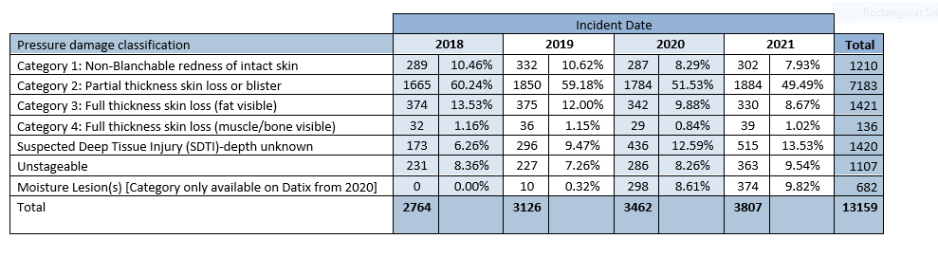

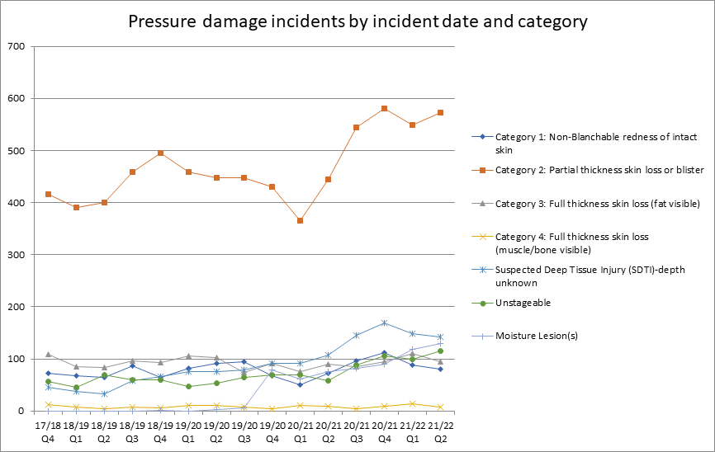

As can be seen by the below chart the highest reporting Clinical Board over the last year is PCIC. It is challenging based on the e-datix reporting system that we use within the Health board currently to stop duplication of pressure damage being reported as patients travel across or access our health care system at different points. As Cardiff and Vale proactively encourages the reporting of incidents and pressure damage it is likely that there is much duplication of pressure incidents in the current e-datix system. The collaborative are in the process of developing a QI dashboard for pressure damage which will triangulate data from both e-datix and our business intelligence system (BIS) to provide a more robust streamlined reliable data set and measurement.

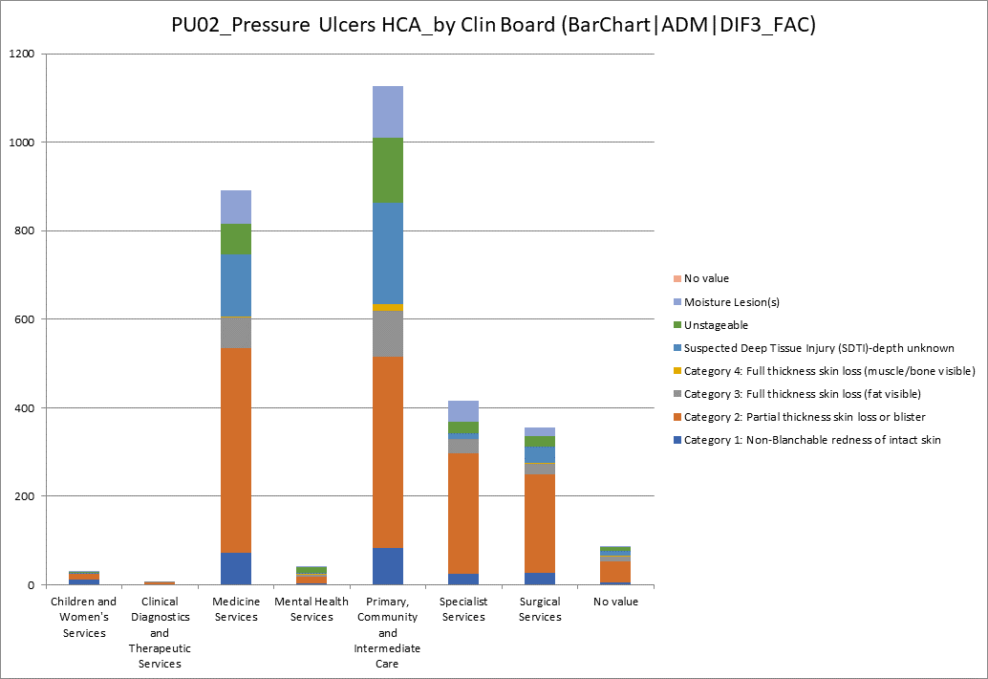

Assessment and Risk Implications

Assessment
The Pressure Damage Collaborative since its formation in April 21 has progressed with a robust work plan. This work has led to the development of 7 subgroups lead by experinced clinical leads from the Health Board under the following headings

- Information and Data
- Education and training
- Incident Management and SI process
- Heel offloading.
- Pressure redistribution work stream
- Documentation
- Perfect Ward roll out

The key actions taken by the colloborative so far since July 2021 are listed below:

- Bariatric cushion procurement completed
- Duo 2 replacments being evaluted ( Aria Pro)
- Scoping RL Datix Cloud IQ system training package for incident reporters and incident managers to include coaching for novice incident managers​
- Scrutiny Panel Terms of Reference and Standard Operating procedure drafted and sent out for comments ​
- Pathway to redress and litigation already in place. Flow chart for pressure damage redress to be agreed between Clinical Boards and Concerns Team​
- Agreed use UHB wide of AsskinG – updated standardised skin bundle
- Perfect Ward is now rolled out to 45 wards will be rolled out by end of October​
- Audit results will be able to be extracted onto a live dashboard for display against other metrics (i.e. Datix)
- Draft QI dashboard created and shared with collaborative, detailing a range of possible metrics available​
- Meeting held to determine most useful/ priority metrics to display. 10 data sets identified, of which 8 metrics are possible to create​
- Work underway to display these 8 metrics on a ward level dashboard
- Launch of pressure damage Collaborative Twitter page @CV_UHBPressure
- Development of Skin Safety Card and Pressure Ulcer Quick Reference guide ( Appendix 1 and 2)
- Restart of Pressure Ulcer and Prevention Virtual Study Sessions
- Updated Stop the Pressure film for both Staff and Patients - https://youtu.be/Bv7wRrG0M5I

Risks to the Collaboratives Goal

- We cannot deliver this goal in isolation of other important work that is already being undertaken across the organisation. The current overwhemling and unprecidented pressures on inpatient occupance and our workforce requirement in the Health Board may impact on the ability to deliver the reduction goal by July 2022
- As our goal is ambitious and needs to be achieved while recognising the work that is required to deliver the reduction of ‘four harms approach’ to our Covid-19 recovery plans
- There may be some short-term limitation with the delay in the roll out of the new “Once for Wales” reporting system
- The slow roll out of the All Wales E-documentation programme may cause duplication of work and effort

Recommendation:

The Quality, Safety and Experience Committee is asked to NOTE the contents of this report and the actions being taken forward to address areas for improvement.

Shaping our Future Wellbeing Strategic Objectives
This report should relate to at least one of the UHB’s objectives, so please tick the box of the relevant objective(s) for this report
- Reduce health inequalities |  |  |  |  |  |  |  |  |  | - Have a planned care system where demand and capacity are in balance
- Deliver outcomes that matter to people |  |  |  |  |  |  |  |  | x | - Be a great place to work and learn
- All take responsibility for improving our health and wellbeing |  |  |  |  |  |  |  |  | x | - Work better together with partners to deliver care and support across care sectors, making best use of our people and technology
- Offer services that deliver the population health our citizens are entitled to expect |  |  |  |  |  |  |  |  | xx | - Reduce harm, waste and variation sustainably making best use of the resources available to us
- Have an unplanned (emergency) care system that provides the right care, in the right place, first time |  |  |  |  |  |  |  |  |  | - Excel at teaching, research, innovation and improvement and provide an environment where innovation thrives |  |  |  |  |  |  |  |  |  | x
Five Ways of Working (Sustainable Development Principles) considered
Please tick as relevant, click here for more information
 | Prevention | X | Long term |  | X |  | Integration |  |  |  |  | Collaboration |  |  |  |  | Involvement |  | X
Equality and Health Impact Assessment Completed: |  |  | Yes / No / Not Applicable  If “yes” please provide copy of the assessment. This will be linked to the report when published.

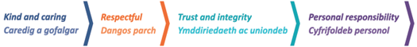
Appendix 1

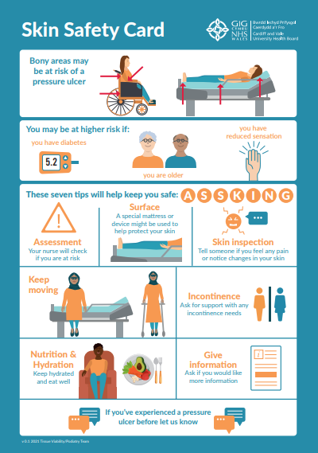

Appendix 2

