Report Title: | PERFORMANCE REPORT
Meeting: | Board Meeting |  |  |  |  | Meeting Date: |  | 27 January 2022
Status: | For Discussion |  | For Assurance | x | For Approval |  | For Information
Lead Executive: | Chief Operating Officer and Executive Finance Director
Report Authors (Title): | Information Manager & Service Manager – Operations
Background and current situation:

Whilst the Health Board continues to progress plans outlined in its updated 2021/22 annual plan and ‘Planning for Recovery and Redesign’ addendum as submitted to Welsh Government in June 2021, current operational pressures are having an impact on performance against a number of key operational indicators.

Specific details of current operational system wide challenges are set out in a separate report to the Board - System Resilience.

There has been no change to national requirements for performance and waiting list reporting and published information since the last Committee meeting.

The current performance report remains a condensed report focusing on a limited number of indicators. The format of the performance report is being reviewed with a view to enhancing the scope as recovery of all services continues.

Key Issues to bring to the attention of the Board/ Committee:

- The Health Board continues to experience significant operational pressures, driven by our inability to achieve timely discharge of patients. Covid continues to add an increased level of complexity and uncertainty. Current operational pressures are having an impact on performance against a number of key operational indicators.
- Whilst the Health Board continues to monitor the position for key operational performance indicators, prioritisation of need and service delivery continues to be based on clinical prioritisation rather than time-based targets.
- Whilst headline performance on the Part 1a Mental Health measures is not compliant overall, CAMHs performance specifically is now above target. Demand for Mental Health Services continues to be high.
Assessment and Risk Implications (Safety, Financial, Legal, Reputational etc. :)

Appendix 1 provides sets out the current performance position for the following areas of performance:
- Unscheduled Care
- Primary Care
- Mental Health Measures
- Cancer
- Elective access – RTT, diagnostics and outpatient follow-ups

Appendix 2 provides the Finance report for the Board.

Note: Commentary and assessment on the latest quality and safety indicators is provided in a separate report from the Executive Nurse Director.
Recommendation:

The Board is asked to NOTE:
- The current position against specific performance indicators for 2021-22

Shaping our Future Wellbeing Strategic Objectives
This report should relate to at least one of the UHB’s objectives, so please tick the box of the relevant objective(s) for this report
- Reduce health inequalities |  |  |  |  |  |  | - Have a planned care system where demand and capacity are in balance |  |  |  |  |  | X
- Deliver outcomes that matter to people |  |  |  |  |  | X | - Be a great place to work and learn
- All take responsibility for improving our health and wellbeing |  |  |  |  |  |  | - Work better together with partners to deliver care and support across care sectors, making best use of our people and technology
- Offer services that deliver the population health our citizens are entitled to expect |  |  |  |  |  |  | - Reduce harm, waste and variation sustainably making best use of the resources available to us
- Have an unplanned (emergency) care system that provides the right care, in the right place, first time |  |  |  |  |  | X | - Excel at teaching, research, innovation and improvement and provide an environment where innovation thrives
Five Ways of Working (Sustainable Development Principles) considered
Please tick as relevant, click here for more information
 | Prevention | X | Long term | X | Integration |  |  | X | Collaboration | X | Involvement | X
Equality and Health Impact Assessment Completed: |  |  | Not Applicable


Appendix 1
Unscheduled Care
Overview | - Emergency Unit attendances reduced slightly in December 2021 (10,379) from October 2021 (11,975) a decrease of 15%. This is 19% higher than 8,399 in December 2020.  - 4-hour performance in EU improved in November 2021 to 64% from October (62%) but deteriorated to 62% in December. This compares to 70% in December 2020. 12-hour waits have been high in the recent quarter and at their highest (1,177) in December 2021.  - 661 Ambulance handovers took place in over 1 hour in December 2021. This compares with 441 in October 2021.  - The percentage of red calls responded to within 8 minutes has increased to 65% in December 2021 from 64% recorded in October 2021.
 | Graph 1: % A&E Attendances |  | Graph 2: A&E waits – 4 & 12 hours
 | 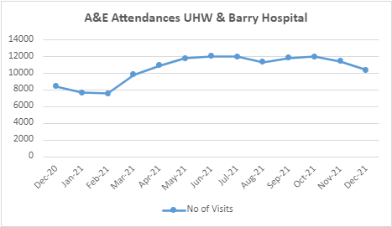 |  | 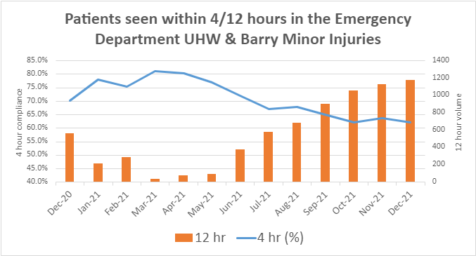
 | Graph 3: Ambulance handover > 1 hour |  | Graph 4: Red calls responded to within 8 minutes
 | 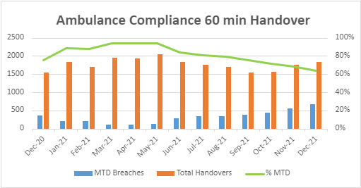 |  | 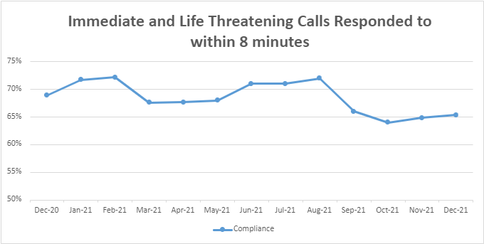
Primary Care
Overview | In relation to General Medical Services (GMS):  - Sustainability applications: The UHB currently has one sustainability application.  - Contract terminations/resignations: There have been no contract terminations and 2 contract resignations.  - Directly managed GP services: The UHB presently has no directly managed primary medical care services  In relation to GP Out of Hours (GPOOHs):  - In November 2021, 100% of patients prioritised as ‘emergency’ requiring a home visit were seen within one hour.  - In November 2021, 100% of patients prioritised as ‘emergency’ requiring a primary care centre appointment were seen within one hour, an increase from September 2021 (80%)
Performance | Chart 1: % of GP OOH appointments requiring a home visit provided within 1 hour | Chart 2: % of GP OOH “emergency” patients attending a primary care center appointment within 1 hour
Performance | 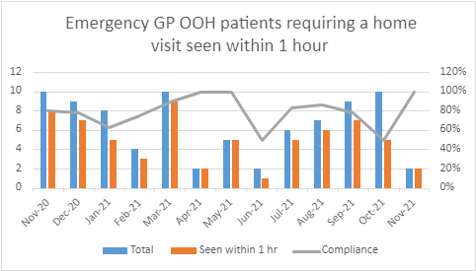 | 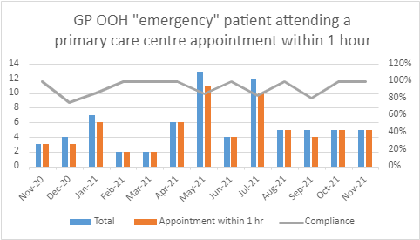

Mental Health Measures
Overview | - Referrals increased in November 2021 (1369) remaining above 1300 since September 2021. Levels of referrals still remain significantly higher than pre-Covid levels.  - Part 1a: The percentage of Mental Health assessments undertaken within 28 days increased to 33% overall and 85% for CAMHs in November 2021.  - Part 1b: 99% of therapeutic treatments started within 28 days following assessment at the end of November 2021.  - Part 2: 77% of health board residents in receipt of secondary mental health services have a valid care and treatment plan (CTP) at the end of November 2021.  - Part 3: 67% of health board residents were sent their outcome assessment report within 10 days of their assessment in November 2021.
Performance | Chart 1: Mental Health Referrals | Chart 2: Performance against Mental Health Measures – Part 1a, 1b, 2 and 3
Performance | 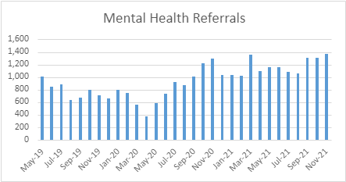  Start of COVID | 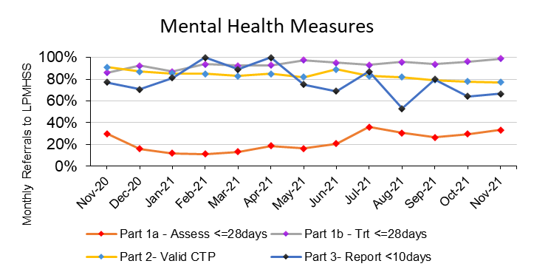
Performance | Chart 3: CAMHS Part 1a compliance
Performance | 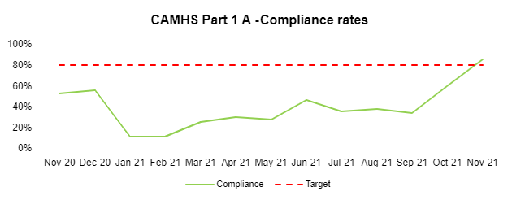
Cancer
Overview | - Referrals for patients with suspected Cancer have returned to pre-Covid levels. There were 1417 referrals from GPs in November. Incidental findings remain at higher levels than pre-Covid levels.  - SCP performance improved to 58% in October 2021 (from 54% in September) but reduced in November 2021 to 54%.
Performance | Chart 1: Cancer referrals | Chart 2: SCP performance
Performance | 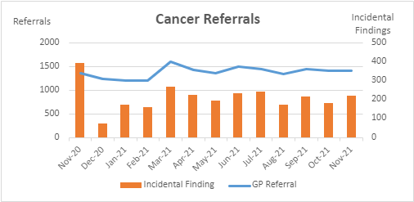 | 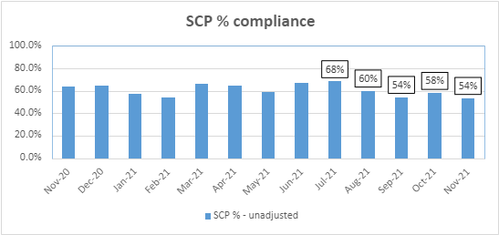

Elective access
Overview | - The overall Referral to Treatment (RTT) waiting list increased to 117,002 at the end of November 2021, an increase of 4,953 from September 2021. There were 39,782 patients waiting over 36 weeks for treatment for planned care, 1,761 more than at the end of September.  - Patients waiting greater than 8 weeks for a diagnostic test have increased since September (7,428) to 7,459 in November 2021.  - The total number of patients waiting for a follow-up increased to 172,804 at the end of November 2021. The number of Follow Up patients waiting over 100% beyond their target date has decreased to 43,237 patients and is 25% of the total follow up outpatient waiting list compared to 27% in September 2021.
Performance | Graph 1: RTT total size of the waiting list | Graph 2: RTT % of patients 26 weeks and number of patients > 36 weeks
Performance | 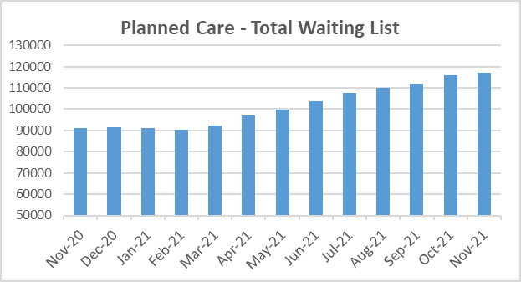 | 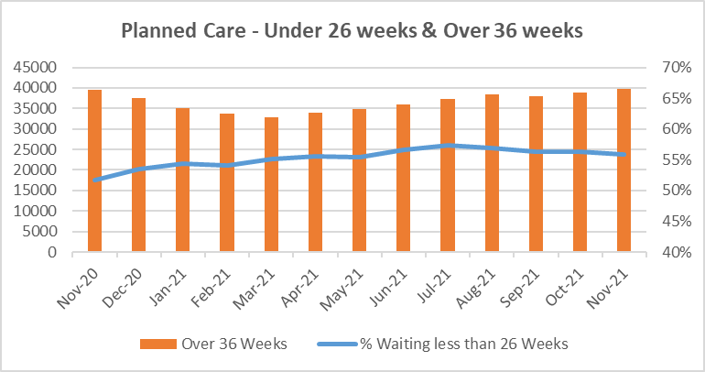
Performance | Graph 3: Diagnostics > 8 weeks | Graph 4: Outpatient follows ups – Total waiting list and > 100% delayed
Performance | 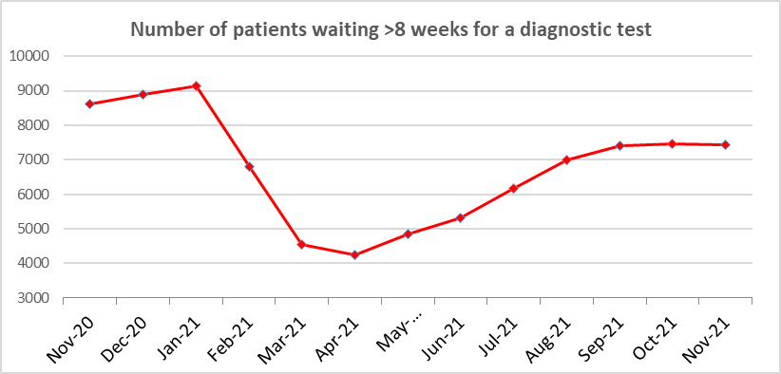 | 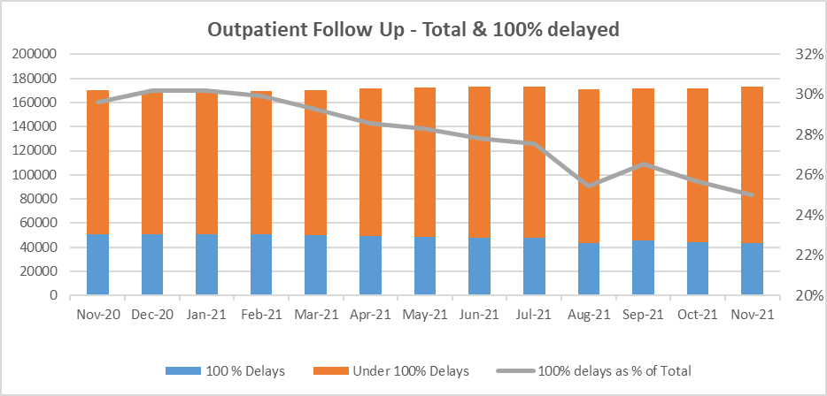

8) FINANCE

How are we doing?

After submitting a draft financial plan at the end of March 2021 the UHB submitted a final annual financial plan to Welsh Government the end of quarter 1 2021 following the receipt of further planning guidance. The final plan includes a breakeven year end position.

The Financial Plan sets out the UHB’s financial strategy in three parts:
- Core Financial Plan: Delivering in-year financial stability and maintain the current level of underlying deficit
- Continuation of non-recurrent response to COVID within available funding
- COVID recovery and reset (service) within available funding

The Welsh Government have now confirmed non recurrent funding for the brought forward COVID deficit of £21.313m which relates to non-delivery of the savings target in 2020/21 that was required to fund inflation and demand growth in 2020/21.

The reported financial position for the 8 months to the end of November is an operational surplus of £0.305m.

Delivery of the core financial plan includes a 2% (£16.0m) savings requirement. At month 8 £15.419m Green and Amber savings were identified against the target. Further progress needs to be made with a focus on recurrent schemes. £7.735m recurrent schemes were identified against the £12.0m recurrent element of the target leaving a further £4.265m to find.

The full year gross COVID forecast has moved in the month from £124.687m at month 7 to £117.608m at month 8. The reduction in forecast costs primarily relates to reductions in National Programme forecasts (COVID Vaccination, TTP, Cleaning Standards and PPE) and the recovery of 2020/21 accruals.

Reported month 8 position

The Welsh Government amended the monthly financial monitoring returns to capture and monitor costs due to COVID 19. The financial position reported to Welsh Government for month 8 is a surplus of £0.305m and this is summarised in Table 1.

Table 1 : Financial Performance for the period ended 30th November 2021

The additional COVID 19 expenditure at month 8 was £64.600m with full year forecast costs totalling £117.608m

Welsh Government has now agreed confirmed and anticipated COVID 19 funding. The UHB has an operational surplus of £0.305m at Month 8 and is forecasting a break even position by year end and all risks will need to be managed to deliver this. The forecast is based on the premise that COVID 19 allocations will be sufficient to meet COVID costs and that reductions arising in planned expenditure will be used to offset non COVID operational pressures and support system resilience.

Underlying deficit position

The UHB’s accumulated underlying deficit brought forward into 2021/22 is £25.3m which reflects the £21.3m shortfall against the recurrent savings 2020/21 target due to the pandemic. This is being offset by non recurrent COVID 19 funding.

Delivery of the UHB’s financial plan will ensure that the underlying position does not deteriorate in 2021/22 and further work on identifying further recurrent savings is required to achieve this and leave an underlying deficit of £25.3m to carry forward to 2022/23.

Creditor payment compliance

The UHB’s public sector payment compliance performance was 94.2% at the end of November which is just below the statutory target of 95%. Performance deteriorated marginally in month but is expected to improve as the year progresses.

Remain within capital resource limit

The UHB’s approved annual capital resource limit was £55.865m at the end of November 2021. Net expenditure to the end of November was 17.6% of the UHB’s approved Capital Resource Limit which reflects the large number and value of schemes approved by Welsh Government since Month 6. The UHB has plans to fully utilise its capital allocation and most expenditure is planned for the later part of the year. There is an inherent risk in this due to potential supplier delays and works slippage. The UHB is therefore being proactive in managing these risks.

What are the UHB’s key areas of risk?

Delivery of the core financial plan includes a 2% (£16.0m) savings requirement for which good progress is being made. At month 8 however, £7.8m recurrent schemes have been identified against the £12.000m recurrent element of the target. Further progress is required to find another £4.2m recurrent schemes in order to maintain the underlying position.

The UHB is forecasting a breakeven position at the year end in line with the submitted annual financial plan. In order to achieve this there are a number of risks that need to be managed including the full utilization of resources that have been allocated to the UHB.

