Report Title: | PATIENT SAFETY QUALITY AND EXPERIENCE REPORT |  |  |  |  | Agenda Item no. |  | 6.4a
Meeting: | Board Meeting |  |  |  |  | Meeting Date: |  | 25.11.21
Status: | For Discussion |  | For Assurance |  | For Approval |  | For Information
Lead Executive: | Executive Nurse Director  Executive Medical Director
Report Author (Title): | Assistant Director, Patient Experience 029 21836336

Background and current situation:

The purpose of this paper is to present an integrated Quality, Safety and Experience report which covers the period from September to October 2021.

The development of an integrated Patient Safety Quality and Experience report, presents an opportunity for greater triangulation and analysis of information. It enables Clinical Boards and the Corporate Teams to identify areas of good practice but also to identify emerging trends and issues that require action in order to improve the safety and quality of services.

The UHB has a wide range of data which provides a level of assurance on the safety and quality of services, as well as on the experience of patients and families. This report provides an analysis of information drawn from the reporting of patient safety incidents, Serious Incidents (SIs) and Never Events, as well as concerns raised by patients and families and feedback from national and local patient surveys. Themes emerging from internal and external inspections of clinical areas also provide a very valuable level of assurance in relation to the quality and safety of clinical services.

Where available, benchmarking data with peers is provided. Assurance in relation to the action that is being taken to address areas for improvement is also described.

Executive Director Opinion/Key Issues to bring to the attention of the Board/Committee:

It is pleasing to note that the Health Boards 30-day performance in responding to concerns has been maintained at 81% despite the increasing numbers of concerns being received.

During this reporting period the highest reported incident is unavailability of staff which is reflected in our risk register.

The Internal Audit report advising of limited assurance for the Quality Assurance and Clinical Effectiveness function of Patient Safety and Quality which is currently being considered and informs the QSE business case the detail of which has been reported to the Audit Committee.

The Patient Experience Team were successful in two PENNA (Patient Experience National Awards) categories this year. The first category ‘Support for Families and Care Givers’ we were successful runners up , this work involved the Bereavement Team undertaking and ensuring that all bereaved families are contacted after a death of a loved one and offered telephone support and signposting during a very difficult time

In addition, the whole team were winners in the category of ‘Team of the Year’ for the work they have undertaken throughout the pandemic. Cardiff and Vale Health Board are the first Welsh Health Board to have achieved this winning status in the Team of the Year category.

Assessment and Risk Implications (Safety, Financial, Legal, Reputational etc.):

During September to October 2021, the following Nationally Reportable Incidents (Serious Incidents) and No Surprises have been reported to Welsh Government:

Nationally Reportable Incidents

Clinical Board | Number | Description
Medicine Clinical Board | 7 | - 3 injurious falls  - 2 gastroenterology delays in patients found to have malignancy  - Hospital acquired grade 3 pressure damage  - Mismanagement of thromboprophylaxis in patient with acute stroke
Children and Women | 1 | - New born baby developed hypoxic brain injury during surgery
Surgery | 2 | - Spark in theatre following use of diathermy and chlorhexidine  - Intra-operative accidental Augmentin overdose to a baby
PCIC | 4 | - Unexpected death in prison  - Suicide in prison  - Unexpected child death  - Grade 3 pressure damage in community
Mental Health | 4 | - Inpatient suicide  - 2 injurious falls  - Patient known to CMHT arrested on suspicion of murder
TOTAL | 18
No Surprises

Clinical Board | Number | Description
Medicine | 1 | - Norovirus outbreak
Executive | 3 | - Infected blood inquiry publishing documents relating to the testing, management and support of patients with HIW between 1984 and 1990  - Restricted visiting decision due to Covid-19 outbreak at UHL  - Parents of patient pursuing private route for specialised treatment
Mental Health | 4 | - Air rifle purchased by patient and brought onto hospital site  - Patient on MH section absconded in a taxi  - Fire started by MH inpatient  - Inquest with potential media interest
TOTAL | 8

How do we compare to our peers?

Following the change in the way organisations report their more serious incidents from June 2021, Cardiff and Vale have adapted their approach to ensure that appropriate information is gathered via a Patient Safety Fact Finding tool to support the NRI (previously SI) meeting and therefore decision making around the need for external reporting. This process is now embedded within Clinical Boards and supports timelier reporting to the Delivery Unit (DU).

All Covid-19 related restrictions to NRI reporting are fully lifted and we are now reporting anything that is in line with the DU guidance this includes:

- All Never Events
- Inpatient suicides
- Maternal deaths
- Neonatal deaths
- Homicides
- Incidents of high impact/likely to happen again including child related deaths (for local decision)

The closure process has also changed and dependent on whether causative factors are identified as part of the investigation, will determine on the closure form required. Organisations are also now able to downgrade a reported incident if during the process of investigation it is identified that this in fact does not meet reporting criteria.

We hope that this change in practice and the implemented Fact Finding Tool will better enable us to meet the 7-day reporting timeframe with the DU and significantly reduce the number of outstanding incidents exceeding their closure due date. It should also lead to early identification of immediate actions to mitigate any risk

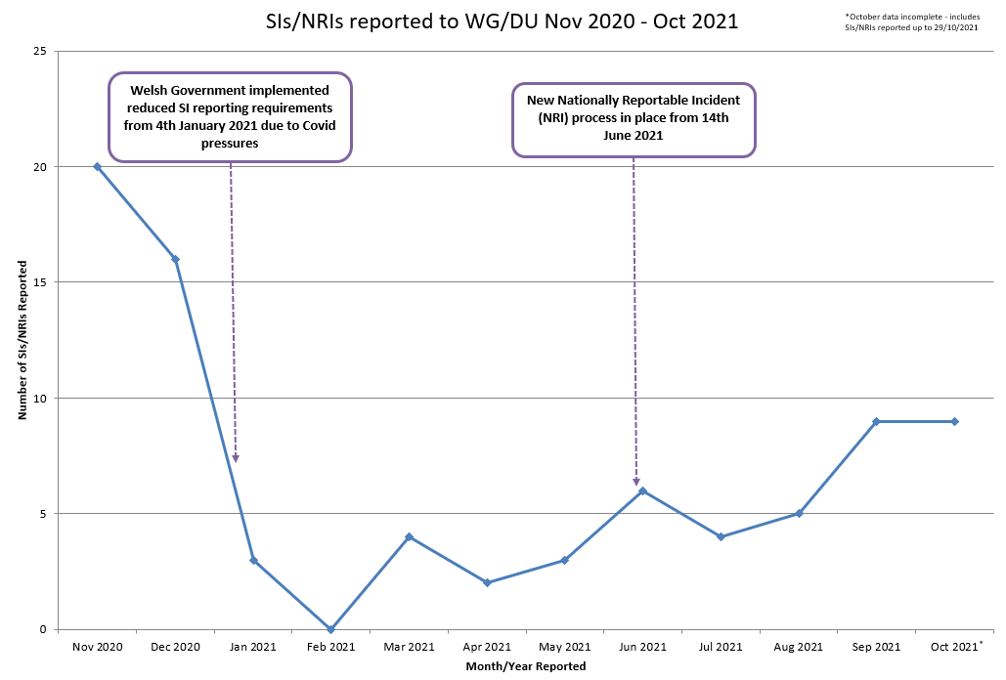

The chart above demonstrates the significant reduction in Nationally Reportable Incidents (NRIs) following Covid-19 restricted reporting criteria which came in in January 2021. External reporting to the DU remained fairly low until the new NRI process came in in June 2021 when the Covid-19 related restrictions ceased. We have not returned to pre-pandemic/pre-national changes reporting of NRIs, however changes in what is now deemed an NRI could have a large bearing on this. An example is the change to not report sudden deaths of Mental Health patients in the community until a review of the case has been completed – Health Boards now have 120 days to undertake this review. These will then only be reported nationally if there are deemed to be causative or contributory factors. These are fairly significant in number and all would have been reported previously, even if the cause of death was later found out to be natural causes. It is for this reason that the change in reporting was made and helps explain our lower NRI reporting rates.

Despite the reduction in NRI reporting, we do know that the number of general patient safety incidents reported on Datix however has remained fairly consistent and so we are assured that staff are still able to openly report areas of concern.

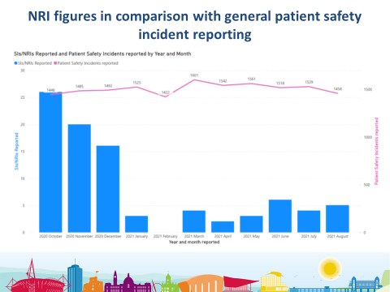

This chart demonstrates the point made above that patient safety incident reporting has remained fairly consistent despite changes in NRI reporting rates. This is reassuring as we know clinical areas are under significant operational pressures currently which could impact on the ability of staff to report incidents.

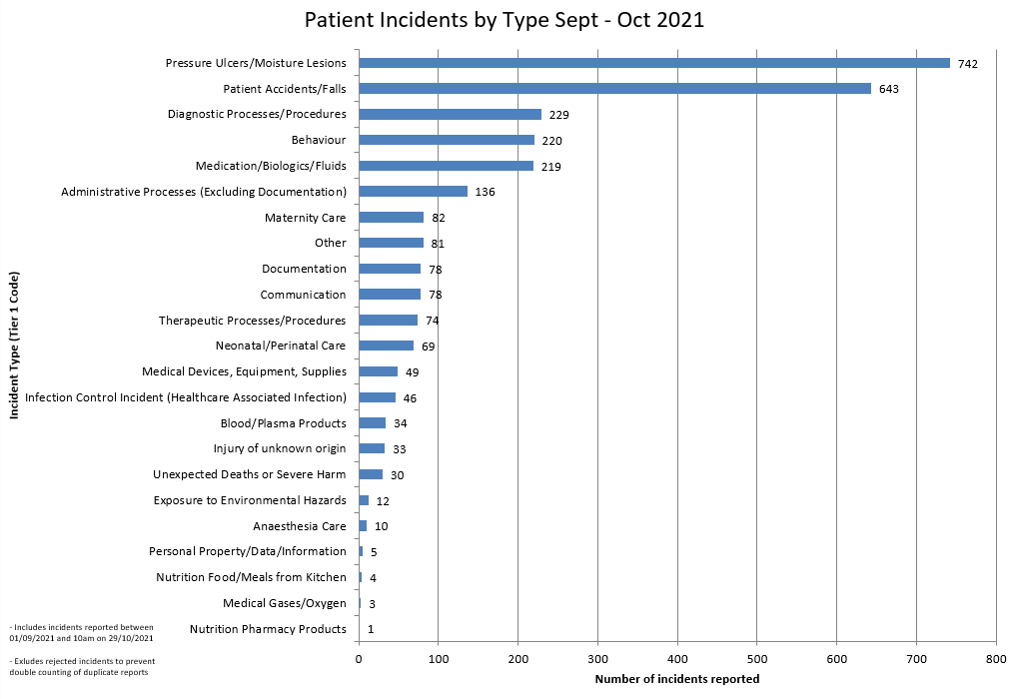
The above chart shows that pressure damage and falls are our most commonly reported patient safety incident, as has been highlighted in previous reports to Board. It is for this reason that there are collaborative improvement groups in existence focusing on tackling these two high reporting themes.

The multi-disciplinary, multi-agency Falls Delivery Group has been in existence with a Falls Lead since January 2021; their purpose is to monitor a range of quality and performance indicators in relation to falls prevention and management across the whole healthcare system. There is a big focus on staff education with ward based simulation, however some of this work has been delayed by the Covid-19 pandemic. The Falls Awareness campaign ahead of Falls Awareness Week on 20th September was well received.

The Pressure Damage Collaborative Group chaired by the Director of Nursing for Surgery Clinical Board has set the goal to reduce pressure damage by 25% by July 2022. A Scrutiny Panel process has been established in Primary Care Clinical Board and this is to extend to all Clinical Boards. The Wound Healing Team launched their Pressure Ulcer Advisory Group in November 2020 with a Pressure Damage link nurse role for each clinical area to improve knowledge and skills on assesssment and first line management of pressure damage.

These two categories are commonly reported by other Health Boards and as such will feature as part of the DU phase 2 approach to incident reporting. Phase 1 was the change in national reporting of the serious incidents which has already been established. Phase 2 will focus on themes and trends of commonly reported incidents and assist with benchmarking against other Health Boards as well as improve shared learning across Wales. We are still waiting to hear more about the phase 2 approach but look forward to what we will gain in terms of intelligence from this.

The overall numbers of Covid-19 related incidents still remain low in comparison with the peak of the pandemic, however we are seeing numbers starting to increase. During September and October, unavailability of staff to treat has now become the highest reported Covid-19 related incident by a significant margin. This is followed by aggressive/inappropriate behaviour which is predominantly aggressive behaviour towards staff by relatives who are unable to visit their family. This has previously been reported in higher figures, however due to the opening up of visiting this is now less frequently reported unless there are localised closures due to outbreaks.

The Safe2Move risk assessment, which was designed collaboratively following learning from the Covid-19 investigations, has been implemented across the Health Board and details a framework for safe patient placement and movement to maintain patient safety but also ensure flow. We hope that this will reduce the incidences associated with potential exposure and hospital acquired Covid-19.

The Head of Covid Investigations continues to oversee the review of the care patients with nosocomial Covid-19. Executive oversight is provided through the established Covid-19 Stakeholder Group and through its sub-group Covid-19 Scrutiny Panel.

Clinical Effectiveness Committee Feedback

Since the last paper to Board, there has been one Clinical Effectiveness Committee meeting which took place on 13th October, chaired by the Associate Medical Director. The Committee is now well embedded and clinicians are attending to present their National Data and outline work that is being undertaken in relation to continuous improvement.

The TARN audit was discussed and the lack of resource to deliver the audit which has previously been discussed with the Clinical Board. A meeting will take place with the Associate Medical Director, Head of Patient Safety and Quality Assurance, MTC management and Clinical Lead to expedite progress with addressing the issues.

Five national clinical audits were discussed. It was noted that the Epilepsy 12 (children and young people) audit had no data was submitted for Cardiff and Vale for 2019 (2018-19) or 2021(2019-20). Assurance is being sought from the Clinical Board that this has been addressed and a clinical lead is in place for this national clinical audit.

The NDQP peer review was presented by the Paediatric Diabetes Lead Consultant. The report highlighted positive aspects of care provided by the team including good multi-disciplinary working, positive service user feedback and continuous improvement in HbA1c. The report identified concerns in relation to inadequate specialist dietetic time, patients waiting up to 12 months for pump therapy and that transition services may reach threshold for serious concern if no improvements are made. An Improvement Plan has been developed to address these concerns which will be re-visited in six months’ time at the CEC to review progress. The report has been presented through the Directorate and Clinical Board quality and safety processes and placed on the risk register.

The Orthopedic Joint Replacement Peer Review has been published and will be presented by the Clinical Lead at the next CEC meeting.

An overview of the progress of the Clinical Effectiveness Committee has been presented to the October 2021 Special QSE Committee meeting.

It is also pertinent to note that an ‘Internal Audit of Clinical Audit’ arrangements has taken place and the report has been published which provides limited assurance. The business case has been submitted outlining the investment and resource required to adequately fulfill the Quality Assurance and Clinical Effectiveness function of Patient Safety and Quality which is currently being considered.

Learning from Deaths/Mortality

The Mortality Review Group is well established and continues to meet bi-monthly. One of its functions is to oversee progress with the implementation of the Medical Examiners (ME) which continues both within the UHB and across Wales.

Emerging themes include:

- Management of high risk (elderly/co-morbidities) patients
- Discharge/re-admission
- Communication
- Nutrition
- Pressure damage
- Falls
- Infection Prevention and Control – hospital acquired Covid
- Nurse staffing
- Good practice
- Best interest meeting for a patient with Learning Disabilities
- Named consultant in good care

Many of these themes are being progressed and are highlighted within this report.

The Datix Mortality Module went live in the middle of October 2021. This is essential for monitoring and reporting, particularly as the volume of mortality reviews by the MEs increase.

Summer 2022 is the latest prediction for this to become statutory. In the meantime we will continue to establish processes that support the spread to all deaths including primary care.

Patient Experience

As previously reported, since March 2020, the PET (Patient Experience Team) has worked very differently, utilizing a variety of methods to gain patient feedback.

We are continuing to gather limited feedback using paper surveys, but are supplementing this with the increased use of electronic surveying via text, electronic tablet and kiosk.

Currently, we routinely survey a number of areas on three of our hospital sites: UHW, UHL and St David’s. However, beginning in November, we will restart surveying various Mental Health wards in Hafan Y Coed hospital and it is hoped in coming months that this will expand to include more areas, with the introduction of the CIVICA ‘Once for Wales ( Patient Experience) ’ platform in early 2022.

In addition to the above, we have continued to gain routine patient feedback from the UHB MVCs (Mass Vaccination Centres) and since their introduction in March 2021, have received feedback from 26450 respondents. This feedback has been very positive, with 99% of respondents (based on 25713 responses from the Viewpoint kiosks) rating their experience at the MVC as either ‘very good’ or ‘good’.

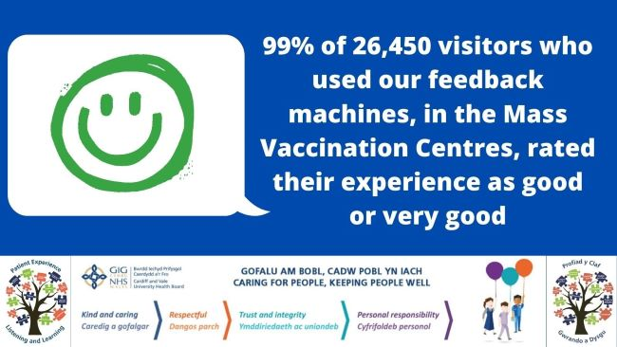

Also, our ‘HappyOrNot’ kiosks have been reintroduced to various areas including the Concourse, Information Centre at UHL and the Emergency unit. Of the 6685 respondents that have left feedback, 77% have given a positive response when asked to rate the care they have received.

In relation to the expansion of the routine surveying of patients, the implementation of the CIVICA ‘Once for Wales’ platform is proceeding as planned and it is hoped that this will be fully ‘up and running’ by April 2022. This will not only enable us to reach out to more patients to gather feedback, but will also mean their feedback will be available much more quickly to our frontline staff.

In addition to the routine surveying, we are also involved in numerous projects which involve working with various teams to produce bespoke material. Examples of these bespoke projects include:

- PHW Breast clinic survey. This was a short ‘one day’ survey carried out in collaboration with Public Health Wales, to gain feedback from patients regarding their mammogram appointment preferences. In total, 17 patients were surveyed. Of the 14 patients who answered the question: ‘If given the choice, would you have preferred to receive your results on the same day as your mammogram, even if this meant a wait in clinic of 3 - 4 hours?’, 79% responded that they ‘Definitely would’ or ‘Probably would’. The service is using this feedback to review the pathway.

- Inpatient feedback telephone survey. This was a ‘one off’ survey carried out during August/September 2021 and involved a support worker calling a random sample of patients discharged during June, July and August 2021, to gain feedback on their experiences whilst admitted. In total, we received feedback from 223 patients. Of the 222 patients who answered the question ‘Using a scale of 0 - 10 where 0 is poor and 10 is excellent, how would you rate the care you received?’ 93% rated the care received as 7 or more.

- Patient Experience Framework survey. This was a ‘one off’ survey where staff and non-staff were asked what would be important to them if attending hospital as a patient. They were also asked for feedback on the Patient Experience Department and the 5-year framework (staff only). In total, we had feedback from 1243 respondents (89% staff and 11% non-staff). Of the 1019 staff who answered the question: ‘Are you aware that the Health Board has a Patient Experience Team?’ 20% responded ‘No’.It is evident that we need to promote the awareness of the Patient Experience team and its role and functions across the UHB and our communities.

- Examples of other bespoke projects in the design phase/currently underway include:

- MVC staff survey
- District nurse survey
- CRT survey
- Sex Worker survey
- Rehabilitation survey - General
- Rehabilitation survey - TBI
- NICU Psychology survey
- Paediatric CF Nebuliser survey
- Paediatric Speech and Language Therapy survey
- Cancer diagnosis survey
- Cardiac Obstetric survey
- Radiology webpage evaluation survey
- Haematology prehab survey
- Children’s hospital wayfinding survey
- Oral surgery survey

Bereavement Services

Within our Bereavement Support Service, we continue to support those whose loved ones have died within our hospitals. During the last month we have contacted approximately 190 families to offer them emotional support and the option of being referred for counselling within the third sector. In total over 3000 families have been contacted often more than once and a percentage have been referred for specialised bereavement support

PENNA 2021 Awards

The Patient Experience Team were successful in two PENNA categories this year. The first category ‘Support for Families and Care Givers’ we were successful runners up , this work involved the Bereavement Team undertaking and ensuring that all bereaved families are contacted after a death of a loved one and offered telephone support and signposting during a very difficult time. Watch the video here.

Secondly the whole team were winners in the category of ‘Team of the Year’ for the work they have undertaken throughout the pandemic. Cardiff and Vale Health Board are the first Welsh Health Board to have achieved this winning status in the Team of the Year category which is an enormous achievement for the whole team.
Watch the video here.

Digital Stories Agenda

Following the recent recruitment to the role of People Experience Digital Stories lead in September who has begun working closely with Swansea Bay on the Once for Wales approach to digital stories including implementation of a platform to host as a library for these stories, the lead for this project is currently in discussions with staff to collate 11 patient stories.

Complaints Management / Redress

In September and October, 1,317 concerns/contacts were received. This is an increase when compared to 1,033 contacts received in July and August. This increase reflects in part the higher number of enquiries the Concerns Team received as more people are requesting updates on their COVID-19 booster vaccinations

When compared to the same period last year, when 557 concerns were received, there has been more than a 100% increase in concerns being raised during September and October this year. It is pleasing to note that despite the current significant Clinical Pressures and staff availability, reported in the last Board Report, the Health Board has maintained an 81% 30-day performance in responding to concerns.

Since the beginning of April, the Concerns Team have been hosting a 7-day booking line (including Bank Holidays) for relatives to arrange a visit which is consistently extremely busy. We receive, on average, approximately 600 visiting requests a week, with approximately 70% of calls resulting in a visit being arranged. The Team work closely with the clinicians to provide advice regarding safe visiting practices and to collate the required contact information. Visiting on the UHL site was postponed for a short period due to rising Covid cases and this is reflected in the decrease in the number of visiting calls received. However, visiting has now recommenced and we anticipate that visiting requests will increase, particularly leading up to the Christmas period.

Concerns | Vaccination enquiries | Visiting Calls
571 | 740 | 3,580

We currently have 349 active concerns. Medicine Clinical Board have the highest number of active concerns, with Surgery having the second highest.

EU Directorate continue to receive a high number of concerns, however, this would be expected based on the significantly higher number of patient contacts and level of activity they experience in conjunction with the rest of Medicine Clinical Board during the pandemic.

As mentioned in previous reports, we continue to receive a high volume of concerns relating to follow up treatment, appointments and waiting lists and a number of actions have been taken by Clinical Boards to address some of these issues:

- Clinical Boards have been encouraged to contact patients to provide assurance that they have not been forgotten and to provide updates on services and current waiting times
- Clinical Boards/Directorates have redesigned pathways to fast track patients that have not accessed care during the pandemic
- Primary care services are being utilised so patients can be seen more timely
- Some areas have introduced weekend clinics to catch up with the back logs

Communication is a theme consistently identified in Concerns and this can be particularly distressing for relatives and patients when there is poor communication regarding diagnosis, treatment plans and discharge requirements. It is particularly difficult when visiting is restricted. One initiative being undertaken within Medicine Clinical Board is the implementation of the Safer Bundle which incorporates communicating with patients regarding their progress and making them active participants of their care.

The Health Board has also noted a high number of concerns relating to the environment and social distancing, particularly, within the EU Department.

In order to address these issues, we have as a Health Board:

- designed materials to help/encourage social distancing
- enhanced cleaning procedures and rota’s
- brightened up areas with redecoration

What are we doing?

The Concerns Team continue to operate a 7-day working rota (including Bank Holidays) which has helped support/facilitate communication between wards and relatives.

In order to facilitate visiting when possible, the Concerns Team provide a 7-day booking line to support this – on average, we receive over 600 calls a week. Approximately 70% of these calls result in a visit being arranged.

As mentioned above, we anticipate a high number of visiting requests over the festive period and therefore, we will maintain cover over the Christmas Bank Holiday period on 27th and 28th December. This will include maintaining the concerns and vaccination enquiry lines.

The Patient Experience Team have also supported virtual visiting which has helped to allay concerns regarding relatives not being able to visit during this very difficult time.

Recommendation:

The Board is asked to NOTE the contents of the Integrated QSE report.

Shaping our Future Wellbeing Strategic Objectives
This report should relate to at least one of the UHB’s objectives, so please tick the box of the relevant objective(s) for this report

1. Reduce health inequalities |  | 6. Have a planned care system where demand and capacity are in balance
2. Deliver outcomes that matter to people |  | 7. Be a great place to work and learn
3. All take responsibility for improving our health and wellbeing |  | 8. Work better together with partners across care sectors, making best use of our people and technology
4. Offer services that deliver the population health our citizens are entitled to expect |  | 9. Reduce harm, waste and variation sustainability making best use of the resources available to us
5. Have an unplanned (emergency) care system that provides the right care, in the right place, first time |  | 10. Excel at teaching, research, innovation and improvement and provide an environment where innovation thrives
Five Ways of Working (Sustainable Development Principles) considered
Please tick as relevant, click here for more information
Prevention |  | Long term |  | Integration |  | Collaboration |  | Involvement

Equality and Health Impact Assessment Completed: | Yes / No / Not Applicable  If “yes” please provide copy of the assessment. This will be linked to the report when published.

