Department | Cardiff & Vale University Health Board
Clinical Board | Surgery
Development or Scheme | National Robotics-assisted Surgery Programme
Author/s | Mike Bond: Director of Operations
Version | 1
Date | 24th November 2021

- Executive Summary & Recommendations
  - Vision

To develop Robotic Assisted Surgery (RAS) across Wales as part of a bold strategy to improve outcomes for our patients. It is part of a wide range of health redesign principles in Wales that look to utilise the finite health resource we have as effectively and efficiently as possible. In conjunction with diagnostic hubs, health pathways and systems to establish early diagnosis of disease the RAS programme will deliver cutting edge technology in our tertiary hospitals. The Royal College of Surgeons’ Future of Surgery Commission has identified RAS as one of the key technologies that will deliver the greatest impact for our patients. It allows doctors to perform complex procedures with more precision, flexibility and control than is possible with conventional techniques. It is usually associated with minimally invasive surgery – procedures performed through small (keyhole) incisions.

  - Purpose

The aim of the All Wales programme is to rapidly implement a National Robotics Assisted Surgery Programme (NRP), the first of its kind worldwide for Colorectal, Upper Gastrointestinal, Urological and Gynaecology Oncology at CVUHB along with three other health boards, ABUHB, BCUHB and SBUHB.

The purpose of this case is to progress the Cardiff & Vale University Health Board business case, ensuring that we utilise the Welsh Government funding available to implement and commission RAS in the University Hospital of Wales and understand the medium to long term financial impact, risks and benefits. The managed service contract has been awarded to CMR and the aim is to develop a close partnership with the company to drive improvements for our patients needing surgical intervention.

The key objectives of the programme are:

- Create a partnership with industry across Wales to promote innovation and develop a vibrant and exciting environment that will entice and retain a highly skilled and motivated workforce in Wales.
- To utilise the introduction of RAS as a driver for whole system improvement.
- To procure a robotic industry partner to introduce the new technique and develop the robotic programme in a 21st century long-term innovation partnership for improving surgical services across Wales.
- To develop robust governance systems to ensure the safe introduction of the new technology and continued monitoring of the technique.
- To focus on developing an excellent education system to train consultant surgeons, senior surgical trainees and wider members of the surgical team.
- To develop a robotic research network across Wales to measure clinical outcomes, share good practice and ensure sustainability of the technique.
- To understand the financial quantum and ensure that the benefits both economical, quality and financial are fully realised over the years.

  - Benefits

The benefits to patients and the health economy are considerable and are detailed in the detailed business case but predominantly include:

- Improved patient outcomes through less invasive trauma, blood loss and associated transfusions
- Decrease cancer waiting times (e.g. 62-day target for patients requiring surgical management)
- Improve access for patients and allow care closer to home
- Improve patient experience by delivering best practice surgical techniques for patients
- Create a value-based product that evidences it’s worth through an agreed economic, financial and quality framework
- Potential for reduced length of stay, complications and reduced open procedures

  - Finance & Activity

Financial Summary

The proposal presented to the Welsh Government is an All-Wales case, but the preferred supplier (CMR) has confirmed that the robotic partnership and the associated financial model will remain valid on a pro rata basis if not all Health Boards choose to ultimately pursue.

The contractual arrangement is in the form of a managed service. It is for an initial seven-year period, with the option to extend for a further three years if all parties wish.

Welsh Government have indicated they would provide transitional funding over the first three years of the contract on a tapered basis (100% year 1, 50% year 2, 30% year 3).

The total cost to the Health Board over this seven-year period is £2.73m having offset anticipated funding from Welsh Government. This would support the delivery of up 200 robotic cases per year without incurring any additional cost. The position is summarised in the table below:-

If the Health Board choose to extend this contract for an additional three years, there would be an additional commitment of £0.413m per year (£1.240m in total).

It should be noted that formal confirmation has not yet been received from Welsh Government for this transitional support; nor has the timing of year 1 been clarified. If the year 1 support (at 100%) is intended for 2021/22 then this would not align with anticipated expenditure and would result in a surplus that the Health Board would have to re-provide in the financial plan for 2022/23.

This anticipated offer of transitional funding is on a revenue basis. This is important as the accounting treatment of leasing contracts will change from 1st April 2022. IFRS 16 sets out that that capital expenditure within these contracts must be capitalised and shown on the balance sheet. This has been brought to the attention of the acting Head of Capital at Welsh Government.

The team are very confident that the robot can be built and delivered before 31st March 2022 and as such this contract would not fall within the realms of the proposed changes to IFRS 16.

This assessment is net of VAT. Whilst not formally confirmed it is expected that VAT will be recoverable in line similar managed service contracts. This treatment will be the same regardless of the time of delivery as IFRS 16 does not require the associated VAT to be capitalised.

All training and education requirements are included in this proposal by the preferred supplier over the lifetime of this contract. There are no additional costs for the Health Board.

The supplier has included within this proposal financial support of £30k per year to support the appointment of a fellow/other clinician (to include a Nurse). This will be important given that this role has proven essential to support Urological robotic activity.

Separate external funding has been secured to support the Programme Management of this proposal, which will be available to support the proposed robotic partnership across Wales.

Activity

The full proposal (to deliver a robotic partnership providing four robots across Wales) includes an annual baseline of 800 cases within its financial model. Whilst not formally agreed, it is anticipated that this will be acknowledged as 200 cases per robot, per year, per Health Board.

Additional cases above baseline are subject to an additional charge of £590 per case.

The activity proposed is not new activity, but current activity utilising a new technology. Current activity has been assessed at 284 case per year. Year one reflects the phased introduction of this new technology.

The expected activity profile is shown in the table below:-

Speciality | Year 1 | Year 2 | Year 3
Colorectal | 88 | 88 | 88
Gynae-Oncology | 52 | 89 | 89
Upper Gastrointestinal | 28 | 107 | 107
Total | 168 | 284 | 284

There are a range of laparoscopic and open procedures that will convert to robotically assisted procedures. It is understood that some of the consumable costs associated with current techniques will no longer be required, but a full assessment has not yet been completed.

The maximum financial committment over the seven-year initial period is estimated at £3m, based upon activity levels not exceeding 284 cases per year.

The position, which is summarised in the table below, will be mitigated by the validation of any current consumable expenditure that will no longer be required.

Year | C&V Contn | Activity | Chargeable | Activity/£590 | Total
 | £'000 | Cases | Cases | £'000 | £'000
1 | 0 | 168 | 0 | 0 | 0
2 | 263 | 284 | 52 | 31 | 293
3 | 368 | 284 | 84 | 50 | 417
4 | 525 | 284 | 84 | 50 | 575
5 | 525 | 284 | 84 | 50 | 575
6 | 525 | 284 | 84 | 50 | 575
7 | 525 | 284 | 84 | 50 | 575
Totals | 2,730 | 1,872 | 472 | 278 | 3,008

The proposed activity needs to be understood on a more granular basis to understand the impact on the Health Board’s Long Term Agreements (LTA’s) with other Health Boards. It is proposed to use the first year of commissioning as an opportunity to explore this more fully, acknowledging the expectation that Welsh Government will fund 100% of additionality in year one.

This assessment has not considered the impact upon the existing robot, which undertakes Radical Prostatectomy, Partial Nephrectomy and Transoral robotic surgery for Head and Neck cancer, which may in time result in the repatriation of current activity flows and an associated disinvestment in fixed costs. The Health Board executive had agreed to treat this as separate issue once the situation is clearer.

Given the economic and value-based case detailed in the Welsh Government business case it is imperative that a robust financial and economic evaluation is undertaken as part of the review process of the RAS. It is recommended that this is monitored and reviewed on a six-monthly basis, based on the following:

- Length of stay of robotic surgery vs non-robotic surgery
- Number of complications
- Number of readmissions
- Level of open procedures pre and post RAS
- Cost of procedure
- Clinical outcomes vs peers (upper quartile)

A summary report will be developed in conjunction with CMR and the clinical teams as part of the evaluations process.

  - Recommendation

This is an exciting and important opportunity to develop robotic assisted surgery in partnership with an industry leading company. The benefits afforded to the population of Cardiff & Vale and Wales are deemed to be considerable both from a quality of care perspective and a socio-economic perspective. Wales hasn’t had the best record for its outcomes in the delivery of cancer treatments and this programme will deliver a stepped change. This case is looking for the health board to agree to the implementation and commissioning of this managed service, whilst recognising that through a robust and effective review process we monitor delivery against expected improvements in care to our patients whilst utilising what is a finite health resource efficiently and effectively.

- The Strategic Case
2.1 The Case for Change

The surgical model of care worldwide has transitioned over the years with the shift from open surgery to less invasive laparoscopic (keyhole) surgery and is now transitioning to minimally invasive Robotic Assisted Surgery (RAS) being the norm and with this, bringing significant and wide-ranging benefits. RAS addressed many of the inherent limitations of the laparoscopic approach thus making it possible to perform complex surgical procedures that traditionally can only be attempted by specific highly trained and skilled operators.

The 2019 Royal College of Surgeons (RCS) England Future of Surgery¹ report outlined how surgery is likely to change in the NHS over the next decade with major predicted expansion in the provision of RAS. The Topol Review exploring the impact of a digital future on the NHS came to similar conclusions.

The potential benefit of increased RAS provision in a post-COVID-19 world has also been noted with the ability to address substantially expanded waiting lists.

Our journey to RAS is being mirrored across the UK and internationally. Figure 5 presents the worldwide and UK trend in the uptake of robotic surgery in various surgical specialities. demonstrating increasing trend in implementation of robotics in general surgery and its sub-specialities.

This trend reflects the ability to adopt the robotic approach to safely and effectively replace laparoscopic techniques as well as the use of the robotic approach to perform open procedures that are not suitable for laparoscopic approach given their complexity. For example, complex rectal cancer surgery especially in obese patients, male patients with a deep narrow pelvis and low-lying tumours are particularly challenging via the laparoscopic approach. Similarly, oesophageal cancer surgery, major pancreatic resections and advanced liver surgery are not inherently suitable for the laparoscopic approach.

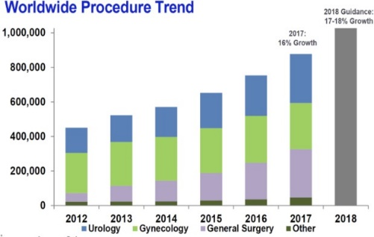 | 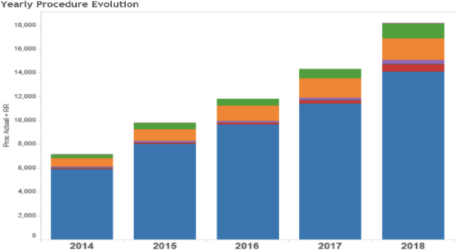  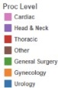
Worldwide and UK trends for RAS uptake

In total some, 65,367 procedures were performed using RAS in the UK in 2018 across all specialities, with number of RAS procedures being performed anticipated to grow to more than double current levels, to some 138,000 (6400 in Wales), by 2028 (see Table 3).

In England, 74 surgeons performed 374 robot-assisted colorectal cancer surgery procedures in 2019 while robot-assisted colorectal cancer surgery has yet to be achieved in Wales.

It is imperative that NHS Wales’ RAS capacity can meet this anticipated demand and Cardiff & Vale lead the way as the main tertiary centre and hub for many complex surgical procedures. Also Wales needs to provide equitable services with the rest of the UK and international practice- not only meeting patient case-load requirements but also meeting the expectations of current and future surgical staff.

The table below provides a summary demand forecast by indication and local of service delivery. Further detailed demand forecast for all sites will be modelled as part of the NRP development based on regional service provision and local data. Phase one will focus on colorectal cancer but there is a requirement to rapidly integrate other cancer sites potentially including gynaecological and oesophago-gastric cancers.

Cancer site | Approx cases/year | % that have surgery | Potential cases for robotic surgery/year
All Cancers | 20000
Colorectal cancer | 2200 | 65 | 1430
Endometrial/Ovarian cancer | 900 | 65 | 585
Gastric cancer | 600 | 40 | 240
Prostate | 2600 | 30 | 780
Lung | 2500 | 30 | 750
Liver | 300 | 25 | 75
Total |  |  | 3860
Estimates of cases suitable for robotic surgery per annum in Wales

With an ageing population, cancer incidence rates in Wales are increasing and rates in some parts of Wales are higher than UK averages.

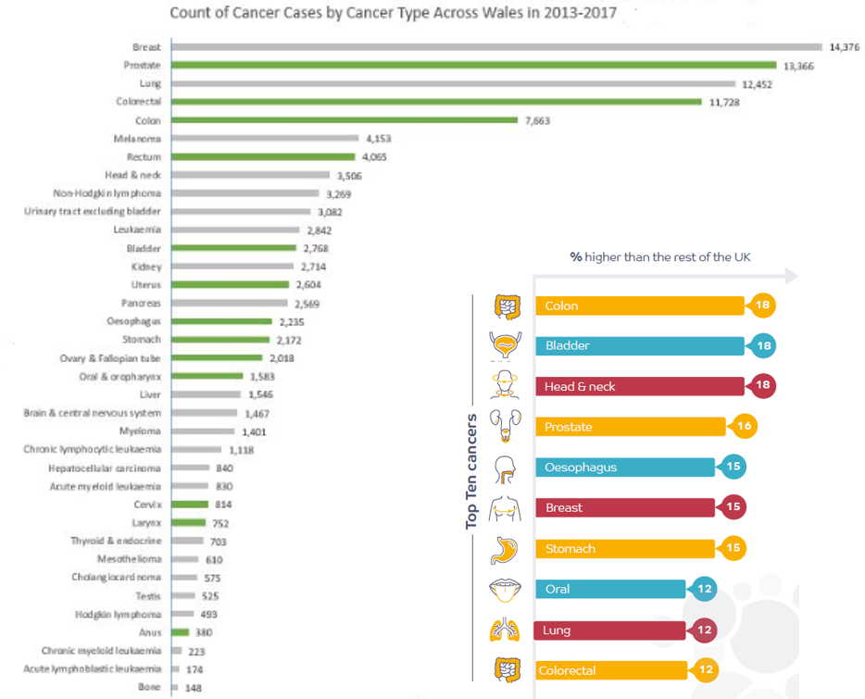

Cancer cases by cancer type across Wales (2013-2017) and higher incidence in North Wales to UK average

CVUHB is anticipated to perform 270-320 RAS procedures each year across the gynae-oncology, upper gastro-intestinal, and colorectal departments as part of managing multiple services of a regional and sub-regional nature.

Colorectal disease

There are currently nine subspecialty trained colorectal surgeons at UHW. The colorectal surgery department provides tertiary services to patients with all aspects of colorectal disease and functions as a multidisciplinary team, supported by oncology, radiology and colorectal / stoma nurse specialists. On average, the colorectal department performs X number of laparoscopic cases per annum.

Gynaecology oncology

Within CVUHB, the South East Wales gynaecology oncology surgical team is based at the University Hospital of Wales (UHW) and is the largest tertiary referral centre for gynaecological cancers in Wales. It covers a population of over 1 million. There are currently three subspecialty trained gynaecological oncological surgeons who cover the service with a planned expansion to four. Over 450 cancer cases are operated on per year at this centre with just over 150 of these being performed via the minimally invasive route. The long-term ambition is to undertake all major, minimally invasive gynaecological cancer surgeries robotically, and delivery of the NRP is a necessity in achieving this. This aim would be in line with most other gynaecology oncology centres in the UK.

According to a senior clinician:
“Without RAS in gynaecology oncology in Wales, we will increasingly struggle to recruit trainees to fellowship training and consultants in post as our services fall behind the majority of our counterparts in the UK.”

Oesophagogastric (OG) cancer

UHW also provides a tertiary Oesophagogastric (OG) cancer service for all 5 health boards in South Wales, serving a population of over 1.3 million. From next year, all cancer surgery will be undertaken on one site within a fully regionalised service at UHW, amounting to approximately 100 – 120 major oesophageal and gastric cancer resections annually. There are currently seven OG cancer surgeons within the network, two of which currently provide a minimally invasive service. The long-term vision for the unit is that minimally invasive surgery (robotic or laparoscopic) will become the standard of care for all patients undergoing major OG surgery in South Wales. Based on projected number of cancer resections in the next year, UHW will be one of the busiest OG cancer units in the UK, with potential to safely adopt new techniques in a relatively short time frame.

2.2 Barriers to usage of RAS and how the NRP will address:

Silo-Thinking in the Management of Resources

‘Invest to save’, specifically investing in the theatre time and equipment to deliver minimally invasive surgery (MIS) is outweighed by the savings accrued from improved recovery and reduced length of stay. However, the costs / benefits may be drawn / accrued from different budgets (operating theatre vs ward) and other factors need to be considered (see section 3). This requires the necessary oversight to balance the costs and savings associated with a move to MAS. Whilst this is generally well understood, this system-wide perspective needs to translate to individual decision-making.

Immediate financial pressures should not be permitted to drive short-sighted decision-making. A systems-wide understanding is required to tackle this barrier. In order to understand the trade-offs and allow efficient allocation of resources the NRP will adopt a Value Based approach.

Surgeon Preferences

Surgeon preferences are a product of experience and interpretation of the evidence base, and this varies greatly by clinician. Core medical training plays an important role in preferred techniques, which can be strongly influenced by when the medical professional was trained (with those more recently trained generally being more familiar with and open to RAS). The NRP will promote “clinical champions” to drive change and promote the adoption of this technology. The Programme incorporates a collaboration network supported by training and Preceptorship (Paring or mentoring junior staff with more experienced surgeons) Programmes. Referral of cases between clinicians will also be encouraged and supported (e.g. where RAS would be beneficial but the surgeon is not adequately trained or it is not their preferred technique), and transfer of skills and expertise encouraged A cultural change requires everyone to be on board, across consultants, theatre staff, directors and management.

Training

Training, and a lack of suitably trained clinical staff, are key factors identified and important barriers to uptake of RAS. Provision of funded training forms part of the NRP and surgeons will be enabled to practice their skills in settings where patient throughput is sufficient.

Financial Constraints: Capital

The NHS is under increasing financial pressure to deliver more with less money, and access to public capital is increasingly scarce. A Managed equipment service offers opportunity to overcome, additional marginal costs offset by risk transfer, opportunity costs for use of scare capital for other services and assurance of technology being maintained and upgraded.

Early Wins Made

MIS uptake may have plateaued as the procedures for which MIS has been largely adopted are those most easily transferred to MIS, and the surgeons that have adopted the technique are those most open to it. Therefore, what is left is the more difficult cases and the surgeons who are more resistant to adoption (as characterised by the ‘s-shaped’ curve for uptake of innovation summarised). Technological innovation (RAS) can support an expansion of the application of MIS, either to new procedures or by making MIS amenable to more surgeons.

The provision of information to patients and formalising their integration into the decision-making process will also provide a catalyst to increase the uptake of RAS.
2.3 International Evidence

Robotic Surgery is utilised for a number of different procedures to improve outcomes for patients as well as long term clinical efficiency to service providers. There are a significant number of clinical studies demonstrating efficacy of robotic surgery especially in urology. Literature reviews do identify weaknesses in the quality of information and robustness of evidence for other indications, as should be expected given the current adoption phase for RAS. Evidence highlights reduced invasiveness of complex surgical interventions with improved outcomes and reduced variability in surgical performance.

The case for RAS is well made for a number of urology procedures which has seen reduced invasiveness of complex surgical interventions with improved outcomes and reduced variability in surgical performance. In 2012, NICE recommended RAS for the management of radical prostatectomy and the procedure is routinely commissioned in England and formed an important part in delivery at CVHUB serving the regional population since 2014.

Specialties with a less mature RAS background, such as gynaecology and thoracic surgery (reviewed by Health technology Wales are limited in terms of evidence for benefit.

A range of complex published modelling reports have been produced that have drawn data from a range of studies to assess this technology. Amongst this evidence base is work done by Health Technology Wales, and peer reviews. These publications suggest that whilst the immediate costs of RAS are greater than laparoscopic technology the clinical outcomes are significantly improved and provided there is sufficient volume these improved outcomes and avoidance of harm translate over a 10-year period to be cost effective.

In February 2021, Healthcare Improvement Scotland released a review of recently published evidence to inform the National Planning Robotic Review Group on the impact of the number of robotic-assisted procedures (gynaecological, colorectal, urological) per treatment centre/surgeon on the outcomes achieved and any related evidence on the learning curves for these procedures.

Currently, evidence from high quality randomised clinical trials with economic analysis is not available to draw from. A full review of evidence and evaluation of benefits will form part of the NRP.

2.4 Workforce pressures

Workforce instability is a significant contributor to weakened performance. A key financial challenge across UHB’s in Wales is to reduce dependency on temporary agency staffing across a range of hard to fill specialised roles. Two of the areas that have struggled to recruit and where the utilisation of agency cover is high, are General Surgery for consultant medical staff and Theatre Nursing.

In 2018, almost one-third of advertised consultant posts were unfilled across Wales. In north Wales, only 43% of advertised consultant jobs were filled despite extensive and targeted recruitment campaigns.

Wales has the second lowest number of doctors (only Poland is lower) in leading European nations relative to its population (2.85 per 1000 population), compared with an average of 3.5 doctors across the OECD. 43% of consultants in North Wales and 39% in South Wales are expected to reach the mean intended retirement age (62.5years) over the next decade, more than UK average (36%).

Rota gaps are created by a shortage of doctors. 53% of consultant physicians in Wales face frequent rota gaps in their team with 36% reporting rota gaps caused problems with patients’ safety. 28% “act down to cover a rota gap and 78% reported gaps or vacancies most negatively impacted on work-life balance the impacts and need to address have been highlighted by the Royal College of Physicians.

Surgeons in the early part of their careers increasingly wish to embrace RAS to ensure their skill set matches that of their UK and global counterparts and where surgeons have undertaken fellowships or training in RAS and are fully qualified, but unable to utilise these skills, they may decide to move to enable them to work in more modern surgical settings.

2.5 Research

There is a recognised need to increase research capacity, its impact and translation. The NRP will incorporate a research programme with strong data collection and focus on evaluation of the clinical effectiveness of RAS. A strong research base offers a platform for innovation, results in better patient outcomes, population and social well-being, positively impacts on recruitment and retention and contributes to economic productivity.

Without clinical research, we cannot improve treatments for patients, or help the NHS to meet the challenges it faces in the future. Numerous reports have called for research and innovation to be part of health boards’ core activity, the importance of a research aware and engaged culture that supports the spread and adoption of research and innovation, and for research to be understood to be a key indicator of improving patient care.,,

Research active healthcare settings have better outcomes

There is a growing body of evidence which has recently been reviewed evidencing patients in research-active healthcare settings have better outcomes and receive better care, with benefits extending to patients beyond those actively involved in research. Patient are also more likely to benefit from earlier access to new treatments, technologies and approaches.

Research positively impacts recruitment and retention

The positive impact of Research and Innovation for the workforce is being increasingly recognised with evidence reviewed.. In recruitment of consultants, there is direct evidence that access to latest technology and being at the forefront of service delivery is important in successful recruitment and retention of consultant surgeons.

  - Policy context and alignment

The following sets out the main policy context in which plans are set, highlighting key alignment with the core rationale for the NRP. Elsewhere and throughout the document, references are made to reports, strategies etc against which the NRP is aligned and will make a significant contribution to delivering (see figure 9 for strategy/policy map). The proposals for the NRP are aligned with the clinical, workforce development and research and innovation strategies for the various health boards and with IMTP’s.

Well-being of Future Generations (Wales) Act

This ground-breaking legislation is a commitment, and presents opportunities, to work differently - across sectors and with communities - to address the increasing health, social and economic challenges in a more effective and sustainable way. The Act also sets out five ways of working (known as ‘the Sustainable Development Principle’) that public bodies should use to achieve that vision. They are: long-term, prevention, integration, collaboration and involvement which the NRP embraces and given the fundamental changes to be delivered it health provision impact at a societal level are expected (see figure 8).

A Healthier Wales

Long-term plan for health and social services which sets out the vision of a 'whole system approach to health and social care' based on a philosophy of Prudent Healthcare and the central idea of the Quadruple Aim. It maps out the need for system transformation and describes the ambition to bring health and social care services together, to deliver a seamlessly co-ordinated approach from different providers and reinforces the need to strengthen and expand services in primary and community settings. The development of a medical and health sciences school with core rationale as described is directly aligned and will be key to realising this vision in North Wales.

Workforce Strategy for Health and Social Care

Produced by Health Education and Improvement Wales (HEIW) and Social Care Wales (SCW). Plans are aligned to all seven themes but in particular, focus on attraction and recruitment, excellent education and learning, leadership and succession, workforce supply and shape.

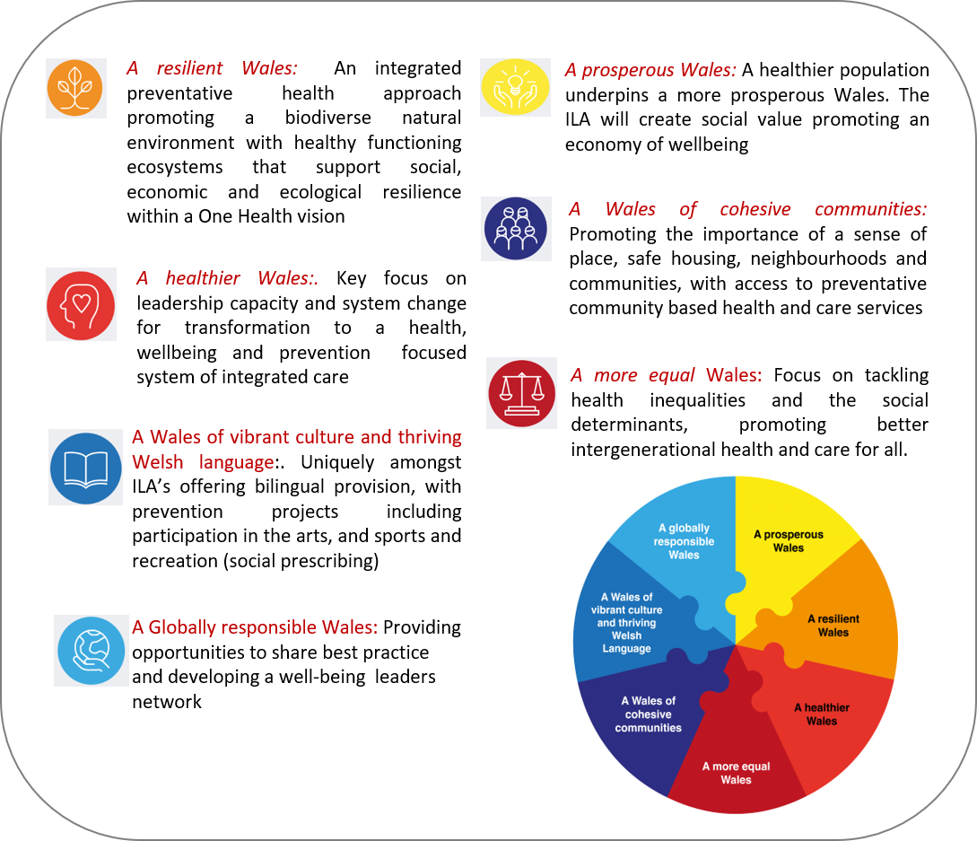

Alignment of NRP with Well-being of Future Generations (Wales) Act

The Life Sciences Industrial Strategy

Focused on health life sciences, sets out a vision for a system that has NHS-industry collaboration at its heart, setting a challenge to create an innovation ecosystem that will deliver improved patient outcomes, service efficiency and economic growth, driving the innovation required to address the challenges that the health system faces.

Foundational Economy

At its core, the services and products within the foundational economy provide those basic goods and services on which every citizen relies and which keep them safe, sound and civilized. Wales is the first country in the world to adopt the foundational economy approach at a national level, with Welsh Government’s approach to supporting and developing the foundational economy focusing on three areas:

- A Foundational Economy Challenge Fund: This series of experimental projects will enable Welsh Government, and its project partners, to test how they can best support the foundational economy and which Government interventions work best

- A renewed focus on growing the ‘missing middle’: To increase the number of grounded firms in Wales and establish a firm base of medium sized Welsh firms which are capable of selling outside Wales but have decision making rooted firmly in Welsh communities
- Spreading and scaling best practice: Welsh Government will start looking at social value within procurement and will support Public Service Boards to use and strengthen local supply chains.

- Formulation and Short-listing of Options
  - Options framework

A wide range of potential options have been considered, with a preferred way forward selected. In accordance with Green Book guidance a long list was developed and winnowed to a short list using an “options framework”, examining a range of less ambitious through to more ambitious options, Further work will be undertaken as part of the programme development to evidence value for money (VfM) with ‘status quo’ as the benchmark.

Investment Objectives were used to develop the long list and reduced to the short-list by discounting any solutions that were clear unrealistic outliers as unaffordable, undeliverable or will obviously not optimise value for money. The ‘options framework’ utilised, is based on five categories of choice:-

- service scope (the ‘what’ in terms of services and coverage)
- service solution (the practical approach to ‘how’ services will be delivered)
- service delivery (‘who’ will deliver the required services)
- timing and phasing of delivery (‘when’ will the services be delivered)
- funding of the investment

Options were assessed against investment objectives and Critical Success Factors (CSF’s) Strategic Fit; Potential Value for Money; Supplier capacity/capability; Potential Affordability and Potential Achievability as per Green Book Guidance.

The table below presents the Preferred Way Forward and summary of the assessment undertaken using the options framework assessment identified through the filter.

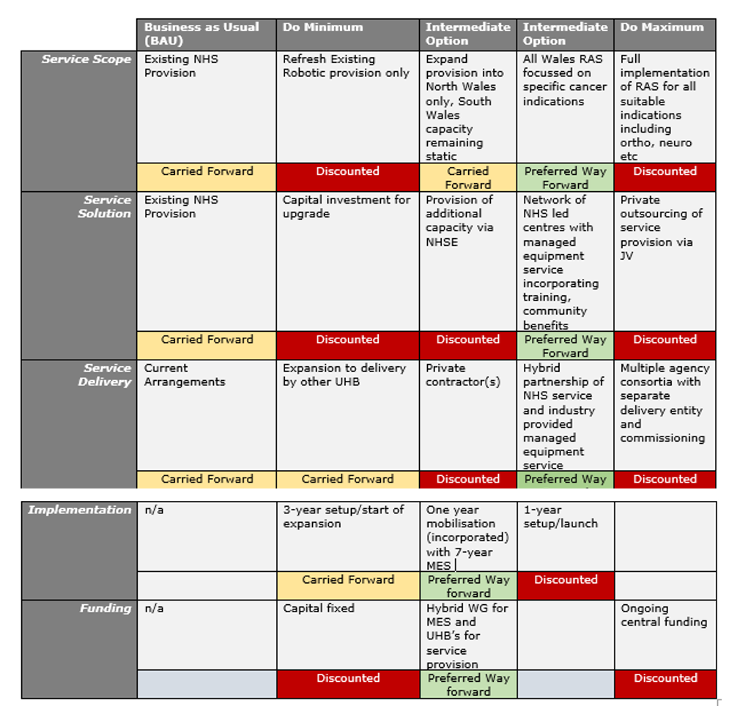

- Cost & Benefit Analysis
  - Cost benefit analysis

The NRP will deliver a wide range of benefits for patients, the wider population, society and organisations.

The NRP also forms an important solution in managing the impact of COVID-19 on the delivery of elective surgical care, currently compromised due to competing needs for critical care facilities, reduced surgical bed capacity and theatre efficiency and likely to remain a key issue as current backlogs are addressed.

At a high level the NRP will provide benefits and make a significant contribution to:
Direct Patient Benefits
- Improved health and clinical outcomes for those directly accessing these services
- More patients will be able to access RAS
- Increased efficiencies/productivity (achieved across the whole pathway of surgical care)
- Widened scope of potential patients able to undergo surgery who are not suitable for traditional surgical methods, reducing inequalities across population groups
- More surgeons enabled to offer minimally invasive surgical approach through RAS
- Reduction in complications, pain, blood loss and infections
- Less likelihood of surgeon error
- Reduced length of hospital stay and therefore less time away from family/home environment
- Shorter recovery time, allowing quicker return to work/normal activities which reduces the risk of negative impacts such as income/personal finances, social isolation and mental health and wellbeing
- Preservation of function and improved quality of life
- Reduced waiting time

Indirect Benefits for Patients/Wider Population
Improved access to community health and social care services for wider population due to:

- the reduced demand on post-operative requirements by those patients accessing robotics
- reduced incidence of wound infection managed in community due to smaller incisions
- reduced demand due to prevention/reduction of morbidities associated with open and laparoscopic procedures due to the transition to RAS

Patient benefits of RAS outlined above will have some positive impacts on society and wider detriments of health and smaller socioeconomic impact, for example

- shorter recovery time supporting a quicker return to work/normal activities, minimising negative impacts such as reduced income/financial consequences, social isolation and personal/family mental health and wellbeing
- preserved function/improved quality of life with reduced dependency on health and social care/wider support services
- Service Sustainability
- Many services pathways have optimised their threshold in productivity linked to enhanced recovery and other improvement initiatives
- Finite people, skills and resources, therefore critical all are used optimally to maximise health outcomes for the population
- This proposal will also support greater collaboration resulting in increased sustainability, flexibility and resilience across Wales

Clinical outcomes

Wider uptake of minimally invasive surgery (MIS): Currently MIS is offered via the laparoscopic approach (with exception or urology at C&V via RAS). It is well documented the learning curve for laparoscopic surgery is quite steep. The rate of laparoscopic cancer surgery in Wales is lower than the UK average, where the UK average is around 50%. The robotic platform presents the advantage of a shorter learning curve compared to laparoscopic surgery and therefore allows for widening the uptake of MIS in two different ways as below:

Widening the patient population suitable for MIS (patient related): The technical ease provided by robotic surgery will enable more complex and higher risk patients to be offered MIS thus increasing the rate of MIS in Wales. It is anticipated that in the first year after the technique is embedded in clinical practice, the rate of MIS should increase to at least over 50%.

Widening the surgeon cohort able to offer MIS (team, patient and service related): Due to the shorter learning curve and more intuitive functionality, thus passing on the benefit of MIS to their patient population. In the longer run, this should help with improving the MIS rates to as high as 80% accepting a cohort of patients who have had previous complex surgery and therefore not suitable MIS at all.

Reduction in length of stay (service and patient related): The benefit of a reduced length of stay subsequent to MIS is well established. If the MIS rate is improved to above 50%, this will automatically impact across the hospital bed capacity and bed-management.

Reduction in post-operative complications (service and patient related): There is published evidence to suggest a reduction in post-operative complications in patients offered a robotic approach for their procedure.

Reduced utilisation of critical care beds (predominantly service related): With an improved rate of MIS and reduced post-operative complications and length of stay, there will be a reduction in access of critical care beds.

Better theatre utilisation and potential reduction of operative time (service related): Robotic surgery offers the potential for standardisation of the operative technique across Wales thereby potentially standardising the operative time. This will allow for better prediction and theatre utilisation with a possibility for increasing theatre utilisation. Moreover, once embedded, robotic surgery allows for reduction in operative time for straight forward procedures.

Preservation of function (patient related): A frequent and significant complication of colorectal cancer surgery is a compromise in the functional outcome for the patient. This may be in the form of a stoma or a loss of bladder/bowel control or difficulties with sexual function. These complications have significant emotional and economic implications negatively affecting the patients’ post-operative quality of life. Robotic surgery offers the ability for precision dissection to preserve the nerves resulting in the above complications thus preserving patients’ quality of life as well as allowing for restoration of bowel continuity and preventing stomas.

Occupational risk reduction (team related): There is evidence to suggest a reduction in repetitive strain injury as well as back and neck injuries associated with laparoscopic surgery in surgeons adopting robotic surgery due to the ergonomic design of the platform. Also, there is anecdotal evidence to suggest that there is less emotional fatigue and stress on a robotic platform compared to the laparoscopic or open approach.

Economic & Financial (Value-based) Outcomes

Aspects not covered above include the benefit of future proofing our services through access to robotic surgery. The cost-effectiveness of robotic surgery is not robustly demonstrated in the literature. Detailed modelling will be undertaken and a comprehensive impact analysis will be undertaken by the NRP in parallel to the introduction of this enhanced service to understand the real world impact of this technology and to ensure unintended consequences are realised and mitigated.

Reduced Length of Stay
In addition to the obvious benefits to the patient from a reduced hospital stay there is a significant productivity benefit. On average a RAS procedure will reduce the length of stay in hospital by 2.3 days compared to traditional laparoscopic surgery. In General Surgery the accuracy of the RAS system will allow operations to be performed on certain patients that, where presently, the only options are open surgery or other treatment options and this will also mean a reduced stay in hospital for some of these cases.

Patient Experience
Reduced operating times and improved accuracy allow a quicker recovery with less pain offering an ability to get back to normal activity faster and lower complication and re operation rates with better long-term outcomes. Modelling of individual and societal value will be undertaken.

Recruitment and Retention
There is growing evidence, from recent efforts to recruit consultant surgeons and skilled theatre nurses, and also recent enquiries from skilled professionals interested in key roles, that guaranteed access to RAS within a structured professional training and development programme is a key consideration in the decision to accept a job offer.

It also follows that this will be a key factor when staff in these key roles decide to remain employed in Wales. Surgeons in the early part of their careers increasingly wish to embrace RAS to ensure their skill set matches that of their UK and global counterparts and where surgeons have undertaken fellowships or training in RAS and are fully qualified, but unable to utilise these skills, they may decide to move to enable them to work in more modern surgical settings. Agency/locum costs across the Health board within relevant areas will be modelled.

Improved Surgical Team Ergonomics and Elongated Career Lifespan
Certain operating conditions can impact a surgeon’s physical comfort dramatically, and as a result, impair their ability to operate at peak capability. Conventional MIS procedures require the surgeon to perform repetitive motion and maintain an awkward positioning for a prolonged period of time, all of which contribute to the physical strain and fatigue a surgeon suffers from. At a larger scale, the healthcare system is at risk of losing their most skilled surgeons due to early retirement that result from injuries sustained from performing conventional MIS procedures over the course of their careers. For surgeons, the benefits that access to a robotic platform brings are better access, improved ability to deliver small precise movement, and improved ergonomics that enable an extended working life thanks to the design of the ergonomic open console, as well as hand controllers that allow the wrists to retain a neutral position. Surgeons wish to deliver the best possible surgical care to the patient with the optimal tool. RAS can deliver this by increasing the likelihood of higher quality MIS, optimised port placement setup for each patient, and only using arms that are needed, when they are needed. RAS allows surgeons to enhance their skills and this is delivered through enhanced accuracy and dexterity of movements, and access to in-depth magnified and stable 3D vision, while working in an ergonomic position. Robotic systems potentially address the ergonomic issues that currently affect surgeons during MIS.

Other Efficiency and Productivity Benefits

As rehearsed, there is little evidence available in the form of randomised control trials that quantify the efficiency and productivity impact of RAS. What is certain however from the evidence that is available, including experience in the C&V UHB Urology service, is that the increased accuracy of the technology will deliver significant benefits to the patients care journey and in turn this will bring cost savings both long term due to improved QALYs and short term reduced direct costs for many cases.

- Service Management
Governance arrangements

The RAS programme in Cardiff will be led and managed by a programme board providing oversight, co-ordination and providing assurance for QA, audit, risk management, adhering to contractual arrangements and monitoring outputs and programme deliverables. The governance arrangements within the health board will be led by the clinical board team and chaired by Jared Torkington as Clinical Lead for this project.

The NRP Steering Group as a whole consists of senior leaderships, clinical and Welsh Government representation, The Chair is the CVUHB Chief Executive. Jared Torkington, CVUHB Associate Medical Director for Innovation and National Lead for NHS Wales Bowel Cancer Initiative, is Deputy Chair. Welsh Government is represented by Ifan Evans, Director of Technology, Digital & Transformation, Health & Social Group, and Anthony Davies, Senior Policy Manager for Major Health Conditions.

The collaborative network of NHS Wales Health Boards will formalise and agree the process for surgical pathway RAS delivery, patient selection, training programmes, and quality assurance at each robot-host Health Board. This work will require detailed consultation of the various contributing stakeholders (for example: clinicians, operational managers, potential industry partners and UHB medicine academia). This work will be undertaken as soon as possible with dedicated expert resource to co-ordinate and manage.

Local service managers aligned to national workstreams will be responsible for development of detailed speciality specific service and implementation plans for their aligned area. This will include inter alia:
- Training and accreditation of surgeons, other theatre staff and decontamination staff.
- clinical governance arrangements
- Undertake a Data Protection Impact Assessment (DPIA) to ensure that patient data is being held in accordance with the Data Protection Act (2018)
- development of patient information
- Finalise install date (around first patients scheduled)
- Coordination of delivery, installation and testing on site
- Coordination of consumables order and delivery
- Monitoring, evaluation and reporting as appropriate

Clinical Governance
Clinical governance will be applied as per routine practice and policies with any new/additional requirement developed as part of a national framework for RAS. Training, proctoring, and programme evaluation support from the NRP industry partner will ensure surgical teams are working within RAS best practice and that service delivery is developed to improve clinical practice and patient outcomes, where required.

Clinical audit
Following RAS introduction, data will be captured across all NHS Wales oncology surgical sites to enable audit of complications, operating time, conversion to traditional laparoscopy / open surgery, etc. This is essential for maintaining programme governance and provision of software and reporting from the NRP industry partner will facilitate this. Data collection, analyses and dissemination of NRP outcomes will be supported through fellowships.

Risk Management
Risk management has been embedded in the programme governance structures as an essential and integral part of planning and decision-making. Best practice as per the HM Treasury: The Orange Book, Management of Risks Principles and Concepts will be adopted, integrating the project risk management systems with established practice at the UHB’s. A risk register will be maintained. Mitigating actions will be approved by the Programme Board and escalated to UHB’s boards for further review and validation, where necessary.

Critical dependencies
The main critical dependencies to the NRP are:
- Ensuring high-levels of NHS Wales clinical buy-in to enable training, recruitment, and proctoring of RAS surgical teams
- Ensuring NHS Wales Executive Level buy-in to the potential need for an initial reduction in oncology surgical volumes to allow surgical training opportunities
- Improving NHS Wales data infrastructure, availability, and quality to enable real-time data collection and analyses
- Ensuring capacity and support from Health Boards’ IT teams, as well as NWIS teams and services, to deliver national improvement to data infrastructure, availability, and quality
- Ensuring information governance is appropriately managed across the new national RAS service
- Funding availability and commitments from Welsh Government to co-fund £4.2m across the initial three years of the NRP
- Funding availability and commitments from all NHS Wales Health Boards

Reporting, Monitoring and Evaluation

During NRP, a key responsibility of the Programme Board will be to establish a framework for the monitoring and management of the benefits the programme will enable, including an escalation framework with the relevant health and care organisations (where the benefits are expected to be realised). This sets out who is responsible for enabling particular benefits, how and when they will be delivered and the required counter measures, as required.

Significant work has been carried out to ensure that project benefits are appropriate and viable. Benefits realisation will be monitored throughout the programme’s implementation stage, and then evaluated as part of the NRP’s ongoing evaluation processes.

With the NRP enabling real-time surgery data collection and analyses, local Managers will perform regular reviews of their Health Board’s clinical performance and escalate concerns or issues identified with relevant clinical teams within performance reviews. As part of this review process, lessons learned will be recorded to feed into national NRP performance reviews.

As part of the MES contract quarterly reports on compliance, which shall include as a minimum the submission of statistical information / reports, will be produced and reviewed by the Programme Board as part of regular contracting reviews. These will be held quarterly, led by the clinical team from the robot-host hospital sites within Health Boards. These will include a review of activity, compliance with clinical standards and agreed performance criteria, and other matters affecting the operational delivery of the service.

The reporting, monitoring, and evaluation processes outlined above will feed into a national improvement approach intended to achieve clinical best practice in RAS across NHS Wales. Communicating RAS service delivery changes, both successful and unsuccessful, as well as the lessons learned and patient-reported feedback resulting from these initiatives will be integral to maintaining and improving a high-quality national RAS service.

- Critical Assumptions, Risk and Issues
Risks and impacts of not investing in the NRP

There are a number of risks and impacts associated with not progressing the proposal. The key areas are highlighted below.

Patient Choice
Patients are increasingly aware of available treatment choices and would naturally prefer treatment modalities providing a potentially better rate of minimally invasive approach.

Effectiveness, efficiency and productivity gains lost
Services will not be as efficient or productive and gain the many benefits set out in this case. It will also be a loss of opportunity to make significant progress to RAS which is fast becoming the new norm for surgical delivery.

Lack of Attractiveness
Most eminent general surgical units across the UK and internationally boast of robotic technology. Wales is already in the lag phase of adoption. Further delay is likely to be detrimental to reputation. It is fairly difficult to attract high calibre trainees to Wales and a lack of exposure to contemporary technological advancements further hinders any attempts towards this.

Difficulty with Attracting High Calibre Staff
Similar to the above point, Wales loses its attractiveness for pursuing a competitive career as a surgeon due to lack of access to robotic technology. This also translates in a difficulty with employing allied healthcare professionals especially in theatres.

Improving standards of care and outcomes
It is obvious that new technologies drive up standards of care and improve morbidity and mortality. As already highlighted Wales lags behind much of Europe in it’s cancer outcomes and there is a significant risk that we drop back even further if we do not embrace RAS.

NHS (2019) The Topol Review Preparing the healthcare workforce to deliver the digital future An independent report on behalf of the Secretary of State for Health and Social Care February 2019 https://topol.hee.nhs.uk/wp-content/uploads/HEE-Topol-Review-2019.pdf
https://medical.globaldata.com/Reports/details/united--kingdom--robotic--surgery--market-2015-2028
Based on extrapolation by population
Source: Welsh Cancer Intelligence and Surveillance unit (WCISU)
North West Cancer Research (2018) Regional Report: Putting our region’s cancer needs first https://www.nwcr.org/media/1717/nwcr_regional_report_10.pdf
Clinical Commissioning Policy: Robotic-Assisted Surgical Procedures for Prostate Cancer Reference: NHSEngland B14/P/a
HEALTH TECHNOLOGY WALES (HTW) GUIDANCE 010 (August 2019) Robot-assisted thoracic surgery
Health Technology Wales Evidence Appraisal Report Robot-assisted thoracic surgery (EAR011)
Robertson C, et al. Relative effectiveness of robot-assisted and standard laparoscopic prostatectomy as alternatives to open radical prostatectomy for treatment of localised prostate cancer: a systematic review and mixed treatment comparison meta-analysis. BJU Int. 2013; 112: 798–812
Close A, et al. Comparative Cost-effectiveness of Robot-assisted and Standard Laparoscopic Prostatectomy as Alternatives to Open Radical Prostatectomy for Treatment of Men with Localised Prostate Cancer: A Health Technology Assessment from the Perspective of the UK National Health Service. European Urology. 2013; 64, Issue 3, 347-522
Ramsay C, et al. Systematic review and economic modelling of the relative clinical benefit and cost-effectiveness of laparoscopic surgery and robotic surgery for removal of the prostate in men with localised prostate cancer. Health Technology Assessment 2012; Vol. 16: No. 41
RAS-SHTG-Assessment-03-21.pdf
OECD (2019) Health at a Glance 2019 OECD Indicators https://www.oecd-ilibrary.org/docserver/4dd50c09-en.pdf?expires=1586879788&id=id&accname=guest&checksum=058FAD991B4566BD9E32538FAD921473
Royal College of Physicians (2019) Doing things differently Supporting junior doctors in Wales https://www.rcplondon.ac.uk/projects/outputs/doing-things-differently-supporting-junior-doctors-wales
Royal College of Physicians (2016) Research for all https://www.rcplondon.ac.uk/projects/outputs/research-all
Association of Medical Research Charities (2013) Our vision for research in the NHS https://www.amrc.org.uk/Handlers/Download.ashx?IDMF=25fc862d-5249-44ed-9e3f-7d9e1807340b
- Kings Fund (2019) Closing the Gap https://www.kingsfund.org.uk/sites/default/files/2019-03/closing-the-gap-health-care-workforce-full-report.pdf
Boaz A, Hanney S, Jones T, Soper B. Does the engagement of clinicians and organisations in research improve healthcare performance: a three-stage review. BMJ Open 2015;5:e009415
The Academy of Medical Sciences (2020) Transforming health through innovation: Integrating the NHS and academia https://acmedsci.ac.uk/file-download/23932583
Hanney S, Boaz A, Jones T, Soper B. Engagement in research: an innovative three-stage review of the benefits for health-care performance. Health Services and Delivery Research, No. 1.8
Foundational Economy, Business Wales https://businesswales.gov.wales/foundational-economy
Waters, L. It’s time to focus on the everyday economy. Institute of Welsh Affairs. (2020): https://www.iwa.wales/agenda/2020/01/its-time-to-focus-on-the-everyday-economy/
Foundational Economy Guidance. Welsh Government. https://gov.wales/foundational-economy

