Report Title: |  |  | Operational Performance Update |  |  |  |  |  |  |  |  |  |  | Agenda Item no. |  |  |  |  | 2.2
Meeting: |  |  | Finance and Performance Committee |  |  |  |  | Public |  |  |  |  |  | x |  |  | Meeting Date: |  | 21.5.25
 |  |  |  |  |  |  |  | Private
Status: |  |  | Assurance |  |  |  | x | Approval |  |  |  |  |  |  |  |  | Information
Lead Executive: |  |  | Chief Operating Officer
Report Author: |  |  | Head of Performance
Background and current situation:
The Operations and Information Teams have redesigned the Integrated Performance Report to better meet the requirements of the Board, the Board sub-committees and to improve performance reporting for the Health Board as a whole, both internally and externally. This updated report incorporates progress against the Cabinet Secretary’s priorities and our performance ambitions/IMTP priorities. It also includes performance against the updated NHS Performance Framework for 24/25.

The sections of the full report covering Operation Performance, which are pertinent to the Finance and Performance Committee are:
Section 1: Ministerial Priorities
Section 2: Quadruple Aim 2

Executive Director Opinion and Key Issues to bring to the attention of the Board/Committee:
Urgent and Emergency Care

April saw a decrease in attendances at the Emergency Unit from last month, and a small drop in the number of 12-hour EU waits. The most recent data from April shows a slight deterioration in ambulance performance with a small increase average handover time and the number of 2-hour waits reported. EU activity data has been added to the accompanying IPR. EU total reportable attendances and Majors attendances in April 25 were similar in volume to April 24, however, admissions from EU were reduced. We will continue to track and report these metrics throughout 25/26.

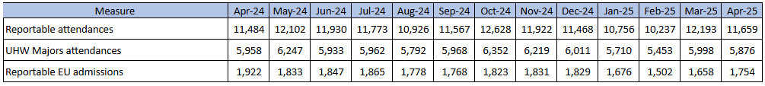

Following increased bed closures in March due to Norovirus, April has seen an overall reduction in closed and empty beds related to Norovirus, Flu and Covid-19. One outbreak in-month saw the number of closed beds increase, impacting flow and contributing to a small number of 24-hour EU waits and 3-hour ambulance holds. Bed closures on the acute sites continue to be monitored and reported to the organization daily through the ‘hot reports’.

Despite these challenges, the UHB is still the best performing Health Board in Wales regarding ambulance handover delays and we continue to make ambulance handovers an operational priority.

Performance against the standards within the National Falls and Fragility Fracture Audit Programme (FFFAP) remains improved from our historic trends. Time to specialist beds for hip fracture and stroke patients remain an operational priority and we are conducting regular analysis of breaches to improve implementation of the pathways. For hip fracture patients we saw improvements in compliance with the 4-hour standard for admission to a specialist ward through last year and performance in Q1 is improved from last year where it dipped below 30%. Despite seasonal pressures, monthly compliance in March was 40%, against the national annualized average of 8.8%.

We continue to measure our performance against the acute stroke pathway on a daily and weekly basis, through the hot report and COO led operational meetings. The UHB has held a further stroke summit continuing our focus on the stroke pathway. We are also working with colleagues in the NHS Executive around what KPIs will be the focus in Wales. We will continue to update Finance & Performance Committee and Board on the impact of the changes. Our analysis of the latest data has shown that our door-to-ward performance improved again in March, while the percentage of patients receiving their CT scan within 1 hour improved. Time to CT scan is one of the metrics which has been revised in the new SSNAP dataset, and performance against the new 20-minute standard has varied from 17.7% - 8.5% since October 2024, with 16.7% of patients scanned within 20 minutes in March, an improvement from February’s performance. In March our thrombolysis rate was 7.5%, while our thrombectomy rate improved to 4.5%. We have recently conducted an internal review of reperfusion rates against high performing months and the same period last year. We continue to work closely with colleagues in NHS Executive regarding thrombolysis and thrombectomy rates.

Hospital Flow and Discharge

The proportion of beds occupied by long length-of-stay patients has fluctuated in recent months as additional beds have been opened and closed in line with our operational plan. The number of pathway of care delays (POCD) remains a national focus and has reduced since the high point in February 2024. Seasonal pressures and associated operational challenges in January and February 2025 saw the number of delays increase although not to the volume seen last year. The February and March census showed 163 delays across all patient groups, with a drop in April to 150 patients. This is an improvement from April 2025 (185) in line with our commitment.

In addition to the monthly POCD census, patients with a length of stay >7 and >21 days in acute beds forms part of our weekly ‘hot’ reporting and end of month snapshots are provided in the IPR. We have seen the number of long-length-of stay reduce from high point in January associated with season pressures. At the time of writing there are c400 patients with a length of stay over 21 days across our acute wards.

Cancer

Our Single Cancer Pathway compliance has remained above 60% since September 2023 and we reported compliance of over 70% for August, September and October 2024.

In March, our most recently reported position improved from February and 68.7% of patients with Cancer received their first definitive treatment within 62 days. The SCP standard of 75% was met in seven tumour sites: Brain/CNS, Gynae, Haematology, Head and Neck, Endocrine, Sarcoma and Skin.

We continue to treat from the backlog and anticipate that April performance will drop as a result of an increase in referrals.

The cancer PTL is tracked daily through Cancer services and operational teams, with weekly oversight of KPIs by the Cancer Delivery Group. We recently held the second ‘stocktake’ session for teams to share their actions plans to consistently deliver the capacity required to meet the outpatient, diagnostic and treatment standards. Further sessions are planned in Q1 as we continue to support teams to right size their cancer capacity.

Planned Care

The numbers of patients waiting on an RTT waiting list has reduced during Q4. We continue to focus on long-waiting cohorts and Cancer pathways with weekly scrutiny against the national standards and ministerial ambitions.

At the end of March we delivered our revised commitment to Welsh Government, by reducing the number of patients waiting 2-years for treatment to 1,632. This was a significant reduction from the previous month and is the lowest number of 2-year waits reported since July 2021 as long waits increased following the Covid-19 pandemic. Challenge for Q1 is to hold the position.

We are clear that there are still too many patients waiting too long for treatment across a number of key services and continue to work to reduce the length of time patients are waiting for treatment. Four- year waits were eradicated in September 2024, and we have maintained this position. The number of patients waiting over 3-years reduced to 38 in March 2025, with the number of specialties with 3-year waits remaining reduced to two (Ophthalmology and Spines).

We utilised non-recurrent financial resource from Welsh Government to drive the improvements through Q4. As forecast, our position deteriorated in April 2025 and we reported 2,036 2-year and 46 3-year waits at the end of the month. We have secured additional funding to reduce back to our March 2025 position by the end of Q1 this year and continue to work with Welsh Government, NHS Wales and the NHS Executive to drive further reductions of the number of waiting patients.

Last year we did not deliver our commitment to reduce 52-week outpatient waits to fewer than 9000. Our work to eliminate 3-year outpatient waits and reduce the number of 2-year waits has improved outpatient waiting times, but we continue to see high volumes of 52-week outpatient waits within some of our treatment specialties where we are focusing on reducing long waits across the pathway.

We continue to address outpatient waits through activity, validation and pathway redesign to ensure only those who need secondary care intervention are referred. This is not a UHB wide issue and we have seen a reduction in the number of specialties reporting 52-week waits. We continue to work with specialties, particularly in Paediatrics, Medicine and Specialised services, to reduce to or maintain their outpatient waits below 52 weeks.

Our Planned Care Programme is revising its approach Outpatient Transformation, this includes the appointment of a Clinical Lead for Outpatients and alignment with the national Clinical Implementation Networks (CINs) to drive best practice. The use of See on Symptoms (SOS) and Patient Initiated Follow-up (PIFU) pathways is an important tool in the management of follow-up services and we continue to develop their use across our services with additional clinical support from specialties who have successfully implemented these pathways. SOS, PIFU and utilization of outpatient clinics will be an area of significant focus as we move in to 25/26.

Diagnostics

The waiting list position for Diagnostics deteriorated through Q1 and Q2, with particular challenges in Radiology and Endoscopy. As part of the £2.8m community diagnostic hub investment to improve imaging waiting times we will continue to use mobile solutions. Since September, we have seen a small improvement in the 8-week position with reductions in Endoscopy and non-obstetric ultrasound during Q3, continued into Q4.

Endoscopy capacity has been focused on Cancer, Urgent and long waiting surveillance patients. The service has an improvement plan, with additional theatre and insourcing capacity, aligned to a longer-term workforce plan to further address the deterioration in the length of wait. The number of 8-week waits increased through the first half of the year, albeit at a slower rate than last year. November saw the first reduction in the number of 8-week waits for the first time since February 2023. To clear the backlog of patients and create enough core capacity is going to require significant investment and support from Welsh Government. Looking forwards, consideration is being given to scale of the opportunity that might be available through the Llantrisant Health Park regional proposals.

At the end of March 2025, 13,825 patients had waited 8 weeks or longer for their treatment, equating to 55.1% of patients on a diagnostic waiting list. The reduction in recent months has been driven by an improved Endoscopy and non-obstetric ultrasound, with the continued reduction from February to March the result of further improvement in NOUS position. Our March position is in line with our commitment to Welsh Government.

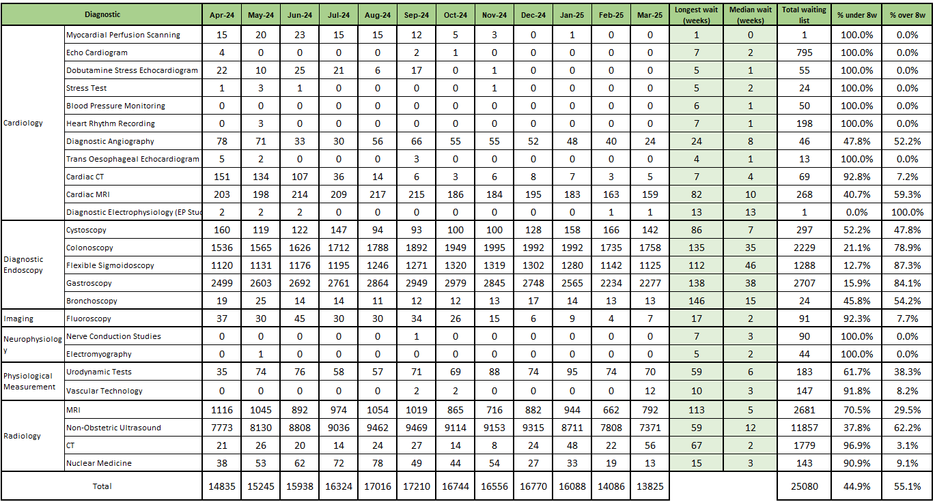

The above table shows the scale of the impact that long waits for endoscopy and non-obstetric US are having on performance, while a number of modalities report zero or small numbers of patients waiting over the 8-week standard.

Mental Health

Demand for adult and children’s Mental Health services remains high, including an increased presentation of patients with complex mental health and behavioral needs. Part 1a compliance for adults has, as forecast, remained low throughout last year as a result of capacity issues within the team. An additional WTE has been in post since October and two further WTE positions have been appointed to, we have seen the increased in capacity leading to improved performance as we moved through Q4 and into Q1 25/26. Our Part 1b compliance remains strong with >99% of patients receiving interventions within 28 days on the vast majority of months. Part 2 compliance remains challenged, an improvement trajectory has been shared with NHS Executive colleagues, with Part 1 service developments supporting improvements.

For children and young people, Part 1a remains compliant, our latest information from March 2025 shows 100% of assessments were completed within 28 days. Part 1b has made a strong return to compliance in September, as per our forecast and compliance with the 80% standard has since been maintained. As part of the improvement work we have seen the size of waiting list and average wait reduce.

Primary and Community Care

We continue to see a high number of GP practices in high escalation (level 3 and 4), reflecting the pressures on all parts of our health system, although this has reduced from the exceptionally high levels seen through last year. Our primary care teams continue to support practices as required.

Through this year greater visibility will be brought the activity carried out in Primary and Community Care. Work is ongoing to provide high level data across a number of services; this data will be updated as available and is intended to demonstrate the volume of activity undertaken through primacy and community care services. The latest available data shows over 2.8 million GP appointments have been offered so far this year in Cardiff and the Vale, and over 8 million items issued via prescription.

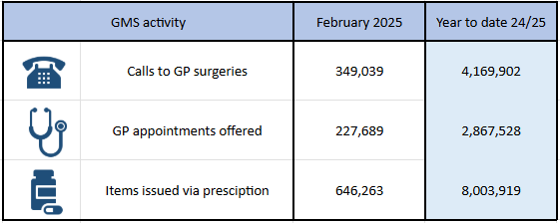
Source: Primary Care Information Portal. Note: The analyses and associated visualizations presented within this tile of the Primary Care Information Portal (PCIP) are a product of source data that has been provided at the initial stages of a quality improvement process and as such the completeness, accuracy, and validity of this source data (and hence any analyses/visualizations derived from such data) cannot be guaranteed. Please note there is a lag in receiving this national dataset.

We continue to see high utilisation of our Urgent Primary Care Centers across Cardiff and the Vale. Total utilization across all 6 sites was 91% in March, with 3,743 consultations in month. Utilisation for 25/26 was 92%, with 50,669 consultations throughout the year.

Our community teams and integrated services continue to support patients out of hospital, including 18,065 District Nursing visits in March 2025 – over 5,800 more than our reported attendances to the EU in the same period. These services continue to provide vital support to patients in the community allowing them to remain at home and reducing the demand for secondary cares services.

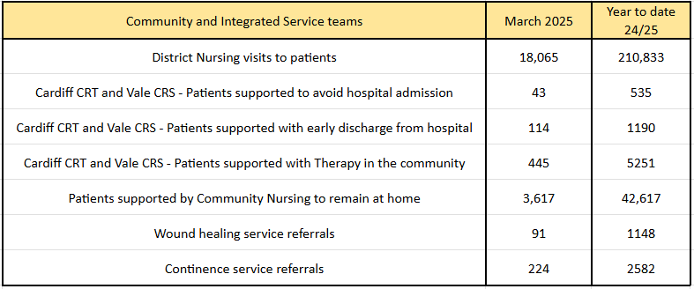

Recommendation:
The Board/Committee (delete as appropriate) are requested to:

- NOTE the year to date position against key organisational performance indicators for 2024-25 and the update against the Operational Plan programmes.

Link to Strategic Objectives of Shaping our Future Wellbeing:
https://shapingourfuturewellbeing.com/
  1.  Click the objective above to view more detail. |  |  |  |  |  |  |  |  |  |  |  |   2.  Click the objective above to view more detail. |  |  |  |  |  |  |  | x
  3.  Click the objective above to view more detail. |  |  |  |  |  |  |  |  | x |  |  |   4.  Click the objective above to view more detail.
Five Ways of Working (Sustainable Development Principles) considered
Prevention |  |  | Long term | x |  | Integration |  |  |  | x | Collaboration |  |  |  |  |  |  | Involvement
Quality Impact Assessment Completed?
Yes – (please provide completed QIA document) |  |  |  | No – (Please provide reasoning, e.g. not required) |  |  |  |  |  |  |  |  | x |  | Not required
Impact Assessment:
Risk: No
Safety: No
Financial: No
Workforce: No
Legal: No
Reputational: No
Socio Economic: No
Equality and Health: No
Decarbonisation: No
Welsh Language: No
Approval/Scrutiny Route (please note anywhere else this paper has been before):
Committee/Group/Exec |  |  |  |  | Date:

