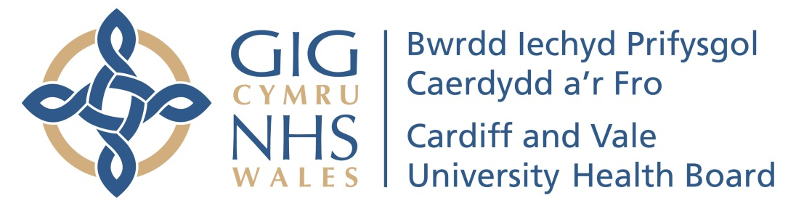

Cardiff and Vale University health Board
Annual General Meeting 2020
To be held on 24th September at 10.00 a.m.

- Welcome and Introduction | Charles Janczewski, Chair
- Annual Report 2019/20  - Financial Accounts 2019/20  - Annual Quality Statement 2019/20 | Len Richards, Chief Executive  Chris Lewis, Acting Executive Director of Finance  Ruth Walker, Executive Nurse Director
- Our Year in Review | Video of UHB achievements
- Closing remarks and thanks | Charles Janczewski

