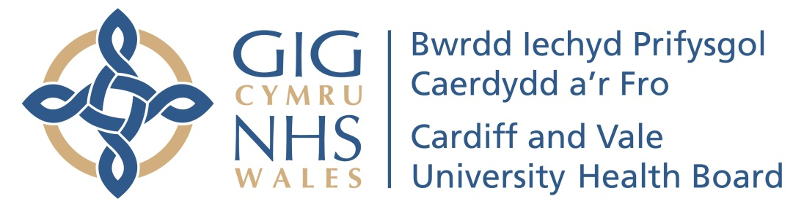

Cardiff and Vale University health Board
Annual General Meeting 2022
To be held on 19th July at 12.30 P.M.
TEAMS MEETING

- Welcome, Introductions & Minutes of AGM 2021  (15 minutes) | Charles Janczewski, Chair
- Annual Report 2021/22  (15 minutes)  - Financial Accounts 2021/22  (30 minutes) | Suzanne Rankin, Chief Executive  Rob Mahoney, Deputy Director of Finance
- Questions from the Public on Annual Report and Accounts 2021/22  (20 minutes) | Charles Janczewski, Chair
- Adoption of the Annual Report and Accounts  (5 minutes) | Charles Janczewski, Chair
- Our Year in Review  (5 minutes) | Video of UHB achievements 2021/22
- Quality and Safety  (15 minutes) | Meriel Jenney, Medical Director
- Closing remarks and thanks  (5 minutes) | Charles Janczewski, Chair

